1.

* Boolean is developed by the English mathematician and computer pioneer [George Boole](https://www.computerhope.com/people/george_boole.htm), a Boolean, bool.
* A boolean expression is an expression that results in a boolean value, that is, in a value of either true or false.

>>> age = 7

>>> old_enough_to_go_to_primary_school = age >=6

>>> print(old_enough_to_go_to_primary_school)

True

>>> type(old_enough_to_go_to_primary_school)

<class 'bool'>

>>> 6 >= 9

False

>>> sex = "female"

>>> able_to_work_in_mining_industry = sex != "female"

>>> print(able_to_work_in_mining_industry)

False

2.

- A flowchart is a type of diagram that represents the logic of the code program.

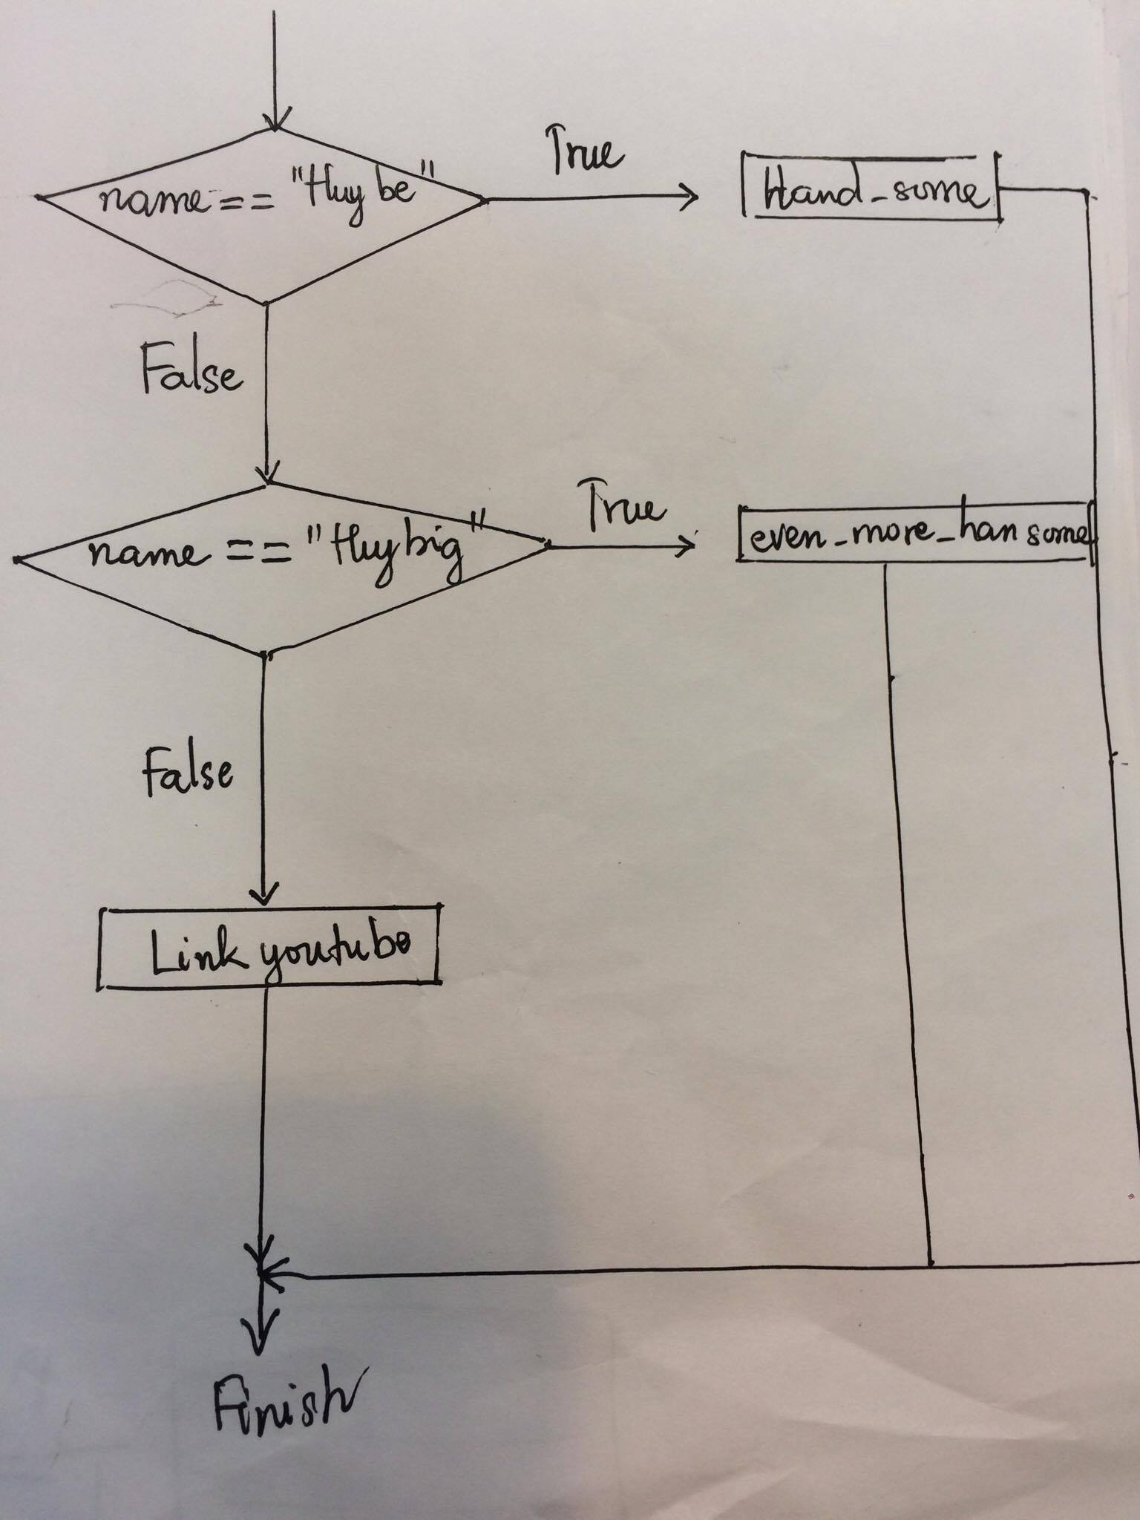

3.

- A nested conditional is an if statement which is attached with another small conditional.

- File py 3.2 nested conditional