Vietnam labor market: Strong recovery
Despite the impacts from the complicated world economic and political situation, the Vietnamese labor market in 2022 still recorded a strong recovery. Supporting and promoting policies from the State play an important role in helping the labor-job market recover after the Covid-19 pandemic.
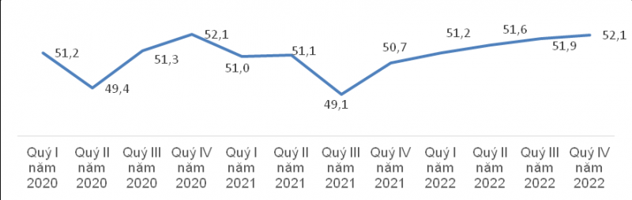
Workforce by the period 2020-2022. (Source: GSO)
Firstly, the labor market has not kept pace with the requirements of socio-economic development, has not yet fully adapted to the economic restructuring and the process of industrialization, modernization, digital transformation and international integration.
Second, the institution of labor market development is still inadequate; there are no adequate mechanisms and policies on employment transactions, market quality management, regulations on labor standards and labor relations.
Thirdly, the labor supply-demand balance is not very effective and sustainable, leading to not approaching potential productivity (lack of local labor surplus, working in the wrong field of training, etc.). The market information system is not really complete. The connection between the domestic and international labor markets is still weak.
Fourth, the social safety net has low coverage, has not yet achieved high efficiency, and has only played the role of a support for part of the labor market.
Low notes of the labor market in the last months of 2022
In the fourth quarter of 2022, when the world economy and politics continued to develop complicatedly, causing the risk of global recession, Vietnam could not avoid negative impacts.
Number of people and unemployment rate in working age by quarter 2020-2022. (Source: GSO)
In that context, the underemployment rate of workers in the fourth quarter of 2022 was 1.98%, an increase of 0.06 percentage points compared to the previous quarter. Compared to the third quarter of 2022, the number of unemployed people of working age in the fourth quarter was more than 1.08 million people, an increase of 24.9 thousand people; unemployment rate in working age is 2.32%, up 0.04 percentage points.
Facing new challenges in 2023
Entering 2023, economic forecasts of all countries are somewhat pessimistic. Inflation is expected to weaken but has not yet fallen to the previous long-term average level as well as the market's expectation. Along with that, major central banks in the world such as the FED and the ECB continue to confirm that they will still pursue a tight monetary policy in 2023.
The biggest challenge to the market is that the ability of workers to change careers is still weak when the labor market information is still fragmentary and the skills and qualifications have not yet met the change of the employment structure.
Stay strong to overcome challenges
Although the recovery rate slowed down in the last months of the year due to the impact of the global crisis and the adjustments of the domestic market, it must be frankly stated that 2022 is still the year of recovery. impression of Vietnam's labor-employment market compared to 2021 and compared to the time before the epidemic in 2019. This will still be a good step to help the market continue to recover and develop in 2023.
If relevant authorities are determined to accompany workers and employers to overcome the challenges of 2023, it is certain that the labor market will continue to have a strong year of recovery and development. make a significant contribution to socio-economic recovery and development not only in 2023 but also for the next period.

