

Requirement & Design Specification
Motorbike Rental Management System (MOTORENT)
Version: 1.1

– Da Nang, October 2026 –

Record of Changes
Version | Date | A*  M, D | In charge | Change Description
V1.0 | 26/09/2026 | A | CaPQ  (Phạm Quốc Cả) | Initial drafting of Software Requirements Specification (SRS: Actors, Use Cases & Functional Requirements).
V1.1 | 18/10/2026 | M | HoangTQB  (Bảo Hoàng) | Consolidated 50 core Use Cases (UC-01..UC-50), authored Section III Design Specifications, Database CRUD & Mongoose queries.
V1.2 | 10/11/2026 | M | HoangTQB  (Bảo Hoàng) | Completed full 50 UI Design screens from live project, Dual-Party E-Contract Signatures, Door-to-Door Delivery, AI Shift Scheduling Optimizer & MSG01–MSG26.
*A - Added M - Modified D - Deleted

Contents
Record of Changes 2
I. Overview 4
1. User Requirements 4
1.1 Actors 4
1.2 Use Cases 4
2. Overall Functionalities 8
2.1 Screens Flow 8
2.2 Screen Descriptions 9
2.3 Screen Authorization 10
2.4 Non-UI Functions 11
3. System High Level Design 11
3.1 Database Design 11
3.2 Code Packages 15
II. Requirement Specifications 16
1. Common Functions 16
1.1 UC-06_Login System 16
1.2 UC-05_Register Account 17
2. Booking Feature 18
2.1 UC-14_Book a Rental 18
2.2 UC-16_Cancel Rental Order 19
3. Counter Desk Feature 20
3.1 UC-27_Confirm Vehicle Handover (Check-in) 20
3.2 UC-28_Confirm Vehicle Return (Check-out) 21
4. Fleet Management Feature 22
4.1 UC-33_Add New Vehicle 22
5. Administration Feature 23
5.1 UC-43_Add New Branch 23
III. Design Specifications 24
1. System Access 24
1.1 User Login 24
1.2 User Registration 25
2. Booking Feature 26
2.1 Booking Modal 26
3. Counter Desk Feature 27
3.1 Check-in Form 27
3.2 Check-out Form 28
IV. Appendix 29
1. Assumptions & Dependencies 29
2. Limitations & Exclusions 30
3. Business Rules 30
3.1 Booking & Payment Rules 30
3.2 Operations & Fleet Rules 31
3.3 Security & Authentication Rules 31

I. Overview

1. User Requirements

1.1 Actors
# | Actor | Description
1 | Guest | An unauthenticated visitor who can browse the system's public pages: locate branch offices, browse the motorbike fleet with filters and sorting, read rental policies, and register/login to gain access to booking features.
2 | Customer | A registered and authenticated user who can book motorbikes, update personal profiles (including eKYC identity verification), track order status, make payments (VNPay deposit 30% / counter payment 70%), write reviews, submit complaints, and participate in the loyalty program. Inherits all Guest capabilities.
3 | Staff | A branch employee responsible for on-site counter operations: performing vehicle Check-in/Check-out, updating vehicle status, creating maintenance tickets, and responding to customer chat. Inherits all Guest capabilities.
4 | Branch Manager | A branch-level administrator who operates the branch vehicle fleet, approves/rejects rental orders and refund requests, oversees vehicle transfers, provisions staff accounts and assigns work shifts, handles complaints, and generates branch-level reports. Inherits all Staff capabilities.
5 | System Admin | The top-level administrator who administers the entire chain: creates/updates branches, provisions Manager accounts, configures RBAC, configures categories and discounts, publishes CMS content, audits security logs, and generates chain-wide KPI dashboards. Inherits all Branch Manager capabilities.

1.2 Use Cases

a. Diagram(s)
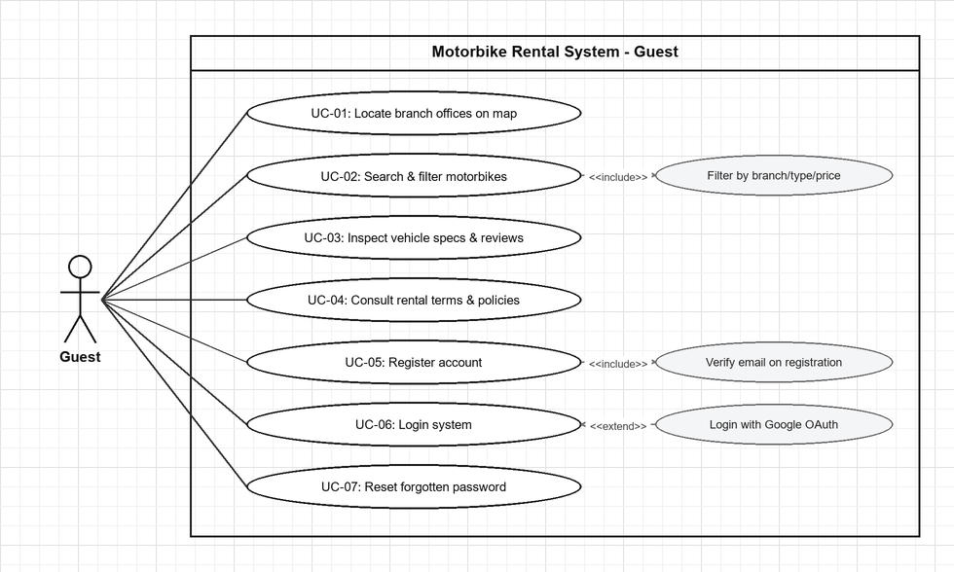
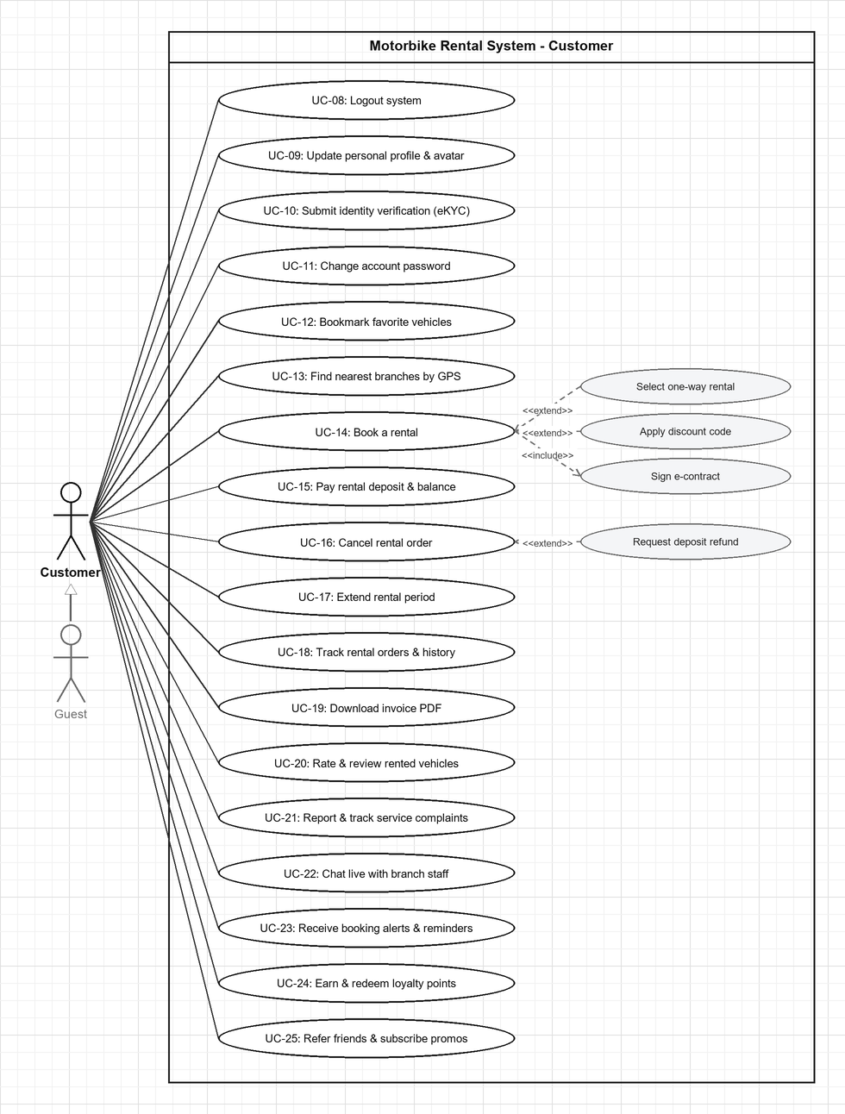
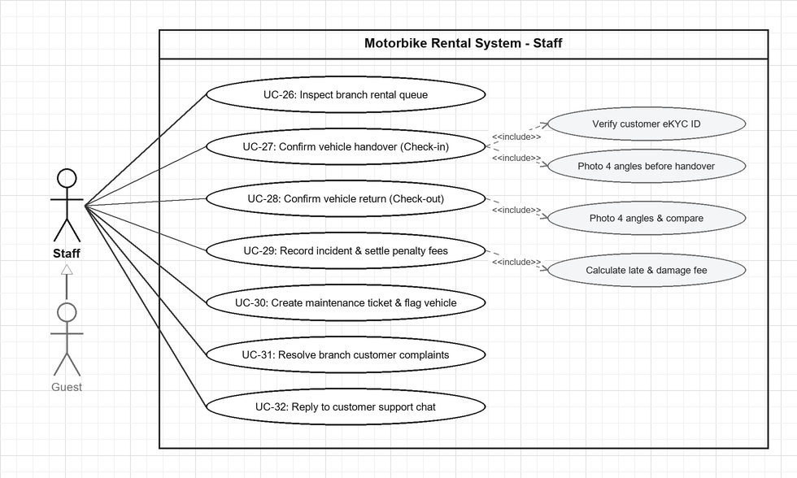
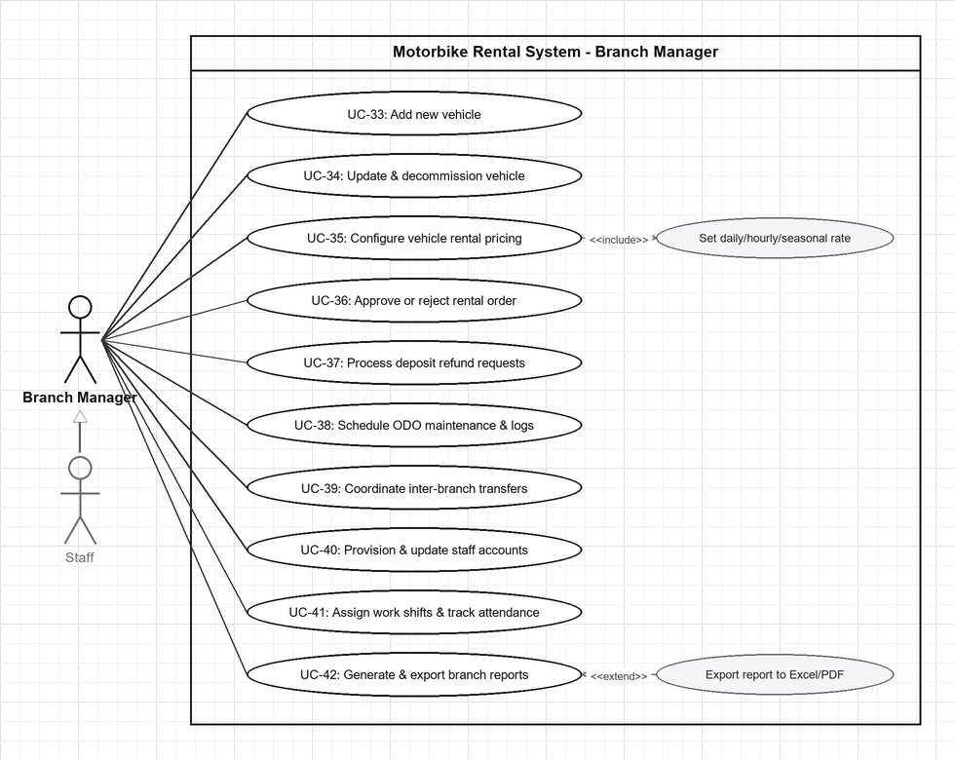
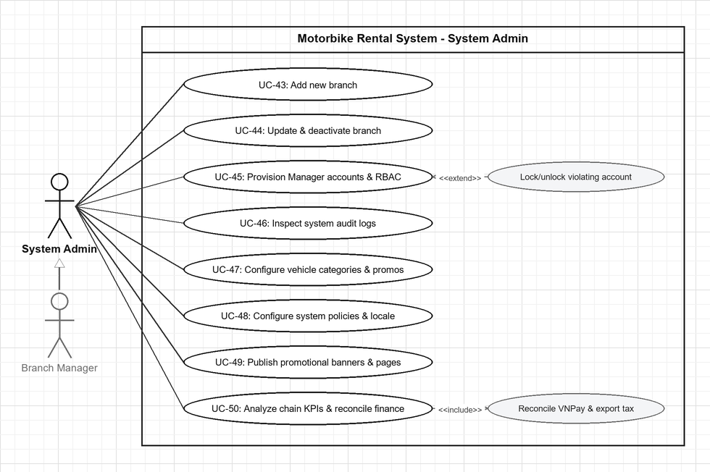

b. Descriptions
Feature 1: Browse & Search (Guest)
ID | Feature | Use Case | Use Case Description
UC-01 | Browse Branches | Locate branch offices on map | Guest explores active branch offices (address, phone, operating hours, available vehicle count) and interactive GPS map markers.
UC-02 | Browse Fleet | Search & filter motorbikes | Guest searches the fleet catalog by keyword, filters by branch, category (Scooter/Manual/Semi-Auto/Electric), price range, brand, or availability, and sorts by price or rating.
UC-03 | Browse Fleet | Inspect vehicle specs & reviews | Guest examines detailed motorbike specifications, photo gallery, daily/hourly pricing, availability status, and customer reviews/ratings.
UC-04 | Rental Policy | Consult rental terms & policies | Guest reads the rental terms, deposit rules (30% online / 70% counter), cancellation policy, and insurance coverage.
Feature 2: Authentication (Guest)
ID | Feature | Use Case | Use Case Description
UC-05 | Authentication | Register account | Guest creates a new Customer account with username, email, phone, and password or Google OAuth. <<include>> Verify email on registration.
UC-06 | Authentication | Login system | User authenticates using email/password credentials or <<extend>> Google OAuth 2.0 to receive a JWT access token.
UC-07 | Authentication | Reset forgotten password | Guest requests a time-limited password reset link sent to their registered email and sets a new password.
UC-08 | Authentication | Logout system | Authenticated user (Customer, Staff, Branch Manager, System Admin) logs out and terminates the active session.
Feature 3: Customer Profile & Account (Customer)
ID | Feature | Use Case | Use Case Description
UC-09 | Profile | Update personal profile & avatar | Customer edits personal information (first/last name, phone, gender, date of birth), uploads an avatar photo, and checks loyalty points balance.
UC-10 | Profile | Submit identity verification (eKYC) | Customer uploads front/back photos of CCCD/CMND and driving license for eKYC identity verification.
UC-11 | Profile | Change account password | Customer updates their current account password after verifying existing credentials.
Feature 4: Booking & Payment (Customer)
ID | Feature | Use Case | Use Case Description
UC-12 | Wishlist | Bookmark favorite vehicles | Customer saves motorbikes to their personal favorites wishlist or removes bookmarked vehicles.
UC-13 | Search | Find nearest branches by GPS | Customer locates available motorbikes at branches nearest to their current GPS coordinates.
UC-14 | Booking | Book a rental | Customer creates a rental order by selecting vehicle, pickup/return branches (<<extend>> one-way rental), dates, <<extend>> promo code, and <<include>> signing e-contract.
UC-15 | Payment | Pay rental deposit & balance | Customer pays 30% deposit or 100% full amount online via VNPay/VietQR, or settles the remaining 70% at the branch counter during pickup.
UC-16 | Order Mgmt | Cancel rental order | Customer cancels a pending/confirmed booking before handover with a reason and <<extend>> requests a deposit refund if applicable.
UC-17 | Order Mgmt | Extend rental period | Customer requests to extend the scheduled return date/time of an active rental.
UC-18 | Order Mgmt | Track rental orders & history | Customer monitors real-time order status via Socket.IO, checks past rental history, and inspects 4-angle check-in/check-out vehicle photos.
UC-19 | Invoice | Download invoice PDF | Customer generates and downloads a formatted PDF invoice/receipt for a completed rental order.
Feature 5: Review, Complaint & Communication (Customer)
ID | Feature | Use Case | Use Case Description
UC-20 | Reviews | Rate & review rented vehicles | Customer submits a 1–5 star review with photos for a completed rental, or edits/deletes their submitted review.
UC-21 | Complaints | Report & track service complaints | Customer submits a complaint about a booking or branch experience and tracks its resolution progress.
UC-22 | Chat | Chat live with branch staff | Customer exchanges real-time support messages with branch staff via Socket.IO.
Feature 6: Notifications & Loyalty (Customer)
ID | Feature | Use Case | Use Case Description
UC-23 | Notifications | Receive booking alerts & reminders | Customer receives in-app push notifications, email confirmations, and automated SMS pickup/return reminders (24h and 2h prior).
UC-24 | Loyalty | Earn & redeem loyalty points | Customer accumulates loyalty points upon rental completion (1 pt per 10,000 VND) and redeems points for discount vouchers.
UC-25 | Marketing | Refer friends & subscribe promos | Customer shares referral codes for bonus points and opts in to promotional offers.
Feature 7: Counter Desk Operations (Staff)
ID | Feature | Use Case | Use Case Description
UC-26 | Orders | Inspect branch rental queue | Staff filters branch rental orders by status and verifies detailed booking, payment, and customer eKYC records.
UC-27 | Check-in | Confirm vehicle handover (Check-in) | Staff <<include>> verifies customer ID/license, collects 70% counter balance, <<include>> captures 4-angle vehicle photos, records start ODO/fuel/accessories, and sets vehicle to Rented.
UC-28 | Check-out | Confirm vehicle return (Check-out) | Staff <<include>> captures 4-angle return photos, <<include>> compares condition with check-in photos, records return ODO/fuel, and updates vehicle to Available or Maintenance.
UC-29 | Penalty | Record incident & settle penalty fees | Staff documents vehicle damage with photos, <<include>> calculates late fee (30,000 VND/hr) and damage fee, and collects final settlement at counter.
UC-30 | Maintenance | Create maintenance ticket & flag vehicle | Staff updates vehicle status to Maintenance and logs a maintenance/repair ticket.
UC-31 | Complaints | Resolve branch customer complaints | Staff investigates and responds to customer complaints assigned to their branch.
UC-32 | Chat | Reply to customer support chat | Staff responds to customer live chat messages in real time via the Staff Chat Console.
Feature 8: Fleet & Staff Management (Branch Manager)
ID | Feature | Use Case | Use Case Description
UC-33 | Fleet | Add new vehicle | Manager registers a new motorbike (specs, license plate, ODO threshold, photos, pricing) to the branch fleet.
UC-34 | Fleet | Update & decommission vehicle | Manager edits vehicle specifications/status or soft-deletes (isDeleted=true) a vehicle from the branch fleet.
UC-35 | Pricing | Configure vehicle rental pricing | Manager sets and updates daily rental price, hourly rental rate, and peak seasonal pricing rules.
UC-36 | Approval | Approve or reject rental order | Manager evaluates pending booking requests and approves or rejects them with a documented reason.
UC-37 | Refund | Process deposit refund requests | Manager evaluates customer deposit refund requests and approves or rejects them with a reason.
UC-38 | Maintenance | Schedule ODO maintenance & logs | Manager schedules periodic ODO-based maintenance and audits full vehicle maintenance history.
UC-39 | Transfer | Coordinate inter-branch transfers | Manager requests incoming vehicle transfers from other branches and approves outgoing vehicle transfers.
UC-40 | Staff | Provision & update staff accounts | Manager creates new Staff accounts, updates staff details, or deactivates staff accounts in their branch.
UC-41 | Staff | Assign work shifts & track attendance | Manager assigns shift schedule entries on the calendar and monitors staff attendance.
UC-42 | Reports | Generate & export branch reports | Manager resolves escalated complaints and generates daily/monthly/annual revenue, fleet utilization, breakdown frequency, and rating reports with <<extend>> Excel/PDF export.
Feature 9: System Administration (System Admin)
ID | Feature | Use Case | Use Case Description
UC-43 | Branch | Add new branch | Admin creates a new branch with name, code, address, GPS coordinates, operating hours, and assigned Branch Manager.
UC-44 | Branch | Update & deactivate branch | Admin updates branch details, reassigns managers, or deactivates a branch (isActive=false).
UC-45 | Account | Provision Manager accounts & RBAC | Admin creates/updates/deactivates Branch Manager accounts, configures RBAC permissions, and <<extend>> locks/unlocks violating accounts.
UC-46 | Audit | Inspect system audit logs | Admin searches, filters, and audits the system-wide security and CRUD activity trail (AuditLog).
UC-47 | Catalog | Configure vehicle categories & promos | Admin creates, updates, and deactivates vehicle categories (Scooter, Manual, Electric) and promotional discount voucher codes.
UC-48 | Config | Configure system policies & locale | Admin configures cancellation/refund rules, default deposit %, loyalty program rules, and multi-language settings.
UC-49 | CMS | Publish promotional banners & pages | Admin creates, updates, and deletes homepage promotional banners and static pages (FAQ, Terms, Privacy).
UC-50 | Finance & KPI | Analyze chain KPIs & reconcile finance | Admin analyzes chain-wide revenue KPIs, branch comparisons, and seasonal demand forecasts; <<include>> reconciles VNPay payments and exports tax reports.

2. Overall Functionalities

2.1 Screens Flow
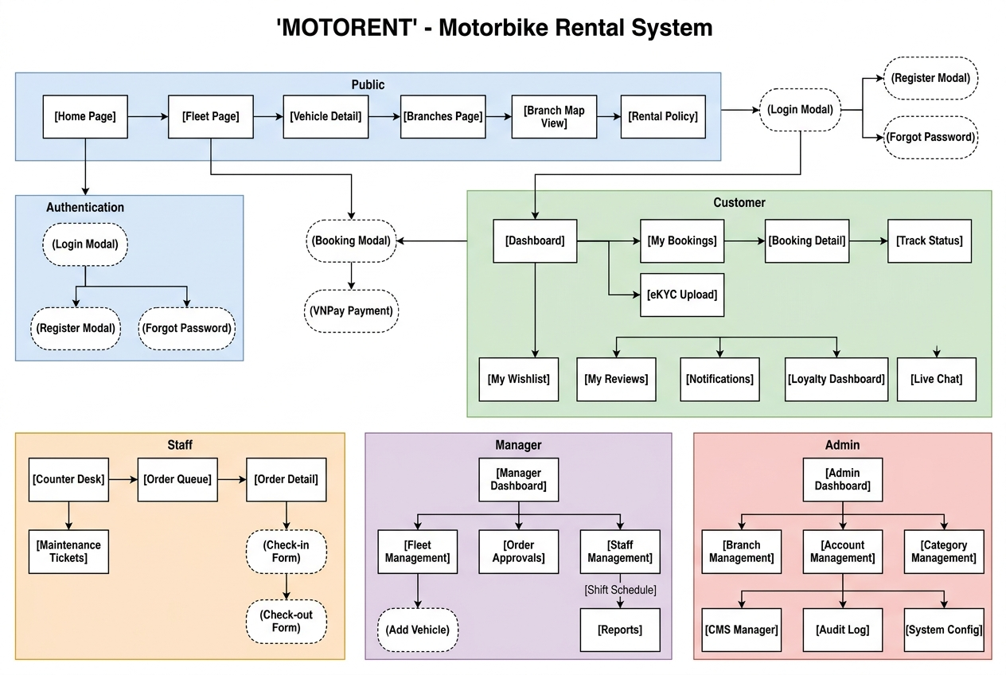

2.2 Screen Descriptions
# | Feature | Screen | Description
1 | Browse | Home Page | Landing page with hero banner slider, booking widget, featured vehicles, and branch highlights
2 | Browse | Fleet Page | Full vehicle catalog with multi-dimensional filters (branch, type, price, availability, brand) and sorting
3 | Browse | Vehicle Detail | Detailed vehicle page with photo gallery, specs, pricing, availability calendar, and reviews
4 | Browse | Branches Page | List of active branches with address, phone, hours, vehicle count, and map view toggle
5 | Browse | Rental Policy Page | Static page with rental terms, cancellation rules, deposit policy, and insurance info
6 | Auth | Login Modal | Pop-up for email/password login with Google OAuth, forgot password link, and register link
7 | Auth | Register Modal | Pop-up for new account creation with username, email, password, and terms acceptance
8 | Auth | Forgot Password Modal | Pop-up for requesting password reset email
9 | Customer | My Profile | Profile page with personal info, avatar, eKYC status badge, and loyalty points balance
10 | Customer | eKYC Upload Page | Form for uploading CCCD/CMND front/back and driving license photos
11 | Customer | My Bookings | Booking list with status tabs: All / Pending / Confirmed / Ongoing / Completed / Cancelled
12 | Customer | Booking Detail | Detailed booking view with status timeline, pricing breakdown, and action buttons
13 | Customer | Booking Modal | Pop-up workflow: select dates, branch, vehicle, payment method, sign e-contract
14 | Customer | Live Chat Window | Real-time chat interface with branch staff via Socket.IO
15 | Customer | My Wishlist | Grid view of customer's saved/favorited vehicles
16 | Customer | My Reviews | List of customer's reviews with edit/delete actions
17 | Customer | My Complaints | List of submitted complaints with status tracking
18 | Customer | Loyalty Dashboard | Points balance, earning history, and voucher redemption interface
19 | Customer | Notifications | Chronological notification list with read/unread status
20 | Staff | Counter Desk | Primary staff workspace with today's order queue, Check-in and Check-out panels
21 | Staff | Check-in Form | Multi-step: verify customer ID, photograph vehicle (4 angles), record ODO, confirm handover
22 | Staff | Check-out Form | Multi-step: photograph returned vehicle (4 angles), compare condition with check-in photos, record damage, calculate penalties
23 | Staff | Maintenance Tickets | List and creation form for vehicle maintenance log entries
24 | Staff | Staff Chat Console | Staff-side chat interface for responding to customer messages
25 | Manager | Manager Dashboard | Branch overview: today's bookings, revenue, fleet status, pending approvals
26 | Manager | Fleet Management | Vehicle CRUD list with add/edit/remove actions and pricing management
27 | Manager | Order Approvals | Queue of pending bookings with approve/reject actions and customer details
28 | Manager | Refund Requests | Queue of refund requests with approve/reject actions
29 | Manager | Vehicle Transfers | Transfer request list (incoming/outgoing) with approval workflow
30 | Manager | Staff Management | Staff account CRUD list with branch assignment
31 | Manager | Shift Schedule Calendar | Calendar view for assigning and viewing staff work shifts
32 | Manager | Reports Dashboard | Branch analytics with revenue charts, utilization metrics, and export options
33 | Admin | Admin KPI Dashboard | Chain-wide executive dashboard with revenue trends and branch comparison
34 | Admin | Branch Management | Branch CRUD list with manager assignment and activation toggle
35 | Admin | Account Management | Manager account CRUD list with RBAC configuration
36 | Admin | Category Management | Vehicle type CRUD list (Scooter, Manual, Semi-Auto, Electric)
37 | Admin | Discount Management | Discount code CRUD list with voucher configuration
38 | Admin | CMS - Banners | Banner CRUD list with image upload, ordering, and activation toggle
39 | Admin | CMS - Static Pages | Rich text editor for FAQ, Terms of Service, Privacy Policy pages
40 | Admin | Audit Log Viewer | Searchable, filterable audit trail of all system actions
41 | Admin | System Configuration | Settings for cancellation policy, deposit %, and loyalty program rules
42 | Admin | Finance Reports | Financial reports with VNPay reconciliation and tax export

2.3 Screen Authorization
Screen | Guest | Customer | Staff | Manager | Admin
Home Page | X | X | X | X | X
Fleet Page | X | X | X | X | X
Vehicle Detail | X | X | X | X | X
Branches Page | X | X | X | X | X
Rental Policy | X | X | X | X | X
Login/Register | X
My Profile |  | X | X | X | X
eKYC Upload |  | X
Booking Modal |  | X
My Bookings |  | X
Live Chat |  | X
My Wishlist |  | X
My Reviews |  | X
My Complaints |  | X
Loyalty Dashboard |  | X
Notifications |  | X | X | X | X
Counter Desk |  |  | X | X | X
Maintenance Tickets |  |  | X | X | X
Staff Chat |  |  | X | X | X
Manager Dashboard |  |  |  | X | X
Fleet Management |  |  |  | X | X
Order Approvals |  |  |  | X | X
Vehicle Transfers |  |  |  | X | X
Staff Management |  |  |  | X | X
Reports Dashboard |  |  |  | X | X
Admin KPI Dashboard |  |  |  |  | X
Branch Management |  |  |  |  | X
Account Management |  |  |  |  | X
Category Management |  |  |  |  | X
Discount Management |  |  |  |  | X
CMS Manager |  |  |  |  | X
Audit Log Viewer |  |  |  |  | X
System Configuration |  |  |  |  | X
Finance Reports |  |  |  |  | X

2.4 Non-UI Functions
# | Feature | System Function | Description
1 | Auth | JWT Token Management | Issues access tokens (24h expiry), validates via authMiddleware
2 | Auth | Email Verification | Sends verification email with unique token link via Nodemailer
3 | Auth | Password Reset Service | Generates time-limited reset token and sends email
4 | Payment | VNPay IPN Handler | Receives IPN callbacks from VNPay to confirm deposits
5 | Booking | Availability Checker | Validates vehicle availability by checking overlapping bookings
6 | Booking | Booking Code Generator | Generates unique codes in format MV-XXXXXX
7 | Booking | Late Fee Calculator | Calculates late fee at 30,000 VND/hour
8 | Booking | Loyalty Points Calculator | Awards 1 point per 10,000 VND spent
9 | Notification | Reminder Scheduler | Cron job for SMS/Email reminders (24h and 2h before)
10 | Notification | Real-time Status Push | Socket.IO broadcasts booking status changes
11 | Fleet | ODO Maintenance Alert | Flags vehicles exceeding maintenance ODO thresholds
12 | Audit | Audit Logger Middleware | Logs all sensitive CRUD operations to AuditLog
13 | Chat | Socket.IO Chat Server | WebSocket real-time message delivery
14 | Data | Database Seeder | Automated test data generator for development

3. System High Level Design

3.1 Database Design
The system uses MongoDB with Mongoose ODM, consisting of 18 collections organized in 4 groups. Total: 18 Tables, 33 Foreign Key Relationships (31 Many-to-One + 2 One-to-One).

a. Database Schema
- AuditLog
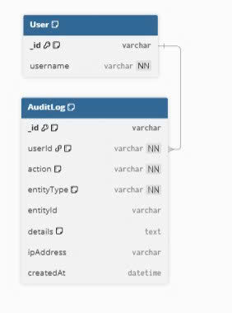
- CMS & Live Chat
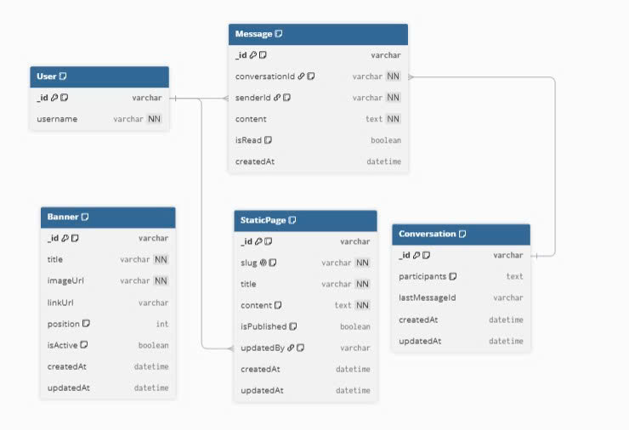
- Reviews, Complaints, Notifications
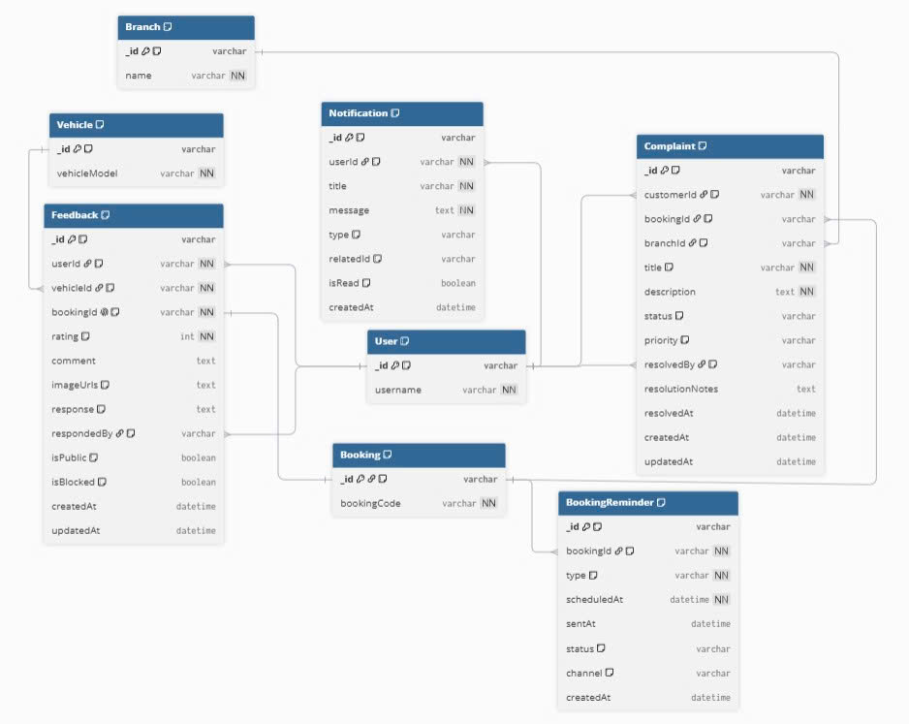
- Staffing & Shifts
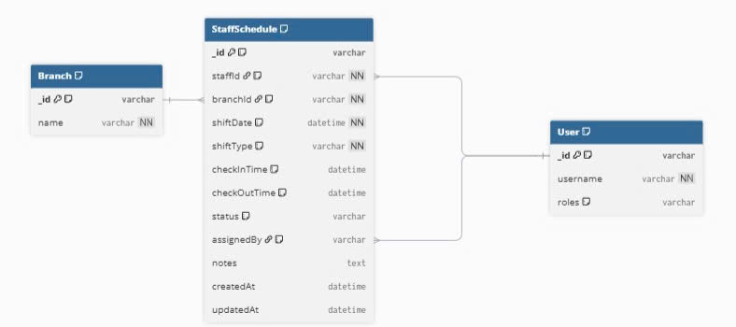
Relocation & Maintenance 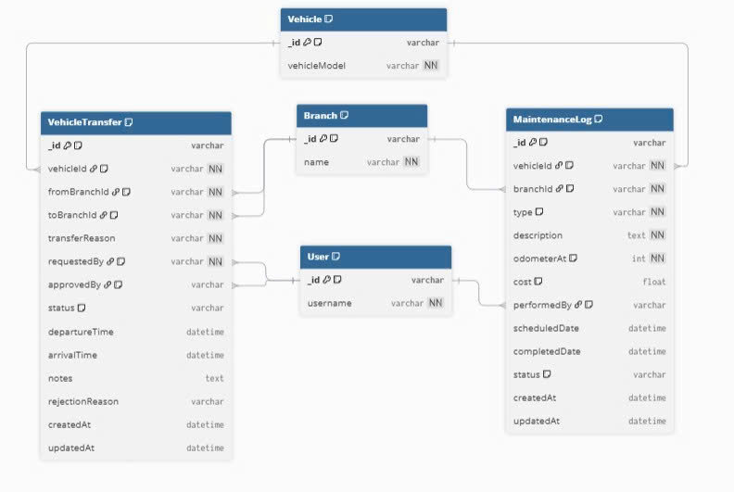
- Book & Pay
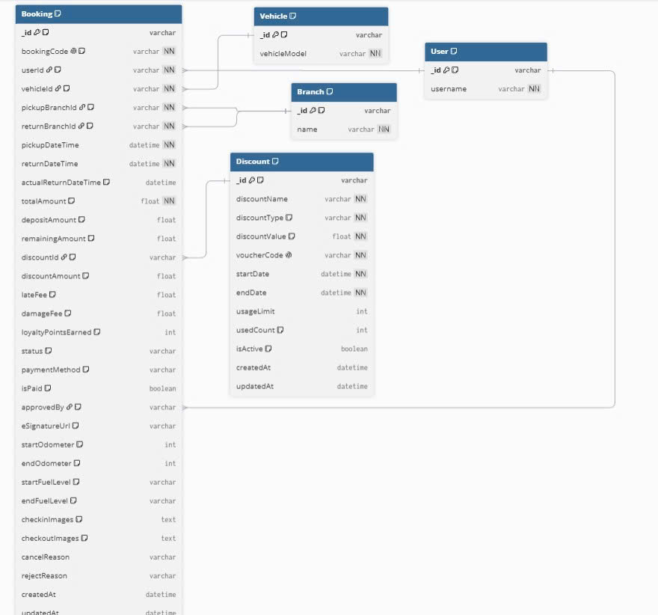
- Fleet & Categories
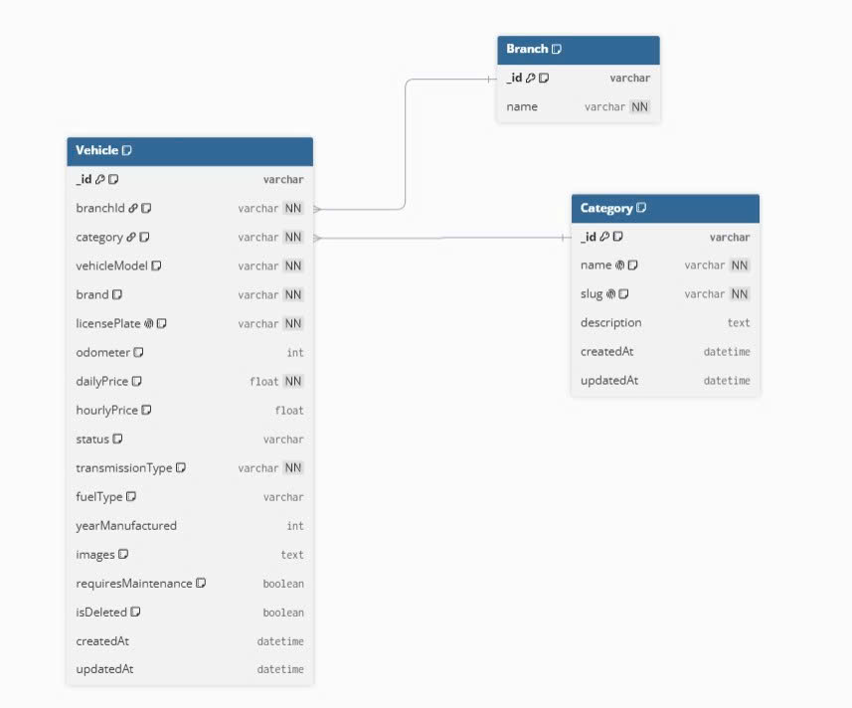
- Users & Branches
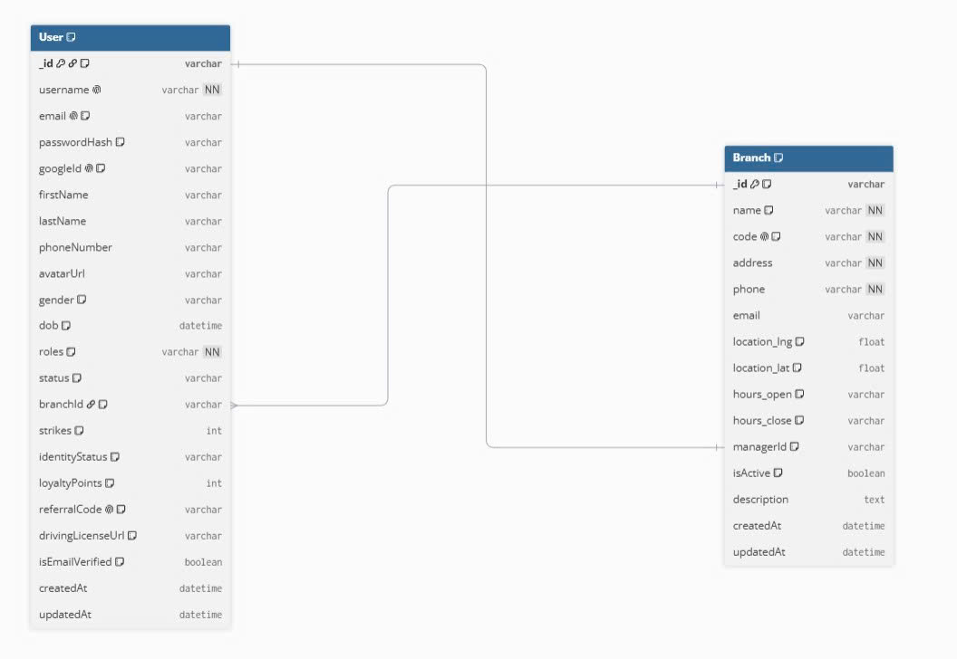

b. Table Descriptions
No | Table | Description
01 | Branch | Branch offices. PK: _id. FK: managerId -> User (1:1)
02 | User | System users, 4 RBAC roles. PK: _id. FK: branchId -> Branch
03 | Category | Vehicle type classifications. PK: _id
04 | Vehicle | Fleet motorbikes. PK: _id. FK: branchId -> Branch, category -> Category
05 | Booking | Rental orders. PK: _id. FK: userId, vehicleId, pickupBranchId, returnBranchId, discountId, approvedBy
06 | VehicleTransfer | Inter-branch transfers. PK: _id. FK: vehicleId, fromBranchId, toBranchId, requestedBy, approvedBy
07 | MaintenanceLog | Maintenance records. PK: _id. FK: vehicleId, branchId, performedBy
08 | Complaint | Customer complaints. PK: _id. FK: customerId, bookingId, branchId, resolvedBy
09 | AuditLog | System audit trail. PK: _id. FK: userId
10 | StaffSchedule | Staff shift schedules. PK: _id. FK: staffId, branchId, assignedBy
11 | Discount | Discount codes/vouchers. PK: _id
12 | Feedback | Customer reviews (1:1 Booking). PK: _id. FK: userId, vehicleId, bookingId, respondedBy
13 | Notification | In-app notifications. PK: _id. FK: userId
14 | BookingReminder | SMS/Email reminders. PK: _id. FK: bookingId
15 | Banner | CMS promotional banners. PK: _id
16 | StaticPage | CMS static pages. PK: _id. FK: updatedBy
17 | Conversation | Chat sessions. PK: _id
18 | Message | Chat messages. PK: _id. FK: conversationId, senderId

3.2 Code Packages
The backend follows a Modular Monolith architecture under server/src/. The diagram below shows the package dependency structure across 4 layers: Entry (routes), Feature Modules (8 business domains), Core Infrastructure (5 cross-cutting middlewares), and Foundation (models + config).

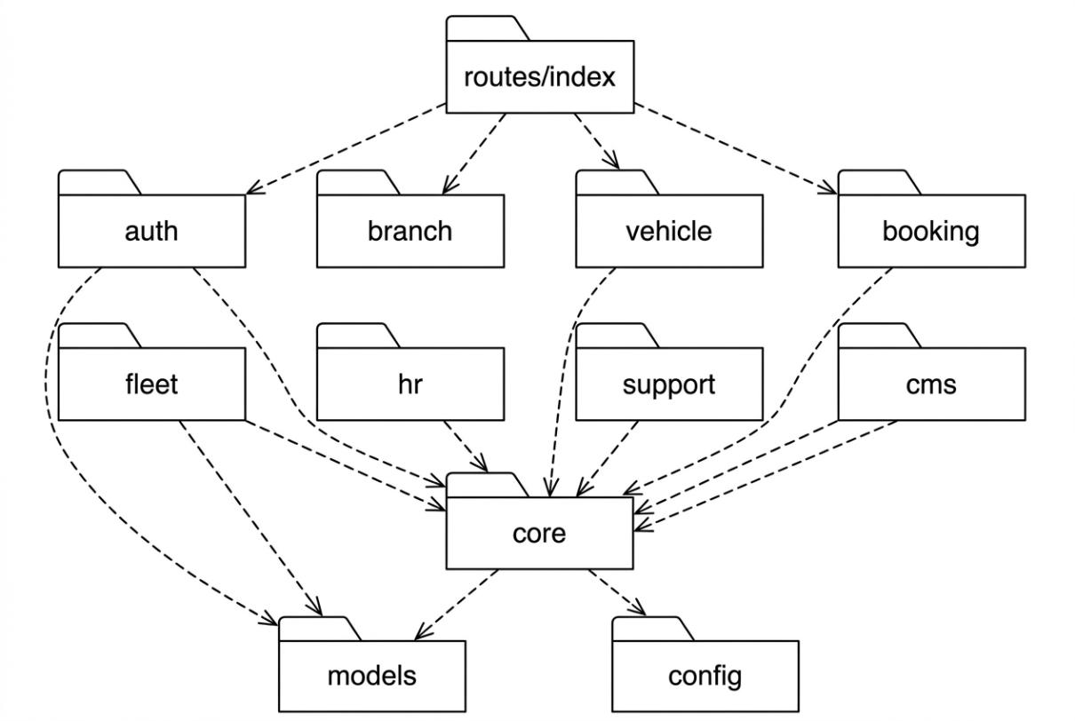
b. Package Descriptions
No | Package | Description
01 | routes/index | Central route aggregator. Imports all module routers and mounts them under /api prefix with appropriate middleware chains.
02 | auth | Authentication & eKYC module: register, login (email + Google OAuth), email verification, forgot/reset password, upload identity documents (CCCD, driving license).
03 | branch | Branch management module: CRUD operations, GPS-based nearest branch search, operating hours configuration, manager assignment.
04 | vehicle | Vehicle & category management module: fleet CRUD, multi-filter search, pricing (daily/hourly/seasonal), availability checking.
05 | booking | Central booking workflow module: create order, VNPay deposit (30%), counter payment (70%), Check-in/Check-out, cancel, refund, extend rental period.
06 | fleet | Fleet operations module: inter-branch vehicle transfers (VehicleTransfer), maintenance logging (MaintenanceLog), ODO-based service alerts.
07 | hr | Human resources module: staff shift scheduling (StaffSchedule), clock-in/clock-out attendance tracking, shift assignment by branch manager.
08 | support | Customer support module: 1-to-1 feedback/reviews (Feedback), complaints with resolution tracking (Complaint), SMS/email booking reminders (BookingReminder).
09 | cms | Content management module: banner slider CRUD, static page editor (FAQ, Terms, Privacy), Socket.IO live chat (Conversation + Message).
10 | core | Cross-cutting middleware layer: authMiddleware (JWT), rbacMiddleware (4-role RBAC), auditMiddleware (action logging), uploadMiddleware (Multer), errorHandler (centralized error response).
11 | models | 18 Mongoose schema definitions with validation rules, virtual fields, and pre-save hooks. Each model maps to one MongoDB collection.
12 | config | Environment configuration: MongoDB connection (database), VNPay payment gateway (vnpay), Nodemailer email transport (mailer), JWT secrets.

Naming Conventions
Element | Convention | Example
Model file | PascalCase.ts | Booking.ts, VehicleTransfer.ts
Controller file | camelCase + Controller.ts | bookingController.ts
Service file | camelCase + Service.ts | bookingService.ts
Route file | camelCase + Routes.ts | bookingRoutes.ts
Middleware file | camelCase + Middleware.ts | authMiddleware.ts
Collection name | lowercase plural (auto by Mongoose) | bookings, vehicletransfers
API endpoint | kebab-case with /api prefix | /api/bookings, /api/vehicle-transfers
Environment var | SCREAMING_SNAKE_CASE | MONGO_URI, JWT_SECRET, VNPAY_HASH_SECRET

II. Requirement Specifications
This section specifies the functional requirements and business rules for all 50 Use Cases (UC-01 to UC-50) organized across the 9 core features of MOTORENT, matching the Total Project Tracking and SDS numbering (1.1 to 9.8).

1. Browse & Search Feature

1.1 UC-01_Locate Branch Offices on Map
a. Functionalities
Attribute | Specification
UC ID and Name: | UC-01 — Locate Branch Offices on Map
Created By: | Cả (Group 4 — MOTORENT) Iteration: ITER1
Primary Actor: | Guest, Customer
Trigger: | Actor navigates to '/branches' or invokes the 'Locate Branch Offices on Map' action on the MOTORENT interface.
Description: | Guest and Customer view active MOTORENT branches in Da Nang with address, operating hours, live vehicle count, and interactive Leaflet GPS map markers.
Preconditions: | PRE-1: System database and API server are online.  PRE-2: Actor has required RBAC permission (Guest, Customer).
Postconditions: | POST-1: Interactive Leaflet map & GPS markers.  POST-2: Database state and audit trail are persisted accurately.
Normal Flow: | 1. Actor opens the 'Locate Branch Offices on Map' screen at route '/branches'.  2. System validates session/RBAC permissions and renders UI fields (branchList, gpsMap, nearestBtn).  3. Actor inputs or selects required parameters and submits the action.  4. Backend Controller & Service validate business rules, execute Mongoose queries on (Branch, Vehicle), and return JSON response.  5. UI displays confirmation message and updates state in real time.
Alternative Flows: | Added interactive GPS camera flyTo focus when clicking branch cards
Exceptions: | E1: Invalid input parameters or business rule violation -> System displays inline/toast message (MSG01–MSG26) and aborts transaction.
Priority: | High (Mandatory Release v1.2)
Business Rules: | Enforces RBAC matrix, input sanitization, and applicable rules BR-01..BR-15 & MSG01..MSG26.
b. Business Rules
ID | Business Rule | Business Rule Description
BR-UC-01-01 | RBAC & Input Validation | Only authorized actors (Guest, Customer) can execute Locate Branch Offices on Map; all request payloads are validated via Zod/Mongoose schemas.
BR-UC-01-02 | Domain Integrity & Audit | Interactive Leaflet map & GPS markers. System logs state changes and returns standardized messages (MSG01–MSG26).

1.2 UC-02_Search & Filter Motorbikes
a. Functionalities
Attribute | Specification
UC ID and Name: | UC-02 — Search & Filter Motorbikes
Created By: | Tài (Group 4 — MOTORENT) Iteration: ITER1
Primary Actor: | Guest, Customer
Trigger: | Actor navigates to '/bikes' or invokes the 'Search & Filter Motorbikes' action on the MOTORENT interface.
Description: | Users search and filter the motorbike fleet by branch, category (Scooter, Manual, Sport, Electric), brand, price range, and availability.
Preconditions: | PRE-1: System database and API server are online.  PRE-2: Actor has required RBAC permission (Guest, Customer).
Postconditions: | POST-1: Full text search & multi-filter query.  POST-2: Database state and audit trail are persisted accurately.
Normal Flow: | 1. Actor opens the 'Search & Filter Motorbikes' screen at route '/bikes'.  2. System validates session/RBAC permissions and renders UI fields (searchKeyword, brandFilter, categoryPills, branchPills).  3. Actor inputs or selects required parameters and submits the action.  4. Backend Controller & Service validate business rules, execute Mongoose queries on (Vehicle, Category), and return JSON response.  5. UI displays confirmation message and updates state in real time.
Alternative Flows: | Actor may filter, reset inputs, or return to the previous screen without saving changes.
Exceptions: | E1: Invalid input parameters or business rule violation -> System displays inline/toast message (MSG01–MSG26) and aborts transaction.
Priority: | High (Mandatory Release v1.2)
Business Rules: | Enforces RBAC matrix, input sanitization, and applicable rules BR-01..BR-15 & MSG01..MSG26.
b. Business Rules
ID | Business Rule | Business Rule Description
BR-UC-02-01 | RBAC & Input Validation | Only authorized actors (Guest, Customer) can execute Search & Filter Motorbikes; all request payloads are validated via Zod/Mongoose schemas.
BR-UC-02-02 | Domain Integrity & Audit | Full text search & multi-filter query. System logs state changes and returns standardized messages (MSG01–MSG26).

1.3 UC-03_Inspect Vehicle Specs & Reviews
a. Functionalities
Attribute | Specification
UC ID and Name: | UC-03 — Inspect Vehicle Specs & Reviews
Created By: | Tài (Group 4 — MOTORENT) Iteration: ITER1
Primary Actor: | Guest, Customer
Trigger: | Actor navigates to '/bikes/:vehicleId' or invokes the 'Inspect Vehicle Specs & Reviews' action on the MOTORENT interface.
Description: | Users view detailed motorbike specifications, 4-angle photo gallery, daily/hourly rental rates, availability calendar, and verified reviews.
Preconditions: | PRE-1: System database and API server are online.  PRE-2: Actor has required RBAC permission (Guest, Customer).
Postconditions: | POST-1: Includes availability calendar & verified ratings.  POST-2: Database state and audit trail are persisted accurately.
Normal Flow: | 1. Actor opens the 'Inspect Vehicle Specs & Reviews' screen at route '/bikes/:vehicleId'.  2. System validates session/RBAC permissions and renders UI fields (angleGallery, specBadges, bookNowBtn, addToCartBtn).  3. Actor inputs or selects required parameters and submits the action.  4. Backend Controller & Service validate business rules, execute Mongoose queries on (Vehicle, Review), and return JSON response.  5. UI displays confirmation message and updates state in real time.
Alternative Flows: | Actor may filter, reset inputs, or return to the previous screen without saving changes.
Exceptions: | E1: Invalid input parameters or business rule violation -> System displays inline/toast message (MSG01–MSG26) and aborts transaction.
Priority: | High (Mandatory Release v1.2)
Business Rules: | Enforces RBAC matrix, input sanitization, and applicable rules BR-01..BR-15 & MSG01..MSG26.
b. Business Rules
ID | Business Rule | Business Rule Description
BR-UC-03-01 | RBAC & Input Validation | Only authorized actors (Guest, Customer) can execute Inspect Vehicle Specs & Reviews; all request payloads are validated via Zod/Mongoose schemas.
BR-UC-03-02 | Domain Integrity & Audit | Includes availability calendar & verified ratings. System logs state changes and returns standardized messages (MSG01–MSG26).

1.4 UC-04_Consult Rental Terms & Policies
a. Functionalities
Attribute | Specification
UC ID and Name: | UC-04 — Consult Rental Terms & Policies
Created By: | Dương (Group 4 — MOTORENT) Iteration: ITER1
Primary Actor: | Guest, Customer
Trigger: | Actor navigates to '/rental-policy' or invokes the 'Consult Rental Terms & Policies' action on the MOTORENT interface.
Description: | Users view rental terms, 30% online deposit rules, 70% counter payment, BR-06 cancellation tiers, eKYC requirements, and penalty policies.
Preconditions: | PRE-1: System database and API server are online.  PRE-2: Actor has required RBAC permission (Guest, Customer).
Postconditions: | POST-1: Connected to CMS StaticPage slug routing.  POST-2: Database state and audit trail are persisted accurately.
Normal Flow: | 1. Actor opens the 'Consult Rental Terms & Policies' screen at route '/rental-policy'.  2. System validates session/RBAC permissions and renders UI fields (policySections, faqLinks).  3. Actor inputs or selects required parameters and submits the action.  4. Backend Controller & Service validate business rules, execute Mongoose queries on (StaticPage), and return JSON response.  5. UI displays confirmation message and updates state in real time.
Alternative Flows: | Actor may filter, reset inputs, or return to the previous screen without saving changes.
Exceptions: | E1: Invalid input parameters or business rule violation -> System displays inline/toast message (MSG01–MSG26) and aborts transaction.
Priority: | High (Mandatory Release v1.2)
Business Rules: | Enforces RBAC matrix, input sanitization, and applicable rules BR-01..BR-15 & MSG01..MSG26.
b. Business Rules
ID | Business Rule | Business Rule Description
BR-UC-04-01 | RBAC & Input Validation | Only authorized actors (Guest, Customer) can execute Consult Rental Terms & Policies; all request payloads are validated via Zod/Mongoose schemas.
BR-UC-04-02 | Domain Integrity & Audit | Connected to CMS StaticPage slug routing. System logs state changes and returns standardized messages (MSG01–MSG26).

2. Authentication Feature

2.1 UC-05_Register Account & Email OTP
a. Functionalities
Attribute | Specification
UC ID and Name: | UC-05 — Register Account & Email OTP
Created By: | Hoàng (Group 4 — MOTORENT) Iteration: ITER1
Primary Actor: | Guest
Trigger: | Actor navigates to '/register' or invokes the 'Register Account & Email OTP' action on the MOTORENT interface.
Description: | Register new account to access features of the Platform by unique email address and 6-digit OTP verification (popup/page register screen).
Preconditions: | PRE-1: System database and API server are online.  PRE-2: Actor has required RBAC permission (Guest).
Postconditions: | POST-1: Includes 6-digit OTP email verification.  POST-2: Database state and audit trail are persisted accurately.
Normal Flow: | 1. Actor opens the 'Register Account & Email OTP' screen at route '/register'.  2. System validates session/RBAC permissions and renders UI fields (username, email, firstName / lastName, phoneNumber, password).  3. Actor inputs or selects required parameters and submits the action.  4. Backend Controller & Service validate business rules, execute Mongoose queries on (User, AuditLog), and return JSON response.  5. UI displays confirmation message and updates state in real time.
Alternative Flows: | Actor may filter, reset inputs, or return to the previous screen without saving changes.
Exceptions: | E1: Invalid input parameters or business rule violation -> System displays inline/toast message (MSG01–MSG26) and aborts transaction.
Priority: | High (Mandatory Release v1.2)
Business Rules: | Enforces RBAC matrix, input sanitization, and applicable rules BR-01..BR-15 & MSG01..MSG26.
b. Business Rules
ID | Business Rule | Business Rule Description
BR-UC-05-01 | RBAC & Input Validation | Only authorized actors (Guest) can execute Register Account & Email OTP; all request payloads are validated via Zod/Mongoose schemas.
BR-UC-05-02 | Domain Integrity & Audit | Includes 6-digit OTP email verification. System logs state changes and returns standardized messages (MSG01–MSG26).

2.2 UC-06_Login/Logout & Google OAuth2
a. Functionalities
Attribute | Specification
UC ID and Name: | UC-06 — Login/Logout & Google OAuth2
Created By: | Hoàng (Group 4 — MOTORENT) Iteration: ITER1
Primary Actor: | User
Trigger: | Actor navigates to '/login' or invokes the 'Login/Logout & Google OAuth2' action on the MOTORENT interface.
Description: | Any User who has an account on the Platform can access the Platform by entering valid Email and password or via Google OAuth2 button.
Preconditions: | PRE-1: System database and API server are online.  PRE-2: Actor has required RBAC permission (User).
Postconditions: | POST-1: Supports JWT + Google OAuth2.0.  POST-2: Database state and audit trail are persisted accurately.
Normal Flow: | 1. Actor opens the 'Login/Logout & Google OAuth2' screen at route '/login'.  2. System validates session/RBAC permissions and renders UI fields (identifier, password, loginBtn, googleOAuthBtn).  3. Actor inputs or selects required parameters and submits the action.  4. Backend Controller & Service validate business rules, execute Mongoose queries on (User, AuditLog), and return JSON response.  5. UI displays confirmation message and updates state in real time.
Alternative Flows: | Stabilized Google GIS SDK load race condition and Referrer-Policy header
Exceptions: | E1: Invalid input parameters or business rule violation -> System displays inline/toast message (MSG01–MSG26) and aborts transaction.
Priority: | High (Mandatory Release v1.2)
Business Rules: | Enforces RBAC matrix, input sanitization, and applicable rules BR-01..BR-15 & MSG01..MSG26.
b. Business Rules
ID | Business Rule | Business Rule Description
BR-UC-06-01 | RBAC & Input Validation | Only authorized actors (User) can execute Login/Logout & Google OAuth2; all request payloads are validated via Zod/Mongoose schemas.
BR-UC-06-02 | Domain Integrity & Audit | Supports JWT + Google OAuth2.0. System logs state changes and returns standardized messages (MSG01–MSG26).

2.3 UC-07_Forgot Password
a. Functionalities
Attribute | Specification
UC ID and Name: | UC-07 — Forgot Password
Created By: | Hoàng (Group 4 — MOTORENT) Iteration: ITER1
Primary Actor: | User
Trigger: | Actor navigates to '/forgot-password' or invokes the 'Forgot Password' action on the MOTORENT interface.
Description: | When users log in if they forgot their password, they can request a verification mail to get an OTP/reset token then set a new password.
Preconditions: | PRE-1: System database and API server are online.  PRE-2: Actor has required RBAC permission (User).
Postconditions: | POST-1: Single-use SHA-256 token with 1h expiry.  POST-2: Database state and audit trail are persisted accurately.
Normal Flow: | 1. Actor opens the 'Forgot Password' screen at route '/forgot-password'.  2. System validates session/RBAC permissions and renders UI fields (email, sendOtpBtn, newPassword).  3. Actor inputs or selects required parameters and submits the action.  4. Backend Controller & Service validate business rules, execute Mongoose queries on (User), and return JSON response.  5. UI displays confirmation message and updates state in real time.
Alternative Flows: | Actor may filter, reset inputs, or return to the previous screen without saving changes.
Exceptions: | E1: Invalid input parameters or business rule violation -> System displays inline/toast message (MSG01–MSG26) and aborts transaction.
Priority: | High (Mandatory Release v1.2)
Business Rules: | Enforces RBAC matrix, input sanitization, and applicable rules BR-01..BR-15 & MSG01..MSG26.
b. Business Rules
ID | Business Rule | Business Rule Description
BR-UC-07-01 | RBAC & Input Validation | Only authorized actors (User) can execute Forgot Password; all request payloads are validated via Zod/Mongoose schemas.
BR-UC-07-02 | Domain Integrity & Audit | Single-use SHA-256 token with 1h expiry. System logs state changes and returns standardized messages (MSG01–MSG26).

2.4 UC-08_Logout System
a. Functionalities
Attribute | Specification
UC ID and Name: | UC-08 — Logout System
Created By: | Hoàng (Group 4 — MOTORENT) Iteration: ITER1
Primary Actor: | User
Trigger: | Actor navigates to '/logout' or invokes the 'Logout System' action on the MOTORENT interface.
Description: | Authenticated users log out of the platform, invalidating their active JWT session and returning to the homepage.
Preconditions: | PRE-1: System database and API server are online.  PRE-2: Actor has required RBAC permission (User).
Postconditions: | POST-1: Token revocation via tokenVersion increment.  POST-2: Database state and audit trail are persisted accurately.
Normal Flow: | 1. Actor opens the 'Logout System' screen at route '/logout'.  2. System validates session/RBAC permissions and renders UI fields (userMenuDropdown, logoutBtn).  3. Actor inputs or selects required parameters and submits the action.  4. Backend Controller & Service validate business rules, execute Mongoose queries on (User, AuditLog), and return JSON response.  5. UI displays confirmation message and updates state in real time.
Alternative Flows: | Actor may filter, reset inputs, or return to the previous screen without saving changes.
Exceptions: | E1: Invalid input parameters or business rule violation -> System displays inline/toast message (MSG01–MSG26) and aborts transaction.
Priority: | High (Mandatory Release v1.2)
Business Rules: | Enforces RBAC matrix, input sanitization, and applicable rules BR-01..BR-15 & MSG01..MSG26.
b. Business Rules
ID | Business Rule | Business Rule Description
BR-UC-08-01 | RBAC & Input Validation | Only authorized actors (User) can execute Logout System; all request payloads are validated via Zod/Mongoose schemas.
BR-UC-08-02 | Domain Integrity & Audit | Token revocation via tokenVersion increment. System logs state changes and returns standardized messages (MSG01–MSG26).

3. Customer Profile & Account Feature

3.1 UC-09_View & Edit Personal Profile
a. Functionalities
Attribute | Specification
UC ID and Name: | UC-09 — View & Edit Personal Profile
Created By: | Hoàng (Group 4 — MOTORENT) Iteration: ITER1
Primary Actor: | Customer
Trigger: | Actor navigates to '/profile (Tab 03)' or invokes the 'View & Edit Personal Profile' action on the MOTORENT interface.
Description: | Users after login successfully can view and edit their profile information (name, phone, DOB, avatar image) on the platform.
Preconditions: | PRE-1: System database and API server are online.  PRE-2: Actor has required RBAC permission (Customer).
Postconditions: | POST-1: Multer image validation & profile update.  POST-2: Database state and audit trail are persisted accurately.
Normal Flow: | 1. Actor opens the 'View & Edit Personal Profile' screen at route '/profile (Tab 03)'.  2. System validates session/RBAC permissions and renders UI fields (firstName / lastName, phoneNumber, avatarUpload, saveProfileBtn).  3. Actor inputs or selects required parameters and submits the action.  4. Backend Controller & Service validate business rules, execute Mongoose queries on (User), and return JSON response.  5. UI displays confirmation message and updates state in real time.
Alternative Flows: | Actor may filter, reset inputs, or return to the previous screen without saving changes.
Exceptions: | E1: Invalid input parameters or business rule violation -> System displays inline/toast message (MSG01–MSG26) and aborts transaction.
Priority: | High (Mandatory Release v1.2)
Business Rules: | Enforces RBAC matrix, input sanitization, and applicable rules BR-01..BR-15 & MSG01..MSG26.
b. Business Rules
ID | Business Rule | Business Rule Description
BR-UC-09-01 | RBAC & Input Validation | Only authorized actors (Customer) can execute View & Edit Personal Profile; all request payloads are validated via Zod/Mongoose schemas.
BR-UC-09-02 | Domain Integrity & Audit | Multer image validation & profile update. System logs state changes and returns standardized messages (MSG01–MSG26).

3.2 UC-10_Submit Identity Verification (eKYC)
a. Functionalities
Attribute | Specification
UC ID and Name: | UC-10 — Submit Identity Verification (eKYC)
Created By: | Hoàng (Group 4 — MOTORENT) Iteration: ITER1
Primary Actor: | Customer
Trigger: | Actor navigates to '/profile (Tab 04)' or invokes the 'Submit Identity Verification (eKYC)' action on the MOTORENT interface.
Description: | Customers upload front/back photos of CCCD/Passport and A1/A2 Driving License for mandatory eKYC identity verification.
Preconditions: | PRE-1: System database and API server are online.  PRE-2: Actor has required RBAC permission (Customer).
Postconditions: | POST-1: Updates identityVerificationStatus to Pending/Verified.  POST-2: Database state and audit trail are persisted accurately.
Normal Flow: | 1. Actor opens the 'Submit Identity Verification (eKYC)' screen at route '/profile (Tab 04)'.  2. System validates session/RBAC permissions and renders UI fields (cccdNumber, cccdFront / cccdBack, drivingLicense, portraitPhoto).  3. Actor inputs or selects required parameters and submits the action.  4. Backend Controller & Service validate business rules, execute Mongoose queries on (User, AuditLog), and return JSON response.  5. UI displays confirmation message and updates state in real time.
Alternative Flows: | Actor may filter, reset inputs, or return to the previous screen without saving changes.
Exceptions: | E1: Invalid input parameters or business rule violation -> System displays inline/toast message (MSG01–MSG26) and aborts transaction.
Priority: | High (Mandatory Release v1.2)
Business Rules: | Enforces RBAC matrix, input sanitization, and applicable rules BR-01..BR-15 & MSG01..MSG26.
b. Business Rules
ID | Business Rule | Business Rule Description
BR-UC-10-01 | RBAC & Input Validation | Only authorized actors (Customer) can execute Submit Identity Verification (eKYC); all request payloads are validated via Zod/Mongoose schemas.
BR-UC-10-02 | Domain Integrity & Audit | Updates identityVerificationStatus to Pending/Verified. System logs state changes and returns standardized messages (MSG01–MSG26).

3.3 UC-11_Change Account Password
a. Functionalities
Attribute | Specification
UC ID and Name: | UC-11 — Change Account Password
Created By: | Hoàng (Group 4 — MOTORENT) Iteration: ITER1
Primary Actor: | Customer
Trigger: | Actor navigates to '/profile (Tab 06)' or invokes the 'Change Account Password' action on the MOTORENT interface.
Description: | Users can change their password if they want as long as they enter a valid old password and a new password >= 8 characters.
Preconditions: | PRE-1: System database and API server are online.  PRE-2: Actor has required RBAC permission (Customer).
Postconditions: | POST-1: Bcrypt 10 rounds + session rotation.  POST-2: Database state and audit trail are persisted accurately.
Normal Flow: | 1. Actor opens the 'Change Account Password' screen at route '/profile (Tab 06)'.  2. System validates session/RBAC permissions and renders UI fields (currentPassword, newPassword, confirmPassword).  3. Actor inputs or selects required parameters and submits the action.  4. Backend Controller & Service validate business rules, execute Mongoose queries on (User), and return JSON response.  5. UI displays confirmation message and updates state in real time.
Alternative Flows: | Actor may filter, reset inputs, or return to the previous screen without saving changes.
Exceptions: | E1: Invalid input parameters or business rule violation -> System displays inline/toast message (MSG01–MSG26) and aborts transaction.
Priority: | High (Mandatory Release v1.2)
Business Rules: | Enforces RBAC matrix, input sanitization, and applicable rules BR-01..BR-15 & MSG01..MSG26.
b. Business Rules
ID | Business Rule | Business Rule Description
BR-UC-11-01 | RBAC & Input Validation | Only authorized actors (Customer) can execute Change Account Password; all request payloads are validated via Zod/Mongoose schemas.
BR-UC-11-02 | Domain Integrity & Audit | Bcrypt 10 rounds + session rotation. System logs state changes and returns standardized messages (MSG01–MSG26).

4. Booking & Payment Feature

4.1 UC-12_Bookmark Favorite Vehicles (Wishlist)
a. Functionalities
Attribute | Specification
UC ID and Name: | UC-12 — Bookmark Favorite Vehicles (Wishlist)
Created By: | Tuyên (Group 4 — MOTORENT) Iteration: ITER1
Primary Actor: | Customer
Trigger: | Actor navigates to '/wishlist' or invokes the 'Bookmark Favorite Vehicles (Wishlist)' action on the MOTORENT interface.
Description: | Customers save or remove favorite motorbikes in their personal wishlist for quick comparison and booking.
Preconditions: | PRE-1: System database and API server are online.  PRE-2: Actor has required RBAC permission (Customer).
Postconditions: | POST-1: Persisted in Wishlist collection.  POST-2: Database state and audit trail are persisted accurately.
Normal Flow: | 1. Actor opens the 'Bookmark Favorite Vehicles (Wishlist)' screen at route '/wishlist'.  2. System validates session/RBAC permissions and renders UI fields (wishlistGrid, removeBookmarkBtn, quickBookBtn).  3. Actor inputs or selects required parameters and submits the action.  4. Backend Controller & Service validate business rules, execute Mongoose queries on (Wishlist), and return JSON response.  5. UI displays confirmation message and updates state in real time.
Alternative Flows: | Actor may filter, reset inputs, or return to the previous screen without saving changes.
Exceptions: | E1: Invalid input parameters or business rule violation -> System displays inline/toast message (MSG01–MSG26) and aborts transaction.
Priority: | High (Mandatory Release v1.2)
Business Rules: | Enforces RBAC matrix, input sanitization, and applicable rules BR-01..BR-15 & MSG01..MSG26.
b. Business Rules
ID | Business Rule | Business Rule Description
BR-UC-12-01 | RBAC & Input Validation | Only authorized actors (Customer) can execute Bookmark Favorite Vehicles (Wishlist); all request payloads are validated via Zod/Mongoose schemas.
BR-UC-12-02 | Domain Integrity & Audit | Persisted in Wishlist collection. System logs state changes and returns standardized messages (MSG01–MSG26).

4.2 UC-13_Find Nearest Branches by GPS
a. Functionalities
Attribute | Specification
UC ID and Name: | UC-13 — Find Nearest Branches by GPS
Created By: | Cả (Group 4 — MOTORENT) Iteration: ITER1
Primary Actor: | Customer
Trigger: | Actor navigates to '/branches' or invokes the 'Find Nearest Branches by GPS' action on the MOTORENT interface.
Description: | Customers locate available motorbikes at branches nearest to their current GPS coordinates using Haversine distance calculation.
Preconditions: | PRE-1: System database and API server are online.  PRE-2: Actor has required RBAC permission (Customer).
Postconditions: | POST-1: Haversine formula distance calculation.  POST-2: Database state and audit trail are persisted accurately.
Normal Flow: | 1. Actor opens the 'Find Nearest Branches by GPS' screen at route '/branches'.  2. System validates session/RBAC permissions and renders UI fields (findNearestBtn, distanceBadge).  3. Actor inputs or selects required parameters and submits the action.  4. Backend Controller & Service validate business rules, execute Mongoose queries on (Branch), and return JSON response.  5. UI displays confirmation message and updates state in real time.
Alternative Flows: | Actor may filter, reset inputs, or return to the previous screen without saving changes.
Exceptions: | E1: Invalid input parameters or business rule violation -> System displays inline/toast message (MSG01–MSG26) and aborts transaction.
Priority: | High (Mandatory Release v1.2)
Business Rules: | Enforces RBAC matrix, input sanitization, and applicable rules BR-01..BR-15 & MSG01..MSG26.
b. Business Rules
ID | Business Rule | Business Rule Description
BR-UC-13-01 | RBAC & Input Validation | Only authorized actors (Customer) can execute Find Nearest Branches by GPS; all request payloads are validated via Zod/Mongoose schemas.
BR-UC-13-02 | Domain Integrity & Audit | Haversine formula distance calculation. System logs state changes and returns standardized messages (MSG01–MSG26).

4.3 UC-14_Book a Rental & Multi-Vehicle Cart
a. Functionalities
Attribute | Specification
UC ID and Name: | UC-14 — Book a Rental & Multi-Vehicle Cart
Created By: | Dương (Group 4 — MOTORENT) Iteration: ITER2
Primary Actor: | Customer
Trigger: | Actor navigates to '/booking/:vehicleId & /cart' or invokes the 'Book a Rental & Multi-Vehicle Cart' action on the MOTORENT interface.
Description: | Customers book a single motorbike via the 4-step wizard or reserve multiple motorbikes in one batch via the Multi-Vehicle Cart Drawer.
Preconditions: | PRE-1: System database and API server are online.  PRE-2: Actor has required RBAC permission (Customer).
Postconditions: | POST-1: Single & Multi-Vehicle Cart booking.  POST-2: Database state and audit trail are persisted accurately.
Normal Flow: | 1. Actor opens the 'Book a Rental & Multi-Vehicle Cart' screen at route '/booking/:vehicleId & /cart'.  2. System validates session/RBAC permissions and renders UI fields (pickupBranchId / returnBranchId, pickupDateTime / returnDateTime, voucherCode, cartBatchCheckout).  3. Actor inputs or selects required parameters and submits the action.  4. Backend Controller & Service validate business rules, execute Mongoose queries on (Booking, Discount), and return JSON response.  5. UI displays confirmation message and updates state in real time.
Alternative Flows: | Added Multi-Vehicle Cart Drawer supporting batch reservation with shared CART-XXE-MV-XXXXXX group code
Exceptions: | E1: Invalid input parameters or business rule violation -> System displays inline/toast message (MSG01–MSG26) and aborts transaction.
Priority: | High (Mandatory Release v1.2)
Business Rules: | Enforces RBAC matrix, input sanitization, and applicable rules BR-01..BR-15 & MSG01..MSG26.
b. Business Rules
ID | Business Rule | Business Rule Description
BR-UC-14-01 | RBAC & Input Validation | Only authorized actors (Customer) can execute Book a Rental & Multi-Vehicle Cart; all request payloads are validated via Zod/Mongoose schemas.
BR-UC-14-02 | Domain Integrity & Audit | Single & Multi-Vehicle Cart booking. System logs state changes and returns standardized messages (MSG01–MSG26).

4.4 UC-15_Pay Deposit via VNPay & Counter Balance
a. Functionalities
Attribute | Specification
UC ID and Name: | UC-15 — Pay Deposit via VNPay & Counter Balance
Created By: | Hoàng (Group 4 — MOTORENT) Iteration: ITER2
Primary Actor: | Customer
Trigger: | Actor navigates to '/vnpay-return' or invokes the 'Pay Deposit via VNPay & Counter Balance' action on the MOTORENT interface.
Description: | Customers pay 30% deposit or 100% full amount online via VNPay Sandbox form (HMAC-SHA512), and settle 70% remaining balance at counter.
Preconditions: | PRE-1: System database and API server are online.  PRE-2: Actor has required RBAC permission (Customer).
Postconditions: | POST-1: VNPay HMAC-SHA512 + batch cart confirmation.  POST-2: Database state and audit trail are persisted accurately.
Normal Flow: | 1. Actor opens the 'Pay Deposit via VNPay & Counter Balance' screen at route '/vnpay-return'.  2. System validates session/RBAC permissions and renders UI fields (paymentMethod, vnpayGatewayForm, returnStatusCard).  3. Actor inputs or selects required parameters and submits the action.  4. Backend Controller & Service validate business rules, execute Mongoose queries on (Payment, Booking), and return JSON response.  5. UI displays confirmation message and updates state in real time.
Alternative Flows: | Batch VNPay return/IPN confirmation for multi-vehicle cart orders
Exceptions: | E1: Invalid input parameters or business rule violation -> System displays inline/toast message (MSG01–MSG26) and aborts transaction.
Priority: | High (Mandatory Release v1.2)
Business Rules: | Enforces RBAC matrix, input sanitization, and applicable rules BR-01..BR-15 & MSG01..MSG26.
b. Business Rules
ID | Business Rule | Business Rule Description
BR-UC-15-01 | RBAC & Input Validation | Only authorized actors (Customer) can execute Pay Deposit via VNPay & Counter Balance; all request payloads are validated via Zod/Mongoose schemas.
BR-UC-15-02 | Domain Integrity & Audit | VNPay HMAC-SHA512 + batch cart confirmation. System logs state changes and returns standardized messages (MSG01–MSG26).

4.5 UC-16_Cancel Rental Order & Mid-Rental Termination
a. Functionalities
Attribute | Specification
UC ID and Name: | UC-16 — Cancel Rental Order & Mid-Rental Termination
Created By: | Dương (Group 4 — MOTORENT) Iteration: ITER2
Primary Actor: | Customer
Trigger: | Actor navigates to '/profile (Tab 01)' or invokes the 'Cancel Rental Order & Mid-Rental Termination' action on the MOTORENT interface.
Description: | Customers cancel pending/confirmed orders under BR-06 refund tiers or terminate an Ongoing rental early to release the motorbike.
Preconditions: | PRE-1: System database and API server are online.  PRE-2: Actor has required RBAC permission (Customer).
Postconditions: | POST-1: Enforces BR-06 refund policy & mid-rental release.  POST-2: Database state and audit trail are persisted accurately.
Normal Flow: | 1. Actor opens the 'Cancel Rental Order & Mid-Rental Termination' screen at route '/profile (Tab 01)'.  2. System validates session/RBAC permissions and renders UI fields (cancelOrderBtn, cancellationReason, refundPreview).  3. Actor inputs or selects required parameters and submits the action.  4. Backend Controller & Service validate business rules, execute Mongoose queries on (Booking, Vehicle), and return JSON response.  5. UI displays confirmation message and updates state in real time.
Alternative Flows: | Allowed mid-rental early cancellation on Ongoing bookings with automatic vehicle release
Exceptions: | E1: Invalid input parameters or business rule violation -> System displays inline/toast message (MSG01–MSG26) and aborts transaction.
Priority: | High (Mandatory Release v1.2)
Business Rules: | Enforces RBAC matrix, input sanitization, and applicable rules BR-01..BR-15 & MSG01..MSG26.
b. Business Rules
ID | Business Rule | Business Rule Description
BR-UC-16-01 | RBAC & Input Validation | Only authorized actors (Customer) can execute Cancel Rental Order & Mid-Rental Termination; all request payloads are validated via Zod/Mongoose schemas.
BR-UC-16-02 | Domain Integrity & Audit | Enforces BR-06 refund policy & mid-rental release. System logs state changes and returns standardized messages (MSG01–MSG26).

4.6 UC-17_Extend Rental Period
a. Functionalities
Attribute | Specification
UC ID and Name: | UC-17 — Extend Rental Period
Created By: | Dương (Group 4 — MOTORENT) Iteration: ITER2
Primary Actor: | Customer
Trigger: | Actor navigates to '/profile (Tab 01)' or invokes the 'Extend Rental Period' action on the MOTORENT interface.
Description: | Customers with an Ongoing rental request to extend their return date/time after automatic conflict checking.
Preconditions: | PRE-1: System database and API server are online.  PRE-2: Actor has required RBAC permission (Customer).
Postconditions: | POST-1: Checks conflict window & recalculates totalAmount.  POST-2: Database state and audit trail are persisted accurately.
Normal Flow: | 1. Actor opens the 'Extend Rental Period' screen at route '/profile (Tab 01)'.  2. System validates session/RBAC permissions and renders UI fields (extendRentalBtn, newReturnDateTime, extraFeeSummary).  3. Actor inputs or selects required parameters and submits the action.  4. Backend Controller & Service validate business rules, execute Mongoose queries on (Booking), and return JSON response.  5. UI displays confirmation message and updates state in real time.
Alternative Flows: | Actor may filter, reset inputs, or return to the previous screen without saving changes.
Exceptions: | E1: Invalid input parameters or business rule violation -> System displays inline/toast message (MSG01–MSG26) and aborts transaction.
Priority: | High (Mandatory Release v1.2)
Business Rules: | Enforces RBAC matrix, input sanitization, and applicable rules BR-01..BR-15 & MSG01..MSG26.
b. Business Rules
ID | Business Rule | Business Rule Description
BR-UC-17-01 | RBAC & Input Validation | Only authorized actors (Customer) can execute Extend Rental Period; all request payloads are validated via Zod/Mongoose schemas.
BR-UC-17-02 | Domain Integrity & Audit | Checks conflict window & recalculates totalAmount. System logs state changes and returns standardized messages (MSG01–MSG26).

4.7 UC-18_Track Rental Orders & History
a. Functionalities
Attribute | Specification
UC ID and Name: | UC-18 — Track Rental Orders & History
Created By: | Dương (Group 4 — MOTORENT) Iteration: ITER2
Primary Actor: | Customer
Trigger: | Actor navigates to '/profile (Tab 01)' or invokes the 'Track Rental Orders & History' action on the MOTORENT interface.
Description: | Customers view their booking list across status tabs (All, Pending, Confirmed, Ongoing, Completed, Cancelled) with real-time Socket.IO updates.
Preconditions: | PRE-1: System database and API server are online.  PRE-2: Actor has required RBAC permission (Customer).
Postconditions: | POST-1: Real-time Socket.IO status transitions.  POST-2: Database state and audit trail are persisted accurately.
Normal Flow: | 1. Actor opens the 'Track Rental Orders & History' screen at route '/profile (Tab 01)'.  2. System validates session/RBAC permissions and renders UI fields (statusFilterTabs, contractSearch, checkInPhotosGrid).  3. Actor inputs or selects required parameters and submits the action.  4. Backend Controller & Service validate business rules, execute Mongoose queries on (Booking), and return JSON response.  5. UI displays confirmation message and updates state in real time.
Alternative Flows: | Actor may filter, reset inputs, or return to the previous screen without saving changes.
Exceptions: | E1: Invalid input parameters or business rule violation -> System displays inline/toast message (MSG01–MSG26) and aborts transaction.
Priority: | High (Mandatory Release v1.2)
Business Rules: | Enforces RBAC matrix, input sanitization, and applicable rules BR-01..BR-15 & MSG01..MSG26.
b. Business Rules
ID | Business Rule | Business Rule Description
BR-UC-18-01 | RBAC & Input Validation | Only authorized actors (Customer) can execute Track Rental Orders & History; all request payloads are validated via Zod/Mongoose schemas.
BR-UC-18-02 | Domain Integrity & Audit | Real-time Socket.IO status transitions. System logs state changes and returns standardized messages (MSG01–MSG26).

4.8 UC-19_Download Invoice PDF
a. Functionalities
Attribute | Specification
UC ID and Name: | UC-19 — Download Invoice PDF
Created By: | Dương (Group 4 — MOTORENT) Iteration: ITER3
Primary Actor: | Customer
Trigger: | Actor navigates to '/booking-details/:id' or invokes the 'Download Invoice PDF' action on the MOTORENT interface.
Description: | Customers generate and download a formatted PDF rental contract and itemized receipt via PDFKit.
Preconditions: | PRE-1: System database and API server are online.  PRE-2: Actor has required RBAC permission (Customer).
Postconditions: | POST-1: Generated dynamically via PDFKit.  POST-2: Database state and audit trail are persisted accurately.
Normal Flow: | 1. Actor opens the 'Download Invoice PDF' screen at route '/booking-details/:id'.  2. System validates session/RBAC permissions and renders UI fields (downloadPdfBtn, contractBreakdown).  3. Actor inputs or selects required parameters and submits the action.  4. Backend Controller & Service validate business rules, execute Mongoose queries on (Booking, Payment), and return JSON response.  5. UI displays confirmation message and updates state in real time.
Alternative Flows: | Actor may filter, reset inputs, or return to the previous screen without saving changes.
Exceptions: | E1: Invalid input parameters or business rule violation -> System displays inline/toast message (MSG01–MSG26) and aborts transaction.
Priority: | High (Mandatory Release v1.2)
Business Rules: | Enforces RBAC matrix, input sanitization, and applicable rules BR-01..BR-15 & MSG01..MSG26.
b. Business Rules
ID | Business Rule | Business Rule Description
BR-UC-19-01 | RBAC & Input Validation | Only authorized actors (Customer) can execute Download Invoice PDF; all request payloads are validated via Zod/Mongoose schemas.
BR-UC-19-02 | Domain Integrity & Audit | Generated dynamically via PDFKit. System logs state changes and returns standardized messages (MSG01–MSG26).

5. Review, Complaint & Communication Feature

5.1 UC-20_Rate & Review Rented Vehicles
a. Functionalities
Attribute | Specification
UC ID and Name: | UC-20 — Rate & Review Rented Vehicles
Created By: | Tuyên (Group 4 — MOTORENT) Iteration: ITER1
Primary Actor: | Customer
Trigger: | Actor navigates to '/bikes/:vehicleId' or invokes the 'Rate & Review Rented Vehicles' action on the MOTORENT interface.
Description: | Customers submit a 1-5 star reputation and vehicle quality review with photos after rental completion.
Preconditions: | PRE-1: System database and API server are online.  PRE-2: Actor has required RBAC permission (Customer).
Postconditions: | POST-1: Updates vehicle average rating atomically.  POST-2: Database state and audit trail are persisted accurately.
Normal Flow: | 1. Actor opens the 'Rate & Review Rented Vehicles' screen at route '/bikes/:vehicleId'.  2. System validates session/RBAC permissions and renders UI fields (starRatingSelector, reviewComment, submitReviewBtn).  3. Actor inputs or selects required parameters and submits the action.  4. Backend Controller & Service validate business rules, execute Mongoose queries on (Review, Vehicle), and return JSON response.  5. UI displays confirmation message and updates state in real time.
Alternative Flows: | Actor may filter, reset inputs, or return to the previous screen without saving changes.
Exceptions: | E1: Invalid input parameters or business rule violation -> System displays inline/toast message (MSG01–MSG26) and aborts transaction.
Priority: | High (Mandatory Release v1.2)
Business Rules: | Enforces RBAC matrix, input sanitization, and applicable rules BR-01..BR-15 & MSG01..MSG26.
b. Business Rules
ID | Business Rule | Business Rule Description
BR-UC-20-01 | RBAC & Input Validation | Only authorized actors (Customer) can execute Rate & Review Rented Vehicles; all request payloads are validated via Zod/Mongoose schemas.
BR-UC-20-02 | Domain Integrity & Audit | Updates vehicle average rating atomically. System logs state changes and returns standardized messages (MSG01–MSG26).

5.2 UC-21_Report & Track Service Complaints
a. Functionalities
Attribute | Specification
UC ID and Name: | UC-21 — Report & Track Service Complaints
Created By: | Tuyên (Group 4 — MOTORENT) Iteration: ITER1
Primary Actor: | Customer
Trigger: | Actor navigates to '/complaints' or invokes the 'Report & Track Service Complaints' action on the MOTORENT interface.
Description: | Customers submit service or vehicle complaints with issues and track resolution status from Open to Resolved.
Preconditions: | PRE-1: System database and API server are online.  PRE-2: Actor has required RBAC permission (Customer).
Postconditions: | POST-1: Full lifecycle state tracking.  POST-2: Database state and audit trail are persisted accurately.
Normal Flow: | 1. Actor opens the 'Report & Track Service Complaints' screen at route '/complaints'.  2. System validates session/RBAC permissions and renders UI fields (bookingSelector, complaintTitle / description, statusBadge).  3. Actor inputs or selects required parameters and submits the action.  4. Backend Controller & Service validate business rules, execute Mongoose queries on (Complaint), and return JSON response.  5. UI displays confirmation message and updates state in real time.
Alternative Flows: | Actor may filter, reset inputs, or return to the previous screen without saving changes.
Exceptions: | E1: Invalid input parameters or business rule violation -> System displays inline/toast message (MSG01–MSG26) and aborts transaction.
Priority: | High (Mandatory Release v1.2)
Business Rules: | Enforces RBAC matrix, input sanitization, and applicable rules BR-01..BR-15 & MSG01..MSG26.
b. Business Rules
ID | Business Rule | Business Rule Description
BR-UC-21-01 | RBAC & Input Validation | Only authorized actors (Customer) can execute Report & Track Service Complaints; all request payloads are validated via Zod/Mongoose schemas.
BR-UC-21-02 | Domain Integrity & Audit | Full lifecycle state tracking. System logs state changes and returns standardized messages (MSG01–MSG26).

5.3 UC-22_Chat Live with Branch Staff
a. Functionalities
Attribute | Specification
UC ID and Name: | UC-22 — Chat Live with Branch Staff
Created By: | Hoàng (Group 4 — MOTORENT) Iteration: ITER3
Primary Actor: | Customer, Staff
Trigger: | Actor navigates to 'LiveChatWidget (Global)' or invokes the 'Chat Live with Branch Staff' action on the MOTORENT interface.
Description: | Customers and branch staff contact each other in real time on platform Socket.IO chat channels.
Preconditions: | PRE-1: System database and API server are online.  PRE-2: Actor has required RBAC permission (Customer, Staff).
Postconditions: | POST-1: Socket.IO room per conversation.  POST-2: Database state and audit trail are persisted accurately.
Normal Flow: | 1. Actor opens the 'Chat Live with Branch Staff' screen at route 'LiveChatWidget (Global)'.  2. System validates session/RBAC permissions and renders UI fields (chatFloatingBtn, messageInput).  3. Actor inputs or selects required parameters and submits the action.  4. Backend Controller & Service validate business rules, execute Mongoose queries on (Conversation, Message), and return JSON response.  5. UI displays confirmation message and updates state in real time.
Alternative Flows: | Actor may filter, reset inputs, or return to the previous screen without saving changes.
Exceptions: | E1: Invalid input parameters or business rule violation -> System displays inline/toast message (MSG01–MSG26) and aborts transaction.
Priority: | High (Mandatory Release v1.2)
Business Rules: | Enforces RBAC matrix, input sanitization, and applicable rules BR-01..BR-15 & MSG01..MSG26.
b. Business Rules
ID | Business Rule | Business Rule Description
BR-UC-22-01 | RBAC & Input Validation | Only authorized actors (Customer, Staff) can execute Chat Live with Branch Staff; all request payloads are validated via Zod/Mongoose schemas.
BR-UC-22-02 | Domain Integrity & Audit | Socket.IO room per conversation. System logs state changes and returns standardized messages (MSG01–MSG26).

6. Notifications & Loyalty Feature

6.1 UC-23_Receive Booking Alerts & Reminders
a. Functionalities
Attribute | Specification
UC ID and Name: | UC-23 — Receive Booking Alerts & Reminders
Created By: | Tuyên (Group 4 — MOTORENT) Iteration: ITER2
Primary Actor: | Customer
Trigger: | Actor navigates to 'Header Notification Bell' or invokes the 'Receive Booking Alerts & Reminders' action on the MOTORENT interface.
Description: | Customers receive in-app push notifications, HTML email confirmations, and 24h/2h pickup/return reminders.
Preconditions: | PRE-1: System database and API server are online.  PRE-2: Actor has required RBAC permission (Customer).
Postconditions: | POST-1: Socket.IO badge count + Nodemailer + Cron.  POST-2: Database state and audit trail are persisted accurately.
Normal Flow: | 1. Actor opens the 'Receive Booking Alerts & Reminders' screen at route 'Header Notification Bell'.  2. System validates session/RBAC permissions and renders UI fields (notificationBell, notificationDropdown).  3. Actor inputs or selects required parameters and submits the action.  4. Backend Controller & Service validate business rules, execute Mongoose queries on (Notification, BookingReminder), and return JSON response.  5. UI displays confirmation message and updates state in real time.
Alternative Flows: | Actor may filter, reset inputs, or return to the previous screen without saving changes.
Exceptions: | E1: Invalid input parameters or business rule violation -> System displays inline/toast message (MSG01–MSG26) and aborts transaction.
Priority: | High (Mandatory Release v1.2)
Business Rules: | Enforces RBAC matrix, input sanitization, and applicable rules BR-01..BR-15 & MSG01..MSG26.
b. Business Rules
ID | Business Rule | Business Rule Description
BR-UC-23-01 | RBAC & Input Validation | Only authorized actors (Customer) can execute Receive Booking Alerts & Reminders; all request payloads are validated via Zod/Mongoose schemas.
BR-UC-23-02 | Domain Integrity & Audit | Socket.IO badge count + Nodemailer + Cron. System logs state changes and returns standardized messages (MSG01–MSG26).

6.2 UC-24_Earn & Redeem Loyalty Points
a. Functionalities
Attribute | Specification
UC ID and Name: | UC-24 — Earn & Redeem Loyalty Points
Created By: | Tuyên (Group 4 — MOTORENT) Iteration: ITER2
Primary Actor: | Customer
Trigger: | Actor navigates to '/profile (Tab 02)' or invokes the 'Earn & Redeem Loyalty Points' action on the MOTORENT interface.
Description: | Customers earn 1 point per 10,000 VND spent on completed rentals and redeem points for discount vouchers.
Preconditions: | PRE-1: System database and API server are online.  PRE-2: Actor has required RBAC permission (Customer).
Postconditions: | POST-1: Tier progression: Bronze, Silver, Gold, Platinum.  POST-2: Database state and audit trail are persisted accurately.
Normal Flow: | 1. Actor opens the 'Earn & Redeem Loyalty Points' screen at route '/profile (Tab 02)'.  2. System validates session/RBAC permissions and renders UI fields (loyaltyPointsCard, redeemVoucherBtn).  3. Actor inputs or selects required parameters and submits the action.  4. Backend Controller & Service validate business rules, execute Mongoose queries on (User, Discount), and return JSON response.  5. UI displays confirmation message and updates state in real time.
Alternative Flows: | Actor may filter, reset inputs, or return to the previous screen without saving changes.
Exceptions: | E1: Invalid input parameters or business rule violation -> System displays inline/toast message (MSG01–MSG26) and aborts transaction.
Priority: | High (Mandatory Release v1.2)
Business Rules: | Enforces RBAC matrix, input sanitization, and applicable rules BR-01..BR-15 & MSG01..MSG26.
b. Business Rules
ID | Business Rule | Business Rule Description
BR-UC-24-01 | RBAC & Input Validation | Only authorized actors (Customer) can execute Earn & Redeem Loyalty Points; all request payloads are validated via Zod/Mongoose schemas.
BR-UC-24-02 | Domain Integrity & Audit | Tier progression: Bronze, Silver, Gold, Platinum. System logs state changes and returns standardized messages (MSG01–MSG26).

6.3 UC-25_Refer Friends & Subscribe Promos
a. Functionalities
Attribute | Specification
UC ID and Name: | UC-25 — Refer Friends & Subscribe Promos
Created By: | Tuyên (Group 4 — MOTORENT) Iteration: ITER2
Primary Actor: | Customer
Trigger: | Actor navigates to '/profile (Tab 02)' or invokes the 'Refer Friends & Subscribe Promos' action on the MOTORENT interface.
Description: | Customers share unique referral codes for bonus loyalty points and toggle promotional email subscriptions.
Preconditions: | PRE-1: System database and API server are online.  PRE-2: Actor has required RBAC permission (Customer).
Postconditions: | POST-1: Unique referralCode per customer.  POST-2: Database state and audit trail are persisted accurately.
Normal Flow: | 1. Actor opens the 'Refer Friends & Subscribe Promos' screen at route '/profile (Tab 02)'.  2. System validates session/RBAC permissions and renders UI fields (referralCodeBox, promoSubscriptionToggle).  3. Actor inputs or selects required parameters and submits the action.  4. Backend Controller & Service validate business rules, execute Mongoose queries on (User), and return JSON response.  5. UI displays confirmation message and updates state in real time.
Alternative Flows: | Actor may filter, reset inputs, or return to the previous screen without saving changes.
Exceptions: | E1: Invalid input parameters or business rule violation -> System displays inline/toast message (MSG01–MSG26) and aborts transaction.
Priority: | High (Mandatory Release v1.2)
Business Rules: | Enforces RBAC matrix, input sanitization, and applicable rules BR-01..BR-15 & MSG01..MSG26.
b. Business Rules
ID | Business Rule | Business Rule Description
BR-UC-25-01 | RBAC & Input Validation | Only authorized actors (Customer) can execute Refer Friends & Subscribe Promos; all request payloads are validated via Zod/Mongoose schemas.
BR-UC-25-02 | Domain Integrity & Audit | Unique referralCode per customer. System logs state changes and returns standardized messages (MSG01–MSG26).

7. Counter Desk Operations Feature

7.1 UC-26_Inspect Branch Rental Queue
a. Functionalities
Attribute | Specification
UC ID and Name: | UC-26 — Inspect Branch Rental Queue
Created By: | Dương (Group 4 — MOTORENT) Iteration: ITER3
Primary Actor: | Staff
Trigger: | Actor navigates to '/counter' or invokes the 'Inspect Branch Rental Queue' action on the MOTORENT interface.
Description: | Counter staff view and filter the branch's daily pickup and return booking queue by status.
Preconditions: | PRE-1: System database and API server are online.  PRE-2: Actor has required RBAC permission (Staff).
Postconditions: | POST-1: Branch-scoped queue with quick search.  POST-2: Database state and audit trail are persisted accurately.
Normal Flow: | 1. Actor opens the 'Inspect Branch Rental Queue' screen at route '/counter'.  2. System validates session/RBAC permissions and renders UI fields (queueSearchInput, queueStatusPills, queueOrderCards).  3. Actor inputs or selects required parameters and submits the action.  4. Backend Controller & Service validate business rules, execute Mongoose queries on (Booking), and return JSON response.  5. UI displays confirmation message and updates state in real time.
Alternative Flows: | Actor may filter, reset inputs, or return to the previous screen without saving changes.
Exceptions: | E1: Invalid input parameters or business rule violation -> System displays inline/toast message (MSG01–MSG26) and aborts transaction.
Priority: | High (Mandatory Release v1.2)
Business Rules: | Enforces RBAC matrix, input sanitization, and applicable rules BR-01..BR-15 & MSG01..MSG26.
b. Business Rules
ID | Business Rule | Business Rule Description
BR-UC-26-01 | RBAC & Input Validation | Only authorized actors (Staff) can execute Inspect Branch Rental Queue; all request payloads are validated via Zod/Mongoose schemas.
BR-UC-26-02 | Domain Integrity & Audit | Branch-scoped queue with quick search. System logs state changes and returns standardized messages (MSG01–MSG26).

7.2 UC-27_Confirm Vehicle Handover (Check-in)
a. Functionalities
Attribute | Specification
UC ID and Name: | UC-27 — Confirm Vehicle Handover (Check-in)
Created By: | Dương (Group 4 — MOTORENT) Iteration: ITER3
Primary Actor: | Staff
Trigger: | Actor navigates to '/counter (Tab 1 Check-in)' or invokes the 'Confirm Vehicle Handover (Check-in)' action on the MOTORENT interface.
Description: | Staff perform 5-point handover: verify ID/license, collect 70% payment, upload 4 vehicle photos, record start ODO/fuel, and capture e-signature.
Preconditions: | PRE-1: System database and API server are online.  PRE-2: Actor has required RBAC permission (Staff).
Postconditions: | POST-1: Transitions Booking -> Ongoing, Vehicle -> Rented.  POST-2: Database state and audit trail are persisted accurately.
Normal Flow: | 1. Actor opens the 'Confirm Vehicle Handover (Check-in)' screen at route '/counter (Tab 1 Check-in)'.  2. System validates session/RBAC permissions and renders UI fields (collectCounterBalanceBtn, startOdometer / startFuel, fourAngleCheckInPhotos, confirmCheckInBtn).  3. Actor inputs or selects required parameters and submits the action.  4. Backend Controller & Service validate business rules, execute Mongoose queries on (Booking, Vehicle), and return JSON response.  5. UI displays confirmation message and updates state in real time.
Alternative Flows: | Actor may filter, reset inputs, or return to the previous screen without saving changes.
Exceptions: | E1: Invalid input parameters or business rule violation -> System displays inline/toast message (MSG01–MSG26) and aborts transaction.
Priority: | High (Mandatory Release v1.2)
Business Rules: | Enforces RBAC matrix, input sanitization, and applicable rules BR-01..BR-15 & MSG01..MSG26.
b. Business Rules
ID | Business Rule | Business Rule Description
BR-UC-27-01 | RBAC & Input Validation | Only authorized actors (Staff) can execute Confirm Vehicle Handover (Check-in); all request payloads are validated via Zod/Mongoose schemas.
BR-UC-27-02 | Domain Integrity & Audit | Transitions Booking -> Ongoing, Vehicle -> Rented. System logs state changes and returns standardized messages (MSG01–MSG26).

7.3 UC-28_Confirm Vehicle Return (Check-out)
a. Functionalities
Attribute | Specification
UC ID and Name: | UC-28 — Confirm Vehicle Return (Check-out)
Created By: | Dương (Group 4 — MOTORENT) Iteration: ITER3
Primary Actor: | Staff
Trigger: | Actor navigates to '/counter (Tab 2 Check-out)' or invokes the 'Confirm Vehicle Return (Check-out)' action on the MOTORENT interface.
Description: | Staff process vehicle return at any Da Nang branch, upload 4 return photos, record end ODO/fuel, and auto-relocate vehicle branchId.
Preconditions: | PRE-1: System database and API server are online.  PRE-2: Actor has required RBAC permission (Staff).
Postconditions: | POST-1: Supports cross-branch return & auto-relocation.  POST-2: Database state and audit trail are persisted accurately.
Normal Flow: | 1. Actor opens the 'Confirm Vehicle Return (Check-out)' screen at route '/counter (Tab 2 Check-out)'.  2. System validates session/RBAC permissions and renders UI fields (endOdometer / endFuel, fourAngleCheckOutPhotos, crossBranchSelector, confirmCheckOutBtn).  3. Actor inputs or selects required parameters and submits the action.  4. Backend Controller & Service validate business rules, execute Mongoose queries on (Booking, Vehicle), and return JSON response.  5. UI displays confirmation message and updates state in real time.
Alternative Flows: | Enabled cross-branch return at any station with automatic Vehicle.branchId relocation
Exceptions: | E1: Invalid input parameters or business rule violation -> System displays inline/toast message (MSG01–MSG26) and aborts transaction.
Priority: | High (Mandatory Release v1.2)
Business Rules: | Enforces RBAC matrix, input sanitization, and applicable rules BR-01..BR-15 & MSG01..MSG26.
b. Business Rules
ID | Business Rule | Business Rule Description
BR-UC-28-01 | RBAC & Input Validation | Only authorized actors (Staff) can execute Confirm Vehicle Return (Check-out); all request payloads are validated via Zod/Mongoose schemas.
BR-UC-28-02 | Domain Integrity & Audit | Supports cross-branch return & auto-relocation. System logs state changes and returns standardized messages (MSG01–MSG26).

7.4 UC-29_Record Incident & Settle Penalty Fees
a. Functionalities
Attribute | Specification
UC ID and Name: | UC-29 — Record Incident & Settle Penalty Fees
Created By: | Dương (Group 4 — MOTORENT) Iteration: ITER3
Primary Actor: | Staff
Trigger: | Actor navigates to '/counter (Tab 2 Penalty)' or invokes the 'Record Incident & Settle Penalty Fees' action on the MOTORENT interface.
Description: | Staff document vehicle damage with photos and calculate late return fees (30,000 VND/hr) plus damage compensation.
Preconditions: | PRE-1: System database and API server are online.  PRE-2: Actor has required RBAC permission (Staff).
Postconditions: | POST-1: Auto-calculates late fee (30k/hr) & damage fee.  POST-2: Database state and audit trail are persisted accurately.
Normal Flow: | 1. Actor opens the 'Record Incident & Settle Penalty Fees' screen at route '/counter (Tab 2 Penalty)'.  2. System validates session/RBAC permissions and renders UI fields (lateFeeAutoCalc, damageFeeInput, incidentPhotos).  3. Actor inputs or selects required parameters and submits the action.  4. Backend Controller & Service validate business rules, execute Mongoose queries on (Booking, Payment), and return JSON response.  5. UI displays confirmation message and updates state in real time.
Alternative Flows: | Actor may filter, reset inputs, or return to the previous screen without saving changes.
Exceptions: | E1: Invalid input parameters or business rule violation -> System displays inline/toast message (MSG01–MSG26) and aborts transaction.
Priority: | High (Mandatory Release v1.2)
Business Rules: | Enforces RBAC matrix, input sanitization, and applicable rules BR-01..BR-15 & MSG01..MSG26.
b. Business Rules
ID | Business Rule | Business Rule Description
BR-UC-29-01 | RBAC & Input Validation | Only authorized actors (Staff) can execute Record Incident & Settle Penalty Fees; all request payloads are validated via Zod/Mongoose schemas.
BR-UC-29-02 | Domain Integrity & Audit | Auto-calculates late fee (30k/hr) & damage fee. System logs state changes and returns standardized messages (MSG01–MSG26).

7.5 UC-30_Create Maintenance Ticket & Flag Vehicle
a. Functionalities
Attribute | Specification
UC ID and Name: | UC-30 — Create Maintenance Ticket & Flag Vehicle
Created By: | Tài (Group 4 — MOTORENT) Iteration: ITER2
Primary Actor: | Staff
Trigger: | Actor navigates to '/manager/fleet-operations' or invokes the 'Create Maintenance Ticket & Flag Vehicle' action on the MOTORENT interface.
Description: | Staff flag a damaged or high-ODO motorbike as Maintenance and log a repair ticket.
Preconditions: | PRE-1: System database and API server are online.  PRE-2: Actor has required RBAC permission (Staff).
Postconditions: | POST-1: Locks vehicle from new bookings.  POST-2: Database state and audit trail are persisted accurately.
Normal Flow: | 1. Actor opens the 'Create Maintenance Ticket & Flag Vehicle' screen at route '/manager/fleet-operations'.  2. System validates session/RBAC permissions and renders UI fields (vehicleSelector, maintenanceReason / cost, flagMaintenanceBtn).  3. Actor inputs or selects required parameters and submits the action.  4. Backend Controller & Service validate business rules, execute Mongoose queries on (MaintenanceLog, Vehicle), and return JSON response.  5. UI displays confirmation message and updates state in real time.
Alternative Flows: | Actor may filter, reset inputs, or return to the previous screen without saving changes.
Exceptions: | E1: Invalid input parameters or business rule violation -> System displays inline/toast message (MSG01–MSG26) and aborts transaction.
Priority: | High (Mandatory Release v1.2)
Business Rules: | Enforces RBAC matrix, input sanitization, and applicable rules BR-01..BR-15 & MSG01..MSG26.
b. Business Rules
ID | Business Rule | Business Rule Description
BR-UC-30-01 | RBAC & Input Validation | Only authorized actors (Staff) can execute Create Maintenance Ticket & Flag Vehicle; all request payloads are validated via Zod/Mongoose schemas.
BR-UC-30-02 | Domain Integrity & Audit | Locks vehicle from new bookings. System logs state changes and returns standardized messages (MSG01–MSG26).

7.6 UC-31_Resolve Branch Customer Complaints
a. Functionalities
Attribute | Specification
UC ID and Name: | UC-31 — Resolve Branch Customer Complaints
Created By: | Tuyên (Group 4 — MOTORENT) Iteration: ITER1
Primary Actor: | Staff
Trigger: | Actor navigates to '/staff/complaints' or invokes the 'Resolve Branch Customer Complaints' action on the MOTORENT interface.
Description: | Staff investigate assigned customer complaints, post responses, and update resolution status.
Preconditions: | PRE-1: System database and API server are online.  PRE-2: Actor has required RBAC permission (Staff).
Postconditions: | POST-1: Includes response thread & escalation.  POST-2: Database state and audit trail are persisted accurately.
Normal Flow: | 1. Actor opens the 'Resolve Branch Customer Complaints' screen at route '/staff/complaints'.  2. System validates session/RBAC permissions and renders UI fields (complaintQueueTable, resolutionNote, markResolvedBtn).  3. Actor inputs or selects required parameters and submits the action.  4. Backend Controller & Service validate business rules, execute Mongoose queries on (Complaint), and return JSON response.  5. UI displays confirmation message and updates state in real time.
Alternative Flows: | Actor may filter, reset inputs, or return to the previous screen without saving changes.
Exceptions: | E1: Invalid input parameters or business rule violation -> System displays inline/toast message (MSG01–MSG26) and aborts transaction.
Priority: | High (Mandatory Release v1.2)
Business Rules: | Enforces RBAC matrix, input sanitization, and applicable rules BR-01..BR-15 & MSG01..MSG26.
b. Business Rules
ID | Business Rule | Business Rule Description
BR-UC-31-01 | RBAC & Input Validation | Only authorized actors (Staff) can execute Resolve Branch Customer Complaints; all request payloads are validated via Zod/Mongoose schemas.
BR-UC-31-02 | Domain Integrity & Audit | Includes response thread & escalation. System logs state changes and returns standardized messages (MSG01–MSG26).

7.7 UC-32_Reply to Customer Support Chat
a. Functionalities
Attribute | Specification
UC ID and Name: | UC-32 — Reply to Customer Support Chat
Created By: | Hoàng (Group 4 — MOTORENT) Iteration: ITER3
Primary Actor: | Staff
Trigger: | Actor navigates to 'Header Chat Trạm Console' or invokes the 'Reply to Customer Support Chat' action on the MOTORENT interface.
Description: | Staff reply to incoming customer live chat messages in real time via the Staff Chat Console.
Preconditions: | PRE-1: System database and API server are online.  PRE-2: Actor has required RBAC permission (Staff).
Postconditions: | POST-1: Real-time bidirectional messaging.  POST-2: Database state and audit trail are persisted accurately.
Normal Flow: | 1. Actor opens the 'Reply to Customer Support Chat' screen at route 'Header Chat Trạm Console'.  2. System validates session/RBAC permissions and renders UI fields (branchChatDrawer, replyInput).  3. Actor inputs or selects required parameters and submits the action.  4. Backend Controller & Service validate business rules, execute Mongoose queries on (Conversation, Message), and return JSON response.  5. UI displays confirmation message and updates state in real time.
Alternative Flows: | Actor may filter, reset inputs, or return to the previous screen without saving changes.
Exceptions: | E1: Invalid input parameters or business rule violation -> System displays inline/toast message (MSG01–MSG26) and aborts transaction.
Priority: | High (Mandatory Release v1.2)
Business Rules: | Enforces RBAC matrix, input sanitization, and applicable rules BR-01..BR-15 & MSG01..MSG26.
b. Business Rules
ID | Business Rule | Business Rule Description
BR-UC-32-01 | RBAC & Input Validation | Only authorized actors (Staff) can execute Reply to Customer Support Chat; all request payloads are validated via Zod/Mongoose schemas.
BR-UC-32-02 | Domain Integrity & Audit | Real-time bidirectional messaging. System logs state changes and returns standardized messages (MSG01–MSG26).

8. Fleet & Staff Management Feature

8.1 UC-33_Add New Vehicle
a. Functionalities
Attribute | Specification
UC ID and Name: | UC-33 — Add New Vehicle
Created By: | Tài (Group 4 — MOTORENT) Iteration: ITER1
Primary Actor: | Branch Manager
Trigger: | Actor navigates to '/manager/vehicles' or invokes the 'Add New Vehicle' action on the MOTORENT interface.
Description: | Branch Managers register new motorbikes with unique license plate, specs, ODO, and photos into their branch fleet.
Preconditions: | PRE-1: System database and API server are online.  PRE-2: Actor has required RBAC permission (Branch Manager).
Postconditions: | POST-1: Enforces unique licensePlate constraint.  POST-2: Database state and audit trail are persisted accurately.
Normal Flow: | 1. Actor opens the 'Add New Vehicle' screen at route '/manager/vehicles'.  2. System validates session/RBAC permissions and renders UI fields (brand / vehicleModel, licensePlate, categorySelect, dailyPrice / hourlyPrice).  3. Actor inputs or selects required parameters and submits the action.  4. Backend Controller & Service validate business rules, execute Mongoose queries on (Vehicle, AuditLog), and return JSON response.  5. UI displays confirmation message and updates state in real time.
Alternative Flows: | Actor may filter, reset inputs, or return to the previous screen without saving changes.
Exceptions: | E1: Invalid input parameters or business rule violation -> System displays inline/toast message (MSG01–MSG26) and aborts transaction.
Priority: | High (Mandatory Release v1.2)
Business Rules: | Enforces RBAC matrix, input sanitization, and applicable rules BR-01..BR-15 & MSG01..MSG26.
b. Business Rules
ID | Business Rule | Business Rule Description
BR-UC-33-01 | RBAC & Input Validation | Only authorized actors (Branch Manager) can execute Add New Vehicle; all request payloads are validated via Zod/Mongoose schemas.
BR-UC-33-02 | Domain Integrity & Audit | Enforces unique licensePlate constraint. System logs state changes and returns standardized messages (MSG01–MSG26).

8.2 UC-34_Update & Decommission Vehicle
a. Functionalities
Attribute | Specification
UC ID and Name: | UC-34 — Update & Decommission Vehicle
Created By: | Tài (Group 4 — MOTORENT) Iteration: ITER1
Primary Actor: | Branch Manager
Trigger: | Actor navigates to '/manager/vehicles' or invokes the 'Update & Decommission Vehicle' action on the MOTORENT interface.
Description: | Branch Managers edit motorbike specifications or soft-delete decommissioned vehicles.
Preconditions: | PRE-1: System database and API server are online.  PRE-2: Actor has required RBAC permission (Branch Manager).
Postconditions: | POST-1: Soft delete with active booking guard.  POST-2: Database state and audit trail are persisted accurately.
Normal Flow: | 1. Actor opens the 'Update & Decommission Vehicle' screen at route '/manager/vehicles'.  2. System validates session/RBAC permissions and renders UI fields (editVehicleModal, statusSelect, deleteVehicleBtn).  3. Actor inputs or selects required parameters and submits the action.  4. Backend Controller & Service validate business rules, execute Mongoose queries on (Vehicle), and return JSON response.  5. UI displays confirmation message and updates state in real time.
Alternative Flows: | Actor may filter, reset inputs, or return to the previous screen without saving changes.
Exceptions: | E1: Invalid input parameters or business rule violation -> System displays inline/toast message (MSG01–MSG26) and aborts transaction.
Priority: | High (Mandatory Release v1.2)
Business Rules: | Enforces RBAC matrix, input sanitization, and applicable rules BR-01..BR-15 & MSG01..MSG26.
b. Business Rules
ID | Business Rule | Business Rule Description
BR-UC-34-01 | RBAC & Input Validation | Only authorized actors (Branch Manager) can execute Update & Decommission Vehicle; all request payloads are validated via Zod/Mongoose schemas.
BR-UC-34-02 | Domain Integrity & Audit | Soft delete with active booking guard. System logs state changes and returns standardized messages (MSG01–MSG26).

8.3 UC-35_Configure Vehicle Rental Pricing
a. Functionalities
Attribute | Specification
UC ID and Name: | UC-35 — Configure Vehicle Rental Pricing
Created By: | Tài (Group 4 — MOTORENT) Iteration: ITER1
Primary Actor: | Branch Manager
Trigger: | Actor navigates to '/manager/vehicles' or invokes the 'Configure Vehicle Rental Pricing' action on the MOTORENT interface.
Description: | Branch Managers configure daily rental prices, hourly rates, and seasonal peak multipliers.
Preconditions: | PRE-1: System database and API server are online.  PRE-2: Actor has required RBAC permission (Branch Manager).
Postconditions: | POST-1: Logs all price changes to AuditLog.  POST-2: Database state and audit trail are persisted accurately.
Normal Flow: | 1. Actor opens the 'Configure Vehicle Rental Pricing' screen at route '/manager/vehicles'.  2. System validates session/RBAC permissions and renders UI fields (dailyPriceInput, hourlyPriceInput, seasonalMultiplier).  3. Actor inputs or selects required parameters and submits the action.  4. Backend Controller & Service validate business rules, execute Mongoose queries on (Vehicle, SeasonalPricingRule), and return JSON response.  5. UI displays confirmation message and updates state in real time.
Alternative Flows: | Actor may filter, reset inputs, or return to the previous screen without saving changes.
Exceptions: | E1: Invalid input parameters or business rule violation -> System displays inline/toast message (MSG01–MSG26) and aborts transaction.
Priority: | High (Mandatory Release v1.2)
Business Rules: | Enforces RBAC matrix, input sanitization, and applicable rules BR-01..BR-15 & MSG01..MSG26.
b. Business Rules
ID | Business Rule | Business Rule Description
BR-UC-35-01 | RBAC & Input Validation | Only authorized actors (Branch Manager) can execute Configure Vehicle Rental Pricing; all request payloads are validated via Zod/Mongoose schemas.
BR-UC-35-02 | Domain Integrity & Audit | Logs all price changes to AuditLog. System logs state changes and returns standardized messages (MSG01–MSG26).

8.4 UC-36_Approve or Reject Rental Order
a. Functionalities
Attribute | Specification
UC ID and Name: | UC-36 — Approve or Reject Rental Order
Created By: | Dương (Group 4 — MOTORENT) Iteration: ITER2
Primary Actor: | Branch Manager
Trigger: | Actor navigates to '/manager/dashboard' or invokes the 'Approve or Reject Rental Order' action on the MOTORENT interface.
Description: | Branch Managers review pending booking orders, verify eKYC, and approve or reject with mandatory reason.
Preconditions: | PRE-1: System database and API server are online.  PRE-2: Actor has required RBAC permission (Branch Manager).
Postconditions: | POST-1: Triggers customer email & push notification.  POST-2: Database state and audit trail are persisted accurately.
Normal Flow: | 1. Actor opens the 'Approve or Reject Rental Order' screen at route '/manager/dashboard'.  2. System validates session/RBAC permissions and renders UI fields (pendingBookingsList, approveBookingBtn, rejectBookingBtn).  3. Actor inputs or selects required parameters and submits the action.  4. Backend Controller & Service validate business rules, execute Mongoose queries on (Booking), and return JSON response.  5. UI displays confirmation message and updates state in real time.
Alternative Flows: | Actor may filter, reset inputs, or return to the previous screen without saving changes.
Exceptions: | E1: Invalid input parameters or business rule violation -> System displays inline/toast message (MSG01–MSG26) and aborts transaction.
Priority: | High (Mandatory Release v1.2)
Business Rules: | Enforces RBAC matrix, input sanitization, and applicable rules BR-01..BR-15 & MSG01..MSG26.
b. Business Rules
ID | Business Rule | Business Rule Description
BR-UC-36-01 | RBAC & Input Validation | Only authorized actors (Branch Manager) can execute Approve or Reject Rental Order; all request payloads are validated via Zod/Mongoose schemas.
BR-UC-36-02 | Domain Integrity & Audit | Triggers customer email & push notification. System logs state changes and returns standardized messages (MSG01–MSG26).

8.5 UC-37_Process Deposit Refund Requests
a. Functionalities
Attribute | Specification
UC ID and Name: | UC-37 — Process Deposit Refund Requests
Created By: | Dương (Group 4 — MOTORENT) Iteration: ITER3
Primary Actor: | Branch Manager
Trigger: | Actor navigates to '/manager/dashboard' or invokes the 'Process Deposit Refund Requests' action on the MOTORENT interface.
Description: | Branch Managers evaluate customer deposit refund requests under BR-06 and approve or reject refund disbursement.
Preconditions: | PRE-1: System database and API server are online.  PRE-2: Actor has required RBAC permission (Branch Manager).
Postconditions: | POST-1: Records Payment refund transaction.  POST-2: Database state and audit trail are persisted accurately.
Normal Flow: | 1. Actor opens the 'Process Deposit Refund Requests' screen at route '/manager/dashboard'.  2. System validates session/RBAC permissions and renders UI fields (refundRequestsTable, confirmRefundBtn).  3. Actor inputs or selects required parameters and submits the action.  4. Backend Controller & Service validate business rules, execute Mongoose queries on (Booking, Payment), and return JSON response.  5. UI displays confirmation message and updates state in real time.
Alternative Flows: | Actor may filter, reset inputs, or return to the previous screen without saving changes.
Exceptions: | E1: Invalid input parameters or business rule violation -> System displays inline/toast message (MSG01–MSG26) and aborts transaction.
Priority: | High (Mandatory Release v1.2)
Business Rules: | Enforces RBAC matrix, input sanitization, and applicable rules BR-01..BR-15 & MSG01..MSG26.
b. Business Rules
ID | Business Rule | Business Rule Description
BR-UC-37-01 | RBAC & Input Validation | Only authorized actors (Branch Manager) can execute Process Deposit Refund Requests; all request payloads are validated via Zod/Mongoose schemas.
BR-UC-37-02 | Domain Integrity & Audit | Records Payment refund transaction. System logs state changes and returns standardized messages (MSG01–MSG26).

8.6 UC-38_Schedule ODO Maintenance & Logs
a. Functionalities
Attribute | Specification
UC ID and Name: | UC-38 — Schedule ODO Maintenance & Logs
Created By: | Tài (Group 4 — MOTORENT) Iteration: ITER2
Primary Actor: | Branch Manager
Trigger: | Actor navigates to '/manager/fleet-operations' or invokes the 'Schedule ODO Maintenance & Logs' action on the MOTORENT interface.
Description: | Branch Managers monitor 3,000 km ODO alerts, schedule preventive maintenance, and audit maintenance cost logs.
Preconditions: | PRE-1: System database and API server are online.  PRE-2: Actor has required RBAC permission (Branch Manager).
Postconditions: | POST-1: Automated cron ODO threshold check (3,000 km).  POST-2: Database state and audit trail are persisted accurately.
Normal Flow: | 1. Actor opens the 'Schedule ODO Maintenance & Logs' screen at route '/manager/fleet-operations'.  2. System validates session/RBAC permissions and renders UI fields (odoAlertBanner, quickScheduleModal, completeMaintenanceBtn).  3. Actor inputs or selects required parameters and submits the action.  4. Backend Controller & Service validate business rules, execute Mongoose queries on (MaintenanceLog, Vehicle), and return JSON response.  5. UI displays confirmation message and updates state in real time.
Alternative Flows: | Added 1-click quick maintenance schedule modal directly in Branch Manager Fleet table
Exceptions: | E1: Invalid input parameters or business rule violation -> System displays inline/toast message (MSG01–MSG26) and aborts transaction.
Priority: | High (Mandatory Release v1.2)
Business Rules: | Enforces RBAC matrix, input sanitization, and applicable rules BR-01..BR-15 & MSG01..MSG26.
b. Business Rules
ID | Business Rule | Business Rule Description
BR-UC-38-01 | RBAC & Input Validation | Only authorized actors (Branch Manager) can execute Schedule ODO Maintenance & Logs; all request payloads are validated via Zod/Mongoose schemas.
BR-UC-38-02 | Domain Integrity & Audit | Automated cron ODO threshold check (3,000 km). System logs state changes and returns standardized messages (MSG01–MSG26).

8.7 UC-39_Coordinate Inter-Branch Transfers
a. Functionalities
Attribute | Specification
UC ID and Name: | UC-39 — Coordinate Inter-Branch Transfers
Created By: | Tài (Group 4 — MOTORENT) Iteration: ITER2
Primary Actor: | Branch Manager
Trigger: | Actor navigates to '/manager/fleet-operations' or invokes the 'Coordinate Inter-Branch Transfers' action on the MOTORENT interface.
Description: | Branch Managers request and approve motorbike transfers between Da Nang branches.
Preconditions: | PRE-1: System database and API server are online.  PRE-2: Actor has required RBAC permission (Branch Manager).
Postconditions: | POST-1: Two-step request & approval workflow.  POST-2: Database state and audit trail are persisted accurately.
Normal Flow: | 1. Actor opens the 'Coordinate Inter-Branch Transfers' screen at route '/manager/fleet-operations'.  2. System validates session/RBAC permissions and renders UI fields (sourceBranch / destBranch, transferVehiclesSelect, approveTransferBtn).  3. Actor inputs or selects required parameters and submits the action.  4. Backend Controller & Service validate business rules, execute Mongoose queries on (VehicleTransfer, Vehicle), and return JSON response.  5. UI displays confirmation message and updates state in real time.
Alternative Flows: | Actor may filter, reset inputs, or return to the previous screen without saving changes.
Exceptions: | E1: Invalid input parameters or business rule violation -> System displays inline/toast message (MSG01–MSG26) and aborts transaction.
Priority: | High (Mandatory Release v1.2)
Business Rules: | Enforces RBAC matrix, input sanitization, and applicable rules BR-01..BR-15 & MSG01..MSG26.
b. Business Rules
ID | Business Rule | Business Rule Description
BR-UC-39-01 | RBAC & Input Validation | Only authorized actors (Branch Manager) can execute Coordinate Inter-Branch Transfers; all request payloads are validated via Zod/Mongoose schemas.
BR-UC-39-02 | Domain Integrity & Audit | Two-step request & approval workflow. System logs state changes and returns standardized messages (MSG01–MSG26).

8.8 UC-40_Provision & Update Staff Accounts
a. Functionalities
Attribute | Specification
UC ID and Name: | UC-40 — Provision & Update Staff Accounts
Created By: | Cả (Group 4 — MOTORENT) Iteration: ITER2
Primary Actor: | Branch Manager
Trigger: | Actor navigates to '/manager/fleet-operations' or invokes the 'Provision & Update Staff Accounts' action on the MOTORENT interface.
Description: | Branch Managers create, update, or deactivate Staff accounts assigned to their branch.
Preconditions: | PRE-1: System database and API server are online.  PRE-2: Actor has required RBAC permission (Branch Manager).
Postconditions: | POST-1: Scoped strictly to manager's branchId.  POST-2: Database state and audit trail are persisted accurately.
Normal Flow: | 1. Actor opens the 'Provision & Update Staff Accounts' screen at route '/manager/fleet-operations'.  2. System validates session/RBAC permissions and renders UI fields (staffForm, staffStatusToggle).  3. Actor inputs or selects required parameters and submits the action.  4. Backend Controller & Service validate business rules, execute Mongoose queries on (User), and return JSON response.  5. UI displays confirmation message and updates state in real time.
Alternative Flows: | Actor may filter, reset inputs, or return to the previous screen without saving changes.
Exceptions: | E1: Invalid input parameters or business rule violation -> System displays inline/toast message (MSG01–MSG26) and aborts transaction.
Priority: | High (Mandatory Release v1.2)
Business Rules: | Enforces RBAC matrix, input sanitization, and applicable rules BR-01..BR-15 & MSG01..MSG26.
b. Business Rules
ID | Business Rule | Business Rule Description
BR-UC-40-01 | RBAC & Input Validation | Only authorized actors (Branch Manager) can execute Provision & Update Staff Accounts; all request payloads are validated via Zod/Mongoose schemas.
BR-UC-40-02 | Domain Integrity & Audit | Scoped strictly to manager's branchId. System logs state changes and returns standardized messages (MSG01–MSG26).

8.9 UC-41_Assign Work Shifts & Track Attendance
a. Functionalities
Attribute | Specification
UC ID and Name: | UC-41 — Assign Work Shifts & Track Attendance
Created By: | Cả (Group 4 — MOTORENT) Iteration: ITER2
Primary Actor: | Branch Manager
Trigger: | Actor navigates to '/manager/fleet-operations' or invokes the 'Assign Work Shifts & Track Attendance' action on the MOTORENT interface.
Description: | Branch Managers assign Morning/Afternoon/Evening work shifts on the calendar and track staff attendance.
Preconditions: | PRE-1: System database and API server are online.  PRE-2: Actor has required RBAC permission (Branch Manager).
Postconditions: | POST-1: Flags late attendance > 15 minutes.  POST-2: Database state and audit trail are persisted accurately.
Normal Flow: | 1. Actor opens the 'Assign Work Shifts & Track Attendance' screen at route '/manager/fleet-operations'.  2. System validates session/RBAC permissions and renders UI fields (shiftCalendarGrid, assignShiftModal, attendanceBadge).  3. Actor inputs or selects required parameters and submits the action.  4. Backend Controller & Service validate business rules, execute Mongoose queries on (StaffSchedule), and return JSON response.  5. UI displays confirmation message and updates state in real time.
Alternative Flows: | Actor may filter, reset inputs, or return to the previous screen without saving changes.
Exceptions: | E1: Invalid input parameters or business rule violation -> System displays inline/toast message (MSG01–MSG26) and aborts transaction.
Priority: | High (Mandatory Release v1.2)
Business Rules: | Enforces RBAC matrix, input sanitization, and applicable rules BR-01..BR-15 & MSG01..MSG26.
b. Business Rules
ID | Business Rule | Business Rule Description
BR-UC-41-01 | RBAC & Input Validation | Only authorized actors (Branch Manager) can execute Assign Work Shifts & Track Attendance; all request payloads are validated via Zod/Mongoose schemas.
BR-UC-41-02 | Domain Integrity & Audit | Flags late attendance > 15 minutes. System logs state changes and returns standardized messages (MSG01–MSG26).

8.10 UC-42_Generate & Export Branch Reports
a. Functionalities
Attribute | Specification
UC ID and Name: | UC-42 — Generate & Export Branch Reports
Created By: | Cả (Group 4 — MOTORENT) Iteration: ITER3
Primary Actor: | Branch Manager
Trigger: | Actor navigates to '/reports' or invokes the 'Generate & Export Branch Reports' action on the MOTORENT interface.
Description: | Branch Managers view daily/monthly branch revenue and utilization charts and export Excel/PDF reports.
Preconditions: | PRE-1: System database and API server are online.  PRE-2: Actor has required RBAC permission (Branch Manager).
Postconditions: | POST-1: Exports ExcelJS & PDFKit reports.  POST-2: Database state and audit trail are persisted accurately.
Normal Flow: | 1. Actor opens the 'Generate & Export Branch Reports' screen at route '/reports'.  2. System validates session/RBAC permissions and renders UI fields (dateRangePicker, exportExcelBtn, exportPdfBtn).  3. Actor inputs or selects required parameters and submits the action.  4. Backend Controller & Service validate business rules, execute Mongoose queries on (Booking, Payment), and return JSON response.  5. UI displays confirmation message and updates state in real time.
Alternative Flows: | Actor may filter, reset inputs, or return to the previous screen without saving changes.
Exceptions: | E1: Invalid input parameters or business rule violation -> System displays inline/toast message (MSG01–MSG26) and aborts transaction.
Priority: | High (Mandatory Release v1.2)
Business Rules: | Enforces RBAC matrix, input sanitization, and applicable rules BR-01..BR-15 & MSG01..MSG26.
b. Business Rules
ID | Business Rule | Business Rule Description
BR-UC-42-01 | RBAC & Input Validation | Only authorized actors (Branch Manager) can execute Generate & Export Branch Reports; all request payloads are validated via Zod/Mongoose schemas.
BR-UC-42-02 | Domain Integrity & Audit | Exports ExcelJS & PDFKit reports. System logs state changes and returns standardized messages (MSG01–MSG26).

9. System Administration Feature

9.1 UC-43_Add New Branch
a. Functionalities
Attribute | Specification
UC ID and Name: | UC-43 — Add New Branch
Created By: | Cả (Group 4 — MOTORENT) Iteration: ITER1
Primary Actor: | System Admin
Trigger: | Actor navigates to '/admin (Tab Chi nhánh)' or invokes the 'Add New Branch' action on the MOTORENT interface.
Description: | System Admins create new rental branches with unique code, address, GPS coordinates, and assigned Branch Manager.
Preconditions: | PRE-1: System database and API server are online.  PRE-2: Actor has required RBAC permission (System Admin).
Postconditions: | POST-1: Validates unique branch code & GPS.  POST-2: Database state and audit trail are persisted accurately.
Normal Flow: | 1. Actor opens the 'Add New Branch' screen at route '/admin (Tab Chi nhánh)'.  2. System validates session/RBAC permissions and renders UI fields (addBranchBtn, branchCode / name, gpsLat / gpsLng).  3. Actor inputs or selects required parameters and submits the action.  4. Backend Controller & Service validate business rules, execute Mongoose queries on (Branch, AuditLog), and return JSON response.  5. UI displays confirmation message and updates state in real time.
Alternative Flows: | Actor may filter, reset inputs, or return to the previous screen without saving changes.
Exceptions: | E1: Invalid input parameters or business rule violation -> System displays inline/toast message (MSG01–MSG26) and aborts transaction.
Priority: | High (Mandatory Release v1.2)
Business Rules: | Enforces RBAC matrix, input sanitization, and applicable rules BR-01..BR-15 & MSG01..MSG26.
b. Business Rules
ID | Business Rule | Business Rule Description
BR-UC-43-01 | RBAC & Input Validation | Only authorized actors (System Admin) can execute Add New Branch; all request payloads are validated via Zod/Mongoose schemas.
BR-UC-43-02 | Domain Integrity & Audit | Validates unique branch code & GPS. System logs state changes and returns standardized messages (MSG01–MSG26).

9.2 UC-44_Update & Deactivate Branch
a. Functionalities
Attribute | Specification
UC ID and Name: | UC-44 — Update & Deactivate Branch
Created By: | Cả (Group 4 — MOTORENT) Iteration: ITER1
Primary Actor: | System Admin
Trigger: | Actor navigates to '/admin (Tab Chi nhánh)' or invokes the 'Update & Deactivate Branch' action on the MOTORENT interface.
Description: | System Admins update branch information, reassign managers, or deactivate branches.
Preconditions: | PRE-1: System database and API server are online.  PRE-2: Actor has required RBAC permission (System Admin).
Postconditions: | POST-1: Prevents deactivating branches with active rentals.  POST-2: Database state and audit trail are persisted accurately.
Normal Flow: | 1. Actor opens the 'Update & Deactivate Branch' screen at route '/admin (Tab Chi nhánh)'.  2. System validates session/RBAC permissions and renders UI fields (branchFilterPills, editBranchBtn).  3. Actor inputs or selects required parameters and submits the action.  4. Backend Controller & Service validate business rules, execute Mongoose queries on (Branch), and return JSON response.  5. UI displays confirmation message and updates state in real time.
Alternative Flows: | Actor may filter, reset inputs, or return to the previous screen without saving changes.
Exceptions: | E1: Invalid input parameters or business rule violation -> System displays inline/toast message (MSG01–MSG26) and aborts transaction.
Priority: | High (Mandatory Release v1.2)
Business Rules: | Enforces RBAC matrix, input sanitization, and applicable rules BR-01..BR-15 & MSG01..MSG26.
b. Business Rules
ID | Business Rule | Business Rule Description
BR-UC-44-01 | RBAC & Input Validation | Only authorized actors (System Admin) can execute Update & Deactivate Branch; all request payloads are validated via Zod/Mongoose schemas.
BR-UC-44-02 | Domain Integrity & Audit | Prevents deactivating branches with active rentals. System logs state changes and returns standardized messages (MSG01–MSG26).

9.3 UC-45_Provision Manager Accounts & RBAC
a. Functionalities
Attribute | Specification
UC ID and Name: | UC-45 — Provision Manager Accounts & RBAC
Created By: | Hoàng (Group 4 — MOTORENT) Iteration: ITER2
Primary Actor: | System Admin
Trigger: | Actor navigates to '/admin (Tab Người dùng) & /rbac' or invokes the 'Provision Manager Accounts & RBAC' action on the MOTORENT interface.
Description: | System Admins manage user accounts, Ban/Unban (Lock/Unlock) users, assign Branch Managers, and configure RBAC.
Preconditions: | PRE-1: System database and API server are online.  PRE-2: Actor has required RBAC permission (System Admin).
Postconditions: | POST-1: Enforces 4-role RBAC permission matrix.  POST-2: Database state and audit trail are persisted accurately.
Normal Flow: | 1. Actor opens the 'Provision Manager Accounts & RBAC' screen at route '/admin (Tab Người dùng) & /rbac'.  2. System validates session/RBAC permissions and renders UI fields (userRoleFilter, banUnbanBtn, assignRoleSelect).  3. Actor inputs or selects required parameters and submits the action.  4. Backend Controller & Service validate business rules, execute Mongoose queries on (User, AuditLog), and return JSON response.  5. UI displays confirmation message and updates state in real time.
Alternative Flows: | Actor may filter, reset inputs, or return to the previous screen without saving changes.
Exceptions: | E1: Invalid input parameters or business rule violation -> System displays inline/toast message (MSG01–MSG26) and aborts transaction.
Priority: | High (Mandatory Release v1.2)
Business Rules: | Enforces RBAC matrix, input sanitization, and applicable rules BR-01..BR-15 & MSG01..MSG26.
b. Business Rules
ID | Business Rule | Business Rule Description
BR-UC-45-01 | RBAC & Input Validation | Only authorized actors (System Admin) can execute Provision Manager Accounts & RBAC; all request payloads are validated via Zod/Mongoose schemas.
BR-UC-45-02 | Domain Integrity & Audit | Enforces 4-role RBAC permission matrix. System logs state changes and returns standardized messages (MSG01–MSG26).

9.4 UC-46_Inspect System Audit Logs
a. Functionalities
Attribute | Specification
UC ID and Name: | UC-46 — Inspect System Audit Logs
Created By: | Hoàng (Group 4 — MOTORENT) Iteration: ITER3
Primary Actor: | System Admin
Trigger: | Actor navigates to '/audit' or invokes the 'Inspect System Audit Logs' action on the MOTORENT interface.
Description: | System Admins search, filter, and inspect the tamper-evident security AuditLog trail.
Preconditions: | PRE-1: System database and API server are online.  PRE-2: Actor has required RBAC permission (System Admin).
Postconditions: | POST-1: Auto-redacts sensitive password/token fields.  POST-2: Database state and audit trail are persisted accurately.
Normal Flow: | 1. Actor opens the 'Inspect System Audit Logs' screen at route '/audit'.  2. System validates session/RBAC permissions and renders UI fields (auditFilterBar, auditPayloadViewer).  3. Actor inputs or selects required parameters and submits the action.  4. Backend Controller & Service validate business rules, execute Mongoose queries on (AuditLog), and return JSON response.  5. UI displays confirmation message and updates state in real time.
Alternative Flows: | Actor may filter, reset inputs, or return to the previous screen without saving changes.
Exceptions: | E1: Invalid input parameters or business rule violation -> System displays inline/toast message (MSG01–MSG26) and aborts transaction.
Priority: | High (Mandatory Release v1.2)
Business Rules: | Enforces RBAC matrix, input sanitization, and applicable rules BR-01..BR-15 & MSG01..MSG26.
b. Business Rules
ID | Business Rule | Business Rule Description
BR-UC-46-01 | RBAC & Input Validation | Only authorized actors (System Admin) can execute Inspect System Audit Logs; all request payloads are validated via Zod/Mongoose schemas.
BR-UC-46-02 | Domain Integrity & Audit | Auto-redacts sensitive password/token fields. System logs state changes and returns standardized messages (MSG01–MSG26).

9.5 UC-47_Configure Vehicle Categories & Promos
a. Functionalities
Attribute | Specification
UC ID and Name: | UC-47 — Configure Vehicle Categories & Promos
Created By: | Cả (Group 4 — MOTORENT) Iteration: ITER2
Primary Actor: | System Admin
Trigger: | Actor navigates to '/admin/categories & /admin (Tab Khuyến mãi)' or invokes the 'Configure Vehicle Categories & Promos' action on the MOTORENT interface.
Description: | System Admins create, update, and delete vehicle categories and promotional discount voucher codes.
Preconditions: | PRE-1: System database and API server are online.  PRE-2: Actor has required RBAC permission (System Admin).
Postconditions: | POST-1: Supports percentage & fixed-amount promo codes.  POST-2: Database state and audit trail are persisted accurately.
Normal Flow: | 1. Actor opens the 'Configure Vehicle Categories & Promos' screen at route '/admin/categories & /admin (Tab Khuyến mãi)'.  2. System validates session/RBAC permissions and renders UI fields (categoryTable, voucherModal).  3. Actor inputs or selects required parameters and submits the action.  4. Backend Controller & Service validate business rules, execute Mongoose queries on (Category, Discount), and return JSON response.  5. UI displays confirmation message and updates state in real time.
Alternative Flows: | Actor may filter, reset inputs, or return to the previous screen without saving changes.
Exceptions: | E1: Invalid input parameters or business rule violation -> System displays inline/toast message (MSG01–MSG26) and aborts transaction.
Priority: | High (Mandatory Release v1.2)
Business Rules: | Enforces RBAC matrix, input sanitization, and applicable rules BR-01..BR-15 & MSG01..MSG26.
b. Business Rules
ID | Business Rule | Business Rule Description
BR-UC-47-01 | RBAC & Input Validation | Only authorized actors (System Admin) can execute Configure Vehicle Categories & Promos; all request payloads are validated via Zod/Mongoose schemas.
BR-UC-47-02 | Domain Integrity & Audit | Supports percentage & fixed-amount promo codes. System logs state changes and returns standardized messages (MSG01–MSG26).

9.6 UC-48_Configure System Policies & Locale
a. Functionalities
Attribute | Specification
UC ID and Name: | UC-48 — Configure System Policies & Locale
Created By: | Hoàng (Group 4 — MOTORENT) Iteration: ITER3
Primary Actor: | System Admin
Trigger: | Actor navigates to '/admin (Tab Chính sách & Đa ngôn ngữ)' or invokes the 'Configure System Policies & Locale' action on the MOTORENT interface.
Description: | System Admins configure deposit %, cancellation tiers, loyalty rules, and VI/EN multi-language locale.
Preconditions: | PRE-1: System database and API server are online.  PRE-2: Actor has required RBAC permission (System Admin).
Postconditions: | POST-1: Includes VI/EN i18n language switcher.  POST-2: Database state and audit trail are persisted accurately.
Normal Flow: | 1. Actor opens the 'Configure System Policies & Locale' screen at route '/admin (Tab Chính sách & Đa ngôn ngữ)'.  2. System validates session/RBAC permissions and renders UI fields (policyConfigForm, localeSwitcher).  3. Actor inputs or selects required parameters and submits the action.  4. Backend Controller & Service validate business rules, execute Mongoose queries on (StaticPage), and return JSON response.  5. UI displays confirmation message and updates state in real time.
Alternative Flows: | Actor may filter, reset inputs, or return to the previous screen without saving changes.
Exceptions: | E1: Invalid input parameters or business rule violation -> System displays inline/toast message (MSG01–MSG26) and aborts transaction.
Priority: | High (Mandatory Release v1.2)
Business Rules: | Enforces RBAC matrix, input sanitization, and applicable rules BR-01..BR-15 & MSG01..MSG26.
b. Business Rules
ID | Business Rule | Business Rule Description
BR-UC-48-01 | RBAC & Input Validation | Only authorized actors (System Admin) can execute Configure System Policies & Locale; all request payloads are validated via Zod/Mongoose schemas.
BR-UC-48-02 | Domain Integrity & Audit | Includes VI/EN i18n language switcher. System logs state changes and returns standardized messages (MSG01–MSG26).

9.7 UC-49_Publish Promotional Banners & Pages
a. Functionalities
Attribute | Specification
UC ID and Name: | UC-49 — Publish Promotional Banners & Pages
Created By: | Tuyên (Group 4 — MOTORENT) Iteration: ITER1
Primary Actor: | System Admin
Trigger: | Actor navigates to '/admin/banners & /admin/pages' or invokes the 'Publish Promotional Banners & Pages' action on the MOTORENT interface.
Description: | System Admins manage homepage promotional banners and rich-text static policy pages (FAQ, Terms, Privacy).
Preconditions: | PRE-1: System database and API server are online.  PRE-2: Actor has required RBAC permission (System Admin).
Postconditions: | POST-1: Dynamic homepage carousel & slug pages.  POST-2: Database state and audit trail are persisted accurately.
Normal Flow: | 1. Actor opens the 'Publish Promotional Banners & Pages' screen at route '/admin/banners & /admin/pages'.  2. System validates session/RBAC permissions and renders UI fields (bannerListTable, tiptapRichEditor).  3. Actor inputs or selects required parameters and submits the action.  4. Backend Controller & Service validate business rules, execute Mongoose queries on (Banner, StaticPage), and return JSON response.  5. UI displays confirmation message and updates state in real time.
Alternative Flows: | Actor may filter, reset inputs, or return to the previous screen without saving changes.
Exceptions: | E1: Invalid input parameters or business rule violation -> System displays inline/toast message (MSG01–MSG26) and aborts transaction.
Priority: | High (Mandatory Release v1.2)
Business Rules: | Enforces RBAC matrix, input sanitization, and applicable rules BR-01..BR-15 & MSG01..MSG26.
b. Business Rules
ID | Business Rule | Business Rule Description
BR-UC-49-01 | RBAC & Input Validation | Only authorized actors (System Admin) can execute Publish Promotional Banners & Pages; all request payloads are validated via Zod/Mongoose schemas.
BR-UC-49-02 | Domain Integrity & Audit | Dynamic homepage carousel & slug pages. System logs state changes and returns standardized messages (MSG01–MSG26).

9.8 UC-50_Analyze Chain KPIs & Reconcile Finance
a. Functionalities
Attribute | Specification
UC ID and Name: | UC-50 — Analyze Chain KPIs & Reconcile Finance
Created By: | Hoàng (Group 4 — MOTORENT) Iteration: ITER3
Primary Actor: | System Admin
Trigger: | Actor navigates to '/admin (Tab Đối soát & Thuế / Báo cáo)' or invokes the 'Analyze Chain KPIs & Reconcile Finance' action on the MOTORENT interface.
Description: | System Admins analyze chain-wide revenue KPIs, compare branches, and reconcile VNPay transactions.
Preconditions: | PRE-1: System database and API server are online.  PRE-2: Actor has required RBAC permission (System Admin).
Postconditions: | POST-1: Chain-wide executive analytics & VNPay reconciliation.  POST-2: Database state and audit trail are persisted accurately.
Normal Flow: | 1. Actor opens the 'Analyze Chain KPIs & Reconcile Finance' screen at route '/admin (Tab Đối soát & Thuế / Báo cáo)'.  2. System validates session/RBAC permissions and renders UI fields (chainKpiCards, vnpayReconciliationTable).  3. Actor inputs or selects required parameters and submits the action.  4. Backend Controller & Service validate business rules, execute Mongoose queries on (Booking, Payment), and return JSON response.  5. UI displays confirmation message and updates state in real time.
Alternative Flows: | Actor may filter, reset inputs, or return to the previous screen without saving changes.
Exceptions: | E1: Invalid input parameters or business rule violation -> System displays inline/toast message (MSG01–MSG26) and aborts transaction.
Priority: | High (Mandatory Release v1.2)
Business Rules: | Enforces RBAC matrix, input sanitization, and applicable rules BR-01..BR-15 & MSG01..MSG26.
b. Business Rules
ID | Business Rule | Business Rule Description
BR-UC-50-01 | RBAC & Input Validation | Only authorized actors (System Admin) can execute Analyze Chain KPIs & Reconcile Finance; all request payloads are validated via Zod/Mongoose schemas.
BR-UC-50-02 | Domain Integrity & Audit | Chain-wide executive analytics & VNPay reconciliation. System logs state changes and returns standardized messages (MSG01–MSG26).

III. Design Specifications
This section provides the complete UI Design (live screenshots captured from the running MOTORENT application), UI Field Specifications, Database Access CRUD tables, and Mongoose queries for all 50 functions (1.1 to 9.8).

1. Browse & Search

1.1 Locate Branch Offices on Map (UC-01)
Route: /branches | Actors: Guest, Customer | Related Use Case: UC-01 (Locate Branch Offices on Map). Guest and Customer view active MOTORENT branches in Da Nang with address, operating hours, live vehicle count, and interactive Leaflet GPS map markers.
UI Design
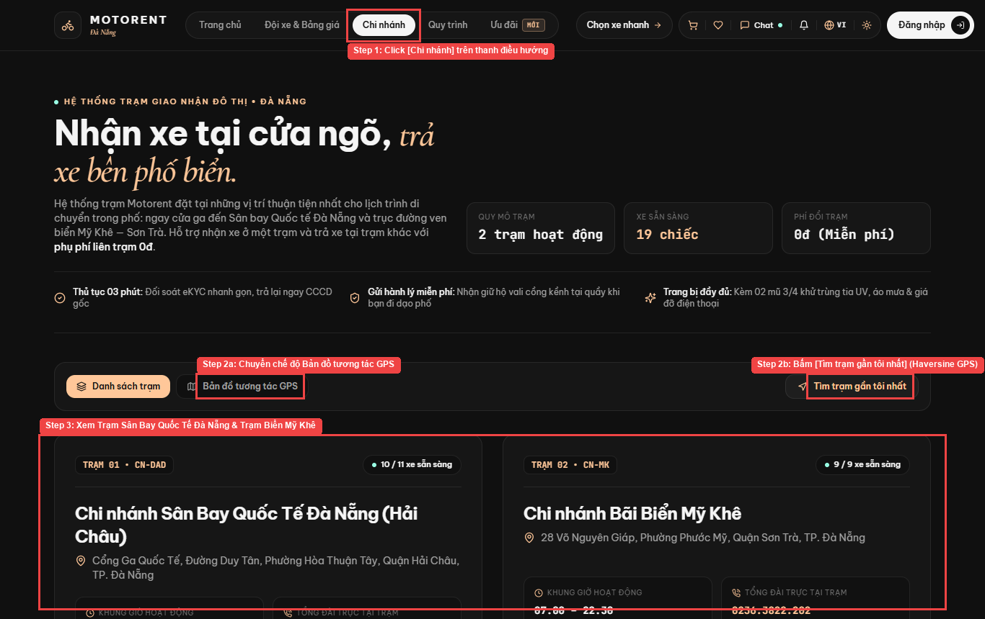
Figure III.1.1: Live UI Screen for Locate Branch Offices on Map (/branches)
Field Name | Field Type | Description
branchList | Card List | Displays branch name, code, address, hours, and available vehicle count
gpsMap | Leaflet Map | Interactive map with markers and flyTo camera focus
nearestBtn | Button | Triggers browser geolocation and Haversine sorting
Database Access
Table / Collection | CRUD | Description
Branch | R | Query active Da Nang branches & GPS coordinates
Vehicle | R | Aggregate available motorbike count per branch
Mongoose / Database Queries:
const branches = await Branch.find({ isActive: true }).lean();
const counts = await Vehicle.aggregate([{ $match: { status: 'Available' } }, { $group: { _id: '$branchId', total: { $sum: 1 } } }]);

1.2 Search & Filter Motorbikes (UC-02)
Route: /bikes | Actors: Guest, Customer | Related Use Case: UC-02 (Search & Filter Motorbikes). Users search and filter the motorbike fleet by branch, category (Scooter, Manual, Sport, Electric), brand, price range, and availability.
UI Design
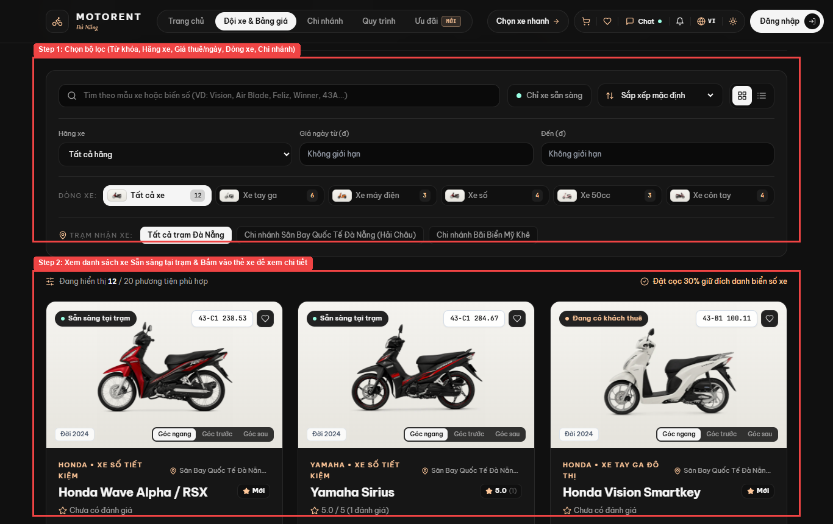
Figure III.1.2: Live UI Screen for Search & Filter Motorbikes (/bikes)
Field Name | Field Type | Description
searchKeyword | Text Input | Filter by vehicle model or license plate (e.g., Vision, Air Blade, 43-C1)
brandFilter | Select Dropdown | Filter by Honda, Yamaha, VinFast
categoryPills | Filter Pills | Xe tay ga, Xe máy điện, Xe số, Xe 50cc, Xe côn tay
branchPills | Filter Pills | Filter by Da Nang Airport or My Khe Beach station
Database Access
Table / Collection | CRUD | Description
Vehicle | R | Filter motorbikes by branch, category, brand, price, and status
Category | R | Load 5 standard vehicle categories
Mongoose / Database Queries:
const vehicles = await Vehicle.find({ status: 'Available', branchId, category, dailyPrice: { $gte: minPrice, $lte: maxPrice } }).populate('branchId category').sort({ createdAt: -1 });

1.3 Inspect Vehicle Specs & Reviews (UC-03)
Route: /bikes/:vehicleId | Actors: Guest, Customer | Related Use Case: UC-03 (Inspect Vehicle Specs & Reviews). Users view detailed motorbike specifications, 4-angle photo gallery, daily/hourly rental rates, availability calendar, and verified reviews.
UI Design
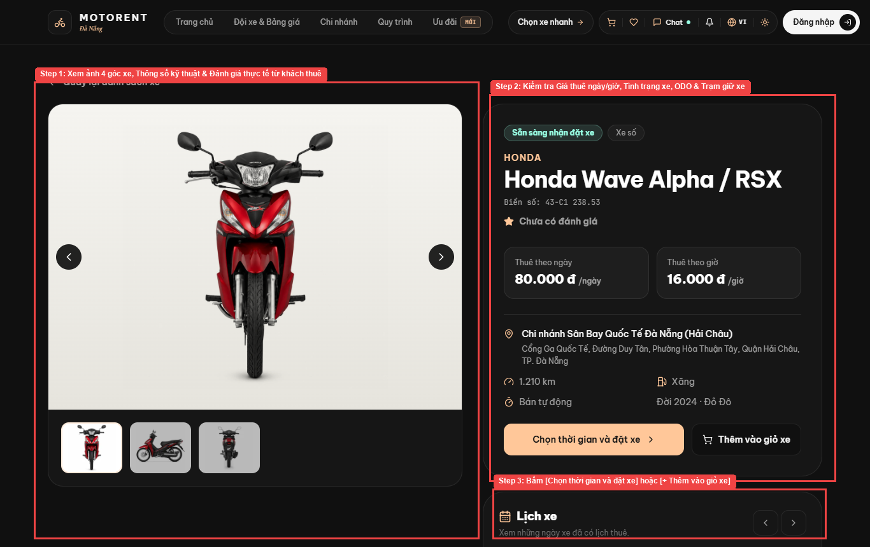
Figure III.1.3: Live UI Screen for Inspect Vehicle Specs & Reviews (/bikes/:vehicleId)
Field Name | Field Type | Description
angleGallery | Image Switcher | Switches between Side, 3/4 Front, and Rear vehicle photos
specBadges | Info Cards | Displays transmission, fuel consumption, year, and ODO
bookNowBtn | Primary Button | Navigates directly to /booking/:vehicleId
addToCartBtn | Secondary Button | Adds motorbike to Multi-Vehicle Cart
Database Access
Table / Collection | CRUD | Description
Vehicle | R | Fetch motorbike specs, 4-angle images, and daily/hourly price
Review | R | Load verified customer ratings & review comments
Mongoose / Database Queries:
const vehicle = await Vehicle.findById(vehicleId).populate('branchId category');
const reviews = await Review.find({ vehicleId }).populate('userId', 'firstName lastName avatarUrl').sort({ createdAt: -1 });

1.4 Consult Rental Terms & Policies (UC-04)
Route: /rental-policy | Actors: Guest, Customer | Related Use Case: UC-04 (Consult Rental Terms & Policies). Users view rental terms, 30% online deposit rules, 70% counter payment, BR-06 cancellation tiers, eKYC requirements, and penalty policies.
UI Design
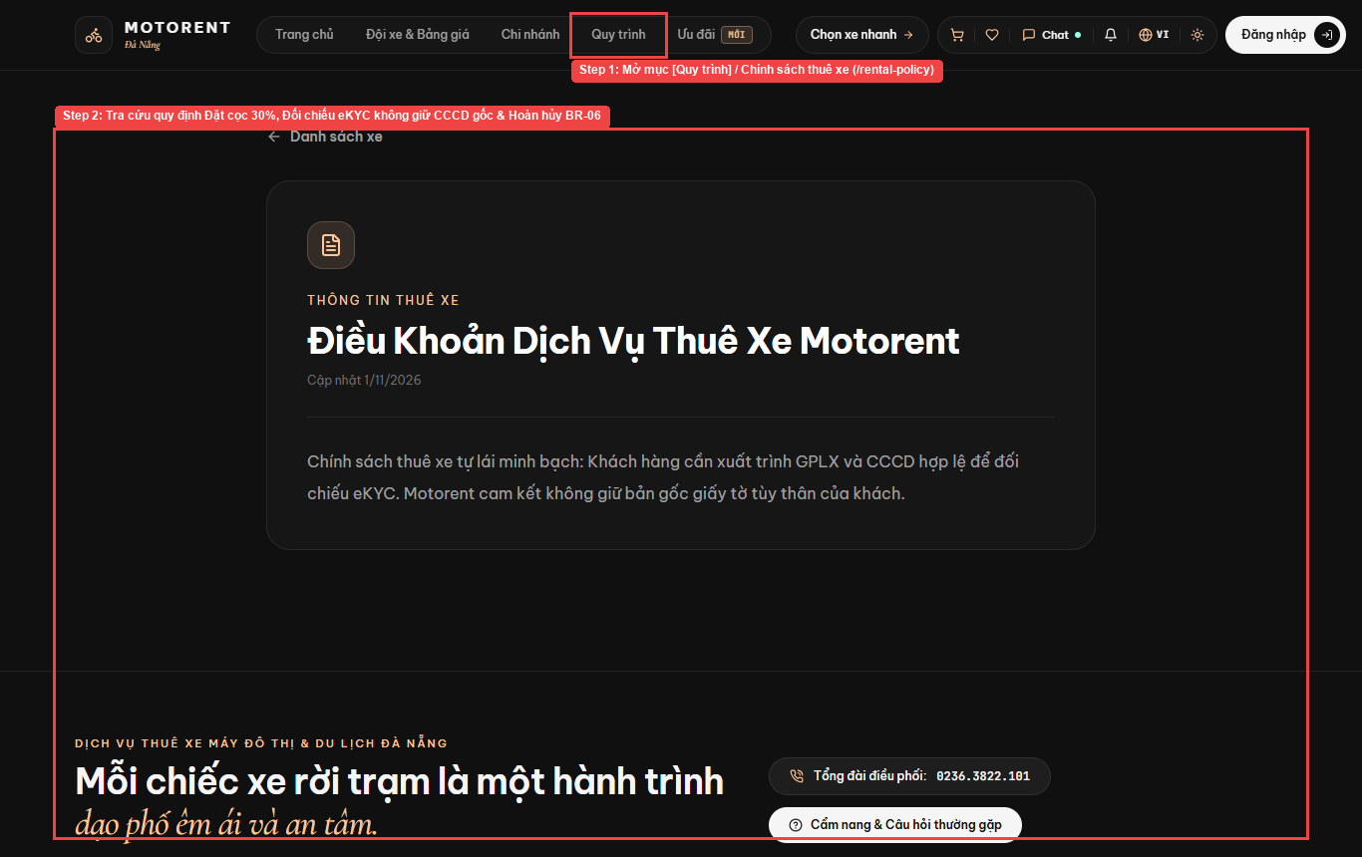
Figure III.1.4: Live UI Screen for Consult Rental Terms & Policies (/rental-policy)
Field Name | Field Type | Description
policySections | Accordion / Content | Displays 30% deposit rule, eKYC verification policy, and BR-06 refund tiers
faqLinks | Navigation Links | Links to FAQ (/faq), Terms (/terms), and Privacy (/privacy)
Database Access
Table / Collection | CRUD | Description
StaticPage | R | Fetch published rental terms, deposit rules, and BR-06 refund tiers
Mongoose / Database Queries:
const policyPage = await StaticPage.findOne({ slug: 'terms', isPublished: true }).lean();

2. Authentication

2.1 Register Account & Email OTP (UC-05)
Route: /register | Actors: Guest | Related Use Case: UC-05 (Register Account & Email OTP). Register new account to access features of the Platform by unique email address and 6-digit OTP verification (popup/page register screen).
UI Design
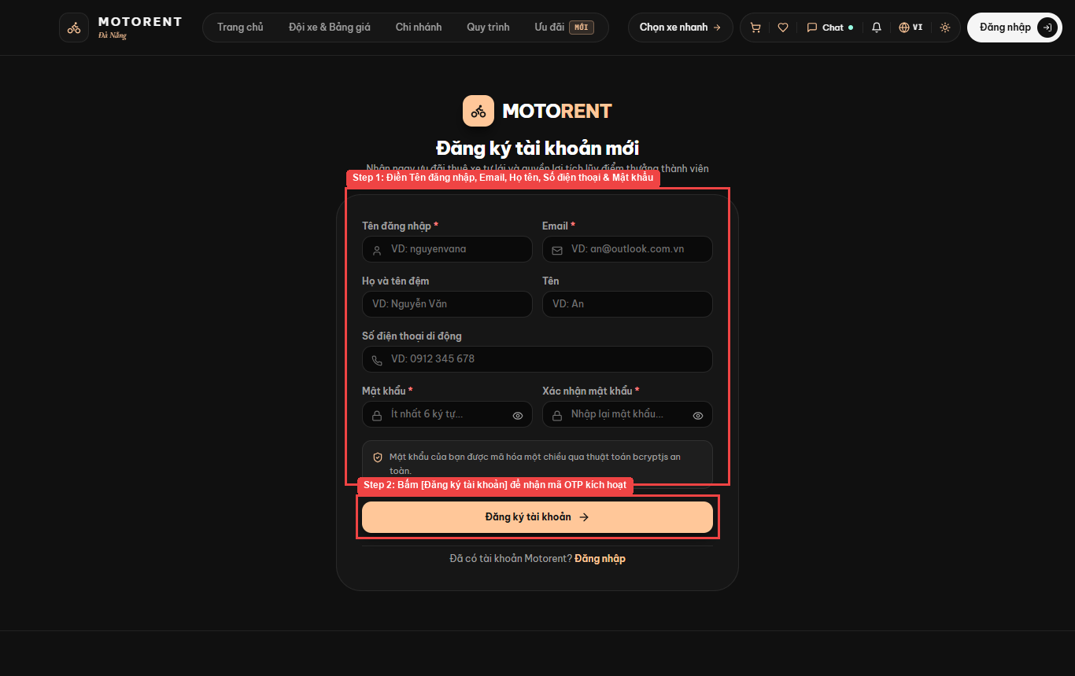
Figure III.2.1: Live UI Screen for Register Account & Email OTP (/register)
Field Name | Field Type | Description
username | Text Input | Unique username (required)
email | Email Input | Unique email address for OTP verification
firstName / lastName | Text Input | Customer full name
phoneNumber | Tel Input | 10-digit Vietnamese phone number
password | Password Input | Hashed with bcryptjs (10 salt rounds)
Database Access
Table / Collection | CRUD | Description
User | C, R | Check unique email/username and create new Customer record
AuditLog | C | Log account registration event
Mongoose / Database Queries:
const exists = await User.findOne({ $or: [{ email }, { username }] });
const user = await User.create({ username, email, firstName, lastName, phoneNumber, passwordHash, roles: 'Customer', emailVerificationOtp });

2.2 Login/Logout & Google OAuth2 (UC-06)
Route: /login | Actors: User | Related Use Case: UC-06 (Login/Logout & Google OAuth2). Any User who has an account on the Platform can access the Platform by entering valid Email and password or via Google OAuth2 button.
UI Design
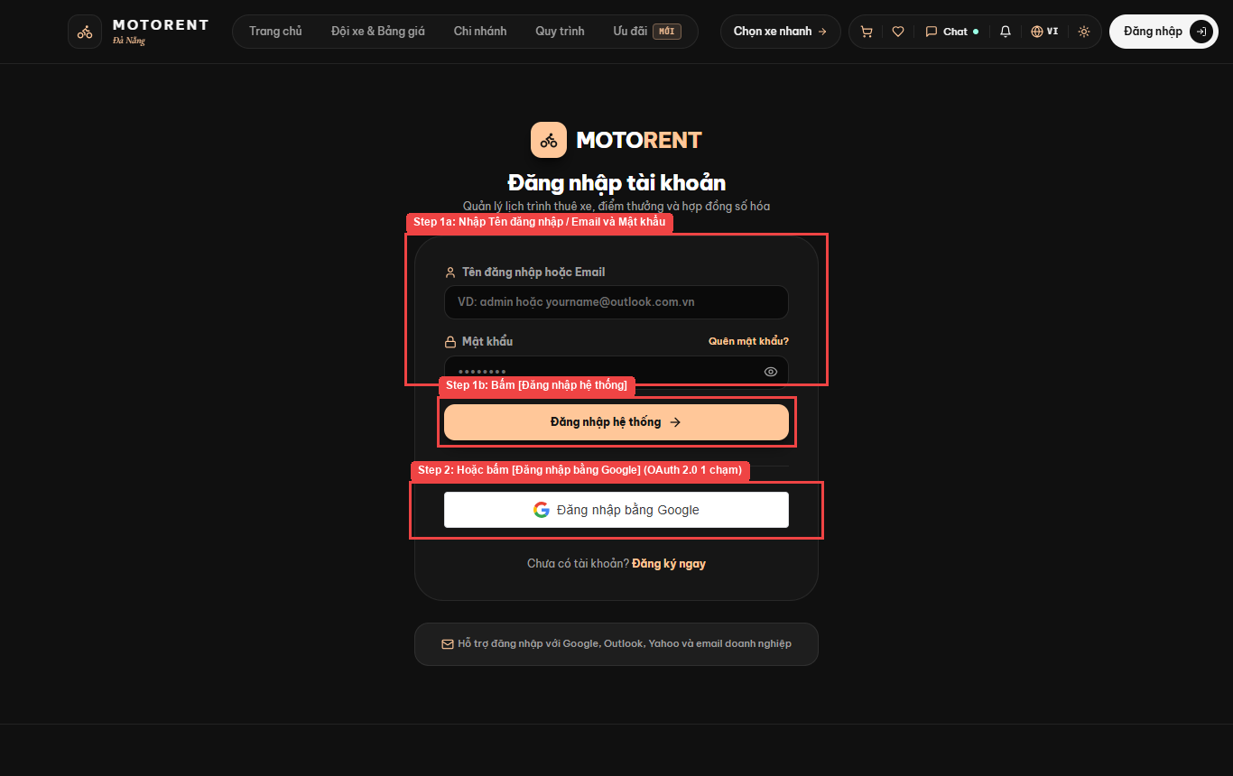
Figure III.2.2: Live UI Screen for Login/Logout & Google OAuth2 (/login)
Field Name | Field Type | Description
identifier | Text Input | Username or registered Email address
password | Password Input | Account password with show/hide toggle
loginBtn | Submit Button | Authenticates via POST /api/auth/login
googleOAuthBtn | GIS Button | 1-Click Google Identity Services OAuth 2.0 login
Database Access
Table / Collection | CRUD | Description
User | R, U | Verify credentials or Google OAuth2 ID Token; update login counter
AuditLog | C | Record authentication audit trail
Mongoose / Database Queries:
const user = await User.findOne({ $or: [{ email: identifier }, { username: identifier }] }).select('+passwordHash');
const isValid = await bcrypt.compare(password, user.passwordHash);

2.3 Forgot Password (UC-07)
Route: /forgot-password | Actors: User | Related Use Case: UC-07 (Forgot Password). When users log in if they forgot their password, they can request a verification mail to get an OTP/reset token then set a new password.
UI Design
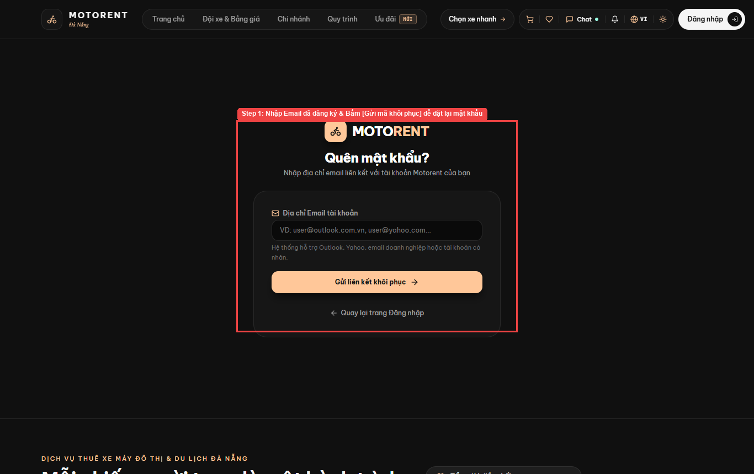
Figure III.2.3: Live UI Screen for Forgot Password (/forgot-password)
Field Name | Field Type | Description
email | Email Input | Registered email address to receive recovery OTP
sendOtpBtn | Submit Button | Triggers Nodemailer OTP dispatch
newPassword | Password Input | New password on /reset-password screen
Database Access
Table / Collection | CRUD | Description
User | R, U | Generate single-use password reset OTP/token with 1-hour expiry
Mongoose / Database Queries:
const user = await User.findOne({ email });
user.resetPasswordToken = hashedOtp;
user.resetPasswordExpires = new Date(Date.now() + 3600000);
await user.save();

2.4 Logout System (UC-08)
Route: /logout | Actors: User | Related Use Case: UC-08 (Logout System). Authenticated users log out of the platform, invalidating their active JWT session and returning to the homepage.
UI Design
Figure III.2.4: Live UI Screen for Logout System (/logout)
Field Name | Field Type | Description
userMenuDropdown | Header Menu | Displays logged-in user avatar, role badge, and Logout button
logoutBtn | Action Button | Clears JWT from storage, disconnects Socket.IO, and revokes token
Database Access
Table / Collection | CRUD | Description
User | U | Increment tokenVersion to revoke active JWT token
AuditLog | C | Record user logout event
Mongoose / Database Queries:
await User.findByIdAndUpdate(req.user.id, { $inc: { tokenVersion: 1 } });
await AuditLog.create({ userId: req.user.id, action: 'LOGOUT', entity: 'User' });

3. Customer Profile & Account

3.1 View & Edit Personal Profile (UC-09)
Route: /profile (Tab 03) | Actors: Customer | Related Use Case: UC-09 (View & Edit Personal Profile). Users after login successfully can view and edit their profile information (name, phone, DOB, avatar image) on the platform.
UI Design
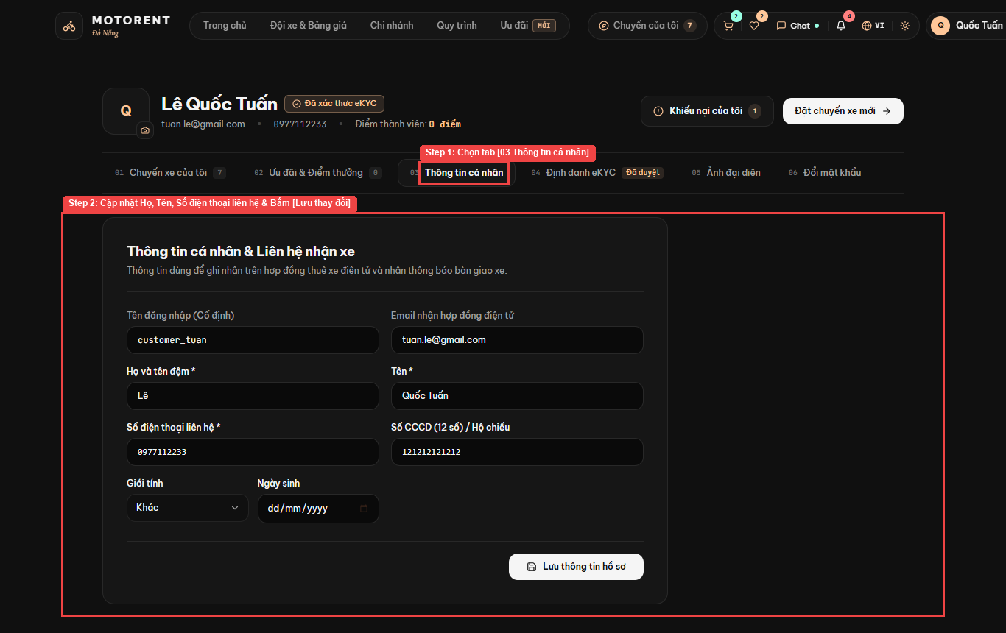
Figure III.3.1: Live UI Screen for View & Edit Personal Profile (/profile (Tab 03))
Field Name | Field Type | Description
firstName / lastName | Text Input | Editable customer full name
phoneNumber | Tel Input | Editable contact number
avatarUpload | File Upload | Profile picture upload (JPEG/PNG/WebP <= 5MB)
saveProfileBtn | Submit Button | Persists profile updates via PUT /api/auth/profile
Database Access
Table / Collection | CRUD | Description
User | R, U | Fetch and update personal profile details and avatar photo
Mongoose / Database Queries:
const updated = await User.findByIdAndUpdate(req.user.id, { $set: { firstName, lastName, phoneNumber, dateOfBirth, avatarUrl } }, { new: true });

3.2 Submit Identity Verification (eKYC) (UC-10)
Route: /profile (Tab 04) | Actors: Customer | Related Use Case: UC-10 (Submit Identity Verification (eKYC)). Customers upload front/back photos of CCCD/Passport and A1/A2 Driving License for mandatory eKYC identity verification.
UI Design
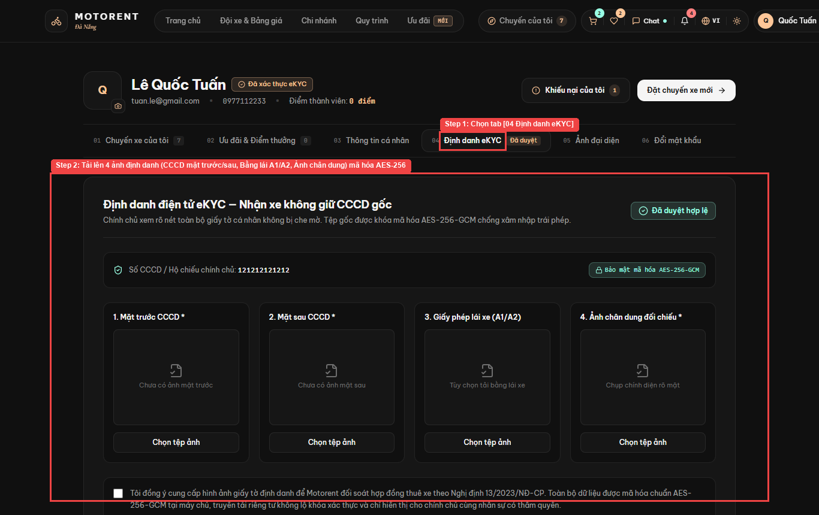
Figure III.3.2: Live UI Screen for Submit Identity Verification (eKYC) (/profile (Tab 04))
Field Name | Field Type | Description
cccdNumber | Text Input | 12-digit Citizen ID / Passport number
cccdFront / cccdBack | File Upload | Front and back photos of CCCD
drivingLicense | File Upload | A1/A2 Driving License image
portraitPhoto | File Upload | Selfie portrait for facial verification
Database Access
Table / Collection | CRUD | Description
User | U | Store encrypted CCCD front/back, Driving License A1/A2, and portrait photo
AuditLog | C | Record eKYC submission
Mongoose / Database Queries:
await User.findByIdAndUpdate(req.user.id, { $set: { cccdNumber, cccdFrontUrl, cccdBackUrl, licenseFrontUrl, portraitUrl, identityStatus: 'Pending' } });

3.3 Change Account Password (UC-11)
Route: /profile (Tab 06) | Actors: Customer | Related Use Case: UC-11 (Change Account Password). Users can change their password if they want as long as they enter a valid old password and a new password >= 8 characters.
UI Design
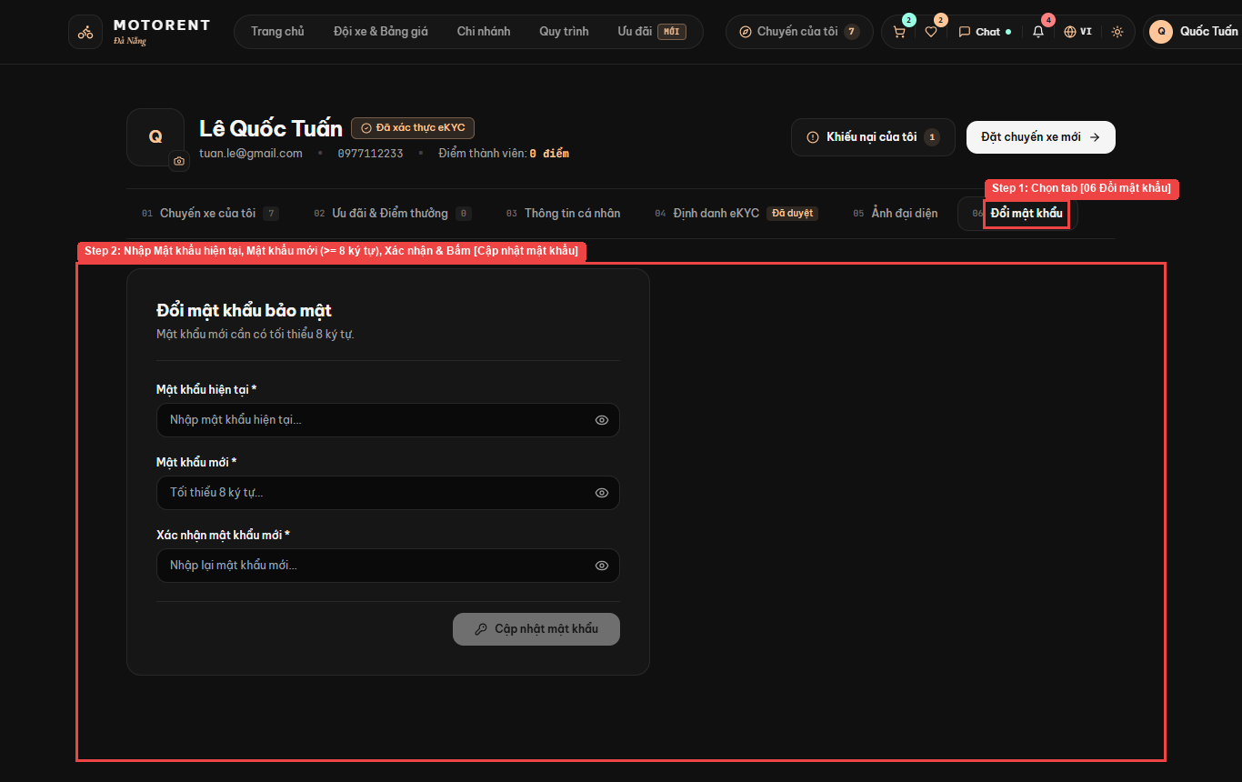
Figure III.3.3: Live UI Screen for Change Account Password (/profile (Tab 06))
Field Name | Field Type | Description
currentPassword | Password Input | Existing password for verification
newPassword | Password Input | New password (>= 8 characters)
confirmPassword | Password Input | Must match newPassword
Database Access
Table / Collection | CRUD | Description
User | R, U | Verify current password, hash new password, and rotate tokenVersion
Mongoose / Database Queries:
const user = await User.findById(req.user.id).select('+passwordHash');
user.passwordHash = await bcrypt.hash(newPassword, 10);
user.tokenVersion += 1;
await user.save();

4. Booking & Payment

4.1 Bookmark Favorite Vehicles (Wishlist) (UC-12)
Route: /wishlist | Actors: Customer | Related Use Case: UC-12 (Bookmark Favorite Vehicles (Wishlist)). Customers save or remove favorite motorbikes in their personal wishlist for quick comparison and booking.
UI Design
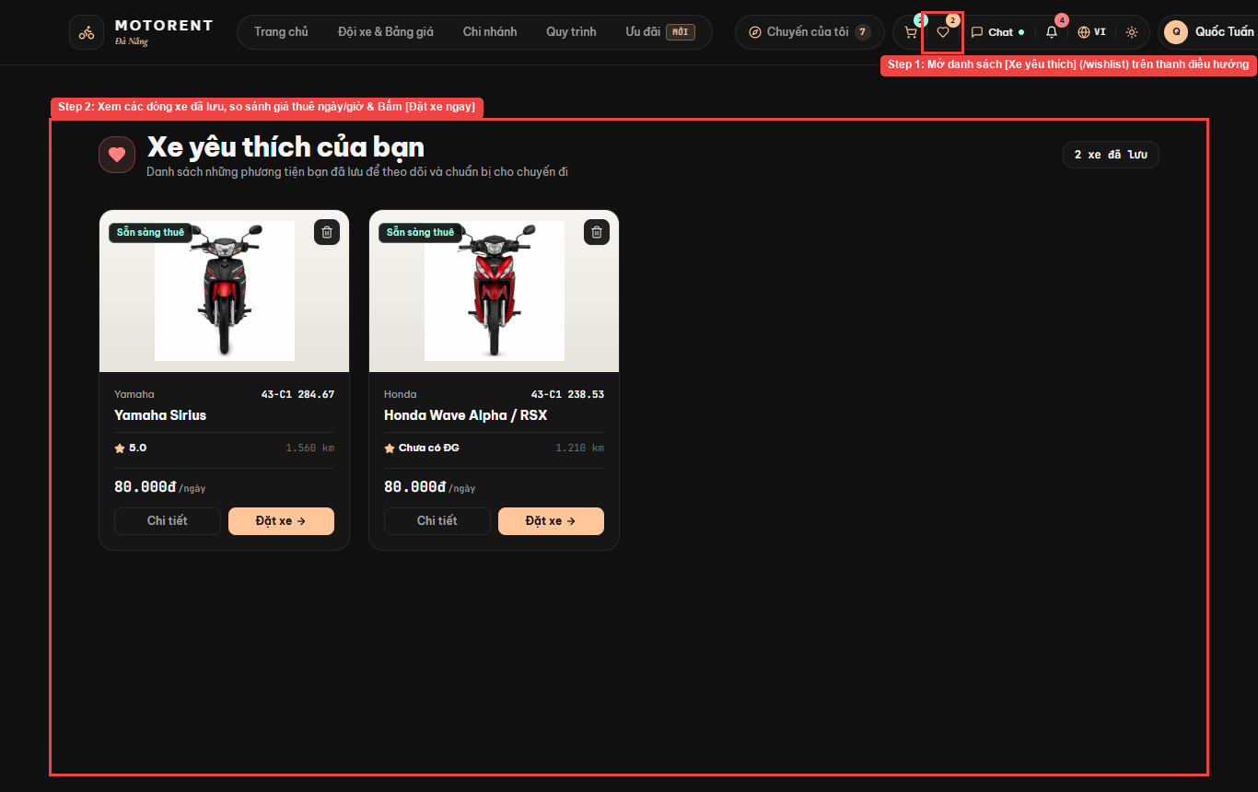
Figure III.4.1: Live UI Screen for Bookmark Favorite Vehicles (Wishlist) (/wishlist)
Field Name | Field Type | Description
wishlistGrid | Vehicle Grid | Displays saved motorbikes with live availability status
removeBookmarkBtn | Icon Button | Removes motorbike from Wishlist
quickBookBtn | Button | Opens booking wizard for the saved motorbike
Database Access
Table / Collection | CRUD | Description
Wishlist | C, R, D | Add, list, or remove bookmarked motorbikes for the authenticated customer
Mongoose / Database Queries:
const wishlist = await Wishlist.find({ userId: req.user.id }).populate({ path: 'vehicleId', populate: ['branchId', 'category'] });

4.2 Find Nearest Branches by GPS (UC-13)
Route: /branches | Actors: Customer | Related Use Case: UC-13 (Find Nearest Branches by GPS). Customers locate available motorbikes at branches nearest to their current GPS coordinates using Haversine distance calculation.
UI Design
Figure III.4.2: Live UI Screen for Find Nearest Branches by GPS (/branches)
Field Name | Field Type | Description
findNearestBtn | Button | Requests navigator.geolocation and sorts branches by km distance
distanceBadge | Badge | Displays calculated distance in km from customer's location
Database Access
Table / Collection | CRUD | Description
Branch | R | Retrieve branch coordinates and compute Haversine distance from user GPS
Mongoose / Database Queries:
const branches = await Branch.find({ isActive: true }).lean();
// Sorted by Haversine distance (R = 6371 km) from (lat, lng)

4.3 Book a Rental & Multi-Vehicle Cart (UC-14)
Route: /booking/:vehicleId & /cart | Actors: Customer | Related Use Case: UC-14 (Book a Rental & Multi-Vehicle Cart). Customers book a single motorbike via the 4-step wizard or reserve multiple motorbikes in one batch via the Multi-Vehicle Cart Drawer.
UI Design
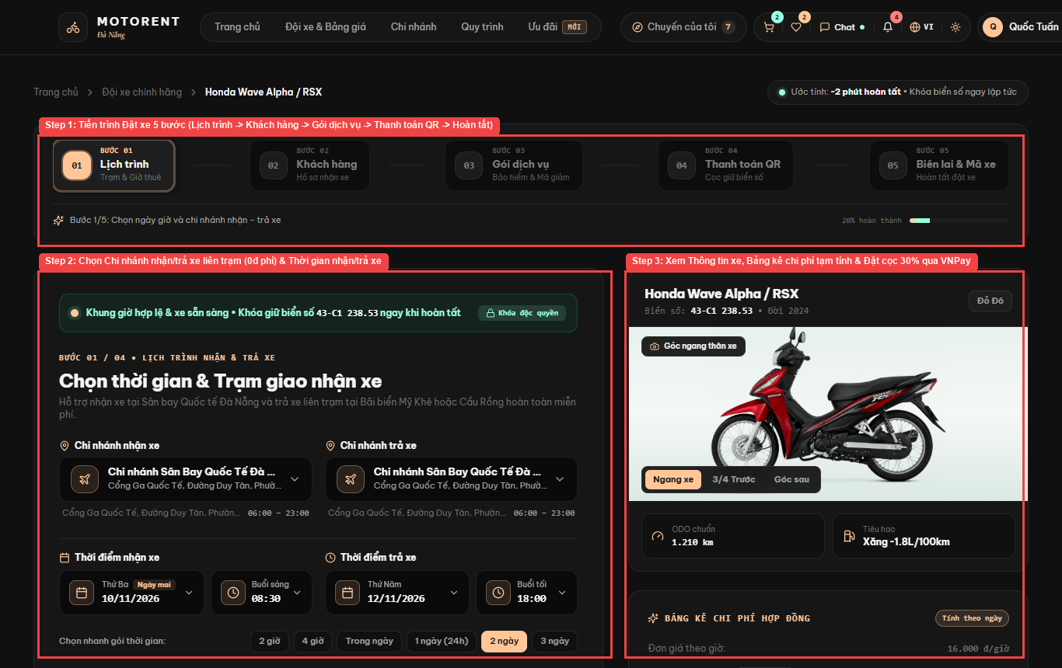
Figure III.4.3: Live UI Screen for Book a Rental & Multi-Vehicle Cart (/booking/:vehicleId & /cart)
Field Name | Field Type | Description
pickupBranchId / returnBranchId | Select Dropdown | Supports cross-branch return at any Da Nang station (0 VND fee)
pickupDateTime / returnDateTime | DateTime Picker | Rental schedule with real-time conflict check
voucherCode | Text Input | Applies promo code (e.g., CHAOBANMOI, DANANGVIP)
cartBatchCheckout | Cart Drawer (/cart) | Allows booking multiple motorbikes in one shared CART-XXE order
Database Access
Table / Collection | CRUD | Description
Booking | C, R | Verify zero date-overlap conflicts and create single or multi-vehicle cart bookings
Discount | R, U | Validate promo voucher and increment usedCount
Mongoose / Database Queries:
const conflict = await Booking.findOne({ vehicleId, status: { $in: ['Pending', 'Confirmed', 'Ongoing'] }, pickupDateTime: { $lt: returnDateTime }, returnDateTime: { $gt: pickupDateTime } });
const booking = await Booking.create({ bookingCode, groupCode, userId, vehicleId, pickupBranchId, returnBranchId, pickupDateTime, returnDateTime, totalAmount, depositAmount });

4.4 Pay Deposit via VNPay & Counter Balance (UC-15)
Route: /vnpay-return | Actors: Customer | Related Use Case: UC-15 (Pay Deposit via VNPay & Counter Balance). Customers pay 30% deposit or 100% full amount online via VNPay Sandbox form (HMAC-SHA512), and settle 70% remaining balance at counter.
UI Design
Figure III.4.4: Live UI Screen for Pay Deposit via VNPay & Counter Balance (/vnpay-return)
Field Name | Field Type | Description
paymentMethod | Radio Group | 30% Online Deposit via VNPay / VietQR and 70% Counter Settlement
vnpayGatewayForm | VNPay Sandbox | NCB Test Card 9704198526191432198, OTP 123456
returnStatusCard | Status View | Displays verified transaction reference and confirmed booking codes
Database Access
Table / Collection | CRUD | Description
Payment | C, U | Create payment record and verify VNPay HMAC-SHA512 IPN/Return signature
Booking | U | Confirm single booking or all bookings in a Multi-Vehicle Cart group
Mongoose / Database Queries:
const isValid = verifyVnPayChecksum(vnp_Params, process.env.VNP_HASHSECRET);
await Booking.updateMany({ $or: [{ bookingCode: txnRef }, { groupCode: txnRef }] }, { $set: { status: 'Confirmed', depositPaid: true } });

4.5 Cancel Rental Order & Mid-Rental Termination (UC-16)
Route: /profile (Tab 01) | Actors: Customer | Related Use Case: UC-16 (Cancel Rental Order & Mid-Rental Termination). Customers cancel pending/confirmed orders under BR-06 refund tiers or terminate an Ongoing rental early to release the motorbike.
UI Design
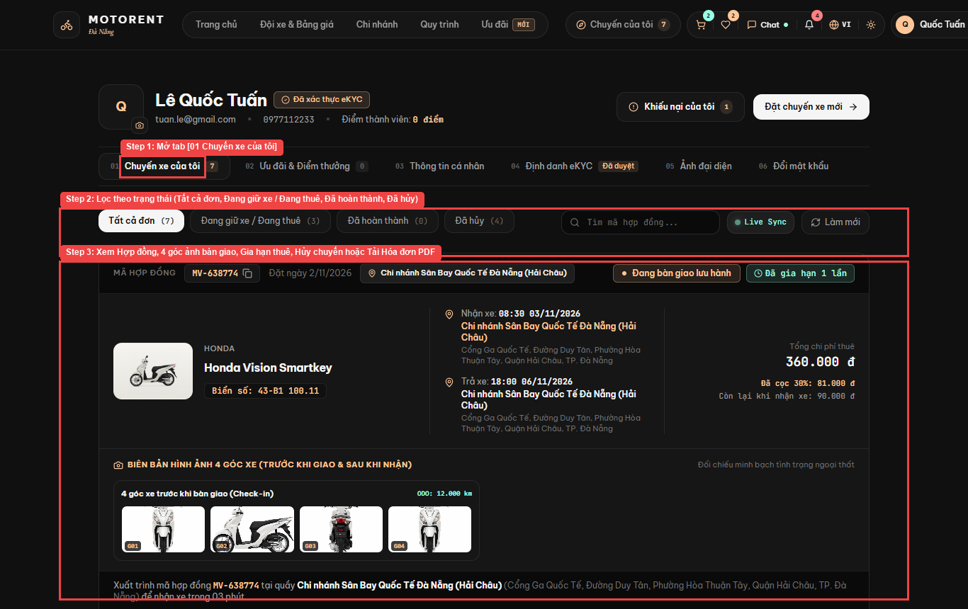
Figure III.4.5: Live UI Screen for Cancel Rental Order & Mid-Rental Termination (/profile (Tab 01))
Field Name | Field Type | Description
cancelOrderBtn | Danger Button | Triggers cancellation modal on Pending, Confirmed, or Ongoing bookings
cancellationReason | Textarea | Customer reason for cancellation or early return
refundPreview | Alert Box | Shows automatic BR-06 refund tier (>24h: 100%, 12-24h: 50%, <12h: 0%)
Database Access
Table / Collection | CRUD | Description
Booking | R, U | Cancel Pending/Confirmed order per BR-06 tiers or terminate Ongoing trip early
Vehicle | U | Immediately release motorbike status back to Available
Mongoose / Database Queries:
booking.status = 'Cancelled';
booking.cancellationReason = reason;
booking.refundAmount = calcRefundByBR06(booking.pickupDateTime, booking.depositAmount);
await booking.save();
await Vehicle.findByIdAndUpdate(booking.vehicleId, { $set: { status: 'Available' } });

4.6 Extend Rental Period (UC-17)
Route: /profile (Tab 01) | Actors: Customer | Related Use Case: UC-17 (Extend Rental Period). Customers with an Ongoing rental request to extend their return date/time after automatic conflict checking.
UI Design
Figure III.4.6: Live UI Screen for Extend Rental Period (/profile (Tab 01))
Field Name | Field Type | Description
extendRentalBtn | Action Button | Opens extension date/time modal on Ongoing bookings
newReturnDateTime | DateTime Picker | New requested return date/time
extraFeeSummary | Calculation Box | Displays additional rental days/hours and fee
Database Access
Table / Collection | CRUD | Description
Booking | R, U | Check subsequent booking conflicts and extend returnDateTime for Ongoing trip
Mongoose / Database Queries:
const conflict = await Booking.findOne({ _id: { $ne: bookingId }, vehicleId: booking.vehicleId, status: { $in: ['Pending', 'Confirmed', 'Ongoing'] }, pickupDateTime: { $lt: newReturnDate }, returnDateTime: { $gt: booking.returnDateTime } });
booking.returnDateTime = newReturnDate;
booking.totalAmount += extraFee;
await booking.save();

4.7 Track Rental Orders & History (UC-18)
Route: /profile (Tab 01) | Actors: Customer | Related Use Case: UC-18 (Track Rental Orders & History). Customers view their booking list across status tabs (All, Pending, Confirmed, Ongoing, Completed, Cancelled) with real-time Socket.IO updates.
UI Design
Figure III.4.7: Live UI Screen for Track Rental Orders & History (/profile (Tab 01))
Field Name | Field Type | Description
statusFilterTabs | Tab Bar | Tất cả đơn, Đang giữ xe / Đang thuê, Đã hoàn thành, Đã hủy
contractSearch | Search Input | Search by booking code (e.g., MV-638774)
checkInPhotosGrid | 4-Photo Gallery | Displays 4 pre-rental and 4 return inspection photos
Database Access
Table / Collection | CRUD | Description
Booking | R | List customer bookings filtered by status with 4-angle handover photos
Mongoose / Database Queries:
const bookings = await Booking.find({ userId: req.user.id }).populate('vehicleId pickupBranchId returnBranchId').sort({ createdAt: -1 });

4.8 Download Invoice PDF (UC-19)
Route: /booking-details/:id | Actors: Customer | Related Use Case: UC-19 (Download Invoice PDF). Customers generate and download a formatted PDF rental contract and itemized receipt via PDFKit.
UI Design
Figure III.4.8: Live UI Screen for Download Invoice PDF (/booking-details/:id)
Field Name | Field Type | Description
downloadPdfBtn | Button | Downloads formatted PDF rental contract & receipt
contractBreakdown | Summary Panel | Shows itemized daily price, voucher discount, 30% deposit, and 70% balance
Database Access
Table / Collection | CRUD | Description
Booking | R | Fetch full contract, vehicle, branch, and payment breakdown for PDF generation
Payment | R | Include deposit and settlement transaction timestamps
Mongoose / Database Queries:
const booking = await Booking.findById(id).populate('userId vehicleId pickupBranchId returnBranchId');
// Stream PDF document via PDFKit with itemized rental & deposit table

5. Review, Complaint & Communication

5.1 Rate & Review Rented Vehicles (UC-20)
Route: /bikes/:vehicleId | Actors: Customer | Related Use Case: UC-20 (Rate & Review Rented Vehicles). Customers submit a 1-5 star reputation and vehicle quality review with photos after rental completion.
UI Design
Figure III.5.1: Live UI Screen for Rate & Review Rented Vehicles (/bikes/:vehicleId)
Field Name | Field Type | Description
starRatingSelector | 1-5 Stars | Selects overall satisfaction rating
reviewComment | Textarea | Detailed feedback on engine, brakes, and counter service
submitReviewBtn | Submit Button | Posts verified review and updates vehicle rating
Database Access
Table / Collection | CRUD | Description
Review | C, R | Create 1-5 star review for Completed booking and recalculate Vehicle.averageRating
Vehicle | U | Update averageRating and reviewCount
Mongoose / Database Queries:
const review = await Review.create({ bookingId, userId: req.user.id, vehicleId, rating, comment });
const stats = await Review.aggregate([{ $match: { vehicleId } }, { $group: { _id: '$vehicleId', avg: { $avg: '$rating' }, count: { $sum: 1 } } }]);
await Vehicle.findByIdAndUpdate(vehicleId, { averageRating: stats[0].avg, reviewCount: stats[0].count });

5.2 Report & Track Service Complaints (UC-21)
Route: /complaints | Actors: Customer | Related Use Case: UC-21 (Report & Track Service Complaints). Customers submit service or vehicle complaints with issues and track resolution status from Open to Resolved.
UI Design
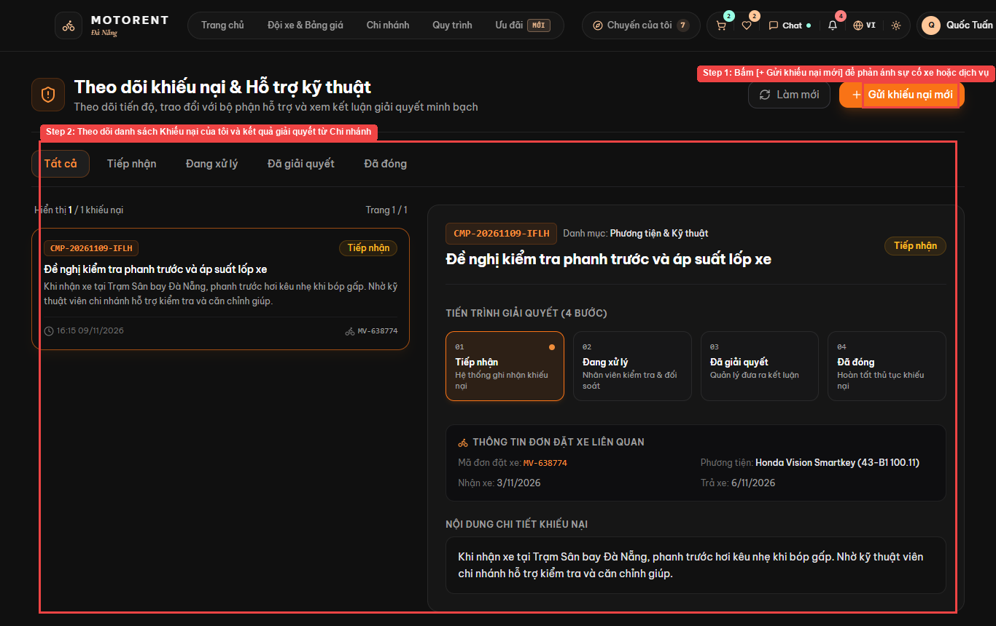
Figure III.5.2: Live UI Screen for Report & Track Service Complaints (/complaints)
Field Name | Field Type | Description
bookingSelector | Select Dropdown | Links complaint to a specific rental contract
complaintTitle / description | Text & Textarea | Describes vehicle or service issue
statusBadge | Status Pill | Tracks Open -> In Progress -> Resolved state
Database Access
Table / Collection | CRUD | Description
Complaint | C, R | Submit service/vehicle complaint linked to booking and track resolution status
Mongoose / Database Queries:
const complaint = await Complaint.create({ userId: req.user.id, bookingId, branchId, title, description, severity, status: 'Open' });

5.3 Chat Live with Branch Staff (UC-22)
Route: LiveChatWidget (Global) | Actors: Customer, Staff | Related Use Case: UC-22 (Chat Live with Branch Staff). Customers and branch staff contact each other in real time on platform Socket.IO chat channels.
UI Design
Figure III.5.3: Live UI Screen for Chat Live with Branch Staff (LiveChatWidget (Global))
Field Name | Field Type | Description
chatFloatingBtn | Header / Floating Button | Opens real-time Socket.IO Live Chat popover
messageInput | Text Input | Sends instant message to branch counter staff
Database Access
Table / Collection | CRUD | Description
Conversation | C, R | Find or create customer-branch chat room
Message | C, R | Persist real-time Socket.IO chat messages
Mongoose / Database Queries:
const msg = await Message.create({ conversationId, senderId: req.user.id, content, readBy: [req.user.id] });
io.to(conversationId).emit('new_message', msg);

6. Notifications & Loyalty

6.1 Receive Booking Alerts & Reminders (UC-23)
Route: Header Notification Bell | Actors: Customer | Related Use Case: UC-23 (Receive Booking Alerts & Reminders). Customers receive in-app push notifications, HTML email confirmations, and 24h/2h pickup/return reminders.
UI Design
Figure III.6.1: Live UI Screen for Receive Booking Alerts & Reminders (Header Notification Bell)
Field Name | Field Type | Description
notificationBell | Header Icon + Badge | Displays unread notification count in real time
notificationDropdown | Popover List | Lists booking confirmations, eKYC approval, and return reminders
Database Access
Table / Collection | CRUD | Description
Notification | C, R, U | Deliver real-time push notifications and mark as read
BookingReminder | C, U | Cron job dispatches 24h/2h pickup & return email reminders
Mongoose / Database Queries:
const notifications = await Notification.find({ userId: req.user.id }).sort({ createdAt: -1 }).limit(20);
await Notification.updateMany({ userId: req.user.id, isRead: false }, { $set: { isRead: true } });

6.2 Earn & Redeem Loyalty Points (UC-24)
Route: /profile (Tab 02) | Actors: Customer | Related Use Case: UC-24 (Earn & Redeem Loyalty Points). Customers earn 1 point per 10,000 VND spent on completed rentals and redeem points for discount vouchers.
UI Design
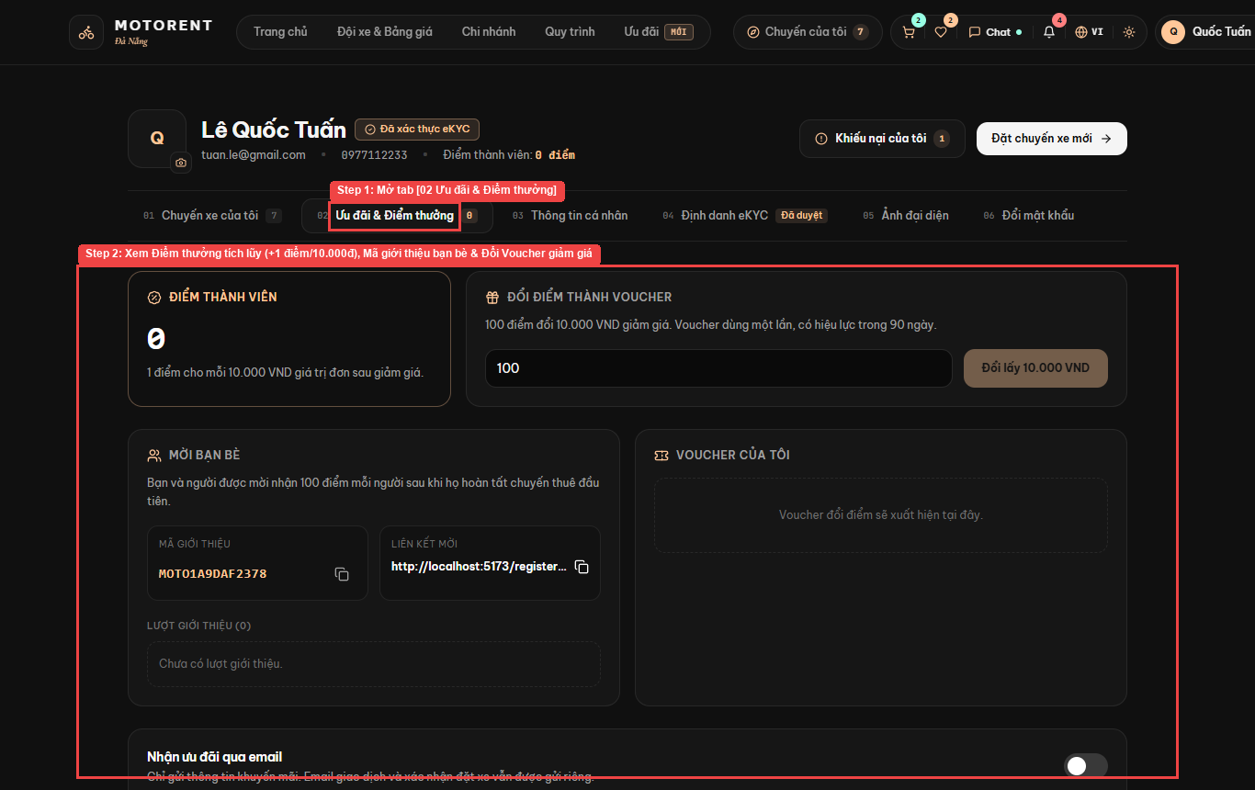
Figure III.6.2: Live UI Screen for Earn & Redeem Loyalty Points (/profile (Tab 02))
Field Name | Field Type | Description
loyaltyPointsCard | Metric Card | Displays current loyalty points and membership tier
redeemVoucherBtn | Action Button | Exchanges loyalty points for a discount code
Database Access
Table / Collection | CRUD | Description
User | R, U | Credit +1 point per 10,000 VND completed rental and deduct points on voucher redemption
Discount | C, R | Issue personal discount voucher code
Mongoose / Database Queries:
await User.findByIdAndUpdate(userId, { $inc: { loyaltyPoints: earnedPoints } });

6.3 Refer Friends & Subscribe Promos (UC-25)
Route: /profile (Tab 02) | Actors: Customer | Related Use Case: UC-25 (Refer Friends & Subscribe Promos). Customers share unique referral codes for bonus loyalty points and toggle promotional email subscriptions.
UI Design
Figure III.6.3: Live UI Screen for Refer Friends & Subscribe Promos (/profile (Tab 02))
Field Name | Field Type | Description
referralCodeBox | Copyable Code | Displays personal referral code for bonus points
promoSubscriptionToggle | Switch | Enables/disables promotional email alerts
Database Access
Table / Collection | CRUD | Description
User | R, U | Generate unique referralCode and toggle promotional newsletter subscription
Mongoose / Database Queries:
await User.findByIdAndUpdate(req.user.id, { $set: { newsletterSubscribed: isSubscribed } });

7. Counter Desk Operations

7.1 Inspect Branch Rental Queue (UC-26)
Route: /counter | Actors: Staff | Related Use Case: UC-26 (Inspect Branch Rental Queue). Counter staff view and filter the branch's daily pickup and return booking queue by status.
UI Design
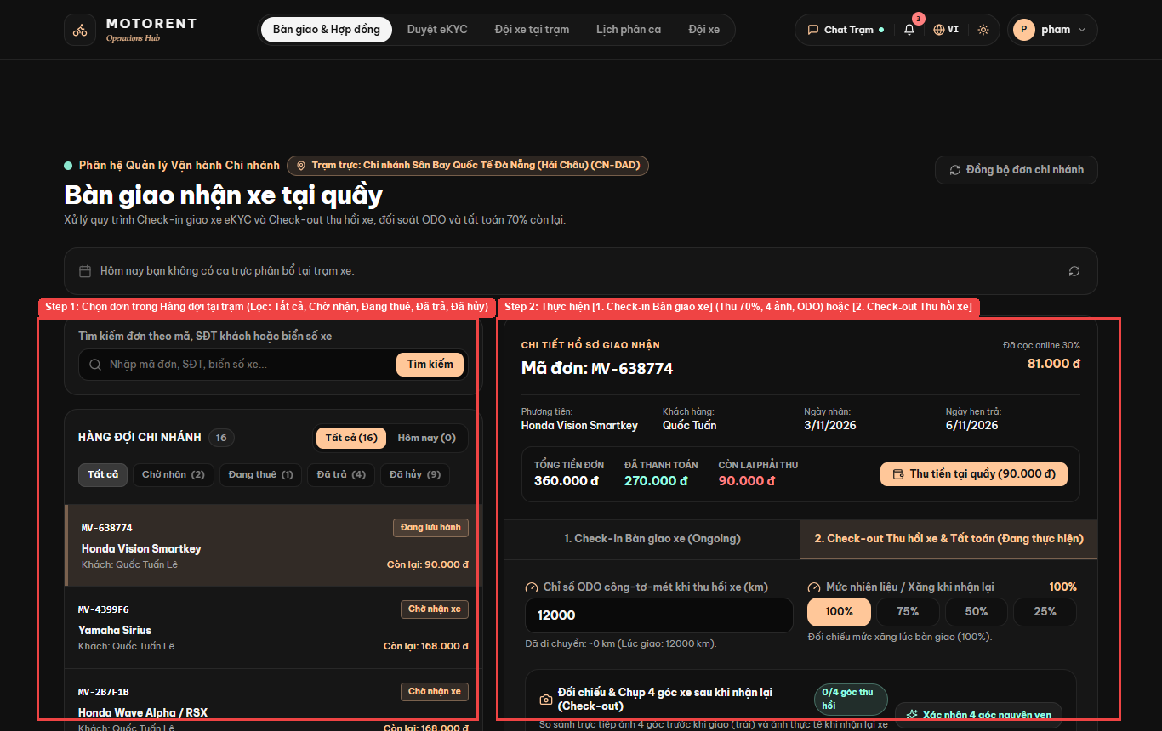
Figure III.7.1: Live UI Screen for Inspect Branch Rental Queue (/counter)
Field Name | Field Type | Description
queueSearchInput | Search Input | Search by booking code (MV-xxxxxx), customer phone, or license plate
queueStatusPills | Filter Pills | Tất cả (16), Chờ nhận (2), Đang thuê (1), Đã trả (4), Đã hủy (9)
queueOrderCards | Selectable List | Loads selected booking into the right-hand Check-in / Check-out workspace
Database Access
Table / Collection | CRUD | Description
Booking | R | Query branch pickup & return queue filtered by status and search keyword
Mongoose / Database Queries:
const queue = await Booking.find({ $or: [{ pickupBranchId: branchId }, { returnBranchId: branchId }], status: { $in: statusFilter } }).populate('userId vehicleId').sort({ pickupDateTime: 1 });

7.2 Confirm Vehicle Handover (Check-in) (UC-27)
Route: /counter (Tab 1 Check-in) | Actors: Staff | Related Use Case: UC-27 (Confirm Vehicle Handover (Check-in)). Staff perform 5-point handover: verify ID/license, collect 70% payment, upload 4 vehicle photos, record start ODO/fuel, and capture e-signature.
UI Design
Figure III.7.2: Live UI Screen for Confirm Vehicle Handover (Check-in) (/counter (Tab 1 Check-in))
Field Name | Field Type | Description
collectCounterBalanceBtn | Action Button | Records 70% remaining balance collection at counter
startOdometer / startFuel | Number & Pill Selector | Records starting ODO (km) and fuel level (100%, 75%, 50%, 25%)
fourAngleCheckInPhotos | 4-Slot Upload | Uploads Front, Rear, Left, Right photos before handover
confirmCheckInBtn | Submit Button | Transitions contract to Ongoing
Database Access
Table / Collection | CRUD | Description
Booking | U | Record 5-point handover: eKYC check, 70% payment, 4 pre-rental photos, start ODO/fuel, e-signature
Vehicle | U | Transition vehicle status to Rented
Mongoose / Database Queries:
await Booking.findByIdAndUpdate(bookingId, { $set: { status: 'Ongoing', startOdometer, startFuelLevel, checkInPhotos, customerSignatureUrl, actualPickupDateTime: new Date() } });
await Vehicle.findByIdAndUpdate(vehicleId, { $set: { status: 'Rented', odometer: startOdometer } });

7.3 Confirm Vehicle Return (Check-out) (UC-28)
Route: /counter (Tab 2 Check-out) | Actors: Staff | Related Use Case: UC-28 (Confirm Vehicle Return (Check-out)). Staff process vehicle return at any Da Nang branch, upload 4 return photos, record end ODO/fuel, and auto-relocate vehicle branchId.
UI Design
Figure III.7.3: Live UI Screen for Confirm Vehicle Return (Check-out) (/counter (Tab 2 Check-out))
Field Name | Field Type | Description
endOdometer / endFuel | Number & Pill Selector | Records ending ODO (km) and return fuel level
fourAngleCheckOutPhotos | 4-Slot Upload | Compares 4 return photos against pre-rental photos
crossBranchSelector | Branch Indicator | Automatically relocates vehicle inventory to the return station
confirmCheckOutBtn | Submit Button | Closes contract as Completed and awards loyalty points
Database Access
Table / Collection | CRUD | Description
Booking | U | Complete vehicle return, record end ODO/fuel & 4 return photos, credit loyalty points
Vehicle | U | Automatically relocate Vehicle.branchId to actual return branch and set Available
Mongoose / Database Queries:
await Booking.findByIdAndUpdate(bookingId, { $set: { status: 'Completed', endOdometer, endFuelLevel, checkOutPhotos, actualReturnBranchId, actualReturnDateTime: new Date() } });
await Vehicle.findByIdAndUpdate(vehicleId, { $set: { branchId: actualReturnBranchId, odometer: endOdometer, status: 'Available' } });

7.4 Record Incident & Settle Penalty Fees (UC-29)
Route: /counter (Tab 2 Penalty) | Actors: Staff | Related Use Case: UC-29 (Record Incident & Settle Penalty Fees). Staff document vehicle damage with photos and calculate late return fees (30,000 VND/hr) plus damage compensation.
UI Design
Figure III.7.4: Live UI Screen for Record Incident & Settle Penalty Fees (/counter (Tab 2 Penalty))
Field Name | Field Type | Description
lateFeeAutoCalc | Read-only Field | Auto-computes overdue hours x 30,000 VND/hr (BR-08)
damageFeeInput | Number Input | Additional compensation for scratches or damaged parts
incidentPhotos | File Upload | Evidence photos of vehicle damage
Database Access
Table / Collection | CRUD | Description
Booking | U | Calculate late fee (30,000 VND/hr per BR-08) and record damage compensation fee
Payment | C | Log penalty settlement transaction
Mongoose / Database Queries:
const lateHours = Math.max(0, Math.ceil((actualReturn - scheduledReturn) / 3600000));
const lateFee = lateHours * 30000;
await Booking.findByIdAndUpdate(bookingId, { $set: { lateFee, damageFee, damageNotes, totalPenalty: lateFee + damageFee } });

7.5 Create Maintenance Ticket & Flag Vehicle (UC-30)
Route: /manager/fleet-operations | Actors: Staff | Related Use Case: UC-30 (Create Maintenance Ticket & Flag Vehicle). Staff flag a damaged or high-ODO motorbike as Maintenance and log a repair ticket.
UI Design
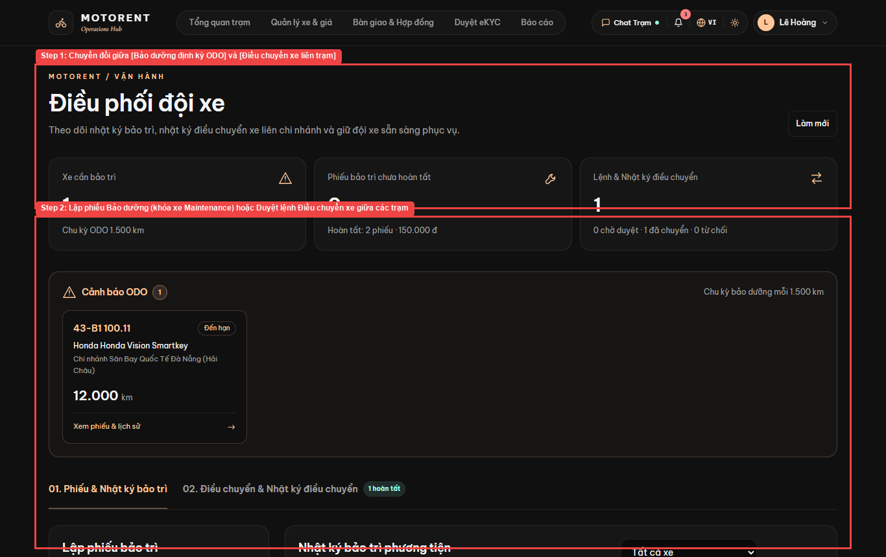
Figure III.7.5: Live UI Screen for Create Maintenance Ticket & Flag Vehicle (/manager/fleet-operations)
Field Name | Field Type | Description
vehicleSelector | Select Dropdown | Selects damaged or high-ODO motorbike
maintenanceReason / cost | Text & Number Input | Describes repair items (oil change, brake pad, tire)
flagMaintenanceBtn | Submit Button | Locks vehicle in Maintenance state
Database Access
Table / Collection | CRUD | Description
MaintenanceLog | C | Create maintenance repair ticket with estimated cost and description
Vehicle | U | Flag vehicle status as Maintenance to block new bookings
Mongoose / Database Queries:
await MaintenanceLog.create({ vehicleId, branchId, reportedBy: req.user.id, reason, cost, odoAtMaintenance: vehicle.odometer, status: 'InProgress' });
await Vehicle.findByIdAndUpdate(vehicleId, { $set: { status: 'Maintenance', requiresMaintenance: true } });

7.6 Resolve Branch Customer Complaints (UC-31)
Route: /staff/complaints | Actors: Staff | Related Use Case: UC-31 (Resolve Branch Customer Complaints). Staff investigate assigned customer complaints, post responses, and update resolution status.
UI Design
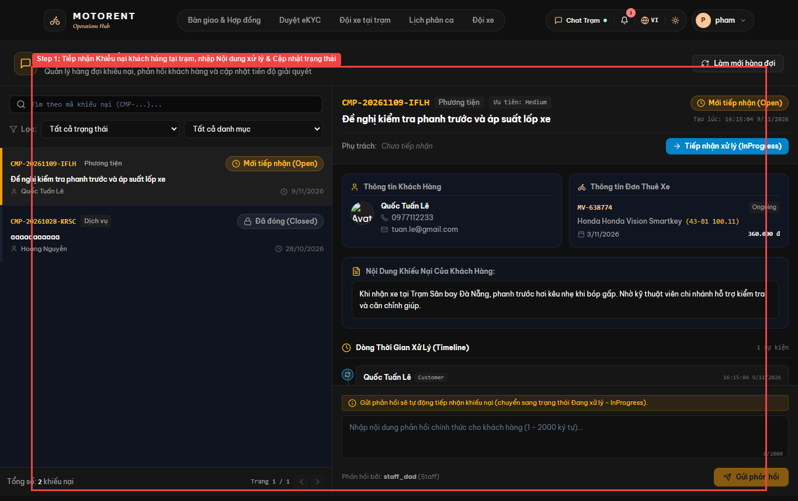
Figure III.7.6: Live UI Screen for Resolve Branch Customer Complaints (/staff/complaints)
Field Name | Field Type | Description
complaintQueueTable | Data Table | Lists Open and In-Progress complaints for the branch
resolutionNote | Textarea | Staff response and compensation explanation
markResolvedBtn | Submit Button | Updates status to Resolved and notifies customer
Database Access
Table / Collection | CRUD | Description
Complaint | R, U | Inspect branch customer complaints, post staff resolution notes, and update status
Mongoose / Database Queries:
await Complaint.findByIdAndUpdate(complaintId, { $set: { status: 'Resolved', resolutionNote, resolvedBy: req.user.id, resolvedAt: new Date() } });

7.7 Reply to Customer Support Chat (UC-32)
Route: Header Chat Trạm Console | Actors: Staff | Related Use Case: UC-32 (Reply to Customer Support Chat). Staff reply to incoming customer live chat messages in real time via the Staff Chat Console.
UI Design
Figure III.7.7: Live UI Screen for Reply to Customer Support Chat (Header Chat Trạm Console)
Field Name | Field Type | Description
branchChatDrawer | Header Button (Chat Trạm) | Opens branch live support console with unread badge
replyInput | Text Input | Sends instant response to customer
Database Access
Table / Collection | CRUD | Description
Conversation | R, U | List active customer chat threads assigned to the branch
Message | C, R | Send real-time staff reply via Socket.IO
Mongoose / Database Queries:
const reply = await Message.create({ conversationId, senderId: req.user.id, senderRole: 'Staff', content });
io.to(conversationId).emit('new_message', reply);

8. Fleet & Staff Management

8.1 Add New Vehicle (UC-33)
Route: /manager/vehicles | Actors: Branch Manager | Related Use Case: UC-33 (Add New Vehicle). Branch Managers register new motorbikes with unique license plate, specs, ODO, and photos into their branch fleet.
UI Design
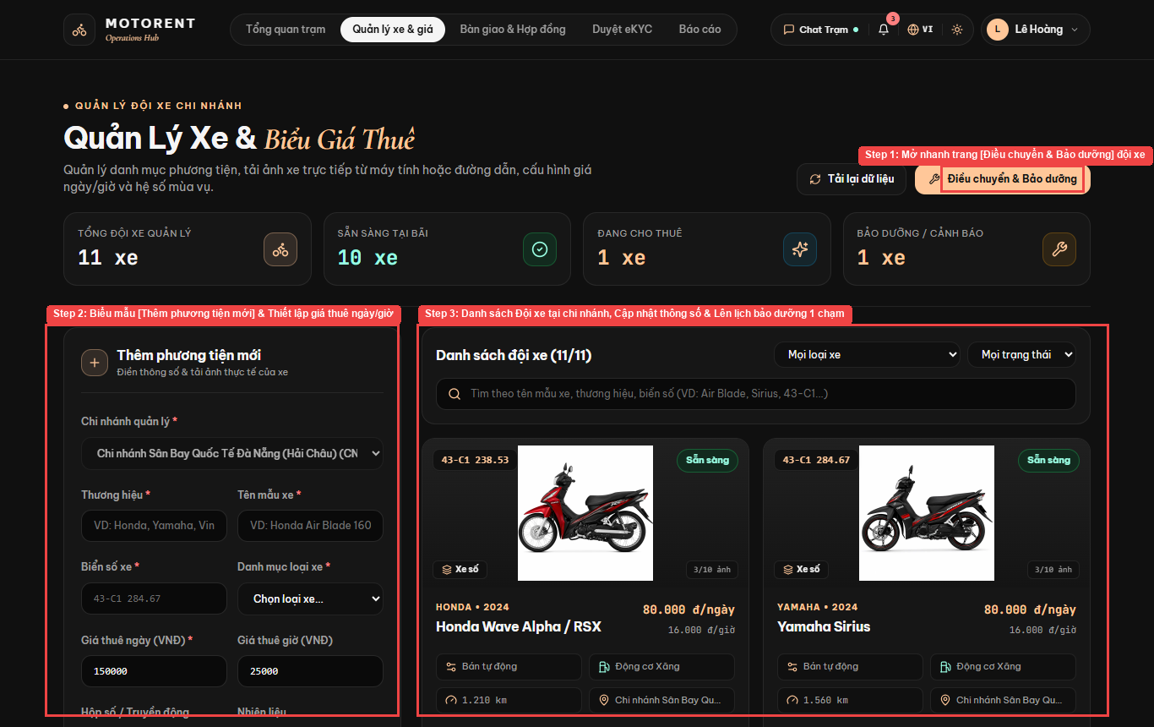
Figure III.8.1: Live UI Screen for Add New Vehicle (/manager/vehicles)
Field Name | Field Type | Description
brand / vehicleModel | Text Input | Brand (Honda, Yamaha, VinFast) and model name
licensePlate | Text Input | Unique license plate (e.g., 43-C1 284.67)
categorySelect | Select Dropdown | Assigns to 1 of 5 standard categories
dailyPrice / hourlyPrice | Number Input | Rental rates in VND
Database Access
Table / Collection | CRUD | Description
Vehicle | C | Register new motorbike with unique license plate, category, daily/hourly price, and photos
AuditLog | C | Log fleet addition
Mongoose / Database Queries:
const vehicle = await Vehicle.create({ branchId, category, brand, vehicleModel, licensePlate, dailyPrice, hourlyPrice, transmissionType, fuelType, images, status: 'Available' });

8.2 Update & Decommission Vehicle (UC-34)
Route: /manager/vehicles | Actors: Branch Manager | Related Use Case: UC-34 (Update & Decommission Vehicle). Branch Managers edit motorbike specifications or soft-delete decommissioned vehicles.
UI Design
Figure III.8.2: Live UI Screen for Update & Decommission Vehicle (/manager/vehicles)
Field Name | Field Type | Description
editVehicleModal | Modal Form | Edits existing motorbike specifications and image gallery
statusSelect | Select Dropdown | Available, Maintenance, Decommissioned
deleteVehicleBtn | Danger Button | Soft-deletes vehicle when no active bookings exist
Database Access
Table / Collection | CRUD | Description
Vehicle | U, D | Update motorbike specs/photos or decommission (soft-delete) if no active bookings exist
Mongoose / Database Queries:
const activeBooking = await Booking.findOne({ vehicleId, status: { $in: ['Pending', 'Confirmed', 'Ongoing'] } });
if (activeBooking) throw new AppError('Cannot decommission vehicle with active bookings', 400);
await Vehicle.findByIdAndUpdate(vehicleId, { $set: { status: 'Decommissioned' } });

8.3 Configure Vehicle Rental Pricing (UC-35)
Route: /manager/vehicles | Actors: Branch Manager | Related Use Case: UC-35 (Configure Vehicle Rental Pricing). Branch Managers configure daily rental prices, hourly rates, and seasonal peak multipliers.
UI Design
Figure III.8.3: Live UI Screen for Configure Vehicle Rental Pricing (/manager/vehicles)
Field Name | Field Type | Description
dailyPriceInput | Number Input | Standard 24-hour rental rate (VND)
hourlyPriceInput | Number Input | Hourly rental rate (VND)
seasonalMultiplier | Number Input | Peak season rate multiplier (e.g., 1.2x)
Database Access
Table / Collection | CRUD | Description
Vehicle | U | Update dailyPrice and hourlyPrice
SeasonalPricingRule | C, R, U | Configure holiday/weekend peak multiplier rules
Mongoose / Database Queries:
await Vehicle.findByIdAndUpdate(vehicleId, { $set: { dailyPrice, hourlyPrice } });
await SeasonalPricingRule.create({ name, startDate, endDate, multiplier, branchId });

8.4 Approve or Reject Rental Order (UC-36)
Route: /manager/dashboard | Actors: Branch Manager | Related Use Case: UC-36 (Approve or Reject Rental Order). Branch Managers review pending booking orders, verify eKYC, and approve or reject with mandatory reason.
UI Design
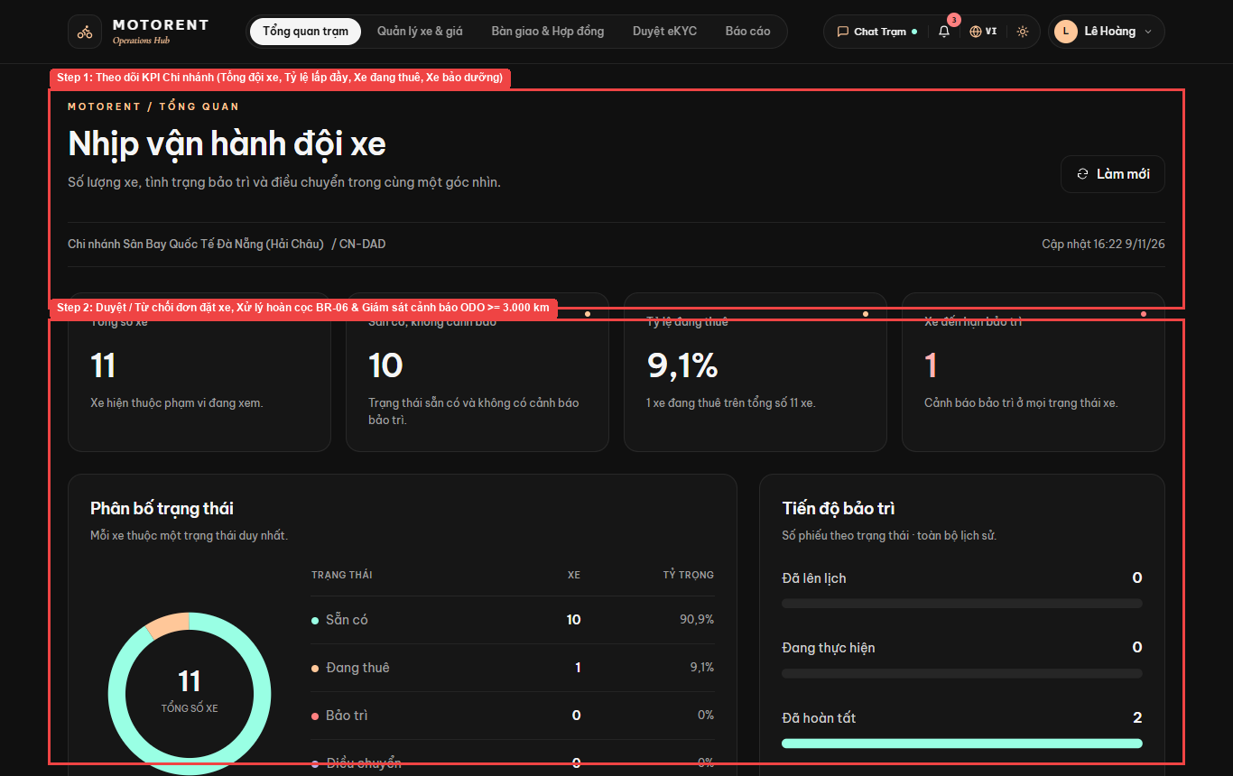
Figure III.8.4: Live UI Screen for Approve or Reject Rental Order (/manager/dashboard)
Field Name | Field Type | Description
pendingBookingsList | Queue Table | Displays bookings awaiting manager verification
approveBookingBtn | Success Button | Approves order and notifies customer
rejectBookingBtn | Danger Button | Rejects order with mandatory reason and initiates refund
Database Access
Table / Collection | CRUD | Description
Booking | R, U | Review pending bookings, verify eKYC documents, and approve or reject with reason
Mongoose / Database Queries:
await Booking.findByIdAndUpdate(bookingId, { $set: { status: decision, managerNote, reviewedBy: req.user.id } });

8.5 Process Deposit Refund Requests (UC-37)
Route: /manager/dashboard | Actors: Branch Manager | Related Use Case: UC-37 (Process Deposit Refund Requests). Branch Managers evaluate customer deposit refund requests under BR-06 and approve or reject refund disbursement.
UI Design
Figure III.8.5: Live UI Screen for Process Deposit Refund Requests (/manager/dashboard)
Field Name | Field Type | Description
refundRequestsTable | Data Table | Lists cancelled orders eligible for 100% or 50% deposit refund
confirmRefundBtn | Action Button | Confirms refund transfer and logs Payment record
Database Access
Table / Collection | CRUD | Description
Booking | R, U | Evaluate cancelled bookings with BR-06 refund eligibility and mark refund completed
Payment | C | Record refund disbursement transaction
Mongoose / Database Queries:
await Payment.create({ bookingId, userId: booking.userId, amount: booking.refundAmount, type: 'Refund', status: 'Completed', processedBy: req.user.id });
await Booking.findByIdAndUpdate(bookingId, { $set: { refundStatus: 'Refunded' } });

8.6 Schedule ODO Maintenance & Logs (UC-38)
Route: /manager/fleet-operations | Actors: Branch Manager | Related Use Case: UC-38 (Schedule ODO Maintenance & Logs). Branch Managers monitor 3,000 km ODO alerts, schedule preventive maintenance, and audit maintenance cost logs.
UI Design
Figure III.8.6: Live UI Screen for Schedule ODO Maintenance & Logs (/manager/fleet-operations)
Field Name | Field Type | Description
odoAlertBanner | Warning Card | Highlights motorbikes exceeding the 3,000 km maintenance interval
quickScheduleModal | 1-Click Modal | Creates preventive maintenance ticket directly from Fleet list
completeMaintenanceBtn | Action Button | Restores motorbike to Available and updates ODO bucket
Database Access
Table / Collection | CRUD | Description
MaintenanceLog | C, R, U | Monitor >= 3,000 km ODO alerts (BR-10), schedule maintenance, and close completed logs
Vehicle | U | Reset lastMaintenanceBucket and restore status to Available
Mongoose / Database Queries:
const highOdoVehicles = await Vehicle.find({ branchId, $expr: { $gte: [{ $subtract: ['$odometer', '$lastMaintenanceBucket'] }, 3000] } });
await MaintenanceLog.findByIdAndUpdate(logId, { $set: { status: 'Completed', completedAt: new Date() } });

8.7 Coordinate Inter-Branch Transfers (UC-39)
Route: /manager/fleet-operations | Actors: Branch Manager | Related Use Case: UC-39 (Coordinate Inter-Branch Transfers). Branch Managers request and approve motorbike transfers between Da Nang branches.
UI Design
Figure III.8.7: Live UI Screen for Coordinate Inter-Branch Transfers (/manager/fleet-operations)
Field Name | Field Type | Description
sourceBranch / destBranch | Select Dropdown | Selects origin and destination Da Nang branches
transferVehiclesSelect | Multi-Select | Chooses motorbikes to relocate
approveTransferBtn | Submit Button | Approves transfer and updates Vehicle.branchId
Database Access
Table / Collection | CRUD | Description
VehicleTransfer | C, R, U | Create inter-branch transfer order, approve dispatch, and relocate Vehicle.branchId
Vehicle | U | Update branchId to destination branch
Mongoose / Database Queries:
const transfer = await VehicleTransfer.create({ vehicleId, fromBranchId, toBranchId, requestedBy: req.user.id, reason, status: 'Approved' });
await Vehicle.findByIdAndUpdate(vehicleId, { $set: { branchId: toBranchId } });

8.8 Provision & Update Staff Accounts (UC-40)
Route: /manager/fleet-operations | Actors: Branch Manager | Related Use Case: UC-40 (Provision & Update Staff Accounts). Branch Managers create, update, or deactivate Staff accounts assigned to their branch.
UI Design
Figure III.8.8: Live UI Screen for Provision & Update Staff Accounts (/manager/fleet-operations)
Field Name | Field Type | Description
staffForm | Modal Form | Provisions new Counter Staff account for the branch
staffStatusToggle | Action Button | Activates or deactivates branch staff member
Database Access
Table / Collection | CRUD | Description
User | C, R, U | Create, update, or lock Staff accounts scoped to the manager's branch
Mongoose / Database Queries:
const staff = await User.create({ username, email, firstName, lastName, phoneNumber, passwordHash, roles: 'Staff', branchId: req.user.branchId, status: 'Active' });

8.9 Assign Work Shifts & Track Attendance (UC-41)
Route: /manager/fleet-operations | Actors: Branch Manager | Related Use Case: UC-41 (Assign Work Shifts & Track Attendance). Branch Managers assign Morning/Afternoon/Evening work shifts on the calendar and track staff attendance.
UI Design
Figure III.8.9: Live UI Screen for Assign Work Shifts & Track Attendance (/manager/fleet-operations)
Field Name | Field Type | Description
shiftCalendarGrid | Weekly Calendar | Displays Morning (07:00-15:00) and Afternoon (15:00-22:30) shifts
assignShiftModal | Form Modal | Assigns staff member to date and shift
attendanceBadge | Status Badge | Tracks On-Time, Late (>15m), or Absent status
Database Access
Table / Collection | CRUD | Description
StaffSchedule | C, R, U | Assign Morning/Afternoon/Evening shifts and record staff check-in/out attendance
Mongoose / Database Queries:
const schedule = await StaffSchedule.create({ staffId, branchId, workDate, shiftType, startTime, endTime, attendanceStatus: 'Scheduled' });

8.10 Generate & Export Branch Reports (UC-42)
Route: /reports | Actors: Branch Manager | Related Use Case: UC-42 (Generate & Export Branch Reports). Branch Managers view daily/monthly branch revenue and utilization charts and export Excel/PDF reports.
UI Design
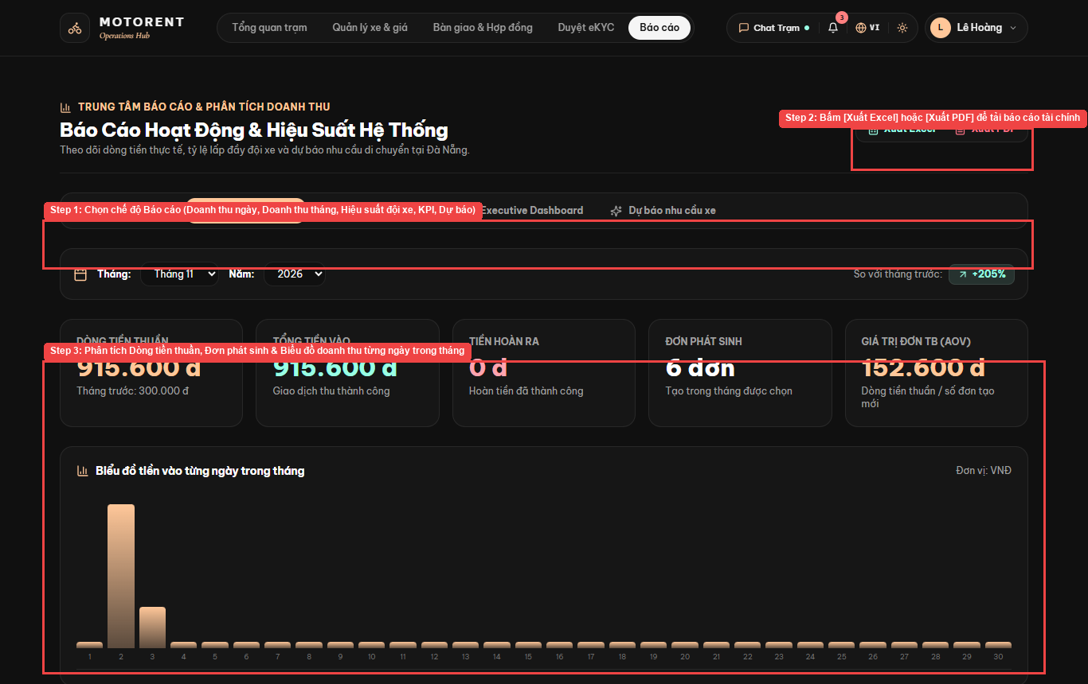
Figure III.8.10: Live UI Screen for Generate & Export Branch Reports (/reports)
Field Name | Field Type | Description
dateRangePicker | Date Filter | Filters report by day, month, or custom range
exportExcelBtn | Button | Exports branch financial report via ExcelJS (.xlsx)
exportPdfBtn | Button | Exports printable PDF revenue report via PDFKit
Database Access
Table / Collection | CRUD | Description
Booking | R | Aggregate branch revenue, completed trips, and fleet utilization
Payment | R | Summarize deposit and settlement cashflows for Excel/PDF export
Mongoose / Database Queries:
const revenue = await Booking.aggregate([{ $match: { pickupBranchId: branchId, status: 'Completed' } }, { $group: { _id: { $month: '$createdAt' }, total: { $sum: '$totalAmount' }, trips: { $sum: 1 } } }]);

9. System Administration

9.1 Add New Branch (UC-43)
Route: /admin (Tab Chi nhánh) | Actors: System Admin | Related Use Case: UC-43 (Add New Branch). System Admins create new rental branches with unique code, address, GPS coordinates, and assigned Branch Manager.
UI Design
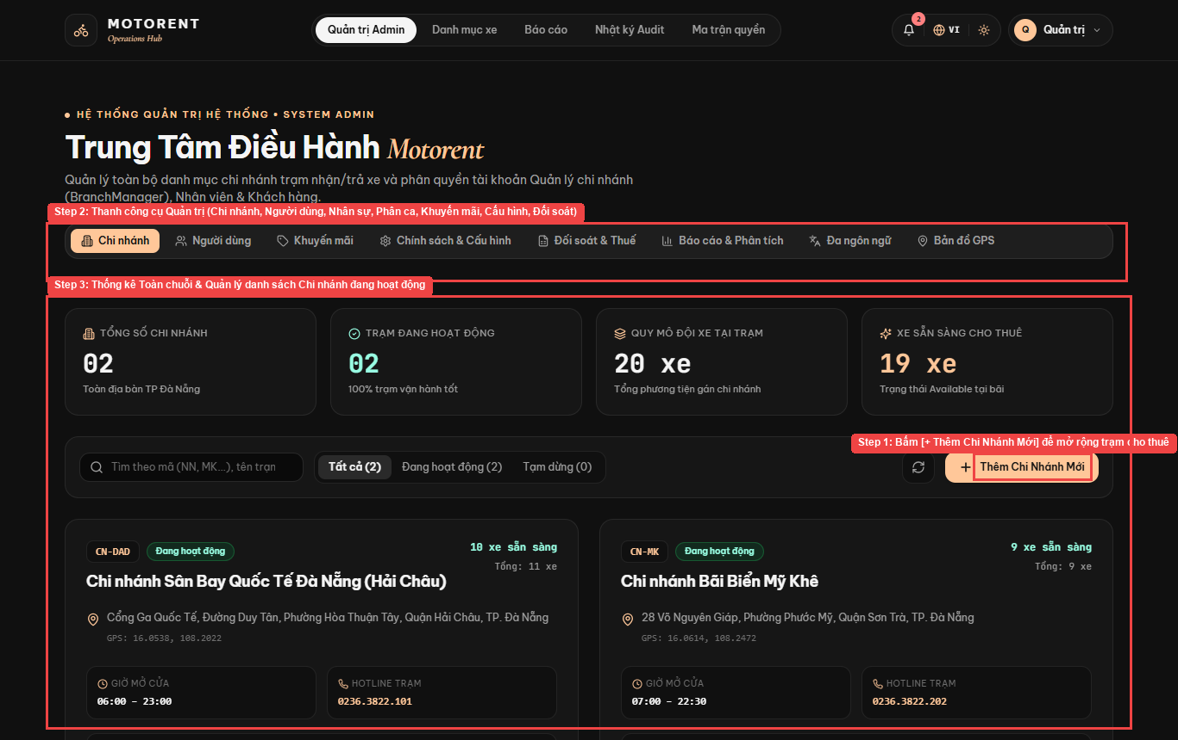
Figure III.9.1: Live UI Screen for Add New Branch (/admin (Tab Chi nhánh))
Field Name | Field Type | Description
addBranchBtn | Primary Button (+ Thêm Chi Nhánh Mới) | Opens new branch creation modal
branchCode / name | Text Input | Unique code (e.g., CN-DAD, CN-MK) and branch title
gpsLat / gpsLng | Number Input | Latitude & Longitude for Leaflet GPS map
Database Access
Table / Collection | CRUD | Description
Branch | C, R | Create new rental branch with unique code, address, GPS coordinates, and managerId
AuditLog | C | Log branch creation
Mongoose / Database Queries:
const branch = await Branch.create({ name, code, address, phone, email, location_lat, location_lng, hours_open, hours_close, managerId, isActive: true });

9.2 Update & Deactivate Branch (UC-44)
Route: /admin (Tab Chi nhánh) | Actors: System Admin | Related Use Case: UC-44 (Update & Deactivate Branch). System Admins update branch information, reassign managers, or deactivate branches.
UI Design
Figure III.9.2: Live UI Screen for Update & Deactivate Branch (/admin (Tab Chi nhánh))
Field Name | Field Type | Description
branchFilterPills | Filter Pills | Tất cả (2), Đang hoạt động (2), Tạm dừng (0)
editBranchBtn | Action Button | Updates branch address, hotline, GPS, or active state
Database Access
Table / Collection | CRUD | Description
Branch | U | Update branch details, operating hours, assigned manager, or deactivate branch
Mongoose / Database Queries:
const activeRentals = await Booking.countDocuments({ pickupBranchId: branchId, status: 'Ongoing' });
if (activeRentals > 0 && !isActive) throw new AppError('Branch has ongoing rentals', 400);
await Branch.findByIdAndUpdate(branchId, { $set: updatePayload });

9.3 Provision Manager Accounts & RBAC (UC-45)
Route: /admin (Tab Người dùng) & /rbac | Actors: System Admin | Related Use Case: UC-45 (Provision Manager Accounts & RBAC). System Admins manage user accounts, Ban/Unban (Lock/Unlock) users, assign Branch Managers, and configure RBAC.
UI Design
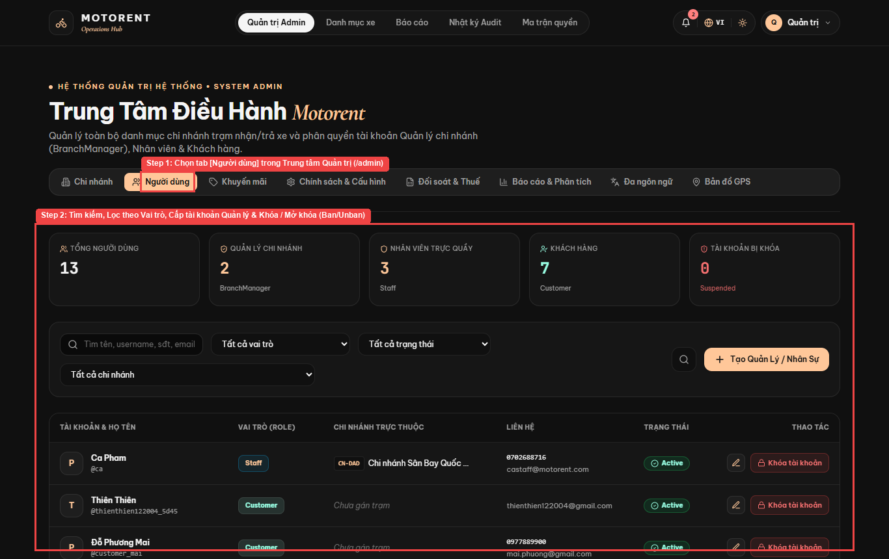
Figure III.9.3: Live UI Screen for Provision Manager Accounts & RBAC (/admin (Tab Người dùng) & /rbac)
Field Name | Field Type | Description
userRoleFilter | Filter Tabs | Filter by SystemAdmin, BranchManager, Staff, Customer
banUnbanBtn | Action Button | Locks (Ban) or unlocks (Unban) user account and revokes active tokens
assignRoleSelect | Select Dropdown | Updates user RBAC role and assigned branch
Database Access
Table / Collection | CRUD | Description
User | C, R, U | List all users, provision Branch Managers, assign roles, and Ban/Unban accounts
AuditLog | C | Record RBAC and account lock/unlock actions
Mongoose / Database Queries:
await User.findByIdAndUpdate(targetUserId, { $set: { status: isBanned ? 'Banned' : 'Active', roles: newRole }, $inc: { tokenVersion: 1 } });

9.4 Inspect System Audit Logs (UC-46)
Route: /audit | Actors: System Admin | Related Use Case: UC-46 (Inspect System Audit Logs). System Admins search, filter, and inspect the tamper-evident security AuditLog trail.
UI Design
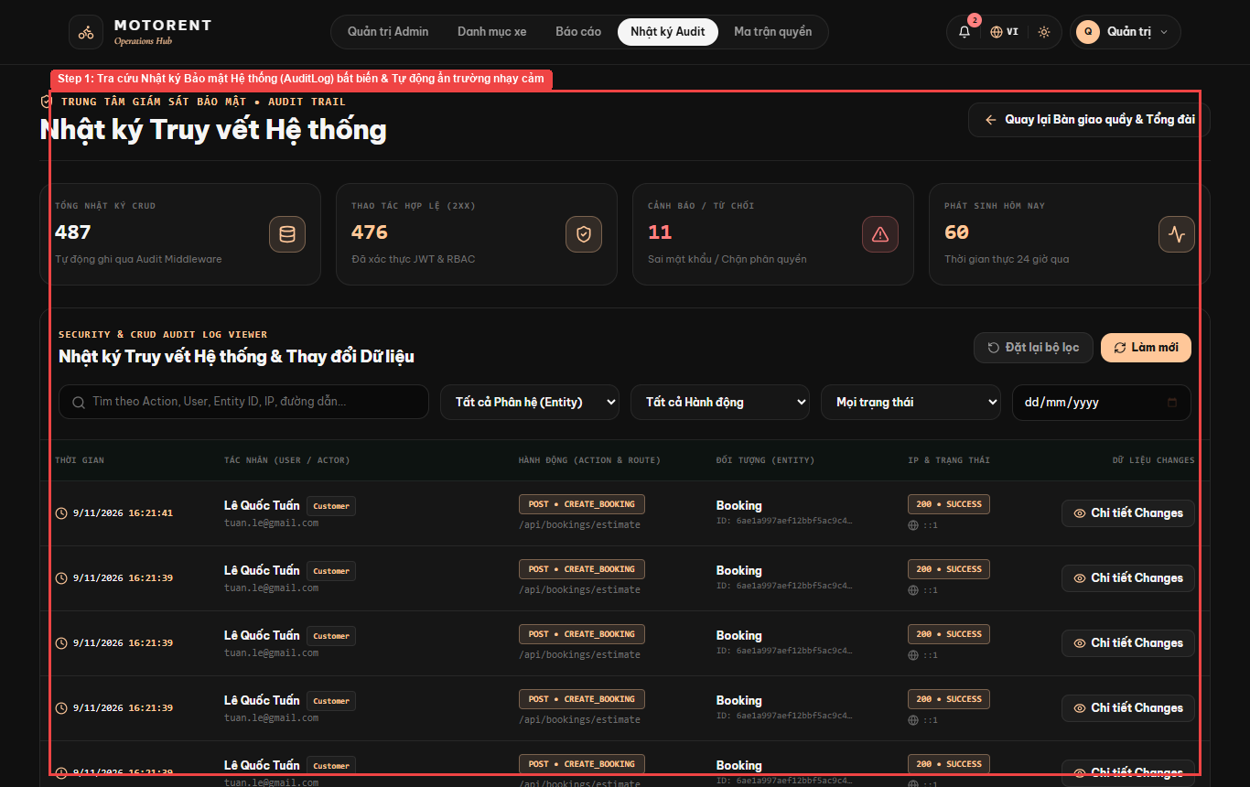
Figure III.9.4: Live UI Screen for Inspect System Audit Logs (/audit)
Field Name | Field Type | Description
auditFilterBar | Search & Filter | Filter by Actor, Action (CREATE/UPDATE/DELETE/LOGIN), Entity, and Date
auditPayloadViewer | JSON Diff Drawer | Displays request metadata with passwordHash/token automatically redacted
Database Access
Table / Collection | CRUD | Description
AuditLog | R | Search and inspect tamper-evident system security logs with sensitive field redaction
Mongoose / Database Queries:
const logs = await AuditLog.find(filter).populate('userId', 'username email roles').sort({ createdAt: -1 }).limit(100);

9.5 Configure Vehicle Categories & Promos (UC-47)
Route: /admin/categories & /admin (Tab Khuyến mãi) | Actors: System Admin | Related Use Case: UC-47 (Configure Vehicle Categories & Promos). System Admins create, update, and delete vehicle categories and promotional discount voucher codes.
UI Design
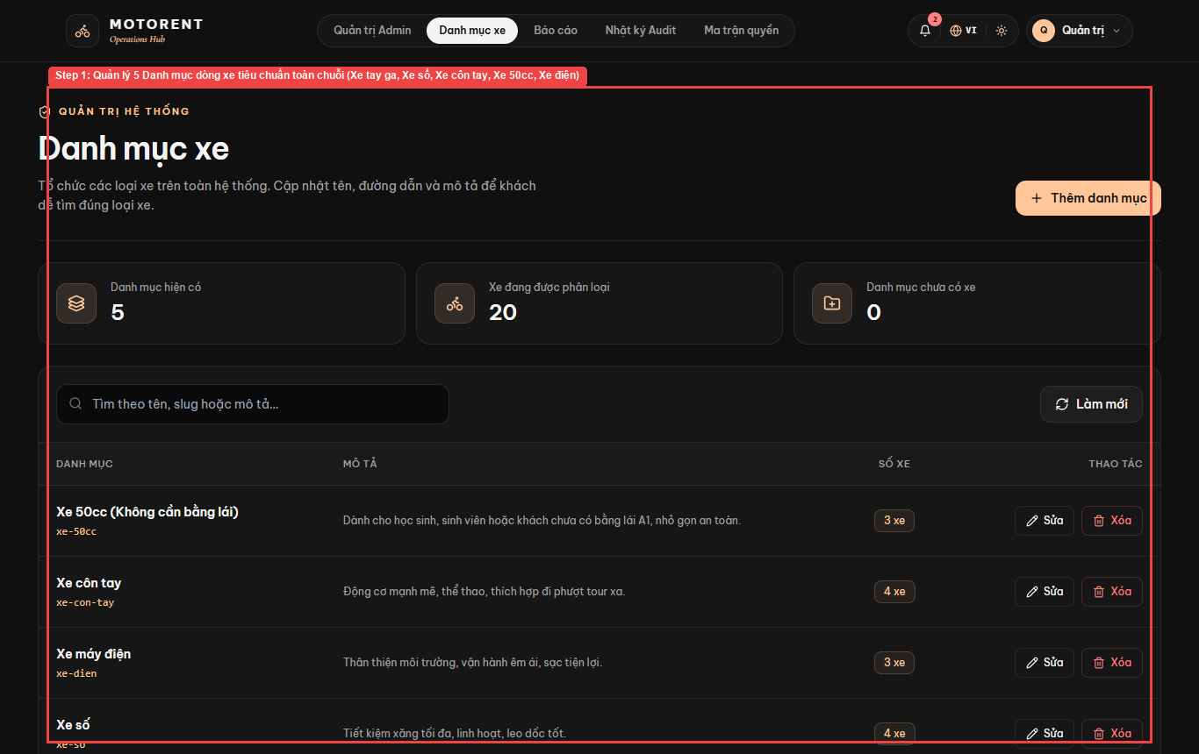
Figure III.9.5: Live UI Screen for Configure Vehicle Categories & Promos (/admin/categories & /admin (Tab Khuyến mãi))
Field Name | Field Type | Description
categoryTable | CRUD Table | Manages Xe tay ga, Xe số, Xe côn tay, Xe 50cc, Xe máy điện
voucherModal | Form Modal | Configures promo code, %, max discount, and validity dates
Database Access
Table / Collection | CRUD | Description
Category | C, R, U, D | Manage 5 standard motorbike categories
Discount | C, R, U, D | Create and manage promotional voucher codes
Mongoose / Database Queries:
const category = await Category.create({ name, slug, description });
const discount = await Discount.create({ code, discountPercent, minBookingAmount, maxDiscountAmount, startDate, endDate, usageLimit, isActive: true });

9.6 Configure System Policies & Locale (UC-48)
Route: /admin (Tab Chính sách & Đa ngôn ngữ) | Actors: System Admin | Related Use Case: UC-48 (Configure System Policies & Locale). System Admins configure deposit %, cancellation tiers, loyalty rules, and VI/EN multi-language locale.
UI Design
Figure III.9.6: Live UI Screen for Configure System Policies & Locale (/admin (Tab Chính sách & Đa ngôn ngữ))
Field Name | Field Type | Description
policyConfigForm | Settings Panel | Configures 30% deposit ratio, 3,000 km ODO threshold, and 30,000 VND/hr late fee
localeSwitcher | VI / EN Toggle | Switches application interface between Vietnamese and English
Database Access
Table / Collection | CRUD | Description
StaticPage | U | Update global deposit %, BR-06 refund tiers, BR-08 late fee, and VI/EN locale dictionary
Mongoose / Database Queries:
await StaticPage.findOneAndUpdate({ slug: 'system-config' }, { $set: { content: JSON.stringify(policyConfig), lastUpdatedBy: req.user.id } }, { upsert: true });

9.7 Publish Promotional Banners & Pages (UC-49)
Route: /admin/banners & /admin/pages | Actors: System Admin | Related Use Case: UC-49 (Publish Promotional Banners & Pages). System Admins manage homepage promotional banners and rich-text static policy pages (FAQ, Terms, Privacy).
UI Design
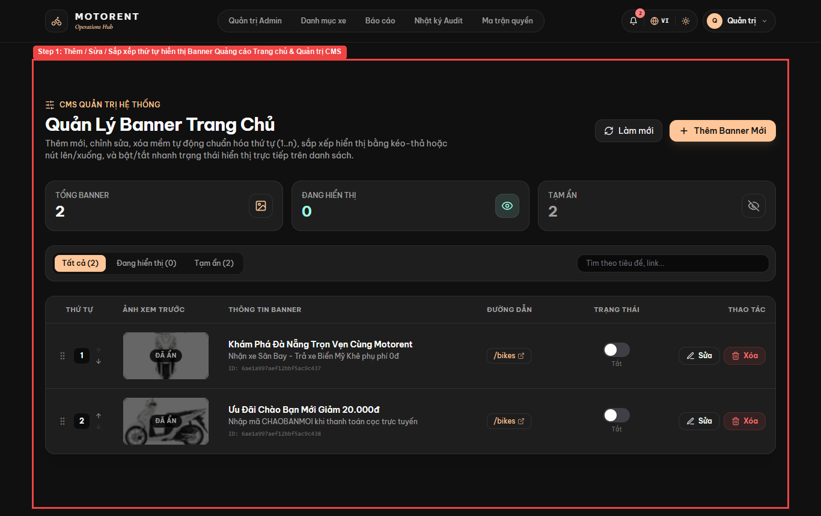
Figure III.9.7: Live UI Screen for Publish Promotional Banners & Pages (/admin/banners & /admin/pages)
Field Name | Field Type | Description
bannerListTable | Sortable List | Manages hero banner title, subtitle, image URL, and active toggle
tiptapRichEditor | Rich Text Editor | Edits HTML content for /faq, /terms, and /privacy
Database Access
Table / Collection | CRUD | Description
Banner | C, R, U, D | Manage homepage promotional banners and display order
StaticPage | C, R, U, D | Edit rich-text FAQ, Terms, and Privacy pages
Mongoose / Database Queries:
const banners = await Banner.find().sort({ order: 1 });
await StaticPage.findOneAndUpdate({ slug }, { $set: { title, content: sanitizeHtml(content), isPublished: true } });

9.8 Analyze Chain KPIs & Reconcile Finance (UC-50)
Route: /admin (Tab Đối soát & Thuế / Báo cáo) | Actors: System Admin | Related Use Case: UC-50 (Analyze Chain KPIs & Reconcile Finance). System Admins analyze chain-wide revenue KPIs, compare branches, and reconcile VNPay transactions.
UI Design
Figure III.9.8: Live UI Screen for Analyze Chain KPIs & Reconcile Finance (/admin (Tab Đối soát & Thuế / Báo cáo))
Field Name | Field Type | Description
chainKpiCards | Executive KPI Row | Displays total branches, fleet utilization, and chain revenue
vnpayReconciliationTable | Audit Table | Cross-checks VNPay vnp_TxnRef payments against confirmed bookings
Database Access
Table / Collection | CRUD | Description
Booking | R | Aggregate chain-wide revenue KPIs and branch comparison metrics
Payment | R | Reconcile VNPay IPN transactions and export tax reports
Mongoose / Database Queries:
const kpis = await Booking.aggregate([{ $match: { status: { $in: ['Confirmed', 'Ongoing', 'Completed'] } } }, { $group: { _id: '$pickupBranchId', revenue: { $sum: '$totalAmount' }, deposits: { $sum: '$depositAmount' }, count: { $sum: 1 } } }]);

IV. Appendix

1. Assumptions & Dependencies
ID | Type | Description
AS-1 | Assumption | The system will be deployed on a cloud server (VPS/AWS) with Node.js v18+ runtime environment and MongoDB Atlas database service available.
AS-2 | Assumption | All branch staff will have access to a tablet or smartphone with a camera for taking vehicle check-in/check-out photos.
AS-3 | Assumption | Customers have access to a modern web browser (Chrome, Firefox, Safari, Edge) with JavaScript enabled on desktop or mobile devices.
AS-4 | Assumption | VNPay payment gateway sandbox/production credentials are provided by the business and remain valid throughout the system operation.
AS-5 | Assumption | All motorbike rental transactions are conducted in Vietnamese Dong (VND) within Da Nang city area.
AS-6 | Assumption | Branch operating hours are consistent (e.g., 7:00 AM - 9:00 PM daily) and can be configured per branch.
AS-7 | Assumption | Customer identity documents (CCCD/CMND and driving license) are valid Vietnamese government-issued documents.
AS-8 | Assumption | The initial fleet size is approximately 50-200 motorbikes per branch, with 3-5 branches in the first phase.
DE-1 | Dependency | VNPay Payment Gateway: The system depends on VNPay API for online deposit payments. If VNPay is unavailable, customers must pay full amount at counter.
DE-2 | Dependency | Google OAuth 2.0: Social login depends on Google's authentication service. If unavailable, users must register with email/password.
DE-3 | Dependency | Nodemailer + SMTP: Email verification, password reset, and booking notifications depend on a configured SMTP server (Gmail/SendGrid).
DE-4 | Dependency | MongoDB Atlas: The database service must maintain 99.9% uptime SLA. Local MongoDB fallback is not supported.
DE-5 | Dependency | Cloudinary/AWS S3: Image storage for vehicle photos, eKYC documents, and user avatars depends on cloud storage service.

2. Limitations & Exclusions
ID | Category | Description
LI-01 | Limitation | The system does not support real-time GPS tracking of rented vehicles. Vehicle location is only known at check-in/check-out.
LI-02 | Limitation | eKYC verification is manual (staff reviews uploaded documents). No automated OCR or facial recognition is implemented in v1.0.
LI-03 | Limitation | The system supports only Vietnamese language in v1.0. Multi-language support (English, Korean, Chinese) is planned for v2.0.
LI-04 | Limitation | SMS notifications depend on a third-party SMS gateway (e.g., Twilio, SpeedSMS). SMS delivery is not guaranteed in all network conditions.
LI-05 | Limitation | The system does not integrate with external insurance providers. Insurance coverage is handled offline by branch management.
LI-06 | Limitation | Maximum file upload size is 5MB per image. Vehicle photo galleries are limited to 10 images per vehicle.
EX-01 | Exclusion | Mobile native application (iOS/Android) is not included in v1.0 scope. The system is a responsive web application only.
EX-02 | Exclusion | Automated vehicle damage detection using AI/ML image analysis is excluded from v1.0.
EX-03 | Exclusion | Integration with government traffic violation databases is not included.
EX-04 | Exclusion | Multi-currency support and international payment gateways (Stripe, PayPal) are excluded from v1.0.
EX-05 | Exclusion | Fleet predictive maintenance using IoT sensors or telematics devices is not included.
EX-06 | Exclusion | Customer credit scoring or automated risk assessment for booking approval is excluded.

3. Business Rules
The following business rules govern the operation of the MOTORENT system across all modules.
3.1 Booking & Payment Rules
ID | Category | Rule Definition
BR-01 | Computation | Default deposit is 30% of total rental price, paid online via VNPay. Remaining 70% is collected at the branch counter during vehicle pickup.
BR-02 | Constraint | A vehicle cannot have overlapping active bookings. The system checks for date/time conflicts against all bookings with status Pending, Approved, Confirmed, or Ongoing.
BR-03 | Constraint | Minimum rental period is 1 day (24 hours). Bookings shorter than 24 hours are not permitted.
BR-04 | Computation | Booking codes are auto-generated in format MV-XXXXXX (6 random uppercase alphanumeric characters). Codes must be unique system-wide.
BR-05 | Constraint | Customer must complete eKYC identity verification (identityStatus = 'Verified') before creating any booking. Unverified customers are redirected to the eKYC page.
BR-06 | Constraint | Cancellation policy: Free cancellation if > 24 hours before scheduled pickup time. 50% of deposit is forfeited if cancellation is < 24 hours before pickup. No cancellation is permitted after vehicle handover (Check-in completed).
BR-07 | Computation | One-way rental surcharge: If the return branch differs from the pickup branch, an additional fee of 50,000 VND is added to the total price.
BR-08 | Constraint | Booking status transitions follow a strict state machine: Pending -> Confirmed (or Approved) -> Ongoing -> Completed. Side transitions: Pending/Confirmed -> Cancelled.
3.2 Operations & Fleet Rules
ID | Category | Rule Definition
BR-09 | Constraint | Staff must complete a 5-point safety check during vehicle handover: (1) Verify customer CCCD/CMND, (2) Verify driving license, (3) Photograph vehicle from 4 angles, (4) Record odometer reading, (5) Record fuel level.
BR-10 | Fact | Each rental includes standard accessories: 2 helmets, 2 raincoats, and 1 phone mount. Staff must confirm delivery of all items during Check-in.
BR-11 | Computation | Late return fee: 30,000 VND per hour, rounded up to the nearest full hour. Example: 2 hours 15 minutes late = 3 hours x 30,000 = 90,000 VND.
BR-12 | Computation | Loyalty points: Customer earns 1 point per 10,000 VND spent on completed rentals. Points are awarded only after successful Check-out (booking status = Completed).
BR-13 | Constraint | License plates must be globally unique across all branches. The system prevents registration of duplicate license plates.
BR-14 | Constraint | Branch Manager can only manage vehicles, bookings, and staff within their assigned branch. Cross-branch operations require System Admin privileges.
BR-15 | Constraint | Vehicle maintenance alert: When a vehicle's current ODO exceeds maintenanceODOThreshold, the system flags the vehicle for scheduled maintenance.
BR-16 | Constraint | Vehicle transfer between branches requires approval from both the source branch manager (approve out) and destination branch manager (approve in).
3.3 Security & Authentication Rules
ID | Category | Rule Definition
BR-FR01 | Constraint | User passwords must be encoded with bcrypt hashing algorithm using 10 salt rounds. Plain-text passwords are never stored in the database.
BR-FR02 | Constraint | Account lockout policy: After 6 consecutive failed login attempts, the user account is locked for 30 minutes. The counter resets on successful login.
BR-FR03 | Constraint | JWT access tokens expire after 24 hours from issuance. Expired tokens are rejected by authMiddleware and the user must re-authenticate.
BR-FR04 | Constraint | Email verification tokens expire after 24 hours. Unverified accounts cannot log in. Users can request a new verification email.
BR-FR05 | Constraint | Role-Based Access Control (RBAC) enforces 4 roles with hierarchical permissions: SystemAdmin > BranchManager > Staff > Customer. Each API endpoint is guarded by rbacMiddleware.
BR-FR06 | Constraint | All sensitive operations (create, update, delete on critical entities) are automatically logged to AuditLog collection by auditMiddleware with userId, action, entity, and timestamp.
BR-FR07 | Constraint | File uploads are restricted to image formats (JPEG, PNG, WebP) with a maximum size of 5MB per file. Multer middleware validates file type and size before processing.
BR-FR08 | Fact | Password reset tokens are single-use. Once a reset link is clicked and the password is changed, the token is invalidated and cannot be reused.

4. Application Messages List
The table below defines all standardized validation, toast, inline, and pop-up system messages (MSG01 – MSG26) referenced by the Business Rules across all modules of MOTORENT.
# | Message Code | Message Type | Context | Content
1 | MSG01 | In line | Invalid email format when user fills out the email field | Sai định dạng email. Vui lòng nhập email hợp lệ.
2 | MSG02 | In line | Password does not meet the minimum length of 8 characters | Mật khẩu phải từ 8 ký tự trở lên.
3 | MSG03 | Toast message | Email is already used when attempting to register | Email này đã được sử dụng để đăng ký tài khoản.
4 | MSG04 | Toast message | Login failed due to incorrect email or password credentials | Đăng nhập thất bại. Email hoặc mật khẩu không chính xác.
5 | MSG05 | Toast message | Login succeeded with valid credentials or Google OAuth2 | Đăng nhập hệ thống thành công.
6 | MSG06 | Toast message | Account temporarily locked after 6 consecutive failed login attempts (BR-13) | Tài khoản tạm khóa 30 phút do nhập sai mật khẩu quá 6 lần.
7 | MSG07 | Toast message | Email has not been registered when requesting password recovery | Email chưa được đăng ký trong hệ thống MOTORENT.
8 | MSG08 | Toast message | OTP / Reset link sent successfully to user's email | Đã gửi mã xác thực OTP về email của bạn.
9 | MSG09 | Toast message | OTP verified successfully during registration or password reset | Xác thực mã OTP thành công.
10 | MSG10 | Toast message | OTP verification failed or expired | Mã OTP không đúng hoặc đã hết hạn. Vui lòng thử lại.
11 | MSG11 | In line | Re-entered confirmation password does not match new password | Mật khẩu nhập lại không trùng khớp.
12 | MSG12 | Toast message | No motorbikes or branches match the selected filter criteria | Không tìm thấy xe phù hợp với bộ lọc hiện tại.
13 | MSG13 | In line | Required booking or eKYC form fields are incomplete | Vui lòng điền đầy đủ thông tin bắt buộc và tải đủ ảnh CCCD/GPLX.
14 | MSG14 | Toast message | Customer profile and eKYC documents uploaded successfully | Cập nhật hồ sơ và gửi yêu cầu xác thực eKYC thành công.
15 | MSG15 | Toast message | Vehicle overlap conflict detected during booking or extension (BR-03) | Xe đã có lịch đặt hoặc đang bảo dưỡng trong khung giờ này.
16 | MSG16 | Toast message | Single or Multi-Vehicle Cart booking created, redirecting to VNPay | Khởi tạo hợp đồng giữ chỗ thành công. Đang chuyển hướng cổng VNPay.
17 | MSG17 | Toast message | 30% VNPay deposit payment verified via HMAC-SHA512 checksum | Thanh toán đặt cọc 30% qua VNPay thành công. Đơn đặt xe đã xác nhận.
18 | MSG18 | Toast message | VNPay payment cancelled or failed checksum verification | Thanh toán không thành công. Đơn giữ chỗ tạm thời đã được hủy tự động.
19 | MSG19 | Toast message | Booking cancelled and deposit refund calculated per BR-06 tiers | Đã hủy chuyến thành công. Yêu cầu hoàn cọc đã được ghi nhận theo chính sách.
20 | MSG20 | Toast message | 5-point Counter Check-in handover completed by Staff | Bàn giao xe (Check-in) thành công. Hợp đồng chuyển sang trạng thái Đang thuê.
21 | MSG21 | Toast message | Cross-branch Counter Check-out & penalty settlement completed | Nhận xe trả (Check-out) và tất toán hợp đồng thành công.
22 | MSG22 | Pop up message | Automated ODO maintenance threshold alert (>= 3,000 km per BR-10) | Cảnh báo ODO: Xe đã vượt mốc 3.000 km cần lên lịch bảo dưỡng định kỳ.
23 | MSG23 | Toast message | Inter-branch vehicle transfer request approved by Branch Manager | Đã phê duyệt lệnh điều chuyển xe liên chi nhánh thành công.
24 | MSG24 | Toast message | Loyalty points redeemed for discount voucher (BR-11) | Đổi điểm thưởng Loyalty lấy mã giảm giá thành công.
25 | MSG25 | Pop up message | Real-time Socket.IO notification for new live chat message | Bạn có tin nhắn hỗ trợ mới từ chi nhánh MOTORENT.
26 | MSG26 | Toast message | Admin locked/unlocked user account or updated RBAC policy | Cập nhật trạng thái tài khoản và phân quyền hệ thống thành công.

