

Requirement & Design Specification
Motorbike Rental Management System (MOTORENT)
Version: 1.1

– Da Nang, October 2026 –

Record of Changes
Version | Date | A*  M, D | In charge | Change Description
V1.0 | 26/09/2026 | A | HoangTQB | Initial release of Requirement & Design Specification for MOTORENT
V1.1 | 18/10/2026 | M | HoangTQB | Consolidated 122 granular UCs into 50 core Use Cases (UC-01..UC-50), updated UML diagrams, VNPay deposit flow, and 4-angle vehicle inspection
*A - Added M - Modified D - Deleted

Contents
Record of Changes 2
I. Overview 4
1. User Requirements 4
1.1 Actors 4
1.2 Use Cases 4
2. Overall Functionalities 8
2.1 Screens Flow 8
2.2 Screen Descriptions 9
2.3 Screen Authorization 10
2.4 Non-UI Functions 11
3. System High Level Design 11
3.1 Database Design 11
3.2 Code Packages 15
II. Requirement Specifications 16
1. Common Functions 16
1.1 UC-06_Login System 16
1.2 UC-05_Register Account 17
2. Booking Feature 18
2.1 UC-14_Book a Rental 18
2.2 UC-16_Cancel Rental Order 19
3. Counter Desk Feature 20
3.1 UC-27_Confirm Vehicle Handover (Check-in) 20
3.2 UC-28_Confirm Vehicle Return (Check-out) 21
4. Fleet Management Feature 22
4.1 UC-33_Add New Vehicle 22
5. Administration Feature 23
5.1 UC-43_Add New Branch 23
III. Design Specifications 24
1. System Access 24
1.1 User Login 24
1.2 User Registration 25
2. Booking Feature 26
2.1 Booking Modal 26
3. Counter Desk Feature 27
3.1 Check-in Form 27
3.2 Check-out Form 28
IV. Appendix 29
1. Assumptions & Dependencies 29
2. Limitations & Exclusions 30
3. Business Rules 30
3.1 Booking & Payment Rules 30
3.2 Operations & Fleet Rules 31
3.3 Security & Authentication Rules 31

I. Overview

1. User Requirements

1.1 Actors
# | Actor | Description
1 | Guest | An unauthenticated visitor who can browse the system's public pages: locate branch offices, browse the motorbike fleet with filters and sorting, read rental policies, and register/login to gain access to booking features.
2 | Customer | A registered and authenticated user who can book motorbikes, update personal profiles (including eKYC identity verification), track order status, make payments (VNPay deposit 30% / counter payment 70%), write reviews, submit complaints, and participate in the loyalty program. Inherits all Guest capabilities.
3 | Staff | A branch employee responsible for on-site counter operations: performing vehicle Check-in/Check-out, updating vehicle status, creating maintenance tickets, and responding to customer chat. Inherits all Guest capabilities.
4 | Branch Manager | A branch-level administrator who operates the branch vehicle fleet, approves/rejects rental orders and refund requests, oversees vehicle transfers, provisions staff accounts and assigns work shifts, handles complaints, and generates branch-level reports. Inherits all Staff capabilities.
5 | System Admin | The top-level administrator who administers the entire chain: creates/updates branches, provisions Manager accounts, configures RBAC, configures categories and discounts, publishes CMS content, audits security logs, and generates chain-wide KPI dashboards. Inherits all Branch Manager capabilities.

1.2 Use Cases

a. Diagram(s)
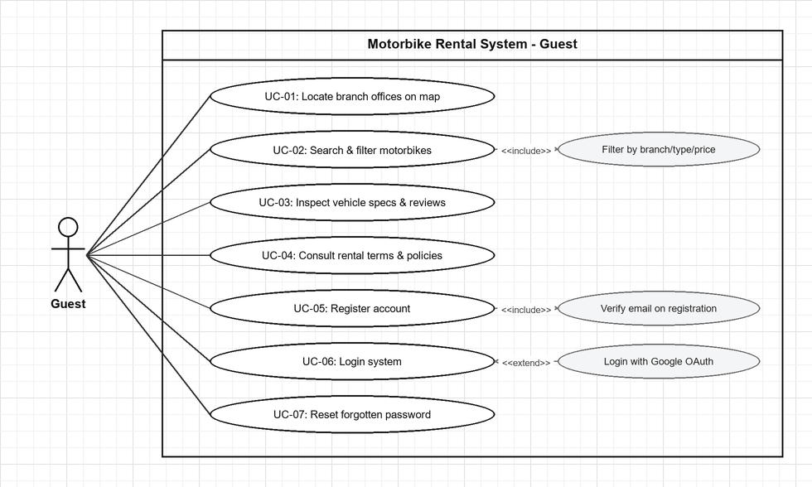
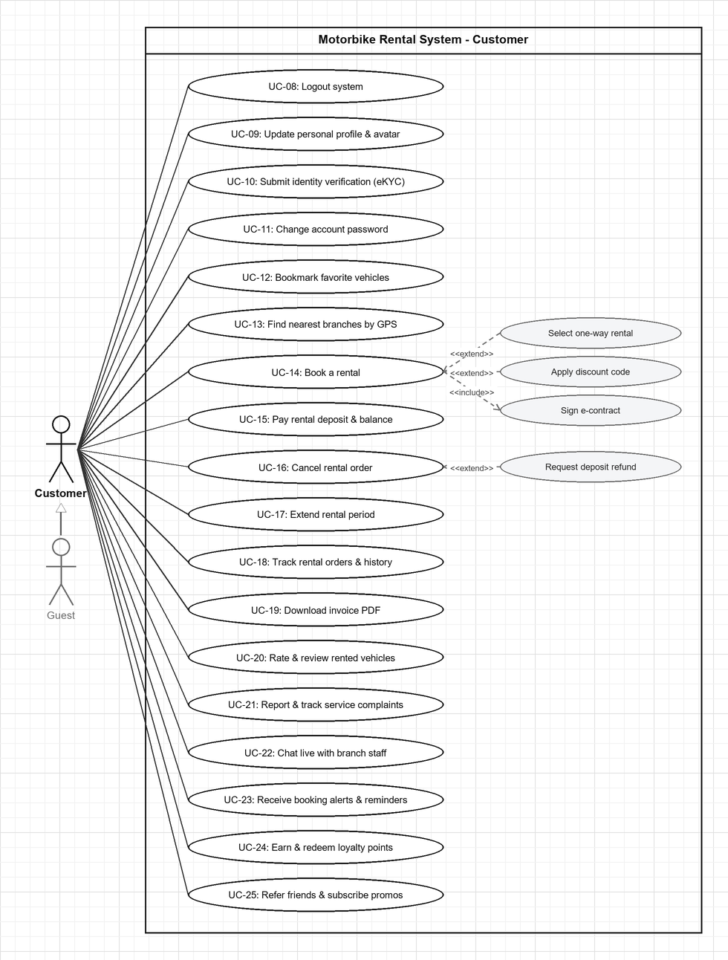
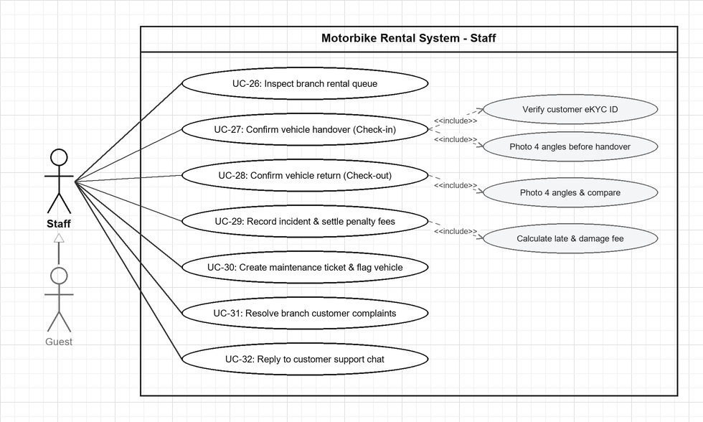
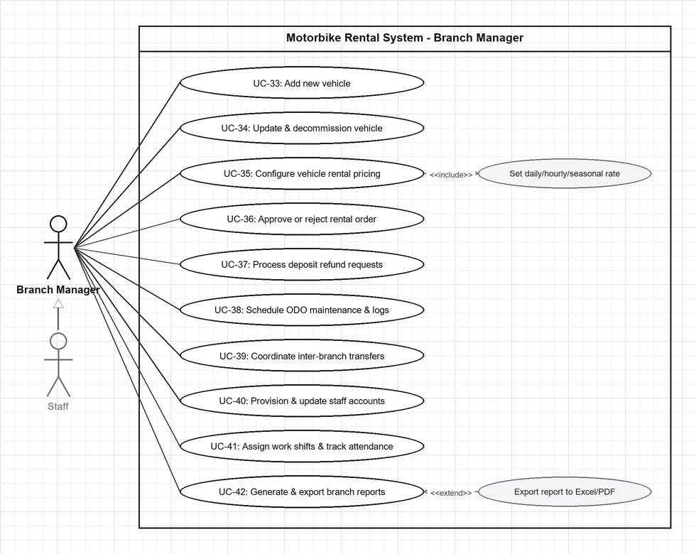
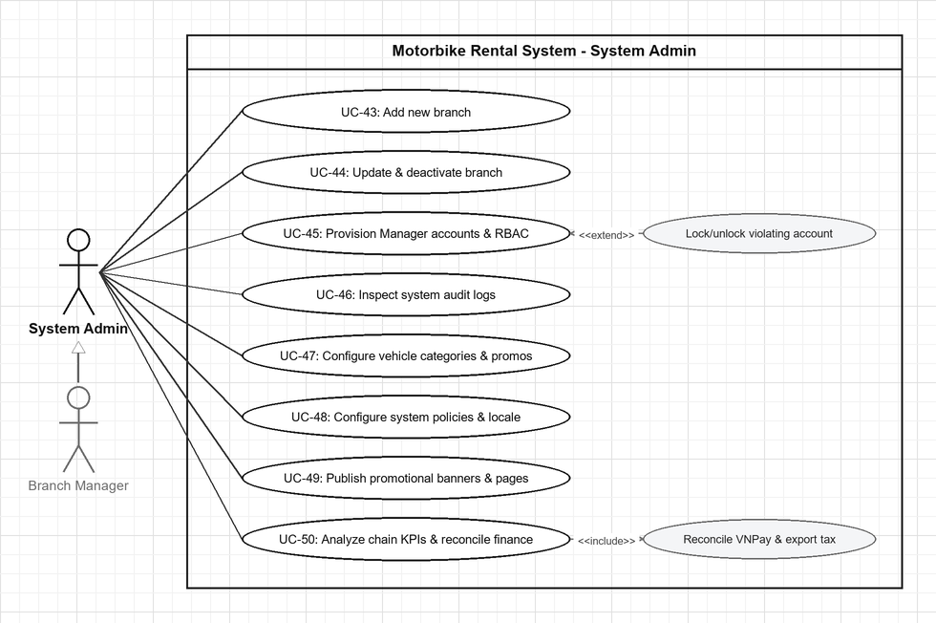

b. Descriptions
Feature 1: Browse & Search (Guest)
ID | Feature | Use Case | Use Case Description
UC-01 | Browse Branches | Locate branch offices on map | Guest explores active branch offices (address, phone, operating hours, available vehicle count) and interactive GPS map markers.
UC-02 | Browse Fleet | Search & filter motorbikes | Guest searches the fleet catalog by keyword, filters by branch, category (Scooter/Manual/Semi-Auto/Electric), price range, brand, or availability, and sorts by price or rating.
UC-03 | Browse Fleet | Inspect vehicle specs & reviews | Guest examines detailed motorbike specifications, photo gallery, daily/hourly pricing, availability status, and customer reviews/ratings.
UC-04 | Rental Policy | Consult rental terms & policies | Guest reads the rental terms, deposit rules (30% online / 70% counter), cancellation policy, and insurance coverage.
Feature 2: Authentication (Guest)
ID | Feature | Use Case | Use Case Description
UC-05 | Authentication | Register account | Guest creates a new Customer account with username, email, phone, and password or Google OAuth. <<include>> Verify email on registration.
UC-06 | Authentication | Login system | User authenticates using email/password credentials or <<extend>> Google OAuth 2.0 to receive a JWT access token.
UC-07 | Authentication | Reset forgotten password | Guest requests a time-limited password reset link sent to their registered email and sets a new password.
UC-08 | Authentication | Logout system | Authenticated user (Customer, Staff, Branch Manager, System Admin) logs out and terminates the active session.
Feature 3: Customer Profile & Account (Customer)
ID | Feature | Use Case | Use Case Description
UC-09 | Profile | Update personal profile & avatar | Customer edits personal information (first/last name, phone, gender, date of birth), uploads an avatar photo, and checks loyalty points balance.
UC-10 | Profile | Submit identity verification (eKYC) | Customer uploads front/back photos of CCCD/CMND and driving license for eKYC identity verification.
UC-11 | Profile | Change account password | Customer updates their current account password after verifying existing credentials.
Feature 4: Booking & Payment (Customer)
ID | Feature | Use Case | Use Case Description
UC-12 | Wishlist | Bookmark favorite vehicles | Customer saves motorbikes to their personal favorites wishlist or removes bookmarked vehicles.
UC-13 | Search | Find nearest branches by GPS | Customer locates available motorbikes at branches nearest to their current GPS coordinates.
UC-14 | Booking | Book a rental | Customer creates a rental order by selecting vehicle, pickup/return branches (<<extend>> one-way rental), dates, <<extend>> promo code, and <<include>> signing e-contract.
UC-15 | Payment | Pay rental deposit & balance | Customer pays 30% deposit or 100% full amount online via VNPay/VietQR, or settles the remaining 70% at the branch counter during pickup.
UC-16 | Order Mgmt | Cancel rental order | Customer cancels a pending/confirmed booking before handover with a reason and <<extend>> requests a deposit refund if applicable.
UC-17 | Order Mgmt | Extend rental period | Customer requests to extend the scheduled return date/time of an active rental.
UC-18 | Order Mgmt | Track rental orders & history | Customer monitors real-time order status via Socket.IO, checks past rental history, and inspects 4-angle check-in/check-out vehicle photos.
UC-19 | Invoice | Download invoice PDF | Customer generates and downloads a formatted PDF invoice/receipt for a completed rental order.
Feature 5: Review, Complaint & Communication (Customer)
ID | Feature | Use Case | Use Case Description
UC-20 | Reviews | Rate & review rented vehicles | Customer submits a 1–5 star review with photos for a completed rental, or edits/deletes their submitted review.
UC-21 | Complaints | Report & track service complaints | Customer submits a complaint about a booking or branch experience and tracks its resolution progress.
UC-22 | Chat | Chat live with branch staff | Customer exchanges real-time support messages with branch staff via Socket.IO.
Feature 6: Notifications & Loyalty (Customer)
ID | Feature | Use Case | Use Case Description
UC-23 | Notifications | Receive booking alerts & reminders | Customer receives in-app push notifications, email confirmations, and automated SMS pickup/return reminders (24h and 2h prior).
UC-24 | Loyalty | Earn & redeem loyalty points | Customer accumulates loyalty points upon rental completion (1 pt per 10,000 VND) and redeems points for discount vouchers.
UC-25 | Marketing | Refer friends & subscribe promos | Customer shares referral codes for bonus points and opts in to promotional offers.
Feature 7: Counter Desk Operations (Staff)
ID | Feature | Use Case | Use Case Description
UC-26 | Orders | Inspect branch rental queue | Staff filters branch rental orders by status and verifies detailed booking, payment, and customer eKYC records.
UC-27 | Check-in | Confirm vehicle handover (Check-in) | Staff <<include>> verifies customer ID/license, collects 70% counter balance, <<include>> captures 4-angle vehicle photos, records start ODO/fuel/accessories, and sets vehicle to Rented.
UC-28 | Check-out | Confirm vehicle return (Check-out) | Staff <<include>> captures 4-angle return photos, <<include>> compares condition with check-in photos, records return ODO/fuel, and updates vehicle to Available or Maintenance.
UC-29 | Penalty | Record incident & settle penalty fees | Staff documents vehicle damage with photos, <<include>> calculates late fee (30,000 VND/hr) and damage fee, and collects final settlement at counter.
UC-30 | Maintenance | Create maintenance ticket & flag vehicle | Staff updates vehicle status to Maintenance and logs a maintenance/repair ticket.
UC-31 | Complaints | Resolve branch customer complaints | Staff investigates and responds to customer complaints assigned to their branch.
UC-32 | Chat | Reply to customer support chat | Staff responds to customer live chat messages in real time via the Staff Chat Console.
Feature 8: Fleet & Staff Management (Branch Manager)
ID | Feature | Use Case | Use Case Description
UC-33 | Fleet | Add new vehicle | Manager registers a new motorbike (specs, license plate, ODO threshold, photos, pricing) to the branch fleet.
UC-34 | Fleet | Update & decommission vehicle | Manager edits vehicle specifications/status or soft-deletes (isDeleted=true) a vehicle from the branch fleet.
UC-35 | Pricing | Configure vehicle rental pricing | Manager sets and updates daily rental price, hourly rental rate, and peak seasonal pricing rules.
UC-36 | Approval | Approve or reject rental order | Manager evaluates pending booking requests and approves or rejects them with a documented reason.
UC-37 | Refund | Process deposit refund requests | Manager evaluates customer deposit refund requests and approves or rejects them with a reason.
UC-38 | Maintenance | Schedule ODO maintenance & logs | Manager schedules periodic ODO-based maintenance and audits full vehicle maintenance history.
UC-39 | Transfer | Coordinate inter-branch transfers | Manager requests incoming vehicle transfers from other branches and approves outgoing vehicle transfers.
UC-40 | Staff | Provision & update staff accounts | Manager creates new Staff accounts, updates staff details, or deactivates staff accounts in their branch.
UC-41 | Staff | Assign work shifts & track attendance | Manager assigns shift schedule entries on the calendar and monitors staff attendance.
UC-42 | Reports | Generate & export branch reports | Manager resolves escalated complaints and generates daily/monthly/annual revenue, fleet utilization, breakdown frequency, and rating reports with <<extend>> Excel/PDF export.
Feature 9: System Administration (System Admin)
ID | Feature | Use Case | Use Case Description
UC-43 | Branch | Add new branch | Admin creates a new branch with name, code, address, GPS coordinates, operating hours, and assigned Branch Manager.
UC-44 | Branch | Update & deactivate branch | Admin updates branch details, reassigns managers, or deactivates a branch (isActive=false).
UC-45 | Account | Provision Manager accounts & RBAC | Admin creates/updates/deactivates Branch Manager accounts, configures RBAC permissions, and <<extend>> locks/unlocks violating accounts.
UC-46 | Audit | Inspect system audit logs | Admin searches, filters, and audits the system-wide security and CRUD activity trail (AuditLog).
UC-47 | Catalog | Configure vehicle categories & promos | Admin creates, updates, and deactivates vehicle categories (Scooter, Manual, Electric) and promotional discount voucher codes.
UC-48 | Config | Configure system policies & locale | Admin configures cancellation/refund rules, default deposit %, loyalty program rules, and multi-language settings.
UC-49 | CMS | Publish promotional banners & pages | Admin creates, updates, and deletes homepage promotional banners and static pages (FAQ, Terms, Privacy).
UC-50 | Finance & KPI | Analyze chain KPIs & reconcile finance | Admin analyzes chain-wide revenue KPIs, branch comparisons, and seasonal demand forecasts; <<include>> reconciles VNPay payments and exports tax reports.

2. Overall Functionalities

2.1 Screens Flow
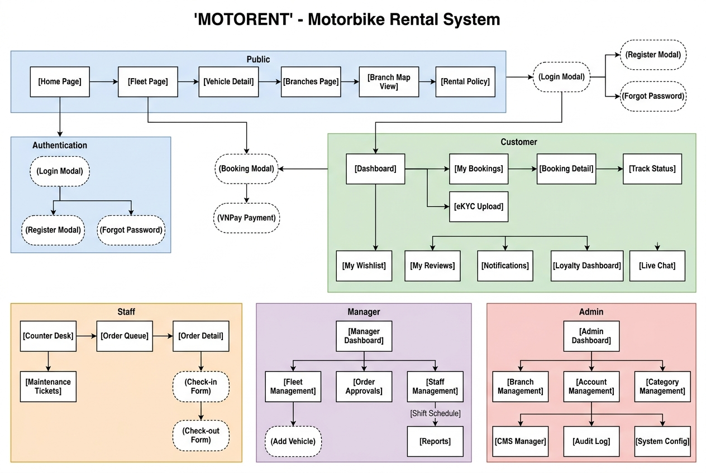

2.2 Screen Descriptions
# | Feature | Screen | Description
1 | Browse | Home Page | Landing page with hero banner slider, booking widget, featured vehicles, and branch highlights
2 | Browse | Fleet Page | Full vehicle catalog with multi-dimensional filters (branch, type, price, availability, brand) and sorting
3 | Browse | Vehicle Detail | Detailed vehicle page with photo gallery, specs, pricing, availability calendar, and reviews
4 | Browse | Branches Page | List of active branches with address, phone, hours, vehicle count, and map view toggle
5 | Browse | Rental Policy Page | Static page with rental terms, cancellation rules, deposit policy, and insurance info
6 | Auth | Login Modal | Pop-up for email/password login with Google OAuth, forgot password link, and register link
7 | Auth | Register Modal | Pop-up for new account creation with username, email, password, and terms acceptance
8 | Auth | Forgot Password Modal | Pop-up for requesting password reset email
9 | Customer | My Profile | Profile page with personal info, avatar, eKYC status badge, and loyalty points balance
10 | Customer | eKYC Upload Page | Form for uploading CCCD/CMND front/back and driving license photos
11 | Customer | My Bookings | Booking list with status tabs: All / Pending / Active / Completed / Cancelled
12 | Customer | Booking Detail | Detailed booking view with status timeline, pricing breakdown, and action buttons
13 | Customer | Booking Modal | Pop-up workflow: select dates, branch, vehicle, payment method, sign e-contract
14 | Customer | Live Chat Window | Real-time chat interface with branch staff via Socket.IO
15 | Customer | My Wishlist | Grid view of customer's saved/favorited vehicles
16 | Customer | My Reviews | List of customer's reviews with edit/delete actions
17 | Customer | My Complaints | List of submitted complaints with status tracking
18 | Customer | Loyalty Dashboard | Points balance, earning history, and voucher redemption interface
19 | Customer | Notifications | Chronological notification list with read/unread status
20 | Staff | Counter Desk | Primary staff workspace with today's order queue, Check-in and Check-out panels
21 | Staff | Check-in Form | Multi-step: verify customer ID, photograph vehicle (4 angles), record ODO, confirm handover
22 | Staff | Check-out Form | Multi-step: photograph return vehicle, compare condition, record damage, calculate penalties
23 | Staff | Maintenance Tickets | List and creation form for vehicle maintenance log entries
24 | Staff | Staff Chat Console | Staff-side chat interface for responding to customer messages
25 | Manager | Manager Dashboard | Branch overview: today's bookings, revenue, fleet status, pending approvals
26 | Manager | Fleet Management | Vehicle CRUD list with add/edit/remove actions and pricing management
27 | Manager | Order Approvals | Queue of pending bookings with approve/reject actions and customer details
28 | Manager | Refund Requests | Queue of refund requests with approve/reject actions
29 | Manager | Vehicle Transfers | Transfer request list (incoming/outgoing) with approval workflow
30 | Manager | Staff Management | Staff account CRUD list with branch assignment
31 | Manager | Shift Schedule Calendar | Calendar view for assigning and viewing staff work shifts
32 | Manager | Reports Dashboard | Branch analytics with revenue charts, utilization metrics, and export options
33 | Admin | Admin KPI Dashboard | Chain-wide executive dashboard with revenue trends and branch comparison
34 | Admin | Branch Management | Branch CRUD list with manager assignment and activation toggle
35 | Admin | Account Management | Manager account CRUD list with RBAC configuration
36 | Admin | Category Management | Vehicle type CRUD list (Scooter, Manual, Semi-Auto, Electric)
37 | Admin | Discount Management | Discount code CRUD list with voucher configuration
38 | Admin | CMS - Banners | Banner CRUD list with image upload, ordering, and activation toggle
39 | Admin | CMS - Static Pages | Rich text editor for FAQ, Terms of Service, Privacy Policy pages
40 | Admin | Audit Log Viewer | Searchable, filterable audit trail of all system actions
41 | Admin | System Configuration | Settings for cancellation policy, deposit %, and loyalty program rules
42 | Admin | Finance Reports | Financial reports with VNPay reconciliation and tax export

2.3 Screen Authorization
Screen | Guest | Customer | Staff | Manager | Admin
Home Page | X | X | X | X | X
Fleet Page | X | X | X | X | X
Vehicle Detail | X | X | X | X | X
Branches Page | X | X | X | X | X
Rental Policy | X | X | X | X | X
Login/Register | X
My Profile |  | X | X | X | X
eKYC Upload |  | X
Booking Modal |  | X
My Bookings |  | X
Live Chat |  | X
My Wishlist |  | X
My Reviews |  | X
My Complaints |  | X
Loyalty Dashboard |  | X
Notifications |  | X | X | X | X
Counter Desk |  |  | X | X | X
Maintenance Tickets |  |  | X | X | X
Staff Chat |  |  | X | X | X
Manager Dashboard |  |  |  | X | X
Fleet Management |  |  |  | X | X
Order Approvals |  |  |  | X | X
Vehicle Transfers |  |  |  | X | X
Staff Management |  |  |  | X | X
Reports Dashboard |  |  |  | X | X
Admin KPI Dashboard |  |  |  |  | X
Branch Management |  |  |  |  | X
Account Management |  |  |  |  | X
Category Management |  |  |  |  | X
Discount Management |  |  |  |  | X
CMS Manager |  |  |  |  | X
Audit Log Viewer |  |  |  |  | X
System Configuration |  |  |  |  | X
Finance Reports |  |  |  |  | X

2.4 Non-UI Functions
# | Feature | System Function | Description
1 | Auth | JWT Token Management | Issues access tokens (24h expiry), validates via authMiddleware
2 | Auth | Email Verification | Sends verification email with unique token link via Nodemailer
3 | Auth | Password Reset Service | Generates time-limited reset token and sends email
4 | Payment | VNPay IPN Handler | Receives IPN callbacks from VNPay to confirm deposits
5 | Booking | Availability Checker | Validates vehicle availability by checking overlapping bookings
6 | Booking | Booking Code Generator | Generates unique codes in format MV-XXXXXX
7 | Booking | Late Fee Calculator | Calculates late fee at 30,000 VND/hour
8 | Booking | Loyalty Points Calculator | Awards 1 point per 10,000 VND spent
9 | Notification | Reminder Scheduler | Cron job for SMS/Email reminders (24h and 2h before)
10 | Notification | Real-time Status Push | Socket.IO broadcasts booking status changes
11 | Fleet | ODO Maintenance Alert | Flags vehicles exceeding maintenance ODO thresholds
12 | Audit | Audit Logger Middleware | Logs all sensitive CRUD operations to AuditLog
13 | Chat | Socket.IO Chat Server | WebSocket real-time message delivery
14 | Data | Database Seeder | Automated test data generator for development

3. System High Level Design

3.1 Database Design
The system uses MongoDB with Mongoose ODM, consisting of 18 collections organized in 4 groups. Total: 18 Tables, 33 Foreign Key Relationships (31 Many-to-One + 2 One-to-One).

Database Schema
- AuditLog
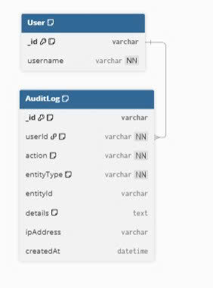

- CMS & Live Chat
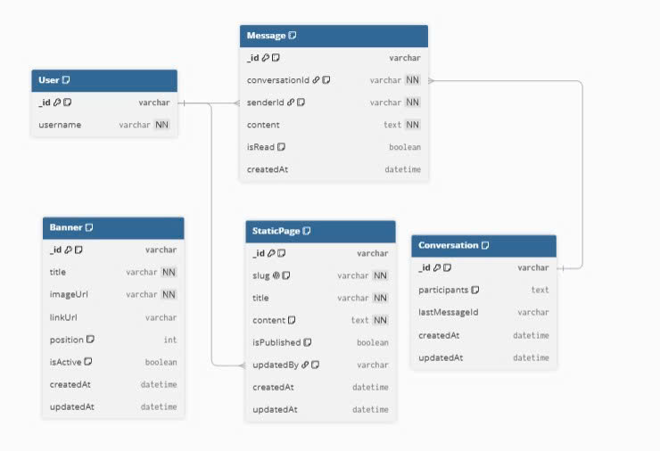

Reviews, Complaints, Notifications

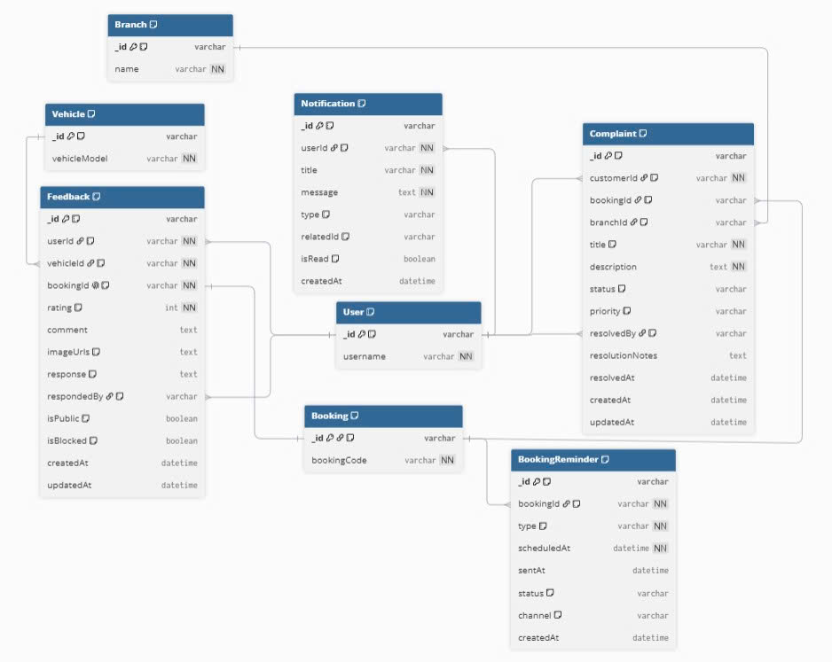

Staffing & Shifts
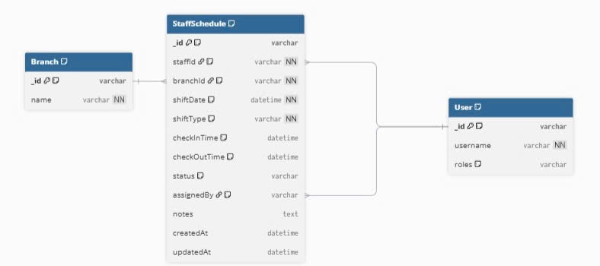

Relocation & Maintenance 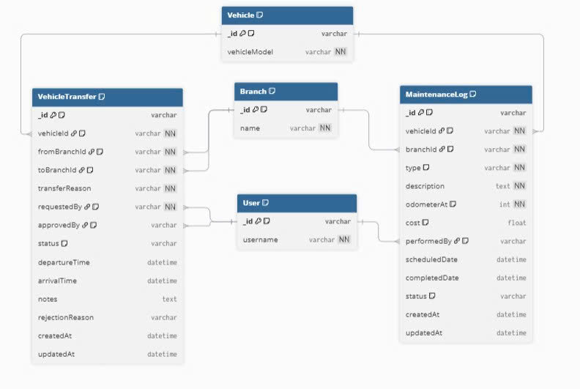

Book & Pay
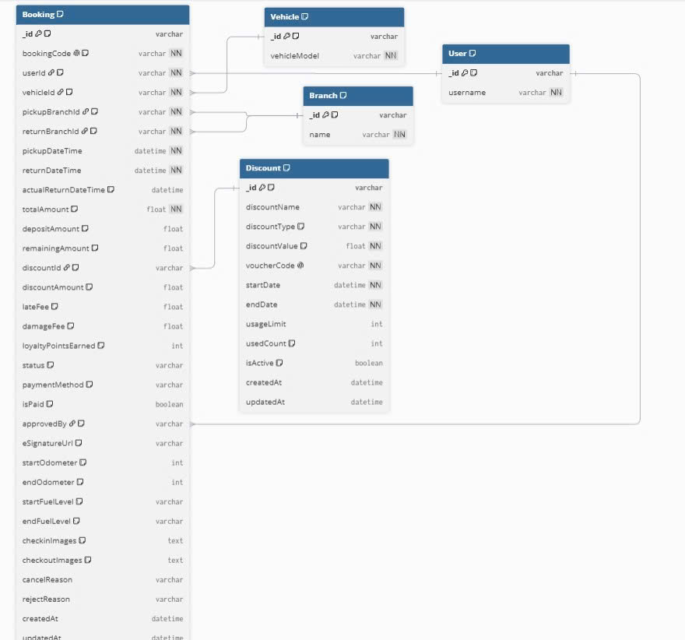

Fleet & Categories
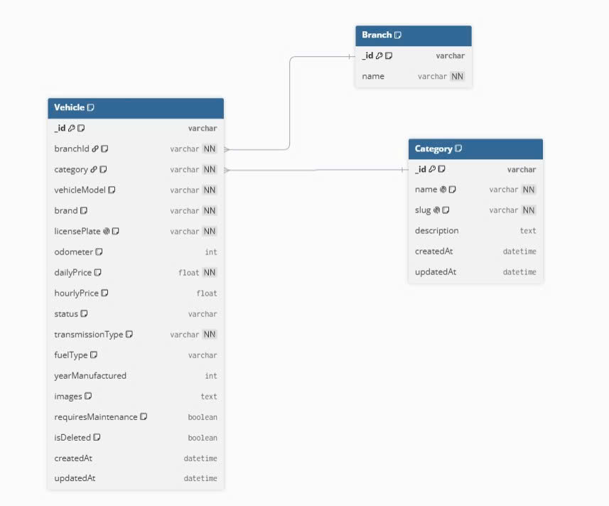

Users & Branches
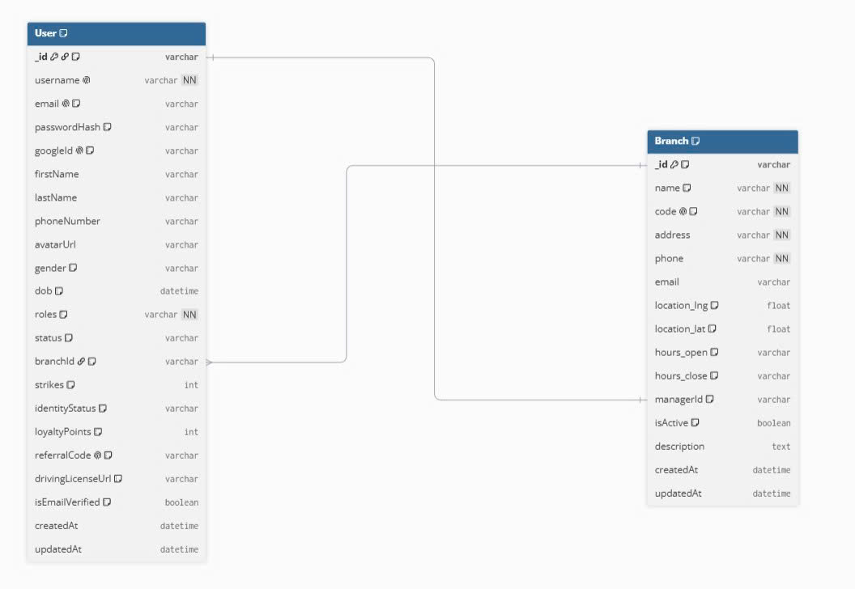

b. Table Descriptions
No | Table | Description
01 | Branch | Branch offices. PK: _id. FK: managerId -> User (1:1)
02 | User | System users, 4 RBAC roles. PK: _id. FK: branchId -> Branch
03 | Category | Vehicle type classifications. PK: _id
04 | Vehicle | Fleet motorbikes. PK: _id. FK: branchId -> Branch, category -> Category
05 | Booking | Rental orders. PK: _id. FK: userId, vehicleId, pickupBranchId, returnBranchId, discountId, approvedBy
06 | VehicleTransfer | Inter-branch transfers. PK: _id. FK: vehicleId, fromBranchId, toBranchId, requestedBy, approvedBy
07 | MaintenanceLog | Maintenance records. PK: _id. FK: vehicleId, branchId, performedBy
08 | Complaint | Customer complaints. PK: _id. FK: customerId, bookingId, branchId, resolvedBy
09 | AuditLog | System audit trail. PK: _id. FK: userId
10 | StaffSchedule | Staff shift schedules. PK: _id. FK: staffId, branchId, assignedBy
11 | Discount | Discount codes/vouchers. PK: _id
12 | Feedback | Customer reviews (1:1 Booking). PK: _id. FK: userId, vehicleId, bookingId, respondedBy
13 | Notification | In-app notifications. PK: _id. FK: userId
14 | BookingReminder | SMS/Email reminders. PK: _id. FK: bookingId
15 | Banner | CMS promotional banners. PK: _id
16 | StaticPage | CMS static pages. PK: _id. FK: updatedBy
17 | Conversation | Chat sessions. PK: _id
18 | Message | Chat messages. PK: _id. FK: conversationId, senderId

3.2 Code Packages
The backend follows a Modular Monolith architecture under server/src/. The diagram below shows the package dependency structure across 4 layers: Entry (routes), Feature Modules (8 business domains), Core Infrastructure (5 cross-cutting middlewares), and Foundation (models + config).

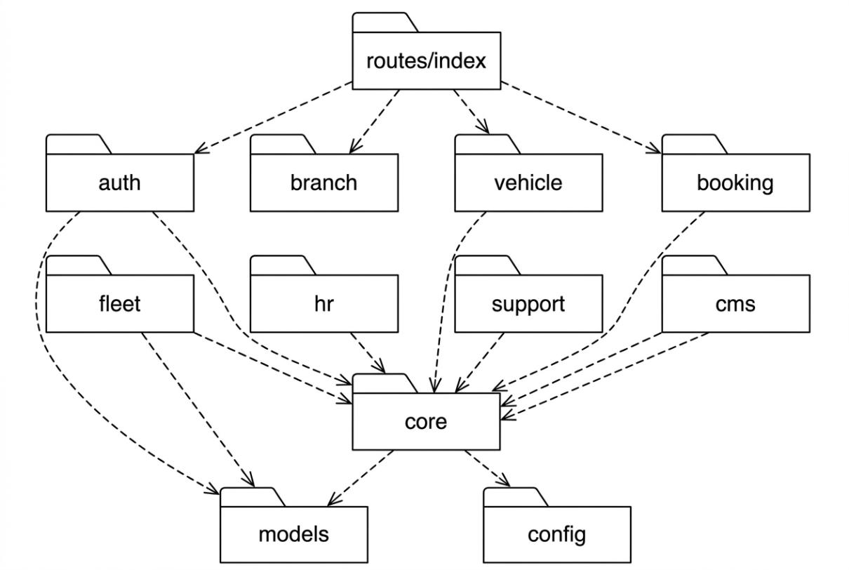
Package descriptions
No | Package | Description
01 | routes/index | Central route aggregator. Imports all module routers and mounts them under /api prefix with appropriate middleware chains.
02 | auth | Authentication & eKYC module: register, login (email + Google OAuth), email verification, forgot/reset password, upload identity documents (CCCD, driving license).
03 | branch | Branch management module: CRUD operations, GPS-based nearest branch search, operating hours configuration, manager assignment.
04 | vehicle | Vehicle & category management module: fleet CRUD, multi-filter search, pricing (daily/hourly/seasonal), availability checking.
05 | booking | Central booking workflow module: create order, VNPay deposit (30%), counter payment (70%), Check-in/Check-out, cancel, refund, extend rental period.
06 | fleet | Fleet operations module: inter-branch vehicle transfers (VehicleTransfer), maintenance logging (MaintenanceLog), ODO-based service alerts.
07 | hr | Human resources module: staff shift scheduling (StaffSchedule), clock-in/clock-out attendance tracking, shift assignment by branch manager.
08 | support | Customer support module: 1-to-1 feedback/reviews (Feedback), complaints with resolution tracking (Complaint), SMS/email booking reminders (BookingReminder).
09 | cms | Content management module: banner slider CRUD, static page editor (FAQ, Terms, Privacy), Socket.IO live chat (Conversation + Message).
10 | core | Cross-cutting middleware layer: authMiddleware (JWT), rbacMiddleware (4-role RBAC), auditMiddleware (action logging), uploadMiddleware (Multer), errorHandler (centralized error response).
11 | models | 18 Mongoose schema definitions with validation rules, virtual fields, and pre-save hooks. Each model maps to one MongoDB collection.
12 | config | Environment configuration: MongoDB connection (database), VNPay payment gateway (vnpay), Nodemailer email transport (mailer), JWT secrets.

Naming Conventions
Element | Convention | Example
Model file | PascalCase.ts | Booking.ts, VehicleTransfer.ts
Controller file | camelCase + Controller.ts | bookingController.ts
Service file | camelCase + Service.ts | bookingService.ts
Route file | camelCase + Routes.ts | bookingRoutes.ts
Middleware file | camelCase + Middleware.ts | authMiddleware.ts
Collection name | lowercase plural (auto by Mongoose) | bookings, vehicletransfers
API endpoint | kebab-case with /api prefix | /api/bookings, /api/vehicle-transfers
Environment var | SCREAMING_SNAKE_CASE | MONGO_URI, JWT_SECRET, VNPAY_HASH_SECRET

II. Requirement Specifications

1. Common Functions

1.1 UC-06_Login System

a. Functional Description
UC ID and Name: | UC-06 Login System
Created By: | Hoang | Date Created: | 26/Sep/2026
Primary Actor: | Guest | Secondary Actors: | Google OAuth Provider
Trigger: | User clicks Login button from the page header, or User accesses an authenticated feature
Description: | As a user, I want to log into the system so that I can use authenticated features and access my personalized account.
Preconditions: | PRE-1: User account has been created and email verified.  PRE-2: System is operational and database is accessible.
Postconditions: | POST-1: User is authenticated and JWT access token is issued (24h expiry).  POST-2: System tracked successful login into AuditLog.
Normal Flow: | 06.0 Login System  1. User accesses the Login Modal.  2. User enters email and password.  3. User clicks the Login button.  4. System validates credentials against User collection (see 06.0.E1, 06.0.E2).  5. System generates JWT access token with userId, role, branchId.  6. System stores token in localStorage.  7. System logs successful login to AuditLog.  8. System redirects to Dashboard (or previous calling page if any).
Alternative Flows: | 06.1 Google OAuth Login  1. User clicks 'Login with Google' button.  2. System redirects to Google OAuth consent screen.  3. User authenticates with Google credentials.  4. Google returns user profile (email, name, avatar).  5. System checks if email exists in User collection.  6a. If exists: Return to step 5 of normal flow.  6b. If not exists: System creates new User with role=Customer, then return to step 5.  06.2 Forgot Password  1. User clicks 'Forgot Password?' link.  2. System displays Forgot Password modal.  3. User enters registered email.  4. System sends password reset email with unique token (24h expiry).  5. User clicks reset link in email.  6. System validates token and displays password reset form.  7. User enters new password (min 8 chars).  8. System updates password (bcrypt hash) and invalidates reset token.
Exceptions: | 06.0.E1 Invalid credentials  1. System displays 'Email or password is incorrect' error message.  2a. User corrects credentials => Return to step 2.  2b. User clicks 'Forgot Password?' => Change to Alternative Flow 06.2.  2c. User clicks 'Register' => Change to UC-05.  06.0.E2 Account locked  1. System displays 'Account locked. Try again after 30 minutes' message.  2. UC stops.  06.0.E3 Email not verified  1. System displays 'Please verify your email first' with resend link.  2. User clicks resend => System sends new verification email.
Priority: | Must Have - High
Frequency of Use: | ~500 logins/day across all branches. Peak: 7:00-9:00 AM.
Business Rules: | BR-FR01, BR-FR02, BR-FR03
Other Information: | User has a modern web browser with JavaScript enabled.
Assumptions: | Google OAuth 2.0 and SMTP email services are configured and reachable.

b. Business Rules
ID | Business Rule | Business Rule Description
BR-FR01 | Password Encoding | User password must be encoded with bcrypt hashing (10 salt rounds)
BR-FR02 | Invalid Login | User cannot authenticate if: credentials are incorrect, email is not verified, or account is locked/blocked
BR-FR03 | Account Locking | After 6 consecutive failed login attempts, account is locked for 30 minutes

1.2 UC-05_Register Account
a. Functional Description
UC ID and Name: | UC-05 Register Account
Created By: | HoangBH Date Created: 26/Sep/2026
Primary Actor: | Guest
Secondary Actors: | Email Service (Nodemailer)
Trigger: | User clicks Register button from Login Modal or navigation header
Description: | As a guest, I want to create a new account so that I can access booking features and manage my rentals.
Preconditions: | PRE-1: User does not have an existing account with the same email.
Postconditions: | POST-1: New User record is created with role=Customer, identityStatus=Unverified.  POST-2: Verification email is sent to the registered email address.
Normal Flow: | 05.0 Register Account  1. User accesses the Register Modal.  2. User enters: firstName, lastName, email, phone, password, confirmPassword.  3. User accepts Terms of Service checkbox.  4. User clicks Register button.  5. System validates all fields (see 05.0.E1, 05.0.E2, 05.0.E3).  6. System creates User record with role=Customer.  7. System hashes password with bcrypt (10 rounds).  8. System generates email verification token (24h expiry).  9. System sends verification email via Nodemailer.  10. System displays 'Registration successful. Please check your email to verify.' message.
Alternative Flows: | 05.1 Register via Google OAuth  1. User clicks 'Register with Google' button.  2. System redirects to Google OAuth consent screen.  3. Google returns profile data.  4. System auto-fills firstName, lastName, email from Google profile.  5. System creates User with emailVerified=true (trusted provider).  6. Return to step 8 of normal flow (skip email verification).
Exceptions: | 05.0.E1 Email already exists  1. System displays 'This email is already registered. Please login instead.'  05.0.E2 Password mismatch  1. System displays 'Passwords do not match.'  05.0.E3 Validation failure  1. System highlights invalid fields with specific error messages.  (Email format invalid, phone format invalid, password < 8 characters)
Priority: | Must Have - High
Frequency of Use: | ~20 new registrations/day
Business Rules: | BR-FR01, BR-FR04
Assumptions: | User has access to the email address they register with.
b. Business Rules
ID | Business Rule | Business Rule Description
BR-FR01 | Password Encoding | User password must be encoded with bcrypt hashing (10 salt rounds)
BR-FR04 | Email Verification | Email verification tokens expire after 24 hours. Unverified accounts cannot login.

2. Booking Feature

2.1 UC-14_Book a Rental
a. Functional Description
UC ID and Name: | UC-14 Book a Rental
Created By: | HoangBH Date Created: 26/Sep/2026
Primary Actor: | Customer
Secondary Actors: | VNPay Payment Gateway
Trigger: | Customer clicks 'Book Now' button on Vehicle Detail page or Fleet Page
Description: | As a customer, I want to book a motorbike so that I can rent it for a specified period with deposit payment.
Preconditions: | PRE-1: Customer is logged in.  PRE-2: Customer has completed eKYC (identityStatus = Verified).  PRE-3: Selected vehicle is available for the requested period.
Postconditions: | POST-1: Booking record is created with status 'Pending' (or 'Confirmed' if deposit paid).  POST-2: Vehicle availability is updated to block the booked period.  POST-3: Deposit payment is recorded (if paid online).  POST-4: Confirmation email and notification are sent to Customer.
Normal Flow: | 14.0 Book a Rental  1. Customer selects a vehicle and clicks 'Book Now'.  2. System verifies eKYC status (see 14.0.E1).  3. System displays Booking Modal with:  - Vehicle info (name, image, daily price)  - Pickup branch (default: vehicle's branch)  - Return branch (default: same as pickup)  - Pickup date/time, Return date/time  - Total calculation (days x daily price)  4. Customer fills in pickup/return dates and branches.  5. System checks vehicle availability for the period (see 14.0.E2).  6. System calculates total price and deposit amount (30%).  7. Customer selects payment method:  a. Online deposit (VNPay) - continue step 8  b. Pay at counter - skip to step 12  8. System redirects to VNPay payment gateway.  9. Customer completes payment on VNPay.  10. VNPay sends IPN callback to system (see 14.0.E3).  11. System updates booking: depositAmount, depositPaidAt, paymentStatus='DepositPaid'.  12. System generates booking code (format: MV-XXXXXX).  13. System creates Booking record with status='Pending'.  14. System sends confirmation email with booking details.  15. System sends push notification to Customer.  16. System sends notification to Branch Manager for approval.
Alternative Flows: | 14.1 One-way Rental (different return branch)  1. Customer selects a different return branch from pickup branch.  2. System adds one-way surcharge (50,000 VND) to total price.  3. Return to step 6 of normal flow.  14.2 Apply Discount Code  1. Customer enters a discount code in the promo field.  2. System validates discount code (see 14.2.E1).  3. System applies discount to total price.  4. Return to step 7 of normal flow.
Exceptions: | 14.0.E1 eKYC not verified  1. System displays 'Please complete identity verification before booking.'  2. System redirects to eKYC Upload page.  14.0.E2 Vehicle not available  1. System displays 'This vehicle is not available for the selected period.'  2. System suggests alternative dates or similar vehicles.  14.0.E3 VNPay payment failed  1. System displays 'Payment failed. Please try again.'  2. Booking is saved with paymentStatus='Unpaid'.  3. Customer can retry payment from My Bookings.  14.2.E1 Invalid discount code  1. System displays 'Invalid or expired discount code.'
Priority: | Must Have - High
Frequency of Use: | ~50-100 bookings/day across all branches. Peak: weekends and holidays.
Business Rules: | BR-01, BR-02, BR-03, BR-04, BR-05, BR-06, BR-07, BR-08
Assumptions: | VNPay payment gateway is available and configured correctly.
b. Business Rules
ID | Business Rule | Business Rule Description
BR-01 | Deposit Amount | Default deposit is 30% of total rental price, paid online via VNPay. Remaining 70% paid at counter.
BR-02 | No Overlapping | A vehicle cannot have overlapping bookings. System prevents double-booking by checking existing active bookings.
BR-03 | Minimum Rental | Minimum rental period is 1 day (24 hours).
BR-04 | Booking Code | Booking codes follow format MV-XXXXXX (6 random uppercase alphanumeric characters).
BR-05 | eKYC Required | Customer must complete eKYC (identityStatus = Verified) before creating any booking.
BR-06 | Cancellation Policy | Free cancellation if > 24h before pickup. 50% deposit forfeited if < 24h. No cancellation after handover.
BR-07 | One-way Surcharge | If return branch differs from pickup branch, a 50,000 VND one-way surcharge is added to total rental price.
BR-08 | State Machine | Booking status transitions strictly follow: Pending -> Confirmed (or Approved) -> Ongoing -> Completed (or Cancelled/Rejected).

2.2 UC-16_Cancel Rental Order
a. Functional Description
UC ID and Name: | UC-16 Cancel Rental Order
Created By: | HoangBH Date Created: 26/Sep/2026
Primary Actor: | Customer
Secondary Actors: | None
Trigger: | Customer clicks 'Cancel Order' button from Booking Detail page
Description: | As a customer, I want to cancel my booking so that I can free up the vehicle for others if my plans change.
Preconditions: | PRE-1: Customer is logged in.  PRE-2: Booking exists with status 'Pending' or 'Approved'.  PRE-3: Vehicle has not been handed over (Check-in not completed).
Postconditions: | POST-1: Booking status updated to 'Cancelled'.  POST-2: Vehicle availability is released for the booked period.  POST-3: Refund request is created if deposit was paid.
Normal Flow: | 16.0 Cancel Rental Order  1. Customer navigates to My Bookings page.  2. Customer selects a booking with status Pending/Approved.  3. Customer clicks 'Cancel Order' button.  4. System displays cancellation confirmation dialog with refund policy.  5. Customer enters cancellation reason.  6. Customer confirms cancellation.  7. System checks cancellation timing vs pickup date (see BR-06).  8. System updates Booking status to 'Cancelled'.  9. System releases vehicle availability.  10. If deposit was paid: System creates refund request with calculated refund amount.  11. System sends cancellation email to Customer.  12. System notifies Branch Manager of cancellation.
Alternative Flows: | None
Exceptions: | 16.0.E1 Vehicle already handed over  1. System displays 'Cannot cancel. Vehicle has already been checked out.'  2. UC stops.
Priority: | Must Have - High
Frequency of Use: | ~5-10 cancellations/day
Business Rules: | BR-06
Assumptions: | Refund processing is handled by Branch Manager via separate UC-37 (Process refund requests).
b. Business Rules
Refer to BR-06 (Cancellation Policy) defined in UC-14.

3. Counter Desk Feature

3.1 UC-27_Confirm Vehicle Handover (Check-in)
a. Functional Description
UC ID and Name: | UC-27 Confirm Vehicle Handover (Check-in)
Created By: | HoangBH Date Created: 26/Sep/2026
Primary Actor: | Staff
Secondary Actors: | Customer (present at counter)
Trigger: | Staff clicks 'Check-in' button on an approved booking from Counter Desk
Description: | As a staff member, I want to complete the vehicle handover process so that the customer receives the motorbike with all conditions properly documented.
Preconditions: | PRE-1: Staff is logged in with role Staff or BranchManager. PRE-2: Booking status is 'Confirmed' (or 'Approved') and customer eKYC is 'Verified'. PRE-3: Remaining 70% payment is collected (if only 30% deposit was paid online).
Postconditions: | POST-1: Booking status updated to 'Ongoing'. POST-2: Vehicle status updated to 'Rented'. POST-3: 4-angle check-in photos (checkinImages), startOdometer, startFuelLevel, and customer e-signature (eSignatureUrl) are recorded. POST-4: AuditLog entry created for the handover.
Normal Flow: | 27.0 Confirm Vehicle Handover  1. Staff selects an approved booking from Counter Desk queue.  2. Staff verifies customer identity (CCCD/CMND vs eKYC data).  3. Staff collects remaining payment (70%) at counter.  4. System updates paymentStatus to 'FullyPaid'.  5. Staff photographs vehicle from 4 angles (front, back, left, right).  6. Staff records current ODO reading.  7. Staff records fuel level (Full/3-4/Half/1-4/Empty).  8. Staff confirms accessories provided: 2 helmets, 2 raincoats, 1 phone mount.  9. Staff clicks 'Complete Check-in' button.  10. System validates all required fields are filled (see 27.0.E1).  11. System updates Booking status to 'Ongoing'.  12. System updates Vehicle status to 'Rented'.  13. System stores check-in data (photos, ODO, fuel, timestamp).  14. System logs action to AuditLog.  15. System sends 'Vehicle picked up' notification to Customer.
Alternative Flows: | 27.1 Customer paid full amount online  1. Staff skips step 3 (payment already complete).  2. Continue from step 5.
Exceptions: | 27.0.E1 Missing required fields  1. System highlights missing fields (photos, ODO, etc.).  2. Staff fills in missing data.  3. Return to step 9.
Priority: | Must Have - High
Frequency of Use: | ~30-50 check-ins/day across all branches
Business Rules: | BR-09, BR-10
Assumptions: | Staff has a device capable of taking photos (tablet or phone).
b. Business Rules
ID | Business Rule | Business Rule Description
BR-09 | Safety Check | Staff must complete 5-point safety check: verify ID, verify driving license, photograph vehicle (4 angles), record ODO, record fuel level
BR-10 | Accessories | Each rental includes 2 helmets, 2 raincoats, 1 phone mount. Staff must confirm delivery.

3.2 UC-28_Confirm Vehicle Return (Check-out)
a. Functional Description
UC ID and Name: | UC-28 Confirm Vehicle Return (Check-out)
Created By: | HoangBH Date Created: 26/Sep/2026
Primary Actor: | Staff
Secondary Actors: | Customer (present at counter)
Trigger: | Staff clicks 'Check-out' button on an active booking from Counter Desk
Description: | As a staff member, I want to process the vehicle return so that the rental is completed with condition documented and penalties calculated.
Preconditions: | PRE-1: Staff is logged in. PRE-2: Booking status is 'Ongoing'. PRE-3: Customer is returning the vehicle at the designated return branch.
Postconditions: | POST-1: Booking status updated to 'Completed' and 4-angle return photos (checkoutImages) are stored for side-by-side comparison. POST-2: Vehicle status updated to 'Available' (or flagged for maintenance if ODO bucket exceeded/damaged). POST-3: Penalty fees (lateFee, damageFee) and final settlementAmount are calculated and collected. POST-4: Loyalty points awarded to Customer.
Normal Flow: | 28.0 Confirm Vehicle Return  1. Staff selects an active booking from Counter Desk.  2. Staff photographs returned vehicle from 4 angles.  3. Staff records return ODO reading.  4. Staff records fuel level.  5. Staff compares vehicle condition with check-in photos.  6. System calculates if return is late (see 28.0.E1).  7. Staff checks for damage (see 28.1).  8. Staff clicks 'Complete Check-out' button.  9. System calculates final bill (late fees + damage fees if any).  10. Staff collects any additional fees at counter.  11. System updates Booking status to 'Completed'.  12. System updates Vehicle status to 'Available'.  13. System awards loyalty points (1 point per 10,000 VND).  14. System logs action to AuditLog.  15. System sends 'Rental completed' notification to Customer.
Alternative Flows: | 28.1 Vehicle has damage  1. Staff documents damage with photos and description.  2. System creates damage record linked to booking.  3. Staff estimates damage fee.  4. System adds damage fee to final bill.  5. Return to step 9 of normal flow.  6. System updates Vehicle status to 'Maintenance' instead of 'Available'.
Exceptions: | 28.0.E1 Late return  1. System calculates late hours (actual return time - scheduled return time).  2. System calculates late fee: 30,000 VND x ceil(late hours).  3. System adds late fee to final bill.  4. Continue to step 7.
Priority: | Must Have - High
Frequency of Use: | ~30-50 check-outs/day across all branches
Business Rules: | BR-11, BR-12
Assumptions: | Penalty fees are collected immediately at counter.
b. Business Rules
ID | Business Rule | Business Rule Description
BR-11 | Late Fee | Late return fee: 30,000 VND per hour, rounded up to the nearest hour.
BR-12 | Loyalty Points | Customer earns 1 loyalty point per 10,000 VND spent. Points awarded only upon booking completion.

4. Fleet Management Feature

4.1 UC-33_Add New Vehicle
a. Functional Description
UC ID and Name: | UC-33 Add New Vehicle
Created By: | HoangBH Date Created: 26/Sep/2026
Primary Actor: | Branch Manager
Secondary Actors: | None
Trigger: | Manager clicks 'Add Vehicle' button from Fleet Management page
Description: | As a Branch Manager, I want to add a new motorbike to my branch fleet so that customers can rent it.
Preconditions: | PRE-1: Manager is logged in with role BranchManager.  PRE-2: Vehicle's license plate is not already registered in the system.
Postconditions: | POST-1: New Vehicle record created with status 'Available'.  POST-2: Vehicle is assigned to the manager's branch.  POST-3: AuditLog entry created.
Normal Flow: | 33.0 Add New Vehicle  1. Manager clicks 'Add Vehicle' button.  2. System displays Add Vehicle form.  3. Manager enters: name, licensePlate, category, brand, model, year, color.  4. Manager enters: engineCapacity, fuelType, transmission.  5. Manager enters: dailyPrice, hourlyPrice.  6. Manager enters: currentODO, maintenanceODOThreshold.  7. Manager uploads vehicle photos (min 1, max 10).  8. Manager enters description.  9. Manager clicks 'Save' button.  10. System validates all required fields (see 33.0.E1).  11. System checks license plate uniqueness (see 33.0.E2).  12. System creates Vehicle record with branchId = manager's branch.  13. System logs action to AuditLog.  14. System displays success message.
Alternative Flows: | None
Exceptions: | 33.0.E1 Missing required fields  1. System highlights missing fields.  2. Manager fills in data, returns to step 9.  33.0.E2 Duplicate license plate  1. System displays 'License plate already registered in the system.'  2. Manager corrects license plate, returns to step 9.
Priority: | Must Have - High
Frequency of Use: | ~2-5 vehicles/month per branch
Business Rules: | BR-13, BR-14
Assumptions: | Manager has vehicle registration documents for reference.
b. Business Rules
ID | Business Rule | Business Rule Description
BR-13 | Unique License Plate | License plates must be globally unique across all branches in the system.
BR-14 | Branch Scope | Branch Manager can only manage vehicles belonging to their assigned branch.

5. Administration Feature

5.1 UC-43_Add New Branch
a. Functional Description
UC ID and Name: | UC-43 Add New Branch
Created By: | HoangBH Date Created: 26/Sep/2026
Primary Actor: | System Admin
Secondary Actors: | None
Trigger: | Admin clicks 'Add Branch' button from Branch Management page
Description: | As a System Admin, I want to create a new branch so that the rental chain can expand to a new location.
Preconditions: | PRE-1: Admin is logged in with role SystemAdmin.  PRE-2: Branch code is unique in the system.
Postconditions: | POST-1: New Branch record created with isActive=true.  POST-2: Branch Manager is assigned (optional).  POST-3: AuditLog entry created.
Normal Flow: | 43.0 Add New Branch  1. Admin clicks 'Add Branch' button.  2. System displays Add Branch form.  3. Admin enters: name, code, address, phone, email.  4. Admin enters GPS coordinates (latitude, longitude).  5. Admin enters operating hours (openTime, closeTime).  6. Admin selects Branch Manager from available Manager accounts.  7. Admin clicks 'Save' button.  8. System validates required fields (see 43.0.E1).  9. System checks branch code uniqueness (see 43.0.E2).  10. System creates Branch record.  11. System updates assigned Manager's branchId.  12. System logs action to AuditLog.  13. System displays success message.
Alternative Flows: | 43.1 No Manager assigned  1. Admin skips step 6.  2. Branch is created without managerId.  3. Manager can be assigned later via Edit Branch.
Exceptions: | 43.0.E1 Missing required fields  1. System highlights missing fields.  43.0.E2 Duplicate branch code  1. System displays 'Branch code already exists.'
Priority: | Must Have - High
Frequency of Use: | ~1-2 branches/quarter
Business Rules: | None specific
Assumptions: | GPS coordinates are available for the branch location.
b. Business Rules
None specific to this use case.

III. Design Specifications

1. System Access

1.1 User Login
This screen allows users to authenticate into the system. Related use case: UC-06_Login System.
UI Design
(See attached mockup: Login Modal)
Field Name | Field Type | Description
Email * | Text Box (String, 100) | User inputs valid email address for logging in. Validation: email format.
Password * | Password Box (String, 50) | User inputs password. Masked input. Min 8 characters.
Remember Me | Checkbox | If checked, JWT token persists across browser sessions (localStorage).
Login | Button | Clicks to authenticate with provided email & password. Triggers POST /api/auth/login.
Register | Button | Redirects to Register Modal for creating new account.
Forgot Password? | Hyperlink | Opens Forgot Password modal for resetting password via email.
Login with Google | Button (OAuth) | Initiates Google OAuth 2.0 flow. Redirects to Google consent screen.
Database Access
Table | CRUD | Description
User | R | Verify email & password credentials. Find user by email, compare bcrypt hash.
User | U | Update failedLoginAttempts counter. Reset on success, increment on failure.
AuditLog | C | Create audit log entry for successful login with action='LOGIN'.
Mongoose Queries:
1/ Verify email & find user
const user = await User.findOne({ email }).select('+passwordHash');
2/ Compare password
const isMatch = await bcrypt.compare(inputPassword, user.passwordHash);
3/ Update failed login attempts
await User.updateOne({ _id: userId }, { $inc: { failedLoginAttempts: 1 } });
4/ Create audit log
await AuditLog.create({ userId, action: 'LOGIN', entity: 'User', timestamp: new Date() });

1.2 User Registration
This screen allows guests to create a new account. Related use case: UC-05_Register Account.
UI Design
Field Name | Field Type | Description
First Name * | Text Box (String, 50) | User's first name. Required.
Last Name * | Text Box (String, 50) | User's last name. Required.
Email * | Text Box (String, 100) | Valid email address. Must be unique. Used for login.
Phone * | Text Box (String, 15) | Vietnamese phone number format (+84 or 0xxx).
Password * | Password Box (String, 50) | Min 8 characters, must contain uppercase, lowercase, and number.
Confirm Password * | Password Box (String, 50) | Must match Password field.
Terms of Service | Checkbox | Must be checked to proceed. Links to Terms page.
Register | Button | Clicks to create account. Triggers POST /api/auth/register.
Login with Google | Button (OAuth) | Register using Google account. Auto-fills name and email.
Database Access
Table | CRUD | Description
User | R | Check if email already exists in the system.
User | C | Create new User record with role=Customer, identityStatus=Unverified.
AuditLog | C | Create audit log entry for registration with action='REGISTER'.
Mongoose Queries:
1/ Check email uniqueness
const exists = await User.findOne({ email });
2/ Create user
const user = await User.create({ username, firstName, lastName, email, phoneNumber, passwordHash, roles: 'Customer', identityStatus: 'Unverified' });

2. Booking Feature

2.1 Booking Modal
This modal allows customers to create a new rental booking. Related use case: UC-14_Book a Rental.
UI Design
Field Name | Field Type | Description
Vehicle Info | Display Only | Shows vehicle name, image, category, and daily price.
Pickup Branch * | Combo Box (Single) | Filled with active branches. Default: vehicle's current branch.
Return Branch * | Combo Box (Single) | Filled with active branches. Default: same as pickup branch.
Pickup Date * | Date Picker | Pickup date and time. Min: current date + 2 hours.
Return Date * | Date Picker | Return date and time. Must be after pickup date. Min rental: 24h.
Rental Duration | Display Only | Auto-calculated: number of days between pickup and return.
Daily Price | Display Only | Price per day from Vehicle record (formatted VND).
One-way Fee | Display Only | Shows 50,000 VND if return branch differs from pickup branch.
Discount Code | Text Box (String, 20) | Optional promo code. Validated on input blur.
Discount Amount | Display Only | Calculated discount amount (if valid code applied).
Total Price | Display Only | = (days x dailyPrice) + oneWayFee - discount.
Deposit (30%) | Display Only | = Total Price x 0.3. Amount to pay online.
Payment Method * | Radio Group | Options: 'Pay Deposit Online (VNPay)' or 'Pay at Counter'.
Confirm Booking | Button | Clicks to submit booking. Triggers POST /api/bookings.
Cancel | Button | Closes modal without saving.
Database Access
Table | CRUD | Description
Vehicle | R | Read vehicle details (price, branch, availability status).
Booking | R | Check overlapping bookings for the same vehicle in the requested period.
Branch | R | Read active branches list for pickup/return selection.
Discount | R | Validate discount code: check existence, expiry date, usage limit.
Booking | C | Create new Booking record with all order details.
Notification | C | Create notification for Customer (confirmation) and Manager (approval request).
AuditLog | C | Create audit log entry for booking creation.
Mongoose Queries:
1/ Check vehicle availability (no overlapping bookings)
const conflict = await Booking.findOne({ vehicleId, status: { $in: ['Pending', 'Approved', 'Confirmed', 'Ongoing'] }, pickupDateTime: { $lt: returnDate }, returnDateTime: { $gt: pickupDate } });
2/ Validate discount code
const discount = await Discount.findOne({ code: discountCode.toUpperCase(), isActive: true, startDate: { $lte: now }, endDate: { $gte: now }, $expr: { $lt: ['$usedCount', '$usageLimit'] } });
3/ Create booking
const booking = await Booking.create({ bookingCode, userId, vehicleId, pickupBranchId, returnBranchId, pickupDateTime, returnDateTime, totalAmount, depositAmount, remainingAmount, status: 'Pending' });

3. Counter Desk Feature

3.1 Check-in Form
This multi-step form processes vehicle handover to the customer. Related use case: UC-27_Confirm Vehicle Handover.
UI Design
Field Name | Field Type | Description
Step 1: Identity Verification
Customer Name | Display Only | From booking's user profile.
CCCD/CMND Photo | Display Only | Customer's uploaded ID document from eKYC.
Driving License | Display Only | Customer's uploaded driving license from eKYC.
Identity Verified | Checkbox * | Staff confirms customer ID matches eKYC documents.
Step 2: Vehicle Photos
Front Photo * | Image Upload | Photo of vehicle front view.
Back Photo * | Image Upload | Photo of vehicle rear view.
Left Photo * | Image Upload | Photo of vehicle left side.
Right Photo * | Image Upload | Photo of vehicle right side.
Step 3: Vehicle Condition
ODO Reading * | Number Input (Integer) | Current odometer reading in kilometers.
Fuel Level * | Combo Box (Single) | Options: Full, 3/4, Half, 1/4, Empty.
Existing Damage Notes | Text Area (500) | Document any pre-existing damage or scratches.
Step 4: Accessories
Helmets (2) | Checkbox * | Confirm 2 helmets provided.
Raincoats (2) | Checkbox * | Confirm 2 raincoats provided.
Phone Mount (1) | Checkbox * | Confirm phone mount provided.
Complete Check-in | Button | Finalizes handover. Triggers PUT /api/bookings/:id/checkin.
Database Access
Table | CRUD | Description
Booking | RU | Read booking details. Update status to 'Ongoing', store check-in data.
Vehicle | U | Update vehicle status to 'Rented'.
User | R | Read customer's eKYC documents for identity verification.
AuditLog | C | Create audit log entry for check-in action.
Mongoose Queries:
1/ Update booking to Ongoing with check-in data
await Booking.updateOne({ _id: bookingId }, { status: 'Ongoing', startOdometer, startFuelLevel, checkinImages, eSignatureUrl, approvedBy: staffId });
2/ Update vehicle status
await Vehicle.updateOne({ _id: vehicleId }, { status: 'Rented' });

3.2 Check-out Form
This form processes vehicle return from the customer. Related use case: UC-28_Confirm Vehicle Return.
UI Design
Field Name | Field Type | Description
Booking Info | Display Only | Booking code, customer name, vehicle name, scheduled return date/time.
Check-in Photos | Display Only | Side-by-side comparison: check-in photos vs current condition.
Return Front Photo * | Image Upload | Photo of returned vehicle front view.
Return Back Photo * | Image Upload | Photo of returned vehicle rear view.
Return Left Photo * | Image Upload | Photo of returned vehicle left side.
Return Right Photo * | Image Upload | Photo of returned vehicle right side.
Return ODO * | Number Input | Current odometer reading. Must be >= check-in ODO.
Return Fuel Level * | Combo Box | Options: Full, 3/4, Half, 1/4, Empty.
Has Damage? | Toggle Switch | If ON, shows damage documentation fields.
Damage Photos | Image Upload (Multi) | Photos of damaged areas (if applicable).
Damage Description | Text Area (500) | Description of damage (if applicable).
Damage Fee | Number Input (VND) | Estimated damage repair cost (if applicable).
Late Hours | Display Only | Auto-calculated: hours past scheduled return time.
Late Fee | Display Only | = Late Hours (rounded up) x 30,000 VND.
Total Additional | Display Only | = Late Fee + Damage Fee.
Complete Check-out | Button | Finalizes return. Triggers PUT /api/bookings/:id/checkout.
Database Access
Table | CRUD | Description
Booking | RU | Read booking & check-in data. Update status to 'Completed', store check-out data.
Vehicle | U | Update status to 'Available' (or 'Maintenance' if damaged).
User | U | Award loyalty points to customer: increment loyaltyPoints field.
AuditLog | C | Create audit log entry for check-out action.
Mongoose Queries:
1/ Complete checkout with penalty calculation
await Booking.updateOne({ _id: bookingId }, { status: 'Completed', actualReturnDateTime: new Date(), endOdometer, endFuelLevel, checkoutImages, lateFee, damageFee, settlementAmount, isPaid: true, remainingAmount: 0 });
2/ Award loyalty points
const points = Math.floor((booking.totalAmount - (booking.discountAmount || 0)) / 10000); await User.updateOne({ _id: booking.userId }, { $inc: { loyaltyPoints: points } });
3/ Update vehicle status
await Vehicle.updateOne({ _id: vehicleId }, { status: hasDamage ? 'Maintenance' : 'Available' });

IV. Appendix

1. Assumptions & Dependencies
ID | Type | Description
AS-1 | Assumption | The system will be deployed on a cloud server (VPS/AWS) with Node.js v18+ runtime environment and MongoDB Atlas database service available.
AS-2 | Assumption | All branch staff will have access to a tablet or smartphone with a camera for taking vehicle check-in/check-out photos.
AS-3 | Assumption | Customers have access to a modern web browser (Chrome, Firefox, Safari, Edge) with JavaScript enabled on desktop or mobile devices.
AS-4 | Assumption | VNPay payment gateway sandbox/production credentials are provided by the business and remain valid throughout the system operation.
AS-5 | Assumption | All motorbike rental transactions are conducted in Vietnamese Dong (VND) within Da Nang city area.
AS-6 | Assumption | Branch operating hours are consistent (e.g., 7:00 AM - 9:00 PM daily) and can be configured per branch.
AS-7 | Assumption | Customer identity documents (CCCD/CMND and driving license) are valid Vietnamese government-issued documents.
AS-8 | Assumption | The initial fleet size is approximately 50-200 motorbikes per branch, with 3-5 branches in the first phase.
DE-1 | Dependency | VNPay Payment Gateway: The system depends on VNPay API for online deposit payments. If VNPay is unavailable, customers must pay full amount at counter.
DE-2 | Dependency | Google OAuth 2.0: Social login depends on Google's authentication service. If unavailable, users must register with email/password.
DE-3 | Dependency | Nodemailer + SMTP: Email verification, password reset, and booking notifications depend on a configured SMTP server (Gmail/SendGrid).
DE-4 | Dependency | MongoDB Atlas: The database service must maintain 99.9% uptime SLA. Local MongoDB fallback is not supported.
DE-5 | Dependency | Cloudinary/AWS S3: Image storage for vehicle photos, eKYC documents, and user avatars depends on cloud storage service.

2. Limitations & Exclusions
ID | Category | Description
LI-01 | Limitation | The system does not support real-time GPS tracking of rented vehicles. Vehicle location is only known at check-in/check-out.
LI-02 | Limitation | eKYC verification is manual (staff reviews uploaded documents). No automated OCR or facial recognition is implemented in v1.0.
LI-03 | Limitation | The system supports only Vietnamese language in v1.0. Multi-language support (English, Korean, Chinese) is planned for v2.0.
LI-04 | Limitation | SMS notifications depend on a third-party SMS gateway (e.g., Twilio, SpeedSMS). SMS delivery is not guaranteed in all network conditions.
LI-05 | Limitation | The system does not integrate with external insurance providers. Insurance coverage is handled offline by branch management.
LI-06 | Limitation | Maximum file upload size is 5MB per image. Vehicle photo galleries are limited to 10 images per vehicle.
EX-01 | Exclusion | Mobile native application (iOS/Android) is not included in v1.0 scope. The system is a responsive web application only.
EX-02 | Exclusion | Automated vehicle damage detection using AI/ML image analysis is excluded from v1.0.
EX-03 | Exclusion | Integration with government traffic violation databases is not included.
EX-04 | Exclusion | Multi-currency support and international payment gateways (Stripe, PayPal) are excluded from v1.0.
EX-05 | Exclusion | Fleet predictive maintenance using IoT sensors or telematics devices is not included.
EX-06 | Exclusion | Customer credit scoring or automated risk assessment for booking approval is excluded.

3. Business Rules
The following business rules govern the operation of the MOTORENT system across all modules.
3.1 Booking & Payment Rules
ID | Category | Rule Definition
BR-01 | Computation | Default deposit is 30% of total rental price, paid online via VNPay. Remaining 70% is collected at the branch counter during vehicle pickup.
BR-02 | Constraint | A vehicle cannot have overlapping active bookings. The system checks for date/time conflicts against all bookings with status Pending, Approved, Confirmed, or Ongoing.
BR-03 | Constraint | Minimum rental period is 1 day (24 hours). Bookings shorter than 24 hours are not permitted.
BR-04 | Computation | Booking codes are auto-generated in format MV-XXXXXX (6 random uppercase alphanumeric characters). Codes must be unique system-wide.
BR-05 | Constraint | Customer must complete eKYC identity verification (identityStatus = 'Verified') before creating any booking. Unverified customers are redirected to the eKYC page.
BR-06 | Constraint | Cancellation policy: Free cancellation if > 24 hours before scheduled pickup time. 50% of deposit is forfeited if cancellation is < 24 hours before pickup. No cancellation is permitted after vehicle handover (Check-in completed).
BR-07 | Computation | One-way rental surcharge: If the return branch differs from the pickup branch, an additional fee of 50,000 VND is added to the total price.
BR-08 | Constraint | Booking status transitions follow a strict state machine: Pending -> Confirmed (or Approved) -> Ongoing -> Completed. Side transitions: Pending/Confirmed -> Cancelled.
3.2 Operations & Fleet Rules
ID | Category | Rule Definition
BR-09 | Constraint | Staff must complete a 5-point safety check during vehicle handover: (1) Verify customer CCCD/CMND, (2) Verify driving license, (3) Photograph vehicle from 4 angles, (4) Record odometer reading, (5) Record fuel level.
BR-10 | Fact | Each rental includes standard accessories: 2 helmets, 2 raincoats, and 1 phone mount. Staff must confirm delivery of all items during Check-in.
BR-11 | Computation | Late return fee: 30,000 VND per hour, rounded up to the nearest full hour. Example: 2 hours 15 minutes late = 3 hours x 30,000 = 90,000 VND.
BR-12 | Computation | Loyalty points: Customer earns 1 point per 10,000 VND spent on completed rentals. Points are awarded only after successful Check-out (booking status = Completed).
BR-13 | Constraint | License plates must be globally unique across all branches. The system prevents registration of duplicate license plates.
BR-14 | Constraint | Branch Manager can only manage vehicles, bookings, and staff within their assigned branch. Cross-branch operations require System Admin privileges.
BR-15 | Constraint | Vehicle maintenance alert: When a vehicle's current ODO exceeds maintenanceODOThreshold, the system flags the vehicle for scheduled maintenance.
BR-16 | Constraint | Vehicle transfer between branches requires approval from both the source branch manager (approve out) and destination branch manager (approve in).
3.3 Security & Authentication Rules
ID | Category | Rule Definition
BR-FR01 | Constraint | User passwords must be encoded with bcrypt hashing algorithm using 10 salt rounds. Plain-text passwords are never stored in the database.
BR-FR02 | Constraint | Account lockout policy: After 6 consecutive failed login attempts, the user account is locked for 30 minutes. The counter resets on successful login.
BR-FR03 | Constraint | JWT access tokens expire after 24 hours from issuance. Expired tokens are rejected by authMiddleware and the user must re-authenticate.
BR-FR04 | Constraint | Email verification tokens expire after 24 hours. Unverified accounts cannot log in. Users can request a new verification email.
BR-FR05 | Constraint | Role-Based Access Control (RBAC) enforces 4 roles with hierarchical permissions: SystemAdmin > BranchManager > Staff > Customer. Each API endpoint is guarded by rbacMiddleware.
BR-FR06 | Constraint | All sensitive operations (create, update, delete on critical entities) are automatically logged to AuditLog collection by auditMiddleware with userId, action, entity, and timestamp.
BR-FR07 | Constraint | File uploads are restricted to image formats (JPEG, PNG, WebP) with a maximum size of 5MB per file. Multer middleware validates file type and size before processing.
BR-FR08 | Fact | Password reset tokens are single-use. Once a reset link is clicked and the password is changed, the token is invalidated and cannot be reused.

