
Motorbike Rental Management System (MOTORENT)
Software Design Specification
Version 1.1 — Full 50 Core Use Cases (UC-01 .. UC-50)
– Da Nang, October 2026 –

Record of Changes
Date | A*M, D | In charge | Change Description
26/09/2026 | A | HoangTQB | Initial release of Software Design Specification (v1.0) aligned with MOTORENT Modular Monolith architecture.
18/10/2026 | M | HoangTQB | Updated SDS to v1.1 covering 18 MongoDB collections, 9 Feature Modules, and 50 core Use Cases (UC-01..UC-50).
29/10/2026 | M | HoangTQB | Completed full Class Diagrams, Class Specifications, 50 individual Sequence Diagrams (1 per UC), and Mongoose Database Queries.
*A - Added M - Modified D - Deleted

Table of Contents

I. Overview

1. Code Packages
The MOTORENT backend follows a Modular Monolith / Clean Architecture under server/src/. The package dependency diagram below illustrates the 4 architectural layers: Entry Layer (routes/index), Feature Modules Layer (8 core business domains), Core Middleware Layer (authMiddleware, rbacMiddleware, auditMiddleware, uploadMiddleware, errorHandler), and Foundation Layer (18 Mongoose models and config).
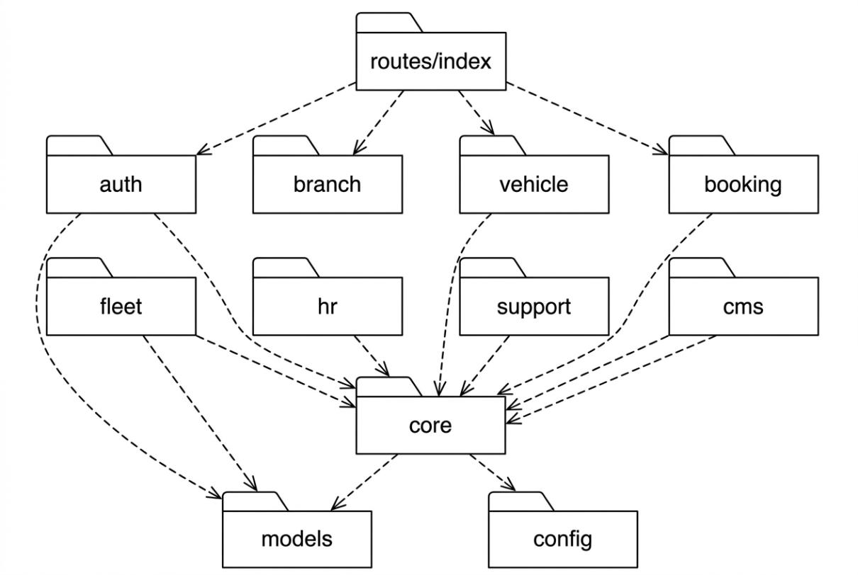
Figure 1.1: MOTORENT Modular Monolith Package Diagram
a. Package Descriptions
No | Package | Description
01 | routes/index | Central route aggregator. Imports all module routers and mounts them under /api prefix with appropriate middleware chains.
02 | auth | Authentication & eKYC module: register, login (email + Google OAuth), email verification, forgot/reset password, upload identity documents (CCCD, driving license).
03 | branch | Branch management module: CRUD operations, GPS-based nearest branch search, operating hours configuration, manager assignment.
04 | vehicle | Vehicle & category management module: fleet CRUD, multi-filter search, pricing (daily/hourly/seasonal), availability checking.
05 | booking | Central booking workflow module: create order, VNPay deposit (30%), counter payment (70%), Check-in/Check-out, cancel, refund, extend rental period.
06 | fleet | Fleet operations module: inter-branch vehicle transfers (VehicleTransfer), maintenance logging (MaintenanceLog), ODO-based service alerts.
07 | hr | Human resources module: staff shift scheduling (StaffSchedule), clock-in/clock-out attendance tracking, shift assignment by branch manager.
08 | support | Customer support module: 1-to-1 feedback/reviews (Feedback), complaints with resolution tracking (Complaint), SMS/email booking reminders (BookingReminder).
09 | cms | Content management module: banner slider CRUD, static page editor (FAQ, Terms, Privacy), Socket.IO live chat (Conversation + Message).
10 | core | Cross-cutting middleware layer: authMiddleware (JWT), rbacMiddleware (4-role RBAC), auditMiddleware (action logging), uploadMiddleware (Multer), errorHandler (centralized error response).
11 | models | 18 Mongoose schema definitions with validation rules, virtual fields, and pre-save hooks. Each model maps to one MongoDB collection.
12 | config | Environment configuration: MongoDB connection (database), VNPay payment gateway (vnpay), Nodemailer email transport (mailer), JWT secrets.
b. Package & Class Naming Conventions
Element | Convention | Example
Model file | PascalCase.ts | Booking.ts, VehicleTransfer.ts
Controller file | camelCase + Controller.ts | bookingController.ts, branchController.ts
Service file | camelCase + Service.ts | bookingService.ts, vnpayService.ts
Route file | camelCase + Routes.ts | bookingRoutes.ts, vehicleRoutes.ts
Middleware file | camelCase + Middleware.ts | authMiddleware.ts, rbacMiddleware.ts
Collection name | lowercase plural (auto by Mongoose) | bookings, vehicletransfers
API endpoint | kebab-case with /api prefix | /api/bookings, /api/vehicle-transfers
Environment var | SCREAMING_SNAKE_CASE | MONGODB_URI, JWT_SECRET, VNP_HASHSECRET

2. Database Design

a. Database Schema
The system uses MongoDB with Mongoose ODM, consisting of 18 core collections organized into 8 domain relationship groups (33 Foreign Key relationships: 31 Many-to-One and 2 One-to-One).
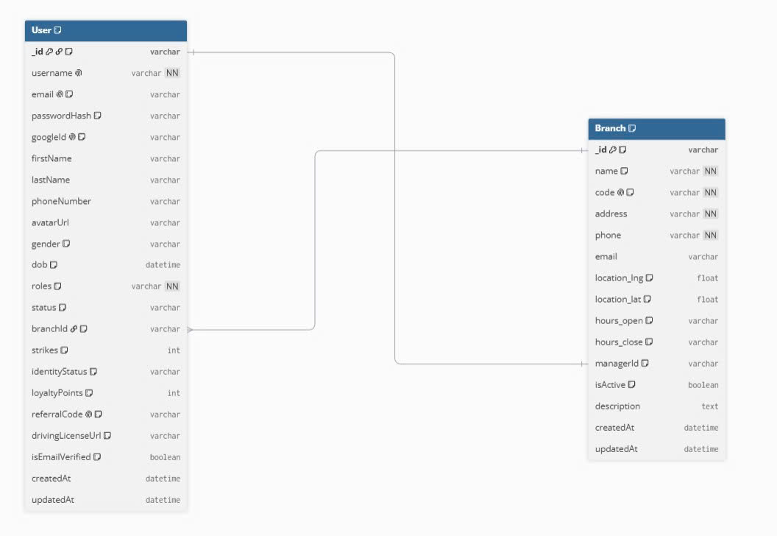
Figure 1.2 - Group 1: Users & Branches (User, Branch)
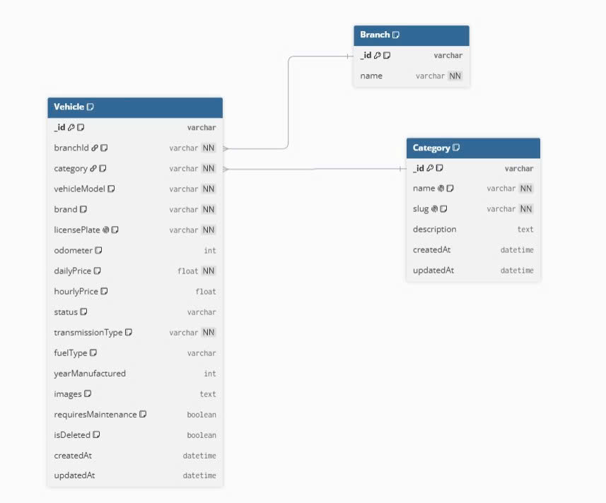
Figure 1.2 - Group 2: Fleet & Categories (Vehicle, Category)
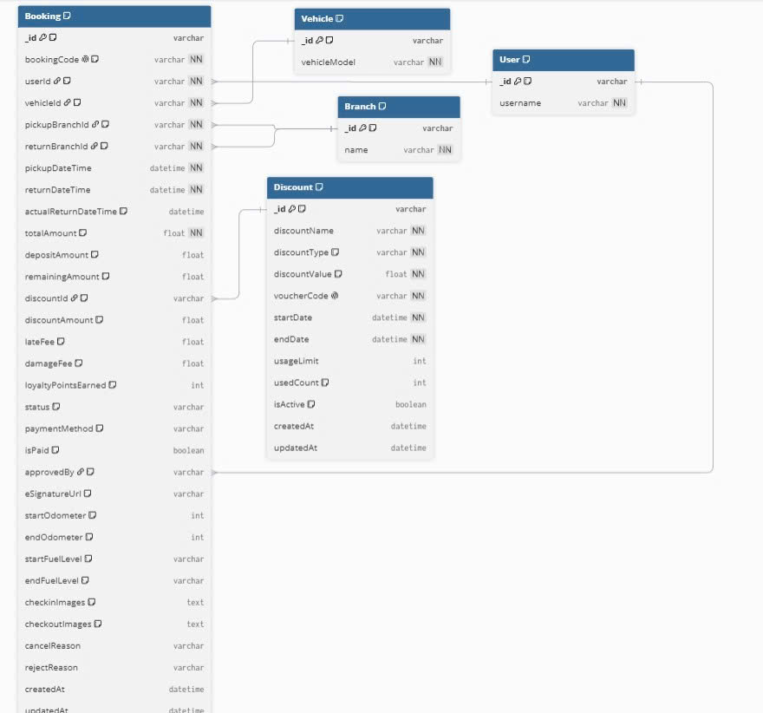
Figure 1.2 - Group 3: Booking & Payment (Booking, Discount, BookingReminder)
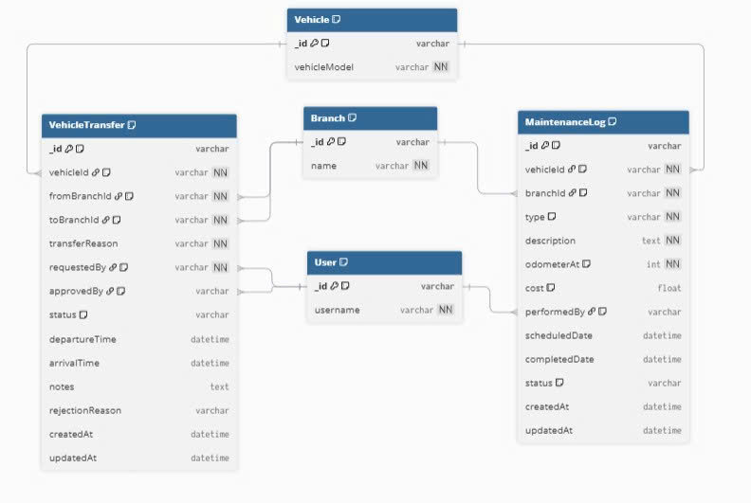
Figure 1.2 - Group 4: Relocation & Maintenance (VehicleTransfer, MaintenanceLog)
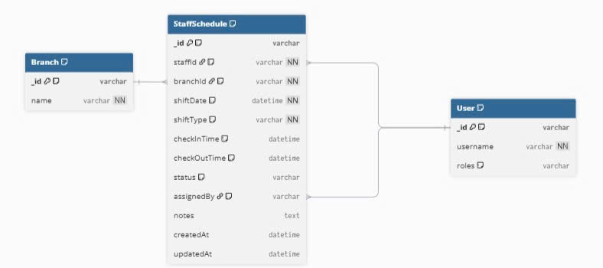
Figure 1.2 - Group 5: Staffing & Shifts (StaffSchedule)
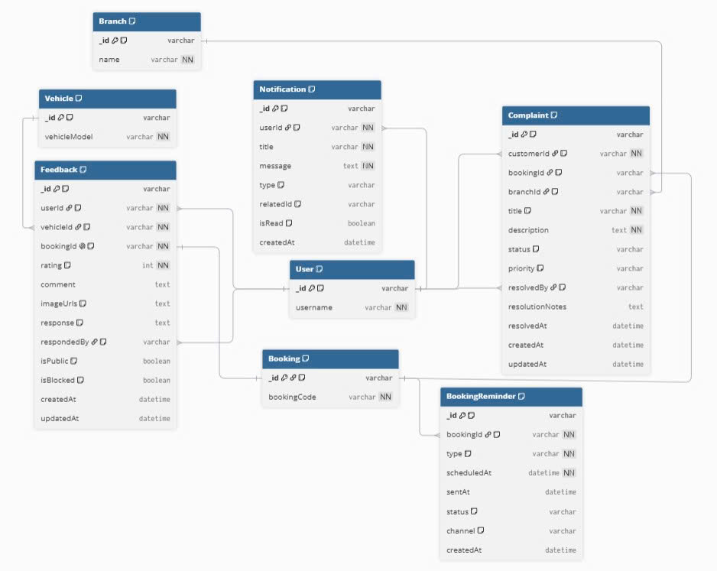
Figure 1.2 - Group 6: Reviews, Complaints & Notifications (Feedback, Complaint, Notification)
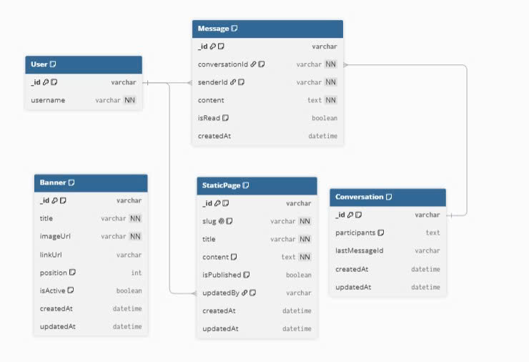
Figure 1.2 - Group 7: CMS & Live Chat (Banner, StaticPage, Conversation, Message)
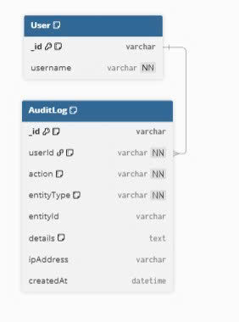
Figure 1.2 - Group 8: Security Audit Trail (AuditLog)

b. Table Description
No | Table | Description
01 | Branch | Branch offices across the chain. PK: _id. FK: managerId -> User (1:1). Stores name, unique code, address, phone, email, GPS latitude/longitude, openingHours, and isActive.
02 | User | System users across 4 RBAC roles (SystemAdmin, BranchManager, Staff, Customer). PK: _id. FK: branchId -> Branch. Stores credentials (passwordHash), profile fields, eKYC documents (CCCD/GPLX), identityStatus, loyaltyPoints, and lockout counters.
03 | Category | Vehicle type classifications (Scooter, Manual, Semi-Auto, Electric). PK: _id. Stores name, slug, description, iconSvg, and isActive.
04 | Vehicle | Fleet motorbikes. PK: _id. FK: branchId -> Branch, category -> Category. Stores brand, vehicleModel, unique licensePlate (BR-13), dailyPrice, hourlyPrice, odometer, maintenanceODOThreshold, 4-angle images, status (Available/Rented/Maintenance), and isDeleted.
05 | Booking | Central rental orders. PK: _id. FK: userId -> User, vehicleId -> Vehicle, pickupBranchId -> Branch, returnBranchId -> Branch, discountId -> Discount, approvedBy -> User. Stores bookingCode (MV-XXXXXX), dates, totalAmount, depositAmount (30%), remainingAmount (70%), 4-angle checkinImages/checkoutImages, ODO/fuel readings, lateFee, damageFee, and status state machine.
06 | VehicleTransfer | Inter-branch motorbike relocation requests (BR-16). PK: _id. FK: vehicleId -> Vehicle, fromBranchId -> Branch, toBranchId -> Branch, requestedBy -> User, approvedBy -> User. Stores reason, transferDate, and status.
07 | MaintenanceLog | Vehicle maintenance and repair tickets (BR-15). PK: _id. FK: vehicleId -> Vehicle, branchId -> Branch, performedBy -> User. Stores description, cost, odometerAtService, serviceDate, and status.
08 | Complaint | Customer service complaints (includes ComplaintResponse & ComplaintStatusLog). PK: _id. FK: customerId -> User, bookingId -> Booking, branchId -> Branch, resolvedBy -> User.
09 | AuditLog | Immutable security and CRUD audit trail (BR-FR06). PK: _id. FK: userId -> User. Stores action, entity, entityId, details (JSON diff), ipAddress, and timestamp.
10 | StaffSchedule | Staff work shift schedules and attendance logs. PK: _id. FK: staffId -> User, branchId -> Branch, assignedBy -> User. Stores date, shiftType, checkInTime, checkOutTime, and attendanceStatus.
11 | Discount | Promotional discount codes and loyalty vouchers. PK: _id. Stores code, discountPercent, discountAmount, maxDiscountAmount, minOrderValue, startDate, endDate, usageLimit, usedCount, and isActive.
12 | Feedback | Verified customer reviews (1:1 with completed Booking). PK: _id. FK: userId -> User, vehicleId -> Vehicle, bookingId -> Booking (unique), respondedBy -> User. Stores 1-5 rating, comment, and photos.
13 | Notification | In-app user notifications. PK: _id. FK: userId -> User. Stores title, body, type (SYSTEM/BOOKING/REMINDER/PROMO/MAINTENANCE/TRANSFER), isRead, and data.
14 | BookingReminder | Scheduled SMS/Email pickup & return reminders (24h and 2h prior). PK: _id. FK: bookingId -> Booking. Stores reminderType, scheduledAt, sentAt, and status.
15 | Banner | CMS homepage hero promotional banners. PK: _id. Stores title, subtitle, imageUrl, linkUrl, displayOrder, and isActive.
16 | StaticPage | CMS static informational & policy pages (FAQ, Terms, Privacy). PK: _id. FK: updatedBy -> User. Stores title, unique slug, sanitized HTML content, type, and isPublished.
17 | Conversation | Real-time Socket.IO support chat sessions. PK: _id. FK: customerId -> User, branchId -> Branch, assignedStaffId -> User. Stores lastMessage, lastMessageAt, and status.
18 | Message | Individual real-time chat messages. PK: _id. FK: conversationId -> Conversation, senderId -> User. Stores content, attachments, isRead, and createdAt.

II. Code Designs

1. Browse & Search Feature (UC-01 .. UC-04)
Provides unauthenticated and authenticated users with public access to active branch locations (with interactive GPS coordinates and live available vehicle counts), multi-criteria motorbike catalog search and filtering, detailed motorbike specification and customer review inspection, and static rental policies (30% online deposit, 70% counter settlement, BR-06 cancellation rules).

a. Class Diagram
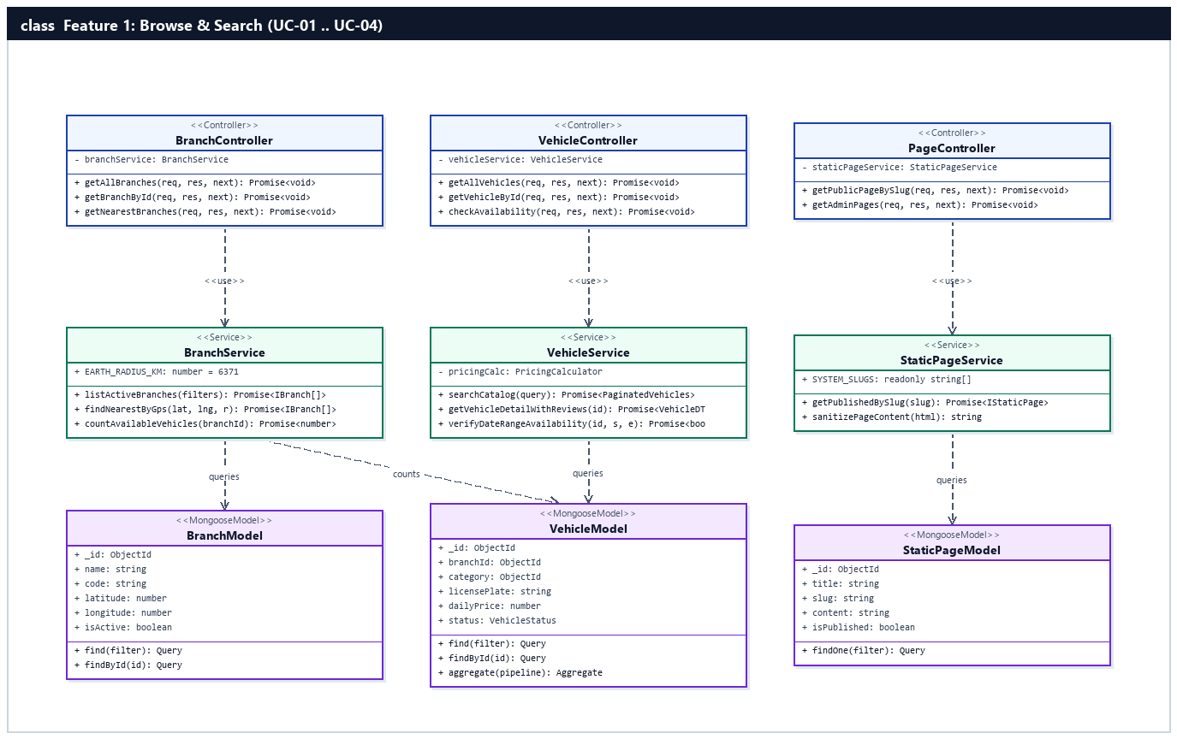
Figure 2.1.a: Class Diagram — Browse & Search Feature (UC-01 .. UC-04)

b. Class Specifications

BranchController Class
Express HTTP controller handling public and GPS-based branch discovery endpoints under /api/branches.
No | Method | Description
01 | getAllBranches(req, res, next) | Inputs: HTTP Request (query: isActive, search). Outputs: HTTP 200 JSON { success, data: BranchDTO[] }. Processing: Delegates to BranchService.listActiveBranches() to fetch active branches with aggregated available vehicle counts.
02 | getBranchById(req, res, next) | Inputs: req.params.id (ObjectId). Outputs: HTTP 200 JSON { success, data: BranchDTO } or 404 AppError. Processing: Validates ObjectId and retrieves branch details and manager info via BranchService.
03 | getNearestBranches(req, res, next) | Inputs: req.query.lat, req.query.lng, req.query.radiusKm. Outputs: HTTP 200 JSON sorted by distanceKm ASC. Processing: Parses coordinates and calls BranchService.findNearestByGps().

VehicleController Class
Express HTTP controller serving motorbike catalog search, filtering, sorting, and detailed specification views under /api/vehicles.
No | Method | Description
01 | getAllVehicles(req, res, next) | Inputs: req.query (keyword, branchId, category, minPrice, maxPrice, transmissionType, fuelType, status, sort, page, limit). Outputs: HTTP 200 JSON with paginated vehicle list. Processing: Invokes VehicleService.searchCatalog().
02 | getVehicleById(req, res, next) | Inputs: req.params.id (ObjectId). Outputs: HTTP 200 JSON { success, data: VehicleDetailDTO }. Processing: Calls VehicleService.getVehicleDetailWithReviews() to return specs, 4-angle images, pricing, and verified customer reviews.
03 | checkAvailability(req, res, next) | Inputs: req.params.id, req.query.pickupDateTime, req.query.returnDateTime. Outputs: HTTP 200 JSON { available: boolean }. Processing: Checks overlapping bookings via VehicleService.verifyDateRangeAvailability() (BR-02).

PageController Class
Express HTTP controller serving CMS static pages (Terms of Service, Rental Policy, Privacy Policy, FAQ) under /api/pages.
No | Method | Description
01 | getPublicPageBySlug(req, res, next) | Inputs: req.params.slug (string). Outputs: HTTP 200 JSON { success, data: StaticPageDTO } or 404. Processing: Normalizes slug and queries StaticPageService.getPublishedBySlug() omitting internal audit fields.

BranchService Class
Business logic service encapsulating branch directory queries, Haversine GPS distance calculation, and live fleet availability counts.
No | Method | Description
01 | listActiveBranches(filters) | Inputs: BranchFilterDTO. Outputs: Promise<BranchWithCountDTO[]>. Processing: Queries Branch.find({ isActive: true }) and joins Vehicle availability aggregation.
02 | findNearestByGps(lat, lng, radiusKm) | Inputs: latitude (number), longitude (number), radiusKm (number). Outputs: Promise<NearestBranchDTO[]>. Processing: Computes spherical Haversine distance in kilometers from user GPS to each active branch and filters within radiusKm.

VehicleService Class
Business logic service managing motorbike catalog queries, specification lookup, and review rating aggregation.
No | Method | Description
01 | searchCatalog(query) | Inputs: VehicleSearchQueryDTO. Outputs: Promise<PaginatedVehicleResult>. Processing: Constructs dynamic Mongoose filter on isDeleted=false, branchId, category, price range, and executes paginated query.
02 | getVehicleDetailWithReviews(vehicleId) | Inputs: vehicleId (string). Outputs: Promise<VehicleDetailDTO>. Processing: Fetches Vehicle populated with branchId and category, then queries Feedback collection for customer reviews and star distribution.

StaticPageService Class
Service managing retrieval and HTML sanitization of static policy and informational pages.
No | Method | Description
01 | getPublishedBySlug(slug) | Inputs: slug (string). Outputs: Promise<IStaticPage>. Processing: Queries StaticPage.findOne({ slug, isPublished: true }).select('-updatedBy -__v').

c. Sequence Diagram(s) — (1 Sequence Diagram per Use Case)

UC-01: Locate Branch Offices on Map
Guest or Customer explores active branch offices with address, hotline, operating hours, live available vehicle count, and interactive GPS map markers.
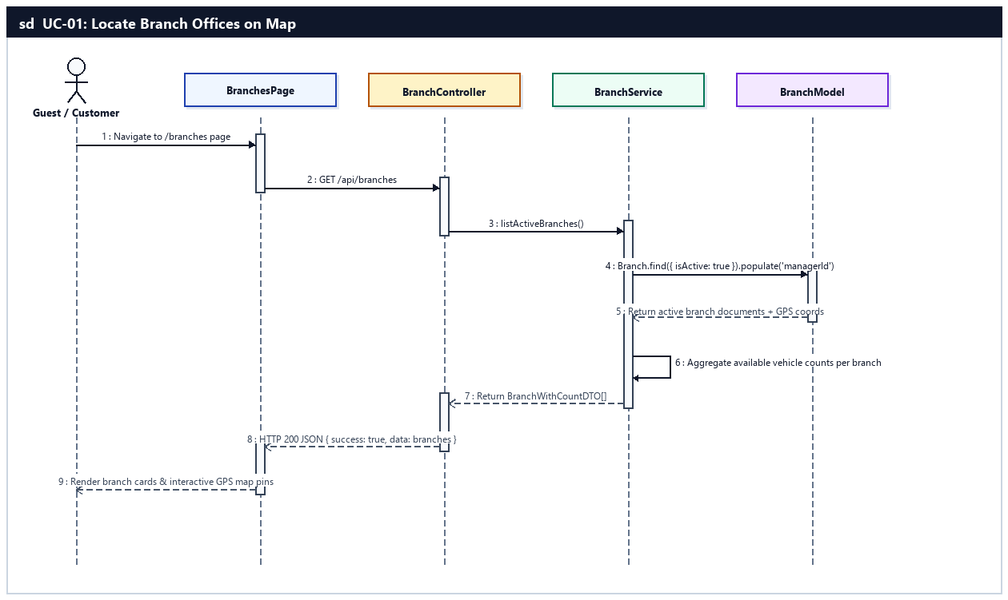
Sequence Diagram — UC-01: Locate Branch Offices on Map

UC-02: Search & Filter Motorbikes
Guest or Customer searches the motorbike fleet catalog by keyword, filters by branch, category (Scooter/Manual/Semi-Auto/Electric), price range, brand, or availability, and sorts by price or rating.
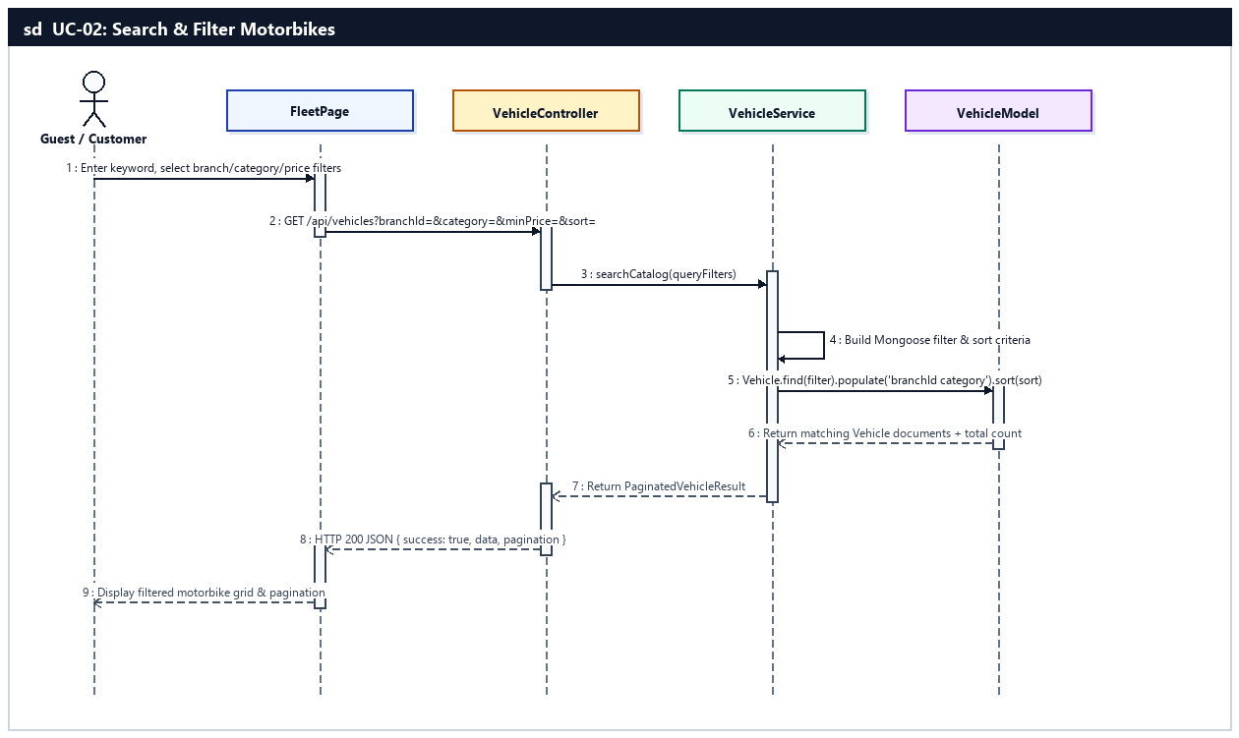
Sequence Diagram — UC-02: Search & Filter Motorbikes

UC-03: Inspect Vehicle Specs & Reviews
Guest or Customer examines detailed motorbike specifications, 4-angle photo gallery, daily/hourly pricing, availability status, and verified customer reviews/ratings.
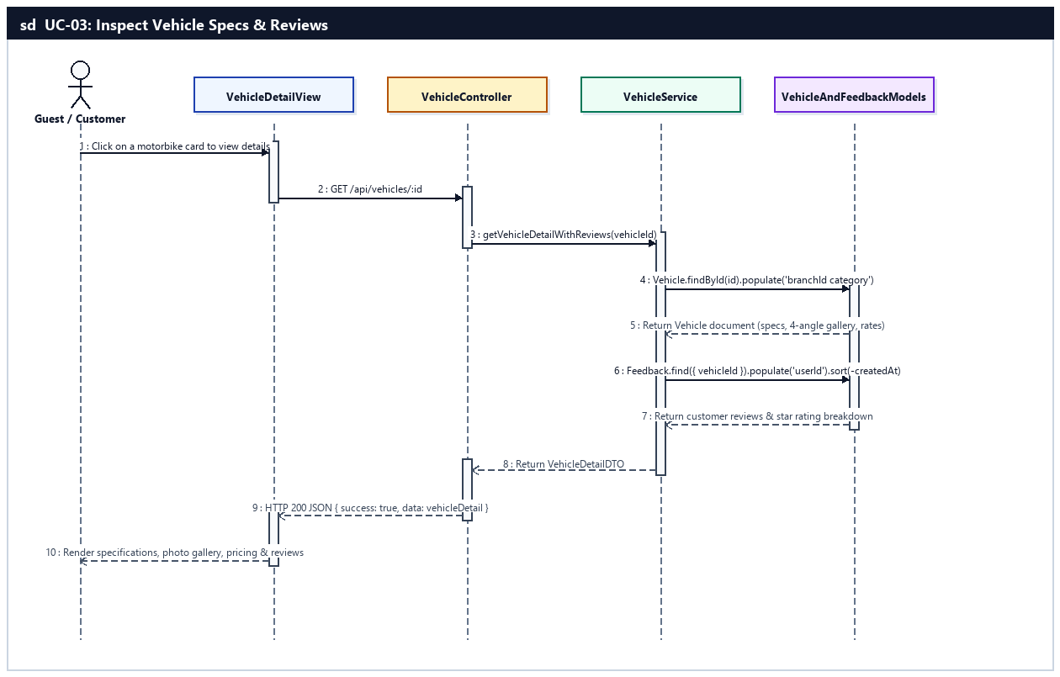
Sequence Diagram — UC-03: Inspect Vehicle Specs & Reviews

UC-04: Consult Rental Terms & Policies
Guest or Customer reads the rental terms, deposit rules (30% online via VNPay / 70% at counter), cancellation policy (BR-06), and insurance coverage.
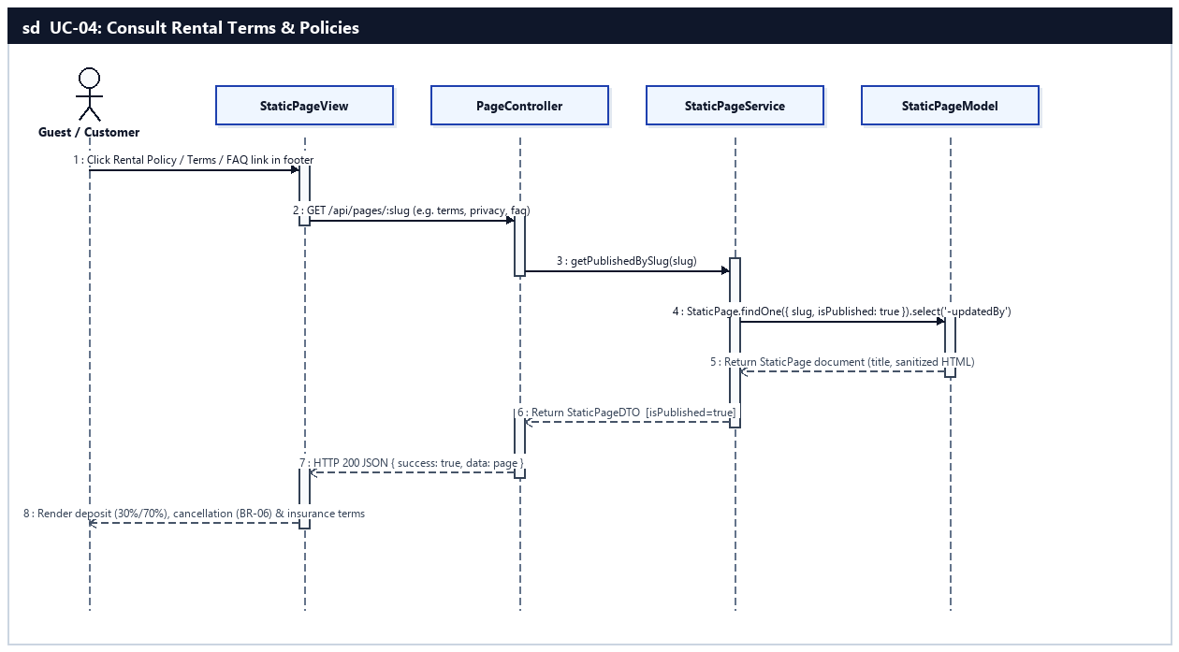
Sequence Diagram — UC-04: Consult Rental Terms & Policies

d. Database Queries
UC-01 — Locate Branch Offices on Map:
// 1. Retrieve all active branches with assigned manager info
const branches = await Branch.find({ isActive: true })
.populate('managerId', 'firstName lastName phoneNumber email')
.sort({ createdAt: 1 })
.lean();

// 2. Aggregate available vehicle counts grouped by branchId
const counts = await Vehicle.aggregate([
{ $match: { isDeleted: false, status: 'Available' } },
{ $group: { _id: '$branchId', availableCount: { $sum: 1 } } }
]);
UC-02 — Search & Filter Motorbikes:
// 1. Build dynamic catalog search query and fetch paginated vehicles
const filter = {
isDeleted: false,
...(branchId ? { branchId: new mongoose.Types.ObjectId(branchId) } : {}),
...(category ? { category: new mongoose.Types.ObjectId(category) } : {}),
...(status ? { status } : {}),
...(minPrice || maxPrice ? { dailyPrice: { ...(minPrice ? { $gte: Number(minPrice) } : {}), ...(maxPrice ? { $lte: Number(maxPrice) } : {}) } } : {}),
...(keyword ? { $or: [{ vehicleModel: new RegExp(keyword, 'i') }, { brand: new RegExp(keyword, 'i') }] } : {})
};
const [items, total] = await Promise.all([
Vehicle.find(filter).populate('branchId', 'name code address').populate('category', 'name slug').sort(sortSpec).skip(skip).limit(limit).lean(),
Vehicle.countDocuments(filter)
]);
UC-03 — Inspect Vehicle Specs & Reviews:
// 1. Fetch vehicle details populated with branch and category
const vehicle = await Vehicle.findOne({ _id: vehicleId, isDeleted: false })
.populate('branchId', 'name code address phone openingHours latitude longitude')
.populate('category', 'name slug description')
.lean();

// 2. Fetch verified customer reviews for this motorbike
const reviews = await Feedback.find({ vehicleId })
.populate('userId', 'firstName lastName username avatarUrl')
.sort({ createdAt: -1 })
.limit(20)
.lean();
UC-04 — Consult Rental Terms & Policies:
// 1. Fetch published static page by slug (terms, privacy, faq)
const page = await StaticPage.findOne({
slug: slug.trim().toLowerCase(),
isPublished: true
}).select('-updatedBy -__v').lean();

2. Authentication Feature (UC-05 .. UC-08)
Handles user identity registration with bcrypt password hashing (BR-FR01) and email verification token dispatch (BR-FR04), multi-strategy authentication (email/password + Google OAuth 2.0) with 6-attempt account lockout protection (BR-FR02) and 24-hour JWT issuance (BR-FR03), single-use password reset tokens (BR-FR08), and audited session logout (BR-FR06).

a. Class Diagram
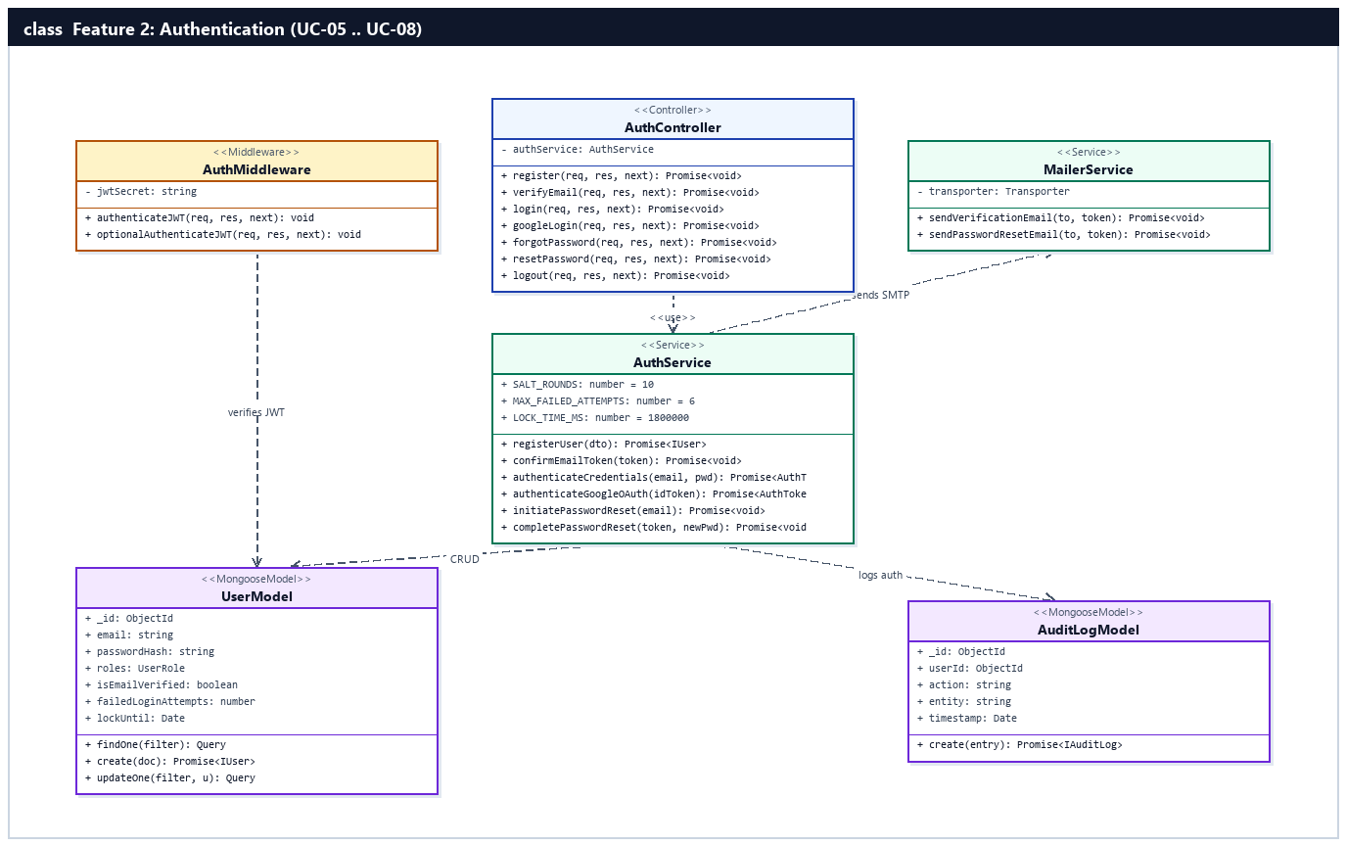
Figure 2.2.a: Class Diagram — Authentication Feature (UC-05 .. UC-08)

b. Class Specifications

AuthMiddleware Class
Core JWT verification middleware in server/src/core/authMiddleware.ts protecting authenticated routes.
No | Method | Description
01 | authenticateJWT(req, res, next) | Inputs: Authorization Bearer header. Outputs: Attaches req.user or throws 401 AppError. Processing: Verifies JWT token using env.JWT_SECRET (BR-FR03), checks User status in DB, and populates req.user.
02 | optionalAuthenticateJWT(req, res, next) | Inputs: Optional Authorization header. Outputs: Attaches req.user if valid, otherwise continues as Guest. Processing: Non-blocking JWT verification for hybrid public/authenticated endpoints.

AuthController Class
Express HTTP controller handling registration, email verification, login, Google OAuth, password recovery, and logout under /api/auth.
No | Method | Description
01 | register(req, res, next) | Inputs: req.body (username, email, password, firstName, lastName, phoneNumber). Outputs: HTTP 201 JSON. Processing: Validates payload and calls AuthService.registerUser().
02 | login(req, res, next) | Inputs: req.body (email, password). Outputs: HTTP 200 JSON { token, user }. Processing: Calls AuthService.authenticateCredentials() and returns signed 24h JWT.
03 | googleLogin(req, res, next) | Inputs: req.body.credential (Google ID Token). Outputs: HTTP 200 JSON { token, user }. Processing: Verifies Google OAuth 2.0 token via google-auth-library and issues JWT.
04 | forgotPassword(req, res, next) | Inputs: req.body.email. Outputs: HTTP 200 JSON. Processing: Generates single-use reset token and sends email via MailerService.
05 | resetPassword(req, res, next) | Inputs: req.body (token, newPassword). Outputs: HTTP 200 JSON. Processing: Validates reset token expiry, updates bcrypt hash, and invalidates token (BR-FR08).
06 | logout(req, res, next) | Inputs: AuthenticatedRequest. Outputs: HTTP 200 JSON. Processing: Records LOGOUT action in AuditLog and clears client session.

AuthService Class
Core authentication domain service implementing bcrypt hashing, account lockout counters, token generation, and audit logging.
No | Method | Description
01 | registerUser(dto) | Inputs: RegisterDTO. Outputs: Promise<IUser>. Processing: Checks email/username uniqueness, hashes password with bcrypt (10 salt rounds, BR-FR01), creates User with roles='Customer' and identityStatus='Unverified', and dispatches verification email (BR-FR04).
02 | authenticateCredentials(email, password) | Inputs: email, password. Outputs: Promise<{ token: string, user: UserDTO }>. Processing: Checks lockUntil (BR-FR02), compares bcrypt hash, increments failedLoginAttempts on mismatch (locks for 30m after 6 failures), or resets counter and signs 24h JWT (BR-FR03).
03 | initiatePasswordReset(email) | Inputs: email (string). Outputs: Promise<void>. Processing: Generates crypto random token, sets resetPasswordExpires (+1h), updates User, and sends reset link.
04 | completePasswordReset(token, newPassword) | Inputs: token, newPassword. Outputs: Promise<void>. Processing: Finds User with valid token, hashes newPassword with 10 salt rounds, unsets resetPasswordToken (BR-FR08), and writes AuditLog.

MailerService Class
Nodemailer SMTP transport wrapper in server/src/config/mailer.ts for transactional emails.
No | Method | Description
01 | sendVerificationEmail(to, token) | Inputs: recipient email, verification token. Outputs: Promise<void>. Processing: Sends HTML email containing 24-hour activation link.
02 | sendPasswordResetEmail(to, token) | Inputs: recipient email, reset token. Outputs: Promise<void>. Processing: Sends HTML email containing single-use password reset link.

c. Sequence Diagram(s) — (1 Sequence Diagram per Use Case)

UC-05: Register Account
Guest creates a new Customer account with username, email, phone, and password (or Google OAuth), and receives an email verification link (BR-FR01, BR-FR04).
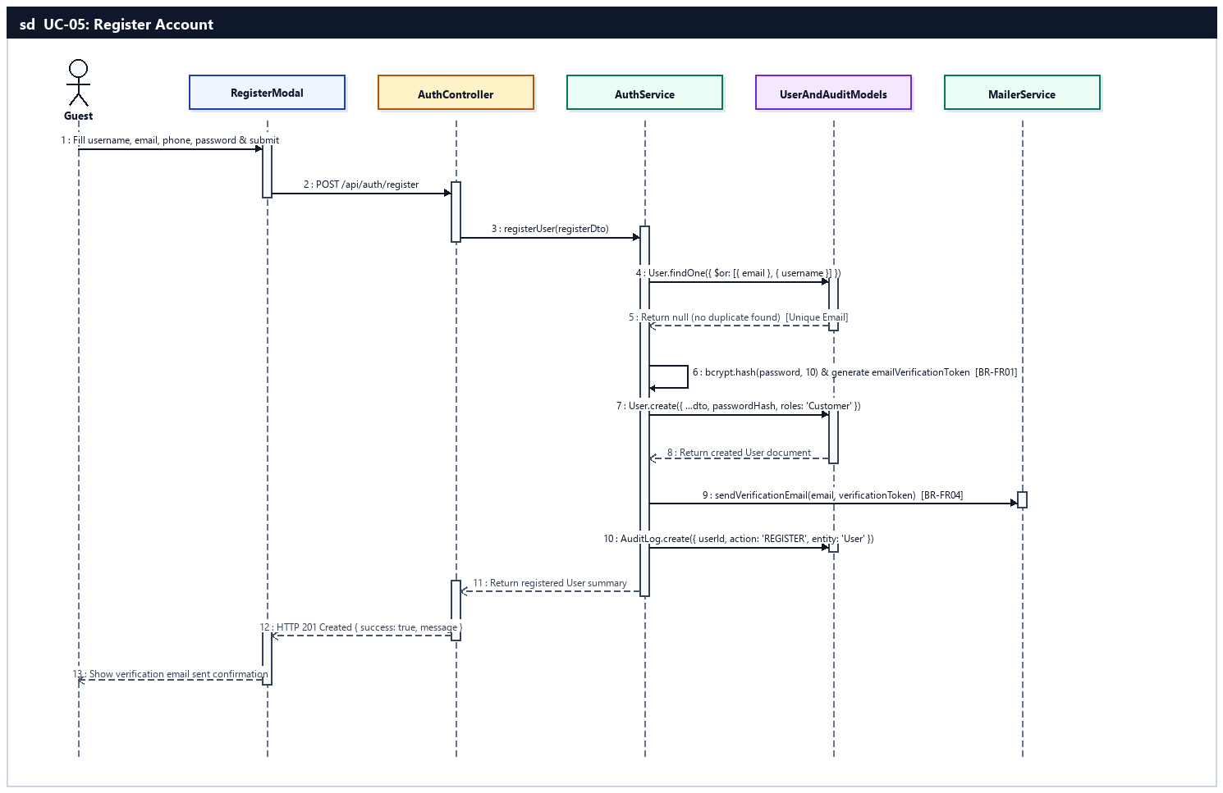
Sequence Diagram — UC-05: Register Account

UC-06: Login System
User authenticates using email/password credentials or Google OAuth 2.0 to receive a 24-hour JWT access token, subject to 6-attempt lockout policy (BR-FR01, BR-FR02, BR-FR03).
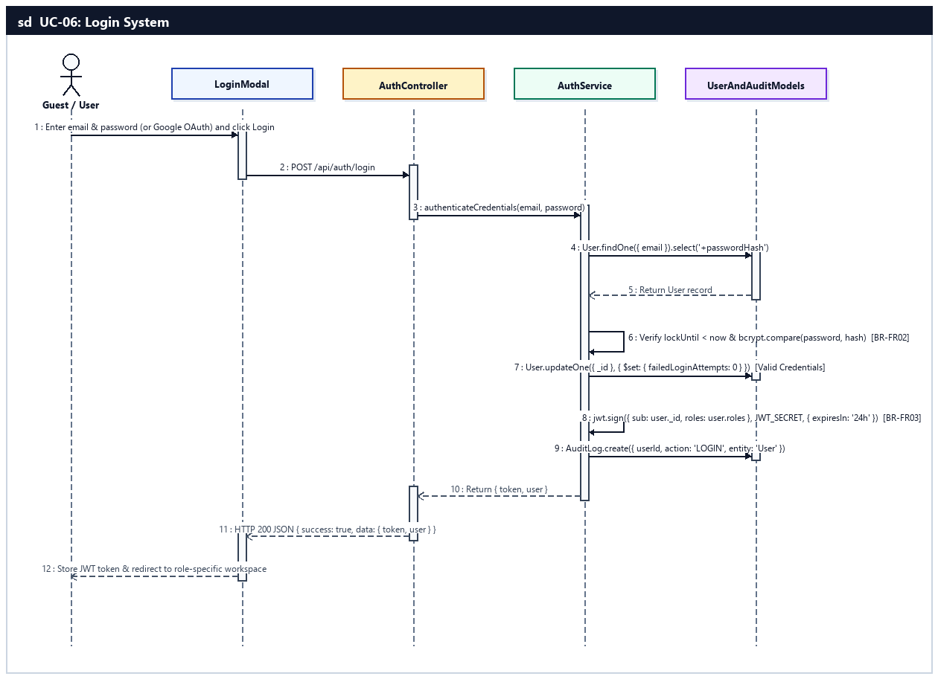
Sequence Diagram — UC-06: Login System

UC-07: Reset Forgotten Password
Guest requests a time-limited single-use password reset link sent to their registered email and sets a new bcrypt-hashed password (BR-FR01, BR-FR08).
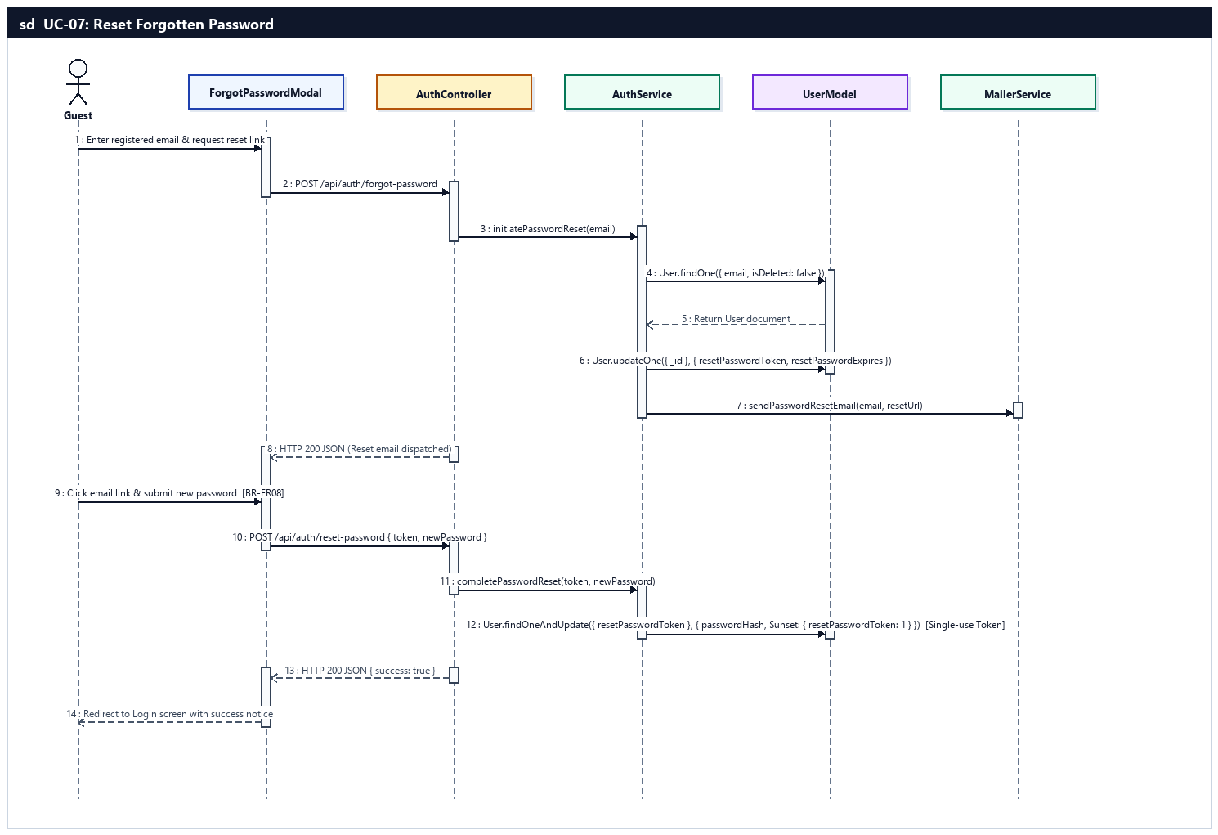
Sequence Diagram — UC-07: Reset Forgotten Password

UC-08: Logout System
Authenticated user (Customer, Staff, Branch Manager, System Admin) logs out, records an audit entry, and terminates the active client session.
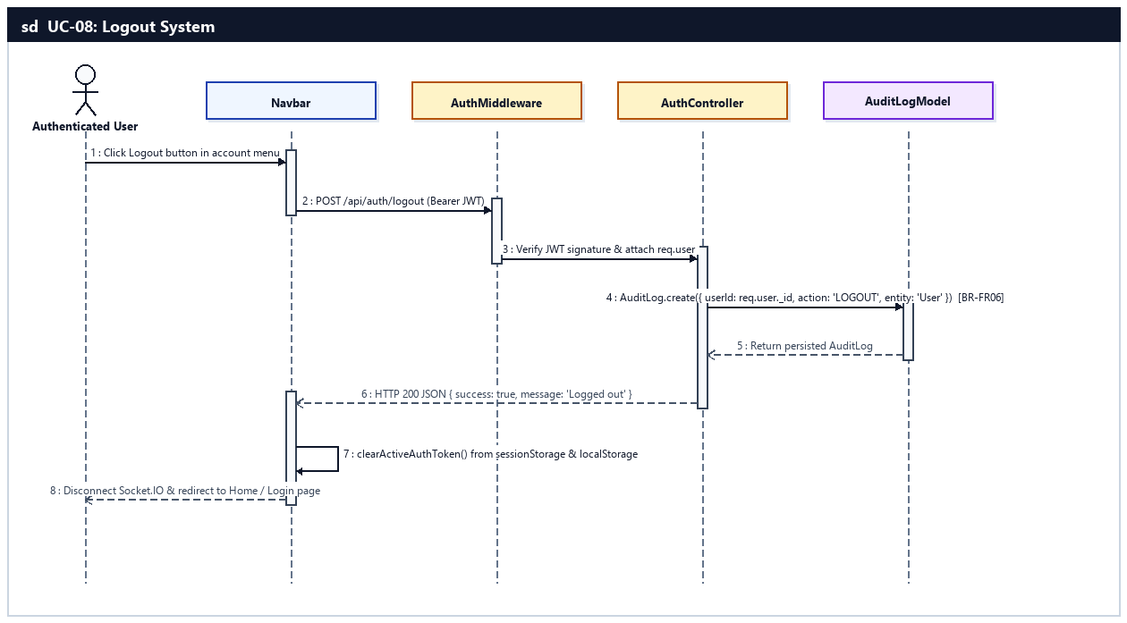
Sequence Diagram — UC-08: Logout System

d. Database Queries
UC-05 — Register Account:
// 1. Check duplicate email or username
const existingUser = await User.findOne({ $or: [{ email: email.toLowerCase() }, { username }] }).lean();

// 2. Hash password (10 salt rounds - BR-FR01) and create Customer account
const passwordHash = await bcrypt.hash(password, 10);
const newUser = await User.create({
username,
email: email.toLowerCase(),
firstName,
lastName,
phoneNumber,
passwordHash,
roles: 'Customer',
identityStatus: 'Unverified',
isEmailVerified: false,
emailVerificationToken,
emailVerificationExpires: new Date(Date.now() + 24 * 3600 * 1000)
});

// 3. Record registration audit trail (BR-FR06)
await AuditLog.create({ userId: newUser._id, action: 'REGISTER', entity: 'User', entityId: newUser._id.toString(), timestamp: new Date() });
UC-06 — Login System:
// 1. Lookup user by email including passwordHash
const user = await User.findOne({ email: email.toLowerCase(), isDeleted: false }).select('+passwordHash');

// 2. On failed password match: increment failedLoginAttempts & lock 30 mins if >= 6 (BR-FR02)
await User.updateOne(
{ _id: user._id },
{
$inc: { failedLoginAttempts: 1 },
...(user.failedLoginAttempts + 1 >= 6 ? { $set: { lockUntil: new Date(Date.now() + 30 * 60 * 1000) } } : {})
}
);

// 3. On successful login: reset lockout counters & log LOGIN audit event
await User.updateOne({ _id: user._id }, { $set: { failedLoginAttempts: 0, lastLoginAt: new Date() }, $unset: { lockUntil: 1 } });
await AuditLog.create({ userId: user._id, action: 'LOGIN', entity: 'User', entityId: user._id.toString(), timestamp: new Date() });
UC-07 — Reset Forgotten Password:
// 1. Store hashed reset token & expiration timestamp on User
await User.updateOne(
{ _id: user._id },
{ $set: { resetPasswordToken: tokenHash, resetPasswordExpires: new Date(Date.now() + 3600 * 1000) } }
);

// 2. Verify valid single-use reset token, update passwordHash & consume token (BR-FR08)
const user = await User.findOneAndUpdate(
{ resetPasswordToken: tokenHash, resetPasswordExpires: { $gt: new Date() } },
{ $set: { passwordHash: newBcryptHash, failedLoginAttempts: 0 }, $unset: { resetPasswordToken: 1, resetPasswordExpires: 1, lockUntil: 1 } },
{ new: true }
);
UC-08 — Logout System:
// 1. Record session logout in AuditLog (BR-FR06)
await AuditLog.create({
userId: req.user._id,
action: 'LOGOUT',
entity: 'User',
entityId: req.user._id.toString(),
ipAddress: req.ip,
timestamp: new Date()
});

3. Customer Profile & Account Feature (UC-09 .. UC-11)
Enables authenticated Customers to manage their personal profile and avatar image, upload CCCD/CMND and driving license photos for eKYC identity verification (BR-05, BR-FR07), and change their account password with current credential verification (BR-FR01).

a. Class Diagram
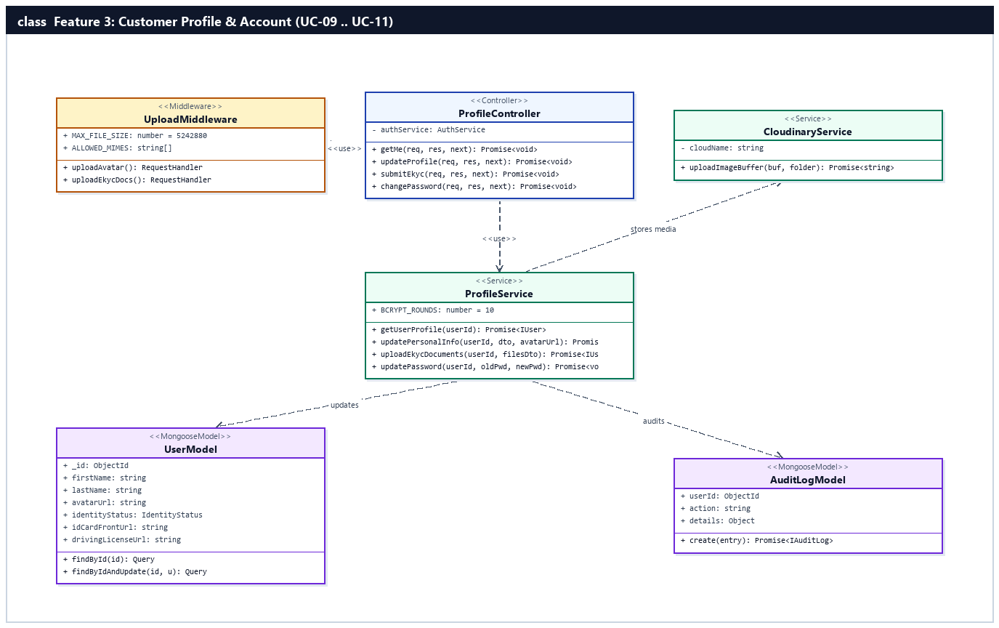
Figure 2.3.a: Class Diagram — Customer Profile & Account Feature (UC-09 .. UC-11)

b. Class Specifications

UploadMiddleware Class
Multer file upload middleware in server/src/core/uploadMiddleware.ts enforcing file format (JPEG, PNG, WebP) and 5MB size limits (BR-FR07).
No | Method | Description
01 | uploadAvatar() | Inputs: multipart/form-data field 'avatar'. Outputs: Validated file buffer/path on req.file. Processing: Rejects non-image MIME types or files > 5MB (BR-FR07).
02 | uploadEkycDocs() | Inputs: multipart/form-data fields (idCardFront, idCardBack, drivingLicense, selfie). Outputs: req.files map. Processing: Validates up to 4 identity document images.

ProfileController Class
Controller handling customer profile updates, eKYC document submission, and password changes under /api/auth.
No | Method | Description
01 | updateProfile(req, res, next) | Inputs: AuthenticatedRequest (firstName, lastName, phoneNumber, gender, dateOfBirth, address, avatar). Outputs: HTTP 200 JSON { data: user }. Processing: Calls ProfileService.updatePersonalInfo().
02 | submitEkyc(req, res, next) | Inputs: AuthenticatedRequest with eKYC images and idCardNumber. Outputs: HTTP 200 JSON { data: user }. Processing: Calls ProfileService.uploadEkycDocuments() and transitions identityStatus to 'Pending'.
03 | changePassword(req, res, next) | Inputs: req.body (currentPassword, newPassword). Outputs: HTTP 200 JSON. Processing: Verifies old password and updates hash via ProfileService.updatePassword().

ProfileService Class
Service logic for customer profile maintenance, eKYC state transitions, and credential updates.
No | Method | Description
01 | updatePersonalInfo(userId, dto, avatarUrl) | Inputs: userId, ProfileUpdateDTO, avatarUrl. Outputs: Promise<IUser>. Processing: Updates allowed profile fields on User document and logs audit trail.
02 | uploadEkycDocuments(userId, filesDto) | Inputs: userId, EkycSubmissionDTO. Outputs: Promise<IUser>. Processing: Stores Cloudinary/local URLs for CCCD front/back, driving license, and selfie; sets identityStatus='Pending' and ekycConsentAgreed=true.
03 | updatePassword(userId, oldPwd, newPwd) | Inputs: userId, oldPwd, newPwd. Outputs: Promise<void>. Processing: Verifies oldPwd against User.passwordHash, hashes newPwd (10 rounds), updates User, and writes AuditLog.

c. Sequence Diagram(s) — (1 Sequence Diagram per Use Case)

UC-09: Update Personal Profile & Avatar
Customer edits personal information (first/last name, phone, gender, date of birth, address), uploads an avatar photo (<= 5MB), and checks loyalty points balance.
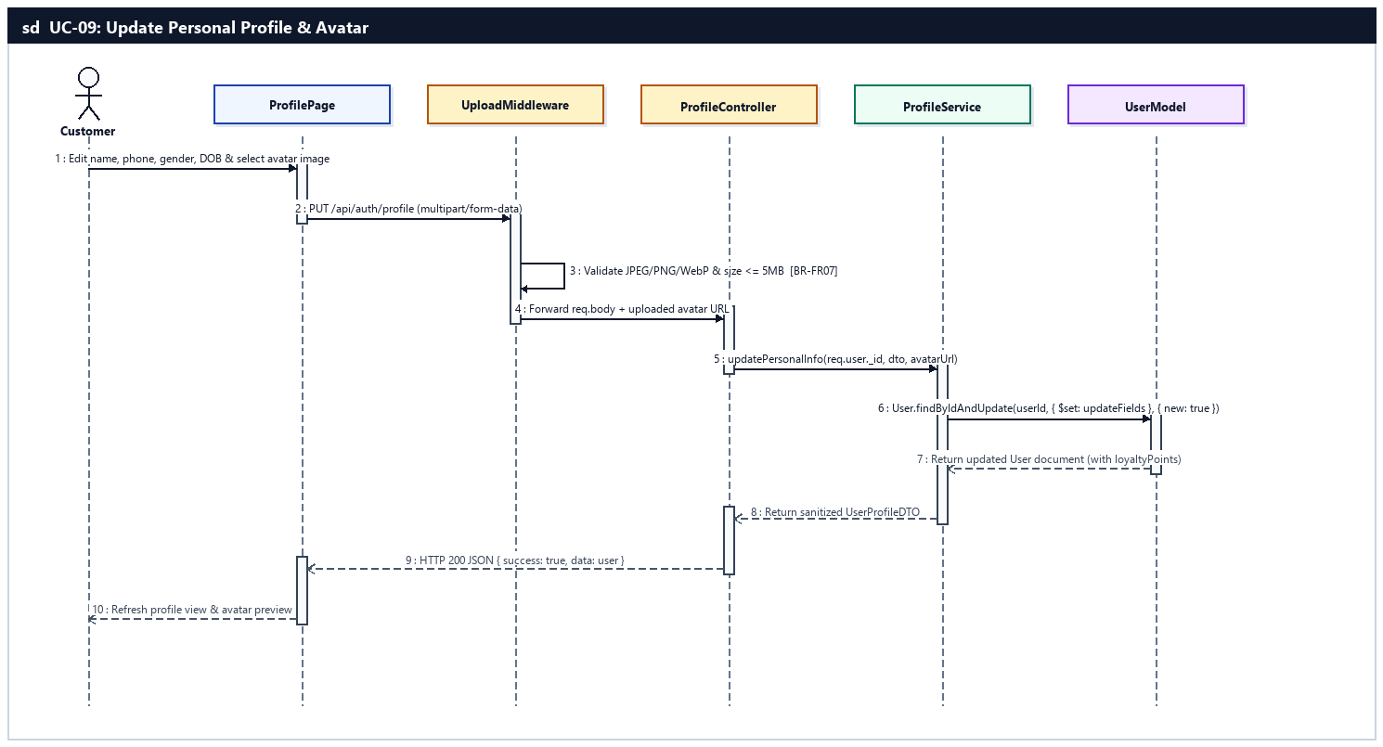
Sequence Diagram — UC-09: Update Personal Profile & Avatar

UC-10: Submit Identity Verification (eKYC)
Customer uploads front/back photos of CCCD/CMND, driving license, and selfie for eKYC identity verification required before motorbike handover/booking (BR-05, BR-FR07).
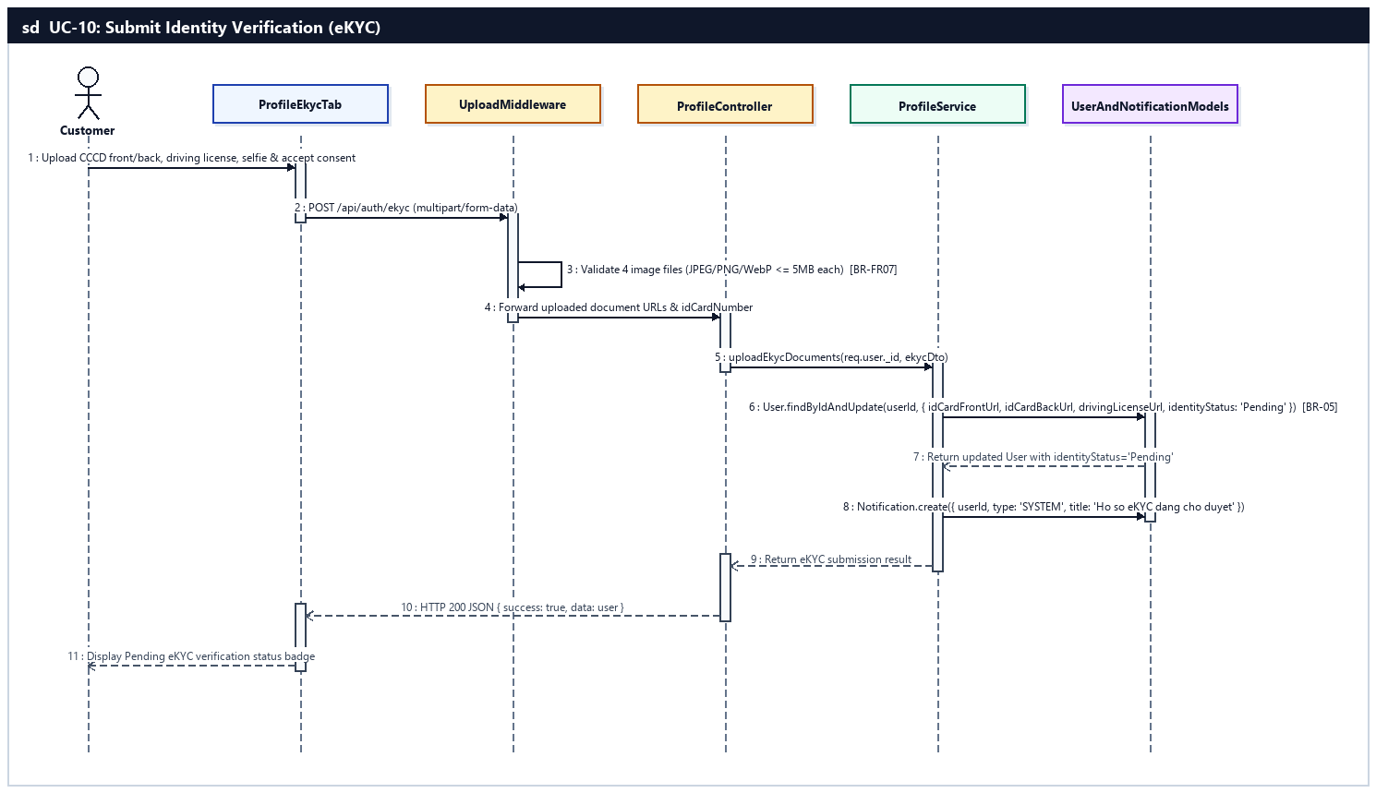
Sequence Diagram — UC-10: Submit Identity Verification (eKYC)

UC-11: Change Account Password
Customer updates their current account password after verifying existing credentials (BR-FR01, BR-FR06).
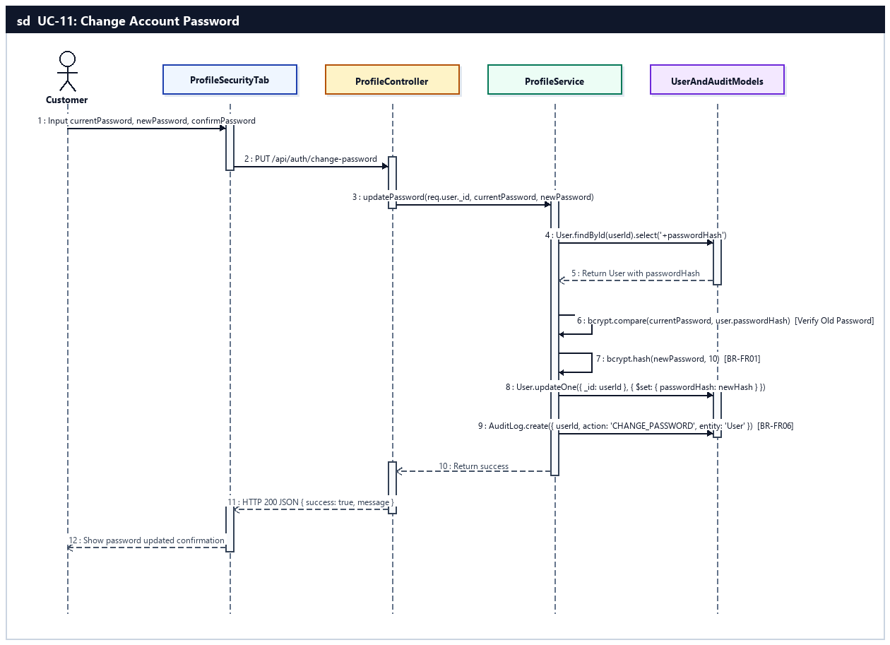
Sequence Diagram — UC-11: Change Account Password

d. Database Queries
UC-09 — Update Personal Profile & Avatar:
// 1. Update personal profile fields and avatarUrl
const updatedUser = await User.findByIdAndUpdate(
req.user._id,
{ $set: { firstName, lastName, phoneNumber, gender, dateOfBirth, address, ...(avatarUrl ? { avatarUrl } : {}) } },
{ new: true, runValidators: true }
).select('-passwordHash');
UC-10 — Submit Identity Verification (eKYC):
// 1. Save eKYC document URLs and transition identityStatus to 'Pending'
const user = await User.findByIdAndUpdate(
req.user._id,
{
$set: {
idCardNumber,
idCardFrontUrl,
idCardBackUrl,
drivingLicenseUrl,
selfieUrl,
ekycConsentAgreed: true,
ekycConsentDate: new Date(),
identityStatus: 'Pending'
}
},
{ new: true }
);

// 2. Create notification for customer & audit log entry
await Notification.create({ userId: req.user._id, type: 'SYSTEM', title: 'Hồ sơ eKYC đang chờ duyệt', body: 'Hệ thống đã tiếp nhận ảnh CCCD và GPLX của bạn.' });
await AuditLog.create({ userId: req.user._id, action: 'SUBMIT_EKYC', entity: 'User', entityId: req.user._id.toString(), timestamp: new Date() });
UC-11 — Change Account Password:
// 1. Fetch current passwordHash for verification
const user = await User.findById(req.user._id).select('+passwordHash');
const isMatch = await bcrypt.compare(currentPassword, user.passwordHash);

// 2. Hash new password with 10 salt rounds and update User
const newPasswordHash = await bcrypt.hash(newPassword, 10);
await User.updateOne({ _id: req.user._id }, { $set: { passwordHash: newPasswordHash } });
await AuditLog.create({ userId: req.user._id, action: 'CHANGE_PASSWORD', entity: 'User', entityId: req.user._id.toString(), timestamp: new Date() });

4. Booking & Payment Feature (UC-12 .. UC-19)
Implements the core rental workflow: favorite motorbike bookmarking (Wishlist), GPS-based nearest branch search, rental order creation with overlapping date prevention (BR-02), minimum 24h duration (BR-03), MV-XXXXXX booking code generation (BR-04), one-way surcharge (BR-07), 30% online deposit payment via VNPay (BR-01), order cancellation with 24h refund rules (BR-06), active rental extension, real-time Socket.IO status tracking, and PDFKit invoice generation.

a. Class Diagram
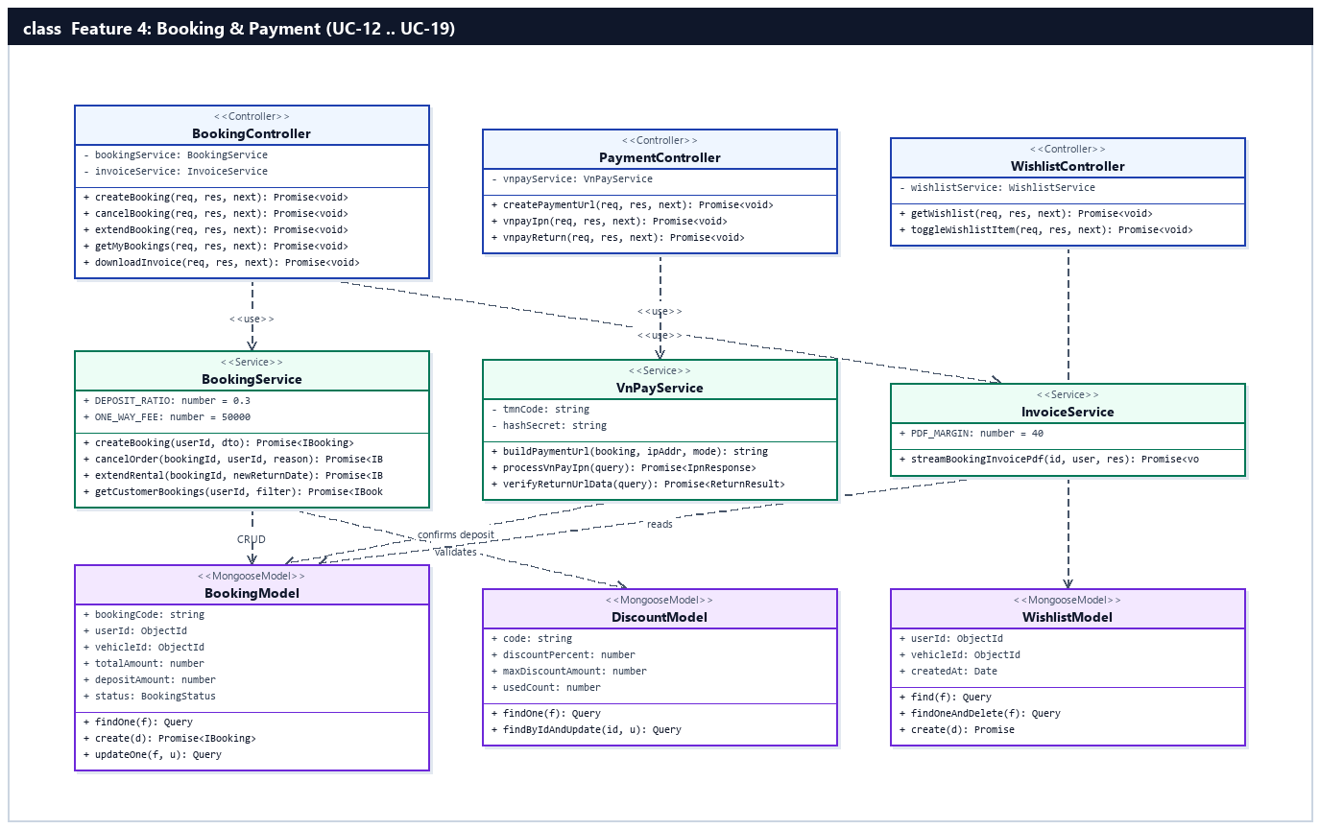
Figure 2.4.a: Class Diagram — Booking & Payment Feature (UC-12 .. UC-19)

b. Class Specifications

BookingController Class
Express HTTP controller managing rental order creation, cancellation, extension, history tracking, and PDF invoice streaming under /api/bookings.
No | Method | Description
01 | createBooking(req, res, next) | Inputs: AuthenticatedRequest (vehicleId, pickupBranchId, returnBranchId, pickupDateTime, returnDateTime, discountCode, paymentMethod, eSignatureUrl). Outputs: HTTP 201 JSON { booking, paymentUrl }. Processing: Calls BookingService.createBooking().
02 | cancelBooking(req, res, next) | Inputs: req.params.id, req.body.cancelReason. Outputs: HTTP 200 JSON { data: booking }. Processing: Invokes BookingService.cancelOrder() applying BR-06 refund policy.
03 | extendBooking(req, res, next) | Inputs: req.params.id, req.body.newReturnDateTime. Outputs: HTTP 200 JSON { data: updatedBooking }. Processing: Validates non-overlapping extension window and updates returnDateTime and balance via BookingService.extendRental().
04 | getMyBookings(req, res, next) | Inputs: req.user._id, req.query.status. Outputs: HTTP 200 JSON { data: BookingTimelineDTO[] }. Processing: Fetches customer rental history with 4-angle check-in/out photos.
05 | downloadInvoice(req, res, next) | Inputs: req.params.id, req.user. Outputs: application/pdf binary stream. Processing: Calls InvoiceService.streamBookingInvoicePdf().

PaymentController Class
Controller handling VNPay payment URL creation, Server-to-Server IPN webhook verification, and browser return verification under /api/payments.
No | Method | Description
01 | createPaymentUrl(req, res, next) | Inputs: req.body (bookingId, paymentType: 'deposit' | 'full'). Outputs: HTTP 200 JSON { paymentUrl }. Processing: Calls VnPayService.buildPaymentUrl().
02 | vnpayIpn(req, res, next) | Inputs: req.query (vnp_TxnRef, vnp_Amount, vnp_ResponseCode, vnp_TransactionNo, vnp_SecureHash). Outputs: HTTP 200 JSON { RspCode, Message }. Processing: Verifies HMAC-SHA512 signature and updates Booking depositPaid=true, status='Confirmed' via VnPayService.processVnPayIpn().

WishlistController Class
Controller managing customer favorite motorbike bookmarks under /api/wishlist.
No | Method | Description
01 | getWishlist(req, res, next) | Inputs: req.user._id. Outputs: HTTP 200 JSON { items }. Processing: Retrieves populated Wishlist items for the customer.
02 | toggleWishlistItem(req, res, next) | Inputs: req.body.vehicleId. Outputs: HTTP 200 JSON { bookmarked: boolean }. Processing: Adds or removes vehicleId from customer's Wishlist.

BookingService Class
Central domain service enforcing all booking state machine transitions (BR-08), conflict detection (BR-02), pricing & promo calculations (BR-01, BR-07), and cancellation rules (BR-06).
No | Method | Description
01 | createBooking(userId, dto) | Inputs: userId, CreateBookingDTO. Outputs: Promise<IBooking>. Processing: Verifies eKYC status (BR-05), checks overlapping bookings (BR-02), validates Discount voucher, calculates totalAmount + 50,000 VND one-way fee (BR-07) + 30% depositAmount (BR-01), generates MV-XXXXXX code (BR-04), and saves Booking.
02 | cancelOrder(bookingId, userId, reason) | Inputs: bookingId, userId, reason. Outputs: Promise<IBooking>. Processing: Verifies status is before handover, computes refundAmount (>24h: 100%, <24h: 50% forfeited per BR-06), restores Discount usedCount, updates status to 'Cancelled', and emits Socket.IO update.
03 | extendRental(bookingId, userId, newReturnDate) | Inputs: bookingId, userId, newReturnDate. Outputs: Promise<IBooking>. Processing: Checks future booking conflicts on the same vehicleId, computes added rental days/amount, and increments totalAmount and remainingAmount.

VnPayService Class
Payment gateway integration service in server/src/modules/payment/vnpayService.ts implementing VNPay v2.1.0 HMAC-SHA512 signing and IPN reconciliation.
No | Method | Description
01 | buildPaymentUrl(booking, ipAddr, mode) | Inputs: IBooking, client IP, mode ('deposit' | 'full'). Outputs: Signed VNPay redirect URL string. Processing: Sorts vnp_* parameters alphabetically and signs query string with VNP_HASHSECRET using HMAC-SHA512.
02 | processVnPayIpn(queryParams) | Inputs: VNPay IPN query object. Outputs: Promise<{ RspCode: string, Message: string }>. Processing: Validates checksum, checks idempotency on Payment collection, updates Booking status='Confirmed', depositPaid=true, and records Payment transaction.

InvoiceService Class
PDF generation service in server/src/modules/booking/invoiceService.ts using PDFKit to render A4 electronic rental invoices.
No | Method | Description
01 | streamBookingInvoicePdf(bookingId, requestingUser, res) | Inputs: bookingId, requestingUser, Express Response. Outputs: Streams PDF document. Processing: Populates Booking with customer, vehicle, and branch data, verifies access permissions, and renders itemized table of rental charges, discounts, penalties, and deposit settlement.

c. Sequence Diagram(s) — (1 Sequence Diagram per Use Case)

UC-12: Bookmark Favorite Vehicles (Wishlist)
Customer saves motorbikes to their personal favorites wishlist or removes bookmarked vehicles.
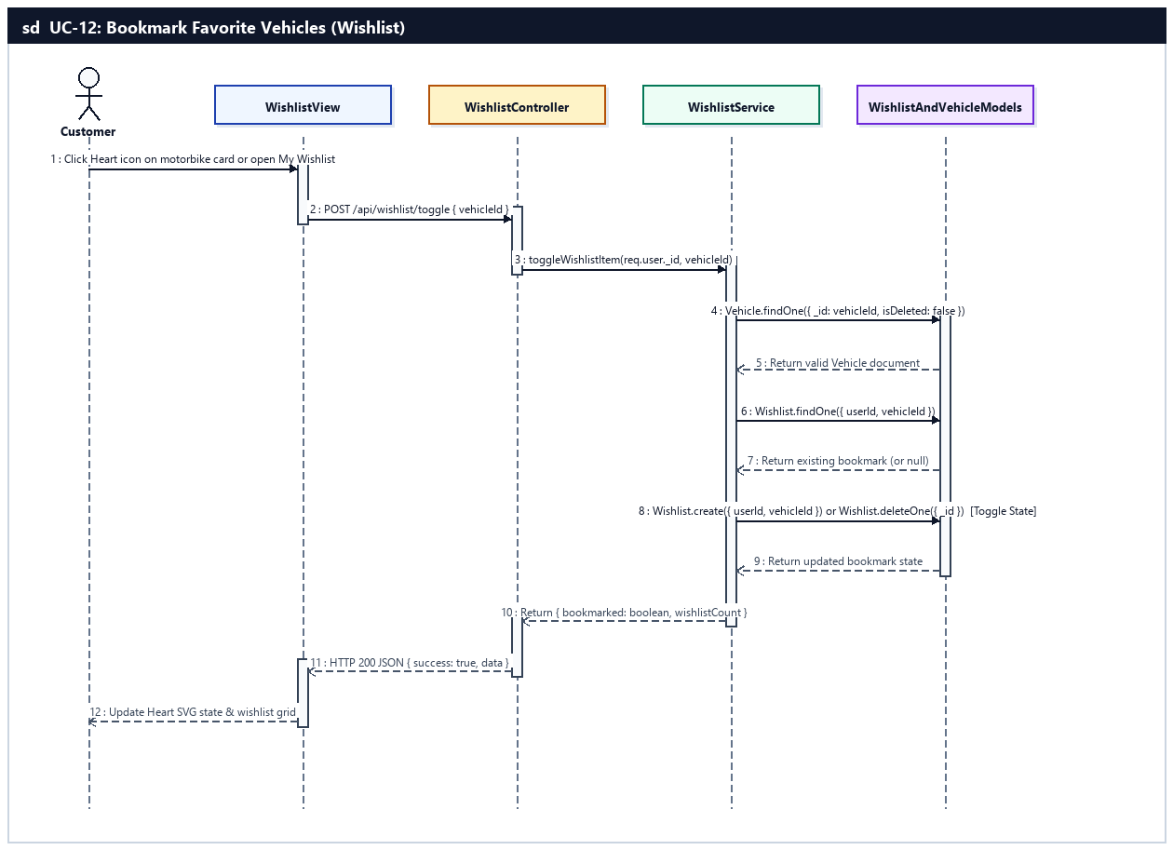
Sequence Diagram — UC-12: Bookmark Favorite Vehicles (Wishlist)

UC-13: Find Nearest Branches by GPS
Customer locates available motorbikes at branches nearest to their current GPS coordinates using spherical Haversine distance calculation.
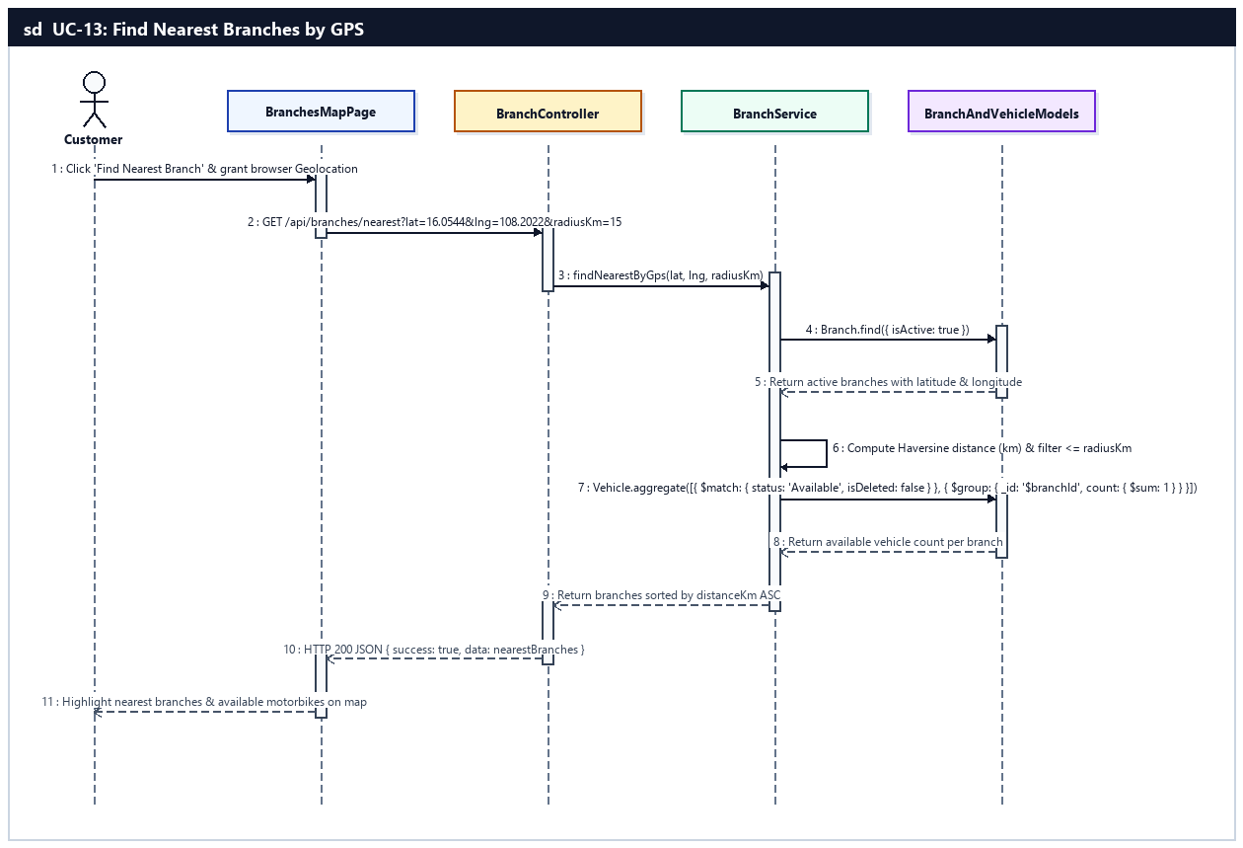
Sequence Diagram — UC-13: Find Nearest Branches by GPS

UC-14: Book a Rental
Customer creates a rental order by selecting vehicle, pickup/return branches (with 50,000 VND one-way surcharge per BR-07), rental dates (>= 24h per BR-03), optional promo code, and signing the e-contract (BR-01..BR-08).
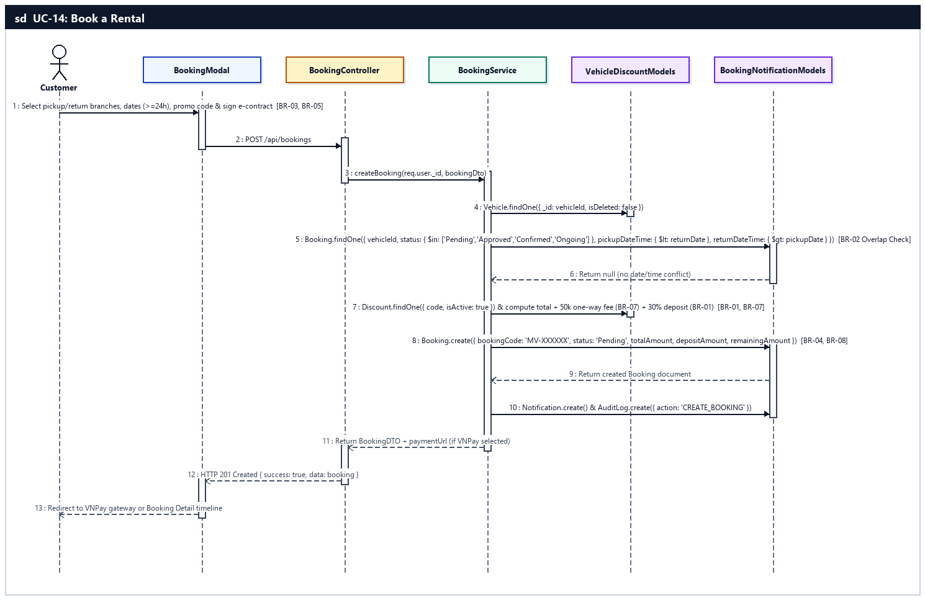
Sequence Diagram — UC-14: Book a Rental

UC-15: Pay Rental Deposit & Balance
Customer pays 30% deposit or 100% full amount online via VNPay/VietQR, or settles the remaining 70% at the branch counter during pickup (BR-01, BR-08).
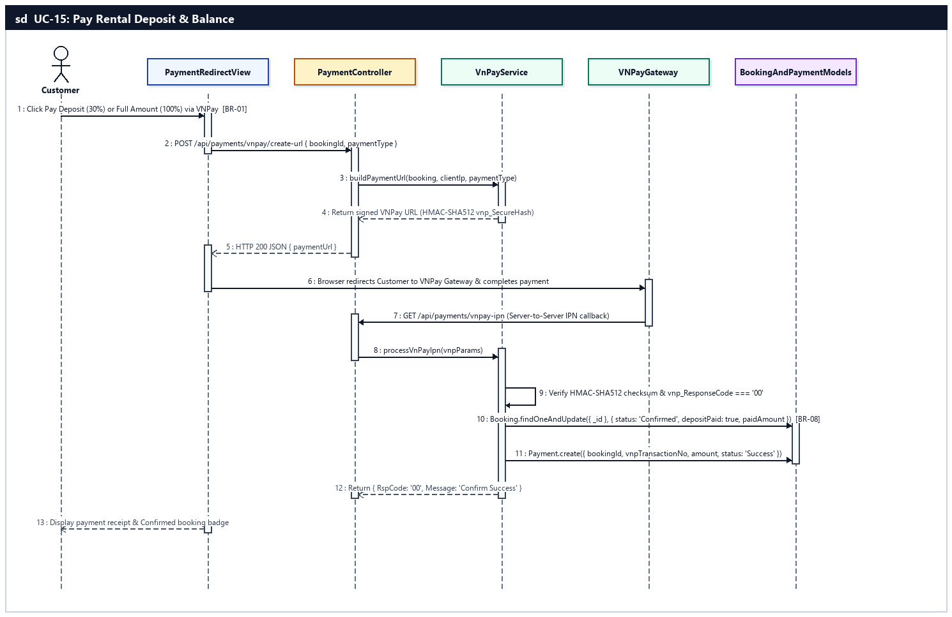
Sequence Diagram — UC-15: Pay Rental Deposit & Balance

UC-16: Cancel Rental Order
Customer cancels a pending/confirmed booking before handover with a reason and requests a deposit refund governed by BR-06 (>24h before pickup: 100% refund; <24h: 50% deposit forfeited).
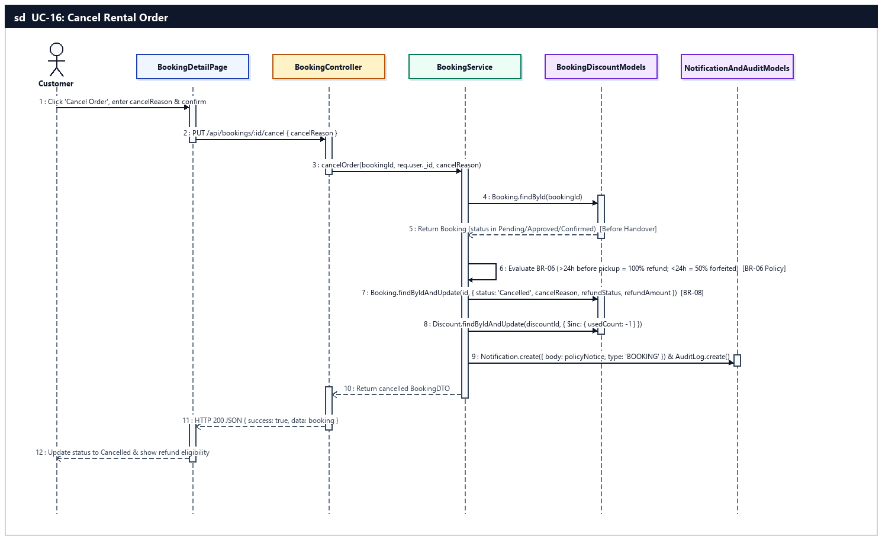
Sequence Diagram — UC-16: Cancel Rental Order

UC-17: Extend Rental Period
Customer requests to extend the scheduled return date/time of an active rental after verifying no overlapping future bookings exist on the same motorbike (BR-02).
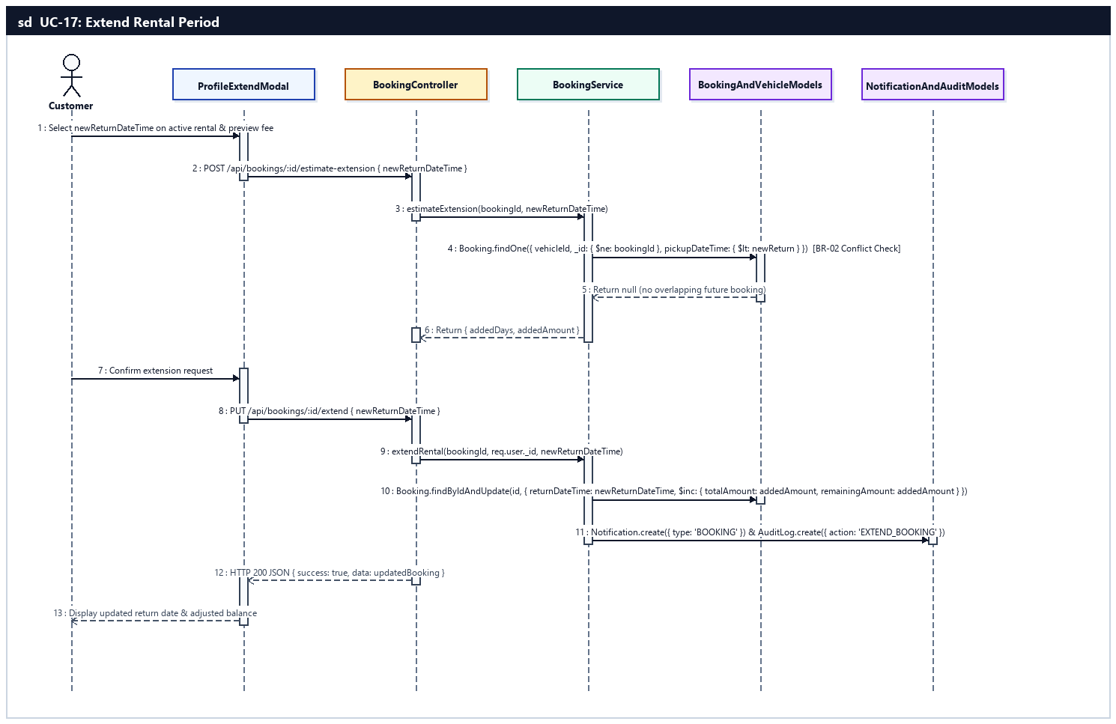
Sequence Diagram — UC-17: Extend Rental Period

UC-18: Track Rental Orders & History
Customer monitors real-time order status via Socket.IO, checks past rental history filtered by status tab, and inspects 4-angle check-in/check-out vehicle photos.
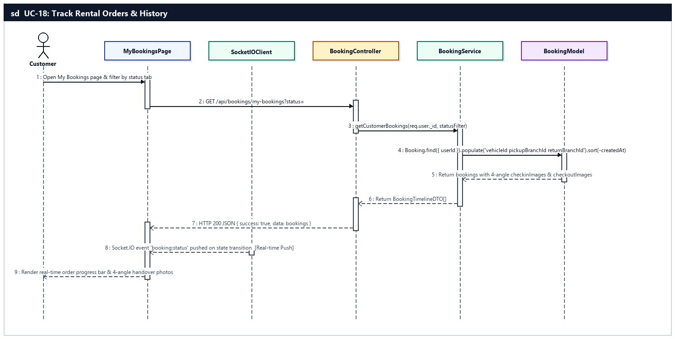
Sequence Diagram — UC-18: Track Rental Orders & History

UC-19: Download Invoice PDF
Customer generates and downloads a formatted A4 PDF invoice/receipt for a rental order.
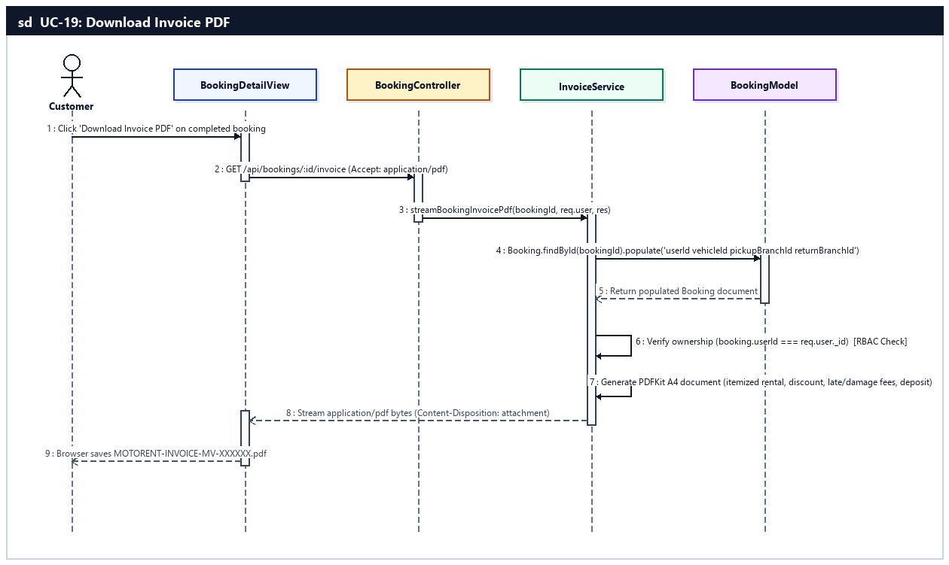
Sequence Diagram — UC-19: Download Invoice PDF

d. Database Queries
UC-12 — Bookmark Favorite Vehicles (Wishlist):
// 1. Check if vehicle is already bookmarked by customer
const existing = await Wishlist.findOne({ userId: req.user._id, vehicleId });

// 2. Toggle bookmark (remove if exists, create if not)
if (existing) {
await Wishlist.deleteOne({ _id: existing._id });
} else {
await Wishlist.create({ userId: req.user._id, vehicleId });
}

// 3. List customer's bookmarked motorbikes
const items = await Wishlist.find({ userId: req.user._id })
.populate({ path: 'vehicleId', populate: ['branchId', 'category'] })
.sort({ createdAt: -1 })
.lean();
UC-13 — Find Nearest Branches by GPS:
// 1. Fetch active branches with valid GPS coordinates
const branches = await Branch.find({
isActive: true,
latitude: { $ne: null },
longitude: { $ne: null }
}).lean();

// 2. Aggregate available vehicle counts per branch
const availableByBranch = await Vehicle.aggregate([
{ $match: { isDeleted: false, status: 'Available' } },
{ $group: { _id: '$branchId', availableVehicles: { $sum: 1 } } }
]);
UC-14 — Book a Rental:
// 1. Check overlapping active bookings for the selected vehicle (BR-02)
const overlappingBooking = await Booking.findOne({
vehicleId,
status: { $in: ['Pending', 'Approved', 'Confirmed', 'Ongoing'] },
pickupDateTime: { $lt: new Date(returnDateTime) },
returnDateTime: { $gt: new Date(pickupDateTime) }
}).lean();

// 2. Validate and atomically increment discount code usage
const discount = await Discount.findOneAndUpdate(
{
code: discountCode.toUpperCase(),
isActive: true,
startDate: { $lte: now },
endDate: { $gte: now },
$expr: { $lt: ['$usedCount', '$usageLimit'] }
},
{ $inc: { usedCount: 1 } },
{ new: true }
);

// 3. Create Booking record with generated MV-XXXXXX code (BR-04) and 30% deposit (BR-01)
const booking = await Booking.create({
bookingCode,
userId: req.user._id,
vehicleId,
pickupBranchId,
returnBranchId,
pickupDateTime,
returnDateTime,
totalAmount,
depositAmount: Math.round(totalAmount * 0.3),
remainingAmount: totalAmount - Math.round(totalAmount * 0.3),
discountId: discount?._id,
discountAmount,
eSignatureUrl,
status: 'Pending',
paymentExpiresAt: new Date(Date.now() + 15 * 60 * 1000)
});
UC-15 — Pay Rental Deposit & Balance:
// 1. Confirm booking deposit upon verified VNPay IPN callback (vnp_ResponseCode === '00')
const updatedBooking = await Booking.findOneAndUpdate(
{ _id: bookingId, status: { $in: ['Pending', 'Approved'] } },
{
$set: {
status: 'Confirmed',
depositPaid: true,
paidAmount: paidVnd,
remainingAmount: Math.max(0, booking.totalAmount - paidVnd),
isPaid: paidVnd >= booking.totalAmount,
vnpTransactionNo: queryParams.vnp_TransactionNo
}
},
{ new: true }
);

// 2. Persist VNPay transaction record for financial reconciliation (UC-50)
await Payment.create({
bookingId,
userId: updatedBooking.userId,
amount: paidVnd,
paymentMethod: 'VNPay',
paymentType: paidVnd >= updatedBooking.totalAmount ? 'Full' : 'Deposit',
vnpTxnRef: queryParams.vnp_TxnRef,
vnpTransactionNo: queryParams.vnp_TransactionNo,
vnpResponseCode: queryParams.vnp_ResponseCode,
status: 'Success'
});
UC-16 — Cancel Rental Order:
// 1. Update booking status to Cancelled and record BR-06 refund calculation
const cancelledBooking = await Booking.findOneAndUpdate(
{ _id: bookingId, userId: req.user._id, status: { $in: ['Pending', 'Approved', 'Confirmed'] } },
{
$set: {
status: 'Cancelled',
cancelReason,
cancelledAt: new Date(),
refundAmount,
refundStatus: refundAmount > 0 ? 'Requested' : 'None'
}
},
{ new: true }
);

// 2. Release applied discount voucher and cancel pending pickup reminders
if (cancelledBooking.discountId) {
await Discount.findByIdAndUpdate(cancelledBooking.discountId, { $inc: { usedCount: -1 } });
}
await BookingReminder.updateMany({ bookingId, status: 'Pending' }, { $set: { status: 'Cancelled' } });
UC-17 — Extend Rental Period:
// 1. Check if another booking conflicts with the requested extension window (BR-02)
const conflict = await Booking.findOne({
vehicleId: booking.vehicleId,
_id: { $ne: booking._id },
status: { $in: ['Pending', 'Approved', 'Confirmed', 'Ongoing'] },
pickupDateTime: { $lt: new Date(newReturnDateTime) },
returnDateTime: { $gt: booking.returnDateTime }
}).lean();

// 2. Update returnDateTime and increment totalAmount and remainingAmount
const updated = await Booking.findByIdAndUpdate(
booking._id,
{
$set: { returnDateTime: new Date(newReturnDateTime), isPaid: false },
$inc: { totalAmount: addedAmount, remainingAmount: addedAmount }
},
{ new: true }
);
UC-18 — Track Rental Orders & History:
// 1. Query customer's bookings with vehicle and branch details
const bookings = await Booking.find({
userId: req.user._id,
...(status && status !== 'All' ? { status } : {})
})
.populate('vehicleId', 'vehicleModel brand licensePlate images dailyPrice')
.populate('pickupBranchId', 'name code address phone')
.populate('returnBranchId', 'name code address phone')
.sort({ createdAt: -1 })
.lean();
UC-19 — Download Invoice PDF:
// 1. Fetch complete booking record with populated relations for PDF invoice rendering
const booking = await Booking.findById(bookingId)
.populate('userId', 'firstName lastName username email phoneNumber')
.populate('vehicleId', 'vehicleModel brand licensePlate transmissionType fuelType dailyPrice')
.populate('pickupBranchId', 'name code address phone email')
.populate('returnBranchId', 'name code address phone email');

5. Review, Complaint & Communication Feature (UC-20 .. UC-22)
Provides post-rental customer engagement and real-time support: 1-to-1 verified booking reviews and star ratings (Feedback), service complaint submission and resolution timeline tracking (Complaint, ComplaintResponse, ComplaintStatusLog), and real-time Socket.IO live chat between customers and branch staff (Conversation, Message).

a. Class Diagram
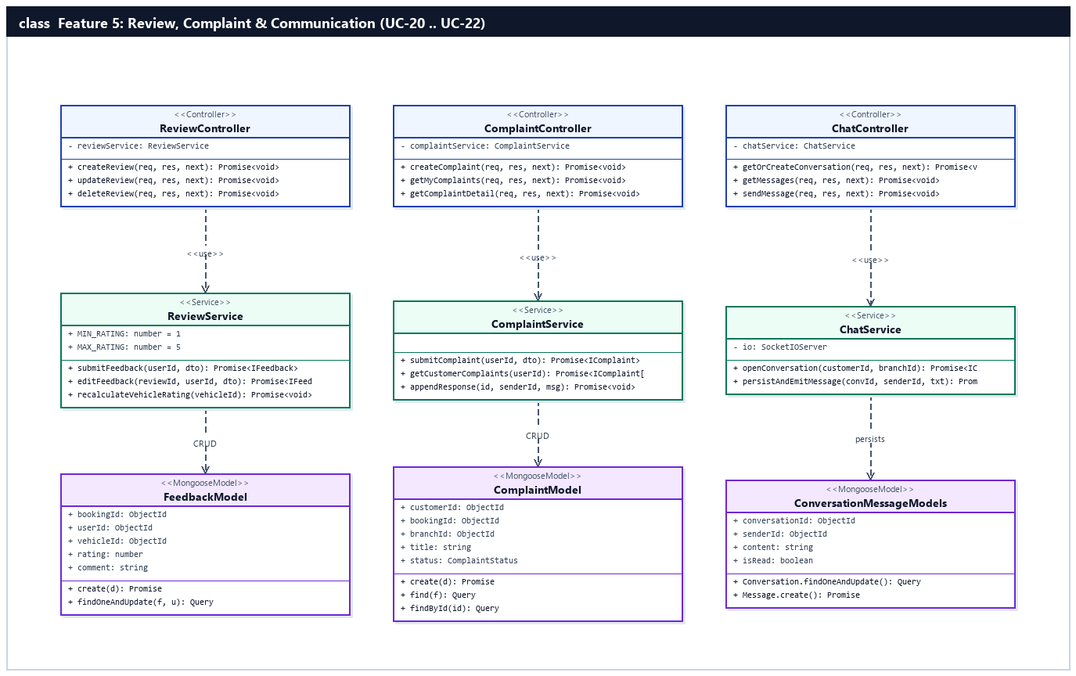
Figure 2.5.a: Class Diagram — Review, Complaint & Communication Feature (UC-20 .. UC-22)

b. Class Specifications

ReviewController Class
Controller handling customer 1-5 star reviews and photo attachments for completed bookings under /api/reviews.
No | Method | Description
01 | createReview(req, res, next) | Inputs: AuthenticatedRequest (bookingId, rating, comment, photos). Outputs: HTTP 201 JSON { data: review }. Processing: Calls ReviewService.submitFeedback().
02 | updateReview(req, res, next) | Inputs: req.params.id, req.body (rating, comment, existingPhotos). Outputs: HTTP 200 JSON. Processing: Updates customer's own review and recalculates vehicle average rating.
03 | deleteReview(req, res, next) | Inputs: req.params.id, req.user._id. Outputs: HTTP 200 JSON. Processing: Deletes review and updates vehicle rating average.

ComplaintController Class
Controller managing customer complaint tickets and status history under /api/complaints.
No | Method | Description
01 | createComplaint(req, res, next) | Inputs: AuthenticatedRequest (bookingId, branchId, title, category, description). Outputs: HTTP 201 JSON { data: complaint }. Processing: Calls ComplaintService.submitComplaint().
02 | getMyComplaints(req, res, next) | Inputs: req.user._id. Outputs: HTTP 200 JSON { items }. Processing: Retrieves customer's submitted complaints and status logs.
03 | getComplaintDetail(req, res, next) | Inputs: req.params.id. Outputs: HTTP 200 JSON { complaint, responses, statusLogs }. Processing: Returns full complaint thread.

ChatController Class
Controller and Socket.IO event handler managing real-time support conversations under /api/chat.
No | Method | Description
01 | getOrCreateConversation(req, res, next) | Inputs: req.user._id, req.body.branchId. Outputs: HTTP 200 JSON { conversation }. Processing: Opens or resumes active Conversation session.
02 | sendMessage(req, res, next) | Inputs: req.body (conversationId, content). Outputs: HTTP 201 JSON { message }. Processing: Saves Message document and broadcasts via Socket.IO.

ReviewService Class
Service enforcing 1-to-1 booking review eligibility and recalculating motorbike star ratings.
No | Method | Description
01 | submitFeedback(userId, dto) | Inputs: userId, CreateReviewDTO. Outputs: Promise<IFeedback>. Processing: Verifies Booking belongs to userId and has status='Completed', creates Feedback (unique bookingId), and recalculates Vehicle averageRating.

ComplaintService Class
Service managing complaint lifecycle, staff/manager responses, and status transition logs.
No | Method | Description
01 | submitComplaint(userId, dto) | Inputs: userId, CreateComplaintDTO. Outputs: Promise<IComplaint>. Processing: Resolves branchId from Booking, creates Complaint with status='Open', inserts initial ComplaintStatusLog, and notifies branch staff.

ChatService Class
Real-time messaging service coordinating MongoDB persistence (Conversation, Message) and Socket.IO room broadcasting.
No | Method | Description
01 | persistAndEmitMessage(convId, senderId, content) | Inputs: conversationId, senderId, content. Outputs: Promise<IMessage>. Processing: Inserts Message document, updates Conversation.lastMessageAt, and emits 'chat:new_message' to conversation room.

c. Sequence Diagram(s) — (1 Sequence Diagram per Use Case)

UC-20: Rate & Review Rented Vehicles
Customer submits a 1-5 star review with photos for a completed rental (1:1 with Booking), or edits/deletes their submitted review.
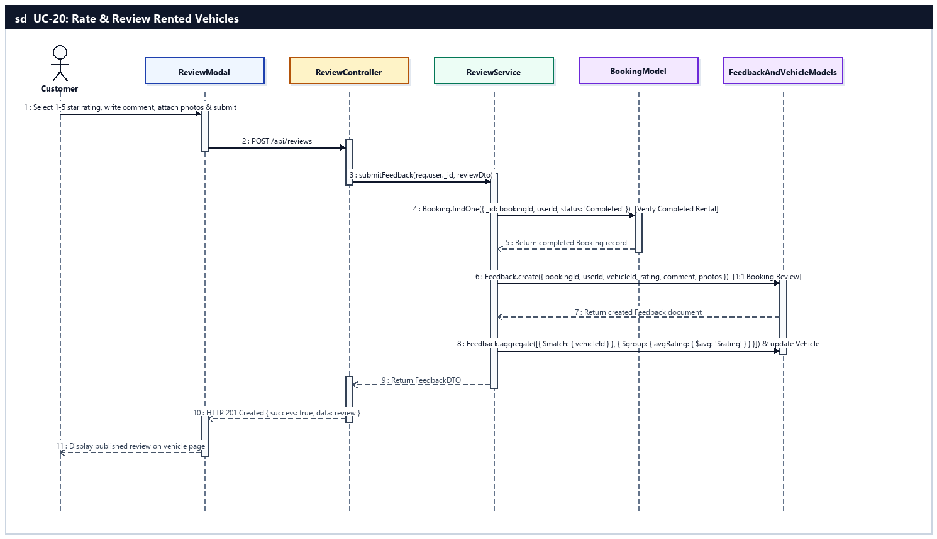
Sequence Diagram — UC-20: Rate & Review Rented Vehicles

UC-21: Report & Track Service Complaints
Customer submits a complaint about a booking or branch experience and tracks its resolution progress and staff responses.
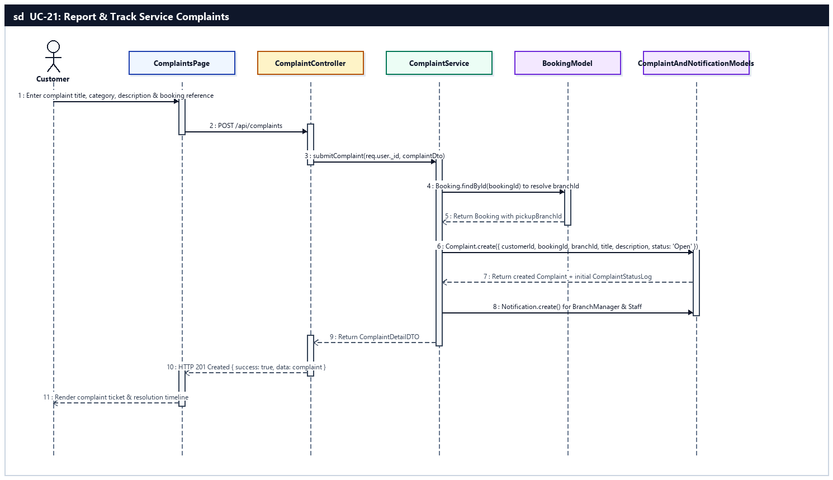
Sequence Diagram — UC-21: Report & Track Service Complaints

UC-22: Chat Live with Branch Staff
Customer exchanges real-time support messages with branch staff via Socket.IO.
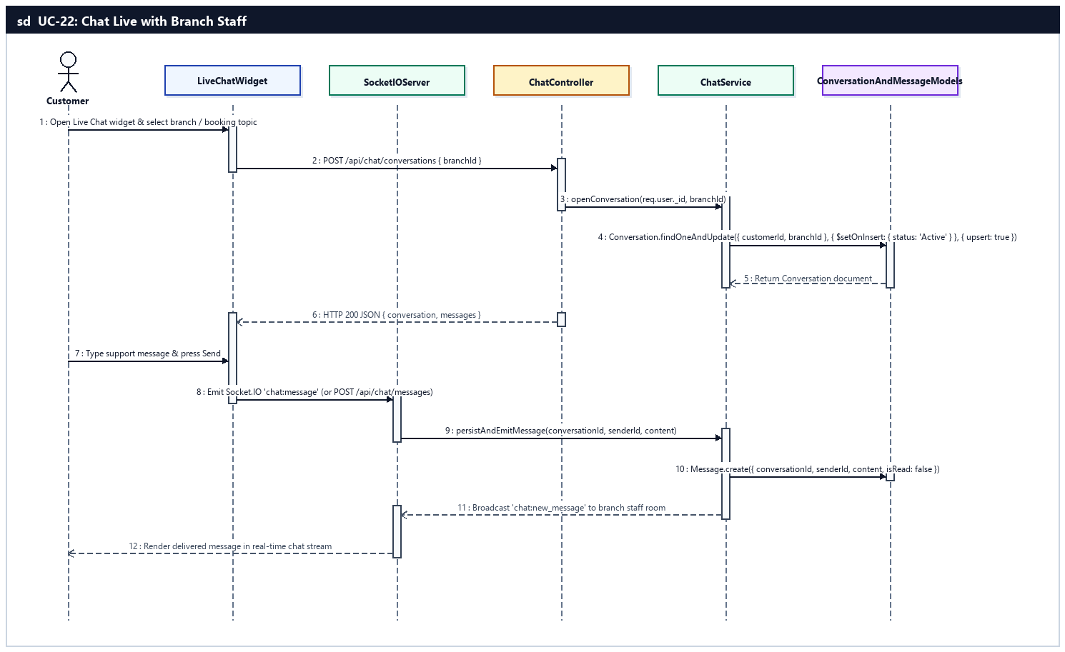
Sequence Diagram — UC-22: Chat Live with Branch Staff

d. Database Queries
UC-20 — Rate & Review Rented Vehicles:
// 1. Verify rental booking is Completed and belongs to Customer
const completedBooking = await Booking.findOne({ _id: bookingId, userId: req.user._id, status: 'Completed' }).lean();

// 2. Create 1:1 Feedback record and recalculate vehicle average rating
const feedback = await Feedback.create({ bookingId, userId: req.user._id, vehicleId: completedBooking.vehicleId, rating, comment, photos });
const stats = await Feedback.aggregate([
{ $match: { vehicleId: completedBooking.vehicleId } },
{ $group: { _id: '$vehicleId', avgRating: { $avg: '$rating' }, reviewCount: { $sum: 1 } } }
]);
await Vehicle.findByIdAndUpdate(completedBooking.vehicleId, { $set: { rating: stats[0]?.avgRating || 5, reviewCount: stats[0]?.reviewCount || 1 } });
UC-21 — Report & Track Service Complaints:
// 1. Create Complaint ticket and initial status log entry
const complaint = await Complaint.create({
customerId: req.user._id,
bookingId,
branchId,
title,
description,
category,
status: 'Open'
});
await ComplaintStatusLog.create({
complaintId: complaint._id,
fromStatus: null,
toStatus: 'Open',
changedBy: req.user._id,
note: 'Khách hàng khởi tạo khiếu nại'
});
UC-22 — Chat Live with Branch Staff:
// 1. Upsert active Conversation for customer and branch
const conversation = await Conversation.findOneAndUpdate(
{ customerId: req.user._id, branchId },
{ $setOnInsert: { customerId: req.user._id, branchId, status: 'Active' } },
{ upsert: true, new: true }
);

// 2. Persist chat Message and update conversation timestamp
const message = await Message.create({
conversationId: conversation._id,
senderId: req.user._id,
content,
isRead: false
});
await Conversation.findByIdAndUpdate(conversation._id, { $set: { lastMessage: content, lastMessageAt: new Date() } });

6. Notifications & Loyalty Feature (UC-23 .. UC-25)
Manages multi-channel customer notifications (in-app Socket.IO push, email confirmations, automated 24h/2h pickup & return reminders via BookingReminder), loyalty point accumulation (1 point per 10,000 VND spent on completed rentals per BR-12) and voucher redemption, and referral code sharing & promotional subscriptions.

a. Class Diagram
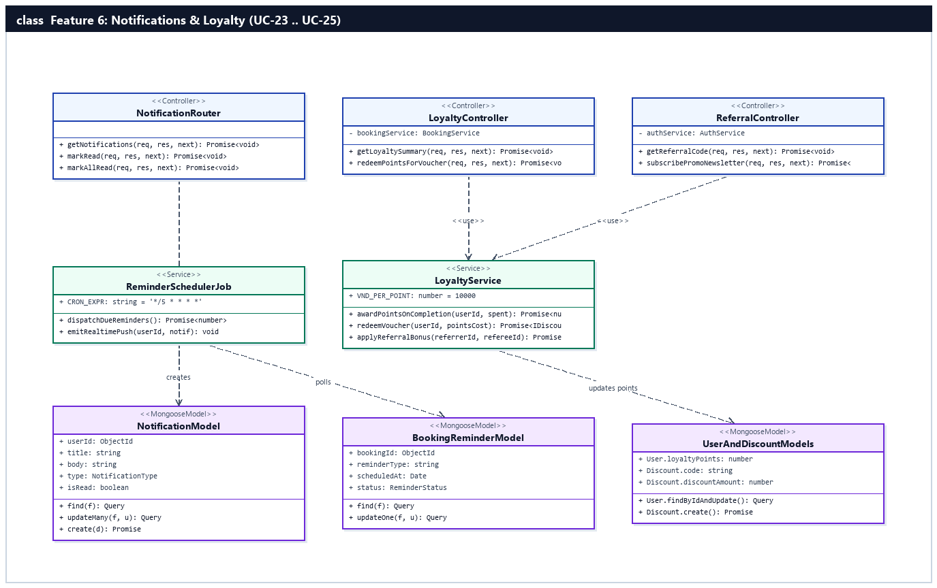
Figure 2.6.a: Class Diagram — Notifications & Loyalty Feature (UC-23 .. UC-25)

b. Class Specifications

NotificationRouter Class
Express router in server/src/modules/system/systemRoutes.ts managing in-app notification retrieval and read/unread state.
No | Method | Description
01 | getNotifications(req, res, next) | Inputs: AuthenticatedRequest. Outputs: HTTP 200 JSON { items, unreadCount }. Processing: Queries latest 30 Notification records for req.user._id.
02 | markRead(req, res, next) | Inputs: req.params.id. Outputs: HTTP 200 JSON. Processing: Sets isRead=true on matching Notification.
03 | markAllRead(req, res, next) | Inputs: req.user._id. Outputs: HTTP 200 JSON. Processing: Bulk updates all unread notifications for the user to isRead=true.

ReminderSchedulerJob Class
Background cron job dispatching scheduled 24-hour and 2-hour pickup/return reminders from BookingReminder.
No | Method | Description
01 | dispatchDueReminders() | Inputs: Current wall-clock timestamp. Outputs: Promise<number>. Processing: Polls BookingReminder(status='Pending', scheduledAt <= now), creates in-app Notification, sends email/SMS alert, and updates status='Sent'.

LoyaltyService Class
Service managing BR-12 loyalty point awards, point-to-voucher redemptions, and referral bonuses.
No | Method | Description
01 | awardPointsOnCompletion(userId, netAmount) | Inputs: userId, netAmount (VND). Outputs: Promise<number>. Processing: Calculates floor(netAmount / 10000) points (BR-12) and increments User.loyaltyPoints.
02 | redeemVoucher(userId, pointsCost) | Inputs: userId, pointsCost. Outputs: Promise<IDiscount>. Processing: Atomically deducts pointsCost from User.loyaltyPoints and generates a single-use Discount voucher code.

c. Sequence Diagram(s) — (1 Sequence Diagram per Use Case)

UC-23: Receive Booking Alerts & Reminders
Customer receives in-app push notifications, email confirmations, and automated SMS/email pickup and return reminders (24h and 2h prior).
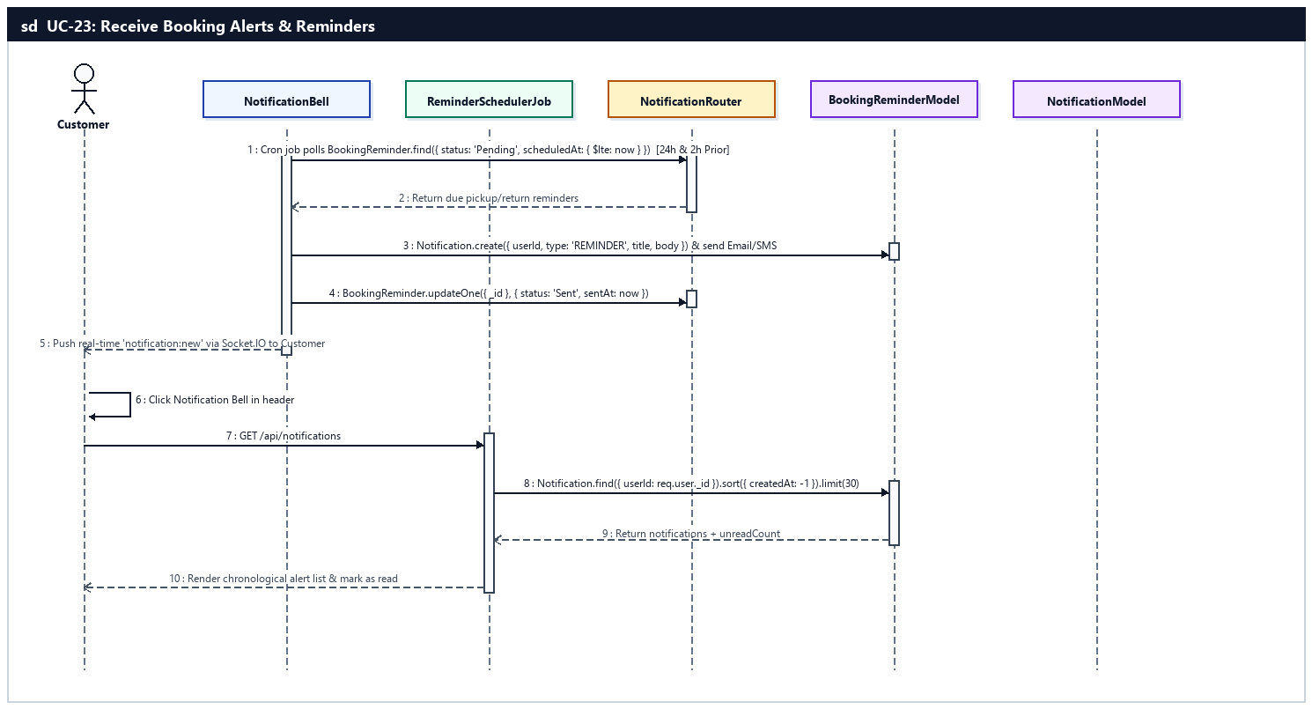
Sequence Diagram — UC-23: Receive Booking Alerts & Reminders

UC-24: Earn & Redeem Loyalty Points
Customer accumulates loyalty points upon rental completion (1 pt per 10,000 VND per BR-12) and redeems points for discount vouchers.
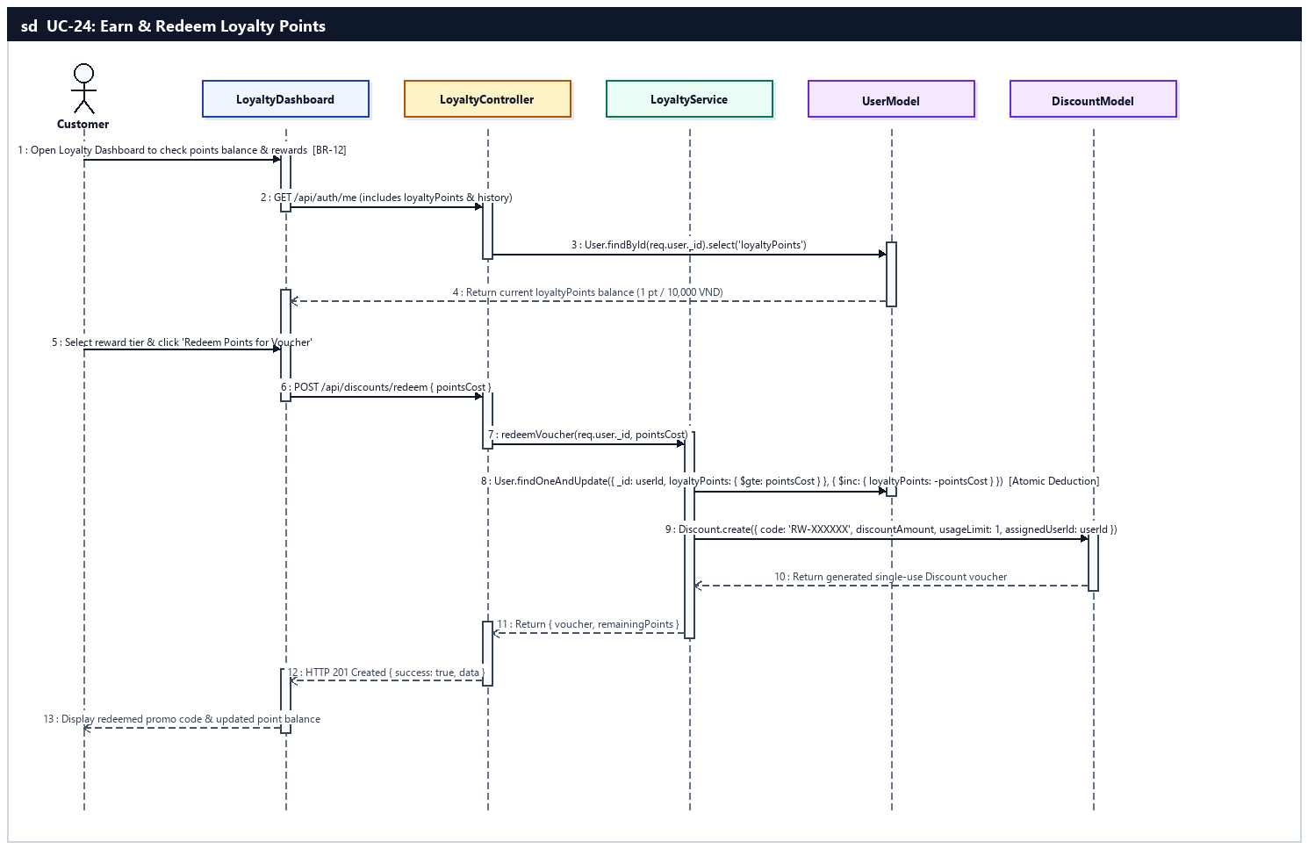
Sequence Diagram — UC-24: Earn & Redeem Loyalty Points

UC-25: Refer Friends & Subscribe Promos
Customer shares referral codes for bonus points and opts in to promotional offers.
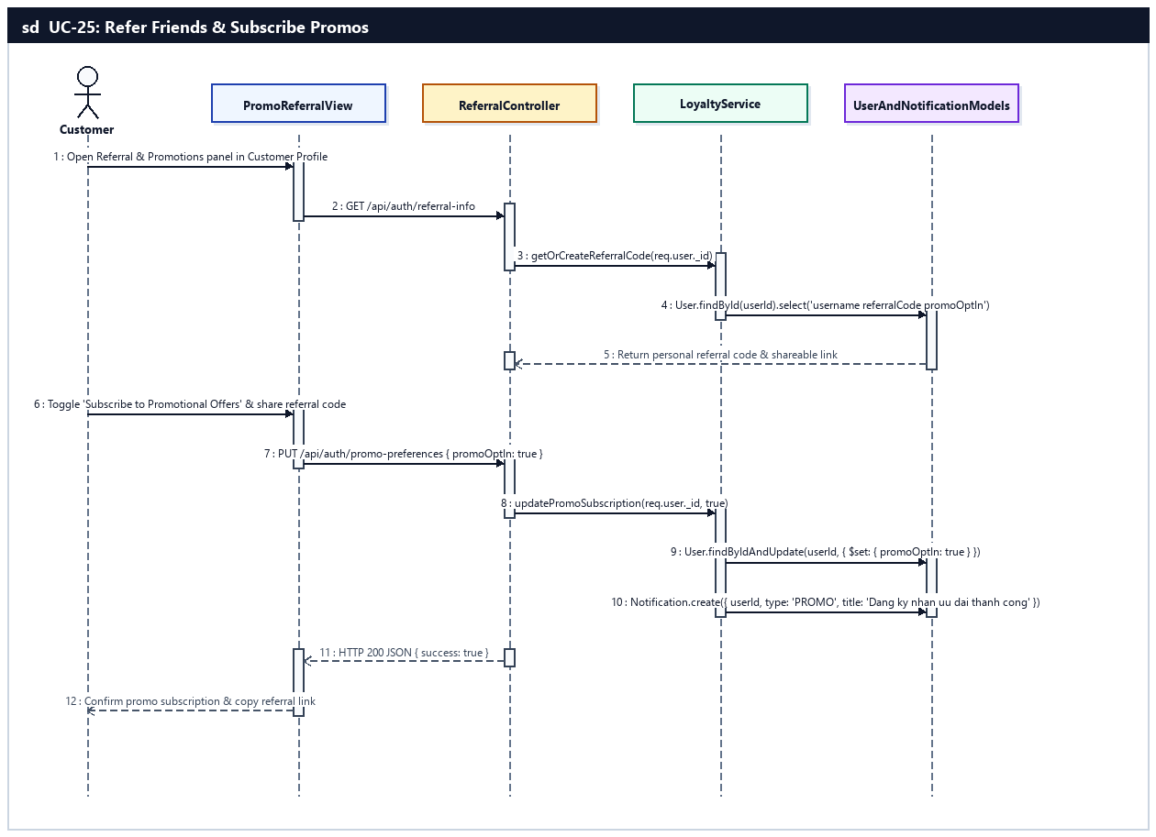
Sequence Diagram — UC-25: Refer Friends & Subscribe Promos

d. Database Queries
UC-23 — Receive Booking Alerts & Reminders:
// 1. Poll due pickup/return reminders in background cron job
const dueReminders = await BookingReminder.find({
status: 'Pending',
scheduledAt: { $lte: new Date() }
}).populate('bookingId');

// 2. Create in-app notification and mark reminder as Sent
await Notification.create({
userId: booking.userId,
type: 'REMINDER',
title: 'Nhắc lịch nhận/trả xe MOTORENT',
body: `Đơn thuê xe ${booking.bookingCode} sắp đến giờ hẹn tại chi nhánh.`,
isRead: false
});
await BookingReminder.updateOne({ _id: reminder._id }, { $set: { status: 'Sent', sentAt: new Date() } });

// 3. Fetch customer's notification feed and mark read
const items = await Notification.find({ userId: req.user._id }).sort({ createdAt: -1 }).limit(30);
await Notification.updateMany({ userId: req.user._id, isRead: false }, { $set: { isRead: true } });
UC-24 — Earn & Redeem Loyalty Points:
// 1. Atomically deduct loyalty points from Customer account
const updatedUser = await User.findOneAndUpdate(
{ _id: req.user._id, loyaltyPoints: { $gte: pointsCost } },
{ $inc: { loyaltyPoints: -pointsCost } },
{ new: true }
);

// 2. Generate personal single-use Discount voucher code
const voucher = await Discount.create({
code: `RW-${crypto.randomBytes(3).toString('hex').toUpperCase()}`,
description: `Voucher đổi từ ${pointsCost} điểm thưởng Loyalty`,
discountAmount: voucherValueVnd,
minOrderValue: 0,
startDate: new Date(),
endDate: new Date(Date.now() + 30 * 24 * 3600 * 1000),
usageLimit: 1,
usedCount: 0,
isActive: true
});
UC-25 — Refer Friends & Subscribe Promos:
// 1. Update promotional subscription preference & referral tracking on User
const user = await User.findByIdAndUpdate(
req.user._id,
{ $set: { promoOptIn: Boolean(promoOptIn) } },
{ new: true }
).select('username email loyaltyPoints promoOptIn');

7. Counter Desk Operations Feature (UC-26 .. UC-32)
Provides branch Staff with on-site counter workspace operations: inspecting the branch rental order queue and customer eKYC documents, executing the 5-point vehicle handover Check-in (BR-09, BR-10, 70% counter balance settlement), processing vehicle return Check-out with 4-angle photo comparison and loyalty point awards (BR-12), recording damage incidents and late return fees (30,000 VND/hour per BR-11), logging maintenance tickets, resolving branch complaints, and replying to live customer chats.

a. Class Diagram
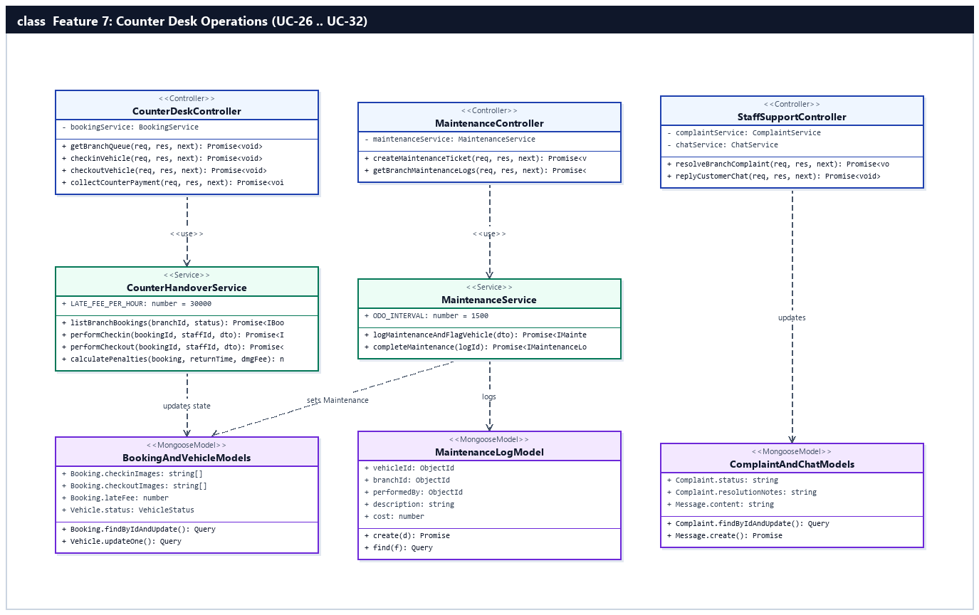
Figure 2.7.a: Class Diagram — Counter Desk Operations Feature (UC-26 .. UC-32)

b. Class Specifications

CounterDeskController Class
Controller managing branch rental queue inspection, Check-in handover, Check-out return, and counter penalty settlement under /api/bookings.
No | Method | Description
01 | getBranchQueue(req, res, next) | Inputs: AuthenticatedRequest (branchId, status, queueFilter, searchCode). Outputs: HTTP 200 JSON { bookings, orderCounts }. Processing: Calls CounterHandoverService.listBranchBookings() scoped to staff's assigned branch (BR-14).
02 | checkinVehicle(req, res, next) | Inputs: req.params.id, req.body (startOdometer, startFuelLevel, checkinImages, eSignatureUrl, accessoriesConfirmed). Outputs: HTTP 200 JSON { data: booking }. Processing: Executes 5-point handover verification and sets Booking='Ongoing', Vehicle='Rented'.
03 | checkoutVehicle(req, res, next) | Inputs: req.params.id, req.body (endOdometer, endFuelLevel, checkoutImages, hasDamage, damageFee, damageNotes). Outputs: HTTP 200 JSON { data: booking }. Processing: Calculates lateFee (BR-11), updates Booking='Completed', awards loyalty points (BR-12), and updates Vehicle status.

MaintenanceController Class
Controller handling vehicle maintenance ticket creation and completion under /api/fleet/maintenance.
No | Method | Description
01 | createMaintenanceTicket(req, res, next) | Inputs: req.body (vehicleId, description, cost, odometerAtService). Outputs: HTTP 201 JSON { data: log }. Processing: Flags Vehicle status='Maintenance' and creates MaintenanceLog.
02 | getBranchMaintenanceLogs(req, res, next) | Inputs: req.user.branchId. Outputs: HTTP 200 JSON { items }. Processing: Lists maintenance history for the branch.

StaffSupportController Class
Controller enabling branch staff to resolve assigned complaints and respond to customer live chat sessions.
No | Method | Description
01 | resolveBranchComplaint(req, res, next) | Inputs: req.params.id, req.body (status, resolutionNotes, responseMessage). Outputs: HTTP 200 JSON. Processing: Appends ComplaintResponse, logs status transition, and updates Complaint status.
02 | replyCustomerChat(req, res, next) | Inputs: req.body (conversationId, content). Outputs: HTTP 201 JSON. Processing: Saves staff Message and emits Socket.IO event to customer.

CounterHandoverService Class
Domain service implementing Check-in (BR-09, BR-10), Check-out (BR-11, BR-12, BR-15), and counter payment settlement.
No | Method | Description
01 | performCheckin(bookingId, staffId, dto) | Inputs: bookingId, staffId, CheckinDTO. Outputs: Promise<IBooking>. Processing: Validates 4-angle checkinImages, startOdometer, fuel level, 2 helmets/2 raincoats/1 phone mount (BR-10), collects remaining 70% counter balance, transitions Booking to 'Ongoing' and Vehicle to 'Rented'.
02 | performCheckout(bookingId, staffId, dto) | Inputs: bookingId, staffId, CheckoutDTO. Outputs: Promise<IBooking>. Processing: Validates endOdometer >= startOdometer, computes lateFee = ceil(lateHours) * 30,000 VND (BR-11), adds damageFee, transitions Booking to 'Completed', awards 1 loyalty point per 10,000 VND (BR-12), and sets Vehicle to 'Available' or 'Maintenance'.

MaintenanceService Class
Service managing MaintenanceLog records and ODO-based maintenance threshold alerts (BR-15).
No | Method | Description
01 | logMaintenanceAndFlagVehicle(user, dto) | Inputs: staffUser, CreateMaintenanceDTO. Outputs: Promise<IMaintenanceLog>. Processing: Sets Vehicle status='Maintenance', requiresMaintenance=true, and creates MaintenanceLog record.

c. Sequence Diagram(s) — (1 Sequence Diagram per Use Case)

UC-26: Inspect Branch Rental Queue
Staff filters branch rental orders by status (Pending, Confirmed, Ongoing, Completed, Cancelled) and verifies detailed booking, payment, and customer eKYC records.
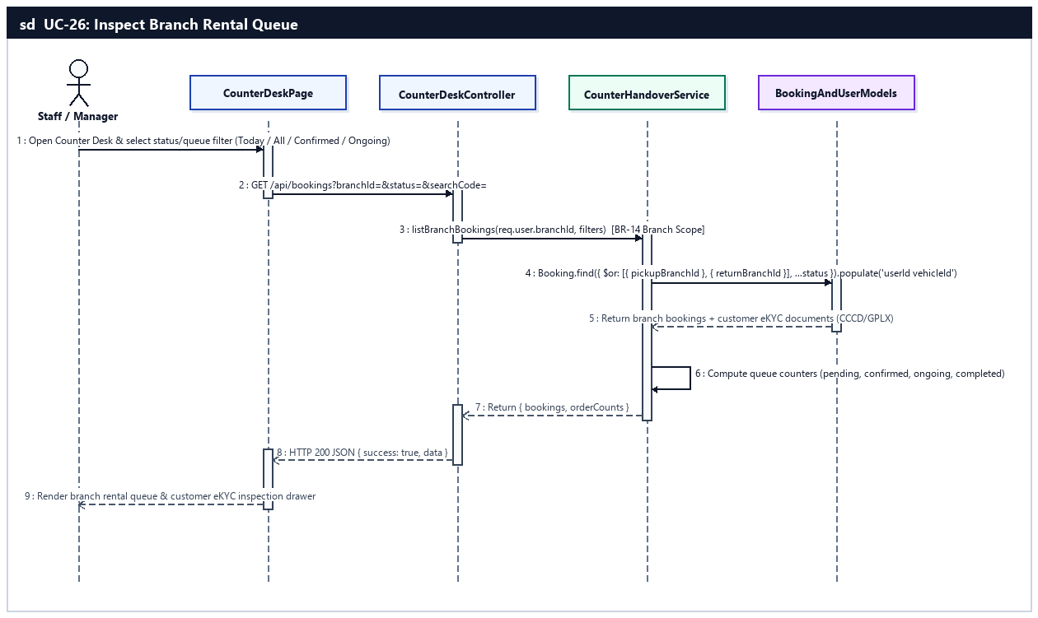
Sequence Diagram — UC-26: Inspect Branch Rental Queue

UC-27: Confirm Vehicle Handover (Check-in)
Staff completes the 5-point safety check (verify customer ID/license, photograph vehicle from 4 angles, record startOdometer and fuel level, confirm 2 helmets/2 raincoats/1 phone mount), collects 70% counter balance, and hands over the motorbike (BR-09, BR-10).
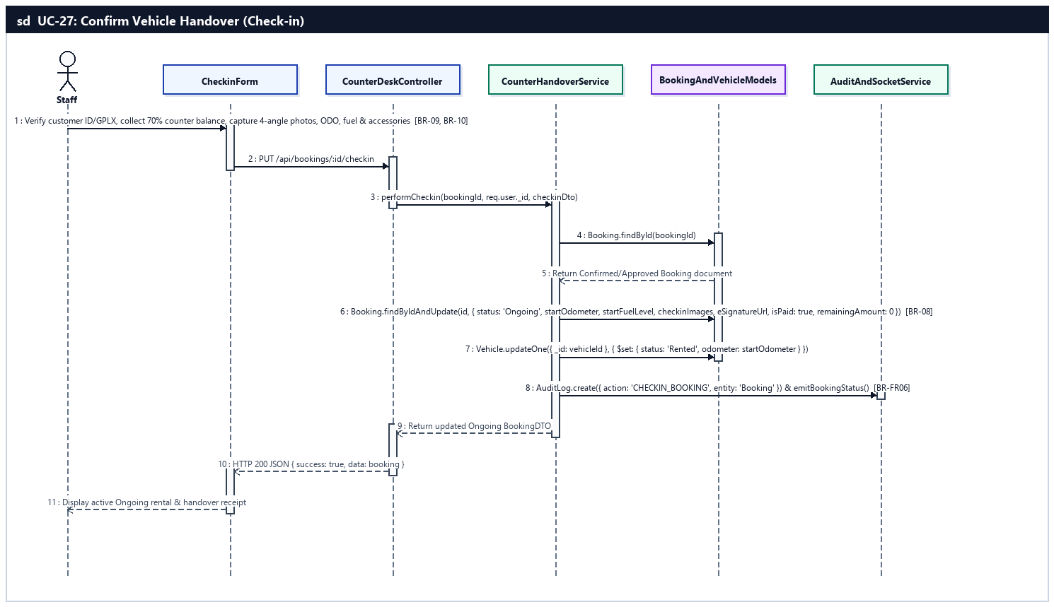
Sequence Diagram — UC-27: Confirm Vehicle Handover (Check-in)

UC-28: Confirm Vehicle Return (Check-out)
Staff captures 4-angle return photos, compares vehicle condition with check-in, records return ODO and fuel level, settles late/damage fees, awards loyalty points, and completes the rental (BR-11, BR-12, BR-15).
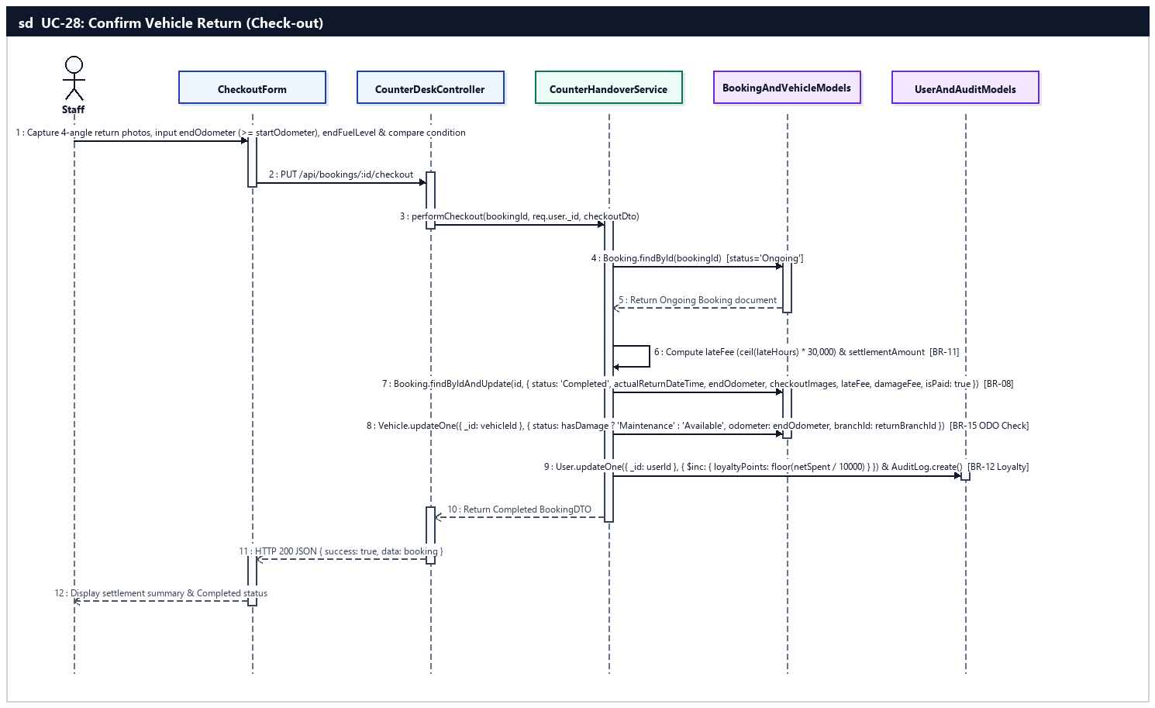
Sequence Diagram — UC-28: Confirm Vehicle Return (Check-out)

UC-29: Record Incident & Settle Penalty Fees
Staff documents vehicle damage with photos, calculates late return fee (30,000 VND/hour rounded up per BR-11) and repair compensation, and records counter settlement.
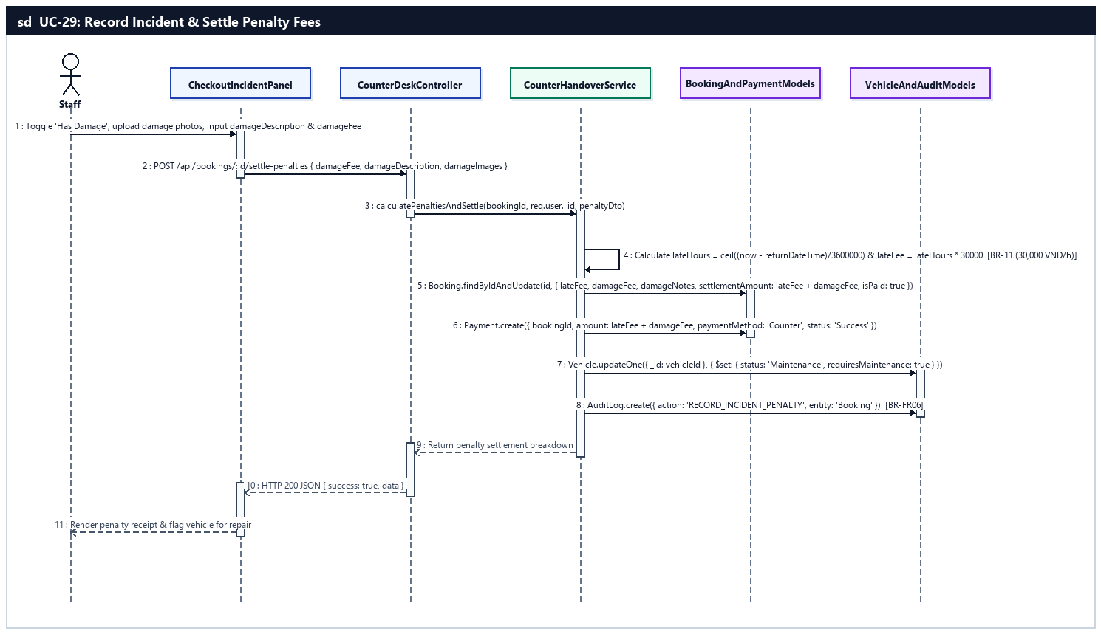
Sequence Diagram — UC-29: Record Incident & Settle Penalty Fees

UC-30: Create Maintenance Ticket & Flag Vehicle
Staff updates vehicle status to Maintenance and logs a maintenance/repair ticket in MaintenanceLog.
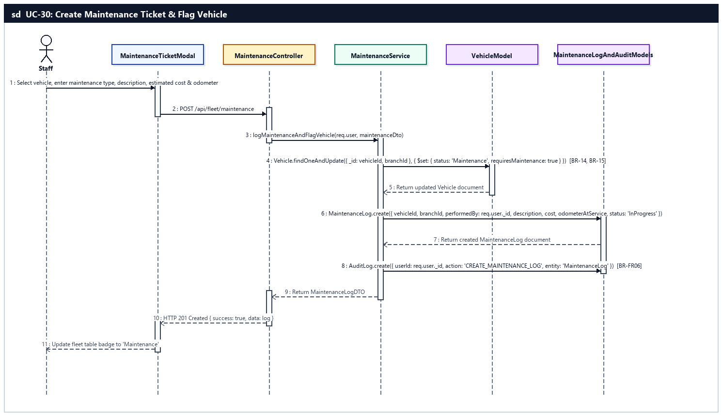
Sequence Diagram — UC-30: Create Maintenance Ticket & Flag Vehicle

UC-31: Resolve Branch Customer Complaints
Staff investigates and responds to customer complaints assigned to their branch.
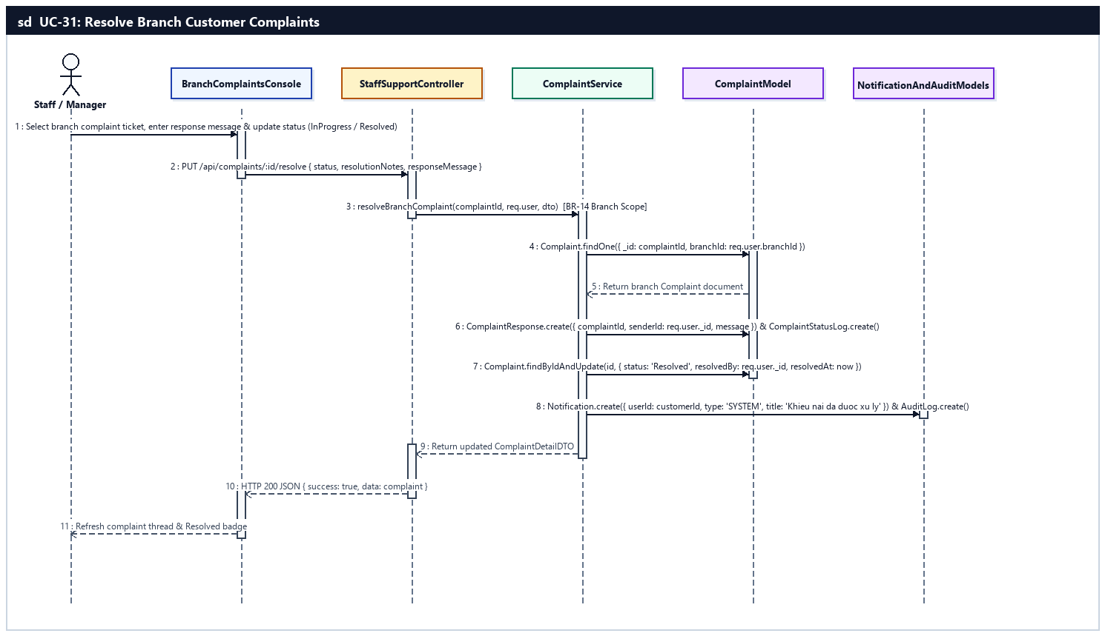
Sequence Diagram — UC-31: Resolve Branch Customer Complaints

UC-32: Reply to Customer Support Chat
Staff responds to customer live chat messages in real time via the Staff Chat Console.
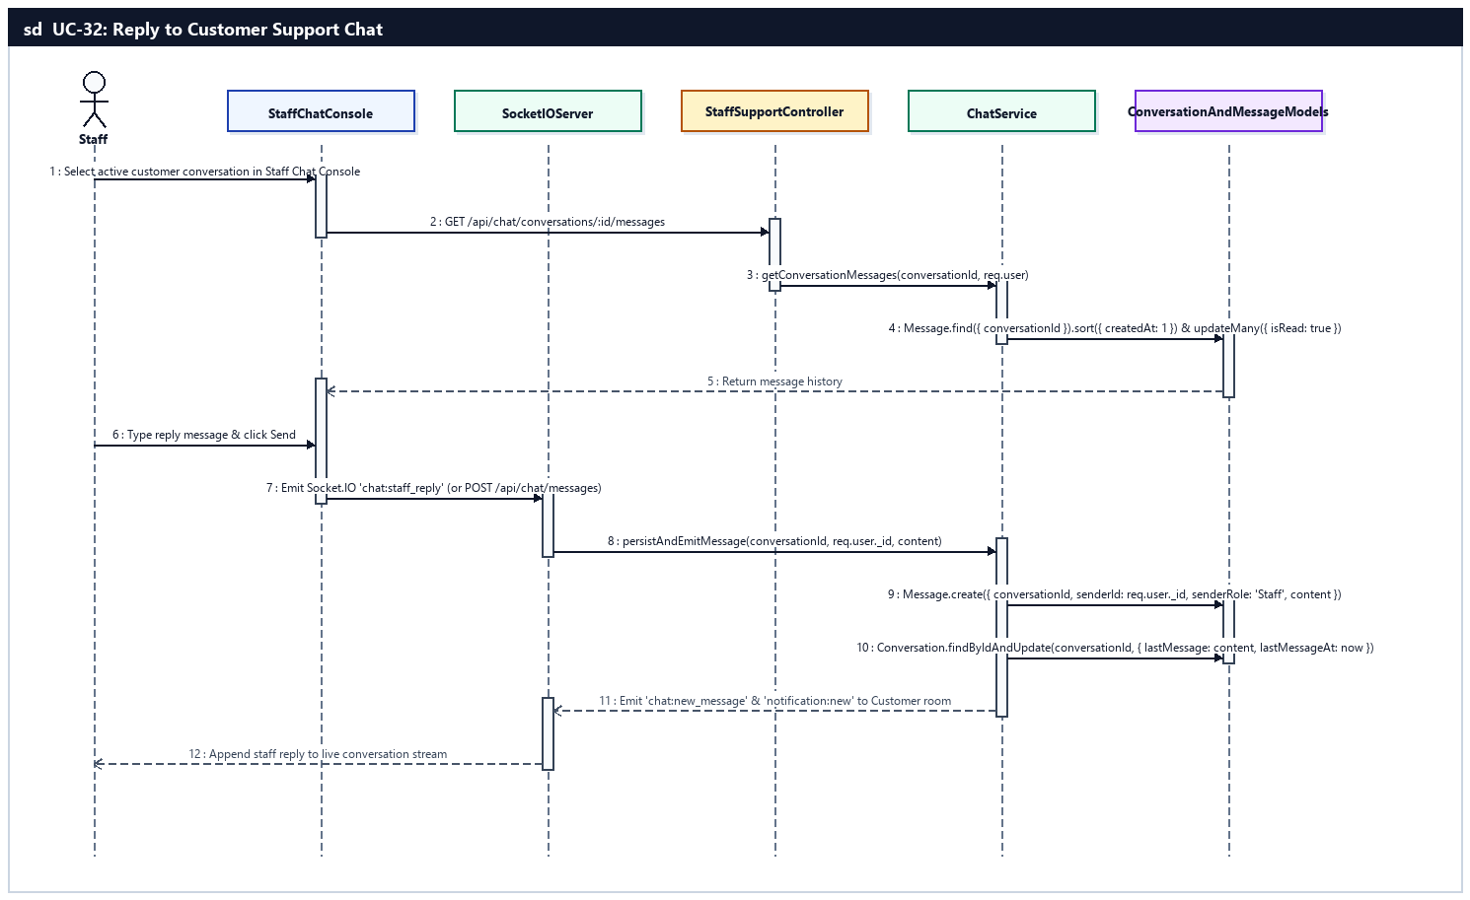
Sequence Diagram — UC-32: Reply to Customer Support Chat

d. Database Queries
UC-26 — Inspect Branch Rental Queue:
// 1. Fetch branch rental queue populated with customer eKYC and vehicle info
const bookings = await Booking.find({
$or: [{ pickupBranchId: branchId }, { returnBranchId: branchId }],
...(status && status !== 'all' ? { status } : {})
})
.populate('userId', 'firstName lastName phoneNumber email identityStatus idCardNumber idCardFrontUrl idCardBackUrl drivingLicenseUrl')
.populate('vehicleId', 'vehicleModel brand licensePlate odometer status images')
.sort({ pickupDateTime: 1 })
.lean();
UC-27 — Confirm Vehicle Handover (Check-in):
// 1. Update Booking to Ongoing with 4-angle check-in photos, ODO, fuel, and 70% counter payment
const booking = await Booking.findByIdAndUpdate(
bookingId,
{
$set: {
status: 'Ongoing',
startOdometer,
startFuelLevel,
checkinImages,
existingDamageNotes,
eSignatureUrl,
isPaid: true,
remainingAmount: 0,
paidAmount: bookingDoc.totalAmount,
approvedBy: req.user._id
}
},
{ new: true }
);

// 2. Update Vehicle status to Rented and sync odometer
await Vehicle.updateOne({ _id: booking.vehicleId }, { $set: { status: 'Rented', odometer: startOdometer } });
await AuditLog.create({ userId: req.user._id, action: 'CHECKIN_BOOKING', entity: 'Booking', entityId: bookingId, timestamp: new Date() });
UC-28 — Confirm Vehicle Return (Check-out):
// 1. Complete Booking with return ODO, 4-angle checkout photos, lateFee, and damageFee
const completedBooking = await Booking.findByIdAndUpdate(
bookingId,
{
$set: {
status: 'Completed',
actualReturnDateTime: new Date(),
endOdometer,
endFuelLevel,
checkoutImages,
lateFee,
damageFee,
settlementAmount: lateFee + damageFee,
isPaid: true,
remainingAmount: 0
}
},
{ new: true }
);

// 2. Award loyalty points (1 pt per 10,000 VND - BR-12) and update Vehicle status/ODO (BR-15)
const points = Math.floor((completedBooking.totalAmount - (completedBooking.discountAmount || 0)) / 10000);
await User.updateOne({ _id: completedBooking.userId }, { $inc: { loyaltyPoints: points } });
await Vehicle.updateOne(
{ _id: completedBooking.vehicleId },
{
$set: {
status: hasDamage ? 'Maintenance' : 'Available',
odometer: endOdometer,
branchId: completedBooking.returnBranchId,
requiresMaintenance: hasDamage || endOdometer >= vehicle.maintenanceODOThreshold
}
}
);
UC-29 — Record Incident & Settle Penalty Fees:
// 1. Record incident photos, damageFee, and lateFee (30,000 VND/hour rounded up - BR-11)
const lateHours = Math.max(0, Math.ceil((Date.now() - new Date(booking.returnDateTime).getTime()) / (3600 * 1000)));
const lateFee = lateHours * 30000;
await Booking.updateOne(
{ _id: bookingId },
{ $set: { lateFee, damageFee, damageNotes, damageImages, settlementAmount: lateFee + damageFee, isPaid: true } }
);

// 2. Record counter penalty payment and flag damaged vehicle for maintenance
await Payment.create({ bookingId, userId: booking.userId, amount: lateFee + damageFee, paymentMethod: 'Counter', paymentType: 'Penalty', status: 'Success' });
await Vehicle.updateOne({ _id: booking.vehicleId }, { $set: { status: 'Maintenance', requiresMaintenance: true } });
UC-30 — Create Maintenance Ticket & Flag Vehicle:
// 1. Transition Vehicle status to Maintenance
await Vehicle.findOneAndUpdate(
{ _id: vehicleId, branchId: req.user.branchId },
{ $set: { status: 'Maintenance', requiresMaintenance: true } }
);

// 2. Insert MaintenanceLog record and AuditLog entry
const log = await MaintenanceLog.create({
vehicleId,
branchId: req.user.branchId,
performedBy: req.user._id,
description,
cost,
odometerAtService,
serviceDate: new Date(),
status: 'InProgress'
});
await AuditLog.create({ userId: req.user._id, action: 'CREATE_MAINTENANCE_LOG', entity: 'MaintenanceLog', entityId: log._id.toString(), timestamp: new Date() });
UC-31 — Resolve Branch Customer Complaints:
// 1. Append staff response and status transition log
await ComplaintResponse.create({ complaintId, senderId: req.user._id, message: responseMessage });
await ComplaintStatusLog.create({ complaintId, fromStatus: complaint.status, toStatus: status, changedBy: req.user._id, note: resolutionNotes });

// 2. Update Complaint status to Resolved
await Complaint.findByIdAndUpdate(complaintId, {
$set: { status: 'Resolved', resolutionNotes, resolvedBy: req.user._id, resolvedAt: new Date() }
});
UC-32 — Reply to Customer Support Chat:
// 1. Mark incoming customer messages as read
await Message.updateMany({ conversationId, senderId: { $ne: req.user._id }, isRead: false }, { $set: { isRead: true } });

// 2. Create staff reply Message and update Conversation preview
const reply = await Message.create({ conversationId, senderId: req.user._id, content, isRead: false });
await Conversation.findByIdAndUpdate(conversationId, { $set: { lastMessage: content, lastMessageAt: new Date(), assignedStaffId: req.user._id } });

8. Fleet & Staff Management Feature (UC-33 .. UC-42)
Empowers Branch Managers to administer their assigned branch (BR-14): adding new motorbikes with globally unique license plates (BR-13), updating or soft-deleting vehicles, configuring daily/hourly/seasonal rental pricing, approving or rejecting bookings, processing deposit refunds (BR-06), scheduling ODO-based maintenance (BR-15), coordinating inter-branch vehicle transfers with dual approval (BR-16), provisioning branch Staff accounts, assigning shift schedules and tracking attendance, and exporting branch analytics reports.

a. Class Diagram
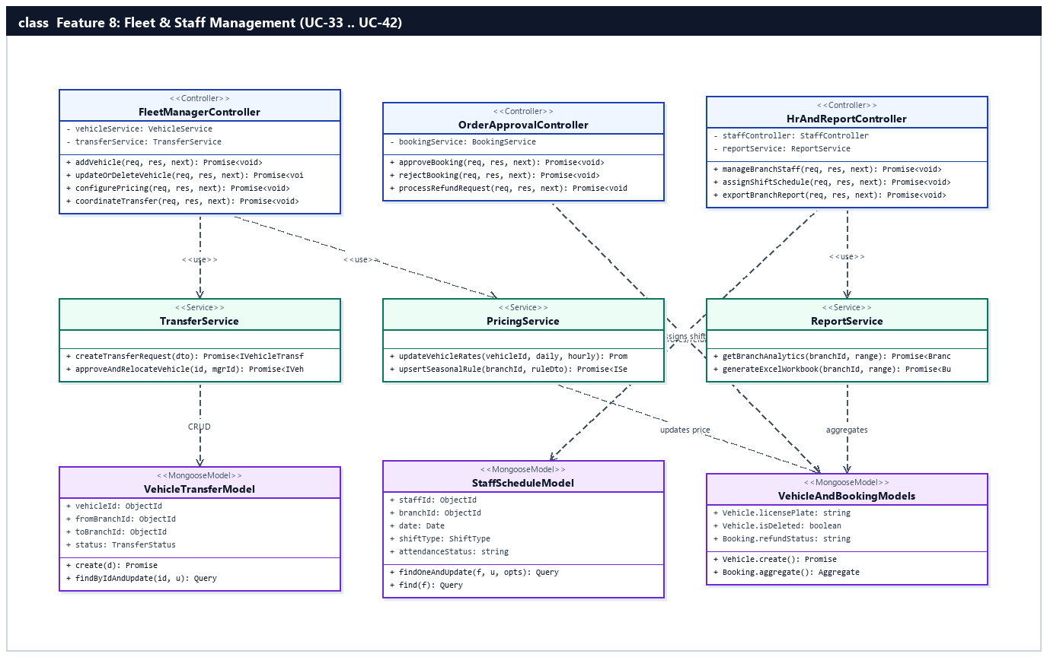
Figure 2.8.a: Class Diagram — Fleet & Staff Management Feature (UC-33 .. UC-42)

b. Class Specifications

FleetManagerController Class
Controller handling branch vehicle CRUD, pricing updates, and inter-branch transfer requests.
No | Method | Description
01 | addVehicle(req, res, next) | Inputs: AuthenticatedRequest (brand, vehicleModel, licensePlate, category, dailyPrice, maintenanceODOThreshold, images). Outputs: HTTP 201 JSON { data: vehicle }. Processing: Enforces BR-13 unique plate and BR-14 branch scope.
02 | updateOrDeleteVehicle(req, res, next) | Inputs: req.params.id, req.body. Outputs: HTTP 200 JSON. Processing: Updates vehicle specs or soft-deletes (isDeleted=true) if no active bookings exist.
03 | configurePricing(req, res, next) | Inputs: req.params.id, req.body (dailyPrice, hourlyPrice, seasonalRules). Outputs: HTTP 200 JSON. Processing: Updates pricing via PricingService.
04 | coordinateTransfer(req, res, next) | Inputs: req.body / req.params.id. Outputs: HTTP 200/201 JSON. Processing: Creates or approves inter-branch VehicleTransfer (BR-16).

OrderApprovalController Class
Controller managing branch booking approvals/rejections and deposit refund requests.
No | Method | Description
01 | approveBooking(req, res, next) | Inputs: req.params.id. Outputs: HTTP 200 JSON. Processing: Transitions Pending booking to Approved and notifies customer.
02 | rejectBooking(req, res, next) | Inputs: req.params.id, req.body.rejectReason. Outputs: HTTP 200 JSON. Processing: Transitions booking to Cancelled with 100% refund eligibility.
03 | processRefundRequest(req, res, next) | Inputs: req.params.id, req.body (decision, managerNote). Outputs: HTTP 200 JSON. Processing: Approves or rejects customer deposit refund request.

HrAndReportController Class
Controller managing branch staff accounts, shift schedules, attendance, and branch revenue/utilization reports.
No | Method | Description
01 | manageBranchStaff(req, res, next) | Inputs: req.body (username, email, password, phoneNumber, status). Outputs: HTTP 200/201 JSON. Processing: Creates or updates Staff accounts assigned to manager's branchId (BR-14).
02 | assignShiftSchedule(req, res, next) | Inputs: req.body (staffId, date, shiftType, notes). Outputs: HTTP 200 JSON. Processing: Upserts StaffSchedule entry and tracks clock-in/out attendance.
03 | exportBranchReport(req, res, next) | Inputs: req.query (startDate, endDate, format). Outputs: JSON or Excel (.xlsx) stream. Processing: Aggregates revenue, utilization, and ratings via ReportService.

TransferService Class
Service in server/src/modules/fleet/transferService.ts managing inter-branch motorbike relocations (BR-16).
No | Method | Description
01 | createTransferRequest(user, dto) | Inputs: managerUser, TransferRequestDTO. Outputs: Promise<IVehicleTransfer>. Processing: Creates VehicleTransfer with status='Pending'.
02 | approveAndRelocateVehicle(transferId, managerUser) | Inputs: transferId, managerUser. Outputs: Promise<IVehicleTransfer>. Processing: Enforces dual-branch approval (BR-16), updates Vehicle.branchId = toBranchId, and sets transfer status='Completed'.

PricingService Class
Service in server/src/modules/pricing/pricingService.ts managing base daily/hourly rates and seasonal pricing multipliers.
No | Method | Description
01 | updateVehicleRates(vehicleId, dailyPrice, hourlyPrice) | Inputs: vehicleId, dailyPrice, hourlyPrice. Outputs: Promise<IVehicle>. Processing: Validates positive rates and updates Vehicle document.
02 | upsertSeasonalRule(branchId, ruleDto) | Inputs: branchId, SeasonalRuleDTO. Outputs: Promise<ISeasonalPricingRule>. Processing: Creates or updates holiday/weekend multiplier rule.

ReportService Class
Analytics service in server/src/modules/report/reportService.ts computing branch KPIs and generating ExcelJS reports.
No | Method | Description
01 | getBranchAnalytics(branchId, dateRange) | Inputs: branchId, { startDate, endDate }. Outputs: Promise<BranchReportDTO>. Processing: Runs MongoDB aggregation pipelines on Booking, Vehicle, MaintenanceLog, and Feedback.
02 | generateExcelWorkbook(branchId, dateRange) | Inputs: branchId, dateRange. Outputs: Promise<Buffer>. Processing: Builds multi-sheet ExcelJS workbook for branch revenue and fleet utilization.

c. Sequence Diagram(s) — (1 Sequence Diagram per Use Case)

UC-33: Add New Vehicle
Branch Manager registers a new motorbike (specs, globally unique license plate, ODO maintenance threshold, 4-angle photos, daily price) into their branch fleet (BR-13, BR-14).
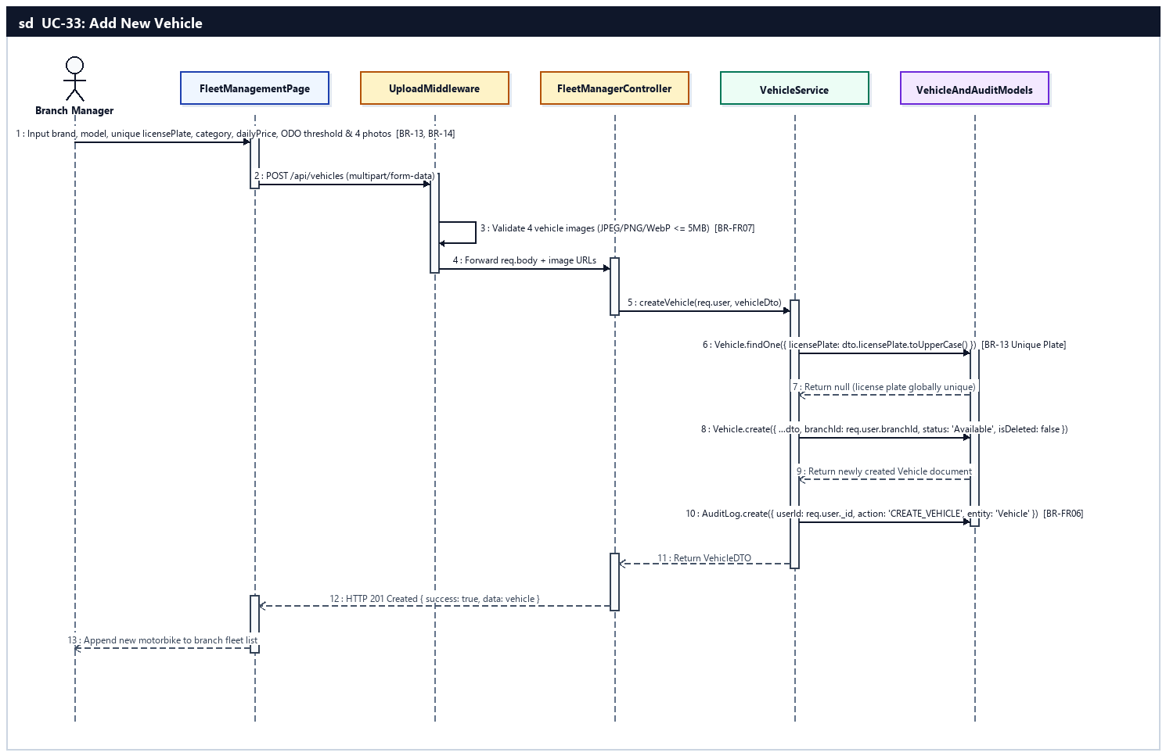
Sequence Diagram — UC-33: Add New Vehicle

UC-34: Update & Decommission Vehicle
Branch Manager edits vehicle specifications/status or soft-deletes (isDeleted=true) a vehicle with no active bookings (BR-14).
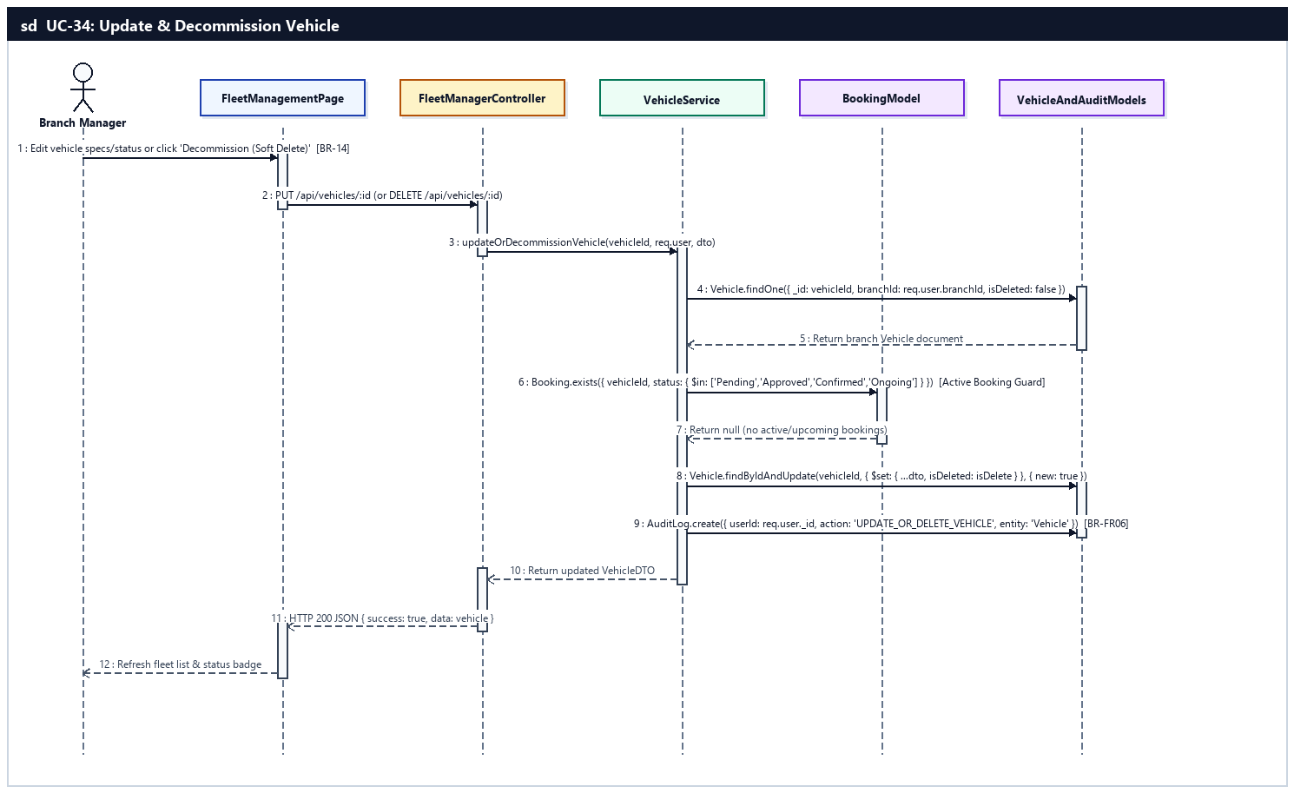
Sequence Diagram — UC-34: Update & Decommission Vehicle

UC-35: Configure Vehicle Rental Pricing
Branch Manager sets and updates daily rental price, hourly rental rate, and peak season/holiday pricing rules.
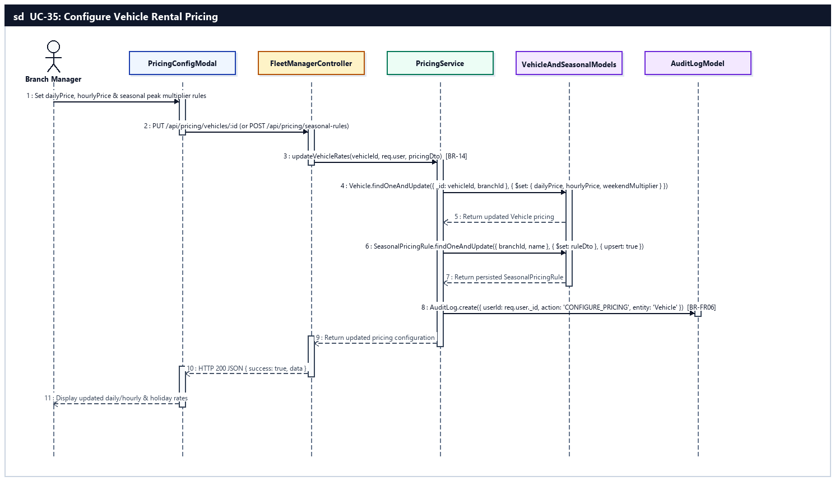
Sequence Diagram — UC-35: Configure Vehicle Rental Pricing

UC-36: Approve or Reject Rental Order
Branch Manager evaluates pending booking requests and approves or rejects them with a documented reason (triggering 100% deposit refund if rejected).
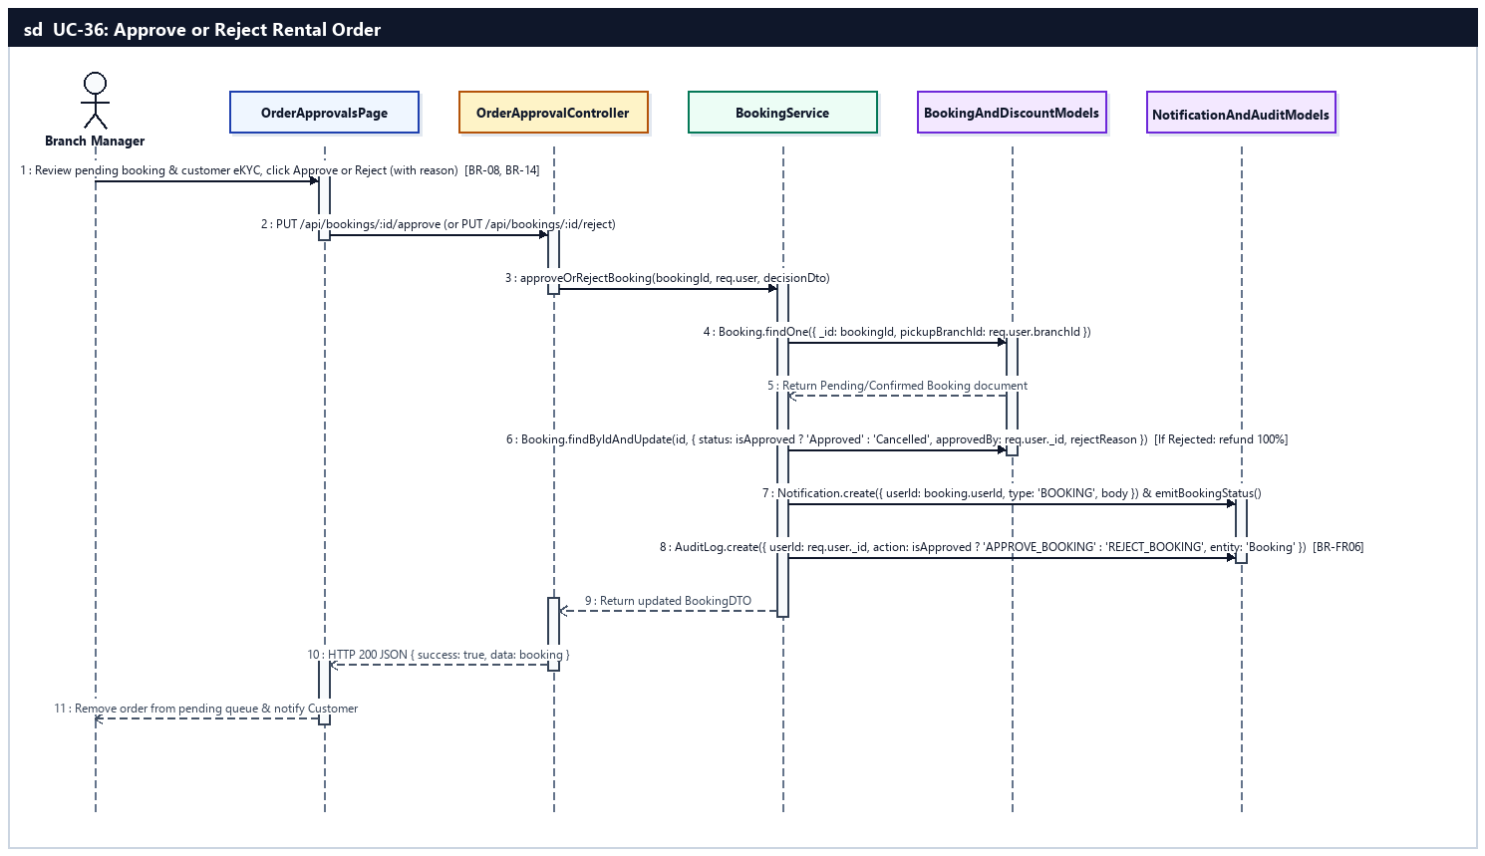
Sequence Diagram — UC-36: Approve or Reject Rental Order

UC-37: Process Deposit Refund Requests
Branch Manager evaluates customer deposit refund requests and approves or rejects them according to the cancellation policy (BR-06).
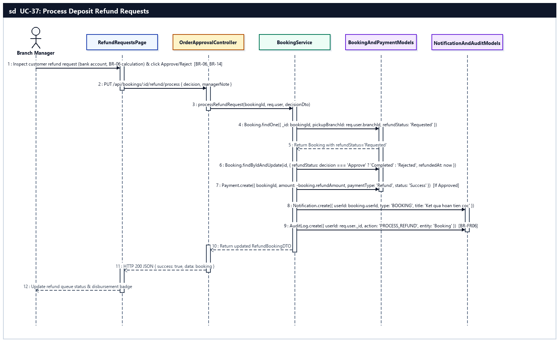
Sequence Diagram — UC-37: Process Deposit Refund Requests

UC-38: Schedule ODO Maintenance & Logs
Branch Manager schedules periodic ODO-based maintenance and audits full vehicle maintenance history (BR-15).
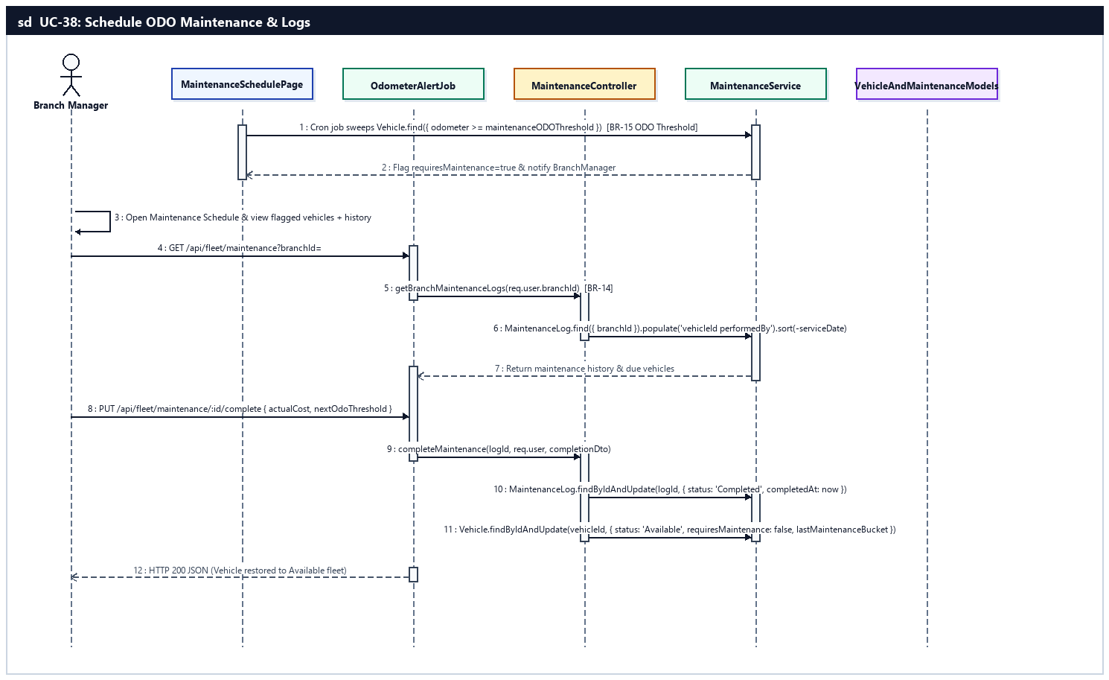
Sequence Diagram — UC-38: Schedule ODO Maintenance & Logs

UC-39: Coordinate Inter-Branch Transfers
Branch Manager requests incoming vehicle transfers from other branches and approves outgoing transfers to relocate fleet inventory (BR-16).
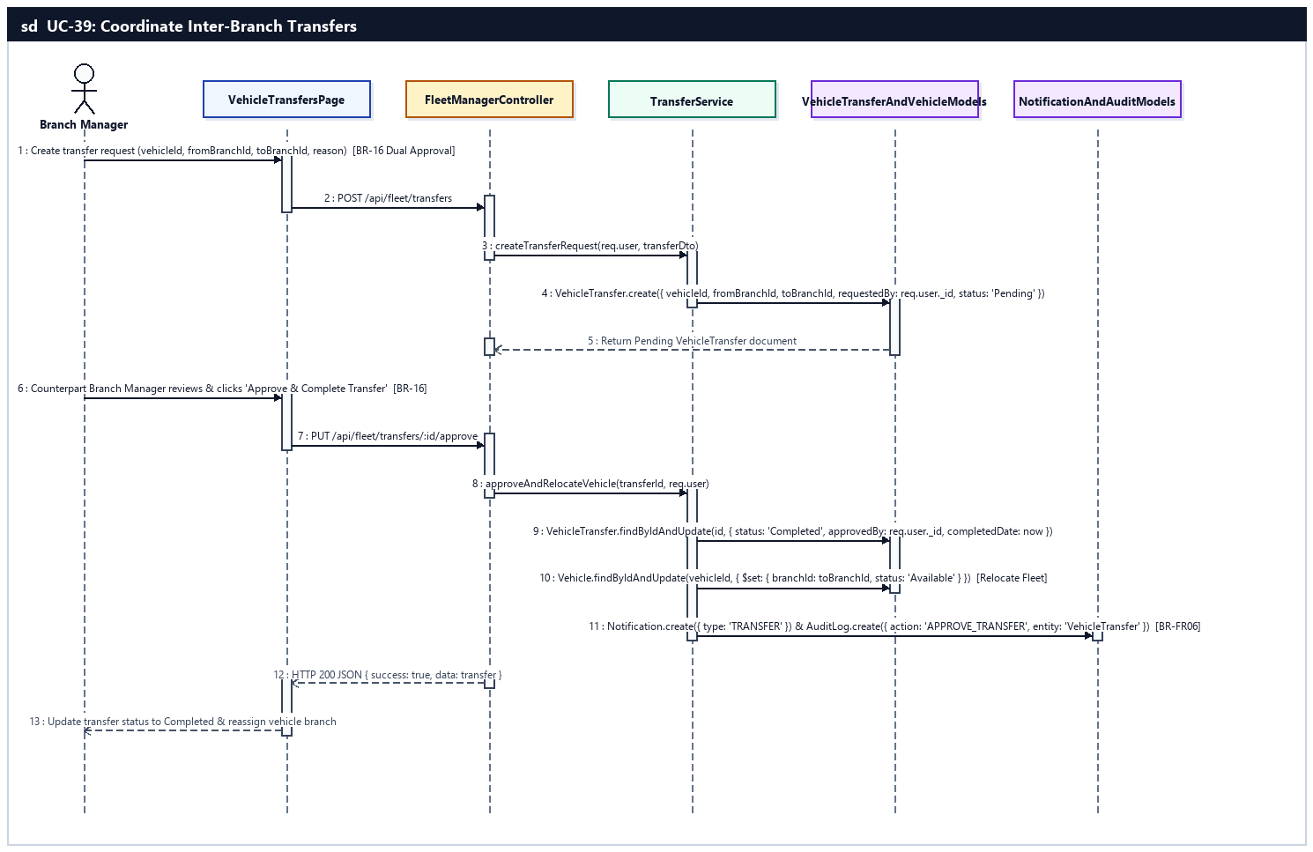
Sequence Diagram — UC-39: Coordinate Inter-Branch Transfers

UC-40: Provision & Update Staff Accounts
Branch Manager creates new Staff accounts, updates staff details, or deactivates staff within their assigned branch (BR-14, BR-FR05).
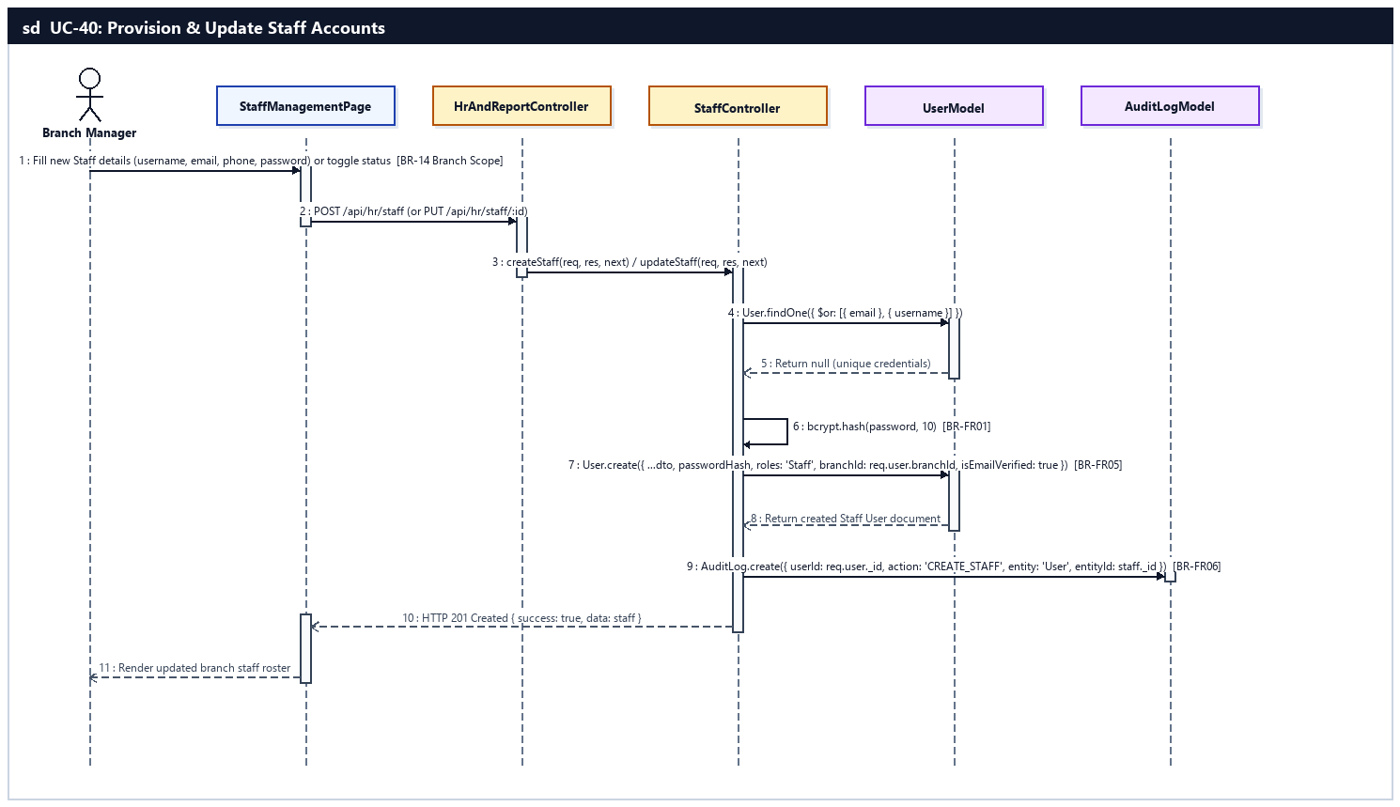
Sequence Diagram — UC-40: Provision & Update Staff Accounts

UC-41: Assign Work Shifts & Track Attendance
Branch Manager assigns shift schedule entries on the calendar and monitors staff clock-in/clock-out attendance.
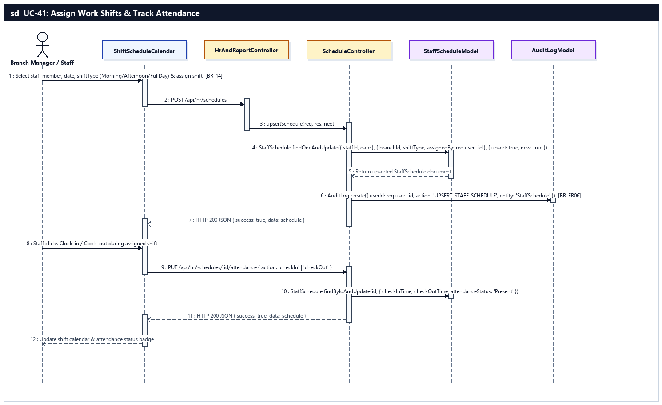
Sequence Diagram — UC-41: Assign Work Shifts & Track Attendance

UC-42: Generate & Export Branch Reports
Branch Manager resolves escalated complaints and generates daily/monthly/annual revenue, fleet utilization, breakdown frequency, and rating reports with Excel/PDF export.
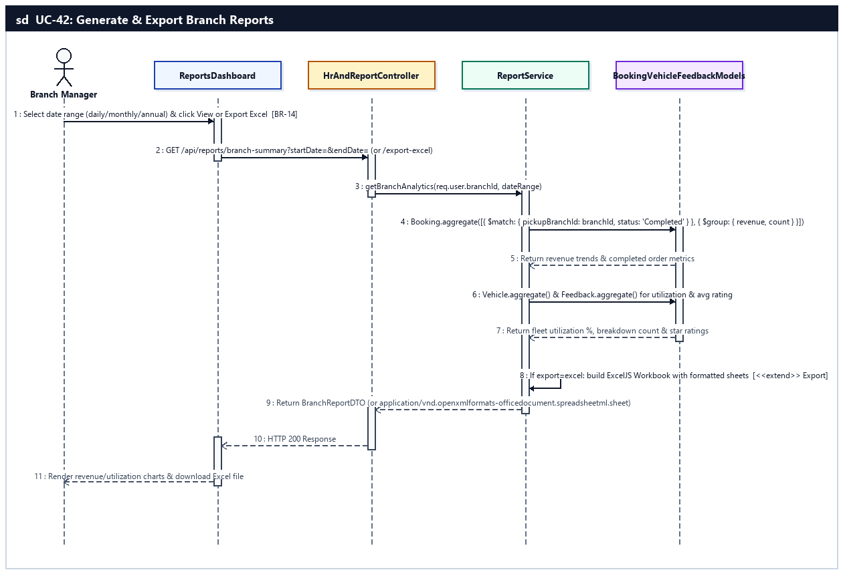
Sequence Diagram — UC-42: Generate & Export Branch Reports

d. Database Queries
UC-33 — Add New Vehicle:
// 1. Verify license plate is globally unique across all branches (BR-13)
const duplicate = await Vehicle.findOne({ licensePlate: licensePlate.trim().toUpperCase() }).lean();

// 2. Insert new Vehicle assigned to manager's branch (BR-14) and log audit trail
const vehicle = await Vehicle.create({
branchId: req.user.branchId,
category,
vehicleModel,
brand,
licensePlate: licensePlate.trim().toUpperCase(),
transmissionType,
fuelType,
dailyPrice,
hourlyPrice,
odometer,
maintenanceODOThreshold: maintenanceODOThreshold || 1500,
images,
status: 'Available',
isDeleted: false
});
await AuditLog.create({ userId: req.user._id, action: 'CREATE_VEHICLE', entity: 'Vehicle', entityId: vehicle._id.toString(), timestamp: new Date() });
UC-34 — Update & Decommission Vehicle:
// 1. Ensure vehicle has no active or upcoming bookings before decommissioning
const hasActiveBooking = await Booking.exists({
vehicleId,
status: { $in: ['Pending', 'Approved', 'Confirmed', 'Ongoing'] }
});

// 2. Soft-delete or update Vehicle within manager's branch
const updatedVehicle = await Vehicle.findOneAndUpdate(
{ _id: vehicleId, branchId: req.user.branchId, isDeleted: false },
{ $set: { ...updateDto, ...(isDecommission ? { isDeleted: true, status: 'Maintenance' } : {}) } },
{ new: true }
);
UC-35 — Configure Vehicle Rental Pricing:
// 1. Update base daily and hourly rates on Vehicle
const vehicle = await Vehicle.findOneAndUpdate(
{ _id: vehicleId, branchId: req.user.branchId },
{ $set: { dailyPrice: Number(dailyPrice), hourlyPrice: Number(hourlyPrice) } },
{ new: true }
);

// 2. Upsert seasonal/holiday pricing multiplier rule
const rule = await SeasonalPricingRule.findOneAndUpdate(
{ branchId: req.user.branchId, name: ruleName },
{ $set: { startDate, endDate, multiplier, isActive: true, createdBy: req.user._id } },
{ upsert: true, new: true }
);
UC-36 — Approve or Reject Rental Order:
// 1. Approve or Reject booking within manager's branch (BR-08, BR-14)
const updatedBooking = await Booking.findOneAndUpdate(
{ _id: bookingId, pickupBranchId: req.user.branchId, status: { $in: ['Pending', 'Confirmed'] } },
{
$set: {
status: isApprove ? 'Approved' : 'Cancelled',
approvedBy: req.user._id,
...(isApprove ? {} : { cancelReason: rejectReason, refundAmount: booking.paidAmount, refundStatus: booking.paidAmount > 0 ? 'Completed' : 'None' })
}
},
{ new: true }
);
UC-37 — Process Deposit Refund Requests:
// 1. Update refundStatus on Booking and log refund payment record
const booking = await Booking.findOneAndUpdate(
{ _id: bookingId, pickupBranchId: req.user.branchId, refundStatus: 'Requested' },
{
$set: {
refundStatus: decision === 'Approve' ? 'Completed' : 'Rejected',
refundNote: managerNote,
refundedAt: new Date(),
refundProcessedBy: req.user._id
}
},
{ new: true }
);
if (decision === 'Approve' && booking.refundAmount > 0) {
await Payment.create({ bookingId: booking._id, userId: booking.userId, amount: -booking.refundAmount, paymentMethod: 'VNPay', paymentType: 'Refund', status: 'Success' });
}
UC-38 — Schedule ODO Maintenance & Logs:
// 1. Flag vehicles exceeding ODO maintenance interval (1,500 km - BR-15)
await Vehicle.updateMany(
{ branchId: req.user.branchId, isDeleted: false, $expr: { $gte: ['$odometer', '$maintenanceODOThreshold'] } },
{ $set: { requiresMaintenance: true } }
);

// 2. Complete scheduled maintenance and reset requiresMaintenance flag
await MaintenanceLog.findByIdAndUpdate(logId, { $set: { status: 'Completed', completedAt: new Date(), cost: actualCost } });
await Vehicle.findByIdAndUpdate(vehicleId, {
$set: {
status: 'Available',
requiresMaintenance: false,
lastMaintenanceBucket: Math.floor(currentOdo / 1500)
}
});
UC-39 — Coordinate Inter-Branch Transfers:
// 1. Create inter-branch transfer request (BR-16)
const transfer = await VehicleTransfer.create({
vehicleId,
fromBranchId,
toBranchId,
requestedBy: req.user._id,
reason,
status: 'Pending'
});

// 2. Approve transfer and relocate Vehicle to destination branchId
const approvedTransfer = await VehicleTransfer.findByIdAndUpdate(
transferId,
{ $set: { status: 'Completed', approvedBy: req.user._id, transferDate: new Date() } },
{ new: true }
);
await Vehicle.findByIdAndUpdate(approvedTransfer.vehicleId, {
$set: { branchId: approvedTransfer.toBranchId, status: 'Available' }
});
UC-40 — Provision & Update Staff Accounts:
// 1. Create Staff account scoped to manager's branchId
const passwordHash = await bcrypt.hash(password, 10);
const staff = await User.create({
username,
email: email.toLowerCase(),
firstName,
lastName,
phoneNumber,
passwordHash,
roles: 'Staff',
branchId: req.user.branchId,
status: 'Active',
isEmailVerified: true,
identityStatus: 'Verified'
});
await AuditLog.create({ userId: req.user._id, action: 'CREATE_STAFF', entity: 'User', entityId: staff._id.toString(), timestamp: new Date() });
UC-41 — Assign Work Shifts & Track Attendance:
// 1. Upsert staff shift assignment on calendar
const schedule = await StaffSchedule.findOneAndUpdate(
{ staffId, date: normalizedDate },
{
$set: {
branchId: req.user.branchId,
shiftType,
assignedBy: req.user._id,
notes
}
},
{ upsert: true, new: true }
);

// 2. Record staff clock-in / clock-out attendance timestamp
await StaffSchedule.findByIdAndUpdate(scheduleId, {
$set: { checkInTime: new Date(), attendanceStatus: 'Present' }
});
UC-42 — Generate & Export Branch Reports:
// 1. Aggregate branch revenue and completed booking count by period
const revenueStats = await Booking.aggregate([
{ $match: { pickupBranchId: new mongoose.Types.ObjectId(branchId), status: 'Completed', createdAt: { $gte: startDate, $lte: endDate } } },
{ $group: { _id: { $dateToString: { format: '%Y-%m-%d', date: '$createdAt' } }, totalRevenue: { $sum: '$totalAmount' }, totalOrders: { $sum: 1 } } },
{ $sort: { _id: 1 } }
]);

// 2. Aggregate fleet utilization and maintenance breakdown frequency
const fleetStats = await Vehicle.aggregate([
{ $match: { branchId: new mongoose.Types.ObjectId(branchId), isDeleted: false } },
{ $group: { _id: '$status', count: { $sum: 1 } } }
]);

9. System Administration Feature (UC-43 .. UC-50)
Provides top-level System Administrators with chain-wide governance: adding, updating, and deactivating branches, provisioning Branch Manager accounts and RBAC permissions (BR-FR05), inspecting the system-wide AuditLog trail (BR-FR06), configuring vehicle categories and promotional discount vouchers, managing global policies (deposit %, cancellation rules, loyalty rate, multi-language locale), publishing homepage banners and static CMS pages, and analyzing chain KPIs with VNPay financial reconciliation and VAT tax exports.

a. Class Diagram
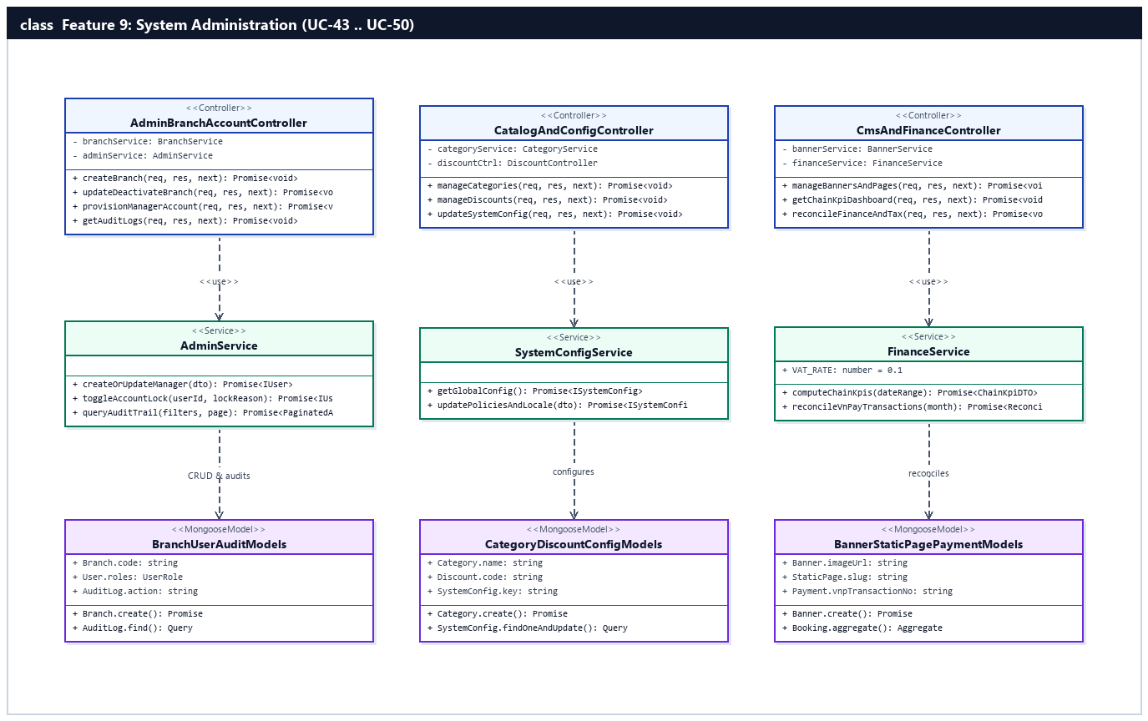
Figure 2.9.a: Class Diagram — System Administration Feature (UC-43 .. UC-50)

b. Class Specifications

AdminBranchAccountController Class
Controller managing chain-wide Branch CRUD, Branch Manager account provisioning, RBAC configuration, and AuditLog queries.
No | Method | Description
01 | createBranch(req, res, next) | Inputs: req.body (name, code, address, phone, email, latitude, longitude, openingHours, managerId). Outputs: HTTP 201 JSON { data: branch }. Processing: Creates Branch and links 1:1 BranchManager.
02 | updateDeactivateBranch(req, res, next) | Inputs: req.params.id, req.body. Outputs: HTTP 200 JSON. Processing: Updates branch metadata or toggles isActive=false.
03 | provisionManagerAccount(req, res, next) | Inputs: req.body (username, email, roles, branchId, status). Outputs: HTTP 200/201 JSON. Processing: Creates/updates Manager account or locks/unlocks violating user.
04 | getAuditLogs(req, res, next) | Inputs: req.query (action, entity, userId, startDate, endDate, page, limit). Outputs: HTTP 200 JSON { data: AuditLog[], pagination }. Processing: Queries system-wide AuditLog restricted to SystemAdmin.

CatalogAndConfigController Class
Controller managing vehicle Categories, Discount vouchers, and SystemConfig policies/locale.
No | Method | Description
01 | manageCategories(req, res, next) | Inputs: req.body (name, slug, description, defaultDailyRate, isActive). Outputs: HTTP 200/201 JSON. Processing: Creates, updates, or deactivates vehicle Category.
02 | manageDiscounts(req, res, next) | Inputs: req.body (code, discountPercent, maxDiscountAmount, minOrderValue, startDate, endDate, usageLimit). Outputs: HTTP 200/201 JSON. Processing: Manages promotional voucher codes.
03 | updateSystemConfig(req, res, next) | Inputs: req.body (depositPercent, cancellationFreeHours, lateFeePerHour, loyaltyVndPerPoint, i18n). Outputs: HTTP 200 JSON. Processing: Updates global SystemConfig document.

CmsAndFinanceController Class
Controller managing homepage promotional Banners, StaticPages, chain-wide KPI dashboards, and VNPay financial/tax reconciliation.
No | Method | Description
01 | manageBannersAndPages(req, res, next) | Inputs: BannerDTO / StaticPageDTO. Outputs: HTTP 200/201 JSON. Processing: Creates, updates, or deletes Banner and sanitized StaticPage entries.
02 | getChainKpiDashboard(req, res, next) | Inputs: req.query (startDate, endDate). Outputs: HTTP 200 JSON. Processing: Computes chain-wide revenue trends, branch comparisons, and seasonal demand forecasts.
03 | reconcileFinanceAndTax(req, res, next) | Inputs: req.query (month, year). Outputs: HTTP 200 JSON / Excel tax report. Processing: Cross-checks VNPay Payment records against Booking totals and computes 10% VAT.

AdminService Class
Service in server/src/modules/admin/adminService.ts handling manager account provisioning, account lock/unlock, and audit log filtering.
No | Method | Description
01 | createOrUpdateManager(adminUser, dto) | Inputs: adminUser, ManagerAccountDTO. Outputs: Promise<IUser>. Processing: Creates/updates User with roles='BranchManager', links Branch.managerId, and records AuditLog.
02 | queryAuditTrail(filters, pagination) | Inputs: AuditFilterDTO, PaginationDTO. Outputs: Promise<PaginatedAuditLogs>. Processing: Executes indexed query on AuditLog populated with userId.

FinanceService Class
Service in server/src/modules/finance/financeService.ts computing chain-wide financial KPIs, VNPay settlement reconciliation, and tax reports.
No | Method | Description
01 | computeChainKpis(dateRange) | Inputs: { startDate, endDate }. Outputs: Promise<ChainKpiDTO>. Processing: Aggregates revenue, booking volume, fleet utilization, and branch rankings across all branches.
02 | reconcileVnPayTransactions(month, year) | Inputs: month, year. Outputs: Promise<ReconcileReportDTO>. Processing: Matches Payment(paymentMethod='VNPay') with Booking.paidAmount and calculates 10% VAT liability.

c. Sequence Diagram(s) — (1 Sequence Diagram per Use Case)

UC-43: Add New Branch
System Admin creates a new branch with name, unique code, address, GPS coordinates, operating hours, and assigned Branch Manager.
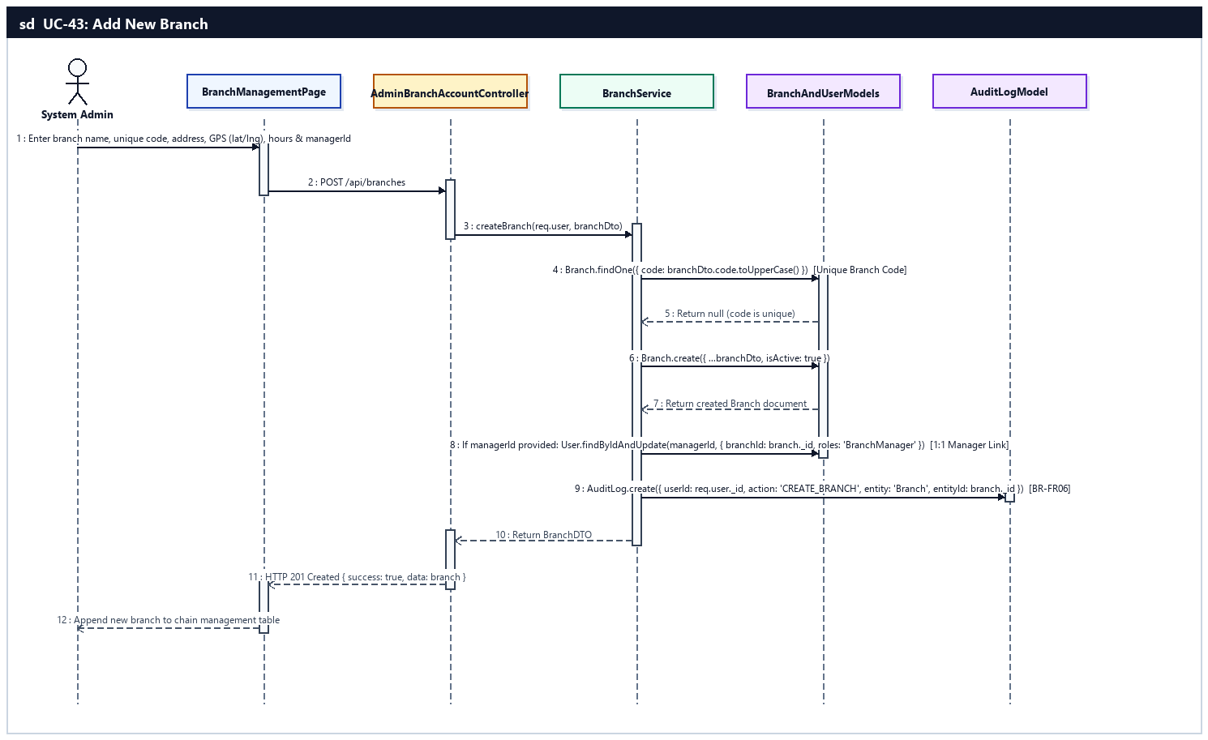
Sequence Diagram — UC-43: Add New Branch

UC-44: Update & Deactivate Branch
System Admin updates branch details, reassigns managers, or deactivates a branch (isActive=false).
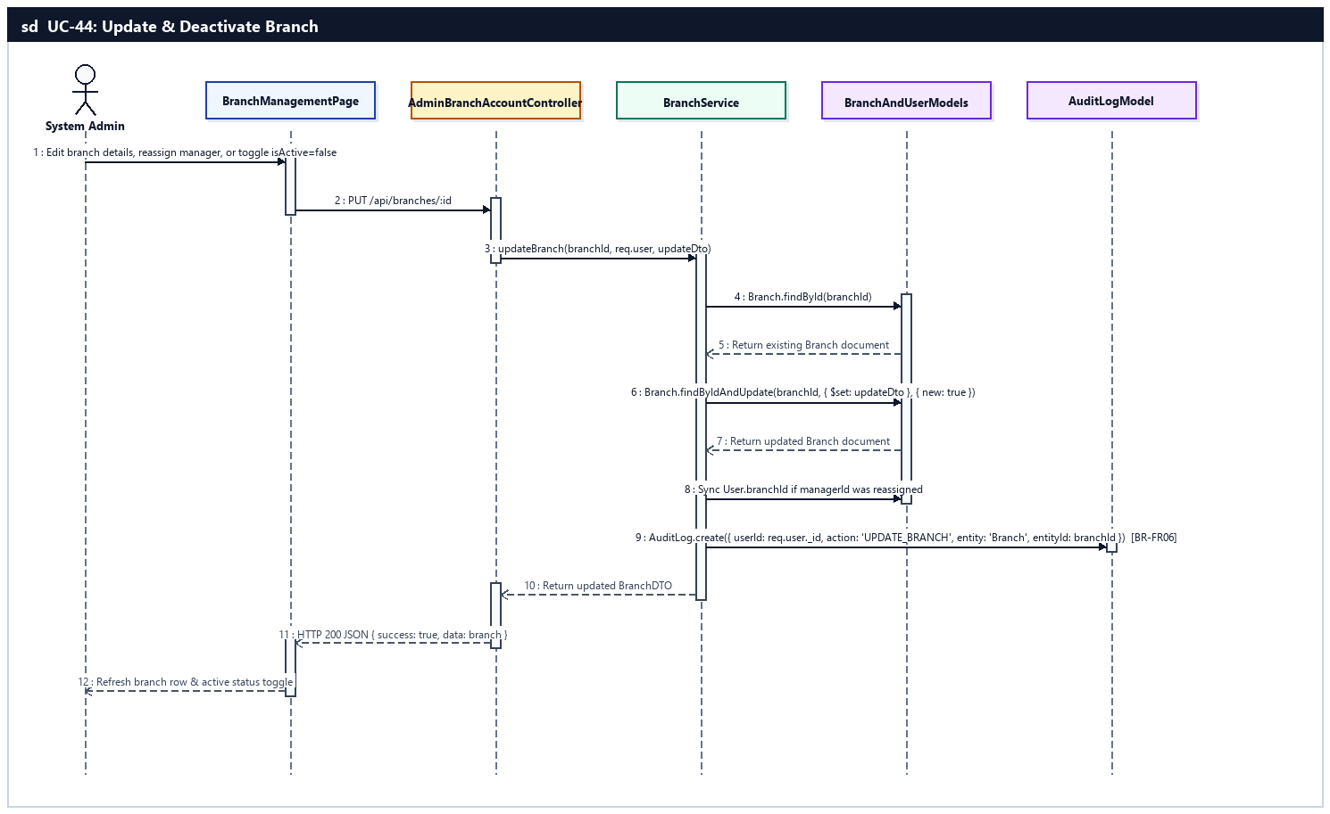
Sequence Diagram — UC-44: Update & Deactivate Branch

UC-45: Provision Manager Accounts & RBAC
System Admin creates/updates/deactivates Branch Manager accounts, configures RBAC permissions, and locks/unlocks violating accounts (BR-FR05, BR-FR06).
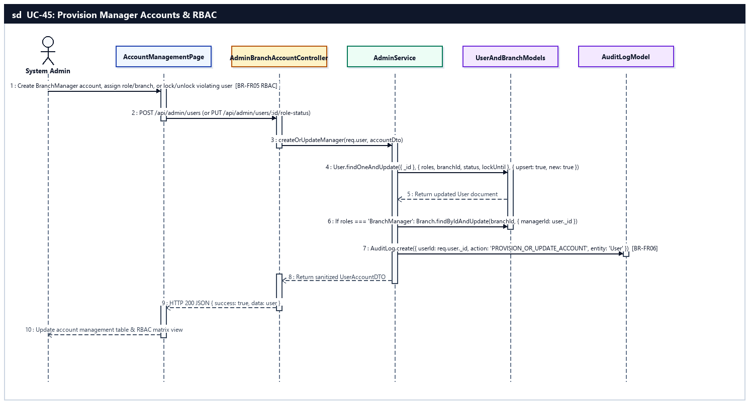
Sequence Diagram — UC-45: Provision Manager Accounts & RBAC

UC-46: Inspect System Audit Logs
System Admin searches, filters, and audits the system-wide security and CRUD activity trail in AuditLog (BR-FR06).
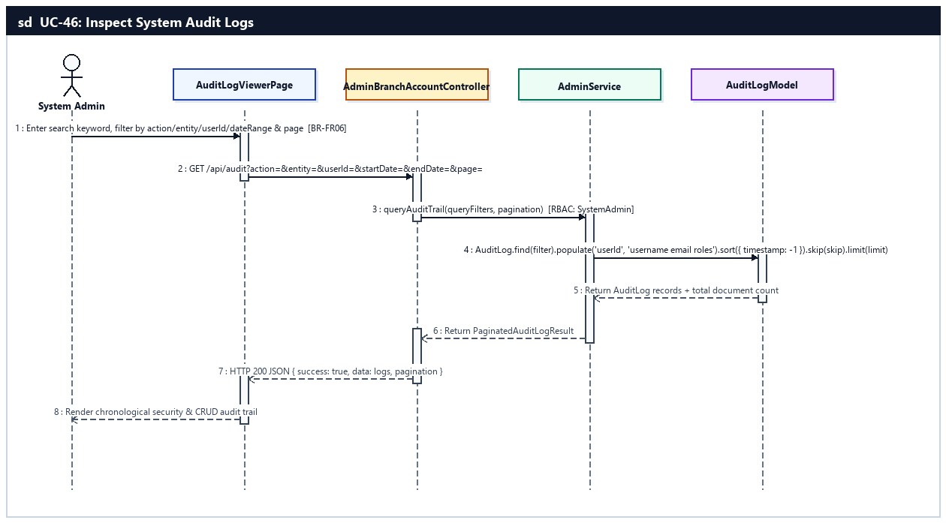
Sequence Diagram — UC-46: Inspect System Audit Logs

UC-47: Configure Vehicle Categories & Promos
System Admin creates, updates, and deactivates vehicle categories (Scooter, Manual, Semi-Auto, Electric) and promotional discount voucher codes.
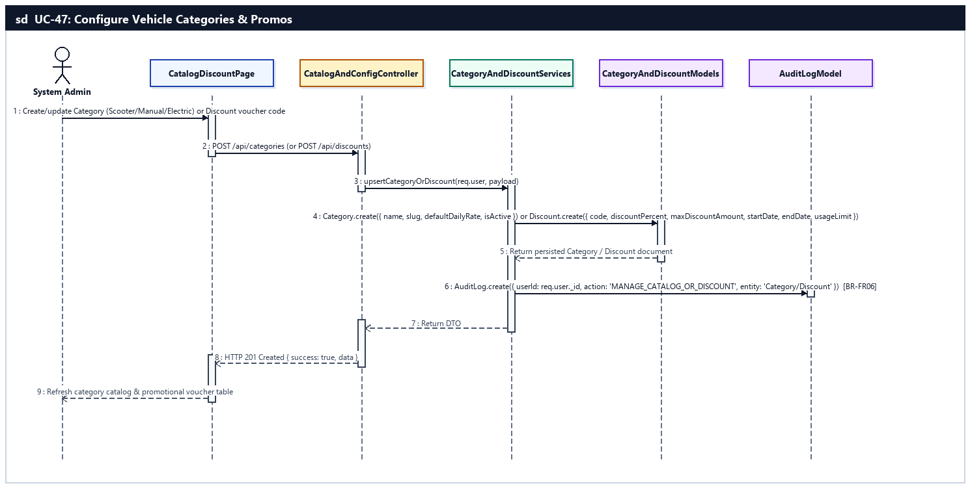
Sequence Diagram — UC-47: Configure Vehicle Categories & Promos

UC-48: Configure System Policies & Locale
System Admin configures cancellation/refund rules, default deposit %, loyalty program rules, and multi-language settings.
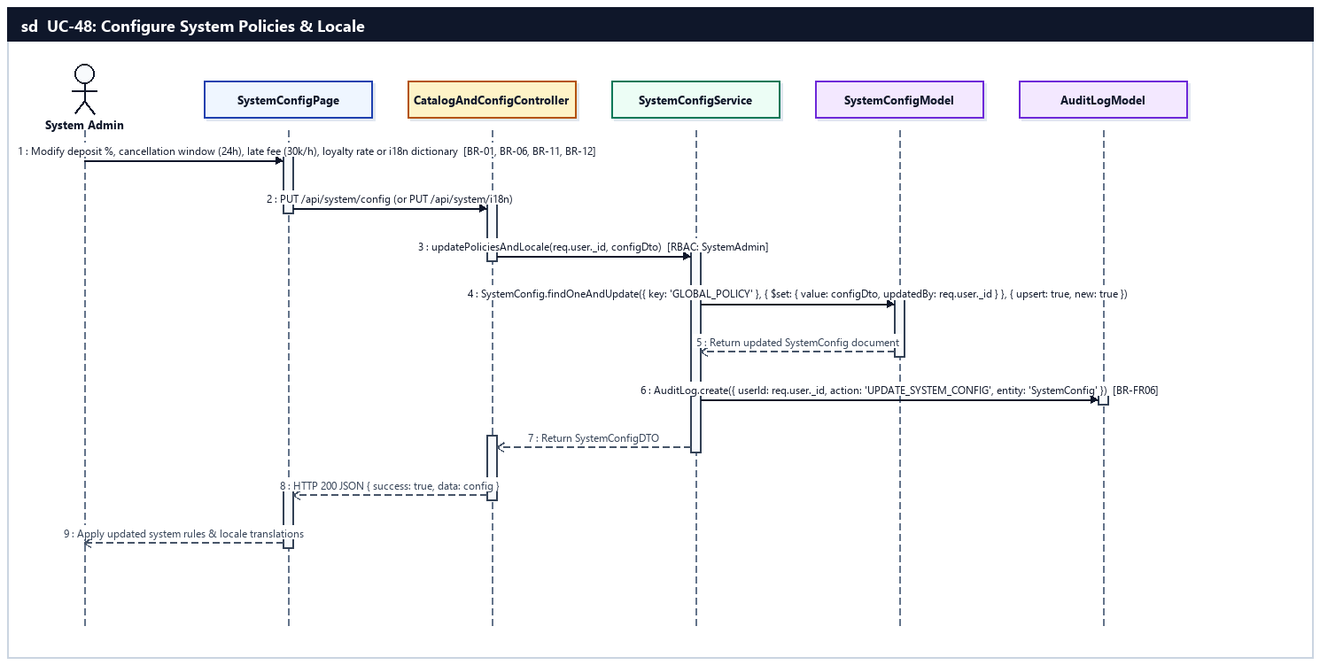
Sequence Diagram — UC-48: Configure System Policies & Locale

UC-49: Publish Promotional Banners & Pages
System Admin creates, updates, and deletes homepage promotional banners and static pages (FAQ, Terms of Service, Privacy Policy).
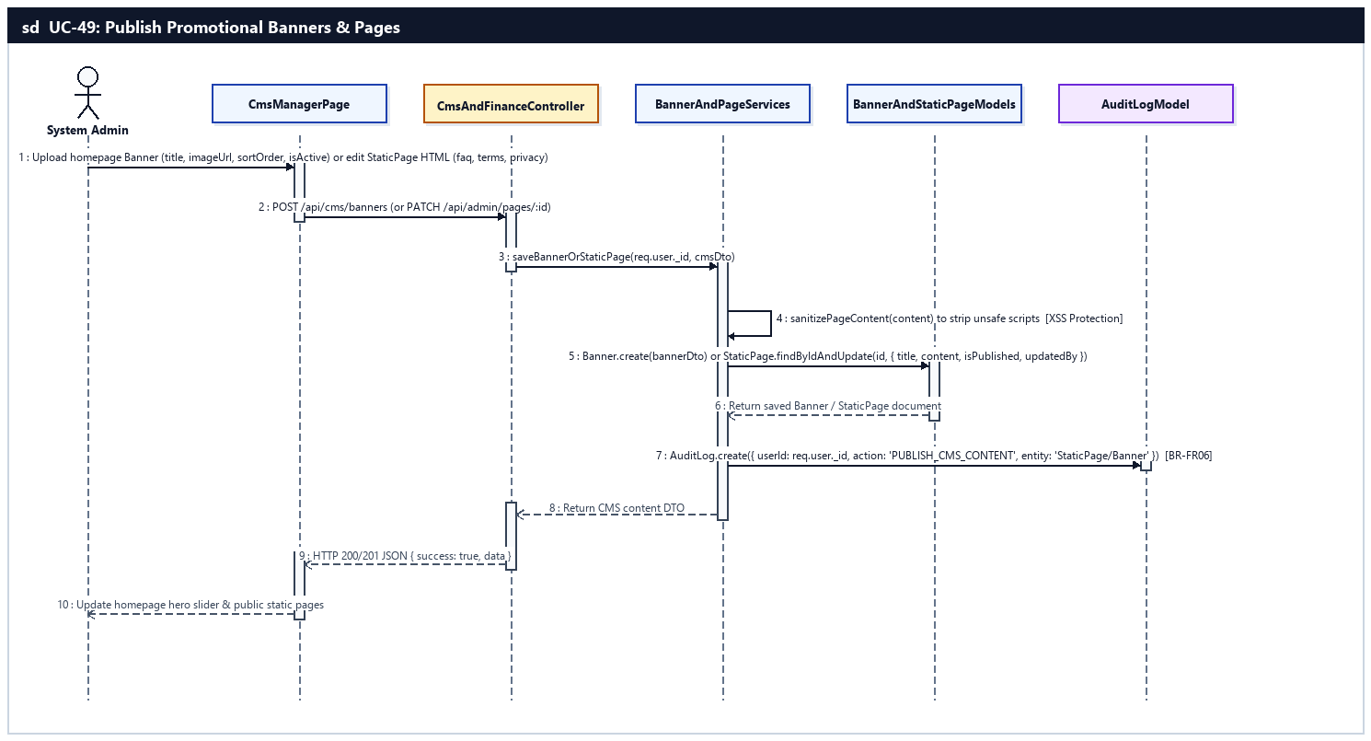
Sequence Diagram — UC-49: Publish Promotional Banners & Pages

UC-50: Analyze Chain KPIs & Reconcile Finance
System Admin analyzes chain-wide revenue KPIs, branch comparisons, and seasonal demand forecasts; reconciles VNPay payments and exports tax reports.
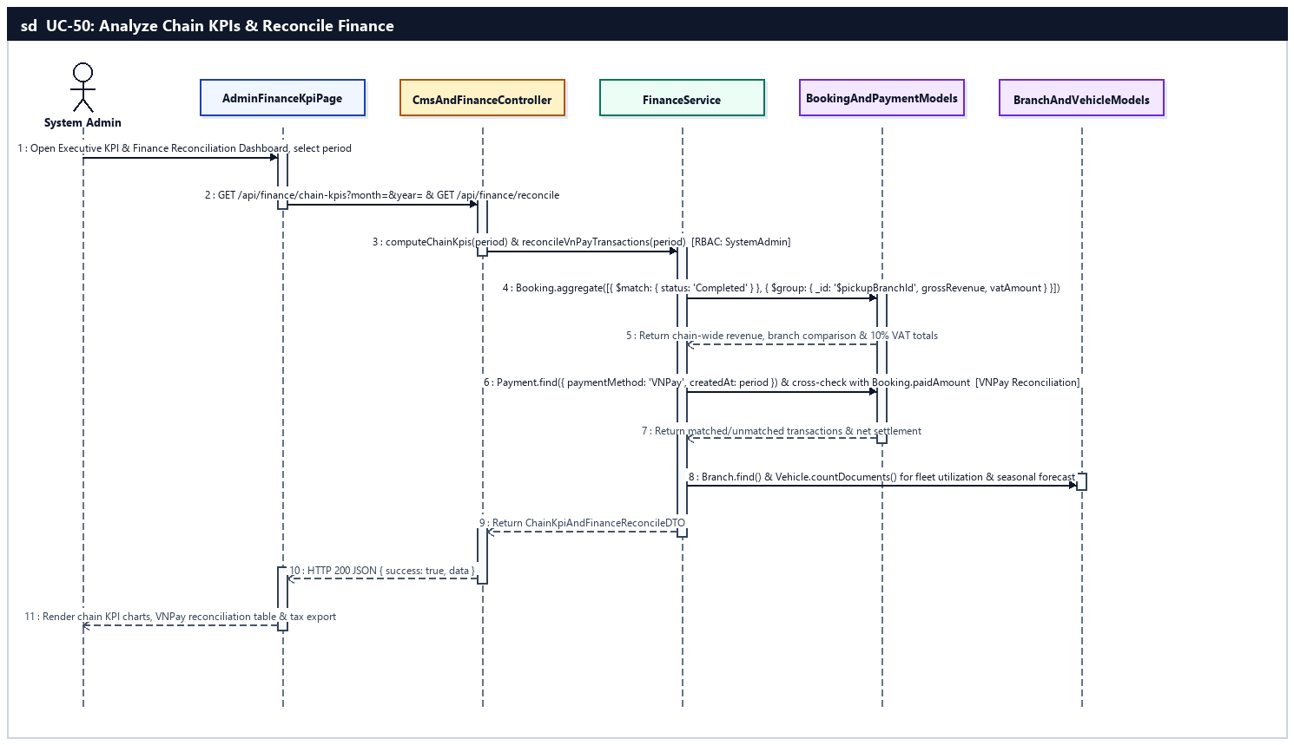
Sequence Diagram — UC-50: Analyze Chain KPIs & Reconcile Finance

d. Database Queries
UC-43 — Add New Branch:
// 1. Verify branch code uniqueness and create Branch
const existing = await Branch.findOne({ code: code.trim().toUpperCase() }).lean();
const branch = await Branch.create({
name,
code: code.trim().toUpperCase(),
address,
phone,
email,
latitude,
longitude,
openingHours,
managerId: managerId || null,
isActive: true
});

// 2. Bind assigned Branch Manager (1:1 relationship) and write AuditLog
if (managerId) {
await User.findByIdAndUpdate(managerId, { $set: { branchId: branch._id, roles: 'BranchManager' } });
}
await AuditLog.create({ userId: req.user._id, action: 'CREATE_BRANCH', entity: 'Branch', entityId: branch._id.toString(), timestamp: new Date() });
UC-44 — Update & Deactivate Branch:
// 1. Update Branch metadata or deactivate (isActive = false)
const updatedBranch = await Branch.findByIdAndUpdate(
branchId,
{ $set: { name, address, phone, email, latitude, longitude, openingHours, managerId, isActive } },
{ new: true, runValidators: true }
);
await AuditLog.create({ userId: req.user._id, action: 'UPDATE_BRANCH', entity: 'Branch', entityId: branchId, timestamp: new Date() });
UC-45 — Provision Manager Accounts & RBAC:
// 1. Provision or update BranchManager account and link to Branch
const manager = await User.findOneAndUpdate(
{ email: email.toLowerCase() },
{ $set: { username, firstName, lastName, phoneNumber, roles: 'BranchManager', branchId, status, isEmailVerified: true } },
{ upsert: true, new: true }
);
await Branch.findByIdAndUpdate(branchId, { $set: { managerId: manager._id } });

// 2. Lock or unlock violating user account
await User.findByIdAndUpdate(targetUserId, {
$set: { status: isLock ? 'Locked' : 'Active', lockUntil: isLock ? new Date(Date.now() + 365 * 24 * 3600 * 1000) : null }
});
await AuditLog.create({ userId: req.user._id, action: isLock ? 'LOCK_ACCOUNT' : 'UNLOCK_ACCOUNT', entity: 'User', entityId: targetUserId, timestamp: new Date() });
UC-46 — Inspect System Audit Logs:
// 1. Query filtered and paginated system audit trail
const filter = {
...(action ? { action } : {}),
...(entity ? { entity } : {}),
...(userId ? { userId: new mongoose.Types.ObjectId(userId) } : {}),
...(startDate || endDate ? { timestamp: { ...(startDate ? { $gte: new Date(startDate) } : {}), ...(endDate ? { $lte: new Date(endDate) } : {}) } } : {})
};
const [logs, total] = await Promise.all([
AuditLog.find(filter).populate('userId', 'username email firstName lastName roles').sort({ timestamp: -1 }).skip(skip).limit(limit).lean(),
AuditLog.countDocuments(filter)
]);
UC-47 — Configure Vehicle Categories & Promos:
// 1. Create or update vehicle Category
const category = await Category.findOneAndUpdate(
{ slug },
{ $set: { name, slug, description, iconSvg, isActive } },
{ upsert: true, new: true }
);

// 2. Create or update promotional Discount voucher
const discount = await Discount.create({
code: code.trim().toUpperCase(),
description,
discountPercent,
discountAmount,
maxDiscountAmount,
minOrderValue,
startDate,
endDate,
usageLimit,
isActive: true
});
await AuditLog.create({ userId: req.user._id, action: 'CREATE_DISCOUNT', entity: 'Discount', entityId: discount._id.toString(), timestamp: new Date() });
UC-48 — Configure System Policies & Locale:
// 1. Upsert global policy configuration in SystemConfig
const config = await SystemConfig.findOneAndUpdate(
{ key: 'GLOBAL_SYSTEM_POLICY' },
{
$set: {
value: {
depositPercent: 30,
oneWaySurchargeVnd: 50000,
lateFeePerHourVnd: 30000,
freeCancelHoursBeforePickup: 24,
loyaltyVndPerPoint: 10000,
maintenanceOdoIntervalKm: 1500,
supportedLocales: ['vi', 'en']
},
updatedBy: req.user._id
}
},
{ upsert: true, new: true }
);
await AuditLog.create({ userId: req.user._id, action: 'UPDATE_SYSTEM_CONFIG', entity: 'SystemConfig', entityId: config._id.toString(), timestamp: new Date() });
UC-49 — Publish Promotional Banners & Pages:
// 1. Create or update homepage promotional Banner
const banner = await Banner.create({
title,
subtitle,
imageUrl,
linkUrl,
displayOrder,
isActive: true
});

// 2. Update CMS StaticPage with sanitized HTML content
const page = await StaticPage.findByIdAndUpdate(
pageId,
{ $set: { title: title.trim(), content: sanitizePageContent(content), type, isPublished: Boolean(isPublished), updatedBy: req.user._id } },
{ new: true }
);
await AuditLog.create({ userId: req.user._id, action: 'UPDATE_STATIC_PAGE', entity: 'StaticPage', entityId: pageId, timestamp: new Date() });
UC-50 — Analyze Chain KPIs & Reconcile Finance:
// 1. Chain-wide revenue KPI and branch comparison aggregation
const branchComparison = await Booking.aggregate([
{ $match: { status: 'Completed', createdAt: { $gte: startDate, $lte: endDate } } },
{
$group: {
_id: '$pickupBranchId',
grossRevenue: { $sum: '$totalAmount' },
netRevenue: { $sum: { $subtract: ['$totalAmount', { $ifNull: ['$discountAmount', 0] }] } },
vatLiability: { $sum: { $multiply: ['$totalAmount', 0.1] } },
completedOrders: { $sum: 1 }
}
},
{ $lookup: { from: 'branches', localField: '_id', foreignField: '_id', as: 'branch' } },
{ $unwind: '$branch' },
{ $sort: { grossRevenue: -1 } }
]);

// 2. Reconcile VNPay IPN Payment records against Booking paidAmount
const vnpayPayments = await Payment.find({
paymentMethod: 'VNPay',
status: 'Success',
createdAt: { $gte: startDate, $lte: endDate }
}).populate('bookingId', 'bookingCode totalAmount depositAmount paidAmount status').lean();

