
TRƯỜNG ĐẠI HỌC FPT
MOTORENT - MOTORBIKE RENTAL CHAIN MANAGEMENT SYSTEM
Final Release Document
– Danang, November 2026 –

Table of Contents
I. Deliverable Package
II. Installation Guides
III. User Manual
1. Overview
2. User Manual Guide for Guest
2.1. Search & Filter Motorbike Fleet (UC-02)
2.2. View Branch Locations on Interactive GPS Map (UC-01, UC-13)
2.3. View Motorbike Details, Specs & Rental Policy (UC-03, UC-04)
2.4. Register New Account & Verify Email OTP (UC-05)
3. User Manual Guide for User (Common Account & Security)
3.1. Login by Email/Password & Login by Google OAuth 2.0 (UC-06, UC-08)
3.2. Forgot Password & Password Recovery Link/OTP (UC-07)
3.3. Change Account Password (UC-11)
3.4. View & Edit Personal Profile & Avatar (UC-09)
3.5. Submit eKYC Identity Verification — CCCD & Driving License (UC-10)
4. User Manual Guide for Customer (Booking, VNPay, Trip Management & Loyalty)
4.1. Bookmark Favorite Vehicles in Wishlist (UC-12)
4.2. Single Motorbike Booking Wizard (UC-14)
4.3. Multi-Vehicle Cart & Pay 30% Deposit via VNPay Sandbox (UC-14, UC-15)
4.4. Manage My Bookings, Extend Trip, Cancel Order & Download PDF (UC-16, UC-17, UC-18, UC-19)
4.5. Submit & Track Service Complaints (UC-21)
4.6. View Loyalty Points, Referral Code & Redeem Vouchers (UC-24, UC-25)
5. User Manual Guide for Staff (Counter Desk Operations)
5.1. Manage Branch Queue, 5-Point Check-in Handover & Cross-Branch Check-out (UC-26, UC-27, UC-28, UC-29)
5.2. Receive & Respond to Customer Complaints (UC-31, UC-32)
6. User Manual Guide for Branch Manager & System Admin
6.1. Monitor Branch Operations & Fleet KPI Dashboard (UC-36, UC-37)
6.2. Manage Branch Vehicles & Rental Pricing (UC-33, UC-34, UC-35)
6.3. Schedule ODO Maintenance & Inter-Branch Vehicle Transfers (UC-30, UC-38, UC-39)
6.4. Analyze Branch Financial Reports & Export Excel / PDF (UC-42)
6.5. System Admin — Manage Branches & Global System Configuration (UC-43, UC-44, UC-48, UC-50)
6.6. System Admin — Manage Users, Roles & Ban/Unban Accounts (UC-45)
6.7. System Admin — Manage Vehicle Categories & Homepage CMS Banners (UC-47, UC-49)
6.8. System Admin — Inspect Security Audit Logs & 4-Role RBAC Matrix (UC-45, UC-46)
IV. Team Member Contributions

I. Deliverable Package
No. | File | Notes
1 | Group4_MotoRent_DB_final (server/src/seeders/seed.ts) | Database, including 18-collection Mongoose schema structures and seed data
2 | Group4_MotoRent_RDS_final.docx (MOTORENT_RDS_Final.docx) | Final RDS (Requirement & Design) Document covering all 50 UCs, 50 UI Screens, and MSG01–MSG26
3 | Group4_MotoRent_SDS_final.docx (MOTORENT_SDS_Final.docx) | Final SDS (Software Design Specification) Document with Package, ER, Class & 50 Sequence Diagrams
4 | Group4_MotoRent_Project_Tracking.xlsx (MOTORENT_Project_Tracking.xlsx) | Final status for all 50 application functions across Project, Iter1, Iter2, Iter3, Iter4 & Effort Distribution
5 | Group4_MotoRent_Issues Report.xlsx (MOTORENT_Issues_Report.xlsx) | Final GitHub issues tracking list of the whole project (160 live GitHub Issues #6–#165 across iter1–iter4)
6 | Group4_MotoRent_Contribution_Report.docx (MOTORENT_Bang_Dong_Gop_Thanh_Vien.docx) | Detailed Team Member Contribution Report across Project Codebase, Git Commits, and Documentation (SRS, RDS, SDS, Release, Tracking)
Other related deliverables:
• Tagged source codes & GitHub Issues: https://github.com/Hoang-124/Motorent

II. Installation Guides
Set up Visual Studio Code, Git, Node.js (>= 20 LTS), and MongoDB Community Server >= 7.0:
1. Clone repository from GitHub: git clone https://github.com/Hoang-124/Motorent.git
2. Install backend & frontend dependencies: cd server && npm install && cd ../client && npm install
3. Configure server/.env (MONGODB_URI, JWT_SECRET, VNP_TMNCODE, VNP_HASHSECRET, GOOGLE_CLIENT_ID) and client/.env (VITE_API_URL, VITE_GOOGLE_CLIENT_ID).
4. Seed sample database: npm run seed
5. Start backend & frontend servers: npm run dev (Backend on http://localhost:5000, Frontend on http://localhost:5173).

III. User Manual

1. Overview
The MOTORENT platform digitizes motorbike rental chain operations across Da Nang City (Da Nang International Airport and My Khe Beach). It connects Guests, Customers, Counter Staff, Branch Managers, and System Administrators with online 30% VNPay deposits, multi-vehicle cart reservations, eKYC verification without holding original IDs, 5-point counter check-in, free cross-branch returns, and automated 3,000 km ODO maintenance alerts.

2. User Manual Guide for Guest

2.1. Search & Filter Motorbike Fleet (UC-02)
Step 1: Open http://localhost:5173/bikes ('Đội xe & Bảng giá') and use the top filter panel to filter by Keyword ('Tìm theo mẫu xe hoặc biển số'), Brand ('Hãng xe'), Daily Price range ('Giá ngày từ / Đến'), Vehicle Category ('Tất cả xe', 'Xe tay ga', 'Xe máy điện', 'Xe số', 'Xe 50cc', 'Xe côn tay'), or Pickup Station ('Tất cả trạm Đà Nẵng', 'Chi nhánh Sân Bay Quốc Tế Đà Nẵng', 'Chi nhánh Bãi Biển Mỹ Khê').
Step 2: Inspect the matching motorbike cards showing availability badge ('Sẵn sàng tại trạm'), license plate, 3-angle photo switcher ('Góc ngang', 'Góc trước', 'Góc sau'), and click any motorbike card to view details.
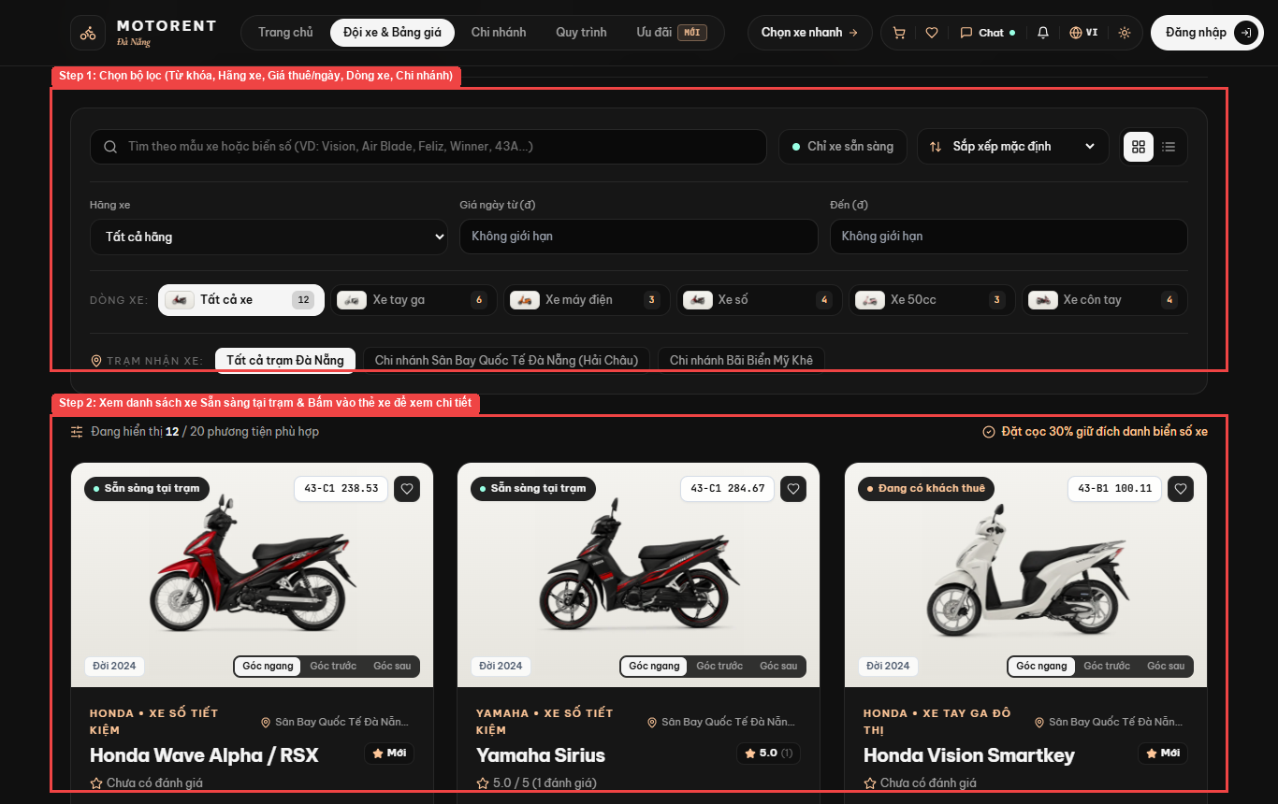
Figure 3.1: Live Project Screen — 2.1. Search & Filter Motorbike Fleet (UC-02)

2.2. View Branch Locations on Interactive GPS Map (UC-01, UC-13)
Step 1: Click [Chi nhánh] on the top navigation bar to open http://localhost:5173/branches.
Step 2a: Toggle between [Danh sách trạm] and [Bản đồ tương tác GPS] to view station pins on the interactive map.
Step 2b: Click [Tìm trạm gần tôi nhất] to sort stations by real-time Haversine GPS distance from your location.
Step 3: Review station details, operating hours, hotline numbers, and live available motorbike counts for Trạm 01 CN-DAD (Sân Bay Quốc Tế Đà Nẵng) and Trạm 02 CN-MK (Bãi Biển Mỹ Khê).
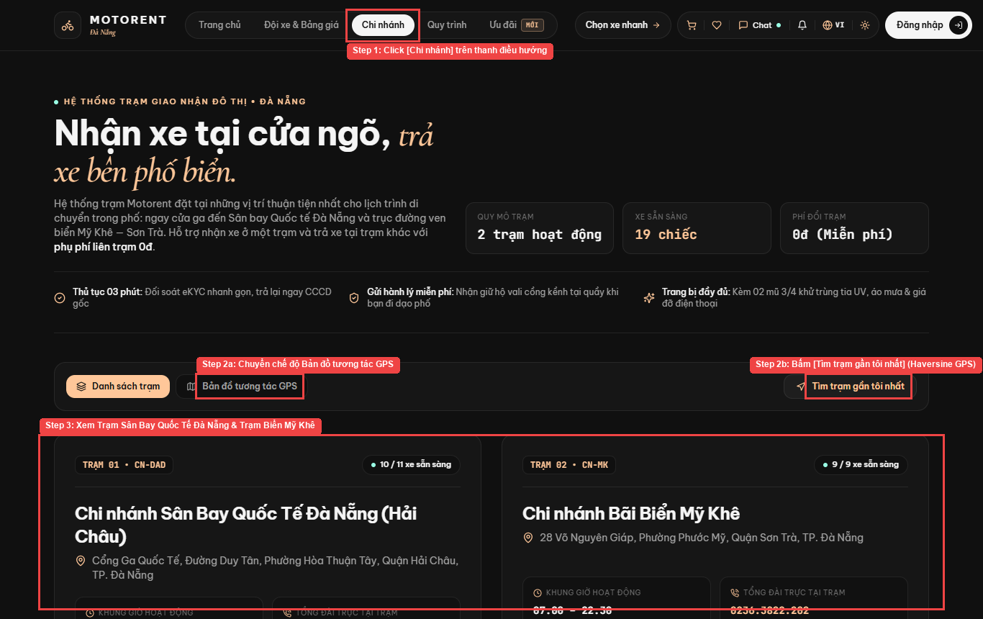
Figure 3.2: Live Project Screen — 2.2. View Branch Locations on Interactive GPS Map (UC-01, UC-13)

2.3. View Motorbike Details, Specs & Rental Policy (UC-03, UC-04)
Step 1: On the Vehicle Detail screen ('/bikes/:vehicleId'), switch between the 4-angle inspection photos and review verified customer ratings.
Step 2: Inspect the daily rate ('Thuê theo ngày'), hourly rate ('Thuê theo giờ'), station address, ODO reading, fuel type, and transmission type.
Step 3: Click [Chọn thời gian và đặt xe] to proceed to the Booking Wizard, or click [+ Thêm vào giỏ xe] to add the motorbike to the Multi-Vehicle Cart.
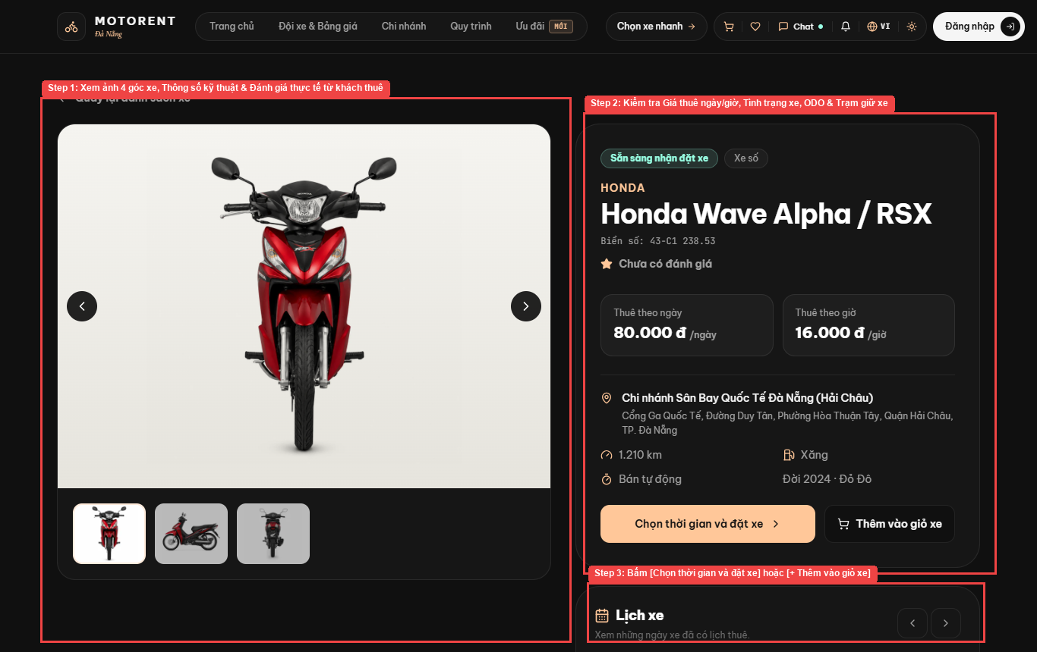
Figure 3.3: Live Project Screen — 2.3. View Motorbike Details, Specs & Rental Policy (UC-03, UC-04)

2.4. Register New Account & Verify Email OTP (UC-05)
Step 1: Open http://localhost:5173/register and fill in Username ('Tên đăng nhập *'), Email ('Email *'), Last & Middle Name ('Họ và tên đệm'), First Name ('Tên'), Mobile Phone ('Số điện thoại di động'), Password ('Mật khẩu *'), and Confirm Password ('Xác nhận mật khẩu *').
Step 2: Click [Đăng ký tài khoản] to receive a 6-digit OTP via email and activate your account.
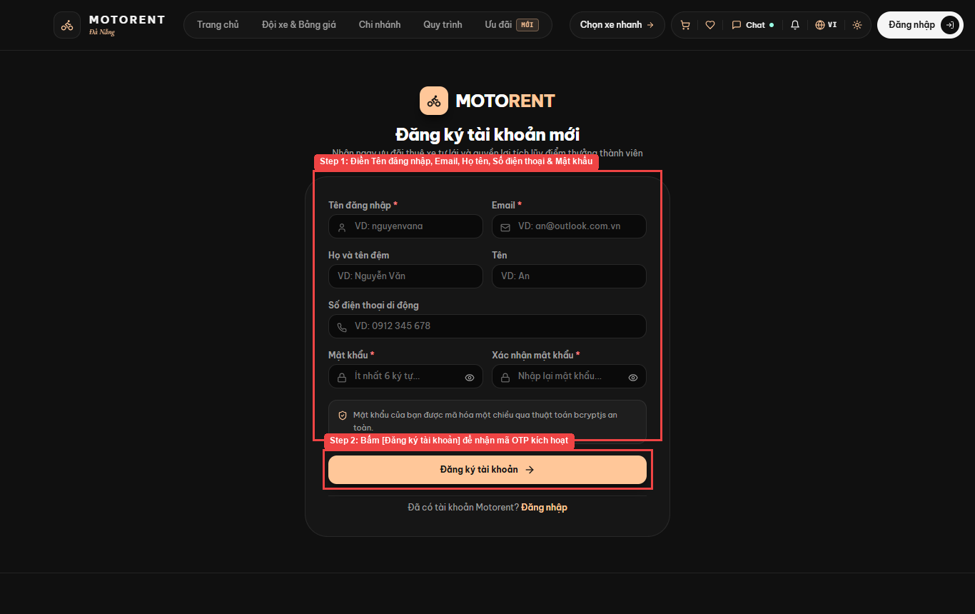
Figure 3.4: Live Project Screen — 2.4. Register New Account & Verify Email OTP (UC-05)

3. User Manual Guide for User (Common Account & Security)

3.1. Login by Email/Password & Login by Google OAuth 2.0 (UC-06, UC-08)
Step 1a: Open http://localhost:5173/login and enter your Username or Email ('Tên đăng nhập hoặc Email') and Password ('Mật khẩu').
Step 1b: Click [Đăng nhập hệ thống] to sign in.
Step 2: Alternatively, click [Đăng nhập bằng Google] for 1-click Google OAuth 2.0 authentication. To log out at any time, click your account badge in the top-right header and choose [Đăng xuất].
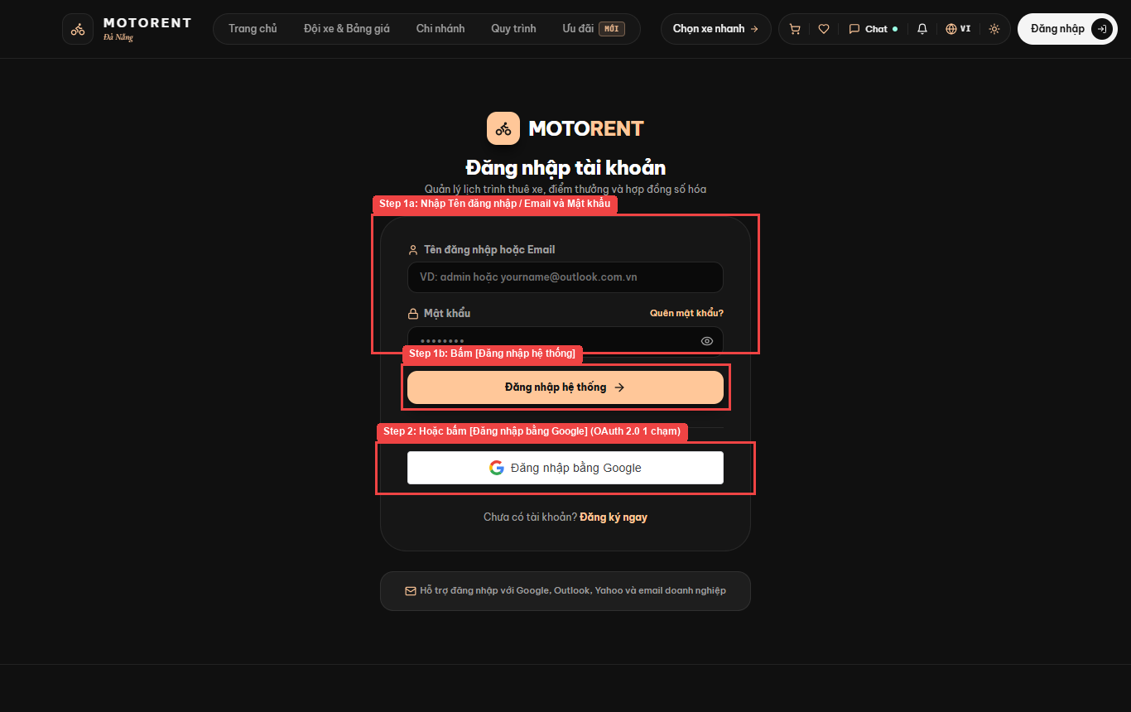
Figure 3.5: Live Project Screen — 3.1. Login by Email/Password & Login by Google OAuth 2.0 (UC-06, UC-08)

3.2. Forgot Password & Password Recovery Link/OTP (UC-07)
Step 1: On the Login screen, click [Quên mật khẩu?] to open http://localhost:5173/forgot-password, enter your registered email address in 'Địa chỉ Email tài khoản', and click [Gửi liên kết khôi phục] to reset your password.
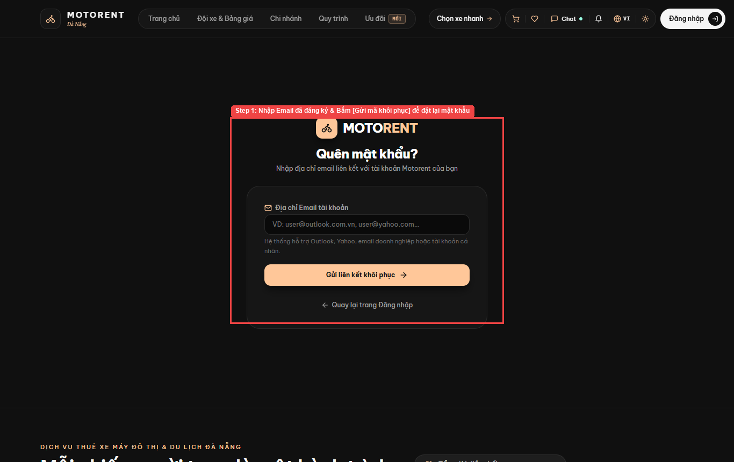
Figure 3.6: Live Project Screen — 3.2. Forgot Password & Password Recovery Link/OTP (UC-07)

3.3. Change Account Password (UC-11)
Step 1: Open http://localhost:5173/profile and click tab [06 Đổi mật khẩu].
Step 2: In the 'Đổi mật khẩu bảo mật' form, enter your Current Password ('Mật khẩu hiện tại *'), New Password ('Mật khẩu mới *', minimum 8 characters), and Confirm New Password ('Xác nhận mật khẩu mới *'), then click [Cập nhật mật khẩu].
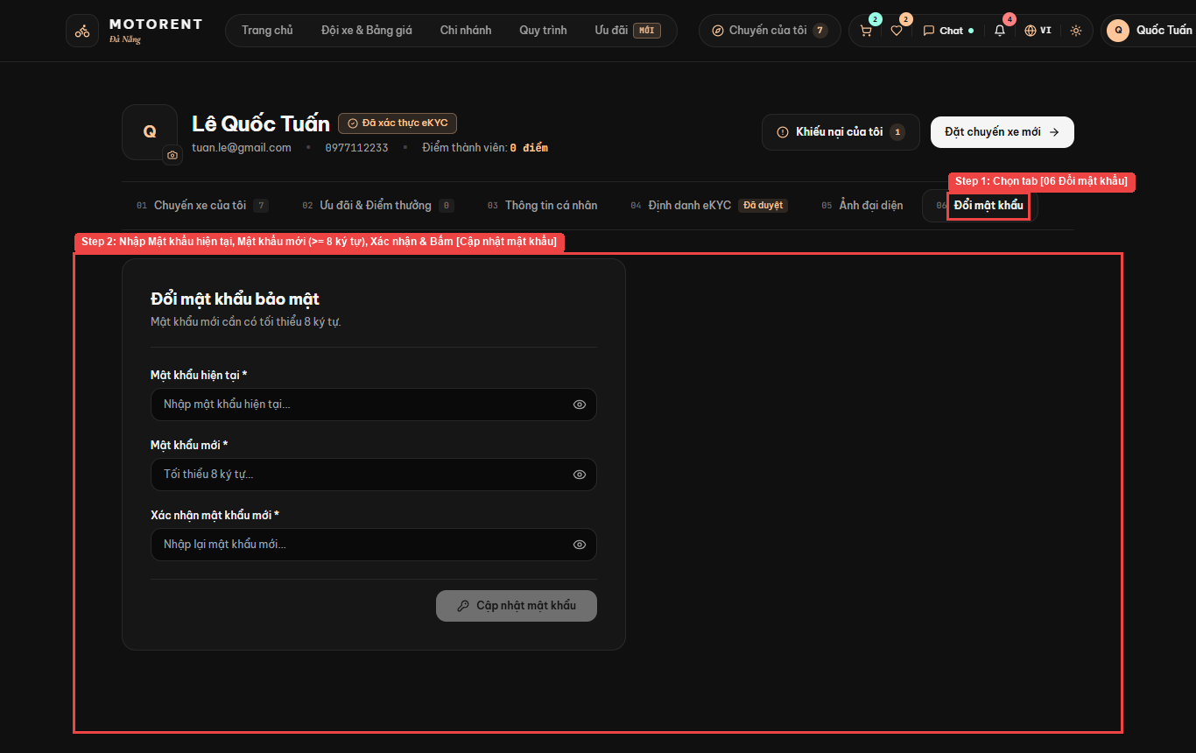
Figure 3.7: Live Project Screen — 3.3. Change Account Password (UC-11)

3.4. View & Edit Personal Profile & Avatar (UC-09)
Step 1: Open http://localhost:5173/profile and select tab [03 Thông tin cá nhân].
Step 2: Update your Last Name ('Họ và tên đệm *'), First Name ('Tên *'), Contact Phone ('Số điện thoại liên hệ *'), CCCD/Passport ('Số CCCD (12 số) / Hộ chiếu'), Gender ('Giới tính'), or Date of Birth ('Ngày sinh'), and click [Lưu thông tin hồ sơ].
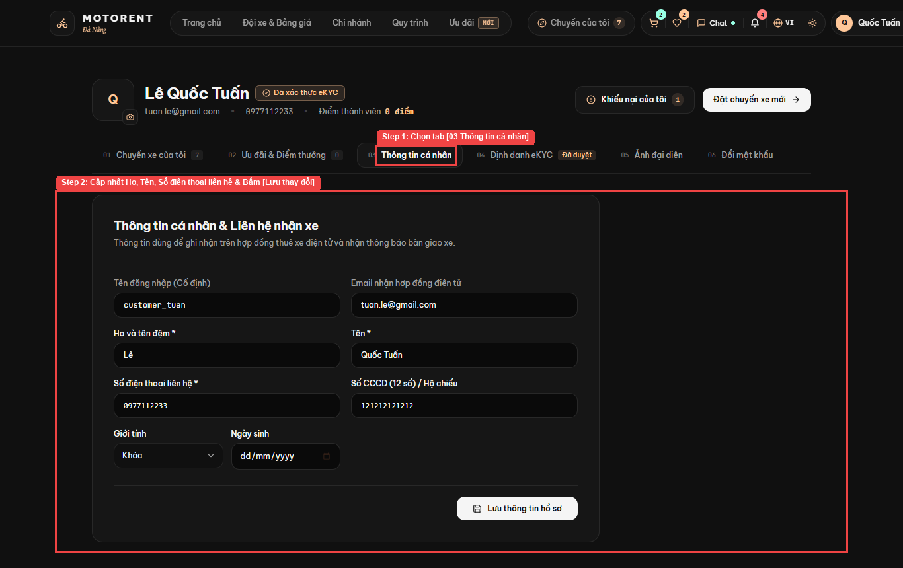
Figure 3.8: Live Project Screen — 3.4. View & Edit Personal Profile & Avatar (UC-09)

3.5. Submit eKYC Identity Verification — CCCD & Driving License (UC-10)
Step 1: Open http://localhost:5173/profile and select tab [04 Định danh eKYC].
Step 2: Upload the 4 required identity verification photos encrypted with AES-256-GCM: (1) '1. Mặt trước CCCD *', (2) '2. Mặt sau CCCD *', (3) '3. Giấy phép lái xe (A1/A2)', and (4) '4. Ảnh chân dung đối chiếu *', check the consent box, and submit for verification without surrendering your original physical ID card at the counter.
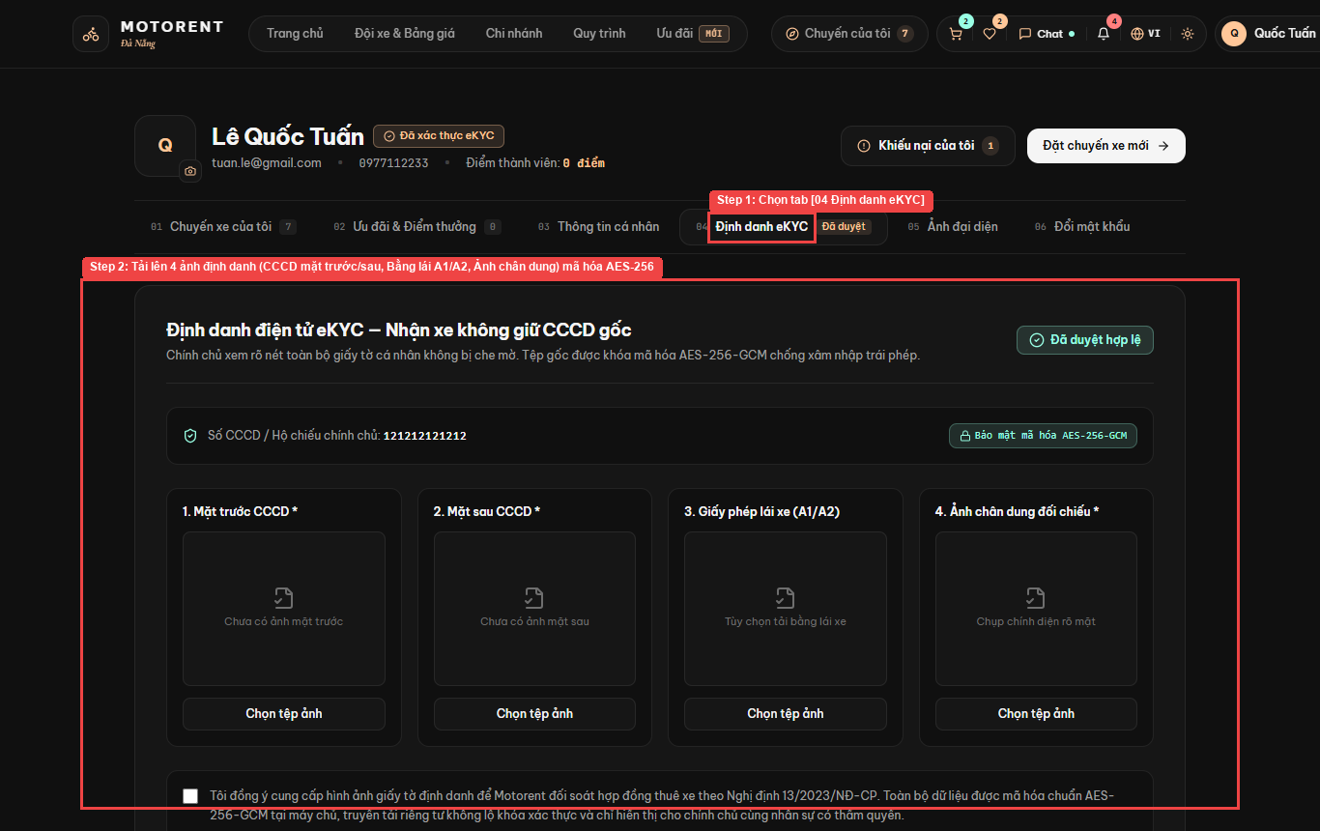
Figure 3.9: Live Project Screen — 3.5. Submit eKYC Identity Verification — CCCD & Driving License (UC-10)

4. User Manual Guide for Customer (Booking, VNPay, Trip Management & Loyalty)

4.1. Bookmark Favorite Vehicles in Wishlist (UC-12)
Step 1: Click the heart icon on any motorbike card to save it, then click the Heart icon in the top navigation bar to open http://localhost:5173/wishlist ('Xe yêu thích của bạn').
Step 2: Compare saved motorbikes, check their live status ('Sẵn sàng thuê') and daily rate ('80.000đ /ngày'), and click [Đặt xe] to book immediately or click the trash icon to remove an item.
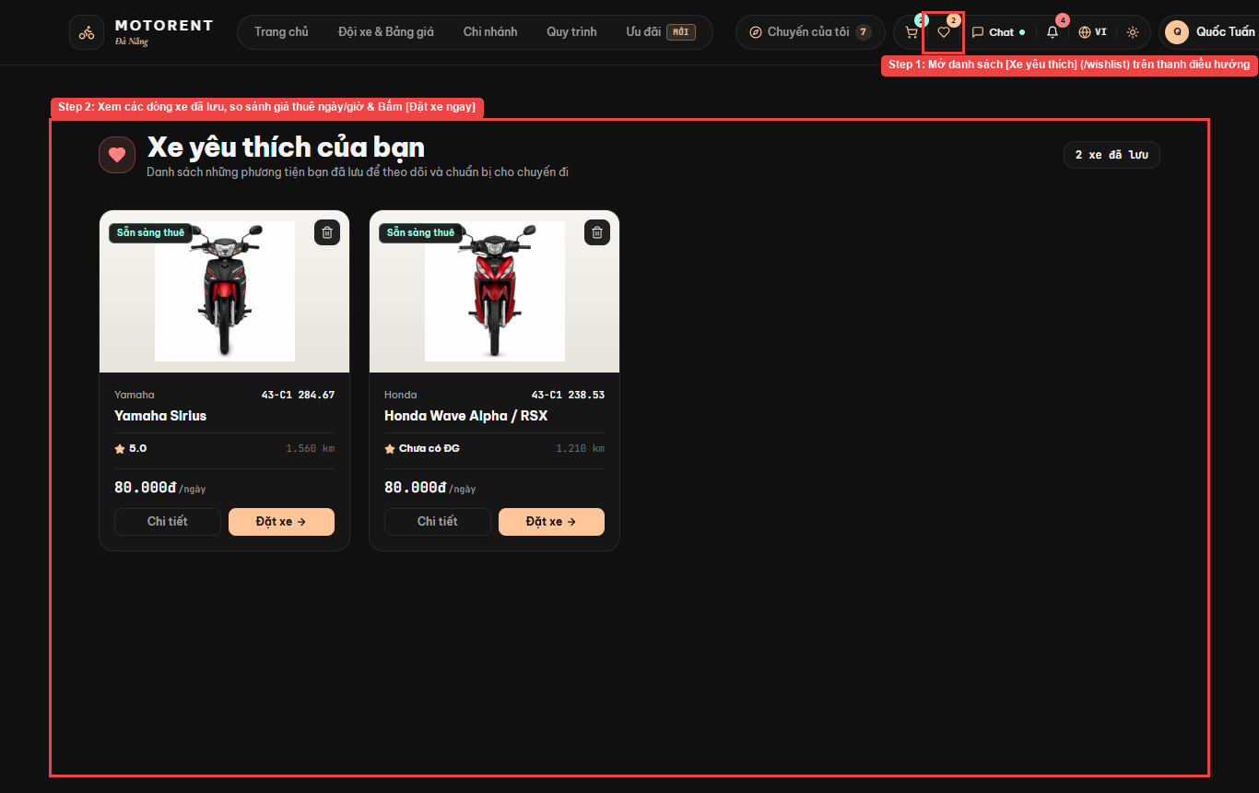
Figure 3.10: Live Project Screen — 4.1. Bookmark Favorite Vehicles in Wishlist (UC-12)

4.2. Single Motorbike Booking Wizard (UC-14)
Step 1: Follow the 5-step Booking Wizard header on '/booking/:vehicleId' (01 Lịch trình -> 02 Khách hàng -> 03 Gói dịch vụ -> 04 Thanh toán QR -> 05 Biên lai & Mã xe).
Step 2: Choose Delivery Mode: [Nhận & Trả tại cửa hàng (0đ)] or [Giao & Nhận xe tận nơi (+50.000đ/chiều)] with custom pickup/return address in Da Nang (hotel, airport lobby, home), and select Pickup/Return Date & Time.
Step 3: Review the itemized rental & delivery cost breakdown ('Bảng kê chi phí hợp đồng'), sign the Customer E-Signature box, verify the Lessor Representative Signature ('Chữ ký đại diện Bên cho thuê'), and submit to receive the bilateral 2-party contract.
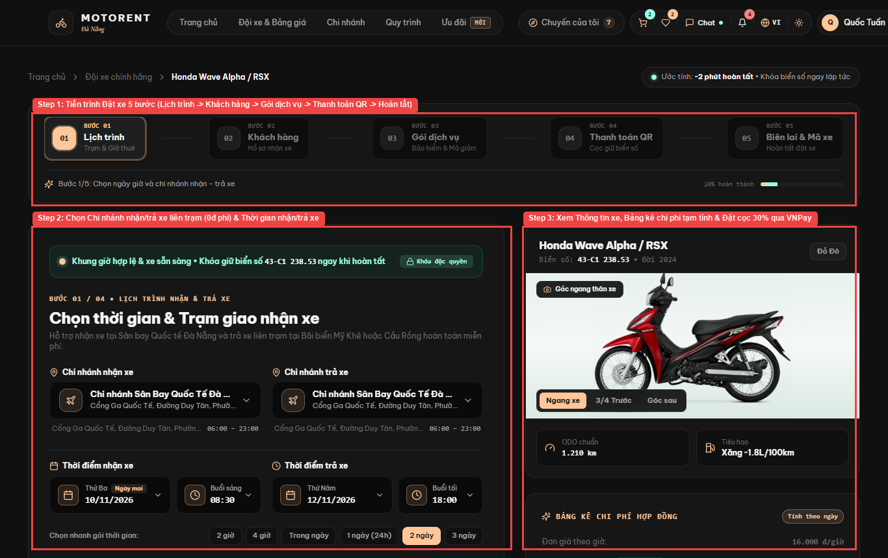
Figure 3.11: Live Project Screen — 4.2. Single Motorbike Booking Wizard (UC-14)

4.3. Multi-Vehicle Cart & Pay 30% Deposit via VNPay Sandbox (UC-14, UC-15)
Step 1: Click the Shopping Cart icon in the top navigation bar to open '/cart' ('Giỏ xe của bạn') when booking multiple motorbikes for a group.
Step 2: Choose the shared Pickup/Return schedule and Return Station for the group, review the total rental fee ('Tổng tiền thuê') and 30% deposit required ('Tổng cọc 30% cần thanh toán'), and click [Tiếp tục: Thông tin & eKYC] to pay the 30% deposit via VNPay Sandbox using the test card below:
Trường thông tin VNPay Sandbox | Giá trị Test chuẩn
Ngân hàng | NCB
Số thẻ Sandbox | 9704198526191432198
Tên chủ thẻ | NGUYEN VAN A
Ngày phát hành | 07/15
Mật khẩu OTP | 123456

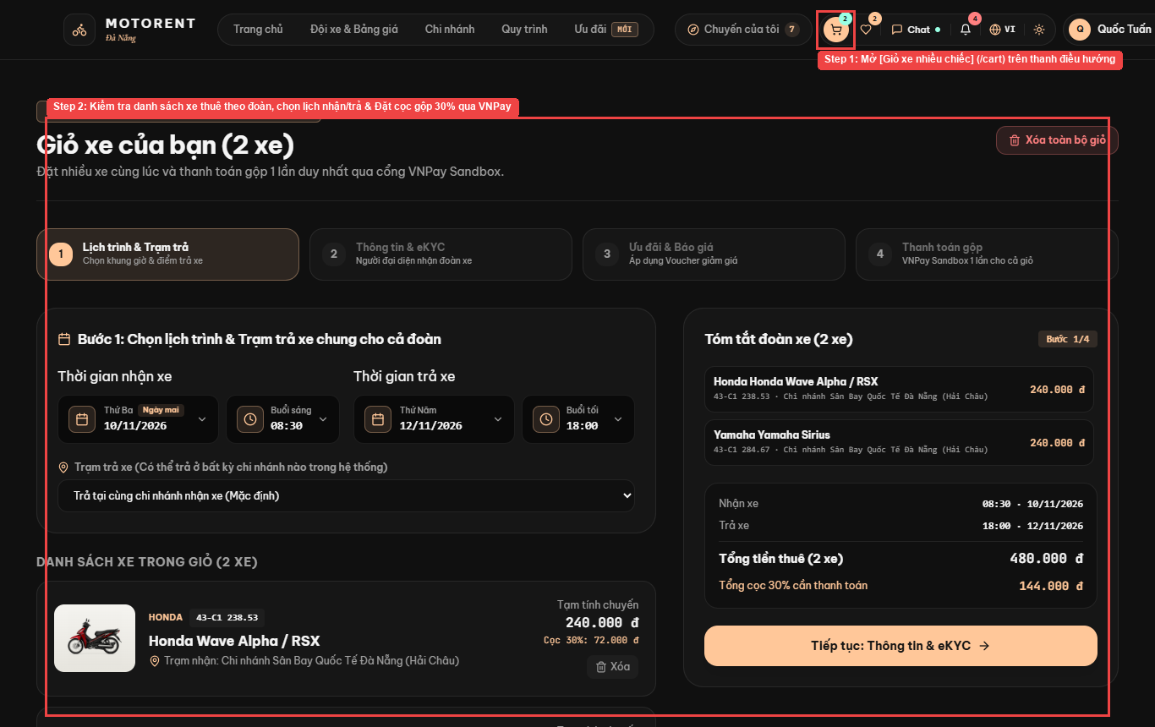
Figure 3.12: Live Project Screen — 4.3. Multi-Vehicle Cart & Pay 30% Deposit via VNPay Sandbox (UC-14, UC-15)

4.4. Manage My Bookings, Extend Trip, Cancel Order & Download PDF (UC-16, UC-17, UC-18, UC-19)
Step 1: Open '/profile' and select tab [01 Chuyến xe của tôi] (or click [Chuyến của tôi] in the top bar).
Step 2: Filter contracts by status ([Tất cả đơn], [Đang giữ xe / Đang thuê], [Đã hoàn thành], [Đã hủy]) or search by contract code ('Tìm mã hợp đồng...').
Step 3: View the contract card (e.g., 'MV-638774'), inspect the 4 pre-rental handover photos ('4 góc xe trước khi bàn giao (Check-in)'), or execute trip actions: extend rental period, cancel order under BR-06 refund tiers, or download the PDF invoice.
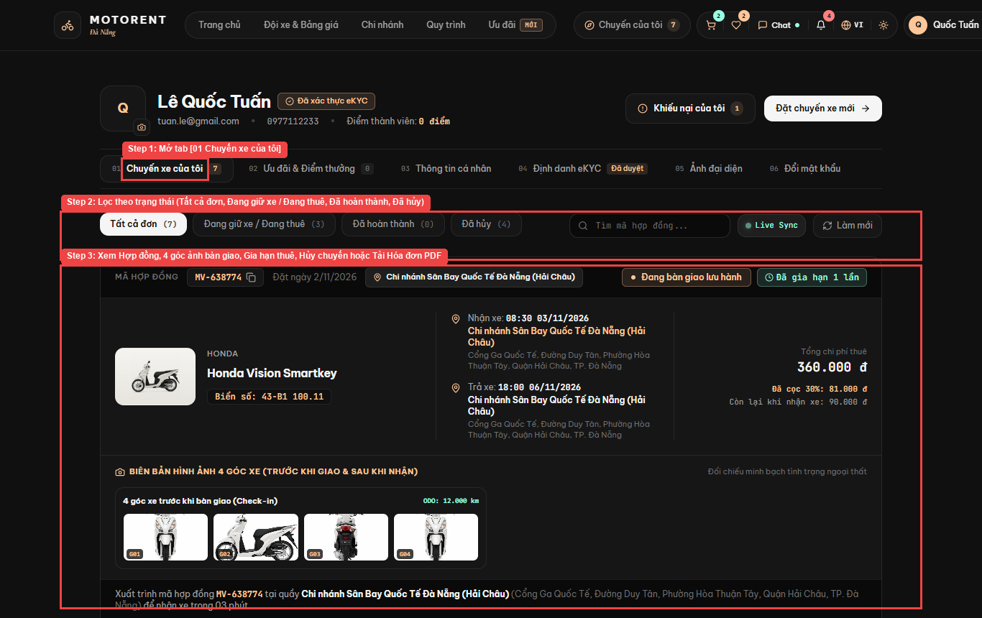
Figure 3.13: Live Project Screen — 4.4. Manage My Bookings, Extend Trip, Cancel Order & Download PDF (UC-16, UC-17, UC-18, UC-19)

4.5. Submit & Track Service Complaints (UC-21)
Step 1: Open http://localhost:5173/complaints ('Theo dõi khiếu nại & Hỗ trợ kỹ thuật') and click [+ Gửi khiếu nại mới] to report a vehicle, service, or payment issue linked to your booking.
Step 2: Select any complaint in the left list (e.g., 'CMP-20261109-IFLH') to track the 4-stage resolution timeline (01 Tiếp nhận -> 02 Đang xử lý -> 03 Đã giải quyết -> 04 Đã đóng) and view branch feedback.
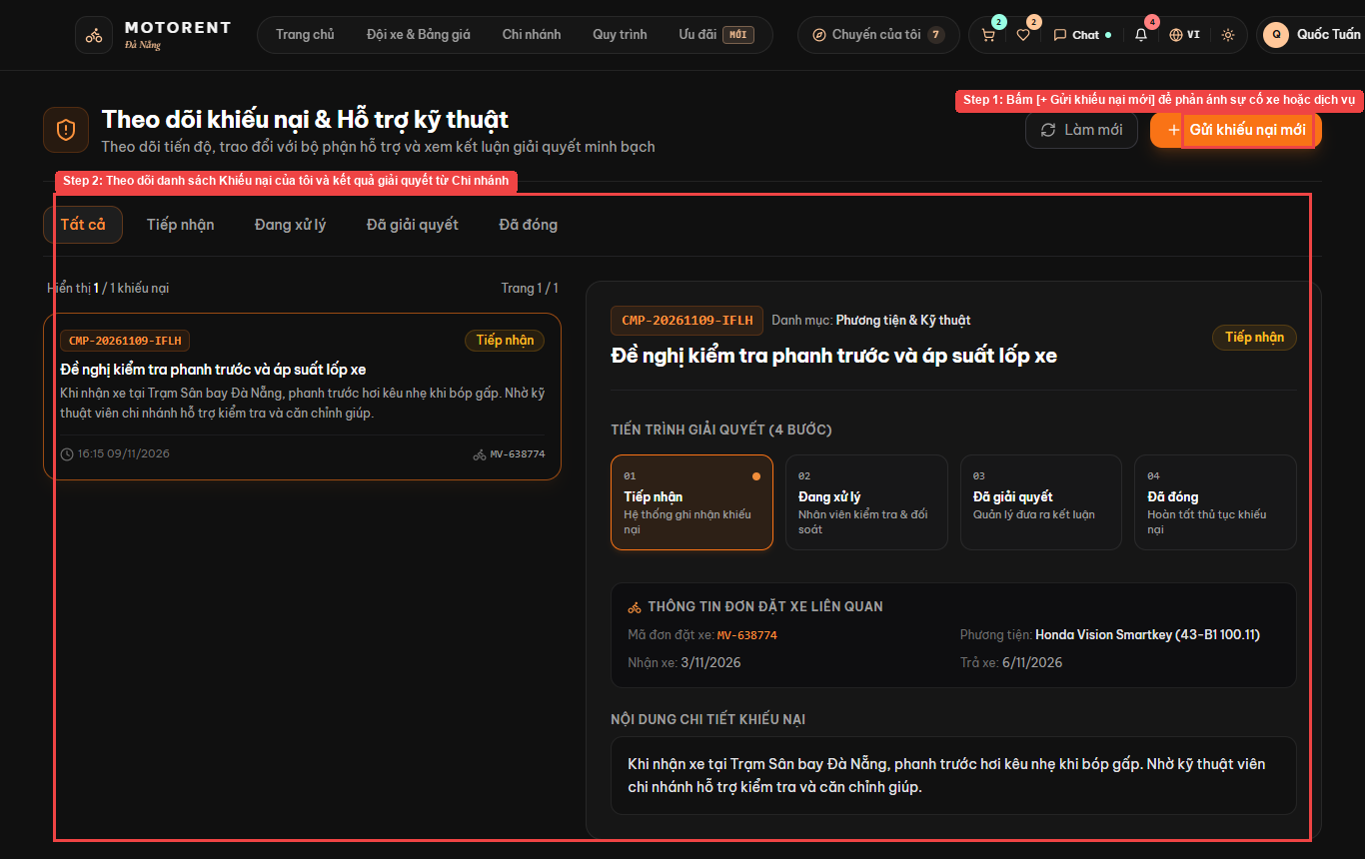
Figure 3.14: Live Project Screen — 4.5. Submit & Track Service Complaints (UC-21)

4.6. View Loyalty Points, Referral Code & Redeem Vouchers (UC-24, UC-25)
Step 1: Open '/profile' and select tab [02 Ưu đãi & Điểm thưởng].
Step 2: Check your accumulated Member Points ('Điểm thành viên' — 1 point per 10,000 VND completed rental), exchange points for discount vouchers in 'Đổi điểm thành Voucher', or copy your personal referral code ('Mã giới thiệu') in 'Mời bạn bè'.
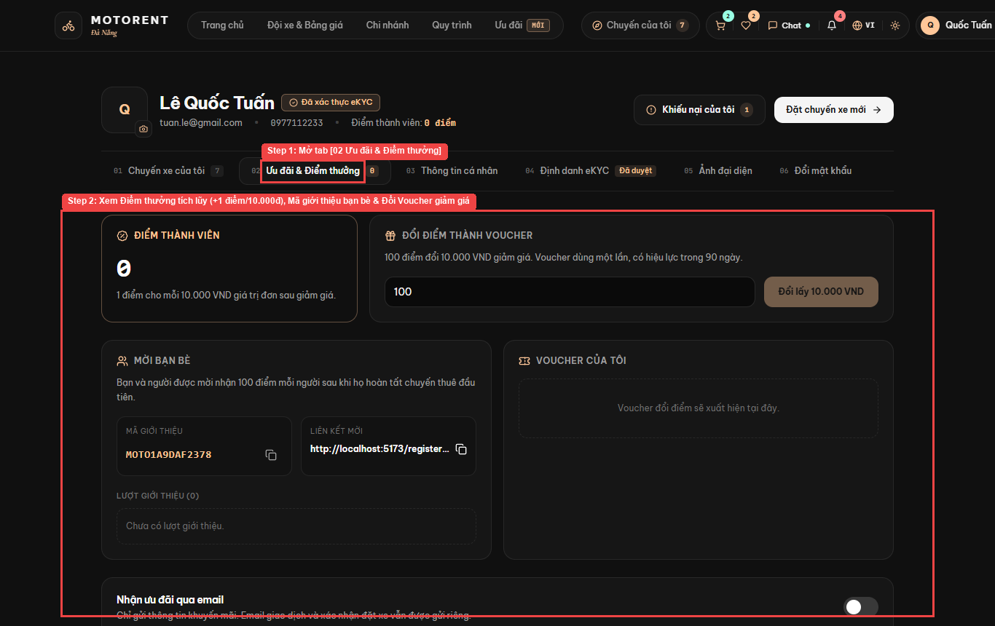
Figure 3.15: Live Project Screen — 4.6. View Loyalty Points, Referral Code & Redeem Vouchers (UC-24, UC-25)

5. User Manual Guide for Staff (Counter Desk Operations)

5.1. Manage Branch Queue, 5-Point Check-in Handover & Cross-Branch Check-out (UC-26, UC-27, UC-28, UC-29)
Step 1: Log in as Counter Staff ('staff_dad') at http://localhost:5173/counter ('Bàn giao nhận xe tại quầy'). Use the left panel ('Hàng đợi chi nhánh') to search by booking code/phone/plate or filter by status ([Tất cả], [Chờ nhận], [Đang thuê], [Đã trả], [Đã hủy]).
Step 2: Select a booking to open the right workspace ('Chi tiết hồ sơ giao nhận'), inspect the Door-to-Door delivery address (if selected), click [Thu tiền tại quầy] to collect the 70% balance, use tab [1. Check-in Bàn giao xe] to upload 4 pre-rental photos and confirm both Customer & Lessor Representative contract signatures, or use tab [2. Check-out Thu hồi xe] to record return ODO, fuel, and 4 return photos.
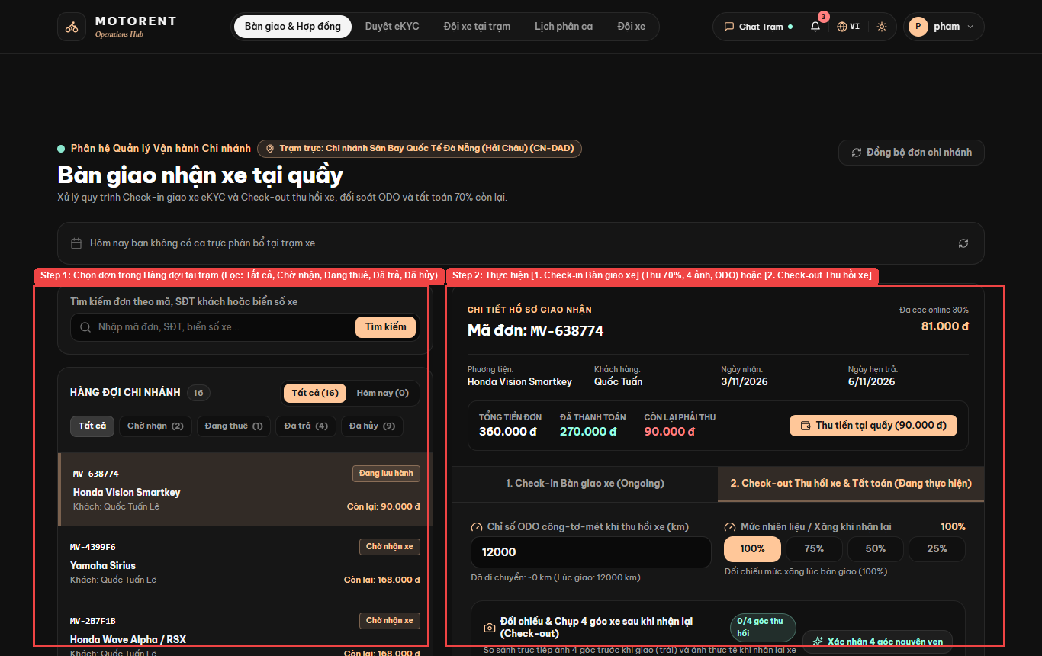
Figure 3.16: Live Project Screen — 5.1. Manage Branch Queue, 5-Point Check-in Handover & Cross-Branch Check-out (UC-26, UC-27, UC-28, UC-29)

5.2. Receive & Respond to Customer Complaints (UC-31, UC-32)
Step 1: Open http://localhost:5173/staff/complaints, select an open complaint from the queue, click [Tiếp nhận xử lý (InProgress)], enter the official response in 'Nhập nội dung phản hồi chính thức cho khách hàng', and click [Gửi phản hồi]. Staff can also click [Chat Trạm] in the top header to reply to customer live chat messages.
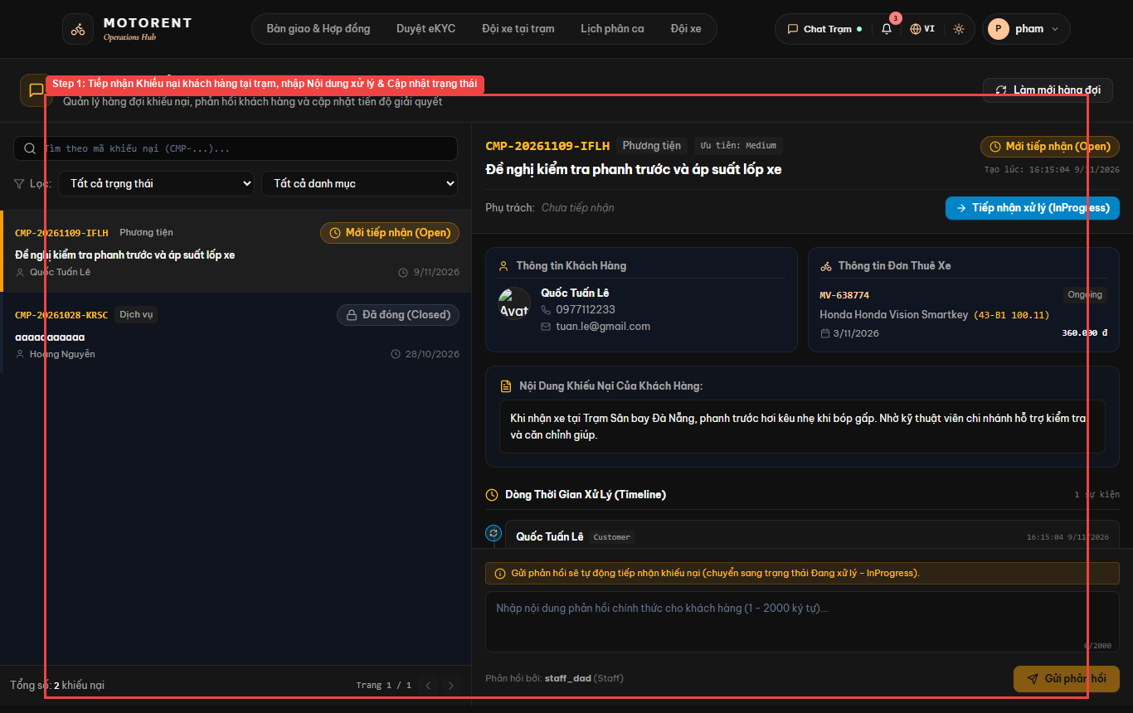
Figure 3.17: Live Project Screen — 5.2. Receive & Respond to Customer Complaints (UC-31, UC-32)

6. User Manual Guide for Branch Manager & System Admin

6.1. Monitor Branch Operations & Fleet KPI Dashboard (UC-36, UC-37)
Step 1: Log in as Branch Manager ('manager_dad') and open [Tổng quan trạm] ('/manager/dashboard' — 'Nhịp vận hành đội xe').
Step 2: Monitor real-time station KPIs ('Tổng số xe', 'Sẵn có', 'Tỷ lệ đang thuê', 'Xe đến hạn bảo trì'), and open [Lịch phân ca] ('/schedules') -> click [AI Tối ưu Phân ca] to automatically generate optimal weekly staff shifts using the 100-point AI Heuristic Optimizer (demand forecast, clopening prevention, and workload balancing).
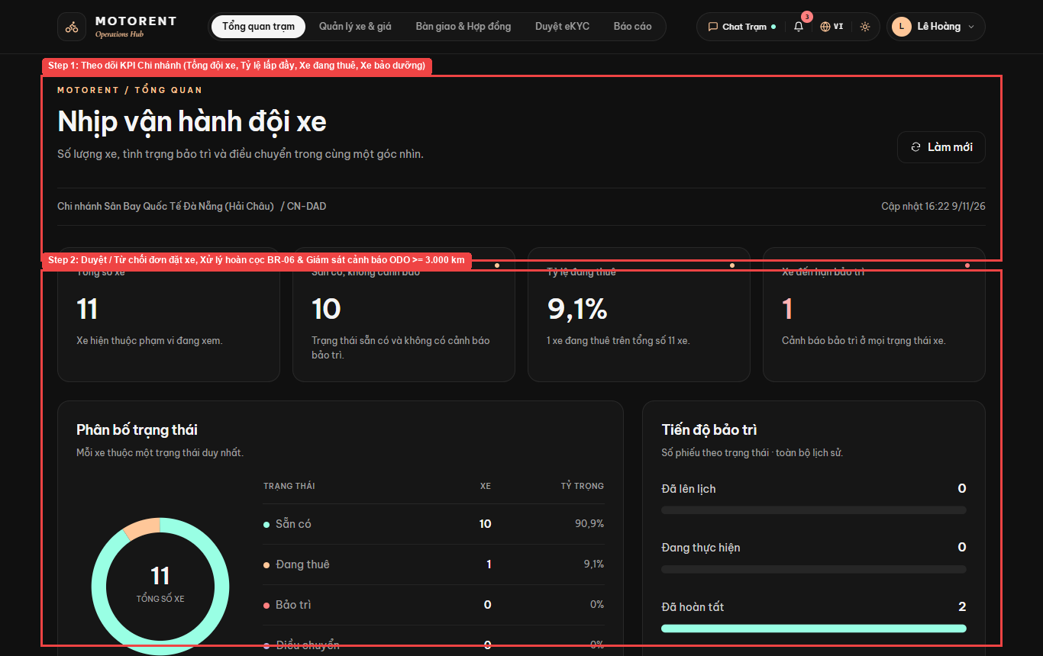
Figure 3.18: Live Project Screen — 6.1. Monitor Branch Operations & Fleet KPI Dashboard (UC-36, UC-37)

6.2. Manage Branch Vehicles & Rental Pricing (UC-33, UC-34, UC-35)
Step 1: Open [Quản lý xe & giá] at http://localhost:5173/manager/vehicles ('Quản Lý Xe & Biểu Giá Thuê'); click [Điều chuyển & Bảo dưỡng] in the top-right to jump to fleet maintenance/transfers.
Step 2: Use the left form ('Thêm phương tiện mới') to register a motorbike with Brand, Model, License Plate, Category, Daily Price ('Giá thuê ngày'), and Hourly Price ('Giá thuê giờ').
Step 3: Use the right fleet catalog ('Danh sách đội xe') to search, filter, edit specifications, or schedule maintenance.
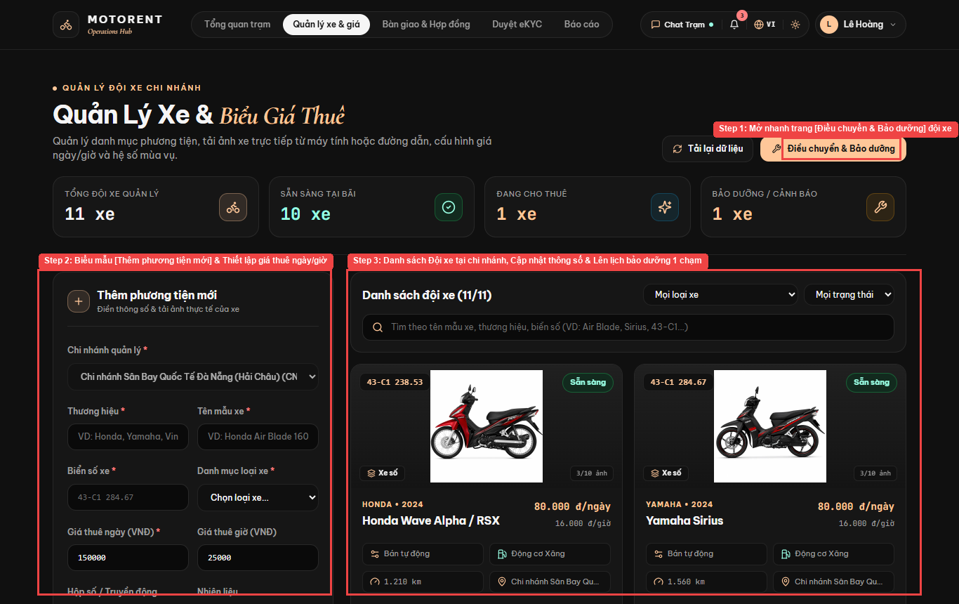
Figure 3.19: Live Project Screen — 6.2. Manage Branch Vehicles & Rental Pricing (UC-33, UC-34, UC-35)

6.3. Schedule ODO Maintenance & Inter-Branch Vehicle Transfers (UC-30, UC-38, UC-39)
Step 1: Open http://localhost:5173/manager/fleet-operations ('Điều phối đội xe') to review summary cards ('Xe cần bảo trì', 'Phiếu bảo trì chưa hoàn tất', 'Lệnh & Nhật ký điều chuyển').
Step 2: Inspect motorbikes flagged under 'Cảnh báo ODO' (e.g., '43-B1 100.11 — 12.000 km'), create or complete maintenance tickets in tab [01. Phiếu & Nhật ký bảo trì], or coordinate inter-branch vehicle transfers in tab [02. Điều chuyển & Nhật ký điều chuyển].
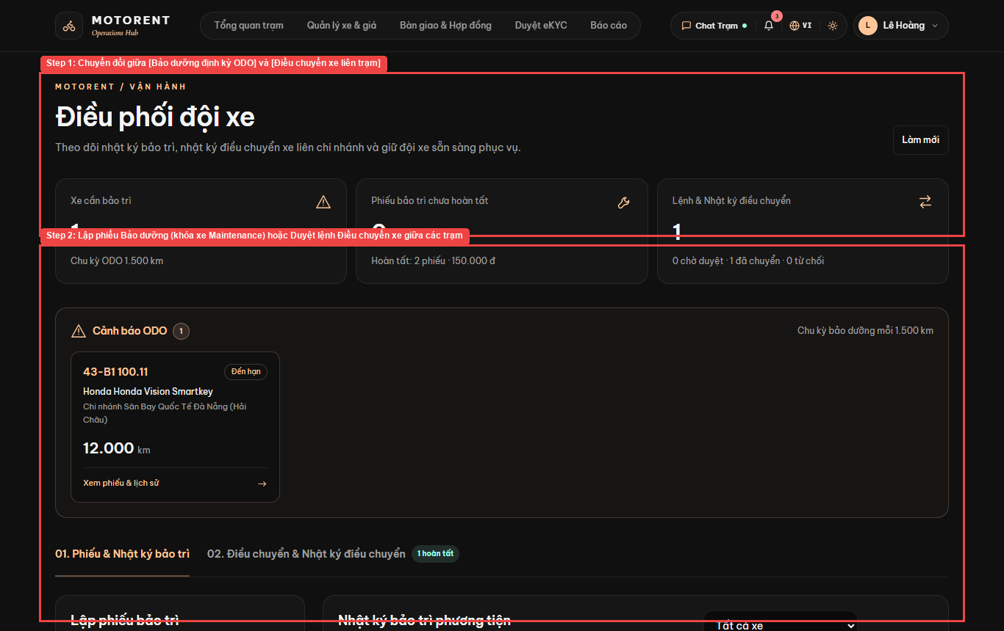
Figure 3.20: Live Project Screen — 6.3. Schedule ODO Maintenance & Inter-Branch Vehicle Transfers (UC-30, UC-38, UC-39)

6.4. Analyze Branch Financial Reports & Export Excel / PDF (UC-42)
Step 1: Open [Báo cáo] at http://localhost:5173/reports ('Báo Cáo Hoạt Động & Hiệu Suất Hệ Thống') and select a report tab ([Doanh thu ngày], [Doanh thu tháng], [Hiệu suất đội xe], [KPI Executive Dashboard], or [Dự báo nhu cầu xe]).
Step 2: Click [Xuất Excel] or [Xuất PDF] in the top-right corner to download formatted financial reports.
Step 3: Review net cashflow ('Dòng tiền thuần'), total inflow ('Tổng tiền vào'), refunds ('Tiền hoàn ra'), total orders ('Đơn phát sinh'), average order value ('Giá trị đơn TB'), and the daily revenue bar chart.
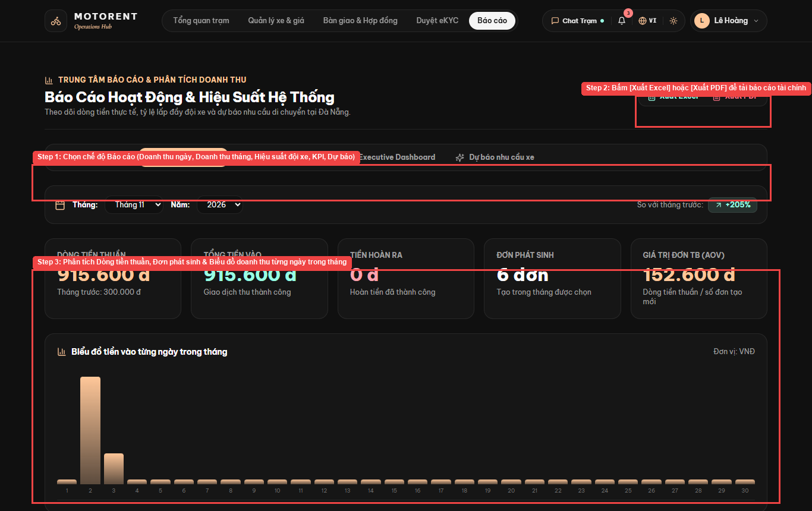
Figure 3.21: Live Project Screen — 6.4. Analyze Branch Financial Reports & Export Excel / PDF (UC-42)

6.5. System Admin — Manage Branches & Global System Configuration (UC-43, UC-44, UC-48, UC-50)
Step 1: Log in as System Admin ('admin') at http://localhost:5173/admin ('Trung Tâm Điều Hành Motorent') and click [+ Thêm Chi Nhánh Mới] to create a new station.
Step 2: Use the administrative tab bar to switch between [Chi nhánh], [Người dùng], [Khuyến mãi], [Chính sách & Cấu hình], [Đối soát & Thuế], [Báo cáo & Phân tích], [Đa ngôn ngữ], and [Bản đồ GPS].
Step 3: Monitor chain-wide KPIs ('Tổng số chi nhánh', 'Trạm đang hoạt động', 'Quy mô đội xe tại trạm', 'Xe sẵn sàng cho thuê') and edit active branches.
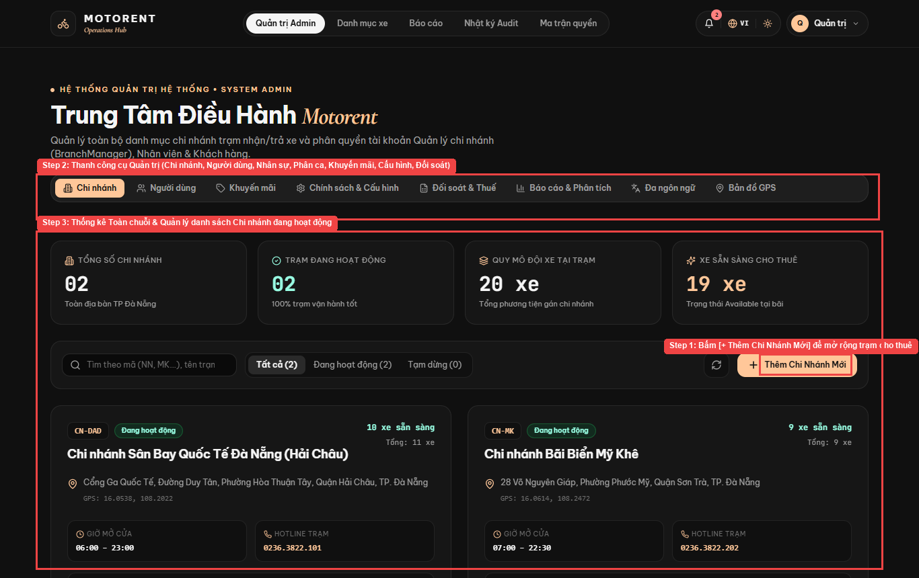
Figure 3.22: Live Project Screen — 6.5. System Admin — Manage Branches & Global System Configuration (UC-43, UC-44, UC-48, UC-50)

6.6. System Admin — Manage Users, Roles & Ban/Unban Accounts (UC-45)
Step 1: In '/admin', click tab [Người dùng] to open the user management console.
Step 2: Review user counters ('Tổng người dùng', 'Quản lý chi nhánh', 'Nhân viên trực quầy', 'Khách hàng', 'Tài khoản bị khóa'), filter by role/status/branch, click [+ Tạo Quản Lý / Nhân Sự] to provision staff/manager accounts, or click [Khóa tài khoản] to lock/unlock access.
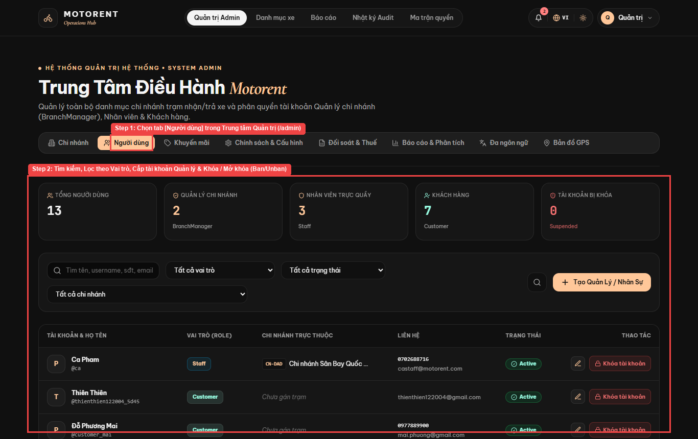
Figure 3.23: Live Project Screen — 6.6. System Admin — Manage Users, Roles & Ban/Unban Accounts (UC-45)

6.7. System Admin — Manage Vehicle Categories & Homepage CMS Banners (UC-47, UC-49)
Step 1: Open [Danh mục xe] ('/admin/categories') to add, edit, or delete the 5 standard motorbike categories ('Xe 50cc', 'Xe côn tay', 'Xe máy điện', 'Xe số', 'Xe tay ga'), and use '/admin/banners' & '/admin/pages' to manage homepage promotional banners and static CMS pages.
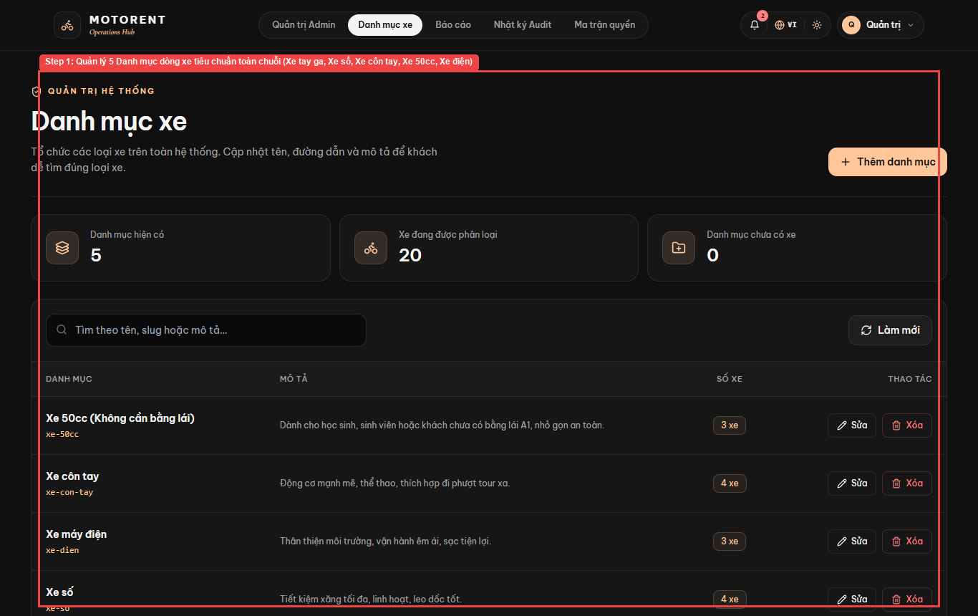
Figure 3.24: Live Project Screen — 6.7. System Admin — Manage Vehicle Categories & Homepage CMS Banners (UC-47, UC-49)

6.8. System Admin — Inspect Security Audit Logs & 4-Role RBAC Matrix (UC-45, UC-46)
Step 1: Open [Nhật ký Audit] ('/audit' — 'Nhật ký Truy vết Hệ thống') to filter immutable CRUD & security logs by Actor, Entity, Action, Status, or Date and click [Chi tiết Changes] to inspect redacted JSON payloads; open [Ma trận quyền] ('/rbac') to review the 4-role authorization matrix.
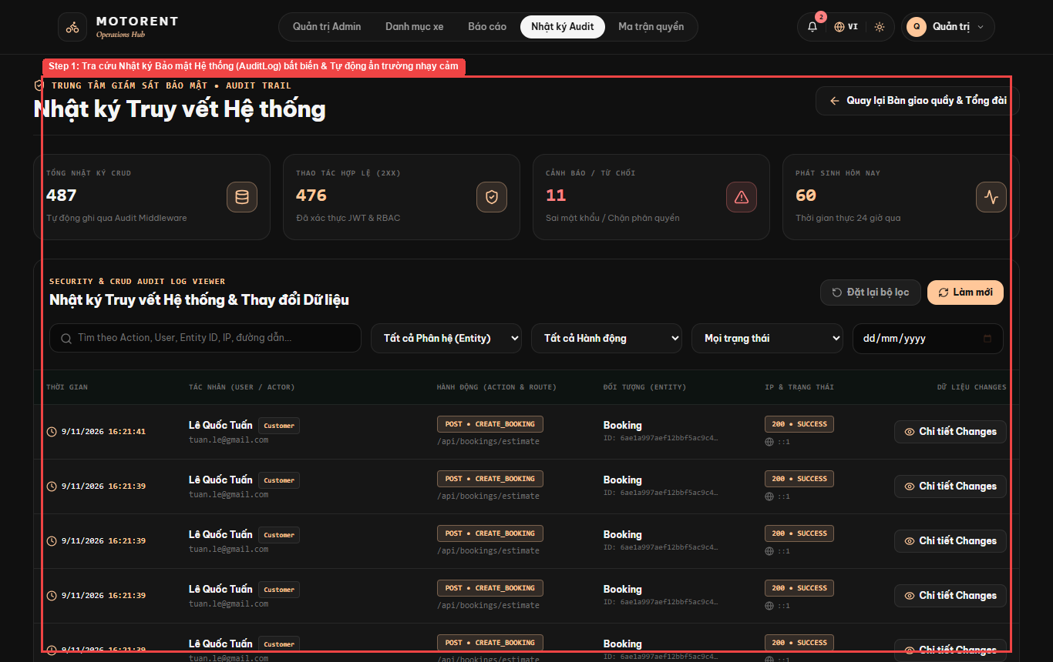
Figure 3.25: Live Project Screen — 6.8. System Admin — Inspect Security Audit Logs & 4-Role RBAC Matrix (UC-45, UC-46)

IV. Team Member Contributions
STT | Thành viên | Vai trò | Đóng góp Git | Đóng góp trong Dự án (Code & Chức năng) | Đóng góp Tài liệu | Tỷ lệ
1 | Trương Quốc Bảo Hoàng  (Leader) | Team Leader /  Full-Stack | 71 commits  (Quản lý nhánh main,  review & merge code) | • Thiết kế kiến trúc hệ thống, phân quyền RBAC & nhật ký bảo mật.  • Đăng ký/Đăng nhập, Google OAuth2, xác thực eKYC.  • Luồng đặt xe, giỏ xe, thanh toán VNPay & VietQR.  • Hợp đồng điện tử 2 bên (chữ ký người thuê & bên cho thuê).  • Giao nhận xe tận nơi ngoài cửa hàng.  • AI tối ưu hóa xếp lịch phân ca nhân viên.  • Live Chat, Thống kê báo cáo Admin, kiểm thử & fix lỗi toàn dự án. | Làm toàn bộ các phần tài liệu còn lại:  • Thiết kế hệ thống & giao diện (RDS, SDS)  • Tài liệu bàn giao & Hướng dẫn sử dụng (Final Release)  • Bảng theo dõi tiến độ & Issues (Project Tracking, Issues Report) | 35%
2 | Phạm Quốc Cả | Business Analyst /  Backend | 7 commits | • Phân tích yêu cầu nghiệp vụ hệ thống.  • Quản lý chi nhánh & tìm kiếm trạm theo bản đồ GPS.  • Quản lý nhân sự trạm, ca trực cơ bản & danh mục khuyến mãi. | Phụ trách làm phần Đặc tả yêu cầu phần mềm (SRS). | 20%
3 | Nguyễn Thái Dương | Full-Stack  Developer | 29 commits | • Chức năng đặt xe, gia hạn thuê, hủy đơn & hoàn cọc.  • Nghiệp vụ quầy giao/nhận xe (Check-in, Check-out trả xe liên trạm, tính phí phạt) & xuất hóa đơn PDF. | Phối hợp cung cấp nghiệp vụ (Hoàng biên soạn tài liệu). | 18%
4 | Nguyễn Văn Tài /  Đặng Vũ | Full-Stack  Developer | 14 commits | • Danh mục đội xe, bộ lọc tìm kiếm & chi tiết xe.  • Quản lý xe, cấu hình giá thuê, cảnh báo bảo dưỡng theo ODO & điều chuyển xe giữa các trạm. | Phối hợp cung cấp nghiệp vụ (Hoàng biên soạn tài liệu). | 15%
5 | Phạm Văn Tuyên | Frontend  Developer | 4 commits | • Danh sách xe yêu thích, đánh giá sao & gửi khiếu nại.  • Thông báo nhắc lịch, tích điểm đổi thưởng & quản lý banner/trang tĩnh. | Phối hợp cung cấp nghiệp vụ (Hoàng biên soạn tài liệu). | 12%

STT | Hạng mục Tài liệu | Người Thực hiện | Trạng thái
1 | Đặc tả yêu cầu phần mềm (SRS) | Phạm Quốc Cả | Hoàn thành 100%
2 | Đặc tả yêu cầu & Thiết kế giao diện (RDS) | Trương Quốc Bảo Hoàng (tổng hợp & làm toàn bộ phần thiết kế UI, CSDL)  Phạm Quốc Cả (phần SRS) | Hoàn thành 100%
3 | Đặc tả thiết kế kỹ thuật (SDS) | Trương Quốc Bảo Hoàng | Hoàn thành 100%
4 | Tài liệu bàn giao & Hướng dẫn sử dụng (Final Release) | Trương Quốc Bảo Hoàng | Hoàn thành 100%
5 | Bảng theo dõi tiến độ dự án (Project Tracking) | Trương Quốc Bảo Hoàng | Hoàn thành 100%
6 | Báo cáo quản lý công việc & lỗi (Issues Report) | Trương Quốc Bảo Hoàng | Hoàn thành 100%

