# Subquery

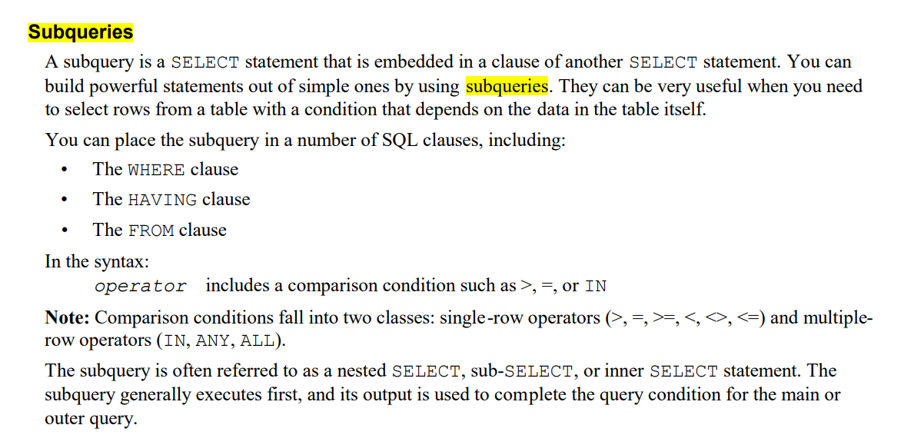

Eigther side of the comparison operator

WHERE : 255 Level

FROM : unlimited depth level

# DML operation on view

Link refer : <https://techgoeasy.com/how-to-perform-dml-operations-on-oracle-view-insert-update-delete/>

<https://forums.oracle.com/ords/apexds/post/dml-on-view-8875>

<https://learning.oreilly.com/library/view/mastering-oracle-sql/0596001290/ch03s05.html>

* Hierarchical query clauses, such as START WITH or CONNECT BY
* GROUP BY or HAVING clauses
* Set operations, such as UNION, UNION ALL, INTERSECT, MINUS
* Aggregate functions, such as AVG, COUNT, MAX, MIN, SUM, and so forth
* The DISTINCT operator
* The ROWNUM pseudocolumn

# [Alternative Quoting Mechanism (''Q'') for String Literals](https://livesql.oracle.com/apex/livesql/file/content_CIREYU9EA54EOKQ7LAMZKRF6P.html)

DECLARE  
 l_dogs_or_cats VARCHAR2(5) := 'cats';  
BEGIN  
 EXECUTE IMMEDIATE  
 q'| BEGIN dbms_output.put_line('All the king |'  
 ||l_dogs_or_cats||  
 q'|'); END; |'  
 ;  
END;

SELECT q'!Hoang Thanh<>{}!@#$%^&*(():">?';./\]`~()[]! Hai's Trang!'  
FROM dual;  
  
  
SELECT q'1Hoang thanh hai 'table'tb @gmail.com ~!@#$%^&*()_+{|}":?><1'  
FROM dual;

# [Format Models](https://docs.oracle.com/en/database/oracle/oracle-database/19/sqlrf/Format-Models.html#GUID-49B32A81-0904-433E-B7FE-51606672183A)

C : CURRENCY

D : Dot(.)

G: Group(1,000)

B: blank

S: sign (+-)

| **Element** | **Example** | **Description** |
| --- | --- | --- |
| , (comma) | 9,999 | Returns a comma in the specified position. You can specify multiple commas in a number format model.  **Restrictions:**   * A comma element cannot begin a number format model. * A comma cannot appear to the right of a decimal character or period in a number format model. |
| . (period) | 99.99 | Returns a decimal point, which is a period (.) in the specified position.  **Restriction:** You can specify only one period in a number format model. |
| $ | $9999 | Returns value with a leading dollar sign. |
| 0 | 0999  9990 | Returns leading zeros.  Returns trailing zeros. |
| 9 | 9999 | Returns value with the specified number of digits with a leading space if positive or with a leading minus if negative. Leading zeros are blank, except for a zero value, which returns a zero for the integer part of the fixed-point number. |
| B | B9999 | Returns blanks for the integer part of a fixed-point number when the integer part is zero (regardless of zeros in the format model). |
| C | C999 | Returns in the specified position the ISO currency symbol (the current value of the NLS_ISO_CURRENCY parameter). |
| D | 99D99 | Returns in the specified position the decimal character, which is the current value of the NLS_NUMERIC_CHARACTER parameter. The default is a period (.).  **Restriction:** You can specify only one decimal character in a number format model. |
| EEEE | 9.9EEEE | Returns a value using in scientific notation. |
| G | 9G999 | Returns in the specified position the group separator (the current value of the NLS_NUMERIC_CHARACTER parameter). You can specify multiple group separators in a number format model.  **Restriction:** A group separator cannot appear to the right of a decimal character or period in a number format model. |
| L | L999 | Returns in the specified position the local currency symbol (the current value of the NLS_CURRENCY parameter). |
| MI | 9999MI | Returns negative value with a trailing minus sign (-).  Returns positive value with a trailing blank.  **Restriction:** The MI format element can appear only in the last position of a number format model. |
| PR | 9999PR | Returns negative value in <angle brackets>.  Returns positive value with a leading and trailing blank.  **Restriction:** The PR format element can appear only in the last position of a number format model. |
| RN  rn | RN  rn | Returns a value as Roman numerals in uppercase.  Returns a value as Roman numerals in lowercase.  Value can be an integer between 1 and 3999. |
| S | S9999  9999S | Returns negative value with a leading minus sign (-).  Returns positive value with a leading plus sign (+).  Returns negative value with a trailing minus sign (-).  Returns positive value with a trailing plus sign (+).  **Restriction:** The S format element can appear only in the first or last position of a number format model. |
| TM | TM | The text minimum number format model returns (in decimal output) the smallest number of characters possible. This element is case insensitive.  The default is TM9, which returns the number in fixed notation unless the output exceeds 64 characters. If the output exceeds 64 characters, then Oracle Database automatically returns the number in scientific notation.  **Restrictions:**   * You cannot precede this element with any other element. * You can follow this element only with one 9 or one E (or e), but not with any combination of these. The following statement returns an error:   SELECT TO_CHAR(1234, 'TM9e') FROM DUAL; |
| U | U9999 | Returns in the specified position the Euro (or other) dual currency symbol, determined by the current value of the NLS_DUAL_CURRENCY parameter. |
| V | 999V99 | Returns a value multiplied by 10n(and if necessary, round it up), where *n* is the number of 9's after the V. |
| X | XXXX  xxxx | Returns the hexadecimal value of the specified number of digits. If the specified number is not an integer, then Oracle Database rounds it to an integer.  **Restrictions:**   * This element accepts only positive values or 0. Negative values return an error. * You can precede this element only with 0 (which returns leading zeroes) or FM. Any other elements return an error. If you specify neither 0 nor FM with X, then the return always has one leading blank. Refer to the format model modifier [FM](https://docs.oracle.com/en/database/oracle/oracle-database/19/sqlrf/Format-Models.html#GUID-7FF68D9E-C7E2-4CA1-9DDB-5CC7169EEEEA__BABDAEDF) for more information. |