Financial Advisor App for Students
Camille Embree, Hoang-Nghi Nguyen

Concept of Operations

REVISION – Draft
28 January 2025
Concept of Operations
for
Financial Advisor App for Students

Team <27>

Approved by:

_____________________________
Project Leader Date

_____________________________
Prof. Kalafatis Date

_____________________________
T/A Date

Change Record
Rev. | Date | Originator | Approvals | Description
1 | 2/5/2025 | Financial Advisor App for Students |  | Draft Release

Table of Contents
Table of Contents III
List of Tables IV
No table of figures entries found. IV
List of Figures V
No table of figures entries found. V
1. Executive Summary 6
2. Introduction 7
2.1. Background 7
2.2. Overview 7
2.3. Referenced Documents and Standards 8
3. Operating Concept 9
3.1. Scope 9
3.2. Operational Description and Constraints 9
3.3. System Description 10
3.4. Modes of Operations 11
3.5. Users 12
3.6. Support 13
4. Scenario(s) 13
4.1. Budget Planning 13
4.2. Financial Education and Advice 13
4.3. Expense Tracking 13
5. Analysis 14
5.1. Summary of Proposed Improvements 14
5.2. Disadvantages and Limitations 14
5.3. Alternatives 14
5.4. Impact 15

List of Tables

No table of figures entries found.

List of Figures

Figure 1. System Units Block Diagram……………………………10

Executive Summary
This project involves the development of a mobile application aimed at helping students better manage their finances. The app will leverage a camera function to scan receipts and use Machine Learning (ML) to extract and categorize the relevant data. Additionally, the app will provide personalized financial insights, such as spending patterns and budgeting advice, to help users meet their financial goals.
Core Features:
- Receipt Scanning & Data Extraction:
Users will be able to take a picture of their receipts using their phone’s camera. The app will use an OCR (Optical Character Recognition) model to extract key data such as:
  - Merchant Name
  - Transaction Date
  - Total Amount
  - Tax Amount
  - Payment Method (e.g., Credit/Debit, Cash)
  - Itemized List (for detailed analysis)
- Financial Tracking & Reporting:
The app will provide students with a real-time overview of their financial status by:
  - Tracking their spending based on scanned receipts.
  - Displaying progress toward user-defined financial goals (e.g., monthly spending limits, budget categories).
- Personalized Financial Advice:
Using ML algorithms, the app will:
  - Analyze spending trends and provide recommendations to help users stay within their budget.
  - Offer advice on investment options and financial literacy, tailored to the student’s needs.
  - Track recurring payments (e.g., rent, subscriptions) and provide itemized lists of tuition fees and payment deadlines.
- Account Management:
Users can input and update their personal information, including work experience, income details, and current job status (for student workers).

Introduction
Learning to manage money is an essential skill that everybody should have the opportunity to improve on. It’s particularly important among younger generations who are just beginning their journey to financial independence. This document will outline the main functions of the Personalized Financial Advisor App for Students, a mobile application designed to assist in creating budgets, tracking expenses, and providing financial advice for its users.

Background
Many banking and financial advising apps today isolate single operations such as tracking subscriptions or displaying recent expenses. Having to navigate back and forth between these platforms can make it difficult for users to successfully economize or gain financial skills. To limit this deterrent and save students time, effort, and money, our mobile app will provide a user-friendly hub that incorporates numerous features.
On top of this, the use of artificial intelligence and machine learning will set our app apart from current systems in place. While AI is growing quickly in mobile app development, we will provide unique features such as investment options, financial literature suggestions, and budgeting ideas that are specific to the user based on their recent purchases and recurring payments. Predictive analytics will assist in student’s financial planning.

Overview

Our versatile mobile app will provide easy access to expense tracking, budget creation, and financial advising all in one intuitive platform. Each user will have a personalized experience based on their profile and past purchases.
The interface will provide clear input on where a user stands on their budget each month, allowing them to make informed decisions on their spending. This will include a graphed report of their current progress towards their expense limit along with an actively updated list of purchases.
A tab for planning and tracking a user’s goals will be included as well. Here, the app will suggest articles for financial literacy and recommend relevant investment options. We will also utilize LLM to incorporate a function to scan store receipts to log purchases. To better accommodate students, this page will include suggestions for scholarship opportunities that are fitting with the user information recorded on the account tab.
A payments page will allow users to easily track their bills for rent, subscriptions, and any recurring payments they might have. If applicable, an itemized list for student tuition by semester along with the deadlines will be provided. This function will ensure that people using our app will remain aware of large payments coming up and allow them to plan their savings accordingly.
Lastly, there will be an account tab. This page will prompt users to fill out relevant information such as work experience, the degree they’re pursuing, and their academic year. They can also input details on their current job or income. This data will be utilized to recommend pertinent scholarships or work opportunities in the planning and tracking portion of the app.

Referenced Documents and Standards

Operating Concept

Scope
The Personal Financial Advisor App for Students is designed to assist students in managing their finances by providing insights, tracking spending habits, and offering tailored financial advice for users. The app allows users to log payments from receipts via a camera function and the ability to manually input transactions, which are then categorized and analyzed onto a database to generate reports on their spending patterns. Using Firebase as the database, the app securely stores financial data and user preferences, while the backend, built in Flask, handles user authentication, transaction processing, and data retrieval. The app also includes features such as budgeting tools, savings goals, and reminders for upcoming bills or payments. Constraints include the reliance on accurate user input for categorizing transactions and maintaining an active internet connection for syncing data and receiving advice. Additionally, the app's effectiveness depends on the accuracy of the financial advice algorithms and user engagement, as personalized recommendations are based on the data provided. Privacy and data security are critical considerations, requiring robust encryption and secure authentication mechanisms to protect sensitive financial information.

Operational Description and Constraints
The Personal Financial Advisor App is designed to help students manage their finances by offering personalized insights, budgeting tools, and tailored financial advice. Upon opening the app, students can create an account or log in using Firebase Authentication, ensuring secure access. The primary interaction begins with the dashboard, where students can link their bank accounts or manually input financial transactions. Once linked, the app automatically categorizes transactions into categories such as food, entertainment, transportation, and bills. Students can view detailed spending reports, track monthly expenses, and set budgeting goals directly from the dashboard.

For added convenience, the app offers a transaction input feature where users can manually add receipts or expenses that weren't automatically tracked, entering details like amount, category, and merchant. Based on the financial data, the app provides personalized financial advice, such as tips for saving, reducing unnecessary spending, and suggestions for budgeting improvements. Students can set savings goals and receive notifications for upcoming bill payments or budget milestones.

The app also includes a financial calendar that helps students track important dates, such as scholarship deadlines or loan payments. Interactive charts and graphs display spending trends over time, providing a clear visual representation of their financial habits. Constraints include the need for accurate transaction input to ensure correct categorization and the requirement of an internet connection for syncing data and accessing real-time advice.

System Description
The Personal Financial Advisor App is a mobile application designed to help students manage their finances through intuitive features and personalized advice. The system is composed of three main sub-systems: the mobile app frontend, the backend server, and the Firebase database.

- The frontend, built using React Native, provides a user-friendly interface where students can link their bank accounts, input financial transactions manually, view categorized spending reports, set budgeting goals, and receive personalized financial advice via interactive chat or AI advice generation.
- The backend, developed in Flask, handles user authentication, processes financial data, and communicates with the Firebase database to store transaction history, budgeting goals, and user preferences. An ML model trained with receipt text processing and expense trend detection serves as the structure for AI response sent to the frontend.
- Firebase serves as the cloud-based database, providing secure data storage, real-time synchronization, and authentication services. The system leverages Firebase Authentication to ensure secure user access and uses encrypted communication channels to protect sensitive financial information. The system also incorporates machine learning algorithms to generate tailored financial advice based on the user's spending patterns, helping students optimize their budgets and savings. The app's interactive features, such as the financial calendar and progress tracking, aim to promote better financial habits and help students stay on top of their financial goals.
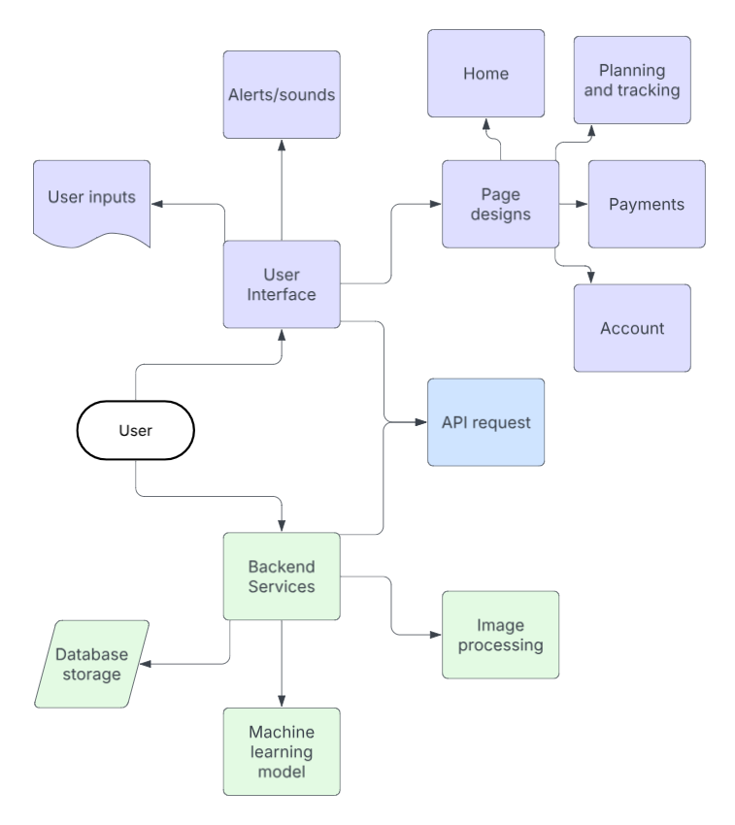
Figure 1. System Units Block Diagram

Modes of Operations
The Personal Financial Advisor App operates in several distinct modes to cater to the needs of the user throughout their financial management process. These modes include:
- User Registration and Authentication: In this function, users create an account or log into the app using Firebase Authentication. Users provide basic personal information and set up secure login credentials. Once authenticated, the user gains access to the app's features, ensuring that financial data remains private and protected.
- Transaction Tracking: This is the core function of the app where users interact with their financial data. Students can manually input transactions by entering details such as the amount, category, merchant, and date, or through the receipt scanning function of the application via the React Native camera function. The system categorizes transactions into predetermined categories like food, entertainment, bills, etc., and updates the user’s financial portfolio in real time.
- Budgeting and Goal-Setting: With this function, users can create and manage budgeting goals for different spending categories such as monthly spending limits for food or entertainment. The app tracks expenses in real-time against the budgeted amounts, alerting users if they are approaching or exceeding their limits. Users can also set savings goals for specific financial milestones, like saving for a trip or an emergency fund, and the app will track progress toward those goals.
- Financial Insights and Advice: Once sufficient data has been accumulated, the app analyzes the user’s spending patterns and provides personalized financial advice. This includes tips for saving, optimizing spending, and setting better budgeting practices based on historical data. The system may also provide suggestions like cutting back on non-essential expenses or recommending more affordable alternatives for recurring payments. Insights are updated regularly based on new transaction data.
- Reporting and Visualization: Users can view comprehensive spending reports and financial charts that show trends over time. The system generates interactive visualizations such as bar graphs and pie charts, which allow students to analyze their spending habits. Reports are updated regularly, providing students with a clear understanding of their financial behavior and how it compares to their established budgets and goals.
- Notification and Reminder: This mode sends notifications and reminders to students about important financial events. For example, users receive notifications for upcoming bill payments, payment due dates for loans, or when they are nearing their budget limits. The app may also remind users about specific savings goals, encouraging them to take action toward meeting those milestones.

- Settings and Profile Management: In this function, users can modify their personal details, configure app preferences, and adjust notification settings. They can also change security settings such as password recovery options and enable multi-factor authentication for increased secure protection.
Each mode operates seamlessly in the background, providing a comprehensive and intuitive experience for users to manage their finances, make informed decisions, and work toward their financial goals.

Users
The primary users of this financial tracking application are college students who need assistance in managing their finances through receipt scanning and expense tracking. The system is designed to be intuitive, requiring minimal training for installation and use.

User Characteristics
- Students (Primary Users)
  - Financial Literacy Level: Varies from beginner to intermediate
  - Technical Knowledge: Basic familiarity with mobile applications
  - Training Required: None; the app is designed for ease of use with a simple onboarding process
  - Benefit: Helps students track expenses, set financial goals, and receive tailored financial advice
- Student Workers & Part-Time Employees
  - Financial Literacy Level: Intermediate
  - Technical Knowledge: Comfortable using mobile finance apps
  - Training Required: Minimal, as the system will automate data entry and categorization
  - Benefit: Helps track income, manage expenses, and budget effectively
- Young Professionals & Recent Graduates (Potential Secondary Users)
  - Financial Literacy Level: Developing
  - Technical Knowledge: Familiar with financial tools and mobile banking apps
  - Training Required: None; self-explanatory UI with guidance for first-time users
  - Benefit: Allows seamless financial tracking for those transitioning to independent financial management
This system is designed for accessibility, ensuring that students and young professionals can manage their finances with minimal effort.

Support

Installation & Usage Training
- Installation: Users will download the app from the App Store (iOS) or Play Store (Android). A setup wizard will guide them through account creation.
- Usage: No training is needed for users that are familiar with mobile devices. Users can scan receipts, review transactions, and get financial insights with simple on-screen instructions.
- Support: FAQs and help documentation will be available within the app.

Scenario(s)

Budget Planning
It can be difficult for students who might be new to maintaining their own personal finances to create reasonable budgets. Our app will include a model that informs its users on popular financial plans that are relevant to them based on their account information and expenses. This will allow for easy and successful budgeting, along with a straightforward way to view progress towards a monthly spending goal.
  - Financial Education and Coaching
It’s vital for students to begin monetary education early so that they can apply practices now and prepare for when they begin seeing increased earnings post-graduation. In the financial education and coaching tab, our app will employ account information along with purchase details input by the user through our receipt scanning function. It will then utilize a machine learning model to recommend suitable financial literacy, investment options, and potential scholarships. This will provide student users with a solid foundation of economic skills for present and future use.
  - Expense Tracking
The average student has a plethora of tasks to complete in a day, so adding seemingly unnecessary chores such as tracking expenses can feel daunting. Our app will aid in relieving some of this stress and encouraging users to keep up with their recent and upcoming expenses. The planning and tracking tab will provide clear information on upcoming bill payments, subscriptions, and recurring payments. It will also have the option to provide an itemized list for student tuition by semester along with a deadline. The easy to navigate interface will allow students to quickly get reminders on these expenses and save accordingly.

Analysis

Summary of Proposed Improvements
Our personalized financial advisor app for students will include multiple improvements from current financial advisor apps including the following:
- Implementing artificial intelligence and machine learning will allow for real-time personalized feedback for users.
- Providing relevant financial literature will save students time and effort from having to complete research on their own.
- The easy to navigate interface will help students view their budgeting goals clearly and stick to a schedule with ease.
- Our machine learning model will allow users to input purchases more easily by scanning their receipts.
- Using React Native will allow for simple and readable code along with smooth cross-platform use.

Disadvantages and Limitations
Some of the disadvantages and limitations of the application include:
- While React Native is beneficial in many ways, one downside is that it typically has a larger app size. This may lead to slower download times or deter users from installing the app.
- This framework also has limitations on the complexity of features/animations available.
- Using Python Flask limits the size of our project to small/medium.

Alternatives
- A couple of alternatives to React Native for mobile app front-end design include Flutter and Ionic. While we did consider using one of these frameworks, React Native was compatible with both IOS and Android despite the extra time and effort it takes to implement. It also provided an easier to decipher code style and language being based largely on JavaScript.
- Node.js and Ruby are both common alternatives for back-end languages. While they do allow for quicker execution and development, Python Django or Flask have more accessibility for implementing machine learning and artificial intelligence.

Impact
Some potential impacts of our personalized financial advisor app are listed below:
- If our AI model suggests a cheaper alternative to a product that a user buys often, it might be less environmentally friendly.
- While finances are important, it is also vital to find a balance between taking care of oneself and saving money. It’s important we ensure that our app doesn’t have the potential to instill unhealthy habits to budget.

