Financial Advisor App for Students
Camille Embree, Hoang-Nghi Nguyen

Functional System Requirements

REVISION – Draft
20 February 2025
Functional System Requirements
for
Financial Advisor App for Students

Prepared by:

_____________________________
Author Date

Approved by:

_____________________________
Project Leader Date

_____________________________
John Lusher, P.E. Date

_____________________________
T/A Date

Change Record
Rev. | Date | Originator | Approvals | Description
1 | 2/20/2025 | Financial Advisor App for Students |  | Draft Release

Table of Contents
Table of Contents III
List of Tables IV
List of Figures V
1. Introduction 6
1.1. Purpose and Scope 6
1.2. Responsibility and Change Authority 6
2. Requirements 7
2.1. System Definition 7
2.2. Characteristics 8
2.2.1. Functional / Performance Requirements 9
2.2.2. User Interface and Experience 9
2.2.3. Data Handling and Security 11
2.2.4. System Scalability and Integration 12
2.2.5. Error Handling and Fault Tolerance 13
3. Support Requirements XIV
Appendix A Acronyms and Abbreviations XV
Appendix B Definition of Terms XVI

List of Tables

List of Figures
Figure 1. Block Diagram of System 1

1. Introduction

Purpose and Scope
Managing budgets and gaining financial education is a pivotal aspect of every student’s experience. The Personalized Financial Advisor App for Students will allow users to easily go about this by displaying relevant financial information in a clear and engaging format. It will begin by connecting with a student's bank account and data mining to get an idea of how much they spend on certain items. The system shall use Finicity to ensure privacy. It shall use Firebase to store pertinent user data and provide security. It shall then use a machine learning model to suggest budgets that may be beneficial to the student based on their specific habits. Once the student has selected a financial plan, it shall be conveniently displayed on the home page in an aesthetically pleasing format. The app should also recommend relevant articles, scholarship opportunities, credit building tips, and more on a separate tab. The UI and database shall be connected through a secure API request.

All of these features will aid students in practicing imperative skills such as economizing which will allow them to accumulate less debt, fill necessary financial obligations, and relieve some of the stress surrounding money management.

Responsibility and Change Authority

Briefly describe who has the responsibility for making sure the requirements are met (i.e., team leader) and who has the authority to make the changes (i.e., client and team leader).

Hoang-Nghi Nguyen will have the responsibility of making sure that the requirements for the back-end coding are met. This includes creating a functioning machine learning model using Sci-kit, providing an organized database for storage, and integrating a secure bank account connection.

Camille Embree, on the other hand, will be responsible for ensuring that the requirements for the front-end coding are met. This will include drafting a user-friendly interface that includes three main components (home, analysis, and education tab), as well making sure that the front and back end are smoothly integrated.

Each member will have the authority to make changes to their respective subsystems under the consensus of the team and acceptance of our sponsor, Niloofar Borzooei.

Requirements

System Definition

Our project, the Personalized Financial Advisor App for Students, is a mobile application designed to facilitate budgeting and gaining financial education for its users. It will succeed in this task by following the block diagram below which has been split into two main subsystems, a front-end and a back-end.

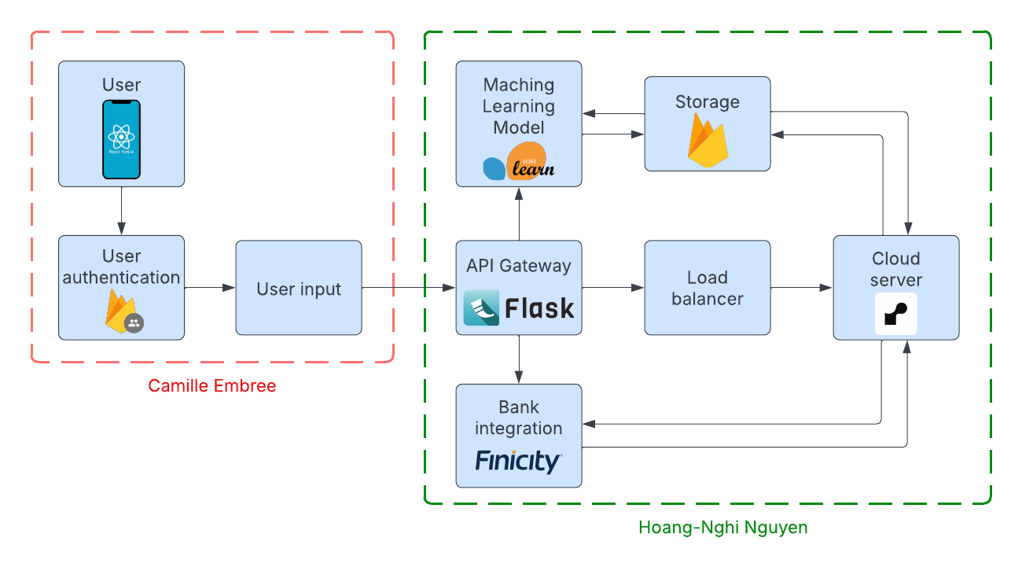
Figure 1. Block Diagram of System

The front-end of this project will primarily focus on building a user-friendly interface for students to easily view their current budget progress, an analysis of their spending, and resources to build financial literacy. It shall be straightforward and comprehensible as well as engaging so that students don’t forget to check it and utilize all of the functions available.

Characteristics

Functional / Performance Requirements

API Response Time Test
The financial tracking application must maintain efficient performance, with API response times of ≤ 500ms under normal load. This ensures that user requests, such as transaction fetching and data updates, are processed quickly without delays. Performance testing should identify potential bottlenecks in Flask API endpoints to optimize response times.

Rationale: Fast response times are essential to ensuring a smooth user experience. Delays in fetching or updating financial data may frustrate users and impact usability. The 500ms threshold aligns with best practices for mobile applications and ensures near-instantaneous feedback when interacting with financial data.

Bank Transaction Fetching
The system must successfully retrieve and update bank transactions for authenticated users from Finicity. This ensures that users always have access to their latest financial data. The API integration should be tested with valid and invalid credentials to verify authentication and error-handling mechanisms.

Rationale: Users rely on real-time updates to track their financial status. If transactions are not retrieved properly, users may make decisions based on outdated information. This requirement ensures reliable transaction fetching, preventing discrepancies between the app and the user’s bank.

ML Model Accuracy
The machine learning model should classify and analyze user spending patterns with an accuracy of at least 85%. Test datasets with labeled transactions will be used to validate the accuracy of the model’s categorizations, ensuring that expenses are grouped correctly into categories such as "Food," "Rent," and "Entertainment."

Rationale: Accurate expense categorization helps users understand their spending habits and budget effectively. A lower accuracy rate could lead to misclassified expenses, reducing trust in the system and requiring manual corrections.

Database Read/Write Performance
Read and write operations to Firebase Firestore should complete in ≤ 200ms for 90% of requests to ensure real-time transaction categorization and user updates. Performance tests should simulate concurrent database operations, including fetching transactions and storing new data.

Rationale: The app relies on real-time data synchronization to reflect updates instantly across devices. Slow database performance could cause laggy interfaces, outdated financial insights, or even synchronization failures. A 200ms threshold ensures smooth interactions without noticeable delays.

End-to-End Module Functionality
Each core feature of the application, including authentication, transaction retrieval, machine learning-based categorization, and UI updates, should function correctly in isolation and together as a complete system. Individual module tests will verify that API calls, ML predictions, and database interactions work as expected.

Rationale: A failure in any core module could render the application unusable. Testing each module separately ensures stability, while integrated testing guarantees that components interact as expected. This is critical for maintaining data consistency and preventing functional breakdowns.

User Interface and Experience

Home Tab
The home page should provide users with a comprehensive financial overview in an easy-to-navigate format. Users should be able to check their budget status quickly, with a learning curve of no more than four minutes. Testing will involve usability evaluations with groups of five students.

Rationale: Users should not feel overwhelmed when accessing their financial information. A simple and intuitive home page improves engagement and retention. The four-minute threshold ensures that even non-tech-savvy users can quickly understand the interface.

Tracking/Analysis Tab
This tab should display clear and visually informative charts and graphs about recent spending patterns. The graphs must be accurate and update dynamically based on the user's financial activity. Usability tests will ensure the effectiveness of the visual representation.

Rationale: Raw transaction data can be difficult to interpret. Visual representations (charts and graphs) help users quickly grasp spending patterns, identify trends, and adjust their budget. The accuracy of these visualizations is critical to preventing misleading financial decisions.

Financial Literacy Tab
The financial literacy tab should offer educational content related to financial strategies, budgeting, and investment opportunities. The information must be engaging and visually appealing. Five students will review three different financial literacy content layouts to determine accessibility.

Rationale: Many students lack formal financial education. A dedicated financial literacy section provides users with knowledge, helping them make informed spending and saving decisions. Having an engaging presentation of content ensures that users stay interested and benefit from the information.

Account Page
The account page should securely store and display user information. All user inputs must be validated against a test database to ensure correctness. Testing will involve submitting valid and invalid user data and verifying proper handling.

Rationale: Security is a top priority when handling financial data. Invalid or incomplete inputs could lead to authentication issues or data corruption. Ensuring strict input validation enhances system reliability and prevents unauthorized data access.

Sounds
The application should include auditory feedback when users interact with buttons or select options. A sandbox environment will be used to verify that sounds are played correctly at least 95% of the time when a relevant button is pressed.

Rationale: Sound cues provide instant confirmation that an action has been registered. Missing or incorrect audio feedback can lead to user confusion, especially for visually impaired individuals or users navigating quickly.

Alerts
Push notifications should remind users of budget limits or suggest lower-priced alternatives. Alerts must be delivered reliably, and tracking in the Apple Push Notification Console will confirm successful message delivery.

Rationale: Notifications help users stay on track with their budgeting goals. If users are not reminded of overspending or available savings opportunities, they may miss chances to improve their financial health.

Data Handling and Security

Secure Transaction Storage
All financial transaction data must be securely stored in Firebase Firestore with encryption enabled. Testing will verify that transactions are stored correctly and cannot be accessed without proper authentication.

Rationale: Financial transactions contain sensitive personal information. Encryption ensures data security and compliance with best practices for financial applications.

Authentication and Access Control
User accounts must be protected with secure authentication mechanisms, including password encryption and Firebase Authentication. Tests will include login attempts with incorrect passwords and unauthorized access attempts.

Rationale: Protecting user accounts from unauthorized access is essential. Firebase Authentication provides a secure, industry-standard mechanism for login and account recovery.

Data Integrity and Validation
The system must prevent invalid or incomplete data entries. All user inputs should be tested against predefined integrity rules to ensure correctness. Invalid transactions should be rejected to maintain accurate financial tracking.

Rationale: Incorrect or corrupted data compromises accuracy. Validation ensures data reliability, preventing duplicate or inconsistent records.

API Security and Error Handling
Flask API endpoints must handle errors properly, including invalid transaction data and unauthorized access attempts. Testing will include sending incorrect API requests and verifying proper error messages are returned instead of system crashes.

Rationale: Proper error handling is critical for security and usability. Without it, invalid inputs or unauthorized access attempts could cause system crashes or expose sensitive information. Clear and structured error messages help users understand issues while preventing attackers from exploiting vulnerabilities. Implementing proper error handling ensures system stability, security, and a better user experience.

System Scalability and Integration

Backend API Performance
The Flask backend must handle increasing numbers of concurrent users and API requests without performance degradation. Load testing will simulate multiple concurrent requests to ensure the system remains responsive.

Rationale: As more users join the platform, the backend must scale efficiently. Ensuring API performance prevents slowdowns or crashes due to high traffic.

Frontend-Backend API Integration
The React Native frontend must communicate smoothly with the Flask backend. API responses should be properly formatted and displayed in the UI without breaking the application. Testing will include sending incorrect API data and observing error handling.

Rationale: Seamless frontend-backend communication ensures that users always see updated and consistent data. Improper integration could cause UI glitches or incorrect financial insights.

Handling Edge Cases
The system should be resilient against unusual inputs, such as empty transaction histories, duplicate entries, or corrupted data. Edge case testing will verify that such conditions do not cause crashes or incorrect calculations.

Rationale: Handling edge cases prevents system crashes and ensures accurate calculations. It ensures the app remains stable and reliable, even with unexpected inputs, enhancing user trust and experience.

Future Scalability Considerations
The system must be designed to integrate additional financial data sources and expand machine learning capabilities without requiring major architectural changes.

Rationale: Building for scalability ensures the system can grow and adapt to future requirements without significant changes. This flexibility supports long-term sustainability and allows for the addition of new features, improving the app’s value and performance over time.

Error Handling and Fault Tolerance

Transaction Categorization Accuracy
Transactions retrieved from Finicity must be correctly categorized and stored. Sample transaction data will be used to verify whether categories like "Food" and "Rent" match expected classifications.

Rationale: Poor categorization can lead to misleading financial reports. Ensuring correct classification reduces user corrections and improves budgeting insights.

Expense Tracking Consistency
The expense tracking feature must maintain long-term consistency in financial calculations. Simulated expense entries will be tested over extended periods to validate tracking accuracy.

Rationale: Users rely on expense tracking for long-term budgeting. If calculations become inconsistent, financial predictions and budgets will be inaccurate, leading to poor decision-making.

API Failure Handling
The backend must handle API failures gracefully, providing appropriate error messages rather than crashing. Tests will simulate scenarios such as Finicity being temporarily unavailable.

Rationale: Third-party API failures are unavoidable, but system crashes can be prevented. Proper error handling ensures users are informed of issues rather than experiencing app failures.

User Error Recovery
Users must be able to recover from input errors without data loss. Testing will involve incorrect inputs in forms and ensuring users can correct mistakes easily.

Rationale: Mistakes in financial apps are common. Allowing users to correct errors prevents frustration and ensures data accuracy.

Alert System Reliability
Push notifications must deliver accurate and timely alerts regarding spending limits and budget warnings. A test environment will track whether alerts are successfully received on mobile devices.

Rationale: Ensuring reliable alerts is essential for user engagement and financial management. Timely, accurate notifications help users stay on top of their spending, while proper testing guarantees that the system delivers critical alerts without failure. This enhances user experience and helps maintain the app’s reliability.

Support Requirements
In order to display our app system as expected, users will require a mobile device of IOS version 13.4 or above. They may also use an Android device of version 6 or above, however the layout likely won’t be as functional and IOS is recommended.
The financial tracking app will require a comprehensive support system to ensure smooth operation, user satisfaction, and long-term success.
- User Support: Users should have access to clear documentation, FAQs, and self-help resources, as well as responsive support through live chat or email for resolving issues such as login problems, transaction disputes, or feature inquiries.
- Technical Support: The backend and infrastructure should be regularly monitored for potential issues, such as server downtime, database errors, or API failures. Timely bug fixes and system updates will be essential for maintaining reliability.
- Security and Data Integrity: Continuous monitoring and prompt patching of security vulnerabilities, including data breaches, authentication issues, and encryption, will be crucial. Regular audits and compliance checks will also ensure the protection of sensitive user data.
- Scalability Support: As the app grows, support will be required for scaling both the infrastructure and feature set. This includes optimizing server performance, expanding data storage capabilities, and managing additional financial data sources or machine learning models.

Appendix A: Acronyms and Abbreviations

API Application Programming Interface
DB Database
JSON JavaScript Object Notation
ML Machine Learning
NoSQL Not Only SQL
REST Representational State Transfer
SDK Software Development Kit
UI User Interface
UX User Experience
ICD Interface Control Document

Appendix B: Definition of Terms
API (Application Programming Interface): A set of protocols, tools, and definitions that allow different software applications to communicate with each other. In the context of the app, the API facilitates data exchange between the frontend (React Native) and backend (Flask).

DB (Database): A system used to store, manage, and retrieve data. In this project, Firebase Firestore is used as the NoSQL database to store user information, transaction records, and other financial data.

JSON (JavaScript Object Notation): A lightweight, text-based data format used for exchanging data between the client (frontend) and server (backend). JSON is easy for both humans and machines to read and write.

ML (Machine Learning): A subset of artificial intelligence that involves the use of algorithms and statistical models to analyze data, learn from it, and make predictions. In this project, ML is used for extracting financial data from receipts and providing personalized financial advice.

NoSQL (Not Only SQL): A type of database designed to handle unstructured or semi-structured data. Firestore, a NoSQL database, is used in this project to store dynamic, scalable user and financial data.

REST (Representational State Transfer): An architectural style for designing networked applications. RESTful APIs use standard HTTP methods (GET, POST, PUT, DELETE) to manage data and ensure stateless interactions between the client and server.

SDK (Software Development Kit): A collection of tools, libraries, and documentation that help developers build applications. For this project, SDKs from third-party services like Finicity are used to integrate bank transaction data into the app.

UI (User Interface): The visual part of the application that users interact with, including elements like buttons, forms, and navigation menus. A well-designed UI ensures a smooth user experience.

UX (User Experience): The overall experience of a user when interacting with an application, focusing on ease of use, satisfaction, and efficiency. A strong UX design ensures that users can easily navigate and engage with the app.

