Question 1: Test your knowledge

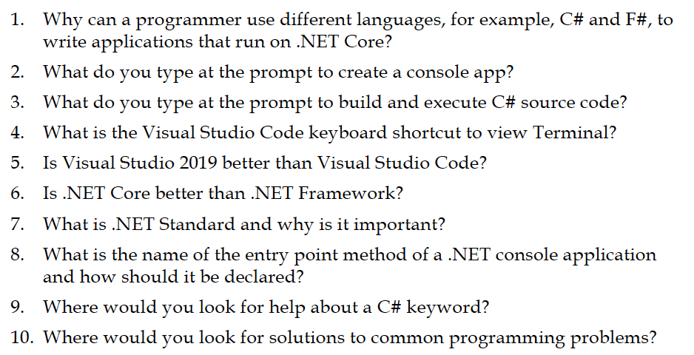

1. Answer: .Net is an open source development platform for building many different types of applications. It supports multiple languages, editors, and libraries to build an applications.

Reason of use different languages:

* Improved ability to find the right code components for the application.
* Reuse code written in other languages.
* It is necessary to have another language for special cases.
* Inheritance code.

1. Answer: Open Command prompt and enter command “dotnet new console -o "ConsoleApplication" ” to create a console app.

* dotnet new console : scaffolds the console application template.
* -o "ConsoleApplication" : inputs the folder in which to scaffold the files into.

1. Answer: enter command “ c:\> cd ConsoleApplication ” to switch the path to the folder that have created.
   * Enter command to open the ConsoleApplication project in VS Code: c:\ConsoleApplication> code .
   * Next, we have to Configure VS Code to build and debug the project.
   * Create a random flie name like “Launch.json”
   * Open launch.json file and find the section "name": ".NET Core Launch (console)"
   * Replace the belwo line:
     + "program": "${workspaceRoot}/bin/Debug/<insert-target-framework-here>/<insert-project-name-here>.dll",
     + With: "program": "${workspaceRoot}/bin/Debug/netcoreapp2.0/ConsoleApplication.dll",
   * Now you are all set to debug your Console application in Visual Studio Code.

Finaly, Place a break point in program.cs file either by clicking on the line of code where you want the debugger to break and pressing F9 key or by clicking on the space to the left of the line number.

Press F5 to begin debug your code.

All the above steps are based on (Kalkere, 2017).

1. Answer: keyboard shortcuts to view termianl in visual studio code is Ctrl+Shift+P
2. Answer: Visual Studio Code is an editor while Visual Studio 2019 is an IDE ( Integrated Development Environment ).

Comparison between Visual Studio Code and Visual Studio 2019

Visual Studio 2019:

* It is mainly used to develop Windows software including DirectX programs, Windows APIs, etc.
* It is quite heavy on CPU and lags on lower end PCs.
* It features built-in debuggers, easy-to-configure project settings.
* Advanced IntelliSense.
* Microsoft support (more than Visual Studio Code).
* There are data collection tools: SQL Server, database, etc.
* Includes tools to generate dependency graphs. Refactoring tools have great support for Visual Studio.

Visual Studio Code:

* Free open source text editor.
* It works on lower-end PCs.
* Has IntelliSense (but it doesn't work out of box if Visual Studio is not installed).
* Mostly used for web development (this applies to all free text editors). They tend to show off JavaScript / HTML support over C/C++. Visual Studio shows off Visual Basic/C++ over other languages.
* Has an integrated terminal (PowerShell is too slow at startup though).
* Conclusion: each tool has its own role. Visual Studio is use to develop complete native applications, and Visual Studio code is use to develop the Web front end.

1. Answer:
2. Answer: .NET Standard is a specification that represents a set of APIs that all .NET platforms have to implement. This unifies the .NET platforms and prevents future fragmentation
   * Why .NET Standard important ? -> because It allowed tailoring .NET to fit the needs that a single platform wouldn’t have been able to.
3. Answer*:* entry point method is the first method which gets invoked whenever an application started and it is present in every C# executable file. So the name of the entry point method of a .Net console application is “static void Main(string[] args)”.

It should be declared simple like this:

static void Main(string[] args) <- here is the entry point method

{

Console.WriteLine("Hello World!");

Console.ReadLine();

}

1. Answer:
2. Answer:

Question 2: Check out what the code does in the console App?

Code A

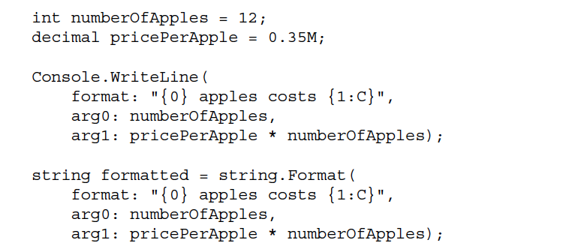

Code in VS 2019:

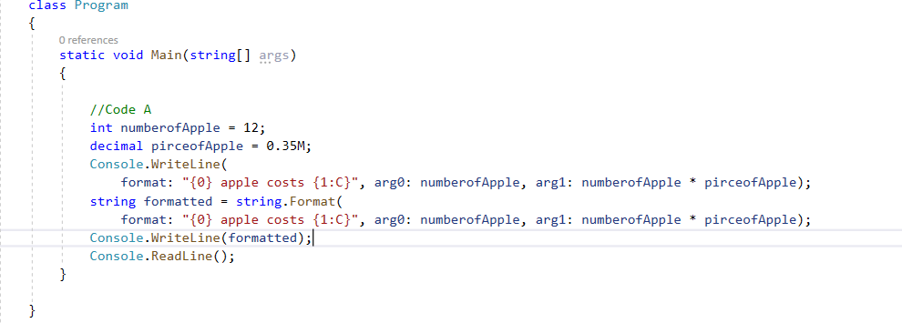

* Output 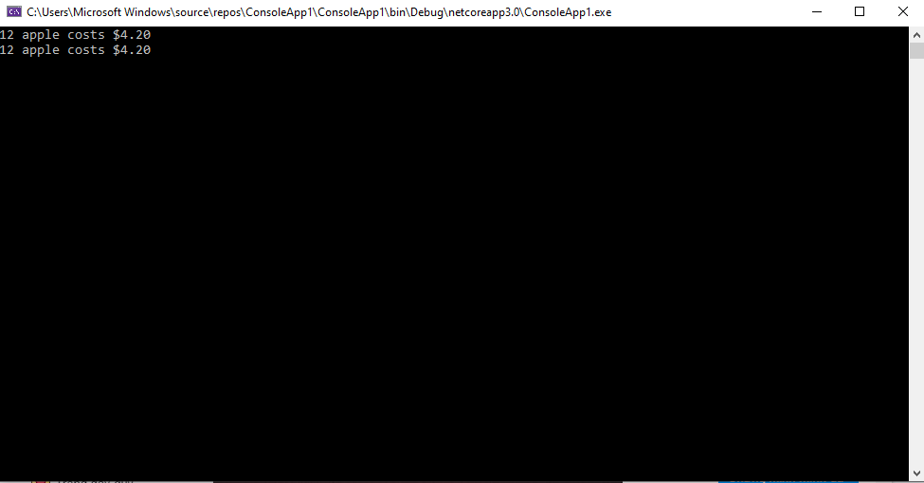

Code B

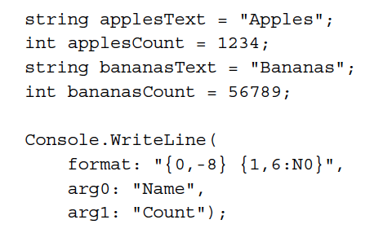

Code in VS 2019:

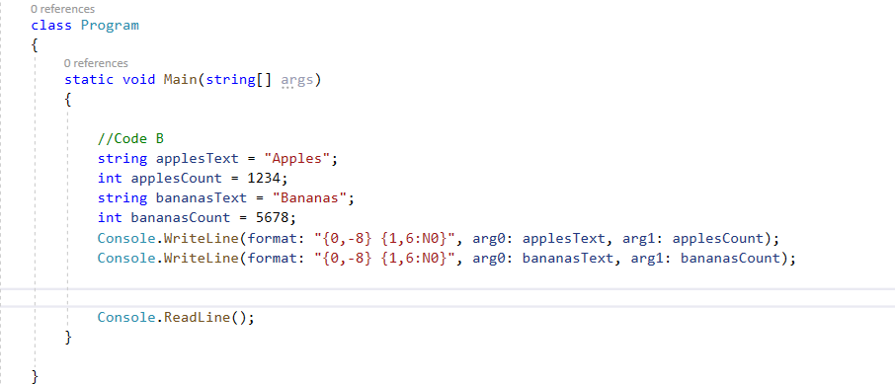

* Output:

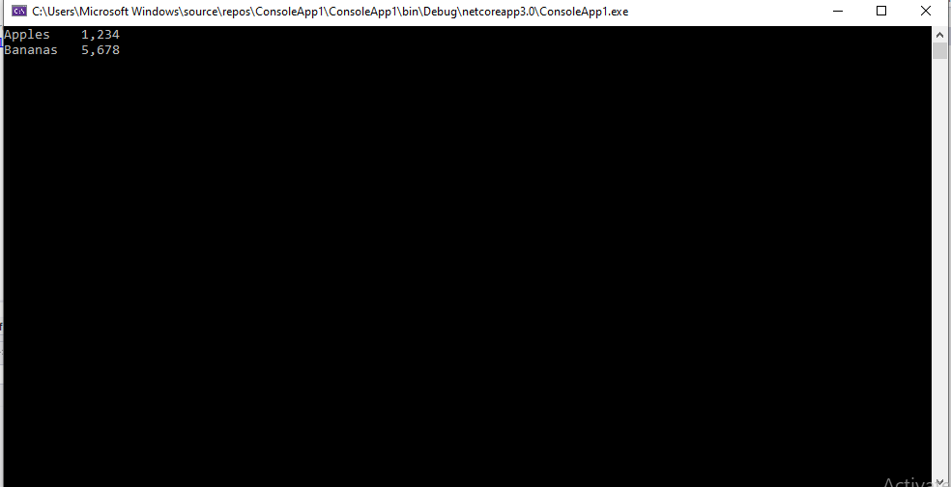

Code C

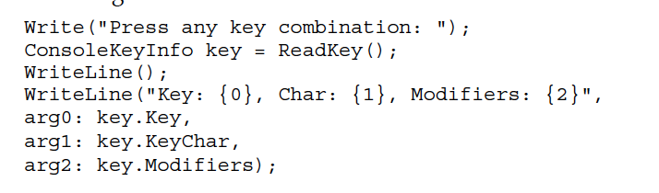

Code in VS 2019:

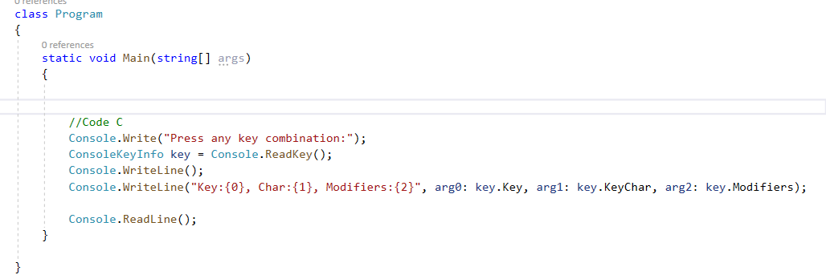

* Output:

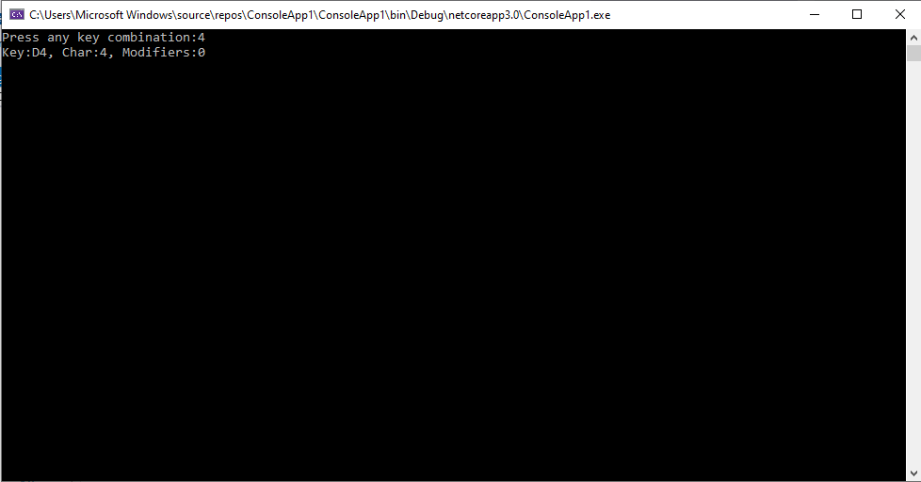

Question 3: Follow instructions at <https://docs.microsoft.com/en-us/dotnet/standard/base-types/composite-formatting> and produce

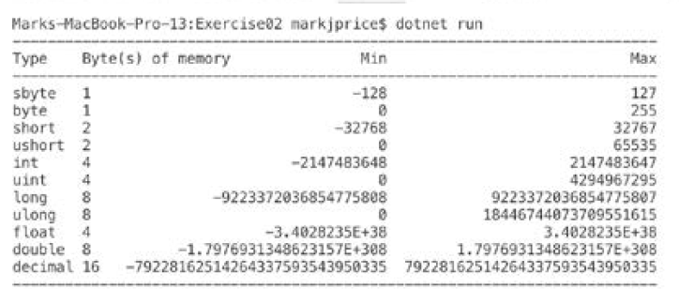

Code in VS 2019:

**using** System**;**

**namespace** ConsoleApp2

**{**

class Program

**{**

**public** static string Repeat**(**char character**,** int numberOfIterations**)**

**{**

**return** ""**.**PadLeft**(**numberOfIterations**,** character**);**

**}**

static void Main**(**string**[]** args**)**

**{**

string**[]** types **=** **{** "sbyte"**,** "byte"**,** "short"**,** "ushort"**,**

"int"**,** "uint"**,** "long"**,** "ulong"**,** "float"**,** "double"**,**"decimal" **};**

int**[]** memory **=** **{**1**,** 1**,** 2**,** 2**,** 4**,** 4**,** 8**,** 8**,** 4**,** 8**,** 16**};**

string**[]** min **=** **{**"-128"**,** "0"**,** "-32768"**,** "0"**,** "-2147483648"**,** "-9223372036854775808"**,** "0"**,** "-3.402823E+38"**,**"-1.79769313486232E+308"**,** "-79228162514264337593543950335" **};**

string**[]** max **=** **{**"127"**,**"255"**,** "32767"**,**"65535"**,** "4294967295"**,** "9223372036854775807"**,** "18446744073709551615"**,** "3.402823E+38"**,** "1.79769313486232E+308"**,** "79228162514264337593543950335" **};**

Console**.**WriteLine**(**Repeat**(**'-'**,** 90**));**

Console**.**WriteLine**(**"{0,-5} {1,20} {2,20} {3,30}"**,** "Types"**,** "Byte(s) of memory"**,** "Min"**,** "Max"**);**

Console**.**WriteLine**(**Repeat**(**'-'**,** 90**));**

**for** **(**int ctr **=** 0**;** ctr **<** min**.**Length**;** ctr**++)**

Console**.**WriteLine**(**"{0,-6} {1,10} {2,40} {3,30}"**,** types**[**ctr**],** memory**[**ctr**],**min**[**ctr**],**max**[**ctr**]);**

Console**.**ReadLine**();**

**}**

**}**

**}**

* Output:

