**ASSIGNMENT 1 FRONT SHEET**

|  |  |  |  |
| --- | --- | --- | --- |
| **Qualification** | **BTEC Level 5 HND Diploma in Computing** | | |
| **Unit number and title** | Unit 9: Software Development Life Cycle | | |
| **Submission date** |  | **Date Received 1st submission** |  |
| **Re-submission Date** |  | **Date Received 2nd submission** |  |
| **Student Name** | Nguyen Van Manh | **Student ID** | BHAF200079 |
| **Class** | PBTIT17101 | **Assessor name** | Ngo Thi Mai Loan |
| **Student declaration**  I certify that the assignment submission is entirely my own work and I fully understand the consequences of plagiarism. I understand that making a false declaration is a form of malpractice. | | | |
|  |  | **Student’s signature** |  |

**Grading grid**

|  |  |  |  |  |  |  |  |
| --- | --- | --- | --- | --- | --- | --- | --- |
| P1 | P2 | P3 | P4 | M1 | M2 | D1 | D2 |
|  |  |  |  |  |  |  |  |

|  |  |  |
| --- | --- | --- |
| **❒ Summative Feedback: ❒ Resubmission Feedback:** | | |
| **Grade:** | **Assessor Signature:** | **Date:** |
| **Internal Verifier’s Comments:** | | |
| **Signature & Date:** | | |

**TABLE OF CONTENTS**

1. **INTRODUCTION**
2. What is SDLC and their roles?
3. My task in this assignment
4. **DESCRIBE TWO ITERATIVE AND TWO SEQUENTIAL SOFTWARE LIFECYCLE MODELS (P1)**
5. Describe two iterative software life cycle model
6. Describe two sequential software life cycle model
7. Select the right model for project
8. **EXPLAIN HOW RISK IS MANAGED IN THE SPIRAL LIFECYCLE MODEL (P2)**
9. What is Spiral model?
10. Phases of Spiral model
11. What is manage risk and how to manage risk?
12. How to manage risk in Spiral model?
13. **EXPLAIN THE PURPOSE OF A FEASIBILITY REPORT (P3)**
14. What is the feasibility of the project?
15. Feasibility study for what and benefits?
16. Components of the feasibility report
17. **DESCRIBE HOW TECHNICAL SOLUTIONS CAN BE COMPARED (P4)**
18. **CONCLUSION**
19. **REFERENCES**

# Introduction

## What is SDLC and their roles?

- SDLC stands for Software development life cycle.

- SDLC is a process used in building software. Plan, define, design, build, test, and finally develop It aims to guarantee the quality and correctness of the software built for the customer. The SDLC process aims to produce high-quality software.

- This methodology is also known as the Application Development life cycle.

(Key Development Team Roles within the Software Development Lifecycle, 2021).

## My task in this assignment

- In this assignment, I am the project manager of ABC company and collaborated with Tune Source to complete the project.

- I need to report on 4 contents:

* Describe 4 SDLC models: Waterfall, V-Model, Spiral, Rapid Development. Which method is best for Tune Source and why?
* My report have list some risks and offer an approach to manage risks.
* Discuss why a team need to conduct feasibility study and what areas should be conducted in feasibility study?
* My team now is offering several technical solutions for Tune Source. Describe how can you choose a solution over the others.

# Describe two iterative and two sequential software life cycle models (P1)

## Describe two iterative software life cycle model.

1. **Agile model**

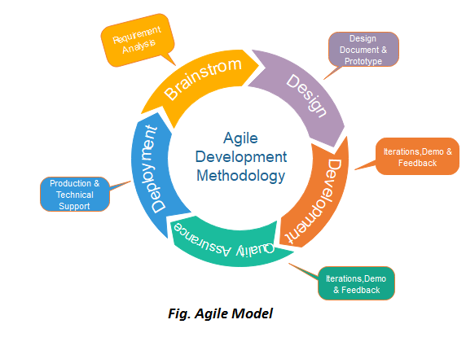

- Agile model is a combination of iterative and incremental process models with focus on process adaptability and customer satisfaction by rapid delivery of working software product.

**- The various phases of Agile model are as follows:**

* **Requirements gathering:** In this phase, you must define the requirements. You should explain business opportunities and plan the time and effort needed to build the project. Based on this information, you can evaluate technical and economic feasibility.
* **Design the requirements:** When you have identified the project, work with stakeholders to define requirements. You can use the user flow diagram or the high-level UML diagram to show the work of new features and show how it will apply to your existing system.
* **Construction/ Iteration:** When the team defines the requirements, the work begins. Designers and developers start working on their project, which aims to deploy a working product. The product will undergo various stages of improvement, so it includes simple, minimal functionality.
* **Testing/ Quality assurance:** In this phase, the Quality Assurance team examines the product's performance and looks for the bug.
* **Deployment:** In this phase, the team issues a product for the user's work environment.
* **Feedback:** After releasing the product, the last step is feedback. In this, the team receives feedback about the product and works through the feedback.

**- Advantages of Agile method:**

* Frequent delivery.
* Face-to-face Communication with clients.
* Efficient design and fulfils the business requirement.
* Anytime changes are acceptable.
* It reduces total development time.

**- Disadvantages of Agile method:**

* Not suitable for handling complex dependencies.
* There are many risks in terms of sustainability, maintainability, and scalability.
* Need an experienced team.
* Depends heavily on clear customer interaction.

**- When to use the Agile model?**

* When frequent changes are required.
* When a highly qualified and experienced team is available.
* When a customer is ready to have a meeting with a software team all the time.
* When project size is small.

(Agile Model (Software Engineering) - javatpoint, 2021).

1. **Iterative model**

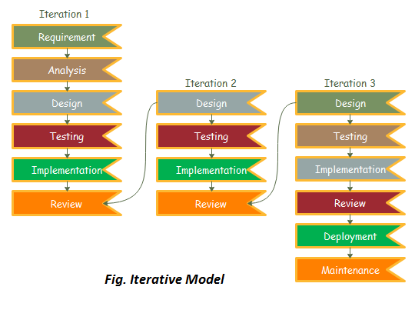

- In this Model, you can start with some of the software specifications and develop the first version of the software. After the first version if there is a need to change the software, then a new version of the software is created with a new iteration. Every release of the Iterative Model finishes in an exact and fixed period that is called iteration.

**- The various phases of Iterative model are as follows:**

* **Requirement gathering & Analysis:** In this phase, requirements are gathered from customers and check by an analyst whether requirements will fulfil or not. Analyst checks that need will achieve within budget or not. After all of this, the software team skips to the next phase.
* **Design and Development:** In the design phase, team design the software by the different diagrams like Data Flow diagram, activity diagram, class diagram, state transition diagram, etc.
* **Implementation:** In the implementation, requirements are written in the coding language and transformed into computer programmes which are called Software.
* **Testing:** After completing the coding phase, software testing starts using different test methods. There are many test methods, but the most common are white box, black box, and grey box test methods.
* **Deployment:** After completing all the phases, software is deployed to its work environment.
* **Review:** In this phase, after the product deployment, review phase is performed to check the behaviour and validity of the developed product. And if there are any error found then the process starts again from the requirement gathering.
* **Maintenance:** In the maintenance phase, after deployment of the software in the working environment there may be some bugs, some errors or new updates are required. Maintenance involves debugging and new addition options.

**- Advantages of Iterative model:**

* Testing and debugging during smaller iteration is easy.
* A Parallel development can plan.
* It is easily acceptable to ever-changing needs of the project.
* Risks are identified and resolved during iteration.
* Limited time spent on documentation and extra time on designing.

**- Disadvantages of Iterative model:**

* It is not suitable for smaller projects.
* More Resources may be required.
* Design can be changed again and again because of imperfect requirements.
* Requirement changes can cause over budget.
* Project completion date not confirmed because of changing requirements.

**- When to use the Iterative model?**

* When requirements are defined clearly and easy to understand.
* When the software application is large.
* When there is a requirement of changes in future.

(Iterative Model (Software Engineering) - javatpoint, 2021)

## Describe two sequential software life cycle model

1. **Waterfall model**

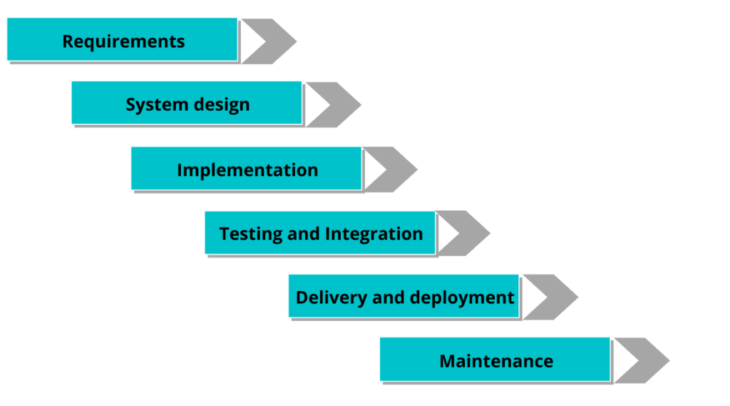

- The waterfall model is a classical model used in the system development life cycle to create a system with a linear and sequential approach.

**-** **The various phases of Waterfall model are as follows:**

* **Requirements analysis and specification:** The aim of this phase is to understand the exact requirements of the customer and to document them properly. Both the customer and the software developer work together so as to document all the functions, performance, and interfacing requirement of the software. It describes the "what" of the system to be produced and not "how."In this phase, a large document called Software Requirement Specification (SRS) document is created which contained a detailed description of what the system will do in the common language.
* **Design:** This phase aims to transform the requirements gathered in the SRS into a suitable form which permits further coding in a programming language. It defines the overall software architecture together with high level and detailed design. All this work is documented as a Software Design Document (SDD).
* **Implementation and unit testing:** During this phase, design is implemented. If the SDD is complete, the implementation or coding phase proceeds smoothly, because all the information needed by software developers is contained in the SDD. During testing, the code is thoroughly examined and modified. Small modules are tested in isolation initially. After that these modules are tested by writing some overhead code to check the interaction between these modules and the flow of intermediate output.
* **Integration and System testing:** This phase is highly crucial as the quality of the end product is determined by the effectiveness of the testing carried out. The better output will lead to satisfied customers, lower maintenance costs, and accurate results. Unit testing determines the efficiency of individual modules. However, in this phase, the modules are tested for their interactions with each other and with the system.
* **Operation and maintenance:** Maintenance is the task performed by every user once the software has been delivered to the customer, installed, and operational.

**- Advantages of Waterfall model:**

* This model is simple to implement also the number of resources that are required for it is minimal.
* The requirements are simple and explicitly declared; they remain unchanged during the entire project development.
* The start and end points for each phase is fixed, which makes it easy to cover progress.
* The release date for the complete product, as well as its final cost, can be determined before development.
* It gives easy to control and clarity for the customer due to a strict reporting system.

**- Disadvantages of Waterfall model:**

* In this model, the risk factor is higher, so this model is not suitable for more significant and complex projects.
* This model cannot accept the changes in requirements during development.
* It becomes tough to go back to the phase. For example, if the application has now shifted to the coding phase, and there is a change in requirement, It becomes tough to go back and change it.
* Since the testing done at a later stage, it does not allow identifying the challenges and risks in the earlier phase, so the risk reduction strategy is difficult to prepare.

**- When to use the Waterfall model?**

Some Circumstances where the use of the Waterfall model is most suited are:

* When the requirements are constant and not changed regularly.
* A project is short.
* The situation is calm.
* Where the tools and technology used is consistent and is not changing.
* When resources are well prepared and are available to use.

(Waterfall Model (Software Engineering) - javatpoint, 2021)

1. **V-Model**

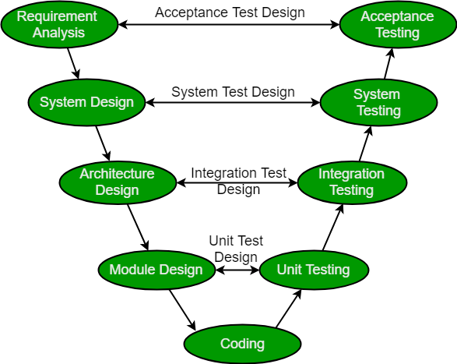

- V-Model also referred to as the Verification and Validation Model. In this, each phase of SDLC must complete before the next phase starts. It follows a sequential design process same as the waterfall model. Testing of the device is planned in parallel with a corresponding stage of development.

**-** **The various phases of V-model are as follows:**

* **Business requirement analysis:** This is the first step where product requirements understood from the customer's side. This phase contains detailed communication to understand customer's expectations and exact requirements.
* **System Design:** In this stage system engineers analyze and interpret the business of the proposed system by studying the user requirements document.
* **Architecture Design:** The baseline in selecting the architecture is that it should understand all which typically consists of the list of modules, brief functionality of each module, their interface relationships, dependencies, database tables, architecture diagrams, technology detail, etc. The integration testing model is carried out in a particular phase.
* **Module Design:** In the module design phase, the system breaks down into small modules. The detailed design of the modules is specified, which is known as Low-Level Design.
* **Coding Phase**: After designing, the coding phase is started. Based on the requirements, a suitable programming language is decided. There are some guidelines and standards for coding. Before checking in the repository, the final build is optimized for better performance, and the code goes through many code reviews to check the performance.

**- Advantages of V-model:**

* Easy to understand.
* Testing method like planning, test designing happens well before coding.
* This saves a lot of time. Hence a higher chance of success over Waterfall model.
* Avoids the downward flow of the defects.
* Works well for small plans where requirements are easily understood.

**- Disadvantages of V-model:**

* Very rigid and least flexible.
* Not a good for a complex project.
* Software is developed during the implementation stage, so no early prototypes of the software are produced.
* If any changes happen in the midway, then the test documents along with the required documents, has to be updated

**- When to use the V-model?**

* When the requirement is well defined and not ambiguous.
* The V-shaped model should be used for small to medium-sized projects where requirements are clearly defined and fixed.
* The V-shaped model should be chosen when sample technical resources are available with essential technical expertise.

(V-model (Software Engineering) - javatpoint, 2021)

## 3. Select the right model for the project

|  |  |  |
| --- | --- | --- |
| Model | Requirement Response | Suitable or not |
| Agile model | Suitable for small projects, easy to use, requirements can change frequently. | Moderately suitable |
| Iterative model | Suitable for big projects and important tasks, requirements must be clearly and specifically defined. | Not suitable |
| Waterfall model | Suitable for short projects and infrequently changing requirements. | Most suitable |
| V-Model | Suitable for small or medium projects, easy to understand. Save a lot of time. | Moderately suitable |

- Based on the comparison table above, we decided to choose the Waterfall model for software development because the project is not too large, the partner side also makes specific requirements and needs to be quick in the development process. All of the above factors are very suitable for us to choose Waterfall model.

# Explain how risk is managed in the Spiral life cycle model (P2)

1. **What is Spiral model?**

- Spiral model is one of the most important Software Development Life Cycle models, which provides support for Risk Handling. In its diagrammatic representation, it looks like a spiral with many loops. The exact number of loops of the spiral is unknown and can vary from project to project. Each loop of the spiral is called a Phase of the software development process.

(Spiral Model (Software Engineering) - javatpoint, 2021)

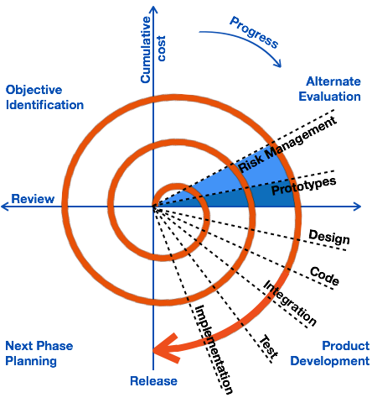

1. **Phases of Spiral model**

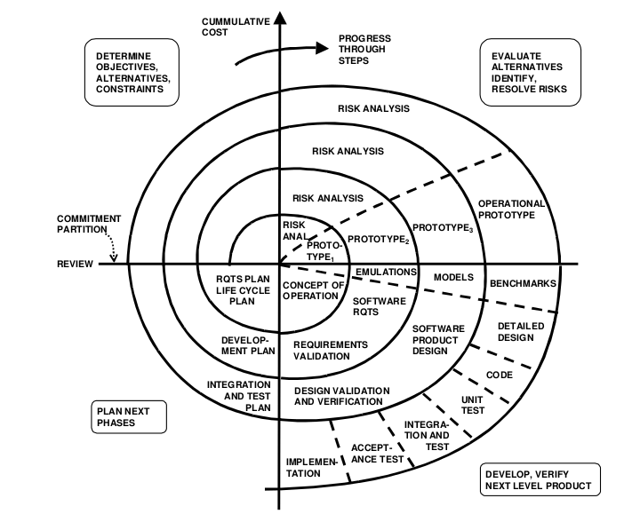

**Each cycle in the spiral is divided into four parts:**

* **Objective setting:** Each cycle in the spiral starts with the identification of purpose for that cycle, the various alternatives that are possible for achieving the targets, and the constraints that exists.
* **Risk Assessment and reduction:** The next phase in the cycle is to calculate these various alternatives based on the goals and constraints. The focus of evaluation in this stage is located on the risk perception for the project.
* **Development and validation:** The next phase is to develop strategies that resolve uncertainties and risks. This process may include activities such as benchmarking, simulation, and prototyping.
* **Planning:** Finally, the next step is planned. The project is reviewed, and a choice made whether to continue with a further period of the spiral. If it is determined to keep, plans are drawn up for the next step of the project.

1. **What is manage risk and how to manage risk?**

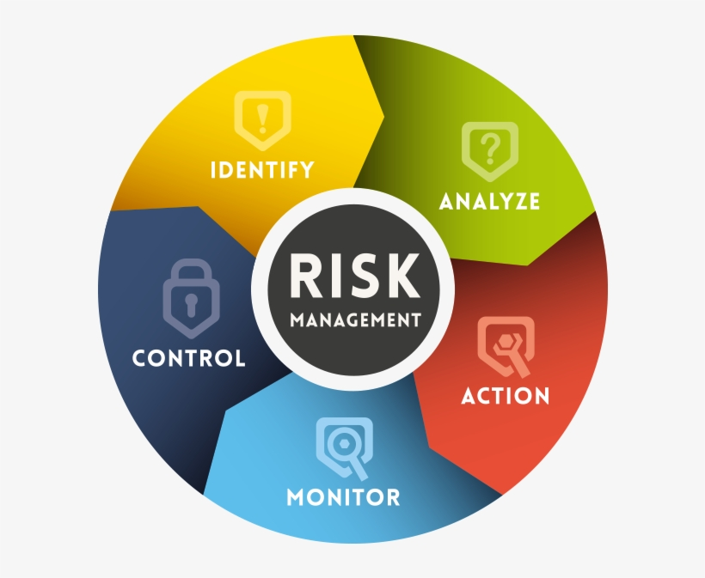

- Risk management encompasses the identification, analysis, and response to risk factors that form part of the life of a business. Effective risk management means attempting to control, as much as possible, future outcomes by acting proactively rather than reactive. Therefore, effective risk management offers the potential to reduce both the possibility of a risk occurring and its potential impact.

- All risk management processes follow the same basic steps, although sometimes different jargon is used to describe these steps. Together these 5 risk management process steps combine to deliver a simple and effective risk management process:

* **Step 1: Identify the risk.** You and your team uncover, recognize and describe risks that might affect your project or its outcomes. There are a number of techniques you can use to find project risks. During this step you start to prepare your Project Risk Register.
* **Step 2: Analyze the risk.** Once risks are identified you determine the likelihood and consequence of each risk. You develop an understanding of the nature of the risk and its potential to affect project goals and objectives. This information is also input to your Project Risk Register.
* **Step 3: Evaluate the risk.** You evaluate or rank the risk by determining the risk magnitude, which is the combination of likelihood and consequence. You make decisions about whether the risk is acceptable or whether it is serious enough to warrant treatment. These risk rankings are also added to your Project Risk Register.
* **Step 4: Treat the risk.** This is also referred to as Risk Response Planning. During this step you assess your highest ranked risks and set out a plan to treat or modify these risks to achieve acceptable risk levels. How can you minimize the probability of the negative risks as well as enhancing the opportunities? You create risk mitigation strategies, preventive plans and contingency plans in this step. And you add the risk treatment measures for the highest ranking or most serious risks to your Project Risk Register.
* **Step 5: Monitor and Review the risk.** This is the step where you take your Project Risk Register and use it to monitor, track and review risks.

(Development, 2021)

1. **How to manage risk in Spiral model?**

- Spiral model is a pattern that is repeated sequentially in a spiral. There the risk control is captured from the beginning of the cycle until the end of a round, they are repeated until the whole process is finished or the process cannot be continued.

- Before the start of the spiral, it is common to identify risks and possible measures, the end of each spiral cycle is a review and assessment of risk. For each spiral, The prototype is gradually being completed. The risk analysis will lead to whether the project should be continued or stopped….

# Explain the purpose of a feasibility report (P3)

1. **What is the feasibility of the project?**

- A feasibility study is an analysis that considers all of a project's relevant factors—including economic, technical, legal, and scheduling considerations—to ascertain the likelihood of completing the project successfully.

(Considering a New Venture? Consider a Feasibility Study, 2021)

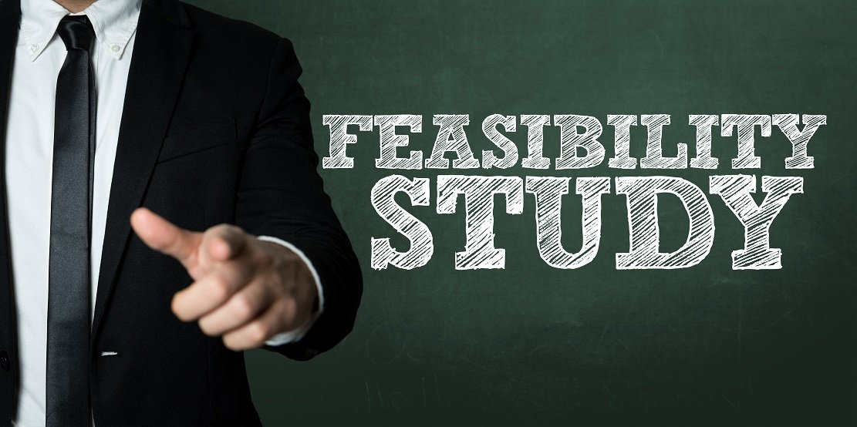

1. **Feasibility study for what and benefits?**
2. **Feasibility study for what?**

**-** Feasibility studies help project managers determine the viability of a project or business venture by identifying the factors that can lead to its success.

- The feasibility study is the second step of the SDLC. It is the stage at which all of the software needs and requirements are written down and thoroughly documented.

1. **Benefits of feasibility studies.**

- Below are the benefits of doing a feasibility study:

* Identifies valid reasons to advance or veto a project idea.
* Improves the focus of the project team.
* Provides useful information for next steps at the conclusion of the study.
* Narrows potential business alternatives.
* Enhances the success or failure rate of the project by assessing all variables.

1. **Components of the feasibility report**

- Once the initial due diligence has been completed, listed below are several of the components that are typically found in a feasibility study:

* **Economic:** Is it possible to complete this project within the budget approved by upper management and stakeholders?
* **Schedule:** Determine whether or not the project can be completed within the timeframe provided.
* **Legal:** Can this project meet the requirements of cyberlaw as well as other regulatory compliance?
* **Technical:** Determine whether the software is compatible with the current computer system.
* **Operation feasibility:** Are we able to create the operations that the client expects?

- The feasibility study is a significant step in any SDLC process because it examines different elements like cost necessary for creating and executing the system, the time necessary for each step of the system, etc.

(Feasibility Study in SDLC - FreeEducator.com, 2021)

# Describe how technical solutions can be compared (P4)

|  |  |  |
| --- | --- | --- |
| Solution | Advantages | Disadvantage |
| Self-development | Low cost, high security, easy to control when there is a technical problem. | Take a lot of time to develop, requires engineers to have high technical skills |
| Purchased all | Save a lot of time, no need for skilled engineer, on time. | Expensive, low security, difficult to control when system failure occurs. |
| Purchased part | Save time, take a little effort. | Costly, difficult to control when system failure occurs. |

- Based on the above evaluation table and the available conditions, we decided to choose to self-development system because we have a highly skilled IT team, the software system is also available, the project cost is not too big to buy software.

**- Compare technical solutions in self-development**

|  |  |  |  |  |
| --- | --- | --- | --- | --- |
| **Feasibility criteria** | **Weight** | **Code by HTML, CSS, PHP** | **Code by JS** | **Code by C#,C++** |
| **Technical feasibility** | 40% | Score: 90  Team has a lot of experience, this system is also developed based on the platform. | Score: 30  Team is not very experienced, the system is not based on the platform for development | Score: 70  Team has a lot of experience, but the system is not based on this platform for development. |
| **Economical feasibility** | 40% | Score: 80  $50.000 for develop  Payback within 1 year | Score 20  $300.000 for develop  Payback within 2 and a half years | Score: 50  $200.000 for develop  Payback within 2 year |
| **Organization feasibility** | 20% | Score: 90  The organization has a lot of experience | Score: 30  Big-budget  Long payback period | Score: 70  Costly, payback time is not too fast |
| **Ranking** | 100% | Score: 86 | Score: 26 | Score: 62 |

- Based on the above analysis, we will choose to develop on HTML, CSS and PHP platforms because the efficiency that it brings is the greatest. The low cost to develop, the quick payback time, and the team members also have a lot of experience developing on this platform, choosing them is the most feasible.

# Conclusion

# References

* Ubiminds. 2021. Key Development Team Roles within the Software Development Lifecycle. [online] Available at: <https://blog.ubiminds.com/en-us/key-development-team-roles-sdlc/> [Accessed 3 October 2021].
* www.javatpoint.com. 2021. *Agile Model (Software Engineering) - javatpoint*. [online] Available at: <https://www.javatpoint.com/software-engineering-agile-model> [Accessed 3 October 2021].
* www.javatpoint.com. 2021. Iterative Model (Software Engineering) - javatpoint. [online] Available at: <https://www.javatpoint.com/software-engineering-iterative-model> [Accessed 3 October 2021].
* www.javatpoint.com. 2021. Waterfall Model (Software Engineering) - javatpoint. [online] Available at: <https://www.javatpoint.com/software-engineering-waterfall-model> [Accessed 3 October 2021].
* www.javatpoint.com. 2021. Spiral Model (Software Engineering) - javatpoint. [online] Available at: <https://www.javatpoint.com/software-engineering-spiral-model> [Accessed 3 October 2021].
* GeeksforGeeks. 2021. Software Engineering | Spiral Model - GeeksforGeeks. [online] Available at: <https://www.geeksforgeeks.org/software-engineering-spiral-model/> [Accessed 3 October 2021].
* Investopedia. 2021. Considering a New Venture? Consider a Feasibility Study. [online] Available at: <https://www.investopedia.com/terms/f/feasibility-study.asp> [Accessed 3 October 2021].
* Indeed.com. 2021. [online] Available at: <https://www.indeed.com/career-advice/career-development/feasibility-studies> [Accessed 4 October 2021].
* www.javatpoint.com. 2021. *V-model (Software Engineering) - javatpoint*. [online] Available at: <https://www.javatpoint.com/software-engineering-v-model> [Accessed 4 October 2021].
* Development, C., 2021. What are the 5 Risk Management Process Steps?. [online] Continuing Professional Development. Available at: <https://continuingprofessionaldevelopment.org/risk-management-steps-in-risk-management-process/> [Accessed 4 October 2021].
* 2021 Free Study - 2022. 2021. Feasibility Study in SDLC - FreeEducator.com. [online] Available at: <https://www.freestudy.com/feasibility-study-in-sdlc/> [Accessed 4 October 2021].