**ASSIGNMENT 2 FRONT SHEET**

| **Qualification** | **BTEC Level 5 HND Diploma in Computing** | | |
| --- | --- | --- | --- |
| **Unit number and title** | Unit 14: Business Intelligence | | |
| **Submission date** |  | **Date Received 1st submission** |  |
| **Re-submission Date** |  | **Date Received 2nd submission** |  |
| **Student Name** | Nguyen Duc Thang | **Student ID** | BH00151 |
| **Class** | IT0501 | **Assessor name** | Nguyen Thai Cuong |
| **Student declaration**  I certify that the assignment submission is entirely my own work and I fully understand the consequences of plagiarism. I understand that making a false declaration is a form of malpractice. | | | |
|  |  | **Student’s signature** |  |

**Grading grid**

| P3 | P4 | M3 | D3 |
| --- | --- | --- | --- |
|  |  |  |  |

| **❒ Summative Feedback: ❒ Resubmission Feedback:** | | |
| --- | --- | --- |
| **Grade:** | **Assessor Signature:** | **Date:** |
| **I V Signature:** | | |

Table of content

Page

A. Introduction………………………………………………………………………………………………………………3

B. Content……………………………………………………………………………………………………………………..3

I. Determine, with examples, what business intelligence is and the tools and techniques associated with it…………………………………………………………………………………………………………...3

II. Design a business intelligence tool, application or interface that can perform a specific task to support problem solving or decision-making at an advanced level………………………………..10

C. Conclusion………………………………………………………………………………………………………………26

D. References……………………………………………………………………………………………………………...26

A. Introduction

In assignment 2, our next task is to demonstrate to the board of directors about the ability of applying business intelligence in the company's current business processes. To demonstrate BI, we need to prepare a presentation about BI and related tools & techniques and a demonstration on real company dataset.

B. Content

I. Determine, with examples, what business intelligence is and the tools and techniques associated with it.

1. Business intelligence

a, What is business intelligence?

Business intelligence (BI) is software that ingests business data and presents it in user-friendly views such as reports, dashboards, charts and graphs. BI tools enable business users to access different types of data — historical and current, third-party and in-house, as well as semi-structured data and unstructured data like social media. Users can analyze this information to gain insights into how the business is performing.

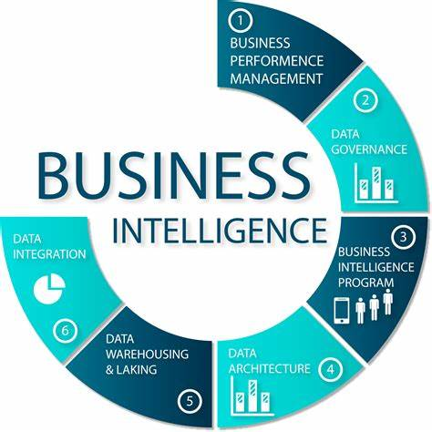

Figure 1: Business intelligence (BI)

b, The example of BI

- CocaCola: Coca-Cola makes use of its social media data. It has 105 million Facebook likes and 35 million Twitter followers. The business can determine when images of its drinks appear online by using AI-powered image recognition technology. The company gains valuable insights into who is drinking its products, where they are, and why they are mentioning the brand online thanks to this data and the power of BI. The data enables advertisers to offer customers with advertisements that are four times more likely to be clicked on than generic ads.

- Netflix: The 148 million members of the online entertainment provider provide it a significant BI advantage. How is business intelligence used by Netflix? Netflix makes numerous uses of data. One illustration is the way the business develops and tests original programming concepts based on previously watched programs. To encourage viewers to interact with its content, Netflix also employs business intelligence. Around 80% of streamed content is driven by the service's recommendation system since it is so effective at promoting tailored content.

- Twitter: To combat unsuitable and potentially dangerous information on its platform, the social media business uses BI with AI. Rather than human users, 95% of blocked accounts tied to terrorism are identified by algorithms. AI and BI both support fine-tuning to enhance the user experience as a whole. Live video streams are monitored by Twitter employees and their business intelligence systems, who then classify them according to their topics. They make use of this information to improve search functions and assist algorithms in locating movies that consumers might find interesting.

- American Express: In the financial sector, business intelligence is essential. In order to provide new payment service solutions and sell offers to clients, American Express has been utilizing technology. As a result of the company's market research in Australia, it can now predict up to 24% of all Australian users who will delete their accounts over the next four months. American Express uses that information to make customer retention decisions. BI aids the business in accurately identifying fraud and safeguarding clients whose card information may have been hacked.

- Starbucks: Starbucks has access to the unique purchasing information of millions of customers through its well-known loyalty card program and mobile application. The business forecasts purchases and emails specific offers to customers based on their expected preferences using this data and BI technologies. This system raises sales volumes and encourages returning consumers to visit its locations more regularly.

c, How does business intelligence work?

Data warehouses have always served as the foundational source of information for BI tools. A data warehouse combines information from various sources into one main database to facilitate reporting and business analytics. The warehouse is queried by business intelligence software, which then displays the findings to the user as reports, charts, and maps. Online analytical processing (OLAP) engines can be added to data warehouses to handle multidimensional queries.

d, Why is business intelligence important?

- Organizations can use business intelligence to ask questions in plain language and receive clear replies. They can base decisions on what their company data is saying to them, whether it relates to production, supply chain, customers, or market trends, rather than relying on best estimates.

- Businesses may become data-driven enterprises, perform better, and acquire a competitive edge with the use of business intelligence. They can:

+ Improve ROI by understanding the business and intelligently allocating resources to meet strategic objectives.

+ Unravel customer behavior, preferences and trends, and use the insights to better target prospects or tailor products to changing market needs.

+ Monitor business operations and fix or make improvements on an ongoing basis, fueled by data insights.

+ Improve supply chain management by monitoring activity up and down the line and communicating results with partners and suppliers.

e, The benefits of BI

Faster, more accurate reporting and analysis, better data quality, improved employee satisfaction, decreased costs and increased revenues, and the capacity to make better business decisions are just a few of the many advantages businesses can experience after incorporating BI into their business models.

2. The tools and technologies associated with BI

a, Definition: BI tools are types of software used to gather, process, analyze, and visualize large volumes of past, current, and future data in order to generate actionable business insights, create interactive reports, and simplify the decision-making processes.

b, Some BI tools:

1. Fusion Chart: is a web-based data visualization software that utilizes JavaScript programming language. This application is beneficial for small-sized businesses to large enterprises. The platform’s primary responsibility is to transform your company’s raw data into easily understandable graphs. This software has over 50 chart types, statistical charts, and 2,000 region-specific data maps. FusionCharts features a customizable dashboard that you can personalize to have a deep understanding of your business’ performance. The main benefits of [FusionCharts](https://www.fusioncharts.com/) are:

+ Intuitive controls: Even for novice software users, FusionCharts has user-friendly controls. With the help of this platform, you and your staff may make intricate graphs in just 15 minutes. Also, the system offers drag-and-drop capabilities that let users input data easily. You may easily export your files and reports using this software. You may send your company's dashboard as a PDF file using FusionCharts as well. Then you can use email platforms to send reports.

+ Organized business reports: Users of FusionCharts can select between bar graphs, stacked bars, heat maps, and lines when creating graphs from raw data. Considering that the system features over 50 ready-to-use diagrams, those representations are just a few of the charts that the platform offers. Moreover, this platform supports multivariate analysis. Then, using the appropriate graphs, you can plot large amounts of data and see these factors. You can get in-depth reports about your company in this method.

+ Accessible company data: You and your developers can access reports at any time and from any location because FusionCharts is a cloud-based data visualization program. The solution also offers Windows and macOS deployment, making it possible for desktop computers or any other device with an Internet connection to manage data with ease.



Figure 2: FusionCharts

- Advantages and disadvantages of FusionCharts

+ Advantages: Large selection of map and chart formatting options, above most other visual tools, more features, compatibity with a variety of different frameworks and programming languages

+ Disadvantages: High cost (a developer license starts at roughly $500), difficulties for basic visualizations outside of a dashboard environment

2. Tableau tool: is a favorite among data scientists, but it was designed for everyone. The company democratizes data science by making the platform accessible to the layperson, regardless of their skillset. As a result, it doesn't take programming or data science expertise to create valuable, actionable reports. Tableau is used more frequently as the tool allows to analyze the data more quickly and visualizations are generated as dashboards and worksheets. Tableau enables us to make dashboards that give actionable insights and spread the business faster. Tableau products are always operated in virtualized environments if they are configured with proper hardware and operating system. It is one of the best business intelligence and project management tools.



Figure 3: Tableau

- The benefits of Tableau tool:

+ Data visualization: To produce stunning representations, Tableau offers complicated calculations, data mixing, and dashboarding. Insights are delivered by the visualizations that are difficult to derive from a spreadsheet.

+ Interactive visualization: Users of Tableau may create incredibly interactive graphics using the hashtag and drop functionalities. In a matter of minutes, an infinite number of graphics are created.

+ High performance: Tableau's overall performance is solid and safe. It quickly and easily handles massive amounts of data and produces a variety of representations.

+ Save time: Fast data analysis enables businesses utilizing Tableau to save a substantial amount of time. To expedite activities, data from currently used Excel sheets is also uploaded to Tableau.

+ Flexibility: Because it connects with the current computing platform and data sources, Tableau is more adaptable than other analytics tools.

- Advantages and disadvantages of tableau tool:

+ Advantages:

Ease of implementation: Tableau offers a wide range of options for visualization that improve the user experience. In addition, Tableau is far simpler to learn than Python, Business Objects, or Domo; someone without any programming experience can quickly become proficient with Tableau.

Tableau can handle large amounts of data: Millions of rows of data may be handled with simplicity with Tableau. Large amounts of data can be used to generate a variety of visualizations without degrading the dashboards' performance. Moreover, Tableau has a feature that allows users to establish "live" connections to a variety of data sources, including SQL, etc.

Use of other scripting languages in Tableau: Users can include Python or R to get around performance problems and do complicated table calculations in Tableau. By using Python script to execute data purification operations with packages, the workload on the software can be reduced. Nevertheless, Tableau does not accept Python as a native scripting language. Hence, you can import some of the packages or visuals.

Mobile Support and Responsive Dashboard: Tableau Dashboard includes a fantastic reporting function that enables you to tailor the dashboard precisely for a given device, like a laptop or mobile phone. Tableau makes modifications to ensure that the correct report is sent to the appropriate device based on the device the user is reading the report on.

Tableau Company Strategy: Tableau has done a fantastic job positioning itself as the leader in data visualization software. As a result, per Gartner Magic Quadrant. Tableau has been a leader for more than six years. Tableau might fall behind if it doesn't innovate quickly, though, given the rising popularity of data science, AI, and machine learning. You can tell that Forbes is worried about the profitability of Tableau from the problems with the 2017 financial reporting.

+ Disadvantages:

Scheduling or notification of reports: Tableau does not offer the option of using scheduling to automatically refresh reports. Tableau does not offer a schedule option. Hence, if users need to change data in the back-end, some human labor is always needed.

No Custom Visual Imports: Tableau isn't a fully functional open tool. Developers have the ability to produce bespoke graphics that are simple to import into Tableau, unlike competing tools like Power BI. Any new visuals must therefore be produced from scratch rather than imported.

Custom formatting in Tableau: Users complain about Tableau's conditional formatting and its 16-column table display limitations. Moreover, there is no direct means for a user to apply the same formatting to all fields at once. Users must complete that manually for each field, which takes a lot of time.

Static and single value parameters: Tableau's parameters are static and can only ever be used to pick a single value. These parameters need to be manually adjusted each time the data is modified. The updating of parameters cannot be automated by the user.

Screen Resolution on Tableau Dashboards: If the screen resolution used by the tableau developer and the end user are different, the layout of the dashboards will be slightly deformed. For instance, if the dashboards were built in a screen resolution of 1920X1080 but are being viewed in 2560X1440. Moreover, their dashboards don't respond. So, you must design a dashboard for both desktop and mobile.

3. Google Chart: is an interactive w[eb service](https://en.wikipedia.org/wiki/Web_service) that creates [graphical](https://en.wikipedia.org/wiki/Graphics) [charts](https://en.wikipedia.org/wiki/Chart) from user-supplied information. The user supplies data and a formatting specification expressed in [JavaScript](https://en.wikipedia.org/wiki/JavaScript) embedded in a Web page; in response the service sends an image of the chart. Google Charts Tools allows you to showcase data on your website using some simple but attractive visualizations. With a simple embedding of JavaScript, users can create a wide variety of charts for their website. Whether it’s just some simple line chart or a complex hierarchical map, you can present data in a digestible way with Google Charts Tools. The main benefits of Google Chart Tools are, it is free, intuitive and highly configurable. Here are more details:

+ Free: Google Chart Tools is completely free, despite its potent capabilities for creating online graphic charts. This program can be utilized by anyone, be it government agencies, freelancers, huge enterprises, professionals or even casual users looking for a cost-efficient solution.

+ Easy to use: User-friendly Google Chart Tools can be fully exploited with just a little bit of JavaScript expertise. Even the most sophisticated graphs and charts can be made using it. The technology will be simple for users to incorporate into their websites. To enter the data required to display the chart, they only need to embed the app and upload the libraries.

+ Customizable: Because it appears professional and is the most user-friendly, the majority of users are happy utilizing the default Google theme for their charts. Nonetheless, users are welcome to modify the program at any time utilizing its customization features. You can use the feature to include the charts into the look, feel, and branding of your website. The charts can be altered using a variety of tools, including new colors, overlays, lines, and points.

+ Interactive: Animations, events and other interactive elements can be integrated into the chart for better user experience. Users can utilize the tool’s dashboard which gives them complete control over how their data are being displayed. It also lets them tweak the data based on the times, dates and roles.

+ Link data: Google Chart Tools allows the data to be sourced from various locations such as Fusion tables and Google Sheets. Users can also utilize several data connection protocols and tools to empower them with real-time data linking.

- Advantages and disadvantages of google chart:

+ Advantages: Easy to learn, interactive, works on all modern browsers, includes maps and can be read from Excel, CSV files,...

+ Disadvantages: Gives you less customization than some other packages at the moment, so if you're an experienced JavaScript coder, you might prefer those. Lacks sophisticated statistical processing for you and requires a network connection.



Figure 4: Google Charts

II. Design a business intelligence tool, application or interface that can perform a specific task to support problem solving or decision-making at an advanced level

1. Data processing

a, Definition: Data processing is the method of collecting raw data and translating it into usable information. It is usually performed in a step-by-step process by a team of [data scientists](https://www.simplilearn.com/a-day-in-the-life-of-a-data-scientist-article) and [data engineers](https://www.simplilearn.com/how-to-become-a-data-engineer-article) in an organization. The raw data is collected, filtered, sorted, processed, analyzed, stored, and then presented in a readable format. Data processing is essential for organizations to create better business strategies and increase their competitive edge. By converting the data into readable formats like graphs, charts, and documents, employees throughout the organization can understand and use the data.

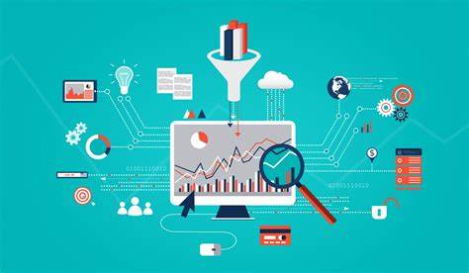

Figure 5: Data processing

b, Why is data processing important?

- The kind of data processing you employ will have an impact on how quickly and accurately a query is answered. The strategy must be carefully determined as a result. Where availability is crucial, such as on a stock exchange portal, transaction processing should be the approach of choice.

- The difference between data processing and a data processing system must be understood. Data processing rules specify how data is transformed into information that is useful.

- A program created specifically to handle a certain type of data is known as a data processing system. For instance, a timesharing system aims to streamline time sharing procedures. Moreover, batch processing can be done with it. For the job, it will not scale well, though.

c, Type of data processing

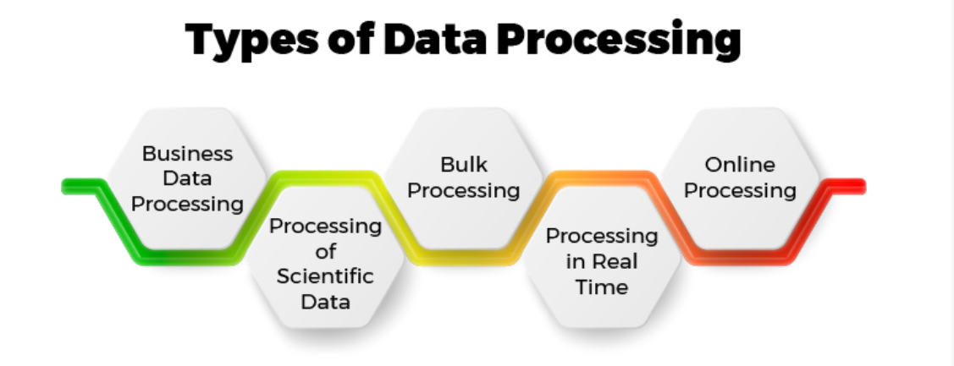

Figure 6: Types of data processing

- Business Data Processing: Commercial data processing is a common method of using batch processing with relational databases. It involves using fewer processing processes while supplying the system with enormous volumes of data and producing enormous amounts of output.

- Processing of Scientific Data: Compared to commercial data processing, scientific data processing makes considerable use of computing techniques but uses fewer inputs and outputs. Among the computer procedures are comparison and arithmetic operations.

- Bulk Processing: A type of data processing known as bulk processing involves processing multiple cases simultaneously. It is primarily used when data is collected and processed in batches, is homogeneous, large, and quantity. Doing a task concurrently, simultaneously, or sequentially is known as batch processing.

- Processing in Real Time: When an instantaneous output is required, real-time processing is used, much like transaction processing. Their approaches to dealing with data loss vary, though. Real-time processing allows for the quickest possible computation of incoming data.

- Online Processing: Online in the context of modern database systems means "interactive" and "within the bounds of patience." Online processing is the opposite of batch processing. Online processing can be built from a collection of fairly simple operators, just as conventional query processing engines.

d, Advantages and disadvantages of data processing

- Advantages:

+ Highly efficient

+ Time-saving

+ High speed

+ Reduces errors

- Disadvantages:

+ Large power consumption

+ Occupies large [memory](https://www.elprocus.com/different-types-of-memory-modules-used-embedded-system/)

+ The cost of installation is high

+ Wastage of memory.

2. Python

a, Definition: Python is an interpreted, object-oriented, high-level programming language with dynamic semantics. Its high-level built in data structures, combined with dynamic typing and dynamic binding, make it very attractive for Rapid Application Development, as well as for use as a scripting or glue language to connect existing components together.



Figure 7: Python

b, What is python used for?

- Python is commonly used for developing websites and software, task automation, data analysis, and data visualization. Since it’s relatively easy to learn, Python has been adopted by many non-programmers such as accountants and scientists, for a variety of everyday tasks, like organizing finances.

c, The importance and the benefits of python

- Python is a particularly lucrative programming language: Python talents translate to some extremely profitable employment opportunities, just like contemporaries Java, JavaScript, and Ruby. Only in the last three years has Python's worth increased significantly. In addition to its high average wage, Python is a wise investment because, as compared to Ruby, the current top earner, it offers more job market advantages.

- Python is used in machine learning & artificial intelligence, fields at the cutting-edge of tech: Machine learning and artificial intelligence are used in everything from Uber's estimated arrival time to Google finishing your sentences and Netflix figuring out which shows you'll like. It's exciting to consider where we're going if we take a moment to recognize how recent many of these advances are. Without a doubt, Python will lead the way in AI innovation. Python, according to experts, is the programming language best suited to machine learning and artificial intelligence. Its large library and framework are excellent for launching new concepts (more on this later). Also, a large community of programmers who are recognized for sharing their accomplishments and errors supports it and it is reasonably succinct.

- Python is simply structured and easy to learn: Learning Python is an excellent place to start if you're intimidated by coding or wondering if it's right for you. Python was created with user-friendliness in mind and has a syntax that is more similar to English than any other language. Moreover, it upholds the "whitespace rule," which leads to cleaner code that is less visually overwhelming.

- Python has a really cool best friend: data science: Python is riding along in what may be the trendiest professional sector of 2020: data science. In case you're wondering what data science is in the first place, let's go back a step. In a nutshell, data science is the alchemy of technology: it transforms massive volumes of data into priceless knowledge. Companies then use that knowledge to create original fixes for issues they might not have otherwise been able to identify.

- Python programming is versatile in terms of platform and purpose: Python is known as the "Swiss Army Knife" of programming languages. It performs admirably on Windows, Linux, and MacOS and is not platform-insensitive as a programming language. Nobody enjoys having their talents categorized; fortunately, Python programmers won't ever face this issue.

- Python is growing in job market demand: Python will undoubtedly play a significant role in the development of technology because it is one of the top-earning programming languages and one of the most popular. Even without evidence, we can state that children should learn to code, and the Department of Labor predicts that by 2028, there will be an additional 546,200 coding jobs in the United States alone. In our humble opinion, Python-related occupations will continue to be a lucrative career choice because they make up a sizable portion of this pie.

- Python dives into deep learning: Although there is some overlap between this topic and the data science applications we previously stated, it is nevertheless important to discuss in light of Python's role in deep learning.

- Python creates amazing graphics: It's a common misconception that coding is only for people with logical aptitudes, yet nothing could be further from the truth. Python is popular among artists because of its gorgeous gaming graphics and capacity to produce brand-new images utilizing the deep learning technique we just explained. The best of both worlds can be found in Python, which mixes right-brained creativity with careful code.

- Python supports testing in tech and has a pretty sweet library: The ideal language to use while testing new software, according to several experts, is Python. Recall the concept of "Swiss Army Knife" programming, platform adaptability, and the "whitespace" rule? This is where everything connects. Python is a more versatile problem-solving programming language than many of its competitors because its code is frequently cleaner and more condensed. Since it works with all the major platforms, there is no issue with the platform.

- There are countless free resources available to Python programming newbies: It can be very scary to learn something new, especially if that new knowledge involves the inner workings of some of the world's most complex software and technological tools.

d, Advantages and disadvantages of python

- Advantages:

+ Easy to read, learn and code: Python is a high-level language with a straightforward syntax. It looks like English and doesn't require any brackets or semicolons. This makes it suitable for beginners.

+ Free, Open Source: It is available for free and under an open-source license. This indicates that the source code is freely accessible to the public and that changes can be made to the original code. There are no limitations on how this changed code can be circulated. This is a very helpful feature that enables businesses or individuals to alter and utilize their version in accordance with their demands.

+ Dynamic Typing: Variable declarations are not necessary in Python. To make dynamic coding easier, the variable's data type is automatically assigned during runtime.

+ Functional, Object-Oriented, and Procedural: It is an object-oriented, procedural, and functional language. Procedural refers to the top-to-bottom execution of the code. Instead than using sentences alone, a functional language operates on functions. A function is a group of instructions that accepts input and produces an output.

+ Memory Management: Python uses a separate module for managing memory, which allows it to do so exceptionally well. To store all the objects and data structures, it employs a private heap. And this heap is managed by a built-in memory manager. Python distinguishes itself from other programming languages thanks to this feature.

- Disadvantages:

+ It’s Simple Nature: A programmer finds it challenging to adapt to the syntax of other programming languages because of its simplicity. For instance, a C programmer might make the mistake of forgetting to declare a variable.

+ Slow Speed and Memory Inefficient: The Python interpreter ran the code line by line, lengthening the overall execution time. The dynamic typing function also slows down the typing process. This is because it must perform additional work while it is running. It also demands a lot of RAM.

+ Weak Mobile Computation: There are several server-side Python apps. On the client-side or in mobile applications, however, it is hardly ever used. The following are the key causes: It takes up a lot of memory, which slows down the operation and makes security more difficult.

+ Poor Database Access: In comparison to other technologies like JDBC (Java DataBase Connection) and ODBC, Python databases are lacking (Open DataBase Connectivity). This restricts its application in large corporations.

+ Runtime Errors due to dynamic typing: You do not need to declare any variables because it is a dynamically typed language, and a variable that initially stores an integer can subsequently hold a string. Although it may go unnoticed, this results in runtime errors when performing operations. This limits how the Python programming language was created. Moreover, only during execution do all errors appear. Thus, testing is challenging.

3. Design data processing and python

- Here I will Apply BI to data processing. Here I use pizza_data1.csv file to process data



Figure 8: Enter pizza_data1.csv

- After entering, we see that there are some empty seats

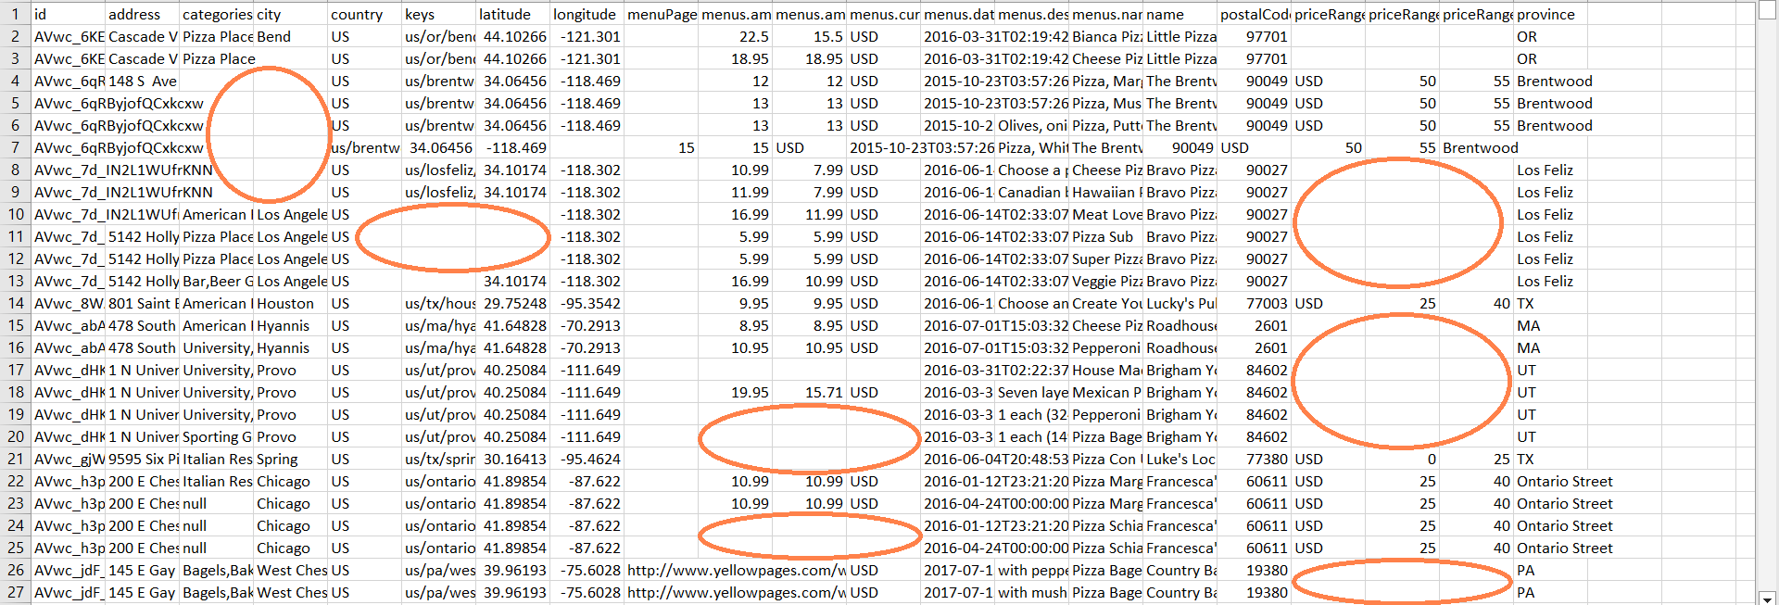

Figure 9: Data is null

- Next, we will build program menu to process data with business intelligence

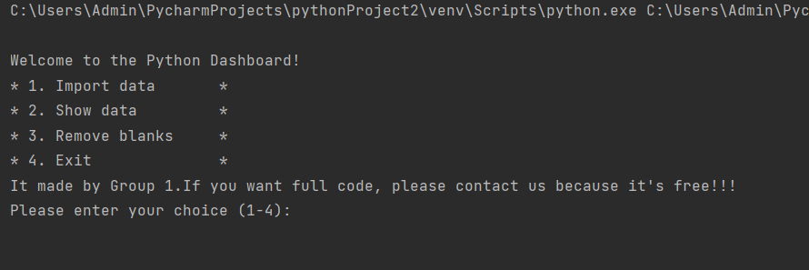

Figure 10: This is the program menu that I build

- Here I import the file so I can process it

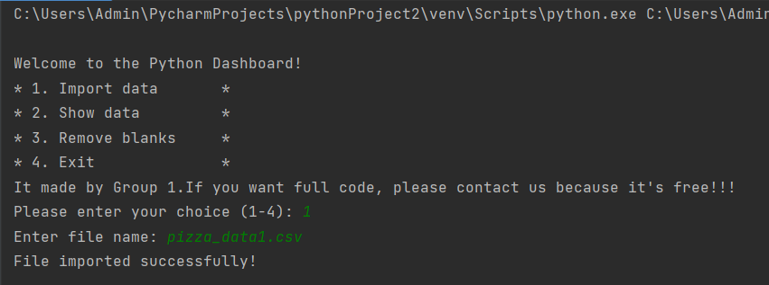

Figure 11: Import data

- Here I show rows and columns in the file to be processed

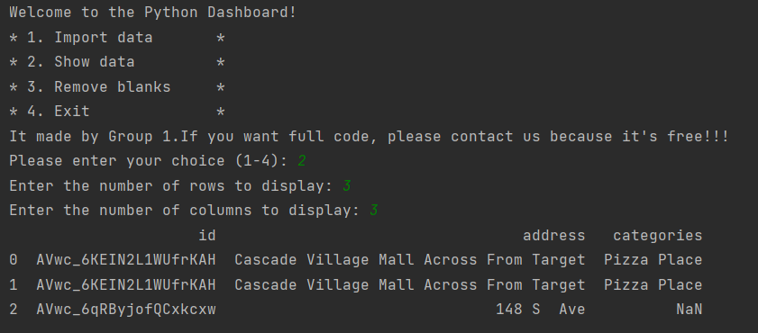

Figure 12: Show data

- Next, I proceed to delete null rows

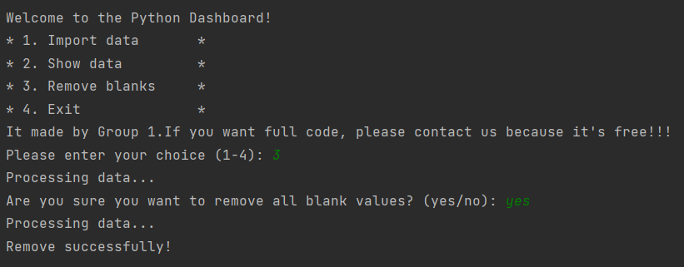

Figure 13: Remove blanks

- Here is the data that does not contain null after applying BI

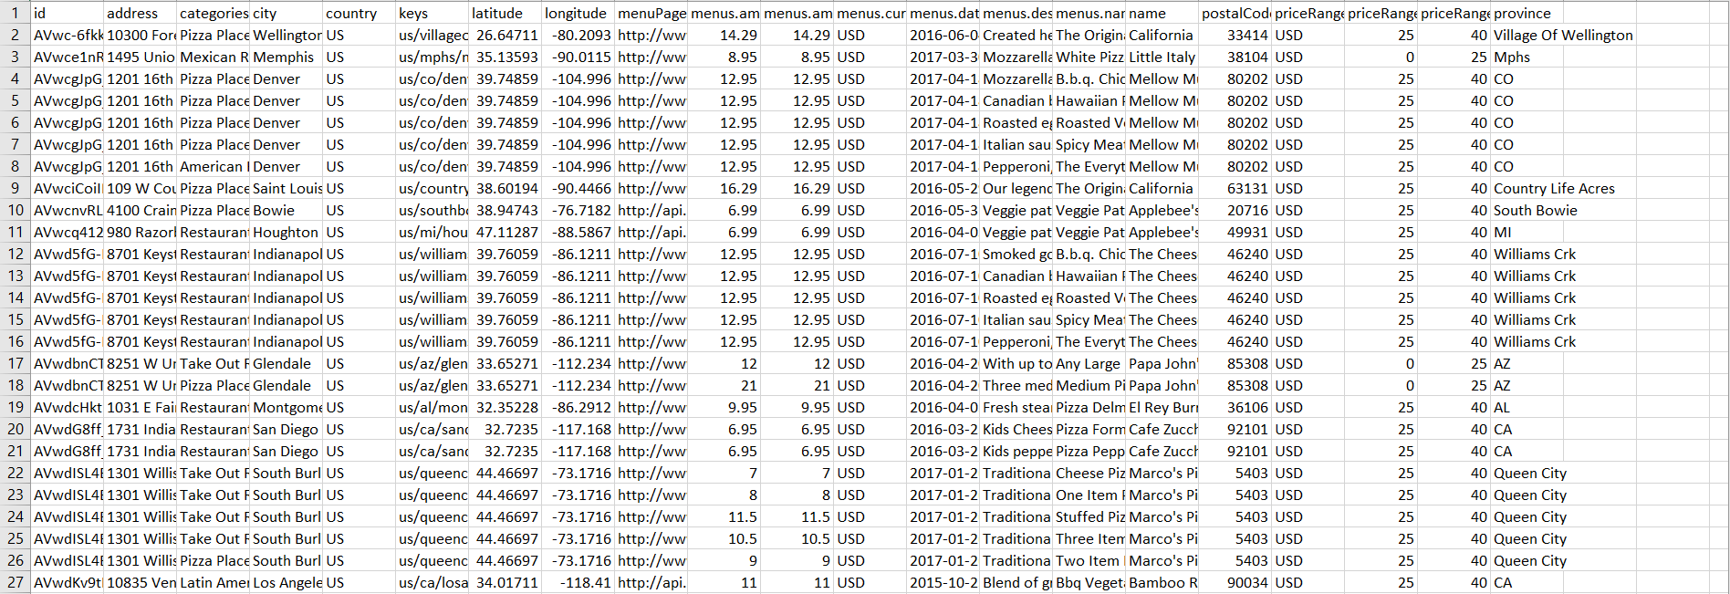

Figure 14: Data is not null

- Next, we have sent user ratings for data processing

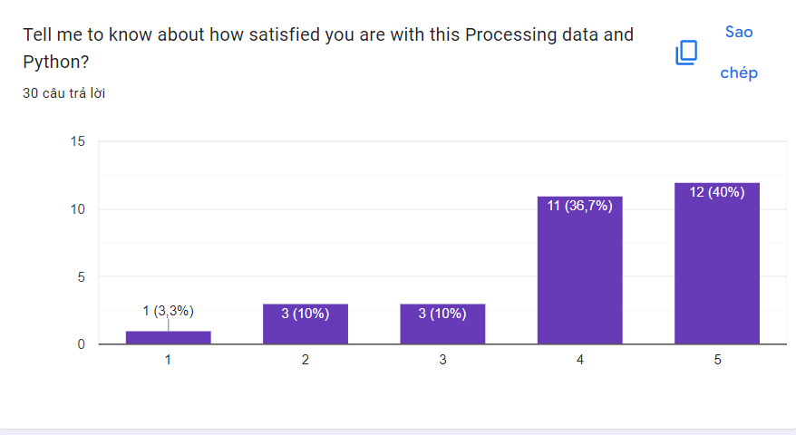

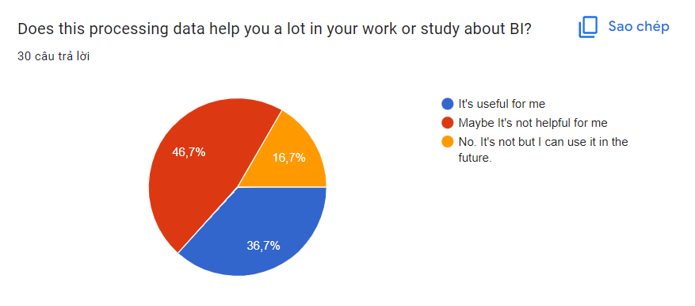

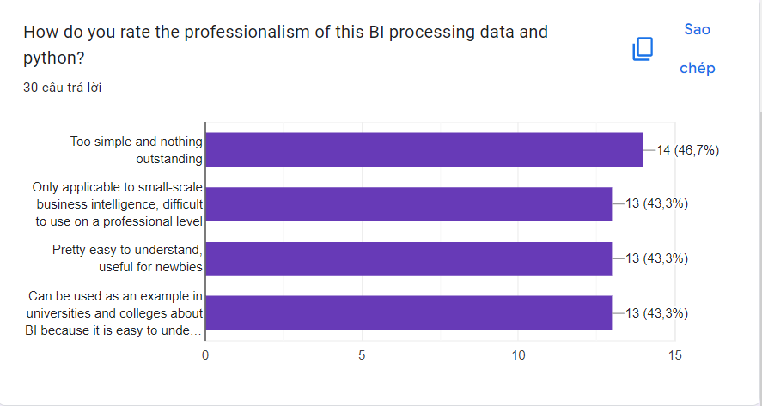

Figure 15: User ratings for data processing

4. Data dashboard

a, Definition

A data dashboard is an interactive analysis tool used by businesses to track and monitor the performance of their strategies with quality KPIs. Armed with real-time data, these tools enable companies to extract actionable insights and ensure continuous growth.

b, How do dashboards work?

Dashboards combine data from several sources to make it easier for non-technical people to read and understand. Everyone utilizing the dashboard is helped by interactive aspects to better comprehend particular concepts, investigate areas of increased interest, and enable additional questioning in order to get to important conclusions or make important decisions.

c, Why are data dashboards important?

Dashboards link a variety of metrics, data sources, APIs, and services to enable businesses to extract pertinent information from various sources and present it in an intuitive manner. Like a car's dashboard, data dashboards organize and present key information quickly so you can grasp the most valuable data for your business and find the answers to pressing problems.

d, Example of data dashboard

Data dashboards assist you in understanding virtually every aspect of your organization, from pricing accuracy to the revenue generated by your sales force. Here are many illustrations of dashboards and the kinds of data they provide for monitoring pertinent KPIs.

e, The benefits of data dashboard

- Performance measurement: Customized dashboards let you create precise KPIs for your company to track the data you need to see how you're doing across departments and in various areas. You might be interested in learning whether organizations are succeeding in their objectives, whether marketing initiatives are having the desired effect, or what the most well-liked restaurant meal is.

- Data transparency and accessibility: In order to display essential metrics and insights in a form that is simple enough for everyone to understand—regardless of whether they have access to backend data—dashboards combine many types of data. Potential data silos can be broken down so that everyone in an organization can see how various departments are performing and be empowered to contribute to the growth of the company.

- Agility: Dashboards are intended to assist in identifying changes within a business, both good and bad, frequently in real time. As you observe something novel as it develops, you have the chance to swiftly alter course if necessary or even to foresee future trends.

- Forecasting: By incorporating AI-powered predictive analytics into your dashboard, you may forge a potent tool for directing the course of your company's future. Dashboards, particularly those driven by AI, make it possible to analyze previous data to understand trajectory, produce more precise sales projections, strategically plan territory, and assist departments in choosing the best course of action to achieve their objectives.

f, The types of data dashboard

- Strategic dashboard: Critical KPIs are utilized in a strategic dashboard to track long-term company strategies. They are typically complicated to create, have an impact on a corporation on a large scale, and are mostly employed by senior-level decision-makers. Strategic dashboards are frequently utilized in a variety of business types to align a company's fundamental objectives. They monitor performance indicators in relation to corporate-wide strategic objectives. Hence, these dashboards typically present progress over predetermined time periods, such as the previous month, quarter, or year. When conceived, designed, and executed correctly, it can significantly shorten the time required to achieve a given business KPI while also lowering operating expenses.

- Operational dashboard: Businesses can monitor and improve the success of their short-term operations by using an operational dashboard. Junior decision-makers typically oversee them since they concentrate on monitoring operational processes. Their usefulness in the current digital era comes from the fact that organizations are beginning to recognize the benefit of accurate and timely data sharing between departments and operations teams. While logistical tasks have been greatly simplified by the unprecedented advancements in dashboard reporting and analysis, operational managers can also greatly benefit from using these types of dashboards and visually and interactively point out a real-time data issue that needs to be addressed right away.

- Analytical dashboard: An analytical dashboard is a tool for data analysis that was developed to enhance a business's decision-making process and comprises a tremendous amount of data. They give firms a thorough picture of complicated data, with middle management playing a key role in its application. As was previously mentioned, the significance of an analytically based dashboard lies in its impact on the usage of historical data, where analysts can identify trends, compare them with various variables, and create predictions and targets that can be used in a company's business intelligence strategy. They are frequently helpful when large and broad complex categorized information requires visualization to execute an accurate analysis of created data.

- Tactical dashboard: Mid-level management analyzes and tracks processes, with an emphasis on the analysis, using a tactical dashboard. The organization then provides analytical recommendations for future initiatives after effectively monitoring the performance of the company's goal. The most analytical dashboards are frequently the tactical dashboards. They are excellent for keeping an eye on the procedures that support the strategic goals of the company. They assist users in making decisions. By letting consumers examine the data, they take advantage of dashboards' interactive features.

5. Design a data dashboard

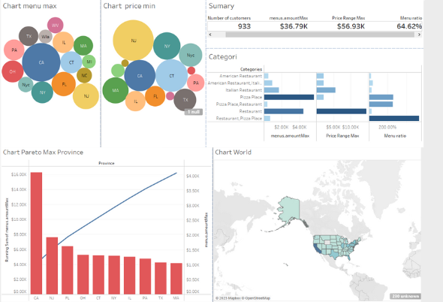

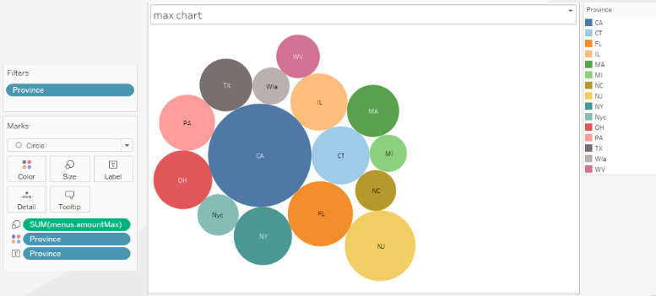

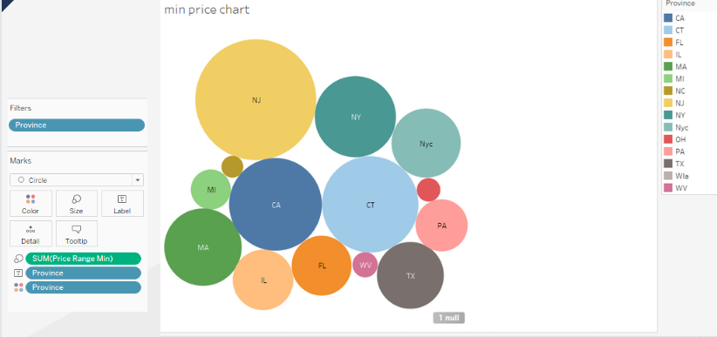

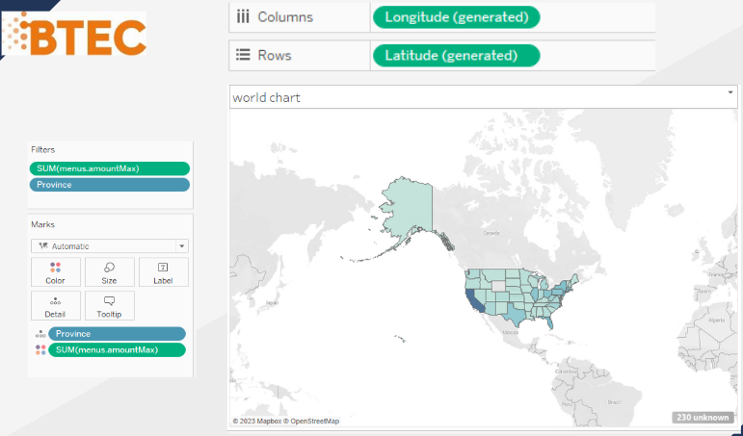

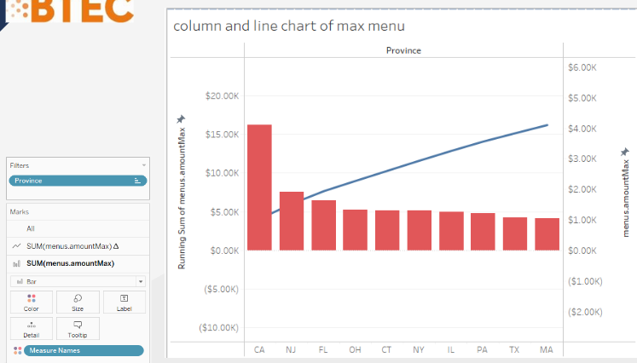

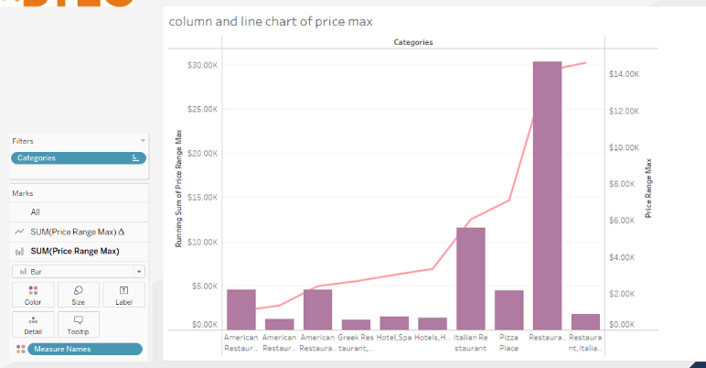

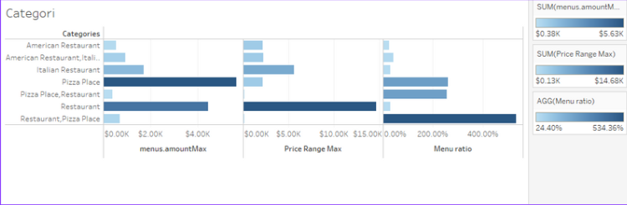

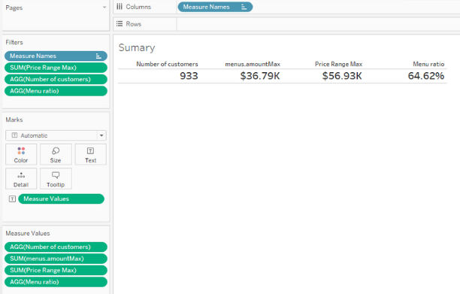

Figure 16: Design a data dashboard

C. Conclusion

Through assignment 2, I and my group did and understood to demonstrate to the board of directors about the ability of applying business intelligence in the company's current business processes. we prepare a presentation about BI and related tools & techniques and a demonstration on real company dataset, show some data set extracted from the company's business processes and design dashboards to show your analysis on pre-processed data so that we can apply it to your life.

D. References

<https://powerbi.microsoft.com/en-us/what-is-business-intelligence/>

<https://www.netsuite.com/portal/resource/articles/business-strategy/business-intelligence-examples.shtml>

<https://www.investopedia.com/terms/b/business-intelligence-bi.asp>

<https://www.coursera.org/articles/bi-tools>

<https://mopinion.com/business-intelligence-bi-tools-overview/>

<https://www.finereport.com/en/bi-tools/business-intelligence-technologies.html>

<https://www.python.org/doc/essays/blurb/>

<https://powerbi.microsoft.com/en-us/data-dashboards/>

<https://www.datapine.com/blog/data-dashboards-definition-examples-templates/>

<https://comparecamp.com/fusioncharts-review-pricing-pros-cons-features/>

<https://www.datacamp.com/blog/all-about-tableau>

<https://www.datasciencelearner.com/advantages-of-tableau-in-business-benefits/>

<https://en.wikipedia.org/wiki/Google_Charts>

<https://comparecamp.com/google-chart-tools-review-pricing-pros-cons-features/>

<https://www.quora.com/What-are-the-pros-and-cons-of-Google-Charts>

<https://www.analyticssteps.com/blogs/what-data-processing-and-why-it-important>

<https://www.coursera.org/articles/what-is-python-used-for-a-beginners-guide-to-using-python>

<https://www.idtech.com/blog/top-reasons-why-you-should-learn-python>

<https://www.tableau.com/learn/articles/dashboards/what-is>

PowerPoint and Python:

<https://drive.google.com/drive/folders/1R6hvCzKpD-vmFYhn9hnu-z91EAhjjG4G?usp=share_link> : Python