PROJECT IOT102

Automatic Water Dispenser

Group 3 - SE1956

Members:

* Phạm Thành Long (Leader) HE194930
* Đinh Tiến Đô HE194306
* Nguyễn Anh Quân HE194250
* Nguyễn Hoàng Bách HE190498
* Nguyễn Vũ Tuấn Minh HE195061

I. Concept

Based on the need to automate simple household and store tasks related to providing drinking water, we created this project with the aim of automating the process of supplying drinking water to users.

In this project, we set the following requirements for the product:

* Support wireless control to turn the system on and off.
* Allow adjustment of the water flow directly at the point of use.
* Automatically stop the water supply when overflow is detected or a certain distance is reached (with an audible notification).

II. Content

1. Hardware Required

* Arduino Uno
* Breadboard
* 1k Resistor
* 5k Potentiometer
* Buzzer (speaker)
* 16x2 LCD
* 1N5408 Diode (max reverse voltage 1000V - 3A)
* 5V Relay
* 12V Pump
* 1 HCSR05 Sensor
* 1 HCSR04 Sensor
* HC-06 Bluetooth Module
* Push Button

1. Block diagram

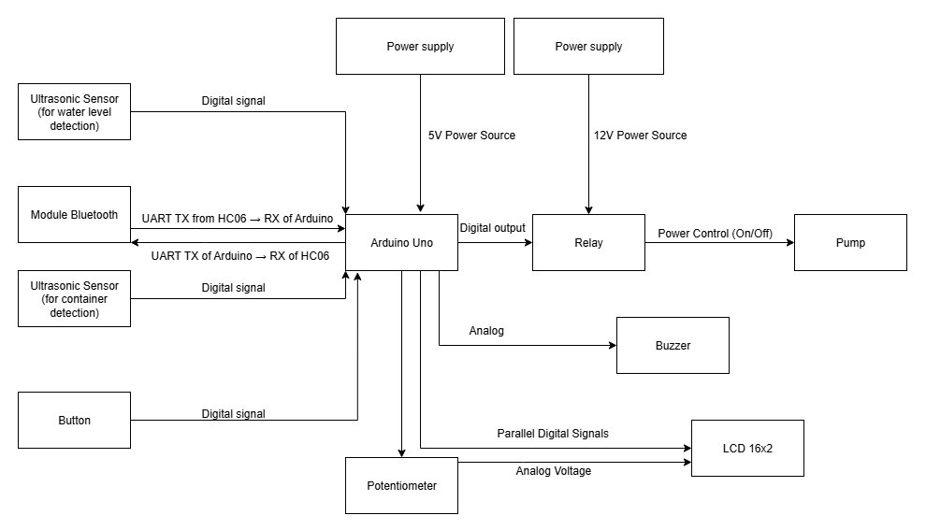

1. Schematic

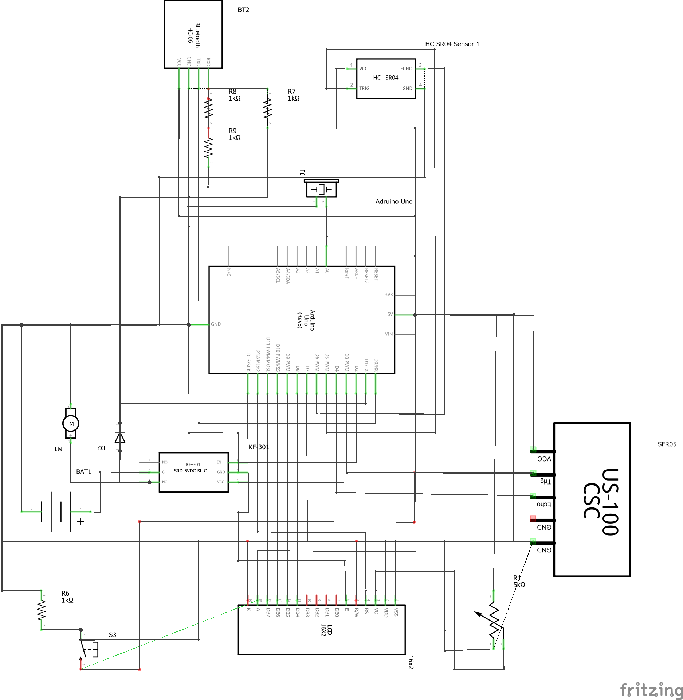

1. Circuit

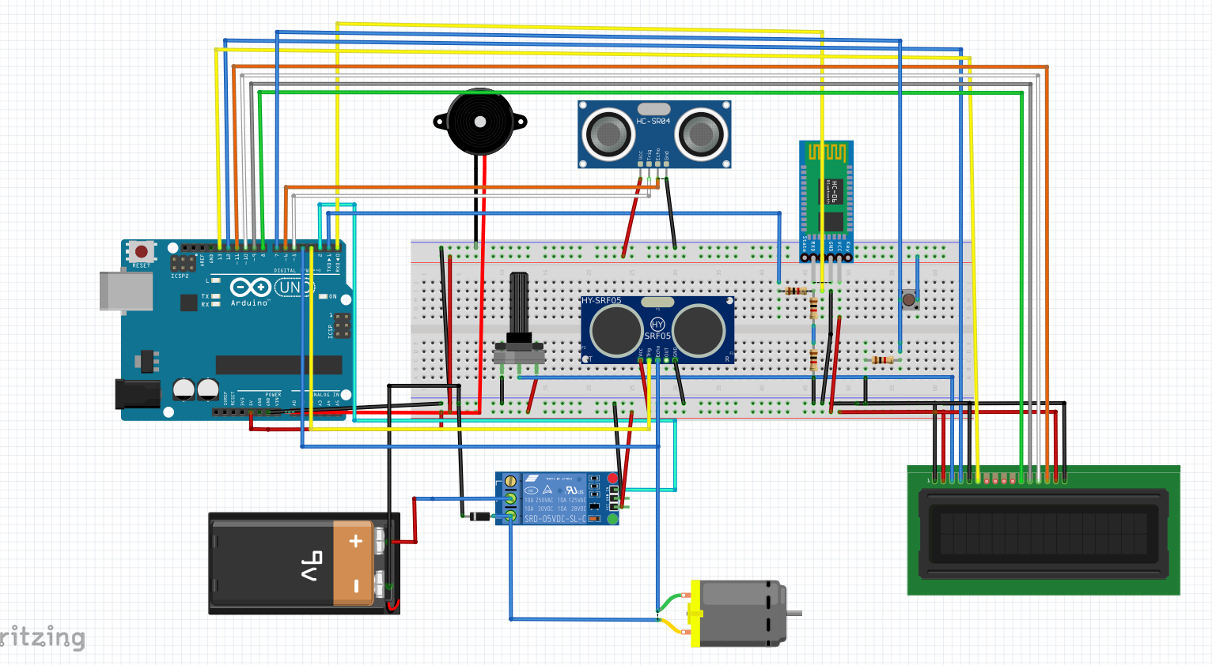

1. Flow chart

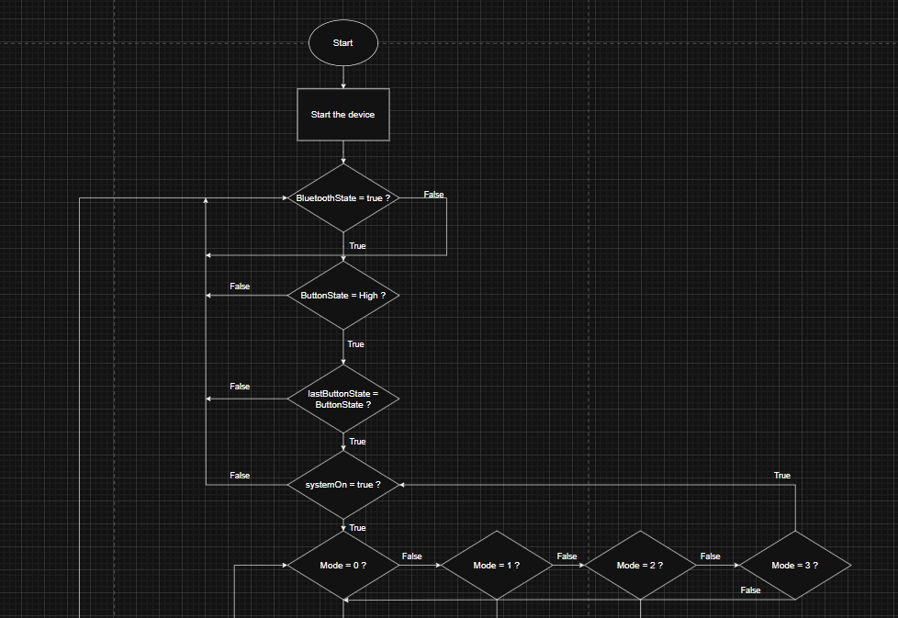

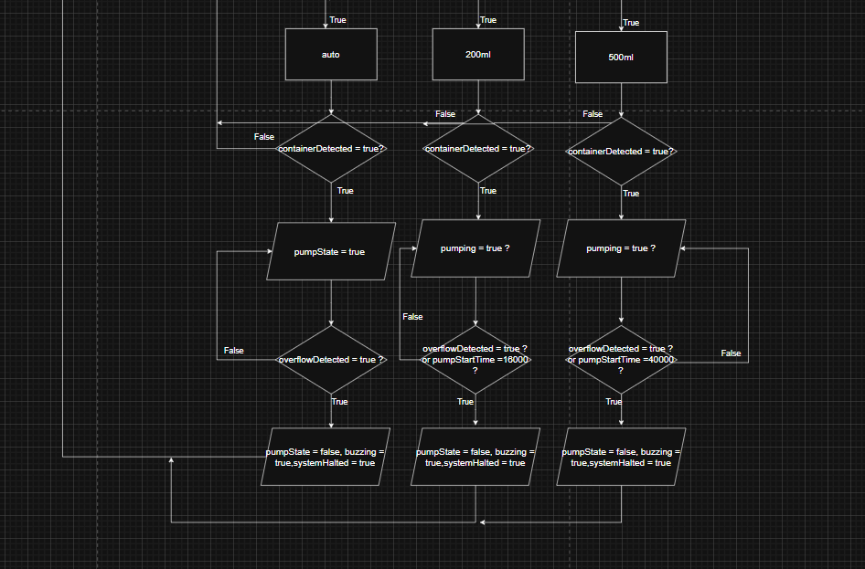

III. Results Achieved

Through the successful implementation of the proposed concept, we achieved the following key outcomes:

1. Wireless Control via Bluetooth

* The system was integrated with Bluetooth functionality, allowing users to remotely turn the water dispensing system on or off using a mobile device.

1. User-Selectable Dispensing Modes

* Users can easily select between different water flow options (Auto, 200ml, or 500ml) using a physical button interface. This meets the requirement of adjusting water volume at the point of use, enabling both precision and flexibility based on user needs.

1. Automated Overflow Protection

* The system includes dual ultrasonic sensors—one for detecting container presence and another for monitoring water level. Overflow is prevented through a smart detection algorithm: the system halts pumping and activates an audible buzzer if the water level fails to change after a predefined interval. This ensures safety and avoids water waste.

1. Real-Time Feedback via LCD and Serial Monitor

* Users receive live status updates through an LCD screen and optional serial output, including system status (ON/OFF) and operating mode.

1. Fail-Safe and Reset Functions

* In the event of an overflow, the system enters a safe halted state and alerts the user with repeated buzzer signals. The system can automatically reset once the container is removed, ensuring continuous usability with minimal manual intervention.