

**ONLINE TUTORING**

**Software Requirement Specification**

– Ho Chi Minh, October 2021 –

**Table of Contents**

I. Overview **4**

1. Introduction 4

a. Problem context 4

b. Context diagram 4

2. System Functions 5

a. Screen Flow 5

b. Screen Details 5

c. User Authorization 6

d. Non-Screen Functions 7

3. Common Requirements 7

3.1. External Interface 7

User Interface 7

Software interface 7

II. Functional Requirements **7**

1. Authenticate 7

a. Register 7

b. Login 8

2. Manage user 9

a. Change user role 9

b. Delete user 10

c. Search user 10

3. Manage Course 10

a. View course 10

b. Create course 11

c. Update course 11

d. Delete course 11

d. Search course 11

3.1. Manage course material 12

a.  Create course material 12

b. View course material 12

c.  Update course material 12

d.  Delete course material 12

3.2. Manage course timetable 13

a.  Create timetable 13

b. View course timetable 13

c.  Update course timetable 13

d.  Delete course timetable 13

3.3. Course Registration 14

a.  Register course 14

b.  Approve course registration 14

4. Feedback 14

a.  Add tutor feedback 14

b.  Update tutor feedback 14

c.  Delete tutor feedback 14

d.  View tutor feedback 14

6.  Manage profile 15

a.  View profile 15

b.  Edit profile 15

7. Forum 15

7.1. Question management 15

a.  Add question 15

b.  View question 16

c. Delete question 16

d. Search question 16

7.2. Answer management 16

a.  Add answer 16

b. Edit answer 17

c. Delete answer 17

# I. Overview

## 1. Introduction

### a. Problem context

While the years that children spend in school, it's not uncommon for them to lose their motivation to learn, it may just be temporary emotions that come due to many reasons, family, external factors, academic achievements are not as desired. Causing negative effects on student learning outcomes Although it has been scientifically proven that grades have no effect on a student's intelligence, it does have an effect on outcomes and future choices. For such reasons, parents often choose to hire a private tutor for their children. The demand for tutoring is currently increasing day by day, mainly through tutor brokerage companies. This form brings many disadvantages to students and tutors, especially with the current Covid-19 pandemic. The complicated development of the Covid-19 epidemic is increasing every day, the traditional form of face-to-face learning brings a high risk of infection. Tutor brokerage companies charge high tuition fees and high brokerage commissions. The risk of tutors being deceived is high, there are many cases of fake hiring tutors to do illegal acts. Students cannot find tutors on their own, and there is no guarantee of the quality of the tutor's expertise. We want to create an Online Tutor System that helps students and tutors solve their problems.

### b. Context diagram

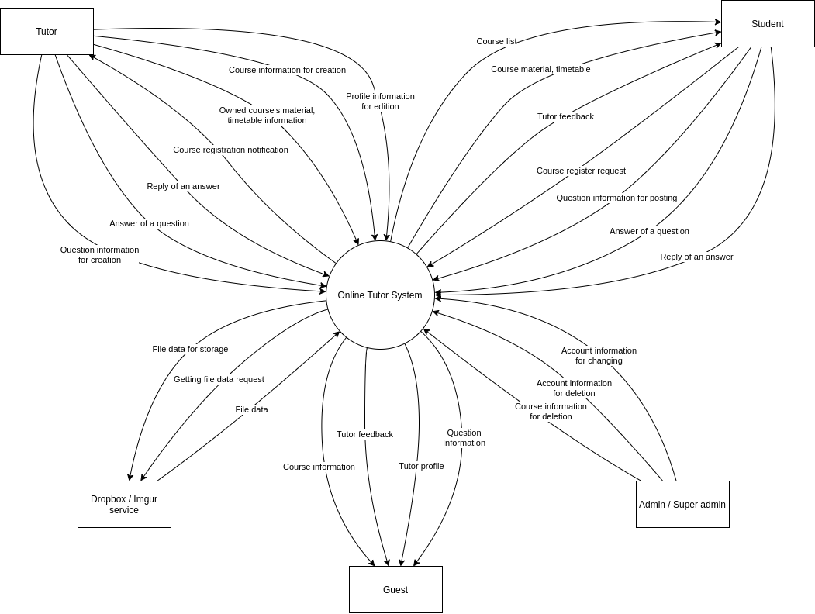

*Figure 1.1: Context diagram*

## 2. System Functions

#### a. Screen Flow

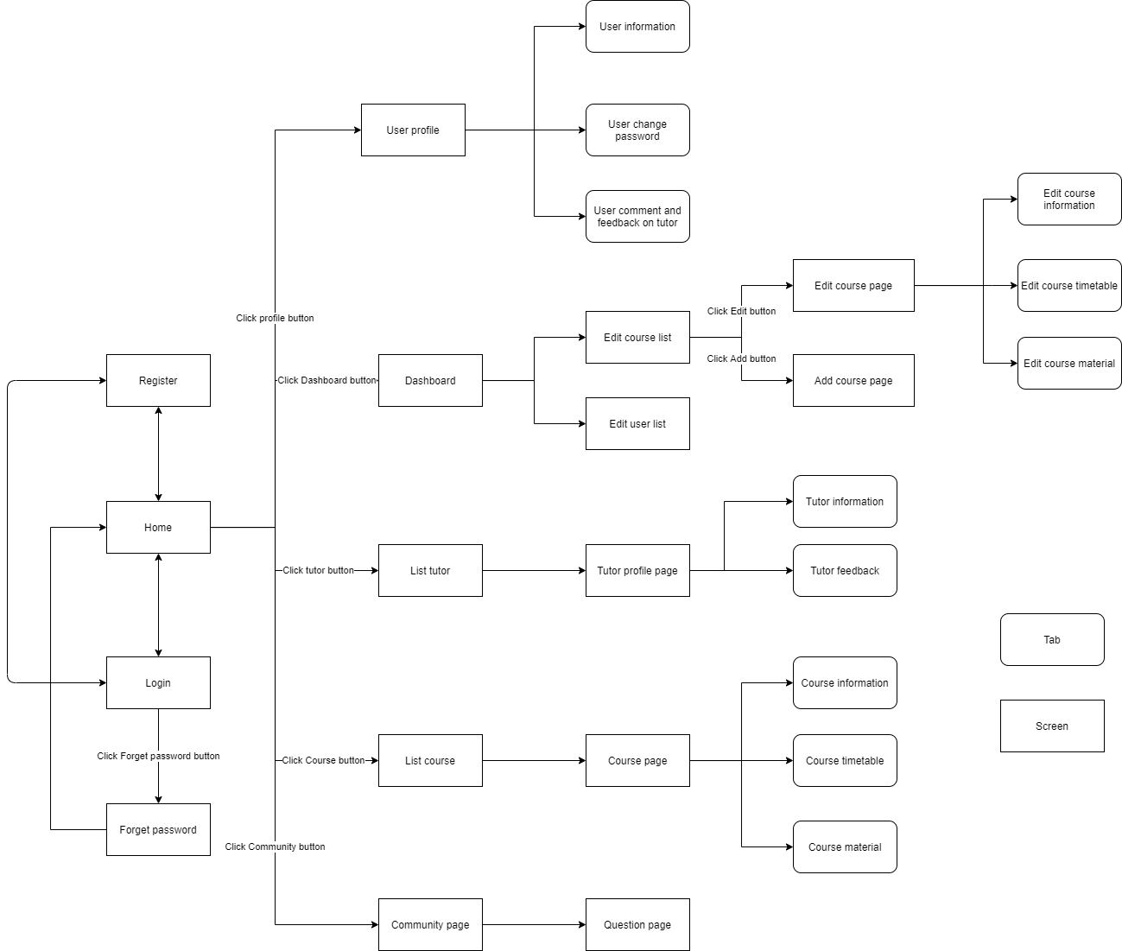

*Figure 2.1: Screen flow diagram*

#### b. Screen Details

| **#** | **Feature** | **Screen** | **Description** |
| --- | --- | --- | --- |
| 1 | Course management,  Tutor management | Home | The screen that shows general information |
| 2 | Authentication | Login | The screen for user to login to already existed account |
| 3 | Authentication | Register | The screen for user to register new account |
| 4 | Authentication | Forgot password | The screen for user to request reset password |
| 5 | Profile | User profile | The account information page |
| 6 | Manage course, Manage user | Dashboard | The screen that shows general feature of admin and super admin |
| 7 | Tutor management | List tutor | List of tutors |
| 8 | Course management | List course | List of courses published |
| 9 | Course management | Edit course list | List of courses for admin and tutor to edit |
| 10 | Account management | Edit user list | List of users for Super admin to edit |
| 11 | Course management | Course page | The general information page of course |
| 12 | Course management | Edit course page | Edit general information page of course |
| 13 | Course management | Add course page | Add page of course |
| 14 | Forum management | Forum page | The page that show a list of question posted by users |
| 15 | Forum management | Question page | The page that shows detail of a question. |

#### c. User Authorization

| **Screen** | **Guest** | **Student** | **Tutor** | **Admin** | **Super Admin** |
| --- | --- | --- | --- | --- | --- |
| Login | X | X | X | X | X |
| Register | X | X | X | X | X |
| Forget password | X | X | X |  |  |
| Home | X | X | X | X | X |
| User profile |  | X | X | X | X |
| Dashboard |  |  | X | X | X |
| *Go to Edit course list screen* |  |  | X | X | X |
| *Go to Edit user list screen* |  |  |  | X | X |
| List tutor | X | X | X | X | X |
| List course | X | X | X | X | X |
| Edit course list |  |  | X | X | X |
| *View all course* |  |  |  | X | X |
| *Delete course* |  |  | X | X | X |
| Edit user list |  |  |  | X | X |
| *Remove user* |  |  |  | X | X |
| *Change user role* |  |  |  |  | X |
| Course page |  | X | X | X | X |
| Edit course page |  |  | X | X | X |
| *Manage course information* |  |  | X | X | X |
| *Manage course timetable* |  |  | X | X | X |
| *Manage course material* |  |  | X | X | X |
| *Delete course* |  |  | X | X | X |
| Add course page |  |  | X | X | X |
| Forum page | X | X | X | X | X |
| *Add question* |  | X | X | X | X |
| *Delete question* |  | X |  | X | X |
| *View question & answer* | X | X | X | X | X |
| *Add answer* |  | X | X | X | X |
| *Delete answer* |  | X | X | X | X |

In which:

* Guest: The user hasn’t signed into the system yet.
* Student: The students finding tutors and courses
* Tutor: The tutor finding student to teach
* Admin: The staff of the organization
* Super Admin: The main manager of the system. Manage user accounts and decentralization.

#### d. Non-Screen Functions

| **#** | **Feature** | **System Function** | **Description** |
| --- | --- | --- | --- |
|  |  |  |  |

## 3. Common Requirements

### 3.1. External Interface

#### a. User Interface

* UI-1: The website must display an error message every time an error occurs. The message must specify whether the error is coming from the user or the system.

#### b. Software interface

* SI-1: Dropbox API: the system should use the Dropbox service to store the user's document file such as PDF in order to save the memory.
* SI-2: Imgur API: the system should use the Imgur service to store images.

# II. Functional Requirements

## 1. Authenticate

### a. Register new account

* Function trigger: The registration page should be displayed when a user clicks on the register button in the login page.
* Function description:
  + Actor: Guest, student, tutor, admin, Super Admin
  + The system shall allow users to register a new account for the Online Tutoring system.
* Function detail:
  + Users shall enter the required fields :
    - Fullname ( required 1 - 50 characters )
    - Username( required 1 - 50 characters )
    - Password (required 6 - 30 characters )
    - Confirm password ( must match password )
    - Phone ( required 10 numbers )
    - Email (required available email)
  + If any of the text fields is left blank the user should see error messages.
  + If the two passwords are different that must also be reported as an error.
  + When the user attempts to register with a username that is already taken the user should see an error message.
  + Users will receive email verification to verify their account.
* Screen layout:

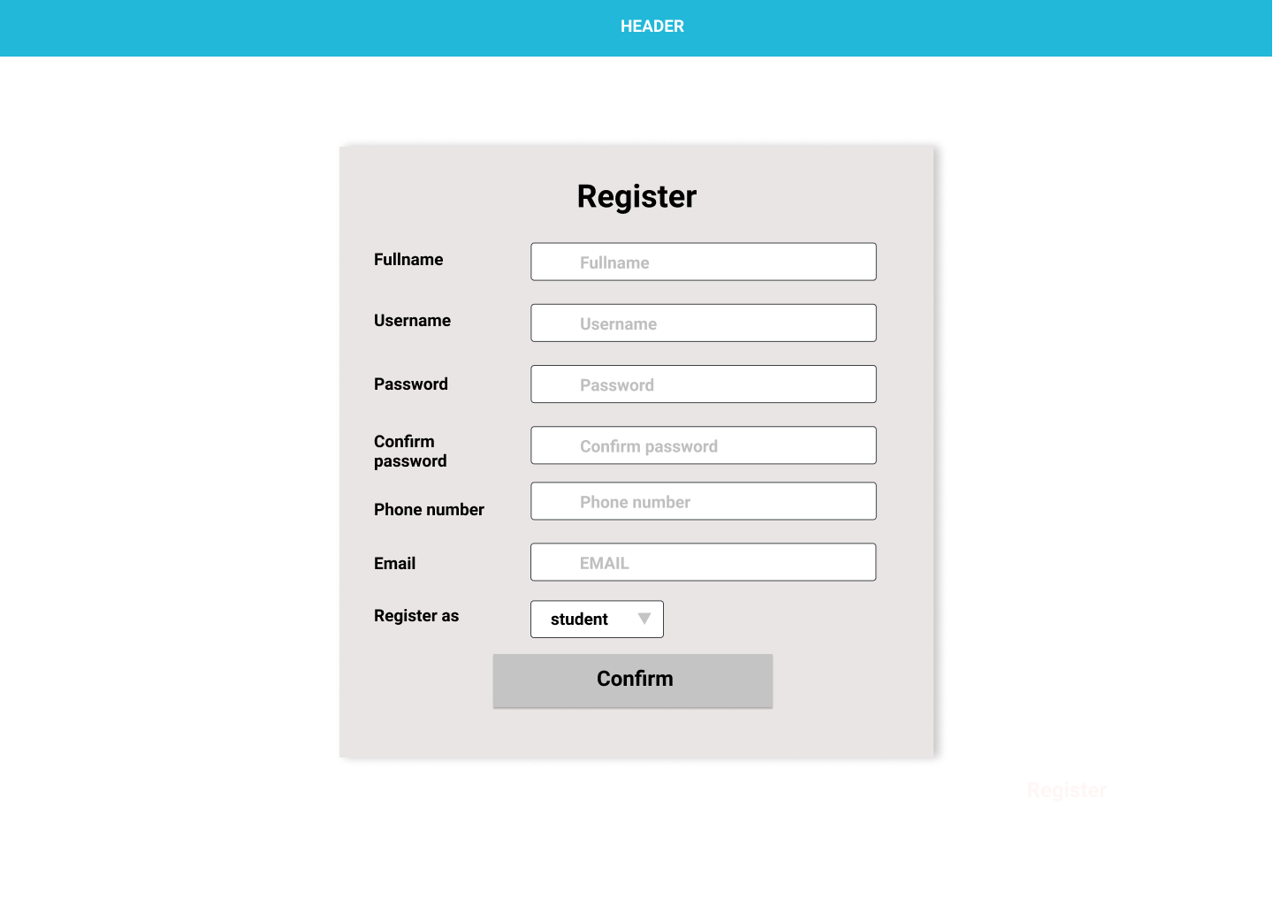

### b. Login

* Function trigger: Users shall choose the Login button.
* Function description:
  + Actor: student, tutor, admin, Super Admin
  + Users that have not yet registered cannot log in. They must first register by clicking on the register command button. They should be able to do this without getting an error for an empty name or password field.
* Function detail:
  + Users shall login to the system by using the username and password which is registered.
  + Users shall be able to use system functionalities and be directed to the home screen after successful login.
  + If a user is not registered, the system shall give user options to register now or to exit.
  + Users shall see error messages if the username or password invalid.
  + When the login command button is clicked without filling in the username field or without filling in the password field the user should see error messages.
* Screen layout:
* 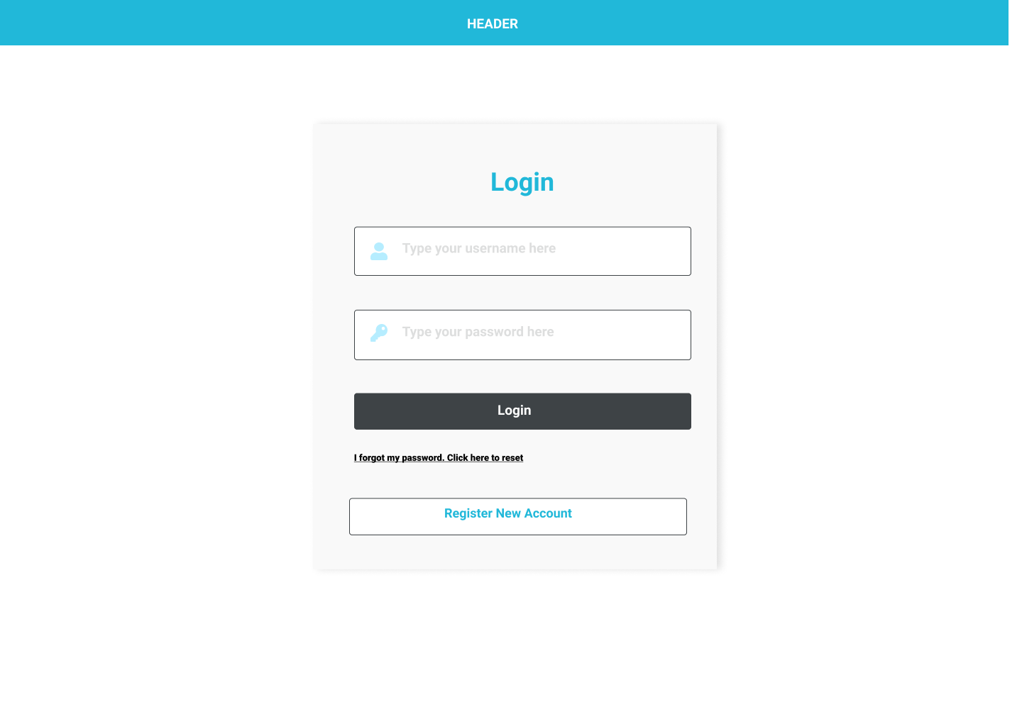

### c**. Logout**

* Function trigger: Users shall click the logout button.
* Function description:
  + Actor: student, tutor, admin, Super Admin
* Function detail:
* Users shall logout if they logged in.
* Users shall be directed to the home screen.
* Screen layout:

### d. Change Password

* Function trigger:
  + Users can click “I forgot my password. Click here to reset” in the Login page.
  + Users can change their password in their Profile by clicking the edit button.
* Function description:
  + Actor: student, tutor, admin, Super Admin.
  + Users want to change their password or they forgot their password.
* Function detail:
  + Users shall enter their email address to receive a code which the system sends.
  + Users shall enter code then enter their new password and confirm the new password.
  + If the two passwords are different that must also be reported as an error.
* Screen layout:

## 2. User Management

### a. Change user role

* Function trigger: Super Admin shall select role in SuperAdmin page.
* Function description:
  + Actor: Super Admin.
  + Assign roles to users.
* Function detail:
  + Super Admin shall select a new role if they want to change user roles.
* Screen layout:

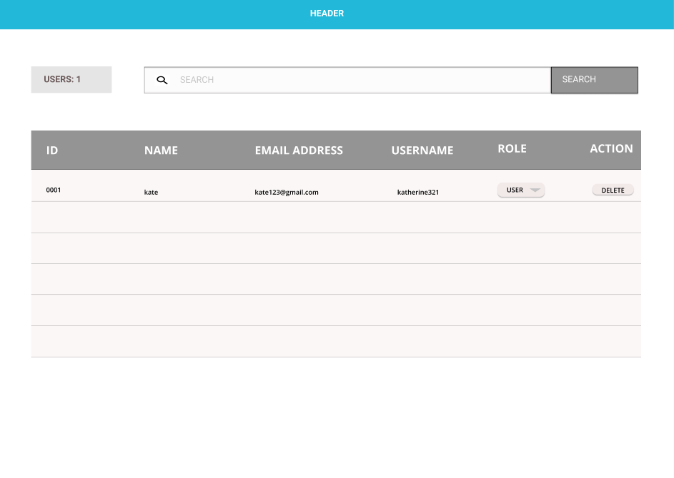

### b. Delete user

* Function trigger: Super Admin shall delete a user by clicking the DELETE button.
* Function description:
  + Actor: Super Admin
  + Manage all users.
* Function detail:
  + System shall allow Super Admin to delete users.
* Screen layout: same as change role function.

### c. Search user

* Function trigger: Super Admin shall enter field search by clicking the SEARCH button.
* Function description:
  + Actor: Super Admin
  + Super Admin can easily find users.
* Function detail:
  + Super Admin can search user by:
    - Username
    - Email address
* Screen layout: same as change role function.

## 3. Course Management

### a. View course

* Function trigger: Users shall click “view course”.
* Function description:
  + Actor: Guest, student, tutor.
  + Let students find a suitable course.
* Function detail:
  + System shall display all courses available with its information.
* Screen layout:

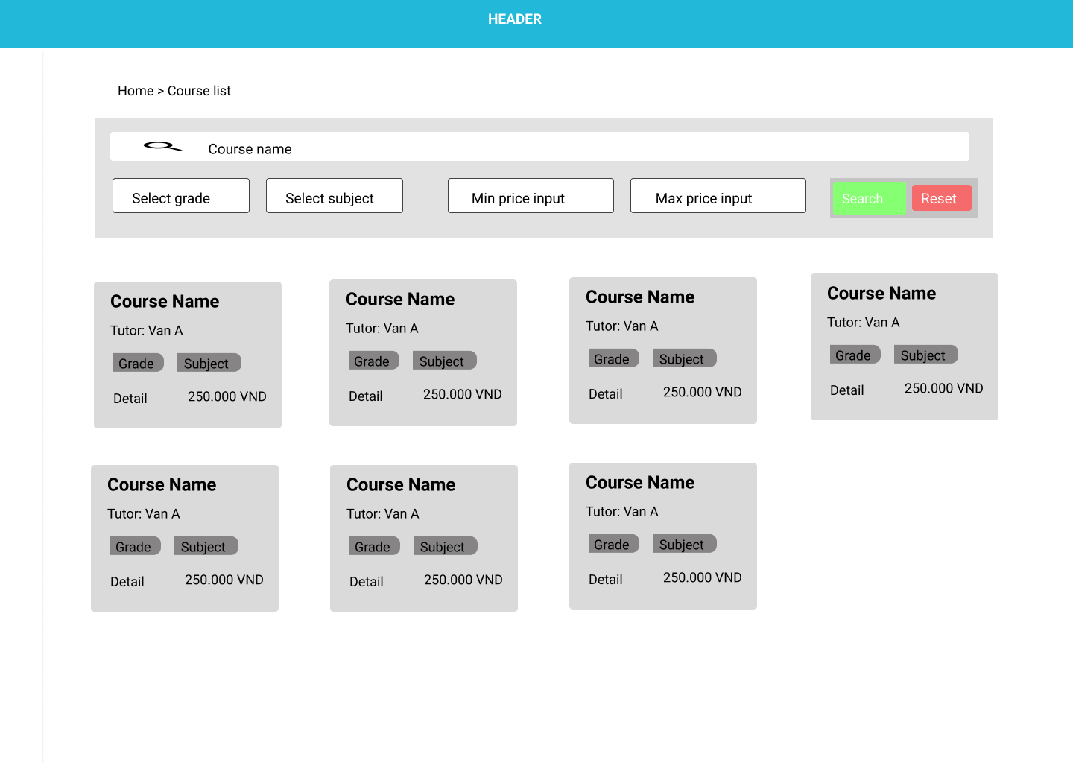

### b. Create course

* Function trigger: Tutors shall create a new course by clicking “create course”.
* Function description:
  + Actor: tutor, admin, Super Admin.
  + Tutors can create a new course with necessary details.
* Function detail:
* System shall allow tutor create new course with following details:
  + Course name. (limit 155 words)
  + Grade ( Limit from Grade 1- 12 )
  + Price. ( limit from 0 VND to 2.000.000VND )
  + Time length of each lesson. ( at least 1 hour )
  + Description. (limit 155 words)
* Screen layout:

### c. Update course

* Function trigger : Tutors shall edit and click save button to update course.
* Function description:
  + Actor: tutor, admin, Super Admin.
  + Let Tutor update their course.
* Function detail:
  + System shall allow tutor create new course with following details:
    - Course name (limit 155 words).
    - Grade ( tutor can select from Grade 1- 12 ).
    - Price ( limit from VND to VND ).
    - Time length of each lesson ( at least 1 hour ).
    - Description (limit 155 words).
    - Subject
* Screen layout:

### d. Delete course

* Function trigger: Tutor shall click the Delete button to delete the course .
* Function description:
  + Actor: tutor, admin, Super Admin.
  + Let Tutors delete their course.
* Function detail:
  + System shall allow Tutors to delete their course.
* Screen layout:

### d. Search course

* Function trigger: Tutor shall enter field search by clicking the SEARCH button.
* Function description:
  + Actor: student, tutor, admin, Super Admin.
  + Let Tutors/Students easily find courses.
* Function detail:
  + Tutors/Students can search courses by:
    - Course name.
    - Subject.
    - Cost range.
    - Time range.
    - Tutor name.
* Screen layout:

## 3.1. Material Management

### a. Create course material

* Function trigger: Tutors shall click the “material” tab to manage material and click “add material” button to create course material.
* Function description:
  + Actor: tutor, admin, Super Admin.
  + Let tutors upload the document for students.
* Function detail:
  + Tutors shall add new course with following details:
    - Title.(limit 155 words )
    - File Attach ( include file,image tutor upload from their device, limit 8MB)
    - Description.(limit 155 words )
* Screen layout:
* 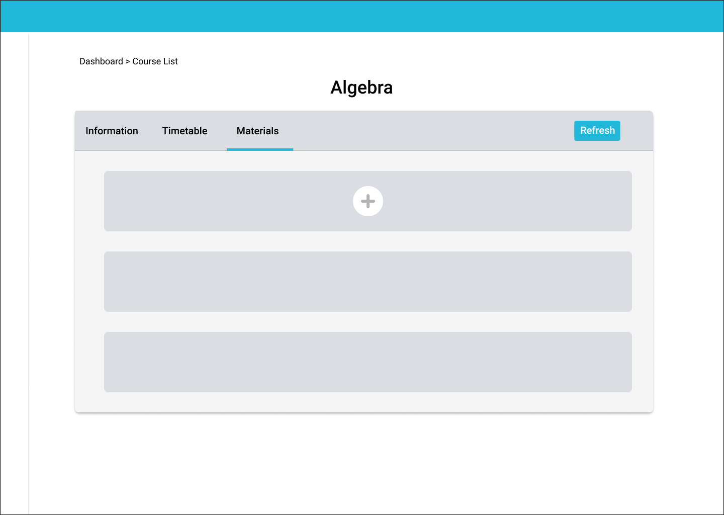

### b. View course material

* Function trigger: Students shall click the “material” tab to view material.
* Function description:
  + Actor: student, tutor, admin, Super Admin.
  + Students can easily find material which tutors upload.
* Function detail:
  + System shall display all material which tutors upload.
* Screen layout:

### c. Update course material

* Function trigger:
  + Tutors shall click the “material” tab to manage material.
  + Tutors shall update material by clicking the edit button.
  + Material shall be updated after tutors edited information and click save button.
* Function description:
  + Actor: tutor, admin, Super Admin.
  + Let Tutors edit course material.
* Function detail:
  + Tutors can edit following information:
    - Title.(limit 155 words )
    - File Attach ( include file,image tutor upload from their device, limit 8MB)
    - Description.(limit 155 words )
* Screen layout:
* 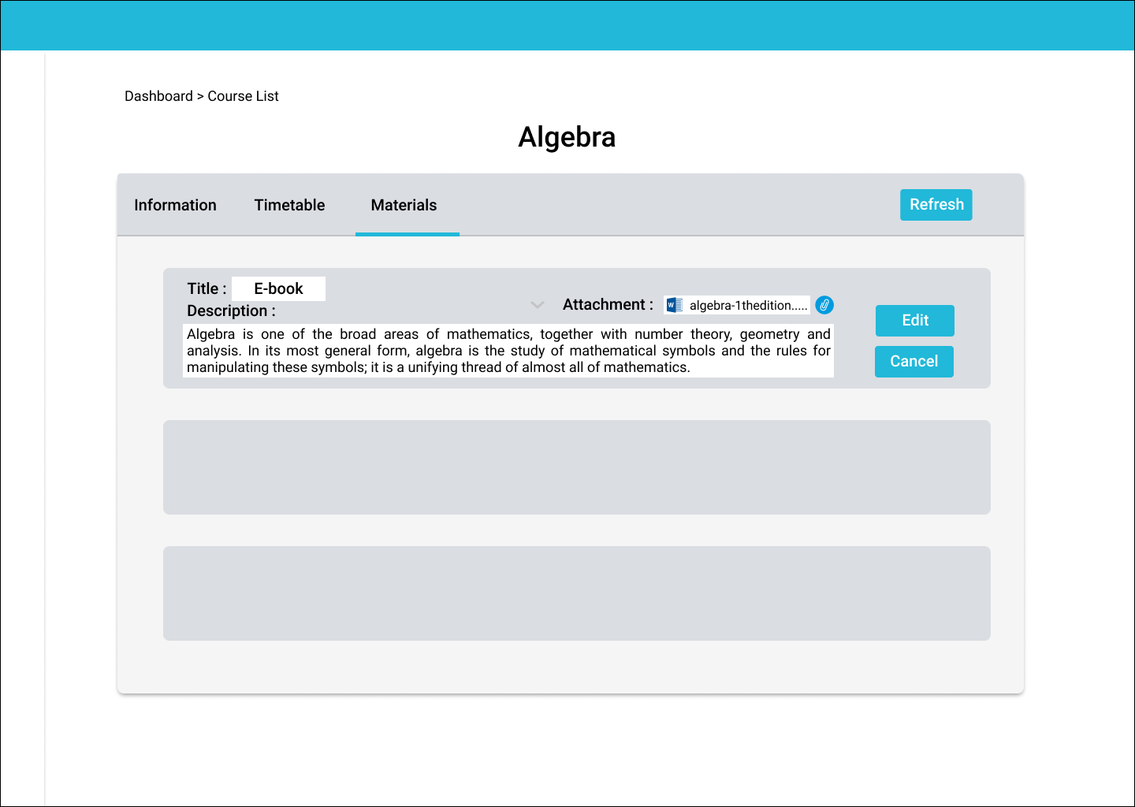

### d. Delete course material

* Function trigger:
  + Tutors shall click the “material” tab to manage material.
  + Tutors shall click the delete button to delete.
* Function description:
  + Actor: tutor, admin, Super Admin.
  + Let Tutors delete course material.
* Function detail:
  + System shall allow Tutors to delete their course material.
* Screen layout:

## 3.2. Timetable management

### a. Create timetable

* Function trigger:
  + Tutors shall click “add timetable”.
  + Each lesson must take at least 2 hours and maximum 5 hours.
  + Function description:
  + Actor: tutor, admin, Super Admin.
  + Let Tutor create a timetable so that students can know and arrange their timetable.
* Function detail:
  + Tutors shall a create timetable with following details:
    - Days.
    - Start Time.
    - End Time.
* Screen layout:

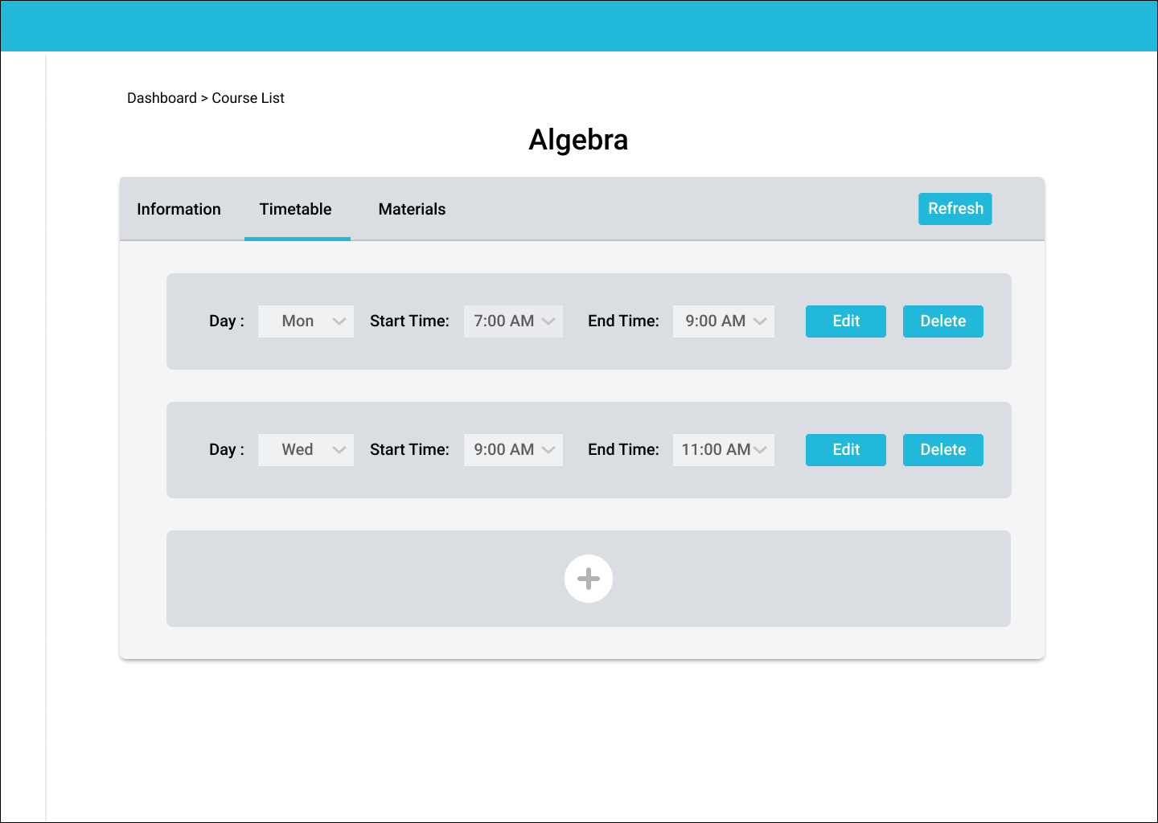

### b. View course timetable

* Function trigger: Students shall click the “timetable” to view timetable.
* Function description:
  + Actor: student, tutor, admin, Super Admin.
  + Students can see the timetable which tutors create.
* Function detail:
  + System shall display timetable which tutors create.
* Screen layout:

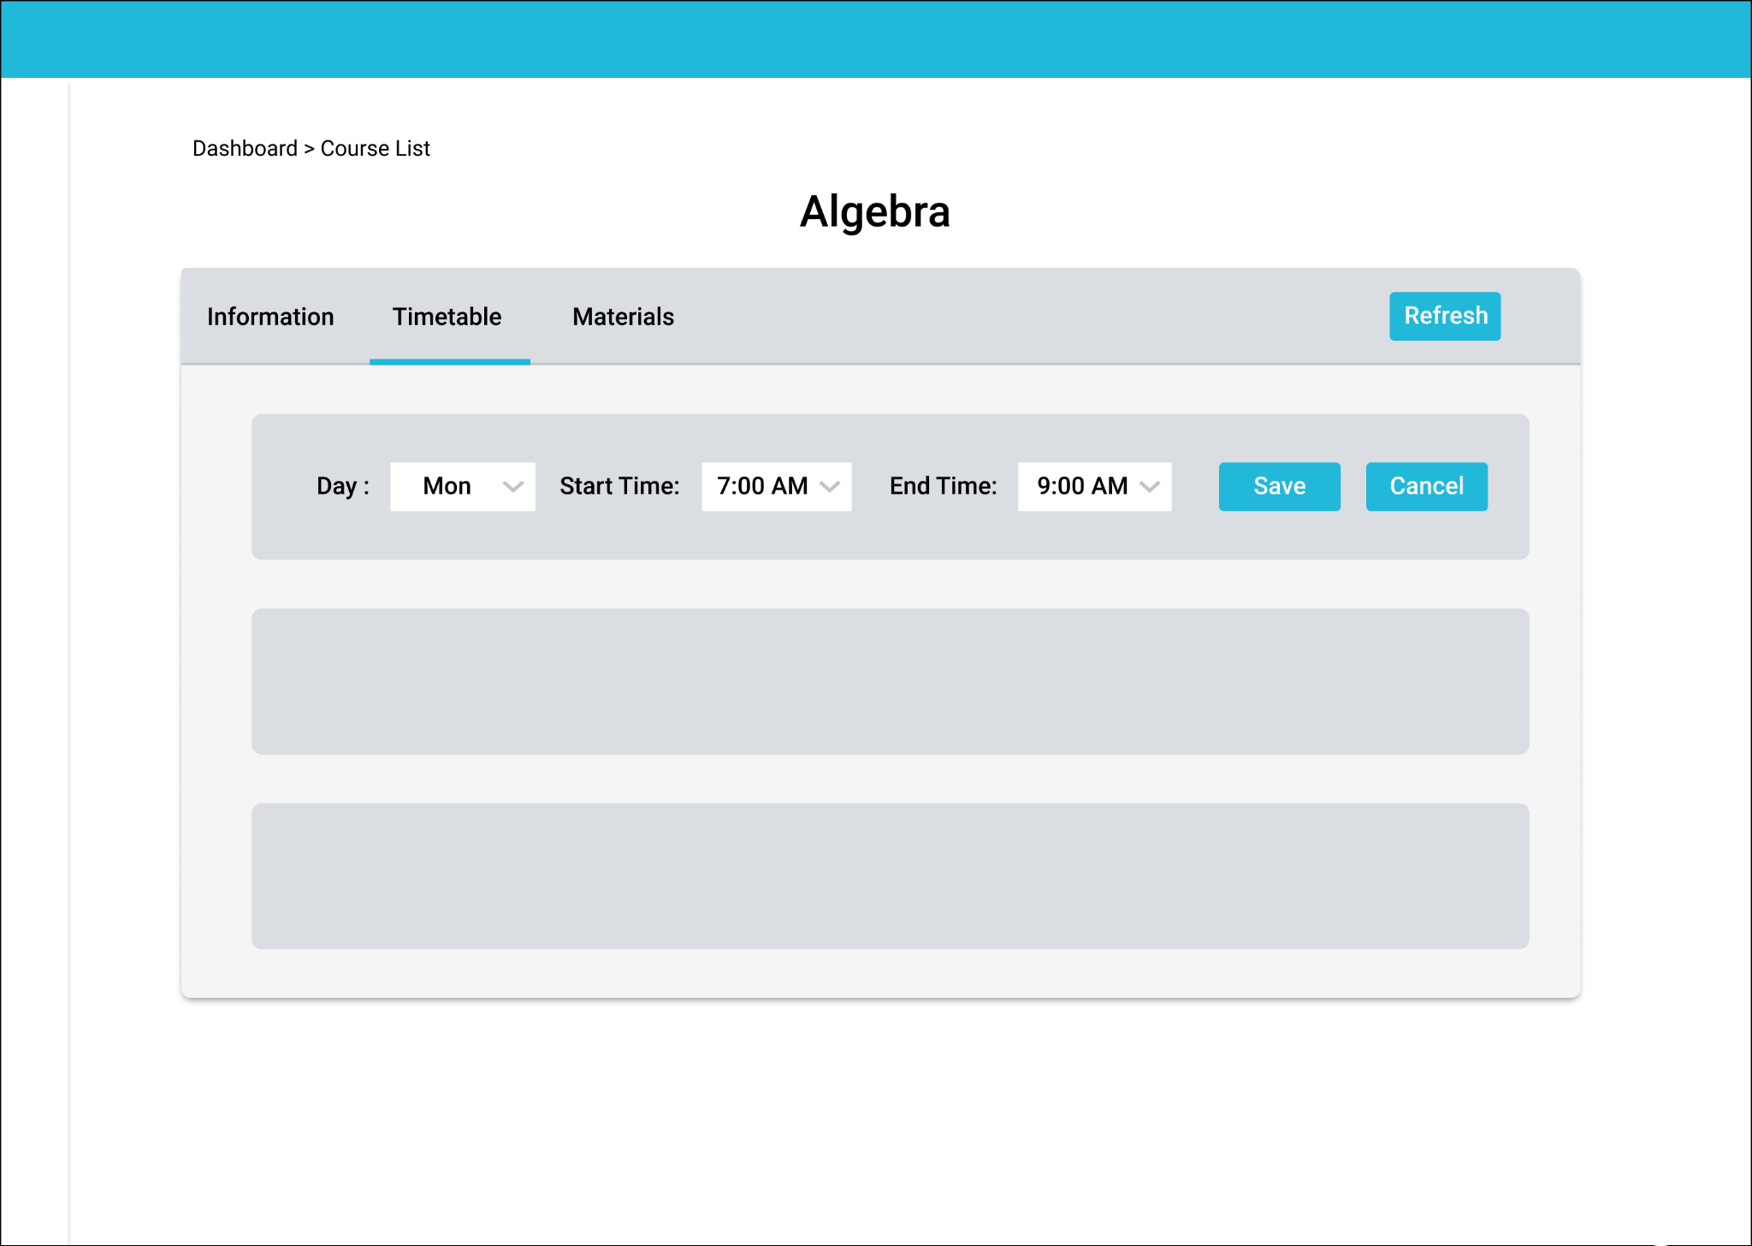

### c. Update course timetable

* Function trigger:
  + Tutors shall update timetable by clicking the edit button.
  + Time limit ...
  + Timetable shall be updated after tutors edited information and click save button.
* Function description:
  + Actor: tutor, admin, Super Admin.
  + Let Tutors edit the course timetable.
* Function detail:
  + Tutors can edit timetable following information:
    - Days ( include existed days )
    - Start Time ( include existed time )
    - End Time ( include existed time )
* Screen layout:



### d. Delete course timetable

* Function trigger:
  + Tutors shall click the delete button to delete.
* Function description:
  + Actor: tutor, admin, Super Admin.
  + Let Tutors delete the course timetable .
* Function detail:
  + System shall allow Tutors to delete their course timetable.
* Screen layout:



## 3.3. Course Registration

### a.  Register course

* Function trigger: Students shall register button.
* Function description:
  + Actor: student, tutor, admin.
  + Let students register the course they want to register for.
* Function detail:
  + System shall allow users to register a course they see in the view course.
  + If users did not login, the system shall give users options to login.
  + After students click the registration button, they shall wait until tutor contact and deal with them about the course.
* Screen layout:

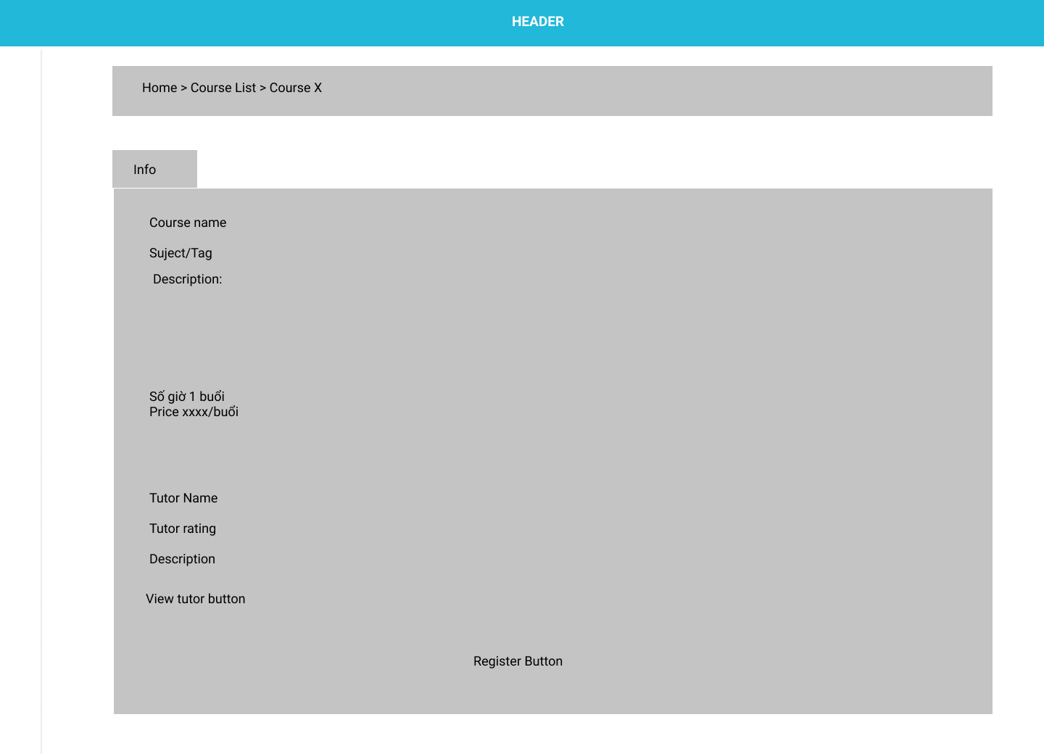

### b.  Approve course registration

* Function trigger: tutorshall click approve button.
* Function description:
  + Actor: tutor, admin, superadmin.
  + Let tutor accept students after dealing with them.
* Function detail:
  + System shall allow tutor to register a course they see in the view course.
  + If users did not login, the system shall give users options to login.
  + After students click the registration button, they shall wait until tutor contact and deal with them about the course.
* Screen layout:
* Students shall wait for tutors to accept the request then contact Student.

## 4. Feedback

### a.  Add tutor feedback

* Function trigger: students can write feedback by clicking “FeedBack”.
* Function description:
  + Actor: student.
  + Students can give feedback after a course.
  + Feedback helps tutor improve their skill and learn from experience.
* Function detail:
  + Students shall rate tutors by grading from 1 to 5.
  + Students shall write comments for the tutor( limit 2500 words ).
* Screen layout:

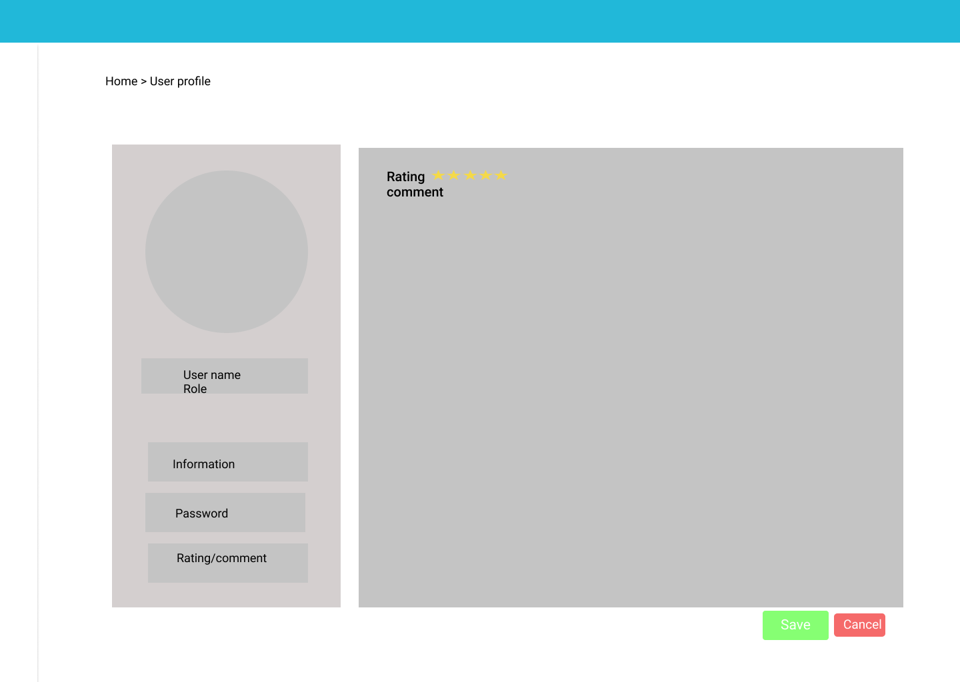

### b.  Update tutor feedback

* Function trigger: students shall edit feedback and click the edit button.
* Function description:
  + Actor: student.
  + Students can edit feedback.
* Function detail:
  + Student can edit feedback with following details:
    - Rating (from 1 to 5 star)
    - Comment.( limit 2500 words )

### c.  Delete tutor feedback

* Function trigger:
  + Tutors shall click the delete button to delete.
* Function description:
  + Actor: student, admin, Super Admin.
  + Let students delete course material.
* Function detail:
  + System shall allow students to delete their feedback.
* Screen layout:

### d.  View tutor feedback

* Function trigger: Students/tutors shall click the feedback button to view feedback .
* Function description:
  + Actor: student, tutor, admin, Super Admin.
  + Students/tutors can see feedback.
* Function detail:
  + System shall display all feedback which students upload with following details:
    - Rating.
    - Comment.
* Screen layout:

## 6.  Profile Management

### a.  View profile

* Function trigger: Students shall click “view profile”.
* Function description:
  + Actor: student, tutor.
  + Students can see their profile information.
* Function detail:
  + The system shall display the profile of the user with following details:
    - Fullname.
    - Username.
    - Phone number.
    - Address.
    - Email.
    - Gender.
    - Date of birth.
    - ResumeURL (Tutor only ).
    - JobTitle (Tutor only ).
    - Affiliation (Tutor only ).
    - GPA (Tutor only ).
* Screen layout:

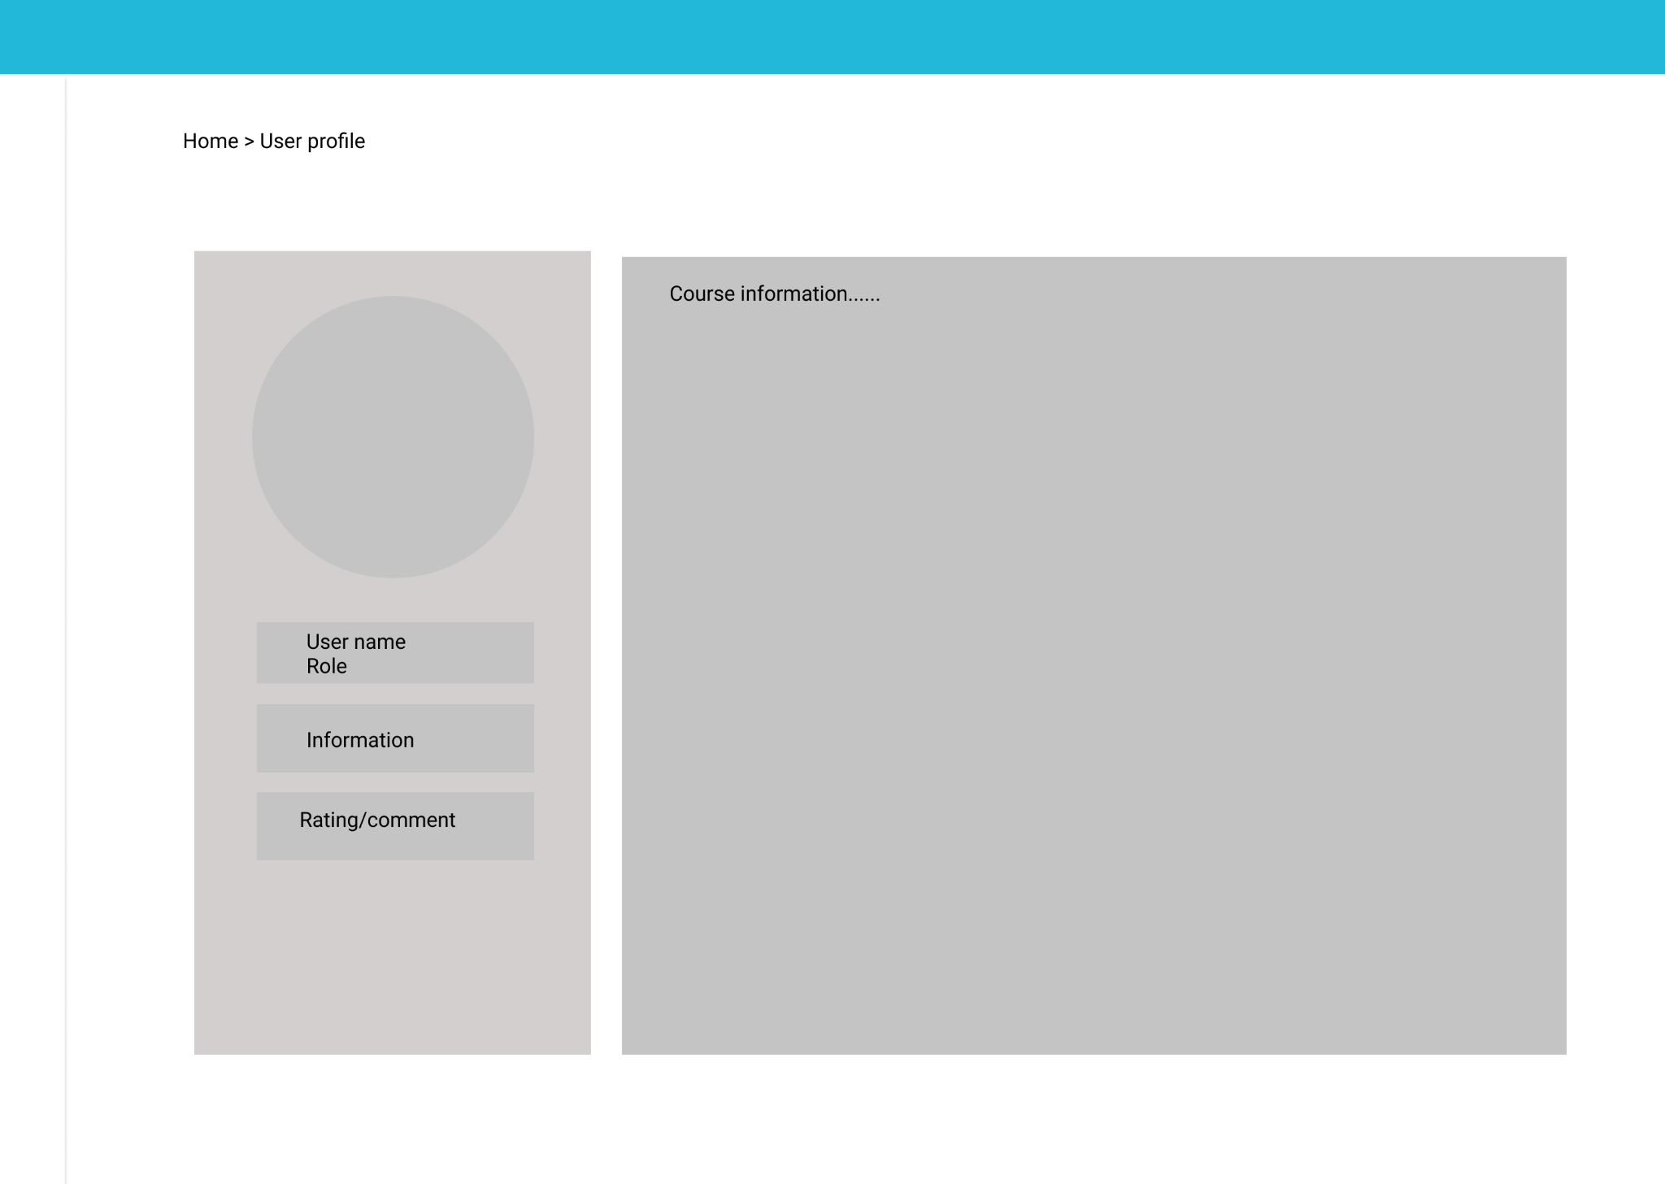

### b.  Edit profile

* Function trigger: Students edit and click the save button.
* Function description:
  + Actor: student, tutor.
  + Let Students/Tutors edit their profiles.
* Function detail:
  + Students/Tutors shall edit their profile with following information:
    - Fullname.
    - Password (required 6 to 30 characters )
    - Phone number
    - Address
    - Email
    - Gender
    - Age
    - FacebookURL
    - ResumeURL (Tutor only ).
    - JobTitle (Tutor only ).
    - Affiliation (Tutor only ).
    - GPA (Tutor only ).
* Screen layout:

## 7. Forum

## 7.1. Question management

### a.  Add question

* Function trigger:
  + Users shall click “Forum” to access the forum.
  + Users shall write posts and click the send button.
* Function description:
  + Actor: student, tutor, admin, SuperAdmin.
  + Users can write a post in order to ask questions about their study.
* Function detail:
  + Users shall write posts in limited 2500 words.
* Screen layout:

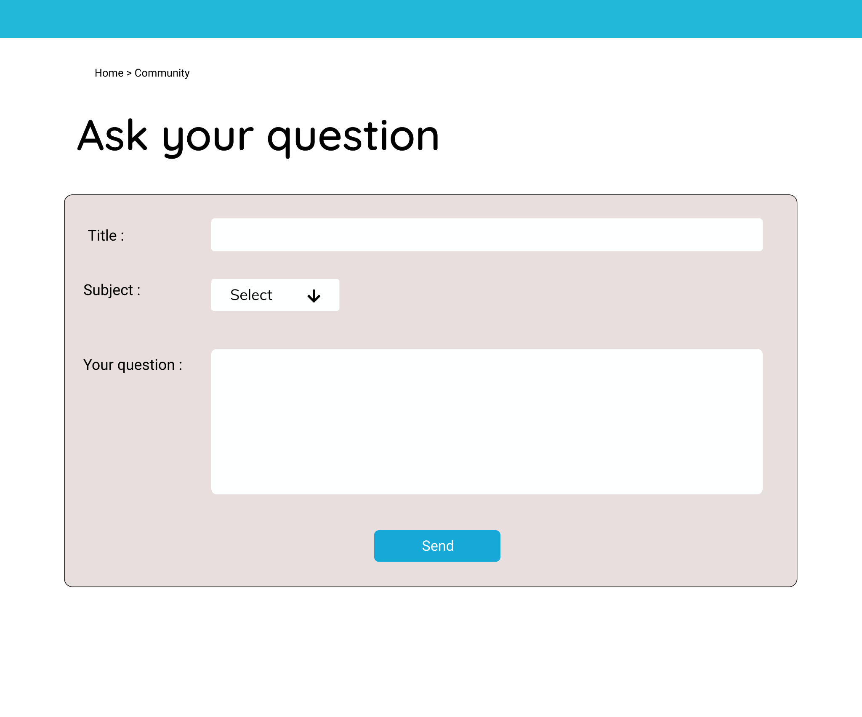

### b.  View question

* function trigger:
  + Users click “Forum” button to access the forum.
  + Users choose and click a question.
* function description:
  + Actor: student, tutor, admin, SuperAdmin.
* function detail:
  + System shall display question with following information:
    - Username.
    - Posted Date
    - Title.
    - Question.
    - Answer.
* Screen layout:

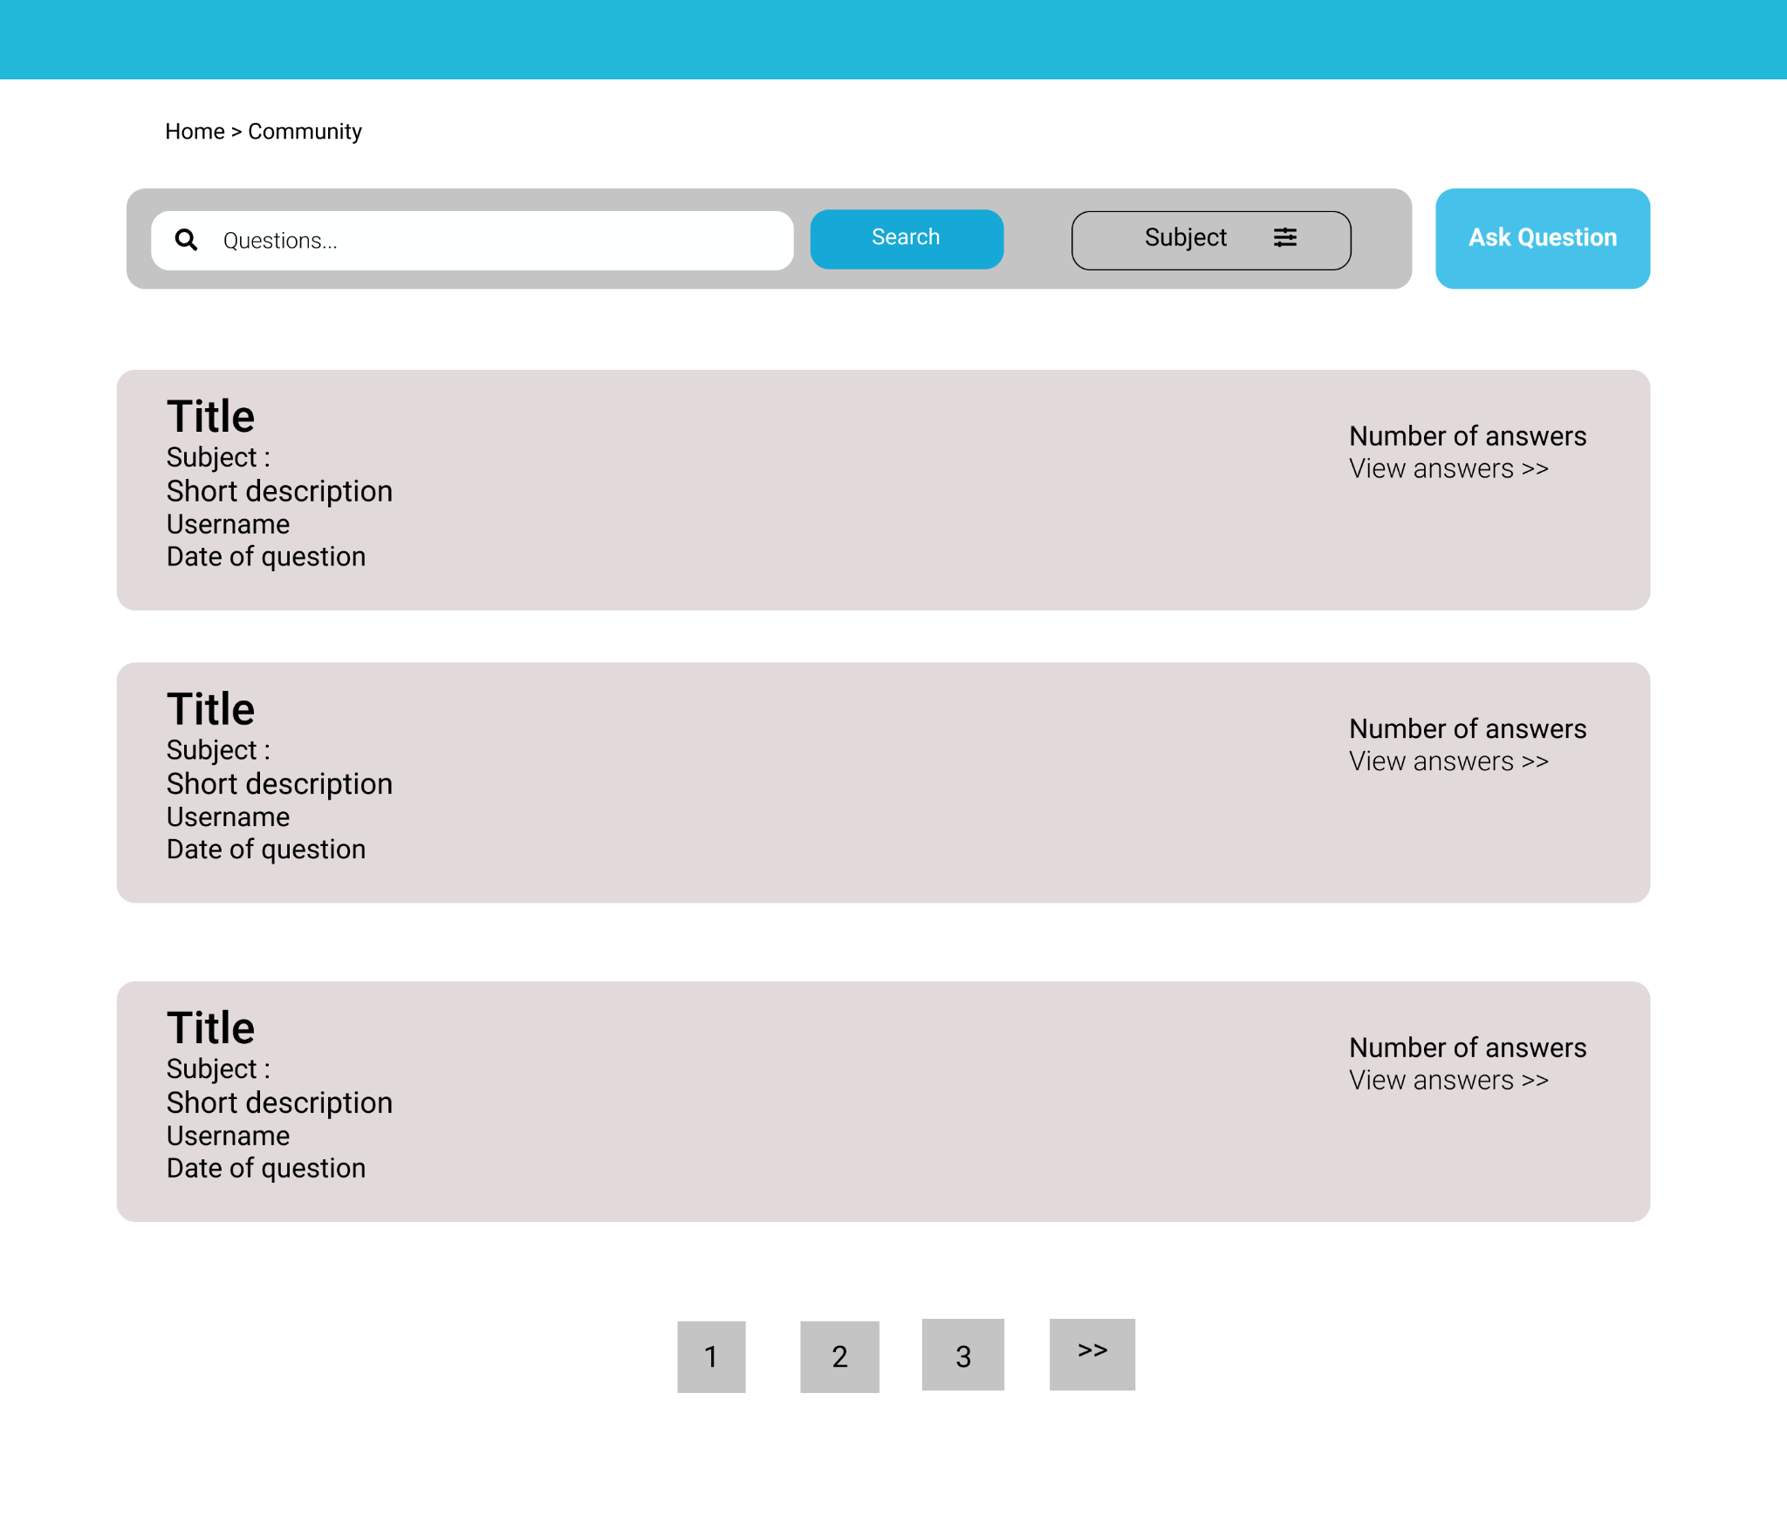

### c. Delete question

* Function trigger:
  + student click “Forum” to access the forum.
  + Users shall click the delete button.
* Function description:
  + Actor: student, tutor, admin, SuperAdmin.
  + Let Users delete the question. ( Only their question but SuperAdmin can delete all question)
  + Question can include image, link, text.
* Function detail:
  + System shall allow Users to delete the question.

### d. Search question

* Function trigger: Users shall enter field search by clicking the SEARCH button.
* Function description:
  + Actor: student, tutor, admin, Super Admin.
  + Let Users easily find questions.
* Function detail:
  + Users can search courses by:
    - Title.
    - Subject.
* Screen layout:

## 7.2. Answer management

### a.  Add answer

* Function trigger: user shall write answer and click the send button.
* Function description:
  + Actor: student, tutor, admin, Super Admin.
  + Users can give their answers in order to help other users.
* Function detail:
  + Answer length should be less than 2500 words.
  + Answer is written in markdown format.
  + Answer can include Link, image, text.
* Screen layout:

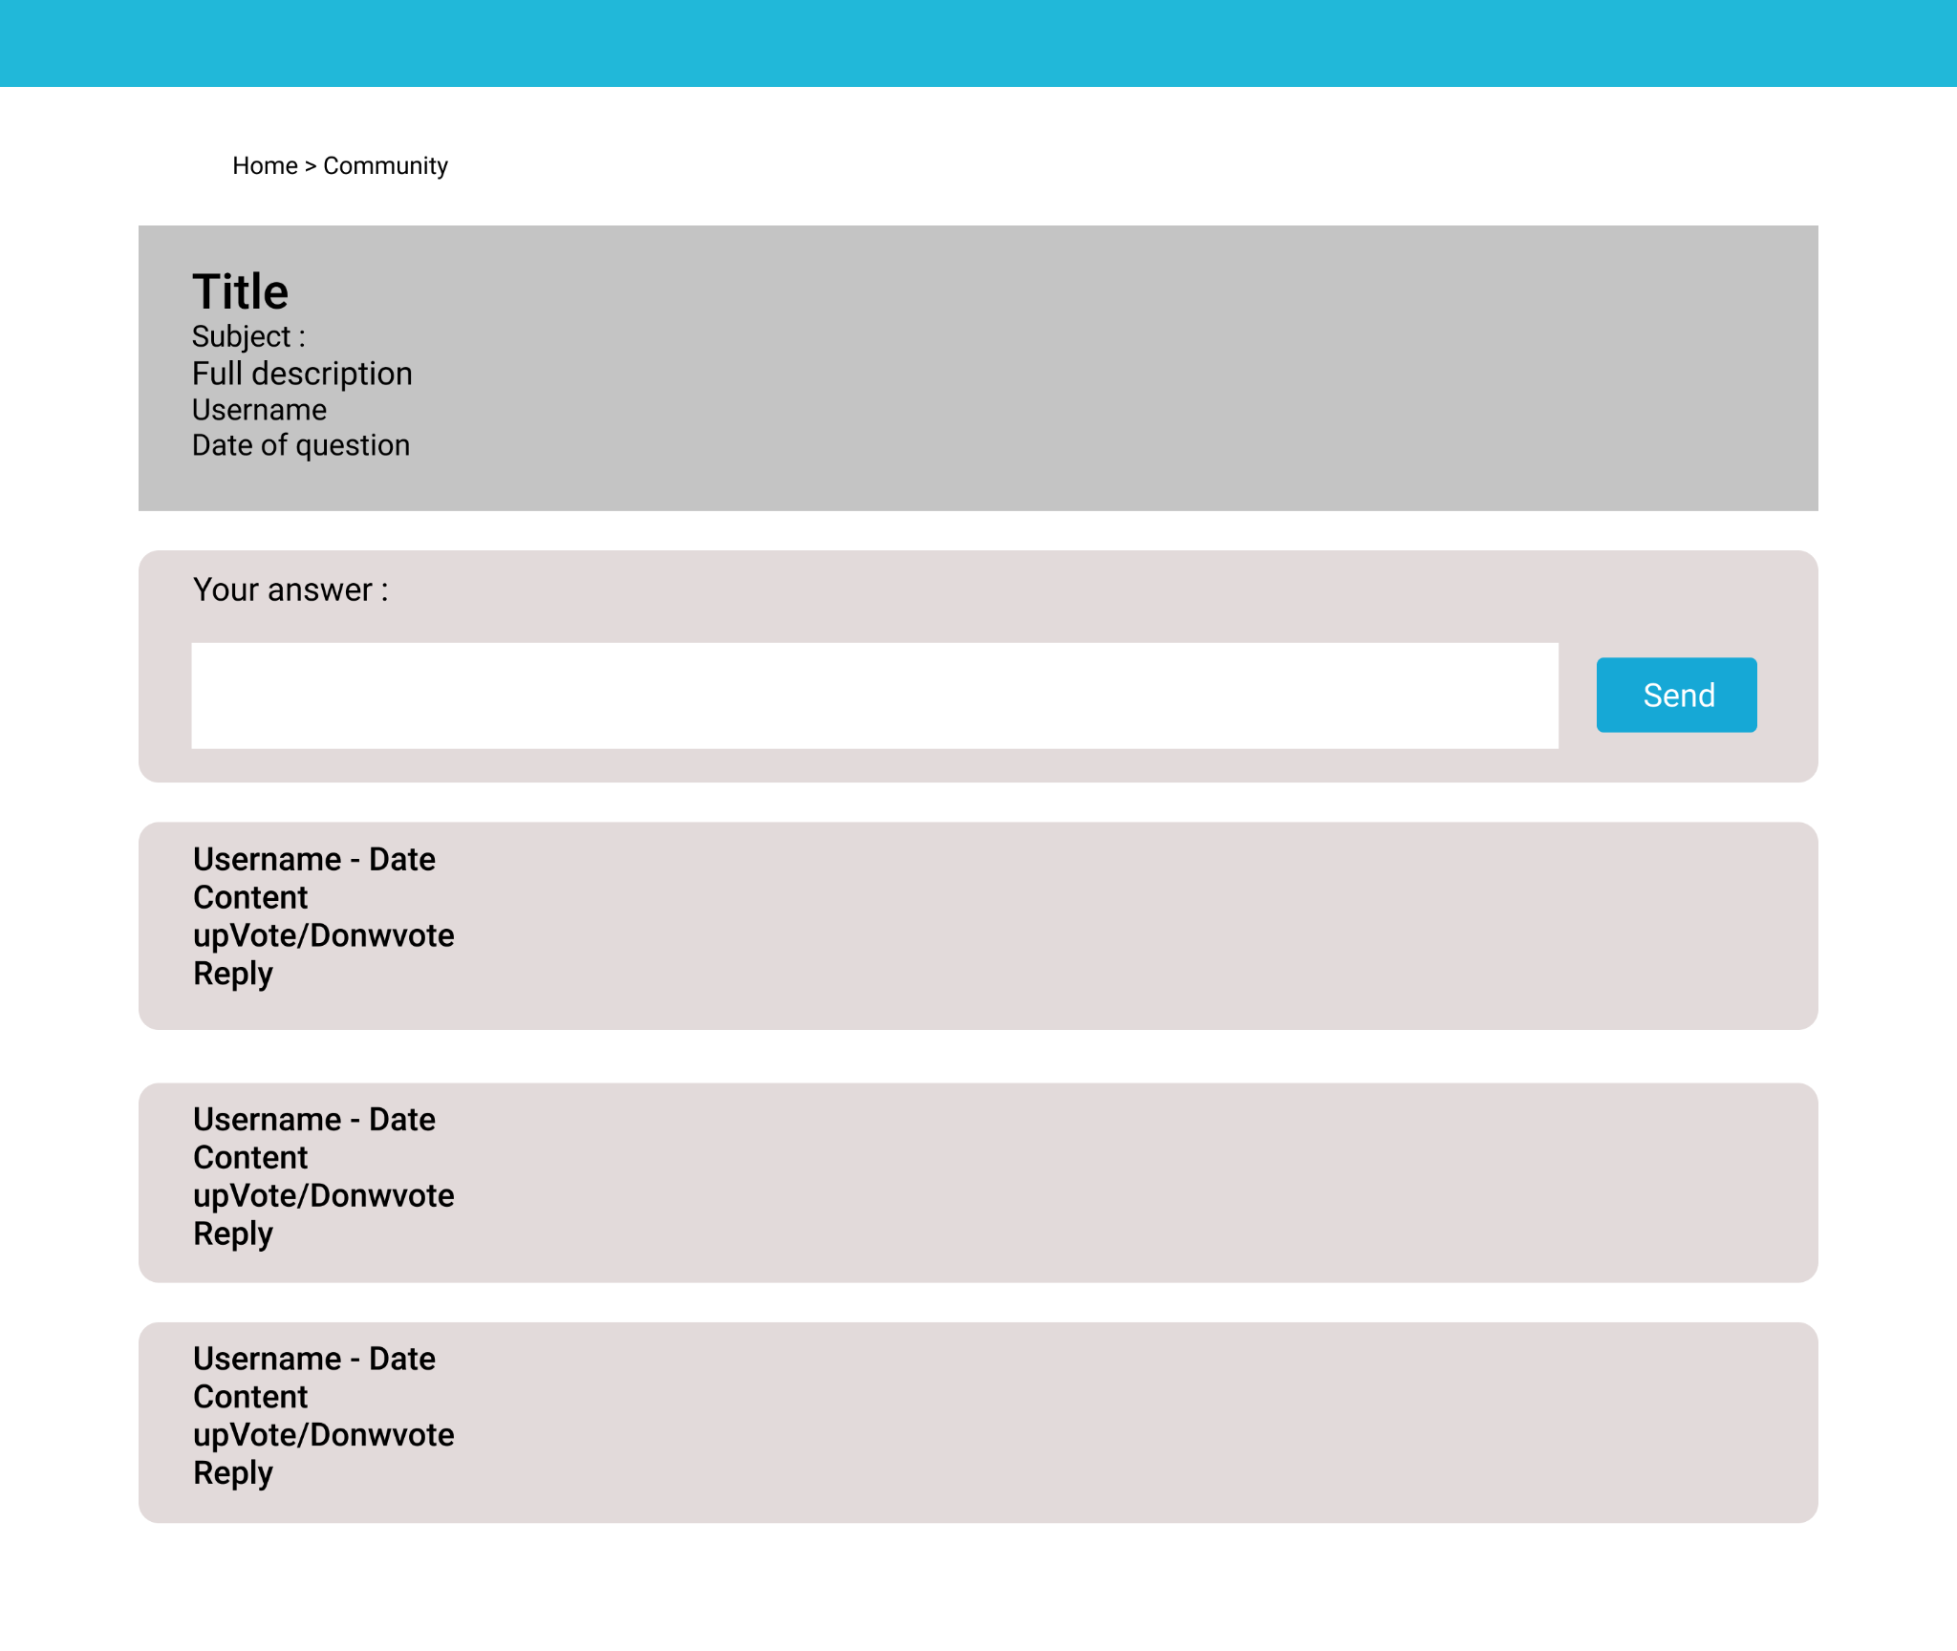

### b. Edit answer

* Function trigger: Users shall click edit button and edit answer then click save button.
* Function description:
  + Actor: student, tutor, admin, SuperAdmin.
  + Let Users edit the answer ( Only their answer )
* Function detail:
  + System shall allow users to edit answers.
  + Answer length should be less than 2500 characters
  + Answer is written in markdown format

### c. Delete answer

* Function trigger: Users shall click delete button.
* Function description:
  + Actor: student, tutor, admin, SuperAdmin.
  + Let Users delete the answer. ( Only their answer but SuperAdmin can delete all answer )
* Function detail:
  + System shall allow users to delete answers.