

**ONLINE TUTOR**

**Software Design Document**

– Ho Chi Minh, November 2021 –

**Table of Contents**

I. Overview **1**0

1. Code Packages/Namespaces 10

a. Package diagram 10

b. Package descriptions 10

2. Database Schema 12

a. Entities relationship diagram 12

b. Table Description 12

II. Code Designs **13**

1. Authenticate account 13

1.1. Register new account 13

a. Class Diagram 13

b. Class Specifications 13

c. Sequence Diagram(s) 14

d. Database queries 14

1.2. Login 14

a. Class Diagram 15

b. Class Specifications 15

c. Sequence Diagram(s) 16

d. Database queries 17

1.3. Log out 17

a. Class Diagram 17

b. Class Specifications 17

c. Sequence Diagram(s) 18

d. Database queries 18

2. User Management 19

2.1. Change user’s role 19

a. Class Diagram 19

b. Class Specifications 19

c. Sequence Diagram(s) 20

d. Database queries 20

2.2. Delete user 21

a. Class Diagram 21

b. Class Specifications 21

c. Sequence Diagram(s) 22

d. Database queries 22

2.3. View user 23

a. Class Diagram 23

b. Class Specifications 23

c. Sequence Diagram(s) 23

d. Database queries 24

2.4. Search tutor 25

a. Class Diagram 25

b. Class Specifications 25

c. Sequence Diagram(s) 26

d. Database queries 26

3. Course Management 27

3.1. View course 27

3.1.1 View all course (admin) 27

a. Class Diagram 27

b. Class Specifications 27

c. Sequence Diagram(s) 28

d. Database queries 28

3.1.2 View details one course (admin) 29

a. Class Diagram 29

b. Class Specifications 29

c. Sequence Diagram(s) 30

d. Database queries 30

3.1.3 View all course (public) 31

a. Class Diagram 31

b. Class Specifications 31

c. Sequence Diagram(s) 32

d. Database queries 32

3.1.2 View details one course (public) 33

a. Class Diagram 33

b. Class Specifications 33

c. Sequence Diagram(s) 34

d. Database queries 34

3.2. Create course 35

a. Class Diagram 35

b. Class Specifications 35

c. Sequence Diagram(s) 36

d. Database Queries 36

3.3. Update course 37

a. Class Diagram 37

b. Class Specifications 37

c. Sequence Diagram(s) 37

d. Database queries 38

3.4. Delete course 39

a. Class Diagram 39

b. Class Specifications 39

c. Sequence Diagram(s) 39

d. Database queries 40

3.6 Toggle course 41

a. Class Diagram 41

b. Class Specifications 41

c. Sequence Diagram(s) 41

d. Database queries 42

4. Course Material Management 43

4.1. Create course material 43

a. Class Diagram 43

b. Class Specifications 43

c. Sequence Diagram(s) 44

d. Database queries 44

4.2. View course material 45

a. Class Diagram 45

b. Class Specifications 45

c. Sequence Diagram(s) 46

d. Database queries 46

4.3. Update course material 47

a. Class Diagram 47

b. Class Specifications 47

c. Sequence Diagram(s) 48

d. Database queries 48

4.4. Delete course material 49

a. Class Diagram 49

b. Class Specifications 50

c. Sequence Diagram(s) 50

d. Database Queries 51

5. Course Timetable Management 52

5.1. Create timetable 52

a. Class Diagram 52

b. Class Specifications 53

c. Sequence Diagram(s) 53

d. Database queries 53

5.2. View course timetable 54

a. Class Diagram 54

b. Class Specifications 54

c. Sequence Diagram(s) 55

d. Database queries 55

5.3. Update course timetable 56

a. Class Diagram 56

b. Class Specifications 57

c. Sequence Diagram(s) 57

d. Database Queries 58

5.4. Delete course timetable 59

a. Class Diagram 59

b. Class Specifications 60

c. Sequence Diagram(s) 60

d. Database Queries 61

6. Course Registration 62

6.1.  Register course 62

a. Class Diagram 62

b. Class Specifications 62

c. Sequence Diagram(s) 63

d. Database queries 63

6.2.  Approve course registration 64

a. Class Diagram 64

b. Class Specifications 64

c. Sequence Diagram(s) 65

d. Database queries 65

7. Rate Management 65

7.1.  Add tutor rating 66

a. Class Diagram 66

b. Class Specifications 66

c. Sequence Diagram(s) 67

d. Database queries 67

7.2.  Update tutor rating 68

a. Class Diagram 68

b. Class Specifications 68

c. Sequence Diagram(s) 69

d. Database queries 69

7.3.  Delete tutor rating 70

a. Class Diagram 70

b. Class Specifications 70

c. Sequence Diagram(s) 70

d. Database queries 71

7.4.  View tutor rating 72

a. Class Diagram 72

b. Class Specifications 72

c. Sequence Diagram(s) 73

d. Database queries 73

8.  Profile management 74

8.1.  View profile 74

a. Class Diagram 74

b. Class Specifications 74

c. Sequence Diagram(s) 74

d. Database queries 75

8.2.  Edit profile 76

a. Class Diagram 76

b. Class Specifications 76

c. Sequence Diagram(s) 76

d. Database queries 77

8.3.  Update password 78

a. Class Diagram 78

b. Class Specifications 78

c. Sequence Diagram(s) 78

d. Database queries 79

9. Community 80

9.1. Question management 80

9.1.1.  Add question 80

a. Class Diagram 80

b. Class Specifications 80

c. Sequence Diagram(s) 81

d. Database queries 81

9.1.2.  View question 82

a. Class Diagram 82

b. Class Specifications 83

c. Sequence Diagram(s) 83

d. Database queries 84

9.1.3. Delete question 85

a. Class Diagram 85

b. Class Specifications 85

c. Sequence Diagram(s) 86

d. Database queries 86

9.2. Answer management 87

9.2.1. View answer 87

a. Class Diagram 87

b. Class Specifications 87

c. Sequence Diagram(s) 88

d. Database queries 88

9.2.2. Add answer 89

a. Class Diagram 89

b. Class Specifications 89

c. Sequence Diagram(s) 90

d. Database queries 90

9.2.3. Edit answer 91

a. Class Diagram 91

b. Class Specifications 91

d. Database queries 92

9.2.4. Delete answer 93

a. Class Diagram 93

b. Class Specifications 93

c. Sequence Diagram(s) 94

d. Database queries 94

III. Database Tables **95**

1. users_account 95

2. user_roles 95

3. roles 95

4. rate 96

5. subject 96

6. question 96

7. answer 96

8. course 97

9. course_student 97

10. course_material 97

11. course_timetable 98

# I. Overview

## 1. Code Packages/Namespaces

#### Package diagram

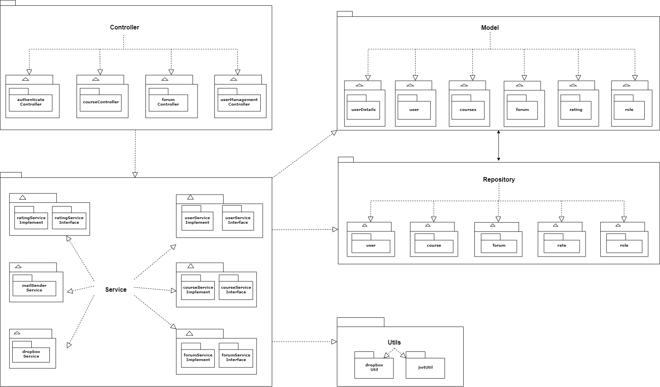

#### Package descriptions & package class naming conventions

| **No** | **Package** | **Description** |
| --- | --- | --- |
| *01* | *controller* | *Containing subpackages for to control each feature specify* |
| *02* | *service* | *Containing subpackages for to service each feature specify* |
| *03* | *model* | *Containing subpackage of each model* |
| *04* | *utils* | *Containing subpackage utils for service use* |
| *05* | *repository* | *Containing subpackage repository for model interact with database* |
| *06* | *authenticateController* | *Containing class for authenticate user such as register account, login, logout* |
| *07* | *courseController* | *Containing classes to control interact between user with the course* |
| *08* | *forumController* | *Containing classes to control interact between user with the forum* |
| *09* | *userController* | *Containing classes to control interact between user with other user or themself* |
| *10* | *userServiceInterface* | *Containing interface classes used to authenticate user and handle request from client* |
| *11* | *userServiceImplement* | *Containing classes implement functions in userServiceInterface* |
| *12* | *courseServiceInterface* | *Containing interface classes used to handle request from client* |
| *13* | *courseServiceImplement* | *Containing classes implement functions in courseServiceInterface* |
| *14* | *forumServiceInterface* | *Containing interface classes used to handle request from client* |
| *15* | *forumServiceImplement* | *Containing classes implement functions in forumServiceInterface* |
| *16* | *ratingServiceInterface* | *Containing interface classes used to handle request from client* |
| *17* | *mailSenderService* | *Containing classes used to handle request from service layer to send email* |
| *18* | *dropboxService* | *Containing classes used to handle request from service layer to interact with dropbox* |
| *19* | *user::model* | *Containing classes define attributes of user* |
| *20* | *course::model* | *Containing classes define attributes of course* |
| *21* | *role::model* | *Containing classes define role of each user* |
| *22* | *rate::model* | *Containing classes define attributes of rate* |
| *23* | *forum::model* | *Containing classes define attributes of forum* |
| *24* | *userDetails::model* | *Containing classes define attributes of user to authenticate* |
| *25* | *user::repository* | *Containing interfaces used to handle request between user and database* |
| *26* | *course::repository* | *Containing interfaces used to handle request between course and database* |
| *27* | *rate::repository* | *Containing interfaces used to handle request between rate and database* |
| *28* | *role::repository* | *Containing interfaces used to handle request between user role and database* |
| *29* | *dropboxUtil* | *Containing classes used to provide method for dropboxService to use when handle request from client* |
| *30* | *jwtUtil* | *Containing classes used to provide jwt information when user log in to the application* |

## 2. Database Schema

#### a. Entities relationship diagram

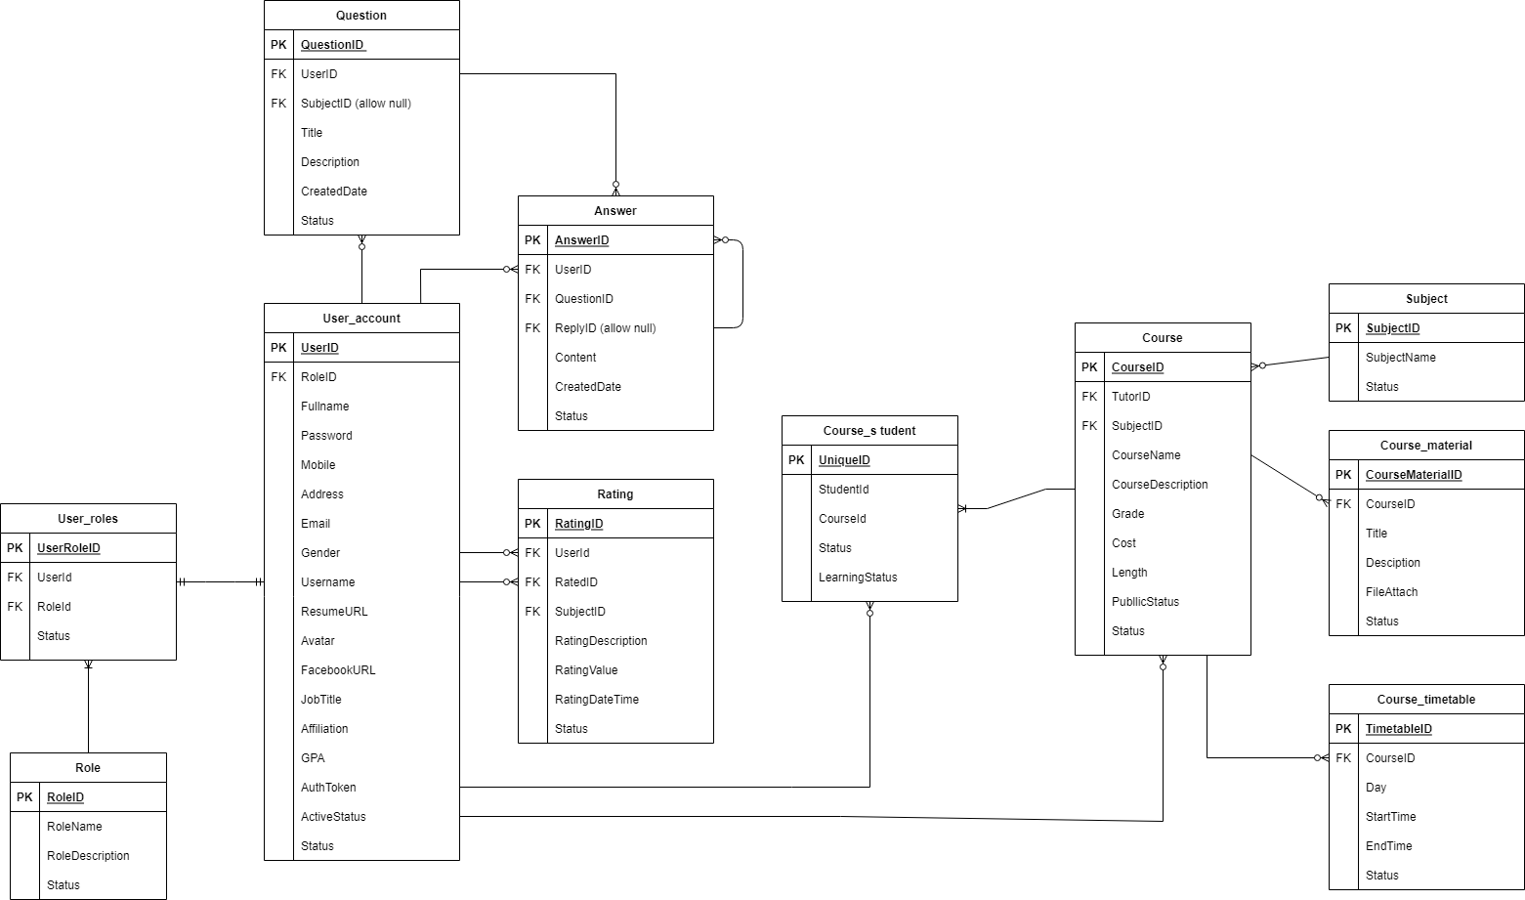

#### b. Table Description

| **No** | **Table** | **Description** |
| --- | --- | --- |
| 01 | Roles | Contains the roles that users in the system are able to have  - Primary keys: RoleID |
| 02 | User_account | Contains basic information of users  - Primary keys: UserID |
| 03 | User_roles | Map role is the roles table to each user in the User_account table  - Primary keys: RoleID  - Foreign keys: UserID, RoleID |
| 04 | Question | Contains basic ìnormation of a question posted by student in forum feature  - Primary keys: QuestionID  - Foreign keys: UserID, SubjectID |
| 05 | Answer | Contains detail of a answer to a question  - Primary keys: AnswerID  - Foreign keys: QuestionID, UserID, ReplyID |
| 06 | Rating | Rating detail of a user to another user  - Primary keys: RateID  - Foreign keys: StudentID, TutorID, SubjectID |
| 07 | Course | Contains basic information of a course  - Primary keys: CourseID  - Foreign keys: SubjectID, TutorID |
| 08 | Subject | Subject that each courses or questions can be related  - Primary keys: SubjectID |
| 09 | Course_student | Listing registered students of a course  - Primary keys: CourseStudentID  - Foreign keys: StudentId, CourseID |
| 10 | Course_material | Contains materials of a course  - Primary keys: CourseMaterialD  - Foreign keys: CourseID |
| 11 | Course_timetable | Contains timetable of a course  - Primary keys: CourseTimetableID  - Foreign keys: CourseID |

# II. Code Designs

## 1. Authentication

### 1.1. Register new account

#### a. Class Diagram

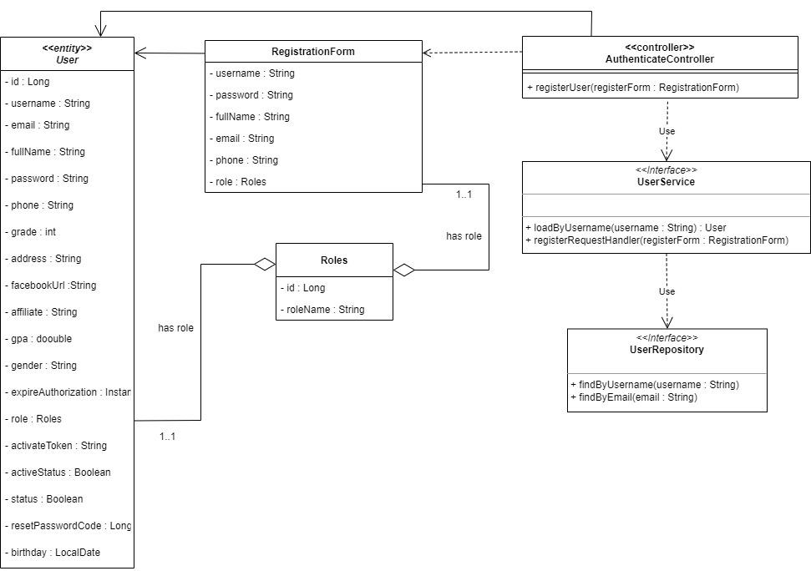

#### b. Class Specifications

##### User Class

* Model of User.

##### Roles Class

* Model of roles.

##### RegistrationForm Class

* Controller will get a Request with this format.

##### UserRepository Class

| **No** | **Method** | **Description** |
| --- | --- | --- |
| *01* | *findByUsername* | *- This method finds and gets a User by existing name.* |
| *02* | *findByEmail* | *- This method finds and gets a User by existing email.* |

##### AuthenticateController Class

| **No** | **Method** | **Description** |
| --- | --- | --- |
| *01* | *RegisterUser* | *- This method will call API Register by using a service from UserService.* |

##### 

##### UserService Class

| **No** | **Method** | **Description** |
| --- | --- | --- |
| *01* | *LoadByUserName* | *- This method will find and get all users By userName.* |
| *02* | *registerRequestHandler* | *- This method will perform Registerfunction.* |

#### c. Sequence Diagram(s)

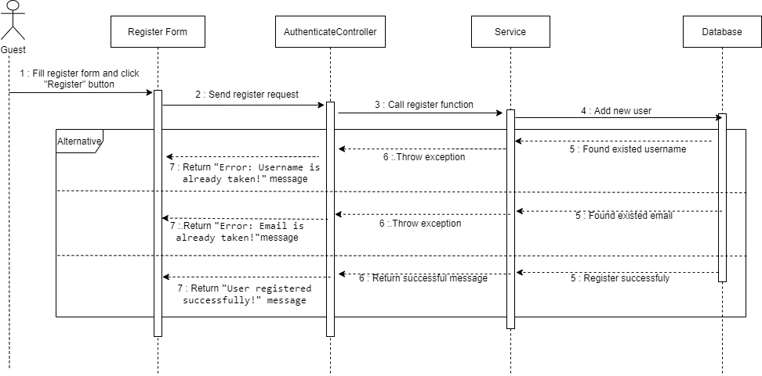

#### d. Database queries

### 1.2. Login

#### a. Class Diagram

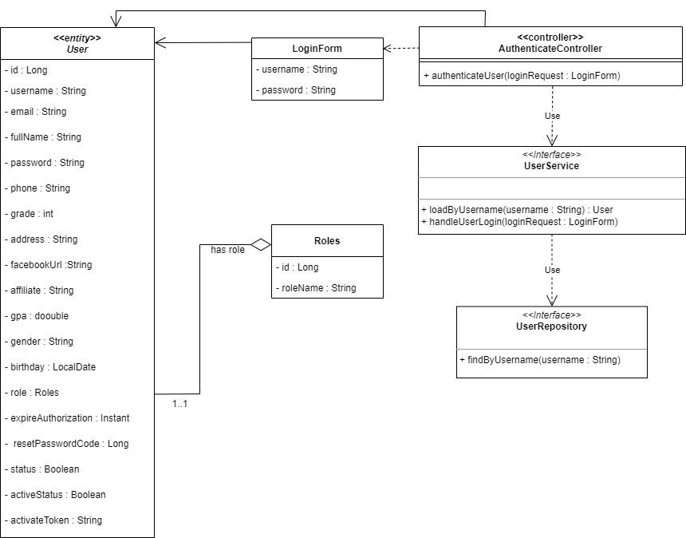

#### b. Class Specifications

##### User Class

* Model of User.

##### Roles Class

* Model of roles.

##### LoginForm Class

* Controller will get a Request with this format.

##### UserRepository Class

| **No** | **Method** | **Description** |
| --- | --- | --- |
| *01* | *findByUsername* | *- This method find and get User by existing name.* |

##### 

##### 

##### 

##### AuthenticateController Class

| **No** | **Method** | **Description** |
| --- | --- | --- |
| *01* | *authenticate* | *- This method will call API Login by using service from UserService.* |

##### UserService Class

| **No** | **Method** | **Description** |
| --- | --- | --- |
| *01* | *LoadByUserName* | *- This method will find and get all user By UserName.* |
| *02* | *handleUserLogin* | *- This method will perform Login function.* |

#### c. Sequence Diagram(s)

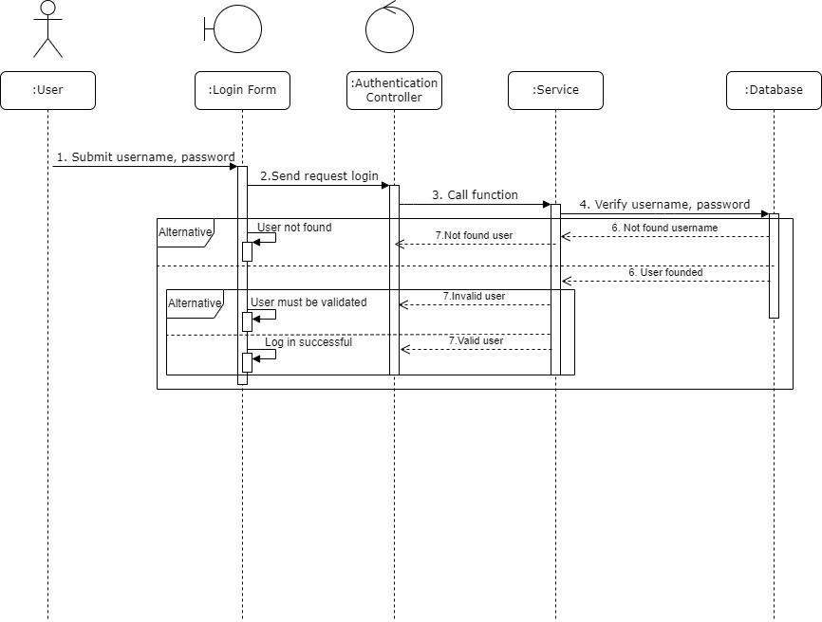

#### d. Database queries

### 1.3. Log out

#### a. Class Diagram

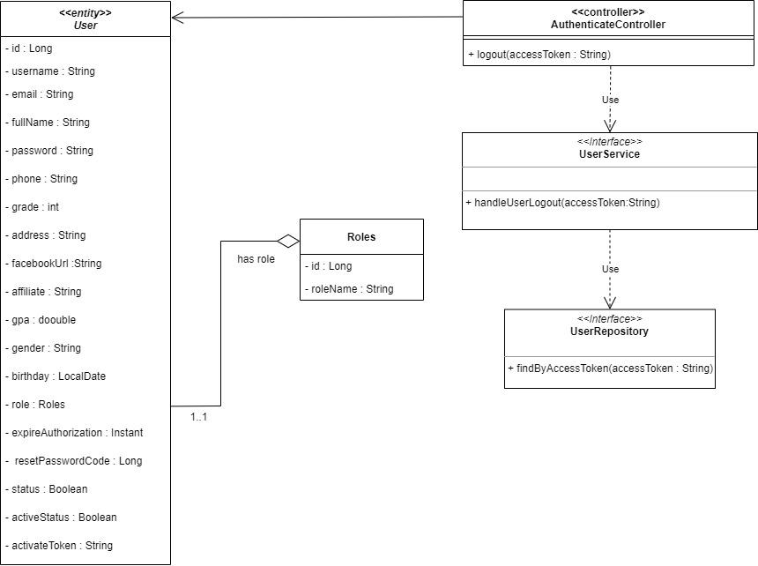

#### b. Class Specifications

##### User Class

* Model of User.

##### Roles Class

* Model of roles.

##### UserRepository Class

| **No** | **Method** | **Description** |
| --- | --- | --- |
| *01* | *findByAccessToken* | *- This method finds and gets User by their Access Token.* |

##### AuthenticateController Class

| **No** | **Method** | **Description** |
| --- | --- | --- |
| *01* | *logout* | *- This method will call API Logout by using a service from UserService.* |

##### UserService Class

| **No** | **Method** | **Description** |
| --- | --- | --- |
| *01* | *handleUserLogout* | *- This method will perform Logout function.* |

#### c. Sequence Diagram(s)

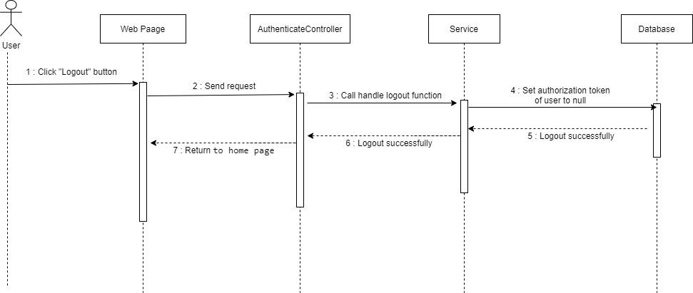

#### d. Database queries

## 2. User Management

### 2.1. Change user’s role

#### a. Class Diagram

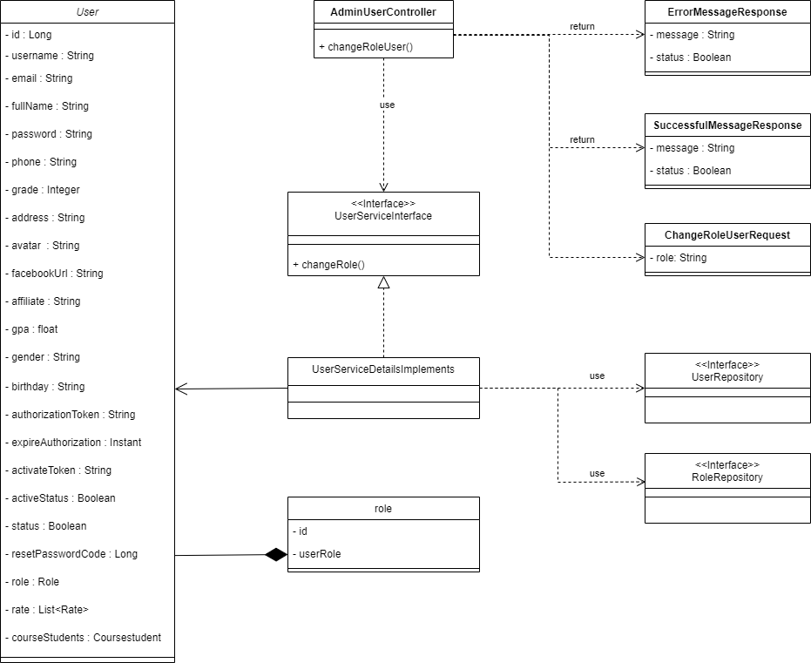

#### b. Class Specifications

##### User Class

* Model of user class

##### Role Class

* Model of role class

##### ErrorMessageResponse Class

* Controller API will return this format if error occur

##### SuccessfulMessageResponse Class

* Controller API will return this format if action successful

##### ChangeRoleUserRequest Class

* Controller API will receive this request to perform action

##### AdminUserController Class

| **No** | **Method** | **Description** |
| --- | --- | --- |
| *01* | *changeRoleUser* | *This method will call service to handle change role request* |

##### UserServiceInterface Interface

| **No** | **Method** | **Description** |
| --- | --- | --- |
| *01* | changeRole | *This method are using to perform change role of user* |

##### UserServiceDetailsImplements Class

* This class will implement the UserServiceInterface Interface

##### UserRepository Interface

* This interface are used to query data on User Table

##### RoleRepository Interface

* This interface are used to query data on Role Table

#### c. Sequence Diagram(s)

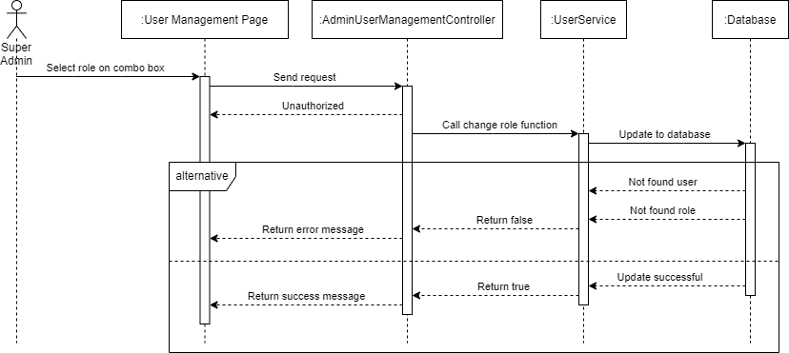

#### d. Database queries

### 2.2. Delete user

#### a. Class Diagram

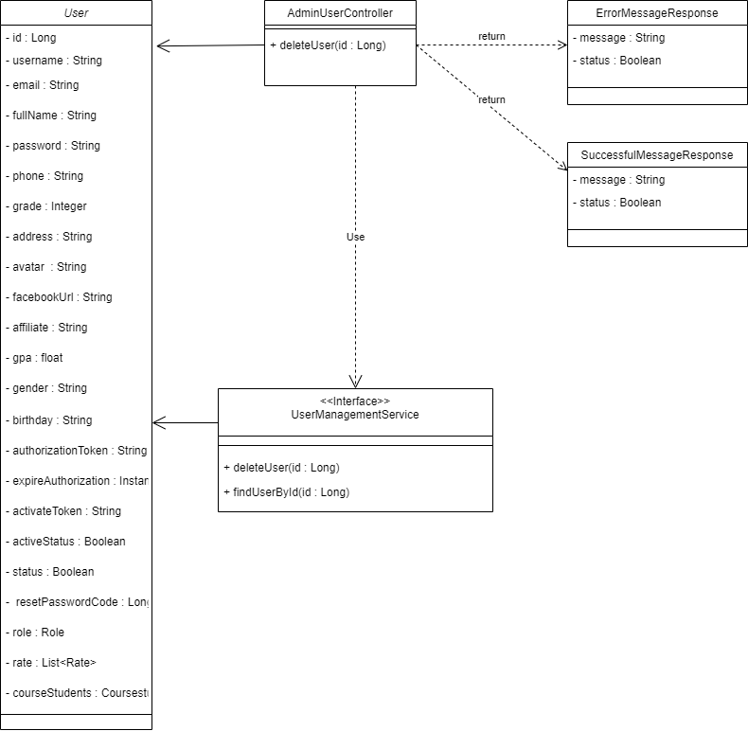

#### b. Class Specifications

##### User Class

* model of User.

##### ErrorMessageResponse Class

* Controller API will return with this format response.

##### SuccessfulMessageResponse Class

* Controller API will return with this format response.

##### AdminUserController Class

| **No** | **Method** | **Description** |
| --- | --- | --- |
| 01 | deleteUser | - This method will call the API of DeleteUser. |

### 

##### UserManagement Class

| **No** | **Method** | **Description** |
| --- | --- | --- |
| 01 | deleteUser | - This method allows a user with the SuperAdmin role to delete a user by finding the User ID and setting the user’s status to False ( Deleted ).  - SuperAdmin can not delete other SuperAdmin. |
| 02 | findUserById | - This method allows you to find a user by user ID. |

#### c. Sequence Diagram(s)

#### d. Database queries

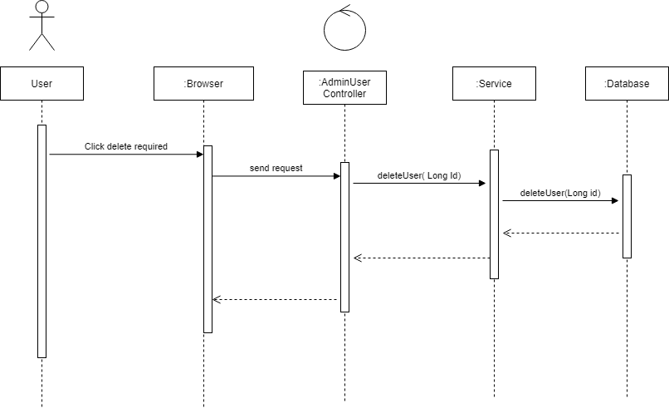

### 2.3. View user

#### a. Class Diagram

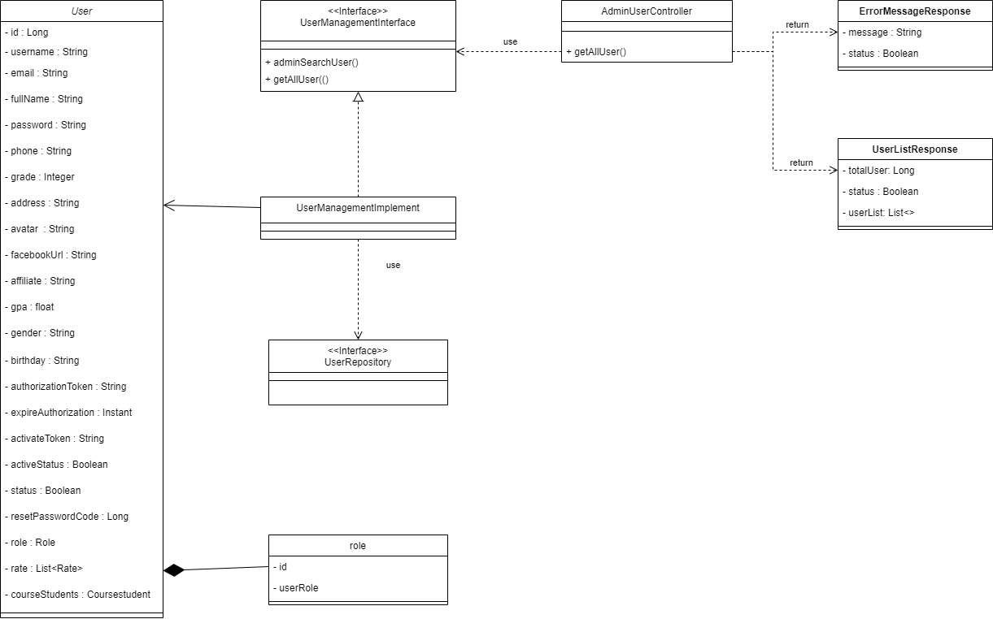

#### b. Class Specifications

##### Role Class

* Model of role

##### User Class

* Model of user

##### ErrorMessageResponse

* Controller API will return this format if error occur

##### UserListResponse

* Controller API will use return User Information list with this format

##### AdminUserController Class

| **No** | **Method** | **Description** |
| --- | --- | --- |
| *01* | *getAllUser* | *This method call service to handle get user list* |

##### 

***UserManagementInterface Interface***

| **No** | **Method** | **Description** |
| --- | --- | --- |
| *01* | *getAllUser* | *This method returns all users with pagination* |
| *02* | *adminSearchUser* | *This method returns searched users with pagination.* |

#### c. Sequence Diagram(s)

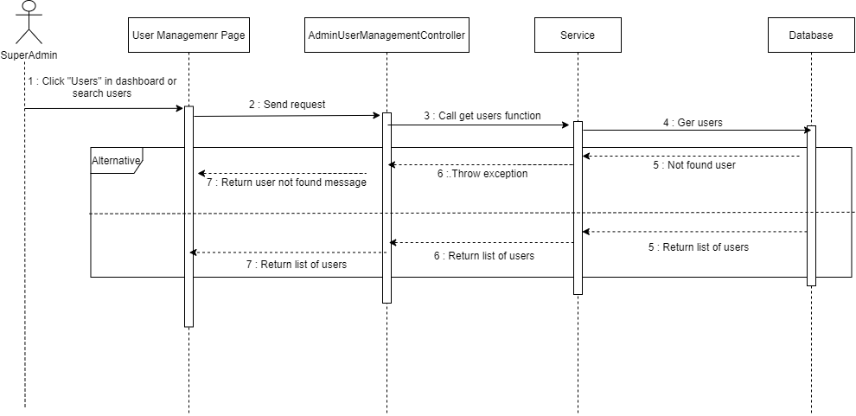

#### d. Database queries

### 2.4. Search tutor

#### a. Class Diagram

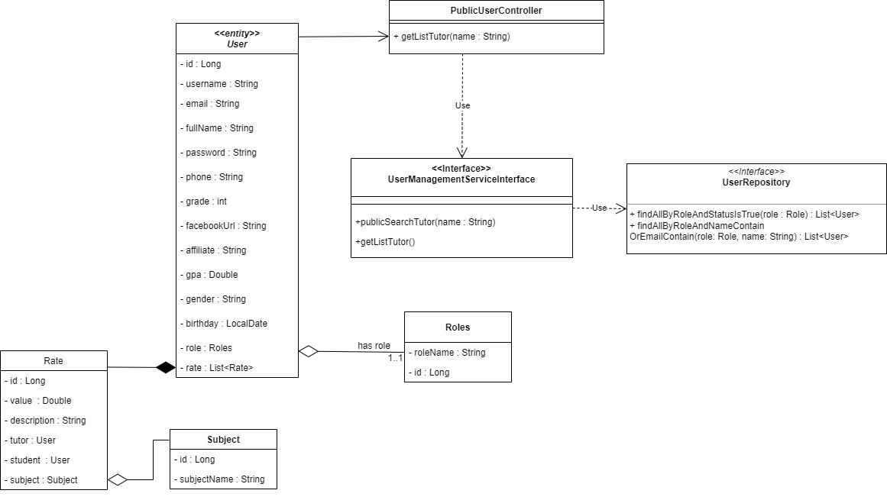

#### b. Class Specifications

##### User Class

* Model of user.

##### Rate Class

* Model of rate.

##### Roles Class

* Model of roles.

##### Subject Class

* Model of subject.

##### PublicUserManagementController Class

| **No** | **Method** | **Description** |
| --- | --- | --- |
| *01* | *getListTutor* | *Call the API of publicSearchTutor* |

#### 

##### UserService Class

| **No** | **Method** | **Description** |
| --- | --- | --- |
| *01* | *publicSearchTutor* | *This method returns a list of tutors with their names.* |
| *02* | *findByUserRole* | *Find the user by role.* |
| *03* | *findAllByStatusIsTrueAndRolesAndEmailContainsOrRolesAndFullNameContainingOrderByIdDesc* | *Finds the tutors with corresponding letters in their names.* |

#### c. Sequence Diagram(s)

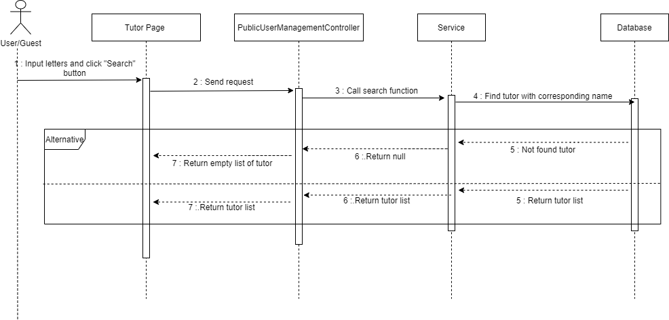

#### d. Database queries

## 3. Course Management

### 3.1. View course

### 3.1.1 View all course (admin)

#### a. Class Diagram

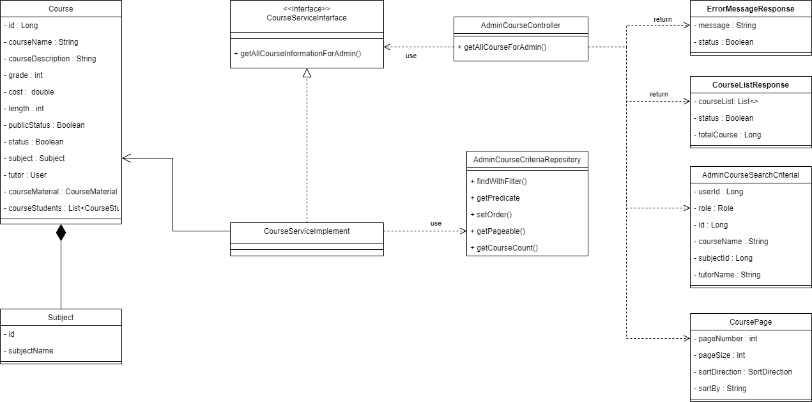

#### b. Class Specifications

##### Course Class

* Model of course

##### Subject Class

* Model of subject

##### ErrorMessageResponse Class

* Controller API will return this format if error occur

##### CourseListResponse Class

* Controller API will return this Course Information list format if action perform successful

##### CoursePage class

* Controller API will use this class to perform pagination

##### AdminCourseSearchCriteria

* This class contains search/filter option for Controller API to perform view course

##### AdminCourseController Class

| **No** | **Method** | **Description** |
| --- | --- | --- |
| *01* | *getAllCourseForAdmin* | *This method will call service to handle view course request* |

##### CourseServiceInterface Interface

| **No** | **Method** | **Description** |
| --- | --- | --- |
| *01* | getAllCourseInformationForAdmin | *This method are using to perform view course* |

##### CourseServiceDetailsImplements Class

* This class will implement the CourseServiceInterface Interface

##### AdminCourseCriteriaRepository Interface

##### 

| **No** | **Method** | **Description** |
| --- | --- | --- |
| *01* | findWithFilter() | *This method are using to perform get course list with filter* |
| *02* | getPredicate() | *This method are using to add predicate for each exist search option* |
| *03* | setOrder() | *This method are using to set course list order* |
| *04* | getPageable() | *This method are using for pagination* |
| *05* | getCourseCount() | *This method are using for counting total course* |

#### c. Sequence Diagram(s)

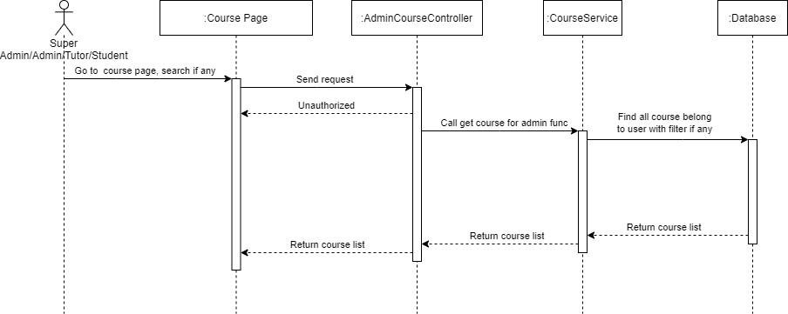

#### d. Database queries

#### 

### 3.1.2 View details one course (admin)

#### a. Class Diagram

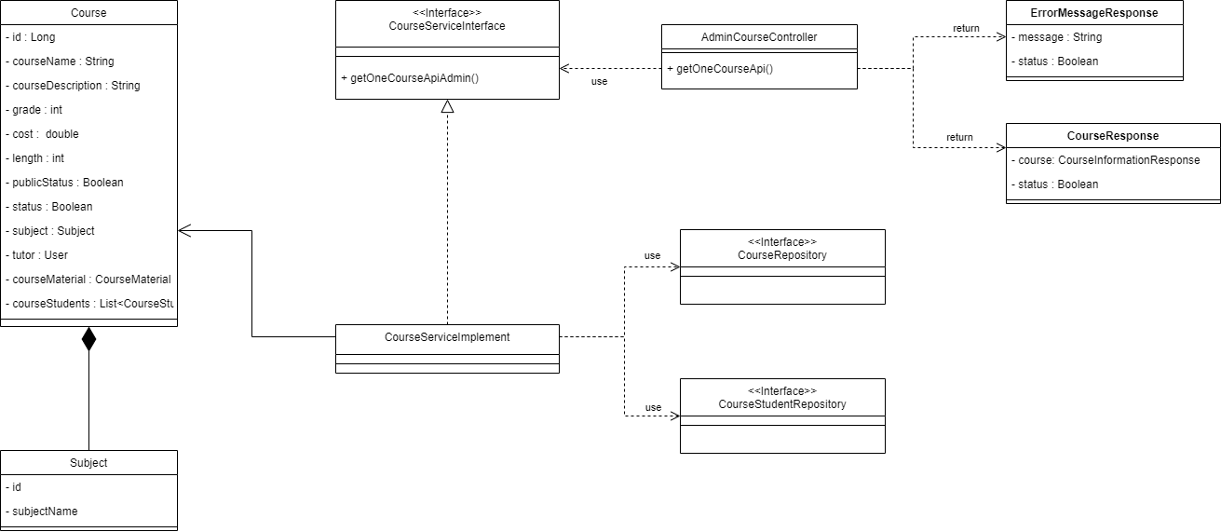

#### b. Class Specifications

##### Course Class

* Model of course

##### Subject Class

* Model of subject

##### ErrorMessageResponse Class

* Controller API will return this format if error occur

##### CourseResponse Class

* Controller API will return this Course Information format if action perform successful

##### AdminCourseController Class

| **No** | **Method** | **Description** |
| --- | --- | --- |
| *01* | *getOneCourseApi* | *This method will call service to handle view one course request* |

##### CourseServiceInterface Interface

| **No** | **Method** | **Description** |
| --- | --- | --- |
| *01* | *getOneCourseApi* | *This method are using to perform view one course* |

##### CourseServiceDetailsImplements Class

* This class will implement the CourseServiceInterface Interface

##### CourseRepository Interface

* This interface are used to query data on Course Table

##### CourseStudentRepository Interface

* This interface are used to query data on CourseStudent Table

#### c. Sequence Diagram(s)

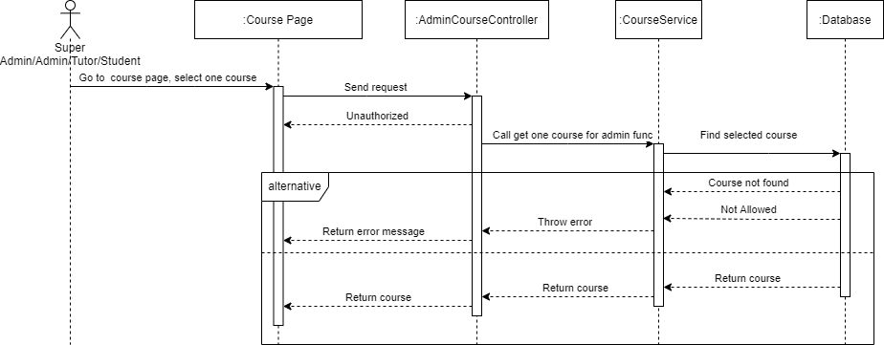

#### d. Database queries

### 3.1.3 View all course (public)

#### a. Class Diagram

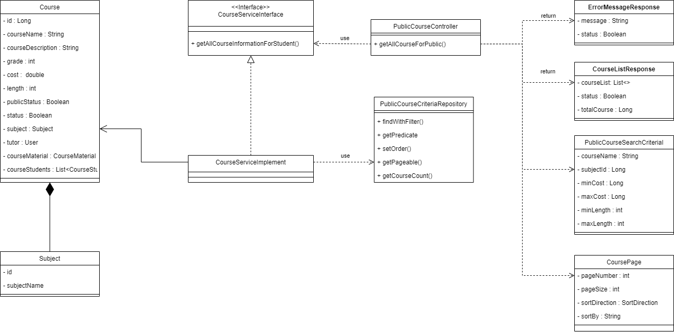

#### b. Class Specifications

##### Course Class

* Model of course

##### Subject Class

* Model of subject

##### ErrorMessageResponse Class

* Controller API will return this format if error occur

##### CourseListResponse Class

* Controller API will return this Course Information list format if action perform successful

##### CoursePage class

* Controller API will use this class to perform pagination

##### PublicCourseSearchCriteria

* This class contains search/filter option for Controller API to perform view course

##### PublicCourseController Class

| **No** | **Method** | **Description** |
| --- | --- | --- |
| *01* | *getAllCourseForPublic* | *This method will call service to handle view course request* |

##### CourseServiceInterface Interface

| **No** | **Method** | **Description** |
| --- | --- | --- |
| *01* | getAllCourseInformationForPublic | *This method are using to perform view course* |

##### CourseServiceDetailsImplements Class

* This class will implement the CourseServiceInterface Interface

##### PublicCourseCriteriaRepository Class

##### 

| **No** | **Method** | **Description** |
| --- | --- | --- |
| *01* | findWithFilter() | *This method are using to perform get course list with filter* |
| *02* | getPredicate() | *This method are using to add predicate for each exist search option* |
| *03* | setOrder() | *This method are using to set course list order* |
| *04* | getPageable() | *This method are using for pagination* |
| *05* | getCourseCount() | *This method are using for counting total course* |

#### c. Sequence Diagram(s)

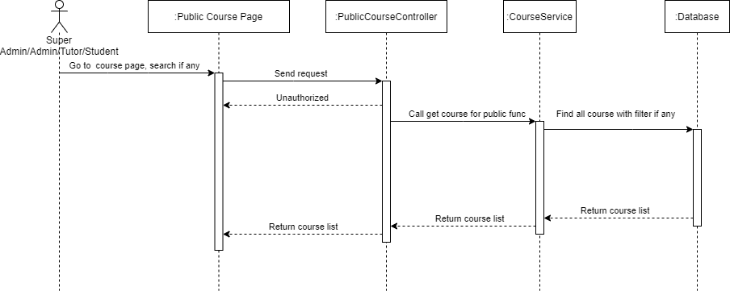

#### d. Database queries

### 3.1.2 View details one course (public)

#### a. Class Diagram

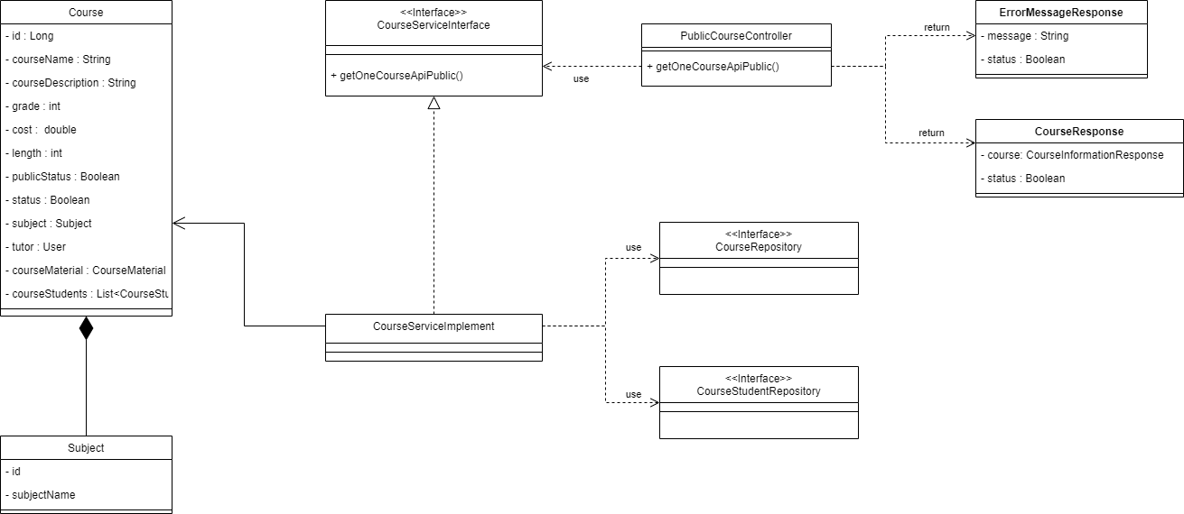

#### b. Class Specifications

##### Course Class

* Model of course

##### Subject Class

* Model of subject

##### ErrorMessageResponse Class

* Controller API will return this format if error occur

##### CourseResponse Class

* Controller API will return this Course Information format if action perform successful

##### PublicCourseController Class

| **No** | **Method** | **Description** |
| --- | --- | --- |
| *01* | *getOneCourseApiPublic* | *This method will call service to handle view one course request* |

##### CourseServiceInterface Interface

| **No** | **Method** | **Description** |
| --- | --- | --- |
| *01* | *getOneCourseApiPublic* | *This method are using to perform view one course* |

##### CourseServiceDetailsImplements Class

* This class will implement the CourseServiceInterface Interface

##### CourseRepository Interface

* This interface are used to query data on Course Table

##### CourseStudentRepository Interface

* This interface are used to query data on CourseStudent Table

#### c. Sequence Diagram(s)

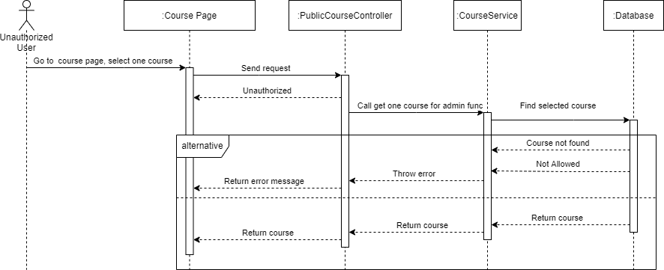

#### d. Database queries

### 3.2. Create course

#### a. Class Diagram

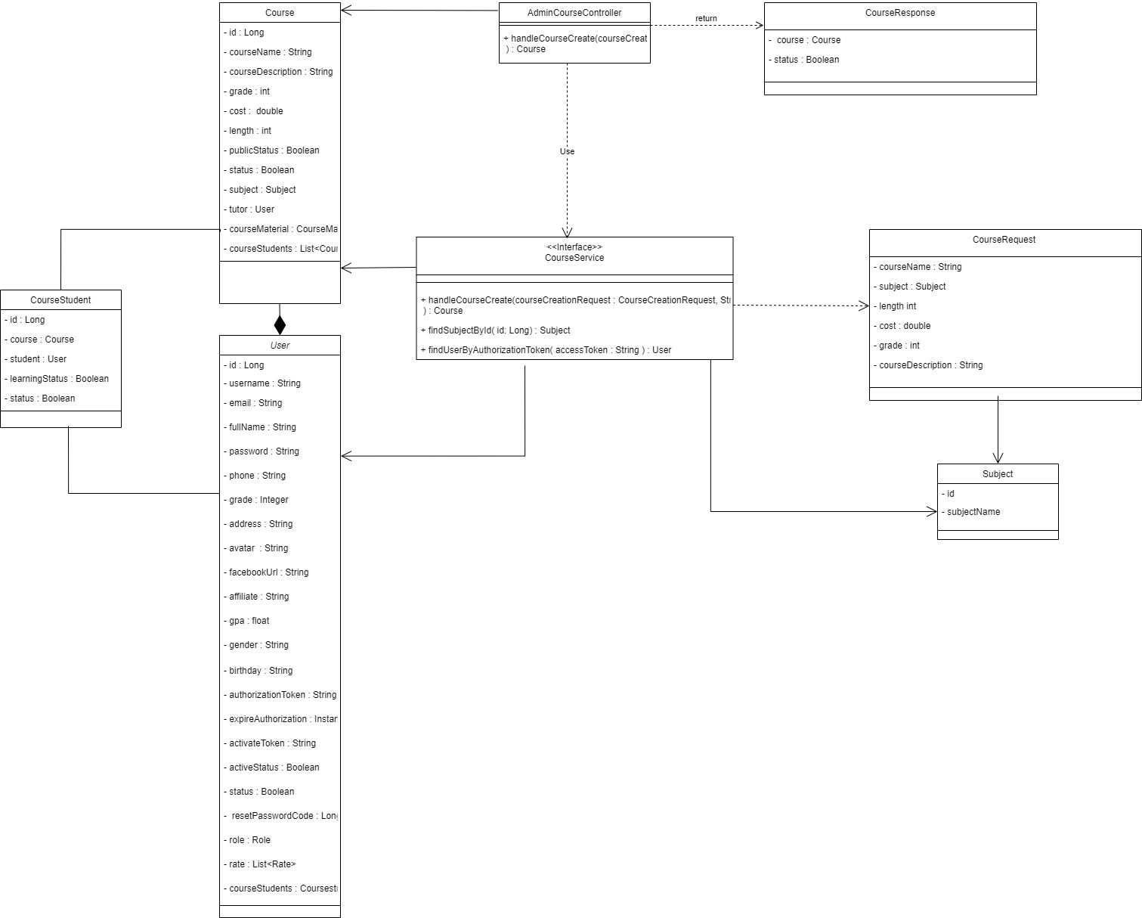

#### b. Class Specifications

##### CourseStudent Class

* Model of specific student of one course.

##### User Class

* Model of User.

##### Course Class

* Model of Course .

##### CourseResponse Class

* Controller will return with this format response.

##### CourseCreateRequest Class

* Controller will receive a Request with this format.

##### Subject Class

* Model of Subject.

##### AdminCourseController Class

| **No** | **Method** | **Description** |
| --- | --- | --- |
| 01 | handleCourseCreate | - This method will call the API of handleCourseCreate . |

#### 

##### CourseService Class

| **No** | **Method** | **Description** |
| --- | --- | --- |
| 01 | handleCourseCreate | - This method allows users with roles Tutor, Admin, SuperAdmin to create courses through CourseCreateRequest and return objects. |
| 02 | findSubjectById | - Finding a Subject by Id. |
| 03 | findUserByAuthorizationToken | - Find a User by Authorization Token. |

#### c. Sequence Diagram(s)

#### 

#### d. Database Queries

### 3.3. Update course

#### a. Class Diagram

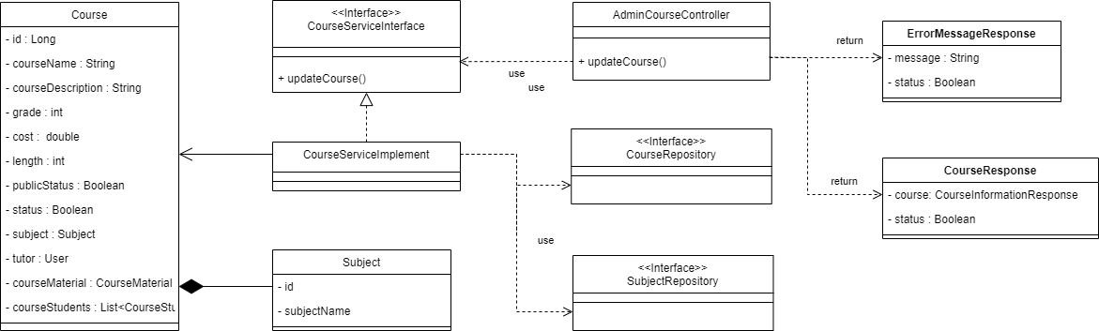

#### b. Class Specifications

##### Course Class

* Model of course

##### Subject Class

* Model of subject

##### ErrorMessageResponse Class

* Controller API will return this format if error occur

##### CourseResponse Class

* Controller API will return this Course Information format if update successful

##### AdminCourseController Class

| **No** | **Method** | **Description** |
| --- | --- | --- |
| *01* | *updateCourse* | *This method will call service to handle update course request* |

##### CourseServiceInterface Interface

| **No** | **Method** | **Description** |
| --- | --- | --- |
| *01* | changeRole | *This method are using to perform update course* |

##### CourseServiceDetailsImplements Class

* This class will implement the CourseServiceInterface Interface

##### SubjectRepository Interface

* This interface are used to query data on Subject Table

##### CourseRepository Interface

* This interface are used to query data on Course Table

#### c. Sequence Diagram(s)

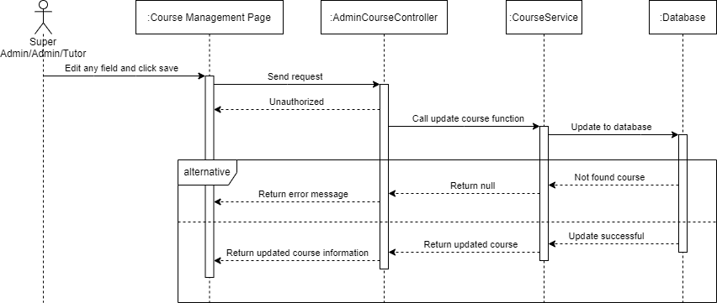

#### d. Database queries

### 3.4. Delete course

#### a. Class Diagram

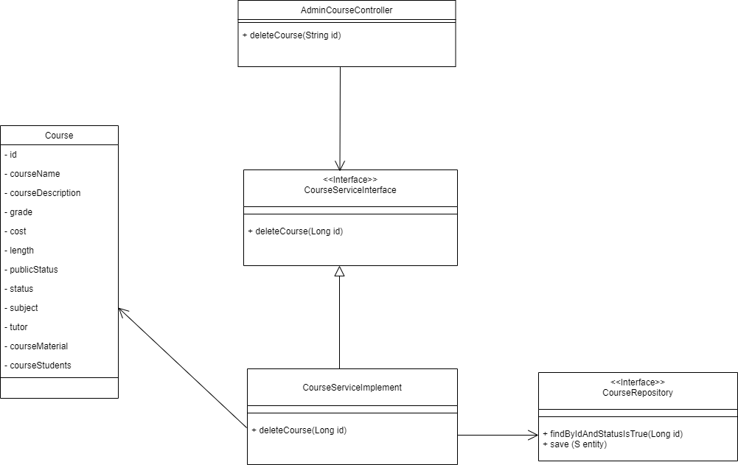

#### b. Class Specifications

#### 

##### AdminCourseController Class

| **No** | **Method** | **Description** |
| --- | --- | --- |
| *01* | *deleteCourse* | *Call the API of deleteCourse* |

##### CourseService Class

| **No** | **Method** | **Description** |
| --- | --- | --- |
| *01* | *findByIdAndStatusIsTrue* | *Find a course with id and status is true.* |
| *02* | *SetStatus* | *Change the status of a course to false (soft delete).* |
| *03* | *setPublicStatus* | *Change the public status of a course to false (soft delete).* |

#### c. Sequence Diagram(s)

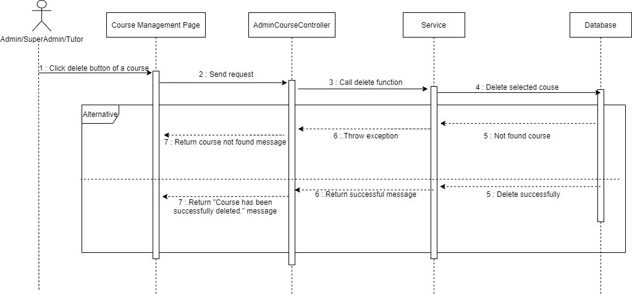

#### d. Database queries

#### 

### 3.6 Toggle course

#### a. Class Diagram

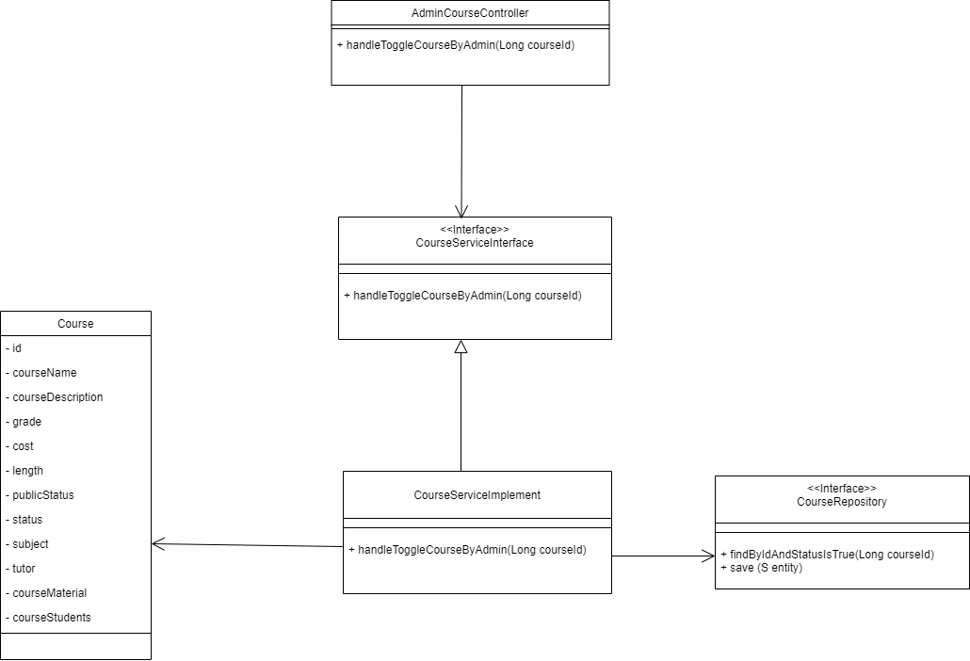

#### b. Class Specifications

##### AdminCourseController Class

| **No** | **Method** | **Description** |
| --- | --- | --- |
| *01* | *handleToggleCourseByAdmin* | *Call the API of handleToggleCourse* |

##### CourseService Class

| **No** | **Method** | **Description** |
| --- | --- | --- |
| *01* | *handleToggleCourseByAdmin* | *This method changes the public status of a course, making it visible to everyone.* |
| *02* | *findByIdAndStatusIsTrue* | *Find a course with id and status is true.* |
| *03* | *setPublicStatus* | *Change the public status of a course to True.* |

#### c. Sequence Diagram(s)

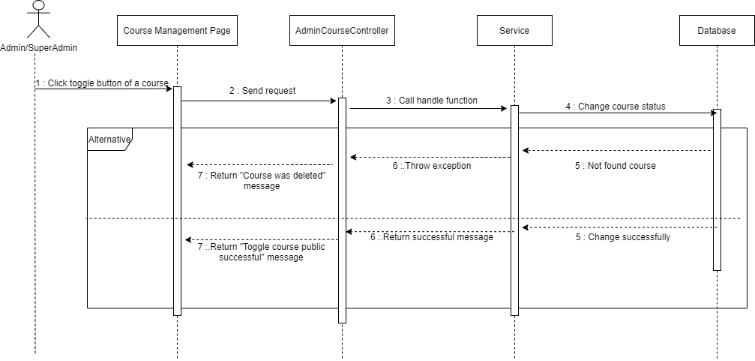

#### d. Database queries

## 4. Course Material Management

### 4.1. Create course material

#### a. Class Diagram

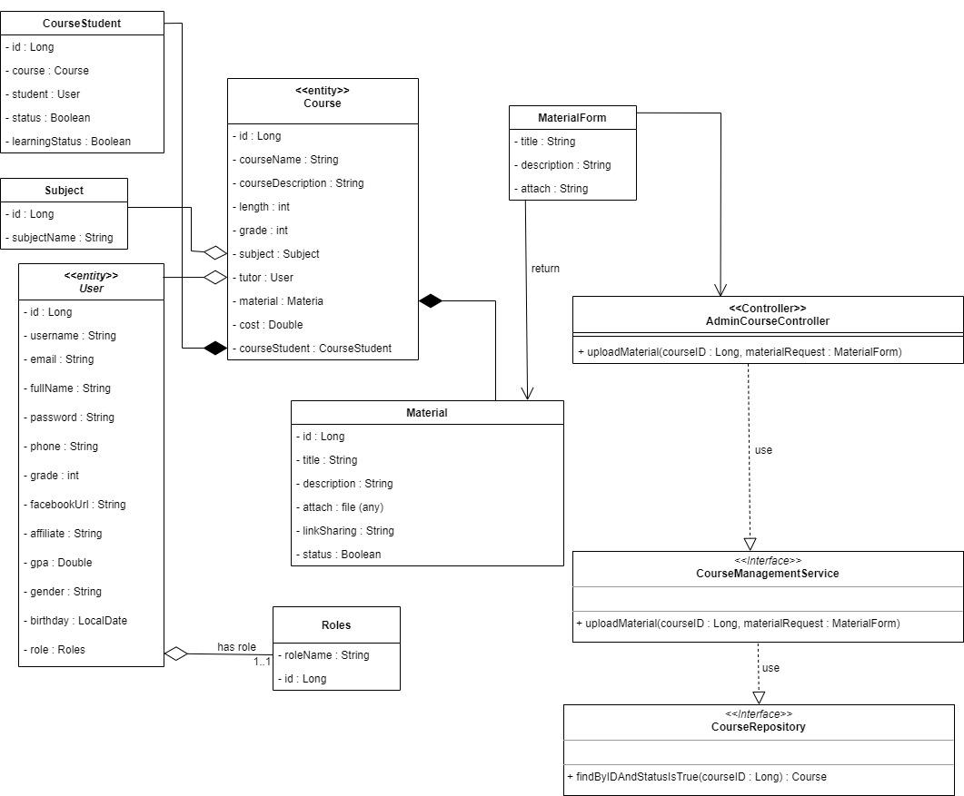

#### b. Class Specifications

##### CourseMaterial Class

* Model of specific material of one course.

##### User Class

* Model of User.

##### Course Class

* Model of Course .

***AdminCourseController Class***

| **No** | **Method** | **Description** |
| --- | --- | --- |
| 01 | uploadMaterial | - This method used to receive request to create material from client then call service layer to implement request |

##### CourseService Class

| **No** | **Method** | **Description** |
| --- | --- | --- |
| 01 | uploadMaterial | - This method allows users with roles Admin, SuperAdmin or owner this course to upload the new material |

##### CourseRepository Class

| **No** | **Method** | **Description** |
| --- | --- | --- |
| 01 | findByIdAndStatusIsTrue | - This is query command using Jpa framework to find out specify course match with ID from parameter and have status is true |

##### 

#### c. Sequence Diagram(s)

#### d. Database queries

### 4.2. View course material

#### a. Class Diagram

#### b. Class Specifications

##### Course Class

* Model of user

##### CourseMaterial Class

* Model of CourseMaterial

##### ErrorMessageResponse Class

* Controller API will return this format if error occur

##### MaterialListResponse Class

* Controller API will return this Course Material Information list format if action perform successful

##### AdminCourseController Class

| **No** | **Method** | **Description** |
| --- | --- | --- |
| *01* | *getAllMaterial()* | *This method will call service to handle view course material request* |

##### CourseServiceInterface Interface

| **No** | **Method** | **Description** |
| --- | --- | --- |
| *01* | getCourseMaterial() | *This method are using to perform view course material* |

##### CourseServiceDetailsImplements Class

* This class will implement the CourseServiceInterface Interface

##### CourseMaterialRepository Interface

* This interface are used to query data on Course Material Table

##### CourseRepository Interface

* This interface are used to query data on Course Table

#### c. Sequence Diagram(s)

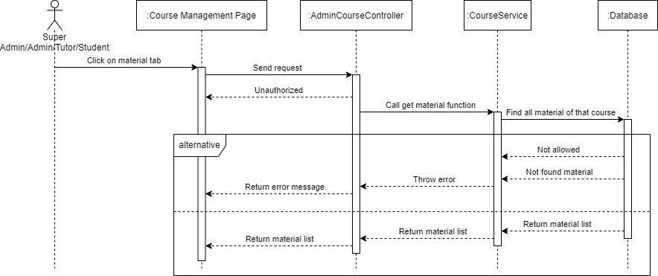

#### d. Database queries

### 4.3. Update course material

#### a. Class Diagram

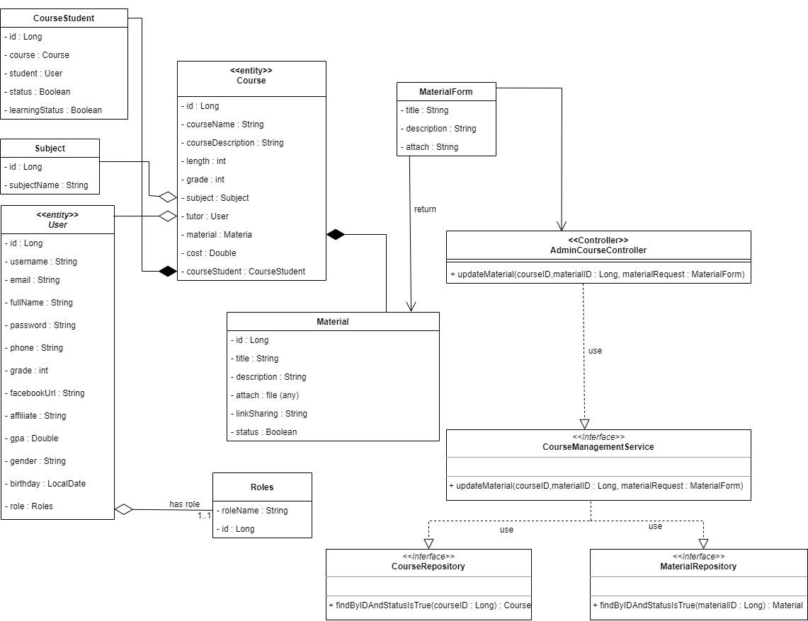

#### b. Class Specifications

##### CourseMaterial Class

* model of specific material of one course.

##### User Class

* model of User.

##### Course Class

* model of Course .

***AdminCourseController Class***

| **No** | **Method** | **Description** |
| --- | --- | --- |
| 01 | updateMaterial | - This method used to receive request to create material from client then call service layer to implement request |

#### 

##### CourseService Class

| **No** | **Method** | **Description** |
| --- | --- | --- |
| 01 | updateMaterial | - This method allows users with roles Admin, SuperAdmin or owner this course to update the material existed |

##### CourseRepository Class

| **No** | **Method** | **Description** |
| --- | --- | --- |
| 01 | findByIdAndStatusIsTrue | - This is query command using Jpa framework to find out specify course match with ID from parameter and have status is true |

##### 

##### MaterialRepository Class

| **No** | **Method** | **Description** |
| --- | --- | --- |
| 01 | findByIdAndStatusIsTrue | - This is query command using Jpa framework to find out specify material match with ID from parameter and have status is true |

#### c. Sequence Diagram(s)

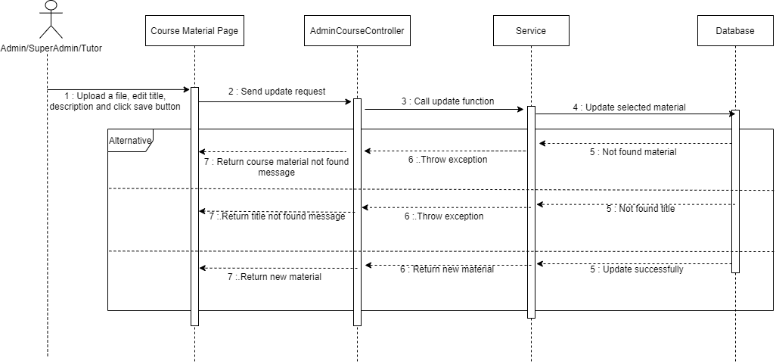

#### d. Database queries

### 4.4. Delete course material

#### a. Class Diagram

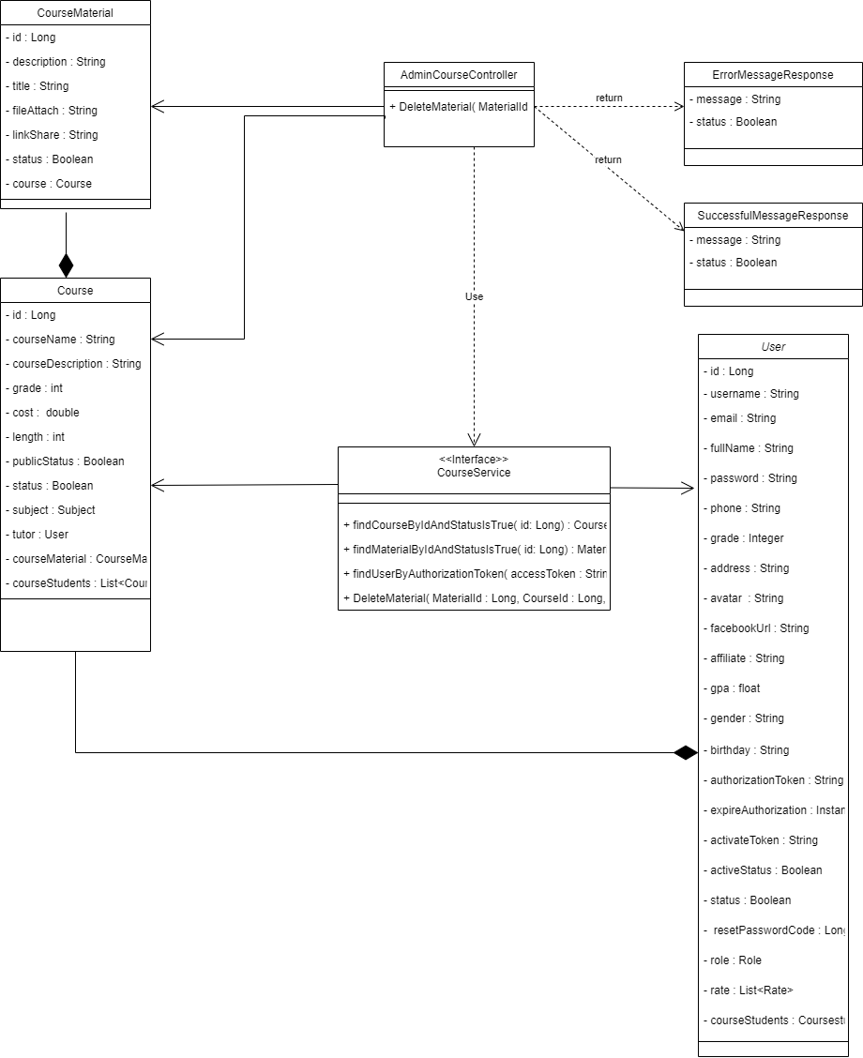

#### b. Class Specifications

##### CourseMaterial Class

* Model of specific material of one course.

##### User Class

* Model of User.

##### Course Class

* Model of Course .

##### ErrorMessageResponse Class

* Controller will return with this format response.

##### SuccessfulMessageResponse Class

* Controller will return with this format response.

##### Subject Class

* Model of Subject.

##### AdminUserController Class

| **No** | **Method** | **Description** |
| --- | --- | --- |
| 01 | DeleteMaterial | - This method will call API of deleteMaterial. |

#### 

##### CourseService Class

| **No** | **Method** | **Description** |
| --- | --- | --- |
| 01 | DeleteMaterial | - This method allow user with role Tutor, Admin, SuperAdmin to create course through CourseCreateRequest and return object. |
| 02 | findCourseByIdAndStatusIsTrue | - This method will find and return all course by id and status is true. |
| 03 | findMaterialByIdAndStatusIsTrue | - This method will find and return all Material of specific course by id and status is true. |
| 04 | findUserByAuthorizationToken | - Find a User by Authorization Token. |

#### c. Sequence Diagram(s)

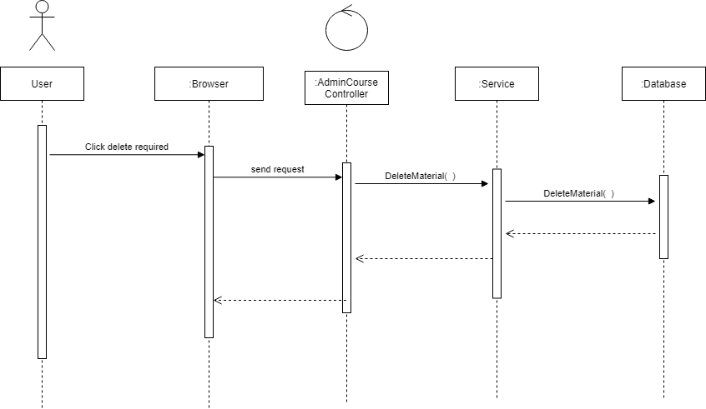

#### d. Database Queries

## 5. Course Timetable Management

### 5.1. Create timetable

#### a. Class Diagram

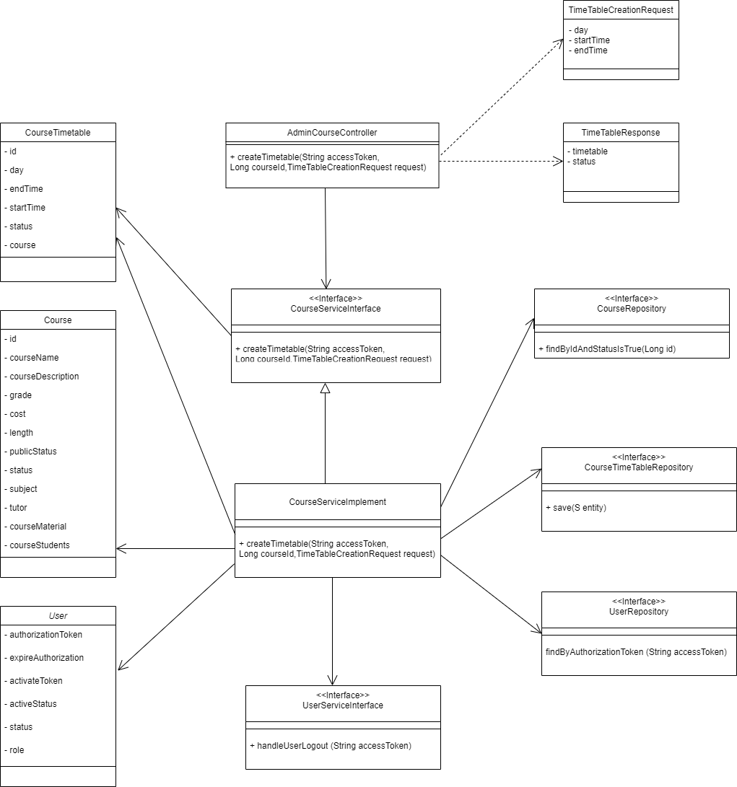

#### 

#### 

#### b. Class Specifications

##### AdminCourseController Class

| **No** | **Method** | **Description** |
| --- | --- | --- |
| *01* | *createTimetable* | *Call the API of createTimetable* |

##### CourseService Class

| **No** | **Method** | **Description** |
| --- | --- | --- |
| *01* | *findByIdAndStatusIsTrue* | *Find a course with id and status is True.* |
| *02* | *setStartTime* | *Set the start time of a course.* |
| *03* | *setEndTime* | *Set the end time of a course.* |
| *04* | *setDay* | *Set the day of a course.* |
| *05* | *isAfter* | *Check if the end time is before the start time or not.* |

#### c. Sequence Diagram(s)

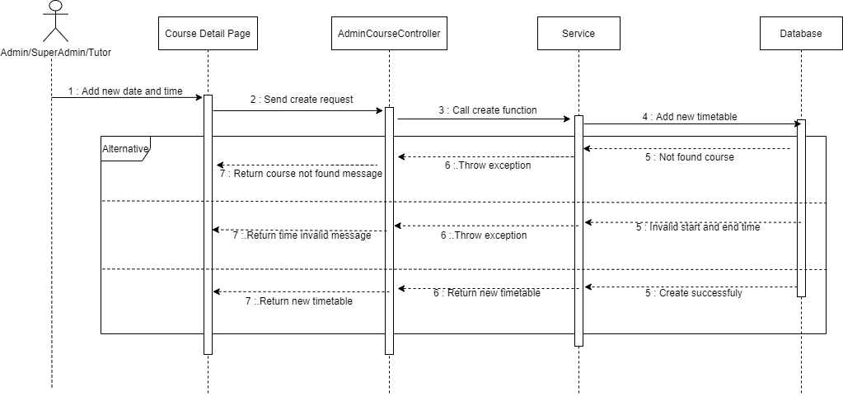

#### d. Database queries

### 

### 5.2. View course timetable

#### a. Class Diagram

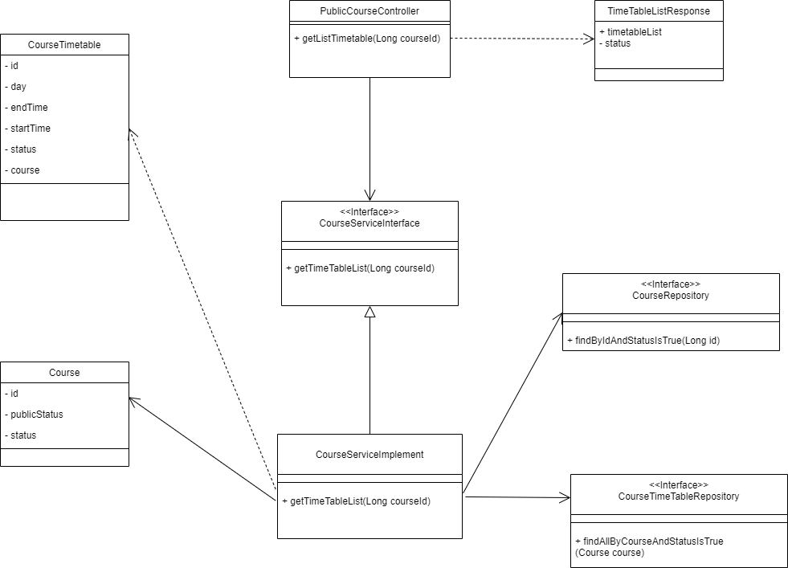

#### b. Class Specifications

##### PublicCourseController Class

| **No** | **Method** | **Description** |
| --- | --- | --- |
| *01* | *getListTimetable* | *Call the API of getTimeTableList* |

***CourseService Class***

| **No** | **Method** | **Description** |
| --- | --- | --- |
| *01* | *findAllByCourseAndStatusIsTrue* | *Find all the timetables of a course.* |
| *02* | *findByIdAndStatusIsTrue* | *Find a course with id and status is true.* |
| *03* | *getTimeTableList* | *Return timetable list of a course.* |

#### c. Sequence Diagram(s)

#### d. Database queries

### 5.3. Update course timetable

#### a. Class Diagram

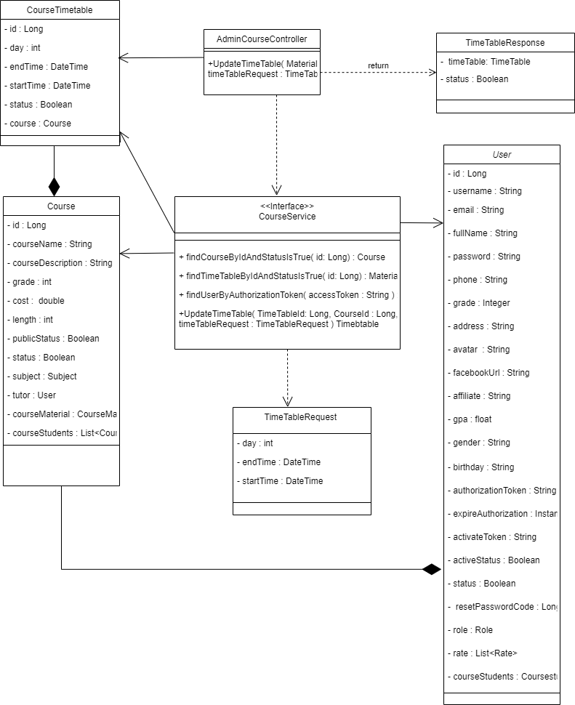

#### b. Class Specifications

##### CourseTimetable Class

* Model of specific timetable of one course.

##### User Class

* Model of User.

##### Course Class

* Model of Course .

##### TimeTableResponse Class

* Controller will return with this format response.

##### TimeTableRequest Class

* Controller will receive a Request with this format.

##### AdminCourseController Class

| **No** | **Method** | **Description** |
| --- | --- | --- |
| 01 | UpdateTimetable | - This method will call the API of UpdateMaterial. |

#### 

##### CourseService Class

| **No** | **Method** | **Description** |
| --- | --- | --- |
| 01 | UpdateTimetable | - This method allows the Tutor to update the Timetable of a specific course through TimetableRequest and return object. |
| 02 | findCourseByIdAndStatusIsTrue | - This method will find and return all courses by id and status is true. |
| 03 | findTimetableByIdAndStatusIsTrue | - This method will find and return all timetables of a specific course by id and status. |
| 03 | findUserByAuthorizationToken | - Find a User by Authorization Token. |

### 

#### c. Sequence Diagram(s)

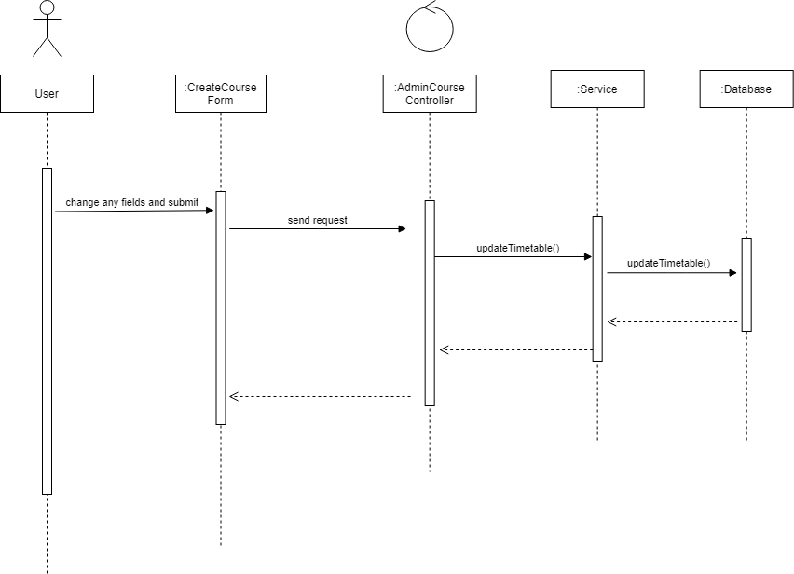

#### d. Database Queries

### 5.4. Delete course timetable

#### a. Class Diagram

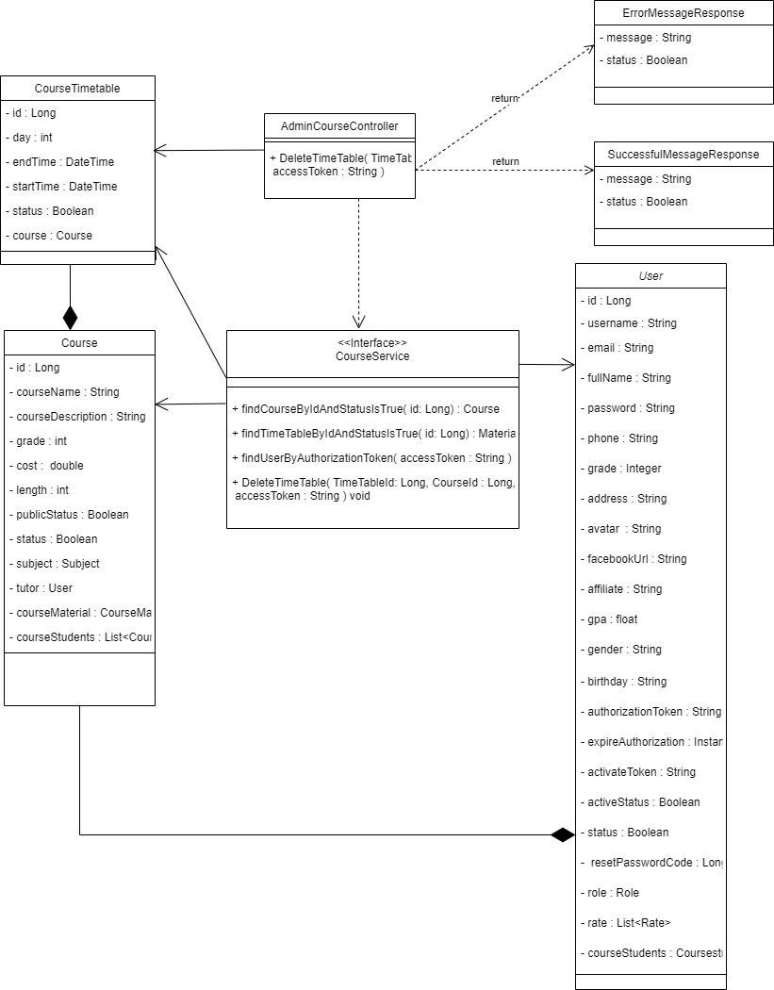

#### b. Class Specifications

##### CourseTimetable Class

* Model of specific timetable of one course.

##### User Class

* Model of User.

##### Course Class

* Model of Course .

##### SuccessfulMessageResponse Class

* Controller will return with this format response if action success.

##### ErrorMessageResponse Class

* Controller will return with this format response if action error.

##### AdminCourseController Class

| **No** | **Method** | **Description** |
| --- | --- | --- |
| 01 | DeleteTimetable | - This method will call API of UpdateMaterial. |

#### 

##### CourseService Class

| **No** | **Method** | **Description** |
| --- | --- | --- |
| 01 | DeleteTimetable | - This method allows the Tutor to delete the Timetable of a specific course . |
| 02 | findCourseByIdAndStatusIsTrue | - This method will find and return all courses by id and status is true. |
| 03 | findTimetableByIdAndStatusIsTrue | - This method will find and return all timetables of specific course by id and status is true. |
| 03 | findUserByAuthorizationToken | - Find a User by Authorization Token. |

### 

#### c. Sequence Diagram(s)

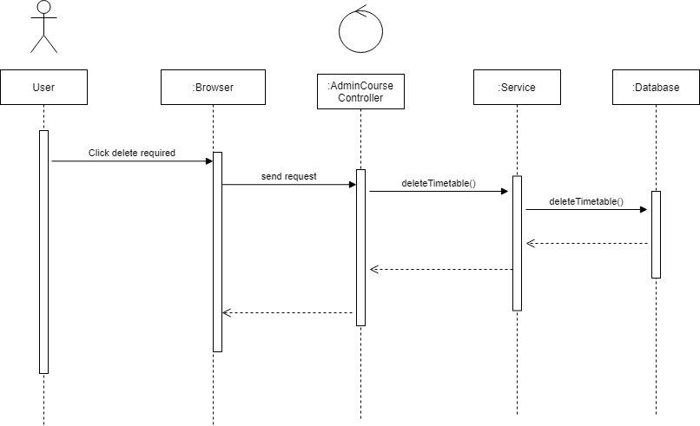

#### d. Database Queries

## 6. Course Registration

### 6.1.  Register course

#### a. Class Diagram

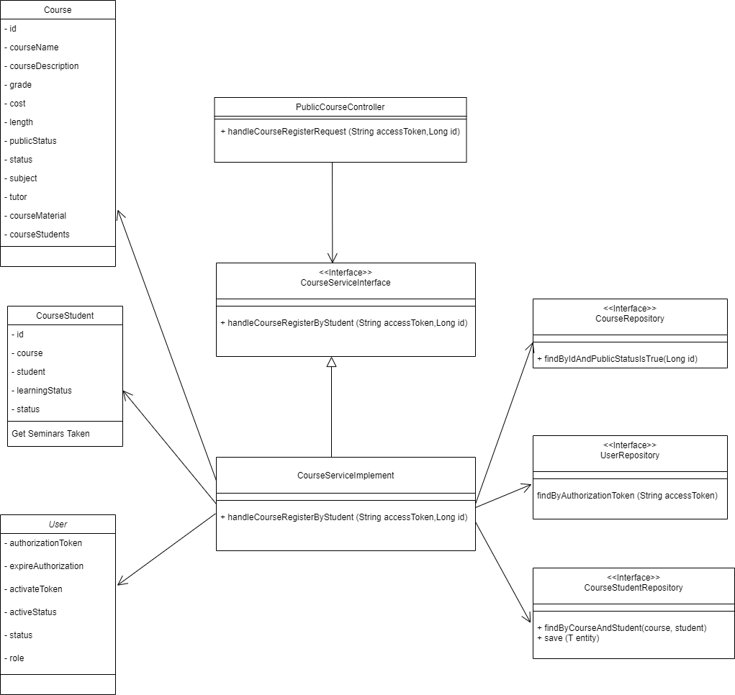

#### b. Class Specifications

##### PublicCourseController Class

| **No** | **Method** | **Description** |
| --- | --- | --- |
| *01* | *registerCourse* | *Call the API of handleCourseRegisterByStudent* |

##### CourseService Class

| **No** | **Method** | **Description** |
| --- | --- | --- |
| *01* | *handleCourseRegisterByStudent* | *Add students to a course pending for approval by the tutor or admin.* |
| *02* | *findByIdAndPublicStatusIsTrue* | *Find the course by Id and status is True.* |
| *03* | *findByCourseAndStudent* | *Check if the student has register this course or not.* |

#### c. Sequence Diagram(s)

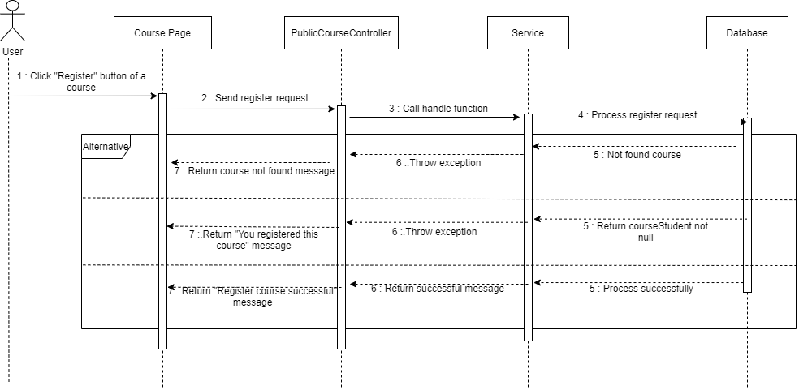

#### d. Database queries

### 

### 6.2.  Approve course registration

#### a. Class Diagram

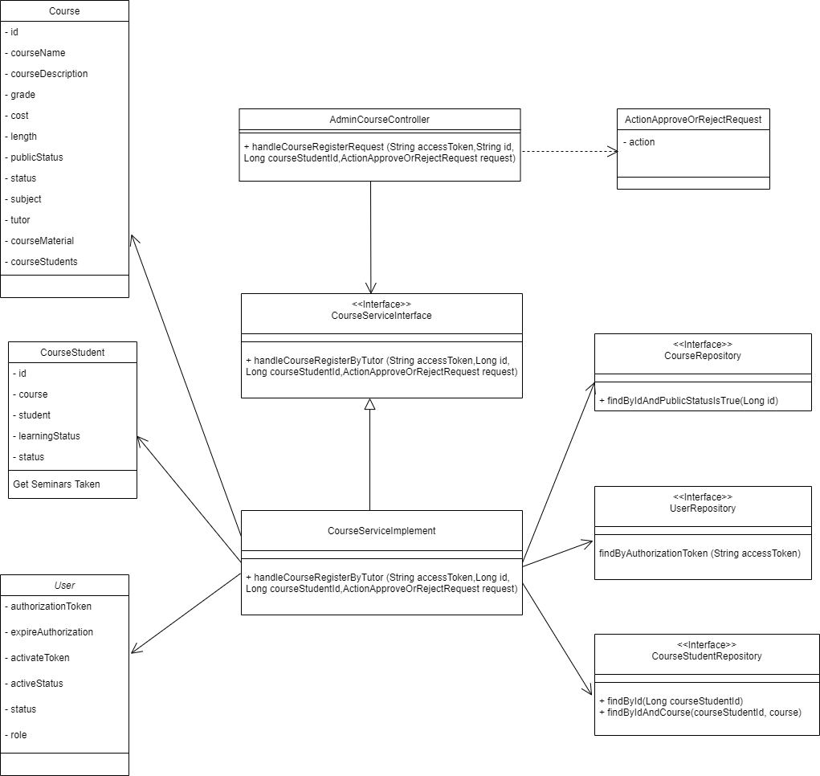

#### b. Class Specifications

##### AdminCourseController Class

| **No** | **Method** | **Description** |
| --- | --- | --- |
| *01* | *handleCourseRegisterRequest* | *Call the API of handleCourseRegisterByTutor* |

##### CourseService Class

| **No** | **Method** | **Description** |
| --- | --- | --- |
| *01* | *handleCourseRegisterByTutor* | *Approve or reject the request of a student* |
| *02* | *findByIdAndPublicStatusIsTrue* | *Find a course with Id and status is True.* |
| *03* | *findByIdAndCourse* | *Check if a student has registered for this course or not.* |
| *04* | *findById* | *Check if the student rejects this course or not.* |
| *05* | *setLearningStatus* | *Set status to approve or reject student for this course.* |

#### c. Sequence Diagram(s)

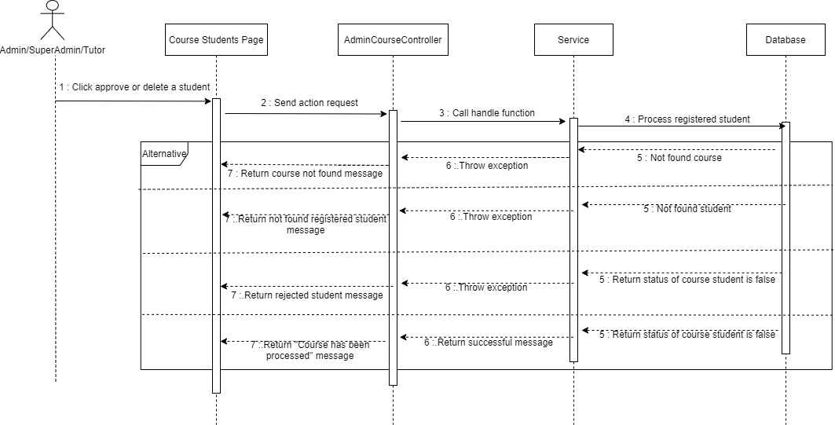

#### d. Database queries

## 7. Rate Management

### 7.1.  Add tutor rating

#### a. Class Diagram

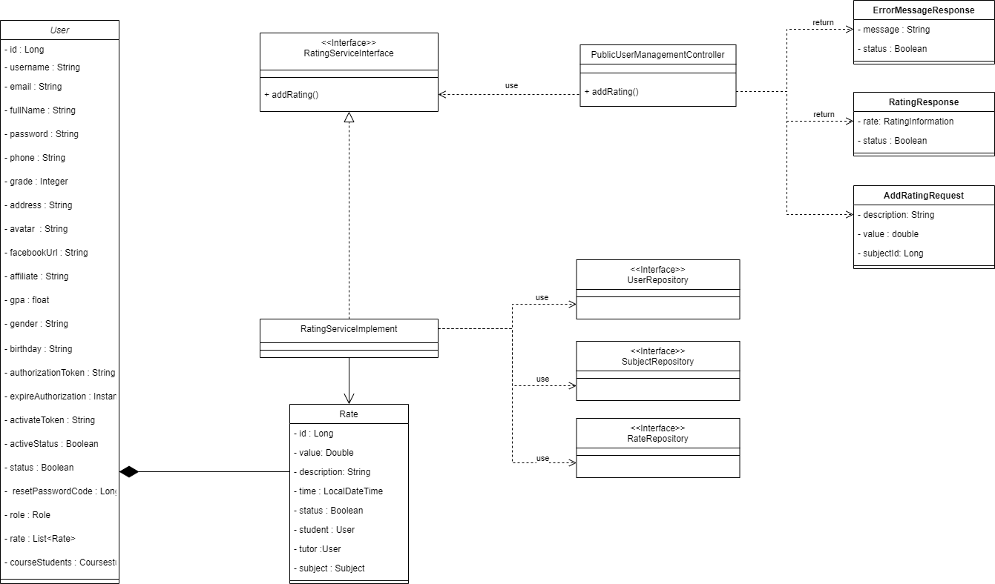

#### b. Class Specifications

##### User Class

* Model of user

##### Rate Class

* Model of rate

##### ErrorMessageResponse Class

* Controller API will return this format if error occur

##### RatingResponse Class

* Controller API will return this Rating Information format if added successful

##### AddRatingRequest Class

* Controller API will use this request to perform add rating action

##### PublicUserManagementController Class

| **No** | **Method** | **Description** |
| --- | --- | --- |
| *01* | *addRating* | *This method will call service to handle add rating request* |

##### RatingServiceInterface Interface

| **No** | **Method** | **Description** |
| --- | --- | --- |
| *01* | addRating | *This method are using to perform add rating* |

##### RatingServiceDetailsImplements Class

* This class will implement the RatingServiceInterface Interface

##### SubjectRepository Interface

* This interface are used to query data on Subject Table

##### UserRepository Interface

* This interface are used to query data on User Table

##### RateRepository Interface

* This interface are used to query data on Rate Table

#### c. Sequence Diagram(s)

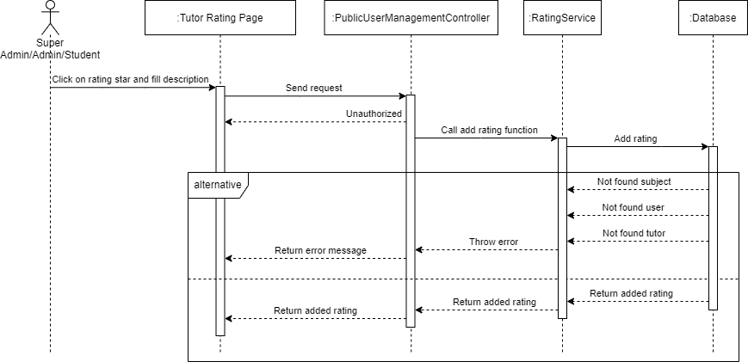

#### d. Database queries

#### 

### 7.2.  Update tutor rating

#### a. Class Diagram

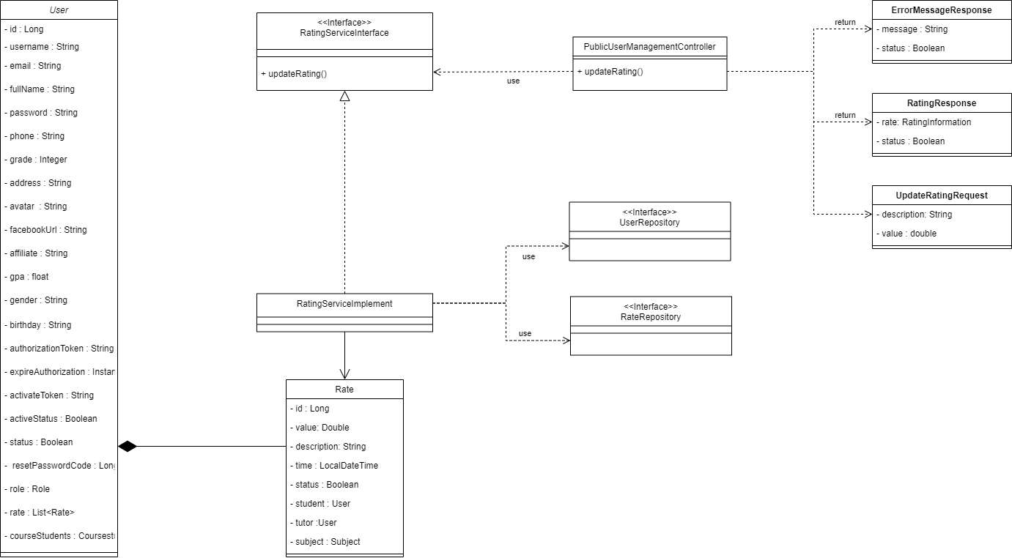

#### b. Class Specifications

##### User Class

* Model of user

##### Rate Class

* Model of rate

##### ErrorMessageResponse Class

* Controller API will return this format if error occur

##### RatingResponse Class

* Controller API will return this Rating Information format if update successful

##### UpdateRatingRequest Class

* Controller API will use this request to perform add rating action

##### PublicUserManagementController Class

| **No** | **Method** | **Description** |
| --- | --- | --- |
| *01* | *updateRating* | *This method will call service to handle update rating request* |

##### RatingServiceInterface Interface

| **No** | **Method** | **Description** |
| --- | --- | --- |
| *01* | updateRating | *This method are using to perform update rating* |

##### RatingServiceDetailsImplements Class

* This class will implement the RatingServiceInterface Interface

##### UserRepository Interface

* This interface are used to query data on User Table

##### RateRepository Interface

* This interface are used to query data on Rate Table

#### c. Sequence Diagram(s)

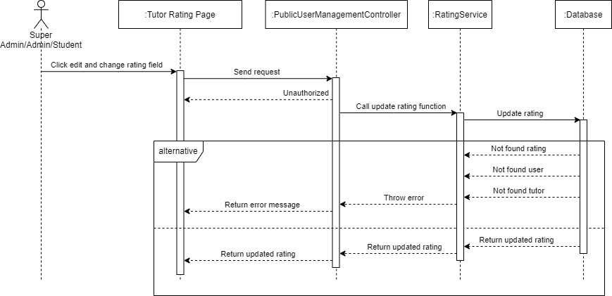

#### d. Database queries

#### 

### 7.3.  Delete tutor rating

#### a. Class Diagram

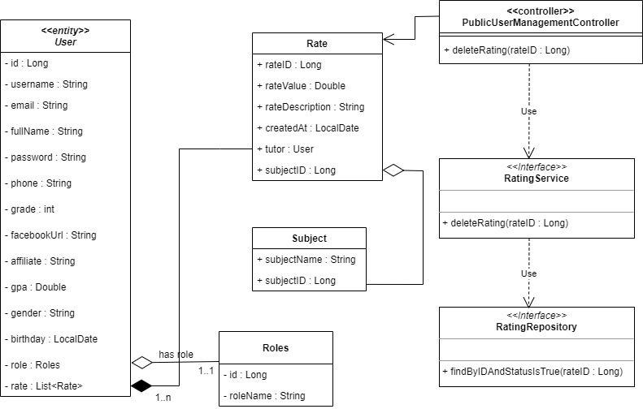

#### b. Class Specifications

##### User Class

* Model of User.

##### Rate Class

* Model of Rate.

##### Subject Class

* Model of Subject.

##### PublicUserManagementController Class

| **No** | **Method** | **Description** |
| --- | --- | --- |
| *01* | *deleteRating* | *Call the API of deleteRating* |

#### 

##### RatingService Class

| **No** | **Method** | **Description** |
| --- | --- | --- |
| *01* | *deleteRating* | *This method deletes the selected rating.* |
| *03* | *findByIdAndStatusIsTrue* | *Find rating with Id and status is True.* |

#### c. Sequence Diagram(s)

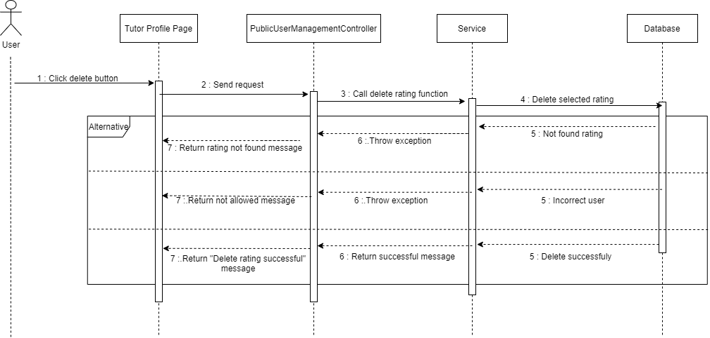

#### d. Database queries

### 7.4.  View tutor rating

#### a. Class Diagram

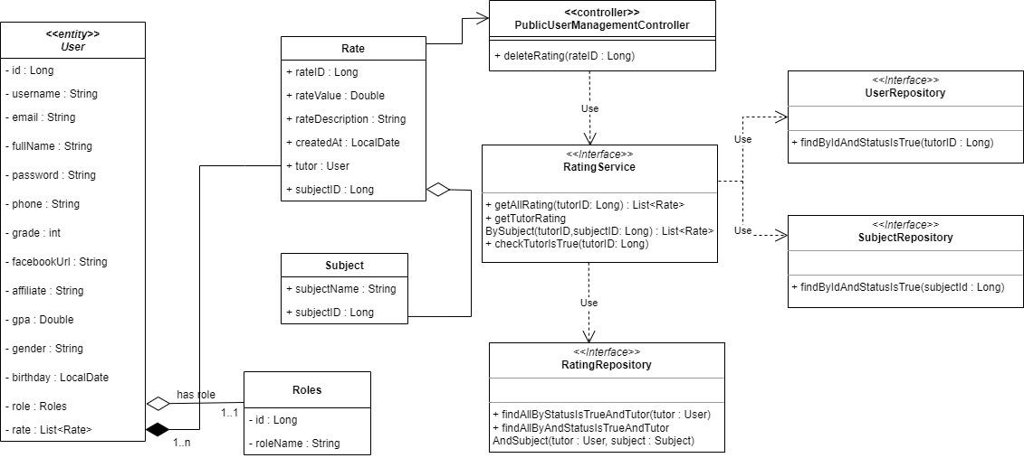

#### b. Class Specifications

##### User Class

* Model of User.

##### Rate Class

* Model of Rate.

##### Subject Class

* Model of Subject.

##### Roles Class

* Model of Role.

##### PublicUserManagementController Class

| **No** | **Method** | **Description** |
| --- | --- | --- |
| *01* | *getTutorRatingBySubject* | *Call the API of getAllRating, getTutorRatingBySubject* |

##### RatingService Class

| **No** | **Method** | **Description** |
| --- | --- | --- |
| *01* | *getAllRating* | *This function returns a list of ratings.* |
| *02* | *getTutorRatingBySubject* | *This function returns a list of ratings by subject.* |
| *03* | *findAllByStatusIsTrueAndTutorOrderByIdDesc* | *Find and sort all ratings.* |
| *04* | *findAllByStatusIsTrueAndTutorAndSubjectOrderByIdDesc* | *Find and sort all ratings by subject.* |

#### c. Sequence Diagram(s)

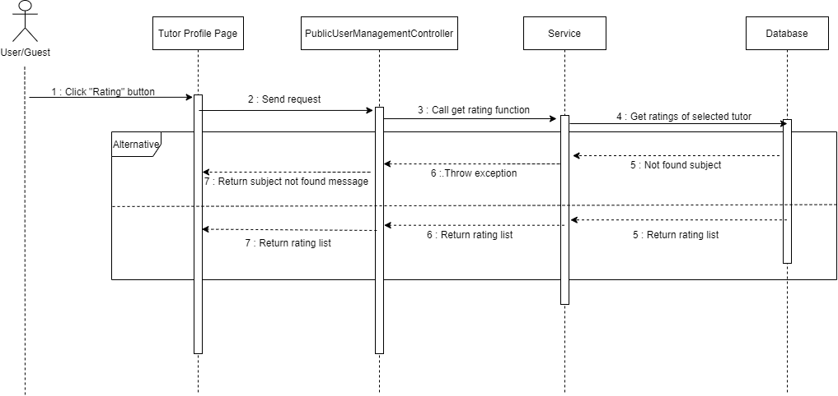

#### d. Database queries

## 8.  Profile management

### 8.1.  View profile

#### a. Class Diagram

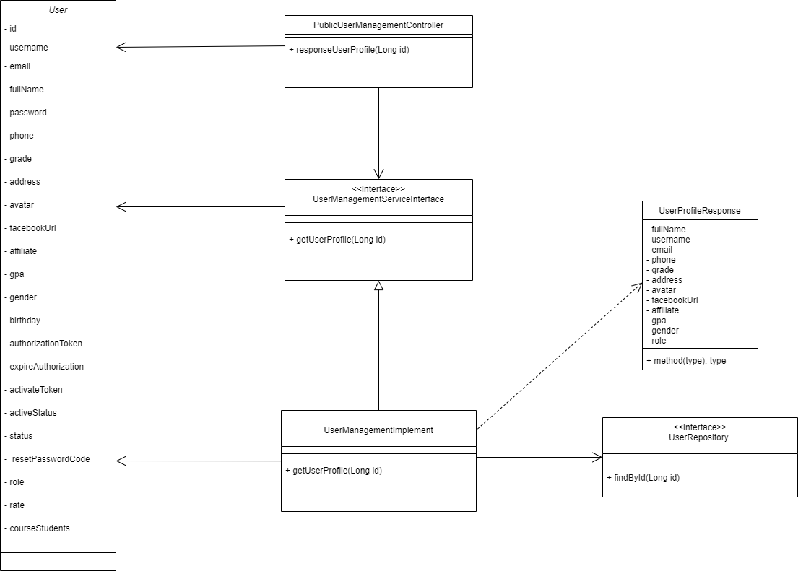

#### b. Class Specifications

##### PublicUserManagementController Class

| **No** | **Method** | **Description** |
| --- | --- | --- |
| *01* | *responseUserProfile* | *Call the API of getUserProfile* |

##### UserService Class

| **No** | **Method** | **Description** |
| --- | --- | --- |
| *01* | *getUserProfile* | *This method returns the profile of the user.* |

#### c. Sequence Diagram(s)

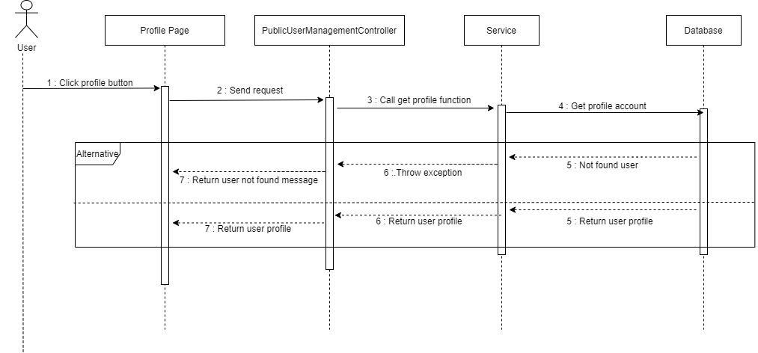

#### d. Database queries

### 8.2.  Edit profile

#### a. Class Diagram

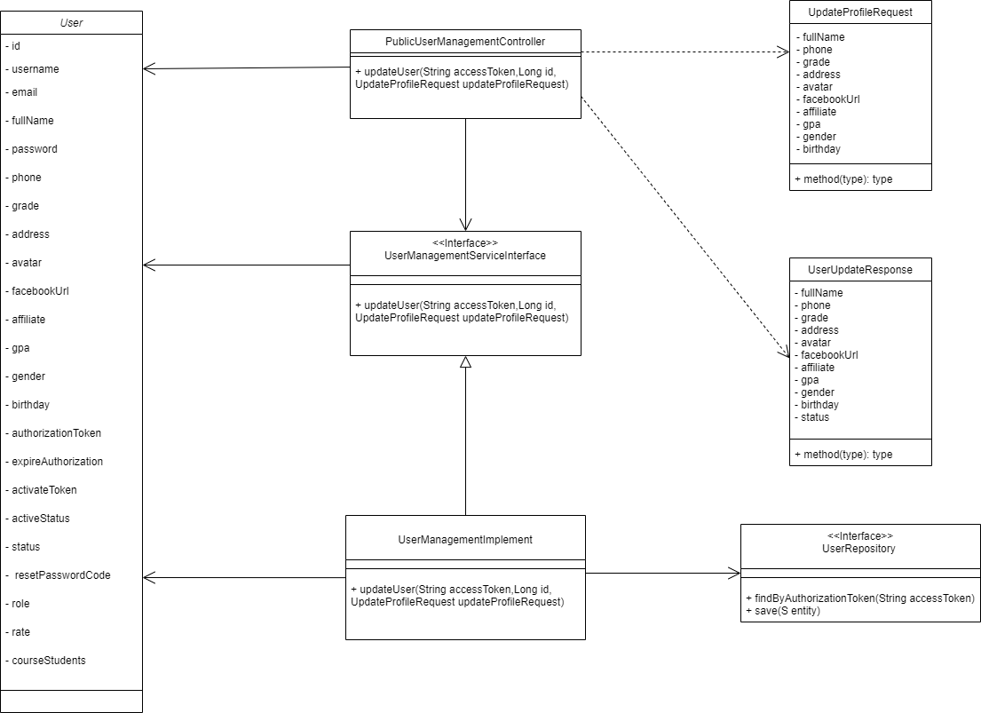

#### b. Class Specifications

##### PublicUserManagementController Class

| **No** | **Method** | **Description** |
| --- | --- | --- |
| *01* | *updateUser* | *Call the API of updateUser* |

##### UserService Class

| **No** | **Method** | **Description** |
| --- | --- | --- |
| *01* | *updateUser* | *This function changes the pieces of information of the user.* |
| *02* | *findByAuthorizationToken* | *Find the user by AuthorizationToken.* |

#### c. Sequence Diagram(s)

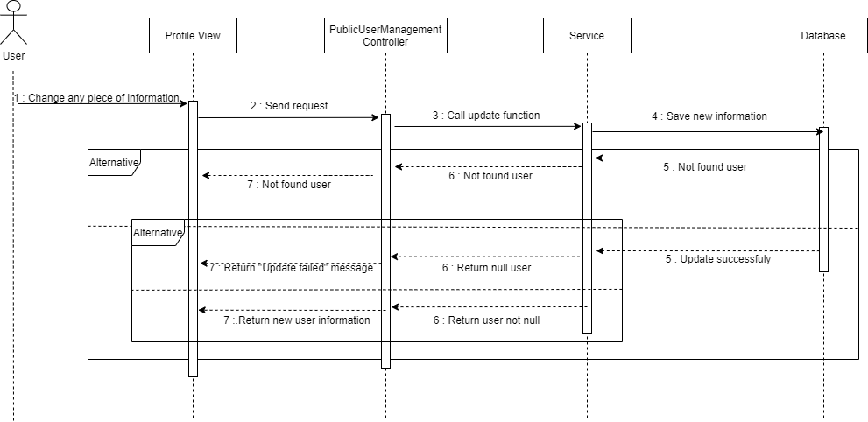

#### d. Database queries

### 8.3.  Update password

#### a. Class Diagram

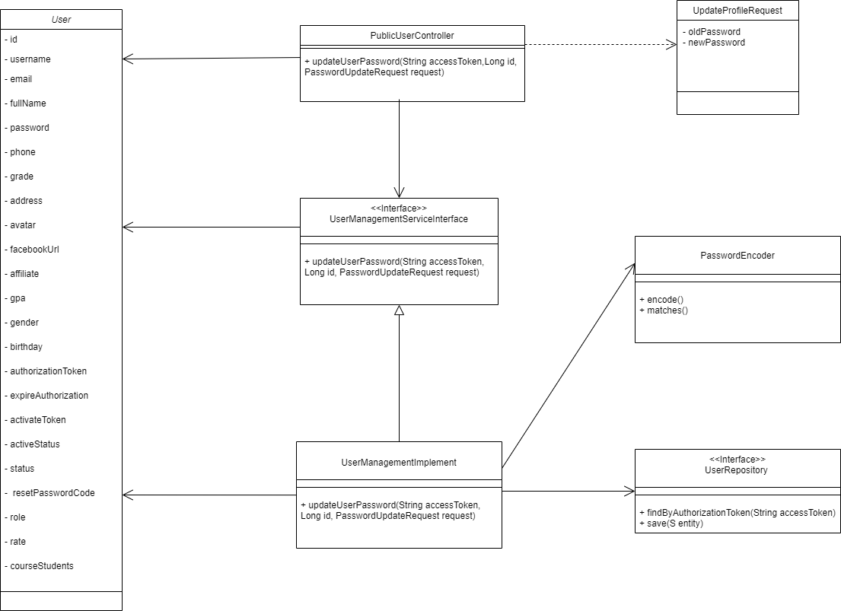

#### b. Class Specifications

##### PublicUserManagementController Class

| **No** | **Method** | **Description** |
| --- | --- | --- |
| *01* | *updateUserPassword* | *Call the API of updateUserPassword* |

##### UserService Class

| **No** | **Method** | **Description** |
| --- | --- | --- |
| *01* | *updateUserPassword* | *This method changes the password of the user.* |
| *02* | *findByAuthorizationToken* | *Find the user by AuthorizationToken.* |
| *03* | *matches* | *Compare the old password in the database to the old password user typed.* |
| *04* | *encode* | *Encode the new password by SHA-1 algorithm or greater hash.* |

#### c. Sequence Diagram(s)

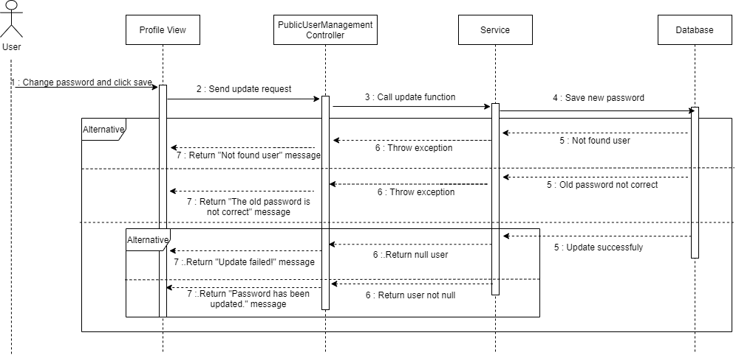

#### d. Database queries

### 9. Community

### 9.1. Question management

### 9.1.1.  Add question

#### a. Class Diagram

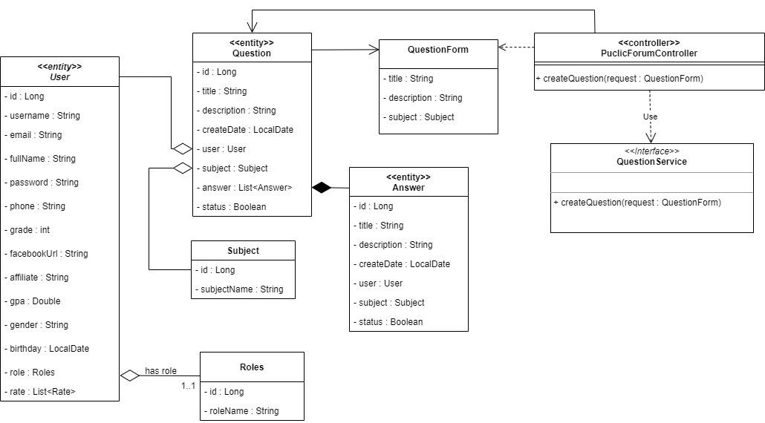

#### b. Class Specifications

##### User Class

* Model of User.

##### Question Class

* Model of Question.

##### QuestionRequest Class

* Controller will receive a request with this format.

##### QuestionResponse Class

* Controller will return with this format response.

##### Subject Class

* Model of Subject.

##### PublicForumController Class

| **No** | **Method** | **Description** |
| --- | --- | --- |
| 01 | CreateQuestion | - This method will call the API of CreateQuestion for the forum service. |

#### 

##### ForumService Class

| **No** | **Method** | **Description** |
| --- | --- | --- |
| 01 | CreateQuestion | - This method allows users with roles Tutor, Admin, SuperAdmin to create questions through QuestionRequest and return objects. |
| 02 | findSubjectById | - Finding a Subject by Id. |
| 03 | findUserByAuthorizationToken | - Find a User by Authorization Token. |

### 

#### c. Sequence Diagram(s)

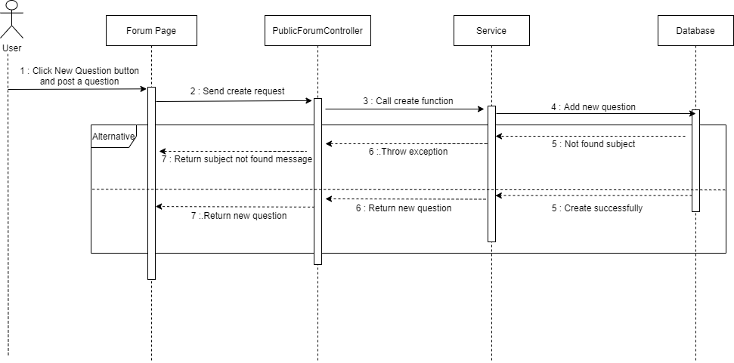

#### d. Database queries

### 9.1.2.  View question

#### a. Class Diagram

* **View detail question**

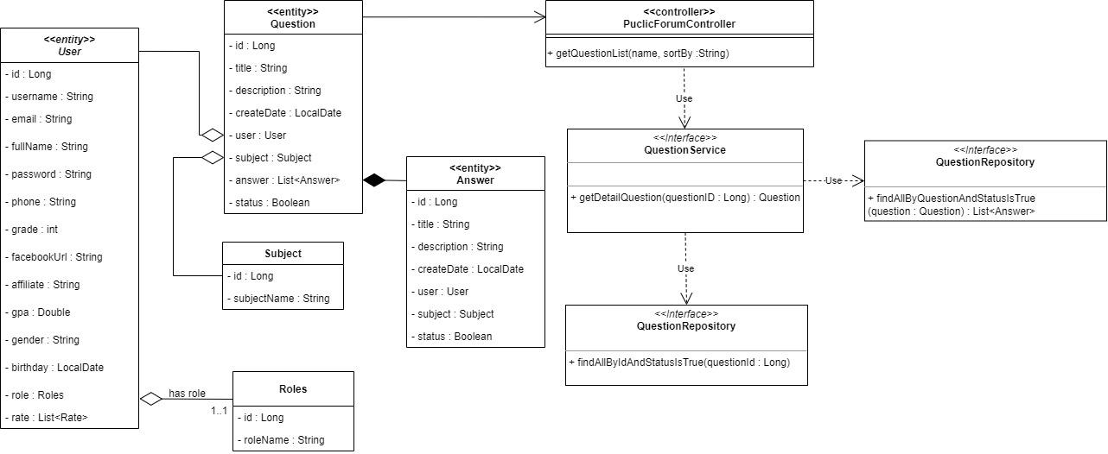

* **View list questions**

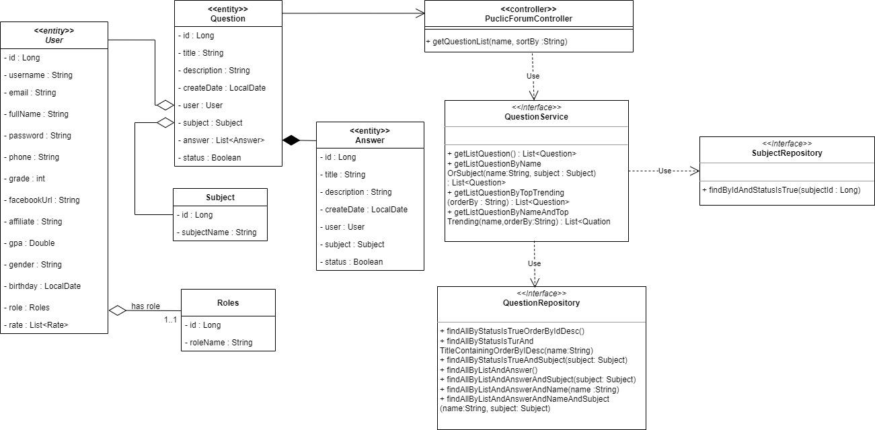

#### b. Class Specifications

##### PublicForumController Class

| **No** | **Method** | **Description** |
| --- | --- | --- |
| *01* | getQuestionList | *Call API of getListQuestion, getListQuestionByNameOrSubject* |
| *02* | getDetailsQuestion | *Call API of getDetailsQuestion* |

##### ForumService Class

| **No** | **Method** | **Description** |
| --- | --- | --- |
| *01* | *getListQuestion* | *This method returns a list of all questions.* |
| *02* | *findAllByStatusIsTrueOrderByIdDesc* | *Find and sort all questions.* |
| *03* | *getListQuestionByNameOrSubject* | *This method returns a list of questions by title or subject.* |
| *04* | *findAllByStatusIsTrueAndTitleContainingOrderByIdDesc* | *Find and sort questions by title.* |
| *05* | *findAllByStatusIsTrueAndSubjectOrderByIdDesc* | *Find and sort questions by subject.* |
| *06* | *findAllByStatusIsTrueAndTitleContainingAndSubjectOrderByIdDesc* | *Find and sort questions by title and subject.* |
| *07* | *getDetailsQuestion* | *This method returns details of a question.* |
| *08* | *findByIdAndStatusIsTrue* | *Find question by Id and status is true.* |

#### 

#### c. Sequence Diagram(s)

* ***view list question***

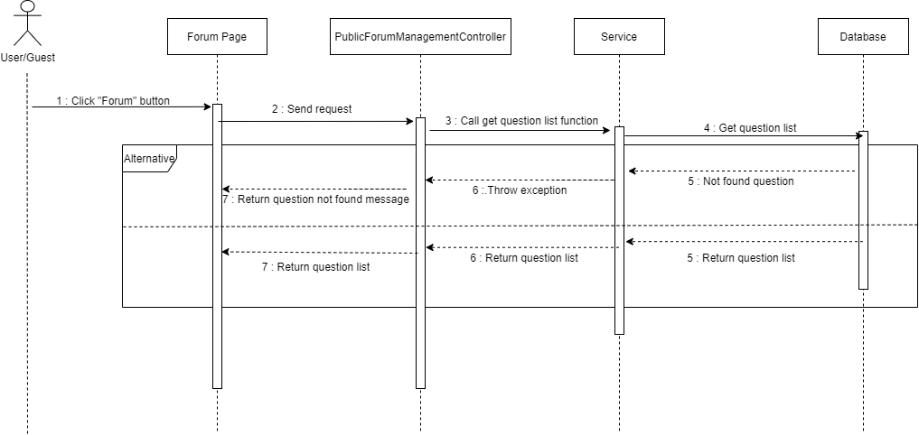

* ***View detail question***

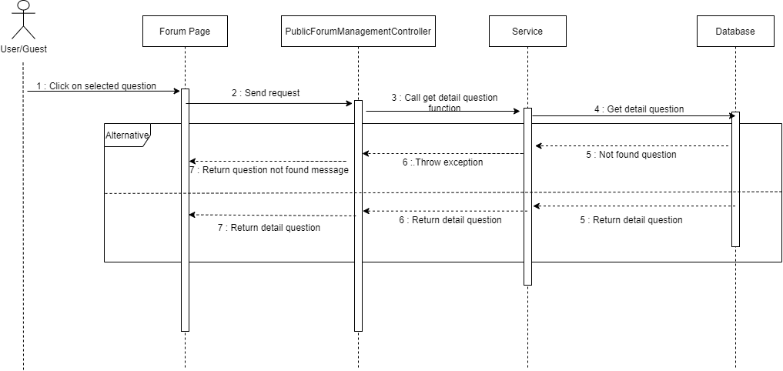

#### d. Database queries

### 9.1.3. Delete question

#### a. Class Diagram

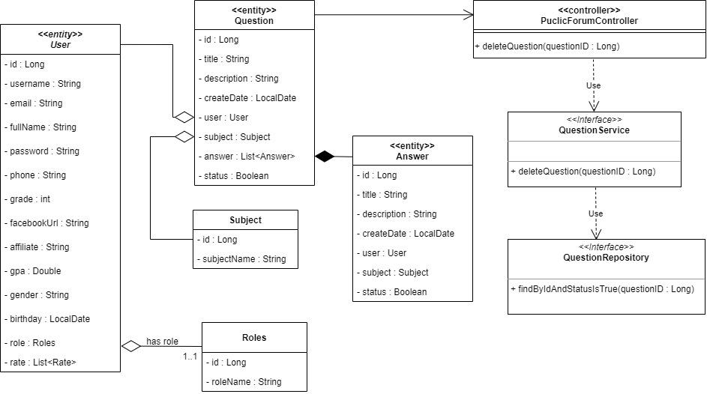

#### b. Class Specifications

##### User Class

* Model of User

##### Question Class

* Model of Question

##### Answer Class

* Model of Answer

##### Roles Class

* Model of Roles

##### Subject Class

* Model of Subject

##### PublicForumController Class

| **No** | **Method** | **Description** |
| --- | --- | --- |
| *01* | *deleteQuestion* | *Call API of deleteQuestion* |

##### 

##### QuestionService Class

| **No** | **Method** | **Description** |
| --- | --- | --- |
| *01* | *deleteQuestion* | *This method deletes a question.* |
| *02* | *findByIdAndStatusIsTrue* | *Find the question by Id and status is True.* |
| *03* | *setStatus* | *Change the status of the question to false (soft delete).* |

#### c. Sequence Diagram(s)

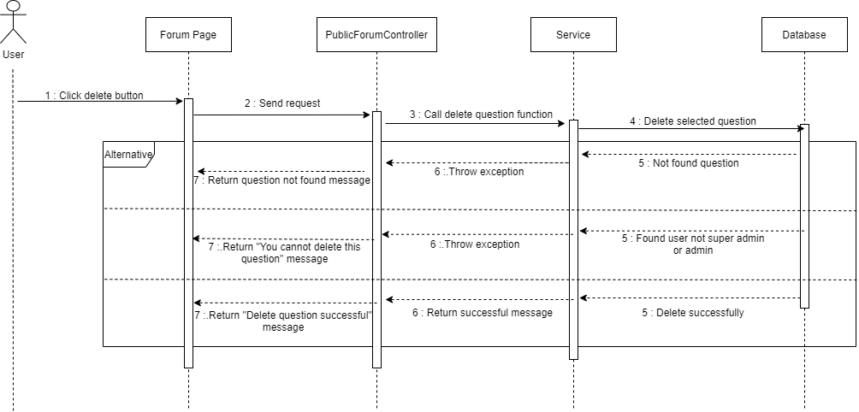

#### d. Database queries

### 

### 9.2. Answer management

### 9.2.1. View answer

#### a. Class Diagram

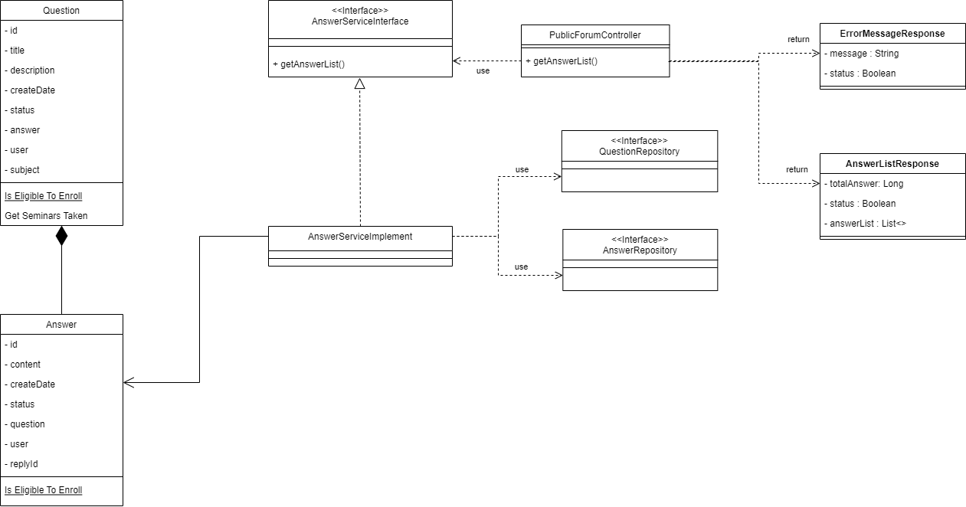

#### b. Class Specifications

##### Question Class

* Model of question

##### Answer Class

* Model of Answer

##### ErrorMessageResponse Class

* Controller API will return this format if error occur

##### AnswerListResponse Class

* Controller API will return this Rating Information list format if action perform successful

##### PublicForumController Class

| **No** | **Method** | **Description** |
| --- | --- | --- |
| *01* | *getAnswerList* | *This method will call service to handle view answer request* |

##### AnswerServiceInterface Interface

| **No** | **Method** | **Description** |
| --- | --- | --- |
| *01* | *getAnswerList* | *This method are using to perform get answer list* |

##### AnswerServiceDetailsImplements Class

* This class will implement the AnswerServiceInterface Interface

##### QuestionRepository Interface

* This interface are used to query data on Question Table

##### AnswerRepository Interface

* This interface are used to query data on Answer Table

#### c. Sequence Diagram(s)

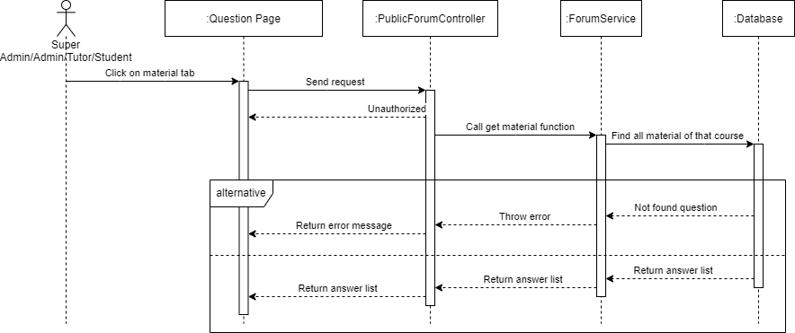

#### d. Database queries

### 9.2.2. Add answer

#### a. Class Diagram

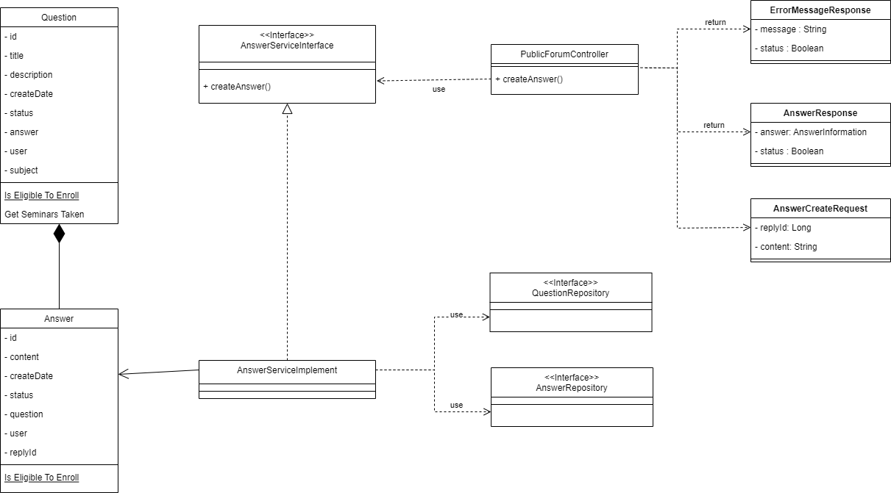

#### b. Class Specifications

##### Question Class

* Model of question

##### Answer Class

* Model of Answer

##### ErrorMessageResponse Class

* Controller API will return this format if error occur

##### AnswerResponse Class

* Controller API will return this Rating Information format if update successful

##### AnswerCreateRequest Class

* Controller API will use this request to perform add question action

##### PublicForumController Class

| **No** | **Method** | **Description** |
| --- | --- | --- |
| *01* | *createAnswer* | *This method will call service to handle create answer request* |

##### AnswerServiceInterface Interface

| **No** | **Method** | **Description** |
| --- | --- | --- |
| *01* | *createAnswer* | *This method are using to perform create answer* |

##### AnswerServiceDetailsImplements Class

* This class will implement the AnswerServiceInterface Interface

##### QuestionRepository Interface

* This interface are used to query data on Question Table

##### AnswerRepository Interface

* This interface are used to query data on Answer Table

#### c. Sequence Diagram(s)

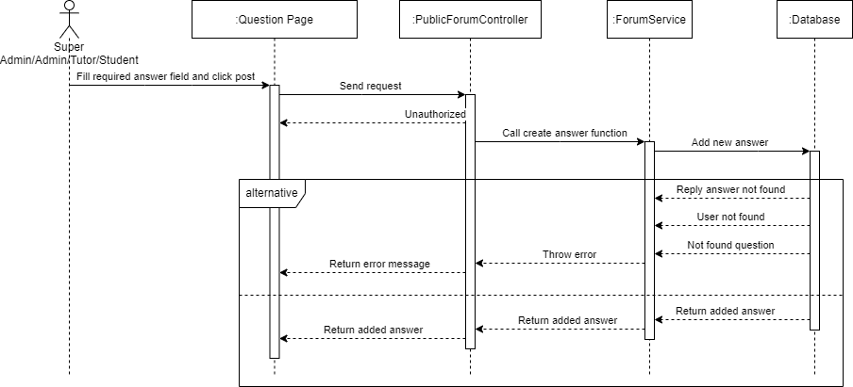

#### d. Database queries

#### 

### 9.2.3. Edit answer

#### a. Class Diagram

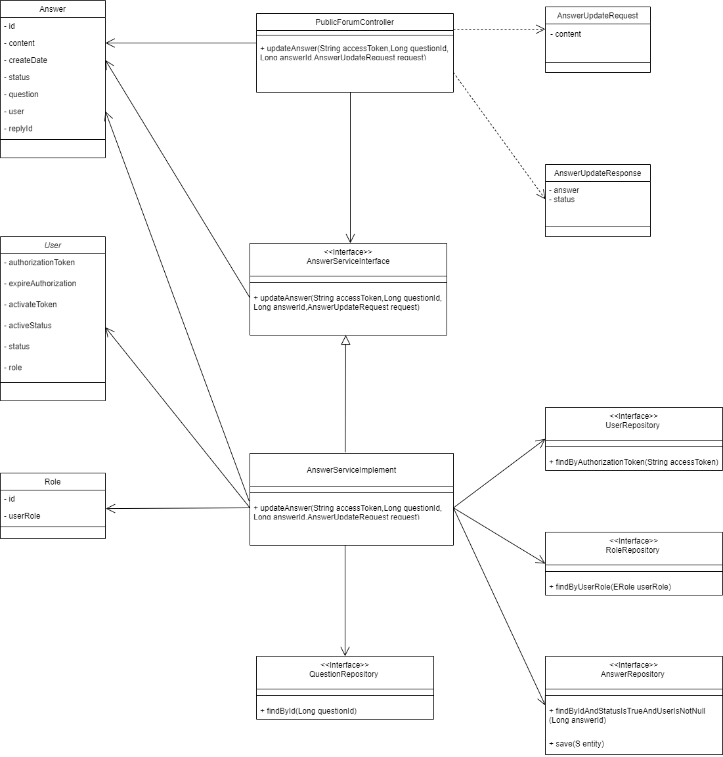

#### b. Class Specifications

##### PublicForumController Class

| **No** | **Method** | **Description** |
| --- | --- | --- |
| *01* | *updateAnswer* | *Call the API of updateAnswer* |

##### ForumService Class

| **No** | **Method** | **Description** |
| --- | --- | --- |
| *01* | *updateAnswer* | *This function changes the content of the answer* |
| *02* | *findByIdAndStatusIsTrueAndUserIsNotNull* | *Find the answer by Id and status is true and the user is not null.* |
| *03* | *findByUserRole* | *Find the role of the user.* |
| *04* | *setContent* | *Change the content of the old answer with the new content.* |

#### c. Sequence Diagram(s)

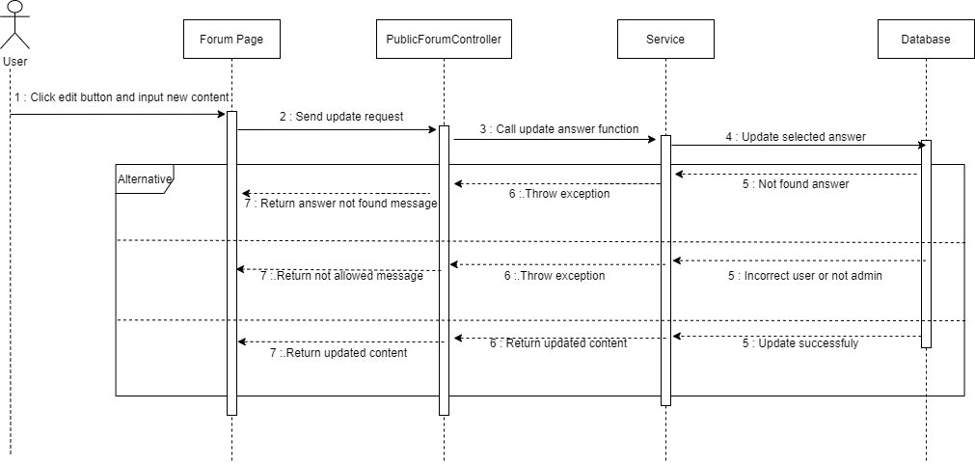

#### d. Database queries

### 9.2.4. Delete answer

#### a. Class Diagram

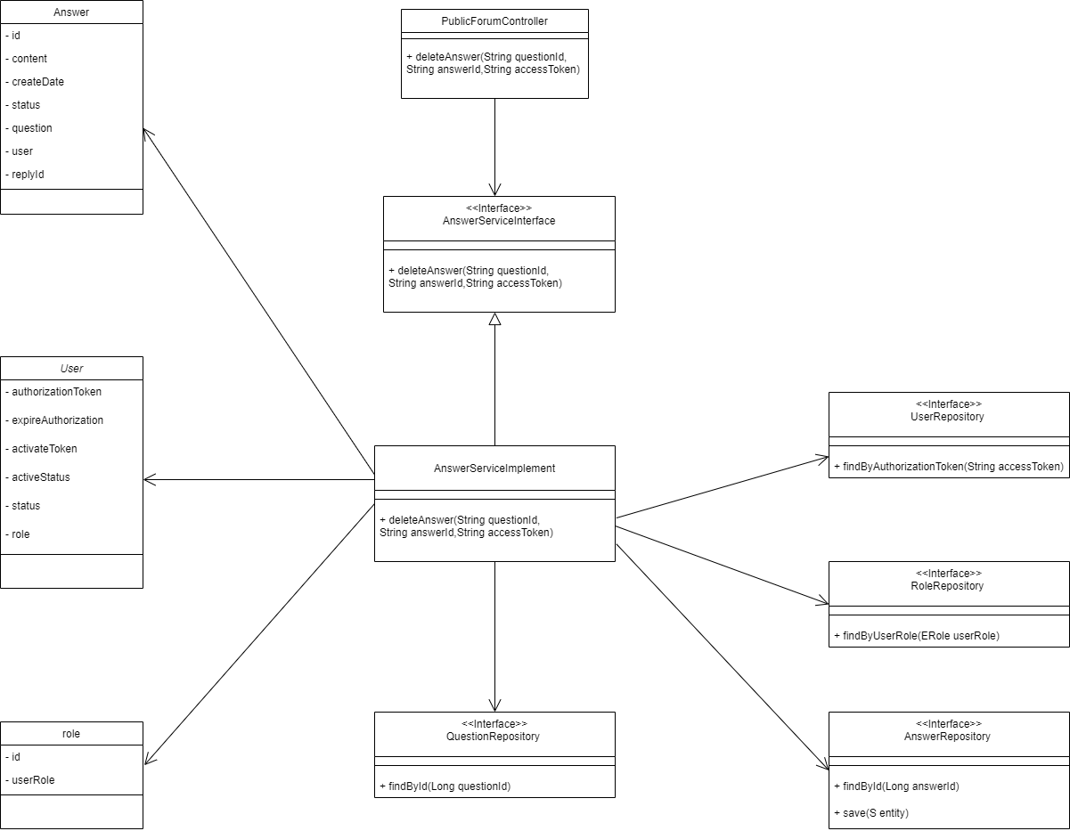

#### b. Class Specifications

##### PublicForumController Class

| **No** | **Method** | **Description** |
| --- | --- | --- |
| *01* | *deleteAnswer* | *Call the API of deleteAnswer* |

##### ForumService Class

| **No** | **Method** | **Description** |
| --- | --- | --- |
| *01* | *deleteAnswer* | *This function deletes the selected answer.* |
| *02* | *findById* | *Find the answer by Id.* |
| *03* | *setStatus* | *Change the status of the answer to false (soft delete).* |

#### c. Sequence Diagram(s)

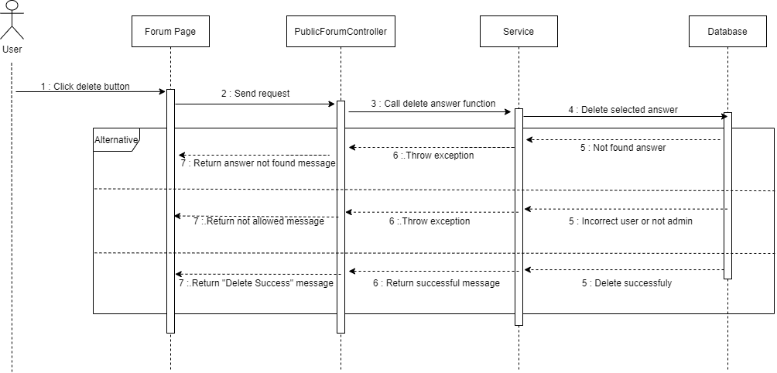

#### d. Database queries

# III. Database Tables

## 1. users_account

| **#** | **Field name** | **Type** | **Size** | **Unique** | **Not Null** | **PK/FK** | **Notes** |
| --- | --- | --- | --- | --- | --- | --- | --- |
| 1 | id | bigint | 8 | Yes | Yes | PK |  |
| 2 | activate_token | varchar | 255 |  | No |  |  |
| 3 | active_status | bit | 1 |  | No |  | this status will true if user active email verification |
| 4 | address | nvarchar | 500 |  | No |  |  |
| 5 | affiliate | varchar | 255 |  | No |  |  |
| 6 | authorization_token | varchar | 255 |  | No |  |  |
| 7 | avatar | varchar | 255 |  | No |  |  |
| 8 | birthday | varchar | 255 |  | No |  |  |
| 9 | email | varchar | 255 |  | No |  |  |
| 10 | expire_authorization | datetime2 | 7 |  | No |  |  |
| 11 | facebook_url | varchar | 255 |  | No |  |  |
| 12 | full_name | nvarchar | 100 |  | No |  |  |
| 13 | gender | varchar | 255 |  | No |  |  |
| 14 | gpa | float | 7 |  | No |  |  |
| 15 | grade | int | 2 |  | No |  |  |
| 16 | password | varchar | 255 |  | No |  |  |
| 17 | phone | varchar | 255 |  | No |  |  |
| 18 | reset_password_code | bigint | 8 |  | No |  |  |
| 19 | status | bit | 1 |  | No |  | Not Deleted: true.  Deleted: false. |
| 20 | username | varchar | 255 | Yes | Yes |  |  |

## 2. user_roles

| **#** | **Field name** | **Type** | **Size** | **Unique** | **Not Null** | **PK/FK** | **Notes** |
| --- | --- | --- | --- | --- | --- | --- | --- |
| 1 | user_id | bigint | 8 | Yes | Yes | PK,FK |  |
| 2 | role_id | bigint | 8 |  | Yes | PK,FK |  |

## 

## 3. roles

| **#** | **Field name** | **Type** | **Size** | **Unique** | **Not Null** | **PK/FK** | **Notes** |
| --- | --- | --- | --- | --- | --- | --- | --- |
| 1 | id | bigint | 8 | Yes | Yes | PK |  |
| 2 | user_role | varchar | 255 |  | No |  |  |

## 

## 4. rate

| **#** | **Field name** | **Type** | **Size** | **Unique** | **Not Null** | **PK/FK** | **Notes** |
| --- | --- | --- | --- | --- | --- | --- | --- |
| 1 | id | bigint | 8 | Yes | Yes | PK |  |
| 2 | description | nvarchar | 4000 |  | No |  |  |
| 3 | status | bit | 1 |  | No |  | Not Deleted: true.  Deleted: false. |
| 4 | time | datetime2 | 7 |  | No |  |  |
| 5 | value | float | 7 |  | No |  |  |
| 6 | student_id | bigint | 8 |  | No | FK |  |
| 7 | subject_id | bigint | 8 |  | No | FK |  |
| 8 | tutor_id | bigint | 8 |  | No | FK |  |

## 5. subject

| **#** | **Field name** | **Type** | **Size** | **Unique** | **Not Null** | **PK/FK** | **Notes** |
| --- | --- | --- | --- | --- | --- | --- | --- |
| 1 | id | bigint | 8 | Yes | Yes | PK |  |
| 2 | subject_name | varchar | 255 |  | No |  |  |

## 

## 6. question

| **#** | **Field name** | **Type** | **Size** | **Unique** | **Not Null** | **PK/FK** | **Notes** |
| --- | --- | --- | --- | --- | --- | --- | --- |
| 1 | id | bigint | 8 | Yes | Yes | PK |  |
| 2 | description | nvarchar | 4000 |  | No |  |  |
| 3 | status | bit | 1 |  | No |  | Not Deleted: true.  Deleted: false. |
| 4 | created_date | date | 7 |  | No |  |  |
| 5 | title | bit | 4000 |  | Yes |  |  |
| 6 | user_id | bigint | 8 |  | No | FK |  |
| 7 | subject_id | bigint | 8 |  | No | FK |  |

## 7. answer

| **#** | **Field name** | **Type** | **Size** | **Unique** | **Not Null** | **PK/FK** | **Notes** |
| --- | --- | --- | --- | --- | --- | --- | --- |
| 1 | id | bigint | 8 | Yes | Yes | PK |  |
| 2 | [content] | nvarchar | 4000 |  | No |  |  |
| 3 | status | bit | 1 |  | No |  | Active: true.  Deleted: false. |
| 4 | created_date | date | 7 |  | No |  |  |
| 5 | question_id | bigint | 8 |  | Yes | FK |  |
| 6 | user_id | bigint | 8 |  | No | FK |  |
| 7 | reply_id | bigint | 8 |  | No |  |  |

## 8. course

| **#** | **Field name** | **Type** | **Size** | **Unique** | **Not Null** | **PK/FK** | **Notes** |
| --- | --- | --- | --- | --- | --- | --- | --- |
| 1 | id | bigint | 8 | Yes | Yes | PK |  |
| 2 | cost | float | 20 |  | Yes |  |  |
| 3 | course_description | nvarchar | 4000 |  | No |  |  |
| 4 | course_name | nvarchar | 4000 |  | No |  |  |
| 5 | grade | int | 2 |  | Yes |  |  |
| 6 | length | int |  |  | Yes |  |  |
| 7 | public_status | bit | 1 |  | No |  |  |
| 8 | status | bit | 1 |  | No |  | Not Deleted: true.  Deleted: false. |
| 9 | subject_id | bigint | 8 |  | No | FK |  |
| 10 | tutor_id | bigint | 8 |  | No | FK |  |

## 9. course_student

| **#** | **Field name** | **Type** | **Size** | **Unique** | **Not Null** | **PK/FK** | **Notes** |
| --- | --- | --- | --- | --- | --- | --- | --- |
| 1 | id | bigint | 8 | Yes | Yes | PK |  |
| 2 | learning_status | bit | 1 |  | No |  |  |
| 3 | status | bit | 1 |  | No |  | Not Deleted: true.  Deleted: false. |
| 4 | course_id | bigint | 8 | Yes | No | FK |  |
| 5 | student_id | bigint | 8 | Yes | No | FK |  |

## 10. course_material

| **#** | **Field name** | **Type** | **Size** | **Unique** | **Not Null** | **PK/FK** | **Notes** |
| --- | --- | --- | --- | --- | --- | --- | --- |
| 1 | id | bigint | 8 | Yes | Yes | PK |  |
| 2 | description | nvarchar | 4000 |  | No |  |  |
| 3 | file_attach | varchar | 255 |  | No |  |  |
| 4 | link_share | varchar | 255 |  | No |  |  |
| 5 | status | bit | 1 |  | No |  | Not Deleted: true.  Deleted: false. |
| 6 | title | nvarchar | 255 |  | No |  |  |
| 7 | course_id | bigint | 8 | Yes | No | FK |  |

## 11. course_timetable

| **#** | **Field name** | **Type** | **Size** | **Unique** | **Not Null** | **PK/FK** | **Notes** |
| --- | --- | --- | --- | --- | --- | --- | --- |
| 1 | id | bigint | 8 | Yes | Yes | PK |  |
| 2 | day | int | 2 |  | No |  |  |
| 3 | end_time | time | 7 |  | No |  |  |
| 4 | start_time | time | 7 |  | No |  |  |
| 5 | status | bit | 1 |  | No |  | Not Deleted: true.  Deleted: false. |
| 6 | course_id | bigint | 8 | Yes | No | FK |  |