VIETNAM NATIONAL UNIVERSITY HO CHI MINH CITY
UNIVERSITY OF SCIENCE
FACULTY OF INFORMATION TECHNOLOGY
INTRODUCTION TO SOFTWARE ENGINEERING


PA1 REPORT
DineVina
Smart Restaurant Reservation and Event Booking System
Project team: Group 8
Instructor:
Instructor:
Instructor:

Ho Chi Minh City, October 14, 2026

Contents
1. Project overview and readiness
2. Group registration
3. Project proposal
4. Existing app survey
5. Team contract
6. Development tools and Scrum process
7. Submission evidence and next actions
References

1. Project overview and readiness
DineVina is a proposed responsive web application that connects diners with restaurants for discovery, menu browsing, table reservations and event inquiries. Restaurant partners manage venue information and incoming requests. The repository currently contains a runnable React and FastAPI scaffold with one health endpoint; the product workflows and AI feature remain planned work.
PA1 area | Current report status | Evidence still needed
Group registration | Team roster and leader recorded | Registration form confirmation
Project proposal | Nine functional groups and AI proposal written | Team and TA scope review
Existing app survey | PasGo and Eatigo reviewed with four captured screens | Team review of findings
Team contract | Terms drafted for adoption | Named duties, availability and member agreement
Tools and process | Private repo, local workflow and Jira sprint verified | Team meetings, actual task owners and AI accounts

2. Group registration
The repository identifies Group 8 and the five members below. Hoàng Cao Phong is listed as group leader. The course registration form link and submission confirmation are not present in the available project files.
Student ID | Full name | Email
24127486 | Hoàng Cao Phong | hcphong2425@clc.fitus.edu.vn
24127294 | Võ Mỹ Ngọc | vmngoc2433@clc.fitus.edu.vn
24127475 | Lương Thiện Nhân | ltnhan2433@clc.fitus.edu.vn
24127068 | Nguyễn Trung Kiên | ntkien2418@clc.fitus.edu.vn
24127160 | Trương Khánh Duy | tkduy2414@clc.fitus.edu.vn

3. Project proposal

3.1. Idea and value

Diners often need to compare venue location, menu, price, availability and suitability for a group before making a reservation. DineVina proposes one journey from discovery to a confirmed table or an event request, while giving restaurants a controlled workspace to keep their information and capacity current. The first release focuses on ordinary bookings; event coordination and AI assistance follow after reliable venue and menu data exist.

3.2. Target users and environment

Customers use a mobile or desktop browser to search and reserve. Restaurant partners use the same responsive web application to maintain listings, menus and booking requests. A platform administrator reviews partner onboarding and moderates records. The planned stack is React with TypeScript, FastAPI and PostgreSQL, developed locally with Docker Compose; no native mobile application is included in the first scope.

3.3. Nine functional groups

1. Accounts and profiles. Customers and partners register, sign in and update basic profile data. Role-aware access keeps restaurant management separate from customer actions.
2. Restaurant onboarding. A partner submits venue details, address, cuisine, images and contact information for review. An administrator approves or returns a listing so customers see a curated and attributable venue record.
3. Restaurant discovery. Customers search by name or location and narrow results by cuisine, price and relevant amenities. Venue details make the shortlist easier to compare before a booking.
4. Menus. Partners maintain dishes, descriptions, prices and availability. Customers read the menu before reserving, reducing uncertainty about whether a venue suits their preferences.
5. Table reservations. Customers choose date, time and party size, submit a request and view its state; partners confirm or reject it. Cancellation and status history prevent a request from being mistaken for a confirmed table.
6. Event booking. Customers provide occasion, headcount, date, budget and special needs in an event brief. The partner can respond with a proposal or request clarification, keeping the negotiation in one visible thread.
7. Availability and partner dashboard. Partners set opening hours, capacity and unavailable slots, then review incoming reservations and event leads. Capacity controls help avoid promises that the restaurant cannot fulfil.
8. Promotions and editorial. Partners publish time-bound offers and short venue content subject to platform rules. Customers can discover relevant value without losing sight of eligibility and expiry conditions.
9. Intelligent assistance. A preference-based recommender ranks suitable restaurants and explains each suggestion using verified venue attributes. A later conversational assistant can answer questions from approved menu and policy records with source links and uncertainty handling.

3.4. AI feature and staged delivery

The first meaningful AI feature is explainable restaurant recommendation. A customer states preferences such as cuisine, area, price and group size; the system filters ineligible venues, scores the remaining candidates and displays reasons such as menu match and suitable capacity. Evaluation should use a small labeled set of realistic queries, measure ranking quality and bad suggestions, and allow customers to continue with ordinary filters. Verified venue data, consent and logging limits are prerequisites; the repository does not yet implement this feature.
Later experiments may add a retrieval-based assistant over approved restaurant data and menu OCR that creates editable partner drafts. Both are separate future slices and must not publish generated facts without human review. Payment processing and full restaurant accounting remain outside the present scope.

4. Existing app survey

4.1. Method and PasGo

The survey inspected public pages on 14 October 2026. PasGo is a direct Vietnamese comparison for restaurant discovery and table booking. Its listing page exposes location, district, price, cuisine and occasion filters, visible offers, ratings and a direct booking call to action. The observed Kingscross page places photos, venue details and a booking panel with party size and arrival time on one screen; the report did not submit a reservation.
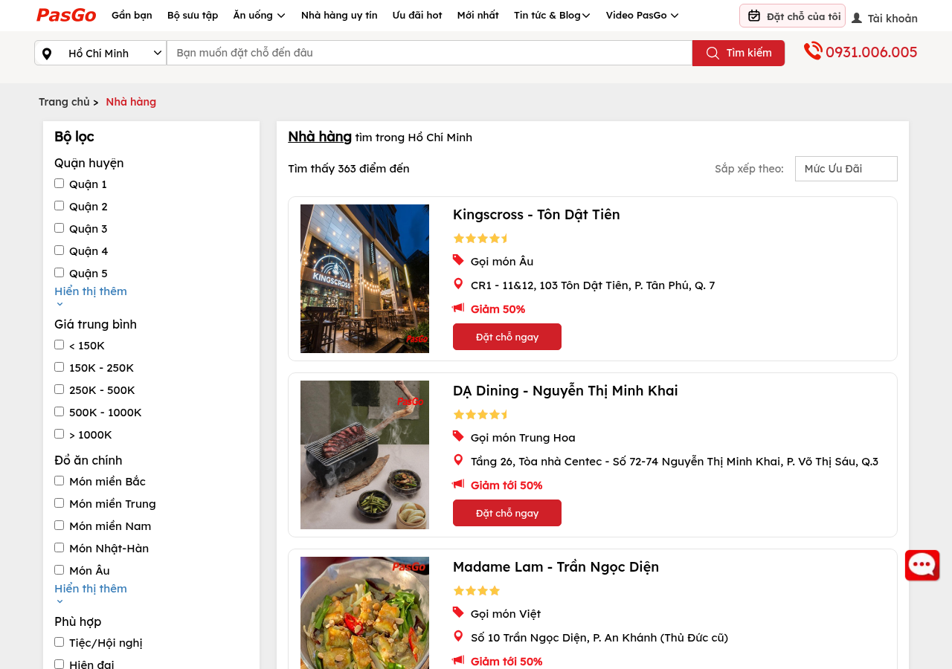
Figure. PasGo listing: filters, offer cards and direct booking actions [4].
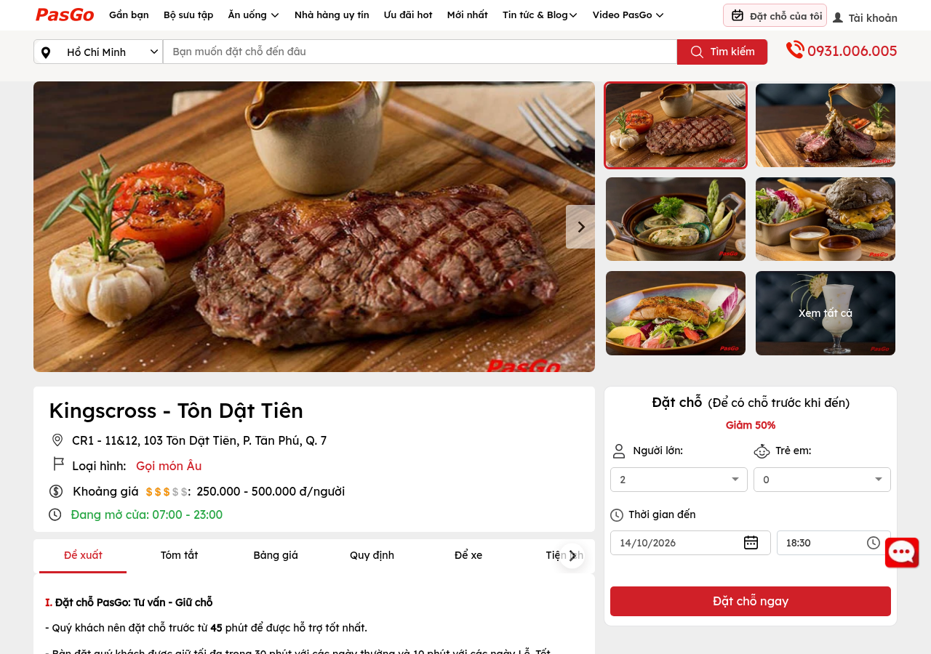
Figure. PasGo venue detail: photos, price context and booking controls [5].

4.2. Method and Eatigo
Eatigo is a regional comparison for reservation discovery and time-linked discounts. Its home page foregrounds date, time, party size and restaurant search. The observed Chiang Mai results page shows filters for price, discount, rating and cuisine, plus discount percentages attached to specific time slots. This is useful interaction evidence, but it is not evidence of Vietnam market coverage or of an event-inquiry workflow.
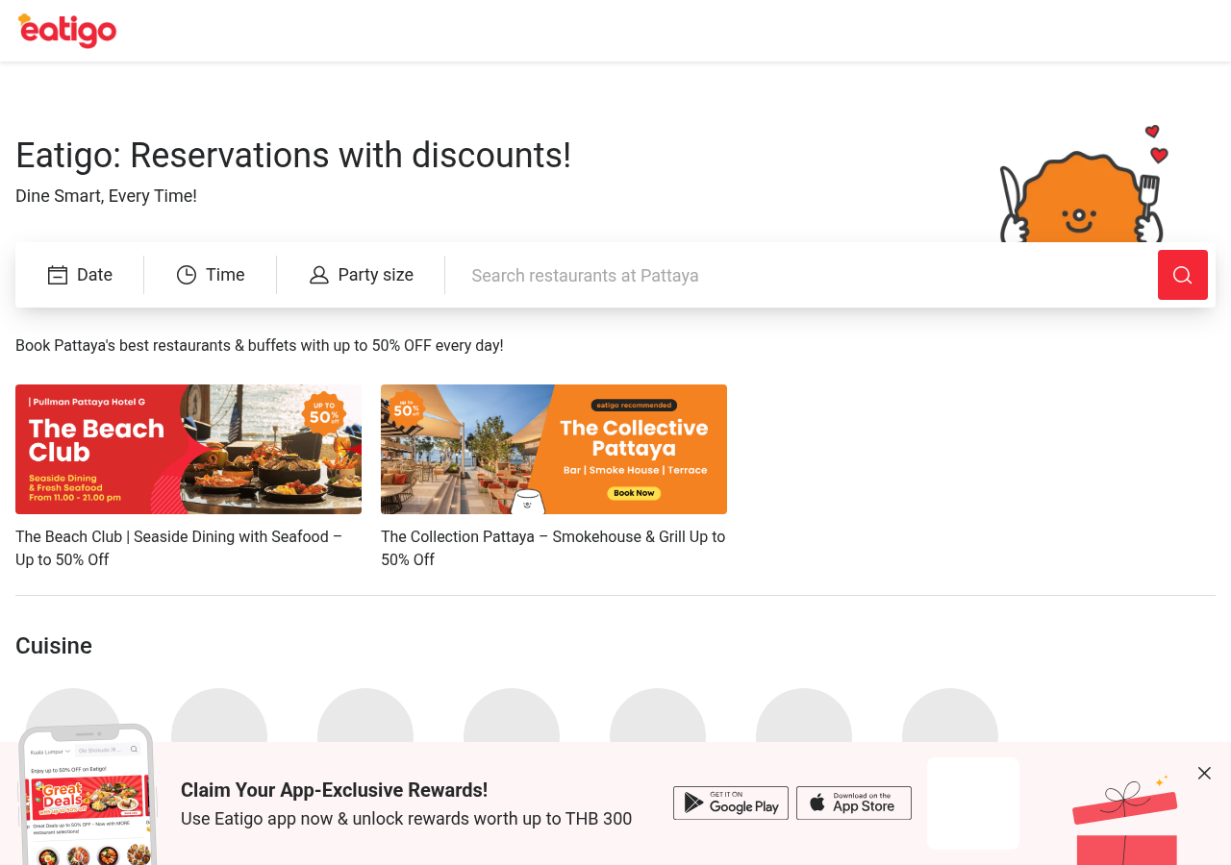
Figure. Eatigo home: date, time, party size and search fields [6].
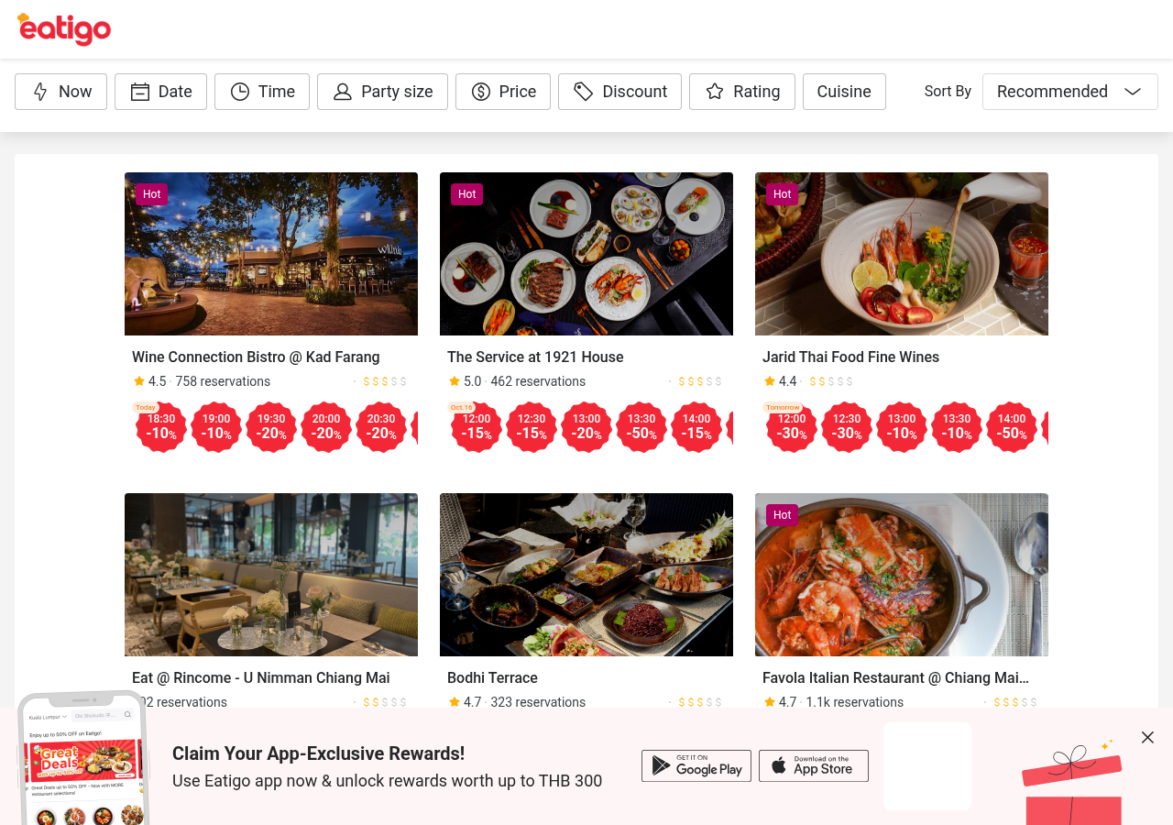
Figure. Eatigo results: filters and time-specific offer chips [7].

4.3. Comparison and design response
Dimension | PasGo | Eatigo | DineVina proposal
Discovery | Detailed local filters | Time and discount filters | Combine venue and booking-fit filters
Venue detail | Photos, price, booking panel | Offer and slot emphasis | Show verified menu, capacity and terms
Reservation | Party size and arrival time | Time-specific offer slots | Request/confirmation state visible to both actors
Events | Occasion-oriented discovery visible | Not established in surveyed screens | Structured event brief and partner response
AI assistance | Not evaluated in surveyed screens | Not evaluated in surveyed screens | Explainable recommendations after data validation
Common patterns worth adopting are early filters, rich venue cards, clear party/date/time input and visible promotion conditions. DineVina should differentiate through transparent request status, partner-maintained data and a structured event path. AI recommendations are a proposed enhancement, not a demonstrated advantage over these products. A team usability review should validate these choices before implementation.

5. Team contract
The following terms are proposed for agreement by all five members. They are not a signed or confirmed team contract until the members approve the responsibilities, communication channel, meeting times and escalation process.

5.1. Roles and responsibilities
Every member acts as a full-stack engineer and participates in requirements, implementation, review, testing and documentation. The known group leader is Hoàng Cao Phong, who coordinates the schedule and consolidates decisions. Other specialization leads and named deliverable owners must be recorded in the Scrum board after the team agrees them; the report does not assign work retrospectively.
Member | Confirmed role | Additional lead / availability
Hoàng Cao Phong | Full-stack engineer and group leader | To be agreed by team
Võ Mỹ Ngọc | Full-stack engineer | To be agreed by team
Lương Thiện Nhân | Full-stack engineer | To be agreed by team
Nguyễn Trung Kiên | Full-stack engineer | To be agreed by team
Trương Khánh Duy | Full-stack engineer | To be agreed by team

5.2. Communication and decisions
The team will choose one primary group chat and keep decisions, meeting minutes and links to tasks in the repository or board. Members should acknowledge project messages within one working day and raise blockers at the next Scrum meeting or earlier when a deadline is at risk. Decisions should seek consensus; when consensus fails, record options and use a majority vote. The leader records the outcome but does not silently replace the group decision. The channel and exact response window need team approval.

5.3. Schedule, quality and accountability

For each sprint, hold one planning meeting, two Scrum meetings and one review/retrospective. Planning assigns one owner and due date per task; members report completed work, next work and blockers. A missed deadline is reported as soon as it becomes likely, with a revised task plan and a reviewer. Every pull request links its task, passes relevant checks and receives review from another member before merge. Documentation uses English Markdown with diagrams when useful; credentials and customer data stay out of Git.
Contribution is assessed from completed tasks, reviewed changes, meeting participation and accepted documentation, rather than commit counts alone. If participation repeatedly falls short, the leader discusses the issue privately, records an agreed recovery plan and escalates unresolved cases to the TA. Review this contract at each sprint review and record agreed amendments. Members must ratify these consequences and identify their regular availability before submission.

6. Development tools and Scrum process

6.1. Tools and repository
Moodle is the course submission channel; the team still needs to agree its project chat. DineVina uses Jira for a 14–28 October 2026 PA1 sprint with 18 labeled tasks (17 To Do, one In Progress) and a linked proposal-review subtask. Each sprint task has a due date and the group leader as provisional assignee. After inviting members, the team must assign actual owners before work begins. Planning and other Scrum meetings remain pending. Jira timestamps start on 14 October; earlier scaffold work cannot be represented as pre-created tasks.
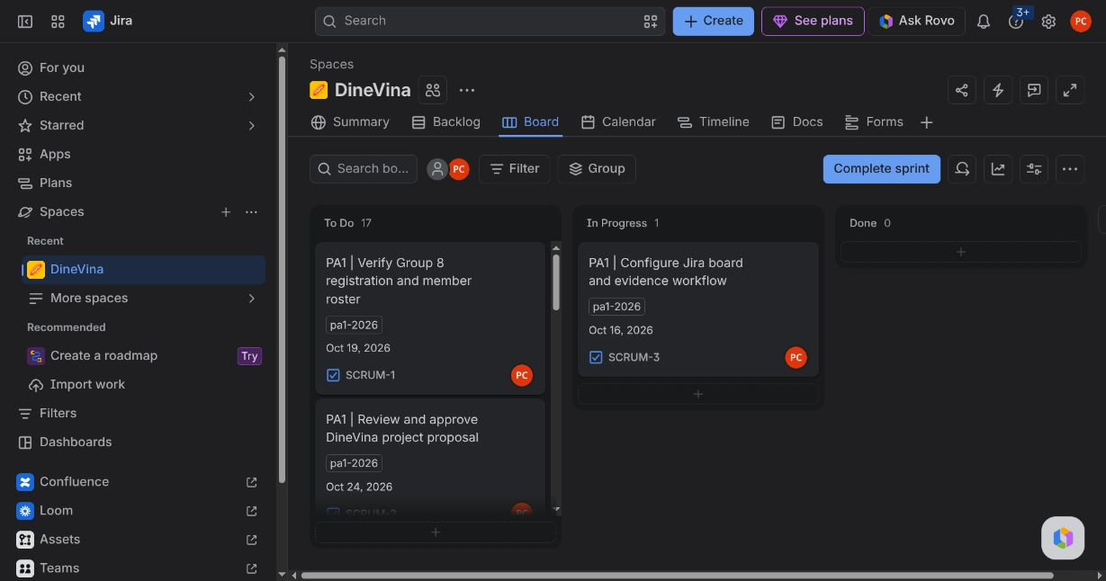
Figure. DineVina PA1 Jira board on 14 October 2026: 17 To Do, one In Progress.
The local Git repository has a private GitHub remote at https://github.com/HoangCaoPhong/DineVina on main. A live repository query confirmed private visibility and the remote main points to the single initial commit 52f75bb. The current project scaffold, documentation, CI and publishing workflows are local untracked changes or edits, so this report does not claim that the remote CI has run or that these materials are already pushed. The README describes local startup and the contribution guide requires branch, review and checks.

6.2. Technical starting point
The frontend is an informational React page that calls /api/health. FastAPI returns {"status":"ok"}; one backend test covers this route. Docker Compose defines web, API and PostgreSQL services, but the database is not used by the API. GitHub Actions workflow files define lint, test, frontend build and Docker validation, and a separate image publishing workflow; they become operational on GitHub only after the files are committed and pushed. The architecture and roadmap documents are working drafts.

6.3. Sprint evidence plan
Ceremony / artifact | Required evidence | Current observation
Sprint planning | Prioritized tasks, owners, dates, minutes | Not found in project files
Two Scrum meetings | Attendance; done/next/blockers for each member | Not found
Sprint review | Outcome, issues, improvements and actions | Not found
Task board | All work items with one owner and real timestamps | DineVina PA1: 18 tasks with one provisional owner and due dates; 17 To Do, 1 In Progress. Board screenshot saved 14 Oct.
AI coding accounts | Member account evidence without secrets | Not found
Git log | Commit history screenshot/export | One commit verified; PA1-Git-Log.txt exported
Spec Kit initialization is scheduled from PA2, not a PA1 completion claim. The repository and report must remain free of API keys, passwords and tokens.

7. Submission evidence and next actions
Before submission, the team must approve scope and contract, review the survey, hold and record Scrum meetings, reassign Jira tasks after invitations, verify AI coding accounts, include the Git log, and replace pending performer/reviewer/editor names. The package requires English Markdown, matching PDF, images and PA1-Group08.zip. The DOCX is an editable copy in the supplied format.
Action | Owner / status
Ratify team contract, roles, meeting availability and communication channel | Team / pending
Capture registration confirmation | Group leader / pending
Maintain PA1 Jira board and assign actual owners before work | Leader / board configured; redistribution pending
Record planning, two Scrum meetings and review | Team / pending
Review survey and approve proposal with TA if needed | Team / pending
Validate Markdown and PDF with images; archive the full evidence package | Team / pending

References
[1] CSC13002, Project Assignment 1 (PA1-2026), course brief, 2026.
[2] CSC13002, Weekly Reports, course handout, 2026.
[3] DineVina repository, README.md, docs/product-scope.md, docs/architecture.md, docs/roadmap.md and CONTRIBUTING.md, inspected 14 October 2026.
[4] PasGo, restaurant listing, https://pasgo.vn/nha-hang, accessed 14 October 2026.
[5] PasGo, Kingscross detail, https://pasgo.vn/nha-hang/kingscross---ton-dat-tien-2406, accessed 14 October 2026.
[6] Eatigo, home, https://eatigo.com/en, accessed 14 October 2026.
[7] Eatigo, Chiang Mai results, https://eatigo.com/en/regions/30/search, accessed 14 October 2026.

