1. The object will be detected

=> If (the distance from sensor to object) < (the THRESH_HOLD distance)

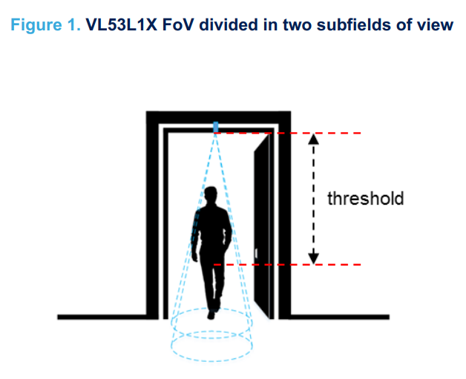

2. Path Track

- if object was detected in front zone

+ AllZoneCurrentStatus +=2 and save in PathTrack array

- if object was detected in back zone

+ AllZoneCurrentStatus +=1 and save in PathTrack array

- check PathTrachFillingSize if it == 4

+ check the order the element of PathTrack array

+ if the order is 2,3,1 => get out => decrease PeopleCount

+ if the order is 1,3,2 => get in => increase PeopleCount