Report lab2
Nguyễn Mai Hoàng Huy – ITCSIU22304
Github link: HoangHuy1405/WebAppLab
Exercise 1:
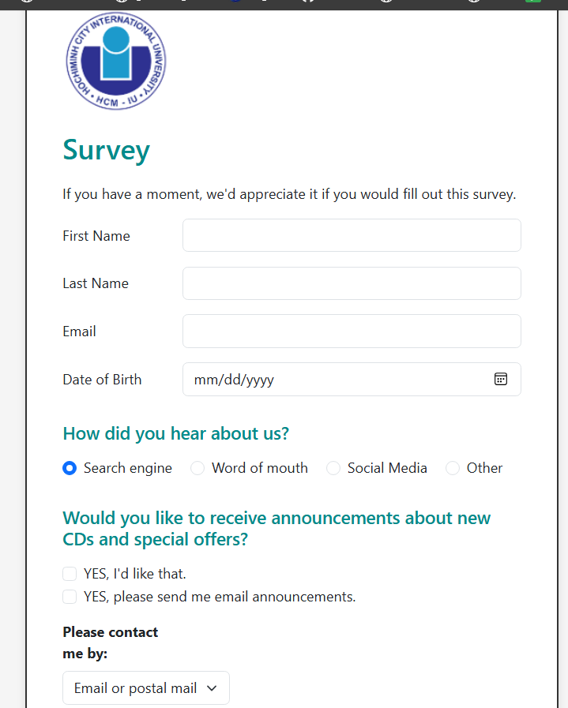

Exercise 2:
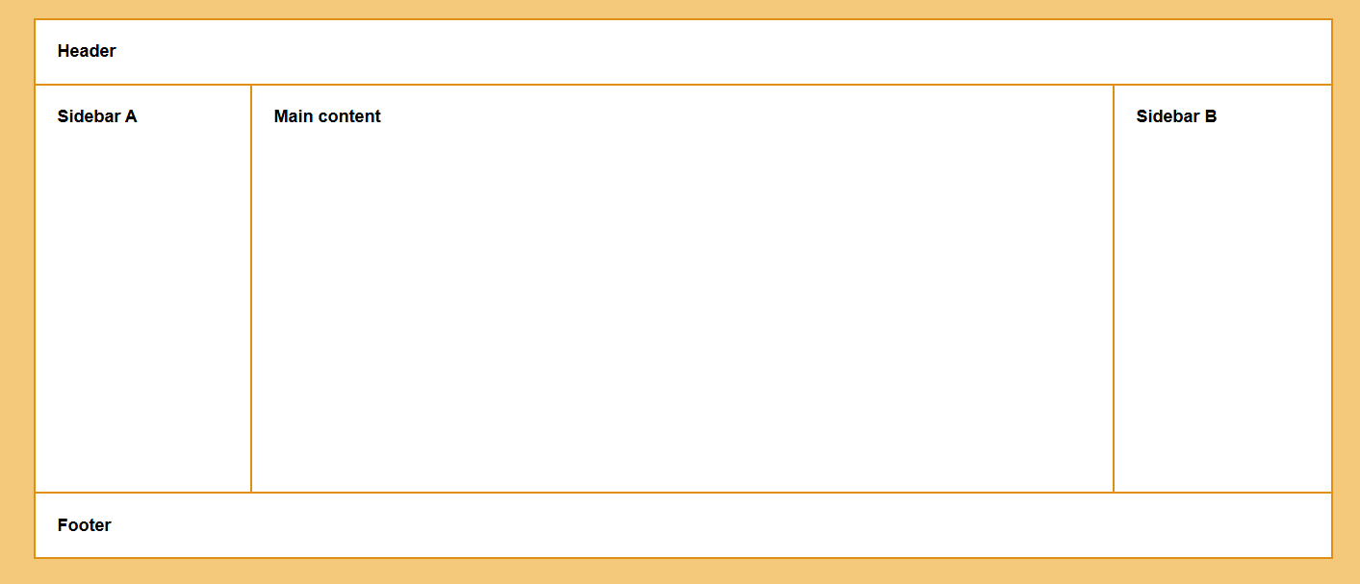

Exercise 3:
