Report Lab 3

  - Task 1.1:
Success case:
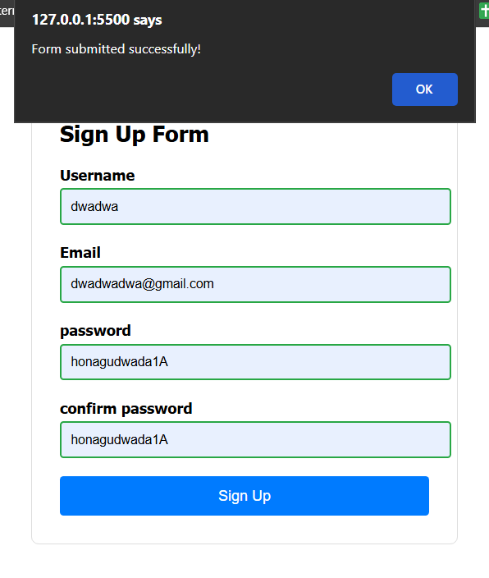

Error case:
- All validation are in real time
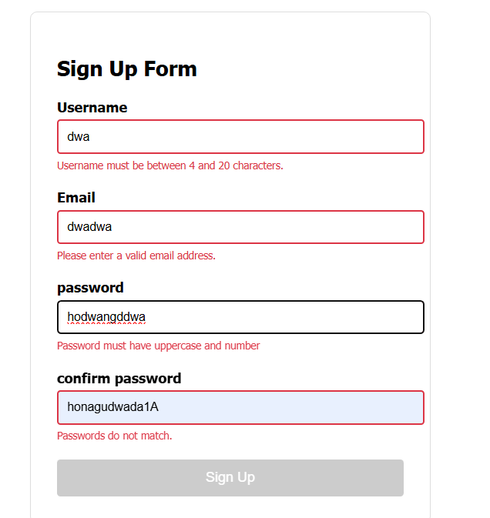
  - Task 1.2:
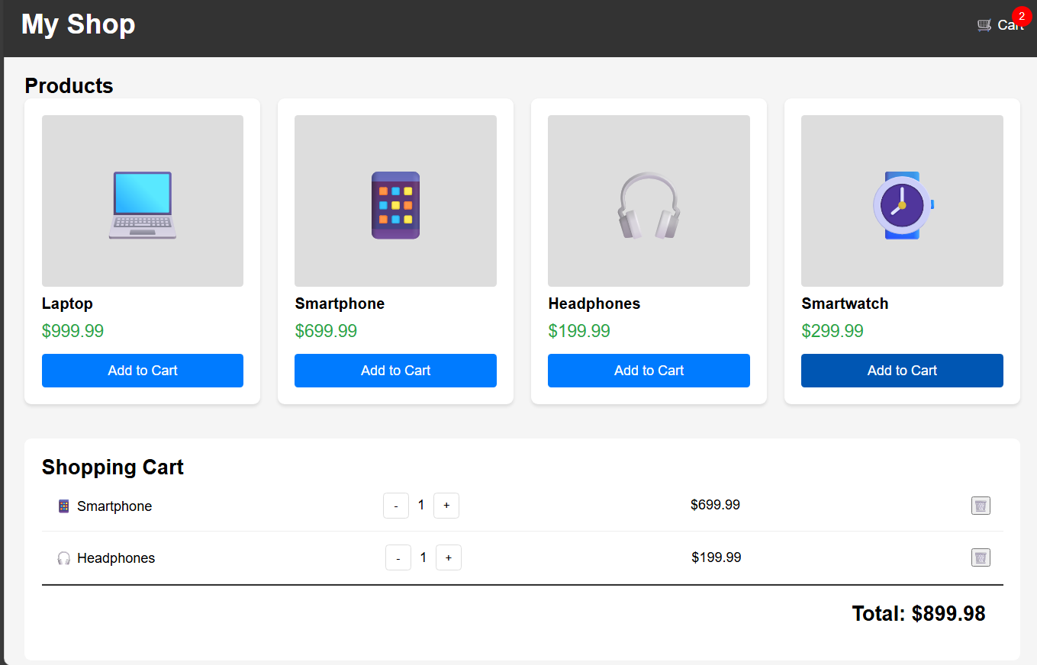

- Cart badge count are in real time.
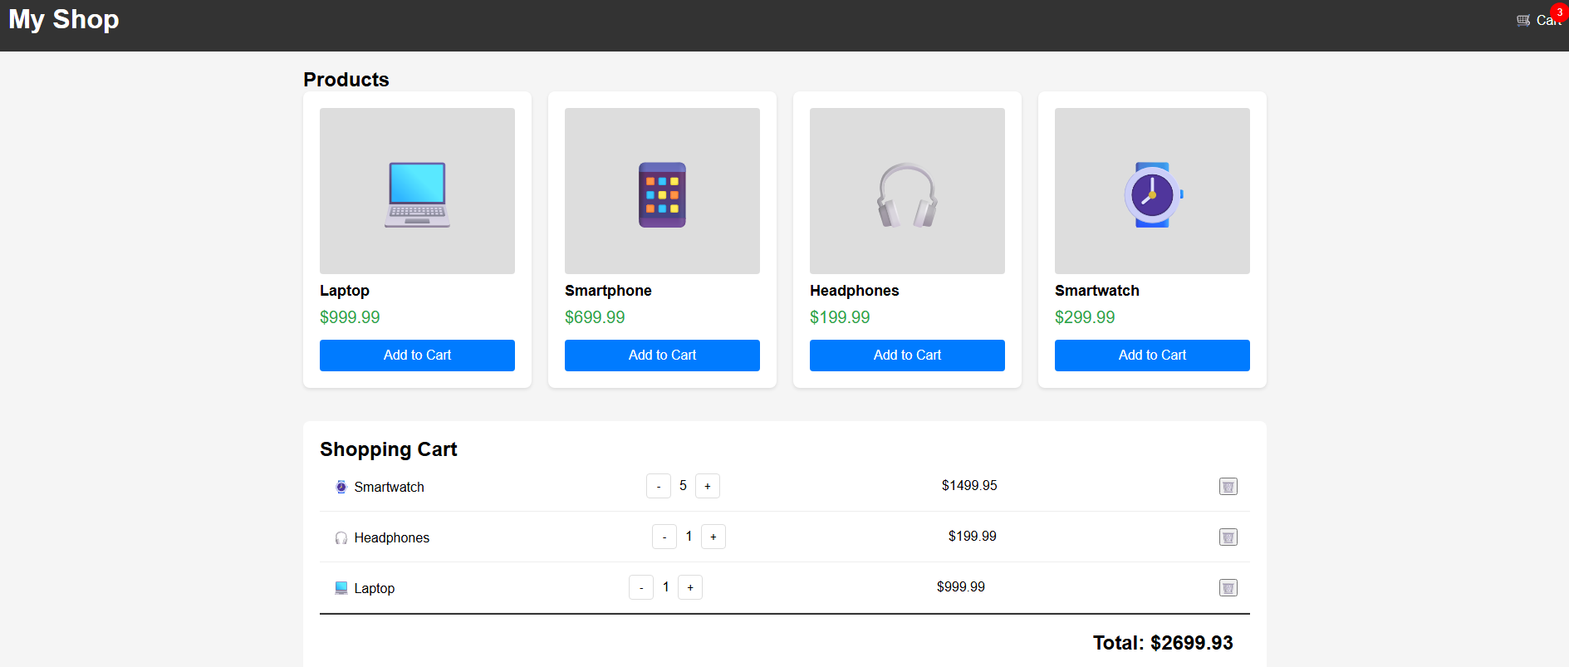

- Subtotal and total price are calculated in real time as user added new product or update quantity.

