Report Lab 4

EXERCISE 5:
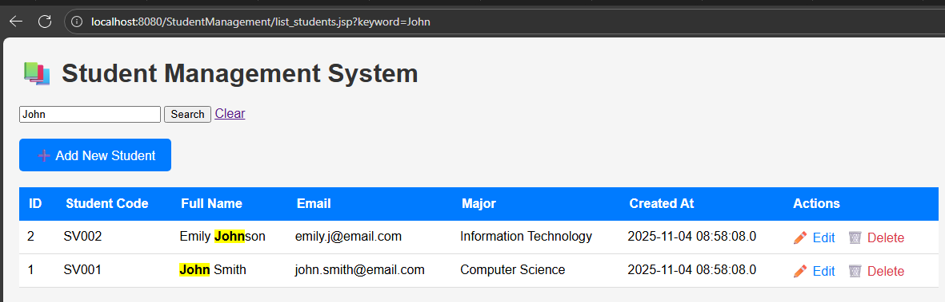
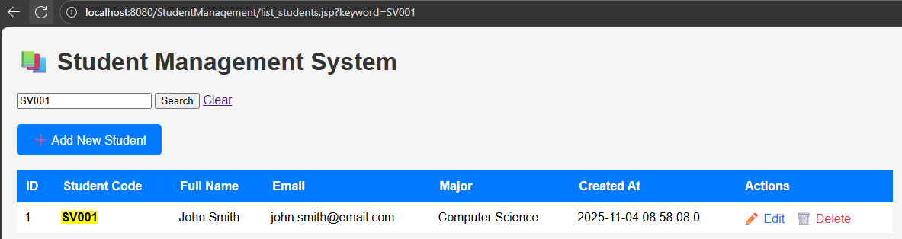
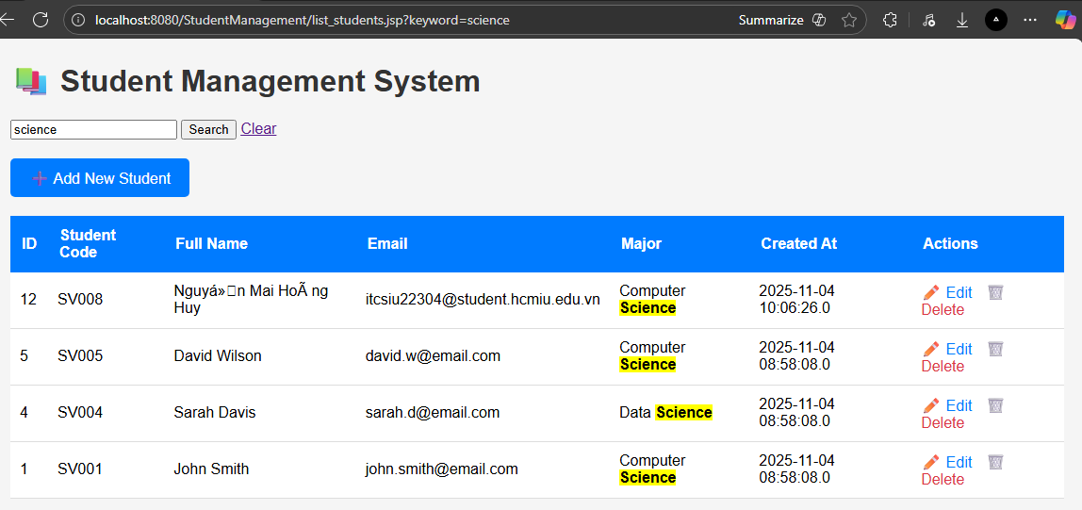
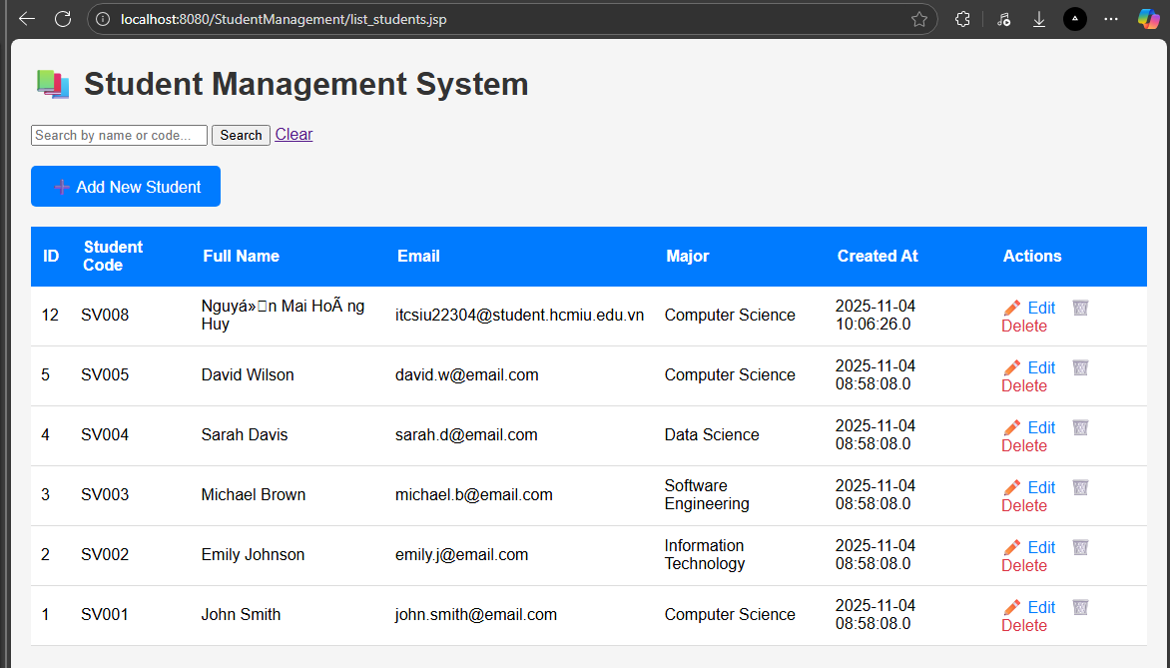
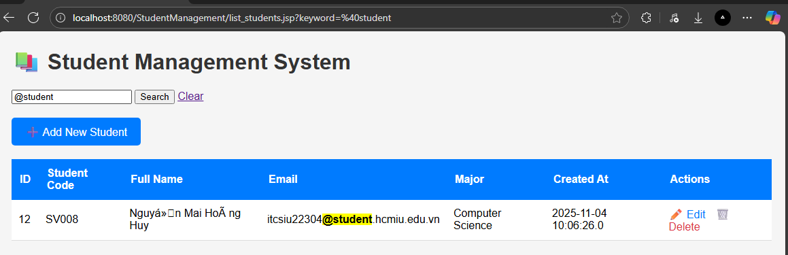

HW 6:
Email Validation:
Test case 1: john@email.com
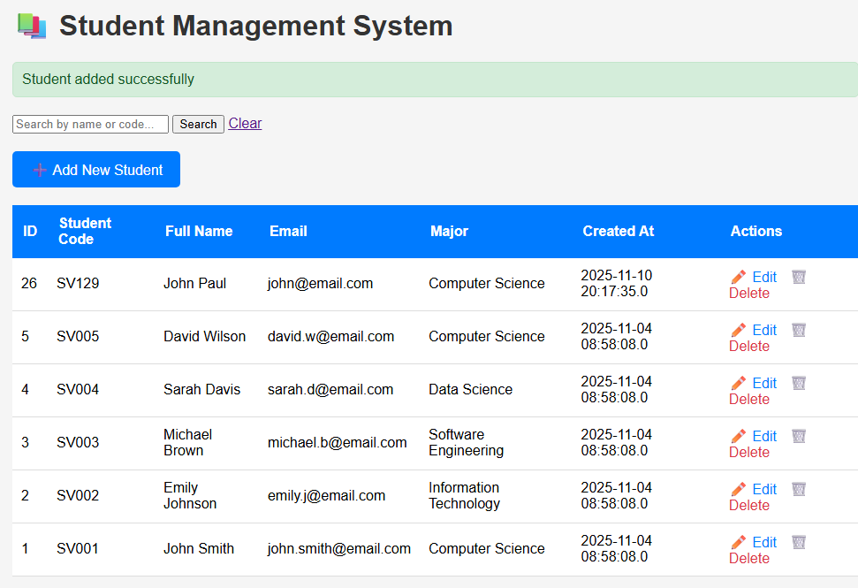
=> Success
Test case 2: john.doe@company.co.uk
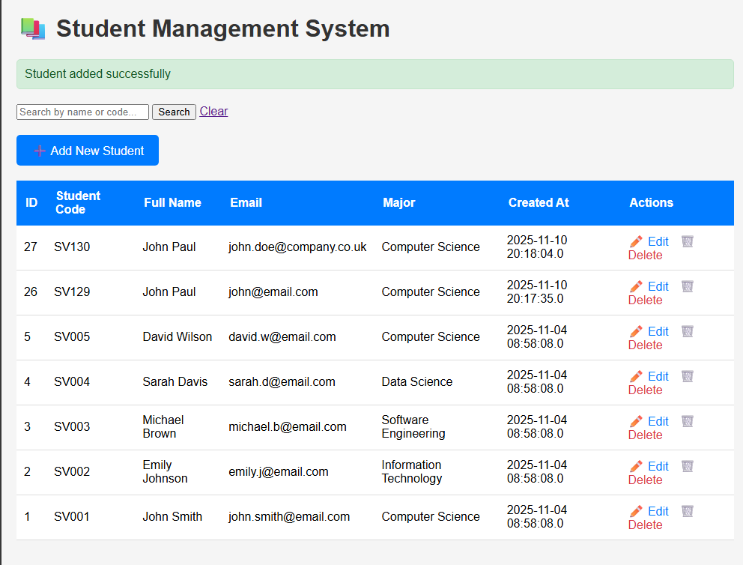

Test case 3: john@email
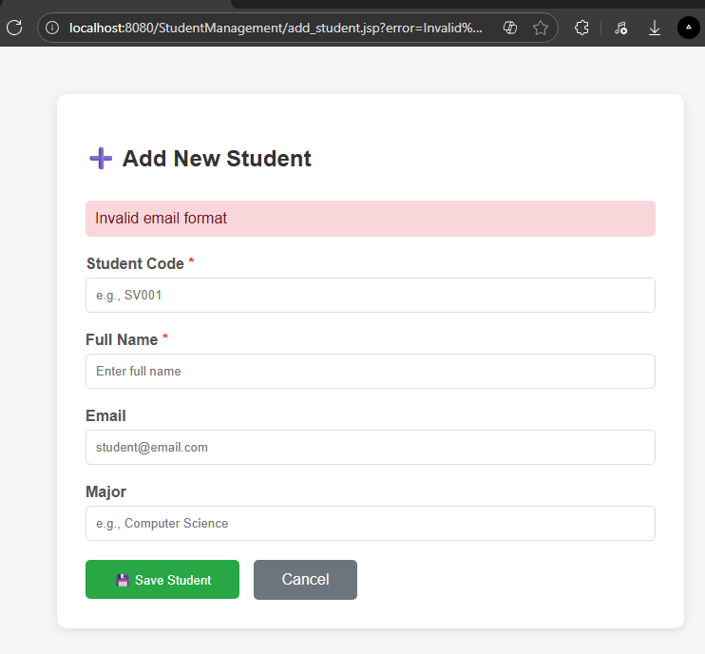
- Email invalid, => add new student failed
Test case 4: johnemail.com
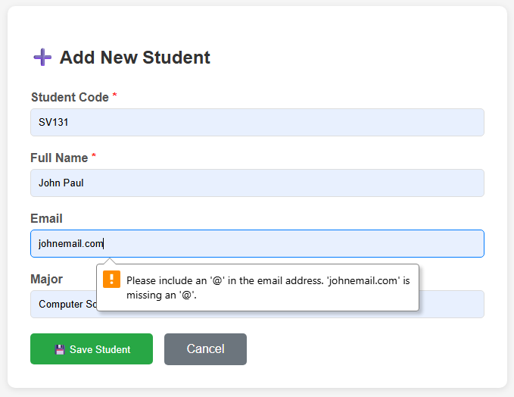
Test case 5: (empty)
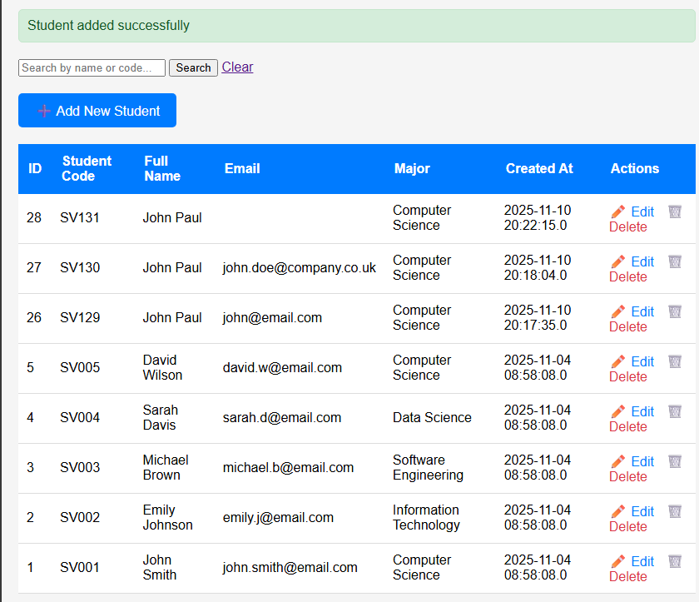
- Success, email is optional

Student Code Pattern Validation:
- Assuming I have disable the pattern check in input of student code in add_student.jsp
Test case 1: sv001
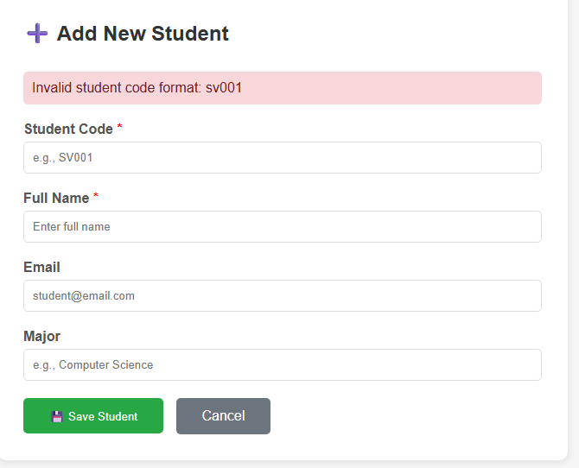
Test case 2: S001
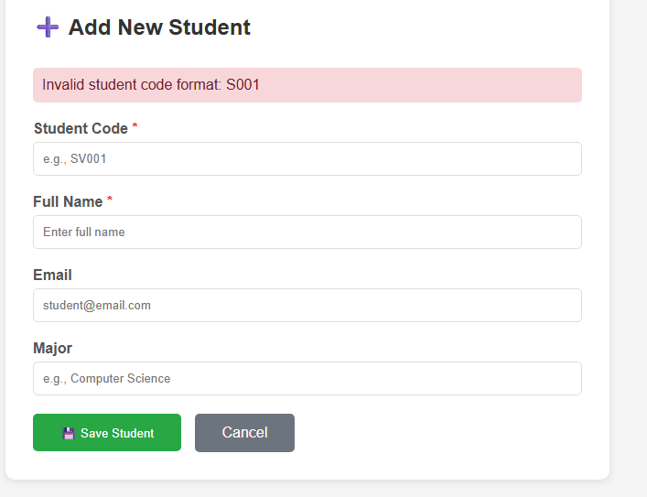
Test case 3: SV12
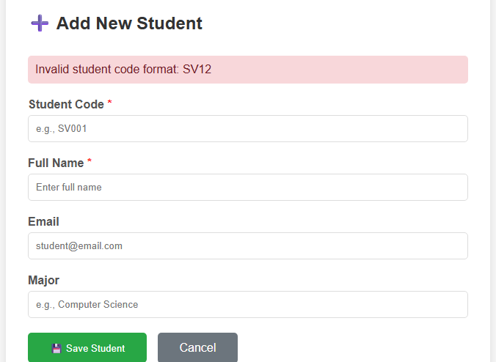
Test case 4: IT123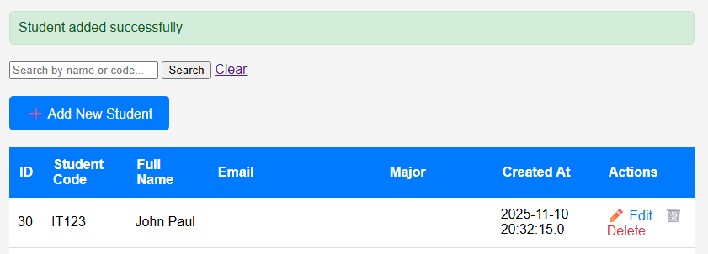

EXERCISE 7:
Before pagination:
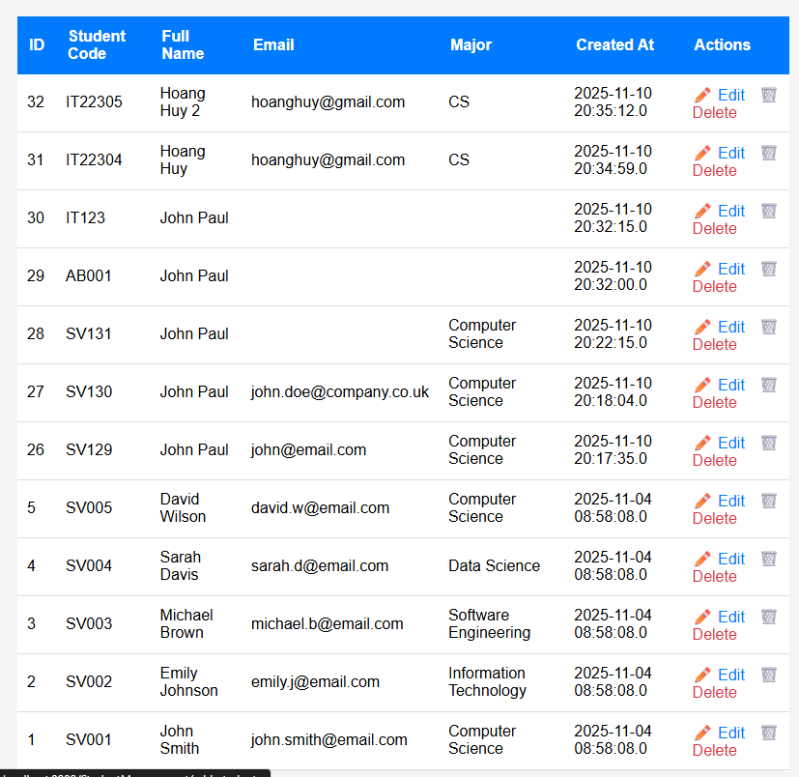
After pagination:
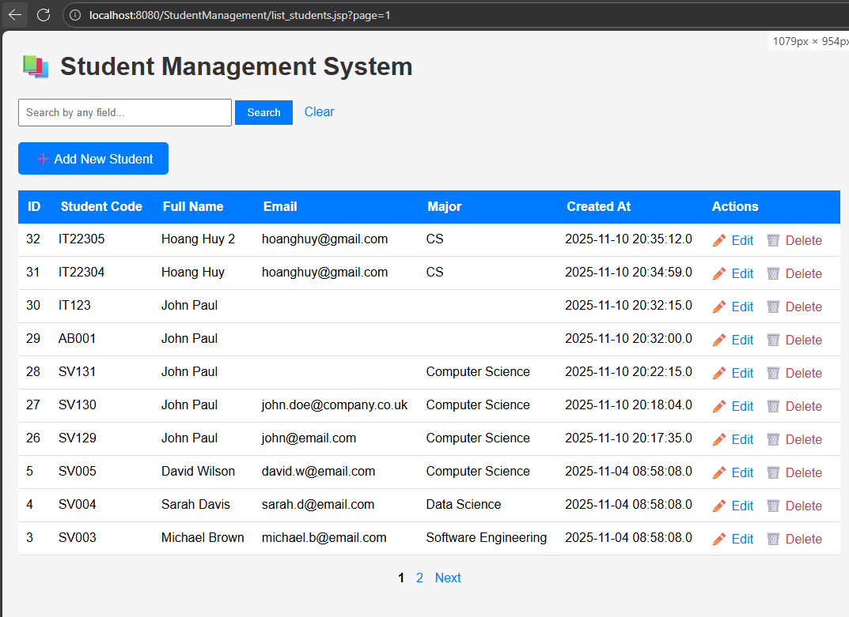
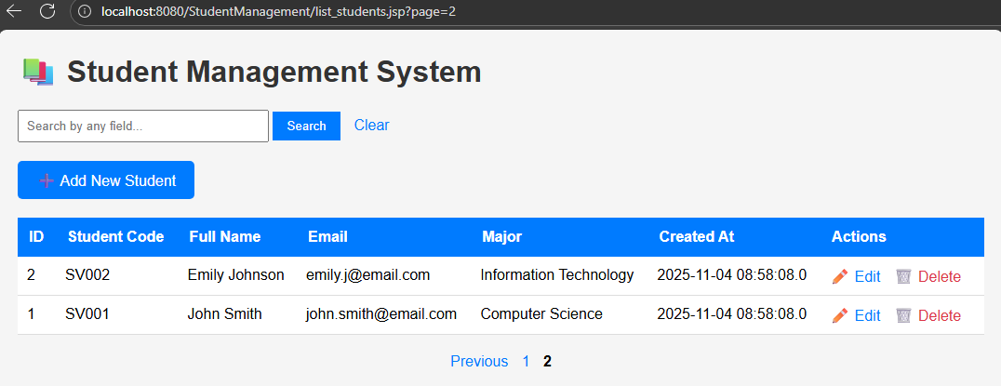

Also work with search (total records by keyword)
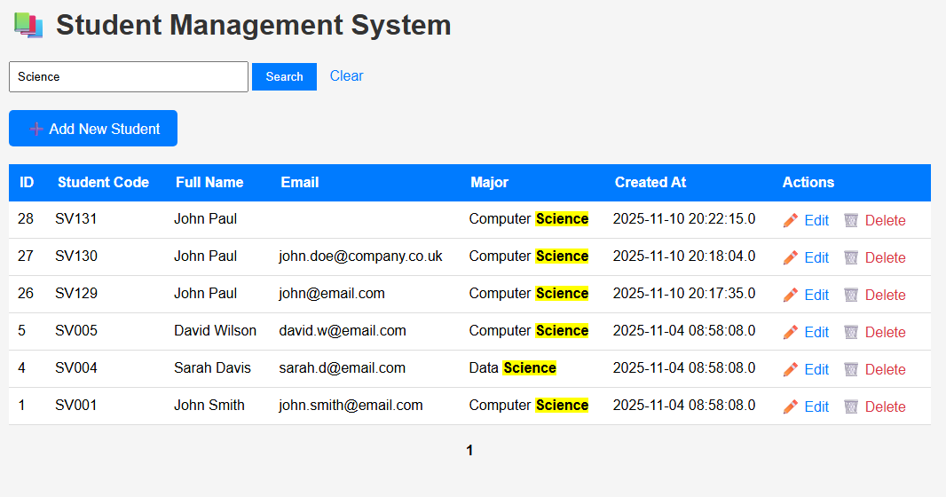

Improved UI/UX:
- Added icons message, green for success, red for error for list_student.jsp, add_student.jsp, edit_student.jsp .
- The message also automatically disappears after 3s
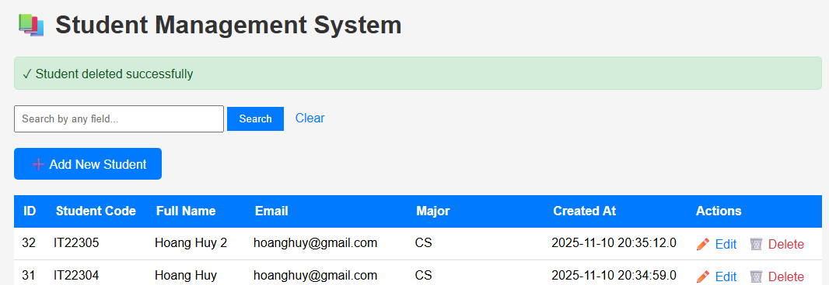
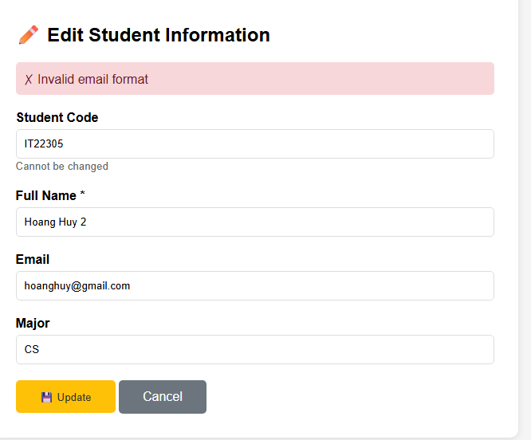

- Added loading state for submit button of add_student.jsp and edit_student.jsp to avoid double click submit.
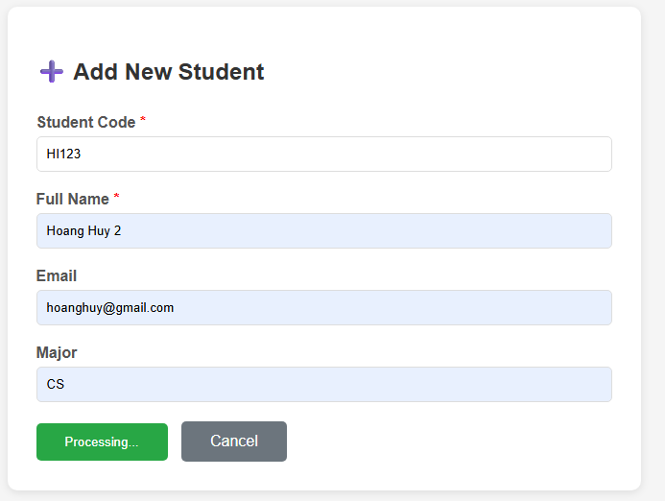
- Responsive
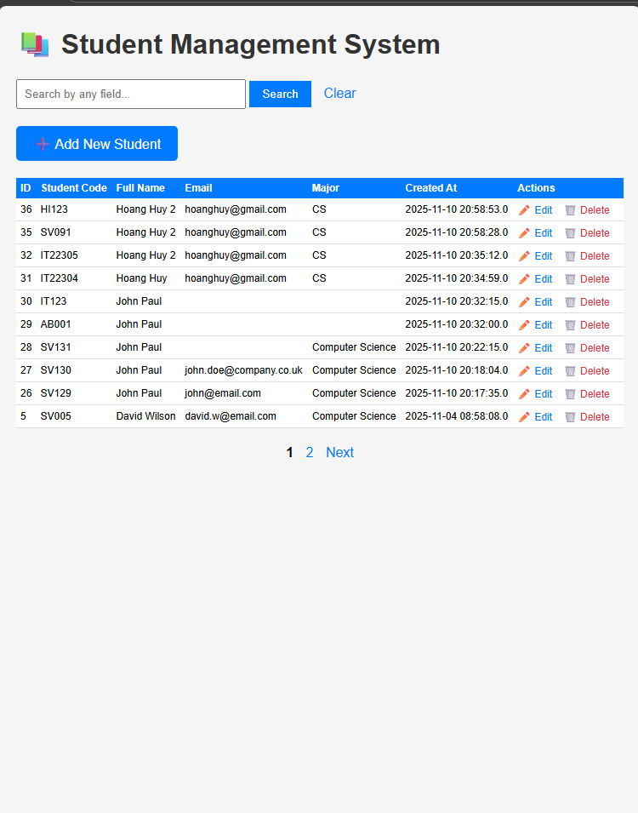

Flow:
I will explain the flow of adding a user step by step:
Step 1: when user go to link: http://localhost:8080/StudentManagement/list_students.jsp
- This will request goes to Tomcat, which executes the jsp code.
Step 2: in the list_students.jsp, it will connect to mysql and query all students and load the data:
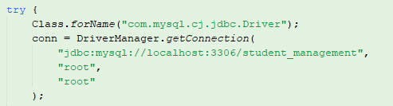
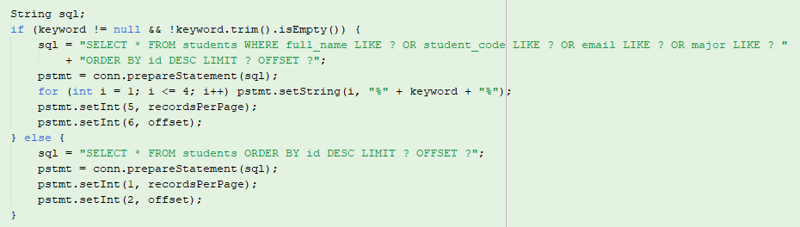
Step 3: the jsp loop through all results and generate html.
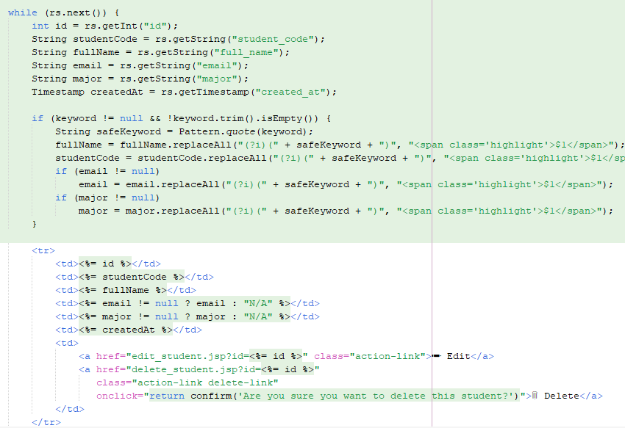
Step 4: When user click on add new student
- It will directs to form page add_student.jsp
Step 5: When user fills in information and submits the form which defined as:
It will direct to process_add.jsp with method post and all of its data from in http body.
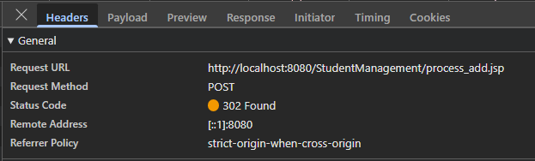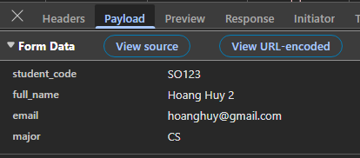
Step 6: process_add.jsp , tomcat will executs the java code to get parameters and validate data
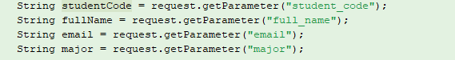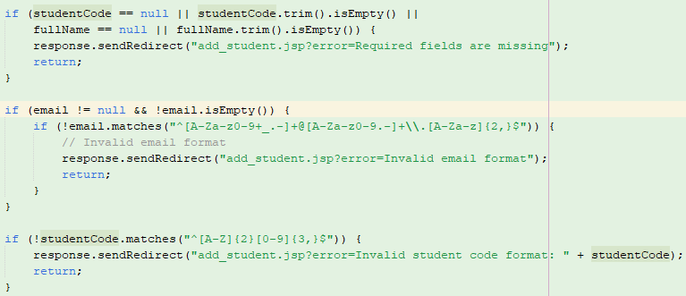
Step 7: it connects to sql to insert data.
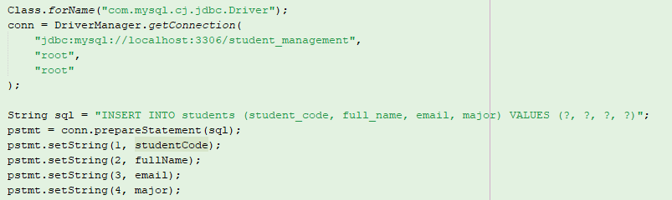
Step 8: It redirects depending on success
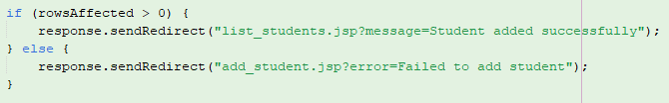
- Redirect to list_student with success message and otherwise it redirect to add_student with error message.
- When direct back to list_student, it repeats the same process as step 1 to step 3 to display data (including new inserted ones).

