|  |
| --- |
|  |
| Capstone Project Document |

SUPER SHIPPER SYSTEM

Software Architectures Design

|  |  |  |
| --- | --- | --- |
| **Super Shipper System** | | |
| **Group Members** | Le Van Quy Hoang | SE90184 |
| Tran Dinh Hoang Huy | SE90201 |
| Nguyen Khac Hoang | SE02564 |
| Kieu Cao Khanh | SE02960 |
| Nguyen Van Quyen | SE02884 |
| Nguyen Thi Hong Nhung | SE02437 |
| **Supervisor** | Mr. Tran Binh Duong | |
| **Project code** | 3S | |

**- Hanoi, 09/2015 -**

TABLE OF CONTENTS

1. INTRODUCTION 2

1.1. Purpose 2

1.2. Scope 2

1.3. Definitions, Acronyms, Abbreviations 2

1.5. Overview 2

2. DESCRIPTION 3

2.1. Use case view 3

2.2. Logical view 3

2.3. Implementation view 3

2.4. Deployment view 3

2.5. Process view 3

3. ARCHITECTURE GOALS & CONSTRAINTS 4

3.1. Technical Platform 4

3.2. Communication 4

3.3. Security 4

3.4. Reliability/Availability 4

3.5. Performance 4

4.4 Maintainability 4

4. USE CASE VIEW 5

4.1. Admin 6

4.2. Store 7

4.3. Shipper 8

5. LOGICAL VIEW 8

6. PROCESS VIEW 8

7. DEPLOYMENT VIEW 8

8. IMPLEMENTATION VIEW 9

9. SIZE AND PERFORMANCE 9

10. QUALITY 9

**ACRONYMS & ABBREVIATIONS**

| Abbreviations | Description | Note |
| --- | --- | --- |
|  |  |  |
|  |  |  |
|  |  |  |
|  |  |  |
|  |  |  |
|  |  |  |
|  |  |  |
|  |  |  |
|  |  |  |
|  |  |  |
|  |  |  |
|  |  |  |
|  |  |  |
|  |  |  |
|  |  |  |
|  |  |  |
|  |  |  |
|  |  |  |
|  |  |  |
|  |  |  |
|  |  |  |
|  |  |  |
|  |  |  |

# INTRODUCTION

## 1.1. Purpose

The Software Architecture Design Document provides a comprehensive architectural overview of the 3S system offered by 3S team. It present a number of different architectural views to depict different aspects of the system. It is intended to capture and convey the significant architectural decisions which have been made on the system.

The development team should read carefully this document to review the architecture of the system before develop. It would also be very helpful for the upgrade and maintain.

## 1.2. Scope

The Scope of this SAD is to depict the architecture design of the 3S system create by 3S team. Documents describing the elements and the most basic acts within the system to help the stakeholders can see the system overall.

## 1.3. Definitions, Acronyms, Abbreviations

|  |  |  |
| --- | --- | --- |
| **Acronym** | **Definition** | **Note** |
| **3S** | Super Shipper System |  |
| **SADD** | Software Architecture Design Document |  |
| **SRS** | Software Requirement Specification |  |
|  |  |  |
|  |  |  |

## 1.4. Overview

This SADD include the flowing subsection:

1. Section 2: Describes the use of each view in 4+1 views
2. Section 3: Describes the gold and constraint of architecture.

# DESCRIPTION

This section depicts the architecture using the views defined in the “4+1” model as below:

Figure 1: View Model 4+1

**Logical view**

**Implementation view**

**Process view**

**Deployment view**

## Use case view

**Audience:** all the stack holder of the system

**Area:** Specific description of each use-case and their role in the system.

**Related Artifacts:** Use-Case Model

## Logical view

**Audience:** Designer

**Area:** Function Requirements: describes the design’s object model. Also describes the most important use-case realizations

**Related Artifacts:** Class diagram, Sequence diagram, Communication diagram

## Implementation view

**Audience:** Programmers

**Area:** Software components: describes the layers and subsystem of the application

**Related Artifacts:** Component diagram, package diagram

## Deployment view

**Audience:** Manager

**Area:** Topology: describes the mapping of the software onto the hardware and shows the system distributed aspects.

**Related Artifacts:** Deployment diagram

## Process view

**Audience:** Integrators

**Area:** non-functional requirements: describes the designer’s concurrency and synchronization aspects

**Related Artifacts:** Activity diagram

# ARCHITECTURE GOAL & CONSTRAINTS

## Technical Platform

This application will be deployed as a hybrid applications that can run on Android and IOS platform.

## Communication

The mobile application and web application request to web service and get response as JSON objects.

## Security

- Information of admin data on server is secured.

- Information of store and shipper on server is secured.

## Reliability/Availability

- The application is available 24/7.

- Find the way to go to places of receive and place of delivery are at least 90%.

## Performance

* Time delay for find shipper who nearest with place of delivery is less than 10s.
* Time delay on web application for tracking state of shipper on map is less than 5m.
* Server can handle least 2000 clients concurrently.
* Other functions of server perform well while have many order running on application.

## 4.4 Maintainability

- Web application is easily to maintain without any crashes. Source code is readability, organized into groups of skeleton (modules) and complies with coding convention.

- Android application is easily to be updated and synchronize with Web application without any crashes. Source code is readability, complies with coding convention.

- System’s architecture has to be design to be easy to extend.

# USE CASE VIEW

This section list all use cases of 3S system. Details on SRS

## Admin

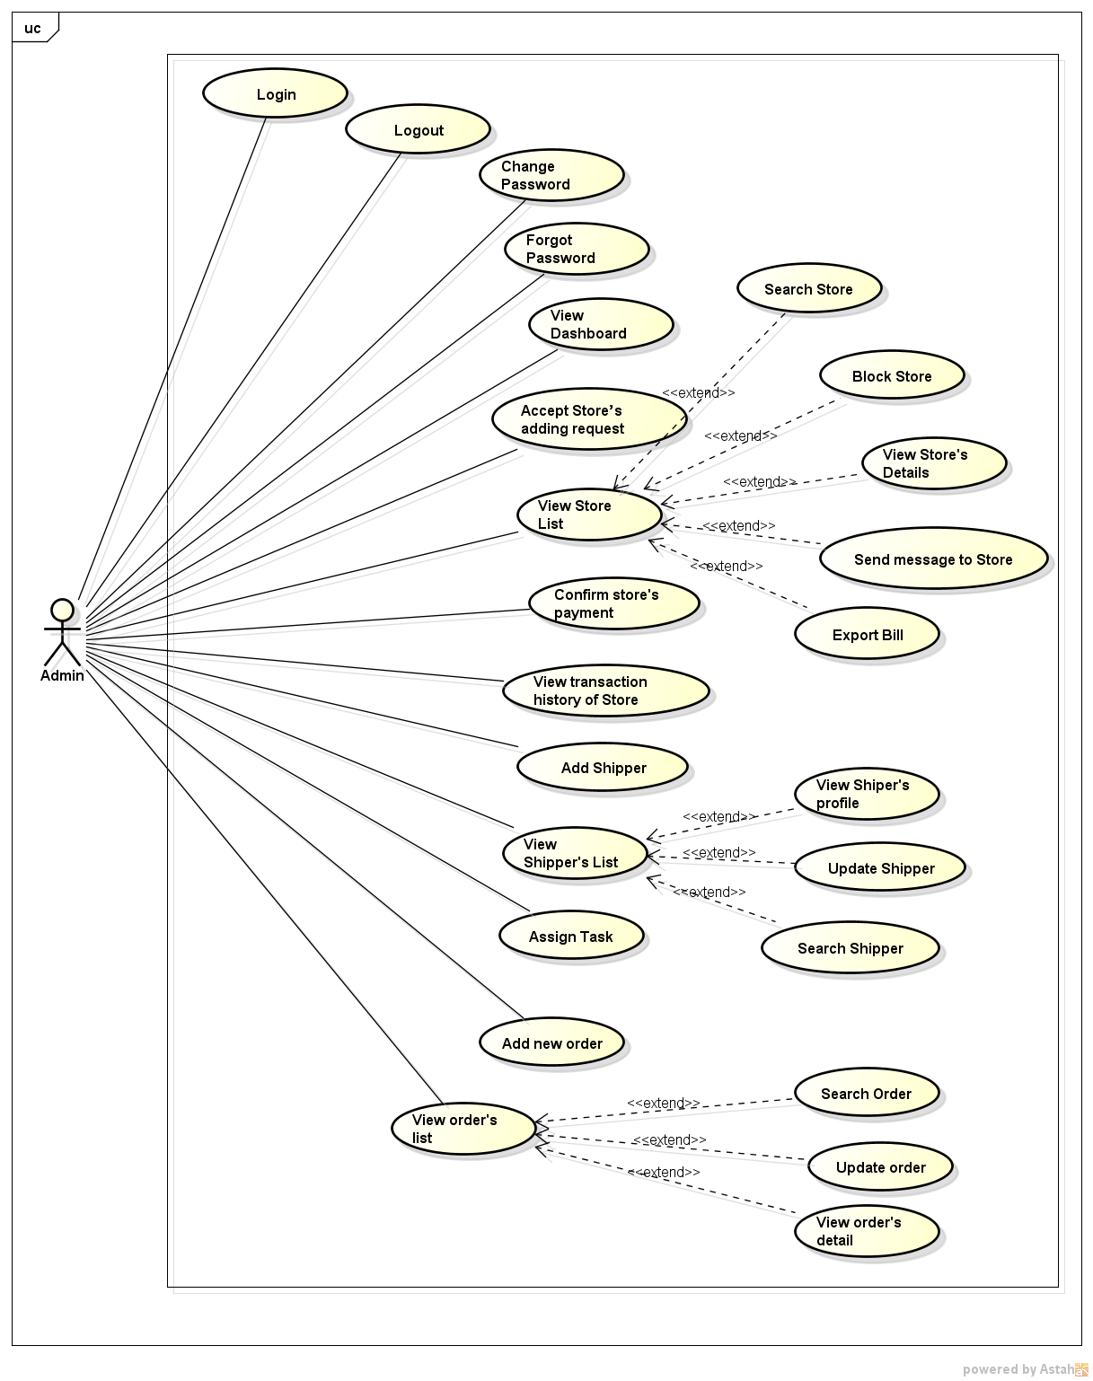

Figure 2: Use case view of Admin

## Store

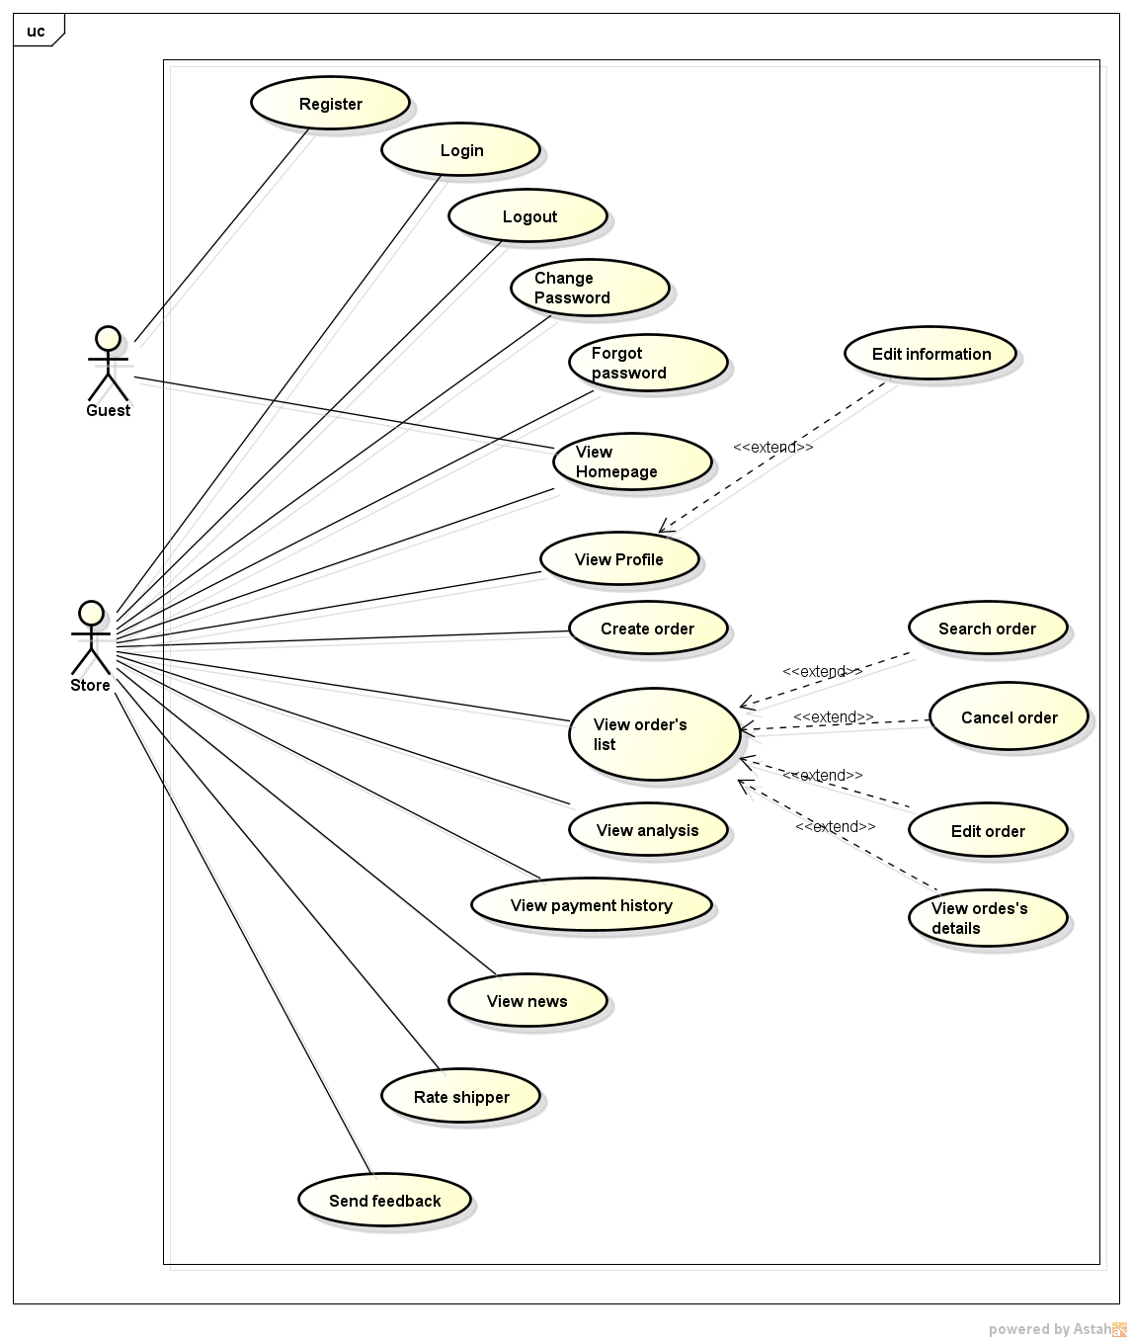

Figure 3: Use case view of Store

## Shipper

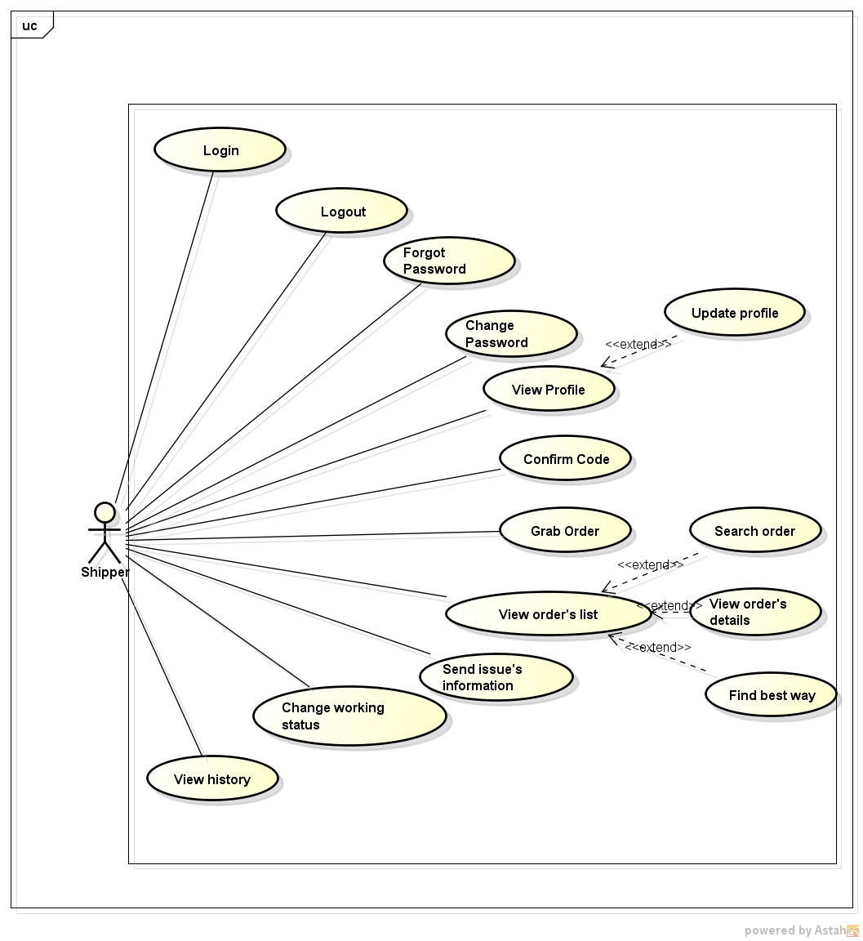

Figure 4: Use case view of Shipper

# LOGICAL VIEW

# PROCESS VIEW

# DEPLOYMENT VIEW

# IMPLEMENTATION VIEW

# SIZE AND PERFORMANCE

3S system includes three critical components that interacts with web service and creating a real-time system. Therefore the system should ensure the continuous synchronization between the components.

Time delay for find shipper who nearest with place of delivery is less than 10s and the time delay on web application for tracking state of shipper on map is less than 5m.

Server can handle at least 2000 clients concurrently

# QUALITY

* ***Performance:***

+ Time delay for find shipper who nearest with place of delivery is less than 10s.

+ Time delay on web application for tracking state of shipper on map is less than 5m.

+ Server can handle least 2000 clients concurrently.

+Other functions of server perform well while have many order running on application.

* ***Reliability:***

+ The application is available 24/7.

+ Find the way to go to places of receive and place of delivery are at least 90%.

* ***Maintainability:***

+ Web application is easily to maintain without any crashes. Source code is readability, organized into groups of skeleton (modules) and complies with coding convention.

+Android application is easily to be updated and synchronize with Web application without any crashes. Source code is readability, complies with coding convention.

+ System’s architecture has to be design to be easy to extend.

* ***Security:***

+ Information of admin/ root admin / data on server is secured.

+Information of store and shipper on server is secured.