|  |
| --- |
|  |
| Capstone Project Document |

SUPER SHIPPER SYSTEM

Software Requirement Specification

|  |  |  |
| --- | --- | --- |
| **Super Shipper System** | | |
| **Group Members** | Le Van Quy Hoang | SE90184 |
| Tran Dinh Hoang Huy | SE90201 |
| Nguyen Khac Hoang | SE02564 |
| Kieu Cao Khanh | SE02960 |
| Nguyen Van Quyen | SE02884 |
| Nguyen Thi Hong Nhung | SE02437 |
| **Supervisor** | Mr. Tran Binh Duong | |
| **Project code** | 3S | |

**- Hanoi, 09/2015 -**

TABLE OF CONTENTS

1. INTRODUCTION 2

1.1. Purpose 2

1.2. Scope 2

1.3. Definition and Acronyms 2

1.4. Overview 2

2. OVERVIEW DESCRIPTION 3

2.1. Product perspective 3

2.2. Product functions 3

2.3. User characteristics 3

2.4. Constraint 3

2.5. Assumption and dependencies 4

2.6. Activity Diagram 4

2.7. State Machine Diagram 5

2.8. Entity Relationship Diagram 6

3. FUNCTIONAL REQUIREMENTS 7

3.1. Web application for Admin 7

3.1.1. User Case Diagram 7

3.1.2. Functions 9

UC-101: Login 9

UC-102: Logout 11

UC-103: Change password 12

UC-104: Forgot password 15

UC- 105: Add Store 17

UC- 106: Search Store 21

UC- 107: View Store’s list 22

UC- 108: Block/Unblock store 25

UC- 109: View Store’s details 27

UC- 111: Confirm Store’s payment 29

UC- 112: View transaction history of Store 31

UC- 113: Add Shipper 33

UC- 114: View Shipper’s list 36

UC- 115: View Order’s list 38

UC- 116: Search Shipper 40

UC- 117: Search Order 42

UC- 118: View Shipper’s profile 45

UC- 119: View Order’s details 47

UC- 120: Update User’s Profile 49

UC- 121: Update Store’s Information 51

UC- 124: Assign Task 53

UC- 125: View Dashboard 55

UC- 126: View IssueBox 57

UC- 127: Resolve Issue 58

UC- 128: View Task’s list 60

UC- 129: View Report 62

UC- 130: Search Task 63

UC- 131: Search Transaction 64

UC- 132: Search Issue 65

**ACRONYMS & ABBREVIATIONS**

| Abbreviations | Description | Note |
| --- | --- | --- |
|  |  |  |
|  |  |  |
|  |  |  |
|  |  |  |
|  |  |  |
|  |  |  |
|  |  |  |
|  |  |  |
|  |  |  |
|  |  |  |
|  |  |  |
|  |  |  |
|  |  |  |
|  |  |  |
|  |  |  |
|  |  |  |
|  |  |  |
|  |  |  |
|  |  |  |
|  |  |  |
|  |  |  |
|  |  |  |
|  |  |  |

# INTRODUCTION

## 1.1. Purpose

This document provides developers, tester, QAs a complete and comprehensive description of both the functional requirement and non-functional requirements of the 3S system. Developers base on this document to develop the system, and testers base on this to assure the quality of the output system. Project manager base on this document to create schedule and assign task to team members.

## 1.2. Scope

This document defines all functional and non-functional requirements for 3S system. Beside, creating the diagrams to helps developers be easy to understand in Software Architecture Design stage.

## 1.3. Definition and Acronyms

## 1.4. Overview

Section 2 of this document provides overall information of the project, while excluding the specific requirements. Instead, it provides the background for those requirements, which are defined in Section 3

Section 3 describes all the requirements in detail, including functional requirements and non-functional requirements. Each function is described based on the following format:

Use Case: the detailed description of all use cases

Screen: The mockup/prototype of the screen which describes the workflow of the Use Case

# OVERVIEW DESCRIPTION

## 2.1. Product perspective

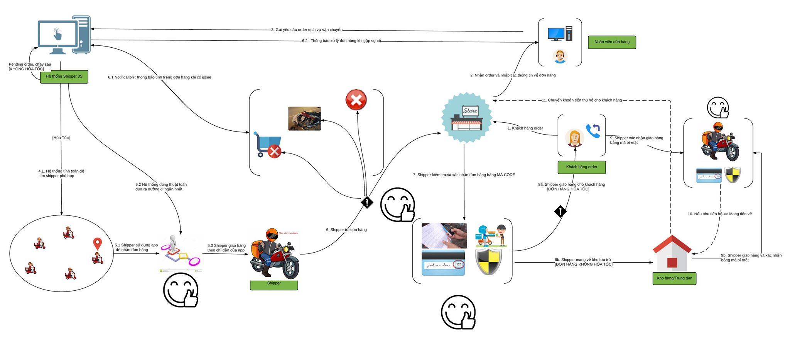The below rich picture describes all perspectives of product:

The product includes 3 types:

* Web Service: This is linking between Web App with Mobile App. Beside, executing logic to response data (JSON) for clients through API.
* Web App: This is an app that supports for 2 types of user
  + Admin: Manage (Shipper, Store), Resolve Issue, Control & Tracking Orders, …
  + Store: Create Order, Find Shipper, Confirm Code, Rate, Send Feedback. …
* Mobile App: This is an app that supports for shipper’s business
  + Shipper: Receive/Reject order, find short path, Send issues message …

## 2.2. Product functions

Refer to Section 3

## 2.3. User characteristics

There are three main actors that system support:

* Store: This system towards the stores which have demand to transport goods to clients but don’t have a team of professional shipper.
* Shipper: They are transformers that enjoy system to get income.
* Administrator: They use all functions that supported by system to manage activities of system.

## 2.4. Constraint

* All products of system have to meets the deadline
* All processes and related documents have to observe procedure of FPT

## 2.5. Assumption and dependencies

* Receive the guidance and good support of teacher
* No one of member got sick in the software development process
* In the development process, no device got fail
* Evert report meets the deadline
* Team member do not conflict and get high responsibility in the working process

## 2.6. Activity Diagram

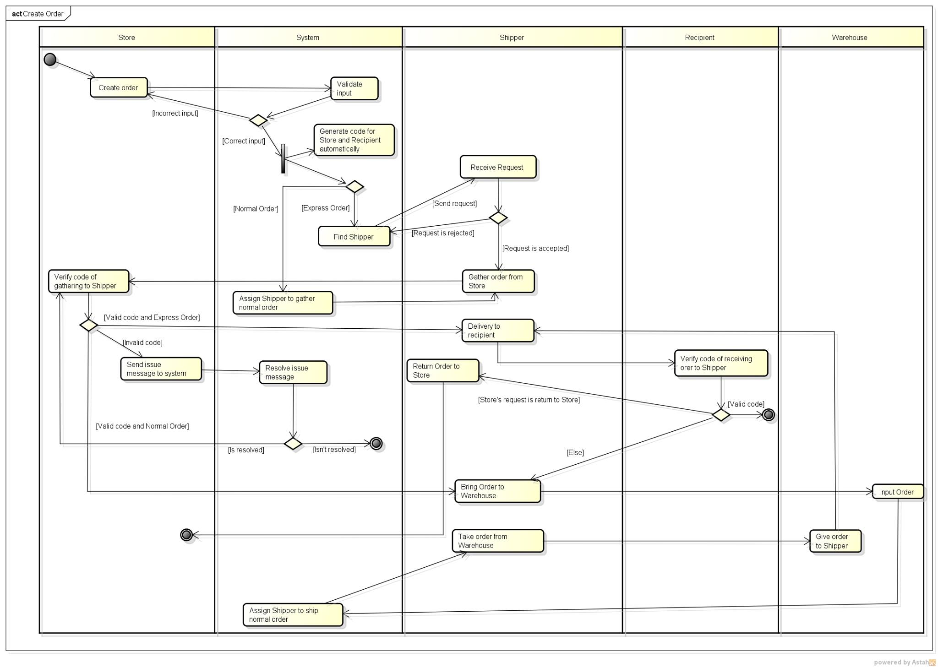This diagram describes the procedure of order

## 2.7. State Machine Diagram

This diagram describes the status of order:

In case express delivery:

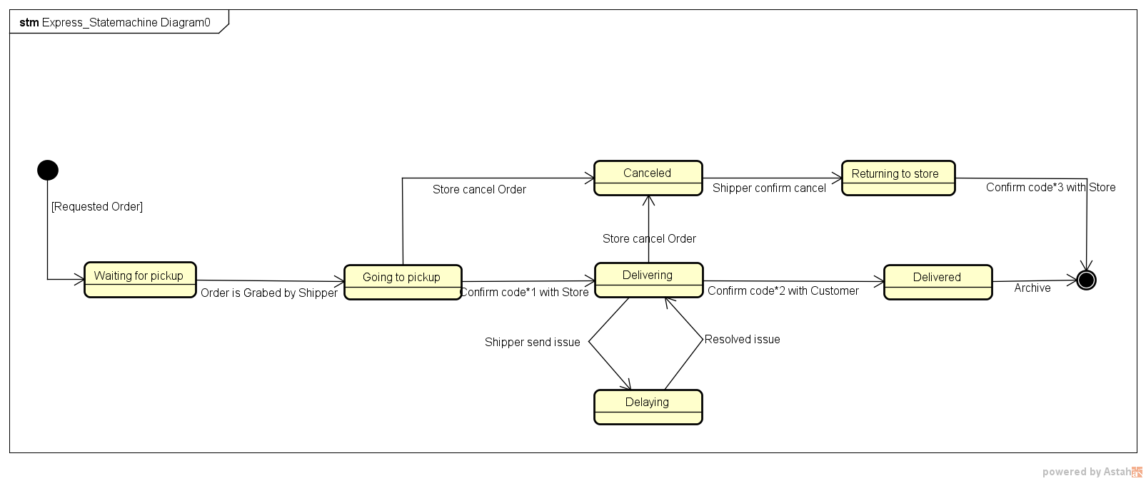

In case normal delivery:

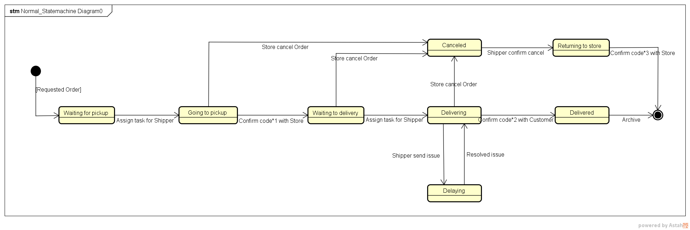

## 2.8. Entity Relationship Diagram

This diagram describes the relationship among entities of system

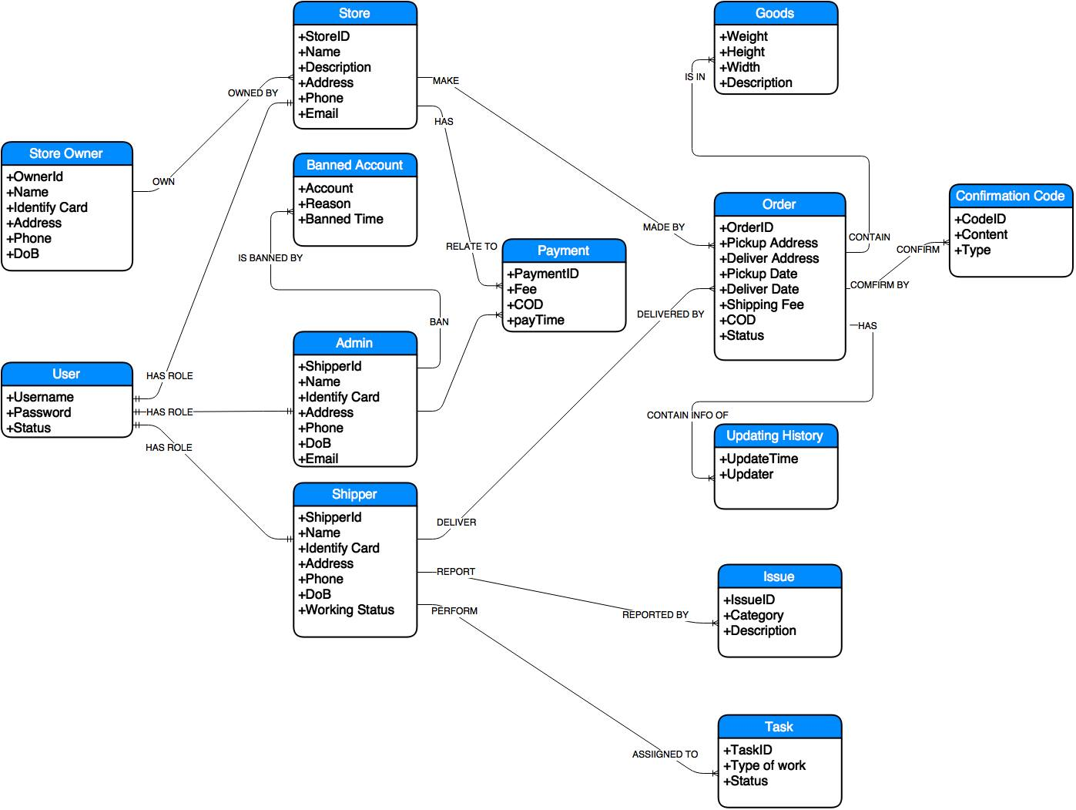

# FUNCTIONAL REQUIREMENTS

## 3.1. Web application for Admin

### 3.1.1. User Case Diagram

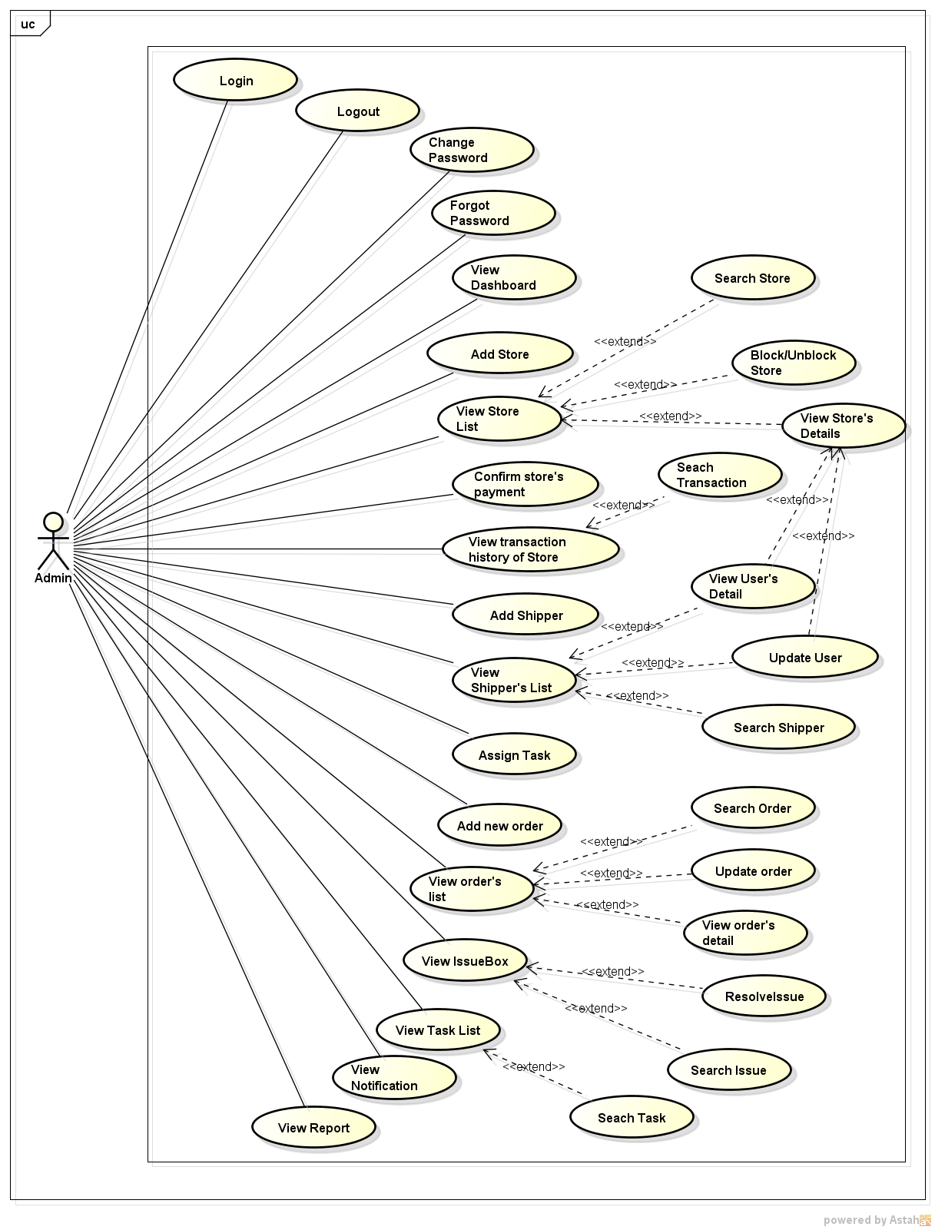

*Figure 11: User case diagram of Web Application for Admin*

### 3.1.2. Functions

###### *UC-101: Login*

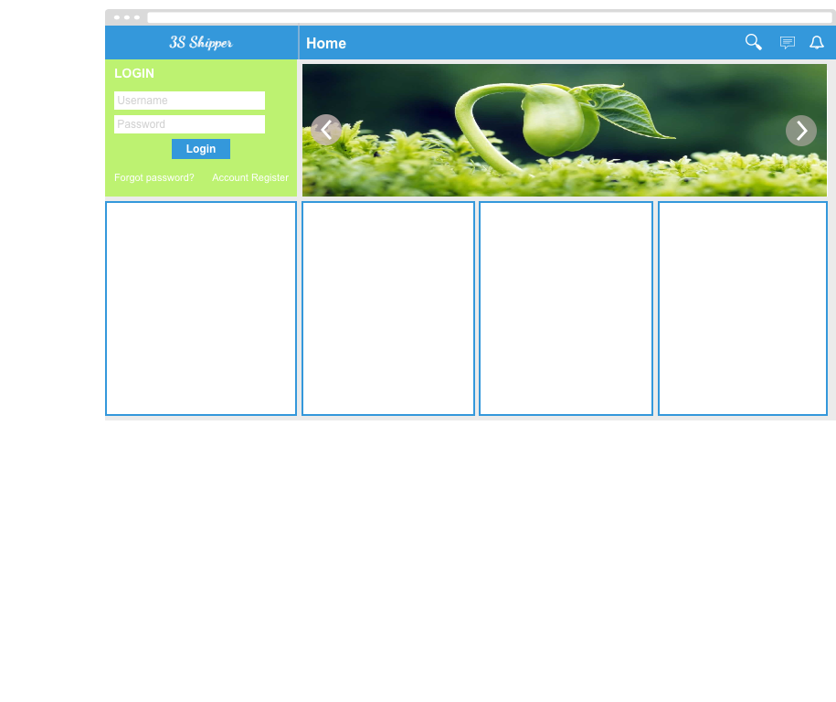

|  |  |  |  |  |
| --- | --- | --- | --- | --- |
| **Use Case ID:** | | UC-101 | | |
| **Use Case Name:** | | Login | | |
| **Created By:** | | HoangNK | **Last Updated By:** | HoangNK |
| **Date Created:** | | 19/09/2015 | **Date Last Updated:** | 20/09/2015 |
| **Actor:** | | Store | | |
| **Description:** | | Users who are not logged in to system can only view the “Homepage”. Admin needs to logins to system to use functions of system. | | |
| **Triggering event:** | | Admin wants to login to system | | |
| **Preconditions:** | | - Admin is on the “Homepage” of KarryWell website  - Admin account must be exits | | |
| **Post conditions:** | | Logs Admin into system  Redirects Admin to “Dashboard” screen (Refer to UC-125: View Dashboard) | | |
| **Priority:** | | High | | |
| **Frequency of Use:** | | Sometime | | |
| **Main flow** | | | | |
| Step | Actor | Action | | |
|  | Admin | Enters User name and Password | | |
|  | Admin | Clicks “Login” | | |
|  | System | Check “Username” and “Password” in database. | | |
|  | System | Logs Admin into system | | |
|  | System | Redirects to “Dashboard” screen. | | |
| **Alternative:** | | | | |
| **Exceptions:** | | | | |
| EC1 | At step 3 in main flow, if Admin entered wrong User name or Password | | | |
| Step | Actor | Action | | |
| 3.1 | System | Displays message “Username or Password is wrong” | | |
| **Includes:** | | N/A | | |
| **Special requirements:** | | N/A | | |
| **Notes and Issues:** | | N/A | | |

***Sequence Diagram***

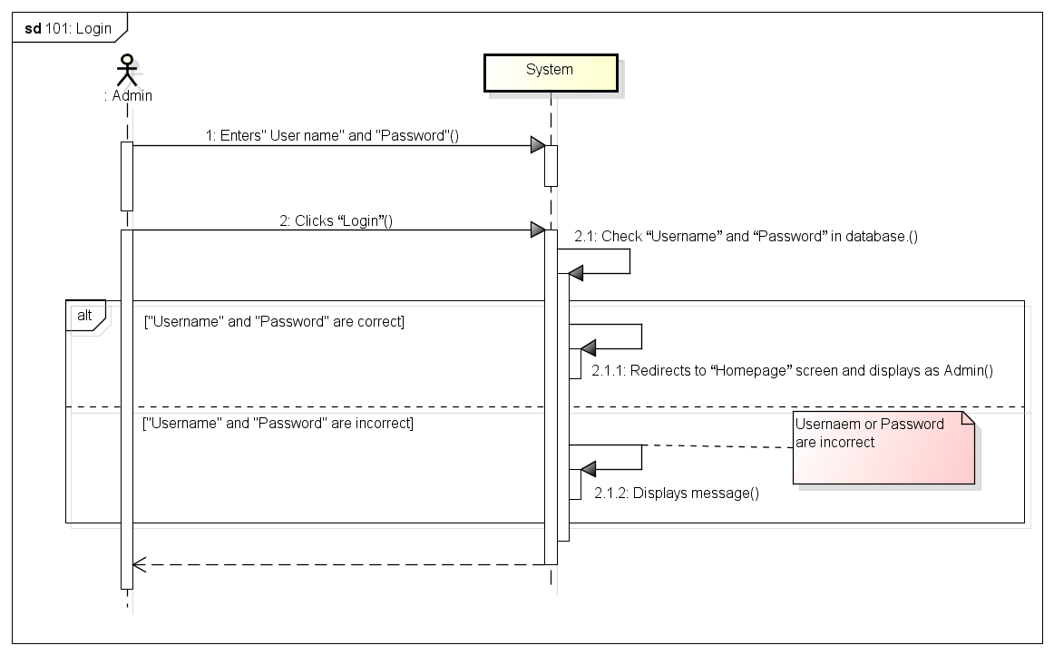

###### *UC-102: Logout*

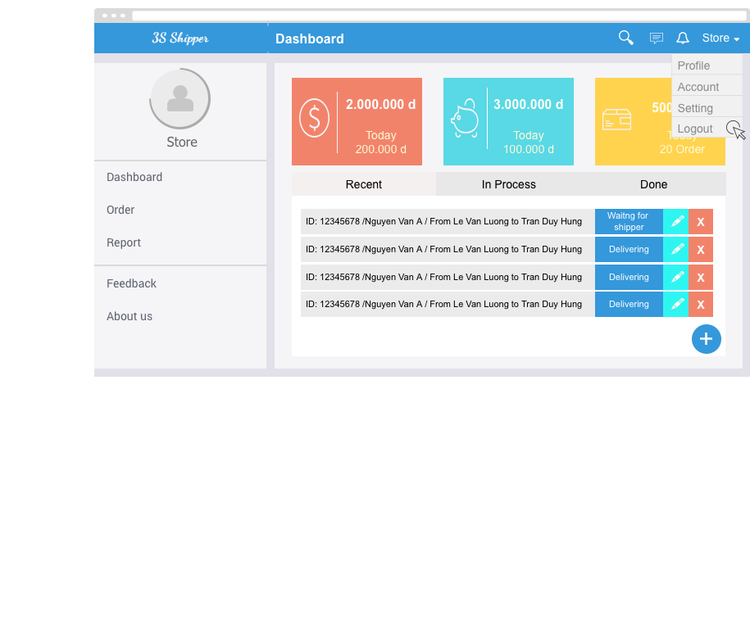

|  |  |  |  |  |
| --- | --- | --- | --- | --- |
| **Use Case ID:** | | UC-102 | | |
| **Use Case Name:** | | Logout | | |
| **Created By:** | | KhanhKC | **Last Updated By:** | KhanhKC |
| **Date Created:** | | 19/09/2015 | **Date Last updated:** | 20/09/2015 |
| **Actor:** | | Admin | | |
| **Description:** | | When Admin logouts from system, Admin will cannot continue using functions of system. Admin needs to login again to be able to use the function of system. | | |
| **Triggering event:** | | Admin wants to logout from system. | | |
| **Preconditions:** | | Admin logged in to system | | |
| **Post conditions:** | | Logs Admin out from system.  Redirects to “Homepage” screen (Refer to UC218: View Homepage) | | |
| **Priority:** | | High | | |
| **Frequency of Use:** | | Often | | |
| **Main flow** | | | | |
| Step | Actor | Action | | |
|  | Admin | Clicks Logout | | |
|  | System | Logouts Admin from system | | |
|  | System | Displays Homepage for Guest | | |
| **Alternative Flows:** | | N/A | | |
| **Exceptions:** | | N/A | | |
| **Includes:** | | N/A | | |
| **Special Requirements:** | | N/A | | |
| **Notes and Issues:** | | N/A | | |

***Sequence Diagram***

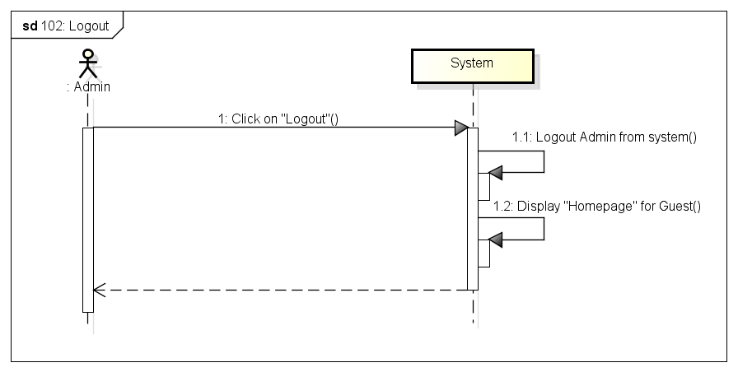

###### *UC-103: Change password*

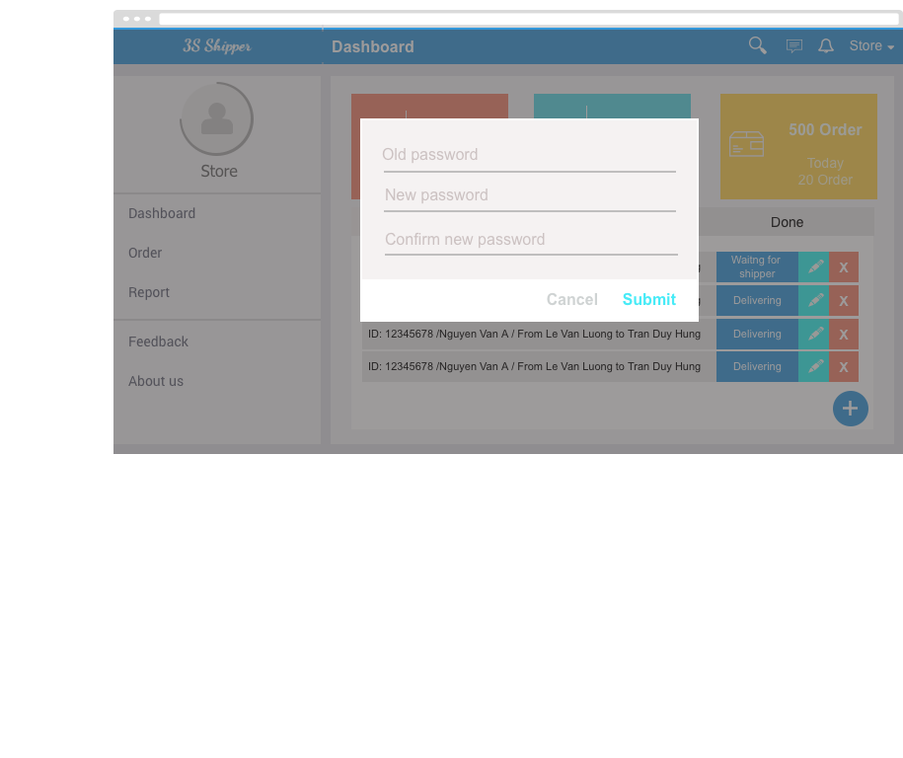

|  |  |  |  |  |
| --- | --- | --- | --- | --- |
| **Use Case ID:** | | UC-204 | | |
| **Use Case Name:** | | Change password | | |
| **Created By:** | | KhanhKC | **Last Updated By:** | KhanhKC |
| **Date Created:** | | 19/09/2015 | **Date Last updated:** | 20/09/2015 |
| **Actor:** | | Admin | | |
| **Description:** | | Admin can change login password but Admin need to remember old password. | | |
| **Triggering event:** | | Admin wants to change password. | | |
| **Preconditions:** | | Admin logged in to system | | |
| **Post conditions:** | | New password has been saved in database. | | |
| **Priority:** | | High | | |
| **Frequency of Use:** | | Sometime | | |
| **Main flow** | | | | |
| Step | Actor | Action | | |
|  | Admin | Clicks “Change password” | | |
|  | System | Displays “Change password” screen includes:  - Old password text box  - New password text box  - Confirm new password text box  - Submit button | | |
|  | Admin | Enters data in fields | | |
|  | Admin | Clicks “Submit” button | | |
|  | System | Validates data | | |
|  | System | Displays “Change password” screen with message “ Changes password successful” | | |
| **Alternative Flows:** | | N/A | | |
| **Exceptions:** | | | | |
| EC1 | At step 4, required fields are not entered | | | |
| Step | Actor | Action | | |
| 4.1 | System | Displays “Change password” screen with error message “*is require” | | |
| EC2 | At step 4, “Old password” is incorrect | | | |
| Step | Actor | Action | | |
| 4.1 | System | Displays “Change password” screen with error message: “Old password is incorrect” | | |
| EC3 | At step 4, confirm new password is not the same with new password | | | |
| Step | Actor | Action | | |
| 4.1 | System | Displays “Change password” screen with error message.” Confirm new password is not the same with new password. Please enter again!” | | |
| **Includes:** | | N/A | | |
| **Special Requirements:** | | Length of “New password” must between 6 and 10. | | |
| **Notes and Issues:** | | N/A | | |

***Sequence Diagram***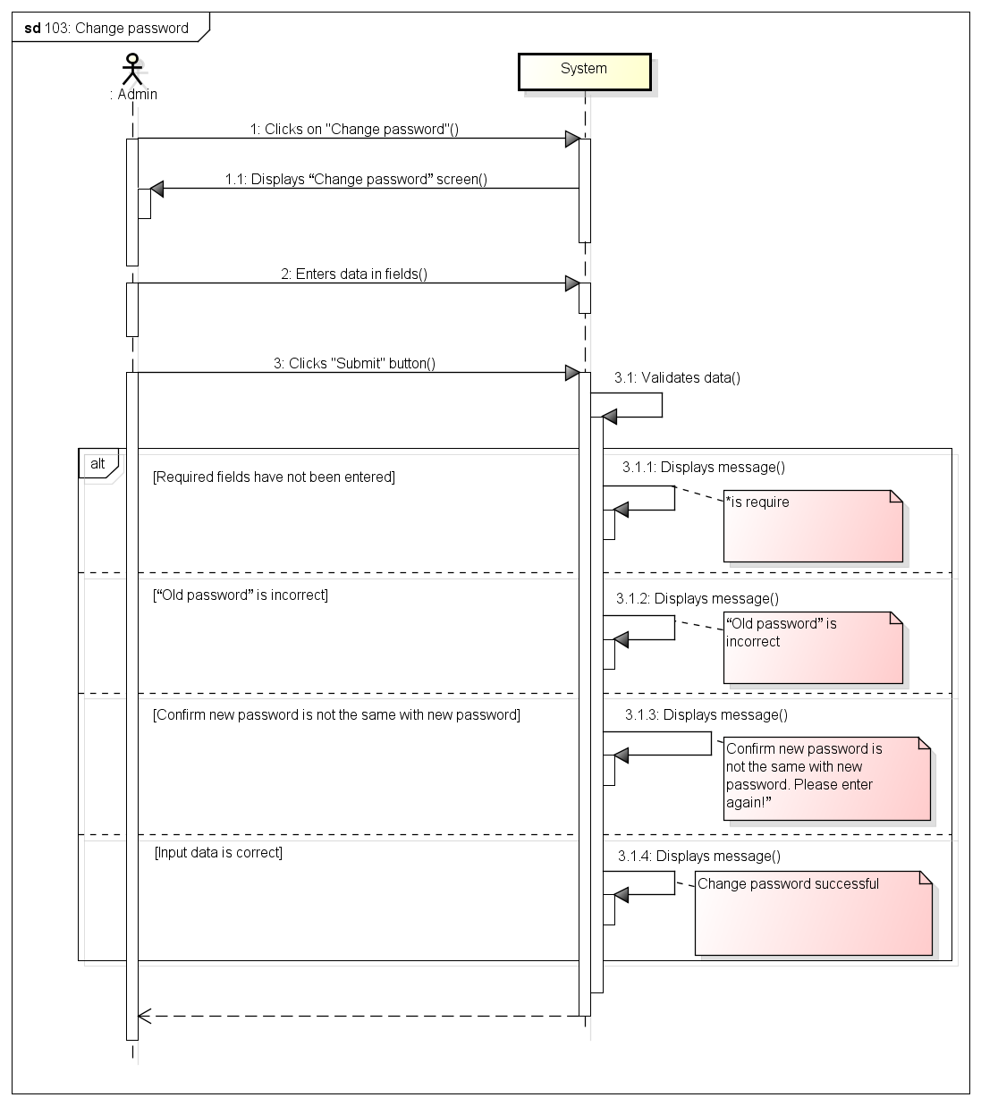

###### *UC-104: Forgot password*

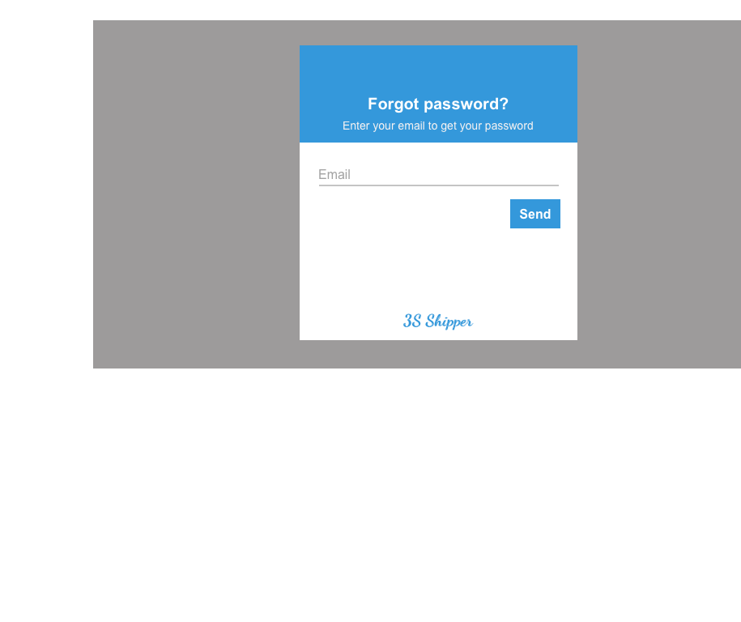

|  |  |  |  |  |
| --- | --- | --- | --- | --- |
| **Use Case ID:** | | UC-205 | | |
| **Use Case Name:** | | Forgot password | | |
| **Created By:** | | KhanhKC | **Last Updated By:** | KhanhKC |
| **Date Created:** | | 19/09/2015 | **Date Last updated:** | 20/09/2015 |
| **Actor:** | | Admin | | |
| **Description:** | | This function help Admin receive their login password when Admin forgot. | | |
| **Triggering event:** | | Admin requests system to receive new password. | | |
| **Preconditions:** | | Admin is on the “Homepage” (Refer to UC-218: View Homepage) | | |
| **Post conditions:** | | - A new password has been updated for Admin  - An email has been send to registered email of Admin include new password. | | |
| **Priority:** | | High | | |
| **Frequency of Use:** | | Sometime | | |
| **Main flow** | | | | |
| Step | Actor | Action | | |
|  | Admin | Clicks “Forgot password” hyperlink on “Login” box | | |
|  | System | Displays “Forgot password” popup includes:  - Email text box  - Submit button | | |
|  | Guest | Enters registered email. | | |
|  | Guest | Clicks “Submit” button | | |
|  | System | Validates data | | |
|  | System | Updates a new password for Admin | | |
|  | System | Sends the new password to registered email of Admin | | |
|  | System | Displays message : “Please check your email to get your new password” | | |
| **Alternative Flows:** | | N/A | | |
| **Exceptions:** | | | | |
| EC1 | At step 3, email are not a registered email | | | |
| Step | Actor | Actor | | |
| 4.1 | System | Displays error message:” Email is not exist” | | |
| **Includes:** | | N/A | | |
| **Special Requirements:** | | N/A | | |
| **Notes and Issues:** | | N/A | | |

***Sequence Diagram***

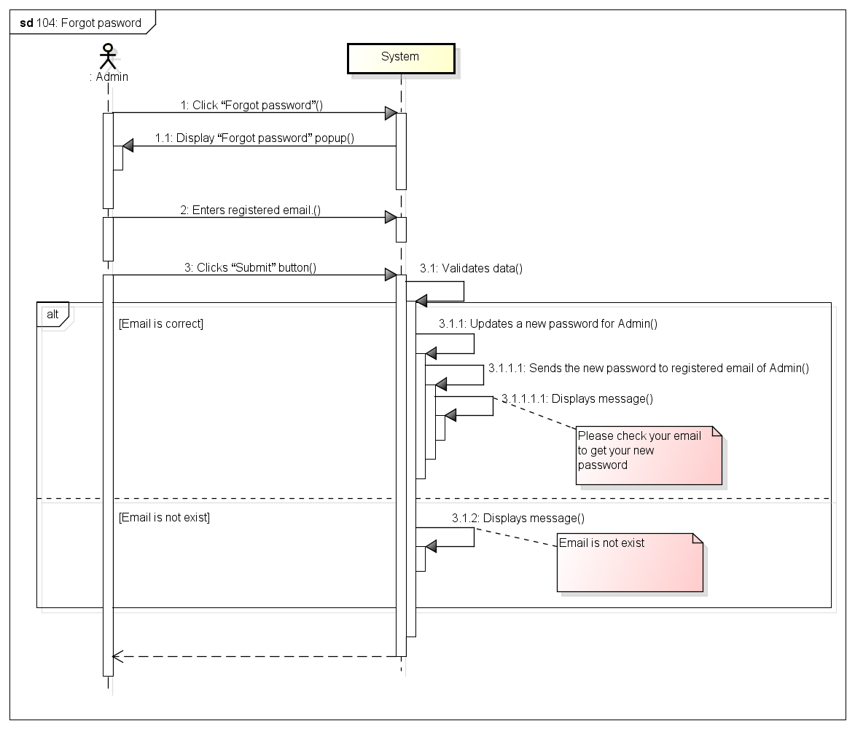

###### *UC- 105: Add Store*

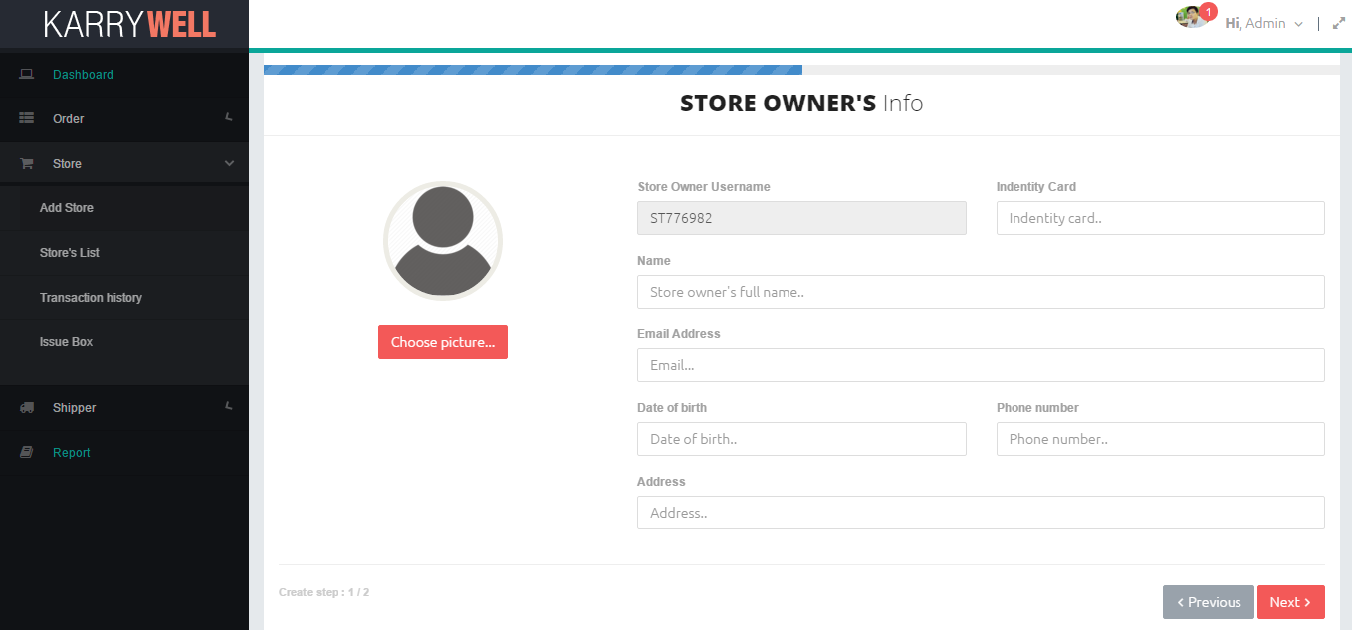

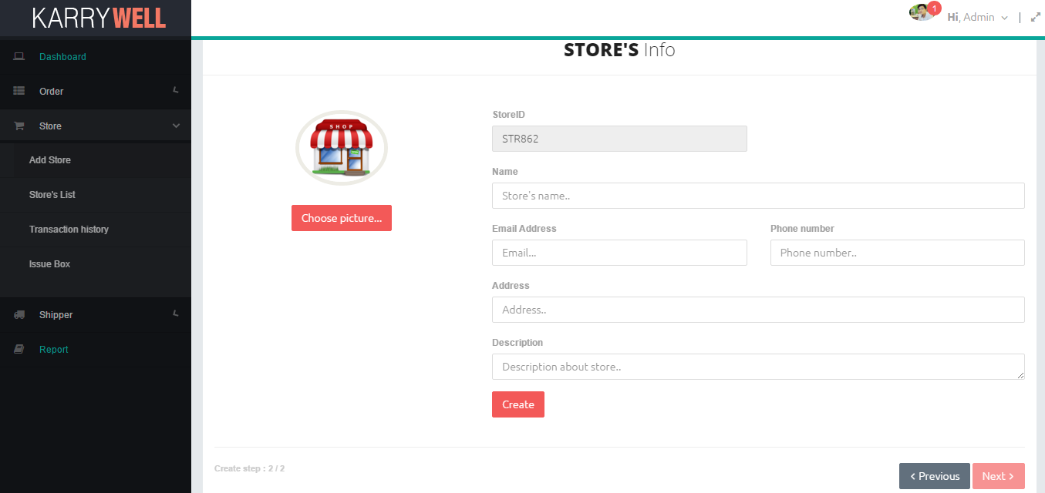

*Figure 11: Screen of Confirm Store’s Adding Request Use case*

|  |  |  |  |  |
| --- | --- | --- | --- | --- |
| **Use Case ID:** | | UC-105 | | |
| **Use Case Name:** | | Add Store | | |
| **Created By:** | | HoangNK | **Last Updated By:** | HoangNK |
| **Date Created:** | | 19/09/2015 | **Date Last updated:** | 24/09/2015 |
| **Actor:** | | Admin | | |
| **Description:** | | Store send information to admin, after that admin add new Store by this information then an email about Store’s detail will be sent to the Store | | |
| **Triggering Event:** | | Admin wants to add new Store to system | | |
| **Preconditions:** | | Admin logged in to system | | |
| **Post conditions:** | | New Store is added to database | | |
| **Priority:** | | High | | |
| **Frequency of Use:** | | Sometime | | |
| **Main flow** | | | | |
| Step | Actor | Action | | |
|  | Admin | Clicks “Store” button in left navigate bar | | |
|  | System | Displays “Store” menu includes: Add Store, Store’s List and Transaction History | | |
|  | Admin | Clicks “Add Store” button | | |
|  | System | Display in “Add Store” step 1 screen includes information of store owner:   * Store owner username textbox * Identity card textbox * Email textbox * Date of birth textbox * Phone number textbox * Address textbox * Choose avatar button * Previous and Next button | | |
|  | Admin | Enters information in these textbox then click button “Next” | | |
|  | System | Validates input | | |
|  | System | Displays “Add Store” step 2 screen includes information of store:   * StoreID textbox * Name textbox * Description textbox * Phone number textbox * Email textbox * Address textbox * Choose picture of profile button * Previous and Next button * Create button * Choose avatar button | | |
|  | Admin | Enters store’s information in textbox then click button “Create” | | |
|  | System | Validates input | | |
|  | System | Adds new Store to database of System, notify to admin a message about adding result and redirect to store’s list page | | |
| **Alternative Flows:** | | N/A | | |
| **Exceptions:** | | | | |
| EC1 | At step 6, if admin doesn’t type any textbox | | | |
| Step | Actor | Action | | |
| 6.1 | System | Displays error message “* is required” | | |
| EC2 | At step 6, if admin types wrong format | | | |
| Step | Actor | Action | | |
| 6.1 | System | Displays error message:   * This value must should be digits * This value should be a valid email. * This value length is invalid. It should be between 10 and 11 characters long. | | |
| EC3 | At step 9, if admin doesn’t type any textbox | | | |
| Step | Actor | Action | | |
| 9.1 | System | Displays error message “* is required” | | |
| EC4 | At step 9, if admin types wrong format | | | |
| Step | Actor | Action | | |
| 9.1 | System | Displays error message:   * * must should be digits * * should be a valid email. * * length is invalid. It should be between 10 and 11 characters long. | | |
| EC5 | At step 10, if email, identity card or phone number has been already existed | | | |
| Step | Actor | Action | | |
| 10.1 | System | Shows error notify: “* has been already existed” | | |
| EC6 | At step 10, system is failed to add new Store by other reason | | | |
| Step | Actor | Action | | |
| 10.1 | System | Shows error notify: “Adding fail” | | |
| **Includes:** | | N/A | | |
| **Special Requirements:** | | * Email must be valid email format * Identity card must be digits and value length is 9 to 12 characters * Phone number must be digits and value length is 10 or 11 characters * StoreID will be generated automatically by system by format “STR***” (* is digits) * Store’s owner username will be generated automatically by system by format “ST*****” (* is digits) * Default account and password for new Store is store’s owner username, Store can change them by website later | | |
| **Notes and Issues:** | | N/A | | |

***Sequence Diagram*** 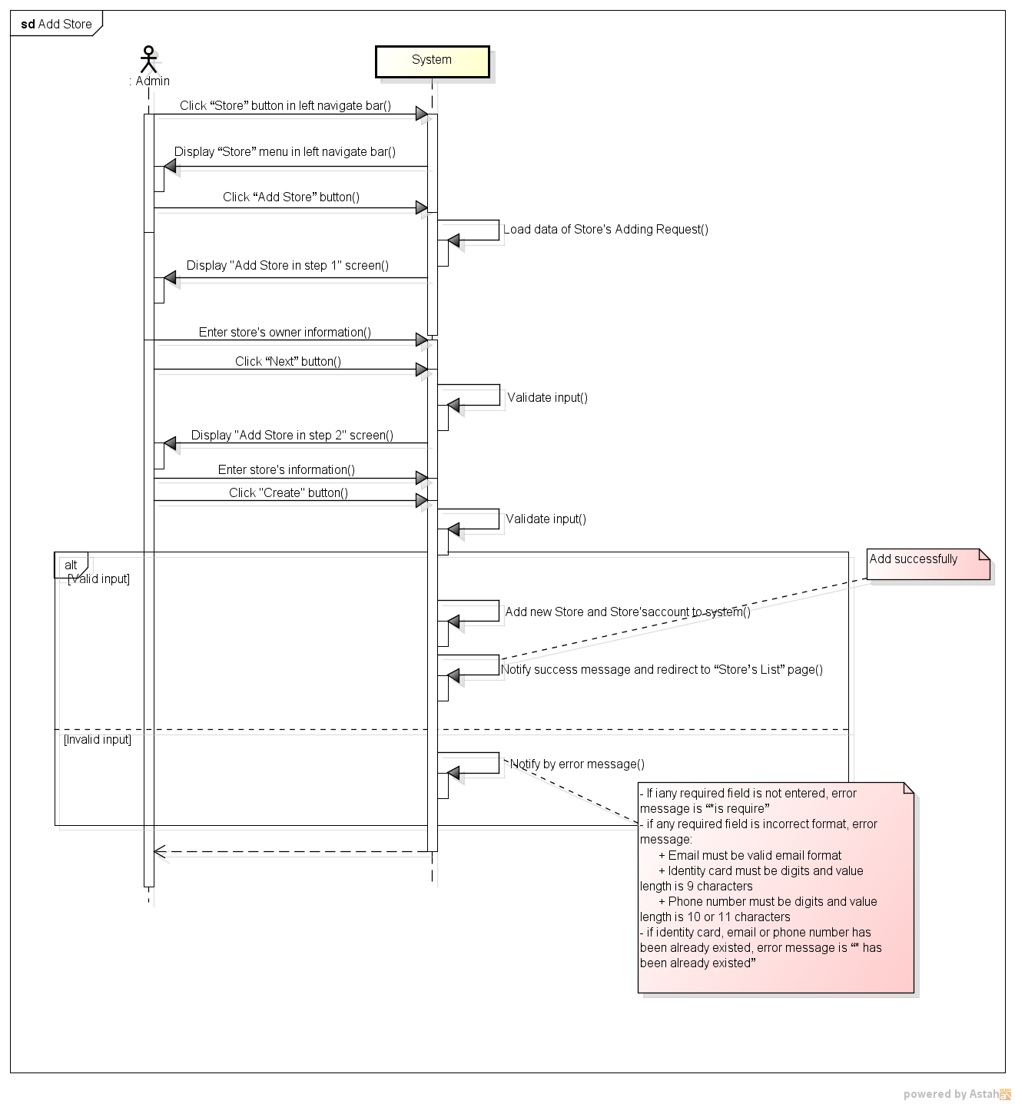

*Figure 11: Sequence Diagram for Confirm Store’s Adding Request Use case*

###### *UC- 106: Search Store*

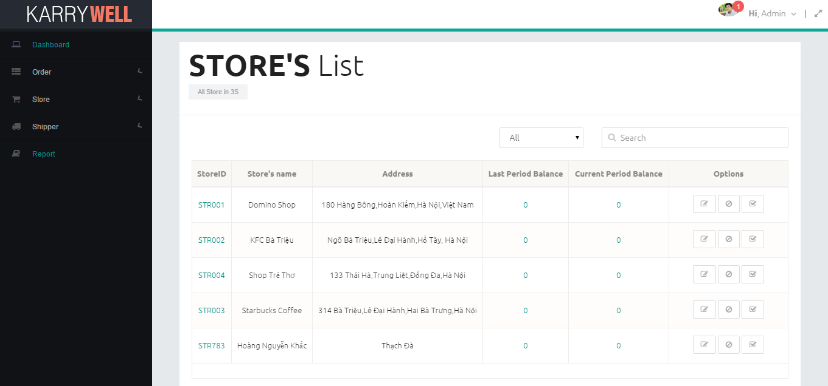

*Figure 11: Screen of Search Store Use case*

|  |  |  |  |  |
| --- | --- | --- | --- | --- |
| **Use Case ID:** | | UC-106 | | |
| **Use Case Name:** | | Search Store | | |
| **Created By:** | | HoangNK | **Last Updated By:** | HoangNK |
| **Date Created:** | | 19/09/2015 | **Date Last updated:** | 24/09/2015 |
| **Actor:** | | Admin | | |
| **Description:** | | Admin wants the system to list all Stores related to a specific keyword and type, after that, Admin can choose a Store to view details, update information and block or unblock this Store. | | |
| **Triggering Event:** | | Admin wants to search store | | |
| **Preconditions:** | | Admin is in view store’s list page ( refer case UC-107 ) | | |
| **Post conditions:** | | Stores have information which matches search key is displayed | | |
| **Priority:** | | High | | |
| **Frequency of Use:** | | Always | | |
| **Main flow** | | | | |
| Step | Actor | Action | | |
|  | Admin | Chooses type of searching | | |
|  | Admin | Enters text to “Search” text box | | |
|  | System | Displays Stores have information which matches search key | | |
| **Alternative Flows:** | | N/A | | |
| **Exceptions:** | | N/A | | |
| **Includes:** | | N/A | | |
| **Special Requirements:** | | * Result of search is case insensitive * Types of search are All, Name, Address and ID | | |
| **Notes and Issues:** | | N/A | | |

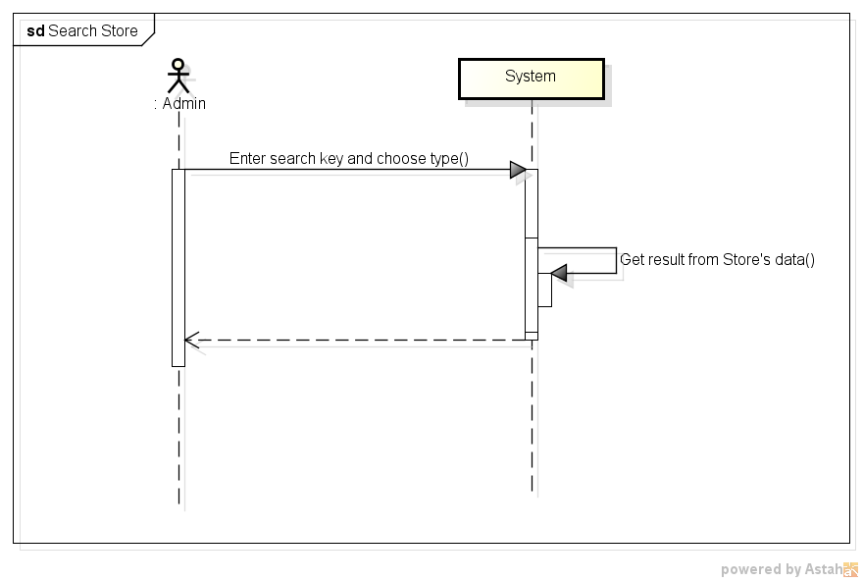

*Figure 11: Sequence Diagram for Search Store Use case*

###### *UC- 107:* *View Store’s list*



*Figure 11: Screen of View Store’s List Use case*

|  |  |  |  |  |
| --- | --- | --- | --- | --- |
| **Use Case ID:** | | UC-107 | | |
| **Use Case Name:** | | View Store’s list | | |
| **Created By:** | | HoangNK | **Last Updated By:** | HoangNK |
| **Date Created:** | | 19/09/2015 | **Date Last updated:** | 19/09/2015 |
| **Actor:** | | Admin | | |
| **Description:** | | Admin views all Store with their position in map and basic information (address, name, payment,..), so after that, Admin can choose a Store to confirm payment, edit and block or unblock | | |
| **Triggering Event:** | | Admin wants to view all of Store and related information | | |
| **Preconditions:** | | Admin logged in to system | | |
| **Post conditions:** | | List of store is displayed to screen | | |
| **Priority:** | | High | | |
| **Frequency of Use:** | | Always | | |
| **Main flow** | | | | |
| Step | Actor | Action | | |
|  | Admin | Clicks “Store” button in left navigate bar | | |
|  | System | Displays “Store” menu in left navigate bar includes: Add Store, Store’s List and Transaction History | | |
|  | Admin | Clicks “Store’s list” button | | |
|  | System | Gets Store’s data then display “Store’s List” screen includes:   * Map of all store * Search textbox and button * Filter drop-downlist * Related Store’s information: storeID, name, address, last balance period, current balance period with 3 buttons Update, Confirm payment and Block or Unblock in a table | | |
| **Alternative Flows:** | | N/A | | |
| **Exceptions:** | | | | |
| EC1 | At step 4, system can’t get data from database because the internet or the database disconnect | | | |
| Step | Actor | Action | | |
| 4.1 | System | Shows error message: “Failed to load data” | | |
| **Includes:** | | N/A | | |
| **Special Requirements:** | | * “All” is default type * The default Store’s list is ordered by Name | | |
| **Notes and Issues:** | | N/A | | |

***Sequence Diagram***

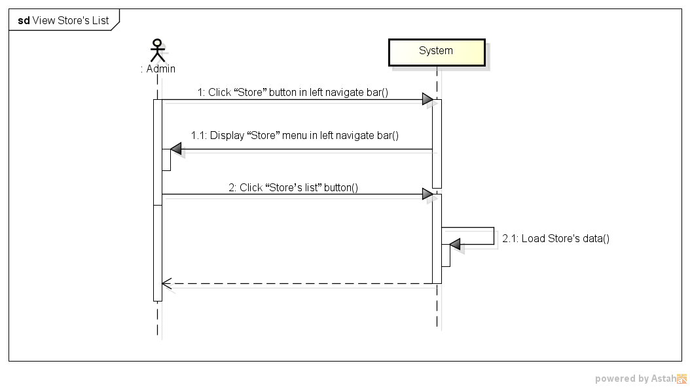

*Figure 11: Sequence Diagram for View Store’s List Use case*

###### *UC- 108:* *Block/Unblock store*

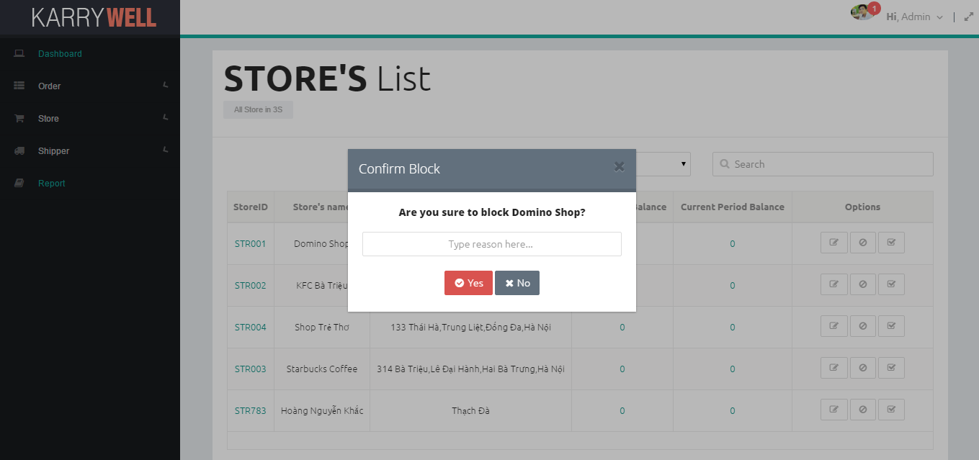

*Figure 11: Screen of Block and Unblock Store Use case*

|  |  |  |  |  |
| --- | --- | --- | --- | --- |
| **Use Case ID:** | | UC-108 | | |
| **Use Case Name:** | | Block/Unblock store | | |
| **Created By:** | | HoangNK | **Last Updated By:** | HoangNK |
| **Date Created:** | | 19/09/2015 | **Date Last updated:** | 24/09/2015 |
| **Actor:** | | Admin | | |
| **Description:** | | Admin bans the store from system if the store has serious breach of contract, so they can’t do any function of system if they were banned. Besides, Admin can unban the Store which is banned to give this Store permission of using Store’s functions | | |
| **Triggering Event:** | | Admin wants to blocks or unblocks store | | |
| **Preconditions:** | | Admin is in view store’s list page ( refer case UC-107 ) | | |
| **Post conditions:** | | Store is blocked or unblocked | | |
| **Priority:** | | Normal | | |
| **Frequency of Use:** | | Sometime | | |
| **Main flow** | | | | |
| Step | Actor | Action | | |
|  | Admin | Clicks “Block”(“Unblock”) button/ | | |
|  | System | Displays confirm popup includes “Yes” and “No” button with reason textbox(if block) | | |
|  | Admin | Enters reason (if block) then clicks “Yes” button | | |
|  | System | Hides popup and change store’s status of blocking | | |
| **Alternative Flows:** | | N/A | | |
| **Exceptions:** | | | | |
| EC1 | At step 2, Admin clicks on “No” button | | | |
| Step | Actor | Action | | |
| 2.1 | System | Closes popup | | |
| **Includes:** | | N/A | | |
| **Special Requirements:** | | N/A | | |
| **Notes and Issues:** | | N/A | | |

***Sequence Diagram***

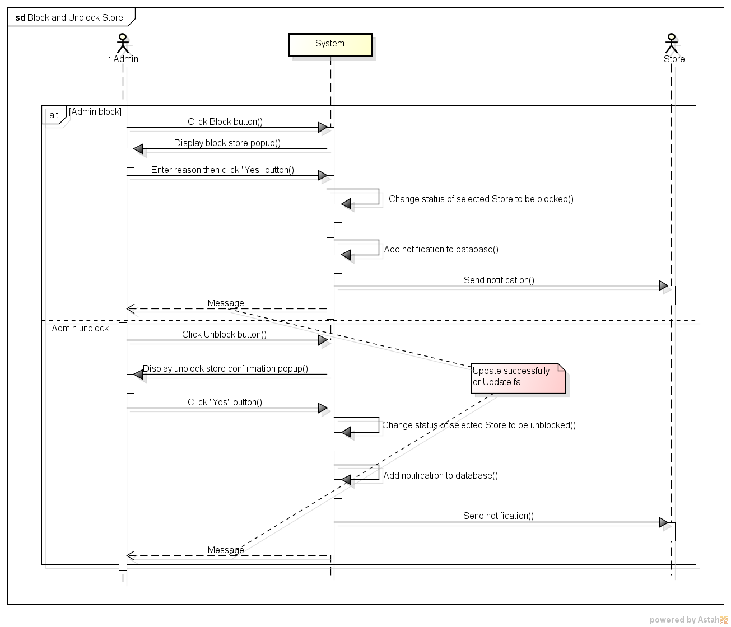

*Figure 11: Sequence Diagram for Block and Unblock Store Use case*

###### *UC- 109:* *View Store’s details*

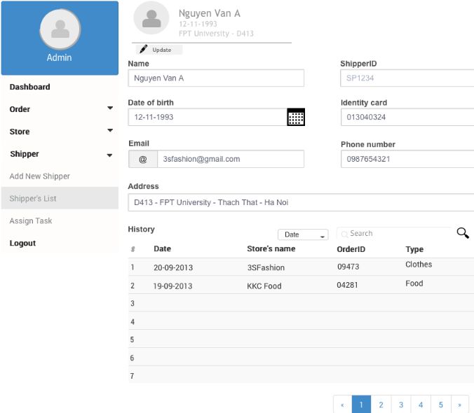

*Figure 11: Screen of View Store’s Details Use case*

|  |  |  |  |  |
| --- | --- | --- | --- | --- |
| **Use Case ID:** | | UC-109 | | |
| **Use Case Name:** | | View Store’s details | | |
| **Created By:** | | HoangNK | **Last Updated By:** | HoangNK |
| **Date Created:** | | 19/09/2015 | **Date Last updated:** | 24/09/2015 |
| **Actor:** | | Admin | | |
| **Description:** | | Admin views all Store’s details (address, name, registered date, phone number, store’s manager, payment, identity card) so after that, Admin can edit and block or unblock this Store | | |
| **Triggering Event:** | | Admin wants to view all information of a Store | | |
| **Preconditions:** | | Admin is in view store’s list page ( refer case UC-107 ) | | |
| **Post conditions:** | | Details of Store are displayed | | |
| **Priority:** | | Normal | | |
| **Frequency of Use:** | | Sometime | | |
| **Main flow** | | | | |
| Step | Actor | Action | | |
|  | Admin | Clicks Store’s name in row (hyperlink) | | |
|  | System | Loads data of selected Store and display “View Store’s details” screen includes store’s details includes: address, name, registered date, phone number, store’s manager, identity card, Change avatar button and Update button | | |
| **Alternative Flows:** | | N/A | | |
| **Exceptions:** | | | | |
| EC1 | At step 2, system can’t get data from database because the internet or the database disconnect | | | |
| Step | Actor | Action | | |
| 2.1 | System | Shows error message: “Failed to load data” | | |
| **Includes:** | | N/A | | |
| **Special Requirements:** | | N/A | | |
| **Notes and Issues:** | | N/A | | |

***Sequence Diagram***

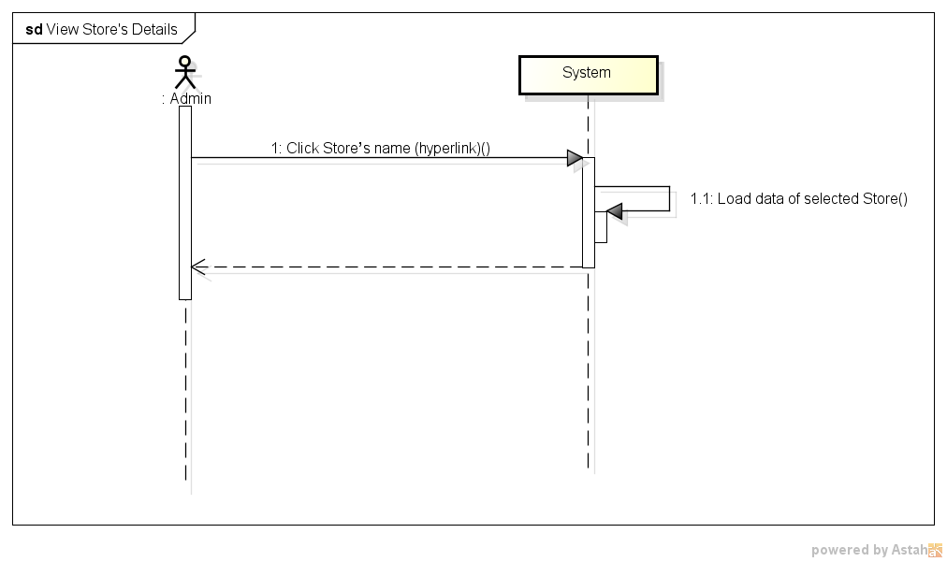

*Figure 11: Sequence Diagram for View Store’s Details Use case*

###### *UC- 111:* *Confirm Store’s payment*

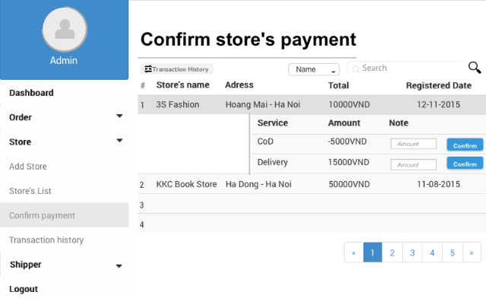

*Figure 11: Screen of Confirm Store’s Payment Use case*

|  |  |  |  |  |
| --- | --- | --- | --- | --- |
| **Use Case ID:** | | UC-111 | | |
| **Use Case Name:** | | Confirm Store’s payment | | |
| **Created By:** | | HoangNK | **Last Updated By:** | HoangNK |
| **Date Created:** | | 19/09/2015 | **Date Last updated:** | 24/09/2015 |
| **Actor:** | | Admin | | |
| **Description:** | | After receiving and sending money to the Store, admin updates Store’s payment by confirming amount of money of transactions | | |
| **Triggering Event:** | | Admin wants to confirms the store’s payment | | |
| **Preconditions:** | | Admin is in view store’s list page ( refer case UC-107 ) | | |
| **Post conditions:** | | Payment of this store is updated in database | | |
| **Priority:** | | High | | |
| **Frequency of Use:** | | Always | | |
| **Main flow** | | | | |
| Step | Actor | Action | | |
|  | Admin | Clicks “Confirm store’s payment” button | | |
|  | System | Displays “Confirm store’s payment” popup includes:   * Amount textbox and button * Payfrom drop-downlist * Store’s basic payment information: store’s name, delivery cost, cash on delivery | | |
|  | Admin | Picks payform, enters amount then clicks “Confirm” button | | |
|  | System | Validates input | | |
|  | System | Gives confirm by displaying confirm popup includes summary information, “Yes” and “No” button | | |
|  | Admin | Clicks “Yes” button | | |
|  | System | Updates payment of this store to database | | |
| **Alternative Flows:** | | N/A | | |
| **Exceptions:** | | | | |
| EC1 | At step 4, if amount textbox is blank | | | |
| Step | Actor | Action | | |
| 4.1 | System | Displays error message “* is required” | | |
| EC2 | At step 4, if amount textbox is incorrect format | | | |
| Step | Actor | Action | | |
| 4.1 | System | Displays error message “* should be digits” | | |
| EC3 | At step 4, if value of amount textbox is 0 | | | |
| Step | Actor | Action | | |
| 4.1 | System | Displays error message “Update fail… amount must greater than 0” | | |
| EC4 | At step 6, if Admin click “No” button | | | |
| Step | Actor | Action | | |
| 6.1 | System | Closes popup | | |
| **Includes:** | | N/A | | |
| **Special Requirements:** | | * Default value of amount textbox is 0 * The value of amount textbox is only number and not equal 0 | | |
| **Notes and Issues:** | | N/A | | |

***Sequence Diagram***

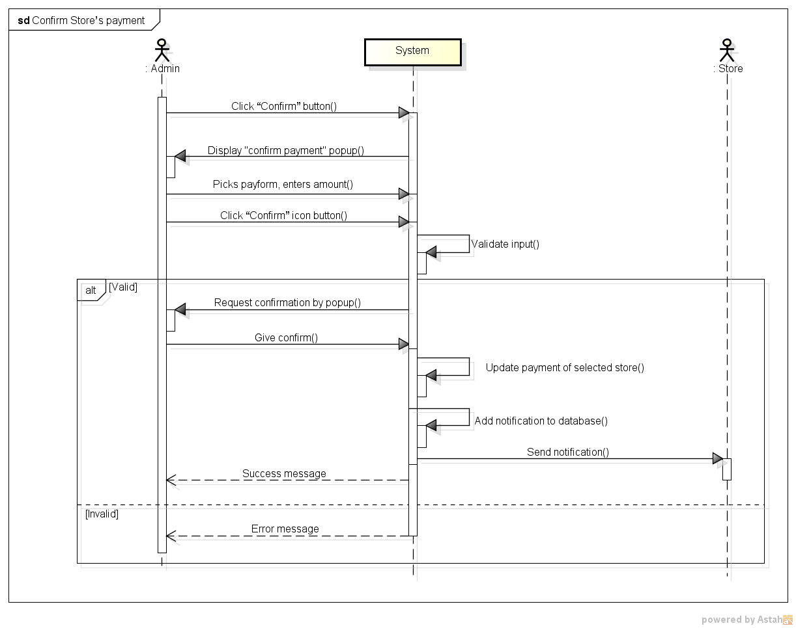

*Figure 11: Sequence Diagram for Confirm Store’s Payment Use case*

###### *UC- 112:* *View transaction history of Store*

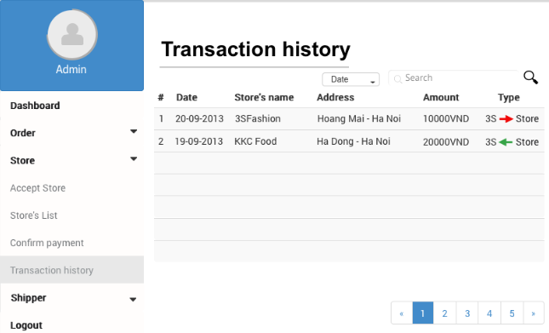

*Figure 11: Screen of View Transaction History of Store Use case*

|  |  |  |  |  |
| --- | --- | --- | --- | --- |
| **Use Case ID:** | | UC-112 | | |
| **Use Case Name:** | | View transaction history of Store | | |
| **Created By:** | | HoangNK | **Last Updated By:** | HoangNK |
| **Date Created:** | | 19/09/2015 | **Date Last updated:** | 19/09/2015 |
| **Actor:** | | Admin | | |
| **Description:** | | Admin wants the system to list all Store’s transaction with basic information (store’s name, address, amount of money, type,..) | | |
| **Triggering Event:** | | Admin wants to view transaction history of Stores | | |
| **Preconditions:** | | Admin logged in to system | | |
| **Post conditions:** | | List of transaction history of Store is displayed | | |
| **Priority:** | | Normal | | |
| **Frequency of Use:** | | Sometime | | |
| **Main flow** | | | | |
| Step | Actor | Action | | |
|  | Admin | Clicks “Store” button in left navigate bar | | |
|  | System | Display “Store” menu in left navigate bar includes: Add Store, Store’s List, Transaction History | | |
|  | Admin | Clicks “Transaction history” button | | |
|  | System | Load data of transaction and display “Transaction history” screen includes   * Search textbox and button * Filter drop-downlist * Two tab auto payment and custom payment with related information(ledgerid, store name, last balance, amount, amount, total delivery, total cod, paydate, note) of transactions | | |
| **Alternative Flows:** | | N/A | | |
| **Exceptions:** | | | | |
| EC1 | At step 4, system can’t get data from database because the internet or the database disconnect | | | |
| Step | Actor | Action | | |
| 4.1 | System | Shows error message: “Failed to load data” | | |
| **Includes:** | | N/A | | |
| **Special Requirements:** | | * “All” is default type * The default transaction list is ordered by Paydate | | |
| **Notes and Issues:** | | * If amount is negative, this transaction is pay from store to system and vice versa | | |

***Sequence Diagram***

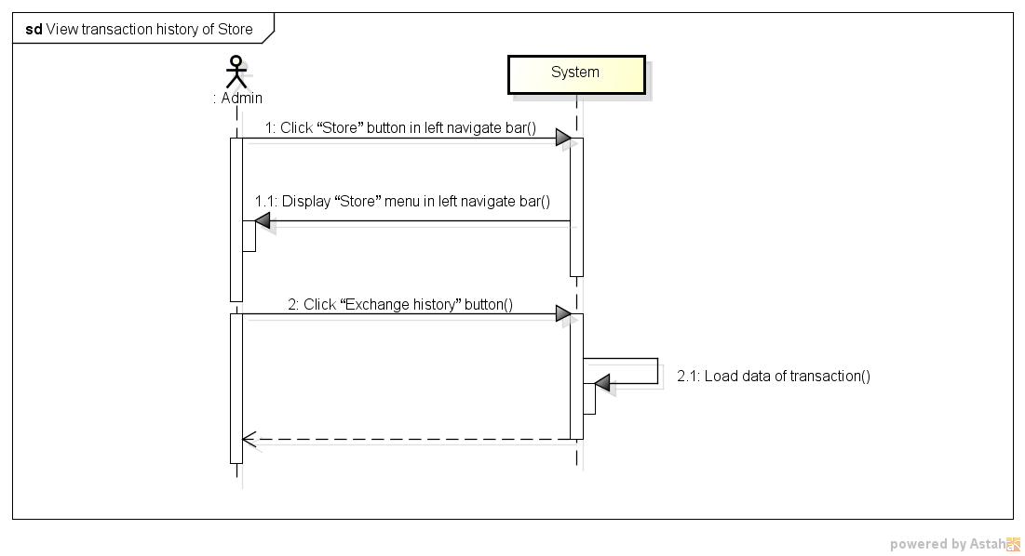

*Figure 11: Sequence Diagram for View Transaction history of Store Use case*

###### *UC- 113:* *Add Shipper*

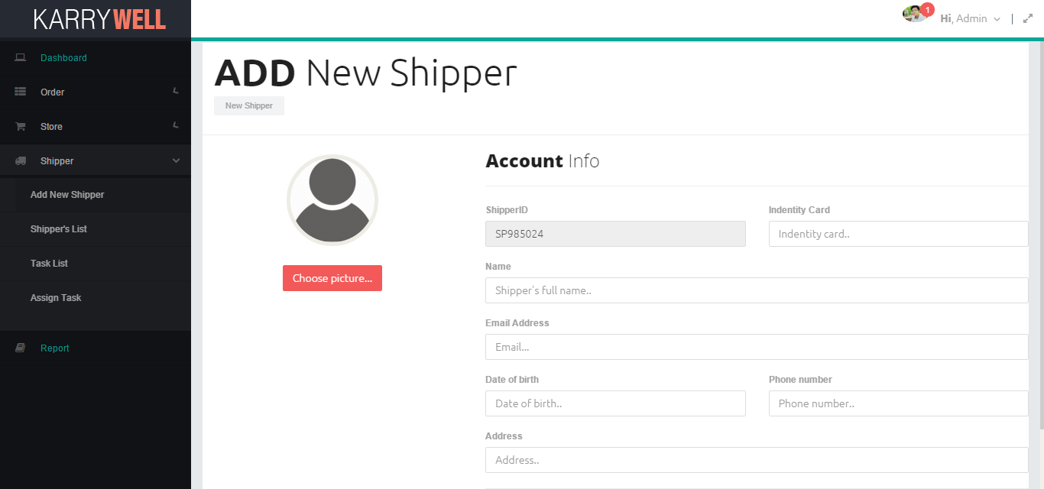

*Figure 11: Screen of Add Shipper Use case*

|  |  |  |  |  |
| --- | --- | --- | --- | --- |
| **Use Case ID:** | | UC-113 | | |
| **Use Case Name:** | | Add New Shipper | | |
| **Created By:** | | HoangNK | **Last Updated By:** | HoangNK |
| **Date Created:** | | 19/09/2015 | **Date Last updated:** | 19/09/2015 |
| **Actor:** | | Admin | | |
| **Description:** | | Admin creates new account to new Shipper with basic information of Shipper: name, date of birth, email, phone number, identity card, address,… | | |
| **Triggering Event:** | | Admin wants to adds a new Shipper to system | | |
| **Preconditions:** | | Admin logged in to system | | |
| **Post conditions:** | | New Shipper and new account for this Shipper are added to database | | |
| **Priority:** | | High | | |
| **Frequency of Use:** | | Often | | |
| **Main flow** | | | | |
| Step | Actor | Action | | |
|  | Admin | Clicks “Shipper” button in left navigate bar | | |
|  | System | Displays “Shipper” menu in left navigate bar includes Add New Shipper, Shipper’s List, Task’s List and Assign Task | | |
|  | Admin | Clicks “Add new Shipper” button | | |
|  | System | Displays “Add new Shipper” form includes:   * ShipperID textbox * Identity card textbox * Email textbox * Date of birth textbox * Phone number textbox * Address textbox * Choose avatar button * Create button | | |
|  | Admin | Enter new Shipper’s information into fields | | |
|  | Admin | Clicks “Create” button | | |
|  | System | Validate input | | |
|  | System | Add new Shipper and new account of this Shipper to database then redirects to “Shipper’s List” page | | |
| **Alternative Flows:** | | N/A | | |
| **Exceptions:** | | | | |
| EC1 | At step 7, if any required field is not entered | | | |
| Step | Actor | Action | | |
| 7.1 | System | Notify in screen by error message “*is require” | | |
| EC2 | At step 7, if any required field is incorrect format | | | |
| Step | Actor | Action | | |
| 7.1 | System | Displays error message:   * * must should be digits * * should be a valid email. * * length is invalid. It should be between 10 and 11 characters long. | | |
| EC3 | At step 7, if identity card or email has been already existed | | | |
| Step | Actor | Action | | |
| 7.1 | System | Notify in screen by error message “* has been already existed” | | |
| EC6 | At step 10, system is failed to add new Shipper by other reason | | | |
| Step | Actor | Action | | |
| 10.1 | System | Shows error notify: “Adding fail” | | |
| **Includes:** | | N/A | | |
| **Special Requirements:** | | * Email must be valid email format * Identity card must be digits and value length is 9 to 12 characters * Phone number must be digits and value length is 10 or 11 characters * ShipperID will be generated automatically by system by format “SP******” (* is digits) * Default account and password for new Shipper is shipperID, Shipper can change them by mobile app later | | |
| **Notes and Issues:** | | N/A | | |

***Sequence Diagram***

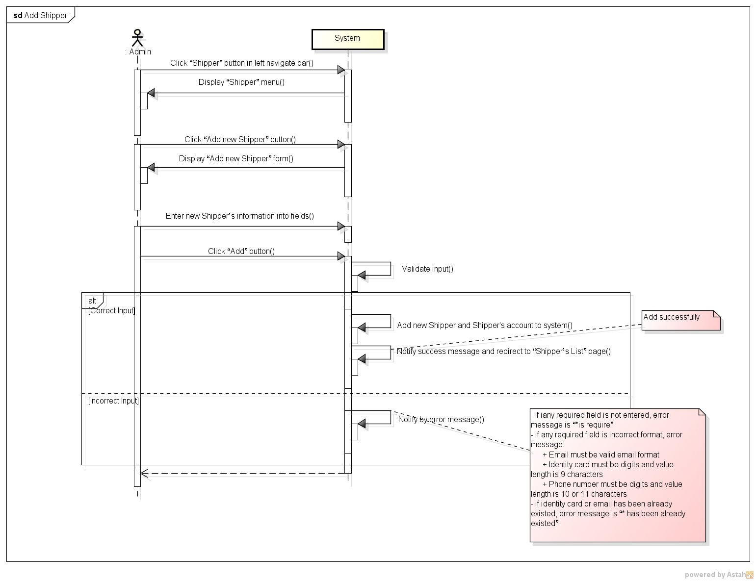

*Figure 11: Sequence Diagram for Add Shipper Use case*

###### *UC- 114:* *View Shipper’s list*

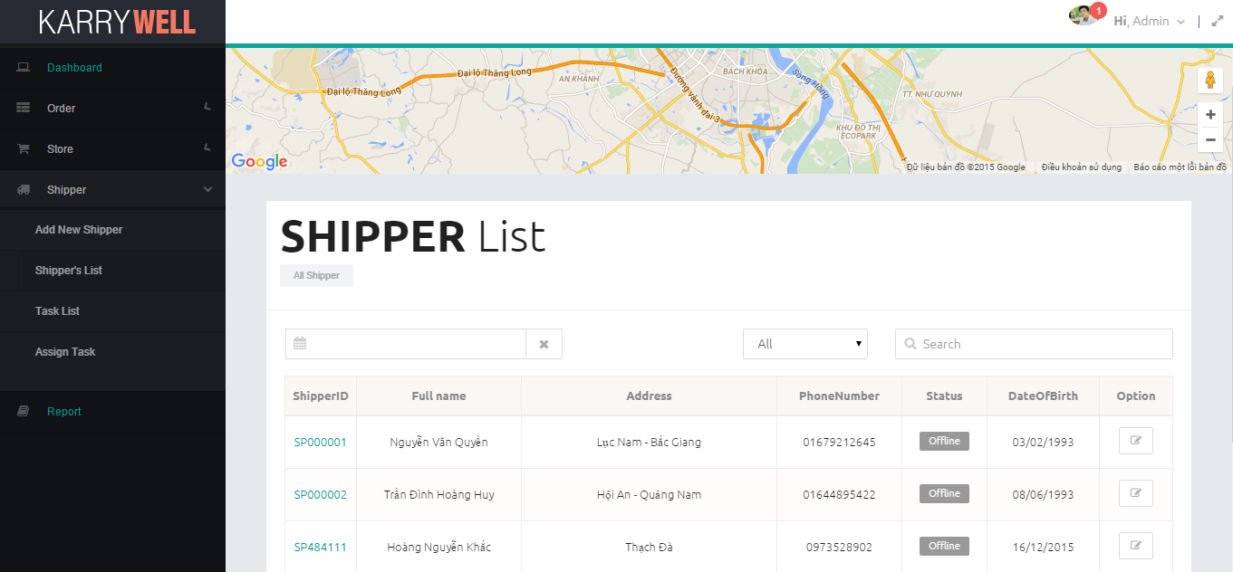

*Figure 11: Screen of View Shipper’s List Use case*

|  |  |  |  |  |
| --- | --- | --- | --- | --- |
| **Use Case ID:** | | UC-114 | | |
| **Use Case Name:** | | View Shipper’s list | | |
| **Created By:** | | HoangNK | **Last Updated By:** | HoangNK |
| **Date Created:** | | 19/09/2015 | **Date Last updated:** | 19/09/2015 |
| **Actor:** | | Admin | | |
| **Description:** | | Admin views all Shipper with their position in map and basic information (address, name, date of birth,..), so after that, Admin can choose a Shipper to update information | | |
| **Triggering Event:** | | Admin wants to view all Shipper | | |
| **Preconditions:** | | Admin logged in to system | | |
| **Post conditions:** | | List of shipper is displayed | | |
| **Priority:** | | High | | |
| **Frequency of Use:** | | Always | | |
| **Main flow** | | | | |
| Step | Actor | Action | | |
|  | Admin | Clicks “Shipper” button in left navigate bar | | |
|  | System | Display “Shipper” menu in left navigate bar includes Add New Shipper, Shipper’s List, Task’s List and Assign Task | | |
|  | Admin | Clicks “Shipper’s list” button | | |
|  | System | Load Shipper's data and display “Shipper’s List” screen includes:   * Map of all online shipper * Search textbox and button * Filter drop-downlist * All Shipper’s basic information(shipperid, full name, address, phone number, status, date of birth) with Update icon buttons | | |
| **Alternative Flows:** | | **N/A** | | |
| **Exceptions:** | | | | |
| EC1 | At step 4, system can’t get data from database because the internet or the database disconnect | | | |
| Step | Actor | Action | | |
| 4.1 | System | Shows error message: “Failed to load data” | | |
| **Includes:** | | N/A | | |
| **Special Requirements:** | | * The default Shipper’s list is ordered by Name * “All” is default type | | |
| **Notes and Issues:** | | N/A | | |

***Sequence Diagram***

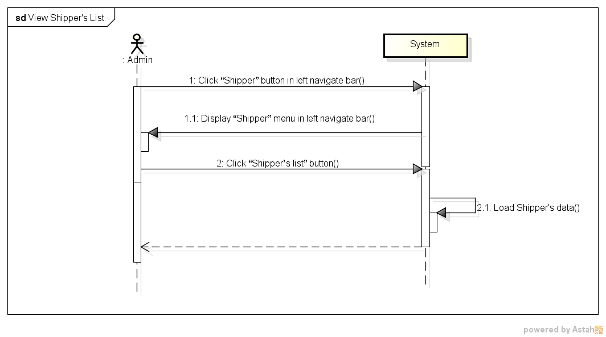

*Figure 11: Sequence Diagram for View Shipper List Use case*

###### *UC- 115:* *View Order’s list*

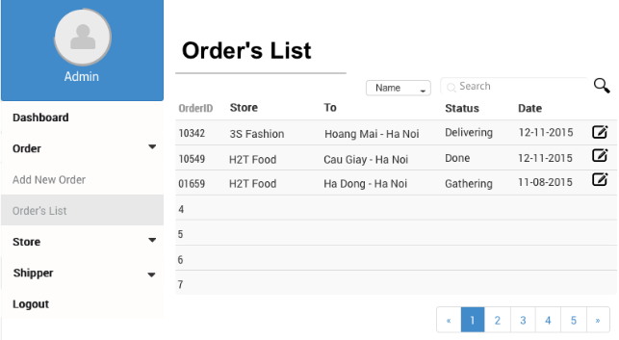

*Figure 11: Screen of View Order’s List Use case*

|  |  |  |  |  |
| --- | --- | --- | --- | --- |
| **Use Case ID:** | | UC-115 | | |
| **Use Case Name:** | | View Order’s list | | |
| **Created By:** | | HoangNK | **Last Updated By:** | HoangNK |
| **Date Created:** | | 19/09/2015 | **Date Last updated:** | 19/09/2015 |
| **Actor:** | | Admin | | |
| **Description:** | | Admin views all Order with basic information (orderID, store’s name, recipient’s address, status, date,..), so after that, Admin can choose an Order to update information | | |
| **Triggering Event:** | | Admin wants to view all Orders | | |
| **Preconditions:** | | Admin logged in to system | | |
| **Post conditions:** | | List of order is displayed | | |
| **Priority:** | | High | | |
| **Frequency of Use:** | | Always | | |
| **Main flow** | | | | |
| Step | Actor | Action | | |
|  | Admin | Clicks “Order” button in left navigate bar | | |
|  | System | Display “Order” menu in left navigate bar includes Add Add New Order, Order’s List | | |
|  | Admin | Clicks “Order’s list” button | | |
|  | System | Load Order's data and display “Order’s List” screen includes   * Search textbox and button * Filter drop-downlist * All Order’s basic information(orderID, store’s name, pickup address, delivery address, pickup date, delivery date, status, type) with Update icon buttons | | |
| **Alternative Flows:** | | **N/A** | | |
| **Exceptions:** | | | | |
| EC1 | At step 4, system can’t get data from database because the internet or the database disconnect | | | |
| Step | Actor | Action | | |
| 4.1 | System | Shows error message: “Failed to load data” | | |
| **Includes:** | | N/A | | |
| **Special Requirements:** | | * The default Shipper’s list is ordered by complete Date * “All” is default type | | |
| **Notes and Issues:** | | N/A | | |

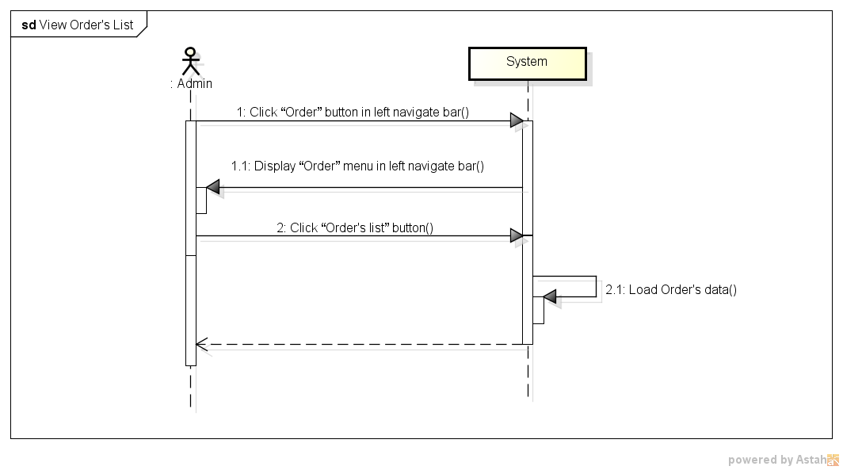***Sequence Diagram***

*Figure 11: Sequence Diagram for View Order’s List Use case*

###### *UC- 116:* *Search Shipper*

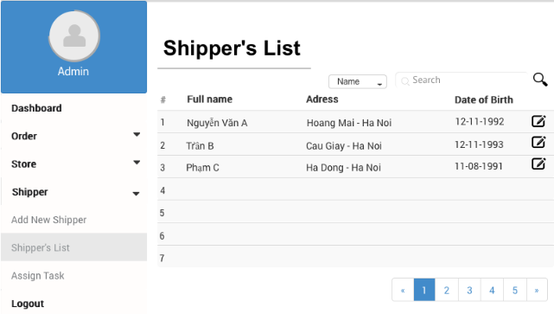

*Figure 11: Screen of Search Shipper Use case*

|  |  |  |  |  |
| --- | --- | --- | --- | --- |
| **Use Case ID:** | | UC-116 | | |
| **Use Case Name:** | | Search Shipper | | |
| **Created By:** | | HoangNK | **Last Updated By:** | HoangNK |
| **Date Created:** | | 19/09/2015 | **Date Last updated:** | 19/09/2015 |
| **Actor:** | | Admin | | |
| **Description:** | | Admin wants the system to list all Shipper related to a specific keyword and type, after that, Admin can choose a Shipper to update information | | |
| **Triggering Event:** | | Admin wants to search Shipper | | |
| **Preconditions:** | | Admin is in view shipper’s list page ( refer case UC-114 ) | | |
| **Post conditions:** | | Shippers have information which matches search key is displayed | | |
| **Priority:** | | High | | |
| **Frequency of Use:** | | Always | | |
| **Main flow** | | | | |
| Step | Actor | Action | | |
|  | Admin | Chooses type of searching | | |
|  | Admin | Enters text to “Search” text box | | |
|  | System | Displays Shippers have information which matches search key | | |
| **Alternative Flows:** | | N/A | | |
| **Exceptions:** | | N/A | | |
| **Includes:** | | N/A | | |
| **Special Requirements:** | | * Result of search is case insensitive * Types of search are All, Name, Address and shipperID | | |
| **Notes and Issues:** | | N/A | | |

***Sequence Diagram***

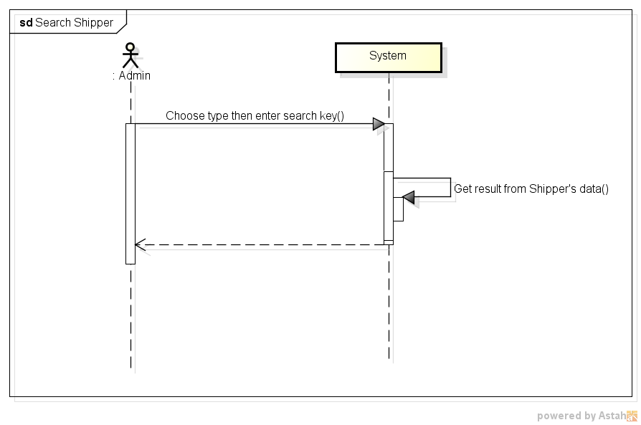

*Figure 11: Sequence Diagram for Search Shipper Use case*

###### *UC- 117:* *Search Order*



*Figure 11: Screen of Search Order Use case*

|  |  |  |  |  |
| --- | --- | --- | --- | --- |
| **Use Case ID:** | | UC-117 | | |
| **Use Case Name:** | | Search Order | | |
| **Created By:** | | HoangNK | **Last Updated By:** | HoangNK |
| **Date Created:** | | 19/09/2015 | **Date Last updated:** | 19/09/2015 |
| **Actor:** | | Admin | | |
| **Description:** | | Admin wants the system to list all Order related to a specific keyword and type, after that, Admin can choose an Order to update information | | |
| **Triggering Event:** | | Admin wants to search Order | | |
| **Preconditions:** | | Admin is in view order’s list page ( refer case UC-115 ) | | |
| **Post conditions:** | | Orders have information which matches search key is displayed | | |
| **Priority:** | | High | | |
| **Frequency of Use:** | | Always | | |
| **Main flow** | | | | |
| Step | Actor | Action | | |
|  | Admin | Chooses type of Order | | |
|  | Admin | Enters text to “Search” text box | | |
|  | System | Displays Orders have information which matches search key | | |
| **Alternative Flows:** | | N/A | | |
| **Exceptions:** | | N/A | | |
| **Includes:** | | N/A | | |
| **Special Requirements:** | | * Result of search is case insensitive * Types of search are All, store’s name, pickup address, delivery address, status | | |
| **Notes and Issues:** | | N/A | | |

***Sequence Diagram***

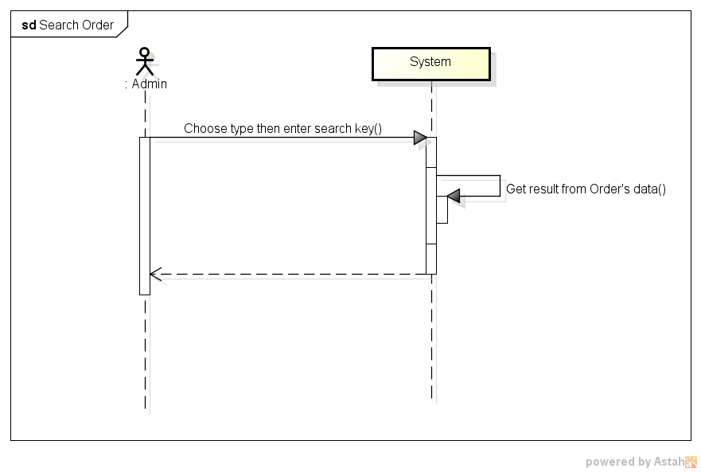

*Figure 11: Sequence Diagram for Search Order Use case*

###### *UC- 118:* *View User’s profile*

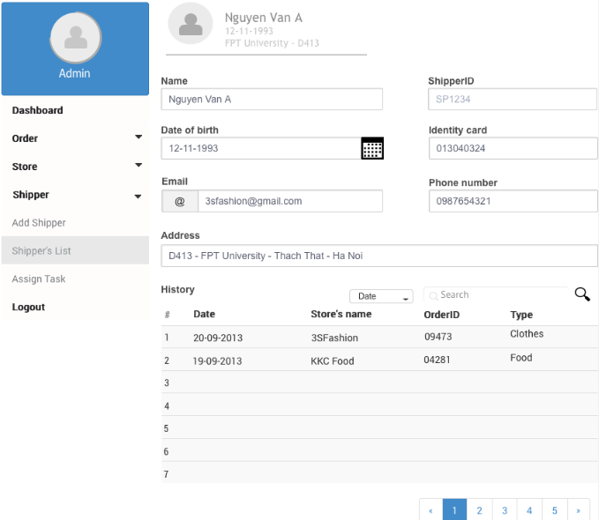

|  |  |  |  |  |
| --- | --- | --- | --- | --- |
| **Use Case ID:** | | UC-118 | | |
| **Use Case Name:** | | View Shipper’s profile | | |
| **Created By:** | | HoangNK | **Last Updated By:** | HoangNK |
| **Date Created:** | | 19/09/2015 | **Date Last updated:** | 24/09/2015 |
| **Actor:** | | Admin | | |
| **Description:** | | Admin views all Shipper’s details (address, name, date of birth, phone number, email, address) so after that, Admin can update Shipper information | | |
| **Triggering Event:** | | Admin wants to view profile of a Shipper | | |
| **Preconditions:** | | Admin is in view shipper’s list page ( refer case UC-114 ) | | |
| **Post conditions:** | | Profile of Shipper is displayed | | |
| **Priority:** | | Normal | | |
| **Frequency of Use:** | | Sometime | | |
| **Main flow** | | | | |
| Step | Actor | Action | | |
|  | Admin | Clicks Shipper’s name in row (hyperlink) | | |
|  | System | Load data of selected Shipper and display “View Shipper’s profile” screen includes information of name, date of birth, phone number, email, address, Change avatar button and Update button | | |
| **Alternative Flows:** | | N/A | | |
| **Exceptions:** | | | | |
| EC1 | At step 2, system can’t get data from database because the internet or the database disconnect | | | |
| Step | Actor | Action | | |
| 2.1 | System | Shows error message: “Failed to load data” | | |
| **Includes:** | | N/A | | |
| **Special Requirements:** | | N/A | | |
| **Notes and Issues:** | | N/A | | |

***Sequence Diagram***

*Figure 11: Sequence Diagram of View Shipper’s Profile Use case*

###### *UC- 119:* *View Order’s details*

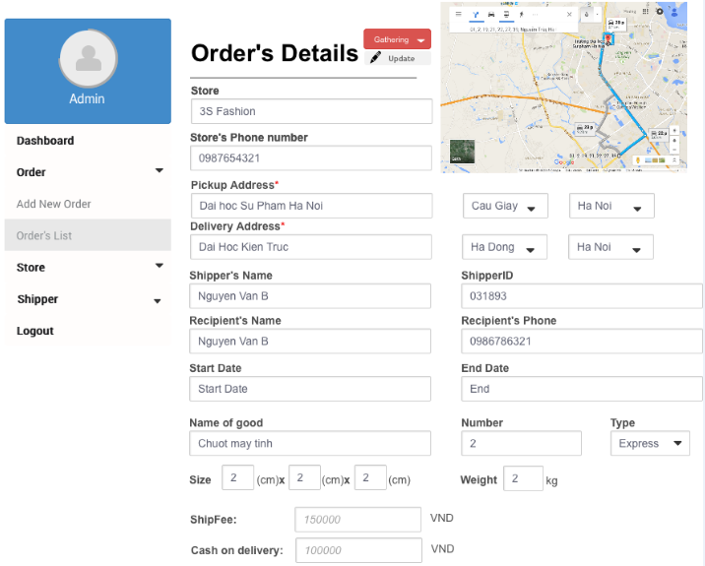

|  |  |  |  |  |
| --- | --- | --- | --- | --- |
| **Use Case ID:** | | UC-119 | | |
| **Use Case Name:** | | View Order’s details | | |
| **Created By:** | | HoangNK | **Last Updated By:** | HoangNK |
| **Date Created:** | | 19/09/2015 | **Date Last updated:** | 19/09/2015 |
| **Actor:** | | Admin | | |
| **Description:** | | Admin views all Order’s details (status of the order , store’s name, pickup and delivery address and date, shipper’s name, recipient’s name, recipient’s phone, goods, type of delivery, size, fee, cash on delivery, …), so after that, Admin can update Shipper information | | |
| **Triggering Event:** | | Admin wants to view all information of the Order | | |
| **Preconditions:** | | Admin is in view shipper’s list page ( refer case UC-115) | | |
| **Post conditions:** | | Details of Order is displayed | | |
| **Priority:** | | Normal | | |
| **Frequency of Use:** | | Sometime | | |
| **Main flow** | | | | |
| Step | Actor | Action | | |
|  | Admin | Clicks Order’s name in row (hyperlink) | | |
|  | System | Load data of selected Order and display to “View Order’s details” screen includes information of status of the order , store’s name, pickup and delivery address and date, shipper’s name, recipient’s name, recipient’s phone, goods, type of delivery, size, fee, cash on delivery, … | | |
| **Alternative Flows:** | | N/A | | |
| **Exceptions:** | |  | | |
| EC1 | At step 2, system can’t get data from database because the internet or the database disconnect | | | |
| Step | Actor | Action | | |
| 2.1 | System | Shows error message: “Failed to load data” | | |
| **Includes:** | | N/A | | |
| **Special Requirements:** | | N/A | | |
| **Notes and Issues:** | | N/A | | |

***Sequence Diagram***

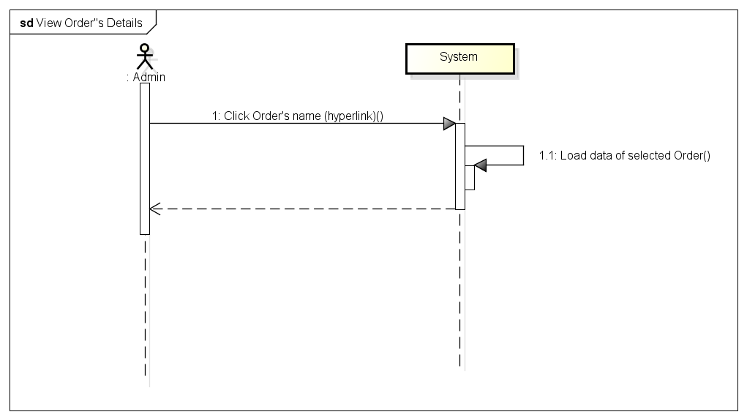

*Figure 11: Sequence Diagram for View Order Details Use case*

###### *UC- 120:* *Update User’s Profile*

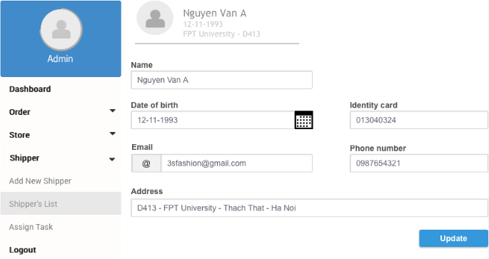

|  |  |  |  |  |
| --- | --- | --- | --- | --- |
| **Use Case ID:** | | UC-120 | | |
| **Use Case Name:** | | Update User’s Profile | | |
| **Created By:** | | HoangNK | **Last Updated By:** | HoangNK |
| **Date Created:** | | 19/09/2015 | **Date Last updated:** | 19/09/2015 |
| **Actor:** | | Admin | | |
| **Description:** | | Admin modifies an existed Shipper or Store’s Owner with related information about name, date of birth, identity card, email, phone number, address,.. | | |
| **Triggering Event:** | | Admin wants to update Shipper or Store’s Owner information | | |
| **Preconditions:** | | Admin is in view shipper’s list page ( refer case UC-114 ) | | |
| **Post conditions:** | | New information of user is updated in database | | |
| **Priority:** | | Normal | | |
| **Frequency of Use:** | | Sometime | | |
| **Main flow** | | | | |
| Step | Actor | Action | | |
|  | Admin | Clicks icon “Update” button | | |
|  | System | Get data of selected user and display “Update” screen includes textbox of information about name, date of birth, phone number, email, address, Change avatar button and Update button | | |
|  | Admin | Enter new information to fields then clicks “Update” button | | |
|  | System | Validate input | | |
|  | System | Update user’s new information to database then notify success message “Update successfully” | | |
| **Alternative Flows:** | | | | |
| AT1 | At step 1, if Admin is in view store’s list page ( refer case UC-107 ) | | | |
| Step | Actor | Action | | |
| 1 | Admin | Clicks icon “Update” button | | |
| 2 | System | Go to step 2 of main flow and continue | | |
| **Exceptions:** | | | | |
| EC1 | At step 4, if any required field is not entered | | | |
| Step | Actor | Action | | |
| 4.1 | System | Notify in screen by error message “*is require” | | |
| EC2 | At step 4, if any required field is incorrect format | | | |
| Step | Actor | Action | | |
| 4.1 | System | Displays error message:   * * must should be digits * * should be a valid email. * * length is invalid. It should be between 10 and 11 characters long. | | |
| EC3 | At step 4, if new identity card or email has been already existed | | | |
| Step | Actor | Action | | |
| 4.1 | System | Notify in screen by error message “* has been already existed” | | |
| EC6 | At step 5, system is failed to update new user by other reason | | | |
| Step | Actor | Action | | |
| 5.1 | System | Shows error notify: “Update fail” | | |
| **Includes:** | | N/A | | |
| **Special Requirements:** | | * Email must be valid email format * Identity card must be digits and value length is 9 to 12 characters * Phone number must be digits and value length is 10 or 11 characters | | |
| **Notes and Issues:** | | N/A | | |

***Sequence Diagram***

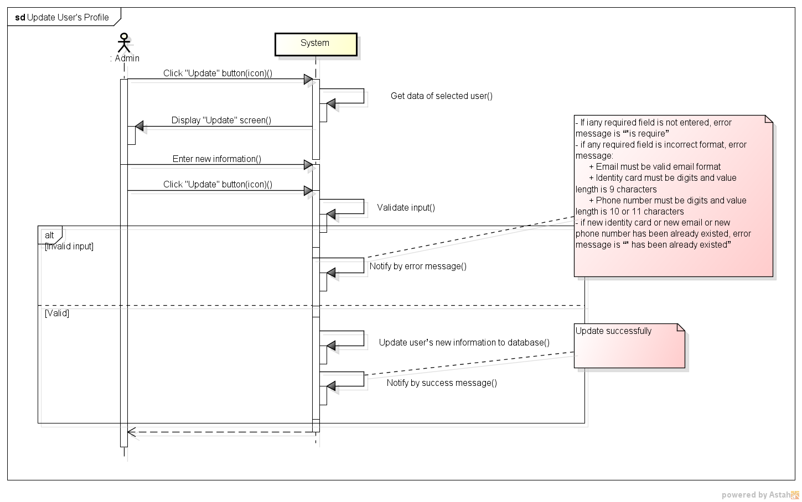

*Figure 11: Sequence Diagram for Update Shipper Use case*

###### *UC- 121:* *Update Store’s Information*



|  |  |  |  |  |
| --- | --- | --- | --- | --- |
| **Use Case ID:** | | UC-121 | | |
| **Use Case Name:** | | Update Store’s Information | | |
| **Created By:** | | HoangNK | **Last Updated By:** | HoangNK |
| **Date Created:** | | 19/09/2015 | **Date Last updated:** | 19/09/2015 |
| **Actor:** | | Admin | | |
| **Description:** | | Admin modifies an existed Store related information about name, email, phone number, address,.. | | |
| **Triggering Event:** | | Admin wants to update Store’s information | | |
| **Preconditions:** | | Admin is in view store’s list page ( refer case UC-114 ) | | |
| **Post conditions:** | | New information of Store is updated in database | | |
| **Priority:** | | Normal | | |
| **Frequency of Use:** | | Sometime | | |
| **Main flow** | | | | |
| Step | Actor | Action | | |
|  | Admin | Clicks icon “Update” button | | |
|  | System | Get data of selected Store and display “Update” screen includes textbox of information about address, name, phone number, store’s manager, identity card, Change avatar button and Update button | | |
|  | Admin | Enter new information to fields then clicks “Update” button | | |
|  | System | Validate input | | |
|  | System | Update Store’s new information to database then redirects to Shipper’s profile page | | |
| **Alternative Flows:** | | N/A | | |
| **Exceptions:** | | | | |
| EC1 | At step 4, if any required field is not entered | | | |
| Step | Actor | Action | | |
| 4.1 | System | Notify in screen by error message “*is require” | | |
| EC2 | At step 4, if any required field is incorrect format | | | |
| Step | Actor | Action | | |
| 4.1 | System | Displays error message:   * * must should be digits * * should be a valid email. * * length is invalid. It should be between 10 and 11 characters long. | | |
| EC3 | At step 4, if new identity card or email has been already existed | | | |
| Step | Actor | Action | | |
| 4.1 | System | Notify in screen by error message “* has been already existed” | | |
| EC6 | At step 5, system is failed to update new Store by other reason | | | |
| Step | Actor | Action | | |
| 5.1 | System | Shows error notify: “Update fail” | | |
| **Includes:** | | N/A | | |
| **Special Requirements:** | | * Email must be valid email format * Identity card must be digits and value length is 9 to 12 characters * Phone number must be digits and value length is 10 or 11 characters | | |
| **Notes and Issues:** | | N/A | | |

***Sequence Diagram***

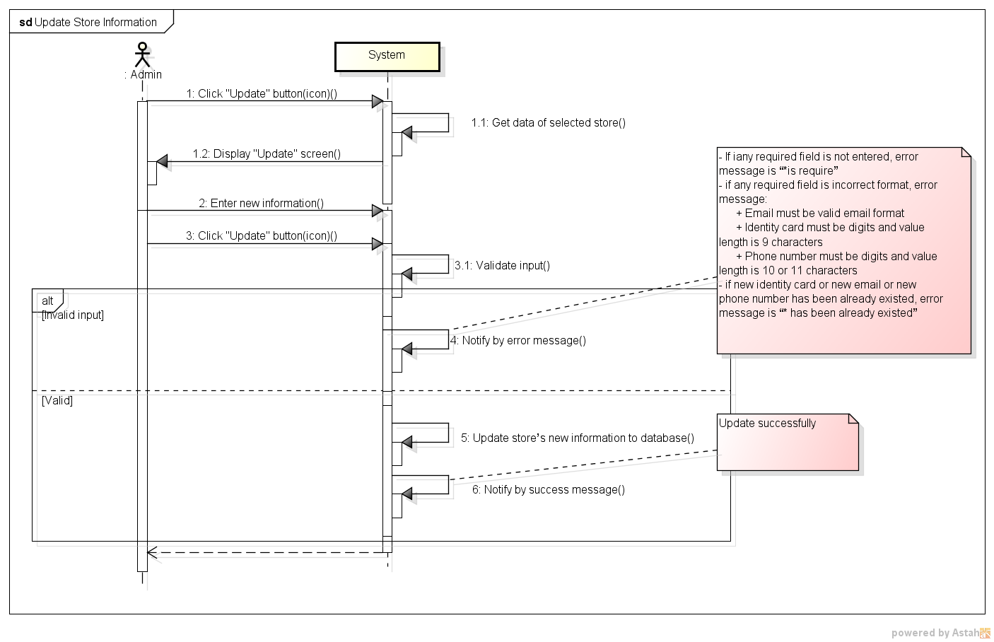

*Figure 11: Sequence Diagram for Update Store’s Information Use case*

###### *UC- 124:* *Assign Task*

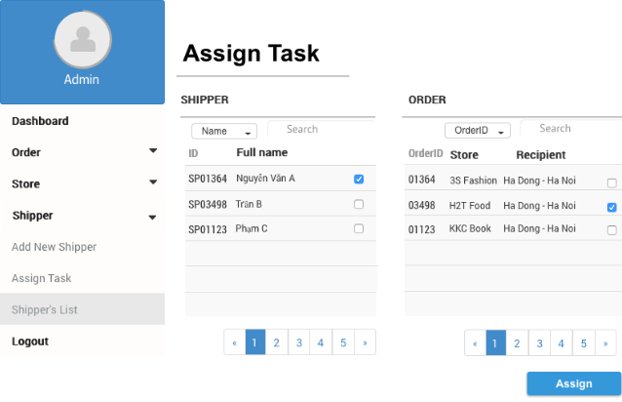

*Figure 11: Screen of Assign Task Use case*

|  |  |  |  |  |
| --- | --- | --- | --- | --- |
| **Use Case ID:** | | UC-124 | | |
| **Use Case Name:** | | Assign Task | | |
| **Created By:** | | HoangNK | **Last Updated By:** | HoangNK |
| **Date Created:** | | 19/09/2015 | **Date Last updated:** | 19/09/2015 |
| **Actor:** | | Admin | | |
| **Description:** | | Admin assigns orders which hasn’t been assign for any Shipper to available Shipper or orders which has issue to other shipper | | |
| **Triggering Event:** | | Admin wants to assign task for Shipper | | |
| **Preconditions:** | | Admin logged in to system | | |
| **Post conditions:** | | Task is assigned for Shipper | | |
| **Priority:** | | High | | |
| **Frequency of Use:** | | Often | | |
| **Main flow** | | | | |
| Step | Actor | Action | | |
|  | Admin | Clicks “Shipper” button in left navigate bar | | |
|  | System | Displays “Shipper” menu in left navigate bar includes Add Shipper, Assign Task, Shipper’s List | | |
|  | Admin | Clicks “Assign Task” button | | |
|  | System | Gets data of Order and Shipper then display “Assign Task” screen includes:   * 3 tables of available Shipper, Task of picked shipper and Order with related information(shipperid, shipper’s name, taskid, task status, ordered, order status, pickup and delivery address) * Search textbox and Filter on each table * Inbox button * Assign button | | |
|  | Admin | Picks a Shipper in Shipper’s list then picks Orders for this Shipper in Order’s list | | |
|  | Admin | Clicks “Assign” button | | |
|  | System | Update Shipper’s information in database, send notification to shipper and notify success message to Admin | | |
| **Alternative Flows:** | | **N/A** | | |
| **Exceptions:** | | | | |
| EC1 | At step 5, if Admin doesn’t pick any shipper | | | |
| Step | Actor | Action | | |
| 5.1 | System | Doesn’t allow to pick order | | |
| EC2 | At step 7, if assign task fail because any reason | | | |
| Step | Actor | Action | | |
| 7.1 | System | Notify message “Assign fail” | | |
| **Includes:** | | N/A | | |
| **Special Requirements:** | | * Only available Orders are displayed in Order’s list | | |
| **Notes and Issues:** | | N/A | | |

***Sequence Diagram***

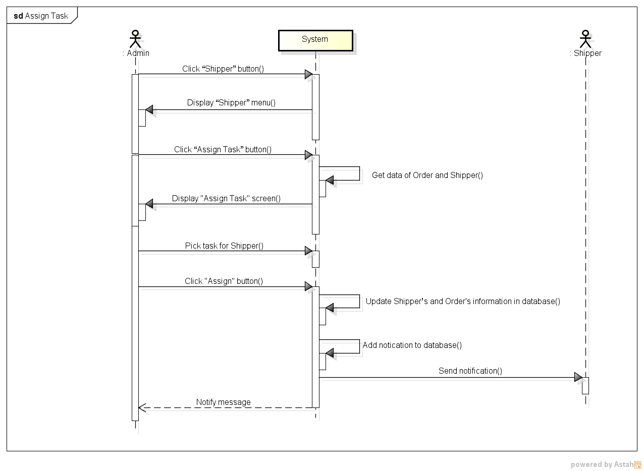

*Figure 11: Sequence Diagram for Assign Task Use case*

###### *UC- 125:* *View Dashboard*

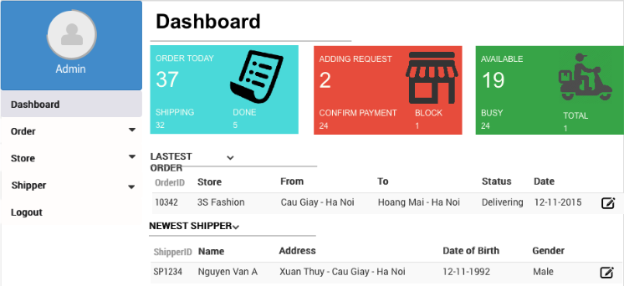

*Figure 11: Screen of View Dashboard Use case*

|  |  |  |  |  |
| --- | --- | --- | --- | --- |
| **Use Case ID:** | | UC-125 | | |
| **Use Case Name:** | | View dashboard | | |
| **Created By:** | | HoangNK | **Last Updated By:** | HoangNK |
| **Date Created:** | | 19/09/2015 | **Date Last updated:** | 19/09/2015 |
| **Actor:** | | Admin | | |
| **Description:** | | A view of some statistics about order, shipper, store and task information (active, inactive, done, fail) is displayed to Admin so Admin has a general view about order, store, shipper and task | | |
| **Triggering Event:** | | Admin wants to view dashboard with the statistics | | |
| **Preconditions:** | | Admin logged in to system | | |
| **Post conditions:** | | Dashboard screen with statistics is displayed | | |
| **Priority:** | | Normal | | |
| **Frequency of Use:** | | Sometime | | |
| **Main flow** | | | | |
| Step | Actor | Action | | |
|  | Admin | Clicks “Dashboard” button in left navigate bar | | |
|  | System | Display “Dashboard” screen includes:   * Map of all online shippers and store * Statistics of order, shipper and store in box * List of task | | |
| **Alternative Flows:** | | N/A | | |
| **Exceptions:** | | | | |
| EC1 | At step 2, system can’t get data from database because the internet or the database disconnect | | | |
| Step | Actor | Action | | |
| 2.1 | System | Shows error message: “Failed to load data” | | |
| **Includes:** | | N/A | | |
| **Special Requirements:** | | N/A | | |
| **Notes and Issues:** | | N/A | | |

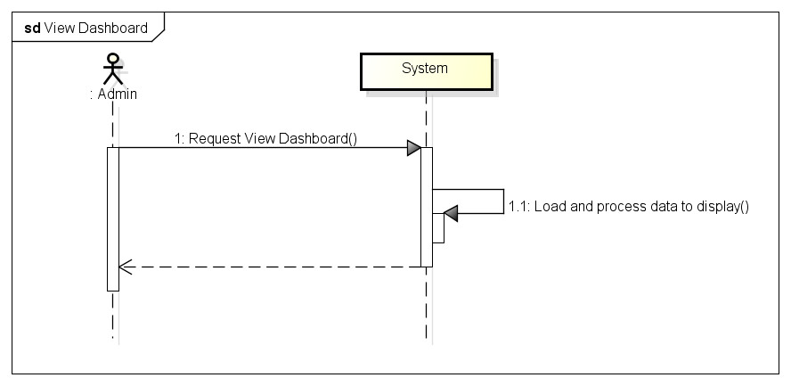***Sequence Diagram***

*Figure 11: Sequence Diagram for View Dashboard Use case*

###### *UC- 126:* *View IssueBox*

|  |  |  |  |  |
| --- | --- | --- | --- | --- |
| **Use Case ID:** | | UC-126 | | |
| **Use Case Name:** | | View IssueBox | | |
| **Created By:** | | HoangNK | **Last Updated By:** | HoangNK |
| **Date Created:** | | 19/09/2015 | **Date Last updated:** | 19/09/2015 |
| **Actor:** | | Admin | | |
| **Description:** | | A view of list of all issues and their detail, so Admin can resolve issue after check it | | |
| **Triggering Event:** | | Admin wants to view issue and their detail | | |
| **Preconditions:** | | Admin logged in to system | | |
| **Post conditions:** | | IssueBox screen with this issue and it’s detail | | |
| **Priority:** | | Normal | | |
| **Frequency of Use:** | | Sometime | | |
| **Main flow** | | | | |
| Step | Actor | Action | | |
|  | Admin | Clicks “IssueBox” button in left navigate bar | | |
|  | System | Display “IssueBox” screen includes:   * List of all issue and related information of each issue: type, category, date, is resolved or not,… * Issue detail include: order has issue and it’s status, shipper and store has issue, content of issue, date of issue, type, category, resolve issue button * Filter issue drop-downlist * Search textbox | | |
| **Alternative Flows:** | | N/A | | |
| **Exceptions:** | | | | |
| EC1 | At step 2, system can’t get data from database because the internet or the database disconnect | | | |
| Step | Actor | Action | | |
| 2.1 | System | Shows error message: “Failed to load data” | | |
| **Includes:** | | N/A | | |
| **Special Requirements:** | | * The default issue’s list is ordered by Date(decrease) * “All” is default type of search | | |
| **Notes and Issues:** | | N/A | | |

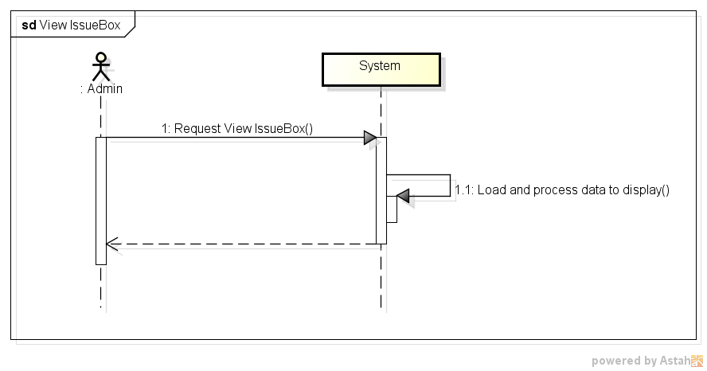***Sequence Diagram***

*Figure 11: Sequence Diagram for View IssueBox Use case*

###### *UC- 127:* *Resolve Issue*

|  |  |  |  |  |
| --- | --- | --- | --- | --- |
| **Use Case ID:** | | UC-127 | | |
| **Use Case Name:** | | Resolve Issue | | |
| **Created By:** | | HoangNK | **Last Updated By:** | HoangNK |
| **Date Created:** | | 19/09/2015 | **Date Last updated:** | 19/09/2015 |
| **Actor:** | | Admin | | |
| **Description:** | | After checking issue which is sent by shipper or store, Admin chooses type of resolve issue to resolve | | |
| **Triggering Event:** | | Admin wants to resolve issue | | |
| **Preconditions:** | | Admin is in view of issue box page ( refer case UC-126 ) | | |
| **Post conditions:** | | Issue is resolved and related information is updated | | |
| **Priority:** | | Normal | | |
| **Frequency of Use:** | | Sometime | | |
| **Main flow** | | | | |
| Step | Actor | Action | | |
|  | Admin | Chooses resolve type to resolve issue (3 types of issue: shipper pending, shipper cancel, store request cancel), then clicks on resolve button | | |
|  | System | Shows confirm popup contain resolve information | | |
|  | Admin | Clicks “Yes” button to give confirm | | |
|  | System | Updates issue and related information, sends notification to shipper and store and notifies success message | | |
| **Alternative Flows:** | | | | |
| AT1 | At step 2, if admin clicks “Assign Task” button (for resolve pending issue) | | | |
| Step | Actor | Action | | |
| 1 | System | Redirect to Assign Task Page | | |
| 2 | Admin | Picks processing task for other shipper then click Assign button | | |
| 3 | System | Updates tasks, issue and related information | | |
| 4 | System | Adds notification to database, send notification to store and shipper and notify success message to admin | | |
| **Exceptions:** | | | | |
| EC1 | At step 1, system can’t get data from database because the internet or the database disconnect | | | |
| Step | Actor | Action | | |
| 1.1 | System | Shows error message: “Failed to load data” | | |
| EC2 | At step 4, if resolve issue fail because any reason | | | |
| Step | Actor | Action | | |
| 4.1 | System | Notify message “Update fail” | | |
| **Includes:** | | N/A | | |
| **Special Requirements:** | | * The default issue’s list is ordered by Date(decrease) * “All” is default type of search | | |
| **Notes and Issues:** | | N/A | | |

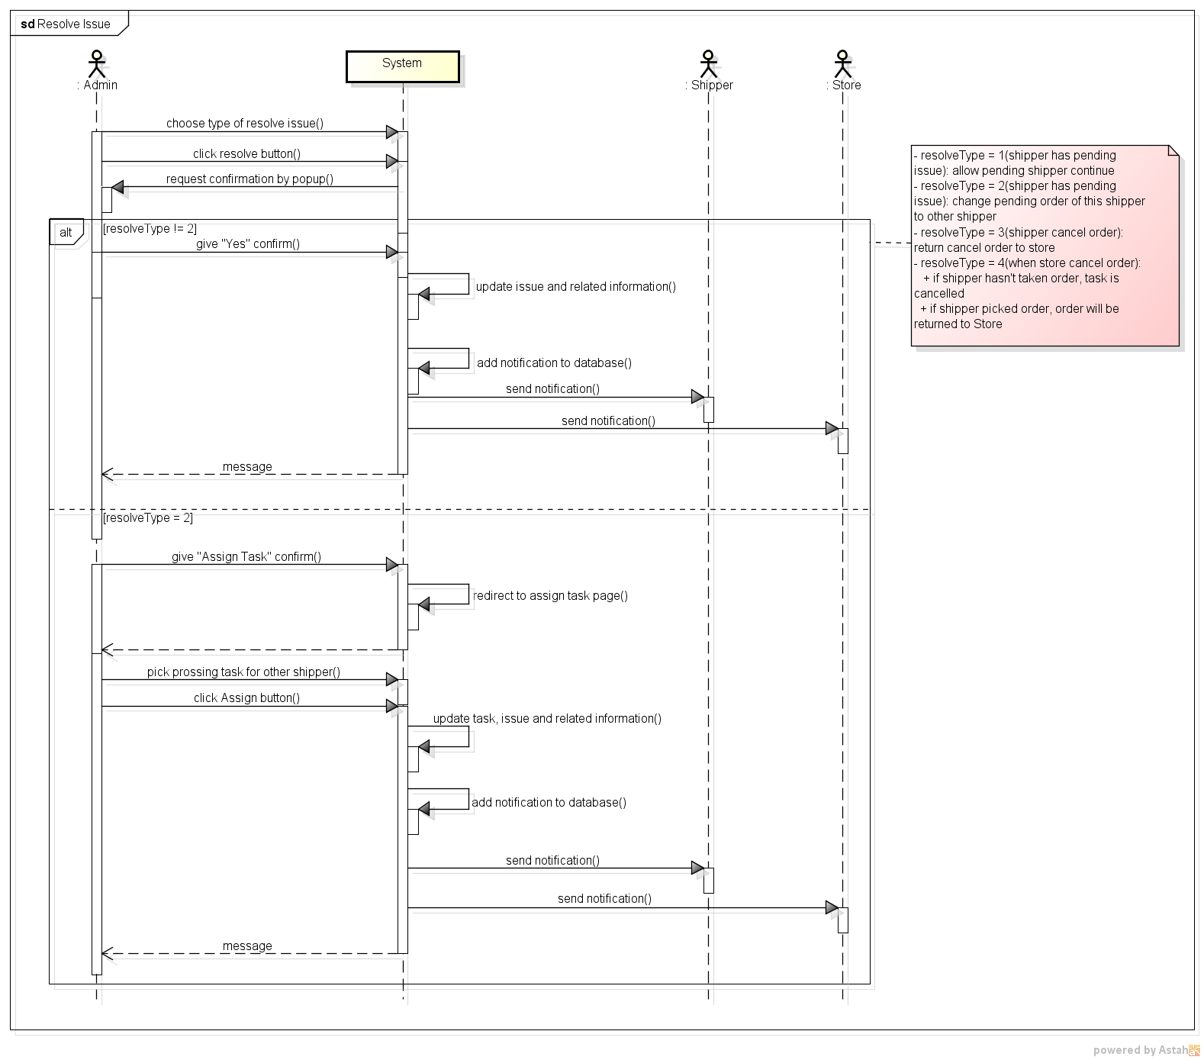***Sequence Diagram***

*Figure 11: Sequence Diagram for Resolve Issue Use case*

###### *UC- 128:* *View Task’s list*

|  |  |  |  |  |
| --- | --- | --- | --- | --- |
| **Use Case ID:** | | UC-128 | | |
| **Use Case Name:** | | View Task’s list | | |
| **Created By:** | | HoangNK | **Last Updated By:** | HoangNK |
| **Date Created:** | | 19/09/2015 | **Date Last updated:** | 19/09/2015 |
| **Actor:** | | Admin | | |
| **Description:** | | Admin views all task with basic information (shipperid, orderid, store’s name, type, status, task date) | | |
| **Triggering Event:** | | Admin wants to view all Task | | |
| **Preconditions:** | | Admin logged in to system | | |
| **Post conditions:** | | List of task is displayed | | |
| **Priority:** | | High | | |
| **Frequency of Use:** | | Always | | |
| **Main flow** | | | | |
| Step | Actor | Action | | |
|  | Admin | Clicks “Shipper” button in left navigate bar | | |
|  | System | Display “Shipper” menu in left navigate bar includes Add New Shipper, Shipper’s List, Task’s List and Assign Task | | |
|  | Admin | Clicks “Task’s list” button | | |
|  | System | Load Task’s data and display “Task’s List” screen includes:   * Search textbox and button * Filter drop-downlist * All Shipper’s basic information(shipperid, taskid, orderid, storeid, task status, order status, task type, task date) | | |
| **Alternative Flows:** | | **N/A** | | |
| **Exceptions:** | | | | |
| EC1 | At step 4, system can’t get data from database because the internet or the database disconnect | | | |
| Step | Actor | Action | | |
| 4.1 | System | Shows error message: “Failed to load data” | | |
| **Includes:** | | N/A | | |
| **Special Requirements:** | | * The default Task’s list is ordered by Task Date(decrease) * “All” is default type | | |
| **Notes and Issues:** | | N/A | | |

***Sequence Diagram***

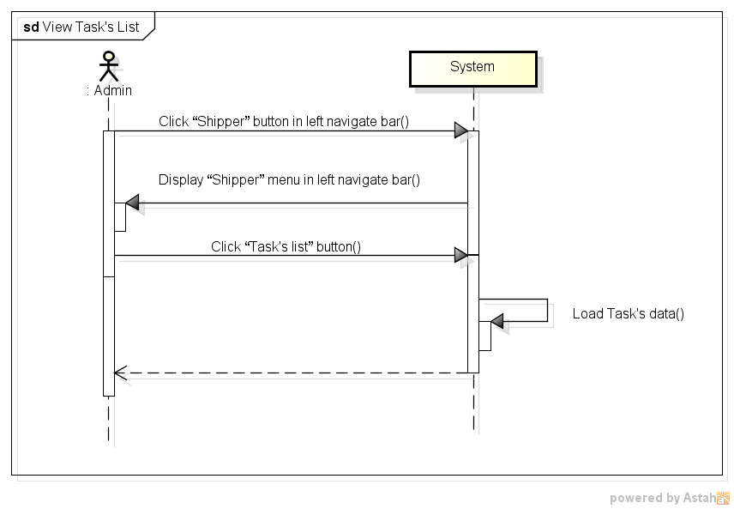

*Figure 11: Sequence Diagram for View Task’s List Use case*

###### *UC- 129:* *View Report*

|  |  |  |  |  |
| --- | --- | --- | --- | --- |
| **Use Case ID:** | | UC-129 | | |
| **Use Case Name:** | | View Report | | |
| **Created By:** | | HoangNK | **Last Updated By:** | HoangNK |
| **Date Created:** | | 19/09/2015 | **Date Last updated:** | 19/09/2015 |
| **Actor:** | | Admin | | |
| **Description:** | | Admin views statistics about Store, Shipper and Order in week, month and year | | |
| **Triggering Event:** | | Admin wants to report about system | | |
| **Preconditions:** | | Admin logged in to system | | |
| **Post conditions:** | | Report information is displayed | | |
| **Priority:** | | High | | |
| **Frequency of Use:** | | Always | | |
| **Main flow** | | | | |
| Step | Actor | Action | | |
|  | Admin | Clicks “Report” button in left navigate menu | | |
|  | System | Load Report data and display screen includes:   * Graph of order, finance by month, year * Over view of system: shipper, store, order, task | | |
| **Alternative Flows:** | | **N/A** | | |
| **Exceptions:** | | | | |
| EC1 | At step 2, system can’t get data from database because the internet or the database disconnect | | | |
| Step | Actor | Action | | |
| 2.1 | System | Shows error message: “Failed to load data” | | |
| **Includes:** | | N/A | | |
| **Special Requirements:** | | N/A | | |
| **Notes and Issues:** | | N/A | | |

***Sequence Diagram***

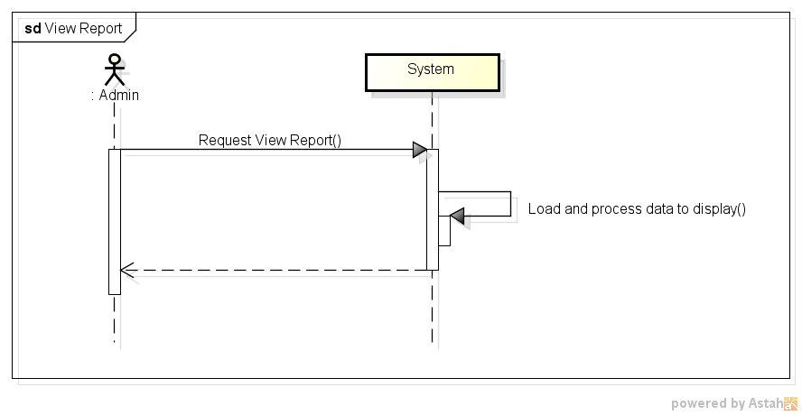

*Figure 11: Sequence Diagram for View Task’s List Use case*

###### *UC- 130: Search Task*

|  |  |  |  |  |
| --- | --- | --- | --- | --- |
| **Use Case ID:** | | UC-130 | | |
| **Use Case Name:** | | Search Task | | |
| **Created By:** | | HoangNK | **Last Updated By:** | HoangNK |
| **Date Created:** | | 19/09/2015 | **Date Last updated:** | 24/09/2015 |
| **Actor:** | | Admin | | |
| **Description:** | | Admin wants the system to list all Tasks related to a specific keyword and type | | |
| **Triggering Event:** | | Admin wants to search task | | |
| **Preconditions:** | | Admin is in view task’s list page ( refer case UC-128) | | |
| **Post conditions:** | | Tasks have information which matches search key is displayed | | |
| **Priority:** | | High | | |
| **Frequency of Use:** | | Always | | |
| **Main flow** | | | | |
| Step | Actor | Action | | |
|  | Admin | Chooses type of searching | | |
|  | Admin | Enters text to “Search” text box | | |
|  | System | Displays Tasks have information which matches search key | | |
| **Alternative Flows:** | | N/A | | |
| **Exceptions:** | | N/A | | |
| **Includes:** | | N/A | | |
| **Special Requirements:** | | * Result of search is case insensitive * Types of search are : All, ShipperID, OrderID, StoreID, Order status, Task status, Type | | |
| **Notes and Issues:** | | N/A | | |

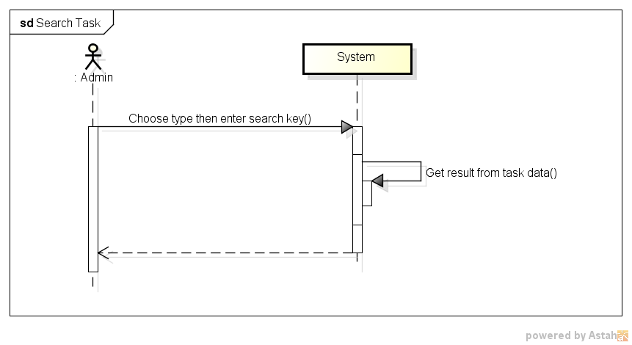

*Figure 11: Sequence Diagram for Search Task Use case*

###### *UC- 131: Search Transaction*

|  |  |  |  |  |
| --- | --- | --- | --- | --- |
| **Use Case ID:** | | UC-131 | | |
| **Use Case Name:** | | Search Transaction | | |
| **Created By:** | | HoangNK | **Last Updated By:** | HoangNK |
| **Date Created:** | | 19/09/2015 | **Date Last updated:** | 24/09/2015 |
| **Actor:** | | Admin | | |
| **Description:** | | Admin wants the system to list all Transaction related to a specific keyword and type | | |
| **Triggering Event:** | | Admin wants to search transaction | | |
| **Preconditions:** | | Admin is in view transaction history page ( refer case UC-112) | | |
| **Post conditions:** | | Transactions have information which matches search key is displayed | | |
| **Priority:** | | High | | |
| **Frequency of Use:** | | Always | | |
| **Main flow** | | | | |
| Step | Actor | Action | | |
|  | Admin | Chooses type of searching | | |
|  | Admin | Enters text to “Search” text box | | |
|  | System | Displays Transactions have information which matches search key | | |
| **Alternative Flows:** | | N/A | | |
| **Exceptions:** | | N/A | | |
| **Includes:** | | N/A | | |
| **Special Requirements:** | | * Result of search is case insensitive * Types of search are : All, ledgerid, store, amount, balance | | |
| **Notes and Issues:** | | N/A | | |

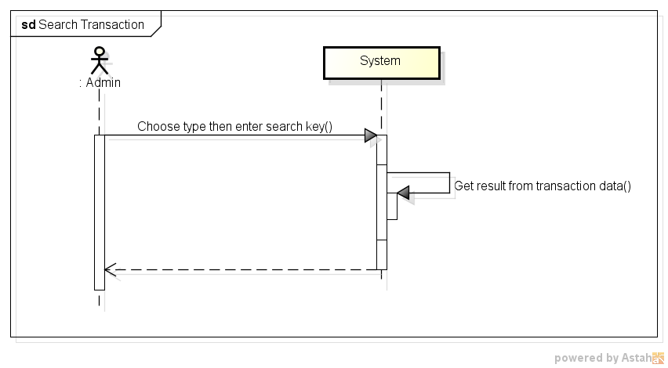

*Figure 11: Sequence Diagram for Search Transaction Use case*

###### *UC- 132: Search Issue*

|  |  |  |  |  |
| --- | --- | --- | --- | --- |
| **Use Case ID:** | | UC-132 | | |
| **Use Case Name:** | | Search Issue | | |
| **Created By:** | | HoangNK | **Last Updated By:** | HoangNK |
| **Date Created:** | | 19/09/2015 | **Date Last updated:** | 24/09/2015 |
| **Actor:** | | Admin | | |
| **Description:** | | Admin wants the system to list all Issue related to a specific keyword | | |
| **Triggering Event:** | | Admin wants to search issue | | |
| **Preconditions:** | | Admin is in view issue box page ( refer case UC-126) | | |
| **Post conditions:** | | Issues have information which matches search key is displayed | | |
| **Priority:** | | High | | |
| **Frequency of Use:** | | Always | | |
| **Main flow** | | | | |
| Step | Actor | Action | | |
|  | Admin | Enters text to “Search” text box | | |
|  | System | Displays Issues have information which matches search key | | |
| **Alternative Flows:** | | N/A | | |
| **Exceptions:** | | N/A | | |
| **Includes:** | | N/A | | |
| **Special Requirements:** | | * Result of search is case insensitive | | |
| **Notes and Issues:** | | N/A | | |

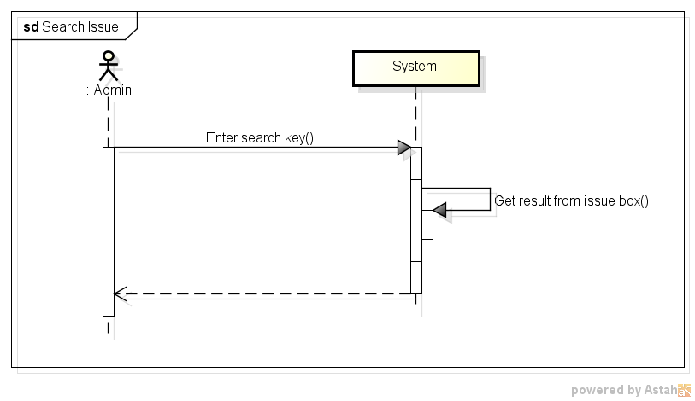

*Figure 11: Sequence Diagram for Search Issue Use case*