# INTRODUCTION

## PROJECT INFORMATION

* **Project name:** Super Shipper System
* **Project code:** 3S
* **Project type:** Web application, Mobile application
* **Project category:** New development
* **Business domain:** Education
* **Project manager:** Le Van Quy Hoang
* **Timeline:** September 7th 2015 to December 15th 2015

## PROJECT TEAM

* **Supervisor**

|  |  |  |
| --- | --- | --- |
| **Name** | **Email** | **Title** |
| **Tran Binh Duong** | duongtb@fpt.edu.vn | Supervisor |

* **Team member**

|  |  |  |  |
| --- | --- | --- | --- |
| **Name** | **Student Roll** | **Email** | **Role** |
| **Le Van Quy Hoang** | SE90184 | hoanglvqse90184@fpt.edu.vn | Leader |
| **Tran Dinh Hoang Huy** | SE90201 | huytdhse90201@fpt.edu.vn | Member |
| **Nguyen Khac Hoang** | SE02564 | hoangnkse02564@fpt.edu.vn | Member |
| **Kieu Cao Khanh** | SE0260 | khanhkcse02960@fpt.edu.vn | Member |
| **Nguyen Van Quyen** | SE02884 | quyennvse02884@fpt.edu.vn | Member |
| **Nguyen Thi Hong Nhung** | SE02437 | nhungnthse02437@fpt.edu.vn | Member |

## **INITIAL IDEAL**

### Background

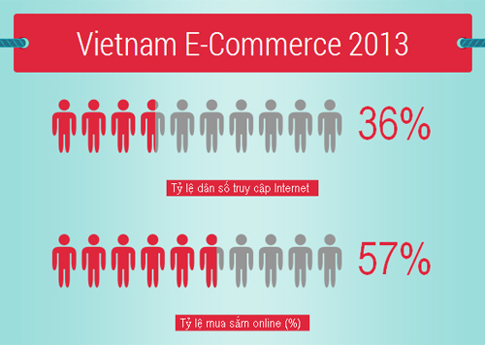

By: Vietnam E-Commerce and Information Technology Agency

According to the statistics, in 2013 the population of Viet Nam is up to 90 million, in which 36% Internet access and more than half of this is shopping online.

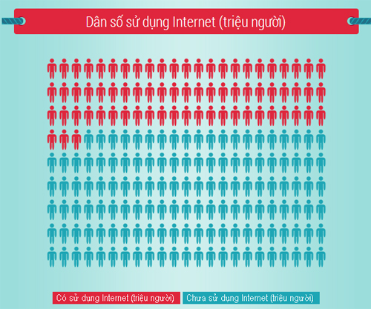

By: Vietnam E-Commerce and Information Technology Agency

In Viet Nam, the number of Internet users is 31,3 million.

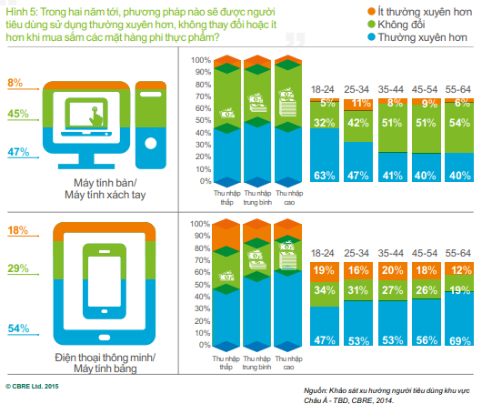

Results of the survey on users purchasing methods in the Asia - Pacific in 2014 have indicated that the number of people who regularly use computers and phones to shop has been very high. Online shopping market, as a result, is very large.

Indeed, nowadays there are a variety of fan pages and online shopping sites with classified advertising such as enbac, muare, rongbay, etc. Therefore, all enterprises are constantly upgrading the quality of customer service to remain competitive in the market.

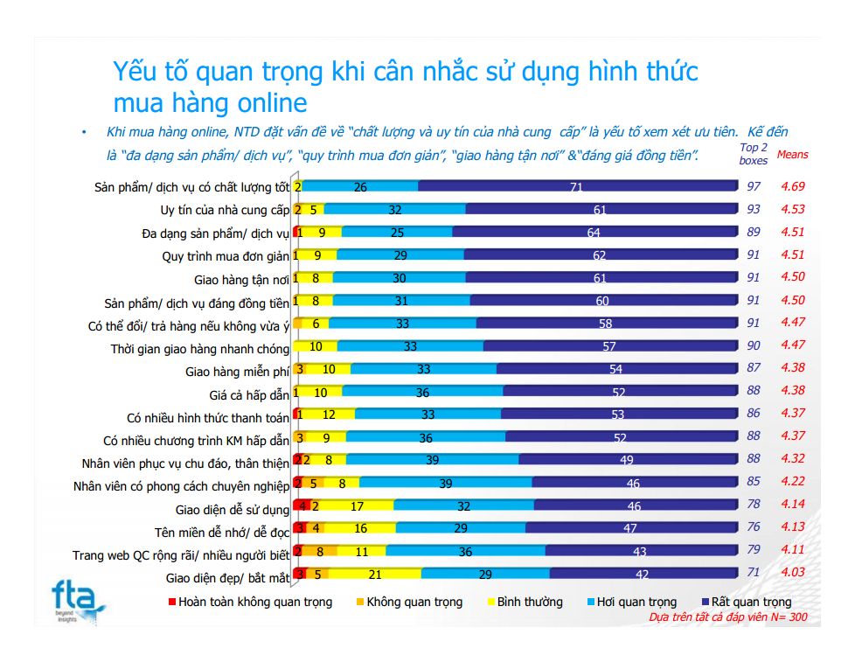

According to FTA Research & Consultant’s survey report, home delivery service is one of customers’ most-concerning criterions. As a result, there have been many businesses investing in developing home delivery service. That makes the service become a potential market.

### Literature review

The current shipping service providers can be devided into 2 groups:

#### Free shipper

This is a group of free shippers through applications to search ship orders. The shipper does not belong to an organization or company. But having just under 100 download times and not work anymore.

Example: Fship, Shipme app

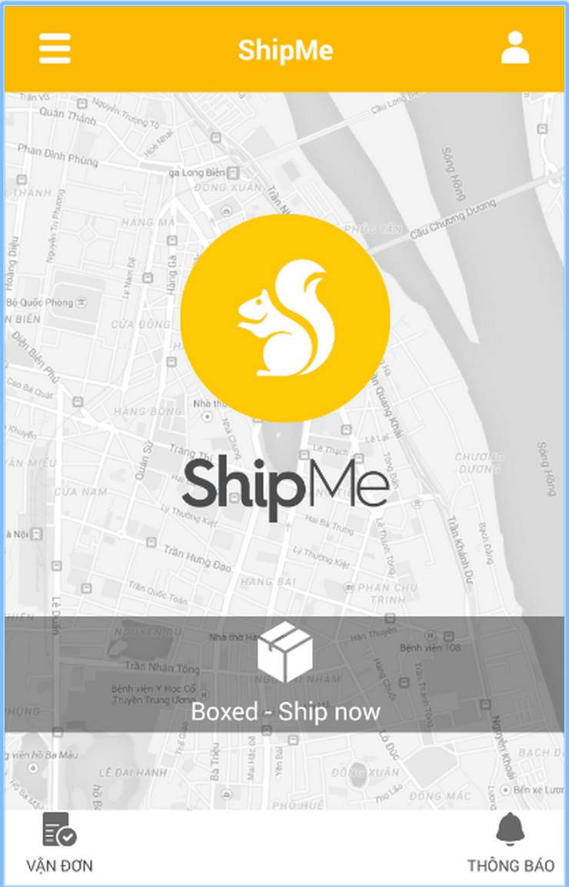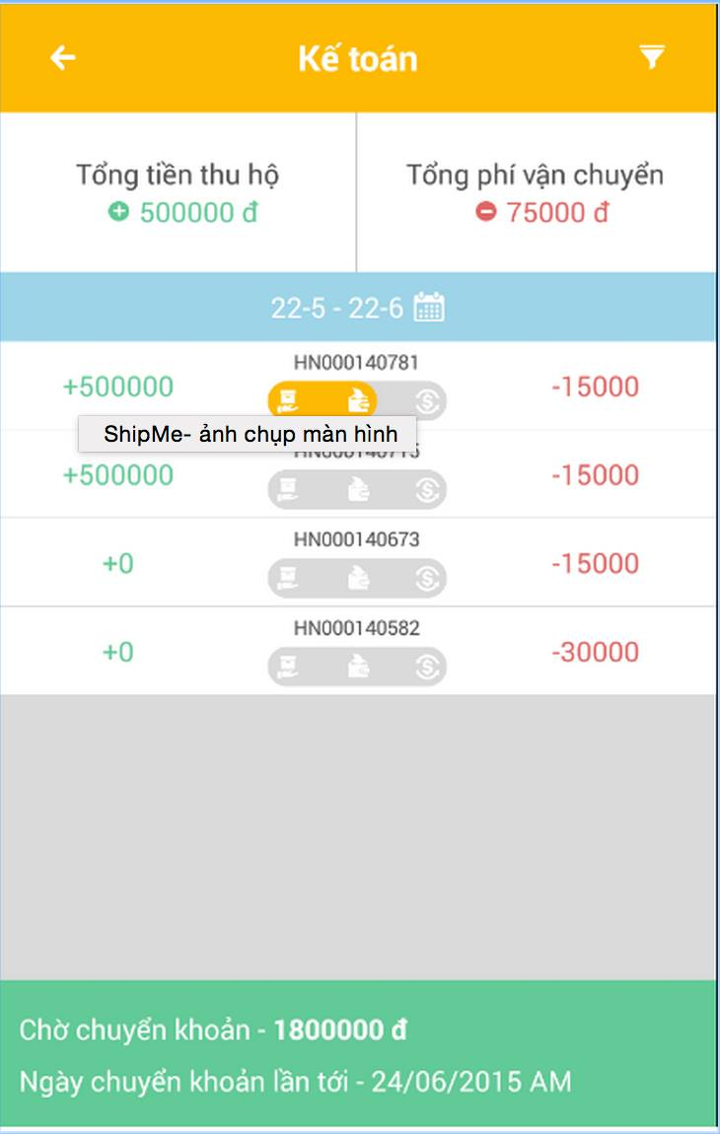

#### Shipper companies

This is a group of large companies but have different modes of operation.

##### Via Facebook

This group use Facebook to advertise and use GoogleForm as a tool for received order.

Example: Family Shipper, Shipper Team.

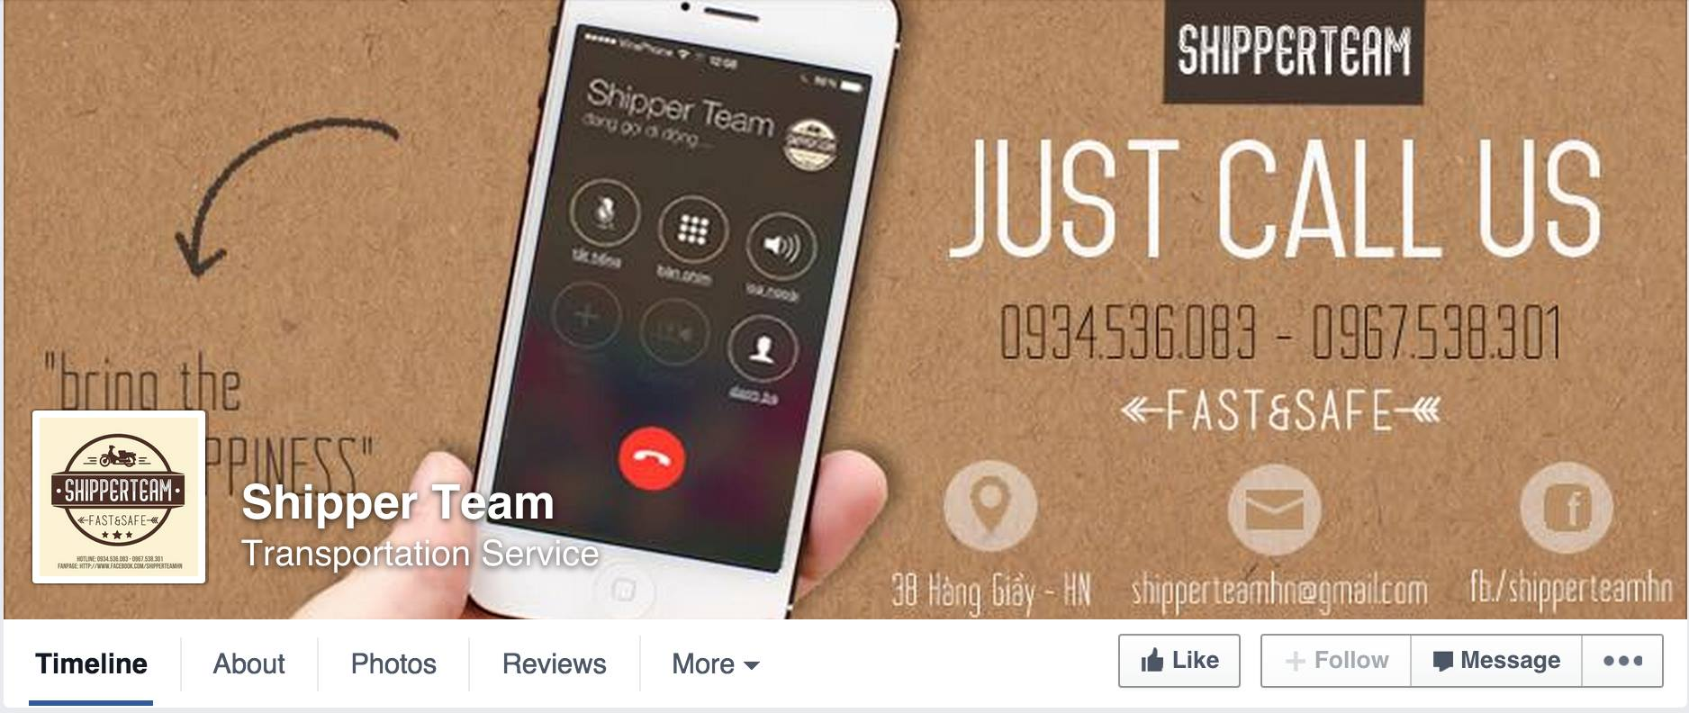

Shipper Team is the best in this group. Shipper Team is a shipping service operates pretty well in Hanoi. All the transactions is confirmed via Facebook and phone.

Bellow are information of Shipper Team:

**Functions:**

- Customer register via Google doc link on Facebook

- Register usual location to receive products

- Make phone call, send inbox on Facebook to create order

- Help the stores collect money

**Pros**

* Express shipping after receiving order
* Work from 8:30 till 21:00 each day, 7 days per week including holiday
* Ensure collecting money without guarantee fee

**Cons:**

* No statistics for customer
* Price is not competitive
* All transactions from shippers are make by telephone
* Operate via Facebook so number of customers is limited

##### 3.2.2.2 Via website

This group just have website for receiving order from the stores, don’t apply technology to support transportation and delivery process.

Example**: - Giaohangnhanh**, HanoiShip, GoGoShip, ShipViet.

* **ZoZoShip**, ProShip (Big companies but haven’t exploited North Vietnam market)

##### Giaohangnhanh.vn

Giaohangnhanh.vn is an express delivery system that delivers commodities and letters nationwide.

**Functions:**

* Customer register
* Create orders to request ship
* Tracking order’s status
* Create usual order receive location
* Deliver and help customer in collecting cash (Cash on delivery-COD)

**Some screenshots:**

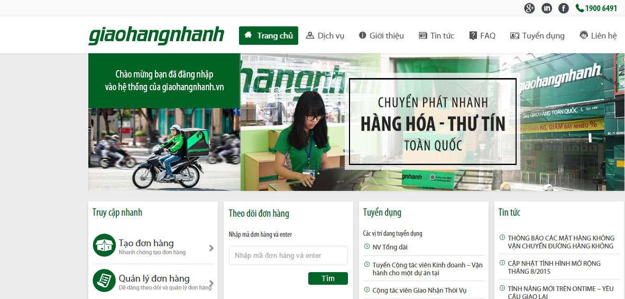

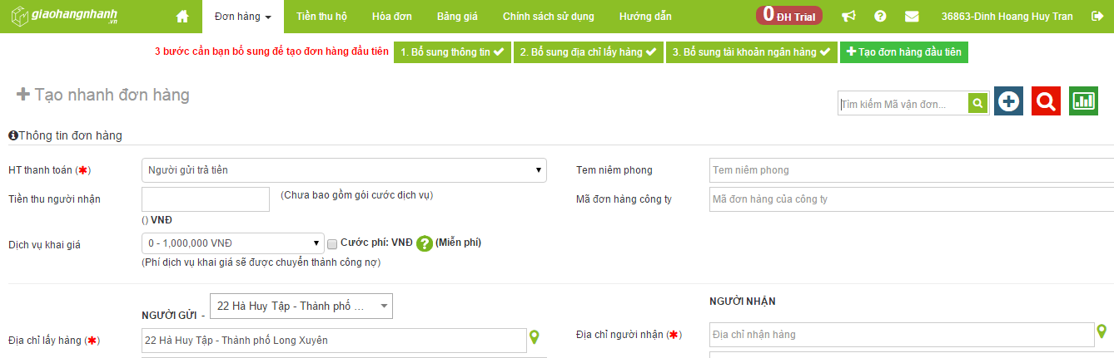

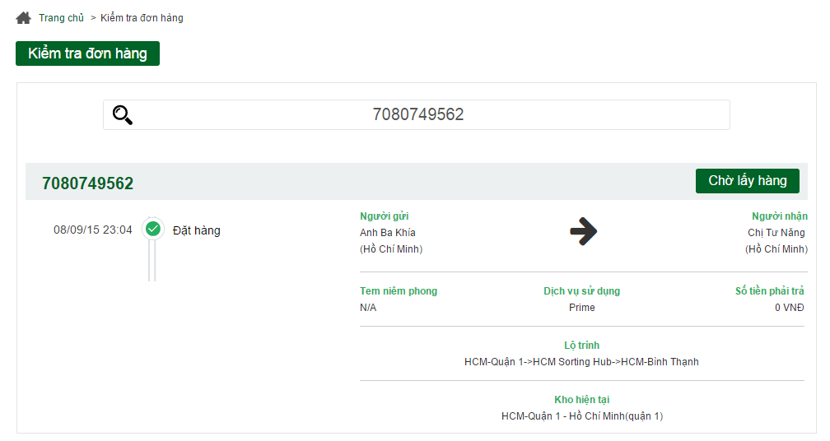

**Pros:**

* Well know brand image in Vietnam
* Having many shippers, system can receive lots of orders
* Low price

**Cons:**

* Don’t apply technology to immediately find the nearest shipper to the order, must wait for staffs to arrange
* Tracking order function is not well interface, just use text to display status (Wait, Shipper is comming, Shipping, Done)
* Don’t have express delivery service.
* Don’t have mobile app for shipper to find the way.

##### ZOZOSHIP: <http://zozoship.vn/>

ZoZoShip is a shipper system that has work method: Customer calls to customer service center or creates order via website. So ZoZo’s shipper go to customer’s store, get commodity and delivers to requested place. When the transaction is done, get receivable money and return to pay back for the store.

**Functions:**

* Customer register
* Create order on website, enter goods information
* Update, add common delivery – received place
* Bank transfer cash on delivery

**Some screenshot:**

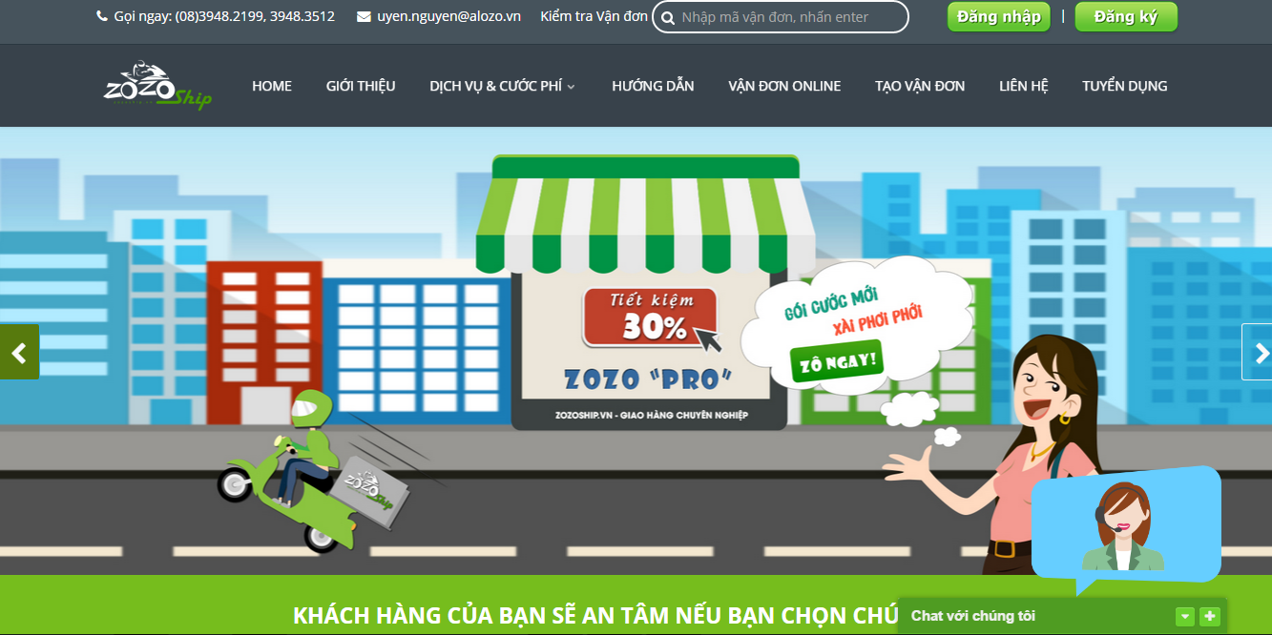

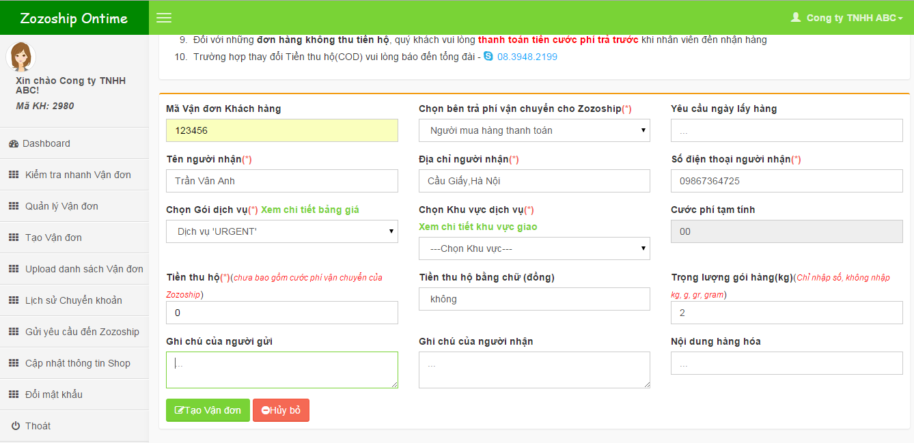

**Pros:**

* Tracking order status on website
* Deliver under 1 day
* Website has good interface, easy to use
* Many service pack with clearly information
* Nationwide delivery
* Goods insurance

**Cons:**

* Working are: only Ho Chi Minh city
* Don’t apply technology to immediately find the nearest shipper to the order, must wait for staffs to arrange
* Tracking order function is not well interface, just use text to display status (Wait, Shipper is comming, Shipping, Done)
* Return cash on delivery on Monday, Wednesday, Friday (instead of daily return)
* Working time is limited: 8.00 – 18.00 on Monday to Saturday, order that come after 17h will be ship in the next day.
* Don’t have mobile app for shipper to find the way.

### Overrall disadvantage of current background

Most of the shipping companies don’t apply technology into system. This leads to many problems in the management and operation of the system.

1. The current Shipping Service Providers don’t apply technology to optimize shipper selection, instead that, they use management staff to arrange work. If there’re many orders, shippers must choose the shortest way up to their experience. These cause the following problems:

* **For shipping providers (shipping companies):** CAN’T optimize transport distance, so the cost will be raised up. Hence, those companies get difference in balance between service’s price and profit.
* **For the stores:** The waiting time is long because of the shipper wait for staff to arrange. That make bad affects for the prestige and quality of the stores.
* **For the shippers:** Optimizing the transport ways is so difficult.

1. Current systems don’t apply technology in tracking transporting orders continuously. When the problems occur, the shippers must call to the staff directly, there isn’t any support from software system. These cause the following problems:

* **For shipping providers:** CAN’T be sure about goods during transportation. Difficult to come up with alternative solutions in time if the incidents occur.
* **For the stores:** CAN’T tracking transportation process. Don’t know their where their goods is.

1. Current systems don’t use security code for goods receiving process between shippers and the stores. When shippers receive goods, they confirm with the store by hard-copy list. This causes the following problems:

* **For shipping providers:** DON’T know the status of goods and the time of consign process => unmanageable
* **For the stores:** DON’T know whether the consignee is reliable or not.

1. Current systems don’t send security code to the customer that shipper and customer will use to confirm delivery was done.

* **For shipping providers:** CAN’T solve the problem in case the customer has received before, but continue to demand products.
* **For the shippers:** CAN’T be sure that goods was delivered to right person.
* **For the customers:** Could receive wrong products.

## Our Proposal

We’ll develop a system that include 4 part:

Part1: Web application for store that support store’s employee everything they need to create an order, verify shipper who come to takes goods. Store also knows location of shipper (goods) on maps, status of order, shipper delivered to right customer of not. Beside, Store can view history of delivery and finance transactions.

Part 2: Mobile-application for shipper that support shipper view information of order, find the best way to receive and delivery address. Beside, sipper can notify to system if have issue while delivering.

Part3: Web application for admin that help system managers manage shipper, store, transaction history (finance, delivery) and know about issue of delivery process.

Part4: System that save all information of store, shipper and transaction history (finance, delivery). System will calculate the best way for shipper, notify admin when have any issue.

Below are main functions for each part:

## Web application for store

* Sign up to service
* Login to system by system account, Google+ account
* Create order
* Input information of goods
* Input customer’s address
* Choose vehicle
* Upload photo of goods (if have)
* Tracking state of shipper
  + Location of shipper on maps
  + Profile of shipper
  + Estimate when shipper will meet customer
* Store can send message if have issue on each order.
* Rate and send feedback for each shipper when an order completed.
* View history of exchange.
* View report by day, week, and month.
* Edit order if have exception.

## Mobile application for shipper

* + - Find the best way to go to target.
    - Decide to pick order or not
    - Confirm received code with store, delivered code with customer.
    - See locations that need to receive goods.
    - Notify to system when have issue on delivered process.
    - View report about delivered history.

## Web application for admin Admin

* Manage store
  + - Add
    - Block
    - Update
    - Search
* Send message to store when have issue.
* Confirm the finance exchange with store.
* Manage shipper
  + - Add
    - Block
    - Update
    - Search
* Due with issue message from shipper
* Analyze and report

## System

* + - Save exchange history of store and shipper
    - Real-time for post and get messages
    - Save shipper’s information, store’s information
    - Save finance exchange history.
    - Send message to admin when have issue

## Out of scope

* Combine order function
* Online payment function
* Auto due with issue
* Chat between store and admin function
* Auto reconnect after disconnect because of error.