1. UC308 Grab Order

**Mockup Design**

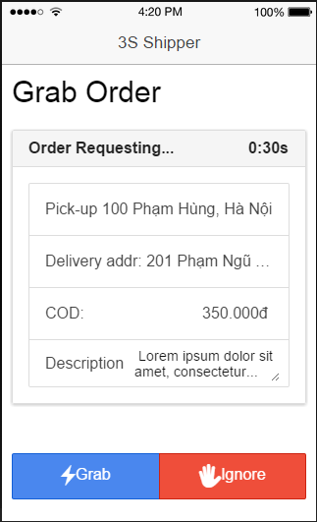

|  |  |  |  |  |  |  |
| --- | --- | --- | --- | --- | --- | --- |
| **Use Case ID:** | | | 3SP_308 | | | |
| **Use Case Name:** | | | Grab order | | | |
| **Created By:** | | | HuyTDH | | **Last Updated By:** | HuyTDH |
| **Date Created:** | | | 19/09/2015 | | **Date Last updated:** | 19/09/2015 |
| **Actor:** | | | Shipper | | | |
| **Description:** | | | When sever concurrently send shipping order to 5 shippers, the shipper who grabs order at the earliest time will take that order | | | |
| **Triggering Event:** | | | Server sends shipping request to shipper | | | |
| **Pre-conditions:** | | | Shipper logged in, internet connection is on, system is requesting to ship order | | | |
| **Post-conditions:** | | | The order is added to shipper working list, shipper’s status change to “Busy” | | | |
| **Priority:** | | | High | | | |
| **Frequency of Use:** | | | Often | | | |
| **Main flow** | | | | | | |
| Step | Actor | | Action | | | |
|  | System | | send shipping request to shipper’s app | | | |
|  | Shipper | | tabs on button “Grab” to take the order | | | |
|  | System | | validates whether the shipping request is taken or not | | | |
|  | System | | adds order to shipper’s working | | | |
|  | System | | changes shipper’s status to “Busy” | | | |
|  | System | | disable this request to other shippers | | | |
| **Alternative :** | | | | | | |
| N/A | | | | | | |
| **Exceptions:** | | | | | | |
| EC1 | | Shipper ignores request at step 2 | | | | |
| Step | | Actor | | Action | | |
| 2.1 | | Shipper | | Shipper tabs on button “Ignore” | | |
| 2.2 | | System | | System show confirm box | | |
|  | | Shipper | | Shipper confirms to ignore | | |
|  | | System | | System show warning “You have ignored x order(s) today!” | | |
| EC2 | | Shipper tabs on button “Grab” later than another shipper at step 2 | | | | |
| Step | | Actor | | Action | | |
| 2.1 | | Shipper | | Shipper tabs on “Grab” | | |
| 2.2 | | System | | System show message “The order has taken by another shipper!” | | |
| **Exceptions:** | | | N/A | | | |
| **Includes:** | | | N/A | | | |
| **Special Requirements:** | | | Shipper who receives shipping request is in top 5 nearest available ones to the store of that order. | | | |
| **Notes and Issues:** | | | N/A | | | |

**Sequence Diagram**

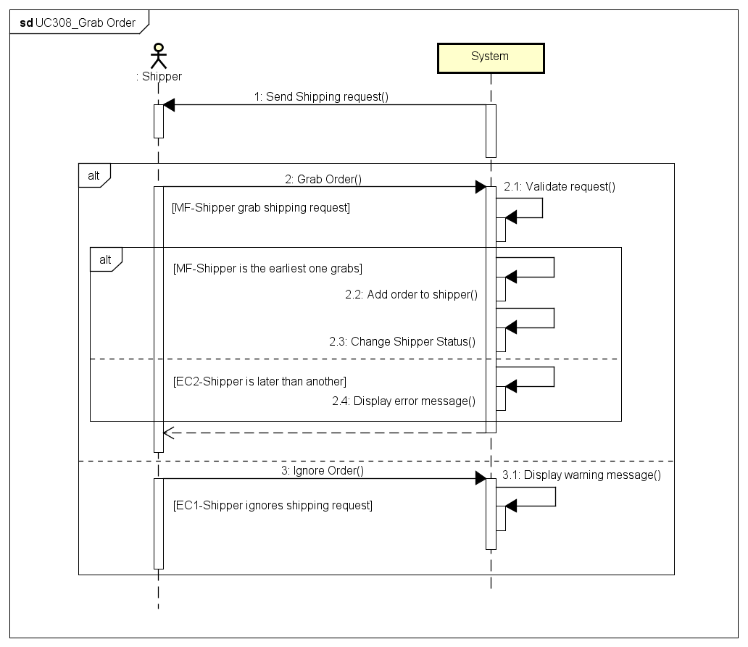

1. UC309 View Orders List

**Mockup Design**

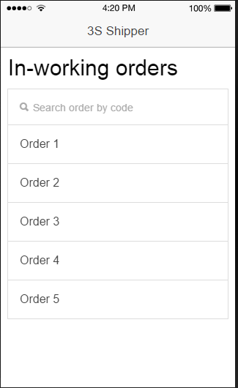

|  |  |  |  |  |
| --- | --- | --- | --- | --- |
| **Use Case ID:** | | 3SP_309 | | |
| **Use Case Name:** | | View orders list | | |
| **Created By:** | | HuyTDH | **Last Updated By:** | HuyTDH |
| **Date Created:** | | 19/09/2015 | **Date Last updated:** | 25/09/2015 |
| **Actor:** | | Shipper | | |
| **Description:** | | Shipper see the list of his in-working orders | | |
| **Triggering Event:** | | Shipper involves see orders list request | | |
| **Preconditions:** | | Shipper logged in | | |
| **Post conditions:** | | List in-working orders of this shipper is showed | | |
| **Priority:** | | High | | |
| **Frequency of Use:** | | Always | | |
| **Main flow** | | | | |
| Step | Actor | Action | | |
|  | Shipper | expands menu bar and tabs on “In-working orders” | | |
|  | System | load all data about in-working orders of that shipper | | |
|  | System | shows list in-working orders as a table, includes content:   * Order code * Pick-up point * Delivery point * Current Status | | |
| **Alternative Flows:** | | | | |
| **Exceptions:** | | | | |
| **Includes:** | | N/A | | |
| **Special Requirements:** | | N/A | | |
| **Notes and Issues:** | | N/A | | |

**Sequence Diagram**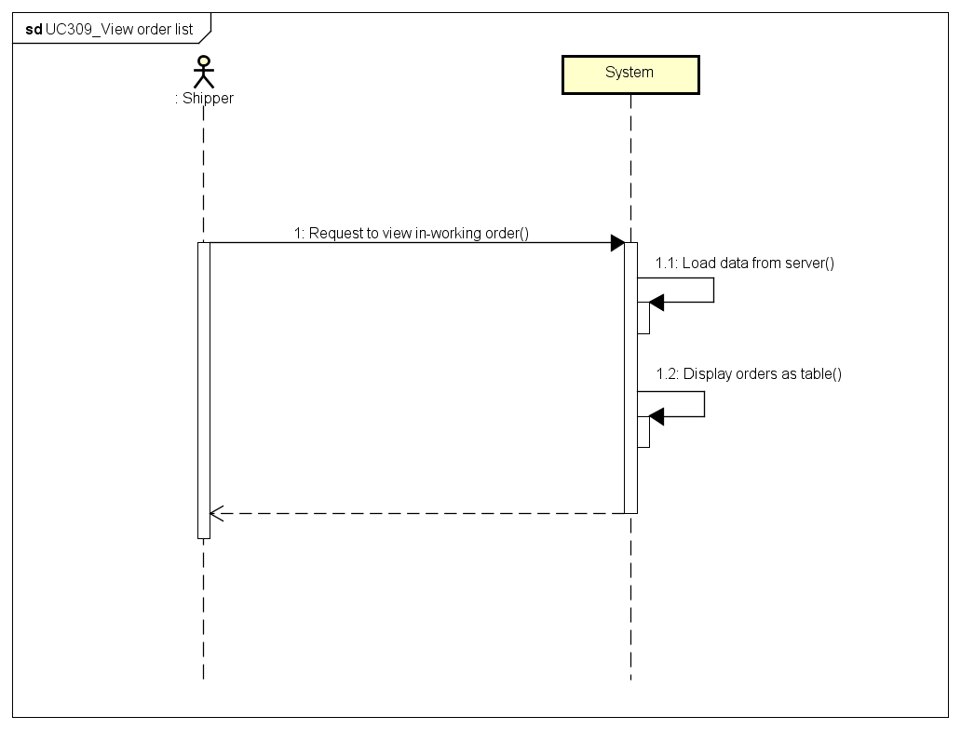

1. UC310 Search Order

|  |  |  |  |  |
| --- | --- | --- | --- | --- |
| **Use Case ID:** | | 3SP_310 | | |
| **Use Case Name:** | | Search order | | |
| **Created By:** | | HuyTDH | **Last Updated By:** | HuyTDH |
| **Date Created:** | | 19/09/2015 | **Date Last updated:** | 25/09/2015 |
| **Actor:** | | Shipper | | |
| **Description:** | | Shipper searches order(s) by order code | | |
| **Triggering Event:** | | Shipper involves find a specific order(s) by code | | |
| **Preconditions:** | | Shipper on View Orders List: 3SP_309 (See above) | | |
| **Post conditions:** | | Orders that match search condition will be displayed | | |
| **Priority:** | | Normal | | |
| **Frequency of Use:** | | Sometimes | | |
| **Main flow** | | | | |
| Step | Actor | Action | | |
|  | Shipper | goes to “View orders list” screen (refer to UC309 View order list) | | |
|  | Shipper | types order’s code to search box | | |
|  | System | filters orders data from current list | | |
|  | System | displays all in-working orders that match with search key | | |
| **Alternative Flows:** | | | | |
| **Exceptions:** | | | | |
| **Includes:** | | N/A | | |
| **Special Requirements:** | | Order code has format **3Sxxxxxx** but shipper no need to enter **3S** prefix of code Case insensitive search | | |
| **Notes and Issues:** | | Code format will be defined in the later phrase | | |

**Sequence Diagram**

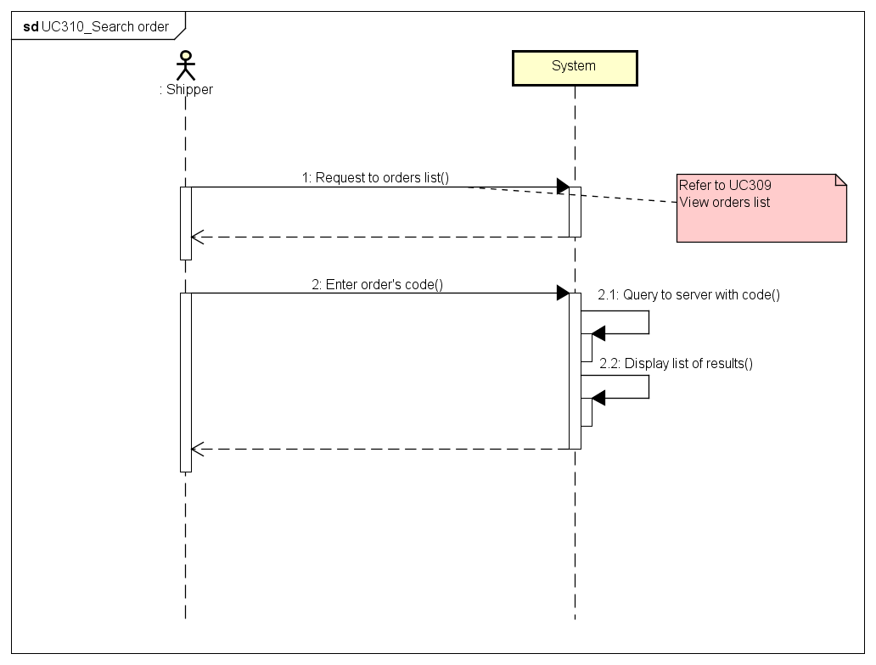

1. UC311 View Order’s Detail

**Mockup Design**

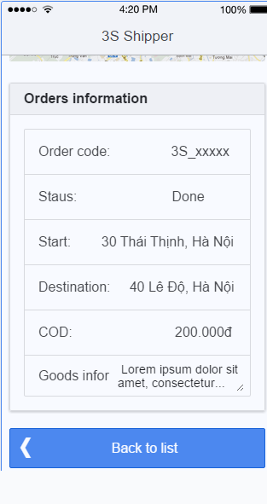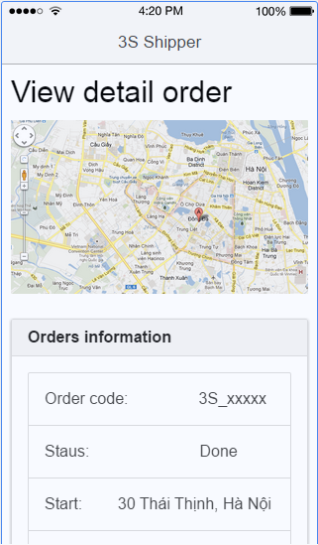

|  |  |  |  |  |
| --- | --- | --- | --- | --- |
| **Use Case ID:** | | 3SP_311 | | |
| **Use Case Name:** | | View order’s detail | | |
| **Created By:** | | HuyTDH | **Last Updated By:** | HuyTDH |
| **Date Created:** | | 19/09/2015 | **Date Last updated:** | 25/09/2015 |
| **Actor:** | | Shipper | | |
| **Description:** | | Shipper view detail of an order | | |
| **Triggering Event:** | | Shipper involves see order’s detail information request | | |
| **Preconditions:** | | Shipper is on list orders screen or working history screen | | |
| **Post conditions:** | | Detail information of that order is displayed | | |
| **Priority:** | | High | | |
| **Frequency of Use:** | | Always | | |
| **Main flow** | | | | |
| Step | Actor | Action | | |
|  | Shipper | Shipper enters “**In-Working Orders**” screen (Refer to UC309 above) | | |
|  | Shipper | Shipper tabs on “**View detail**” of that order from the list | | |
|  | System | System loads detail info of that order from server | | |
|  | System | System displays the detail information of order, includes:   * Order code * Order status * Pick-up address * Delivery address * Products information * COD (cast on delivery amount) | | |
| **Alternative Flows::** | | | | |
| AT1 | Shipper views detail from history: | | | |
| Step | Actor | Action | | |
| 1.1 | Shipper | Shipper enters “History” screen | | |
| 1.2 | Shipper | Shipper tabs on “View detail” of that order from the list | | |
| 1.3 | System | System displays the detail | | |
| **Exceptions:** | | N/A | | |
| **Includes:** | | N/A | | |
| **Special Requirements:** | | N/A | | |
| **Notes and Issues:** | | N/A | | |

**Sequence Diagram**

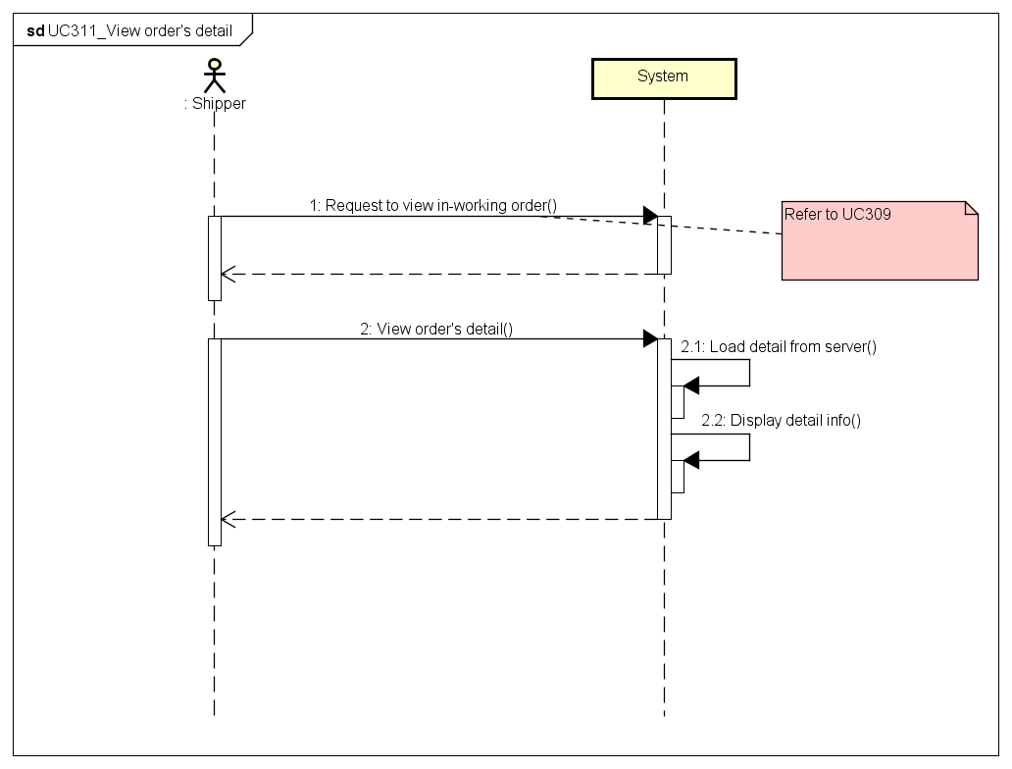

1. UC312 Find Best Way

**Mockup Design**

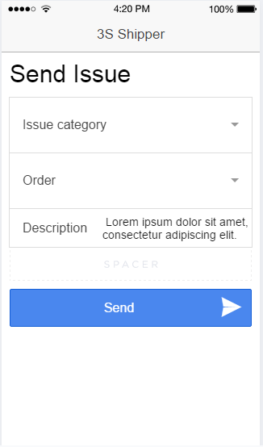

|  |  |  |  |  |
| --- | --- | --- | --- | --- |
| **Use Case ID:** | | 3SP_312 | | |
| **Use Case Name:** | | Find best way | | |
| **Created By:** | | HuyTDH | **Last Updated By:** | HuyTDH |
| **Date Created:** | | 19/09/2015 | **Date Last updated:** | 25/09/2015 |
| **Actor:** | | Shipper | | |
| **Description:** | | Shipper use system to find out the shortest way to go to destinations. | | |
| **Triggering event:** | | Shipper involves find best way request for his in-working orders. | | |
| **Preconditions:** | | Shipper logged in  Internet connection is on  GPS is on | | |
| **Post conditions:** | | The shortest way that go through all selected destinations will be displayed on map. | | |
| **Priority:** | | High | | |
| **Frequency of Use:** | | Always | | |
| **Main flow** | | | | |
| Step | Actor | Action | | |
|  | Shipper | Shipper selects “Find best way” from menu | | |
|  | System | System shows “Find best way” screen, includes:   * Google map * Destinations select box * “Find” button | | |
|  | Shipper | Shipper chooses one or all destinations | | |
|  | Shipper | Shipper tabs on “Find” | | |
|  | System | System call Google API to get the best way | | |
|  | System | System displays the shortest way to destinations on the map | | |
| **Alternative Flows:** | | N/A | | |
| **Exceptions:** | | | | |
| EC1 | At step 1 if GPS is off | | | |
| Step | Actor | Action | | |
| 1.1 | System | System displays message “Please turn on GPS and retry” | | |
| 1.2 | Shipper | Shipper turn on GPS | | |
| 1.3 | | Go to step 2 of main flow | | |
| **Includes:** | | N/A | | |
| **Special Requirements:** | | Shipper can choose <= 7 destinations | | |
| **Notes and Issues:** | | N/A | | |

**Sequence Diagram**

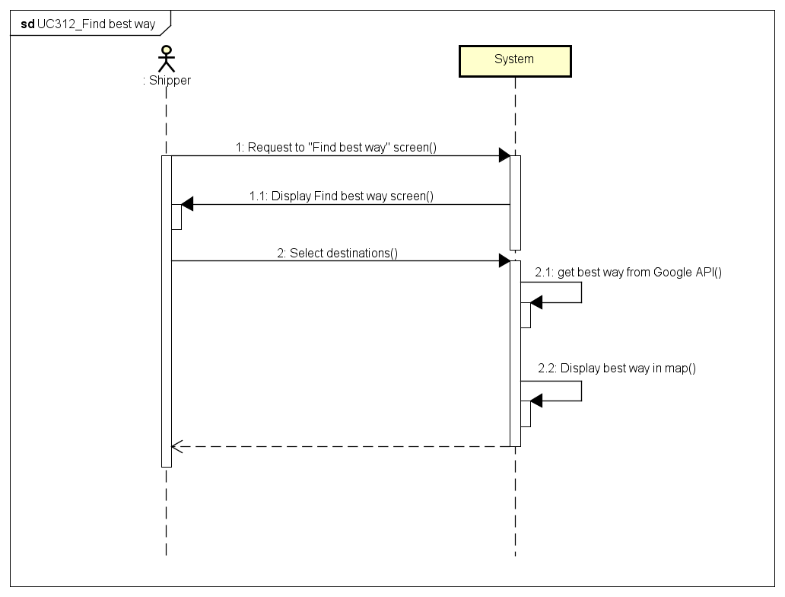

1. UC313 Send Issue’s Information

**Mockup Design**



|  |  |  |  |  |
| --- | --- | --- | --- | --- |
| **Use Case ID:** | | 3SP_313 | | |
| **Use Case Name:** | | Send issue’s information | | |
| **Created By:** | | HuyTDH | **Last Updated By:** | HuyTDH |
| **Date Created:** | | 19/09/2015 | **Date Last updated:** | 19/09/2015 |
| **Actor:** | | Shipper | | |
| **Description:** | | Shipper sends issues to Admin to solve | | |
| **Triggering Event:** | | Shipper got issues need to send to Admin | | |
| **Preconditions:** | | Shipper logged in | | |
| **Post conditions:** | | Issue has been sent to Admin  Notification about issue has been display in admin’s screen | | |
| **Priority:** | | High | | |
| **Frequency of Use:** | | Sometimes | | |
| **Main flow** | | | | |
| Step | Actor | Action | | |
|  | Shipper | Shipper chooses “Send Issue” from Menu | | |
|  | System | System displays “Send Issue Box” | | |
|  | Shipper | Shipper types “Description”, chooses “Issue Category”, and could select one or all of his in-working orders. | | |
|  | Shipper | Shipper tabs on “Send” | | |
|  | System | System shows message “Issue has sent to system. Wait for Admin to solve” | | |
|  | System | System sent notification to admin about issue | | |
| **Alternative Flows:** | | N/A | | |
| **Exceptions:** | | N/A | | |
| **Includes:** | | N/A | | |
| **Special Requirements:** | | N/A | | |
| **Notes and Issues:** | | Issue description should have 30 - 250 characters | | |

**Sequence Diagram**

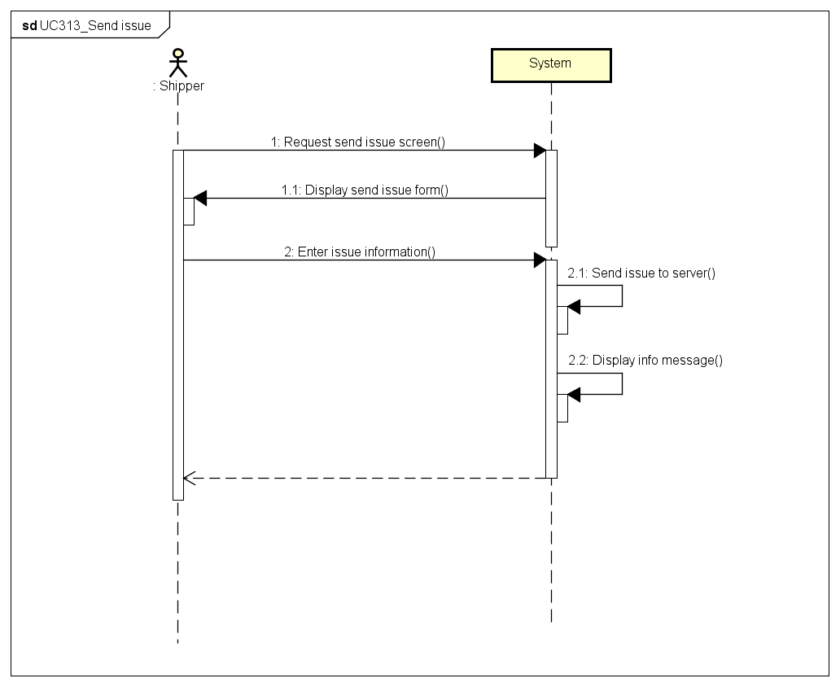

1. UC314 Change Working Status

**Mockup Design**

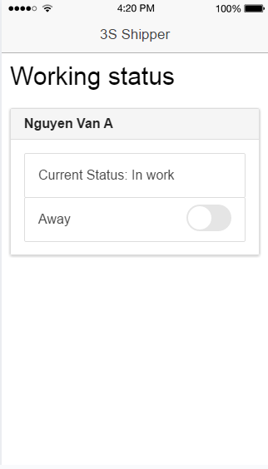

|  |  |  |  |  |
| --- | --- | --- | --- | --- |
| **Use Case ID:** | | 3SP_314 | | |
| **Use Case Name:** | | Change working status | | |
| **Created By:** | | HuyTDH | **Last Updated By:** | HuyTDH |
| **Date Created:** | | 19/09/2015 | **Date Last updated:** | 20/09/2015 |
| **Actor:** | | Shipper | | |
| **Description:** | | Shipper changes his working status “On working” / “Away”. And the system will decides to send shipping request to him or not. | | |
| **Triggering Event:** | | Shipper switches his status between ready to work or not ready. | | |
| **Preconditions:** | | Shipper logged in  Shipper current status is not “Busy” | | |
| **Post conditions:** | | Working status changed to “On working” / ”Away” | | |
| **Priority:** | | Normal | | |
| **Frequency of Use:** | | Sometimes | | |
| **Main flow** | | | | |
| Step | Actor | Action | | |
|  | Shipper | Shipper expands menu bar and tabs on “Change status” | | |
|  | System | System displays current status “On working” or ”Away” | | |
|  | Shipper | Shipper switches status button | | |
|  | System | System shows confirm message “Confirm change your status to [ABC]” ([ABC] is “On working” or ”Away”) | | |
|  | Shipper | Shipper tabs on “Confirm” | | |
|  | System | System changes the status | | |
| **Alternative Flows:** | | N/A | | |
| **Exceptions:** | | | | |
| EC1 | Shipper is on the way to ship some orders | | | |
| Step | Actor | Action | | |
| 1 | System | System displays current status “Busy” | | |
| 2 | Shipper | Shipper tabs on “Change” | | |
|  | System | System shows message “You can’t change status while shipping. Complete all in-working orders or contact to Admin” | | |
| **Includes:** | | N/A | | |
| **Special Requirements:** | | N/A | | |
| **Notes and Issues:** | | Change status should have time | | |

**Sequence Diagram**

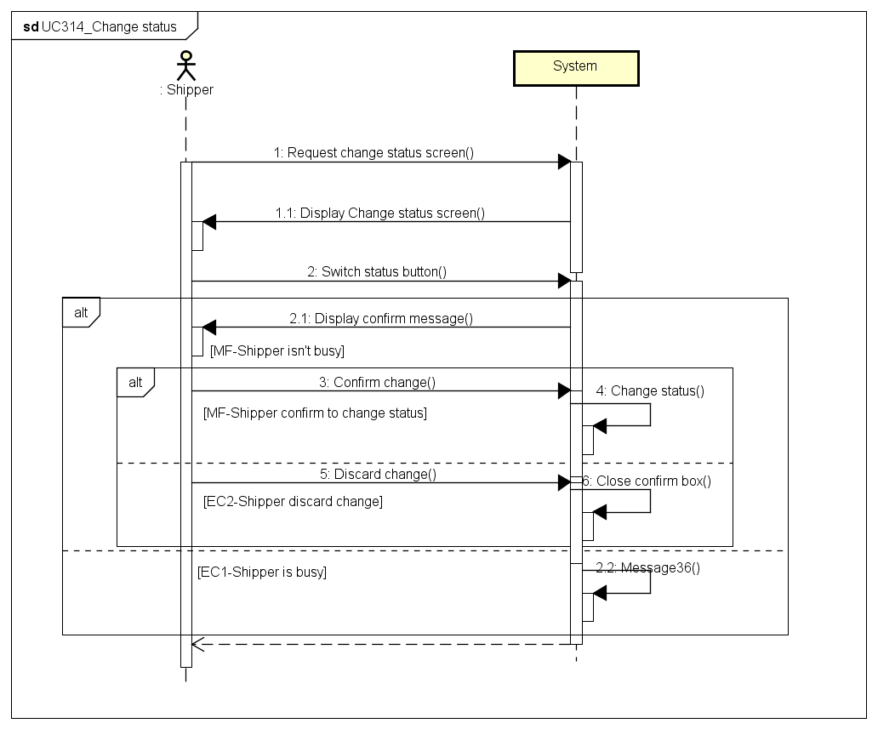

1. UC315 View History

**Mockup Design**

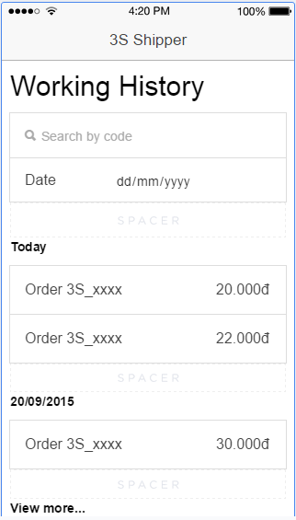

|  |  |  |  |  |
| --- | --- | --- | --- | --- |
| **Use Case ID:** | | 3SP_315 | | |
| **Use Case Name:** | | View history | | |
| **Created By:** | | HuyTDH | **Last Updated By:** | HuyTDH |
| **Date Created:** | | 19/09/2015 | **Date Last updated:** | 26/09/2015 |
| **Actor:** | | Shipper | | |
| **Description:** | | Shipper views his working history to know how much salary and bonus he will get or evidence when problem occurs. | | |
| **Triggering Event:** | | Shipper reviews history | | |
| **Preconditions:** | | Shipper logged in | | |
| **Post conditions:** | | Working history of that shipper will be displayed | | |
| **Priority:** | | High | | |
| **Frequency of Use:** | | Often | | |
| **Main flow** | | | | |
| Step | Actor | Action | | |
|  | Shipper | Shipper chooses “History” from menu | | |
|  | System | System load history saving in device memory | | |
|  | System | System displays working history of that shipper, also includes bellow feature:   * Date filter * Order code filter * List of history orders * “View more” link if there more orders is not yet displayed | | |
| **Alternative Flows:** | | | | |
| AT1 | At step 2, working history in device was cleared and shipper has to load from server | | | |
| Step | Actor | Action | | |
| 2.1 | System | System shows message “Can’t find working history. Reload from server?” | | |
| 2.2 | Shipper | Shipper tabs on “Reload” | | |
| 2.3 | System | Load history log from server and save to device | | |
|  |  | Go to step 3 of main flow | | |
| N/A | | | | |
| **Exceptions:** | | | | |
| N/A | | | | |
| **Includes:** | | N/A | | |
| **Special Requirements:** | | Default will display last 20 orders Click “See more” will load 20 more orders | | |
| **Notes and Issues:** | | History will be save in device memory Shipper don’t need internet to load history | | |

**Sequence Diagram**

