|  |
| --- |
|  |
| Capstone Project Document |

SUPER SHIPPER SYSTEM

Software Requirement Specification

|  |  |  |
| --- | --- | --- |
| **Super Shipper System** | | |
| **Group Members** | Le Van Quy Hoang | SE90184 |
| Tran Dinh Hoang Huy | SE90201 |
| Nguyen Khac Hoang | SE02564 |
| Kieu Cao Khanh | SE02960 |
| Nguyen Van Quyen | SE02884 |
| Nguyen Thi Hong Nhung | SE02437 |
| **Supervisor** | Mr. Tran Binh Duong | |
| **Project code** | KarryWell | |

**- Hanoi, 09/2015 -**

TABLE OF CONTENTS

1.INTRODUCTION 2

1.1. Purpose 2

1.2. Scope 2

1.3. Definition and Acronyms 2

1.4. Overview 2

2.OVERVIEW DESCRIPTION 3

2.1. Product perspective 3

2.2. Product functions 3

2.3. User charactistics 3

2.4. Constraint 3

2.5. Assumption and dependencies 4

2.6. Activity Diagram 4

2.7. State Machine Diagram 5

2.8. Entity Relationship Diagram 6

3.FUNCTIONAL REQUIREMENTS 7

3.1. Web application for Admin 7

3.1.1. User Case Diagram 7

3.1.2. Functions 8

*UC-101: Login* 8

*UC-102: Logout* 10

*UC-103: Change password* 11

*UC-104: Forgot password* 14

*UC- 105: Accept Store* 16

*UC- 106: Search Store* 19

*UC- 107:* *View Store’s list* 21

*UC- 108:* *Block and Unblock store* 23

*UC- 109:* *View Store’s details* 25

*UC- 110:* *Send message to Store* 27

*UC- 111:* *Confirm Store’s payment* 29

*UC- 112:* *View* transaction *history of Store* 32

*UC- 113:* *Add Shipper* 34

*UC- 114:* *View Shipper’s list* 36

*UC- 115:* *View Order’s list* 38

*UC- 117:* *Search Shipper* 40

*UC- 117:* *Search Order* 42

*UC- 118:* *View Shipper’s profile* 44

*UC- 119:* *View Order’s details* 46

*UC- 120:* *Update Shipper* 48

*UC- 121:* *Update Order* 50

*UC- 122:* *Add new Order* 52

*UC- 123:* Export Bill 54

*UC- 124:* *Assign Task* 56

*UC- 125:* *View Dashboard* 58

3.2. Web application for Store 60

3.2.1. User Case Diagram 60

3.2.2. Function 61

*UC-201: Register* 61

*UC-202:* *Login* 64

*UC-203:* *Logout* 66

*UC-204: Change password* 68

*UC-205:* *Forgot password* 71

*UC-206:* *View profile* 73

*UC-207:* *Update profile* 74

*UC-208:* *Create order* 77

*UC-209:* *View order’s list* 80

*UC-210:* *Search orders* 81

*UC-211:* *Cancel order* 83

*UC-212:* *Edit Order* 85

*UC- 213:* *Order’s details* 88

*UC-214:* *View payment history* 89

*UC-215:* *View notifications* 91

*UC-216:* *Rate shipper* 92

*UC-217:* *Send feedback* 95

*UC-218:* *View Homepage* 97

3.3. Mobile application for Shipper 99

3.3.1. User Case Diagram 99

3.3.2. Function 100

*UC-301:* *Login* 100

*UC-302:* *Logout* 103

*UC-303:* *Forgot password* 105

*UC-304:* *Change password* 108

*UC-305:* *View Profile* 111

*UC-306:* *Update Profile* 113

*UC-307:* *Confirm Code* 115

*UC-308:* *Grab order* 118

*UC309: View Orders List* 121

*UC310: Search Order* 123

*UC311: View Order’s Detail* 125

*UC312: Find Best Way* 127

*UC313 Send Issue’s Information* 130

*UC314 Change Working Status* 132

*UC315 View History* 135

4.NON – FUNCTIONAL REQUIREMENTS 138

4.1. Usability 138

4.2 Performance 138

4.3 Reliability 138

4.4 Maintainability 138

4.5 Security 138

## 3.2. Web application for Store

### 3.2.1. User Case Diagram

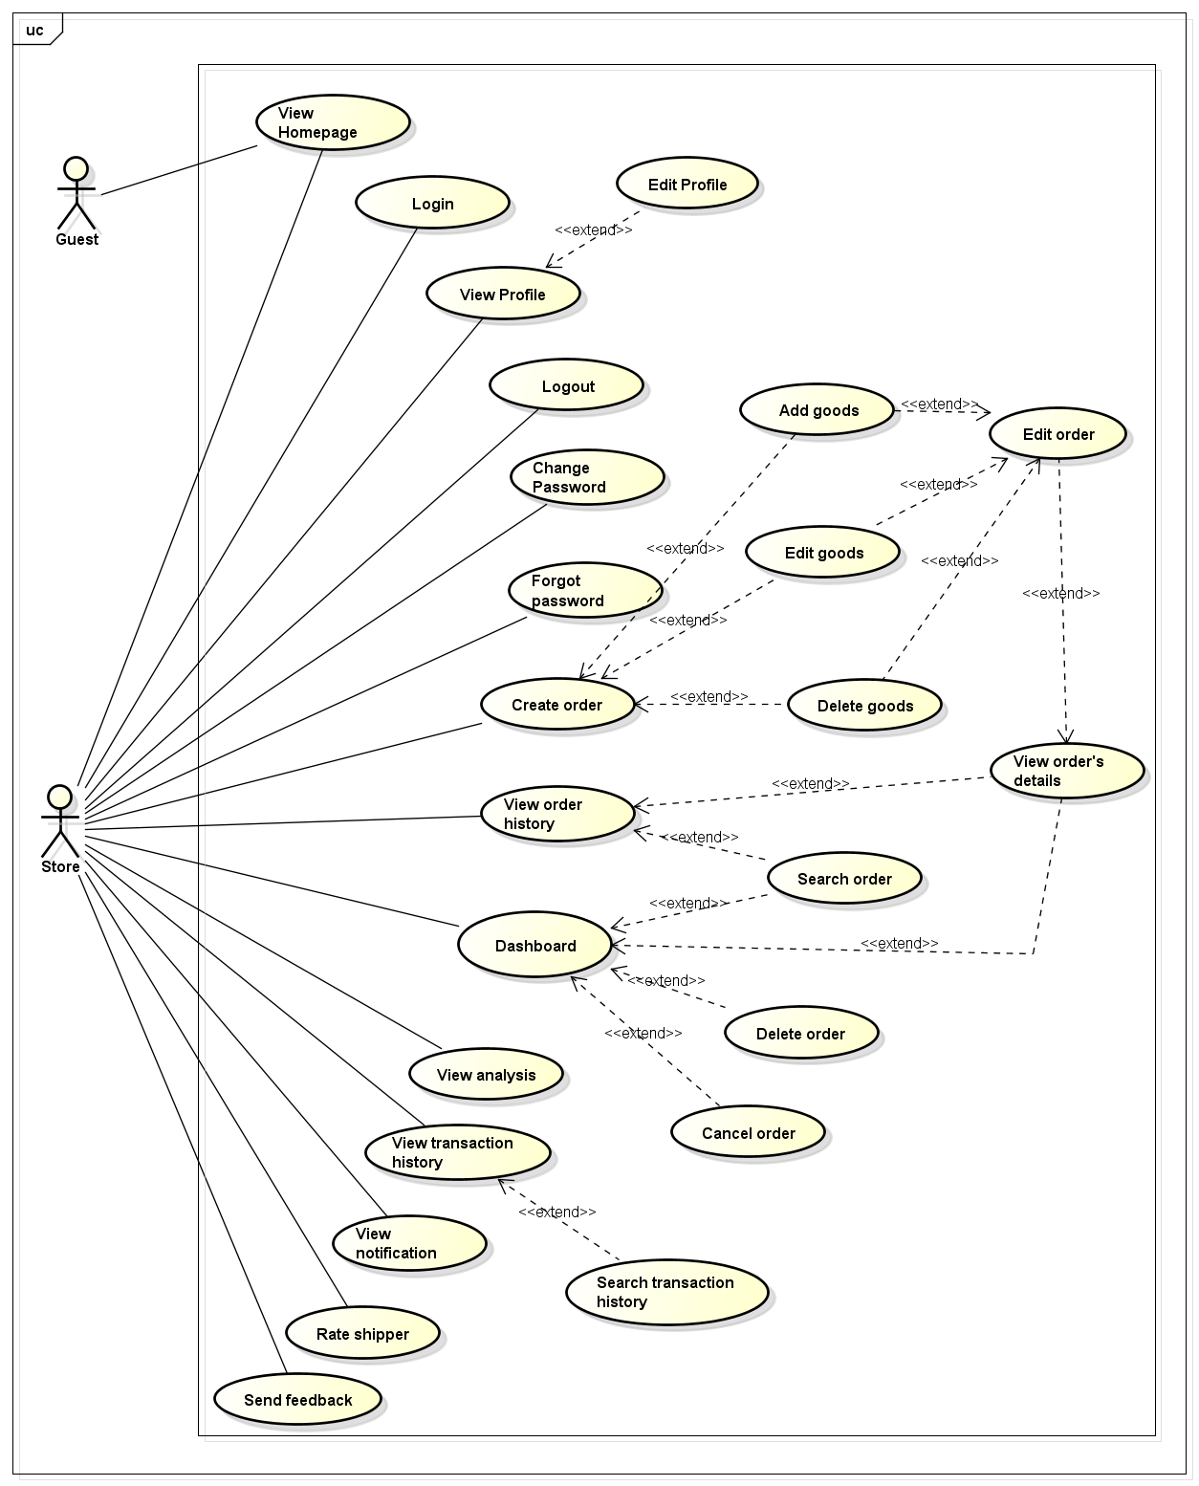

### 3.2.2. Function

###### *UC-200:* *View Homepage*

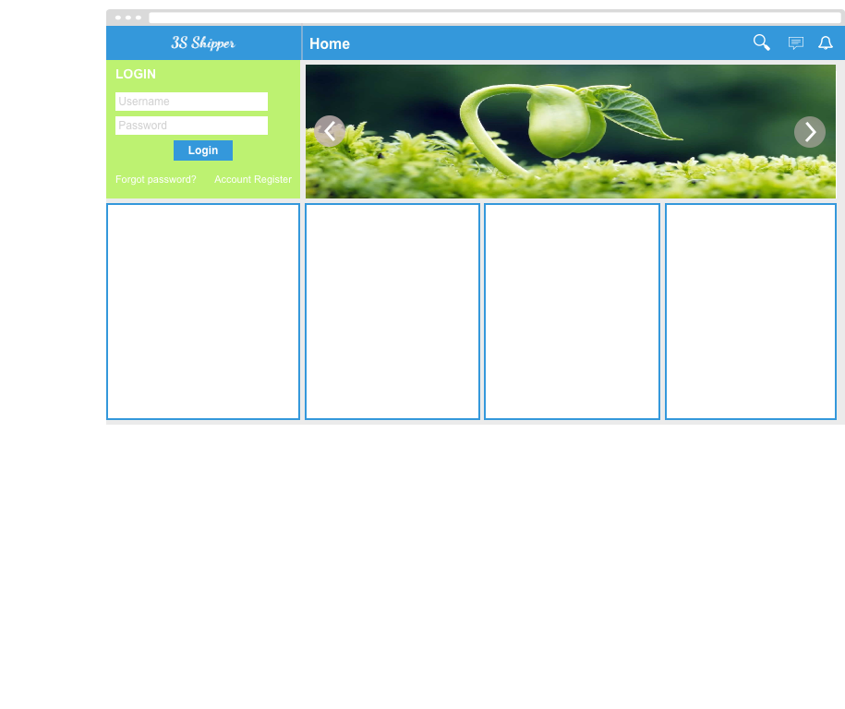

|  |  |  |  |  |
| --- | --- | --- | --- | --- |
| **Use Case ID:** | | UC-200 | | |
| **Use Case Name:** | | View Homepage | | |
| **Created By:** | | KhanhKC | **Last Updated By:** | KhanhKC |
| **Date Created:** | | 09/12/2015 | **Date Last updated:** | 09/12/2015 |
| **Actor:** | | Store, Guest | | |
| **Description:** | | “Homepage” show information about KarryWell service, a “Login” button that help Store login system. Beside, “Homepage” also shows advertisement of system. | | |
| **Triggering event:** | | Store or Guest access to KarryWell website. | | |
| **Preconditions:** | | Store or Guest accessed to KarryWell website. | | |
| **Post conditions:** | | “Homepage” screen has been displayed. | | |
| **Priority:** | | High | | |
| **Frequency of Use:** | | Always | | |
| **Main flow** | | | | |
| Step | Actor | Action | | |
|  | Store, Guest | Access to KarryWell website. | | |
|  | System | Loads data | | |
|  | System | Displays “Homepage” screen. | | |
| **Alternative Flows:** | | N/A | | |
| **Exceptions:** | | N/A | | |
| **Includes:** | | N/A | | |
| **Special Requirements:** | | N/A | | |
| **Notes and Issues:** | | N/A | | |

***Sequence Diagram***

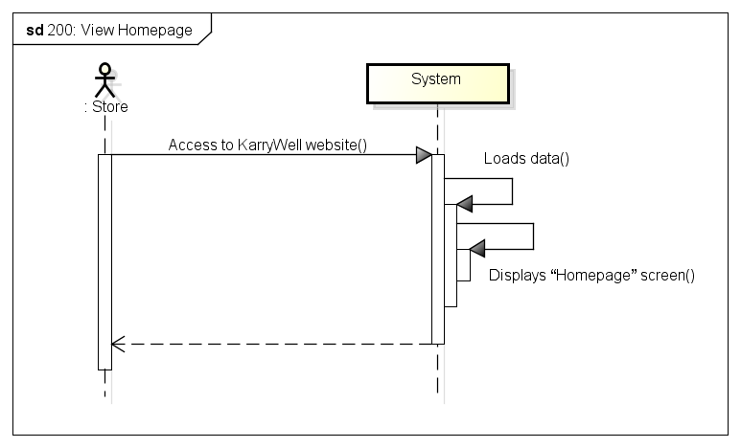

###### *UC-201:* *View dashboard*



|  |  |  |  |  |
| --- | --- | --- | --- | --- |
| **Use Case ID:** | | UC-201 | | |
| **Use Case Name:** | | View Dashboard | | |
| **Created By:** | | KhanhKC | **Last Updated By:** | KhanhKC |
| **Date Created:** | | 19/09/2015 | **Date Last Updated:** | 09/12/2015 |
| **Actor:** | | Store | | |
| **Description:** | | Dashboard has a maps that helps show location of shipper who are working for store and location of store’s customers. Dashboard also displays list of in process orders. | | |
| **Triggering event:** | | Store wants to view dashboard | | |
| **Preconditions:** | | Store logged in to system | | |
| **Post conditions:** | | “Dashboard” screen is displayed | | |
| **Priority:** | | High | | |
| **Frequency of Use:** | | Often | | |
| **Main flow** | | | | |
| Step | Actor | Action | | |
|  | Store | Clicks “Login” | | |
|  | System | Displays “Dashboard” screen | | |
| **Alternative :** | | N/A | | |
| **Exceptions:** | | N/A | | |
| **Includes:** | | N/A | | |
| **Special requirements:** | | N/A | | |
| **Notes and Issues:** | | N/A | | |

***Sequence Diagram***

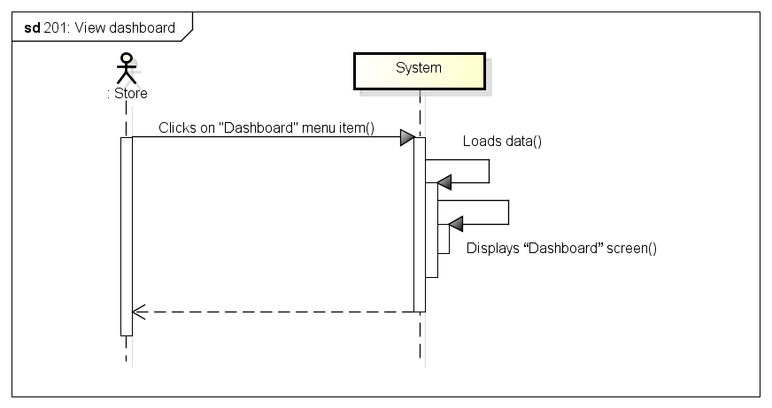

###### *UC-202:* *Login* (HoangLVQ)



|  |  |  |  |  |
| --- | --- | --- | --- | --- |
| **Use Case ID:** | | UC-202 | | |
| **Use Case Name:** | | Login | | |
| **Created By:** | | KhanhKC | **Last Updated By:** | KhanhKC |
| **Date Created:** | | 19/09/2015 | **Date Last Updated:** | 09/12/2015 |
| **Actor:** | | Store | | |
| **Description:** | | Users who are not logged in to system can only view the “Homepage”. Store needs to logins to system to use functions of system. | | |
| **Triggering event:** | | Store wants to login to system | | |
| **Preconditions:** | | - Store is on the “Homepage” of KarryWell website  - Store account must be exits | | |
| **Post conditions:** | | Logs Store into system  Redirects Store to “Dashboard” screen (Refer to UC-201: View Dashboard) | | |
| **Priority:** | | High | | |
| **Frequency of Use:** | | Sometime | | |
| **Main flow** | | | | |
| Step | Actor | Action | | |
|  | Store | Enters User name and Password | | |
|  | Store | Clicks “Login” | | |
|  | System | Check “Username” and “Password” in database. | | |
|  | System | Logs Store into system | | |
|  | System | Redirects to “Dashboard” screen. | | |
| **Alternative:** | | | | |
| **Exceptions:** | | | | |
| EC1 | At step 3 in main flow, if Store entered wrong User name or Password | | | |
| Step | Actor | Action | | |
| 3.1 | System | Displays message “Username or Password is wrong” | | |
| **Includes:** | | N/A | | |
| **Special requirements:** | | N/A | | |
| **Notes and Issues:** | | N/A | | |

***Sequence Diagram***

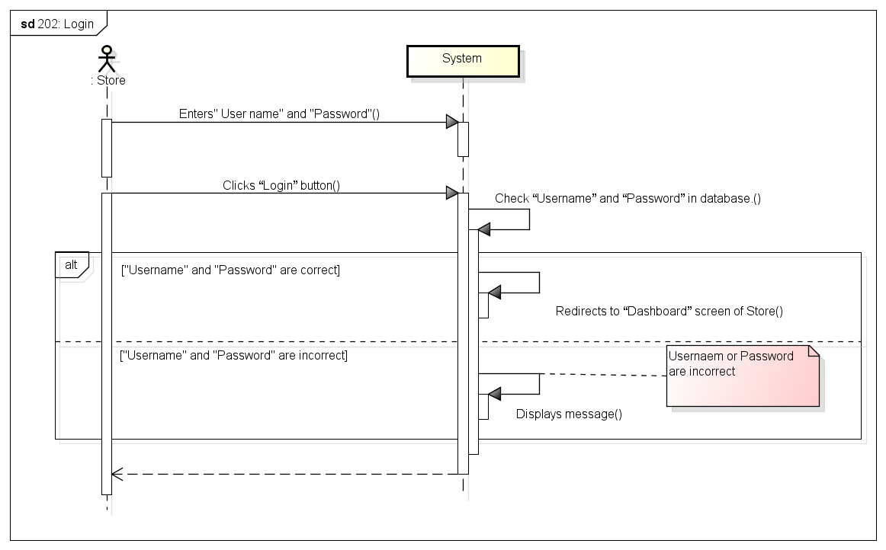

###### *UC-203:* *Logout* (HoangLVQ)

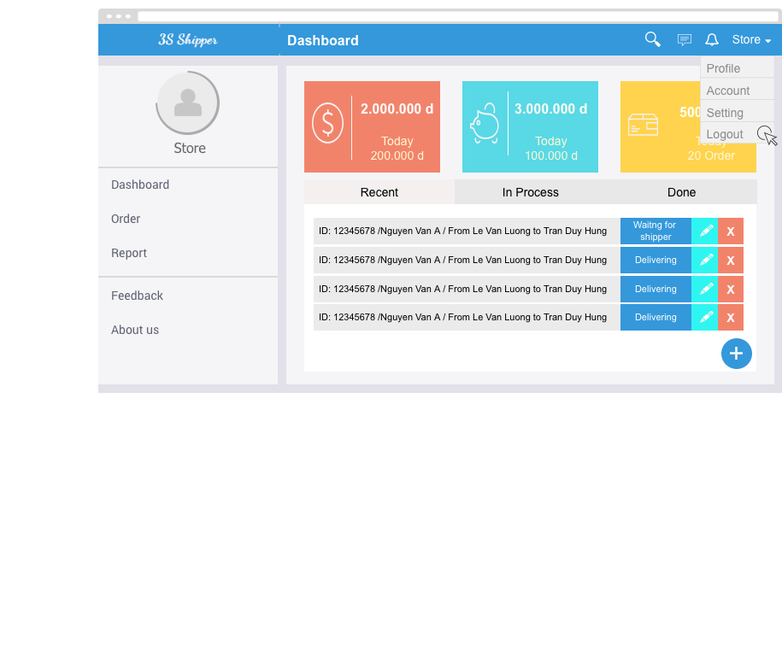

|  |  |  |  |  |
| --- | --- | --- | --- | --- |
| **Use Case ID:** | | UC-203 | | |
| **Use Case Name:** | | Logout | | |
| **Created By:** | | KhanhKC | **Last Updated By:** | KhanhKC |
| **Date Created:** | | 19/09/2015 | **Date Last updated:** | 09/12/2015 |
| **Actor:** | | Store | | |
| **Description:** | | When Store logouts from system, Store will cannot continue using functions of system. Store needs to login again to be able to use the function of system. | | |
| **Triggering event:** | | Store wants to logout from system. | | |
| **Preconditions:** | | Store logged in to system | | |
| **Post conditions:** | | Logs Store out from system.  Redirects Store to “Homepage” screen | | |
| **Priority:** | | High | | |
| **Frequency of Use:** | | Often | | |
| **Main flow** | | | | |
| Step | Actor | Action | | |
|  | Store | Clicks on “Logout” | | |
|  | System | Logouts Store from system | | |
|  | System | Displays Homepage for Guest | | |
| **Alternative Flows:** | | | | |
| **Exceptions:** | | N/A | | |
| **Includes:** | | N/A | | |
| **Special Requirements:** | | N/A | | |
| **Notes and Issues:** | | N/A | | |

***Sequence Diagram***

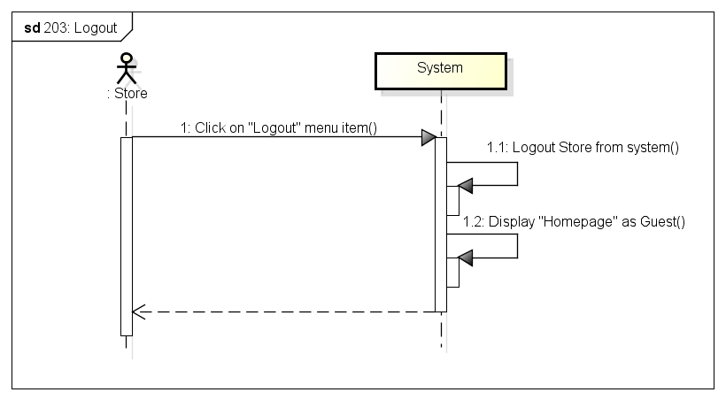

###### *UC-204: Change password*

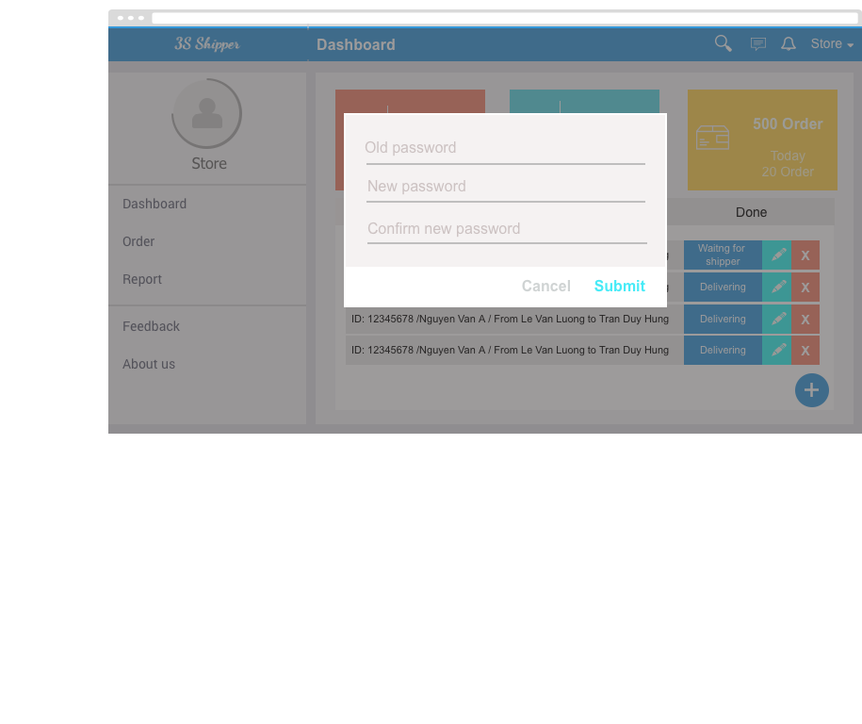

|  |  |  |  |  |
| --- | --- | --- | --- | --- |
| **Use Case ID:** | | UC-204 | | |
| **Use Case Name:** | | Change password | | |
| **Created By:** | | KhanhKC | **Last Updated By:** | KhanhKC |
| **Date Created:** | | 19/09/2015 | **Date Last updated:** | 09/12/2015 |
| **Actor:** | | Store | | |
| **Description:** | | Store can change login password but Store need to remember old password. | | |
| **Triggering event:** | | Store wants to change password. | | |
| **Preconditions:** | | Store logged in to system | | |
| **Post conditions:** | | New password has been saved in database. | | |
| **Priority:** | | High | | |
| **Frequency of Use:** | | Sometime | | |
| **Main flow** | | | | |
| Step | Actor | Action | | |
|  | Store | Clicks “Change password” | | |
|  | System | Displays “Change password” screen includes:  - Old password text box  - New password text box  - Confirm new password text box  - Submit button | | |
|  | Store | Enters data in fields | | |
|  | Store | Clicks “Submit” button | | |
|  | System | Validates data | | |
|  | System | Displays “Change password” screen with message “ Changes password successful” | | |
| **Alternative Flows:** | | N/A | | |
| **Exceptions:** | | | | |
| EC1 | At step 4, required fields are not entered | | | |
| Step | Actor | Action | | |
| 4.1 | System | Displays “Change password” screen with error message “*is require” | | |
| EC2 | At step 4, “Old password” is incorrect | | | |
| Step | Actor | Action | | |
| 4.1 | System | Displays “Change password” screen with error message: “Old password is incorrect” | | |
| EC3 | At step 4, confirm new password is not the same with new password | | | |
| Step | Actor | Action | | |
| 4.1 | System | Displays “Change password” screen with error message.” Confirm new password is not the same with new password. Please enter again!” | | |
| **Includes:** | | N/A | | |
| **Special Requirements:** | | Length of “New password” must between 6 and 10. | | |
| **Notes and Issues:** | | N/A | | |

***Sequence Diagram***

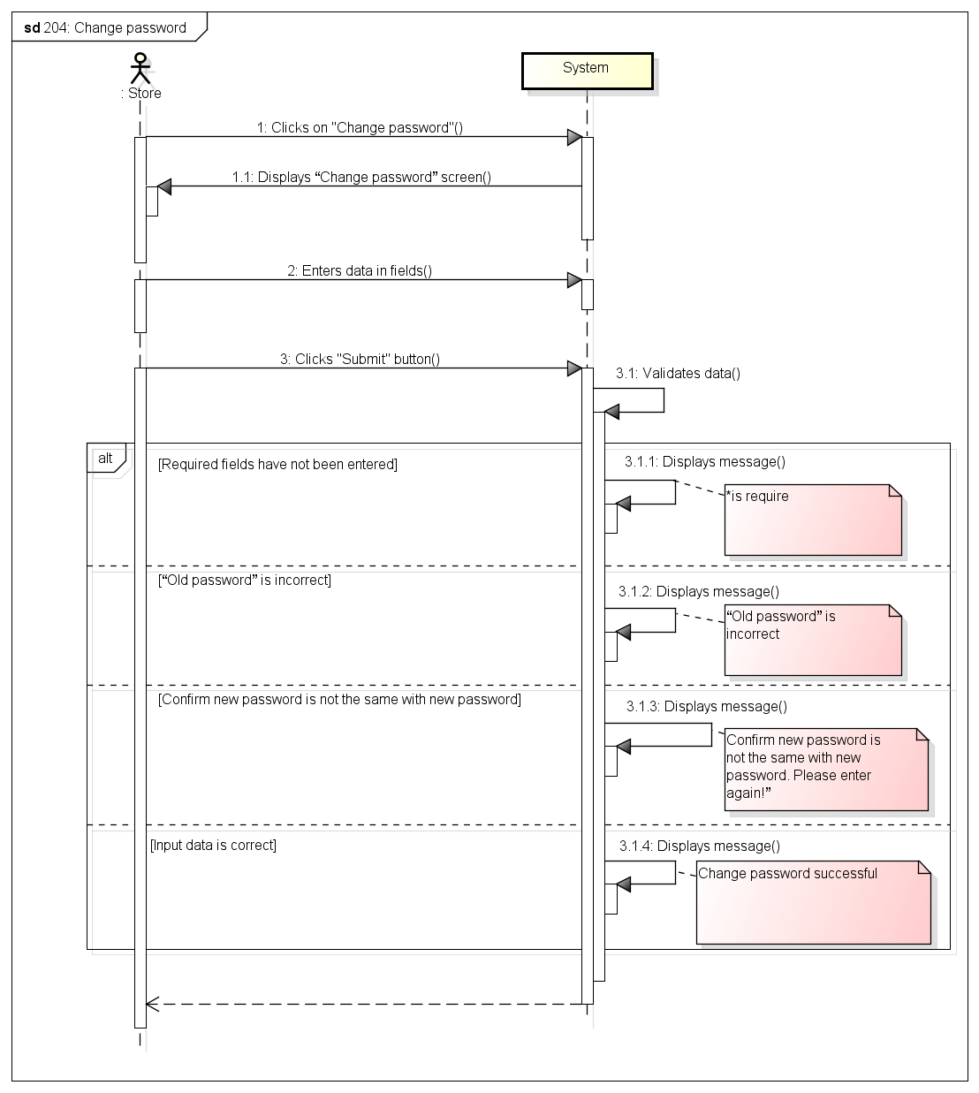

###### *UC-205:* *Forgot password*

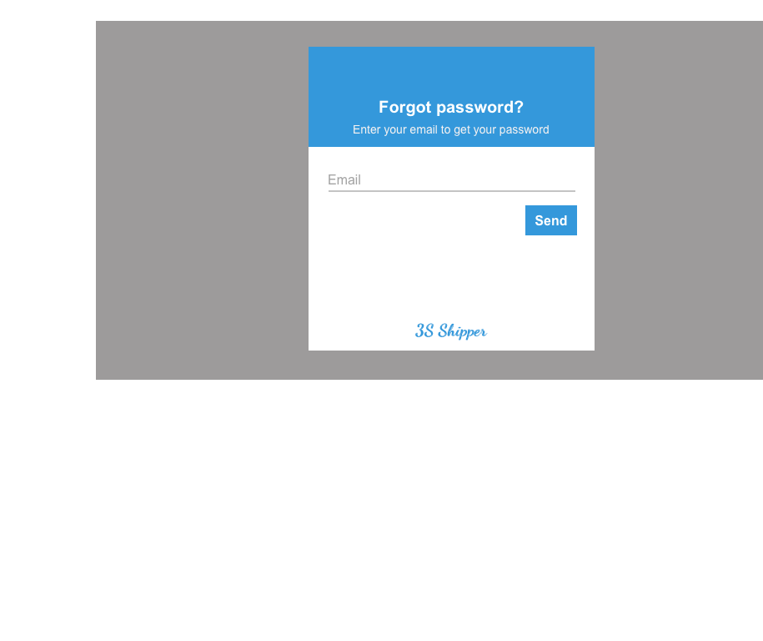

|  |  |  |  |  |
| --- | --- | --- | --- | --- |
| **Use Case ID:** | | UC-205 | | |
| **Use Case Name:** | | Forgot password | | |
| **Created By:** | | KhanhKC | **Last Updated By:** | KhanhKC |
| **Date Created:** | | 19/09/2015 | **Date Last updated:** | 09/12/2015 |
| **Actor:** | | Store | | |
| **Description:** | | This function help Store receive their login password when Store forgot. | | |
| **Triggering event:** | | Store requests system to receive new password. | | |
| **Preconditions:** | | Store is on the “Login” popup (Refer to UC-202: Login) | | |
| **Post conditions:** | | - A new password has been updated for Store  - An email has been send to registered email of Store include new password. | | |
| **Priority:** | | High | | |
| **Frequency of Use:** | | Sometime | | |
| **Main flow** | | | | |
| Step | Actor | Action | | |
|  | Store | Clicks “Forgot password” hyperlink on “Login” popup | | |
|  | System | Displays “Forgot password” popup includes:  - Email text box  - Submit button | | |
|  | Guest | Enters registered email. | | |
|  | Guest | Clicks “Submit” button | | |
|  | System | Validates data | | |
|  | System | Updates a new password for Store | | |
|  | System | Sends the new password to registered email of Store | | |
|  | System | Displays message : “Please check your email to get your new password” | | |
| **Alternative Flows:** | | N/A | | |
| **Exceptions:** | | | | |
| EC1 | At step 3, email are not a registered email | | | |
| Step | Actor | Actor | | |
| 4.1 | System | Displays error message:” Email is not exist” | | |
| **Includes:** | | N/A | | |
| **Special Requirements:** | | N/A | | |
| **Notes and Issues:** | | N/A | | |

***Sequence Diagram***

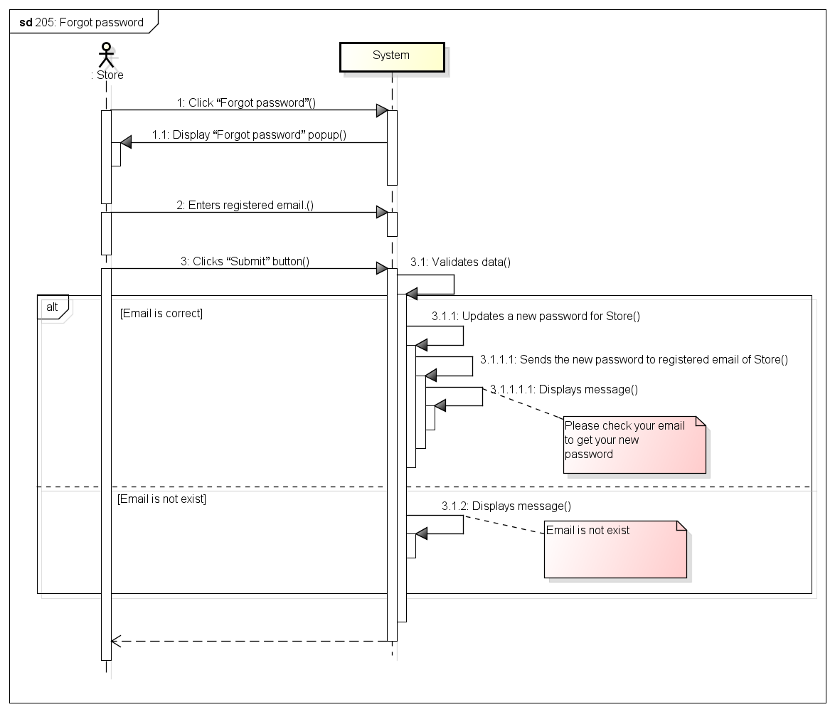

###### *UC-206:* *View profile*

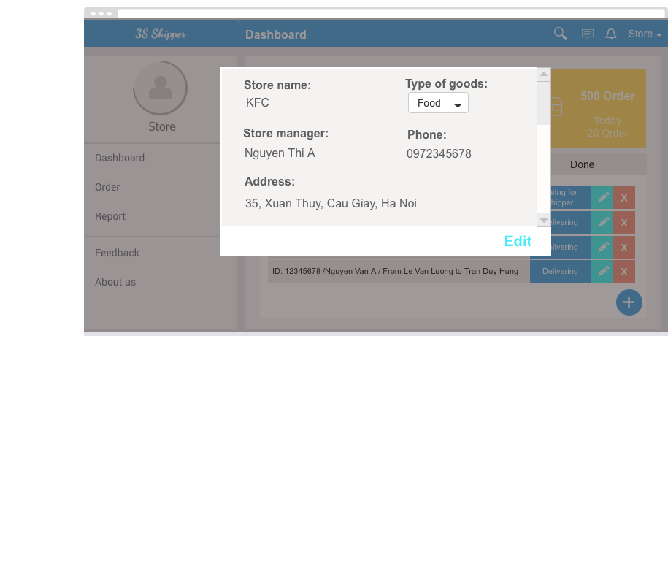

|  |  |  |  |  |
| --- | --- | --- | --- | --- |
| **Use Case ID:** | | UC-206 | | |
| **Use Case Name:** | | View profile | | |
| **Created By:** | | KhanhKC | **Last Updated By:** | KhanhKC |
| **Date Created:** | | 19/09/2015 | **Date Last updated:** | 09/12/2015 |
| **Actor:** | | Store | | |
| **Description:** | | “View profile” screen displays detail information of Store and information of store’s manager. | | |
| **Triggering event:** | | Store wants to view profile. | | |
| **Preconditions:** | | Store logged into system. | | |
| **Post conditions:** | | “Profile” screen are displayed | | |
| **Priority:** | | Normal | | |
| **Frequency of Use:** | | Sometime | | |
| **Main flow** | | | | |
| Step | Actor | Action | | |
|  | Store | Clicks on “Profile” | | |
|  | System | Loads data | | |
|  | System | Displays “Profile” screen includes details information of Store and information of Store’s manager | | |
| **Alternative Flows:** | | N/A | | |
| **Exceptions:** | | N/A | | |
| **Includes:** | | N/A | | |
| **Special Requirements:** | | N/A | | |
| **Notes and Issues:** | | N/A | | |

***Sequence Diagram***

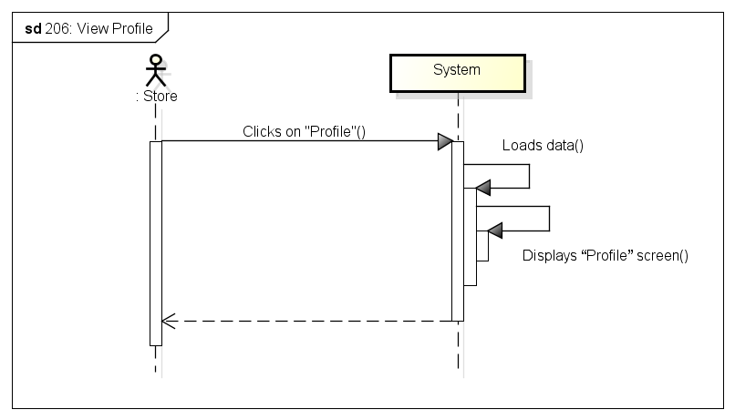

###### Default-6-Edit-profile-29069614*UC-207:* *Update profile*

|  |  |  |  |  |
| --- | --- | --- | --- | --- |
| **Use Case ID:** | | UC-207 | | |
| **Use Case Name:** | | Update profile | | |
| **Created By:** | | KhanhKC | **Last Updated By:** | KhanhKC |
| **Date Created:** | | 19/09/2015 | **Date Last updated:** | 09/12/2015 |
| **Actor:** | | Store | | |
| **Description:** | | Store can edit detail information such as: Store name; type of goods; Store address… This information will be updated to database. | | |
| **Triggering event:** | | Store wants to update profile. | | |
| **Preconditions:** | | Store are on “Profile” screen | | |
| **Post conditions:** | | New profile have been displays on “Profile screen” and updated in database. | | |
| **Priority:** | | Normal | | |
| **Frequency of Use:** | | Sometime | | |
| **Main flow** | | | | |
| Step | Actor | Action | | |
|  | Store | Clicks “Update profile” button on “Profile” screen | | |
|  | System | Enable fields on profile screen. | | |
|  | Store | Enters data in fields | | |
|  | Store | Clicks “Submit” button | | |
|  | System | Validates entered data. | | |
|  | System | Updates data to database | | |
|  | System | Displays “View Profile” screen. (Refer to UC-206: View Profile” | | |
| **Alternative Flows:** | | N/A | | |
| **Exceptions:** | | | | |
| EC1 | At step 3, require fields are empty | | | |
| Step | Actor | Action | | |
| 4.1 | System | Displays error message at empty fields: “* is require” | | |
| EC2 | At step 4, Store Clicks “Cancel” button | | | |
| Step | Actor | Action | | |
| 4.1 | System | Displays “View profile” screen (Refer to UC-206: View Profile” | | |
| **Includes:** | | N/A | | |
| **Special Requirements:** | | N/A | | |
| **Notes and Issues:** | |  | | |

***Sequence Diagram***

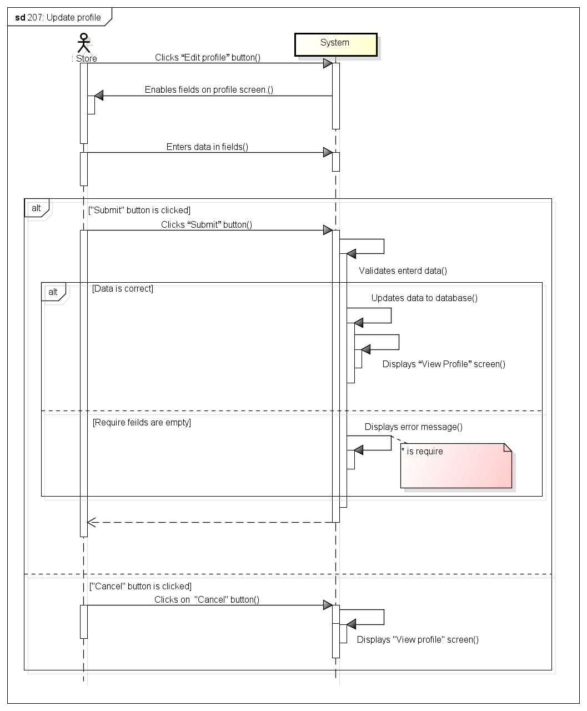

###### *UC-208:* *Create order*

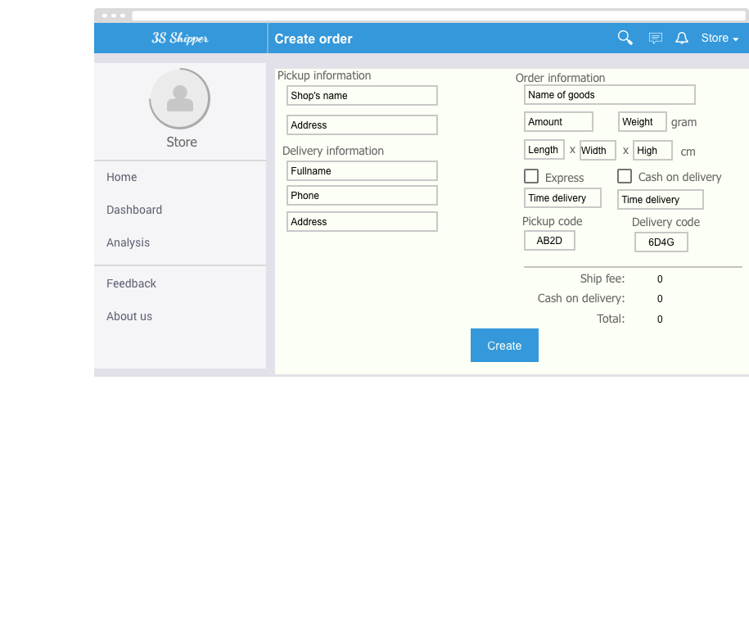

|  |  |  |  |  |
| --- | --- | --- | --- | --- |
| **Use Case ID:** | | UC-208 | | |
| **Use Case Name:** | | Create order | | |
| **Created By:** | | KhanhKC | **Last Updated By:** | KhanhKC |
| **Date Created:** | | 19/09/2015 | **Date Last updated:** | 09/12/2015 |
| **Actor:** | | Store | | |
| **Description:** | | Store creates an order to requests delivery service from system | | |
| **Triggering event:** | | Store wants to create a new order. | | |
| **Preconditions:** | | Store are logged into system. | | |
| **Post conditions:** | | Order information have been send to system and saved to database. | | |
| **Priority:** | | High | | |
| **Frequency of Use:** | | Always | | |
| **Main flow** | | | | |
| Step | Actor | Action | | |
|  | Store | Clicks “Make an order” button | | |
|  | System | Displays “Create order” screen has a wizard form at “Step1” includes:  - “Full name” text box  - “Phone” text box  - “Province” dropdown list  - “District” dropdown list  - “Ward” dropdown list  - “Address” text area  - “Next” button  - “Previous” button | | |
|  | Store | Enters data in fields | | |
|  | Store | Clicks “Next” button | | |
|  | System | Validate data | | |
|  | System | Displays “Step2” of wizard from include:  - “List goods” table  - “Add goods” button  - “Express” radio button  - “Normal” radio button  - “Cash on delivery” text box  - “Previous” button  - “Next” button | | |
|  | Store | Enters data in fields | | |
|  | Store | Add information of goods (Refer to UC211: Add goods) | | |
|  | Store | Clicks “Next” button | | |
|  | System | Validate data | | |
|  | System | Displays “Step3” of wizard from include:  - “Store” dropdown list  - “Phone” text box  - “Address” text box  - “Previous” button  - “Next” button | | |
|  | Store | Select store | | |
|  | Store | Clicks “Submit” button | | |
|  | System | Saves data to database | | |
|  | System | Displays message (Create order successfully!) | | |
| **Alternative Flows:** | | | | |
| AT1 | At step 13, “Express” radio button is checked | | | |
| Step | Actor | Action | | |
| 4.1 | Store | Clicks on “Submit” button | | |
| 4.2 | System | Go to UC-220: Find Shipper | | |
| **Exceptions:** | | | | |
| EC1 | At step 4, Store clicks on “Previous” button. | | | |
| Step | Actor | Action | | |
| 4.1 | Store | Clicks on “Previous” | | |
| 4.2 | System | Displays “Step1” of wizard form | | |
| EC2 | At step 4, input data is incorrect. | | | |
| Step | Actor | Action | | |
| 4.1 | Store | Clicks “Next” button | | |
| 4.2 | System | Displays message (message is depend on type of each data) | | |
| EC3 | At step 9, Store click on “Previous” button. | | | |
| Step | Actor | Action | | |
| 3.1 | Store | Clicks on “Previous” button | | |
| 3.2 | System | Displays “Step2” of wizard form | | |
| EC4 | At step 9, input data is incorrect | | | |
| Step | Actor | Action | | |
| 3.1 | Store | Clicks on “Next” button | | |
| 3.2 | System | Displays message (message is depend on type of each data) | | |
| EC4 | At step 9, store didn’t add any goods | | | |
| Step | Actor | Action | | |
| 3.1 | Store | Clicks on “Next” button | | |
| 3.2 | System | Displays message (“You must add at least on goods”) | | |
| **Includes:** | | N/A | | |
| **Special Requirements:** | | N/A | | |
| **Notes and Issues:** | | N/A | | |

***Sequence Diagram***

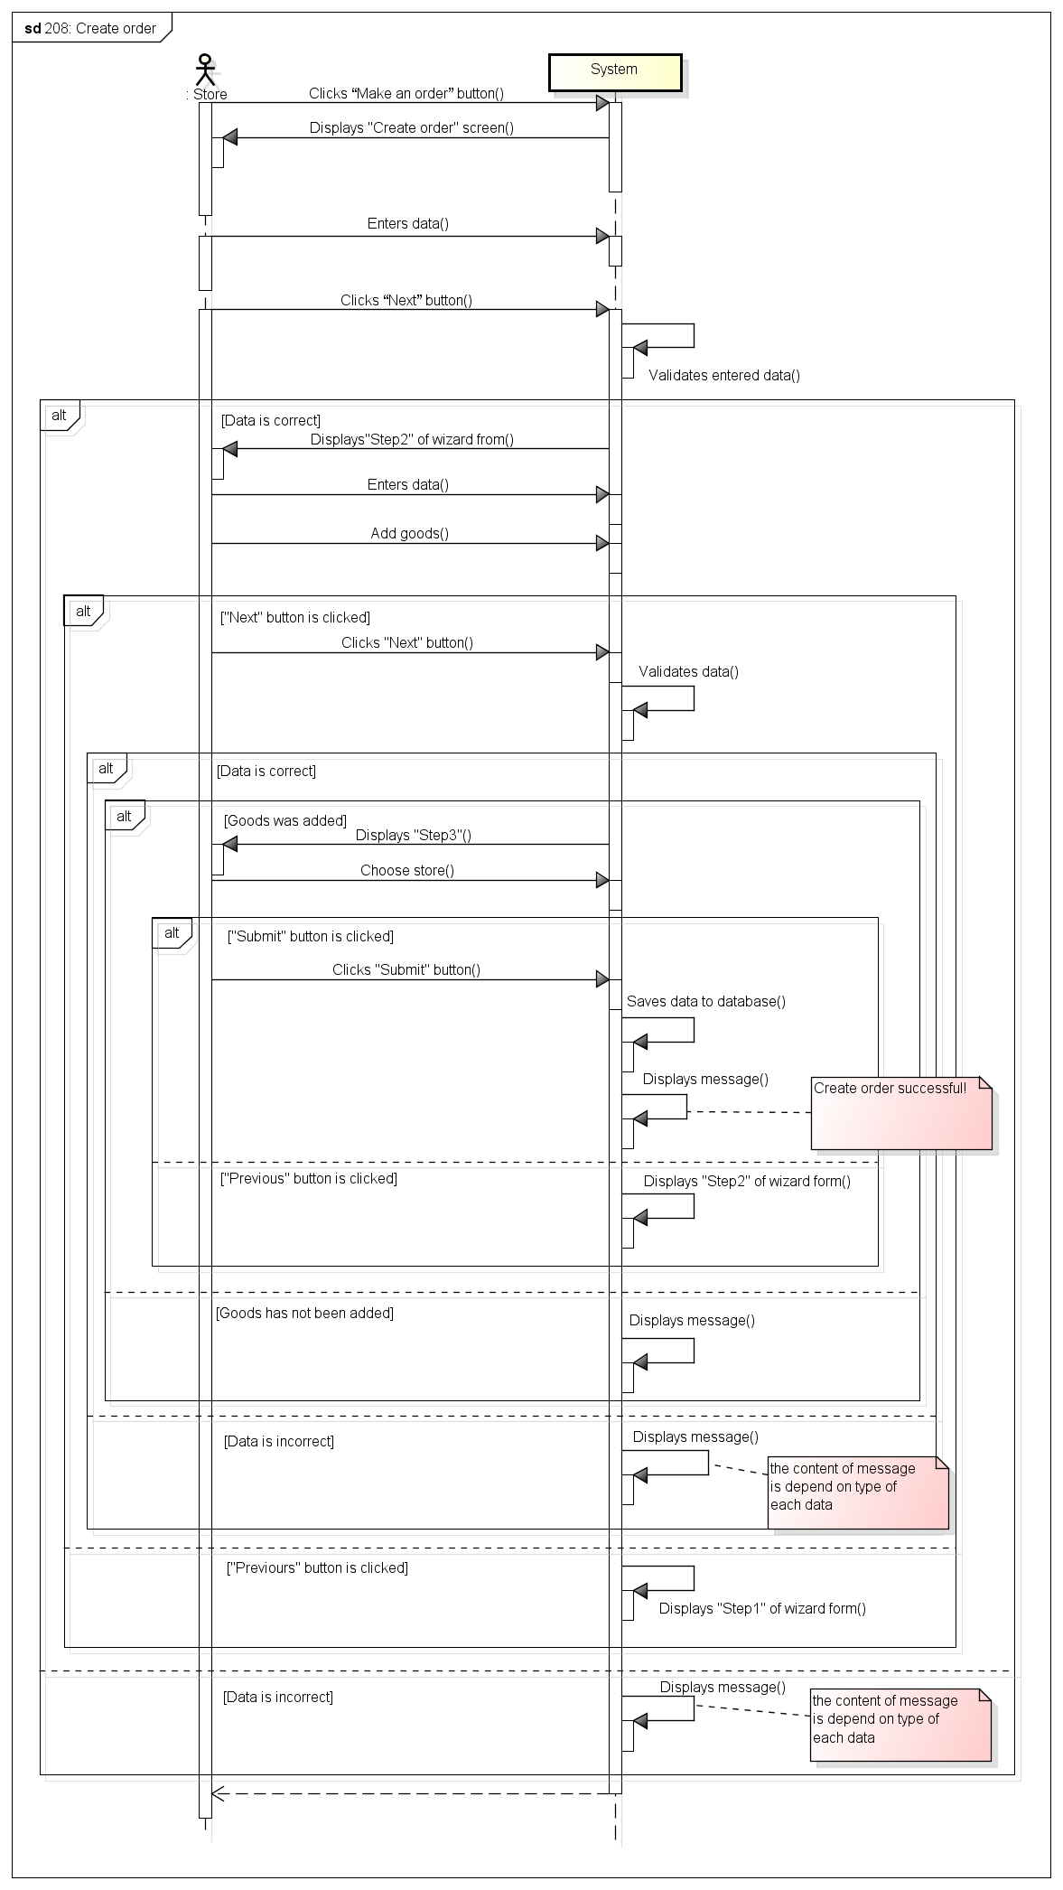

###### *UC-210:* *Edit Order*

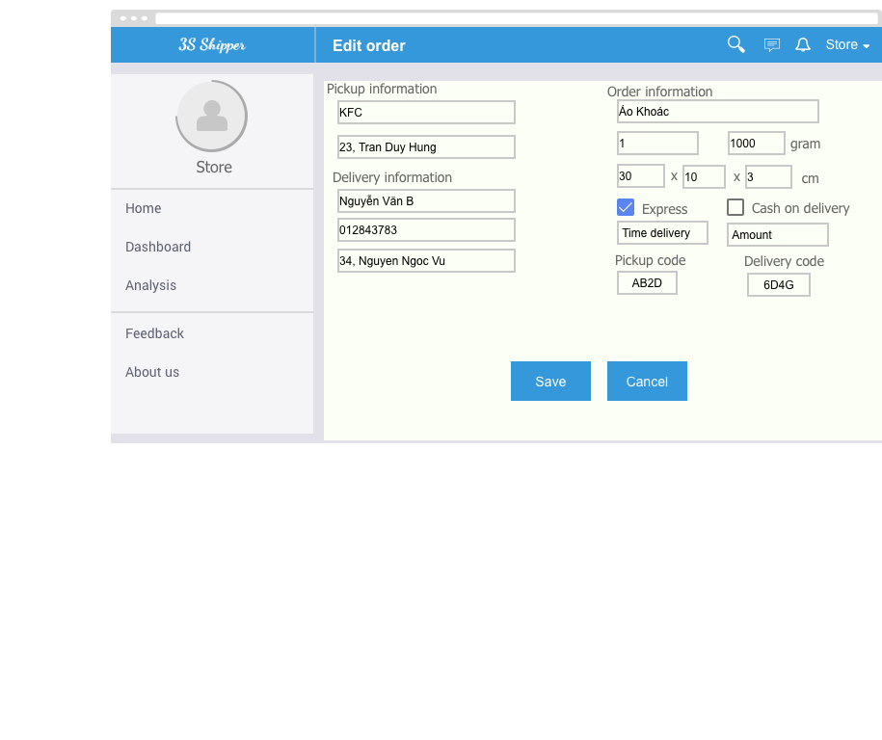

|  |  |  |  |  |
| --- | --- | --- | --- | --- |
| **Use Case ID:** | | UC-210 | | |
| **Use Case Name:** | | Edit Order | | |
| **Created By:** | | KhanhKC | **Last Updated By:** | KhanhKC |
| **Date Created:** | | 19/09/2015 | **Date Last updated:** | 09/12/2015 |
| **Actor:** | | Store | | |
| **Description:** | | Store can edits some information that Store entered when create orders. But the status of order must be in status “waiting” (waiting for shipper go to pick up) | | |
| **Triggering event:** | | Store wants to edits order | | |
| **Preconditions:** | | Store are on “Order details” screen. (Refer to UC-218: Order’s details) | | |
| **Post conditions:** | | Updated information of order have been displays on “Order’s details” screen and updated in database. | | |
| **Priority:** | | High | | |
| **Frequency of Use:** | | Often | | |
| **Main flow** | | | | |
| Step | Actor | Action | | |
|  | Store | Clicks “Edit” button on “Order’s detail” screen. | | |
|  | System | Enable element on “Order’s detail” screen. | | |
|  | Store | Edit information of order. | | |
|  | Store | Clicks “Update order” button | | |
|  | System | Displays “Order details” screen with updated information. | | |
| **Alternative Flows:** | | | | |
| **Exceptions:** | | | | |
| EC1 | At step 4, if input data is incorrect | | | |
| Step | Actor | Action | | |
| 4.1 | Store | Clicks “Update order” button | | |
| 4.2 | System | Displays message (content of message is depend on type of each data) | | |
| EC2 | At step 4, if table of goods is empty | | | |
| Step | Actor | Action | | |
| 4.1 | Store | Clicks “Update order” button | | |
| 4.2 | System | Displays message: “You must add at least one goods to order” | | |
| EC3 | At step 4, if Store clicks on “Cancel” button | | | |
| Step | Actor | Action | | |
| 4.1 | Store | Clicks “Cancel” button | | |
| 4.2 | System | Disable elements on “Order’s details” screen and displays previous data. | | |
| **Includes:** | | N/A | | |
| **Special Requirements:** | | N/A | | |
| **Notes and Issues:** | | N/A | | |

***Sequence Diagram***

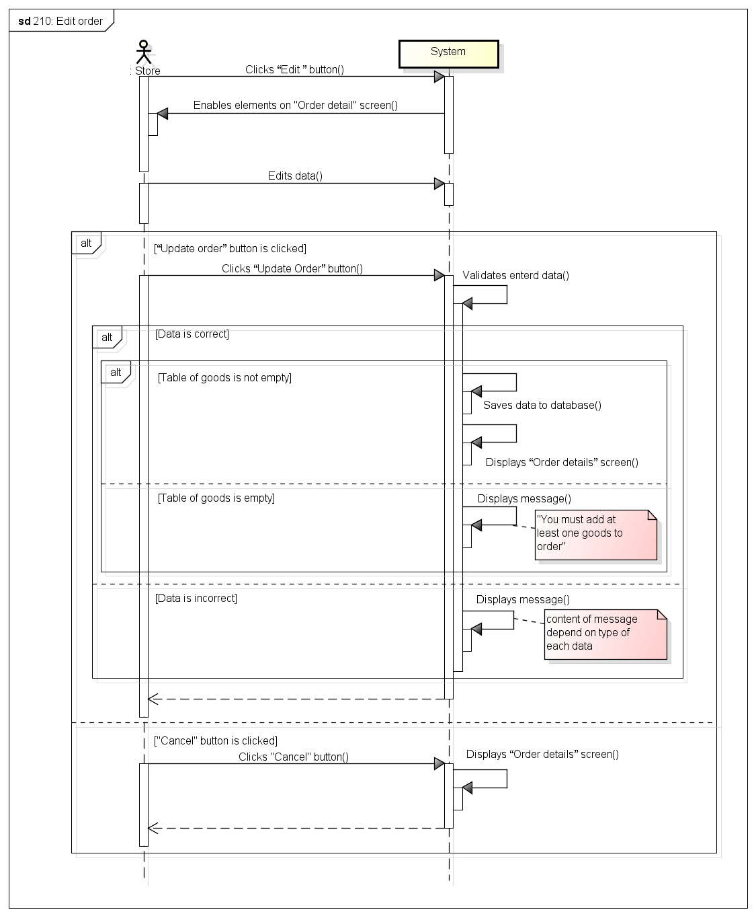

###### *UC-211:* *Add goods*



|  |  |  |  |  |
| --- | --- | --- | --- | --- |
| **Use Case ID:** | | UC-211 | | |
| **Use Case Name:** | | Add goods | | |
| **Created By:** | | KhanhKC | **Last Updated By:** | KhanhKC |
| **Date Created:** | | 19/09/2015 | **Date Last updated:** | 09/12/2015 |
| **Actor:** | | Store | | |
| **Description:** | | Store add information of goods for an orders include: goods name, weight, amount, height, width, length, description. | | |
| **Triggering event:** | | Store wants to add a goods | | |
| **Preconditions:** | | Store are on “Create order” screen (Refer to UC-208: Create order) or “Order’s details” screen (Refer to UC-210: Edit order) | | |
| **Post conditions:** | | A goods has been added to table of goods | | |
| **Priority:** | | High | | |
| **Frequency of Use:** | | Always | | |
| **Main flow** | | | | |
| Step | Actor | Action | | |
|  | Store | Clicks “Add goods” button | | |
|  | System | Displays “Add goods” popup includes:  - “Goods name” text box  - “Amount” text box  - “Weight” text box  - “Height” text box  - “Length” text box  - “Width” text box  - “Description” text box  - “Add” button  - “Cancel” button | | |
|  | Store | Enters data in fields | | |
|  | Store | Clicks “Add” button | | |
|  | System | Validate data | | |
|  | System | Add goods to table of goods | | |
|  | System | Closes popup | | |
| **Alternative Flows:** | | N/A | | |
| **Exceptions:** | | | | |
| EC1 | At step 4, Store clicks on “Cancel” button. | | | |
| Step | Actor | Action | | |
| 4.1 | Store | Clicks on “Cancel” button | | |
| 4.2 | System | Close popup | | |
| EC2 | At step 5, if input data is incorrect | | | |
| Step | Actor | Action | | |
| 4.1 | Store | Clicks on “Add” button | | |
| 4.2 | System | Displays messages (content of messages is depend in type of each data) | | |
| EC3 | At step 4, if total weight of all goods is greater than 30Kg | | | |
| Step | Actor | Action | | |
| 4.1 | Store | Clicks on “Add” button | | |
| 4.2 | System | Displays messages “Total weight must < 30000 gram” | | |
| **Includes:** | | N/A | | |
| **Special Requirements:** | | N/A | | |
| **Notes and Issues:** | | N/A | | |

***Sequence Diagram***

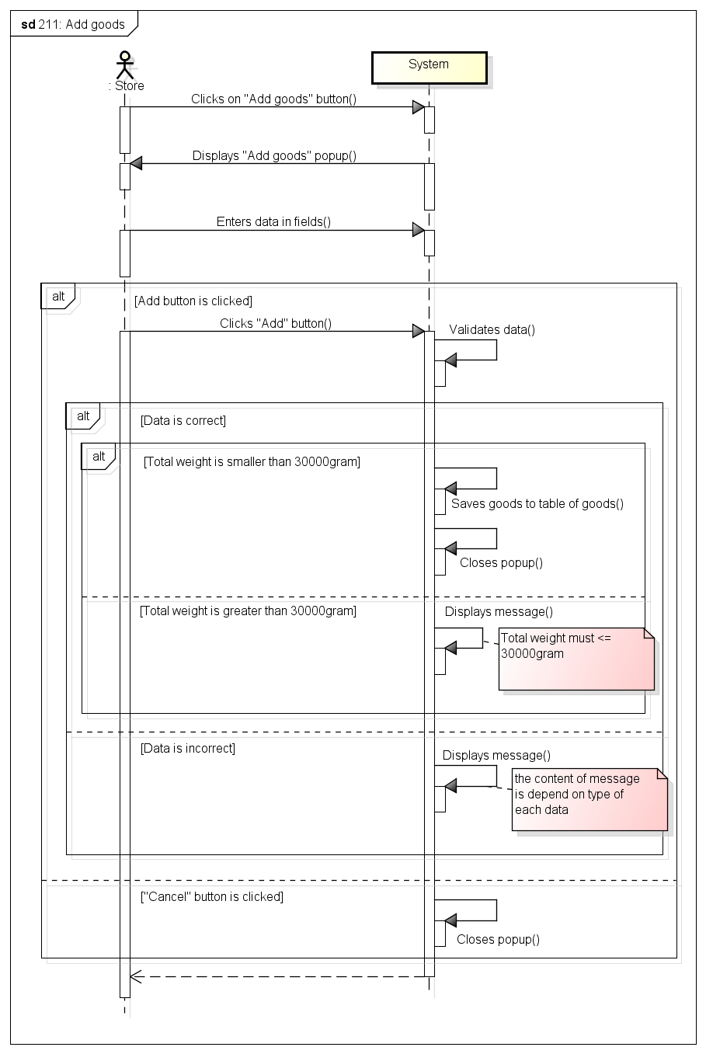

###### *UC-212:* *Edit goods*



|  |  |  |  |  |
| --- | --- | --- | --- | --- |
| **Use Case ID:** | | UC-212 | | |
| **Use Case Name:** | | Edit goods | | |
| **Created By:** | | KhanhKC | **Last Updated By:** | KhanhKC |
| **Date Created:** | | 19/09/2015 | **Date Last updated:** | 09/12/2015 |
| **Actor:** | | Store | | |
| **Description:** | | Store edit information of goods such as: goods name, weight, amount, height, width, length, description. | | |
| **Triggering event:** | | Store wants to edit a goods | | |
| **Preconditions:** | | Store are on “Create order” screen (Refer to UC-208: Create order) or “Order’s details” screen (Refer to UC-210: Edit order) | | |
| **Post conditions:** | | Information of goods has been updated to table of goods | | |
| **Priority:** | | High | | |
| **Frequency of Use:** | | Always | | |
| **Main flow** | | | | |
| Step | Actor | Action | | |
|  | Store | Clicks “Edit ” button on each row of table of goods | | |
|  | System | Displays “Edit goods” popup includes:  - “Goods name” text box  - “Amount” text box  - “Weight” text box  - “Height” text box  - “Length” text box  - “Width” text box  - “Description” text box  - “Save” button  - “Cancel” button | | |
|  | Store | Edit data in fields | | |
|  | Store | Clicks “Save” button | | |
|  | System | Validate data | | |
|  | System | Updated information of goods to table of goods | | |
|  | System | Closes popup | | |
| **Alternative Flows:** | | N/A | | |
| **Exceptions:** | | | | |
| EC1 | At step 4, Store clicks on “Cancel” button. | | | |
| Step | Actor | Action | | |
| 4.1 | Store | Clicks on “Cancel” button | | |
| 4.2 | System | Close popup | | |
| EC2 | At step 5, if input data is incorrect | | | |
| Step | Actor | Action | | |
| 4.1 | Store | Clicks on “Save” button | | |
| 4.2 | System | Displays messages (content of messages is depend in type of each data) | | |
| EC3 | At step 4, if total weight of all goods is greater than 30Kg | | | |
| Step | Actor | Action | | |
| 4.1 | Store | Clicks on “Save” buttons | | |
| 4.2 | System | Displays messages “Total weight must < 30000 gram” | | |
| **Includes:** | | N/A | | |
| **Special Requirements:** | | N/A | | |
| **Notes and Issues:** | | N/A | | |

***Sequence Diagram***

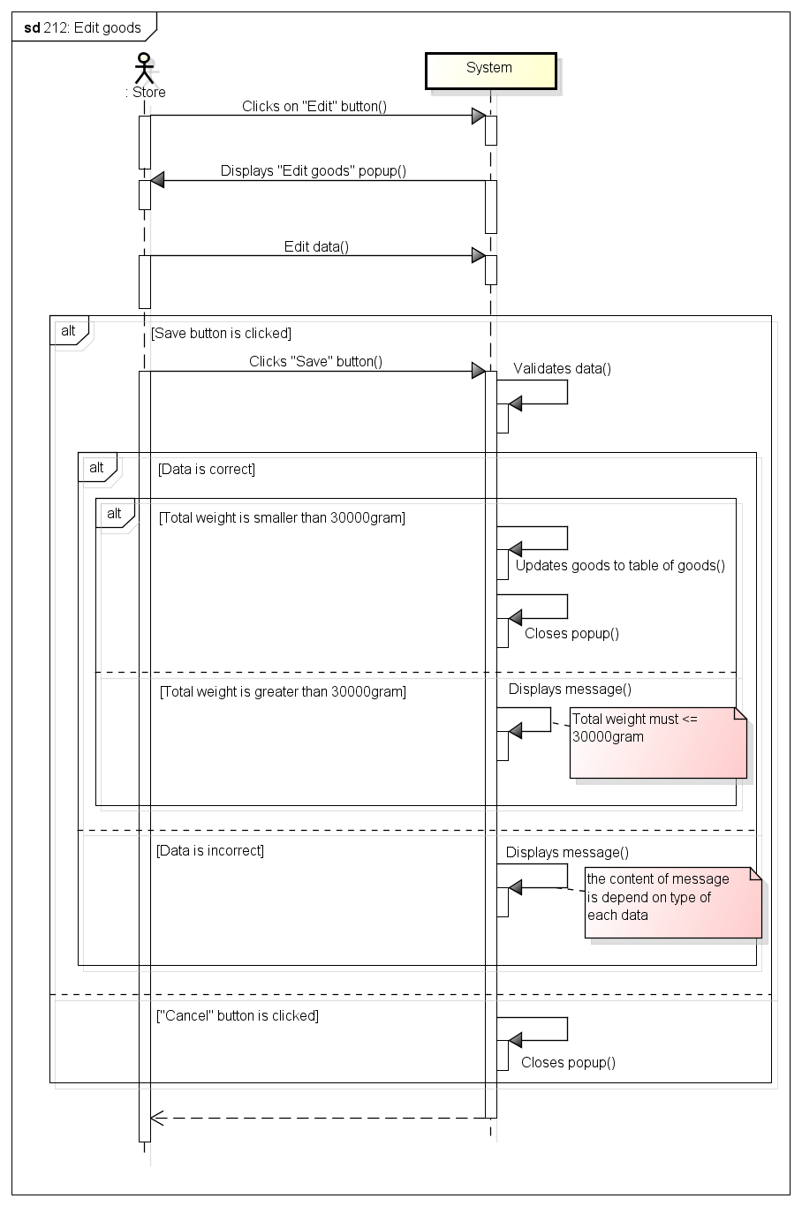

###### *UC-213:* *Delete goods*

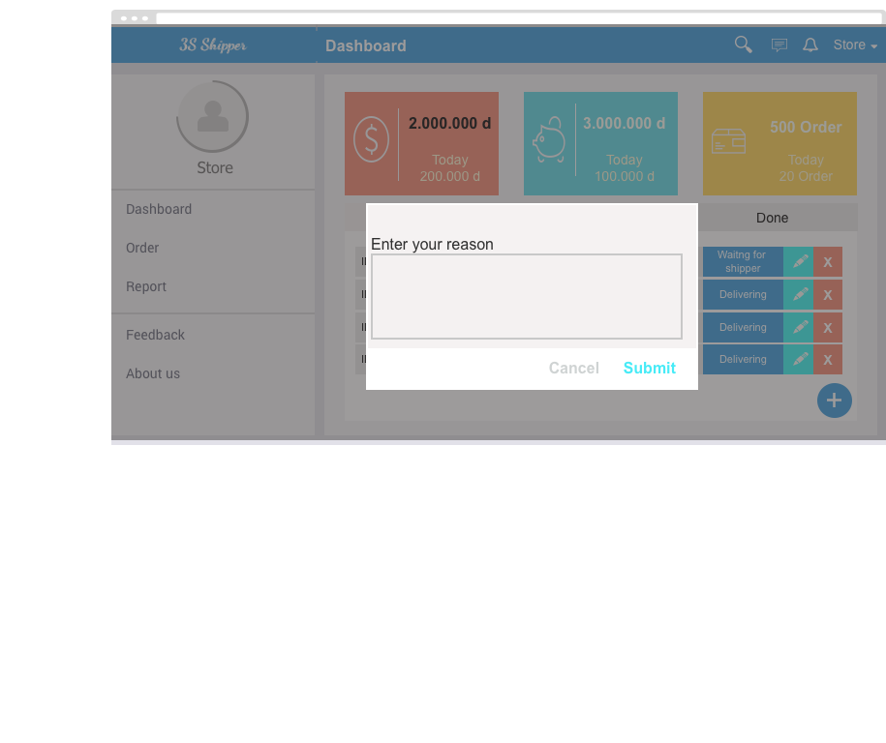

|  |  |  |  |  |
| --- | --- | --- | --- | --- |
| **Use Case ID:** | | UC-213 | | |
| **Use Case Name:** | | Delete goods | | |
| **Created By:** | | KhanhKC | **Last Updated By:** | KhanhKC |
| **Date Created:** | | 19/09/2015 | **Date Last updated:** | 09/12/2015 |
| **Actor:** | | Store | | |
| **Description:** | | Store can delete goods on table of goods | | |
| **Triggering event:** | | Store wants to delete a goods. | | |
| **Preconditions:** | | Store are on “Create order” screen (Refer to UC-208: Create order) or “Order’s details” screen (Refer to UC-210: Edit order) | | |
| **Post conditions:** | | Goods has been deleted from table of goods | | |
| **Priority:** | | High | | |
| **Frequency of Use:** | | Sometime | | |
| **Main flow** | | | | |
| Step | Actor | Action | | |
|  | Store | Clicks “Delete” button | | |
|  | System | Displays “Confirm delete” popup | | |
|  | Store | Clicks “Yes” button | | |
|  | System | Delete goods from table of goods | | |
|  | System | Closes popup | | |
| **Alternative Flows:** | | N/A | | |
| **Exceptions:** | | | | |
| EC1 | At step 3, Store Clicks “No” button | | | |
| Step | Actor | Action | | |
| 3.1 | System | Closes popup | | |
| **Includes:** | | N/A | | |
| **Special Requirements:** | | N/A | | |
| **Notes and Issues:** | | N/A | | |

***Sequence Diagram***

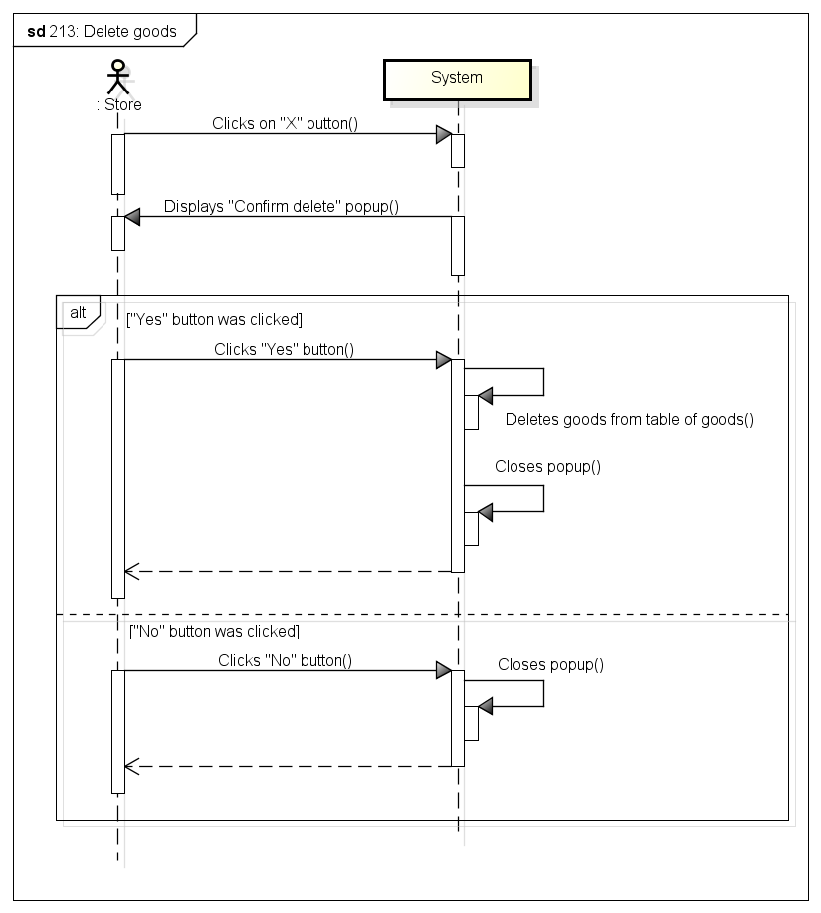

###### *UC-214:* *View order’s history*

|  |  |  |  |  |
| --- | --- | --- | --- | --- |
| **Use Case ID:** | | UC-214 | | |
| **Use Case Name:** | | View order’s history | | |
| **Created By:** | | KhanhKC | **Last Updated By:** | KhanhKC |
| **Date Created:** | | 19/09/2015 | **Date Last updated:** | 09/12/2015 |
| **Actor:** | | Store | | |
| **Description:** | | “View order’s history” screen displays list of all orders that created by and function buttons that help Store cancels and edits information of orders. | | |
| **Triggering event:** | | Store wants to view order history. | | |
| **Preconditions:** | | Store logged into system. | | |
| **Post conditions:** | | “Order’s history” screen are displayed | | |
| **Priority:** | | High | | |
| **Frequency of Use:** | | Always | | |
| **Main flow** | | | | |
| Step | Actor | Action | | |
|  | Store | Clicks on “Order’s history” on menu | | |
|  | System | Loads data | | |
|  | System | Displays “Order’s history” screen | | |
| **Alternative Flows:** | | N/A | | |
| **Exceptions:** | | N/A | | |
| **Includes:** | | N/A | | |
| **Special Requirements:** | | N/A | | |
| **Notes and Issues:** | | N/A | | |

***Sequence Diagram***

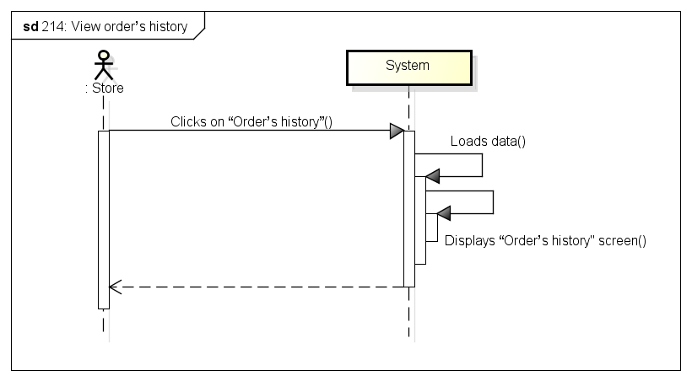

###### *UC-215:* *Search orders*

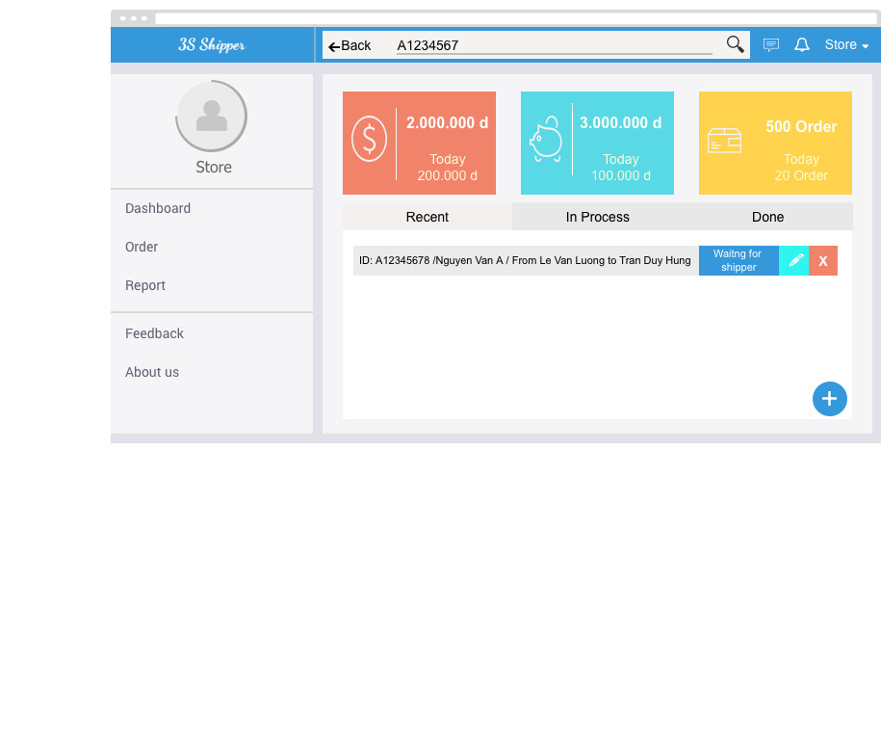

|  |  |  |  |  |
| --- | --- | --- | --- | --- |
| **Use Case ID:** | | UC-215 | | |
| **Use Case Name:** | | Search orders | | |
| **Created By:** | | KhanhKC | **Last Updated By:** | KhanhKC |
| **Date Created:** | | 19/09/2015 | **Date Last updated:** | 09/12/2015 |
| **Actor:** | | Store | | |
| **Description:** | | Store can use order’s information to search orders in list of orders that were created by Store. Example search order by orderid, create date… | | |
| **Triggering event:** | | Store wants to search order | | |
| **Preconditions:** | | Store is on “Order’s history” screen. (Refer to UC-214: View order’s history) or “Dashboard” screen (Refer to UC-201: View dashboard) | | |
| **Post conditions:** | | Search result are displayed on screen. | | |
| **Priority:** | | High | | |
| **Frequency of Use:** | | Often | | |
| **Main flow** | | | | |
| Step | Actor | Action | | |
|  | Store | Selects item on drop down list to search | | |
|  | Store | Types on search box | | |
|  | System | Loads data | | |
|  | System | Displays search result on screen. | | |
| **Alternative Flows:** | | N/A | | |
| **Exceptions:** | | N/A | | |
| **Includes:** | | N/A | | |
| **Special Requirements:** | | N/A | | |
| **Notes and Issues:** | | N/A | | |

***Sequence Diagram***

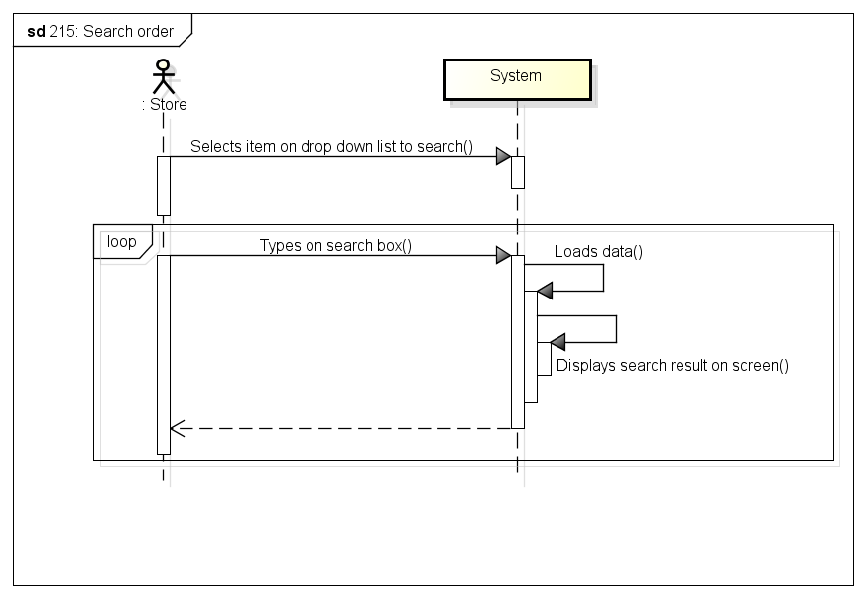

###### *UC-216:* *Cancel order*



|  |  |  |  |  |
| --- | --- | --- | --- | --- |
| **Use Case ID:** | | UC-216 | | |
| **Use Case Name:** | | Cancel order | | |
| **Created By:** | | KhanhKC | **Last Updated By:** | KhanhKC |
| **Date Created:** | | 19/09/2015 | **Date Last updated:** | 09/12/2015 |
| **Actor:** | | Store | | |
| **Description:** | | Stores can cancel uncompleted orders. But Store has to pay 10% ship fee of order. | | |
| **Triggering event:** | | Store wants to cancel orders. | | |
| **Preconditions:** | | Store are on “Dashboard” screen (Refer to UC-201: View dashboard) or “Order’s detail” screen (Refer to UC-218: View order’s details”) | | |
| **Post conditions:** | | - Order status has been changed to “Canceling”  - Notification has been send to admin. | | |
| **Priority:** | | Normal | | |
| **Frequency of Use:** | | Sometime | | |
| **Main flow** | | | | |
| Step | Actor | Action | | |
|  | Store | Clicks “Cancel” button | | |
|  | System | Displays “Confirm Cancel” popup | | |
|  | Store | Clicks “Yes” button | | |
|  | System | Changes status of order to “Canceling” | | |
|  | System | Sends notification to admin | | |
| **Alternative Flows:** | | N/A | | |
| **Exceptions:** | | | | |
| EC1 | At step 3, Store Clicks “No” button | | | |
| Step | Actor | Action | | |
| 3.1 | System | Closes popup | | |
| **Includes:** | | N/A | | |
| **Special Requirements:** | | N/A | | |
| **Notes and Issues:** | | N/A | | |

***Sequence Diagram***

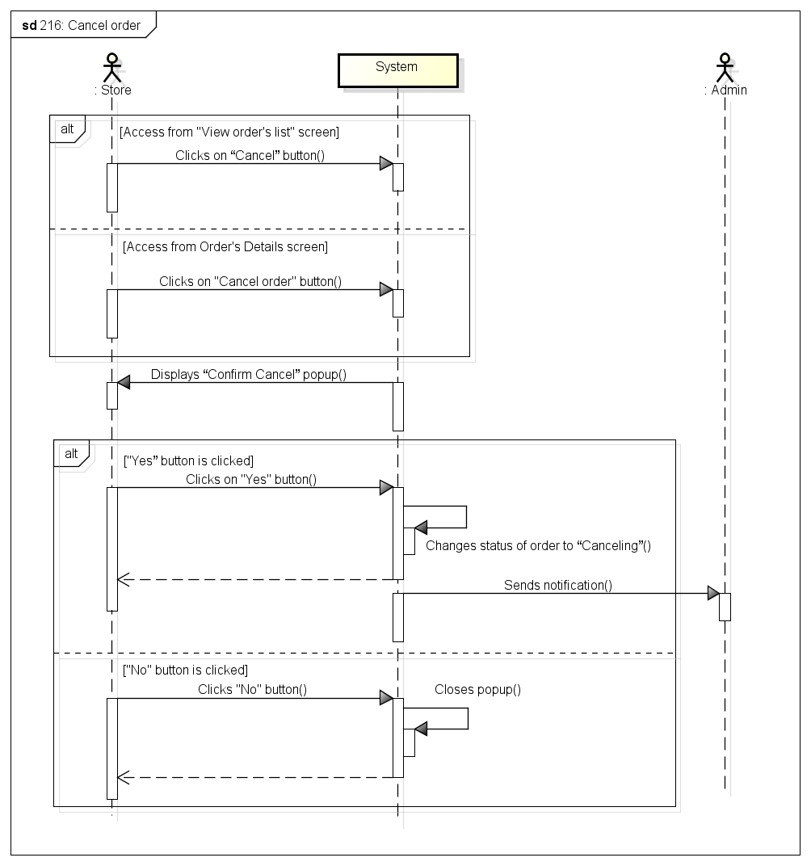

###### *UC-217:* *Delete order*



|  |  |  |  |  |
| --- | --- | --- | --- | --- |
| **Use Case ID:** | | UC-217 | | |
| **Use Case Name:** | | Delete order | | |
| **Created By:** | | KhanhKC | **Last Updated By:** | KhanhKC |
| **Date Created:** | | 19/09/2015 | **Date Last updated:** | 09/12/2015 |
| **Actor:** | | Store | | |
| **Description:** | | Store can delete draft order (Express order that have not yet been grabbed by any shipper) | | |
| **Triggering event:** | | Store wants to delete an order. | | |
| **Preconditions:** | | Store are on “Dashboard” screen (Refer to UC-201: View dashboard) | | |
| **Post conditions:** | | - Order status has been deleted in database | | |
| **Priority:** | | Normal | | |
| **Frequency of Use:** | | Sometime | | |
| **Main flow** | | | | |
| Step | Actor | Action | | |
|  | Store | Clicks “Delete” button | | |
|  | System | Displays “Confirm delete” popup | | |
|  | Store | Clicks “Yes” button | | |
|  | System | Delete order in database | | |
|  | System | Displays message “Delete order successfully!” | | |
| **Alternative Flows:** | | N/A | | |
| **Exceptions:** | | | | |
| EC1 | At step 3, Store Clicks “No” button | | | |
| Step | Actor | Action | | |
| 3.1 | System | Closes popup | | |
| **Includes:** | | N/A | | |
| **Special Requirements:** | | N/A | | |
| **Notes and Issues:** | | N/A | | |

***Sequence Diagram***

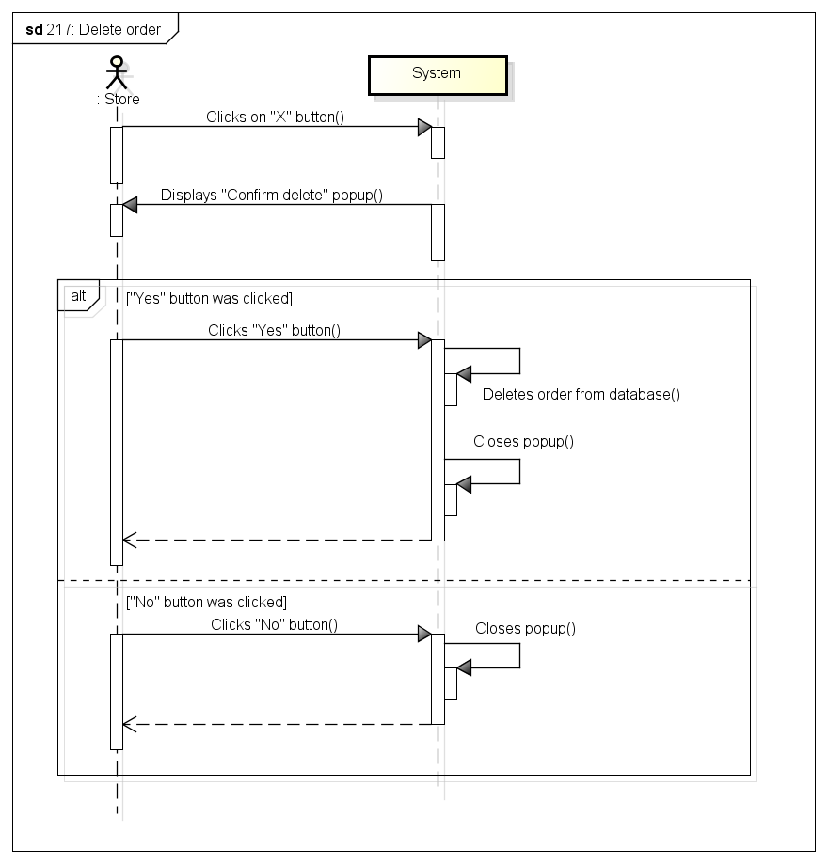

###### *UC-218:* View o*rder’s details*

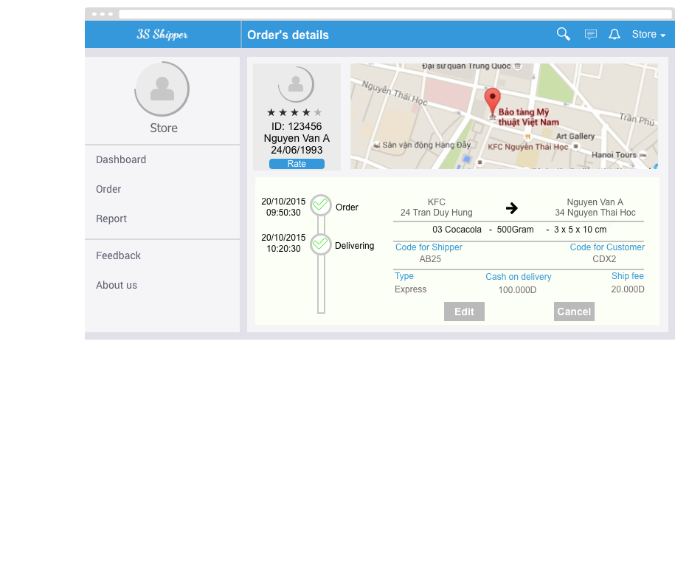

|  |  |  |  |  |
| --- | --- | --- | --- | --- |
| **Use Case ID:** | | UC-218 | | |
| **Use Case Name:** | | Order’ Details | | |
| **Created By:** | | KhanhKC | **Last Updated By:** | KhanhKC |
| **Date Created:** | | 19/09/2015 | **Date Last updated:** | 09/12/2015 |
| **Actor:** | | Store | | |
| **Description:** | | Displays details information of orders with a maps that help Store checking location of Shippers | | |
| **Triggering event:** | | Store wants to view order details | | |
| **Preconditions:** | | Store is on “Order’s history” screen (Refer to UC-214: View order’s history) or “Dashboard” screen (Refer to UC-201: View dashboard) | | |
| **Post conditions:** | | “Order’s details” screen is displayed | | |
| **Priority:** | | High | | |
| **Frequency of Use:** | | Always | | |
| **Main flow** | | | | |
| Step | Actor | Action | | |
|  | Store | Clicks on “View” button on row contain order brief information | | |
|  | System | Loads data | | |
|  | System | Displays “Order’s details” screen | | |
| **Alternative Flows:** | | N/A | | |
| **Exceptions:** | | N/A | | |
| **Includes:** | | N/A | | |
| **Special Requirements:** | | N/A | | |
| **Notes and Issues:** | | N/A | | |

***Sequence Diagram***

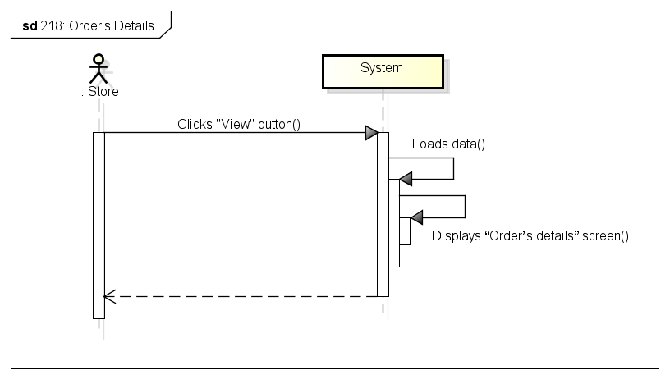

###### *UC-219:* *View transaction history*

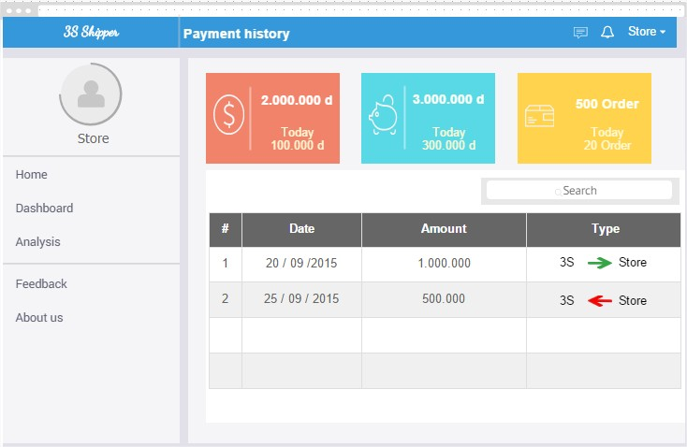

|  |  |  |  |  |
| --- | --- | --- | --- | --- |
| **Use Case ID:** | | UC-219 | | |
| **Use Case Name:** | | View transaction history | | |
| **Created By:** | | KhanhKC | **Last Updated By:** | KhanhKC |
| **Date Created:** | | 19/09/2015 | **Date Last updated:** | 09/12/2015 |
| **Actor:** | | Store | | |
| **Description:** | | Displays transaction history between Store and system | | |
| **Triggering event:** | | Store wants to view transaction history | | |
| **Preconditions:** | | Store is on “Store” screen. | | |
| **Post conditions:** | | “Transaction history” screen are displayed | | |
| **Priority:** | | Normal | | |
| **Frequency of Use:** | | Sometime | | |
| **Main flow** | | | | |
| Step | Actor | Action | | |
|  | Store | Clicks on “Transaction history” menu item on “Navigation bar” | | |
|  | System | Loads data | | |
|  | System | Displays “Transaction history” screen. | | |
| **Alternative Flows:** | | N/A | | |
| **Exceptions:** | | N/A | | |
| **Includes:** | | N/A | | |
| **Special Requirements:** | | N/A | | |
| **Notes and Issues:** | | N/A | | |

***Sequence Diagram***

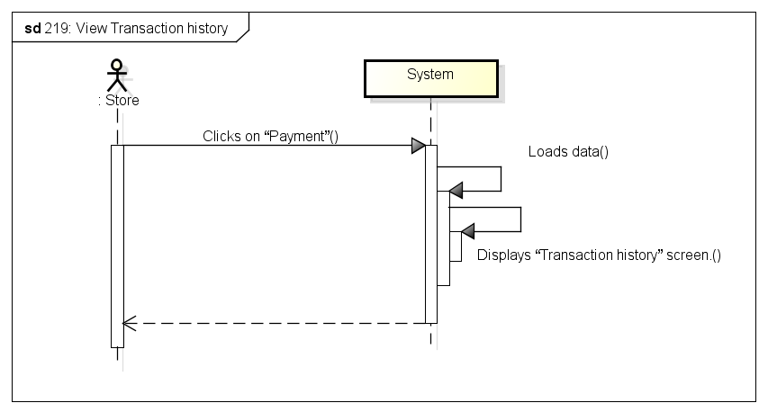

###### *UC-220:* *Search transaction history*



|  |  |  |  |  |
| --- | --- | --- | --- | --- |
| **Use Case ID:** | | UC-220 | | |
| **Use Case Name:** | | Search transaction history | | |
| **Created By:** | | KhanhKC | **Last Updated By:** | KhanhKC |
| **Date Created:** | | 19/09/2015 | **Date Last updated:** | 09/12/2015 |
| **Actor:** | | Store | | |
| **Description:** | | Store can use transaction’s information to search transaction in list of transactions. Example search transaction by balance, create date… | | |
| **Triggering event:** | | Store wants to search transaction | | |
| **Preconditions:** | | Store is on “Transaction’s history” screen. (Refer to UC-219: View transaction’s history) | | |
| **Post conditions:** | | Search result are displayed on screen. | | |
| **Priority:** | | High | | |
| **Frequency of Use:** | | Often | | |
| **Main flow** | | | | |
| Step | Actor | Action | | |
|  | Store | Selects item on drop down list to search | | |
|  | Store | Types on search box | | |
|  | System | Loads data | | |
|  | System | Displays search result on screen. | | |
| **Alternative Flows:** | | N/A | | |
| **Exceptions:** | | N/A | | |
| **Includes:** | | N/A | | |
| **Special Requirements:** | | N/A | | |
| **Notes and Issues:** | | N/A | | |

***Sequence Diagram***

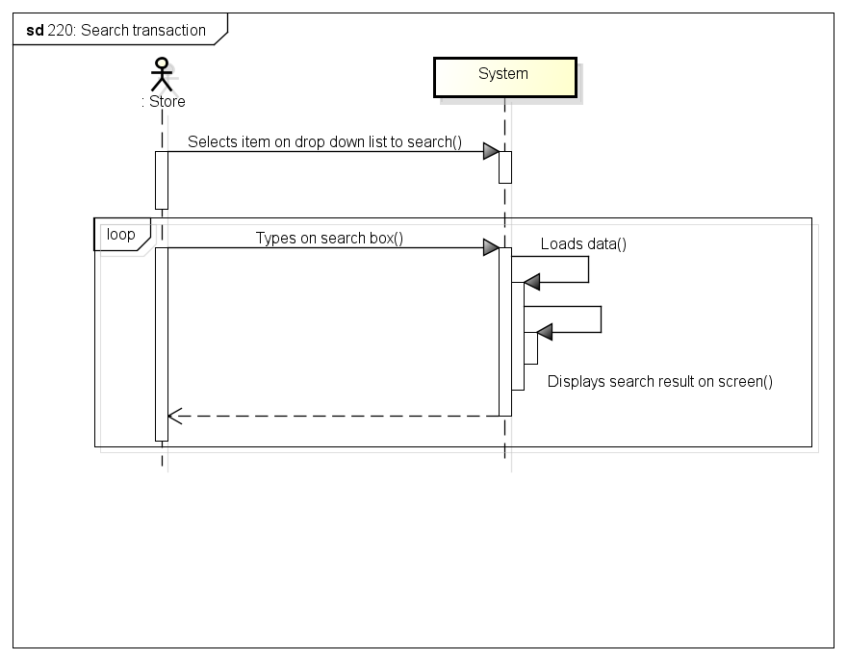

###### *UC-221:* *View notifications* (HoangLVQ)

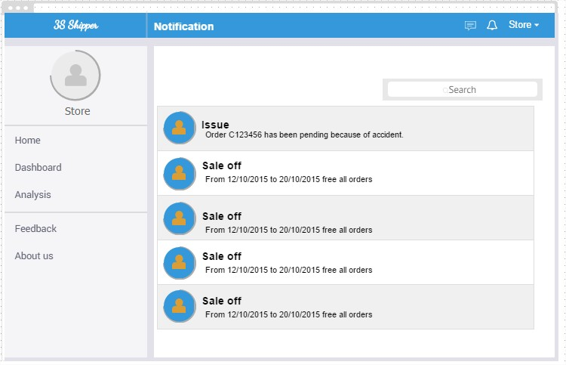

|  |  |  |  |  |
| --- | --- | --- | --- | --- |
| **Use Case ID:** | | UC-221 | | |
| **Use Case Name:** | | View notifications | | |
| **Created By:** | | HuyTDH | **Last Updated By:** | KhanhKC |
| **Date Created:** | | 19/09/2015 | **Date Last updated:** | 09/12/2015 |
| **Actor:** | | Store | | |
| **Description:** | | “View notification” screen displays notification about information, issue of orders and message form admin. | | |
| **Triggering event:** | | Store wants to view notification. | | |
| **Preconditions:** | | Store logged in, internet connection is on | | |
| **Post conditions:** | | All notifications will be listed out | | |
| **Priority:** | | Normal | | |
| **Frequency of Use:** | | Sometimes | | |
| **Main flow** | | | | |
| Step | Actor | Action | | |
|  | Store | Clicks on “Notification” icon | | |
|  | System | Loads data | | |
|  | System | Displays “Notifications” screen. | | |
| **Alternative:** | | N/A | | |
| **Exceptions:** | | N/A | | |
| **Includes:** | | N/A | | |
| **Special Requirements:** | | N/A | | |
| **Notes and Issues:** | | N/A | | |

***Sequence Diagram***

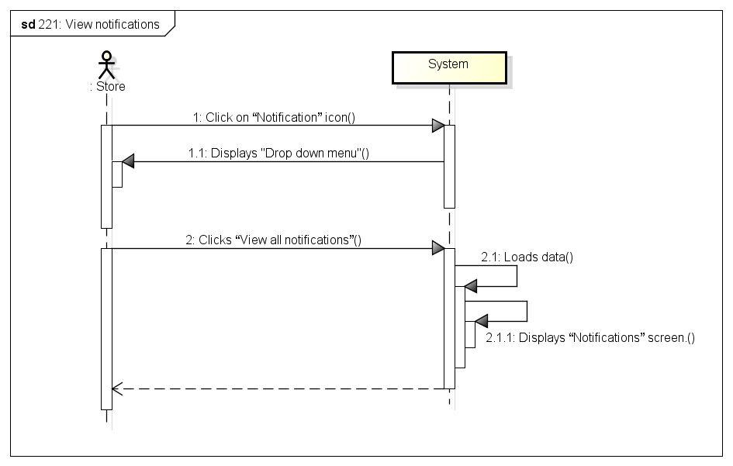

###### *UC-222:* *Rate shipper*

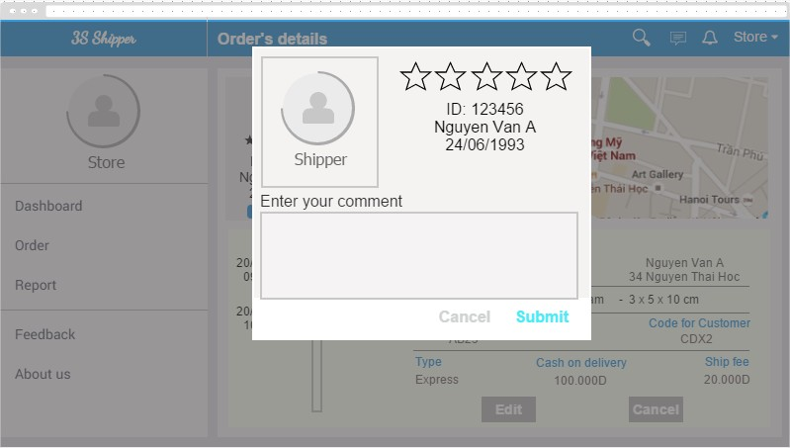

|  |  |  |  |  |
| --- | --- | --- | --- | --- |
| **Use Case ID:** | | UC-222 | | |
| **Use Case Name:** | | Rate shipper | | |
| **Created By:** | | HuyTDH | **Last Updated By:** | KhanHKC |
| **Date Created:** | | 19/09/2015 | **Date Last updated:** | 09/12/2015 |
| **Actor:** | | Store | | |
| **Description:** | | Store rates service quality of shipper for each order by chooses number of star and enters comment. | | |
| **Triggering event:** | | Store rates shipper. | | |
| **Preconditions:** | | Store logged in, there’s a shipper bears responsibility for shipping store’s order | | |
| **Post conditions:** | | Shipper rating send to system | | |
| **Priority:** | | Normal | | |
| **Frequency of Use:** | | Often | | |
| **Main flow** | | | | |
| Step | Actor | Action | | |
|  | Store | Goes to “Order List” | | |
|  | Store | Clicks on “Rate” button | | |
|  | System | Displays “Shipper Rating” pop-up | | |
|  | Store | Selects rate score (1-5 stars) | | |
|  | Store | Enters some content | | |
|  | Store | Clicks on “Send” button | | |
|  | System | Save data to database | | |
|  | System | Displays message “Thanks for your rating!” | | |
| **Alternative Flows:** | | | | |
| **Exceptions:** | | | | |
| EC1 | At step 9, Store Clicks “Cancel” button | | | |
| Step | Actor | Action | | |
| 4.1 | Store | Store Clicks “Cancel” button | | |
| 4.2 | System | Close popup. | | |
| **Includes:** | | N/A | | |
| **Special Requirements:** | | N/A | | |
| **Notes and Issues:** | | N/A | | |

***Sequence Diagram***

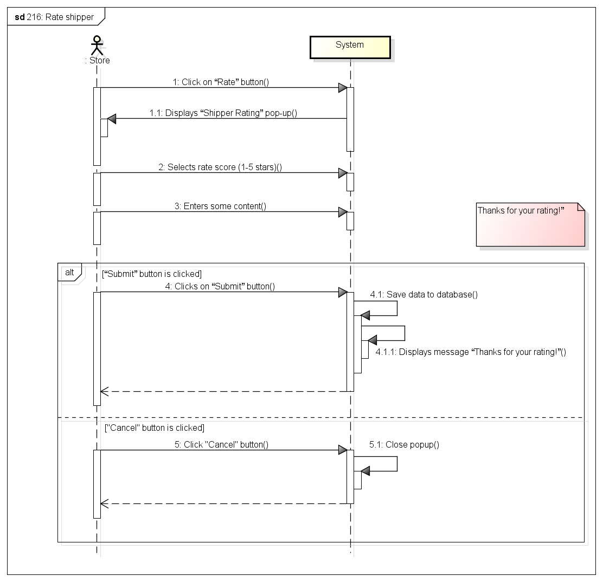

###### *UC-223:* *Send feedback*

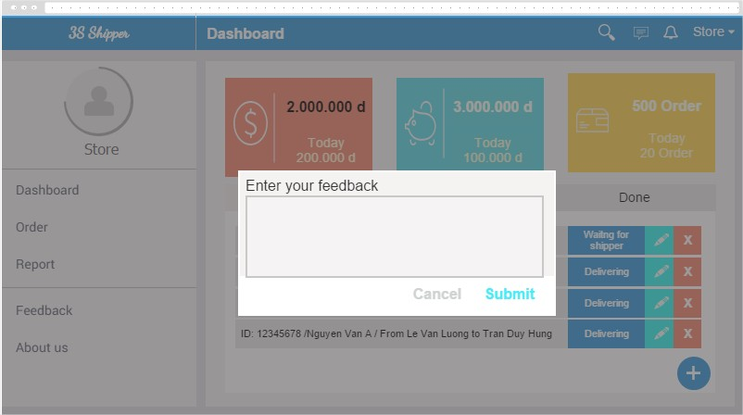

|  |  |  |  |  |
| --- | --- | --- | --- | --- |
| **Use Case ID:** | | UC-223 | | |
| **Use Case Name:** | | Send feedback | | |
| **Created By:** | | HuyTDH | **Last Updated By:** | KhanhKC |
| **sss** | | 19/09/2015 | **Date Last updated:** | 09/12/2015 |
| **Actor:** | | Store | | |
| **Description:** | | Store send feedback about any service of system by enters some content. | | |
| **Triggering event:** | | Store send feedback about service to system | | |
| **Preconditions:** | | Store logged in  Internet connection is on | | |
| **Post conditions:** | | Feedback will be sent to system | | |
| **Priority:** | | Normal | | |
| **Frequency of Use:** | | Sometimes | | |
| **Main flow** | | | | |
| Step | Actor | Action | | |
|  | Store | Clicks on “Send feedback” on navigation bar | | |
|  | System | Displays “Send feedback” pop-up | | |
|  | Store | Enters some content | | |
|  | Store | Clicks on “Submit” | | |
|  | System | Validate content | | |
|  | System | Shows message “Thanks for your feedback!” | | |
| **Alternative Flows:** | | N/A | | |
| **Exceptions:** | | | | |
| EC1 | At step Store doesn’t enter content | | | |
| Step | Actor | Action | | |
| 4.1 | Store | Store Clicks “Submit” | | |
| 4.2 | System | System shows message “Please enter content of feedback!” | | |
| **Includes:** | | N/A | | |
| **Special Requirements:** | | N/A | | |
| **Notes and Issues:** | | N/A | | |

***Sequence Diagram***

