|  |  |
| --- | --- |
|  | **MINISTRY OF EDUCATION AND TRAINING** |

## 3.2. Interface Design

### 3.2.1. Screen flow

*Figure 124: Screen flow of Client Web for Store*

### 3.2.2. Screen Description

#### 3.2.2.1. Login screen

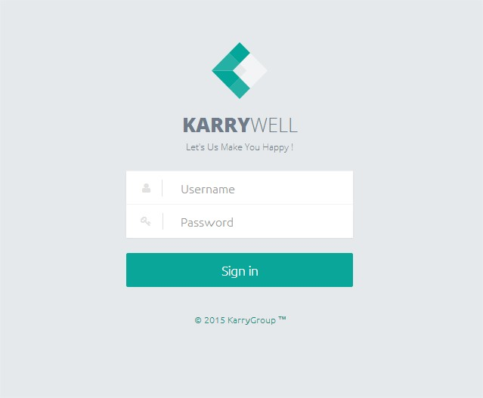This popup is use to edit info of goods in tables of goods on “Create order screen” and “Edit order screen”

|  |  |  |  |
| --- | --- | --- | --- |
| **No** | **Element** | **Type** | **Description** |
| **1** | Logo | Logo | Logo of KarryWell |
| Slogan | Label | Slogan of KarryWell |
| **2** | Username | Text field | Where store input “Username” for login to system |
| **3** | Password | Text field | Where store input “Password” for login to system |
| **4** | Sign in button | Button | After store click on this button if username and password is correct system will log store into system |

#### 3.2.2.2. Dashboard Screen

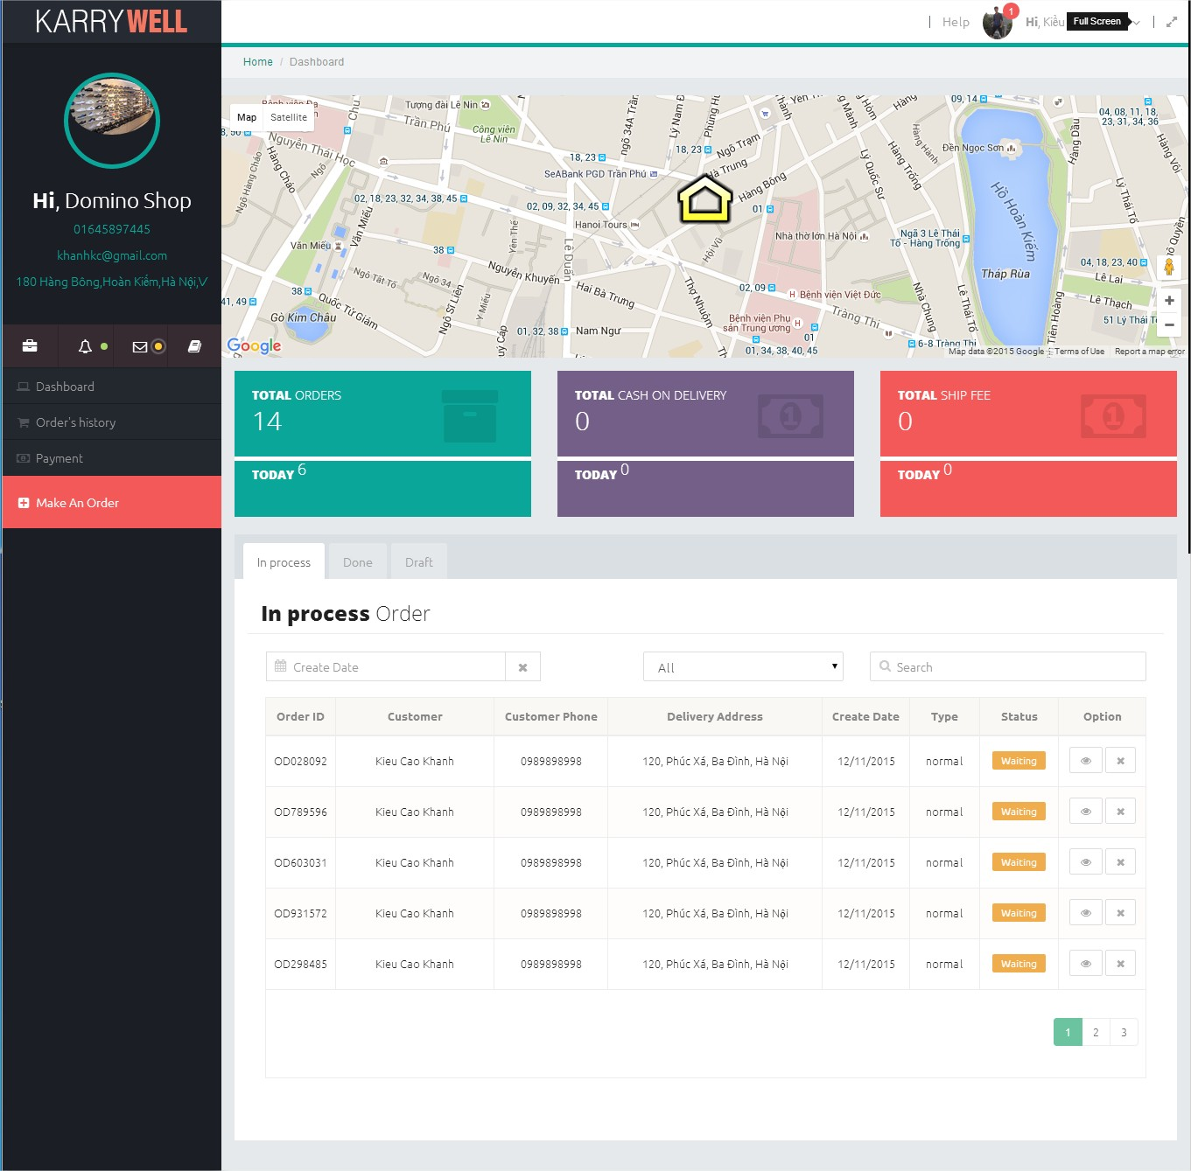This screen displays the overview of current activity of the store.

|  |  |  |  |  |
| --- | --- | --- | --- | --- |
| **No** | **Component** | **Element** | **Type** | **Description** |
| **1** | **Menu** | Logo | Logo | KarryWell logo. |
| Avatar | Image | Avatar of Store |
| Store info | Label group | Info of Store include:  - Name  - Phone number  - Email  - Address |
| Menu item | Hyperlink list | List of the link to direct to other screen ( Create Order , Order’s history ,Transaction’s history , Profile) |
| **2** | **Header** | Manager avatar | Image | Avatar of store manager |
| Notification number | Label | Display number of notification and include a hyperlink to direct to notification screen |
| Store manager’s name | Label | Name of Store manager |
| Full screen button | Button | Enable full screen for page |
| **3** | **Drop down menu** | Profile item | Menu item | Direct to “Profile” screen |
| Signout item | Menu item | Log store out from system. |
| **4** | **Maps** | Maps | Google maps item | Displays location of Shipper who are working delivery for store and location of Customers of store. |
| **5** | **Total order box** | Total order box | Box item | Displays quantity of orders on today and orders that didn’t have finance transaction |
| **6** | **Total COD box** | Total COD box | Box item | Display total cash on delivery of orders on today and orders that didn’t have finance transaction |
| **7** | **Total ship fee box** | Total ship fee box | Box item | Display total delivery fee of orders on today and orders that didn’t have finance transaction |
| **8** | **Orders Tab** | In process tab | Tabs bar | Display table of running orders |
| Done tab | Tabs bar | Display table of done orders that didn’t have finance transaction. |
| Draft tab | Tabs bar | Draft: Display table of express orders that are not yet grab by any shipper |
| **9** | **Table order** | Date range filter | Date piker | Store can use this date piker to show transaction in a period of time  - Filter drop down list  - Search box  - Date picker  - List order. |
| Drop down list filter | Drop down list | Search result will depend on item store chose from this drop down list |
| Search box | Text field | Store type on this text field to search. |
| Table | table | Display list of order and search result |

#### 3.2.2.3. Order history screen

Display all order that created by store.

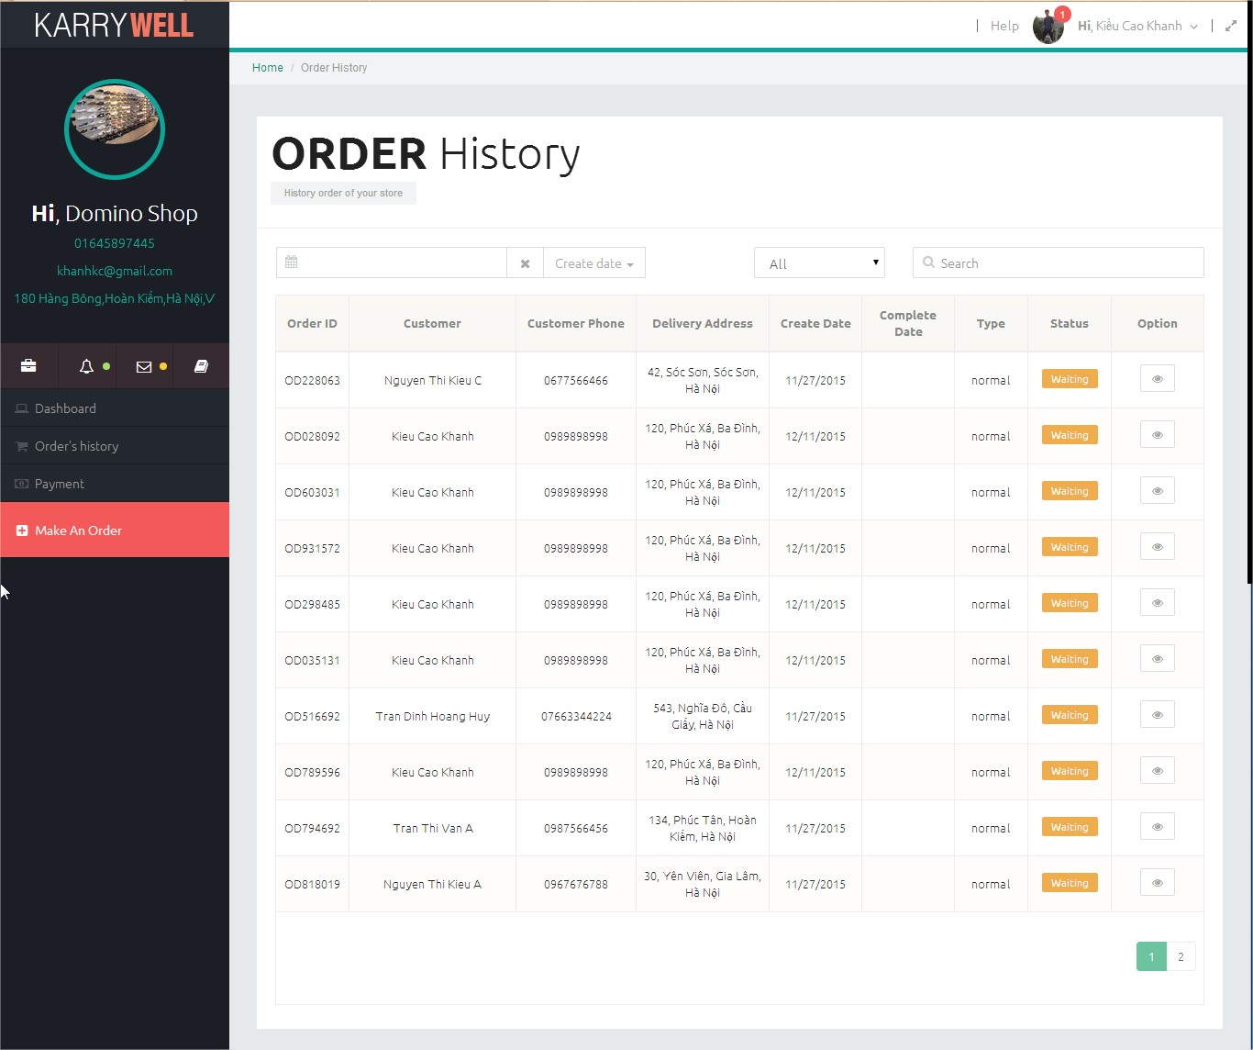

|  |  |  |  |  |
| --- | --- | --- | --- | --- |
| **No** | **Component** | **Element** | **Type** | **Description** |
| **1** | **Menu** | As “Menu” element on Dashboard screen. | | |
| **2** | **Header** | As “Header” element on Dashboard screen. | | |
| **3** | **Drop down menu** | As “Drop down menu” element on Dashboard Screen. | | |
| **8** | **Title** | Title | Label | “Order History” |
| **9** | **Table order** |  | Table | Include:  - Filter drop down list  - Search box  - Date picker  - List order. |
|  |  |  |
|  |  |  |

#### 3.2.2.4. Create order screen

Store use this screen to create a new order and request delivery service form system.

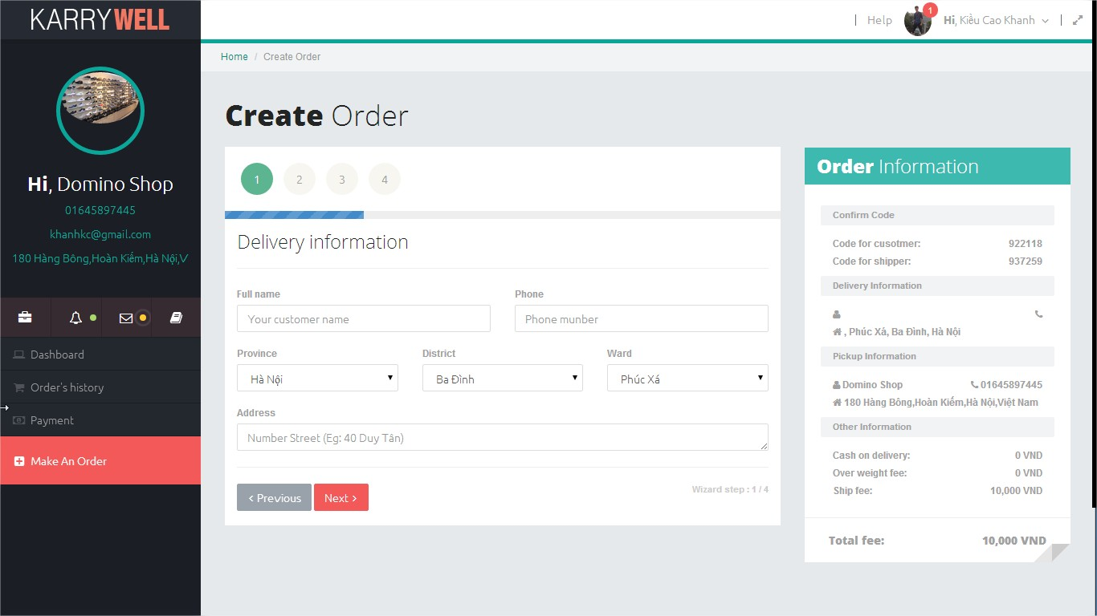

|  |  |  |  |  |
| --- | --- | --- | --- | --- |
| **No** | **Component** | **Element** | **Type** | **Description** |
| **1** | **Menu** | As “Menu” element on Dashboard screen. | | |
| **2** | **Header** | As “Header” element on Dashboard screen. | | |
| **3** | **Drop down menu** | As “Drop down menu” element on Dashboard Screen. | | |
| **4** | **Title** | Title Label | Label | “Create Order” |
| **5** | **Wizard form(Step 1)** | Full name | Textbox | Full name of customer |
| Phone | Textbox | Phone of customer |
| Province | Drop down list | List province of Vietnam |
| District | Drop down list | List districts of Vietnam |
| Ward | Drop down list | List ward of Vietnam |
| Address | Textbox | Address of customer. |
| Next button | Button | Go to step 2 of wizard form |
| Previous button | Button | Disabled |
| **6** | **Wizard form (Step 2)** | Table of goods | Table | Abc |
| Add goods | Button | After click on this button, “Add goods” popup will be displayed. |
| Delivery type | Radio button group | Include 2 radio button: Express, Normal |
| Cash on delivery | Text field | Where store input cash on delivery of order. |
| Next | Button | Go to “Step 3” of wizard form |
| Previous | Button | Go to “Step 1” of wizard form |
| **7** | **Wizard form (Step 3)** | Store | Drop down list | List all name ( abc nen dung store hay |
| Phone | Text field | Display phone number of store (View only) |
| Address | Text field | Display address of store (View only) |
| Previous | Button | Go to “Step 2” of wizard form |
| Submit | Submit button | After click this button information of order will be save to database or active “Find shipper” function if delivery type is express. |
| **8** | **Order Information area** | Header | Header | Content: “Order Information” |
| “Confirm Code area” | Label group | Include: authentication code with shippers and last customer |
| “Delivery Information” area | Label group | Include information of last customer that store entered in wizard form.(Full name, Phone, Address) |
| “Pickup information” area | Label group | Include information of store (where shipper will go to pickup goods): Name, phone, address. |
| “COD/Fee information” area | Label group | Include information about cash on delivery, ship fee, over weight fee and total fee |

#### 3.2.2.5. Profile screen

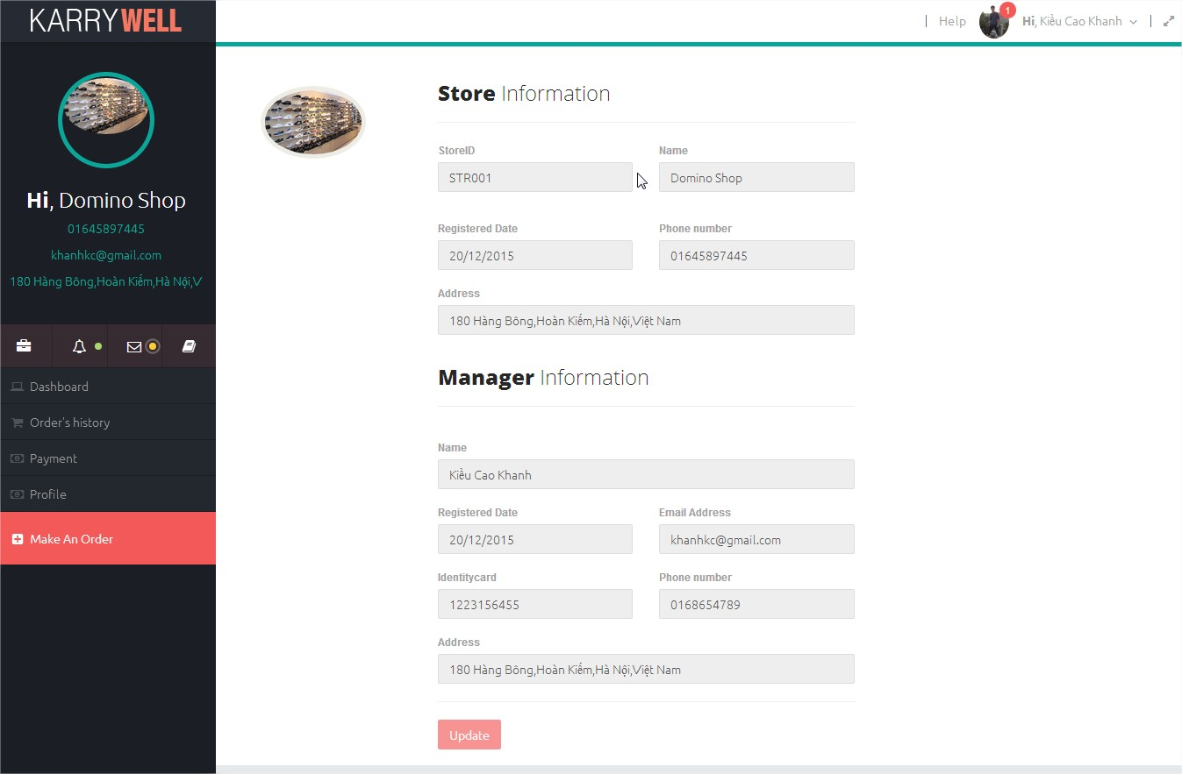Display detail information of store and store manager

|  |  |  |  |  |
| --- | --- | --- | --- | --- |
| **No** | **Area** | **Element** | **Type** | **Description** |
| **1** | **Menu** | As “Menu” element on Dashboard screen. | | |
| **2** | **Header** | As “Header” element on Dashboard screen. | | |
| **3** | **Drop down menu** | As “Drop down menu” element on Dashboard Screen. | | |
| **4** | **Avatar** | Avatar | Image | Avatar of store |
| Choose picture | Button | Active change avatar function |
| **5** | **Store Information** | Header | Label | Content: Store information |
| StoreID | Text field | ID of store |
| Name | Text field | Name of store |
| Registered Date | Text field | Registered Date of store |
| Phone number | Text field | Phone number of store |
| Address | Text field | Address of store |
| **6** | **Manager information** | Header | Label | Content: Manager information |
| Name | Text field | Name of store manager |
| Email address | Text field | Email of store |
| Identity card | Text field | Registered Date of store |
| Phone number | Text field | Phone number of Manager |

#### 3.2.2.6. Order detail screen

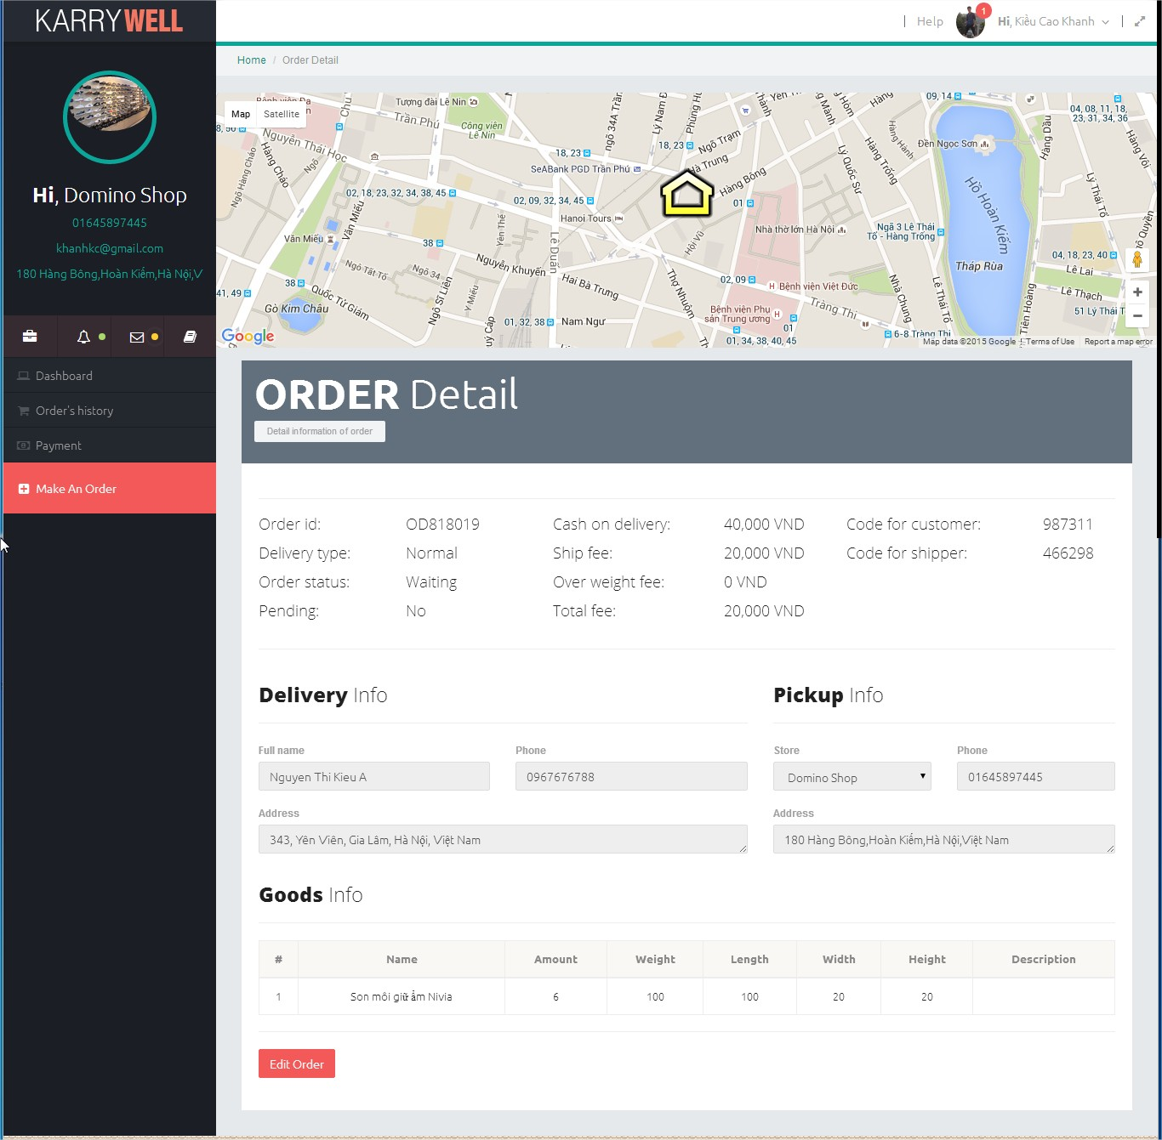Display detail information of an order

|  |  |  |  |  |
| --- | --- | --- | --- | --- |
| **No** | **Component** | **Element** | **Type** | **Description** |
| **1** | **Menu** | As “Menu” element on Dashboard screen. | | |
| **2** | **Header** | As “Header” element on Dashboard screen. | | |
| **3** | **Drop down menu** | As “Drop down menu” element on Dashboard Screen. | | |
| **4** | **Title** | Title | Label | Content: “Order Detail” |
| **5** | **Over view** | Order id | Label | Id of order |
| Delivery type | Label | Delivery type of order |
| Order status | Label | Status of order in moment |
| Pending | Label | Yes/No |
| Cash on delivery | Label | Cash on delivery of order |
| Ship fee | Label | Amount of money store has to pay for delivery service |
| Over weight | Label | Amount of money store has to pay for order heavier than 30000gam |
| Total fee | Label | Sum of Ship fee and Overweight fee |
| Code for customer | Label | Code for authenticate end customer |
| Code for shipper | Label | Code for authenticate Shipper |
| **6** | **Delivery Info** | Title | Label | Content: Delivery Info |
| Full name | Text field | Full name of end customer |
| Phone | Text field | Phone number of end customer |
| Address | Text field | Address of end customer |
| **7** | **Pickup Info** | Title | Label | Content: Pickup info |
| Store | Text field | Name of store where shipper go to pickup goods |
| Phone | Text field | Phone number of store |
| Address | Text field | Address of store |
|  |  |  |
| **8** | **Goods Info** | Title | Label | Content: Goods Info |
| Table of goods | Label | List all goods of order with below info (Name, amount, weight, length, weight, height, description) |
| **9** | **Footer** | Edit Order | Button | Enable Text fields and Table of goods for edit. This button will be enable if status of order is W=”Waiting” or order is a draft order. |

#### 3.2.2.7. Edit order screen

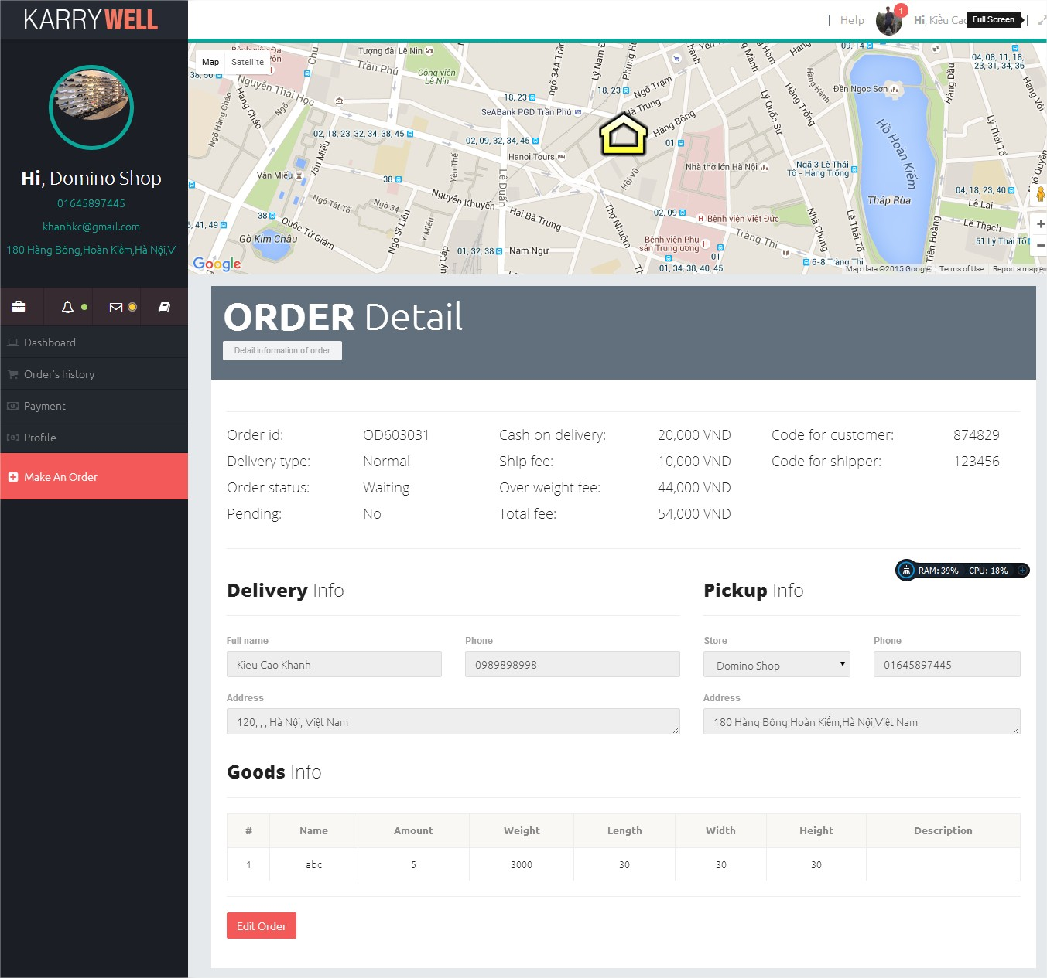This screen helps store edit information of order.

|  |  |  |  |  |
| --- | --- | --- | --- | --- |
| **No** | **Component** | **Element** | **Type** | **Description** |
| **1** | **Menu** | As “Menu” element on Dashboard screen. | | |
| **2** | **Header** | As “Header” element on Dashboard screen. | | |
| **3** | **Maps** | As “Maps” element on Dashbard screen but it only display location of shipper and end customer for this order. | | |
| **4** | **Drop down menu** | As “Drop down menu” element on Dashboard Screen. | | |
| **5** | **Title** | Title | Label | Content: “Order Detail” |
| **6** | **Over view** | As “Over view” area on “Order detail screen” | | |
| **7** | **Delivery Info** | Title | Label | Content: Delivery Info |
| Full name | Text field | Full name of end customer |
| Phone | Text field | Phone number of end customer |
| Province | Drop down list | Store click on to select province of end customer |
| District | Drop down list | Store click on to select district of end customer |
| Ward | Drop down list | Store click on to select ward of end customer |
| Address | Text field | Address of end customer |
| Full address | Text field(disable) | Display full address of end customer |
| **8** | **Pickup Info** | Title | Label | Content: Pickup info |
| Store | Text field | Name of store where shipper go to pickup goods |
| Phone | Text field | Phone number of store |
| Address | Text field | Address of store |
| Cash on delivery | Text field | Cash on delivery of order |
| **9** | **Goods Info** | Title | Label | Content: Goods Info |
| Table of goods | Label | List all goods of order with below info (Name, amount, weight, length, weight, height, description, edit and delete button) |
| Add goods button | Button | Store click on this button to show add goods popup |
| **10** | **Footer** | Update Order | Button | After click on this button information of order will be saved to database |
| Cancel | Button | Discard any change an display previous info of order |

#### 3.2.2.8. Transaction history screen

Display finance transaction history between store and KarryWell.

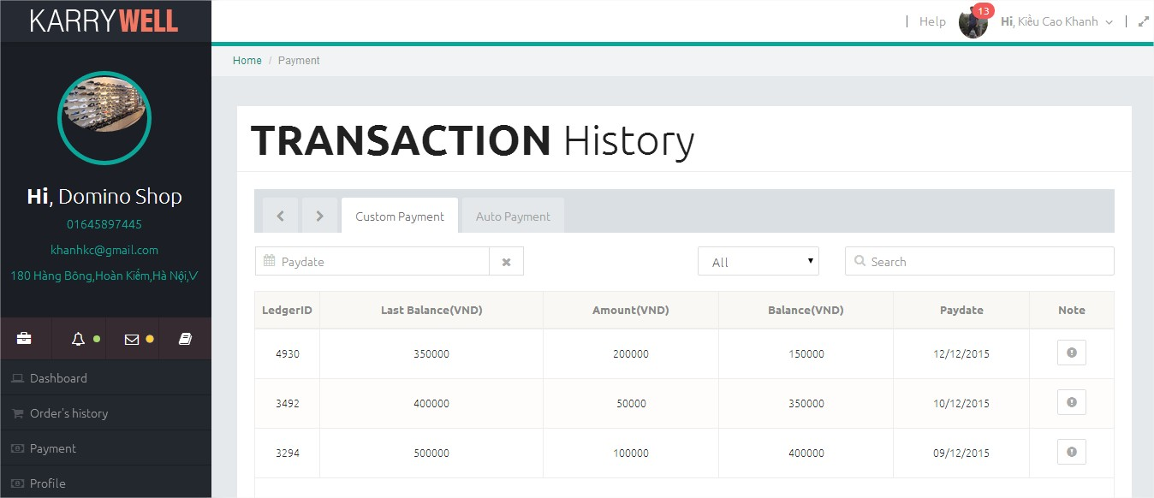

|  |  |  |  |  |
| --- | --- | --- | --- | --- |
| **No** | **Component** | **Element** | **Type** | **Description** |
|  |  | As “Menu” element on Dashboard screen. | | |
| **1** | **Menu** | As “Header” element on Dashboard screen. | | |
| **2** | **Header** | As “Drop down menu” element on Dashboard Screen. | | |
| **3** | **Drop down menu** | As “Menu” element on Dashboard screen. | | |
| **8** | **Transaction Tab** | Click | Tabs bar | There are 3 tabs:  - In process: Display table of running orders  - Done: Display table of done orders that didn’t have finance transaction.  - Draft: Display table of express orders that are not yet grab by any shipper |
| **9** | **Table order** |  | Table | Include:  - Filter drop down list  - Search box  - Date picker  - List order. |
|  |  |  |  |  |
|  |  |  |  |  |
|  |  |  |  |  |

#### 3.2.2.9. Add goods popup

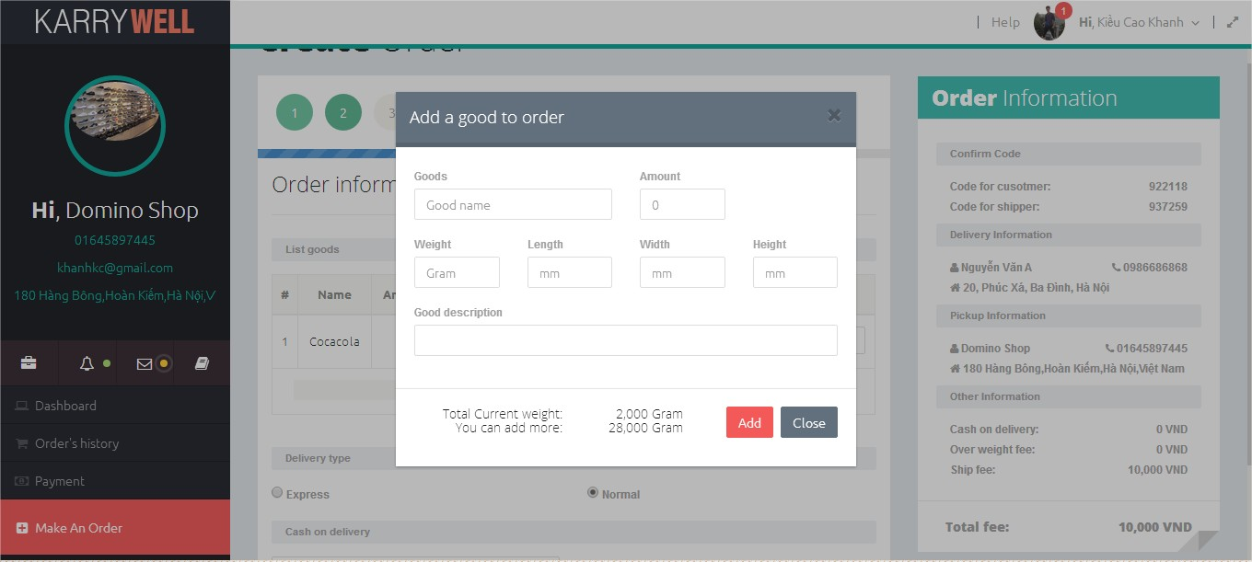This popup is use to add goods to tables of goods on “Create order screen” and “Edit order screen”

|  |  |  |  |  |
| --- | --- | --- | --- | --- |
| **No** | **Area** | **Element** | **Type** | **Description** |
| **1** | **Popup header** | Title | Label | “Add a goods to orders |
| “X” button | Button | Close popup |
| **2** | **Popup body** | Goods | Text field | Store enters name of goods |
| Weight | Text field | Store enters weight of goods |
| Amount | Text field | Store enters amount of goods |
| Length | Text field | Store enters length size of goods |
| Width | Text field | Store enters width size of goods |
| Height | Text field | Store enters height size of goods |
| Goods description | Text field | Store enters description of goods |
| **3** | **Popup footer** | Total current weight | Label | Display total weight of goods on order |
| You can add more | Label | Display total weight that store can add to order |
| Add button | Button | Save info of goods to table of goods |
| Close button | Button | Close popup |

#### 3.2.2.10. Edit goods popup

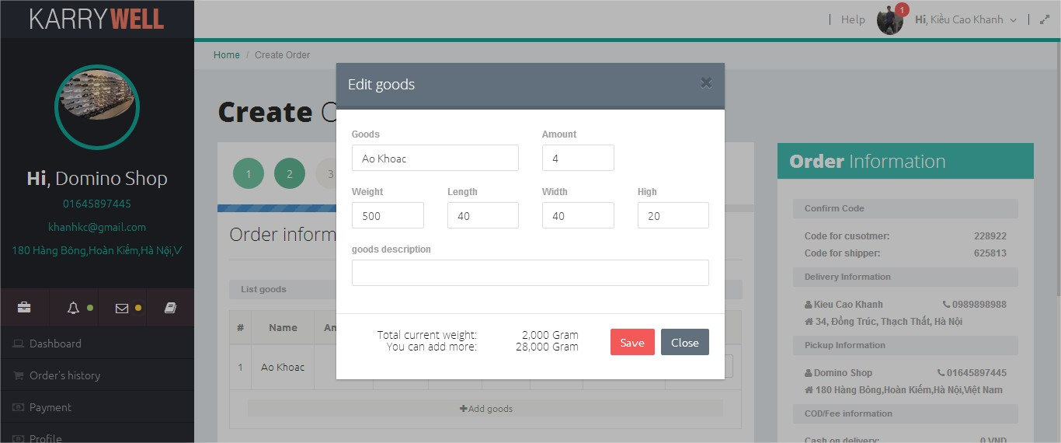This popup is use to edit info of goods in tables of goods on “Create order screen” and “Edit order screen”

|  |  |  |  |  |
| --- | --- | --- | --- | --- |
| **No** | **Area** | **Element** | **Type** | **Description** |
| **1** | **Popup header** | Title | Label | “Edit goods” |
| “X” button | Button | Close popup |
| **2** | **Popup body** | Goods | Text field | Store enters name of goods |
| Weight | Text field | Store enters weight of goods |
| Amount | Text field | Store enters amount of goods |
| Length | Text field | Store enters length size of goods |
| Width | Text field | Store enters width size of goods |
| Height | Text field | Store enters height size of goods |
| Goods description | Text field | Store enters description of goods |
| **3** | **Popup footer** | Total current weight | Label | Display total weight of goods on order |
| You can add more | Label | Display total weight that store can add to order |
| Save button | Button | Save info of goods to table of goods |
| Close button | Button | Close popup |

#### 3.2.2.11. Admin report screen

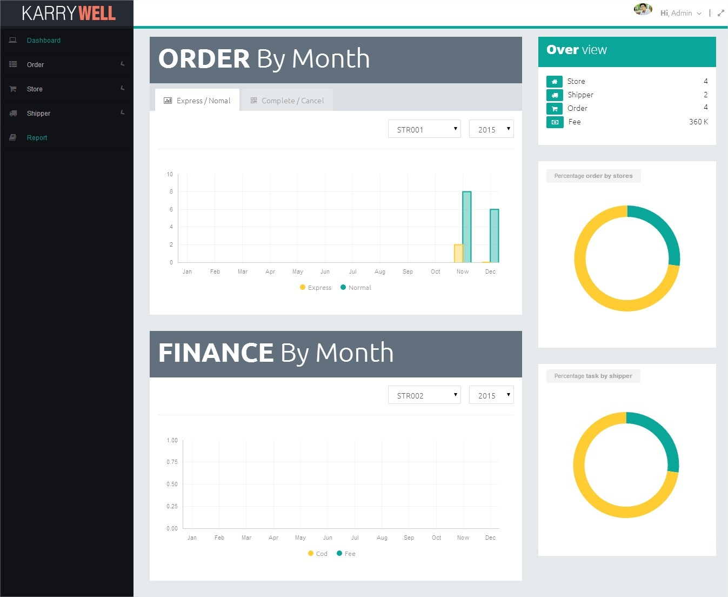This popup is use to edit info of goods in tables of goods on “Create order screen” and “Edit order screen”

|  |  |  |  |  |
| --- | --- | --- | --- | --- |
| **No** | **Component** | **Element** | **Type** | **Description** |
| **1** | **Menu** |  | | |
| **2** | **Header** |  | | |
| **3** | **Drop down menu** |  | | |
| **4** | **Over View** | Title | Label | “Over View” |
| Store | Label | Total number of store in system |
| Shipper | Label | Total number shipper in system |
| Order | Label | Total order made by stores |
| Fee | Label | Total delivery fee of system |
| **5** | **Order by month** | Title | Label | “Order By Month” |
| Report tab bar | Tab bar | Include 2 tabs:  - Express/Normal: Display bar chart of express and normal order by month.  - Complete/Cancel: Display bar chart of complete and cancel order by month. |
| Store Filter | Drop down list | Admin can use filter to view chart of each store |
| Year Filter | Drop down list | Admin can use filter to view chart of each store |
| Chart | Chart | Display chart for Express/Normal tab or Complete/Cancel tab |
| **6** | **Finance by month** | Title | Label | “Finance by month” |
| Store Filter | Drop down list | Admin can use filter to view chart of each store |
| Year Filter | Drop down list | Admin can use filter to view chart of each store |
| Chart | Chart | Display bar chart of cash on delivery and delivery fee by month. |
| **7** | **Order Pei Chart** | Title | Label | Percentage order by stores |
| Chart | Pei Chart | Display percentage order of top 10 stores in system |
| **8** | **Footer** | Title | Label | Percentage task by stores |
| Chart | Pei Chart | Display percentage task of top 10 shipper in system |

## 3.2. USER MANUAL

### 3.2.1. Login to system

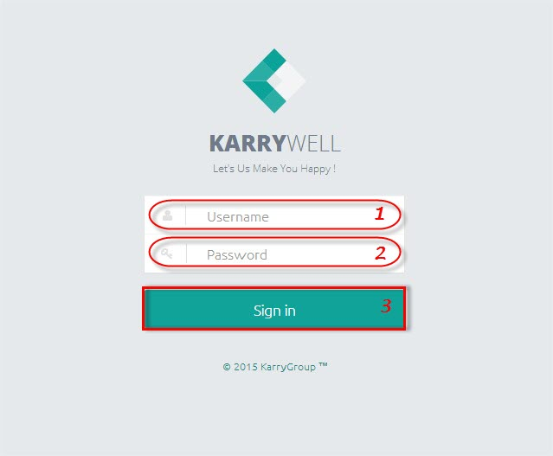

**To login to KarryWell system:**

**Step 1**. Type your “Username” on username text box (“1”)

**Step 2**. Type your “Password” on password text box (“2”)

**Step 3**. Click on “Sign in” button (“3”)

### 3.2.2. Open a screen

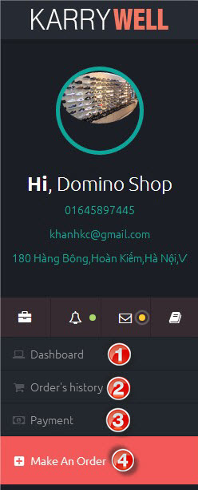**To open a page:**

On right menu, have a list names of screen. You can click on those name to open a screen.

- ➊ : Open Dashboard screen.

- ➋ : Open Order’s history screen.

- ➌ : Open Transaction history screen.

- ➍ : Open Create order screen.

### 3.2.3. View Profile

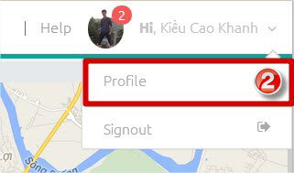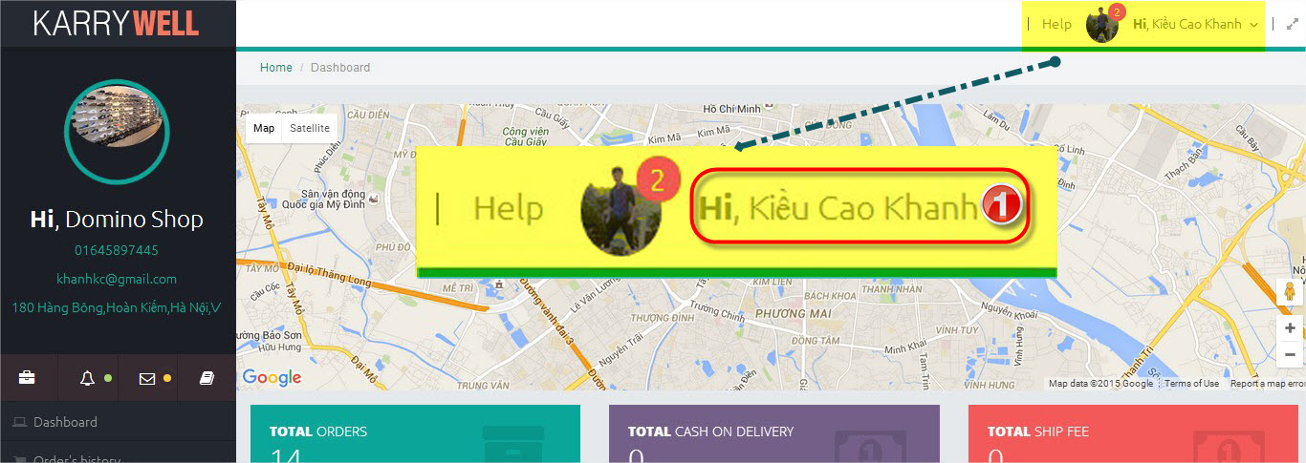

You can access to profile screen from any screen.

**To view profile screen:**

**Step 1**. Click on your name on header (➊). A menu will appear.

**Step 2**. Click on “Profile” item on menu (➋).

### 3.2.4. Create an order

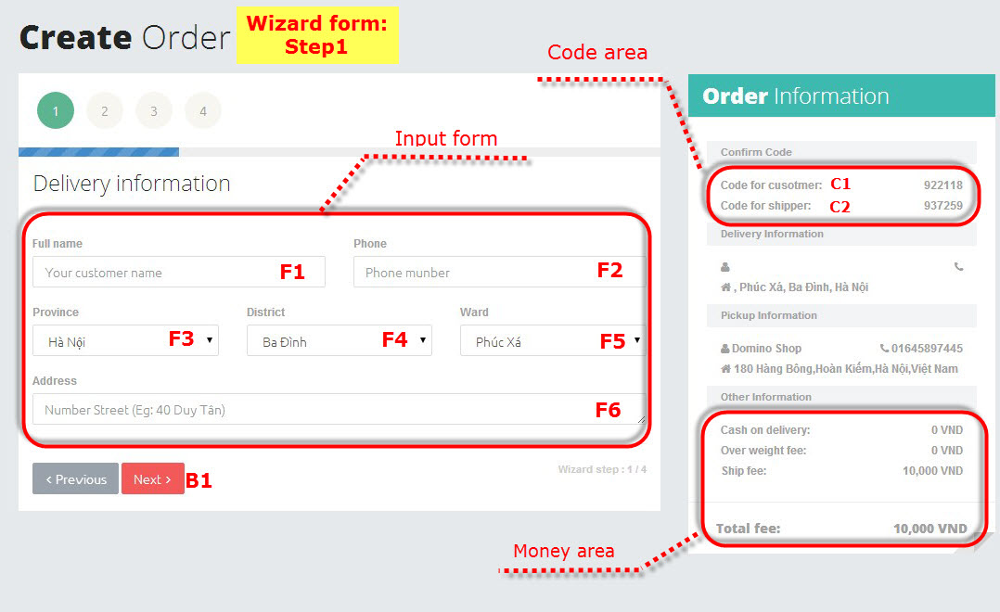

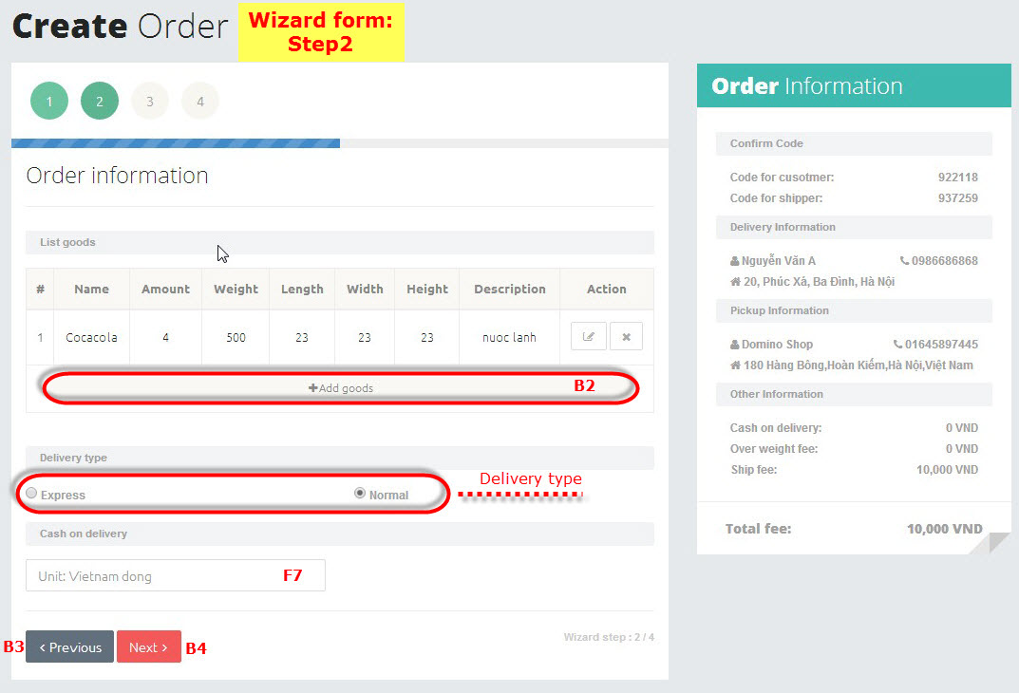

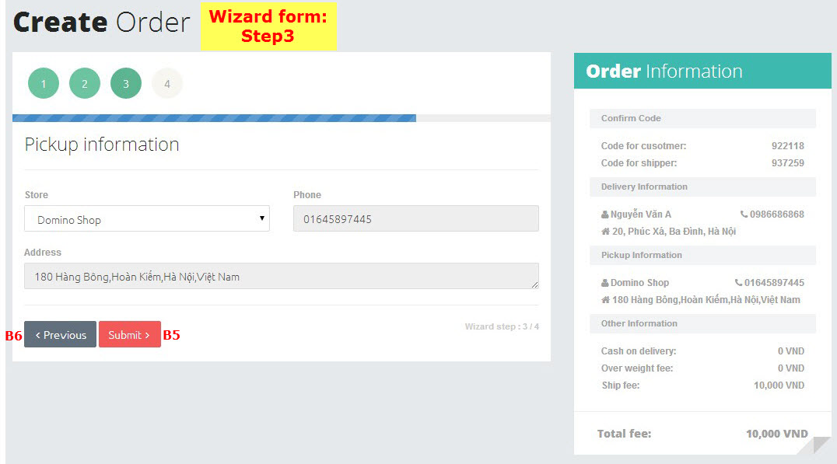

- There is one wizard form on “Create order” screen. You just need to follow on below steps to create an order.

**To create an order:**

**At “Wizard form: Step1”**

**Step 1**. Open “Create order” screen (see 3.2.2: Open a screen).

**Step 2**. Input data on “Input form”

- 1. Type the full name of your customer on (F1).

- 2. Type the phone number of your customer on (F2).

- 3. Click on (F3) to select province of your customer.

- 3. Click on (F4) to select district of your customer.

- 4. Click on (F5) to select ward of your customer.

- 5. Type the address of your customer on (F6).

**Step 3**. Click on “Next” button (B1) to go to “**Wizard form: Step 2**”.

**At “Wizard form: Step2”**

**Step 4**. Click button “Add goods” (B2) to add a goods to order (see 3.2.5: Add a goods).

You can edit and delete goods on table of goods (see 3.2.6: Edit a goods and 3.2.7: Delete a goods)

**Step 5**. Select delivery type on “Delivery type” area.

- Express: System will find a shipper for you and that shipper will come to pick up your goods immediately.

- Normal: Shipper will come to pick up your goods in tomorrow.

**Step 6**. Type amount of cash on delivery on “Cash on delivery” text box (F7)

**Step 7.** Click “Next” button (B4) to go to “Wizard form: Step 3”. If you want to go to “Wizard form: step 1” click on “Precious” button (B3).

**At “Wizard form: Step 3”** (This screen display information of your store)

**Step 8:** Click on “Submit” button (B5) to submit your order.

- If at “**Step 5**” you chose “Normal”, you are create an order successfully, go to “Dashboard” screen to view you order.

- If at “**Step 5**” you chose “Express” system will find a shipper for you. (see 3.2.13.Find a shipper

### 3.2.5. Add a goods

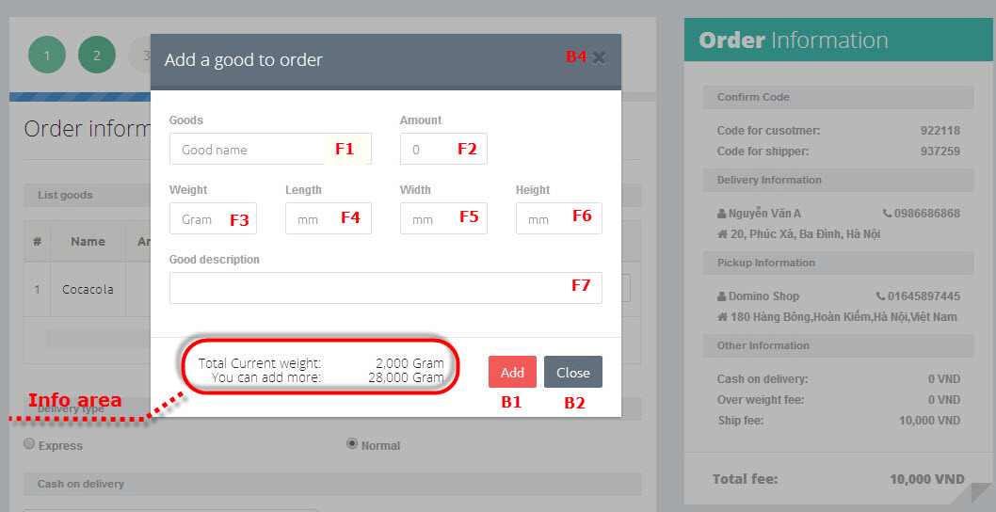

You can add a goods to order form “Create an order” screen (see 3.2.4. Create an order) and “Edit an order” screen (see 3.2.11. Edit an order)

**To add a goods to order**

**Step 1. Type information of goods**

- 1. Type name of goods on “Goods name” text box (F1).

- 2. Type amount of goods on “Amount” text box (F2).

- 3. Type weight of goods on “Weight” text box (F3).

- 4. Type length size of goods on “Length” text box (F4).

- 5. Type width size of goods on “Width” text box (F5).

- 6. Type height size of goods on “Height” text box (F6).

- 7. Type description of goods on “Description” text box (F7)

**Step 2.** Clicks on “Add” button (B1) to add goods to order. If you don’t want to add goods click on “Close” button (B2) or “X” button (B4)

**\* Note**: On Info area there are 2 line

- Total current weight: total weight of all goods in order.

- You can add more: total weigh you can add to order.

### 3.2.6. Edit a goods

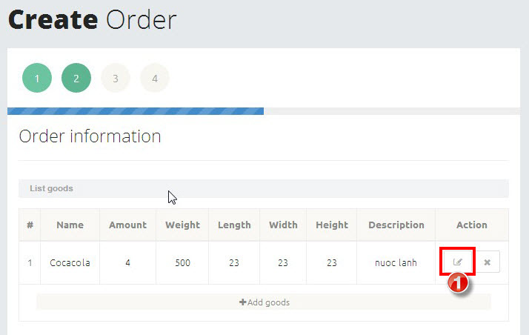

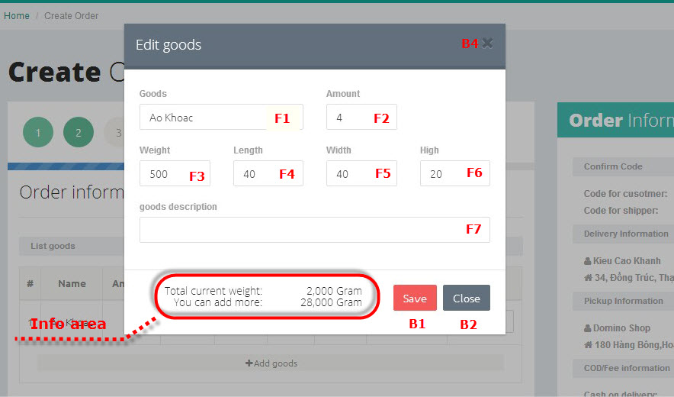

You can edit a goods on “Create an order” screen (see 3.2.4. Create an order) and “Edit an order” screen (see 3.2.11. Edit an order)

**To edit a goods**

**Step 1.** Click on pen icon (➊).

**Step 2.** Editinformation of goods.

- 1. Edit name of goods on “Goods name” text box (F1).

- 2. Edit amount of goods on “Amount” text box (F2).

- 3. Edit weight of goods on “Weight” text box (F3).

- 4. Edit length size of goods on “Length” text box (F4).

- 5. Edit width size of goods on “Width” text box (F5).

- 6. Edit height size of goods on “Height” text box (F6).

- 7. Edit description of goods on “Description” text box (F7)

**Step 3.** Clicks on “Save” button (B1) to save information of goods. If you don’t want to save the change click on “Close” button (B2) or “X” button (B4)

**\* Note:** On Info area there are 2 line

- Total current weight: total weight of all goods in order.

- You can add more: total weigh you can add to order.

### 3.2.7. Delete a goods

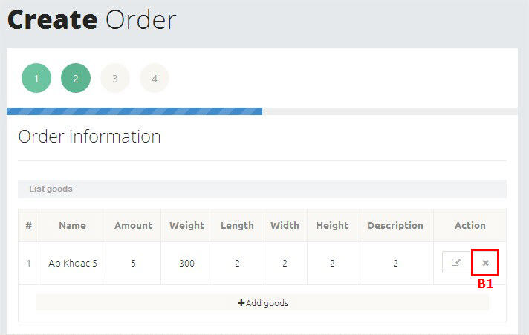

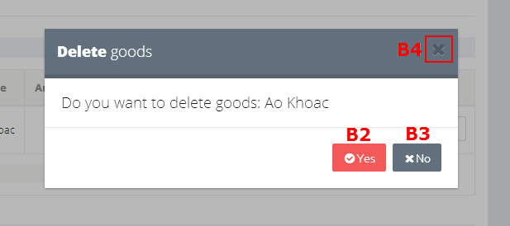

You can delete a goods from “Create an order” screen (see 3.2.4. Create an order) and “Edit an order” screen (see 3.2.11. Edit an order)

**To delete a goods**

**Step 1.** Click on “X” button (B1). A confirm popup will appear.

**Step 2.** Click on “Yes” button to delete goods. If you don’t want to delete that goods any more click on “No” button (B3) or “X” button (B4) to close confirm popup.

### 3.2.8. Delete an order

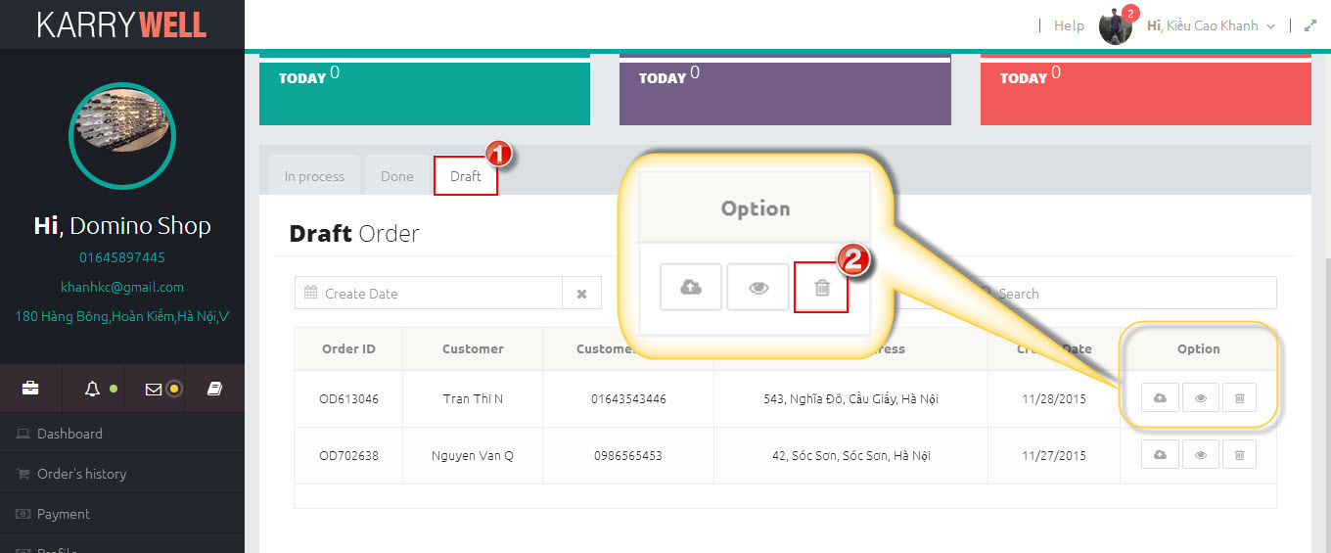

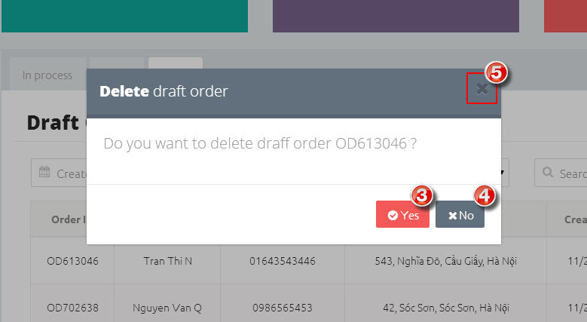

**\* Note:** You can only delete orders that have not been grabbed yet by any shipper (Draft order)

**To delete an order**

**Step 1.** Click on “Draft” tab (➊) on “Dashboard” screen to open table of draft orders.

**Step 2.** Click on trash icon (➋). A popup will appear.

**Step 3.** Click on “Yes” button (➌) to confirm delete order. If you don’t want to delete that order any more, click on “No” button (➍) or “X” button (➎) to close popup.

### 3.2.9. Cancel an order

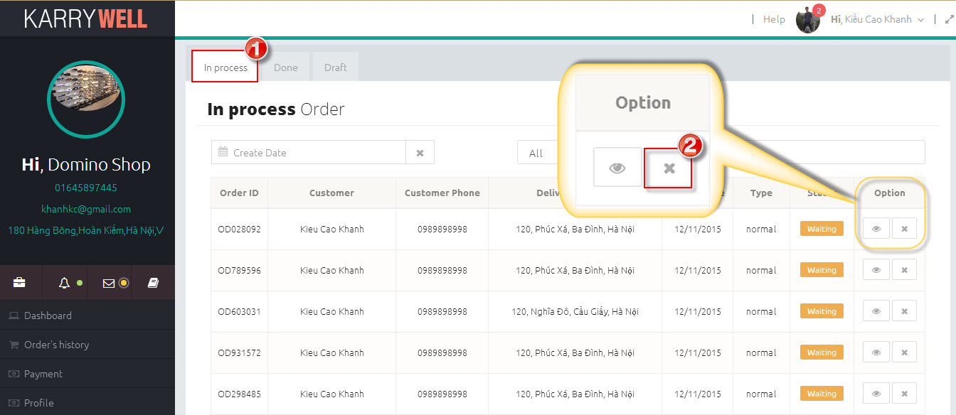

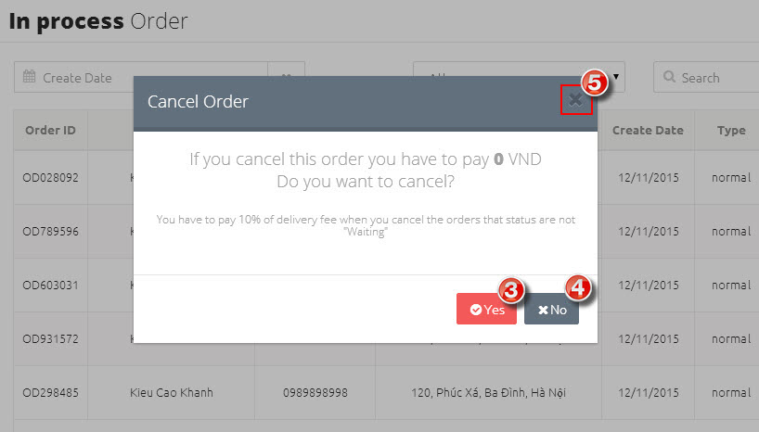

**\* Note:** You can only cancel an orders that have not been completed.

**To cancel an order**

**Step 1.** Click on “In process” tab (➊) on “Dashboard” screen to open table of draft orders.

**Step 2.** Click on “X” button (➋). A popup will appear.

**Step 3.** Click on “Yes” button (➌) to confirm cancel order. If you don’t want to cancel that order any more, click on “No” button (➍) or “X” button (➎) to close popup.

### 3.2.10. View detail of an order

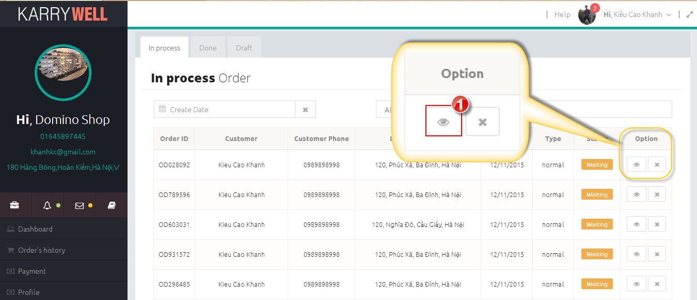

**To view detail of an order:**

You can view detail of an order by click on button that has an eye icon inside.

### 3.2.11. Edit an order

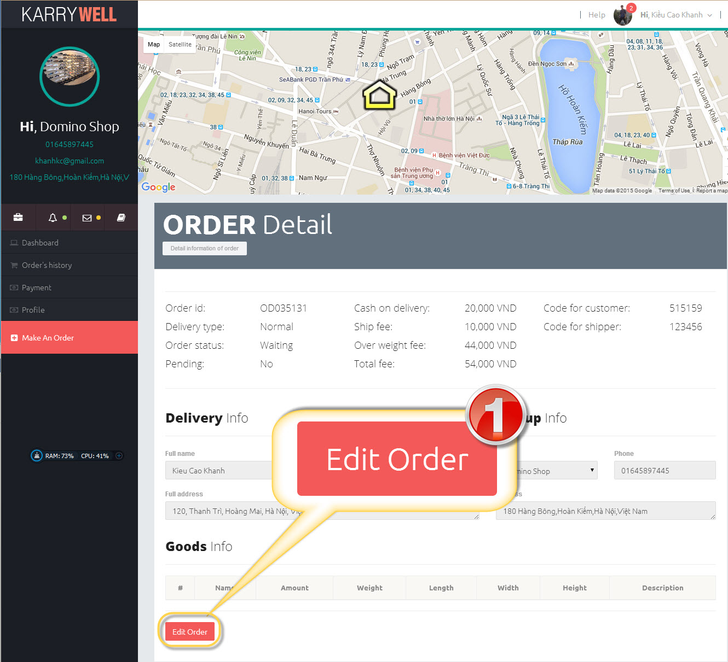

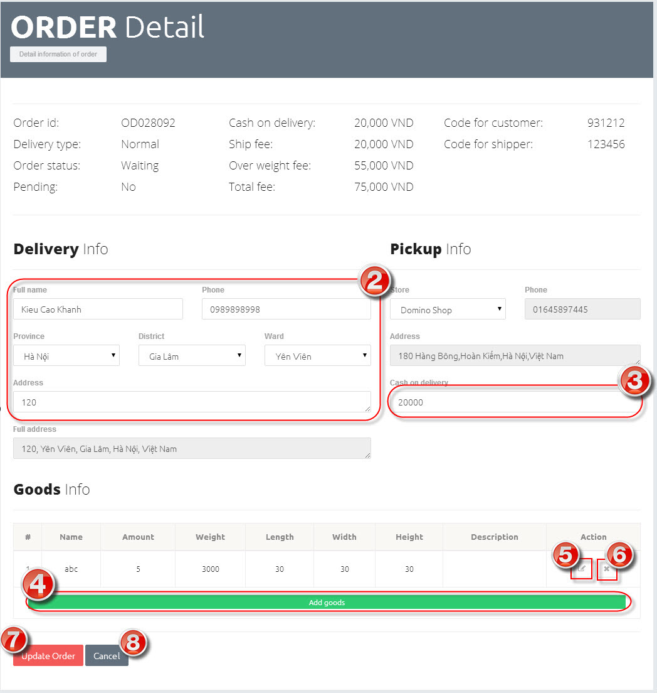

**\* Note:** You can only edit orders that have not been grabbed yet by any shipper or in status “Waiting”

**To view detail of an order:**

**Step 1.** Click on “Edit Order” button (➊). The elements on “Order detail” screen will be enable.

**Step 2.** Edit information of order in text boxes in (➋) and (➌).

**Step 3.** Click on “Add goods” button (➍) to add new goods (see 3.2.5.Add a goods), “Edit” button (➎) to edit a goods (see 3.2.6: Edit a goods) and “X” button (➏) to delete a goods (see 3.2.7. Delete a goods).

**Step 4.** Click on “Update order” button (➐) to update your change or click on “Cancel” button (➑) to discard the change.

### 3.2.12. Search order

( Quyền ơi) Ông thêm phần search order của Hoàng vào đây nha.

### 3.2.13. Find a shipper

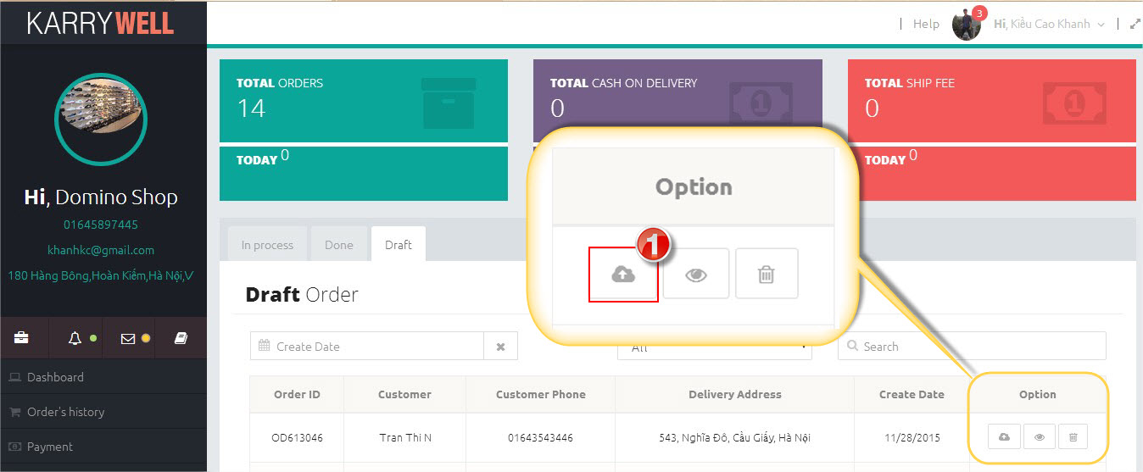

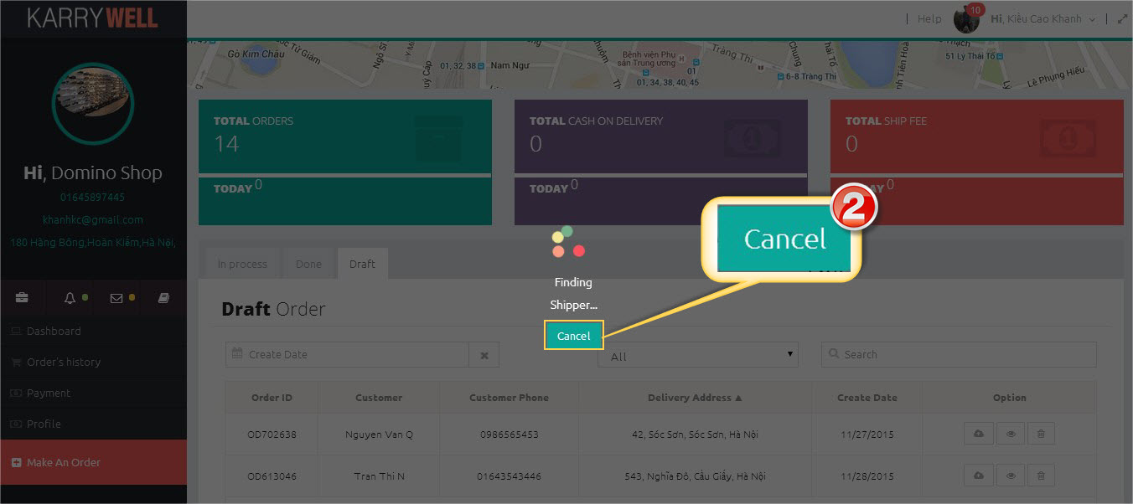

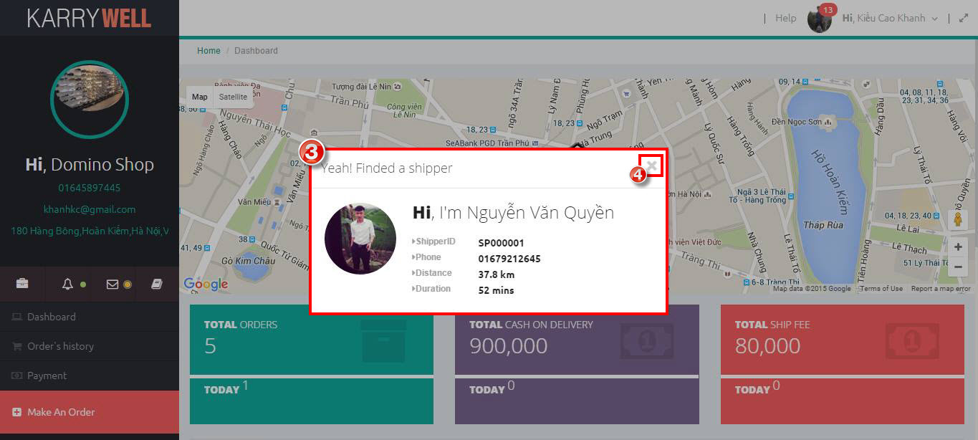

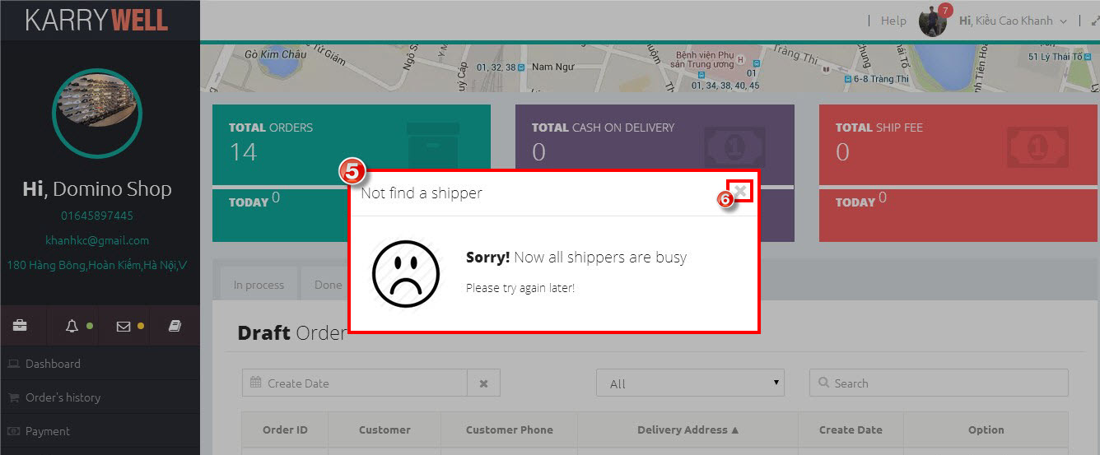

**To find a shipper:**

To find a shipper, **c**lick on “Submit” button (➊). “Find shipper” screen will appear. You can click on “Cancel” button (➋) to cancel finding process.

If finding process is successful a popup will appear (➌). This popup contain information of shipper who’ll come to pick up your goods. Click on “X” button (➍) to close popup.

If finding process is fail a popup will appear (➎). Click on “X” (➏) to close popup.

### 3.2.14. Sign out

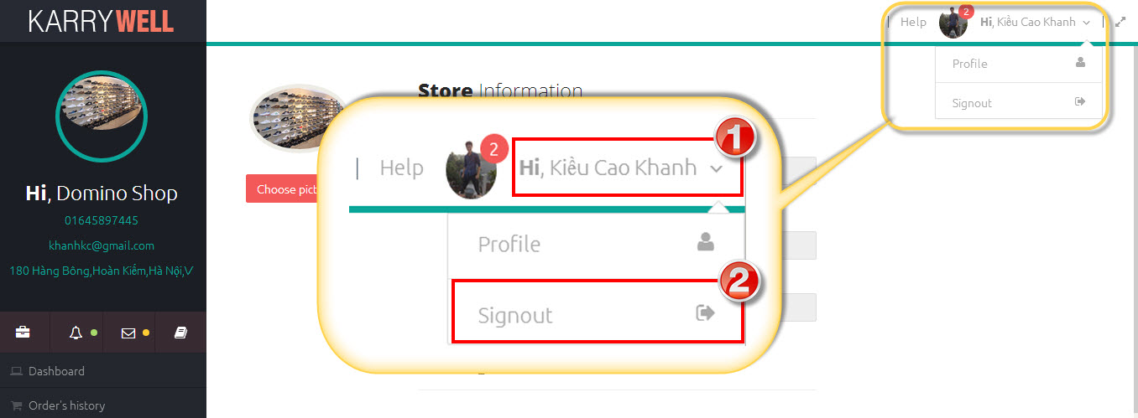

**To sign out:**

**Step 1:** Click on your name on header (➊). A menu will appear.

**Step 2:** Click on “Sign out” item (➋) to sign out.