# INTERFACE DESIGN

## Interface Design of Application

### **Structure and Layout**

The overall structure of the application is relatively simple, as shown in the following diagram.

|  |  |  |
| --- | --- | --- |
| **No** | **Screen Name** | **Description** |
| **1** | Login Screen | Where user can login to the System. System provides his or her access credentials in order to use system. |
| **2** | Profile Screen | Where displays the information of User |
| **3** | Task Screen | Where displays the tasks of User. User sees the list of his/her in working tasks. |
| **4** | Task’s Detail Screen | Where user can view detail information of task. Include information of order. |
| **5** | Issue Screen | Where user can send issue. Include two type of Issue: Pending, Cancel. This issue influents and a short description from user. |
| **6** | History Screen | Where displays the history of task which status of task is Done or Fail |

* Screen Flow:

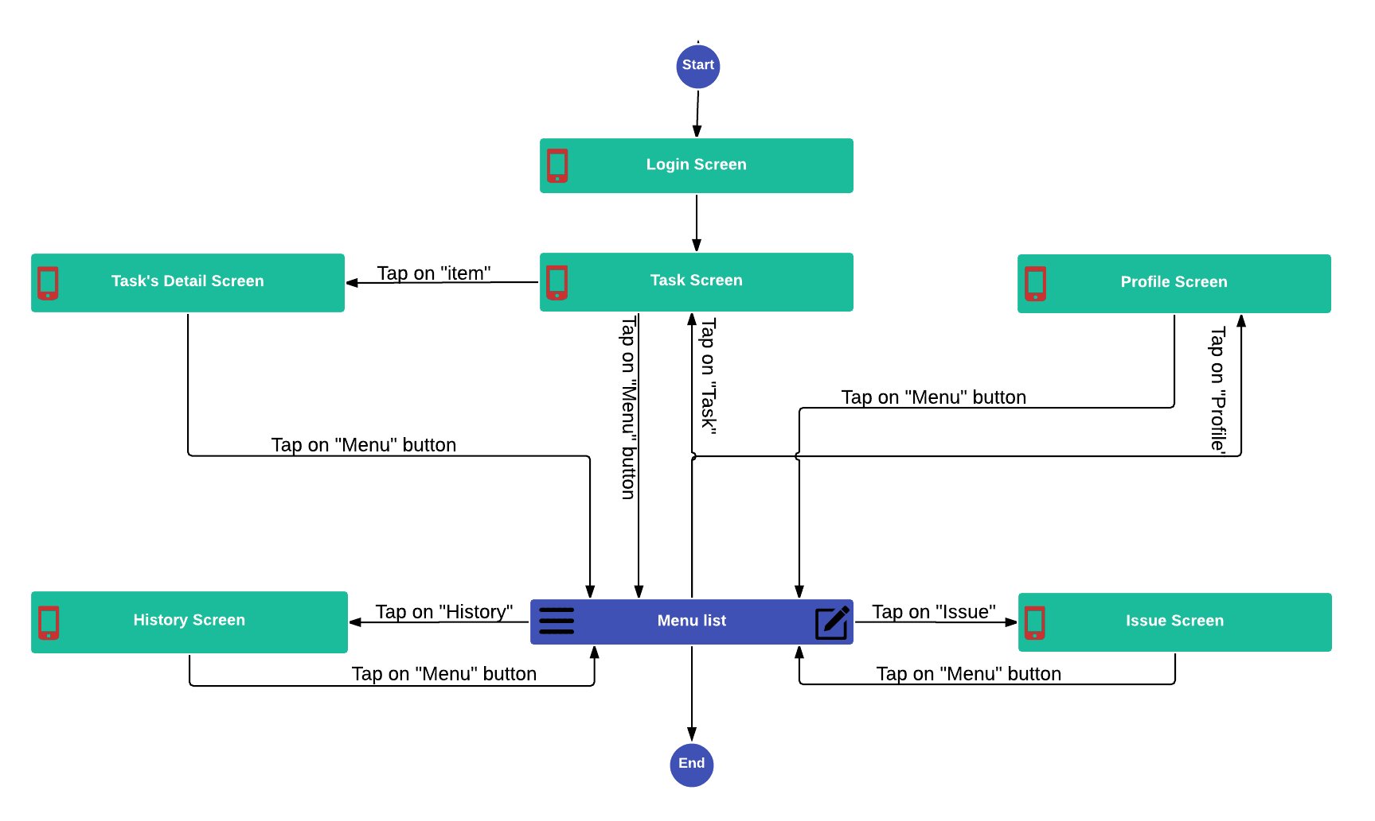

### **Screen Description**

#### Login Screen

This is the first screen after user launched Karry Well application where user can entered account(UserName, Password) to sign-in to the application.

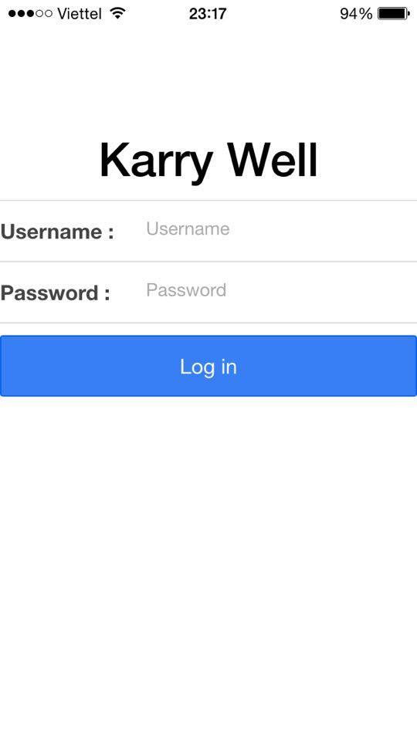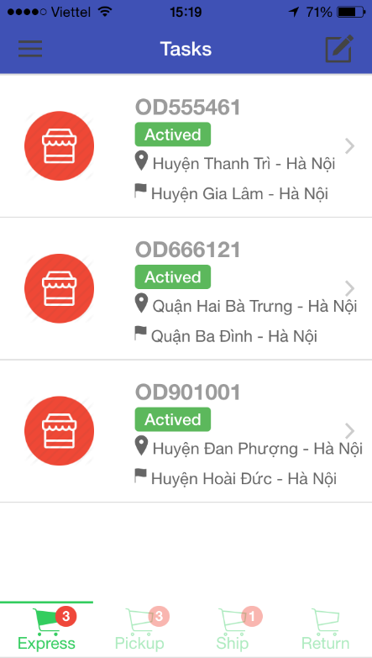

|  |  |  |  |  |
| --- | --- | --- | --- | --- |
| **No** | **Elements** | **Required** | **Type** | **Description** |
| **1** | **Username** | Touch on | Text | Input text for sign-in to the application. |
| **2** | **Password** | Touch on | Password | Input password for sign-in to the application. |
| **3** | **Login** | Touch on | Button | When user click this button, the system provides their access credentials in order to use system. If Sign-in successful then the application will redirect to ‘Task Screen’. |

#### Profile Screen

When user want view their information, Karry Well app will display the information of user. User can view their information: Name, ID, Date of Birth, Identity Card, Phone Number, Email, Address

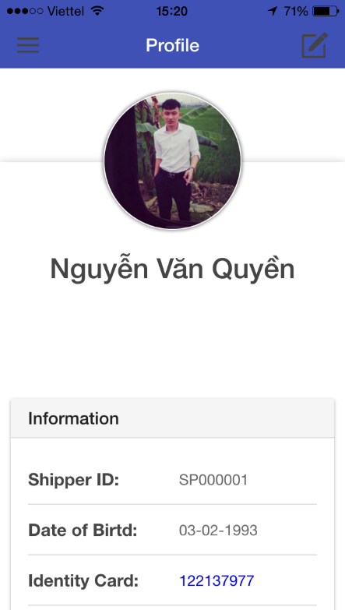

|  |  |  |  |  |
| --- | --- | --- | --- | --- |
| **No** | **Elements** | **Required** | **Type** | **Description** |
| **1** | **Menu** | Touch on | List view | List of the features ( Tasks , History, Send Issue, Profile, Change Status, Logout)when user taped on it.The menu button like a navigation tool to direct to other screens . |
| **2** | **Compose Icon** | Touch on | Button | Button on right of menu bar. If user taped on it, redirect to ‘Send Issue’ Screen. |
| **3** | **Title** |  | Label | The title is “Profile” |
| **4** | **Profile Image** |  | Image | Displays user’s image. |
| **5** | **Profile Information** |  | List view | Displays information of user(ID, Date of Birth, Identity Card, Phone Number, Email, Address). |

#### Task Screen

This is the first screen after user logged to the Karry Well application where user can view and tracking their task. User see the list of their in-working tasks (all of his Active or Inactive of tasks will be displayed here).

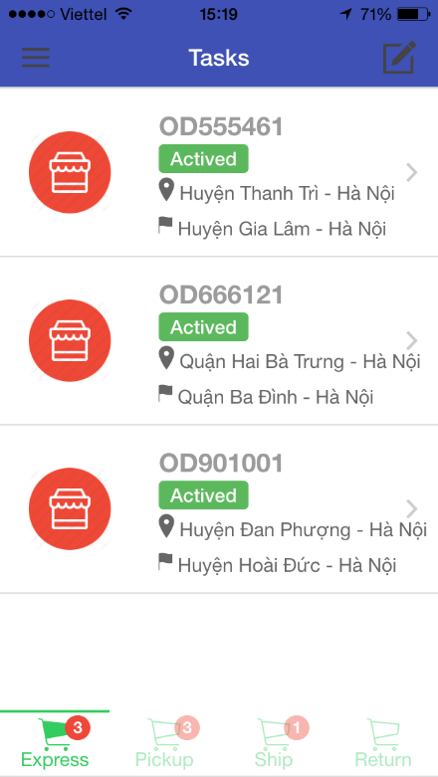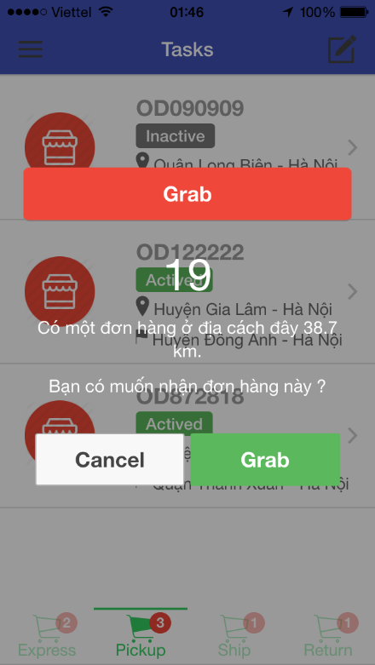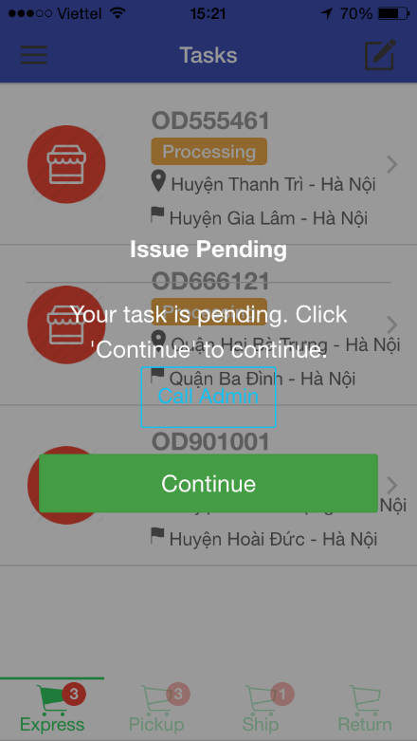

|  |  |  |  |  |
| --- | --- | --- | --- | --- |
| **No** | **Elements** | **Required** | **Type** | **Description** |
| **1** | **Menu** | Touch on | List view | List of the features ( Tasks , History, Send Issue, Profile, Change Status, Logout)when user taped on it.The menu button like a navigation tool to direct to other screens . |
| **2** | **Compose Icon** | Touch on | Button | Button on right of menu bar. If user taped on it, The application will redirect to ‘Send Issue’ Screen. |
| **3** | **Title** |  | Label | The title is “Tasks” |
| **4** | **Tab bar** | Touch on | Sliding tab | Tasks have 4 types correspond 4 tabs: Express, Pickup, Ship, Return. When user click on each of task, the application will show list of their in-working tasks. The number of task is shown on tab icon. |
| **5** | **List Task** | Touch on | List view | A tab has many tasks. Each item is including with information: Order code, Status of Task, Pickup Address and Delivery Address. When user click on task, the application will redirect to ‘Task Detail’ screen. |
| **6** | **Grab Order** | Touch on | ShowDialog | Ask user after have request delivering an order from customer. When user taped on ‘Grab’ button, the application will assign this task for user.  At the main of Dialog is turn the back time (60s). |
| **7** | **Continue** | Touch on | ShowDialog | Ask user after user was issued. If user want continue their work then user requests to Admin to solve this issue.  When user want contact to Admin, then user can click ‘Call Admin’ button. |

#### Task’s Detail Screen

Task’s Detail screen display all detail information of task. User can view map, order status… and tracking that task. User can check code for each step (pickup, delivering, return). The result will be displayed below.

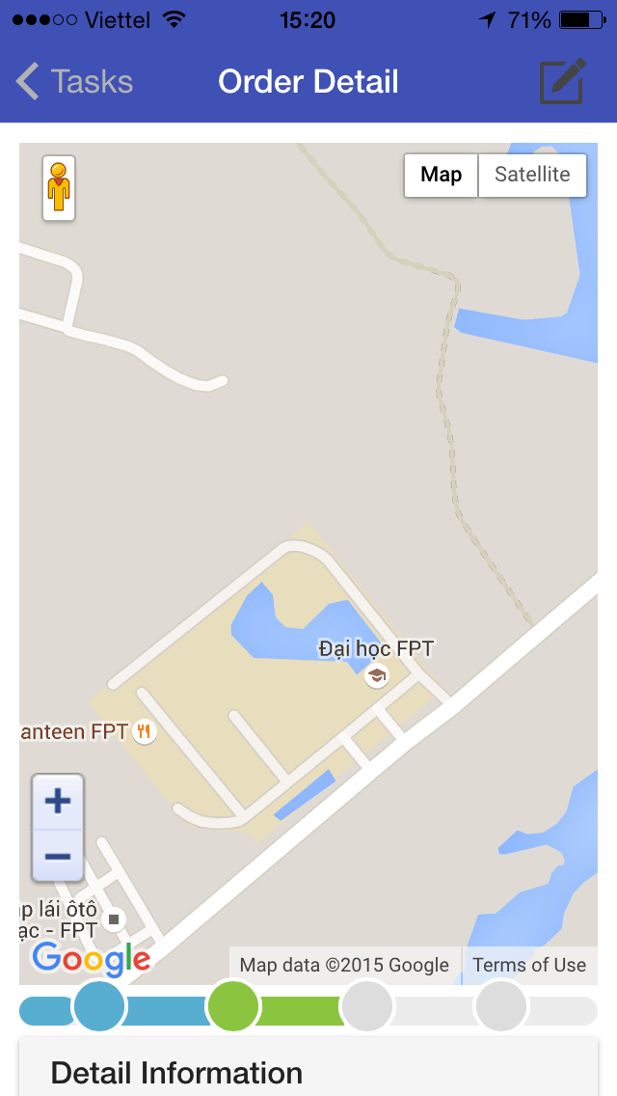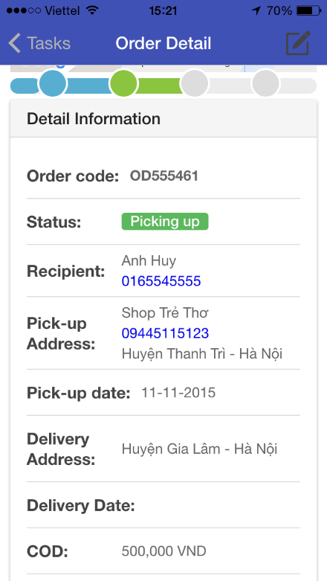

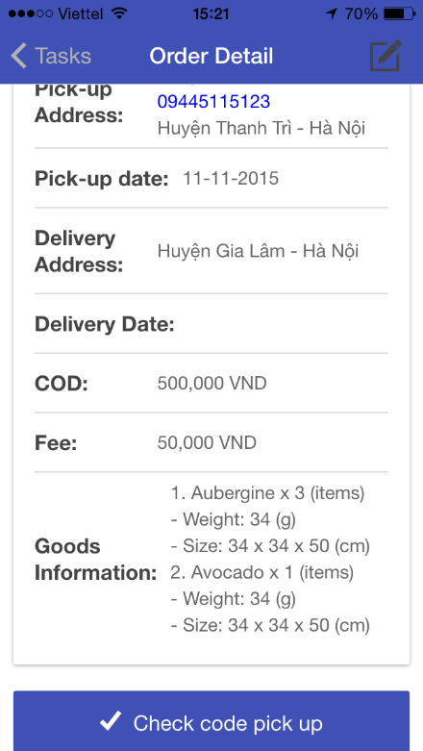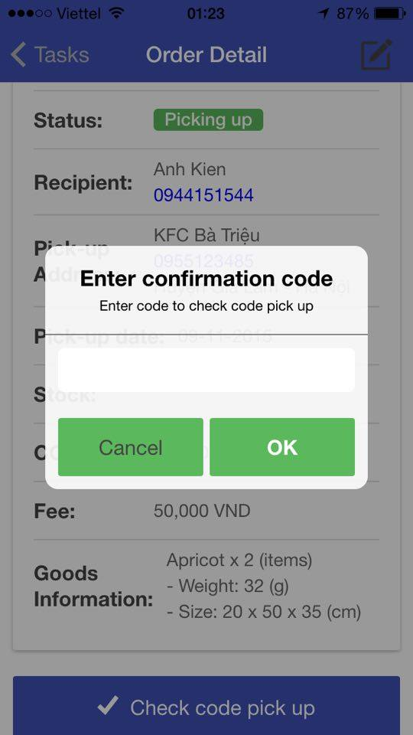

|  |  |  |  |  |
| --- | --- | --- | --- | --- |
| **No** | **Elements** | **Required** | **Type** | **Description** |
| **1** | **Menu** | Touch on | List view | List of the features ( Tasks , History, Send Issue, Profile, Change Status, Logout)when user taped on it.The menu button like a navigation tool to direct to other screens . |
| **2** | **Compose Icon** | Touch on | Button | Button on right of menu bar. If user taped on it, redirect to ‘Send Issue’ Screen. |
| **3** | **Title** |  | Label | The title is “Order Detail” |
| **4** | **Map** | Touch on | Google map item | User can view their current location on map. Use can view the distance from current location to customer of location. |
| **5** | **Timeline** |  | List view | Display timeline of task (Picking up, Delivering, Returning) by status of that task. |
| **6** | **Detail Information** |  | List view | Display detail information of task (Order Code, Status, Recipient, Pick-up Address, Pick-up date, Stock, COD, Fee, Goods Information). |
| **7** | **Check code** |  | Button | User can check code for each process. Example: When user arrived the customer’s location, then user have to tap ‘Check code pick up’ to confirmation. |
| **8** | **Confirmation code** |  | ShowDialog | After taped on ‘Check code’ button, then application will show a confirmation dialog. User have to entered code. To make sure right user.  User tap on “OK” to confirm code. |

#### Issue Screen

Where user can send issue. Include two type of Issue: Pending, Cancel. These issue influents and a short description from user.

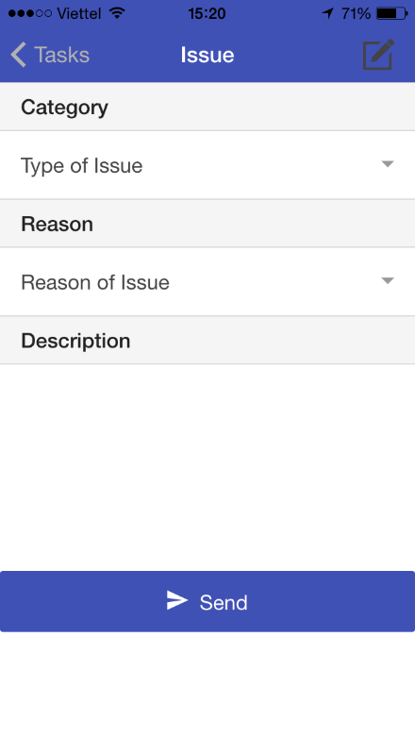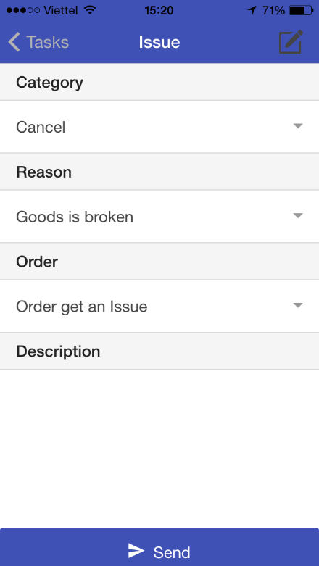

|  |  |  |  |  |
| --- | --- | --- | --- | --- |
| **No** | **Elements** | **Required** | **Type** | **Description** |
| **1** | **Menu** | Touch on | List view | List of the features ( Tasks , History, Send Issue, Profile, Change Status, Logout)when user taped on it.The menu button like a navigation tool to direct to other screens . |
| **2** | **Compose Icon** | Touch on | Button | Button on right of menu bar. If user taped on it, redirect to ‘Send Issue’ Screen. |
| **3** | **Title** |  | Label | The title is “Issue”. |
| **4** | **Category** | Touch on | DropDown List | Display categories include: Pending, Cancel. |
| **5** | **Reason** | Touch on | DropDown List | Display type of each category. If category is Pending, then display list of reason: Traffic jam, Vehicle, Accident, Other. Otherwise If category is Cancel, then list of reason: Good is Broken, Cannot contact with customer. |
| **6** | **Order** | Touch on | List checkbox | This element shown when category of issue is Cancel. User can select order from list. |
| **7** | **Description** | Touch on | TextArea | Use can type short description of that issue. |
| **8** | **Send** | Touch on | Button | When user taped on ‘Send’ button, application will sent an issue to Admin to solve for that issue. |

#### 1.1.2.6. History Screen

History help user saving tasks so that user can review those tasks. When user tap on each task, then application redirect to ‘Task’s Detail’ screen. When history is so long with many records, then application will appear ‘See more…’ button.

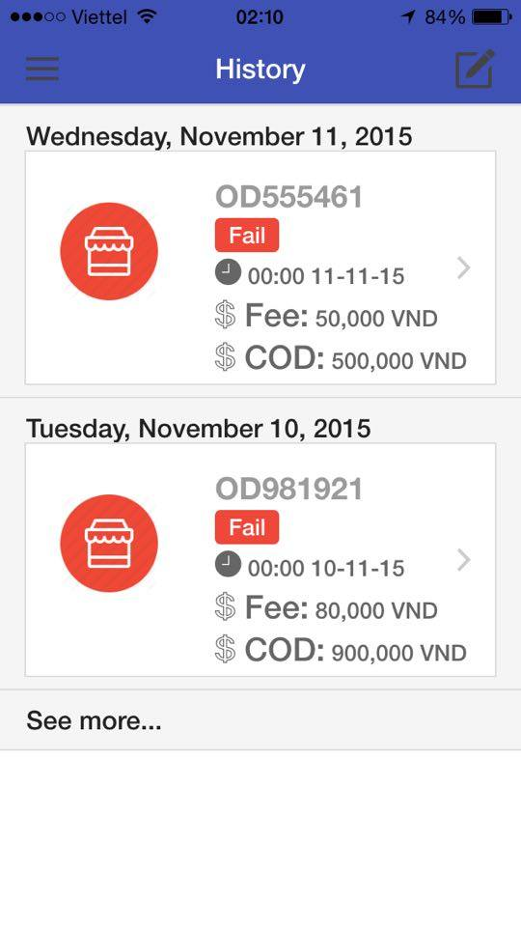

|  |  |  |  |  |
| --- | --- | --- | --- | --- |
| **No** | **Elements** | **Required** | **Type** | **Description** |
| **1** | **Menu** | Touch on | List view | List of the features ( Tasks , History, Send Issue, Profile, Change Status, Logout)when user taped on it.The menu button like a navigation tool to direct to other screens . |
| **2** | **Compose Icon** | Touch on | Button | Button on right of menu bar. If user taped on it, redirect to ‘Send Issue’ Screen. |
| **3** | **Title** |  | Label | The title is “History” |
| **4** | **List task** | Touch on | List view | Each item is including with information: Complete Date, Order code, Status of Task, Time, Fee and COD. If user want view detail information of task, then tap on each item. The application will redirect to detail information of task. |
| **5** | **See more** | Touch on | Button | If list history exceeds 2 then ‘See more’ button will appear at the end of screen. User can view more list history. |

# USER MANUAL

This document guides you how to use Karry Well application. You will need only 10 minutes to learn.

## 2.1. Select Screen

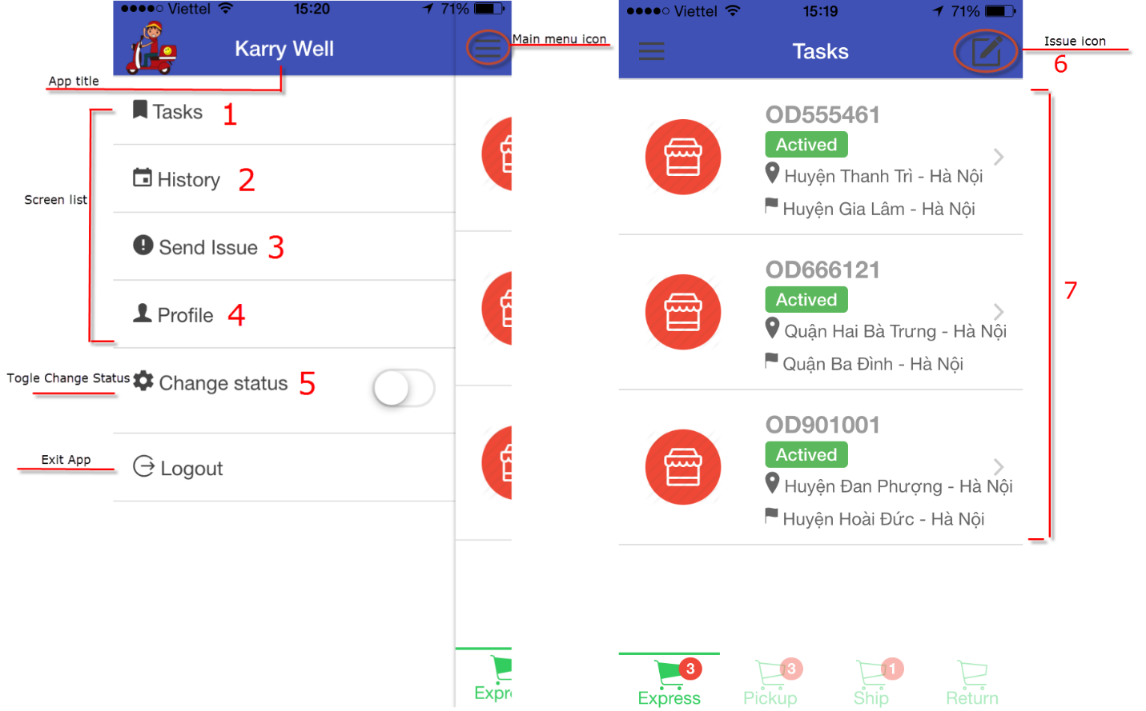

**To select a screen**

1. Tap on Main Menu icon on the upper left corner. The Main Menu will show listing all screen of the application.
2. Tap on the screen that you want to use.

* (1) Tasks Screen: used to view tasks of user.
* (2) History Screen: user want to review history.
* (3) and (6) Send Issue Screen: used to send issue to Admin. When user was issued, then user can send their issue.
* (4) Profile Screen: used to view profile of user.
* (5) Change status Screen: used to change status of user. User want to switch his status between ready to work or not ready.
* (7) Detail Screen: used to view detail of Task. User tap on item, then application redirect to detail screen.

## . Login Screen

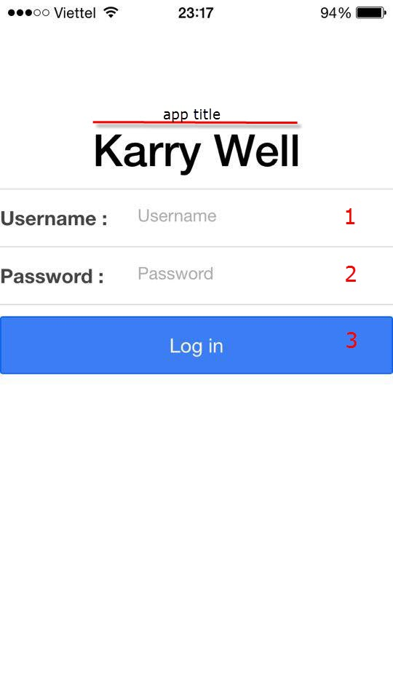

**To Sign-In to Application**

1. Type the text in the text field (1).
2. Type the text in the text field (2).
3. Tap on ‘Login’ button (3).

## . View Tasks

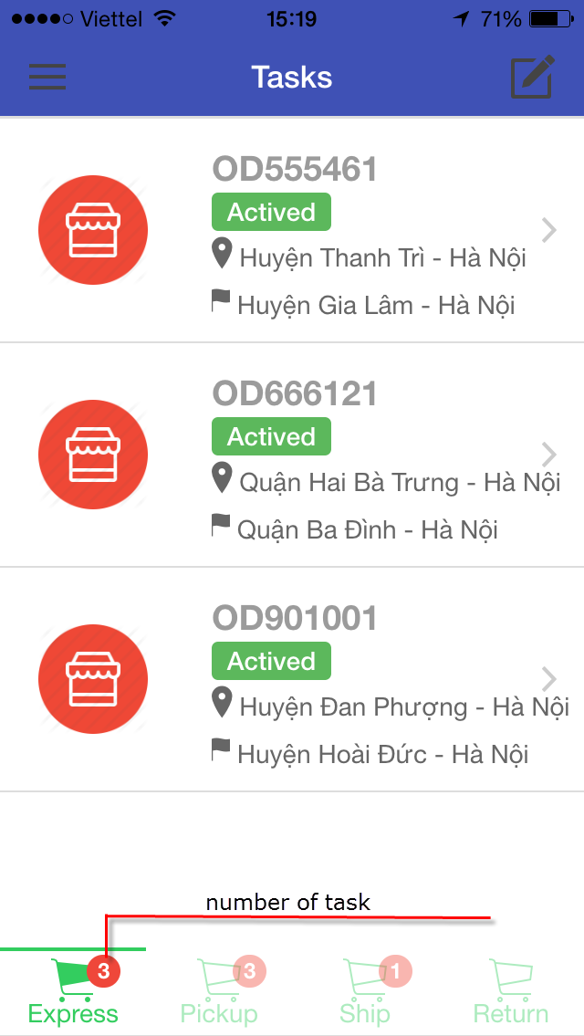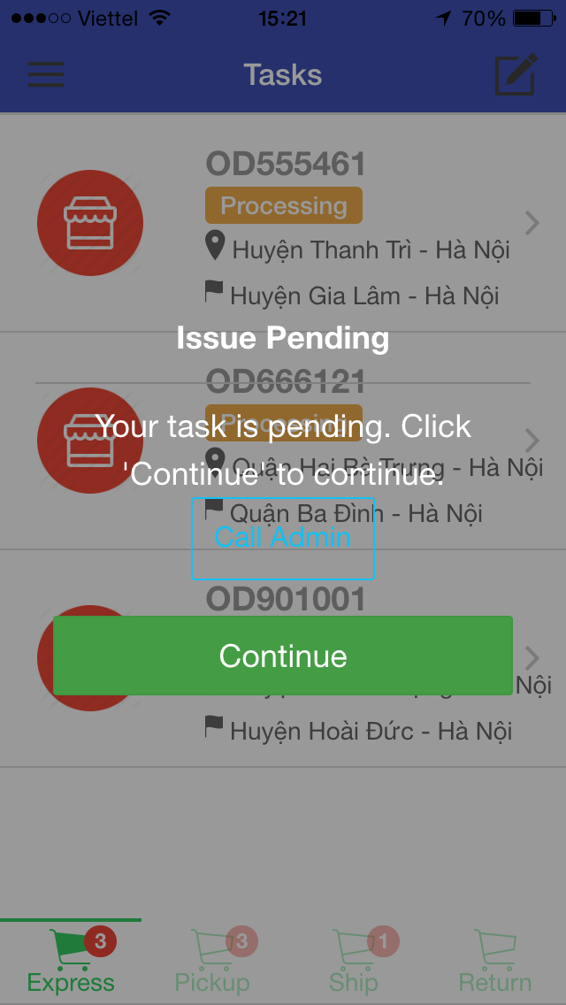

- To view Tasks screen, select Tasks screen from Main Menu (refer 2.1).

- To view detail information of task by tap on each task.

- To view type of task by tap on each tab (Express, Pickup, Ship, Return).

- To view Issue Pending Dialog, send issue from Send Issue Screen (refer 2.4).

**To continue user of task**

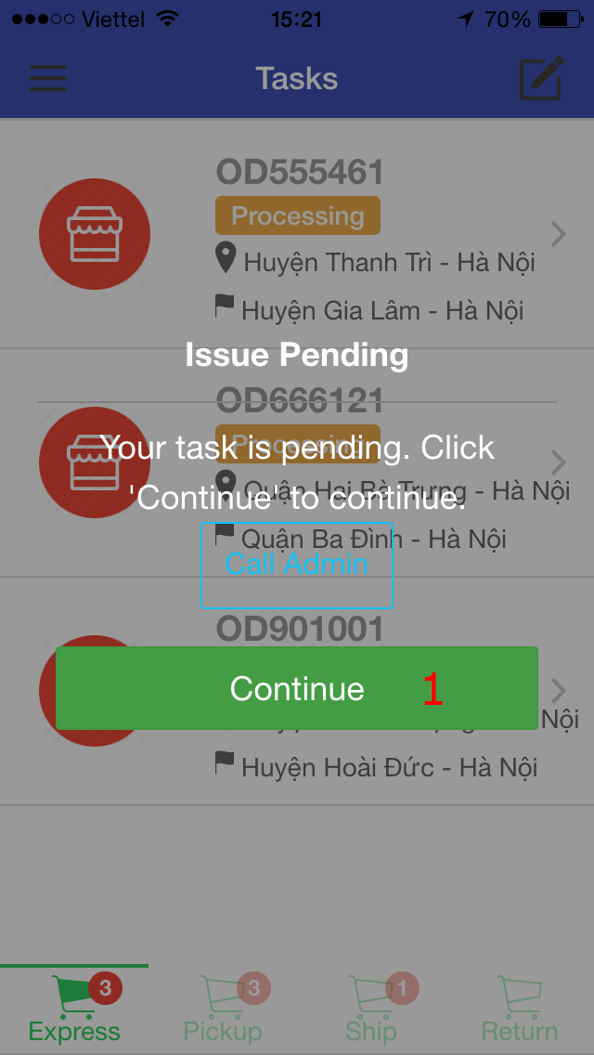

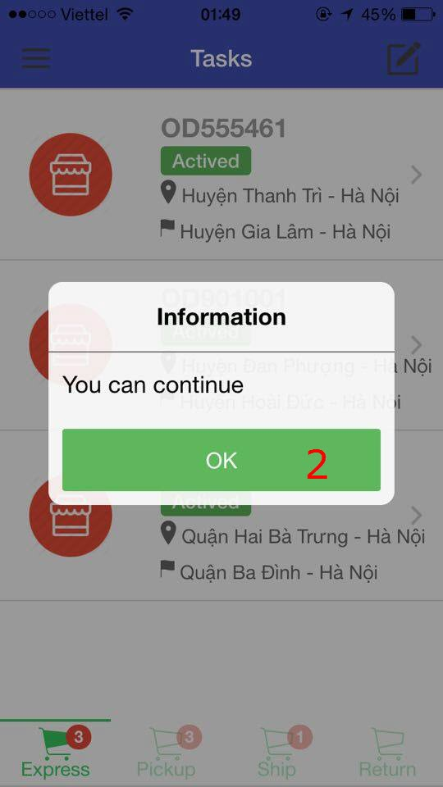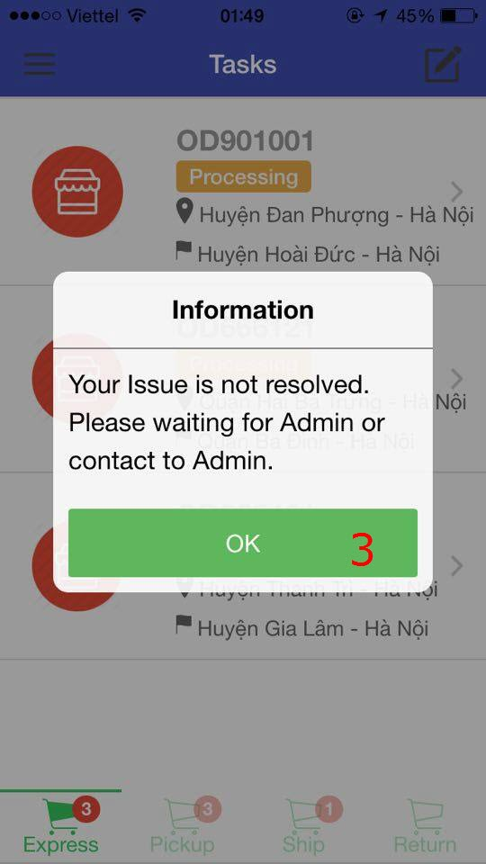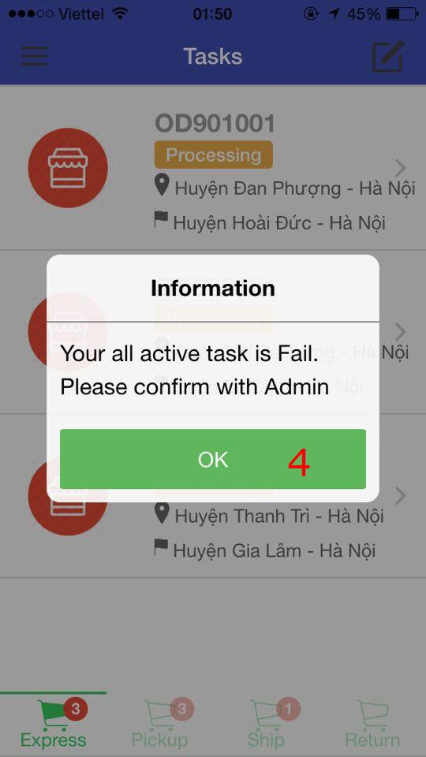

1. Tap on ‘Continue’ button screen (1).
2. If Admin accept for user continue their task, A Dialog (2) appear with content: You can continue.

If Admin haven’t resolve that issue, A Dialog (3) appear with content: Your Issue is not resolved, please waiting for Admin or contact to Admin.

If Admin reject that issue and assign task to other user, A Dialog (4) appear with content: Your all active task is fail. Please confirm with Admin.

1. Tap OK button of the confirmation of dialog.

## 2.4. Send Issue Screen

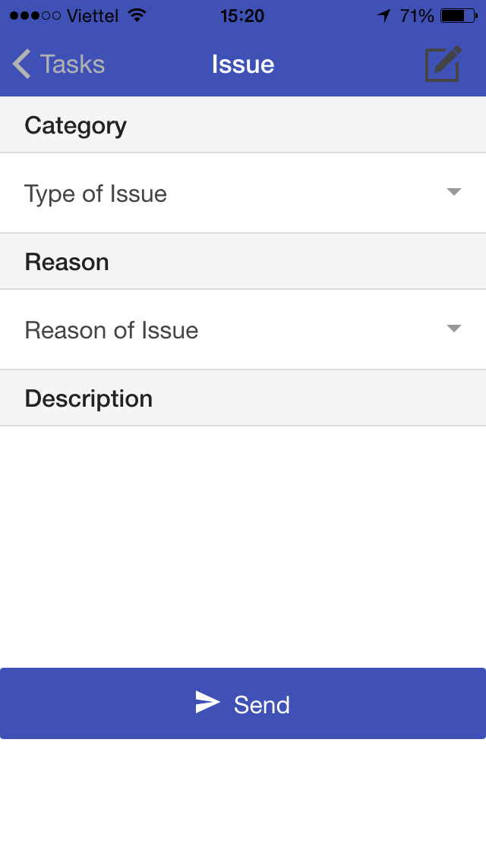

**To Send Issue’s information to Admin**

1. Tap on Category Dropdownlist. (Pending, Cancel).
2. Tap on Reason Dropdownlist (Traffic jam, Vehicle, Accident, Good is Broken, Cannot contact with customer).
3. Type Description.
4. Tap Send button

## 2.5. View Detail’s Task Screen

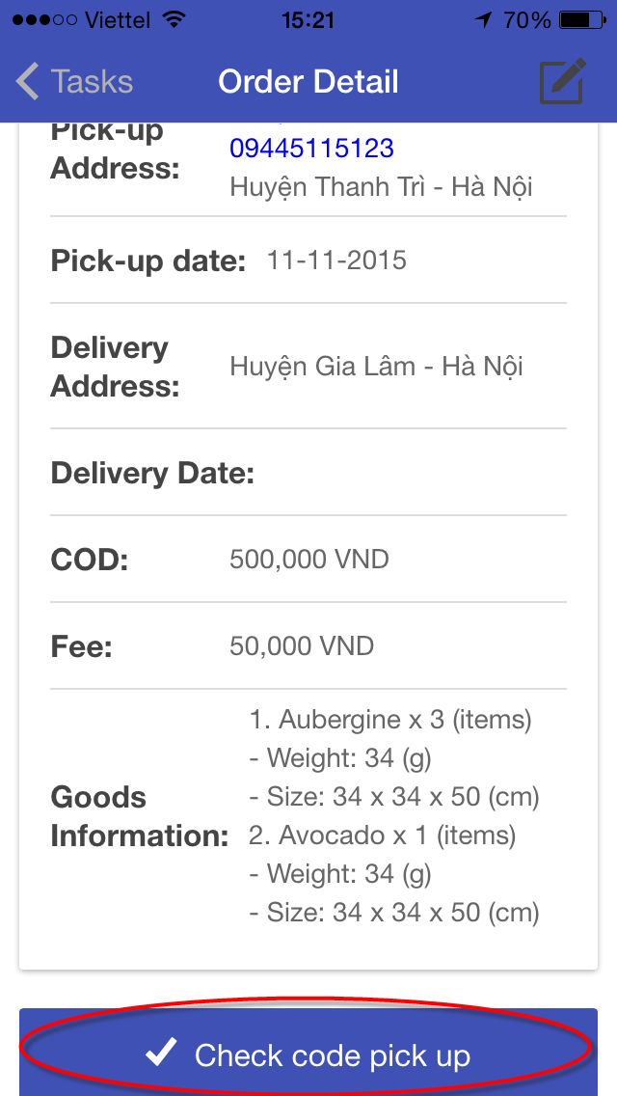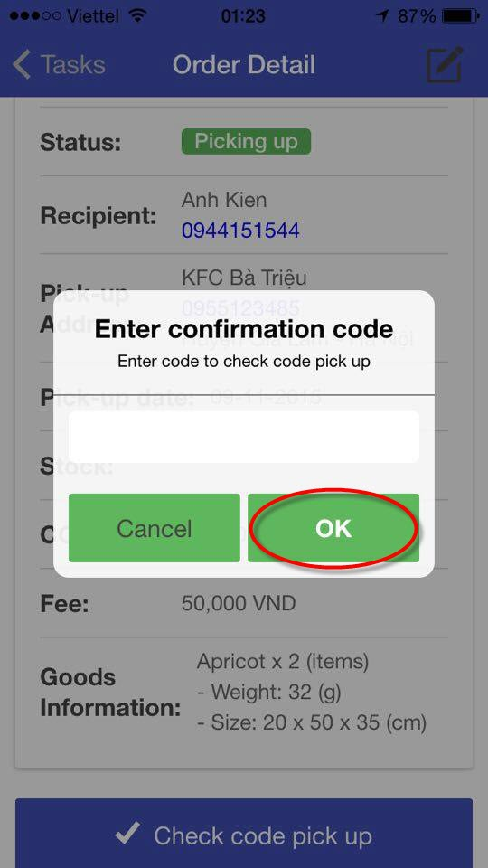

To view Detail’s Task screen, tap on item in list of Task from Tasks screen (see 2.3).

**To check code for Order**

1. Tap Check code pick up button at the end of Detail’s Task screen.
2. Type code on text box of confirmation code.
3. Tap OK button.

## 2.6. View History Screen

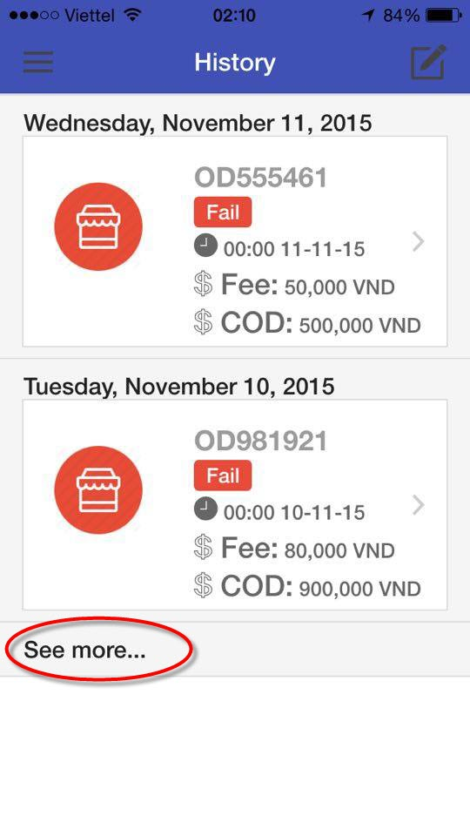

- To view History screen, select History screen from Main Menu (refer 2.1).

- To view detail information of task by tap on each item.

- To view more list of history by tap on See more button.

## 2.8. Change Working Status

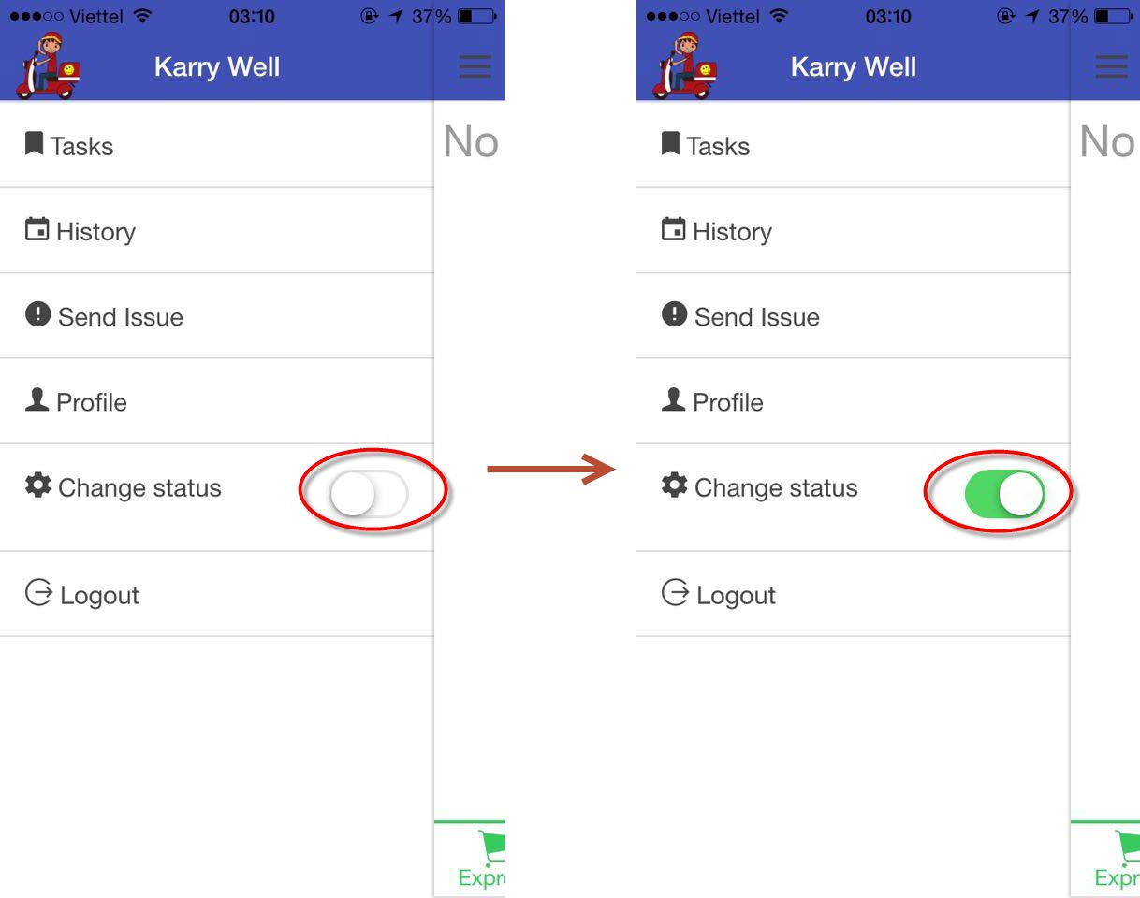

- To change status of current user, tap on toggle Change status.

## 2.9. Grab Order

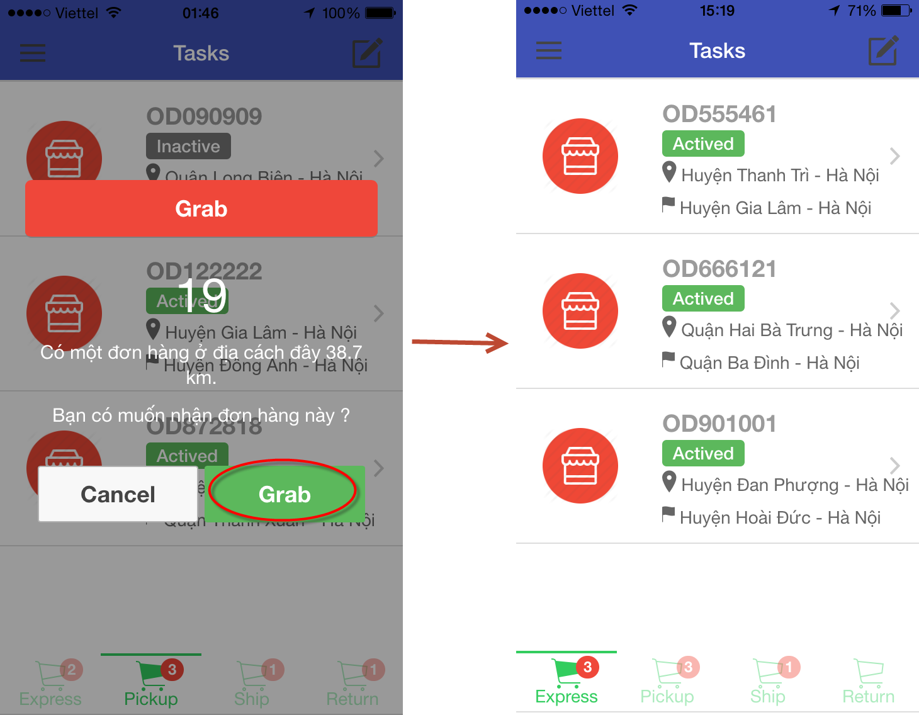

- Tap on Grab button, Task have recently grab, it will appear at tab Express of Task screen.