|  |
| --- |
|  |
| Capstone Project Document |

SUPER SHIPPER SYSTEM

Software Requirement Specification

|  |  |  |
| --- | --- | --- |
| **Super Shipper System** | | |
| **Group Members** | Le Van Quy Hoang | SE90184 |
| Tran Dinh Hoang Huy | SE90201 |
| Nguyen Khac Hoang | SE02564 |
| Kieu Cao Khanh | SE02960 |
| Nguyen Van Quyen | SE02884 |
| Nguyen Thi Hong Nhung | SE02437 |
| **Supervisor** | Mr. Tran Binh Duong | |
| **Project code** | 3S | |

**- Hanoi, 09/2015 -**

TABLE OF CONTENTS

1. FUNCTIONAL REQUIREMENTS 2

1.1. Web application for Admin 2

1.1.1. User Case Diagram 2

1.1.2. Functions 3

*UC- 101: Admin Login* 3

*UC- 103: Admin Change Password* 5

*UC- 104: Admin Forgot Password* 6

*UC- 105: Accept Store* 6

*UC- 106: Search Store* 7

*UC- 107:* *View Store’s list* 8

*UC- 108:* *Block store* 9

*UC- 109:* *View Store’s details* 10

*UC- 110:* *Send message to Store* 11

*UC- 111:* *Confirm Store’s payment* 13

*UC- 112:* *View transaction history of Store* 14

*UC- 113:* *Add Shipper* 15

*UC- 114:* *View Shipper’s list* 17

*UC- 115:* *View Order’s list* 17

*UC- 117:* *Search Shipper* 18

*UC- 117:* *Search Order* 19

*UC- 118:* *View Shipper’s profile* 20

*UC- 119:* *View Order’s details* 21

*UC- 120:* *Update Shipper* 22

*UC- 121:* *Update Order* 24

*UC- 122:* *Add new Order* 25

*UC- 123:* Export transaction 26

*UC- 124:* *Assign Task* 27

1.2. Web application for Store 29

1.2.1. User Case Diagram 29

1.2.2. Function 30

*UC-201:* *Register* 30

*UC-202:* *Login* 33

*UC-203:* *Logout* 35

*UC-205:* *Forgot password* 38

*UC-206:* *View profile* 40

*UC-207:* *Edit profile* 41

*UC-208:* *Create order* 44

*UC-209:* *View order’s list* 45

*UC-210:* *Search orders* 46

*UC-211:* *Cancel order* 48

*UC-212:* *Edit Order* 50

*UC- 213:* *Order’s details* 52

*UC-216:* *Rate shipper* 53

*UC-217:* *Send feedback* 55

*UC-218:* *View Homepage* 57

1.3. Mobile application for Shipper 59

1.3.1. User Case Diagram 59

1.3.2. Function 60

*UC-301:* *Login* 60

*UC-302:* *Logout* 61

*UC-303:* *Forgot password* 62

*UC-304:* *Change password* 64

*UC-305:* *View Profile* 65

*UC-306:* *Update Profile* 67

*UC-307:* *Confirm Code* 68

*UC-308:* *Grab order* 70

*UC309: View Orders List* 73

*UC310: Search Order* 74

*UC311: View Order’s Detail* 76

*UC312: Find Best Way* 78

*UC313 Send Issue’s Information* 80

*UC314 Change Working Status* 82

*UC315 View History* 84

**ACRONYMS & ABBREVIATIONS**

| Abbreviations | Description | Note |
| --- | --- | --- |
|  |  |  |
|  |  |  |
|  |  |  |
|  |  |  |
|  |  |  |
|  |  |  |
|  |  |  |
|  |  |  |
|  |  |  |
|  |  |  |
|  |  |  |
|  |  |  |
|  |  |  |
|  |  |  |
|  |  |  |
|  |  |  |
|  |  |  |
|  |  |  |
|  |  |  |
|  |  |  |
|  |  |  |
|  |  |  |
|  |  |  |

# 1. FUNCTIONAL REQUIREMENTS

## 1.3. Mobile application for Shipper

### 1.3.1. User Case Diagram

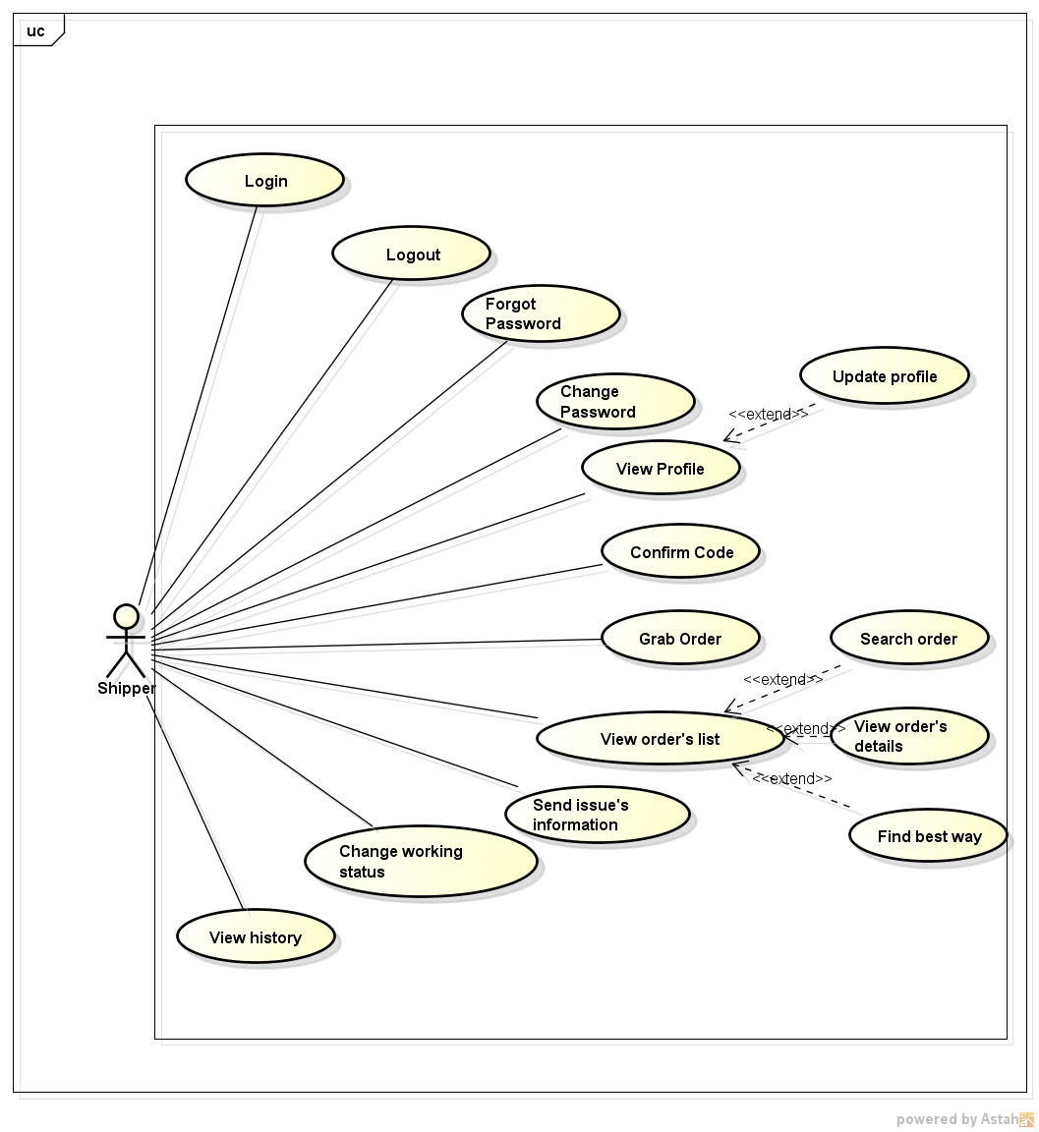

### 1.3.2. Function

###### *UC-301:* *Login*

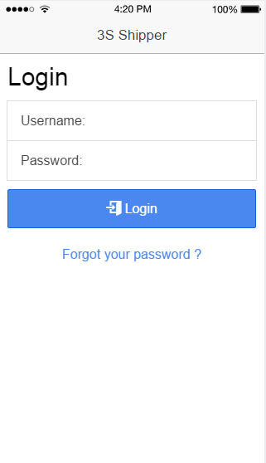

|  |  |  |  |  |
| --- | --- | --- | --- | --- |
| Use Case ID: | | UC-301 | | |
| Use Case Name: | | Login | | |
| Created By: | | QuyenNV | Last Updated By: | QuyenNV |
| Date Created: | | 19/09/2015 | Date Last Updated: | 30/09/2015 |
| Actor: | | Shipper | | |
| Description: | | System provides his or her access credentials in order to use system. | | |
| Triggering event | | Shipper wants to login to system. | | |
| Preconditions: | | - To be pre-registered in the System.  - Internet connection is established. | | |
| Post - conditions: | | The shipper’s session is stored. | | |
| Priority: | | High | | |
| Frequency of Use: | | Sometime | | |
| **Main flow** | | | | |
| Step | Actor | Action | | |
| 1 | Shipper | Tabs on application | | |
| 2 | System | Request the shipper input the following fields are available:  + Username  + Password | | |
| 3 | Shipper | Enter information (Username and Password). Shipper clicks on Log In. | | |
| 4 | System | The queries to shipper database | | |
| 5 | System | The system validates Username and Password to accept or rejects the login request. | | |
| 6 | System | Login successful into application. The login request is accepted shipper will be redirected to the Order’s list screen. | | |
| **Alternative Flows:** | | N/A | | |
| **Exceptions:** | | | | |
| EC1 | At step 4, If system cannot establish a connection to the database due to some reasons (ex: network failure). | | | |
| Step | Actor | | | |
| 4.1 | System | Display an error message “Your network connection failed. Please check your network connection and try again” will show up on screen to tell the shipper about the problem. | | |
| EC2 | At step 5, if account’s information is invalid | | | |
| Step | Actor | Action | | |
| 5.1 | System | Display an error message “ Username or Password is invalid. Try again.” on [Login] screen | | |
| **Includes:** | | N/A | | |
| **Special Requirements:** | | N/A | | |
| **Notes and Issues:** | | N/A | | |

**Sequence Diagram**

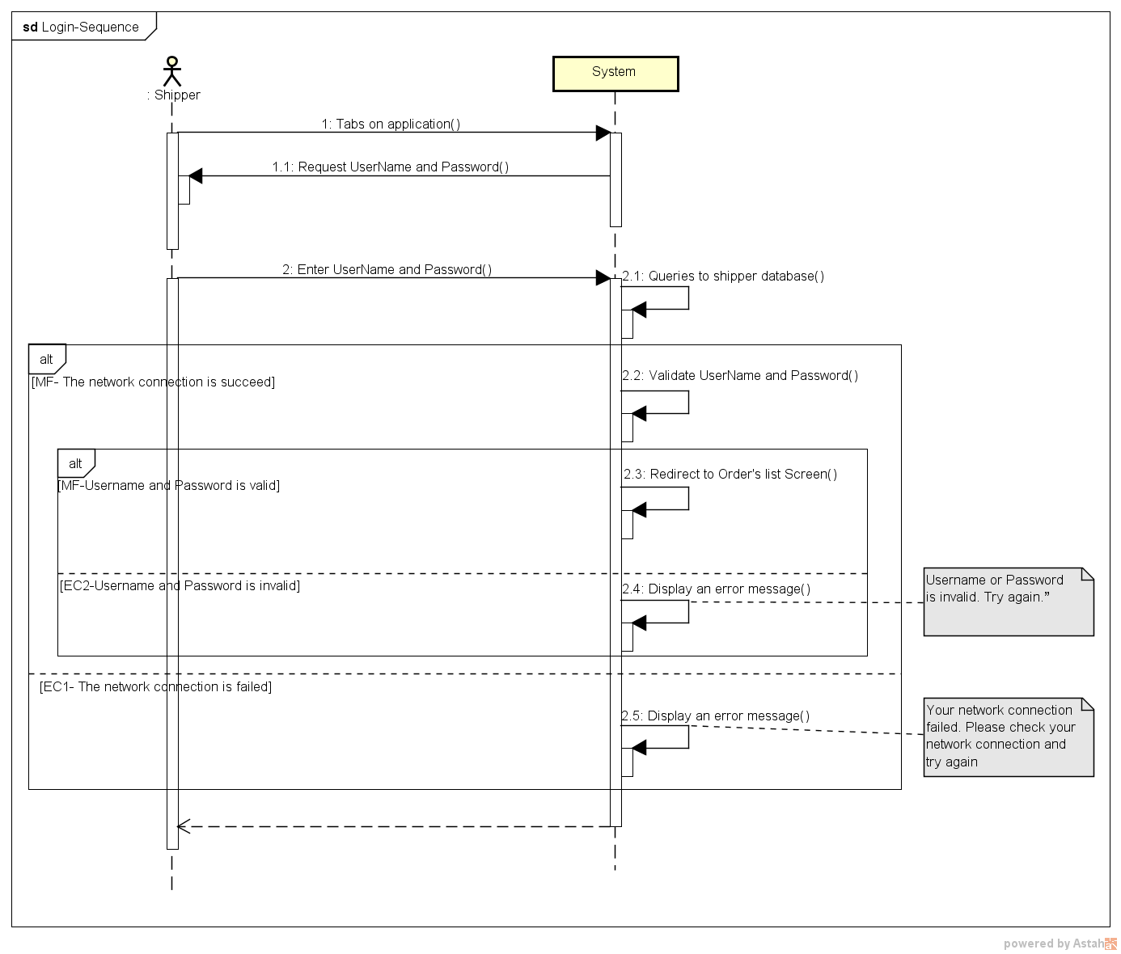

###### *UC-302:* *Logout*

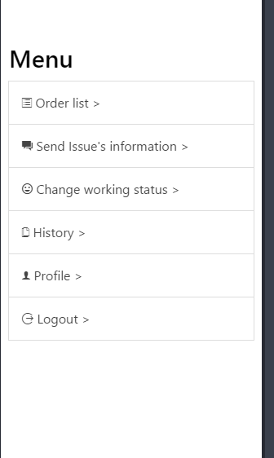

|  |  |  |  |  |
| --- | --- | --- | --- | --- |
| Use Case ID: | | UC-302 | | |
| Use Case Name: | | Logout | | |
| Created By: | | QuyenNV | Last Updated By: | QuyenNV |
| Date Created: | | 19/09/2015 | Date Last Updated: | 30/09/2015 |
| Actor: | | Shipper | | |
| Description: | | When shipper finish their work they will logout of the system. | | |
| Triggering event | | Shipper wants to logout of the system. | | |
| Preconditions: | | * To be logged in the system * Internet connection is established. | | |
| Post - conditions: | | * The connection to the server is terminated. | | |
| Priority: | | High | | |
| Frequency of Use: | | Sometime | | |
| **Main flow** | | | | |
| Step | Actor | Action | | |
|  | Shipper | Click “log out” button. | | |
|  | System | Terminates the connection. Local storage destroy login state. | | |
|  | System | Redirect to “Login” screen of application | | |
| **Alternative Flows:** | | N/A | | |
| **Exceptions:** | | N/A | | |
| **Includes:** | | N/A | | |
| **Special Requirements:** | | N/A | | |
| **Notes and Issues:** | | N/A | | |

* 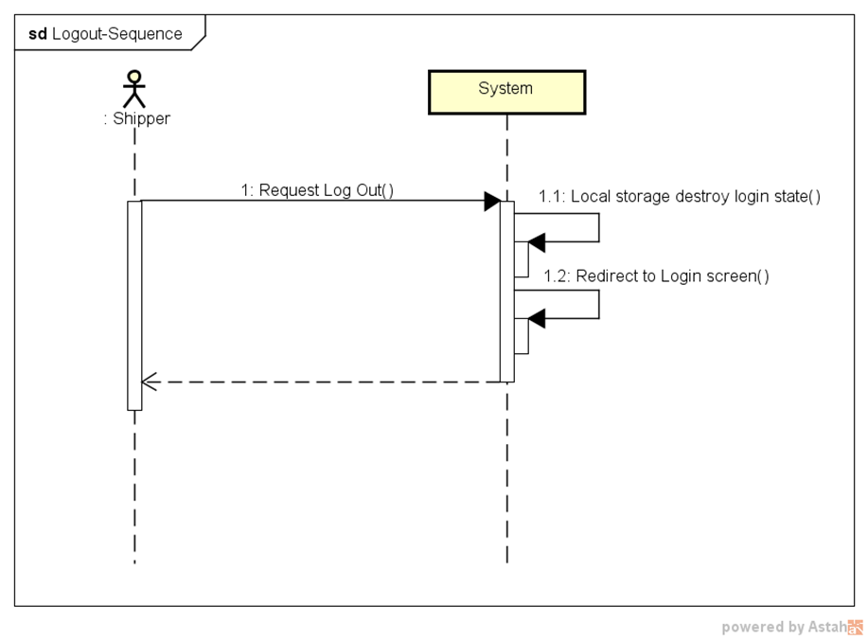**Sequence Diagram:**

###### *UC-303:* *Forgot password*

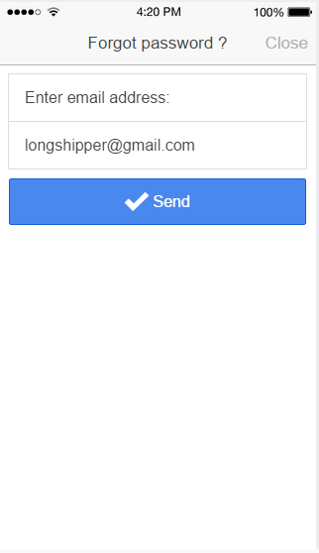

|  |  |  |  |  |
| --- | --- | --- | --- | --- |
| Use Case ID: | | UC-303 | | |
| Use Case Name: | | Forgot password | | |
| Created By: | | QuyenNV | Last Updated By: | QuyenNV |
| Date Created: | | 19/09/2015 | Date Last Updated: | 30/09/2015 |
| Actor: | | Shipper | | |
| Description: | | * When shipper wants to login into system but they forgot their password. Shipper wants reset their password. They will receive a new password via their email address. | | |
| Triggering event | | * Shipper forgot password and they wants to reset their password. | | |
| Preconditions: | | * To have internet connection through device. * Shipper haven’t logged in to the system yet. * On “Login” screen | | |
| Post - conditions: | | * New password is sent to email of shipper | | |
| Priority: | | High | | |
| Frequency of Use: | | Sometime | | |
| **Main flow** | | | | |
| Step | Actor | Action | | |
|  | Shipper | Click “Forgot password” | | |
|  | System | A new page ‘Forgot password’ appears. | | |
|  | Shipper | Enter email address used for registration. Shipper clicks the [Send] button. | | |
|  | System | Validate Email Address. | | |
|  | System | Send new password via email address of shipper | | |
|  | System | The page is refreshed. The message is displayed: “New passwords has been sent to your email” | | |
| **Alternative Flows:** | | N/A | | |
| **Exceptions:** | | | | |
| EC1 | At step 4, if email is invalid | | | |
| Step | Actor | Action | | |
| 4.1 | System | Notify in screen with error message “ Your email is invalid. Please enter try again.” | | |
| **Includes:** | | N/A | | |
| **Special Requirements:** | | **Email Address:** A string from 1 to 244 characters in length, can contain any kind of characters, followed by “@gmail.com”. (Ex: longshipper@gmail.com). Cannot be null. | | |
| **Notes and Issues:** | | N/A | | |

**Sequence Diagram**

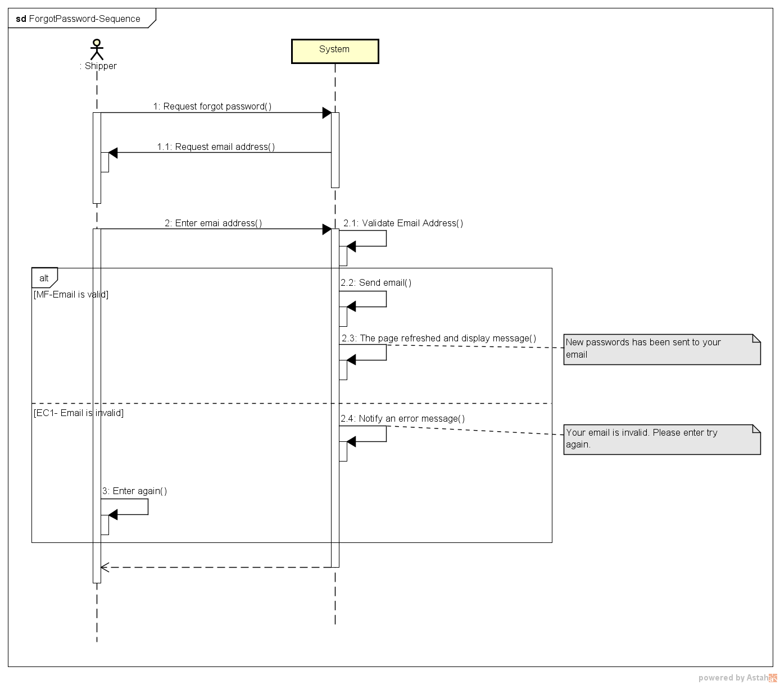

###### *UC-304:* *Change password*

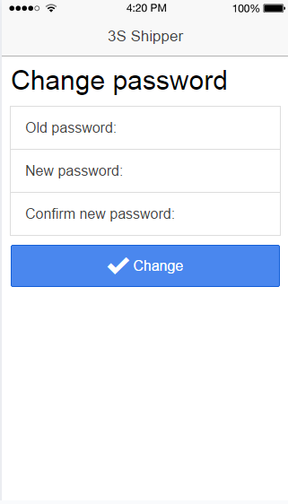

|  |  |  |  |  |
| --- | --- | --- | --- | --- |
| Use Case ID: | | UC-304 | | |
| Use Case Name: | | Change password | | |
| Created By: | | QuyenNV | Last Updated By: | QuyenNV |
| Date Created: | | 19/09/2015 | Date Last Updated: | 30/09/2015 |
| Actor: | | Shipper | | |
| Description: | | If shipper forgot their password and would like to change their password for security reasons. | | |
| Triggering event | | Shipper wants to change password. | | |
| Preconditions: | | * To have internet connection through device * To be logged in the system * Switch to “Profile” screen | | |
| Post - conditions: | | * New password stored in database. Shipper changes password is successfully | | |
| Priority: | | High | | |
| Frequency of Use: | | Sometime | | |
| **Main flow** | | | | |
| Step | Actor | Action | | |
|  | Shipper | Click “Change Password” button | | |
|  | System | “Change Password” screen shows up. | | |
|  | Shipper | Enter required information (Old Password, new password, confirm new password) and click “Change” button. | | |
|  | System | Validate input information. | | |
|  | System | Update new password of this account to database and redirect to the “Profile” screen. | | |
| **Alternative Flows:** | | N/A | | |
| **Exceptions:** | | | | |
| EC1 | At step 4, if any field is incorrect format or blank | | | |
| Step | Actor | Action | | |
| 4.1 | System | Notify in screen with a message “Please fill out all field” on “Change Password” screen. | | |
| EC2 | At step 4, if shipper provides new password doesn’t match the confirm password | | | |
| Step | Actor | Action | | |
| 4.1 | System | Display an error message “Password doesn't match the confirmation” on “Change password” screen. | | |
| **Includes:** | | N/A | | |
| **Special Requirements:** | | **Old Password:** Cannot be null.  **New Password:** Minimum of password is 7 character and needs at least one number.  **Re-Enter Password**: Cannot be null. | | |
| **Notes and Issues:** | | N/A | | |

Sequence Diagram:

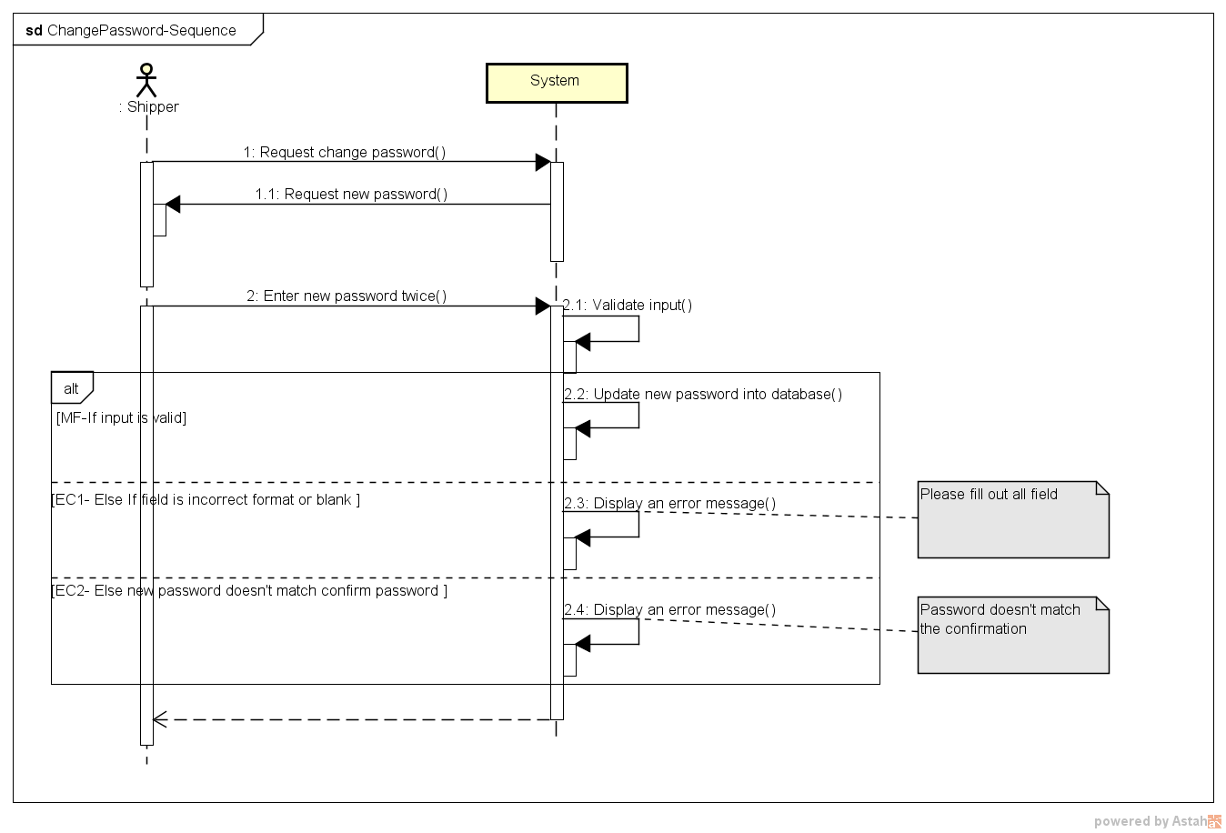

###### *UC-305:* *View Profile*

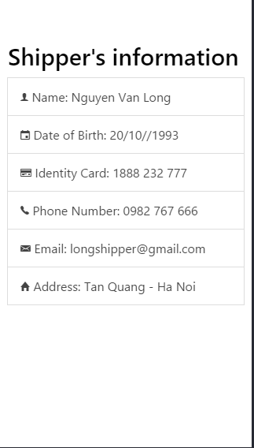

|  |  |  |  |  |
| --- | --- | --- | --- | --- |
| **Use Case ID:** | | UC-005 | | |
| **Use Case Name:** | | View Profile | | |
| **Created By:** | | QuyenNV | **Last Updated By:** | QuyenNV |
| **Date Created:** | | 19/09/2015 | **Date Last updated:** | 30/09/2015 |
| **Actor:** | | Shipper | | |
| **Description:** | | Shipper can view his/her information. Such as Name, Date of Birth, Identity Card, Phone Number, Email, Address. | | |
| **Triggering event** | | Shipper wants to view Profile | | |
| **Preconditions:** | | * To have internet connection through a device * To be logged in the system | | |
| **Post conditions:** | | The information of current logged in will appear in the [Profile] screen. | | |
| **Priority:** | | High | | |
| **Frequency of Use:** | | Sometime | | |
| **Main flow** | | | | |
| Step | Actor | Action | | |
| 1 | Shipper | Click “Profile” button in left navigate bar | | |
| 2 | System | Load information of shipper and Display “Profile” screen | | |
| **Alternative Flows:** | | **N/A** | | |
| **Exceptions:** | | | | |
| **Includes:** | | N/A | | |
| **Special Requirements:** | | N/A | | |
| **Notes and Issues:** | | N/A | | |

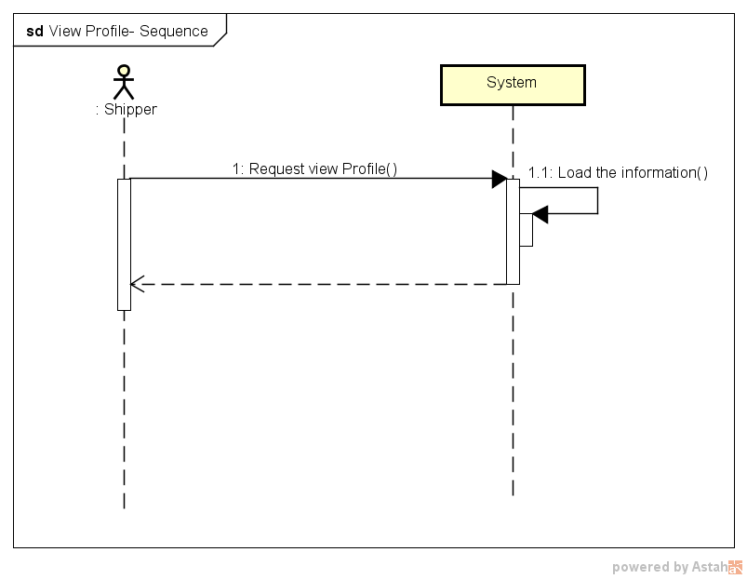**Sequence Diagram:**

###### *UC-306:* *Update Profile*

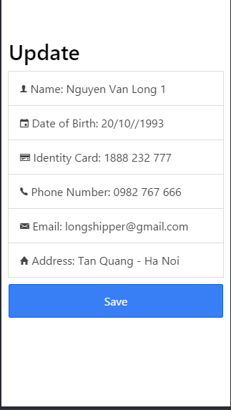

|  |  |  |  |  |
| --- | --- | --- | --- | --- |
| **Use Case ID:** | | UC-006 | | |
| **Use Case Name:** | | Update Profile | | |
| **Created By:** | | QuyenNV | **Last Updated By:** | QuyenNV |
| **Date Created:** | | 19/09/2015 | **Date Last updated:** | 30/09/2015 |
| **Actor:** | | Shipper | | |
| **Description:** | | When Shipper change personal information. They can modify their related information (Email, Date of Birth, Phone Number, Identity Card, Address) | | |
| **Triggering event** | | Shipper wants to update profile | | |
| **Preconditions:** | | * To have internet connection through a device * To be logged in the system * Switch to [Profile] screen. | | |
| **Post conditions:** | | Update new information in database. Update Profile is successfully. | | |
| **Priority:** | | Low | | |
| **Frequency of Use:** | | Sometime | | |
| **Main flow** | | | | |
| Step | Actor | Action | | |
| 1 | Shipper | Click [Edit Profile] button | | |
| 2 | System | Display [Edit profile] screen | | |
| 3 | Shipper | Enter required information (Name, Email, Phone Number, Identity Card, Date of Birth, Address) | | |
| 5 | System | Validate input | | |
| 6 | System | Store new information of Shipper into database | | |
| 7 | System | Display an success message “ Your profile has been updated successfully” | | |
| **Alternative Flows:** | | **N/A** | | |
| **Exceptions:** | | | | |
| EC1 | At step 5 | If any required field is not entered | | |
| Step | Actor | Action | | |
| 5.1 | System | Notify an error message “*is require” | | |
| **Includes:** | | N/A | | |
| **Special Requirements:** | | N/A | | |
| **Notes and Issues:** | | N/A | | |

Sequence Diagram:

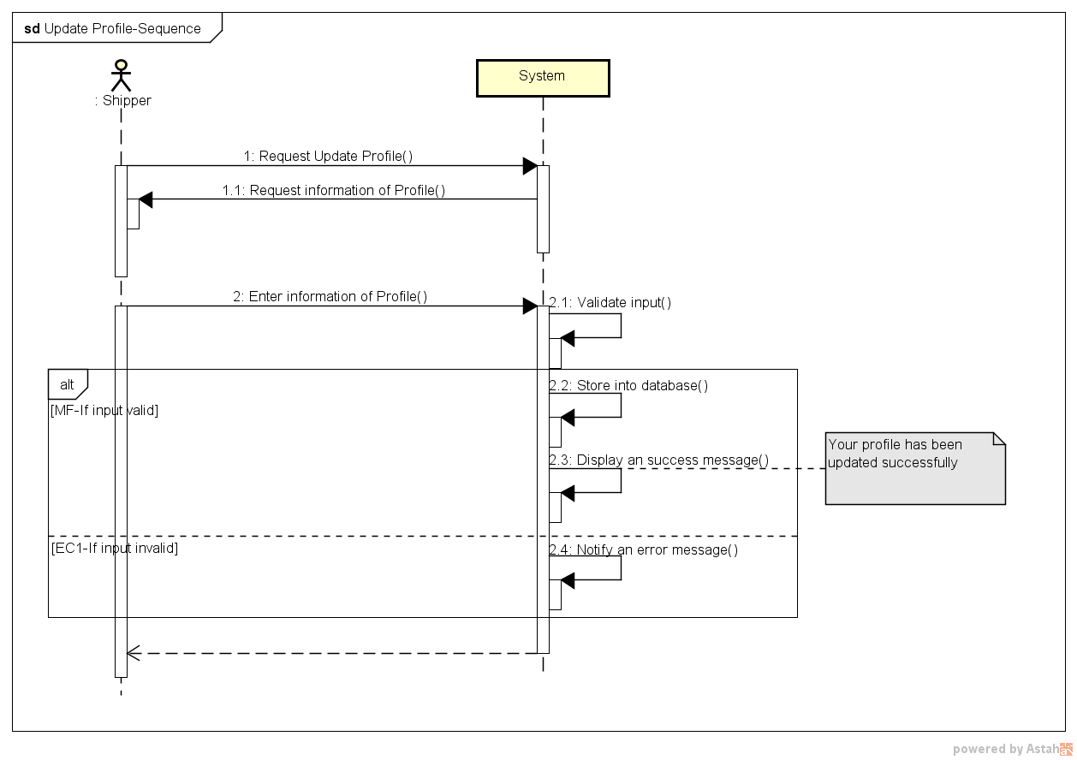

###### *UC-307:* *Confirm Code*

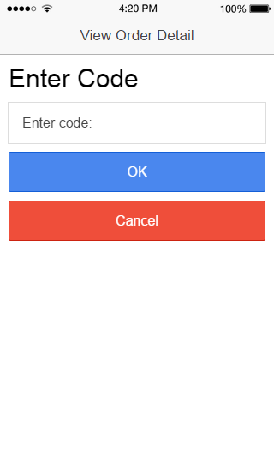

|  |  |  |  |  |
| --- | --- | --- | --- | --- |
| **Use Case ID:** | | UC-007 | | |
| **Use Case Name:** | | Confirm Code | | |
| **Created By:** | | QuyenNV | **Last Updated By:** | QuyenNV |
| **Date Created:** | | 19/09/2015 | **Date Last updated:** | 30/09/2015 |
| **Actor:** | | Shipper | | |
| **Description:** | | When shipper goes to pick up order. Shipper have to provide confirmation which automatically generated by system. System auto generate confirmation code when create an order. Using a confirmation code to avoid wrong order or wrong place. | | |
| **Triggering event** | | Shipper wants to confirm order, store. Shipper needs to enter confirmation code. | | |
| **Preconditions:** | | * To have internet connection through a device * To be logged in the system * Switch to [View Order’s Details] screen. | | |
| **Post conditions:** | | Order’s Code is confirmed | | |
| **Priority:** | | High | | |
| **Frequency of Use:** | | Always | | |
| **Main flow** | | | | |
| Step | Actor | Action | | |
| 1. | Shipper | Click [Enter Code] button | | |
| 2. | System | Display [Enter Code] screen | | |
| 3. | Shipper | Enter code which be provided by customer and click “Enter” button. | | |
| 4. | System | Queries the Order database | | |
| 5. | System | Display an success message on [View Order’s Details] screen | | |
| **Alternative Flows:** | | **N/A** | | |
| **Exceptions:** | | | | |
| EC1 | At step 2, if Shipper doesn’t enter confirmation code. | | | |
| Step | Actor | Action | | |
| 2.1 | Shipper | Taps on “Cancel” button | | |
| 2.2 | System | Display “View Order’s Detail” screen | | |
| EC2 | At step 4, if code in Order database does not exist or Order cannot establish a connection to the database due to some reasons (ex: network failure). | | | |
| Step | Actor | Action | | |
| 4.1 | System | An error message will show up on screen to tell the shipper about the problem | | |
| EC3 | At step 4, Order cannot establish a connection to the database due to some reasons (ex: network failure). | | | |
| Step | Actor | Action | | |
| 4.1 | System | Display a popup message “Your network connection failed. Please check your network connection and try again” will show up on screen to tell the shipper about the problem. | | |
| **Includes:** | | N/A | | |
| **Special Requirements:** | | N/A | | |
| **Notes and Issues:** | | N/A | | |

**Sequence Diagram:**

