# User Case Diagram

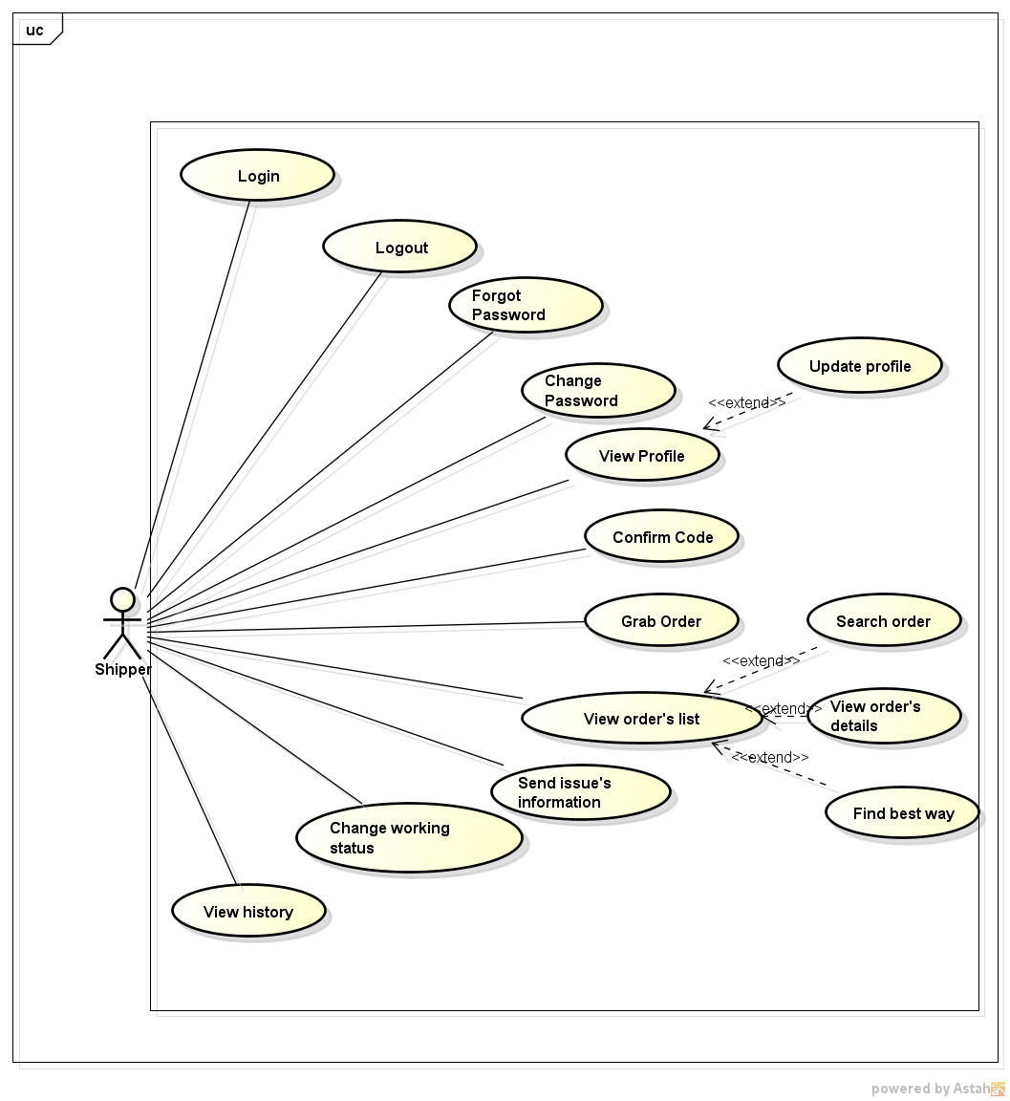

# 2. Function

## 2.1. Login

|  |  |  |  |
| --- | --- | --- | --- |
| Use Case ID: | UC-03 | | |
| Use Case Name: | Login | | |
| Created By: | QuyenNV | Last Updated By: |  |
| Date Created: | 19/09/2015 | Date Last Updated: |  |
| Actor: | Shipper | | |
| Description: | Shipper login to mobile application. | | |
| Preconditions: | Internet connection is established. | | |
| Post - conditions: | The shipper’s session is stored. | | |
| Priority: | High | | |
| Frequency of Use: | Sometime | | |
| Normal Course of Events: | 1. Retrieve [Login] screen for shipper. 2. Mobile application provides access information (username and password). 3. The shipper information is then passed to the System. 4. The system check Shipper database. 5. The system accepted or rejects the login request. 6. If login request is accepted shipper will be redirected to the Screen search. 7. If login request is rejected an error message will show up and shipper can provide his or her access credential again. | | |
| Alternative Courses: |  | | |
| Exceptions: | In step 4, if Shipper cannot establish a connection to the database due to some reasons (ex: network failure) an error message will show up to tell the shipper about the problem. | | |
| Includes: | N/A | | |
| Special Requirements: | N/A | | |
| Assumptions: | N/A | | |
| Notes and Issues: | The content of the error messages will be decided by developers. | | |