


MINISTRY OF SCIENCE AND TECHNOLOGY
POSTS AND TELECOMMUNICATIONS INSTITUTE OF TECHNOLOGY

----------
Assignment 06
Lecturer : Tran Dinh Que
Class : E23TTTN02
Group : 03
Student Name : Lê Huy Hoàng
Student ID : B23DCVT171

Hà Nội, Tháng 3/2024

- Task 1: Requirements Analysis
- Actors
Customer – The main user who searches for products and orders and views returned results.
- Functional Requirements
- Search products by keyword/text.
- Search products by voice.
- Search products by image.
- Search orders.
- View product information.
- View order information.
- Non-Functional Requirements
- Usability: The system should be easy to use.
- Performance: Search results should be returned quickly.
- Maintainability: Components should be easy to modify and maintain.
- Extensibility: New search methods or AI models can be added.
- Modularity: UI, application logic, and data access should be separated.
- Input Modalities
Mode | Input | Processing
Text | Keyword or natural-language query | Text search
Voice | Voice/audio query | Speech-to-text → text search
Image | Product image | Image similarity search

- Search Outputs
- Product Search: A list of relevant products with product information.
- Order Search: Order information such as order ID, status, and total amount.
- Task 2: Use Case Diagram
- Actor: Customer: The main user who interacts with the system to search for products and orders and view related information.
- Main Use Cases
- Search Product: Allows the customer to search for products.
- Search products by keyword/text: Searches for products using keywords or natural-language text.
- Search products by voice: Searches for products using voice input.
- Search products by image: Searches for visually similar products using an image.
- Search Order: Allows the customer to search for order information.
- View product information: Allows the customer to view product details.
- View order information: Allows the customer to view order details.
- Relationships
- The Customer has direct associations with:
  - Customer → Search Product
  - Customer → Search Order
  - Customer → View product information
  - Customer → View order information
- Search Product is a general use case with three specialized search methods:
  - Search products by keyword/text → Search Product
  - Search products by voice → Search Product
  - Search products by image → Search Product
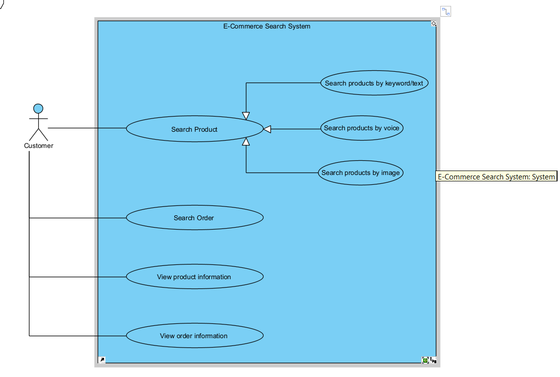
- Task 3: Three-Layer Architecture
The system is organized into three layers: Presentation Layer, Application / Intelligence Layer, and Data Layer. Each layer has a separate responsibility, and the dependencies follow the direction:
Presentation Layer → Application / Intelligence Layer → Data Layer.
- Presentation Layer: contains SearchUI, VoiceInput, ImageUpload, and SearchResultView. This layer receives user input and displays the returned search results.
- Application / Intelligence Layer : contains QueryService, SpeechService, ImageService, SearchService, and RankingService. This layer processes different input types, creates a common query representation, retrieves relevant data, and ranks the results.
- Data Layer : contains ProductRepository, OrderRepository, VectorIndex, ProductDatabase, OrderDatabase, and ImageStorage. This layer stores and provides access to product, order, image, and vector data.
- Main Interaction Flows
- Text Search Flow
  - SearchUI → QueryService → SearchService → ProductRepository → ProductDatabase
  - The user enters a text query through SearchUI. QueryService creates the query representation, and SearchService retrieves matching products from ProductRepository.
- Voice Search Flow
  - VoiceInput → SpeechService → QueryService → SearchService → ProductRepository
  - VoiceInput receives the user's voice input. SpeechService converts it into text, then QueryService creates the query representation and sends it to SearchService. This follows the voice-search process described in the assignment.
- Image Search Flow
  - ImageUpload → ImageService → QueryService → SearchService → VectorIndex
  - The user uploads an image through ImageUpload. ImageService processes the image, while QueryService creates the image-query representation. SearchService then uses VectorIndex to retrieve similar products. ImageService can also access ImageStorage for image data.
- Order Search Flow
  - SearchUI → QueryService → SearchService → OrderRepository → OrderDatabase
  - The system processes the order query and retrieves order information through OrderRepository.
- Ranking Flow
  - SearchService → RankingService
  - After relevant candidates are retrieved, RankingService ranks them before the results are presented to the user. The assignment explicitly separates retrieval from ranking.
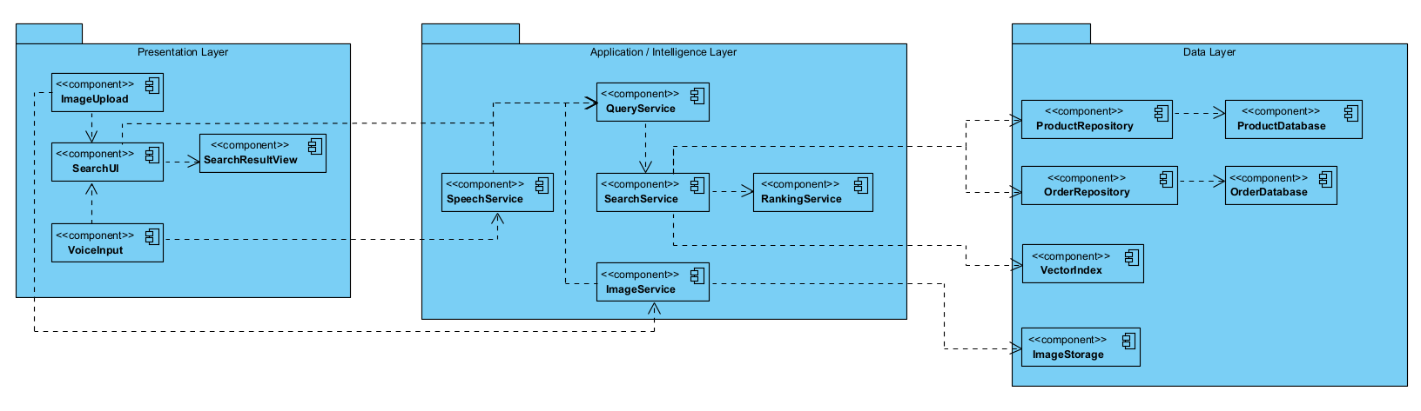
- Task 4: Sequence Diagram
The Sequence Diagram describes the interaction when a Customer searches for a product using voice input. The diagram contains the required participants: Customer, SearchUI, SpeechService, QueryService, SearchService, ProductRepository, and RankingService.
- Participants
Participant | Responsibility
Customer | Provides the voice query and receives the results.
SearchUI | Receives user input and displays search results.
SpeechService | Converts voice input into text.
QueryService | Creates a query representation from the transcribed text.
SearchService | Retrieves relevant products.
ProductRepository | Provides product data for the search process.
RankingService | Ranks the retrieved product candidates.
- Interaction Flow
- 1. The Customer provides voice input to SearchUI.
- 2. SearchUI sends the audio input to SpeechService.
- 3. SpeechService converts the voice input into text and returns it.
- 4. SearchUI sends the text to QueryService to create a voice query representation.
- 5. QueryService returns the generated query.
- 6. SearchUI sends the query to SearchService.
- 7. SearchService retrieves products from ProductRepository.
- 8. ProductRepository returns the candidate products.
- 9. SearchService sends the candidates to RankingService.
- 10. RankingService ranks the candidates and returns the ranked results.
- 11. SearchService returns the results to SearchUI.
- 12. SearchUI displays the results to the Customer.
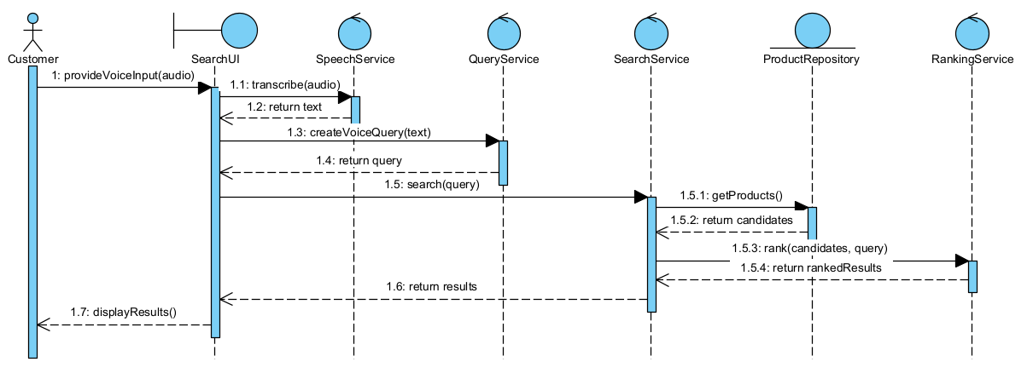
- Task 5: Python Implementation
The Python prototype implements the five required functions using three layers: presentation for input and output, application for search and ranking, and data for storage. main.py creates the repositories and services and connects them to SearchUI.
main.py connects the data repositories and application services to SearchUI. The listings below contain the relevant project methods; imports and other helper methods remain in their source files.
CodePython/main.py — build_ui
def build_ui():
"""Tạo kho dữ liệu và các service, sau đó truyền chúng vào SearchUI."""
repository = ProductRepository()
vector_index = VectorIndex(repository.all_products())
# Console và web dùng chung các thành phần này để thống nhất cách tìm kiếm.
return SearchUI(
QueryService(),
SpeechService(),
SearchService(repository, vector_index, ImageService()),
RankingService(),
)
1 Product repository
- ProductRepository locates products.json beside its source file and loads the 20 product records.
- It validates each record and rejects duplicate IDs before building an ID lookup dictionary.
- Search services receive independent copies through all_products() or find_by_id(); data remains in local JSON.
CodePython/data/product_repository.py — ProductRepository: __init__, _validate_product, all_products, find_by_id
def __init__(self, data_path=None):
"""Đọc products.json mặc định hoặc file được chỉ định và kiểm tra dữ liệu."""
# Lấy đường dẫn theo vị trí file Python để chạy từ folder nào cũng được.
self.data_path = (
Path(data_path) if data_path is not None
else Path(__file__).resolve().with_name("products.json")
)
try:
with self.data_path.open(encoding="utf-8") as source:
products = json.load(source)
except FileNotFoundError as exc:
raise FileNotFoundError(
f"Product data file not found: {self.data_path}"
) from exc
except (json.JSONDecodeError, UnicodeDecodeError) as exc:
raise ValueError(f"Invalid product JSON: {self.data_path}: {exc}") from exc
if not isinstance(products, list):
raise ValueError("Product data must be a JSON list.")
# Kiểm tra từng bản ghi và cấm ID trùng trước khi lập bảng tra cứu.
seen = set()
for position, product in enumerate(products, start=1):
self._validate_product(product, position)
product_id = product["id"]
if product_id in seen:
raise ValueError(f"Duplicate product id: {product_id}")
seen.add(product_id)
self._products = products
# Dictionary giúp tra theo ID mà không phải duyệt toàn bộ danh sách.
self._by_id = {product["id"]: product for product in products}
@staticmethod
def _validate_product(product, position):
"""Kiểm tra ID, tên/danh mục/màu, giá, tồn kho và từ khóa bổ sung."""
prefix = f"Product record {position}"
if not isinstance(product, dict):
raise ValueError(f"{prefix} must be an object.")
product_id = product.get("id")
if not isinstance(product_id, int) or isinstance(product_id, bool):
raise ValueError(f"{prefix} must have an integer id.")
for field in ("name", "category", "color"):
value = product.get(field)
if not isinstance(value, str) or not value.strip():
raise ValueError(f"{prefix}: {field} must be a nonempty string.")
# Giá phải hữu hạn và không âm; bool không được coi là số giá hợp lệ.
price = product.get("price")
try:
valid_price = (
isinstance(price, (int, float)) and not isinstance(price, bool)
and math.isfinite(price) and price >= 0
)
except OverflowError:
valid_price = False
if not valid_price:
raise ValueError(f"{prefix}: price must be a finite nonnegative number.")
stock = product.get("stock")
if not isinstance(stock, int) or isinstance(stock, bool) or stock < 0:
raise ValueError(f"{prefix}: stock must be a nonnegative integer.")
terms = product.get('search_terms', [])
if not isinstance(terms, list) or any(not isinstance(term, str) for term in terms):
raise ValueError(f"{prefix}: search_terms must be a list of strings.")
def all_products(self):
"""Trả bản sao sâu để nơi gọi không sửa nhầm dữ liệu gốc trong kho."""
return deepcopy(self._products)
def find_by_id(self, product_id):
"""Trả bản sao sản phẩm theo ID hoặc None khi ID không có trong kho."""
product = self._by_id.get(product_id)
return deepcopy(product) if product is not None else None
2 Text search
- SearchUI receives the text; QueryService trims it and creates a query with type text.
- SearchService lowercases the query, maps known Vietnamese category phrases, and matches words against names, categories, colors, and search terms.
- Each matching word adds one point. Nonmatching products are excluded; the shared ranking and display flow handles the candidates.
CodePython/application/query_service.py — QueryService: _normalize_text, text_query
@staticmethod
def _normalize_text(text):
"""Kiểm tra kiểu chuỗi và bỏ khoảng trắng thừa ở hai đầu."""
if not isinstance(text, str):
raise ValueError("Text and voice queries must be strings.")
return text.strip()
def text_query(self, text):
"""Gắn loại text cho nội dung tìm kiếm đã được kiểm tra."""
return {"type": "text", "query": self._normalize_text(text)}
CodePython/application/search_service.py — SearchService: search_text
def search_text(self, query_text):
"""Mỗi từ truy vấn khớp chuỗi thông tin sản phẩm đóng góp một điểm."""
if not isinstance(query_text, str):
raise ValueError("Text search query must be a string.")
normalized = query_text.lower()
# Đổi cụm danh mục tiếng Việt sang tiếng Anh trước khi tách từ.
# Dùng ranh giới từ để "ban phim" không bị khớp nhầm với "bang".
aliases = {'điện thoại': 'phone', 'dien thoai': 'phone',
'máy tính bảng': 'tablet', 'may tinh bang': 'tablet',
'máy tính xách tay': 'laptop', 'may tinh xach tay': 'laptop',
'bàn phím': 'keyboard', 'ban phim': 'keyboard',
'chuột': 'mouse', 'chuot': 'mouse',
'phụ kiện': 'accessory', 'phu kien': 'accessory'}
for phrase, category in aliases.items():
normalized = re.sub(r'(?<!\w)' + re.escape(phrase) + r'(?!\w)', category, normalized)
words = normalized.split()
if not words:
return []
candidates = []
# Tìm trong tên, danh mục, màu và từ khóa bổ sung; đây là khớp chuỗi con,
# chưa phải tìm kiếm ngữ nghĩa hay phân tích điều kiện giá trong câu.
for product in self.repository.all_products():
searchable = " ".join(
product[field] for field in ("name", "category", "color")
).lower() + " " + " ".join(product.get("search_terms", [])).lower()
score = sum(word in searchable for word in words)
# Chỉ trả sản phẩm khớp ít nhất một từ; chưa sắp xếp ở bước này.
if score > 0:
candidates.append((product, float(score)))
return candidates
CodePython/presentation/search_ui.py — SearchUI: search_text
def search_text(self, text, top_k=None):
"""Tạo truy vấn text và báo lỗi đầu vào thân thiện thay vì in traceback."""
print("\n=== TEXT SEARCH ===")
print("Processing mode: Text")
print("Input:", text)
try:
query = self.query_service.text_query(text)
return self._retrieve_rank_display(query, top_k=top_k)
except (ValueError, TypeError) as exc:
print(f"Validation error: {exc}")
return []
3 Simulated voice search
- SearchUI accepts an already-transcribed string, such as "find laptop"; no audio is recorded.
- SpeechService checks that the input is text and returns it unchanged; QueryService creates a voice query.
- SearchService processes voice queries through the text-search algorithm, then the shared flow ranks and displays the products.
CodePython/application/speech_service.py — SpeechService: transcribe
def transcribe(self, audio_input):
"""Kiểm tra đầu vào rồi trả nguyên văn bản phiên âm, không nhận dạng âm thanh."""
if not isinstance(audio_input, str):
raise ValueError("Simulated voice input must be already-transcribed text.")
return audio_input
CodePython/application/query_service.py — QueryService: voice_query
def voice_query(self, text):
"""Gắn loại voice cho văn bản phiên âm do SpeechService trả về."""
return {"type": "voice", "query": self._normalize_text(text)}
CodePython/presentation/search_ui.py — SearchUI: search_voice
def search_voice(self, audio_input, top_k=None):
"""Mô phỏng phiên âm, tạo truy vấn voice rồi chạy luồng tìm kiếm chung."""
print("\n=== VOICE SEARCH ===")
print("Processing mode: Voice (simulated speech-to-text)")
print("Voice input:", audio_input)
try:
text = self.speech_service.transcribe(audio_input)
print("Transcribed text:", text)
query = self.query_service.voice_query(text)
return self._retrieve_rank_display(query, top_k=top_k)
except (ValueError, TypeError) as exc:
print(f"Validation error: {exc}")
return []
4 Image similarity search
- QueryService validates a manually supplied vector. VectorIndex provides the artificial product vectors stored in products.json.
- SearchService checks the dimension and retrieves each indexed product; ImageService calculates cosine similarity for each vector pair.
- The shared flow ranks the similarity scores and displays the products. A zero vector scores 0; no photo features are extracted.
CodePython/application/query_service.py — QueryService: image_query
def image_query(self, embedding):
"""Kiểm tra vector số trước khi tạo truy vấn loại image."""
return {"type": "image", "embedding": normalize_embedding(embedding)}
CodePython/application/image_service.py — ImageService: cosine_similarity
def cosine_similarity(self, a, b):
"""Tính cosine trong khoảng [-1, 1]; vector toàn số 0 trả điểm 0."""
left = np.asarray(normalize_embedding(a), dtype=np.float64)
right = np.asarray(normalize_embedding(b), dtype=np.float64)
if left.size != right.size:
raise ValueError(
f"Embedding dimension mismatch: {left.size} and {right.size}."
)
# Chia theo phần tử lớn nhất trước để tránh tràn hoặc hụt số
# khi tính tích vô hướng và độ dài với các giá trị quá lớn/nhỏ.
left_scale = float(np.max(np.abs(left)))
right_scale = float(np.max(np.abs(right)))
if left_scale == 0.0 or right_scale == 0.0:
return 0.0
left /= left_scale
right /= right_scale
# Đưa mỗi vector về độ dài 1, sau đó lấy tích vô hướng làm điểm cosine.
left /= np.linalg.norm(left)
right /= np.linalg.norm(right)
# Giới hạn kết quả để sai số số thực không vượt ra ngoài [-1, 1].
return float(np.clip(np.dot(left, right), -1.0, 1.0))
CodePython/application/search_service.py — SearchService: search_image
def search_image(self, query_embedding):
"""So sánh vector truy vấn với các vector sản phẩm có cùng số chiều."""
vector = normalize_embedding(query_embedding)
dimension = self.vector_index.dimension
if dimension is not None and len(vector) != dimension:
raise ValueError(
f"Image query dimension {len(vector)} does not match "
f"product embedding dimension {dimension}."
)
candidates = []
# Chỉ mục lưu ID và vector; lấy thông tin sản phẩm tương ứng từ repository.
for product_id, embedding in self.vector_index.all_embeddings().items():
product = self.repository.find_by_id(product_id)
if product is None:
continue
score = self.image_service.cosine_similarity(vector, embedding)
candidates.append((product, float(score)))
return candidates
CodePython/presentation/search_ui.py — SearchUI: search_image
def search_image(self, embedding, top_k=None):
"""Tìm bằng vector nhân tạo và hiển thị điểm với nhãn similarity."""
print("\n=== IMAGE SEARCH ===")
print("Processing mode: Image (artificial embedding; cosine similarity)")
print("Query embedding:", embedding)
try:
query = self.query_service.image_query(embedding)
return self._retrieve_rank_display(query, top_k=top_k, score_label="similarity")
except (ValueError, TypeError) as exc:
print(f"Validation error: {exc}")
return []
5 Result ranking and display
- SearchService returns (product, score) candidates; RankingService checks their structure and finite scores.
- Candidates are sorted by score in descending order. Equal scores retain their original order, and top_k limits the ranked list.
- SearchUI displays the product details and scores through a shared retrieval, ranking, and display method.
CodePython/application/ranking_service.py — RankingService: rank
def rank(self, candidates, top_k=None):
"""Kiểm tra các cặp (sản phẩm, điểm) rồi lấy tối đa top_k kết quả tốt nhất."""
if top_k is not None and (
not isinstance(top_k, int) or isinstance(top_k, bool) or top_k < 0
):
raise ValueError("top_k must be a nonnegative integer or None.")
try:
entries = list(candidates)
except TypeError as exc:
raise ValueError("Candidates must be an iterable of (product, score) pairs.") from exc
# Không cho phép điểm NaN/vô cực hoặc dữ liệu sai cấu trúc tham gia xếp hạng.
for candidate in entries:
if not isinstance(candidate, (tuple, list)) or len(candidate) != 2:
raise ValueError("Every candidate must be a (product, score) pair.")
score = candidate[1]
try:
valid_score = (
isinstance(score, Real) and not isinstance(score, bool)
and math.isfinite(score)
)
except OverflowError:
valid_score = False
if not valid_score:
raise ValueError("Candidate scores must be finite numbers.")
# sorted giữ thứ tự ban đầu của các phần tử đồng điểm (sắp xếp ổn định).
ranked = sorted(entries, key=lambda candidate: candidate[1], reverse=True)
return ranked if top_k is None else ranked[:top_k]
CodePython/presentation/search_ui.py — SearchUI: _retrieve_rank_display, display_results
def _retrieve_rank_display(self, query, top_k=None, score_label="score"):
"""Luồng dùng chung: tìm ứng viên → xếp hạng → hiển thị kết quả."""
candidates = self.search_service.search(query)
results = self.ranking_service.rank(candidates, top_k=top_k)
self.display_results(results, score_label=score_label)
return results
def display_results(self, results, top_k=None, score_label="score"):
"""In thông tin sản phẩm và điểm, hỗ trợ giới hạn số kết quả hiển thị."""
if not results:
print("No products found.")
return

displayed = results if top_k is None else results[:top_k]
for position, (product, score) in enumerate(displayed, start=1):
print(f"{position}. {product['name']}")
print(
f" category: {product['category']} | color: {product['color']}"
f" | price: {product['price']} | stock: {product['stock']}"
f" | {score_label}: {score:.4f}"
)
Implementation evidence
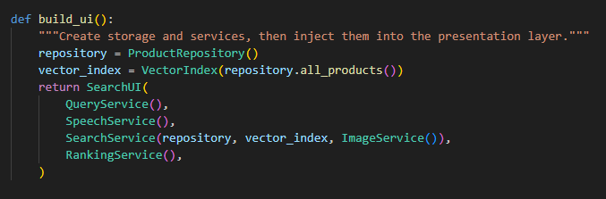
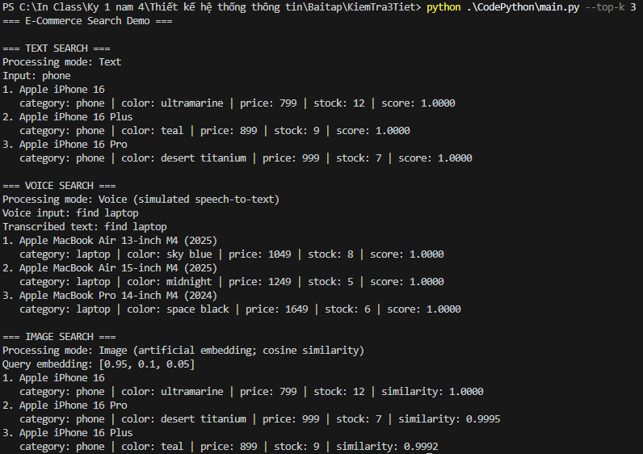
- Task 6: Demonstration
- Home
The home page displays all 20 products across phones, tablets, laptops, and accessories when no keyword is entered. Users can select a category or open product details. This is catalog browsing, so item numbers are shown instead of relevance scores.
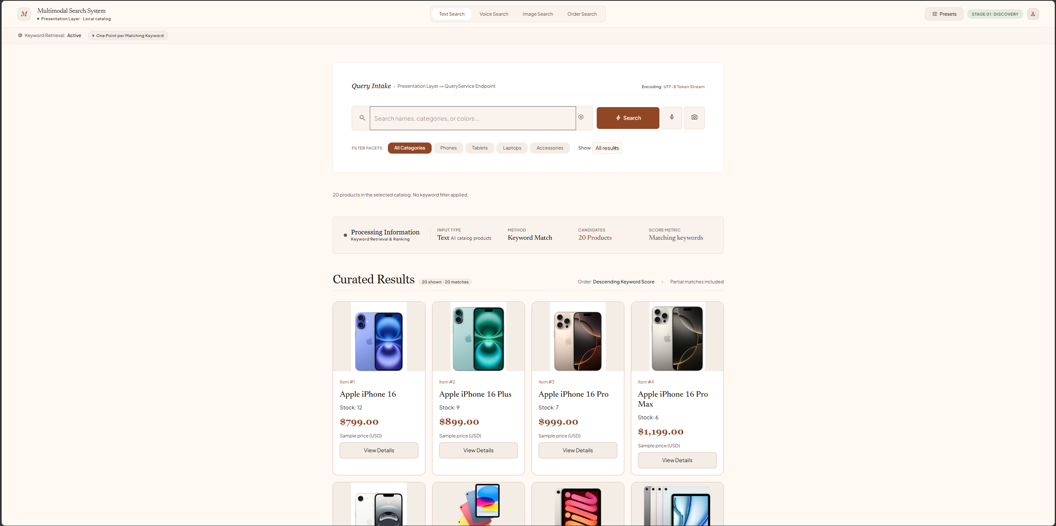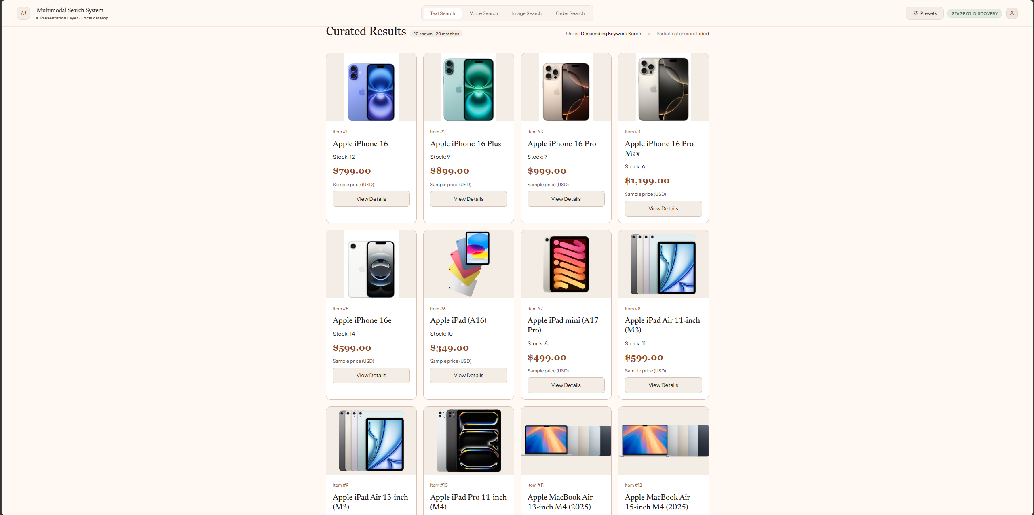
- Text search
Input: "tablet" with All Categories selected. The system lowercases the query and matches its words against product names, categories, colors, and search terms. Five tablets are returned: iPad (A16), iPad mini (A17 Pro), iPad Air 11-inch (M3), iPad Air 13-inch (M3), and iPad Pro 11-inch (M4). Each has a keyword score of 1.0000; ties retain catalog order.
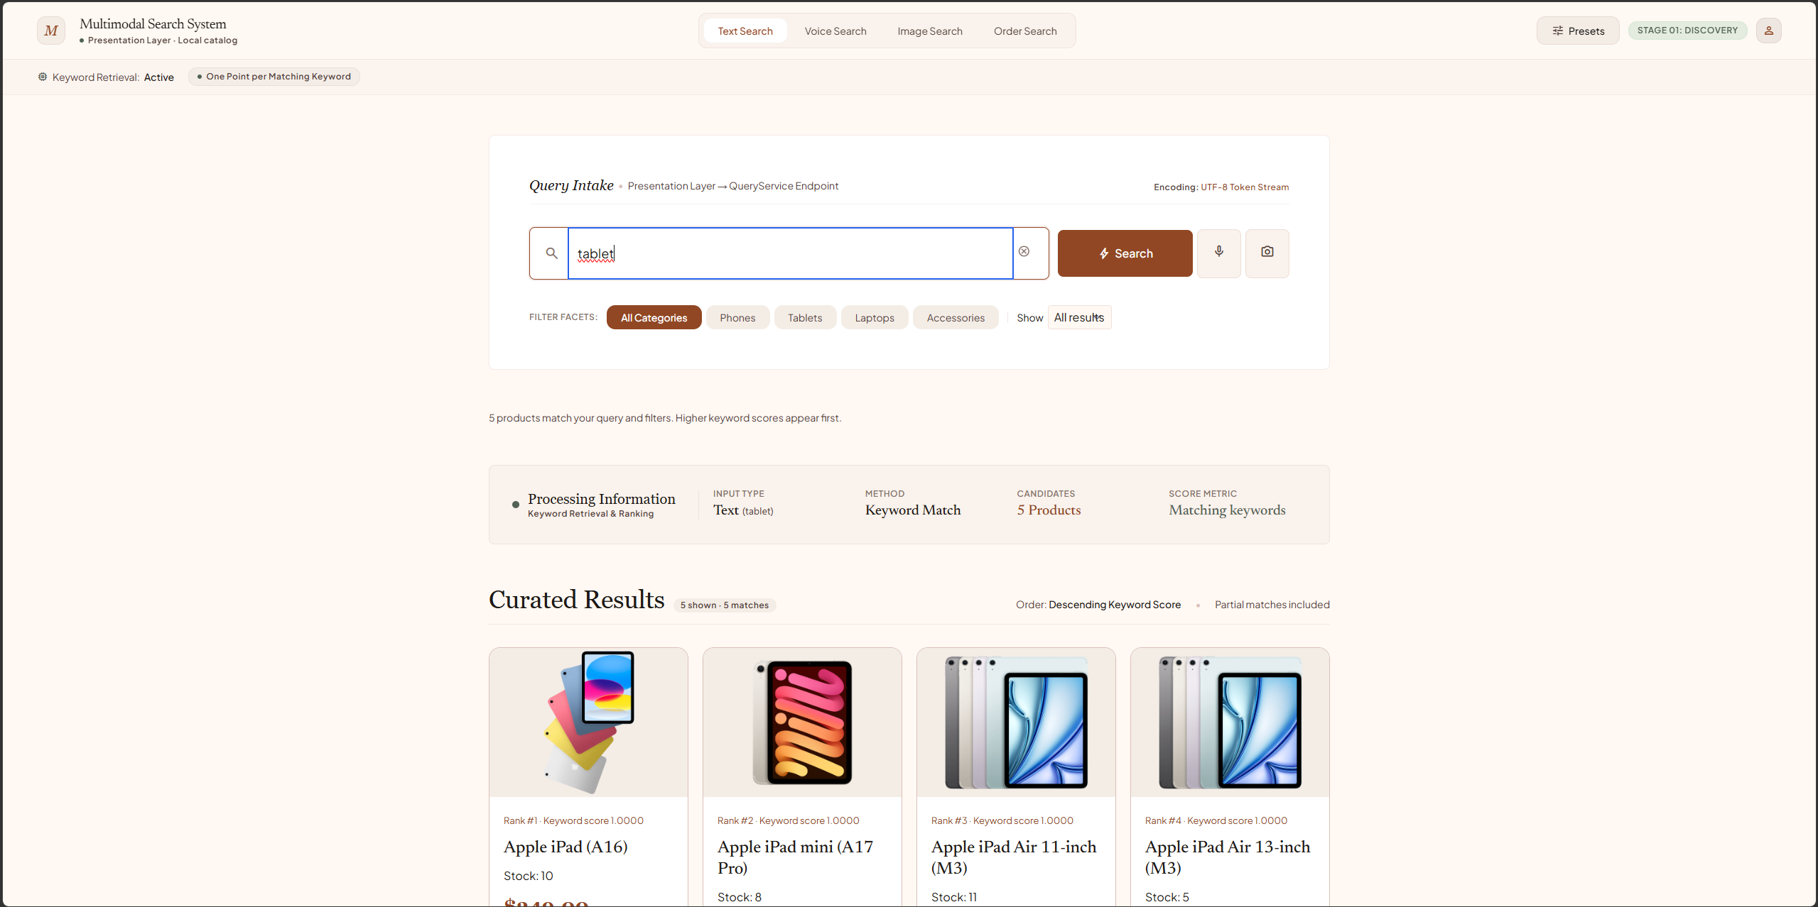
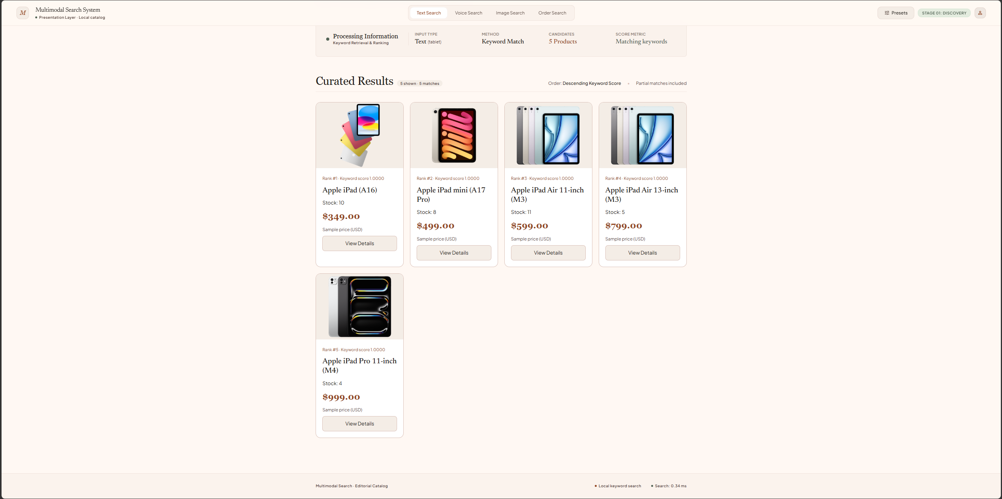
- Voice Search
Input: "find phone" entered as a simulated transcript. No microphone or real speech recognition is used; the transcript is passed to the text-search service. Five phones are returned, led by iPhone 16, iPhone 16 Plus, and iPhone 16 Pro. Each scores 1.0000 because "phone" matches the product category; "find" adds no points.
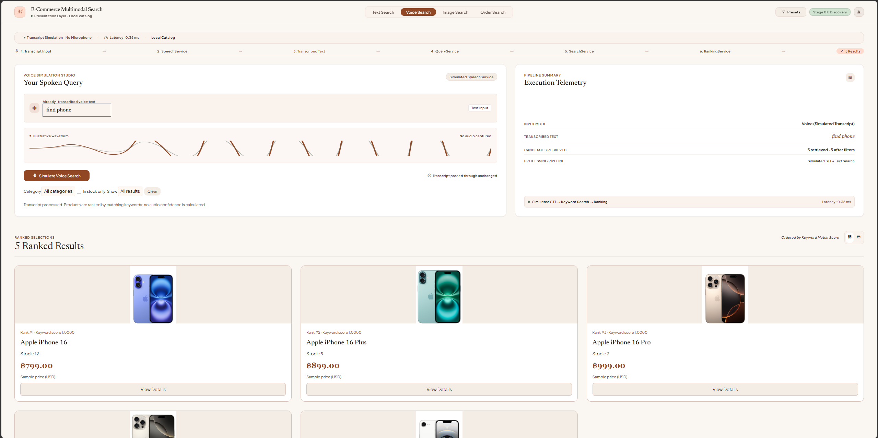
The next screenshot shows a separate laptop-search example: five laptops are returned, led by MacBook Air 13-inch (M4, 2025). All five have a keyword score of 1.0000.
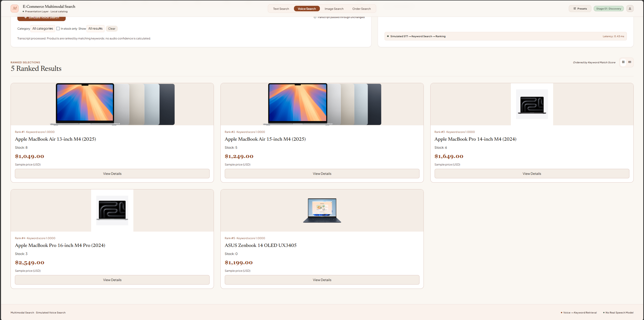

- Image search
Input: the iPhone 16 preset with vector [0.95, 0.1, 0.05]. The system compares this vector with all 20 product vectors using cosine similarity and ranks results in descending order. iPhone 16 ranks first (1.0000), followed by iPhone 16 Pro (0.9995) and iPhone 16 Plus (0.9992). These manually assigned three-dimensional vectors simulate image search; they are not extracted from the photos.
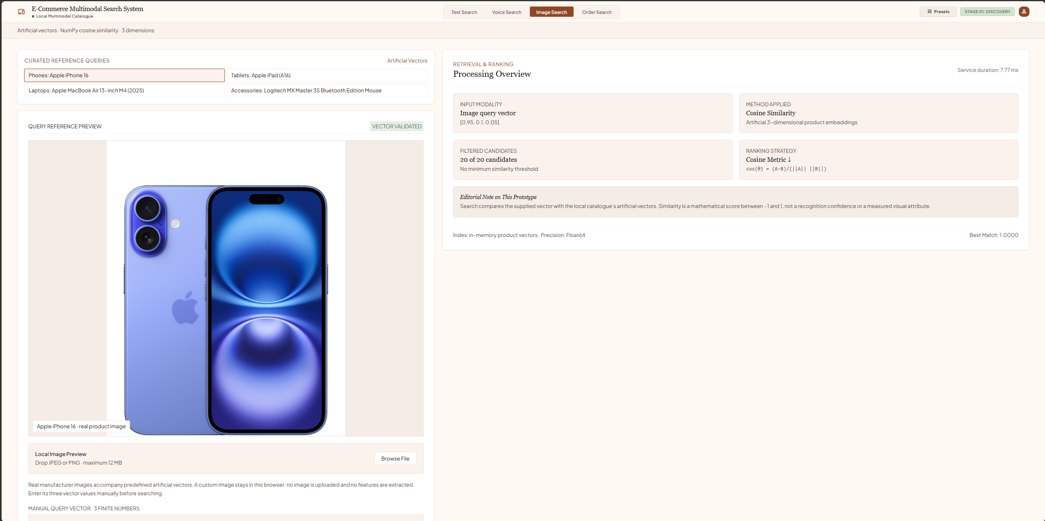
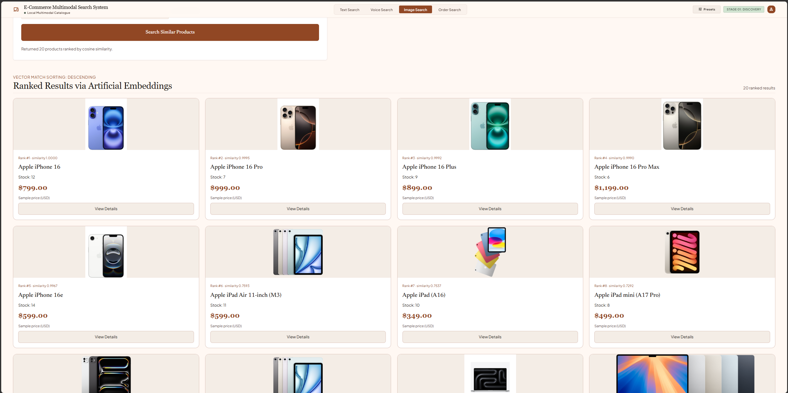
- Order
Input: order ID "O001". An exact ID lookup returns a Shipped sample order containing one iPhone 16 and two Logitech MX Master 3S mice. The subtotal is $989.00 and shipping is $5.00, giving a total of $994.00. This read-only order lookup does not use relevance scores or process a real payment.
