


MINISTRY OF SCIENCE AND TECHNOLOGY
POSTS AND TELECOMMUNICATIONS INSTITUTE OF TECHNOLOGY

----------
Assignment 06
Lecturer : Tran Dinh Que
Class : E23TTTN02
Group : 03
Student Name : Lê Huy Hoàng
Student ID : B23DCVT171

Hà Nội, Tháng 3/2024

- Task 1: Requirements Analysis
- Actors
Customer – The main user who searches for products and orders and views returned results.
- Functional Requirements
- Search products by keyword/text.
- Search products by voice.
- Search products by image.
- Search orders.
- View product information.
- View order information.
- Non-Functional Requirements
- Usability: The system should be easy to use.
- Performance: Search results should be returned quickly.
- Maintainability: Components should be easy to modify and maintain.
- Extensibility: New search methods or AI models can be added.
- Modularity: UI, application logic, and data access should be separated.
- Input Modalities
Mode | Input | Processing
Text | Keyword or natural-language query | Text search
Voice | Voice/audio query | Speech-to-text → text search
Image | Product image | Image similarity search

- Search Outputs
- Product Search: A list of relevant products with product information.
- Order Search: Order information such as order ID, status, and total amount.
- Task 2: Use Case Diagram
- Actor: Customer: The main user who interacts with the system to search for products and orders and view related information.
- Main Use Cases
- Search Product: Allows the customer to search for products.
- Search products by keyword/text: Searches for products using keywords or natural-language text.
- Search products by voice: Searches for products using voice input.
- Search products by image: Searches for visually similar products using an image.
- Search Order: Allows the customer to search for order information.
- View product information: Allows the customer to view product details.
- View order information: Allows the customer to view order details.
- Relationships
- The Customer has direct associations with:
  - Customer → Search Product
  - Customer → Search Order
  - Customer → View product information
  - Customer → View order information
- Search Product is a general use case with three specialized search methods:
  - Search products by keyword/text → Search Product
  - Search products by voice → Search Product
  - Search products by image → Search Product
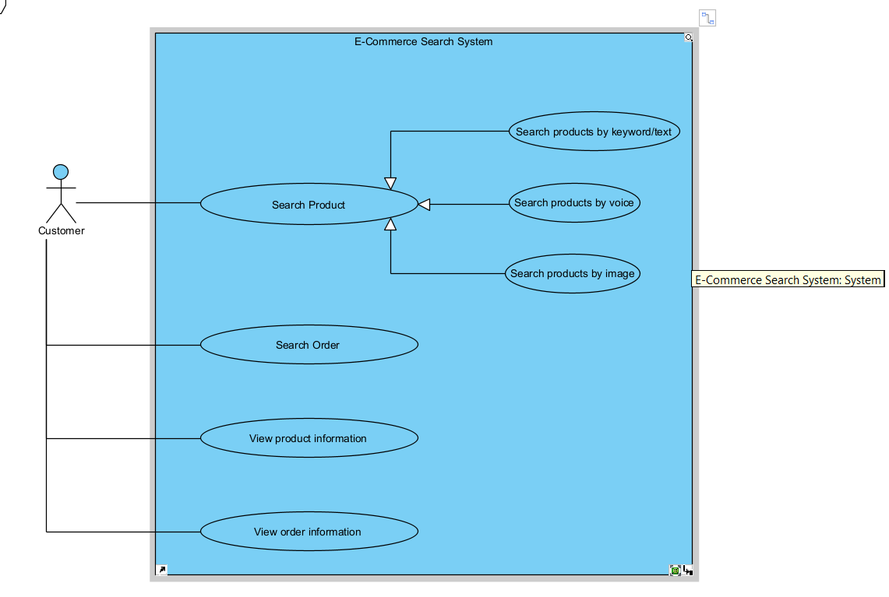
- Task 3: Three-Layer Architecture
The system is organized into three layers: Presentation Layer, Application / Intelligence Layer, and Data Layer. Each layer has a separate responsibility, and the dependencies follow the direction:
Presentation Layer → Application / Intelligence Layer → Data Layer.
- Presentation Layer: contains SearchUI, VoiceInput, ImageUpload, and SearchResultView. This layer receives user input and displays the returned search results.
- Application / Intelligence Layer : contains QueryService, SpeechService, ImageService, SearchService, and RankingService. This layer processes different input types, creates a common query representation, retrieves relevant data, and ranks the results.
- Data Layer : contains ProductRepository, OrderRepository, VectorIndex, ProductDatabase, OrderDatabase, and ImageStorage. This layer stores and provides access to product, order, image, and vector data.
- Main Interaction Flows
- Text Search Flow
  - SearchUI → QueryService → SearchService → ProductRepository → ProductDatabase
  - The user enters a text query through SearchUI. QueryService creates the query representation, and SearchService retrieves matching products from ProductRepository.
- Voice Search Flow
  - VoiceInput → SpeechService → QueryService → SearchService → ProductRepository
  - VoiceInput receives the user's voice input. SpeechService converts it into text, then QueryService creates the query representation and sends it to SearchService. This follows the voice-search process described in the assignment.
- Image Search Flow
  - ImageUpload → ImageService → QueryService → SearchService → VectorIndex
  - The user uploads an image through ImageUpload. ImageService processes the image, while QueryService creates the image-query representation. SearchService then uses VectorIndex to retrieve similar products. ImageService can also access ImageStorage for image data.
- Order Search Flow
  - SearchUI → QueryService → SearchService → OrderRepository → OrderDatabase
  - The system processes the order query and retrieves order information through OrderRepository.
- Ranking Flow
  - SearchService → RankingService
  - After relevant candidates are retrieved, RankingService ranks them before the results are presented to the user. The assignment explicitly separates retrieval from ranking.
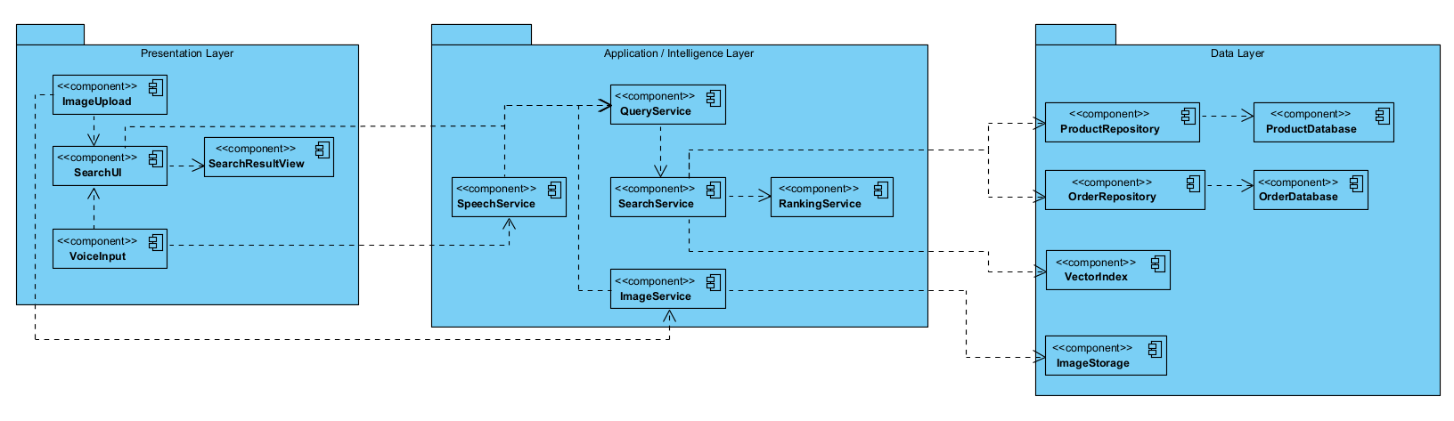
- Task 4: Sequence Diagram
The Sequence Diagram describes the interaction when a Customer searches for a product using voice input. The diagram contains the required participants: Customer, SearchUI, SpeechService, QueryService, SearchService, ProductRepository, and RankingService.
- Participants
Participant | Responsibility
Customer | Provides the voice query and receives the results.
SearchUI | Receives user input and displays search results.
SpeechService | Converts voice input into text.
QueryService | Creates a query representation from the transcribed text.
SearchService | Retrieves relevant products.
ProductRepository | Provides product data for the search process.
RankingService | Ranks the retrieved product candidates.
- Interaction Flow
- 1. The Customer provides voice input to SearchUI.
- 2. SearchUI sends the audio input to SpeechService.
- 3. SpeechService converts the voice input into text and returns it.
- 4. SearchUI sends the text to QueryService to create a voice query representation.
- 5. QueryService returns the generated query.
- 6. SearchUI sends the query to SearchService.
- 7. SearchService retrieves products from ProductRepository.
- 8. ProductRepository returns the candidate products.
- 9. SearchService sends the candidates to RankingService.
- 10. RankingService ranks the candidates and returns the ranked results.
- 11. SearchService returns the results to SearchUI.
- 12. SearchUI displays the results to the Customer.
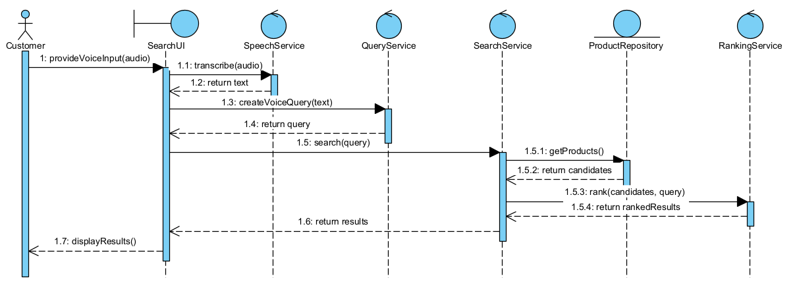
- Task 5: Python Implementation
- Task 6: Demonstration

