


MINISTRY OF SCIENCE AND TECHNOLOGY
POSTS AND TELECOMMUNICATIONS INSTITUTE OF TECHNOLOGY

----------
Assignment 06
Lecturer : Tran Dinh Que
Class : E23TTTN02
Group : 03
Student Name : Lê Huy Hoàng
Student ID : B23DCVT171

Hà Nội, Tháng 3/2024

- Task 1: Requirements Analysis
- Actors
Customer – The main user who searches for products and orders and views returned results.
- Functional Requirements
- Search products by keyword/text.
- Search products by voice.
- Search products by image.
- Search orders.
- View product information.
- View order information.
- Non-Functional Requirements
- Usability: The system should be easy to use.
- Performance: Search results should be returned quickly.
- Maintainability: Components should be easy to modify and maintain.
- Extensibility: New search methods or AI models can be added.
- Modularity: UI, application logic, and data access should be separated.
- Input Modalities
Mode | Input | Processing
Text | Keyword or natural-language query | Text search
Voice | Voice/audio query | Speech-to-text → text search
Image | Product image | Image similarity search

- Search Outputs
- Product Search: A list of relevant products with product information.
- Order Search: Order information such as order ID, status, and total amount.
- Task 2: Use Case Diagram
- Actor: Customer: The main user who interacts with the system to search for products and orders and view related information.
- Main Use Cases
- Search Product: Allows the customer to search for products.
- Search products by keyword/text: Searches for products using keywords or natural-language text.
- Search products by voice: Searches for products using voice input.
- Search products by image: Searches for visually similar products using an image.
- Search Order: Allows the customer to search for order information.
- View product information: Allows the customer to view product details.
- View order information: Allows the customer to view order details.
- Relationships
- The Customer has direct associations with:
  - Customer → Search Product
  - Customer → Search Order
  - Customer → View product information
  - Customer → View order information
- Search Product is a general use case with three specialized search methods:
  - Search products by keyword/text → Search Product
  - Search products by voice → Search Product
  - Search products by image → Search Product
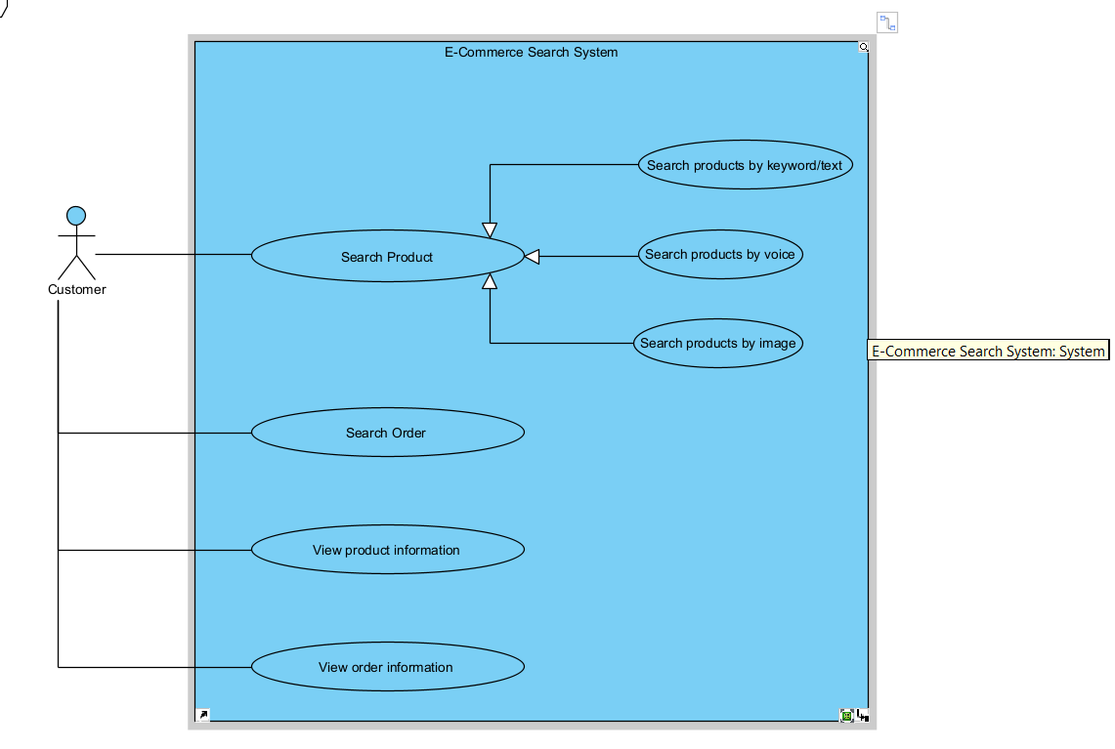
- Task 3: Three-Layer Architecture
The system is organized into three layers: Presentation Layer, Application / Intelligence Layer, and Data Layer. Each layer has a separate responsibility, and the dependencies follow the direction:
Presentation Layer → Application / Intelligence Layer → Data Layer.
- Presentation Layer: contains SearchUI, VoiceInput, ImageUpload, and SearchResultView. This layer receives user input and displays the returned search results.
- Application / Intelligence Layer : contains QueryService, SpeechService, ImageService, SearchService, and RankingService. This layer processes different input types, creates a common query representation, retrieves relevant data, and ranks the results.
- Data Layer : contains ProductRepository, OrderRepository, VectorIndex, ProductDatabase, OrderDatabase, and ImageStorage. This layer stores and provides access to product, order, image, and vector data.
- Main Interaction Flows
- Text Search Flow
  - SearchUI → QueryService → SearchService → ProductRepository → ProductDatabase
  - The user enters a text query through SearchUI. QueryService creates the query representation, and SearchService retrieves matching products from ProductRepository.
- Voice Search Flow
  - VoiceInput → SpeechService → QueryService → SearchService → ProductRepository
  - VoiceInput receives the user's voice input. SpeechService converts it into text, then QueryService creates the query representation and sends it to SearchService. This follows the voice-search process described in the assignment.
- Image Search Flow
  - ImageUpload → ImageService → QueryService → SearchService → VectorIndex
  - The user uploads an image through ImageUpload. ImageService processes the image, while QueryService creates the image-query representation. SearchService then uses VectorIndex to retrieve similar products. ImageService can also access ImageStorage for image data.
- Order Search Flow
  - SearchUI → QueryService → SearchService → OrderRepository → OrderDatabase
  - The system processes the order query and retrieves order information through OrderRepository.
- Ranking Flow
  - SearchService → RankingService
  - After relevant candidates are retrieved, RankingService ranks them before the results are presented to the user. The assignment explicitly separates retrieval from ranking.
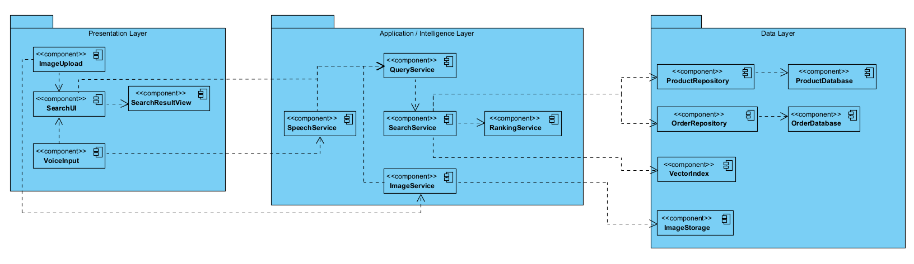
- Task 4: Sequence Diagram
The Sequence Diagram describes the interaction when a Customer searches for a product using voice input. The diagram contains the required participants: Customer, SearchUI, SpeechService, QueryService, SearchService, ProductRepository, and RankingService.
- Participants
Participant | Responsibility
Customer | Provides the voice query and receives the results.
SearchUI | Receives user input and displays search results.
SpeechService | Converts voice input into text.
QueryService | Creates a query representation from the transcribed text.
SearchService | Retrieves relevant products.
ProductRepository | Provides product data for the search process.
RankingService | Ranks the retrieved product candidates.
- Interaction Flow
- 1. The Customer provides voice input to SearchUI.
- 2. SearchUI sends the audio input to SpeechService.
- 3. SpeechService converts the voice input into text and returns it.
- 4. SearchUI sends the text to QueryService to create a voice query representation.
- 5. QueryService returns the generated query.
- 6. SearchUI sends the query to SearchService.
- 7. SearchService retrieves products from ProductRepository.
- 8. ProductRepository returns the candidate products.
- 9. SearchService sends the candidates to RankingService.
- 10. RankingService ranks the candidates and returns the ranked results.
- 11. SearchService returns the results to SearchUI.
- 12. SearchUI displays the results to the Customer.
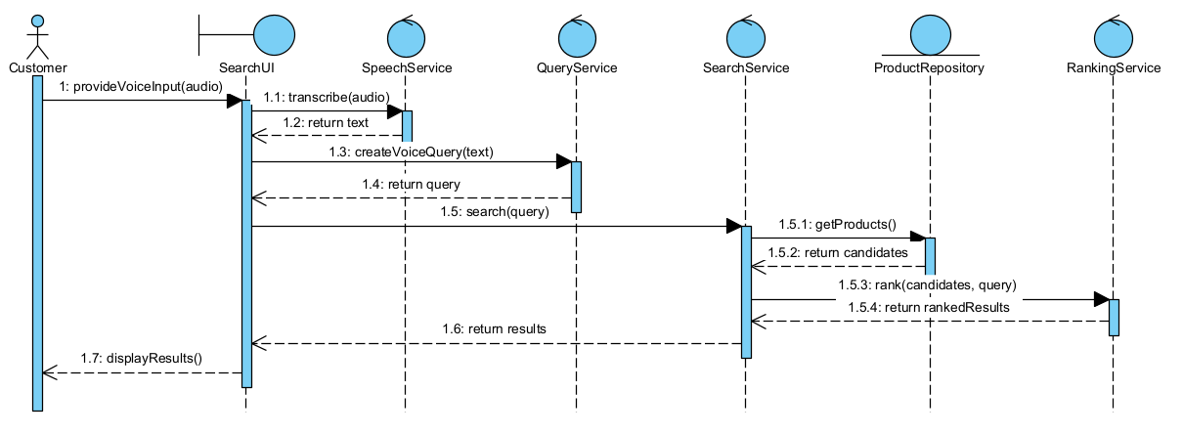
- Task 5: Python Implementation
The Python prototype implements the five required functions using three layers: presentation for input and output, application for search and ranking, and data for storage. main.py creates the repositories and services and connects them to SearchUI.
1. Product repository. ProductRepository reads and validates 20 products from data/products.json: five phones, five tablets, five laptops, and five accessories. Each product has an ID, name, category, color, price, and stock quantity. Data is stored locally in JSON, not a database.
2. Text search. QueryService creates a common query representation. SearchService matches query words against product names, categories, colors, and additional search terms. The score is the number of query words found. Products with no matches are excluded.
3. Simulated voice search. SpeechService accepts a typed transcript, such as "find laptop", and returns the text. QueryService creates a voice query, which uses the same retrieval process as text search. This is a simulation; the prototype does not record audio or perform real speech recognition.
4. Image similarity search. VectorIndex stores artificial three-dimensional product vectors. ImageService calculates cosine similarity between the query vector and each product vector. Higher scores indicate greater similarity. Invalid dimensions are rejected, and zero vectors return a score of zero. Product photos are real, but vectors are assigned manually, not extracted from images.
5. Result ranking. RankingService sorts candidates by score in descending order and optionally returns the top_k results. Equal scores preserve the original candidate order. SearchUI displays the input, processing mode, returned products, and scores. Retrieval and ranking remain separate.
Implementation evidence
The figures show actual Python code and execution output, formatted as images for readability.
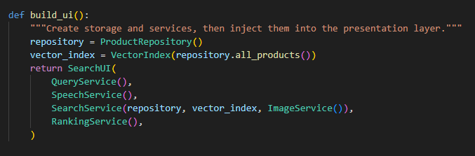
Figure 5.1. Source excerpt connecting repositories, search services, and SearchUI.
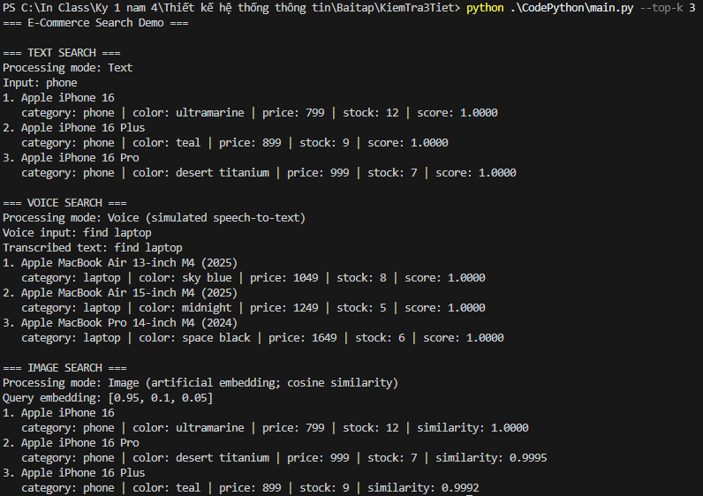
Figure 5.2. Captured output for text, simulated voice, and artificial-vector image search.
- Task 6: Demonstration
- Home
The home page displays all 20 products across phones, tablets, laptops, and accessories when no keyword is entered. Users can select a category or open product details. This is catalog browsing, so item numbers are shown instead of relevance scores.
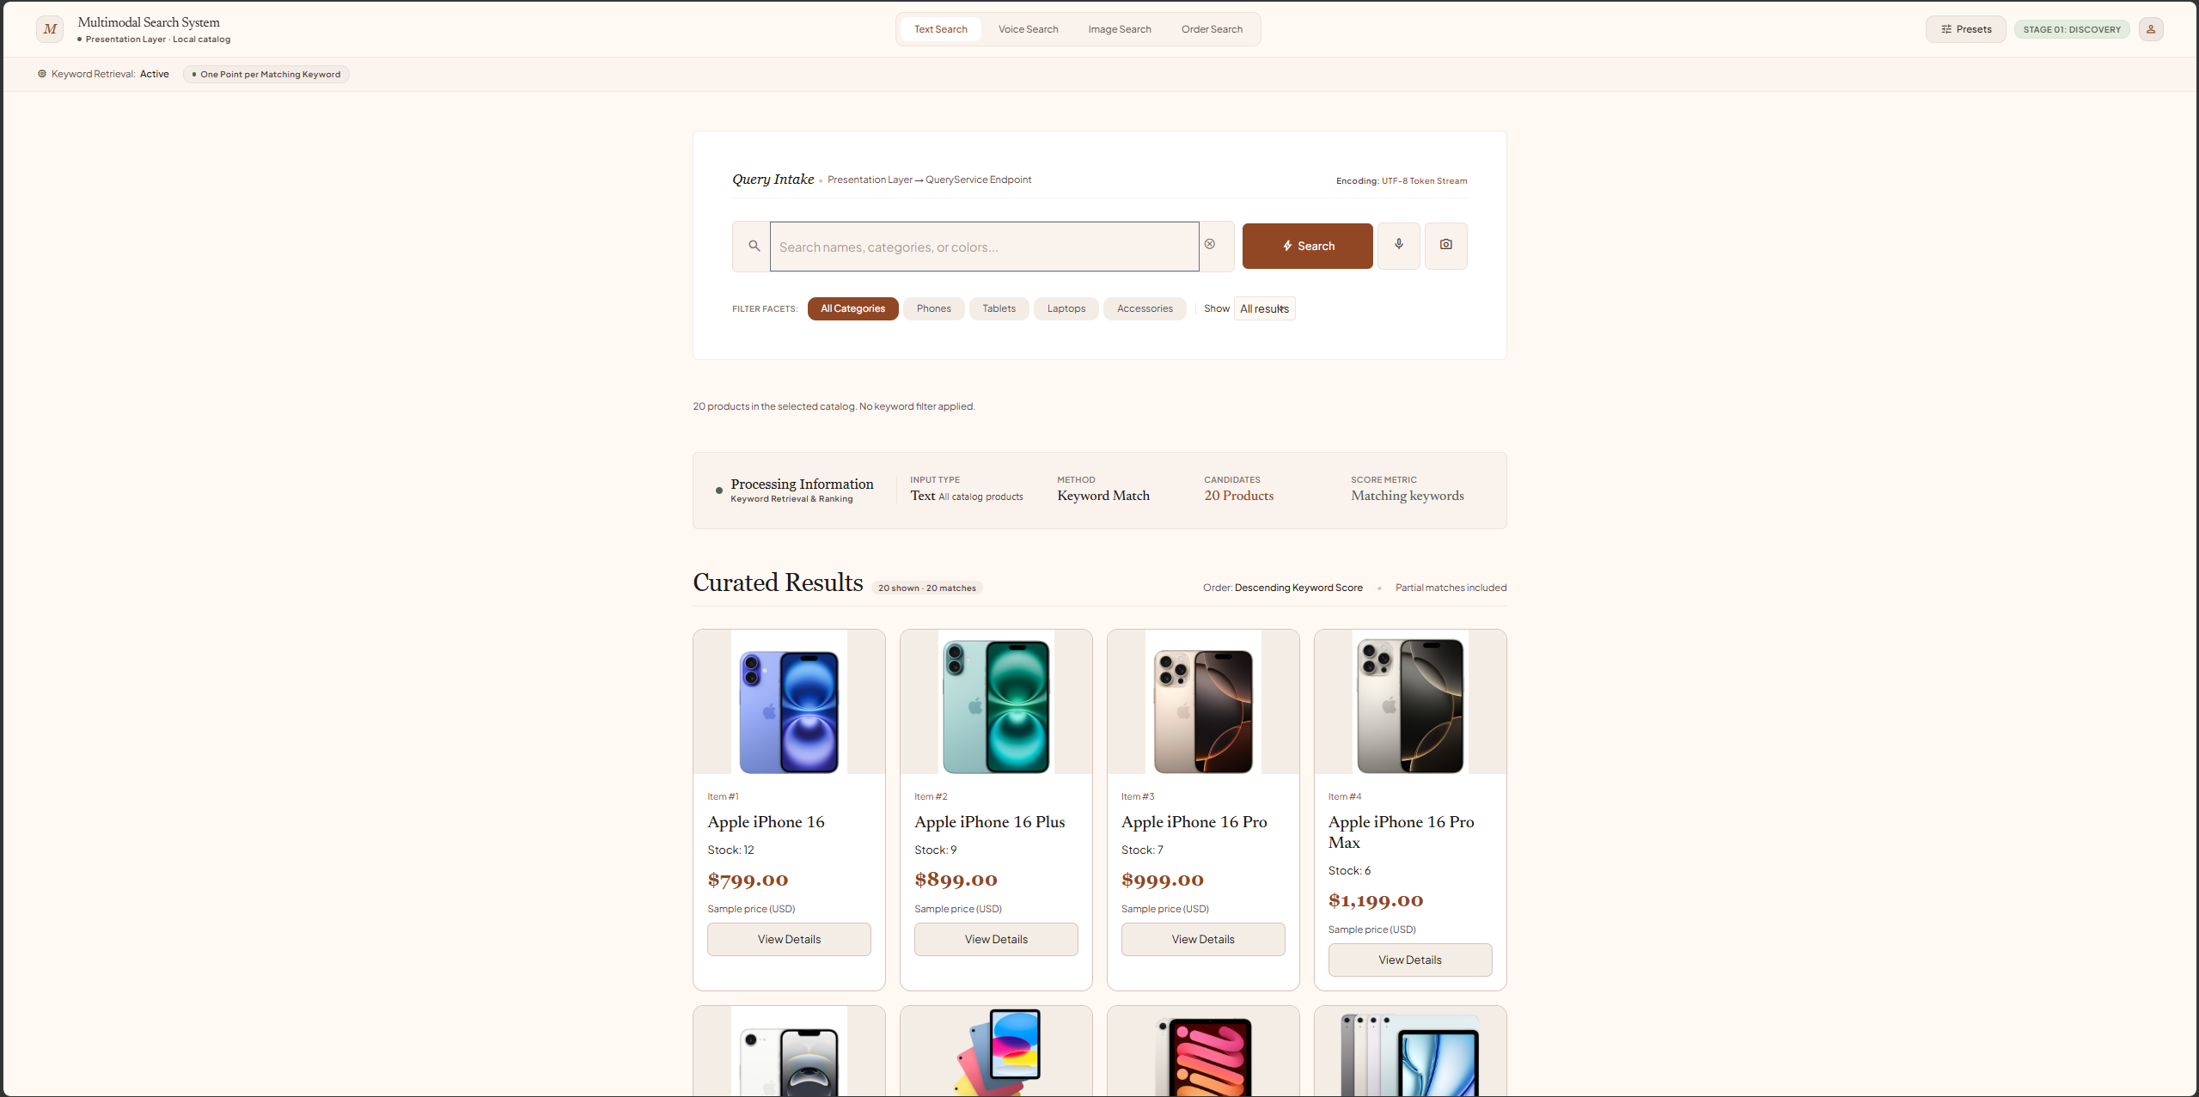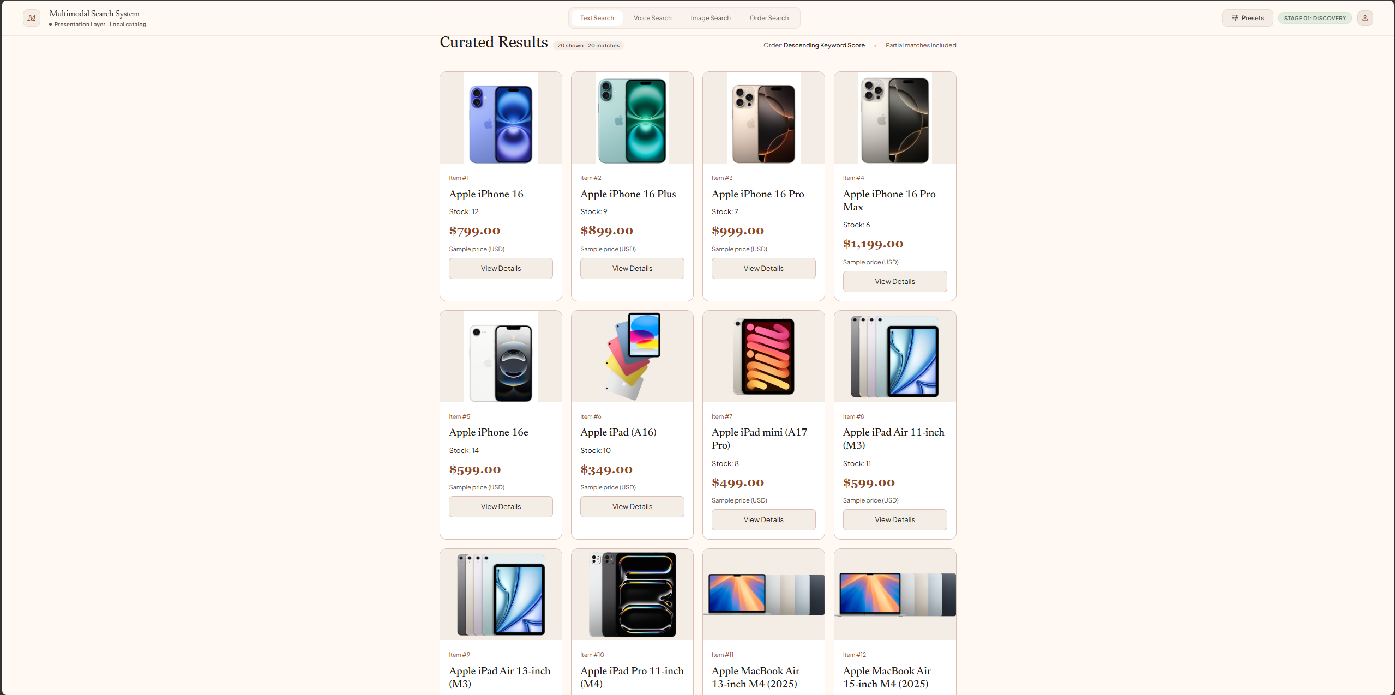
- Text search
Input: "tablet" with All Categories selected. The system lowercases the query and matches its words against product names, categories, colors, and search terms. Five tablets are returned: iPad (A16), iPad mini (A17 Pro), iPad Air 11-inch (M3), iPad Air 13-inch (M3), and iPad Pro 11-inch (M4). Each has a keyword score of 1.0000; ties retain catalog order.
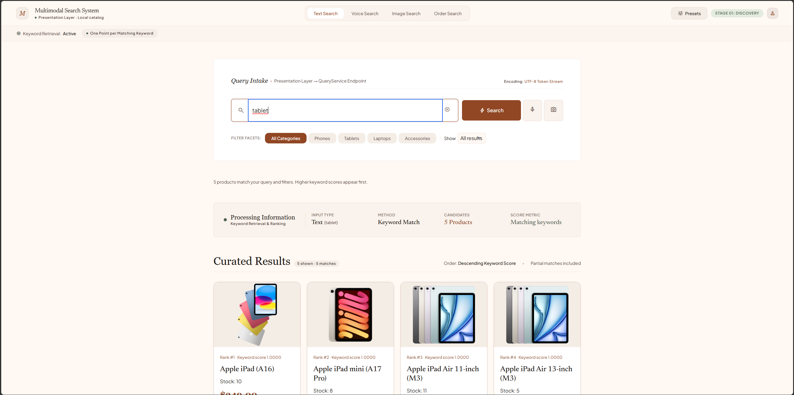
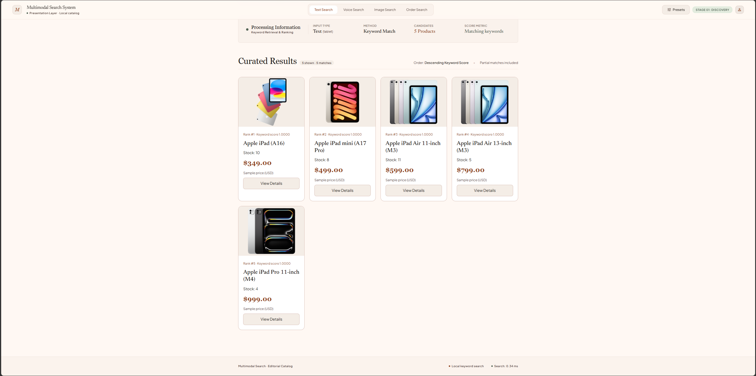
- Voice Search
Input: "find phone" entered as a simulated transcript. No microphone or real speech recognition is used; the transcript is passed to the text-search service. Five phones are returned, led by iPhone 16, iPhone 16 Plus, and iPhone 16 Pro. Each scores 1.0000 because "phone" matches the product category; "find" adds no points.
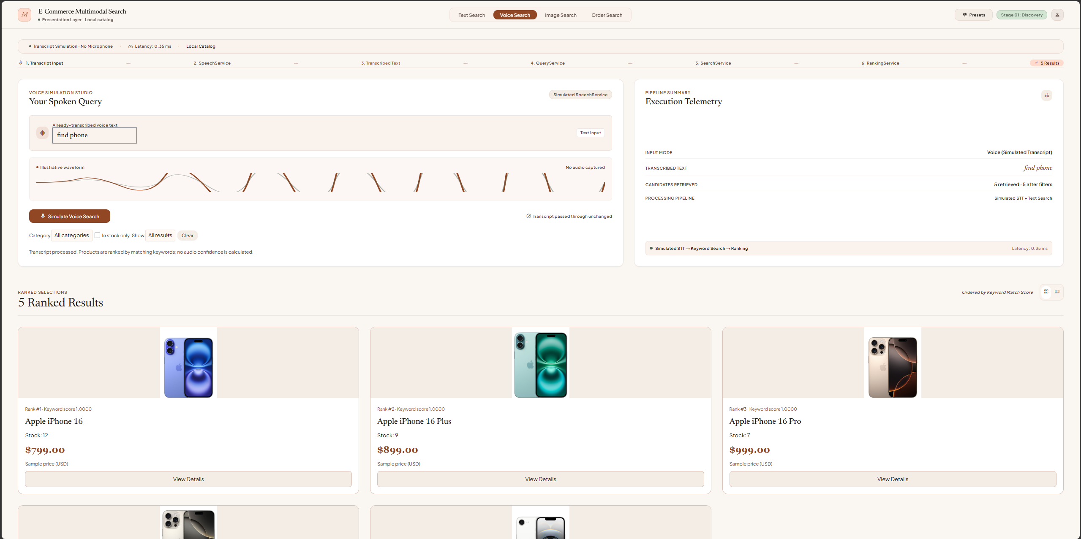
The next screenshot shows a separate laptop-search example: five laptops are returned, led by MacBook Air 13-inch (M4, 2025). All five have a keyword score of 1.0000.
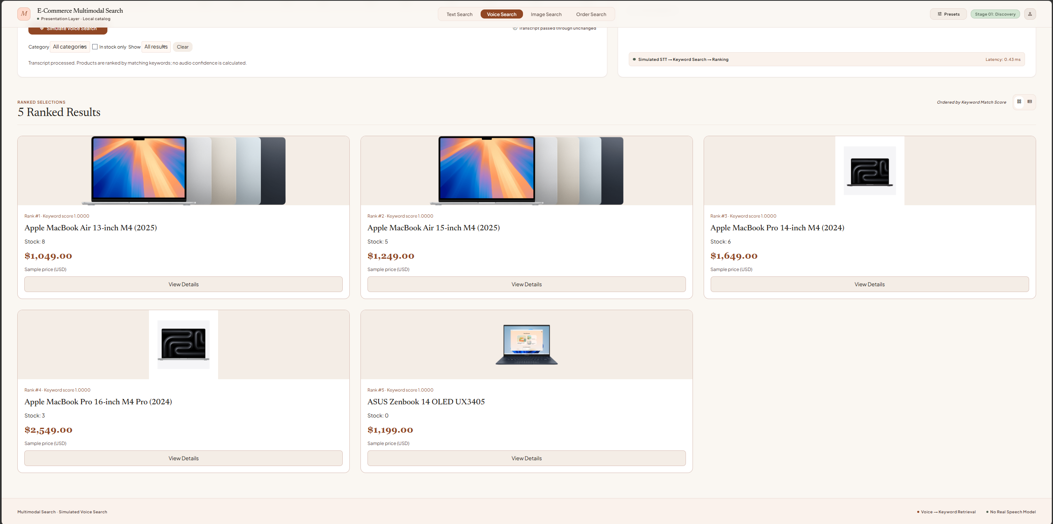

- Image search
Input: the iPhone 16 preset with vector [0.95, 0.1, 0.05]. The system compares this vector with all 20 product vectors using cosine similarity and ranks results in descending order. iPhone 16 ranks first (1.0000), followed by iPhone 16 Pro (0.9995) and iPhone 16 Plus (0.9992). These manually assigned three-dimensional vectors simulate image search; they are not extracted from the photos.
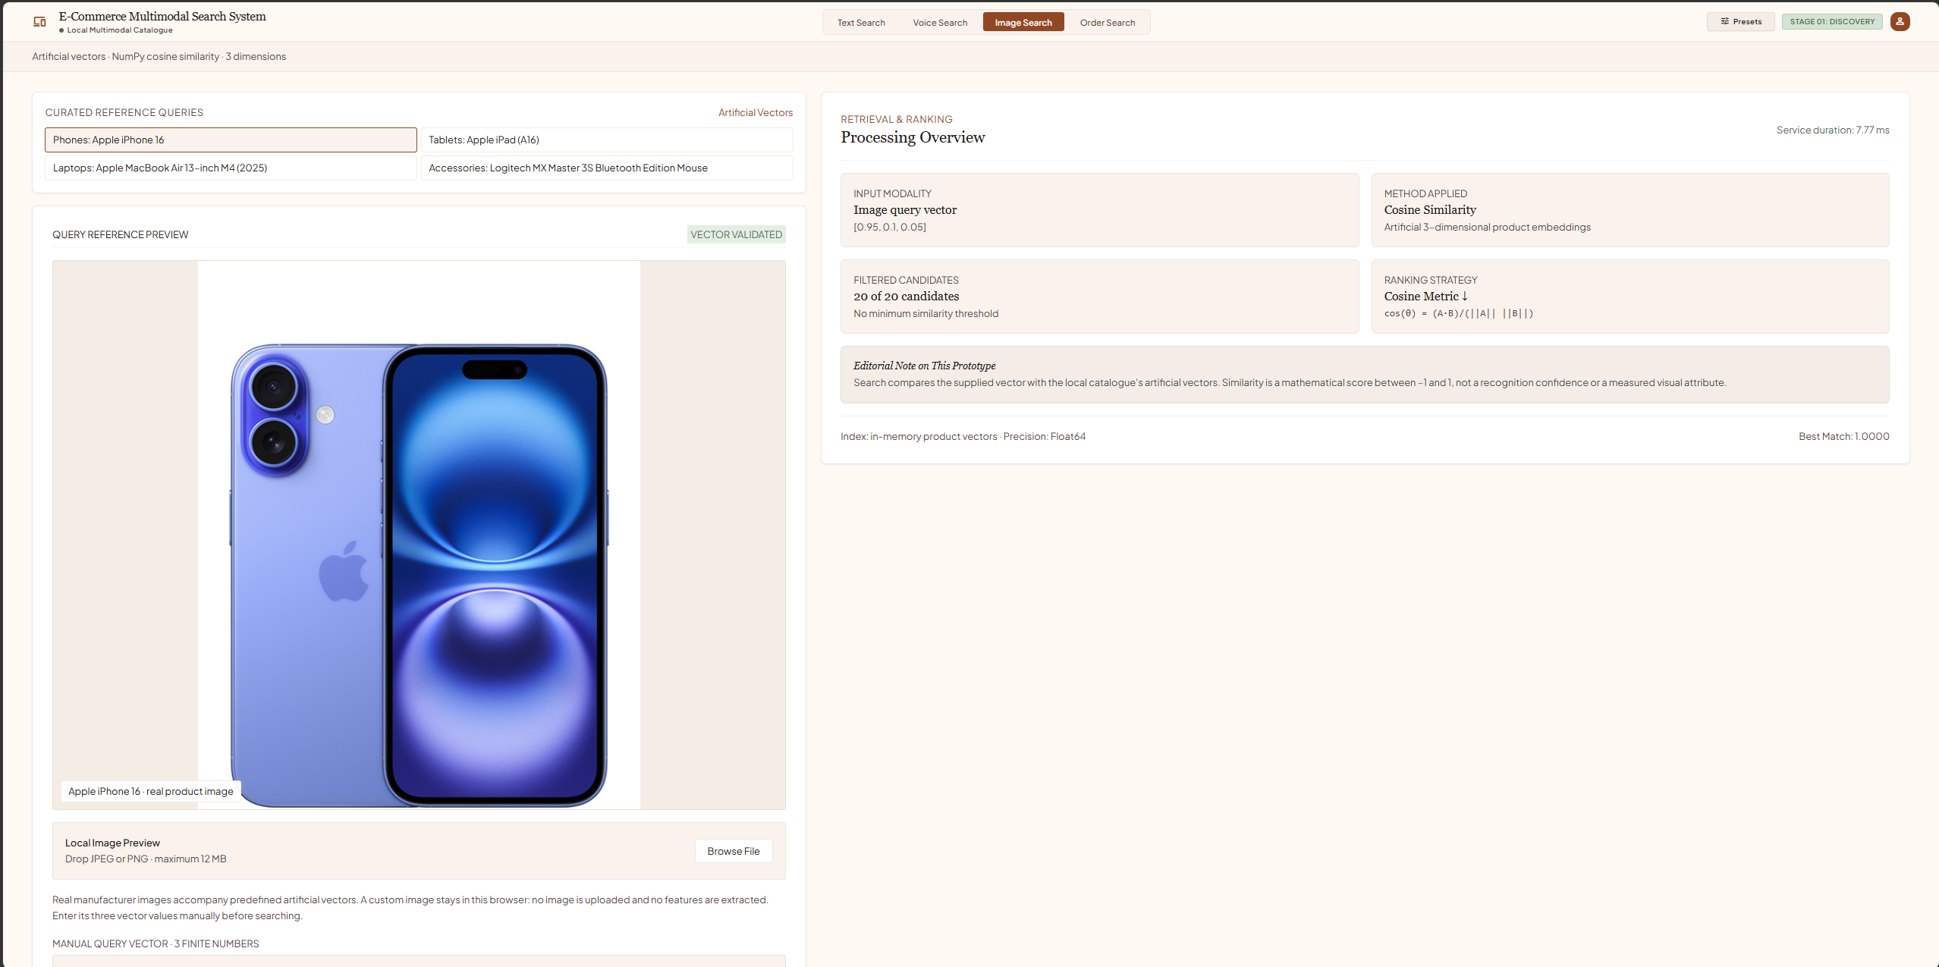
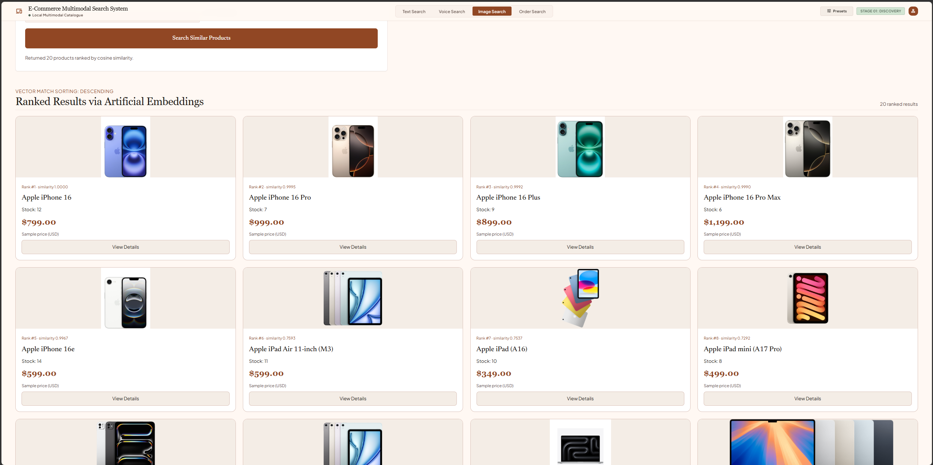
- Order
Input: order ID "O001". An exact ID lookup returns a Shipped sample order containing one iPhone 16 and two Logitech MX Master 3S mice. The subtotal is $989.00 and shipping is $5.00, giving a total of $994.00. This read-only order lookup does not use relevance scores or process a real payment.
