**E-COMMERCE SYSTEM DESIGN**

**Notes:**

* This is not a compete design, this only a basic design to guide to student about this system. So please discuss with your teacher to complete design before develop system.

1. **Use Case Diagram**

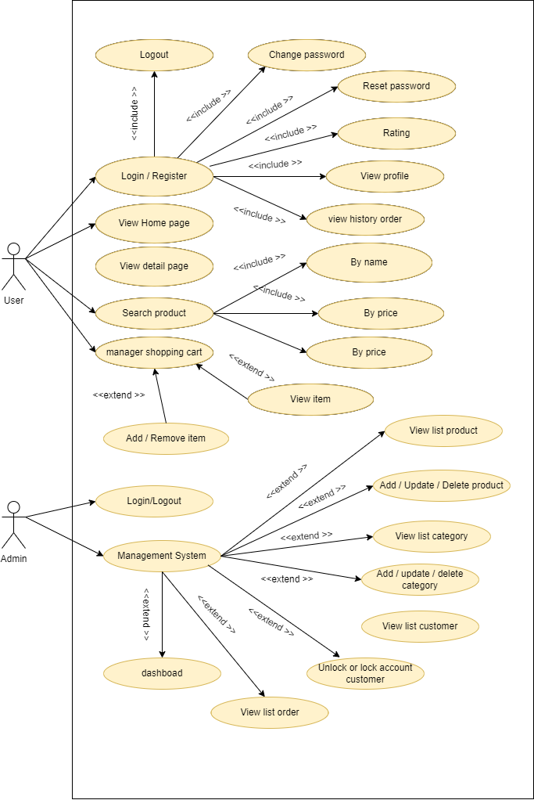

1. **Class Diagram**

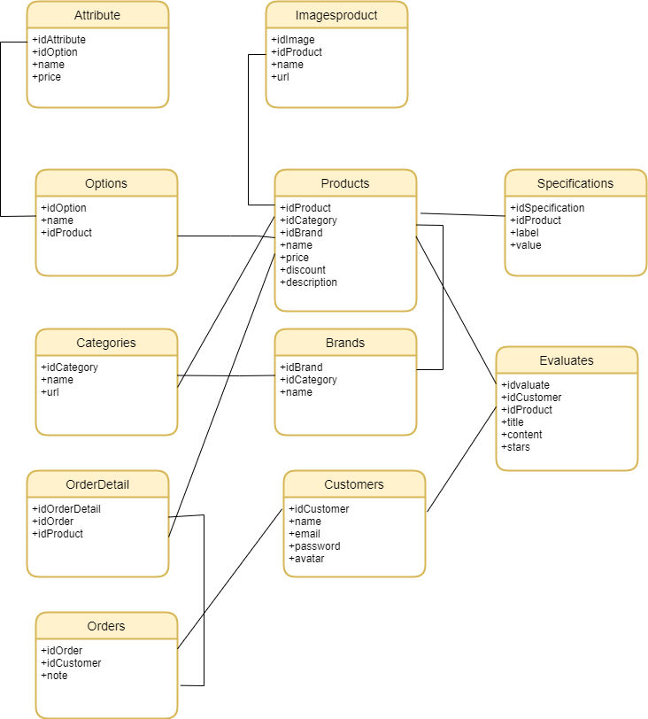

This is Entity Class Diagarm and not complete. You need to apply MVC to implement it to your code and add more attribute, operation to class even add more class you need.

v