**PROFESSIONAL PROGRAMMING TRAINING CENTER**



PROJECT DOCUMENT

**Project Name:**

“*Technical Device Store*”

**Course:**    NodeJS

**Group:**     Nguyen Vo Hoang Long

**Trainer:**   Huynh Quang Vinh

***Danang,***

**PREFACE**

*Up to the present time, the important role of e-commerce cannot be denied, it is associated with people's daily lives, in recent years with the influence of the covid pandemic, and the explosion of shopping demand. The most interesting sales websites*

*With the above characteristics, we choose the topic "Technical device store" as a project, the project uses NodeJs and React JS to design and run the project.*

*During the implementation of the project, we received help from the trainer "Huynh Quang Vinh". We would like to thank the teacher, who helped us in orientation, solved professional questions during the project, and enthusiastically taught the shortcomings as well as fostered more knowledge. when doing the project.*

**TABLE OF CONTENTS**

1. Introduction 4

2. The reasons to implement this project 4

3. Solution Document 4

3.1. Overall Description 4

3.1.1. Product Features 4

4. System Features 6

4.1. Session Manage –Customer Registration 6

4.2. Session Manage – Login 6

4.3. Session Manage – Logout 6

4.4. Shopping - Search Product by Search Tool 7

4.5. Shopping - Search Product in Category 7

4.6. Shopping – View Product Details 7

4.7. Shopping – Add to Cart 7

4.8. Shopping – Manage Basket (Manage Shopping Cart) 8

4.9. Shopping – Customer Information 8

4.10. Shopping – Checkout 8

4.11. Order Lookup – Search Order by Date 9

5. Analysis Document 10

5.1. Behavior – Customers 10

6. Design Document 17

6.1. UI Design: 17

6.2. Database Design 18

7. User Guide 19

8. Management Methods 24

8.1. ReactJs: 24

8.2. NodeJs: 25

9. Conclusions and expand 25

10. References 26

1. Introduction

**PROJECT SUMMARY**

**Project Name:** *Technical device store*

**Project team:** Nguyen Vo Hoang Long

In this project, my team completed a real-life sales website. This app we run on nodeJS and ReactJS. Its activity is stable. Clean, easy-to-access interface.

Main responsibilities:

- Create API

- Design UI/UX

- Communicate and coordinate between Back_end and Front_end

Accomplishments:

- Better understand NodeJS and know more about React JS with the latest technologies.

- Working with Git

Technologies:

- Front_end: HTML, CSS, ReactJS, …

- Back_end: NodeJS, MySQL, ExpressJS, Sequelize, …

1. The reasons to implement this project

Up to the present time, the important role of e-commerce cannot be denied, it is associated with people's daily lives, in recent years with the influence of the covid pandemic, the explosion of shopping demand. The most interested sales websites.

With the above characteristics, we choose the topic "Technical device store" as a project, the project uses NodeJs and React JS to design and run the project.

1. Solution Document
   1. Overall Description
      1. Product Features
         1. Customer side:

* Session Manage:
* User Registration
* Login
* Logout
* Forgot password
* Change password
* Change avatar
* ***Shopping:***
* Search products by category and search box
* View product detail
* Manage shopping cart
* Add item to cart
* Delete item in the cart
* Update the quantity of products the in cart
* Checkout
* Payment
  + - 1. Administration side:
* ***Session Manage:***
* Login
* Logout
* ***Manage Orders:***
* Search orders by date
* View all orders
* ***Manage Customers:***
* View all customers
* Add a user
* Delete a user
* Set permission for account
* ***Manage Product:***
* View all product
* Add a product
* Update a product
* Delete a product

* ***Manager Category***
* View all categories
* Add category
* Delete a category
* Update a category

1. System Features

         There are detailed descriptions of system features.

* 1. Session Manage –Customer Registration

- Customers must register before they make a payment.

- Functional Requirements

REQ-1:  Users click on the Registration link and the Registration form will display.

REQ-2: System will check requirement fields and special formats like email addresses and passwords before sending the data to the server.

REQ-3:  The system shows error messages if the registration fails and moves to the login page if the registration succeeds.

* 1. Session Manage – Login

- Users must log in to use system functions. Users can use functionality based on their role.

- Functional Requirements:

REQ-1: The Login form includes username, password textboxes, and a Login button.

REQ-2:  System will move to the home page if logged in successfully.

REQ-3:  The system shows an error message if login failed.

* 1. Session Manage – Logout

- Functional Requirements

REQ-1:   The user clicks on the Exit menu logs output.

REQ-2: The system moves to the home page when log out successfully.

* 1. Shopping - Search Product by Search Tool

- User has the ability to search products by:

* Category
* Name

- Functional Requirements

REQ-1: System views search field and Go button on Homepage.

REQ-2:  User input searches text to the search field and click the button.

REQ-3:   All products in matching condition are displayed and ordered ascending by price.

REQ-4:   Users can view details of the product by clicking on the product link from the result page.

* 1. Shopping - Search Product in Category

- The function allows the user to search for products by a set of many conditions (Kind of product, manufactory, price). This function is of high priority.

- Functional Requirements

REQ-1: System views Category name, Filter button, and set of Search conditions on top of Search area.

REQ-2: System views Paging Navigator when Search Results are more than 20 records. It means there are 20 records per page.

REQ-3: System views Update Cart, Clear Items, Select All, and Deselect All buttons when the system returns Search Results.

REQ-4: If there is no result, the system shows the message “*No data available”.*

* 1. Shopping – View Product Details

- The function allows the user to view details of the product by clicking on Product Picture. This function is of high priority.

- Functional Requirements

REQ-1: In the results list, the product title is highlighted as hyperlink. Users can click on it to view Product Detail.

REQ-2: Product Detail is open as a new window.

* 1. Shopping – Add to Cart

- The function allows users to add products to Shopping Cart.

- Functional Requirements

REQ-1: The system updates the basket based on selected products from the search result list when the user clicks the “Add to Cart” button.

* 1. Shopping – Manage Basket (Manage Shopping Cart)

- The function allows users to view all of Selected Products in Basket and removes some of them out of Basket.

- Functional Requirements

REQ-1: Users can go into Basket by the Basket link on top of the main page.

REQ-2: Users get the message **“**Your basket is empty” if the Cart is empty.

REQ-3: Due to the unique nature of each product, items selected will only remain in the shopping cart for 1 hour

REQ-4: The system removes checked products from Cart if the user clicks the “Remove Selected Items” button.

REQ-5: System views Estimated Sub Total.

REQ-6: The system shows a message “You have x held orders” at the end of the page. The number x will change as the actual Held Order number.

* 1. Shopping – Customer Information

- This function is used to collect Billing, Shipping, and Discount Information for orders.

- Functional Requirements

REQ-1: The customer Information page has some sessions: Billing Information and Shipping Information.

REQ-2: System must validate Customer Information is correct.

REQ-3: If a user was logged on to the system, this information is automatically filled.

REQ-4: Click the Continue button to go to the Checkout page.

* 1. Shopping – Checkout

- Checkout flow creates an order with products for a customer.

- Functional Requirements

REQ-1: The checkout form contains list of Products that detail Price: unit price, discount amount, discounted price, sub total, and total

REQ-2: The system calculates the discount Amount automatically based on Unit Price and Discount Percent.

REQ-3: The system opens the checkout – Shipping page when the user clicks the “continue checkout” on the checkout page.

REQ-4: User selects Shipping Method and Continue Checkout.

REQ-5: The system generates an “Order Number” and shows it on the Checkout page.

REQ-6: The system shows the summary of Billing Information, Shipping Information, and Order Totals.

REQ-7: Click on Cancel Order link to cancel the Order. The system will return the Basket page.

REQ-8: Click on the submit order link to submit the order. The system will show a Summary of the Order.

* 1. Order Lookup – Search Order by Date

- Users can search the Orders based on the period of time (Year, Month, and Day). System will return a summary list of Orders in a period time. User opens this form from the General Tools of Main Order Lookup page.

- Functional Requirements

REQ-1: Users open the Order by Date page from the Main Order Lookup, and the system does searching for the current year automatically.

REQ-2: System views searching period time beside the name of the page on the top of the page. Ex: 2013, 01/2013, 01/04/2013.

REQ-3: When searched by year, the system returns a list with months, the number of Orders in month, Sale Prices and Discounts Statistics.

REQ-4: The user selects year in the Time Period combo box and clicks Update to search by year.

REQ-5: Users click on a Month to search by month of year. System views the Order by Month page. The search time is updated on GUI. System returns list all of the days in the month and Order statistics in each day.

REQ-6: Users can click on the Year link to go back Search by Year results.

REQ-7: Users click on a Day link to view all orders that were created on that day. The System opens the Order by Day page.

REQ-8: On the Order by Day page, users can click on Year, Month links to search by Year or by Month.

REQ-9: On the Order by Day page, users can click on the Order Number link to open the Order Detail page.

REQ-10: On the Order by Day page, users can click on the name to go to the Manage Customer Information page

1. Analysis Document
   1. Behavior – Customers

*-Login:*

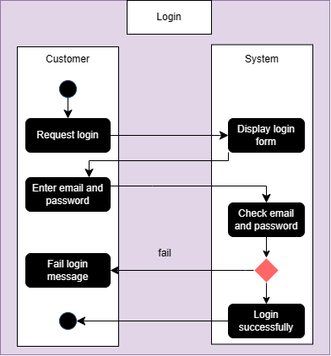

*-Register:*

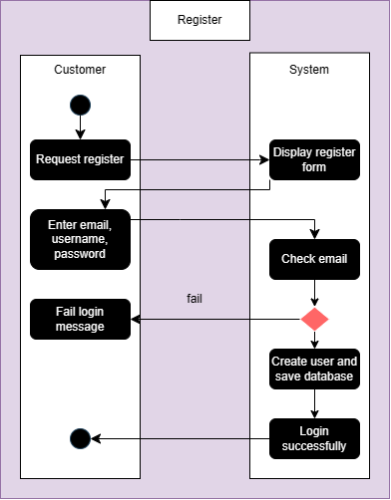

*-Forgot password:*

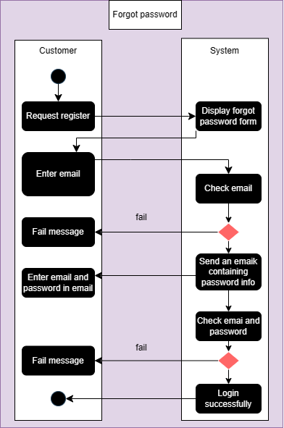

*-Logout:*

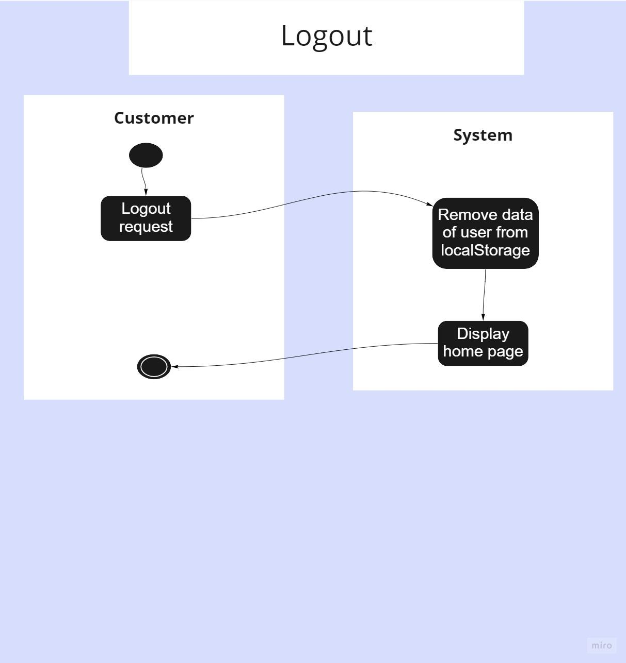

*-Add to Cart:*

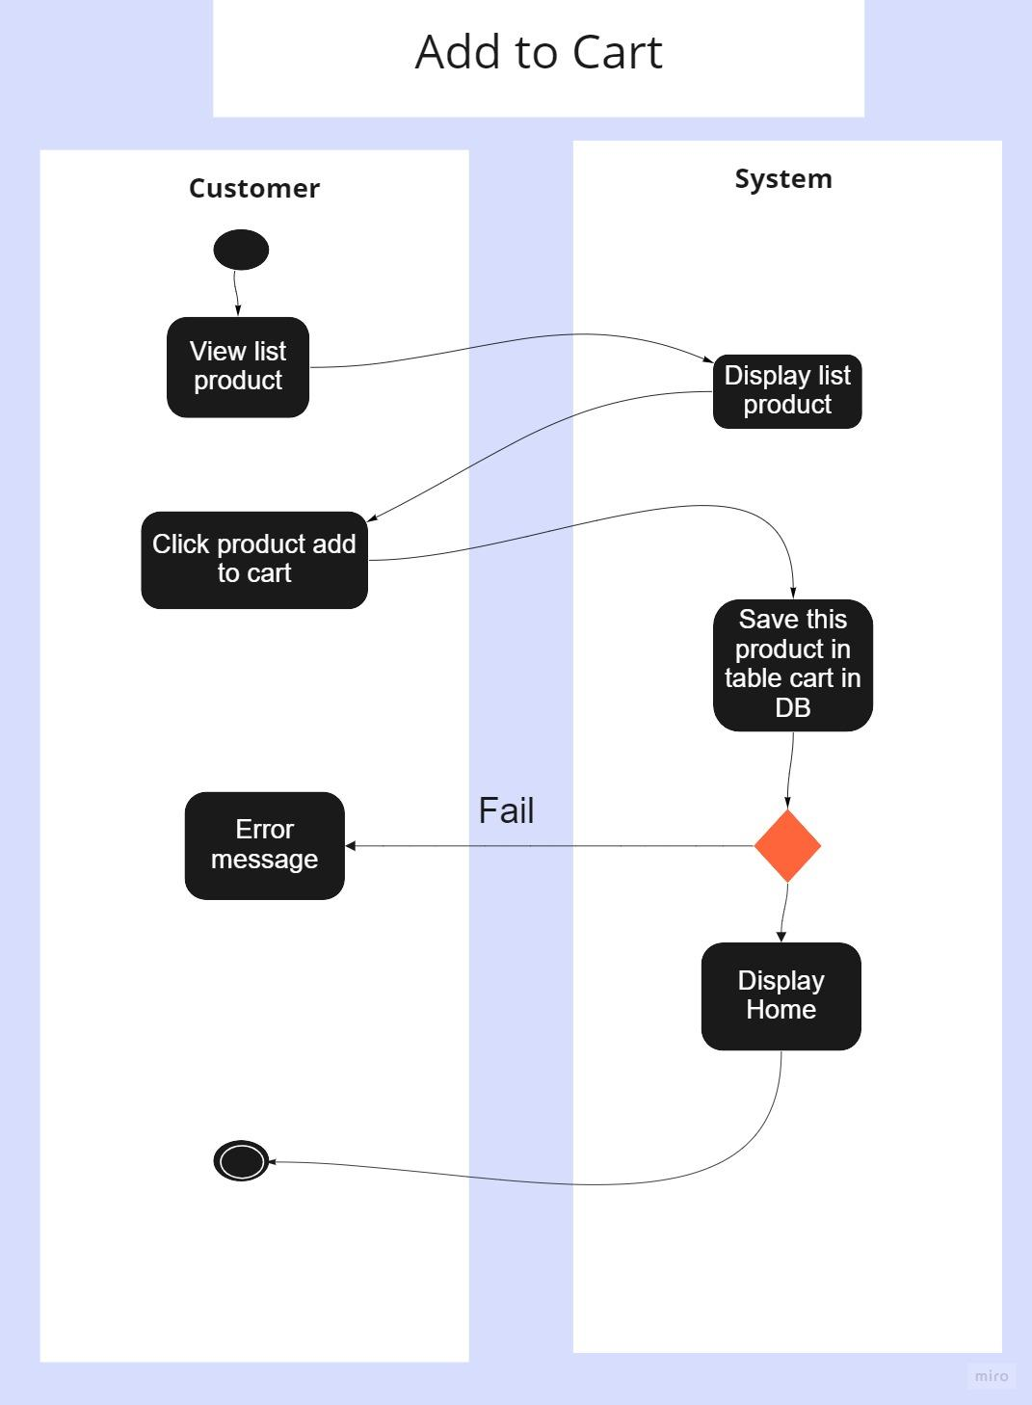

*-Delete product in Cart:*

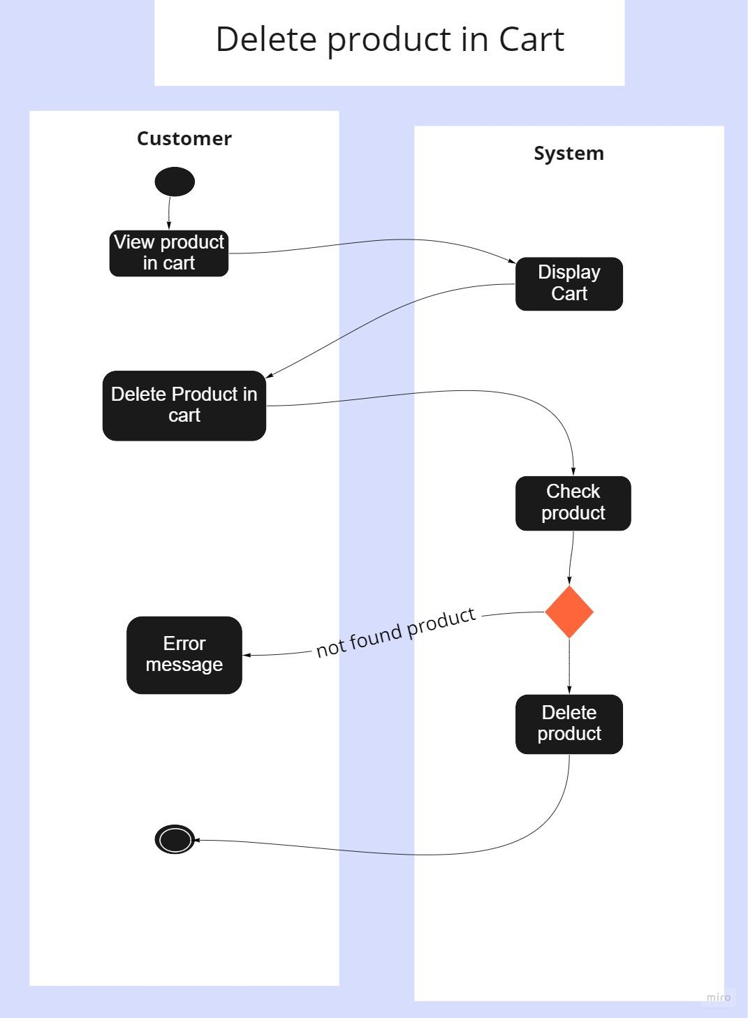

*-Checkout:*

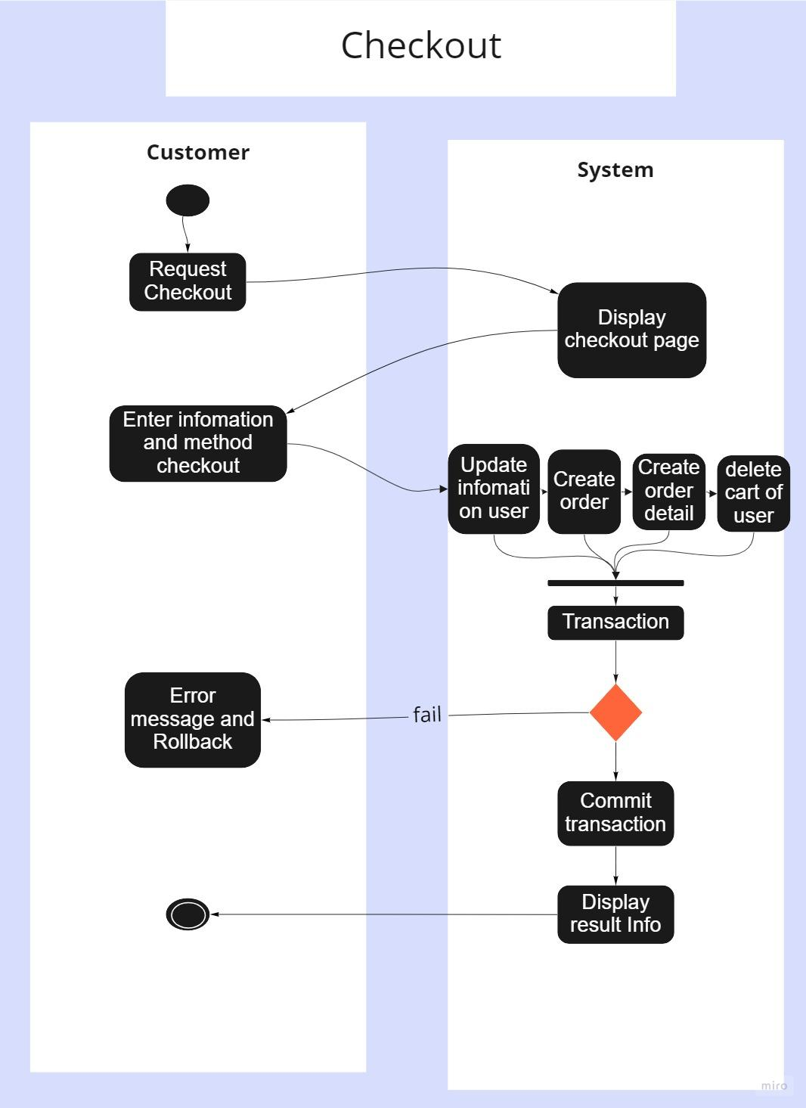

1. Design Document
   1. UI Design:

*The website interface is similar to other sales websites such as:* [*https://phongvu.vn/*](https://phongvu.vn/)

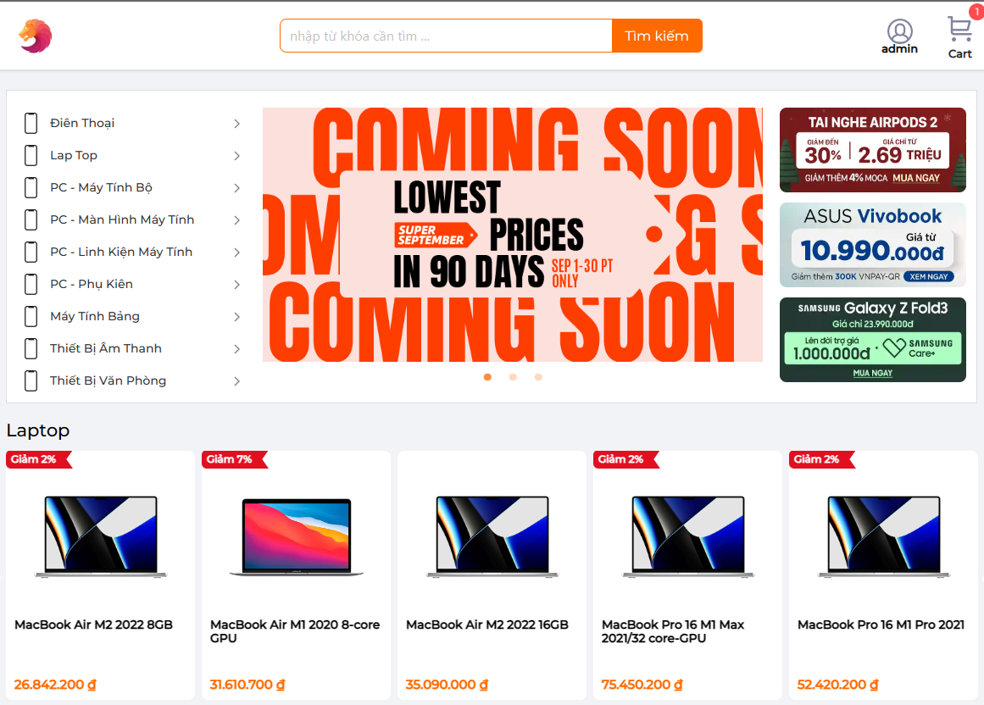

* 1. Database Design

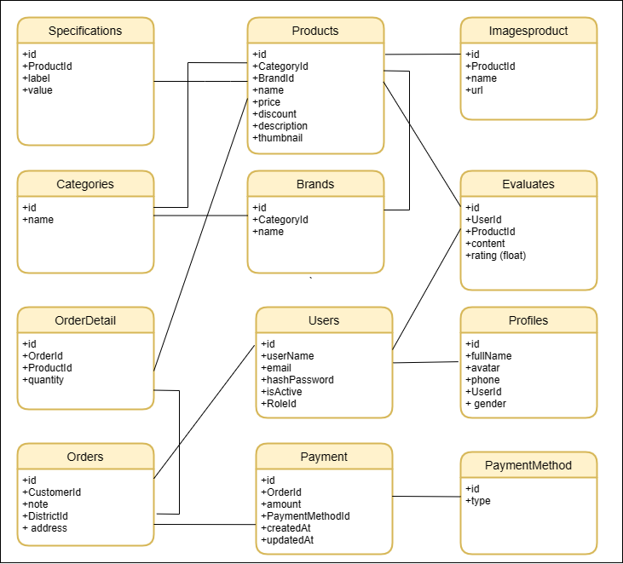

1. User Guide

* *Home page:*



* *Resgister account:*

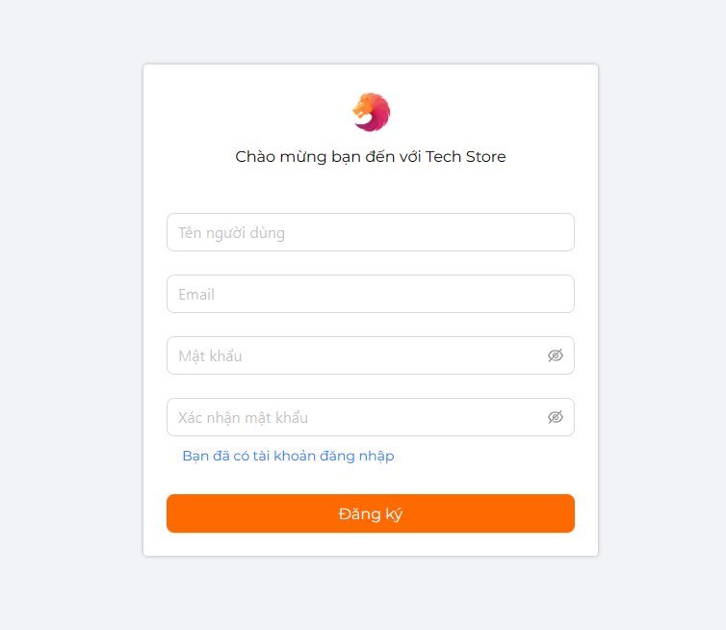

* *Detail product:*

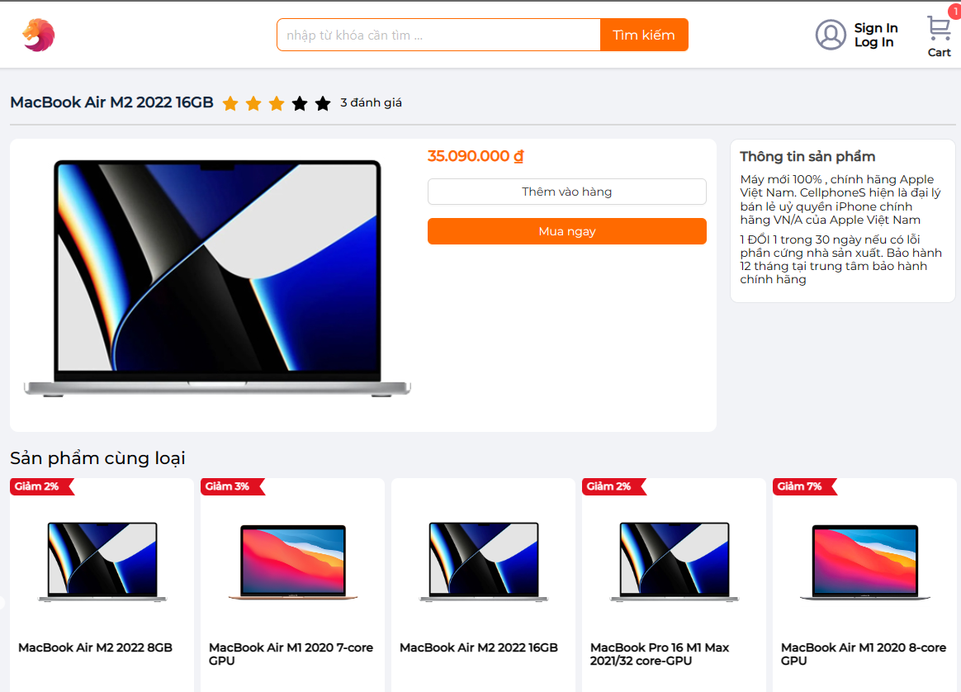

* *The user selects the product he wants to buy:*

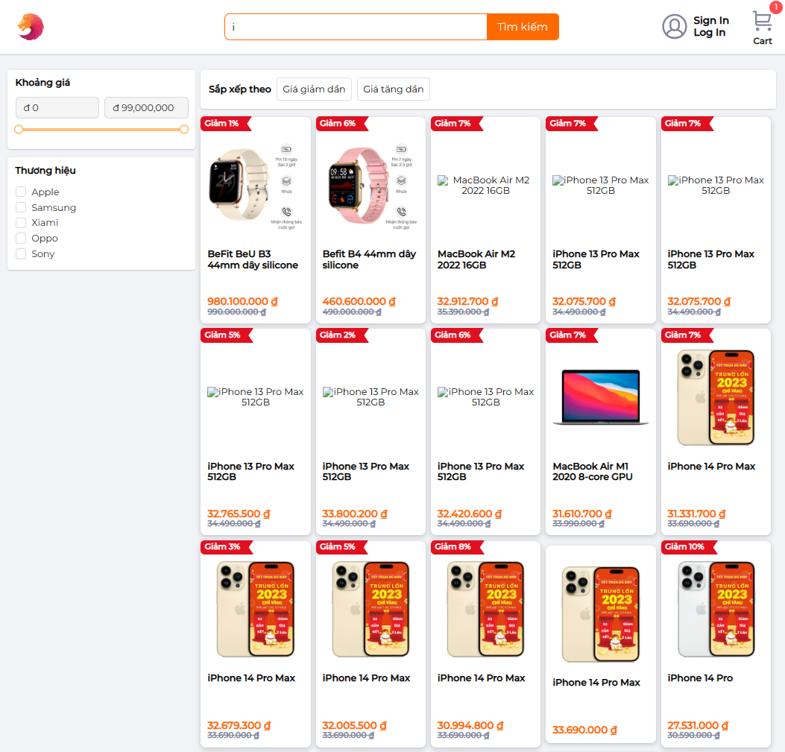

* *Complete payment and purchase*

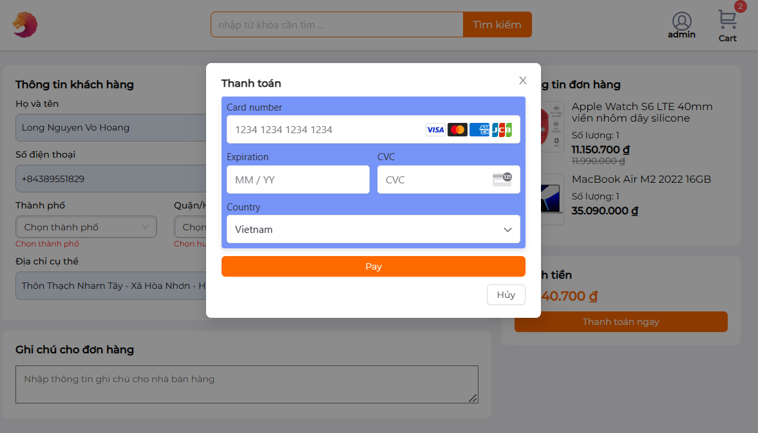

* *Dashboard*

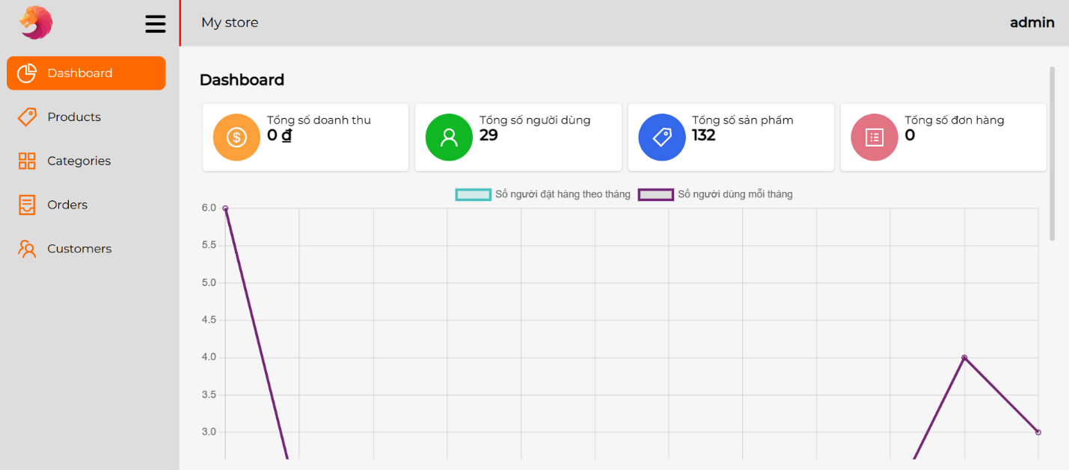

* *Management products*

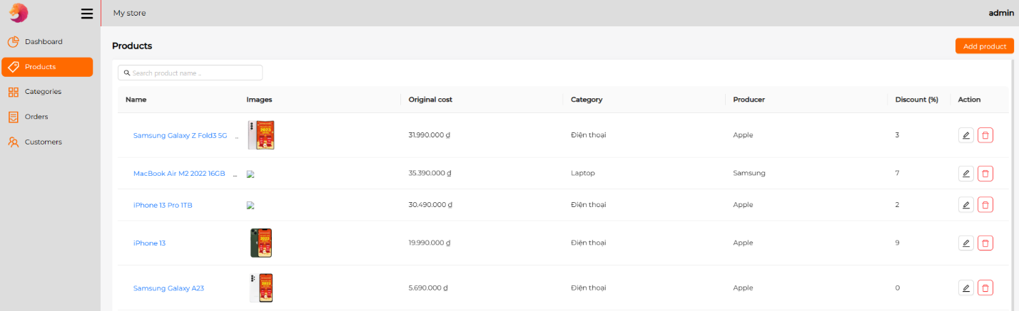

* *Management orders*

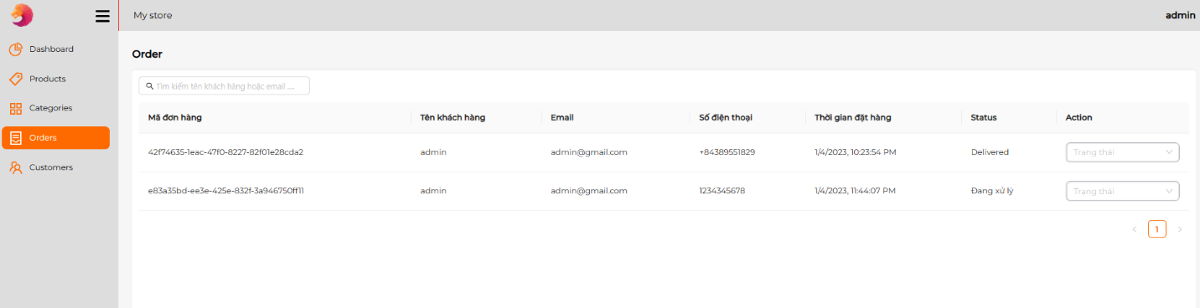

* *Management customer*

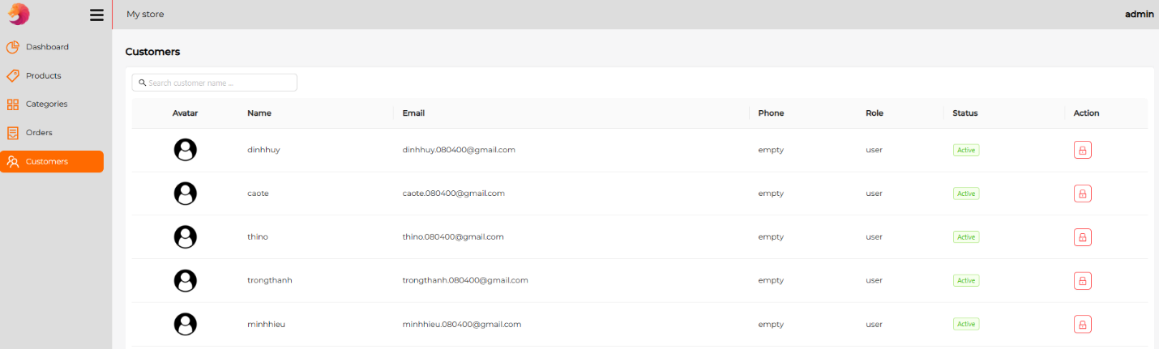

1. Management Methods

*The project is run using NodeJS and ReactJS:*

* 1. ReactJs:

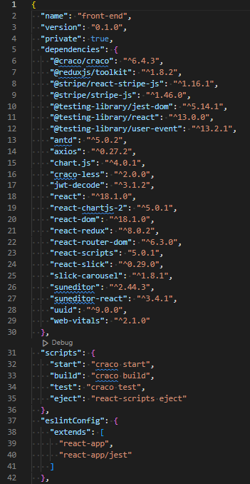

* 1. NodeJs:

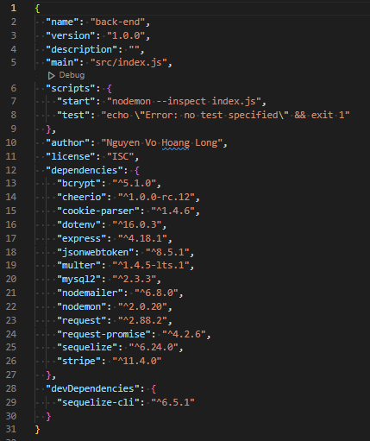

1. Conclusions and expand

+ In this topic, my team learned about packages used in ReactJs and NodeJS. My team also used the above packages to do real projects.  
     + Along with that, our group also achieved the following results when completing the project:  
         - Better understand NodeJS and know more about React JS  
         - Learn the latest technologies in the ReactJS and NodeJS programming industry  
         - Create real projects.  
     + In addition to the things that have been done because of the limited time, the thesis still has some shortcomings that need to be overcome.  
     + In order to improve the shortcomings, the future development direction of the topic we will focus on:  
         - Optimize the user interface to be able to reach more customers.   
         - Continue to learn and develop projects with better stability and better performance

1. References

|  |
| --- |
| *[1] NodeJS Design Patterns, Mario Casciaro and Luciano Mammino, 2nd*  *[2] Mastering NodeJs, Sandro Pasquali, 2013*  *[3]* [*https://expressjs.com/*](https://expressjs.com/)  *[4]* [*https://sequelize.org/docs/v6/getting-started/*](https://sequelize.org/docs/v6/getting-started/)  *[5] https://reactjs.org/* |