Unit test *testing an isolated unit of code.*

Mockito

<https://dzone.com/articles/use-mockito-mock-autowired>

Mock, Spy, Injectmocks

Mock: hollow instance. We mock which we use.

Spy: real instance. We mock which we change.

Mockito.*doReturn*(mock)  
 .when(**reportDefinitionFilter**).filterByProductCode(*any*(String.**class**), *anyListOf*(ReportFeatureCodeMapping.**class**), *anyListOf*(ReportDefinition.**class**));

Private method. Powermock.

Return without run the code.

Mockito.*doReturn*(Lists.*newArrayList*(**"00000000-0000-0000-0000-000000000003"**))  
 .when(**reportEntityService**).filterBaseIdsByPermission(  
 *any*(String.**class**), *any*(String.**class**), *anyListOf*(String.**class**));

Mock db

<http://testdrivendevelopment.ourownjava.com/spring-test/spring-data-mongodb-unit-testing-using-in-memory-fongo/>

@UsingDataSet(locations = {**"/FindDevicesReportDefinitionTestData.json"**, **"/FindDevicesReportEntityTestData.json"**}, loadStrategy = LoadStrategyEnum.***CLEAN_INSERT***)

@Rule  
**public** MongoDbRule **mongoDbRuleReporting** = *newMongoDbRule*().defaultSpringMongoDb(**"Reporting"**);

Controllers call outside ws, cannot mock ws. Test service instead.

Mockception

@Autowired  
@InjectMocks  
@Spy  
DefaultReportDefinitionService **reportDefinitionService**;  
  
@Autowired  
@Spy  
**private** DefaultReportEntityService **reportEntityService**;

//--------------------------------------------

**public class** DefaultReportDefinitionService {

@Autowired

**private** DefaultReportEntityService **reportEntityService**;

}

Intellij support Run test with Coverage.

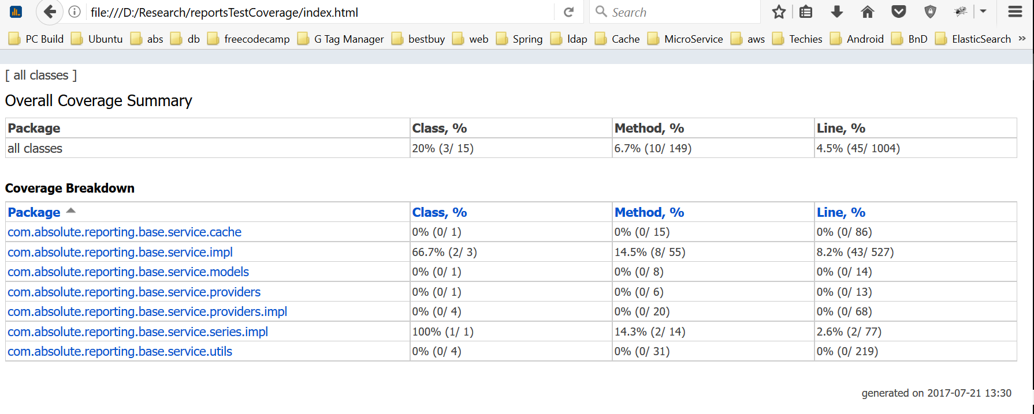

Right-click on file/folder Run … with Coverage.