Talend

Leading Open Source Solution

# Data Integration

## ETL

<https://www.talend.com/resource/etl/>

Developing ETL solutions in-house can be a long and complex effort, and over time and multiple projects usually results in a difficult to maintain patchwork of ad hoc applications.

* painful

On the other hand, powerful proprietary data integration platforms can be forbiddingly expensive, particularly in the current budgetary climate.

* $$$

Powerful Open Source ETL from Talend: Talend Open Studio for Data Integration

Usages:

* synchronization or replication of databases
* right-time or batch exchanges of data
* [ETL](https://en.wikipedia.org/wiki/Extract,_transform,_load) (Extract/Transform/Load) for [analytics](https://en.wikipedia.org/wiki/Analytics)
* [data migration](https://en.wikipedia.org/wiki/Data_migration)
* complex data transformation and loading
* [data quality](https://en.wikipedia.org/wiki/Data_quality) exercises
* [big data](https://en.wikipedia.org/wiki/Big_data)

Feature set:

* A graphical integrated development environment with an intuitive Eclipse-based interface.
* Drag-and-drop job design.
* A unified repository for storing and reusing metadata.
* The broadest data connectivity support of any data integration platform, with more than 900 components and built-in connectors that let you quickly bridge between databases, mainframes, file systems, web services, packaged enterprise applications, data warehouses, OLAP applications, Software-as-a-Service and Cloud-based applications, and more.
* Advanced ETL functionality including string manipulations, automatic lookup handling, and management of slowly changing dimensions.
* Support for ELT (extract, load, and transform) as well as ETL, even within a single job.

# Quick Look

<http://www.talend.com/download/talend-open-studio/#t4-gs>

# [Windows Deployment and Scheduling of Talend Jobs](http://etladvisors.com/2014/05/06/windows-deployment-and-scheduling-of-talend-jobs/)

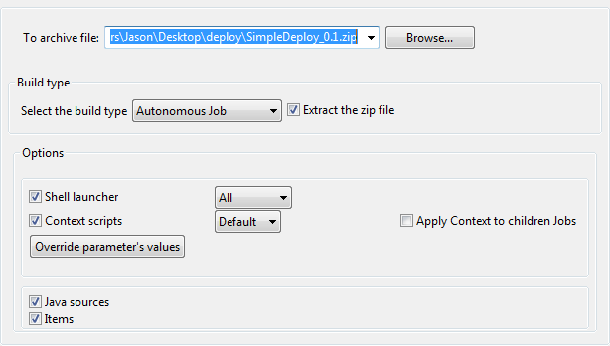

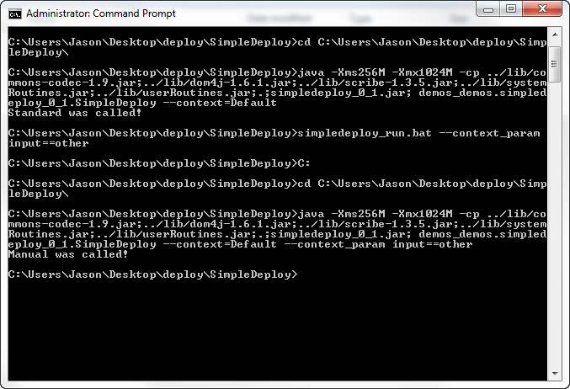

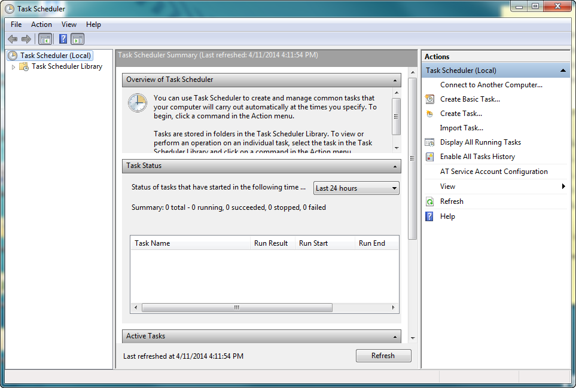

# What is the commercial license cost of the Talend ETL tool?

<https://www.quora.com/What-is-the-commercial-license-cost-of-the-Talend-ETL-tool>

Roundtable you’re counting 6k USD per developer.