# Cookies

https://www.w3schools.com/js/js_cookies.asp

Cookies are data, stored in small text files, **on your computer**.

Cookies are saved in name-value pairs like:

username = John Doe

When a web server has sent a web page to a browser, the connection is shut down, and the server **forgets** everything about the user.

Cookies were invented to solve the problem "how to **remember** information about the user":

When a user visits a web page, his name can be stored in a cookie.

Next time the user visits the page, the cookie "remembers" his name.

When a browser requests a web page from a server, cookies belonging to the page is added to the request. This way the server gets the necessary data to "remember" information about users.

None of the examples below will work if your browser has local cookies support turned off.

Usage:

JavaScript can create, read, and delete cookies with the document.cookie property.

You can also add an expiry date (in UTC time). By default, the cookie is deleted when the browser is closed

expires=date - Optional. Specifies the date in GMT format (See the Date.toUTCString method). If not specified, the cookie is deleted when the browser is closed

# SSO

[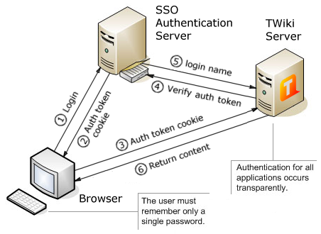](https://www.google.com/url?sa=i&rct=j&q=&esrc=s&source=images&cd=&ved=0ahUKEwiz3uK-693VAhXH44MKHW7oDN4QjRwIBw&url=http%3A%2F%2Fwww.jaumemoron.cat%2Fes%2Fcontent%2Finstalaci%25C3%25B3n-y-configuraci%25C3%25B3n-de-un-servidor-sso&psig=AFQjCNENR2N7_6eYo7_ll5dBoCSB3AMSRQ&ust=1503044381489158)