**<http://www.anandtech.com/show/11722/intel-reveals-ice-lake-core-architecture-10nm-plus>**

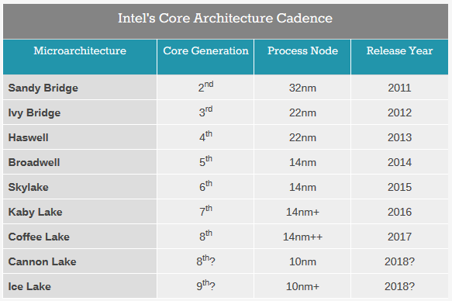

**Core M (Y-Series)**

Core m3, m5 và m7

Core m 6**Y**75 (thuộc Core m7), Core m 6**Y**54 (thuộc Core m5).

**Core i (U-Series và H-Series)**

Ultra Low Power - TDP của dòng U vào khoảng 15W.

Core i H-Series sẽ nằm ở chữ H (2 nhân) hoặc HQ (4 nhân)

Core i7-6920**HQ**, Core i5-6440**HQ**, Core i3-6100**H**

**Desktop**

CPU Skylake dành cho máy bàn thì vẫn đủ cả i3, i5, i7 lẫn Pentium với TDP từ 35W đến 67W.

Skylake 6gn

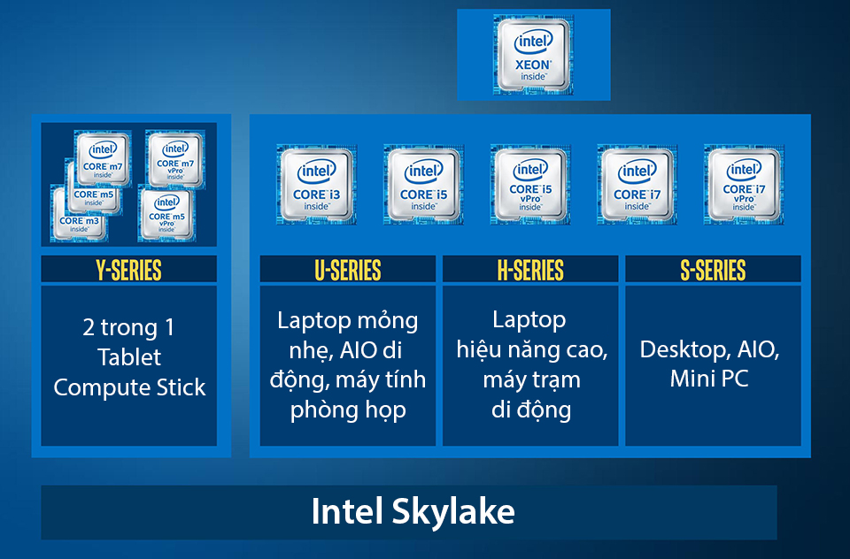

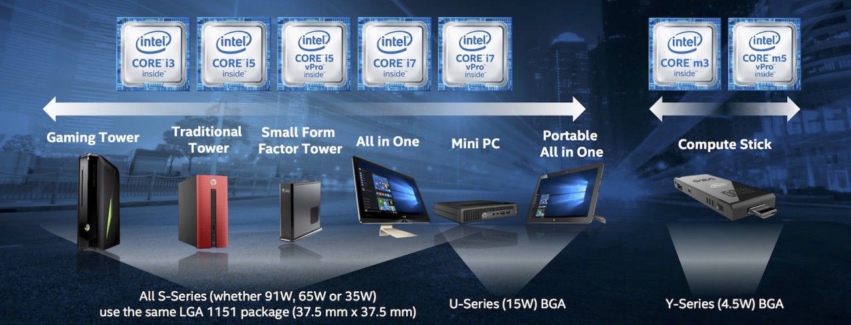

CPU

2 cores: fast processor speed + hyper threading capabilities.

<http://www.hardware-revolution.com/12-cpu-specifications-explained-in-plain-english/>

**Thermal Power Design (TPD)** how much power, in Watts, that your processor will consume in the worst case scenario. This is also used to have an idea of how much heat your processor will produce.

-> fan -> noisy.

Mainboard

Chipset

-> CPU

Socket

-> CPU

Form Factor

<http://www.codesandtutorials.com/hardware/computerfundamentals/motherboard-types-form_factor.php>

AT, **Baby AT (Standard)**, **ATX**, Mini-ATX, Micro-ATX, Flex ATX, LPX and Mini LPX and NLX.

<https://pcpartpicker.com>

<http://www.programmerfriendly.com/best-computer-for-programming/>