1: Create a Vehicle class with max_speed and mileage instance attributes

2: Create a Vehicle class without any variables and methods

3: Create a child class Bus that will inherit all of the variables and methods of the Vehicle class

4: Class Inheritance

**Given**:

Create a **Bus** class that inherits from the **Vehicle** class. Give the capacity argument of Bus.seating_capacity() a default value of 50.

Use the following code for your parent Vehicle class. You need to use method overriding.

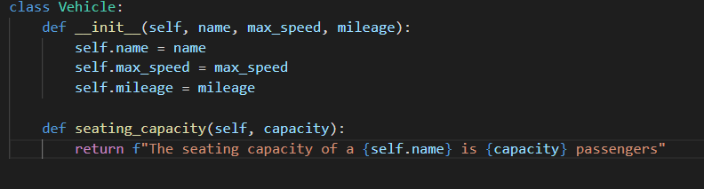

**Expected Output**:

The seating capacity of a bus is 50 passengers



5: Define property that should have the same value for every class instance

Define a **class** attribute”**color**” with a default value **white**. I.e., Every Vehicle should be white.

Use the following code for this exercise.

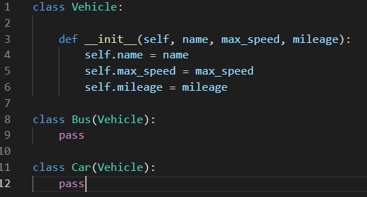

Expected Output:



7: Determine which class a given Bus object belongs to (Check type of an object)

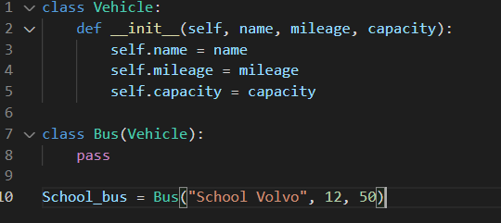

8: Determine if School_bus is also an instance of the Vehicle class

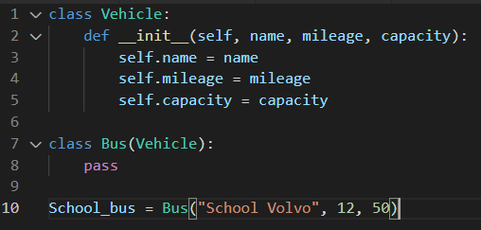

9. Write a Python program to create a class and display the namespace of the said class

10. Write a Python class named Student with two attributes student_name, marks. Modify the attribute values of the said class and print the original and modified values of the said attributes

11. Write a Python class named Student with two instances student1, student2 and assign given values to the said instances attributes. Print all the attributes of student1, student2 instances with their values in the given format

12. Use tkinter python create a window to save information:

* Name
* Age
* Address
* Sex
* Email
* Phone number
* Username
* Password(Hided)

Save to the postgredatabase

Note: email, phone number, username is UNIQUE type. If username, phone number, email already exists on postgreDB, sent popup to window.