# 



**Test-taking application**

**Documentation**

| **Authors** | **C2211L - Group 2** |
| --- | --- |
| **Dang Hoang Nam Vu Hai Hoa Nguyen Tuan Minh**  **Ninh The Manh**  **Hoang Ha Son** |
| **Date** |  |
| **Instructor** | **Nguyen Tien Thanh** |

Hanoi,<date>

**Index**

**1.** **Problem Definition 3**

1.1. Problem Abstraction 3

1.2. The Current System 3

1.3. The Proposed System 3

1.3.1. Boundaries of the System 3

1.3.2. Hardware and Software Requirements 3

**2.** **Customer Requirements Specification 3**

2.1. Users of the System 3

2.2. System functions 3

**3.** **System Designs 3**

3.1. Entity Relationship Diagram 3

3.2. Database Design 3

3.3. Sitemap 3

3.4. System functions design 4

**4.** **Task sheet 4**

**5.** **Validation Checklists 4**

# **Problem Definition**

## ***Problem Abstraction***

In the context of our rapidly evolving educational landscape, there is an increasing demand for a method of assessment that is not only swift but also convenient. To cater to this need, we have developed this software application.

The application is designed with a user-friendly interface that is simple to navigate, making it accessible to a wide range of users. The process of taking a test is straightforward: users select the subject they wish to be assessed on, and a multiple-choice test is generated. Users then select their answers from the provided options. Upon completion of the test, the results are immediately available, providing instant feedback.

One of the key features of our software is the extensive and diverse question pool. This ensures that each test is unique, promoting fairness and accuracy in the assessment process. No matter how many times a user takes a test, or how many users take the same test, the questions will vary each time.

Our software is versatile and can accommodate any subject or user group. Whether you are a student preparing for an exam, a teacher creating assessments, or simply someone who enjoys testing their knowledge, our software is equipped to meet your needs. It is a comprehensive solution for anyone seeking an efficient and effective method of assessment.

## ***The Current System***

**-Question Database**: This database contains thousands of multiple-choice questions with correct answers. These questions are categorized into various topics such as grammar, vocabulary, phonetics, and reading comprehension.

-**User Interface**: The user interface is designed to be user-friendly, with clearly displayed questions and answer choices. Users can select their answers and receive immediate feedback.

## ***The Proposed System***

For the test taker:

- Choose and take the test

- Can see the test results

For the organizer:

- Manage user accounts

- Manage the subjects being tested

- Manage the pool of questions

## ***Boundaries of the System***

User: anyone who needs to self-test or organize a multiple-choice test

Only the organizer is allowed to add, edit, delete subjects, questions and answers, and accounts of test participants

Users only log in, choose and complete the test

## ***Hardware and Software Requirements***

- **Hardware Requirements :**

+ Intel Core I3 or AMD Ryzen or higher

+RAM 256 MB

+Free hard drive space 1 Gb

- **Software Requirements:**

+ MongoDB server

+ Apache NetBeans

+ Studio 3t

# **Customer Requirements Specification**

## ***Users of the System***

- Examiner

- Organizer

## ***System functions***

1. **Login**

| Input | Username and password |
| --- | --- |
| Process | Verify account and password |
| Output | Logged in successfully  Login error |

1. **Choose subject**

| Input | Choose the exam subject |
| --- | --- |
| Process | Pull out random questions from the question pool |
| Output | The exam |

1. **Result**

| Input | The answer is chosen by the examinee |
| --- | --- |
| Process | Compare correct answers |
| Output | Result |

1. **Navigation button**

| Input | user's choice |
| --- | --- |
| Process | Perform the corresponding function |
| Output | change that the user wants |

# **System Designs**

## ***Entity Relationship Diagram***

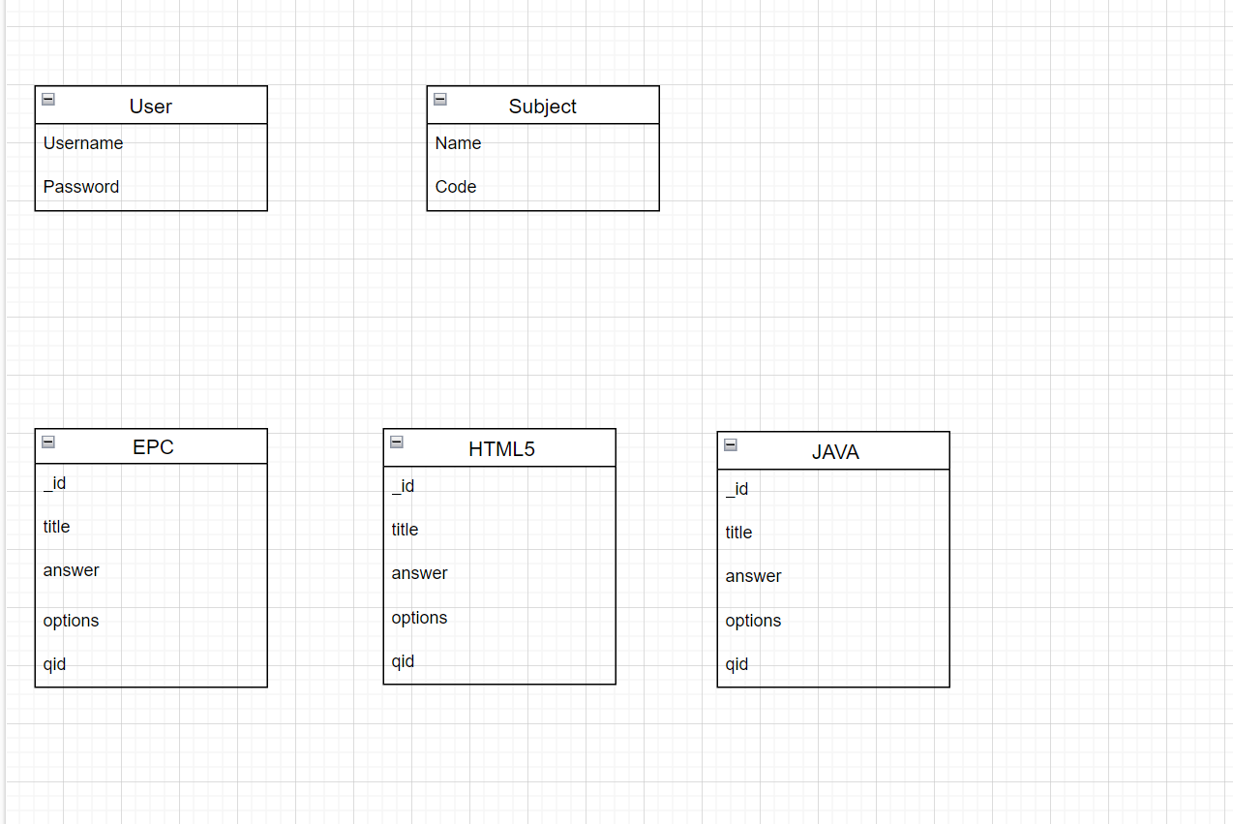

## ***Database Design***

# -User



# -Subject



# -EPC



# -JAVA



# -HTML5



## ***Sitemap***

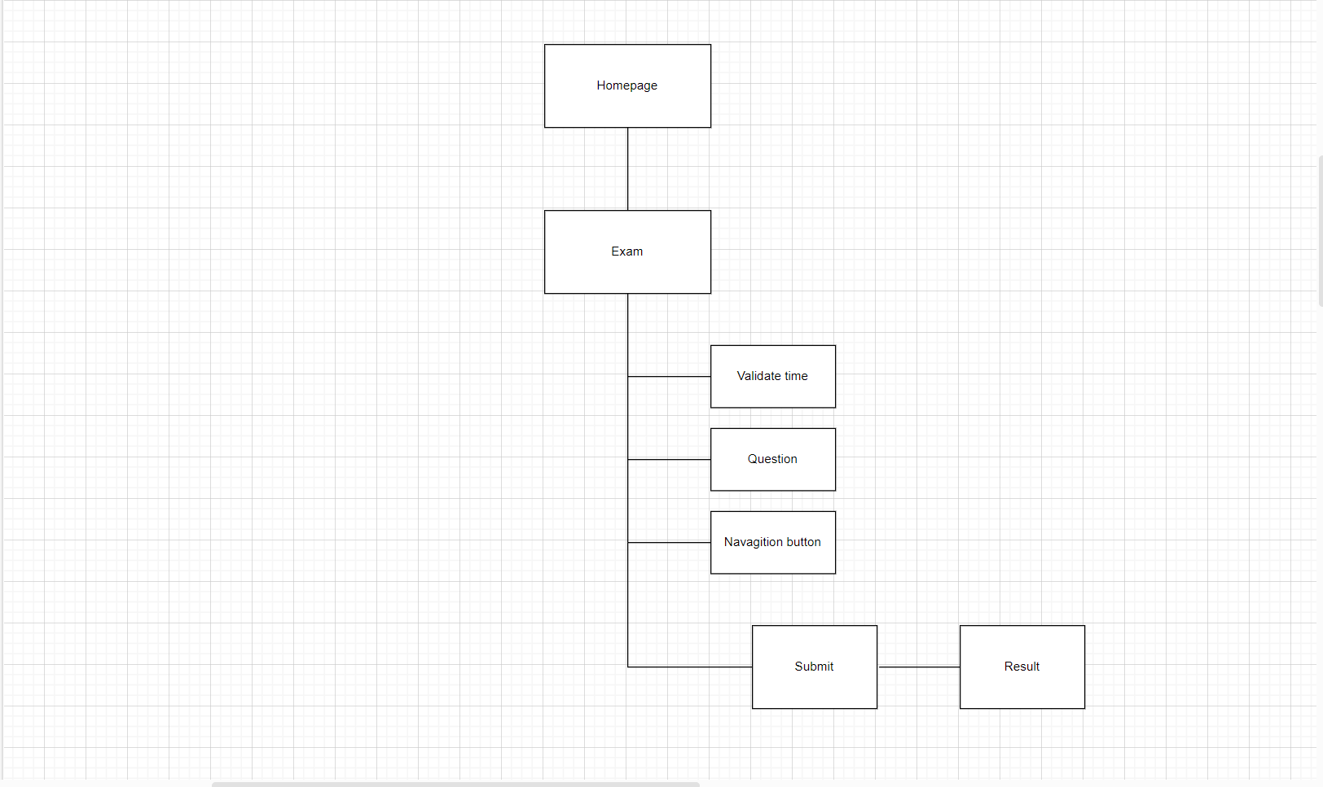

## ***System*** functions ***design***

**3.4.1.App design**

**a.Login**

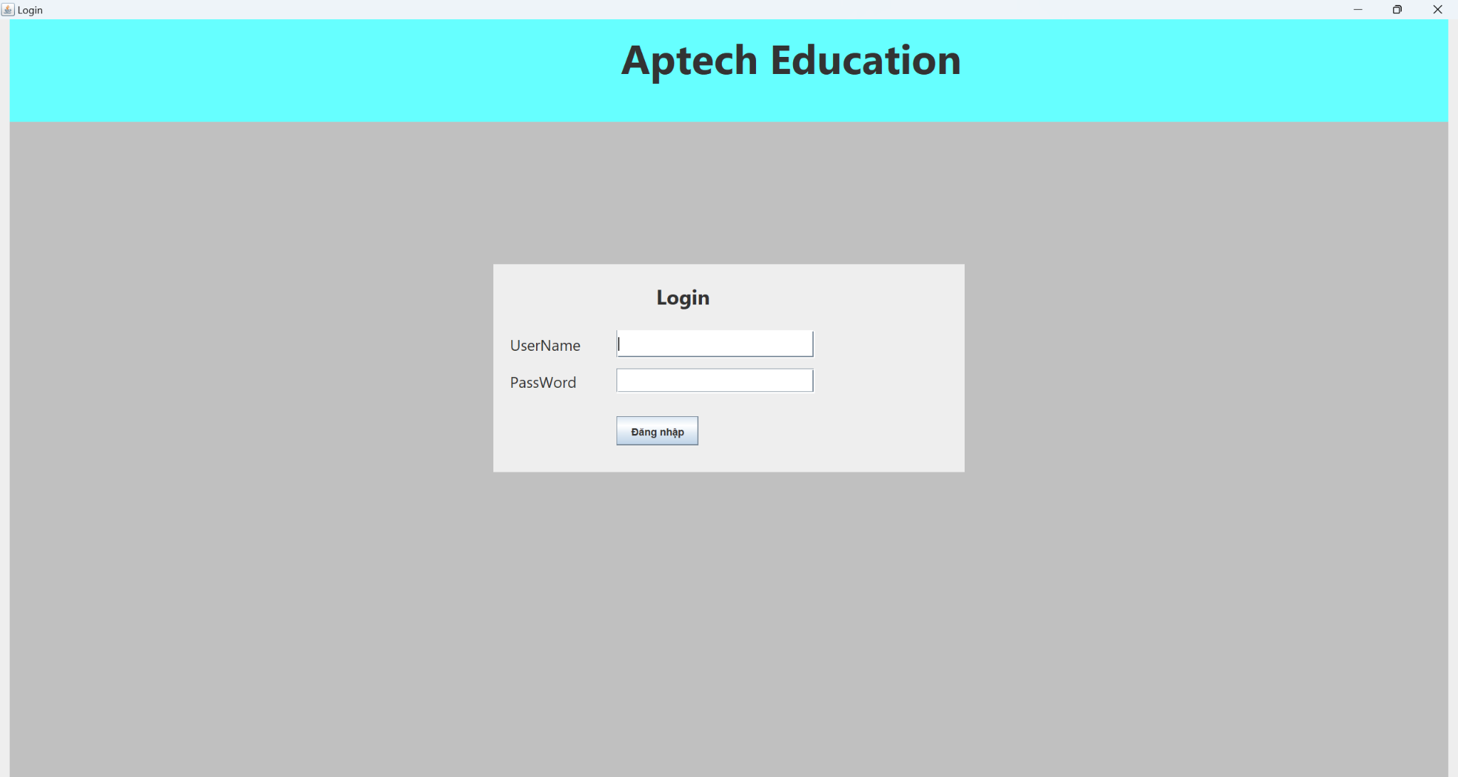

**b.Homepage**

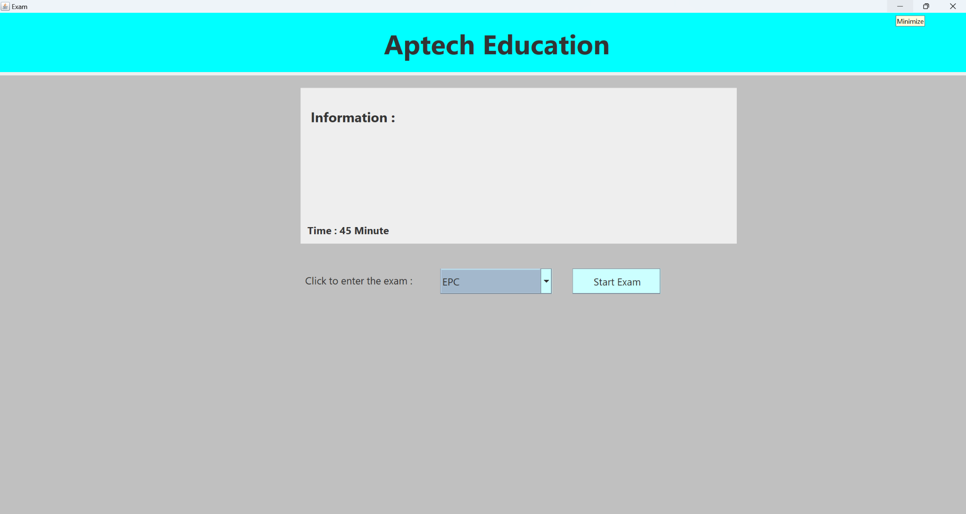

**c. Exam**

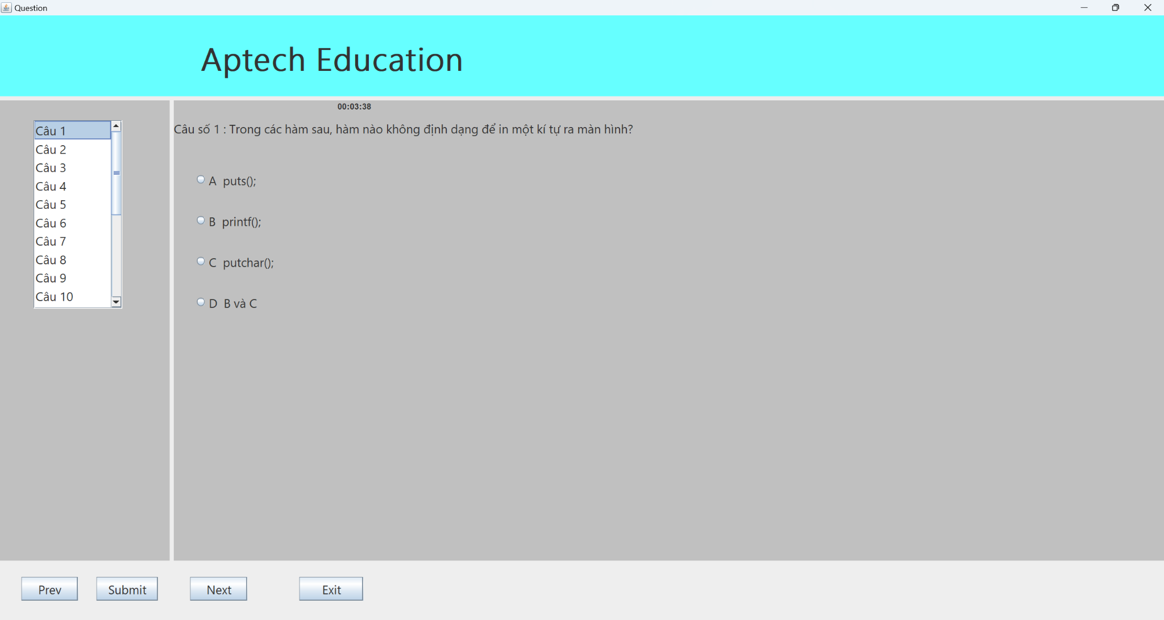

**d.Result**

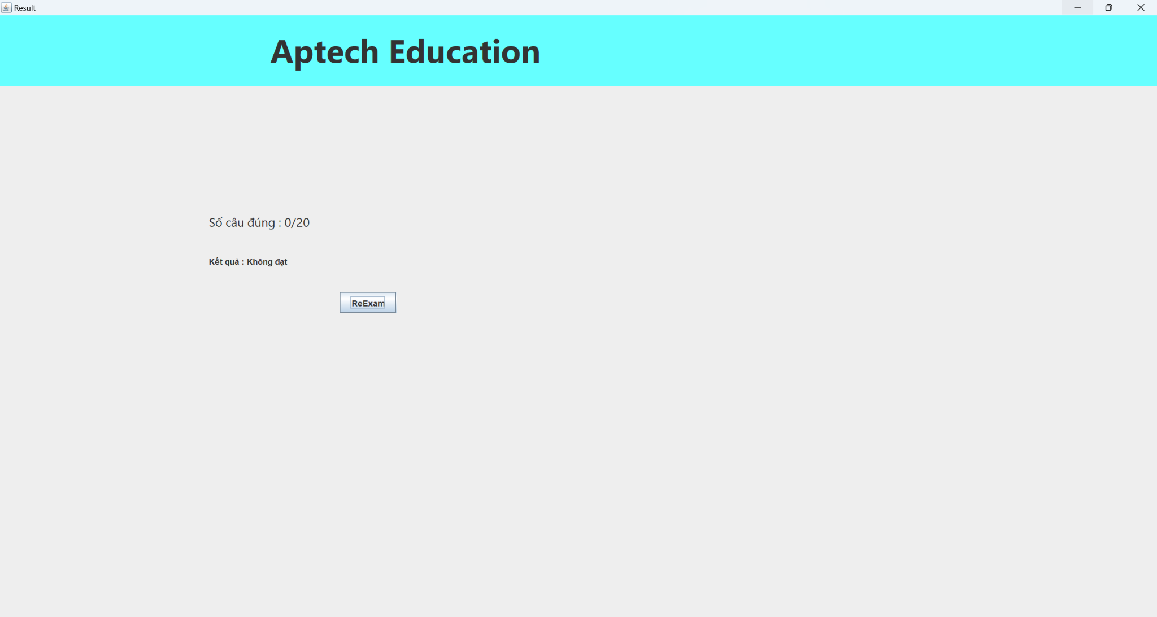

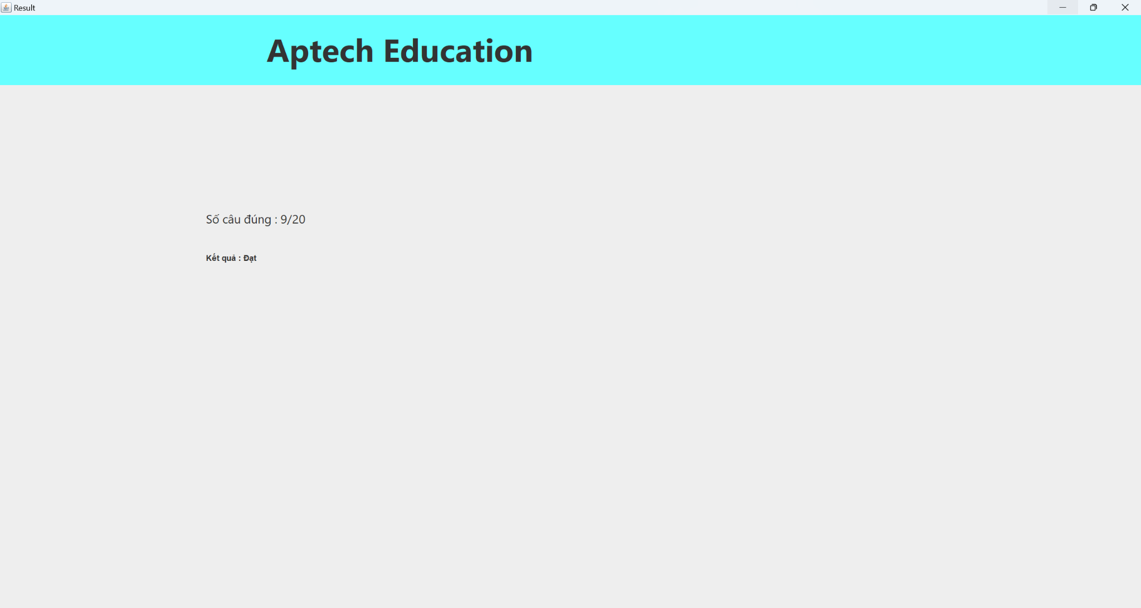

**3.4.2 Process diagram**

**a.Login**

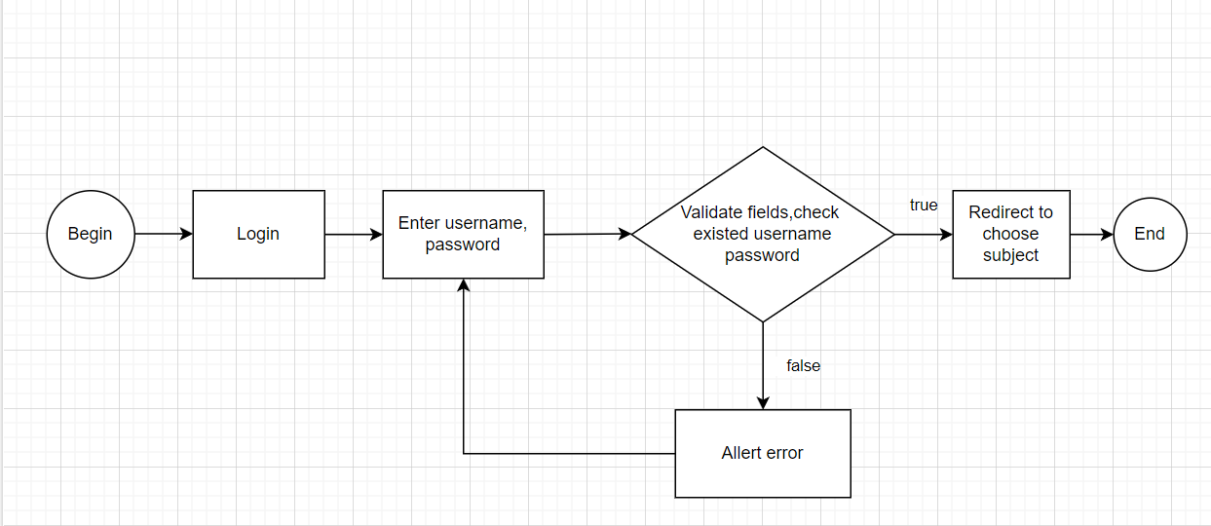

b.Choose subject

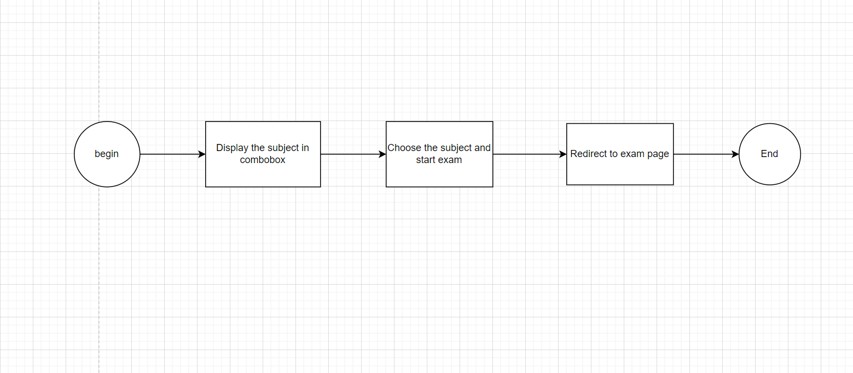

c.List question

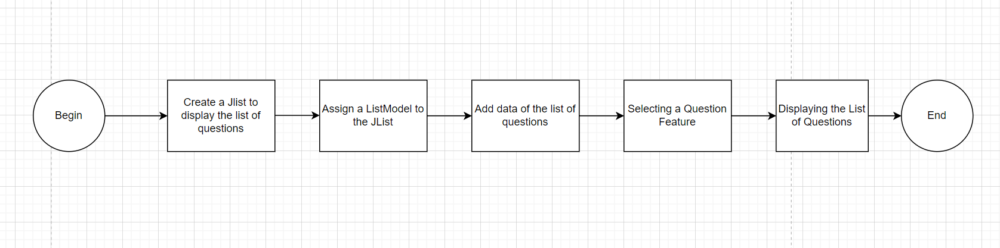

d.Calculate point

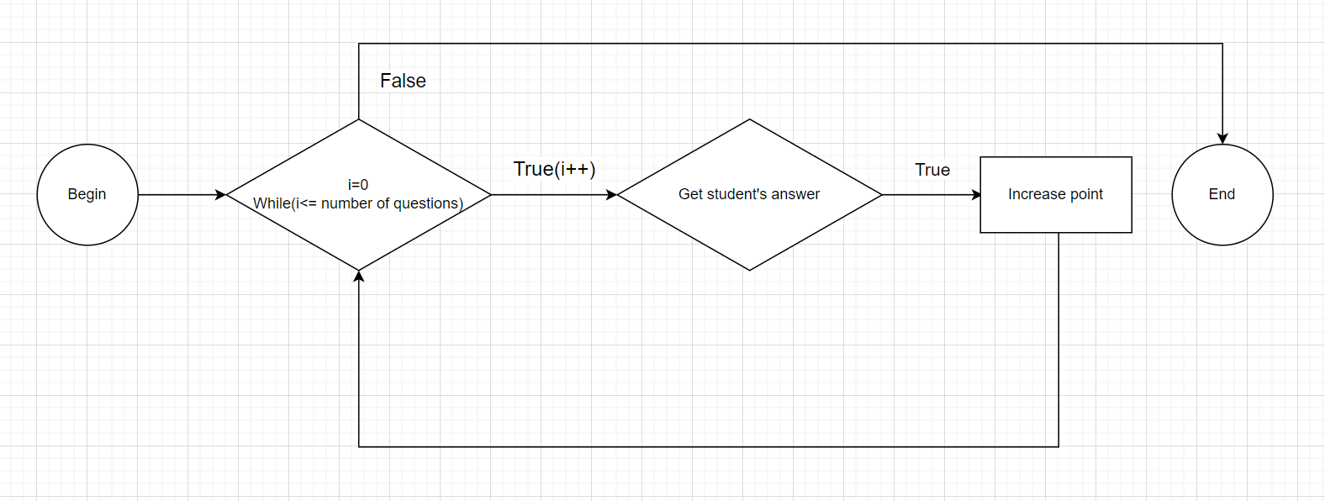

e. Navigation button

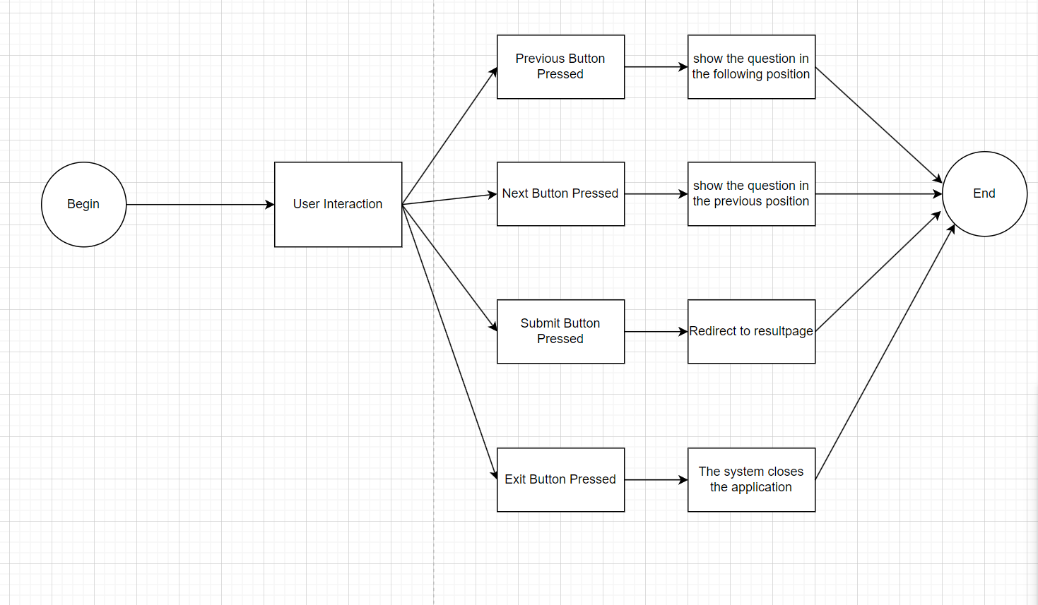

f. Result

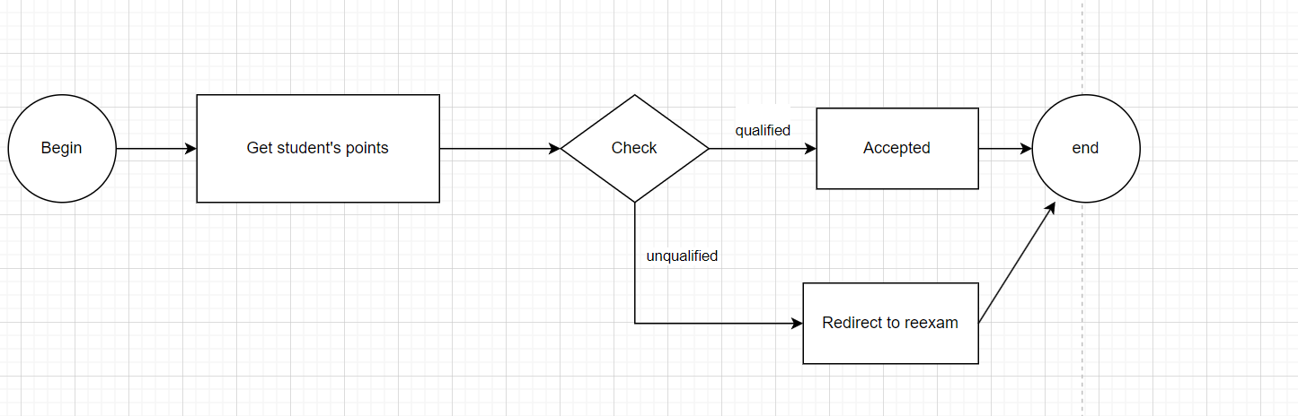

# **Task sheet**

| **Task** | **Start time** | **Finish time** | **Implemented by** | **Evaluation(%)** |
| --- | --- | --- | --- | --- |
| Feasibility study phase |  |  |  |  |
| Ideas | 21/12/2023 | 25/02/2024 | Dang Hoang Nam | 20 % |
| Build Ideas | 21/12/2023 | 25/02/2024 | Nguyen Tuan Ninh | 20 % |
| Build Ideas | 21/12/2023 | 25/02/2024 | Ninh The Manh | 20 % |
| Build Ideas | 21/12/2023 | 25/02/2024 | Vu Hai Hoa | 20 % |
| Build Ideas | 21/12/2023 | 25/02/2024 | Hoang Ha Son | 20 % |
| Review and edit ideas | 21/12/2023 | 25/02/2024 | All member | 100 % |
| Requirement Analysis phase |  |  |  |  |
| Requirements analysis | 28/12/2023 | 01/01/2024 | All member | 100% |
| Design phase | 28/12/2023 | 25/02/2024 | All member | 100% |
| Home Page Design | 28/12/2023 | 25/02/2024 | All member | 100% |
| Subject page Design | 28/12/2023 | 25/02/2024 | All member | 100% |
| Sign-in page Design | 28/12/2023 | 25/02/2024 | All member | 100% |
| Question-Quiz - page Design | 05/1/2023 | 25/02/2024 | All member | 100% |
| Result page Design | 11/1/2023 | 25/02/2024 | All member | 100% |
| Development phase |  |  |  |  |
| Home Page | 21/12/2023 | 25/02/2024 | All member | 100% |
| Sign-in page | 21/12/2023 | 25/02/2024 | All member | 100% |
| Subject page | 21/12/2023 | 25/02/2024 | All member | 100% |
| Question-Quiz page | 21/12/2023 | 25/02/2024 | All member | 100% |
| Result - Page | 21/12/2023 | 25/02/2024 | All member | 100% |
| Create Database | 21/12/2023 | 25/02/2024 | All member | 100% |
| Search data Question | 21/12/2023 | 25/02/2024 | All member | 100% |
| Push data | 21/12/2023 | 25/02/2024 | All member | 100% |
| Testing phase |  |  |  |  |
| Project test | 27/02/2024 | 02/03/2024 | All member | 100% |
| Deployment phase |  |  |  |  |

# **Validation Checklists**

| Option | Validate |
| --- | --- |
| Các hình ảnh và đường dẫn có hiển thị rõ ràng không? | Có |
| Việc điều hướng có hoạt động chính xác trên tất cả các site không? | Có |
| Cơ sở dữ liệu có được lưu trên hệ thống không | Có |
| Các form có validate đúng cách không? | Có |
| Hệ thống câu hỏi có hoạt động ổn định không | Có |