Assignment: DML

Download SQLAssignment.sql database from Canvas and import the database to phpMyAdmin as a new database named “SQLAssignment”. Write the SQL commands for the following queries and execute those in your machine. Also, show the output tables. You need to include the screenshots of running SQL commands and output tables in phpMyAdmin.
- List the property numbers and city of all properties that have been viewed. You need to eliminate duplicates from the list. Also, arrange the list by ascending order of city (alphabetic order), and within city, in descending order of property number (alphabetic order).
[3 Points]
  - SQL Command:
  - Output Table:

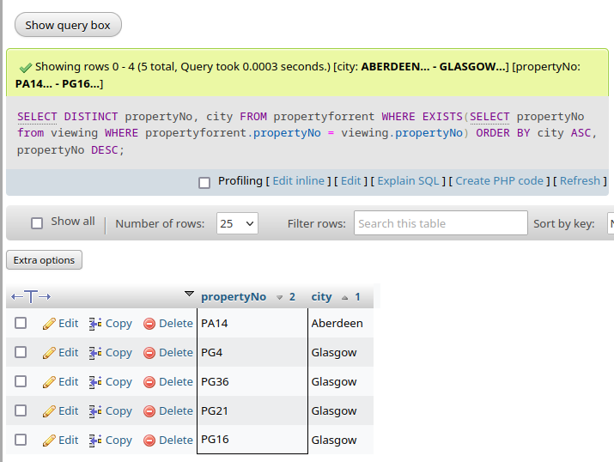

- Assume, the salary column in staff table presents the annual salary of a staff. Now, list all staff with monthly salary less than 1000. In your list, show staff number, last name, and monthly salary. [2 Points]
  - SQL Command:
  - Output Table:
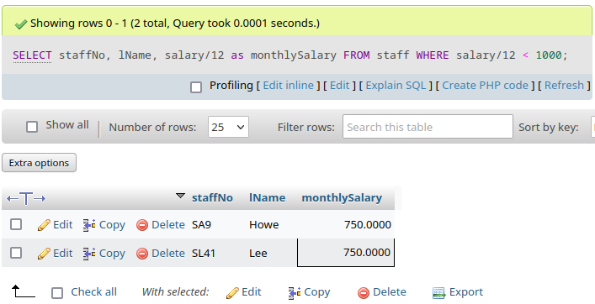

- Find all clients with the string ‘flintyrock’ in their email address. In your list, show client number, last name, and email address. [1 Point]
  - SQL Command:
  - Output Table:
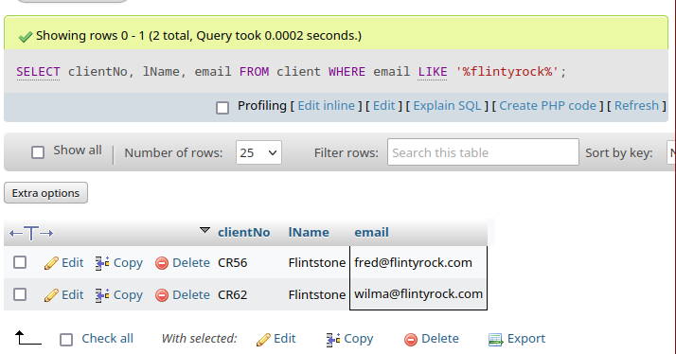
- Find the total number of female staff in the Staff table. You need to name the output column as ‘NumOfFemaleStaff’. [1 Point]
  - SQL Command:
  - Output Table:

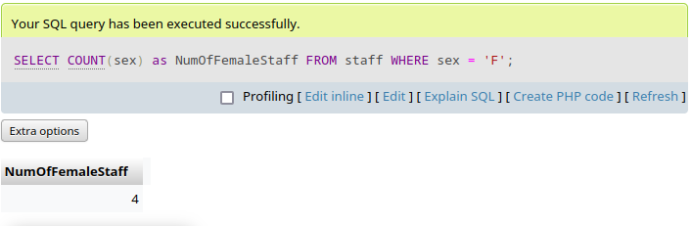

- For each branch office with at least two members of staff, find the number of staff working in each branch and the average of their salaries. Your output table should have three columns: BranchNumber, MyCount, MyAverage. [2 Points]
  - SQL Command:
  - Output Table:
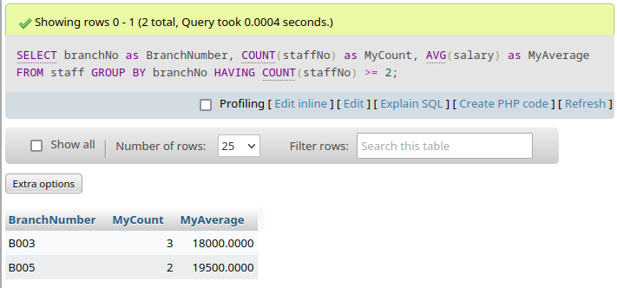

- Increase the number of rooms by 1 and rent by 10% of property PL94. Show your updated row.
[1 Point]
  - SQL Command:
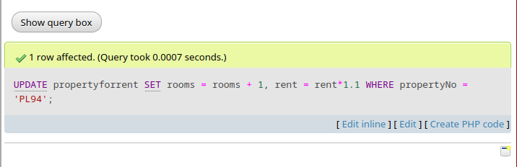
  - Output Table:

