Assignment: DDL

Task 1: PSU Abington University Database Creation [5 points]
Below is a schema of PSU Abington database. Create the database and all tables using SQL command. Also, insert at least 3 rows in each table using SQL command. In phpMyAdmin, Name your database as “universitydb”.

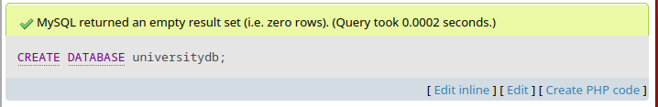
Shcema:
Department (dept_name, building, budget)
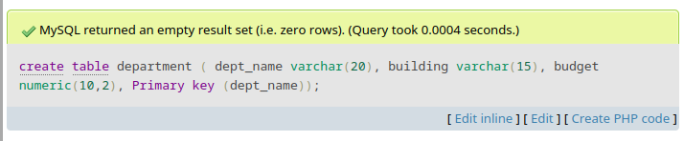
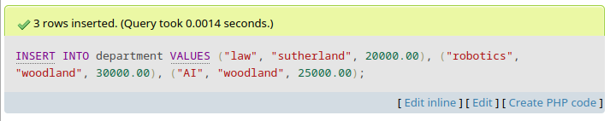

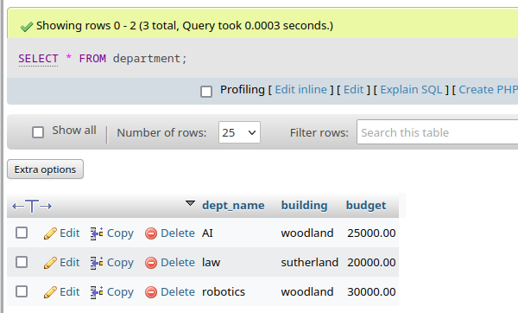

Course (course_id, title, dept_name, credits)
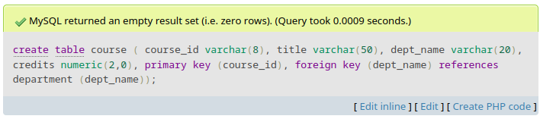
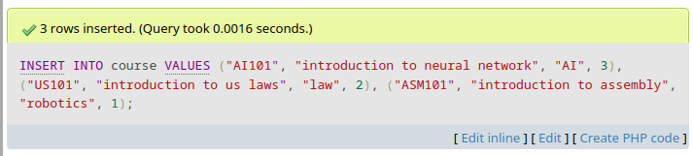
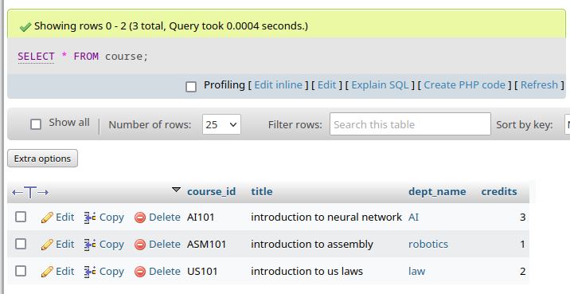

Instructor (ID, name, dept_name, salary)
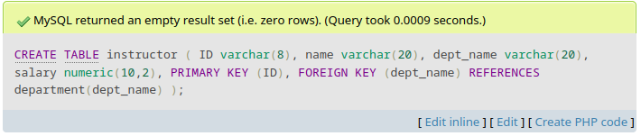
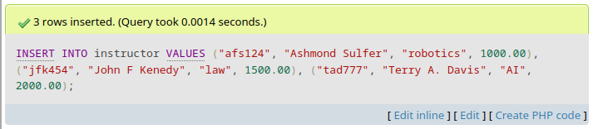
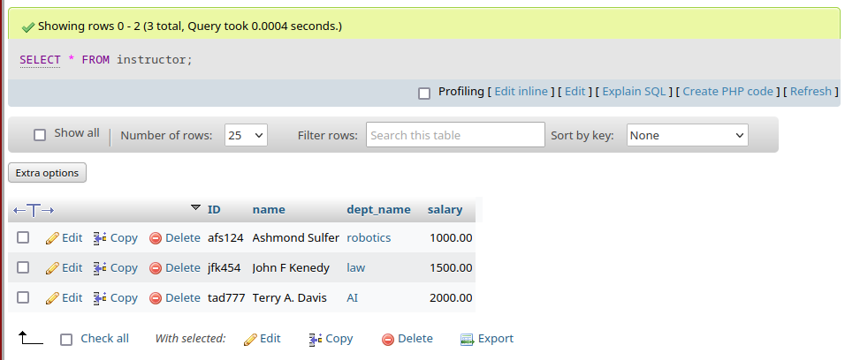

Section (course_id, sec_id, semester, year, building, room_number)

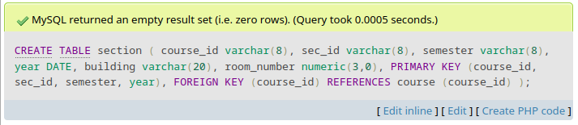
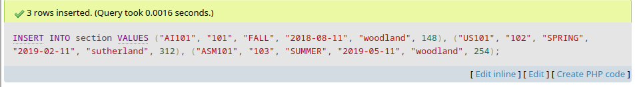

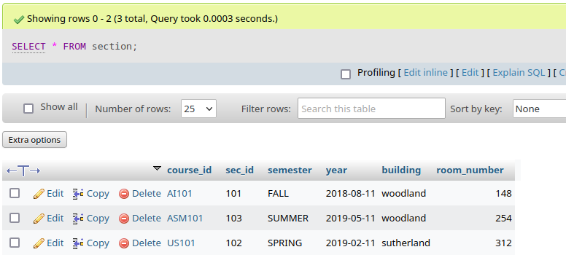

Teaches (ID, course_id, sec_id, semester, year)
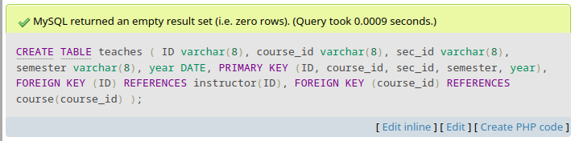
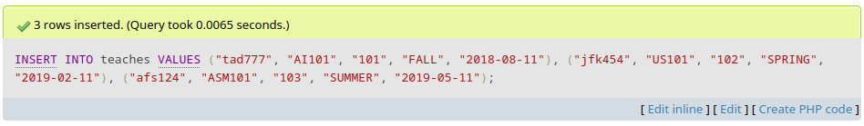
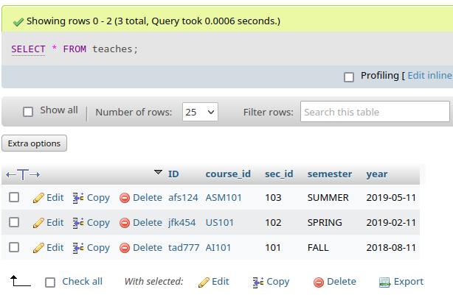

Student (ID, name, dept_name, tot_cred)

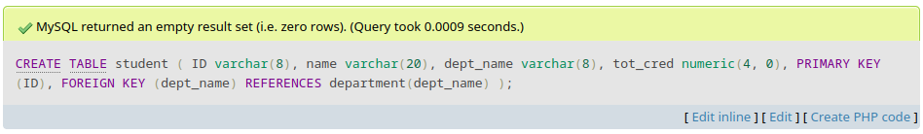
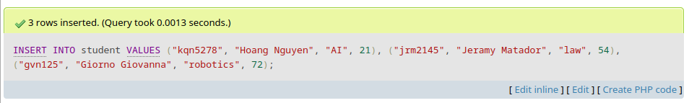

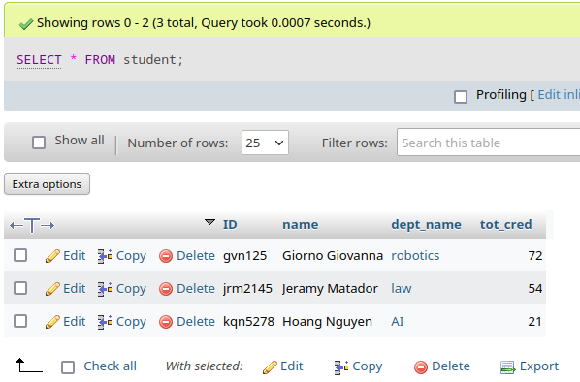

Note:
- Data type/domain of each attribute should be appropriate.
- You should maintain referential integrity (primary key-foreign key relationship. Below are example codes for creating two tables maintaining referential integrity.

create table department (
dept_name varchar(20),
building varchar(15),
budget numeric(10,2),
Primary key (dept_name));

create table course (
course_id varchar(8),
title varchar(50),
dept_name varchar(20),
credits numeric(2,0),
primary key (course_id),
foreign key (dept_name) references department (dept_name));

What to submit: Create a report by putting all SQL commands for table creation and data insertion in a word document. In addition, display your table data using SQL commands in phpMyAdmin and put snapshots of all tables with data in your report. Submit the report through Blackboard.

Task 2: Data Manipulation using SQL Command [5 points]
Perform following data manipulation:
- Increase the budget of law department by 5 percent.
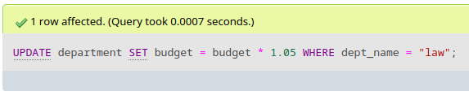
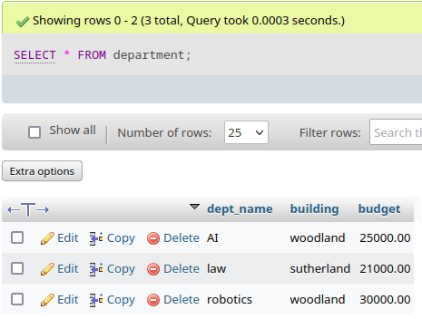

- Show the budget of CSC department.

I add in a new csc department just for this part
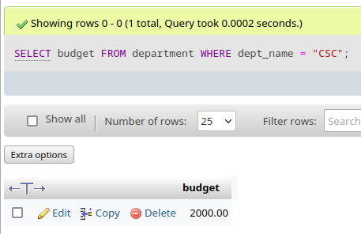

- List name and salary of all instructors of CSC department.

I also add in new instructor for csc department

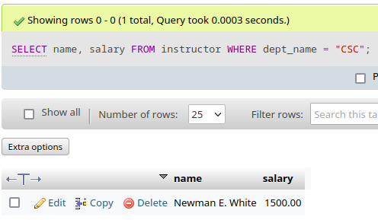

- List name and total credits of all students.

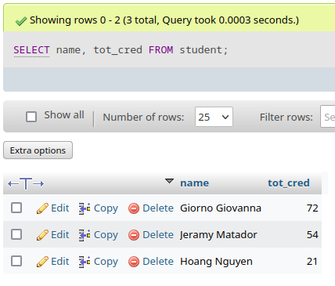

What to submit: Create a report by putting all SQL commands and snapshots of your output from phpMyAdmin in a word document. Submit your report through Blackboard.

