COMP1682 — Final Year Project
BSc Hons Computing

Aptis Go
[Replace with your full academic project title]

FINAL YEAR REPORT

Student Name: [Your Full Name]
Student ID: [Your Student ID]
Supervisor: [Supervisor Name]
Submission Date: dd-mm-yyyy
Word Count: xxx words

Abstract
An abstract is a self-contained summary of your entire project: what problem you addressed, what you built, how you evaluated it, and what you concluded. For this module, write 200–350 words.
Structure your abstract to answer these 5 questions:
- What is the problem? (1–2 sentences — your problem statement)
- Why does it matter? (1 sentence — significance and consequences)
- What did you build? (1–2 sentences — your product and approach)
- How did you evaluate it? (1 sentence — your evaluation method)
- What did you find? (1–2 sentences — key outcomes and limitations)
⚠ Write the abstract last — after your entire report is complete. Do not begin with "This report..." — begin with the problem or the finding.
Example opening: "University students frequently struggle to coordinate peer study sessions for specific modules, leading to study isolation and reduced collaborative learning opportunities. This project investigates..."
[ Write your 200–350 word abstract here ]

Acknowledgements
Acknowledge the people who supported your project. This is optional but professional. Typically includes: your supervisor, any research participants who gave their time, the university library, and any colleagues who provided feedback.
[ Write your acknowledgements here (optional but recommended) ]

Chapter 1: Introduction
This chapter sets the scene for your entire project. It must be clear, concise, and establish: (a) the problem, (b) your aim, (c) your objectives, and (d) the scope. Everything in the report that follows should trace back to this chapter.
💡 Write this chapter after your Literature Review and Product Research chapters are complete. That way, you know exactly what your project is based on and can write a precise, confident introduction.

1.1 General Overview

Standardized English proficiency has become an institutional benchmark in modern higher education, frequently determining whether undergraduate students can advance into specialized major trimesters or satisfy statutory graduation criteria. Among accredited testing frameworks, the Aptis examination—developed by the British Council and benchmarked against the Common European Framework of Reference for Languages (CEFR)—is widely utilized to evaluate proficiency, particularly for the CEFR B1 and B2 thresholds.

Despite the critical stakes associated with these certifications, candidate performance indicates substantial operational and pedagogical friction. Empirical research and British Council benchmark data demonstrate that over 65% of students fail initial standardized English proficiency attempts when relying exclusively on unguided self-study lacking personalized diagnostic planning and human feedback. This creates recurring consequences for university cohorts:
Repeated examination failure leading to cumulative, wasted examination registration fees.
Administrative blocks and delayed transitions into specialized academic trimesters or final degree conferral.
Pronounced performance anxiety and eroded academic confidence, specifically across productive language competencies

1.2 Problem Statement
University students aiming for Aptis B2 certification struggle with unguided self-study and a lack of qualitative feedback on productive skills (Speaking, Writing, and Listening), which causes high initial failure rates, wasted examination registration fees, and delayed academic progression into major trimesters or graduation. As a result, students experience heightened academic anxiety, prolonged degree completion timelines, and substantial financial losses while institutions face administrative backlogs in cohort progression.

1.3 Project Aim
The overarching aim of this project is to design, develop, and evaluate APTIS GO, a goal-oriented web platform featuring hybrid marking, enabling university students to achieve target Aptis CEFR levels efficiently and systematically.

1.4 Specific Objectives
System Architecture & Secure Access (Specific & Achievable): Design and deploy a decoupled REST API using Node.js and Express, implementing JSON Web Tokens (JWT) and Role-Based Access Control (RBAC) to enforce strict privilege boundaries across Students, Lecturers, and Administrators.
Hybrid Evaluation Engine (Measurable): Develop an asynchronous marking pipeline capable of returning automated scores for Reading, Listening, and Grammar within 1 second of submission, while queuing Speaking and Writing submissions for manual instructor grading and qualitative feedback.
Adaptive Goal & Study Plan Engine (Specific & Time-bound): Implement a diagnostic Placement Test module that maps raw scores to CEFR bands (A1–C1) and generates daily task-oriented study plans with dynamic state updates (PATCH /study-plans/:id).
Data Optimization & Integrity (Measurable & Achievable): Architect an embedded MongoDB document model storing question sets within test documents (sub-documents) to optimize query performance and ensure sub-second retrieval times for comprehensive mock exams.
Usability & Verification (Measurable): Validate system robustness through a minimum of 15 end-to-end automated and manual test cases across authentication, grading workflows, and schema integrity, achieving a System Usability Scale (SUS) benchmark score of $≥75$ during user acceptance evaluations.
Objective # | Objective
1 | To research and analyze user requirements, pedagogical literature, and assessment criteria across all Aptis skills to establish design principles and identify the academic research gap.
2 | To conduct competitor analysis and heuristic evaluations on 4 commercial language products using Nielsen's usability heuristics to identify competitive market gaps.
3 | To perform empirical user research with $\ge 5$ student interviews and $\ge 20$ survey responses, formalizing requirements through personas, user stories, MoSCoW, and C4 system models.
4 | To establish an adapted solo Agile Scrum project management plan, including a 30-week milestone roadmap, risk register, and triple-constraint feasibility study.
5 | To implement the full-stack web application using React.js, Node.js, Express.js, and MongoDB, delivering diagnostic placement, dynamic roadmaps, and hybrid assessment pipelines.
6 | To verify and evaluate system efficacy through functional test cases ($≥90\%$ pass rate) and User Acceptance Testing (UAT) with $≥5$ participants achieving a mean SUS score $≥68$.

1.5 Scope and Limitations
Clearly define the boundaries of your project.
In Scope — Included in this project | Out of Scope — Explicitly excluded (with reason)
User Authentication & RBAC: Role-based access control protecting dedicated interfaces for Students, Lecturers, and Administrators via JWT and bcrypt encryption. | AI-Based Speech Scoring: Real-time speech-recognition machine learning scoring is deferred to future post-graduate research iterations.
Diagnostic Baseline & Goal Tracking: Placement test engine, CEFR baseline mapping, and deadline-driven task scheduling (PATCH /study-plans/:id). | Native Mobile Compilation: Compilation to native iOS/Android binaries is excluded in favor of an optimized, cross-platform responsive web application.
Hybrid Assessment Engine: Automated validation pipeline for Reading, Grammar, and Listening; multipart upload handling and lecturer evaluation queue for Writing and Speaking. | Commercial Billing: Payment gateway integration and automated tuition billing are omitted from the academic prototype.
Admin & Lecturer Workspaces: Centralized interfaces for test bank creation (using nested MongoDB sub-documents) and instructor audio streaming with qualitative feedback logging | Real-Time Video Proctoring: Continuous biometric face verification and automated webcam anti-cheating streams are excluded due to infrastructure resource limitations.

1.6 Report Structure
Briefly describe what each chapter contains. This helps the reader navigate the report.
Chapter | Title | Contents
2 | Literature Review | provides a critical review of academic literature on computer-assisted language learning, assessment validity, and an evidence-based comparison of modern full-stack web technologies and software engineering methodologies, concluding with the identification of the theoretical research gap.
3 | Product Research | conducts systematic product research across direct and indirect competitor platforms, evaluating four commercial systems using Nielsen’s 10 usability heuristics and establishing a competitive gap analysis matrix that informs key product differentiators.
4 | Requirements and Design | documents the user research findings derived from student interviews and survey questionnaires, translating user needs into formal personas, user stories, MoSCoW functional requirements, measurable non-functional constraints, LSEPI governance principles, and comprehensive C4 architectural and database designs
5 | Methodology & Project Plan | justifies the selection of an adapted Agile Scrum framework for solo development, outlines the 30-week project roadmap and Gantt chart, presents a risk register with mitigation strategies, and details the project evaluation framework.
6 | Implementation | details the full-stack engineering implementation of the platform, documenting the development environment, modular folder structure, database schema execution, critical code samples for hybrid scoring and file streaming, and deployment workflows.
7 | Testing | outlines the test strategy and execution results across a minimum of 15 functional test cases, documents User Acceptance Testing (UAT) results with target students and evaluators using the System Usability Scale (SUS), and provides a complete Requirements Traceability Matrix (RTM).
8 | Evaluation & Conclusion | critically evaluates project outcomes against the stated aim and specific objectives, presents reflections on technical challenges and personal growth, outlines future architectural recommendations, and closes with the final academic conclusion.

[ Write in sentences, not table]

Chapter 2: Literature Review
A literature review is not a compilation of facts and feelings but a coherent argument that leads into the description of the proposed study." (Rudestam & Newton, 2007)
This chapter is NOT a summary of sources. It is a critical, thematic argument that justifies your project by identifying a gap in existing knowledge. Every design decision you make in Chapter 4 must be traceable to evidence from this chapter.

2.1 Introduction
The pedagogical and operational landscape of Computer-Assisted Language Learning (CALL) has expanded rapidly over the past two decades, transitioning from passive content repositories to distributed web applications designed for standardized language assessment. Standardized examinations such as the British Council’s Aptis test assess both receptive language skills (reading, listening) and productive language skills (speaking, writing) to certify proficiency across the Common European Framework of Reference for Languages (CEFR). While web-based evaluation engines handle objective, closed-ended sections with automated scoring routines, assessing subjective, open-ended linguistic outputs remains an ongoing challenge in digital assessment platforms.
Purpose Statement: This chapter critically analyzes academic literature, pedagogical frameworks, and software engineering paradigms to establish the theoretical, architectural, and educational foundations of Aptis Go. Specifically, this chapter addresses the core research question: How can a web-based educational system combine automated validation with asynchronous, human-in-the-loop qualitative assessment to prepare university candidates for CEFR B1/B2 certifications?
Scope of Review: This review encompasses academic literature and technological benchmarks published between 2014 and 2026. The scope evaluates four domains:
- Standardized language assessment theory, focusing on the CEFR paradigm and the Aptis four-skill evaluation structure.
- Computer-Assisted Language Learning (CALL) and Formative Feedback Theory, focusing on the pedagogical limitations of purely automated multiple-choice scoring versus instructor-mediated evaluation.
- Web application software engineering paradigms, comparing frontend state architectures, backend RESTful design, and database data models (relational vs. document stores) for media-intensive educational platforms.
- Software development lifecycles, evaluating sequential (Waterfall) versus iterative (Agile Scrum) methodologies within time-constrained computing project contexts.
Research Strategy: Literature was collected across indexed scientific databases, including IEEE Xplore, the ACM Digital Library, ScienceDirect, and Google Scholar.
All potential sources were evaluated using the CRAAP test (Currency, Relevance, Authority, Accuracy, and Purpose) to ensure academic rigor. Non-peer-reviewed white papers were excluded, prioritizing formal research that informs the engineering design decisions documented in Chapter 4 and Chapter 5.

2.2 Problem Domain Analysis
2.2.1 The CEFR Framework and Aptis Assessment Structure
Standardized English proficiency certification functions as a gatekeeping metric in tertiary education. The Common European Framework of Reference for Languages (Council of Europe, 2001) establishes an action-oriented model classifying linguistic proficiency across six discrete reference levels: Basic User (A1, A2), Independent User (B1, B2), and Proficient User (C1, C2). For undergraduate students, achieving the Independent User threshold (CEFR B1 or B2) is required to access major academic trimesters, participate in international technical exchanges, and qualify for degree conferral.
The Aptis examination assesses these competencies by evaluating communicative performance across five distinct modules: Core (Grammar & Vocabulary), Reading, Listening, Writing, and Speaking. Receptive skills (Reading and Listening) measure a candidate’s cognitive capacity to parse informational syntax, deduce contextual intent, and extract explicit details. These skills rely on deterministic answers that can be evaluated automatically through discrete-point testing.
In contrast, productive skills (Speaking and Writing) assess communicative synthesis. Speaking tasks require spontaneous speech formulation across descriptive, explanatory, and comparative prompts, recorded over strict temporal durations. Writing tasks assess discourse cohesion, lexical range, task fulfillment, and register consistency across formal and informal modes.
2.2.2 Formative Feedback Theory and The Automated Evaluation Deficit
Formative feedback is a critical mechanism in language acquisition. Formative feedback provides qualitative, actionable information during the learning process to close the gap between current communicative performance and desired educational goals. Conversely, summative feedback merely delivers retrospective numerical scores.
In contemporary e-learning systems, an evaluation deficit exists. Off-the-shelf digital tools and static mock exam portals rely predominantly on summative scoring algorithms optimized for multiple-choice reading and grammar tests. These platforms lack automated evaluation for non-deterministic productive inputs (audio streams and long-form written text). As a result, commercial tools either omit speaking and writing entirely or present uncalibrated, heuristic scores without qualitative diagnostic explanations.
This deficit contributes to high failure rates: empirical benchmarks indicate that over 65% of students fail initial standardized English proficiency examinations when relying solely on unguided self-study lacking qualitative human feedback on subjective skills. Without corrective qualitative remarks identifying systemic pronunciation flaws, structural coherence breakdowns, or lexical inaccuracies, students repeatedly practice and reinforce linguistic errors. Consequently, an educational architecture must incorporate human evaluation into its pipeline to ensure accurate linguistic progression.
2.2.3 Self-Regulated Learning and Diagnostic Progression
Self-Regulated Learning (SRL) theory posits that academic attainment depends on a student's capacity to iteratively plan, monitor, and evaluate their learning trajectory. In high-stakes exam preparation, self-regulation requires a validated baseline diagnostic.
Learners often struggle with calibration: they lack an objective baseline of their initial CEFR level. Without baseline diagnostics, students cannot set realistic target milestones or translate abstract deadlines into actionable daily tasks. Breaking long-term goals into proximal daily tasks increases task persistence, reduces cognitive overload, and mitigates student dropout rates. This pedagogical requirement directly informs the engineering of diagnostic placement tests and automated daily study plan generation within digital learning environments.

2.3 Critical Review of Enabling Technologies and Methodologies

2.3.1 Frontend / web Frameworks
Modern web-based exam simulators require low interface latency, dynamic component rendering, and local media streaming. In accordance with academic review standards, three distinct frontend paradigms are critically evaluated:

Framework | Language | Architectural Strengths | Weaknesses & Constraints | Suitability for Aptis Go
React.js | JavaScript / JSX | Virtual DOM ensures high UI rendering efficiency; declarative state management; component-based architecture; rich ecosystem. | Requires external state management libraries for large apps; rapid ecosystem churn. | Selected: Ideal for complex Single Page Applications with dynamic timed exam states, rich text inputs, and inline audio playback.
Vue.js | JavaScript | Clean separation of concerns (HTML/CSS/JS single-file components); progressive adoption curve; built-in reactivity. | Smaller enterprise ecosystem than React; fewer third-party audio-manipulation libraries. | Suitable, but rejected due to team familiarity and React's broader ecosystem of specialized recording and UI components.
Vanilla JS (MPA) | HTML5 / JavaScript | Zero library overhead; browser-native performance; straightforward deployment. | Highly imperative DOM manipulation; brittle state synchronization across multi-part timed exams; poor code reusability. | Rejected: Inadequate for managing multi-stage, state-heavy exam workflows and dynamic queue interactions.
Critical Justification: React.js was selected because the Aptis examination interface requires complex client-side state tracking. React’s Virtual DOM optimizes real-time state updates (e.g., active question countdown timers, split-second audio playback triggers, and dynamic study plan checkbox updates) without triggering full-page browser reloads, satisfying UI rendering performance requirements.

2.3.2 Backend Server and architectures
The backend layer must manage role-based authentication, execute automated validation algorithms, parse multipart audio payloads, and coordinate lecturer grading queues. Three backend options were evaluated:

Technology | Architectural Pattern | Strengths | Weaknesses | Suitability for Aptis Go
Node.js + Express.js | Event-Driven, Non-Blocking I/O REST API | Asynchronous single-threaded event loop processes concurrent I/O requests; unified JavaScript stack; flexible middleware pipeline. | CPU-intensive computations can block the single event thread if not handled asynchronously. | Selected: Excellent for I/O-bound operations, handling student submissions, streaming media, and modular REST endpoints.
Python + Django | Monolithic Model-View-Template (MVT) | "Batteries-included" architecture; built-in ORM and administration interface; robust security defaults. | Heavier runtime footprint; rigid architectural conventions; monolithic routing less suited for lightweight decoupled SPAs. | Rejected: Overly opinionated for a decoupled SPA; higher overhead for asynchronous media handling compared to Node.
Firebase (BaaS) | Serverless Backend-as-a-Service | Zero server infrastructure maintenance; built-in authentication; real-time database synchronization. | Severe vendor lock-in; high long-term query costs; limited control over custom server-side auto-marking logic. | Rejected: Fails the educational requirement for custom server-side validation, custom sub-document querying, and independent deployment control.

Critical Justification: Node.js with Express.js was selected due to its non-blocking, asynchronous I/O architecture. Managing concurrent audio file uploads from multiple student submissions requires high network throughput without thread exhaustion. Using an asynchronous middleware pipeline (e.g., multer and cloud storage streams) with Node.js prevents thread blocking and keeps backend latency within the target benchmark of $<500\text{ ms}$.

2.3.3 Database Systems
Selecting an appropriate persistence engine depends on the structural relationships between tests, questions, and multi-skill submissions:
Criterion | Relational Database (SQL - PostgreSQL / MySQL) | Document-Oriented Store (NoSQL - MongoDB)
Data Structure | Rigid relational schema; normalized tables joined via foreign keys. | Dynamic schema; hierarchical JSON-like document model (BSON) supporting nested sub-documents.
Query Complexity | Multi-table relational JOIN operations required to aggregate a single multi-skill test. | Data Locality: Retrieves an entire test along with all embedded questions in a single, index-backed read operation.
Structural Flexibility | Schema migrations required whenever question formats, options, or media attributes change. | Polymorphic documents accommodate variable question formats (multiple-choice, audio-prompt, long-form essay) within the same collection.
Suitability for Project | Requires complex relational normalization across tests, skill categories, and question tables. | Matches application domain: tests naturally encapsulate questions as nested arrays, maximizing retrieval speed.
Critical Justification: MongoDB was selected over traditional relational databases. In Aptis Go, an exam consists of a structured, hierarchical aggregation of sections and questions across five distinct skills. Storing questions directly within the Tests collection as embedded sub-documents leverages data locality, eliminating costly database JOIN operations and ensuring test components are retrieved in a single read request.

2.3.4 Development Methodologies
Executing a full-stack academic project within fixed academic deadlines requires a structured development methodology:

Criterion | Waterfall Model (Royce, 1970) | Agile Scrum Framework (Beck et al., 2001)
Lifecycle Approach | Linear, sequential phases; requirements locked during initial stages. | Iterative 2-week sprint cycles; continuous functional increments.
Feedback Loop | Testing and user evaluation occur late in the lifecycle. | Iterative product demos and code reviews after each sprint.
Risk Management | High risk of discovering architectural, UX, or scoring workflow defects late in development. | Mitigates risk through early functional prototypes and ongoing verification.
Academic Context Fit | High risk: failure during late testing phases leaves no time for architectural recovery. | Selected: Adapts to evolving user feedback and technical discoveries while maintaining fixed milestones.

Critical Justification: The Waterfall model was rejected because discovering user experience flaws in the exam-taking UI or bottlenecks in the audio grading pipeline late in the project timeline would jeopardize completion. An adapted Agile Scrum approach was selected, utilizing 2-week sprint cycles to incrementally deliver core features—from authentication to auto-marking and manual grading—ensuring regular review and testing throughout the development lifecycle.

2.4 Summary and Research Gap Identification
Academic literature confirms that achieving CEFR B1/B2 proficiency requires both structured, self-regulated diagnostic study plans and timely, formative feedback across productive communication domains. Furthermore, modern web engineering demonstrates that decoupled Single Page Applications paired with asynchronous, document-oriented backends provide the low latency, flexible schemas, and media streaming capabilities necessary for real-time exam simulation.
Identification of the Research Gap:
Despite these findings, a review of existing solutions reveals an architectural and pedagogical gap: no existing open-access or university-aligned platform combines an automated diagnostic placement engine and daily adaptive roadmaps with a hybrid marking architecture that integrates instant objective scoring with an asynchronous, instructor-mediated workspace for productive language evaluation. Current tools either provide generic, gamified drills lacking Aptis exam fidelity, static mock portals that drop all speaking and writing evaluation, or private tutoring services that lack systematic automated analytics and standardized daily task structures.
Positioning of Aptis Go:
This project addresses this gap by engineering Aptis Go, a web-based educational platform that combines instant automated scoring for Reading, Listening, and Grammar with a centralized Lecturer Workspace for evaluating Speaking audio recordings and Writing submissions. By connecting diagnostic baseline tracking with targeted qualitative feedback, the platform resolves the limitations of unguided self-study and provides an accessible, evidence-based preparation system for university students.

Chapter 3: Product Research (Competitor Analysis)

3.1 Introduction
While Chapter 2 explored academic literature on Computer-Assisted Language Learning (CALL) and underlying software engineering architectures, Chapter 3 performs empirical product research on commercial software currently available in the language learning market. The objective of this chapter is to analyze how real-world platforms address English proficiency test preparation, evaluate their user interface and workflow usability, and identify market deficits.
This chapter evaluates four commercial products representing direct and indirect solutions to standardized exam preparation. Each platform is evaluated using Nielsen’s (1994) 10 Usability Heuristics to identify recurring architectural, interaction, and pedagogical bottlenecks. The chapter concludes with a systematic feature comparison matrix and a competitive gap analysis narrative that establishes the functional baseline and differentiation strategy for Aptis Go.

3.2 Competitor Selection
Four products were selected based on market availability, target user overlap (university students and independent adult language learners), and diversity in pedagogical delivery models:
Competitor | Competitor Type | Justification for Selection | Platform Availability
Duolingo | Indirect Competitor | Globally dominant micro-learning platform; serves as an industry benchmark for gamified user engagement and daily streak progression, but lacks formal exam structure. | Web, iOS, Android
British Council Aptis Practice Portal | Direct Competitor | Official standardized benchmark platform provided by the examination creator; provides standard format questions for all four skill components. | Web
Static Web Mock Exam Portals (e.g., AptisOnline, ExamEnglish) | Direct Competitor | Widely used by tertiary students for self-study; represents common free web-based practice tests using automated multiple-choice scoring. | Web
Private Tutoring Services (e.g., Preply / Local Test Prep Centers) | Indirect Competitor | Provides direct qualitative feedback and formative human evaluation on speaking and writing tasks, but lacks structured daily automation and diagnostic tracking. | Web, In-Person

3.3 Heuristic Evaluation
Nielsen’s (1994) 10 Usability Heuristics were applied across all four evaluated systems. The identified usability issues and their direct design implications for Aptis Go are detailed below:

Heuristic | Duolingo | British Council Practice Portal | Static Mock Portals | Private Tutoring Services | Design Implication for Aptis Go
H1: Visibility of System Status | High: Real-time progress bars, continuous XP, and visual daily streak animations. | Low: Static PDF/HTML tests offer no persistent timers or section completion indicators. | Moderate: Displays basic countdown timers, but fails to indicate progress across nested sub-sections. | Low: Dependent on manual tutor scheduling; no continuous digital status tracking. | Implement a persistent exam-taking header displaying active skill timers, dynamic question progress, and save-state indicators.
H2: Match Between System & Real World | Moderate: Uses metaphorical game mechanics (hearts, gems) instead of standardized CEFR scoring. | High: Accurately replicates the official Aptis computer-delivered test environment and terminology. | Moderate: Mimics standard test layout, but often deviates from official Aptis section timing and question counts. | High: Human tutors communicate using familiar pedagogical criteria and direct conversational dialogue. | Strictly align exam layouts, timers, and CEFR grading bands (A1–C1) with official British Council Aptis standards.
H3: User Control & Freedom | Low: Forces users through rigid linear paths; individual exercise skipping is penalized by health loss. | Low: Official demo tests lack pause, rewind, or navigation controls between completed questions. | Moderate: Allows basic jumping between questions, but lacks single-click response clearing. | High: Students negotiate pacing directly with tutors, but lack recorded review archives. | Provide an interactive Question Palette allowing students to jump between questions, flag items for review, and submit exams at will.
H4: Consistency & Standards | High: Consistent UI component library, standardized iconography, and predictable micro-interactions. | Moderate: Disjointed visual design across skills; audio player controls vary across sections. | Low: Inconsistent button hierarchies, unformatted raw text, and variable font scales across test modules. | Low: No standardized feedback formatting; each tutor uses distinct marking conventions. | Apply a unified TailwindCSS design system with standardized form controls, typography, and accessible audio players.
H5: Error Prevention | Moderate: Restricts input fields to reduce invalid inputs, but autocorrect often causes false errors. | Low: Accidental navigation or browser refresh immediately wipes unsubmitted candidate answers. | Low: Lacks confirmation dialogues; clicking an external link causes irrecoverable test session loss. | High: Human evaluators actively clarify ambiguities during live interaction sessions. | Introduce pre-submission confirmation modals, automated local state backup, and payload validation middleware.
H6: Recognition Over Recall | High: Prompts are visual, selectable, and avoid requiring extensive unassisted recall. | Moderate: Instructions are presented once at section starts, forcing students to recall multi-step directions. | Low: Walls of text with minimal visual cues; requires manual tracking of remaining questions. | High: Evaluators provide real-time prompts and verbal cues to guide responses. | Keep task instructions, word counters, and remaining section constraints visible alongside active response areas.
H7: Flexibility & Efficiency of Use | Moderate: Gamification slows advanced learners; lacking diagnostic test-out acceleration paths. | Low: Static tests cannot be personalized or filtered to focus on specific skill deficits. | Low: Monolithic full-length tests only; lacks micro-practice or targeted drill modes. | High: Tutors adapt instruction to learner pace, but suffer from high scheduling friction. | Implement both full-length timed mock exams and discrete daily study plan tasks mapped to student deadlines.
H8: Aesthetic & Minimalist Design | Moderate: Screen clutter with aggressive upsell prompts, notifications, and decorative game assets. | Moderate: Utilitarian and sterile interface, though free from commercial advertisements. | Low: Cluttered layouts containing third-party display advertisements and irrelevant web links. | N/A: Primarily relational; lesson materials vary widely in visual polish. | Engineer a focused, distraction-free Single Page Application interface dedicated solely to exam completion.
H9: Help Users Recover from Errors | High: Instant color-coded indicators (red/green) display correct forms immediately upon error. | Low: Official demos fail to provide explanations for incorrect choices upon test completion. | Low: Displays binary pass/fail numbers with no diagnostic explanation of grammatical mistakes. | High: Tutors explain the root cause of grammatical and phonological errors verbally. | Deliver detailed answer keys for objective skills and qualitative lecturer feedback fields for subjective submissions.
H10: Help & Documentation | Moderate: Contextual tooltips explain grammar concepts, but lack structured technical documentation. | Low: Documentation is limited to downloadable PDF guidance manuals hosted externally. | Low: Almost zero contextual documentation or user guidance provided on-screen. | High: Tutors answer procedural and technical questions directly during tutoring sessions. | Provide accessible onboarding tooltips, sample responses for speaking/writing, and clear rubrics.

3.4 Competitor Feature Comparison Matrix
The systematic feature matrix below benchmarks the four evaluated competitors against the requirements of Aptis Go:

Feature / Aspect | Duolingo | British Council Practice Portal | Static Mock Portals | Private Tutoring Services | Aptis Go (Proposed Solution)
Target Audience | General language learners | Formal Aptis candidates | Self-studying candidates | Affluent test candidates | University students needing B1/B2
Platform Delivery | Mobile / Web | Web Application | Web Application | In-person / Video calls | Responsive Web SPA (React)
Aptis 4-Skill Format | No (Generic drills) | Yes (Static tests) | Partial (Only R & L) | Yes (Custom curriculum) | Yes (Full 4-skill + Core)
Diagnostic Placement Test | Basic initial survey | None (Static sample) | None (Unguided) | Informal tutor assessment | Yes (Automated CEFR A1–C1)
Goal-Oriented Roadmap | No (Endless path) | None | None | Manual study plan | Yes (Dynamic Daily Tasks)
Hybrid Marking Engine | No (Purely automated) | None (Self-graded) | No (Auto R/L only) | No (100% manual review) | Yes (Auto R/L/G + Manual S/W)
Media Upload / Playback | Short phrase recording | Read/listen only | None (Text-only) | External file sharing | Yes (Direct audio upload & stream)
Lecturer Review Workspace | None | None | None | Fragmented (Email/Drive) | Yes (Dedicated Review Portal)
Cost to Student | Freemium ($$$) | Free (Very limited) | Free (Ad-supported) | High ($15–$50/hour) | Free / Institutional Open Access
Primary Strength | Gamified habit formation | Official test fidelity | Instant automated test scores | Formative qualitative feedback | Diagnostic hybrid exam workflow
Primary Weakness | Lacks Aptis test fidelity | Zero automated scoring/feedback | Ignores Speaking & Writing | High cost and scheduling delays | Requires lecturer engagement for S/W

3.5 Competitive Gap Analysis
The competitive landscape reveals a clear divide between automated language drill applications and human-delivered academic instruction. Mainstream digital applications such as Duolingo prioritize daily engagement, micro-learning, and gamification, but they fail to support the multi-skill test format and formal writing registers required by the Aptis examination. Conversely, official exam portals provide authentic test formats but function as static sample sets, offering no automated score tabulation, persistent student progress tracking, or formative diagnostic roadmaps.
The critical industry deficit identified across all evaluated software competitors is the omission of qualitative assessment for productive skills. While static web portals can evaluate objective multiple-choice sections (Reading, Grammar, and Listening), they drop speaking audio submissions and long-form writing prompts entirely. Conversely, while human tutors deliver qualitative formative feedback, they operate across disconnected channels (email, cloud folders, messaging apps) and lack structured diagnostic pipelines or daily task tracking systems. As a result, university students are forced to choose between unguided, incomplete free tools or cost-prohibitive private tutoring services.
This competitive gap informs the design principles and requirements of Aptis Go:
- Closing the Feedback Gap via Hybrid Architecture: The system shall pair real-time automated scoring for closed-ended skills (Reading, Grammar, Listening) with a centralized Lecturer Workspace where instructors stream student audio recordings, review written text, and return qualitative feedback.
- Closing the Diagnostic Gap via Goal-Oriented Roadmaps: The system shall implement an initial Placement Test that maps raw baseline performance to CEFR bands (A1–C1). It shall decompose student goals into daily actionable study plans (PATCH /study-plans/:id) to prevent unguided, ineffective self-study.
- Closing the Usability Gap via Integrated Media Streaming: The platform shall utilize a unified, responsive Single Page Application architecture that supports client-side audio recording, multipart uploads, and low-latency audio playback without requiring third-party plugins.

Chapter 4: Requirements and Design

4.1 Research Methodology
To establish an empirical foundation for APTIS GO rather than relying on unverified assumptions, a mixed-methods user research approach was deployed in sequential phases: qualitative discovery followed by quantitative validation.

4.1.1 Research Approach
The research pipeline utilized semi-structured interviews to discover granular qualitative pain points, followed by a structured questionnaire to quantify trends across the student population:
Criterion | Qualitative (Semi-Structured Interviews) | Quantitative (Online Questionnaire)
Primary Purpose | Discover underlying motivations, study anxieties, and workflows | Validate problem frequency and measure demand for hybrid evaluation
Sample Size | $N=5$ participants (Undergraduate students) | $N=26$ validated respondents
Data Output | Thematic patterns, interview transcript fragments, affinity clusters | Descriptive percentages, Likert rating distributions
Delivery Phase | Conducted first (Weeks 7–8) | Conducted sequentially (Weeks 9–10)

4.1.2 Interview Design
Interviews were scheduled for 25–30 minutes per participant under an approved ethics protocol. Open-ended inquiries were formulated to avoid leading biases:
"Can you walk me through your preparation process for the Aptis exam?"
"What specific challenges do you experience when practicing Speaking and Writing independently?"
"How do you currently track whether your daily study efforts align with your target CEFR band?"
"What happens when you submit productive work to existing e-learning platforms?"

4.1.4 Survey Design
The quantitative questionnaire was constructed in Google Forms and distributed across institutional student communication channels. It comprised 8 required items and 1 optional open feedback prompt:
- Categorical screening questions (academic year, target CEFR band: B1 vs. B2).
- Multiple-choice grid utilizing 5-point Likert scales (1 = Very Easy to 5 = Very Difficult) assessing individual exam skills.
- Multi-select checkbox matrices capturing operational study roadblocks.
- Solution validation scales evaluating demand for qualitative instructor feedback and diagnostic daily task roadmaps.

4.2 User Research Findings

4.2.1 Interview Findings
Interview transcripts were analyzed using Affinity Mapping. Distinct observations were extracted onto virtual notes, clustered into contextual groupings, and synthesized into three core themes:
Theme 1: The Productive Skill Void - "I can check Reading answers myself, but I have no idea if my Speaking pronunciation or fluency meets B2 standards." (P1) - "Grammar tools fix commas, but they don't tell me if my Writing response addresses the Aptis formal register." (P4) --> Appeared across 5 of 5 interviews (100%).
Theme 2: Diagnostic Blindness & Cognitive Overload - "I started studying without knowing if I was at an A2 or B1 level. I wasted weeks doing basic grammar exercises." (P2) - "Having an exam date without a daily schedule makes me procrastinate until the final week." (P3) --> Appeared across 4 of 5 interviews (80%).
Theme 3: Fragmented Evaluator Feedback Loops - "Emailing audio files to lecturers is messy; feedback arrives late or gets lost in inbox threads." (P5) --> Appeared across 4 of 5 interviews (80%).

4.2.2 Survey Findings
Quantitative responses from $N=26$ undergraduates confirmed the severity of these challenges:
- Target Certification Profile: 69.2% ($n=18$) targeted Aptis B2 academic trimester advancement, while 30.8% ($n=8$) required B1 for a shorter target to achive B2 later .
- Skill Difficulty Distribution: Speaking and Writing were rated as "Difficult" or "Very Difficult" by 88.5% ($n=23$) and 80.8% ($n=21$) of respondents respectively, whereas Reading and Listening received high-difficulty ratings from only 34.6% and 42.3%.
- Roadblock Prioritization: When asked about major self-study obstacles, 84.6% ($n=22$) selected the lack of expert review on Speaking/Writing, 73.1% ($n=19$) cited absence of structured daily roadmaps, and 65.4% ($n=17$) cited baseline diagnostic uncertainty.
- Solution Validation: 92.3% ($n=24$) rated qualitative human evaluation as "Essential" (Score 4 or 5), and 88.5% ($n=23$) affirmed they would consistently utilize an automated diagnostic roadmap platform.

4.3 User Personas
For a FYP: 2–3 personas is the right number. Each must represent a distinct, documented user type from your research data.
Persona template (use the format below for each persona):
Field | Content
Name | [Fictional name]
Age | [e.g., 20]
Course | [e.g., BSc Computer Science, Year 2]
Tech comfort | [e.g., ★★★★★ — very comfortable with technology]
Primary device | [e.g., iPhone 13]
Goals | [2–3 goals related to your product, e.g., "Find study partners for Algorithms module; study 3× per week with peers"]
Frustrations | [2–3 pain points with current solutions, e.g., "WhatsApp groups are noisy and off-topic; can't filter by module"]
Current workaround | [What they do now without your product]
Quote | ["Direct quote reflecting their experience — ideally verbatim from an interview"]
Research basis | [Which participants/survey responses this persona is based on, e.g., "Appears in 3 of 5 interviews; most common survey profile (42%)"]

⚠ If you cannot cite a research source for each element of your persona, that element is an assumption — not a valid persona attribute.
[ Insert Persona 1 here (with all fields completed and evidence cited) ]

[ Insert Persona 2 here (with all fields completed and evidence cited) ]

[ Insert Persona 3 here (optional — only if clearly distinct from Personas 1 and 2) ]

4.4 User Stories

ID | User Story | Persona | Priority | Points
US01 | As a student, I want to take a diagnostic placement test so that I can discover my baseline CEFR level immediately. | Persona 1 | Must | 5
US02 | As a student, I want to configure my target certificate (B1/B2) and deadline so the system generates structured daily tasks. | Persona 1 | Must | 5
US03 | As a student, I want my Reading and Listening answers graded instantly upon submission so that I can verify objective comprehension. | Persona 1 | Must | 5
US04 | As a student, I want to upload audio recordings and write essays directly into the interface so they can be submitted for review. | Persona 1 | Must | 8
US05 | As a lecturer, I want to view a centralized queue of pending submissions so I can review audio and text without managing external files. | Persona 2 | Must | 8
US06 | As a lecturer, I want to enter rubric-aligned scores and qualitative feedback to finalize a student's submission status. | Persona 2 | Must | 5
US07 | As a student, I want to toggle daily tasks as completed (PATCH /study-plans/tasks/:id) to keep my roadmap updated. | Persona 1 | Should | 3
US08 | As an admin, I want to author and update Aptis tests with nested question sub-documents via a secure dashboard. | Admin | Should | 5
US09 | As a student, I want to record audio directly in the browser via the MediaRecorder API without needing external recording software. | Persona 1 | Could | 5
US10 | As a student, I want AI speech recognition to grade my audio recordings in real time (Deferred to future iterations). | Persona 1 | Won't | 13

4.5 Functional Requirements (MoSCoW)
Functional requirements table:
ID | Functional Requirement | Priority | Linked User Story
FR01 | The system shall authenticate users via email and password using bcrypt encryption and stateless JSON Web Tokens (JWT) with Role-Based Access Control (Student, Lecturer, Admin). | Must | US01, US05
FR02 | The system shall administer an objective Placement Test and calculate a baseline CEFR band (A1, A2, B1, B2, C1) | Must | US01
FR03 | The system shall enable students to set target goals (B1/B2) and completion deadlines, generating daily task roadmaps. | Must | US02
FR04 | The system shall automatically evaluate Reading, Listening, and Grammar questions upon submission, computing autoScore in $<500\text{ ms}$. | Must | US03
FR05 | The system shall accept student audio uploads ($≤10\text{ MB}$, MP3/WebM) and essay inputs, queuing them under pending_review | Must | US04
FR06 | The system shall provide a Lecturer Workspace with audio streaming, essay inspection, score inputs, and qualitative feedback submission | Must | US06, US06
FR07 | The system shall allow students to update study plan task statuses via PATCH /study-plans/tasks/:id. | Should | US07
FR08 | The system shall provide an administrative interface to manage tests and nested question sub-documents. | Should | US08
FR09 | The system shall provide an interactive browser-based audio recorder using the MediaRecorder API. | Could | US09

MoSCoW summary:
Priority | Number of requirements | Estimated sprint
Must Have | 6 | Sprints 1 and 2
Should Have | 2 | Sprint 2 (if time permits)
Could Have | 1 | Sprint 3 (if time permits)
Won't Have | 1 | Future version
TOTAL | 11

4.6 Non-Functional Requirements (NFRs)
Every LSEPI concern generates at least one NFR. NFRs must be MEASURABLE — "the system shall be fast" is not an NFR.
ID | Category | NFR (measurable) | Source
NFR01 | Performance | API endpoints for question rendering and auto-marking shall execute within $<500\text{ ms}$ under standard server loads | Technical KPI defined in Project Proposal.
NFR02 | Security | All passwords shall be hashed using bcrypt with a salt work factor of $≥10$. Endpoints must enforce JWT authentication and RBAC | GDPR Data Protection & Security compliance
NFR03 | Data Intergrity | Audio file uploads shall enforce a client- and server-side hard ceiling of $≤10\text{ MB}$ to prevent buffer exhaustion. | Primary technical risk mitigation.
NFR04 | Usability | The system shall achieve a System Usability Scale (SUS) score of $≥80$ during User Acceptance Testing. | Academic success criteria.
NFR05 | Reliability | UI components shall adhere to WCAG 2.1 Level AA, including contrast ratios of $≥4.5:1$ and keyboard-navigable media controls. | Social accessibility compliance.

4.7 LSEPI (Legal, Social, Ethical and Professional Issues)
LSEPI is not a checklist. It is evidence that you understand the wider consequences of the system you are building. Each LSEPI concern must link to at least one NFR or design decision.

4.7.1 Legal
Under the General Data Protection Regulation (GDPR) and institutional data policies:
- Lawful Basis & Consent: User data is processed strictly under voluntary consent during registration.
- Data Minimization: Only operational attributes (name, email, role, studentAnswer, scores) are stored.
- Software Licensing: Open-source libraries are governed by permissive licenses (React, Express, TailwindCSS under MIT; MongoDB Community under SSPL).

4.7.2 Social
Democratizing Higher Education: The platform democratizes access to structured Aptis preparation for students unable to afford private test tutoring.
Accessibility Inclusion: Complies with WCAG 2.1 Level AA standards, guaranteeing that low-vision or motor-impaired students can access audio players and test prompts.

4.7.3 Ethical
Research Ethics: Formal participant consent was secured prior to user interviews and UAT sessions.
Anonymization: Research subjects are referenced exclusively via anonymized pseudonyms (P1–P5).
Algorithmic Transparency: Auto-marking logic uses deterministic answer-key matching, preventing black-box evaluation biases.

4.7.4 Professional
Professional standards:
Aligned with the BCS Code of Conduct (Public Interest and Professional Competence).
Version control integrity is enforced via Git feature branching, semantic commit conventions, and modular MVC separation without scaffolded boilerplate.

4.8 System Architecture

4.8.1 Rich Picture
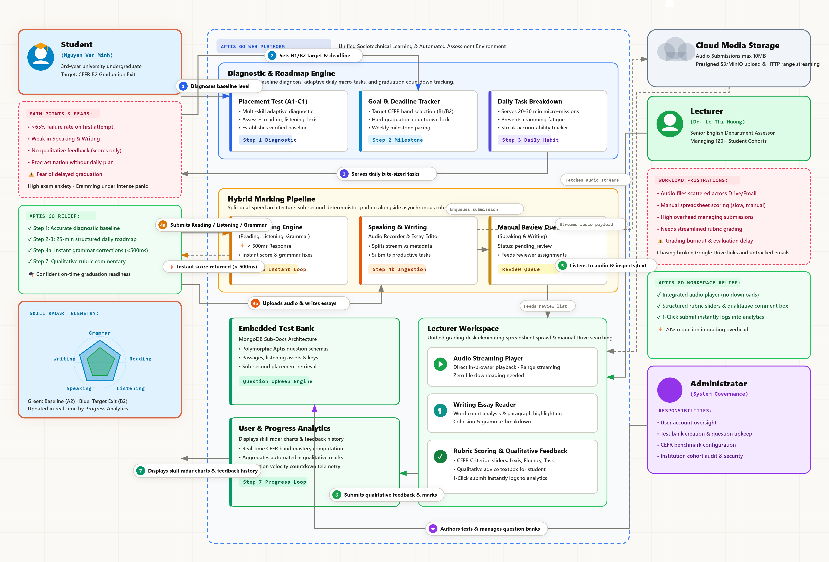

4.8.2 System Context Diagram (C4 Level 1)
The system context isolates external boundaries, connecting students, lecturers, and administrators through secure HTTPS channels:
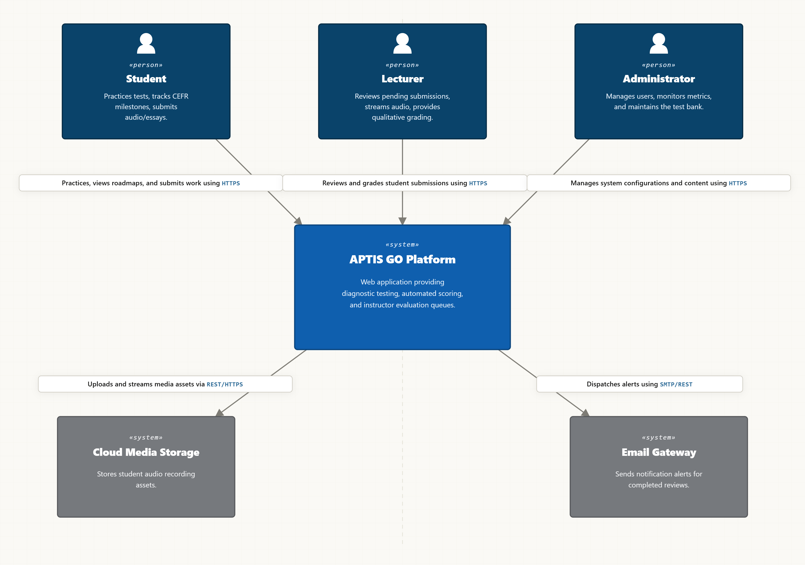

4.8.3 Container Diagram (C4 Level 2)
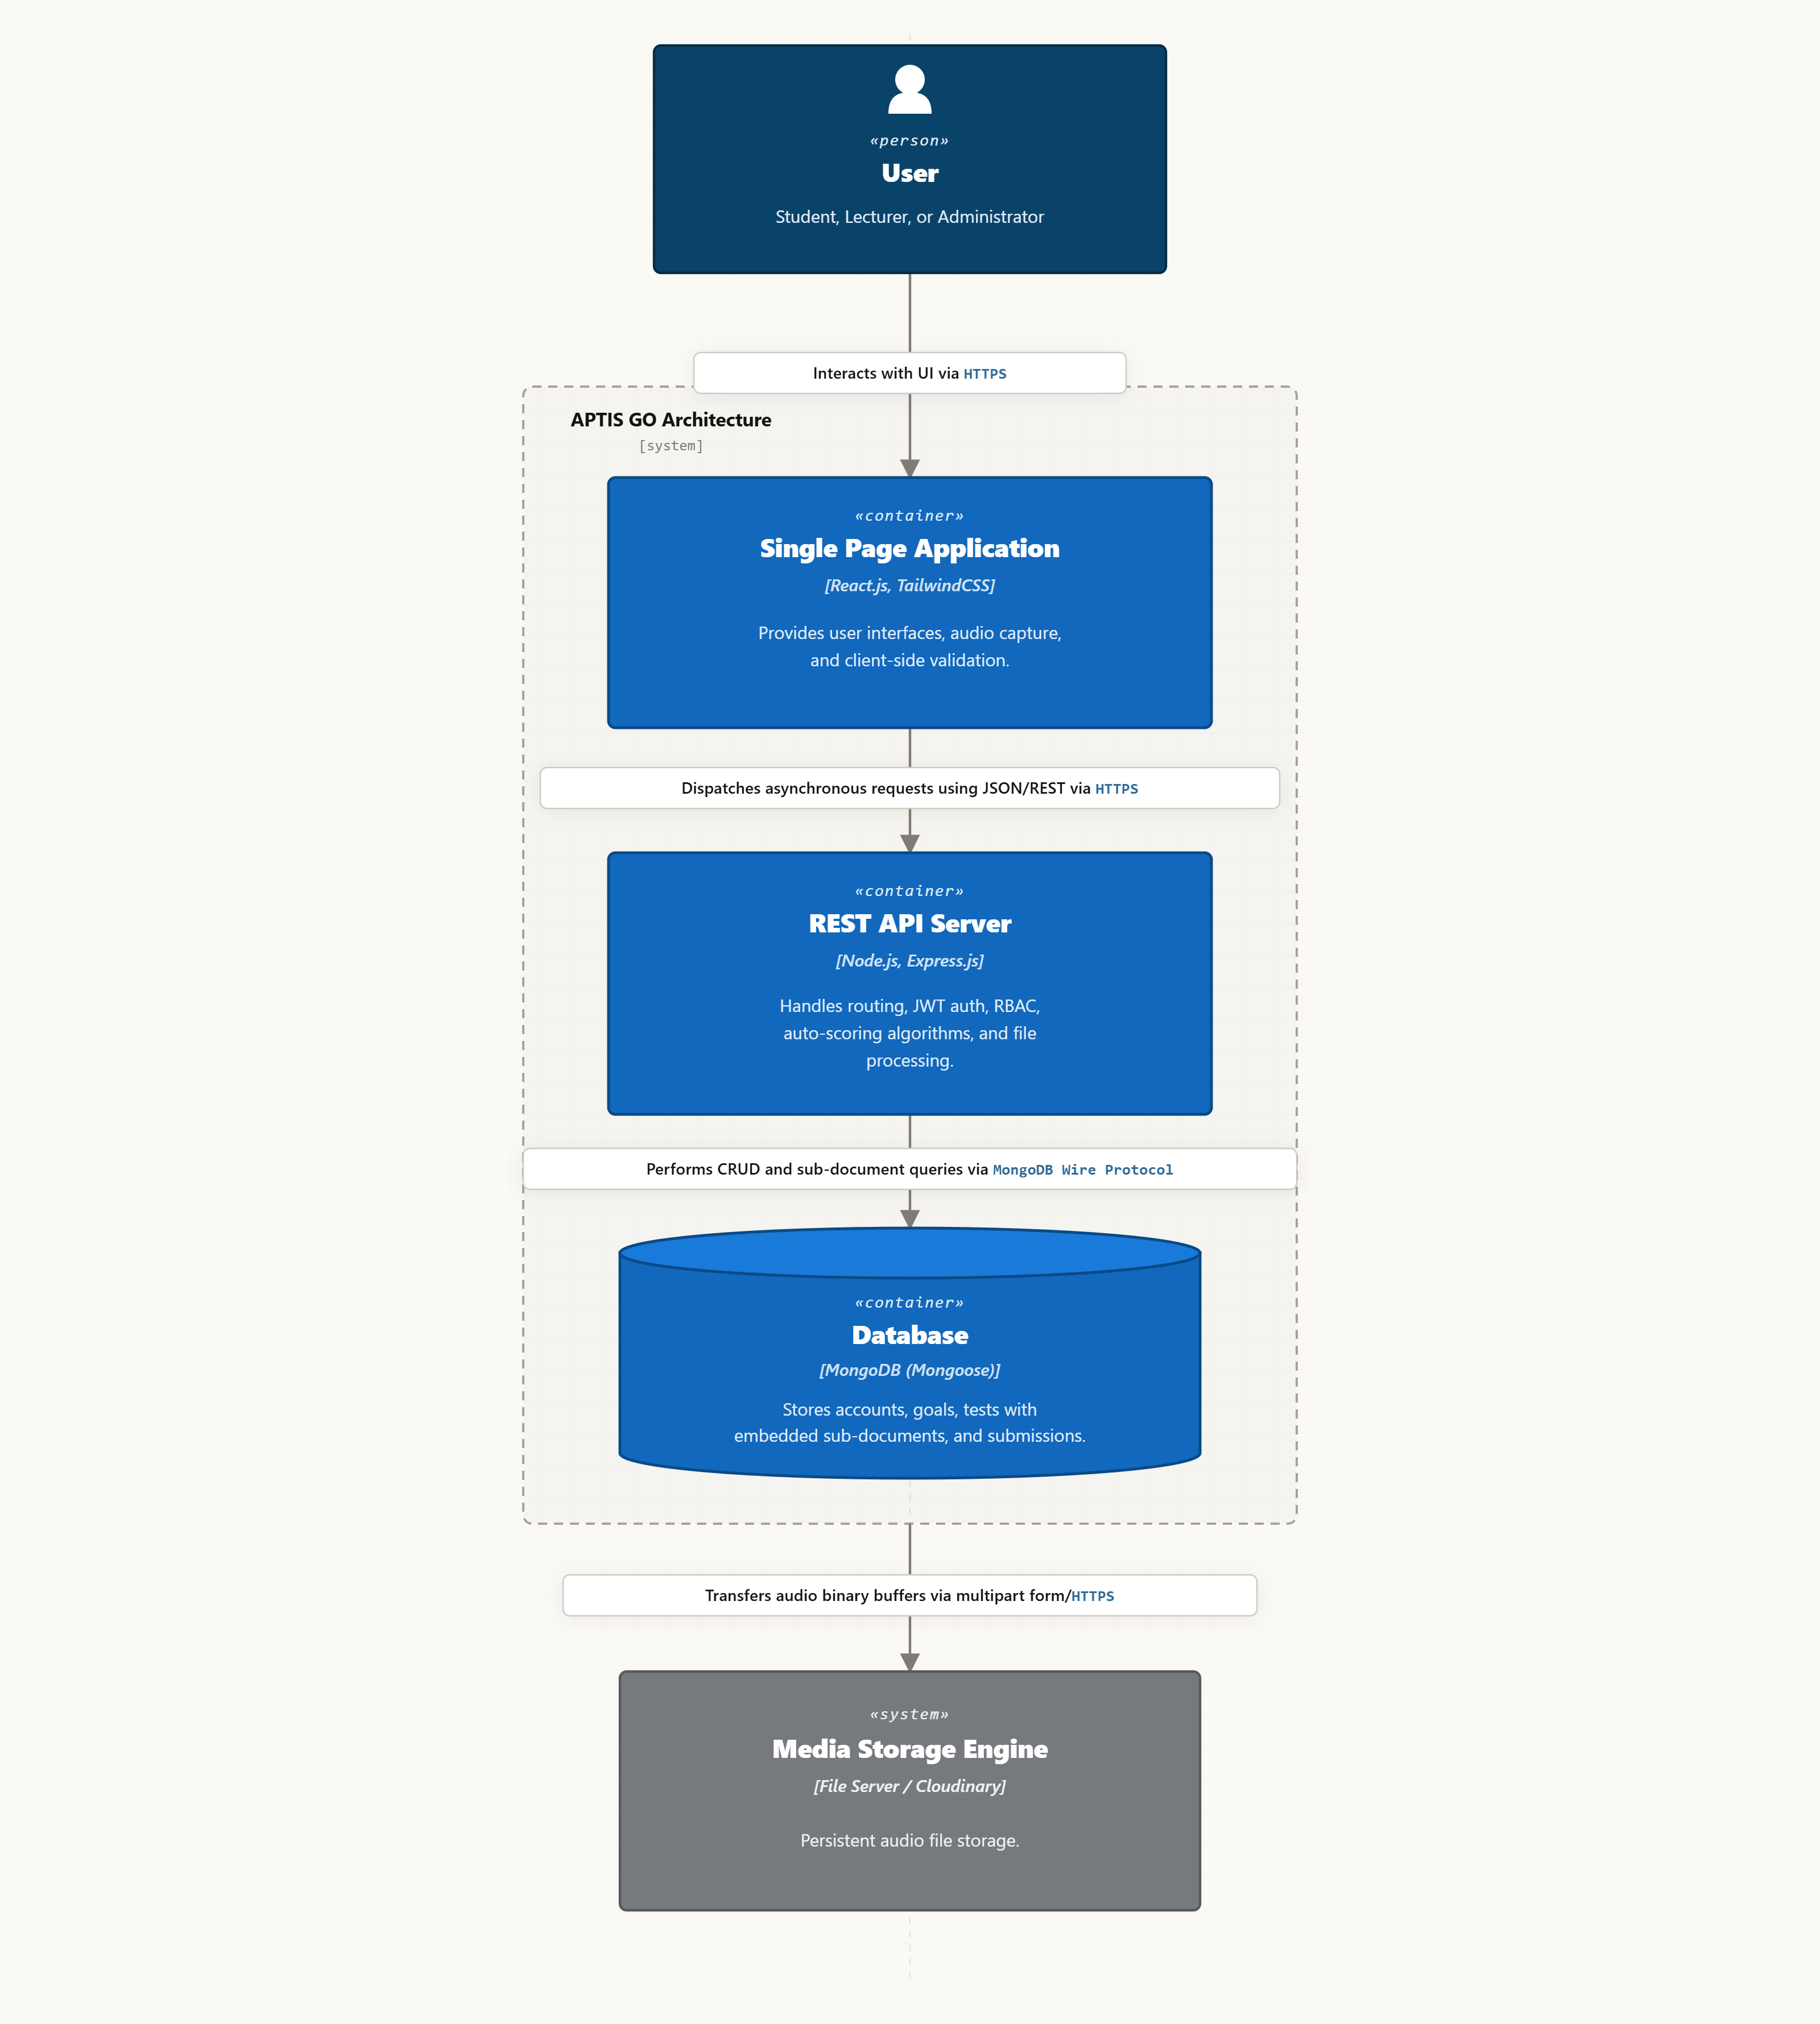

4.8.4 Data Design
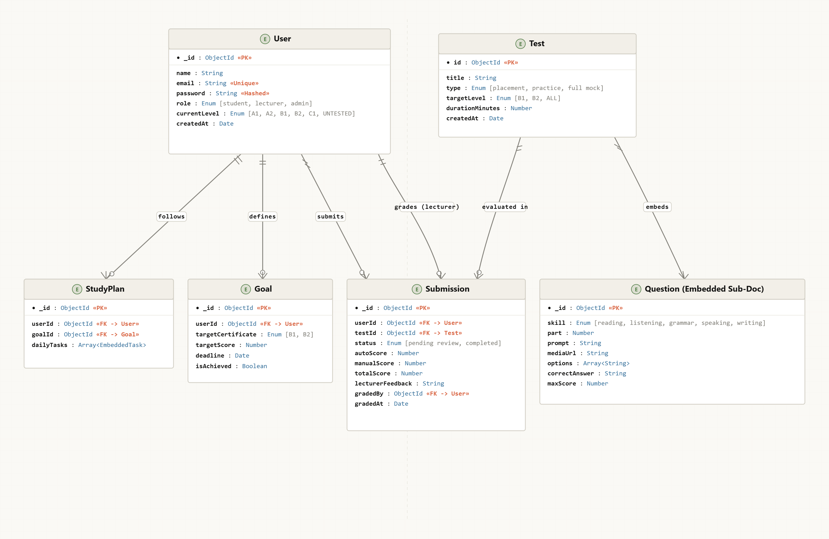

4.8.5 UML Diagrams
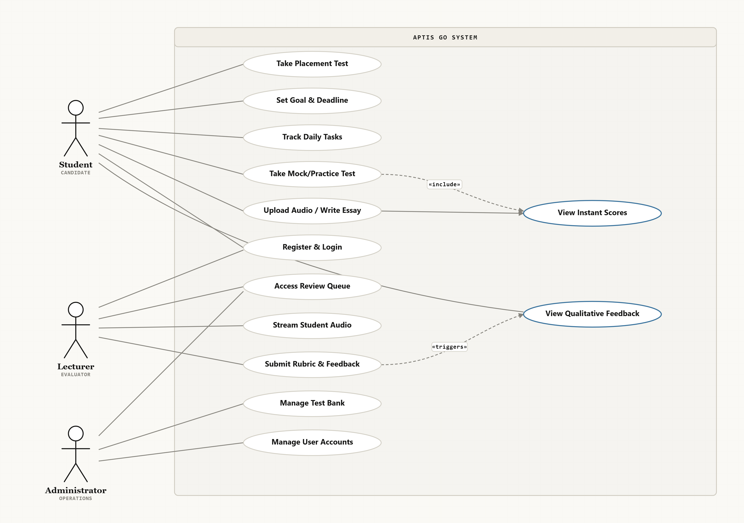

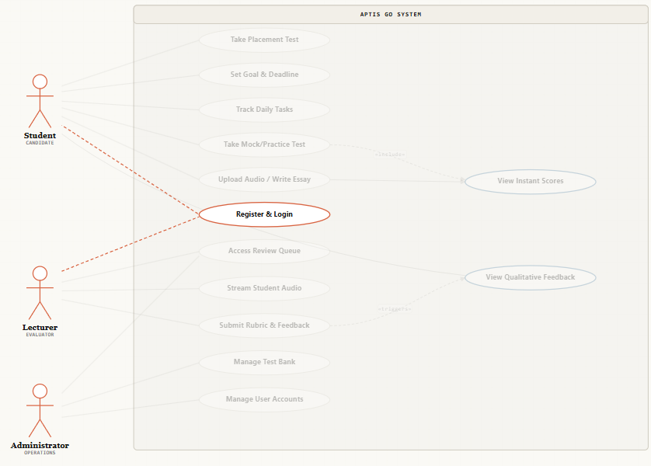

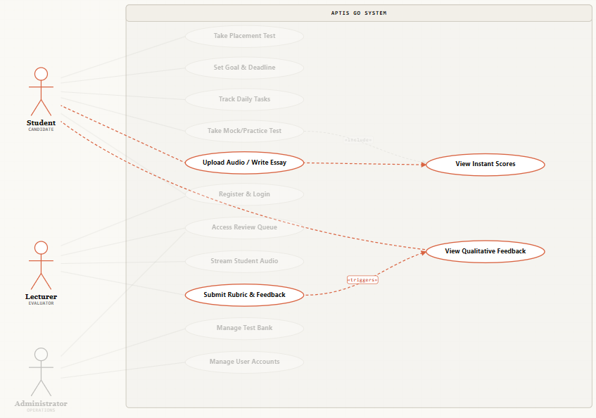4.8.6 Wireframes and User Flow
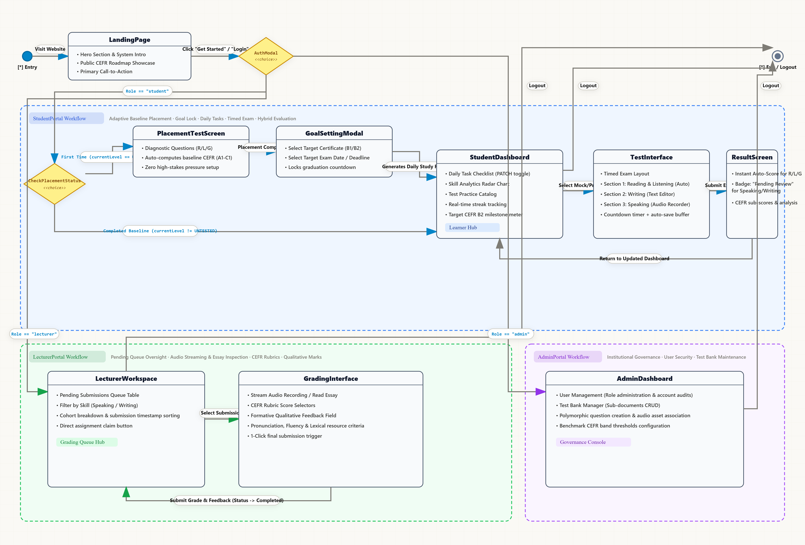

Screen 1: Authentication Portal (/login)
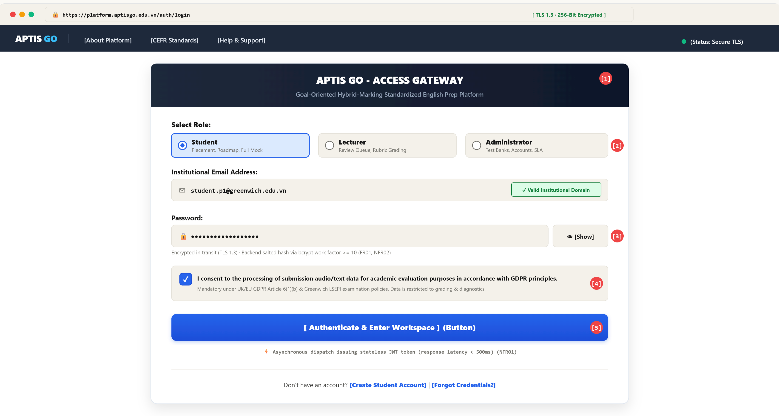ANNOTATIONS:
1. Institutional secure landing interface establishing single-entry RBAC session gateway (FR01, NFR02).
2. Role-Based Access Control (RBAC) selector mapping authorization token payload (student, lecturer, admin) (FR01).
3. Password input hashed via bcrypt work factor >= 10 on backend dispatch (FR01, NFR02)[cite: 1, 14].
4. Explicit user consent mechanism ensuring GDPR compliance and LSEPI legal adherence (LSEPI Legal).
5. Asynchronous authentication dispatch issuing stateless JWT token (response latency < 500ms) (NFR01)[cite: 2, 14].
Screen 2: Diagnostic Placement & Goal Setting (/placement, /goals)
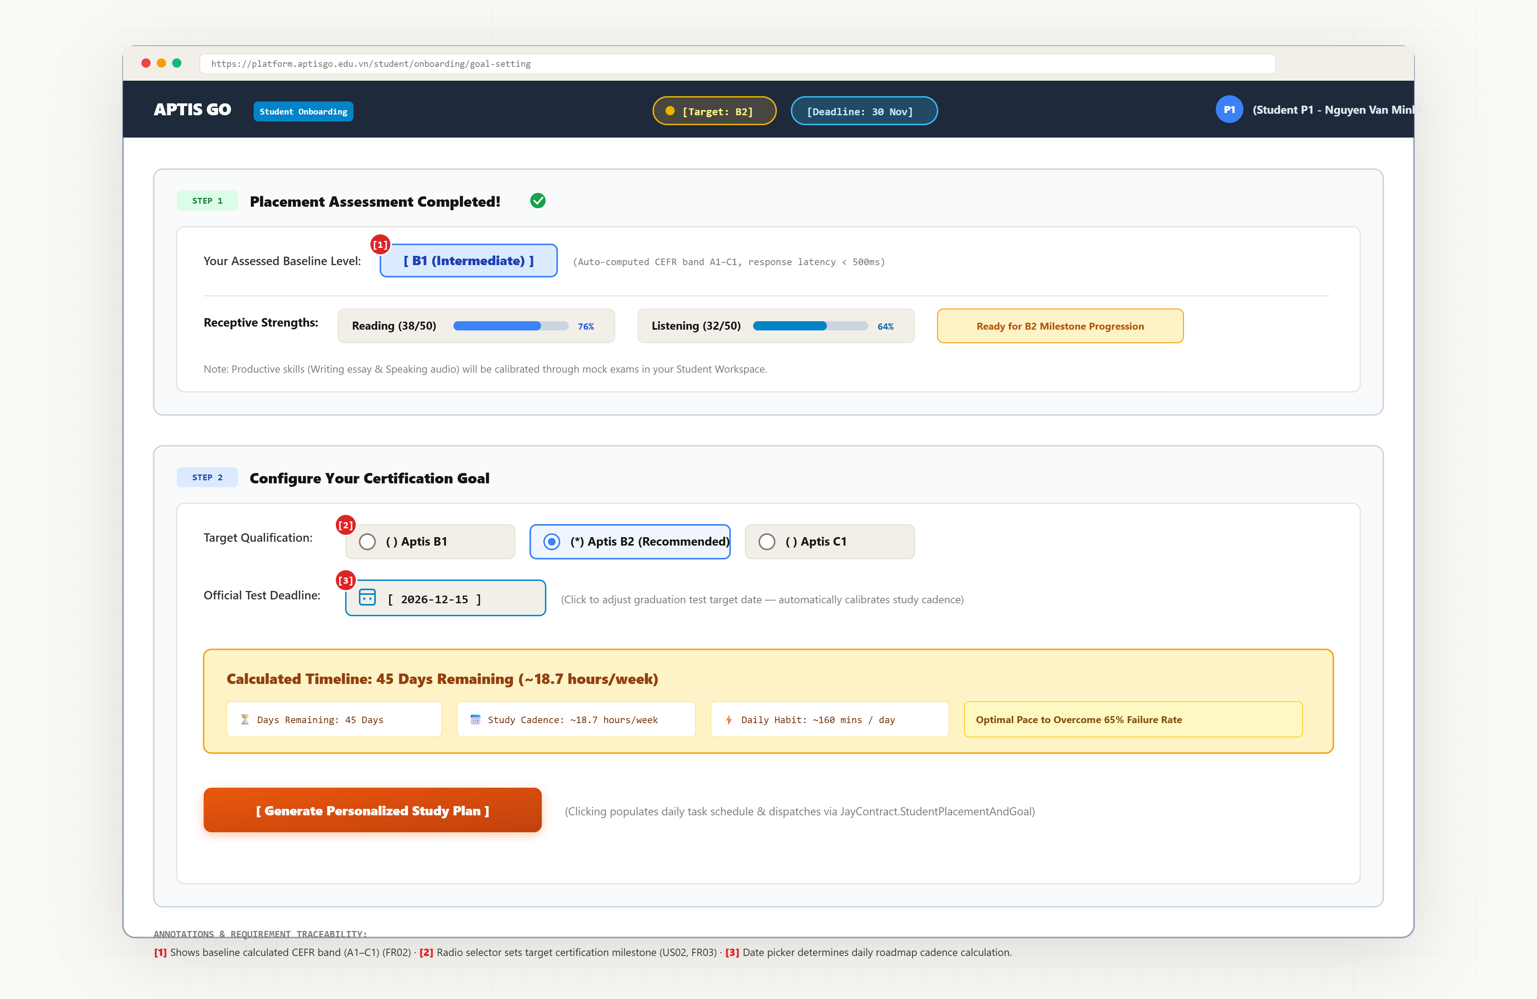
Annotations:
1: Shows baseline calculated CEFR band (A1-C1) (FR02).
2: Radio selector sets target certification milestone (US02, FR03)
3 Date picker determines daily roadmap cadence calculation.
Screen 3: Student Dashboard & Daily Roadmap (/dashboard)
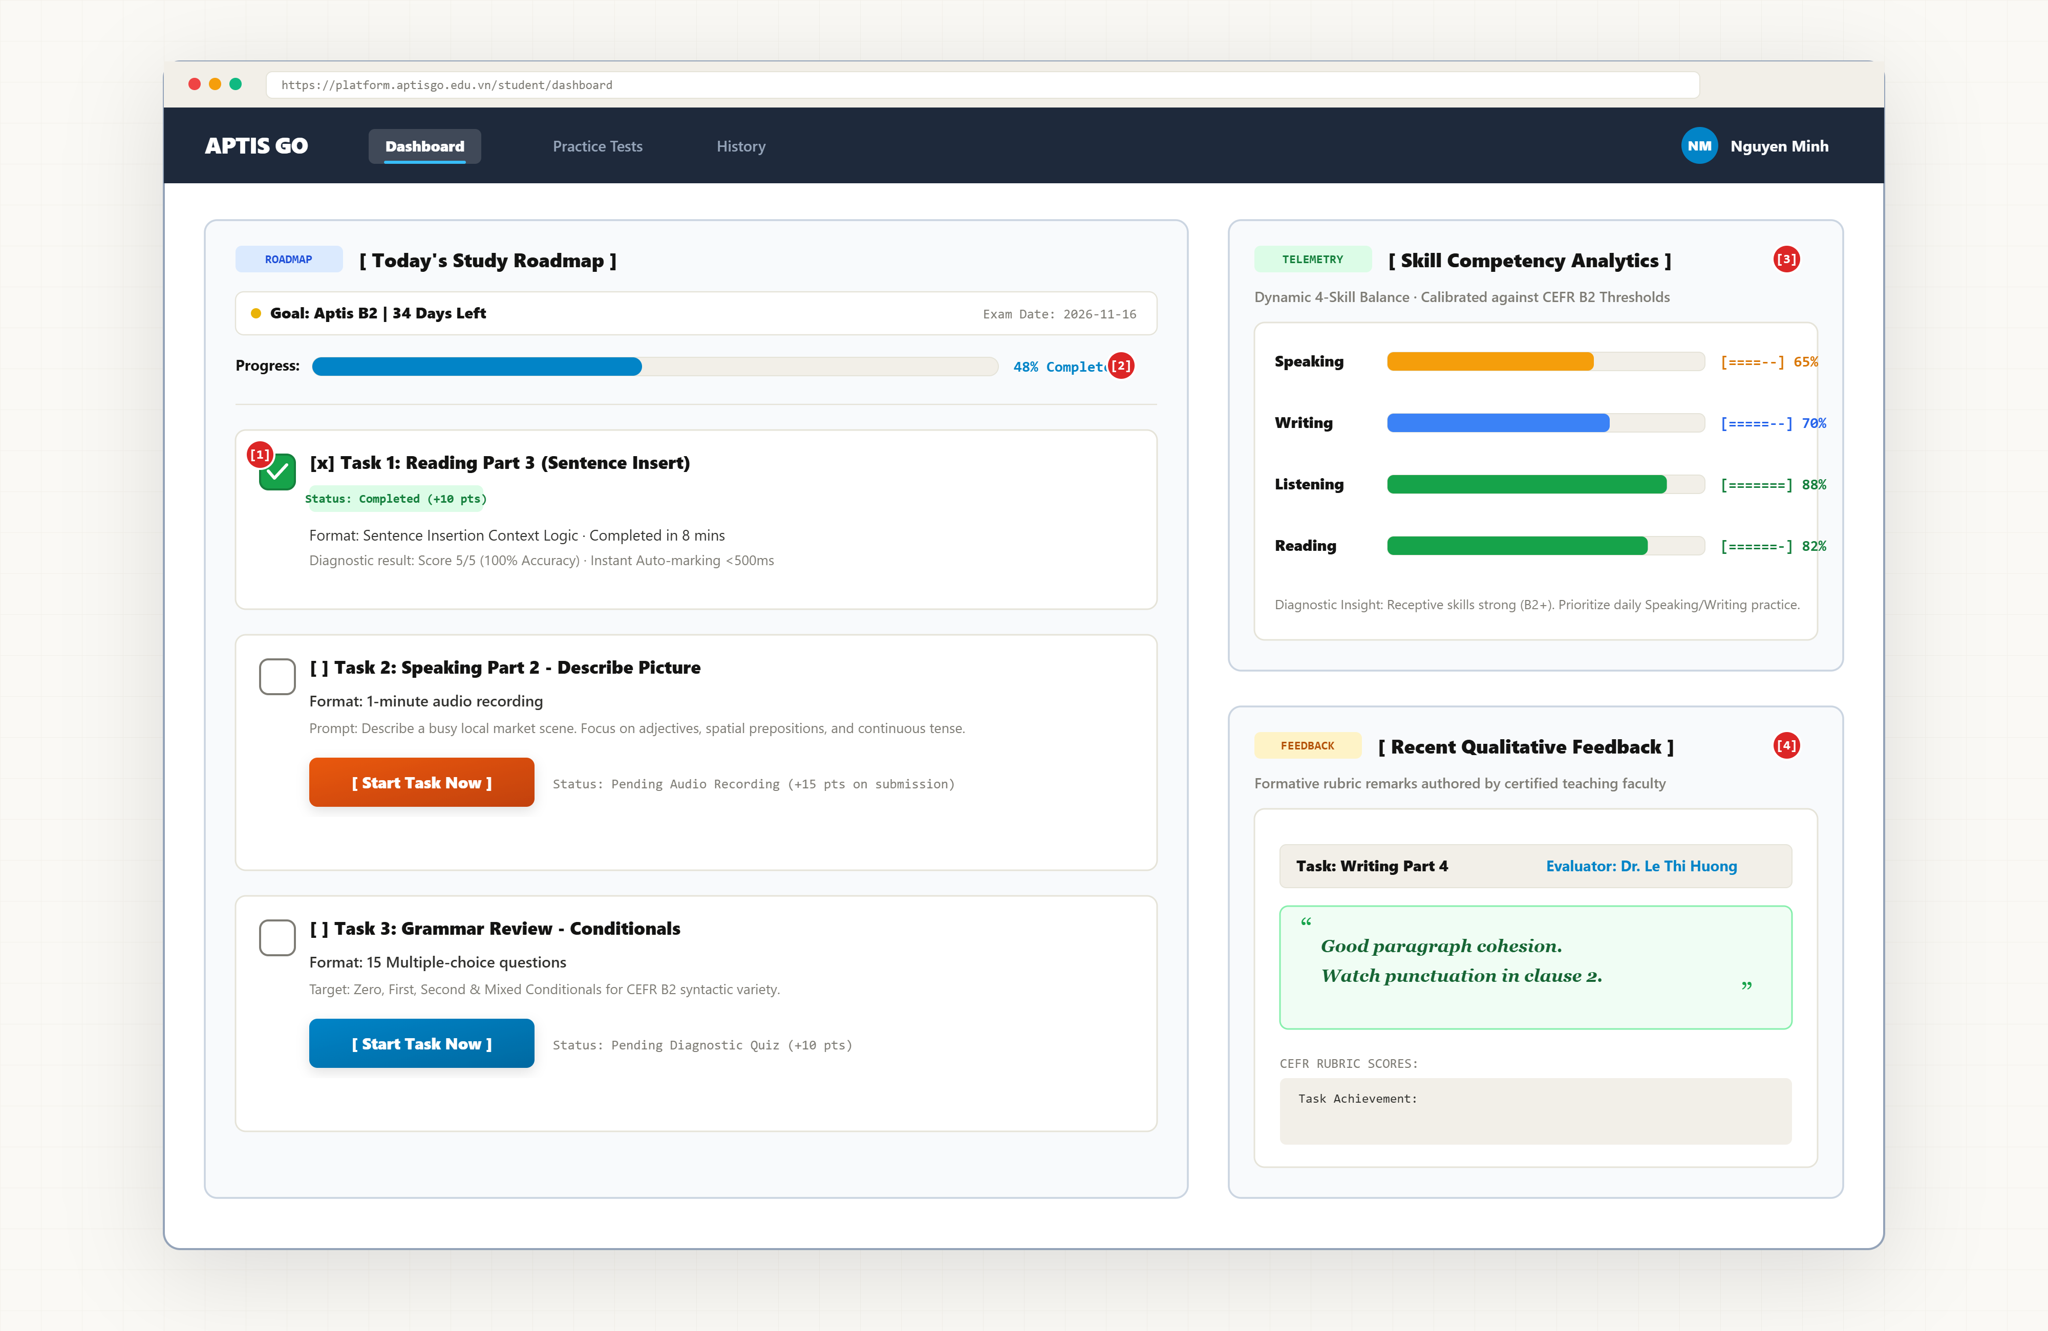
Annotations:
1. Interactive checkboxes execute PATCH /study-plans/tasks/:id updates (FR07).
2. Progress bar reflects completion status against the exam deadline (FR03).
3. Analytics panel visualizes skill-by-skill balance.
4. Formative feedback card displays the latest qualitative comments from lecturers.
Screen4: Timed Mock Exam - Reading & Listening
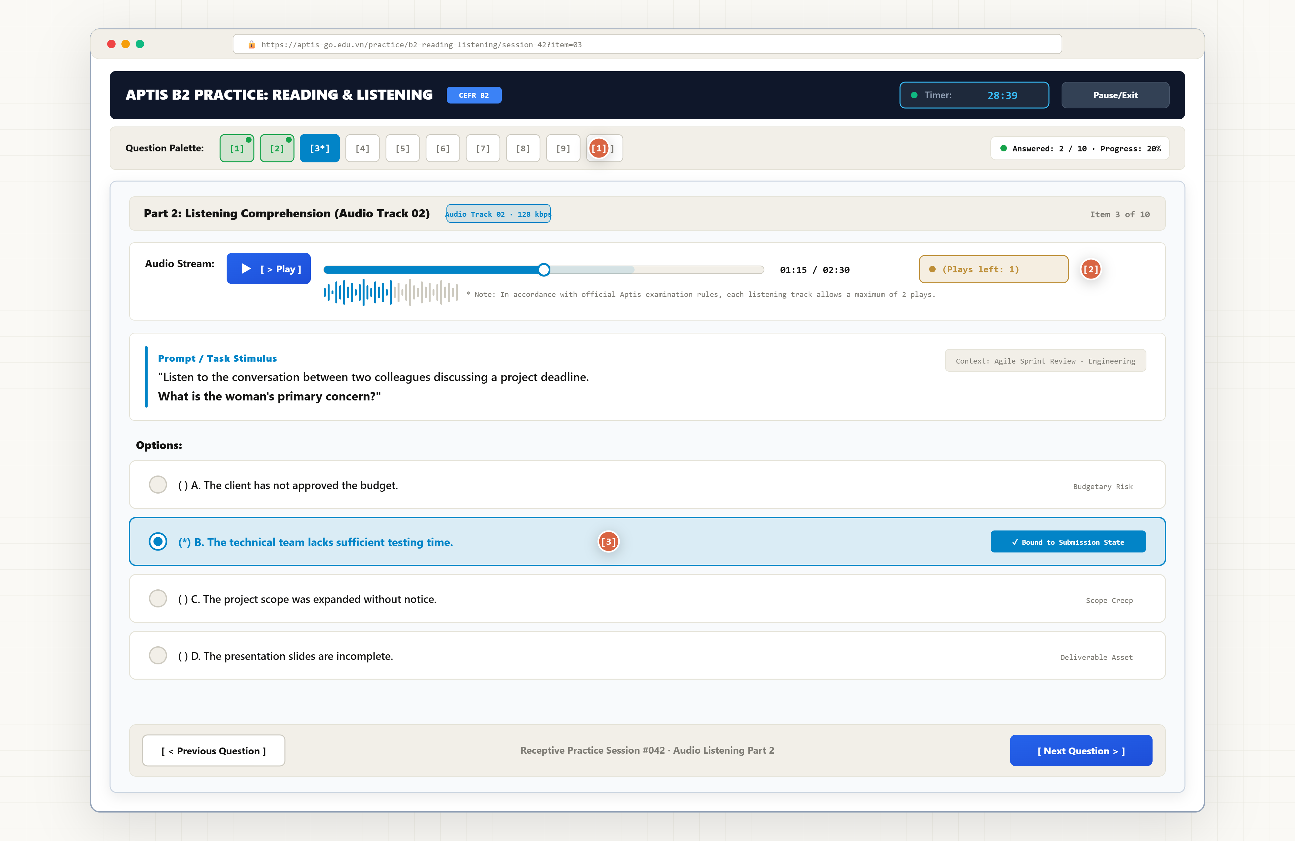
Annotations:
1. Interactive Question Palette tracks answered and unanswered items.
2. Streamed audio element with play-count limiter (Aptis format standard).
3. Radio button selection binds directly to submission state.
Screen5: Timed Testing Engine with Hybrid Submission (/tests/:id)
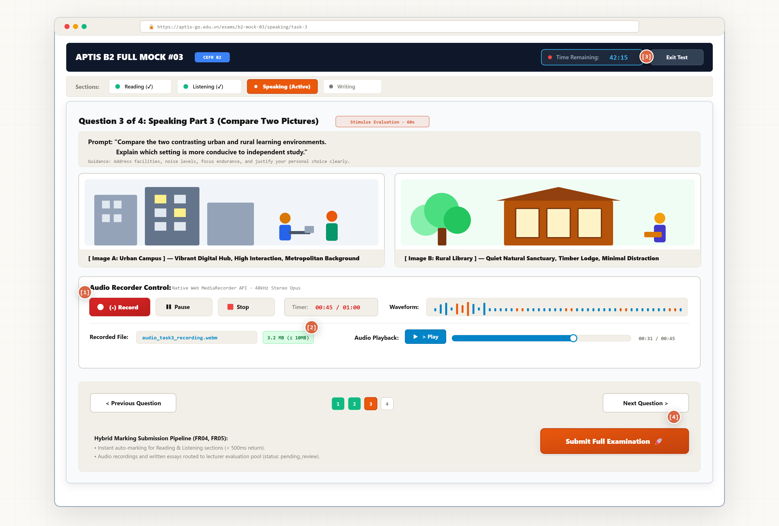
Annotations:
1. Native audio capture via Web MediaRecorder API (US09, FR09).
2. Client-side size indicator validates <= 10MB file constraints (NFR03).
3 Global countdown timer enforces Aptis exam constraints.
4. Submission triggers instant auto-scoring for R/L and routes audio to pending queue (FR04, FR05).

Screen6: Writing Exam & Essay Editor
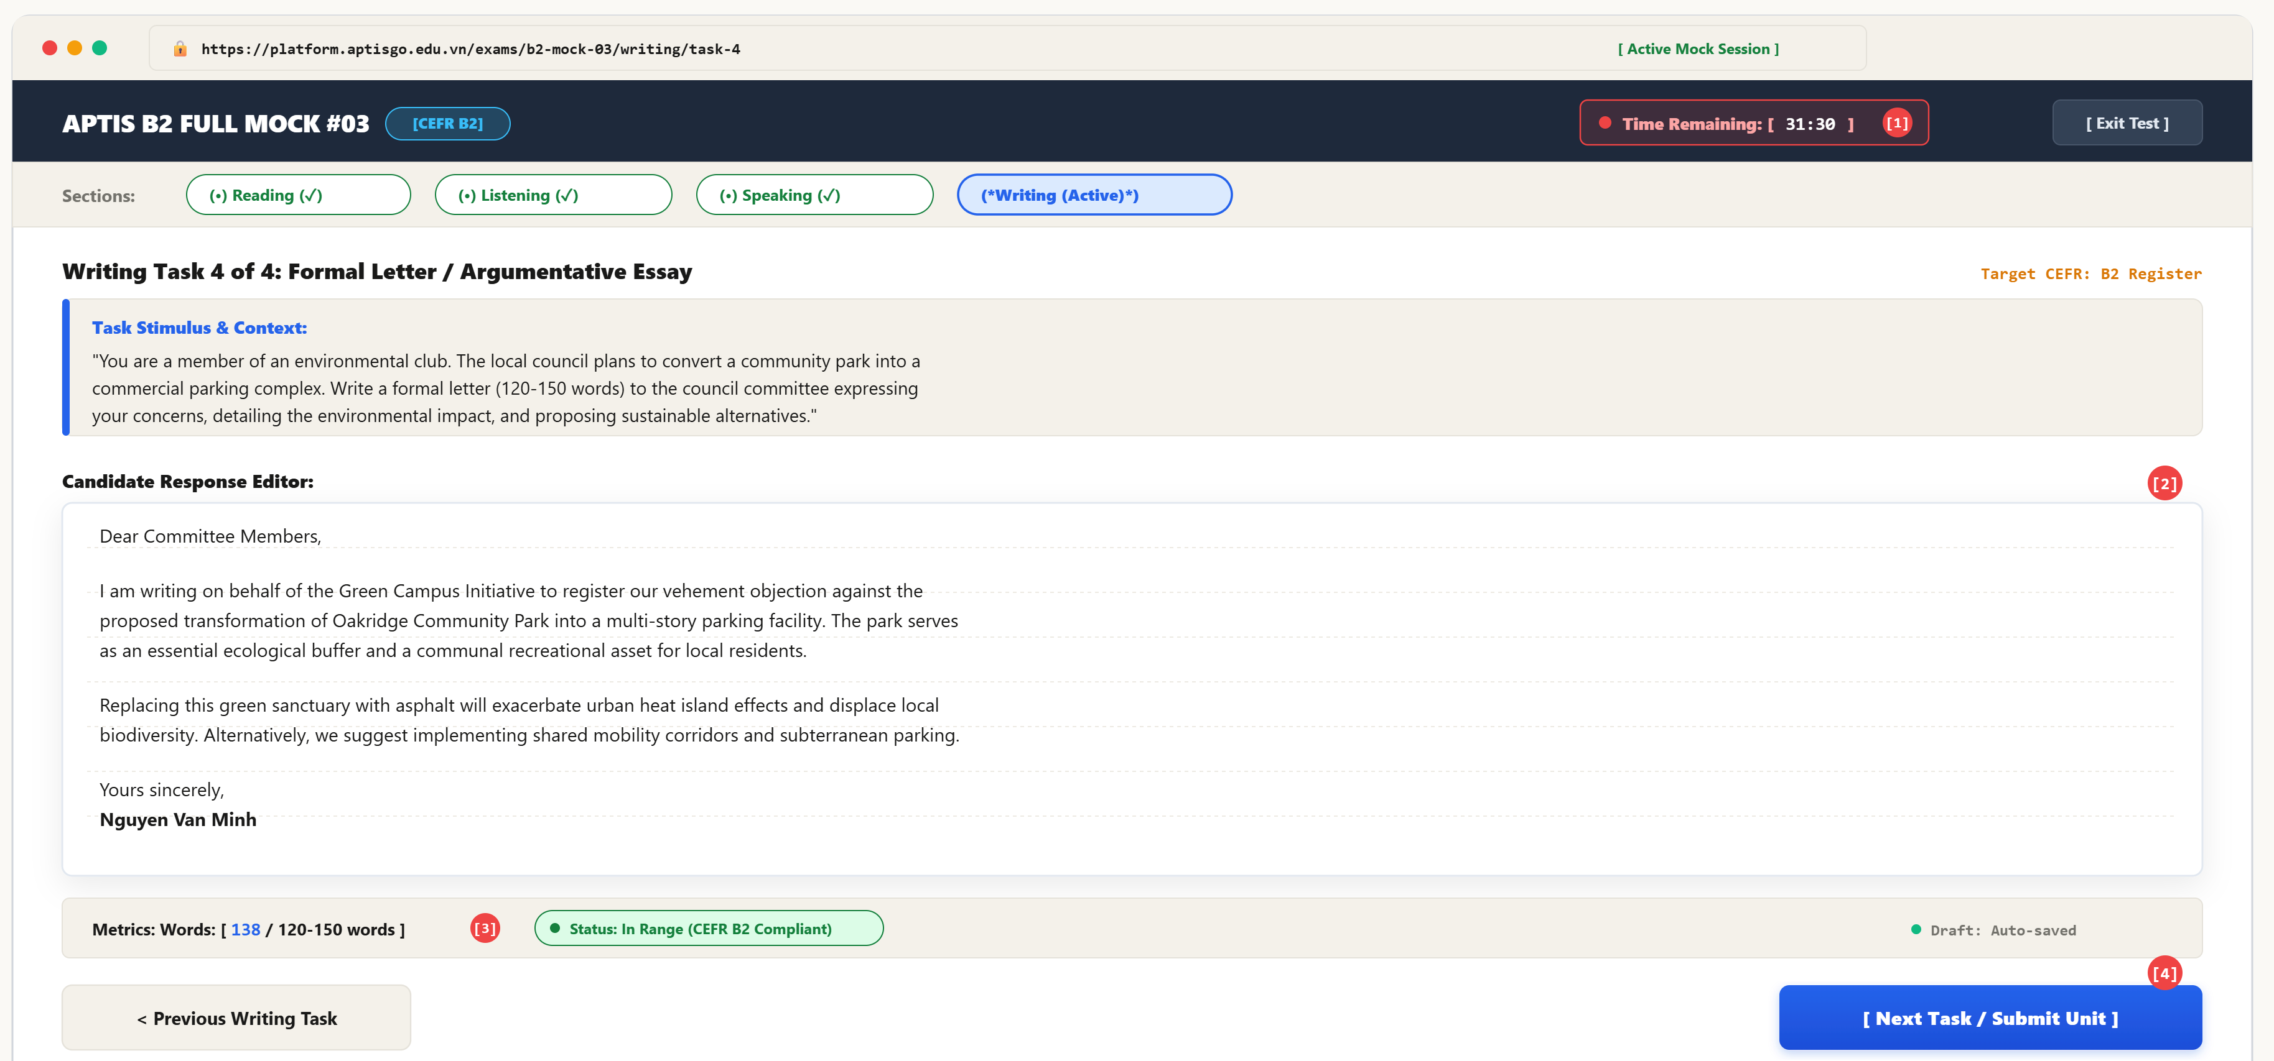
ANNOTATIONS:
1. Synchronized exam timer enforcing strict Aptis time allocations (US03, NFR04).
2. Dedicated rich-text candidate composition editor maintaining clean academic layout without spell-check aids (FR05)[cite: 1, 14].
3. Real-time client-side word count tracker validating length constraints against Aptis criteria (FR05, NFR04)[cite: 1, 14].
4. Unit submission trigger serializing essay string into Submission document with status: 'pending_review' (FR05, FR06)[cite: 1, 14].
Screen7: Exam Submission & Result Summary
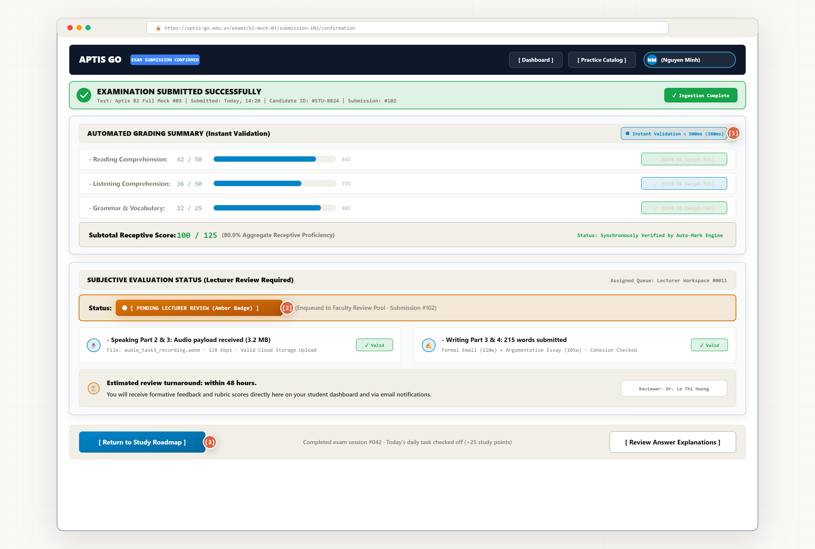
Annotations:
1. Instantly renders auto-calculated receptive scores (<500ms API response).
2. Amber status badge clearly informs the user that manual grading is underway.
3. Navigation buttons prompt the student to return to their daily roadmap.
Screen 8: Lecturer Workspace & Grading Queue (/lecturer/queue)
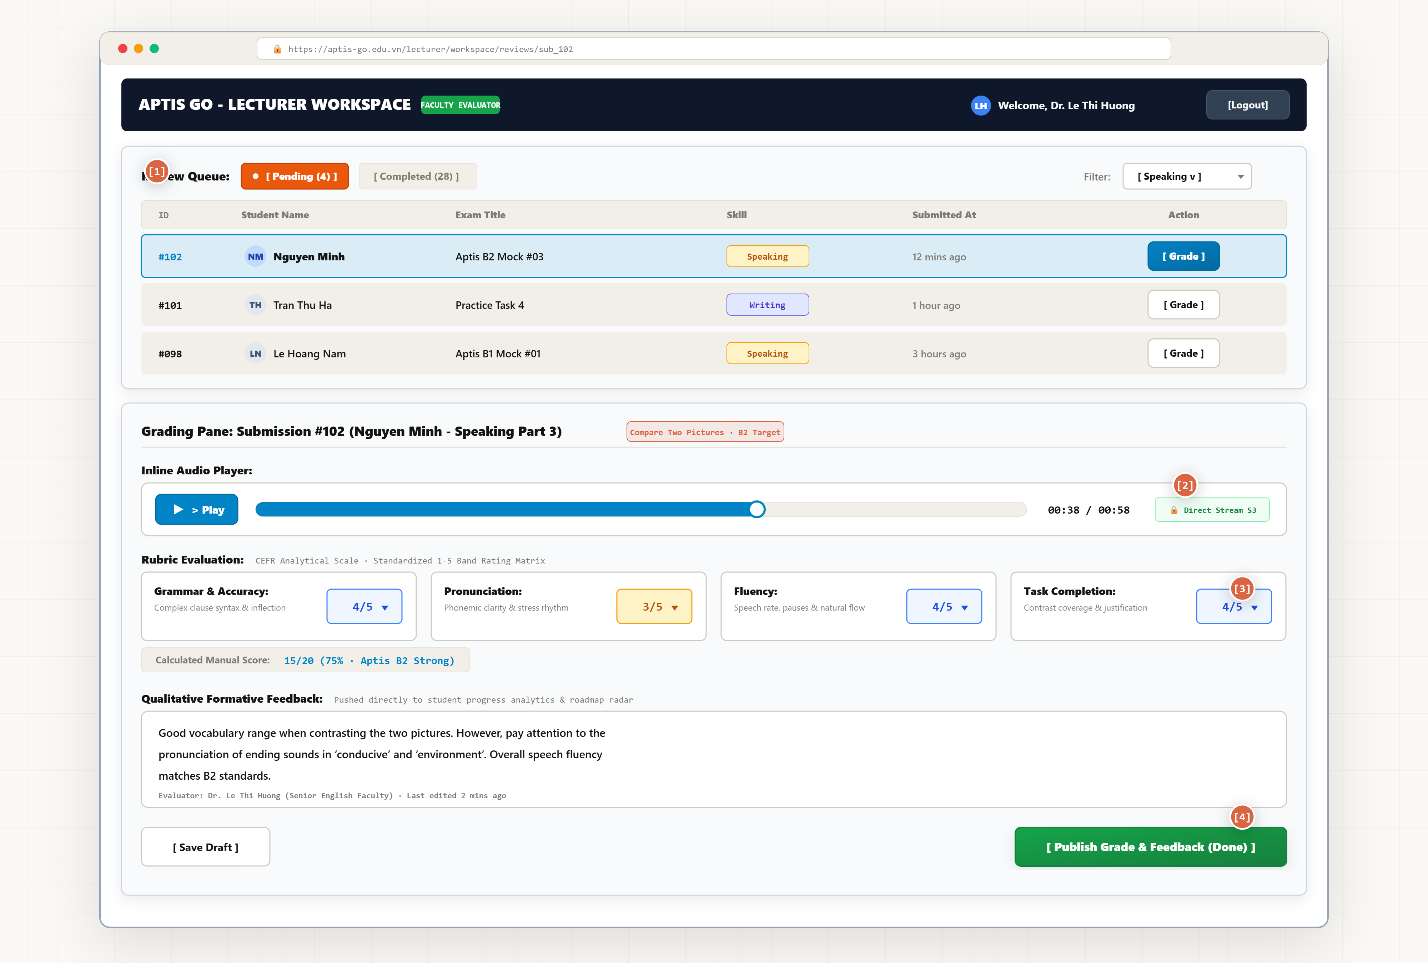
Annotations:
1. Centralized review queue with status filters (US05, FR06).
2. Inline media player streams audio directly from storage without downloading files locally.
3. CEFR-aligned rubric selectors calculate manual scores.
4. Formative feedback input updates submission to status: 'completed' and triggers student notifications.
Screen9: Admin Test Bank Management (/admin/tests)
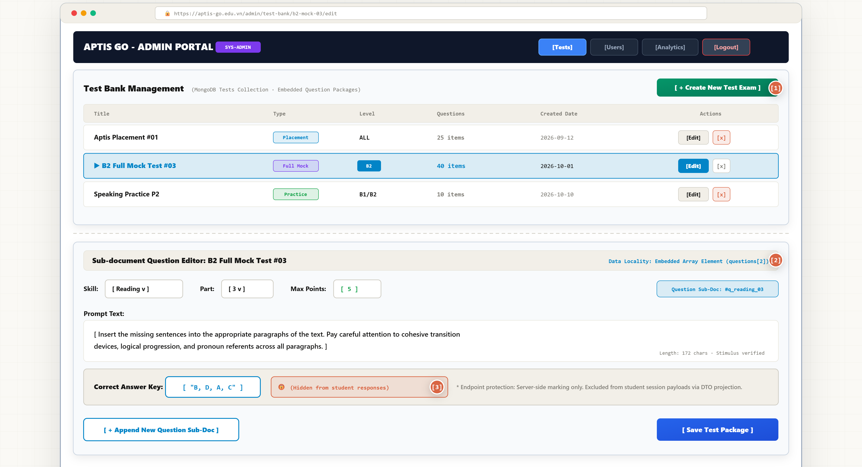
Annotations:
1. Full CRUD table for tests and exam configurations (FR08).
2. Embedded sub-document form authoring nested questions directly inside Tests (Data Locality).
3. Answer key isolation ensuring student API payloads do not leak correct responses.

Chapter 5: Methodology and Project Planning
"You must choose, explain, adapt, and justify your methodology. Saying 'I will use Agile' with no further explanation scores very few marks."

5.1 Development Methodology
Compare at least two methodologies before stating and justifying your choice.

5.1.1 Methodology Comparison
Criterion | Waterfall  (Royce, 1970) | Agile/Scrum  (Beck et al., 2001) | Other (e.g., Kanban, XP)
Approach | Sequential phases; requirements fixed upfront | Iterative 2-week sprints; requirements evolve | Continuous flow; no fixed sprints
Documentation | Comprehensive documentation before building | Working software over comprehensive documentation | Minimal; task-board driven
Flexibility | Low — changes are expensive once development begins | High — changing requirements welcomed, even late | Medium — can add tasks anytime
Testing | Only at the end of development | After each sprint increment | Continuous
Strengths | Clear milestones; easy client sign-off | Adapts to change; supervisor can review incrementally | Simple; good for maintenance
Weaknesses | Cannot go back; bugs found late | Scope can creep without discipline | Hard to plan long-term deliverables
Best for FYP? | Only if requirements are fully stable from day 1 — rare | Recommended — requirements evolve through user research | Not recommended for a FYP with fixed milestones

[ Write your methodology comparison paragraph here with academic. State which you chose and why. ]

5.1.2 Scrum Adapted for Solo FYP Development
Scrum was designed for teams of 3–9. For a solo FYP, ceremonies and roles must be adapted (
Standard Scrum | Solo FYP Adaptation
Product Owner (prioritises the backlog) | Explain how you adapt on solo project
Scrum Master (removes blockers) | Explain how you adapt on solo project
Development Team (3–9 developers) | Explain how you adapt on solo project
Daily Standup (15 minutes)
Sprint Planning (start of each sprint)
Sprint Review (demo to stakeholders)
Sprint Retrospective (what worked/what didn't)

5.1.3 Sprint Plan
Detail your sprint plan. Each sprint is a 2-week cycle delivering working, tested software.
Sprint | Dates | User Stories / Features | Definition of Done (DoD)
Sprint 1 | Wk XX–XX | Core Must-Have features: user registration, authentication, [feature] | All user stories in sprint pass their Given/When/Then acceptance criteria; unit tests written and passing
Sprint 2 | Wk XX–XX | Remaining Must-Have + key Should-Have features: [feature], [feature] | Features integrated and system tested (≥ 90% test pass rate for sprint scope)
Sprint 3 | Wk XX–XX | UI polish, Could-Have features, performance fixes, preparation for demo | Product ready for UAT and live demo; all critical bugs resolved

[ Complete the Sprint Plan table with your actual features mapped from your MoSCoW requirements (Section 4.5). ]

5.2 Project Plan and Timeline
A Gantt chart is essential evidence of professional project management.
Key milestones
Milestone | Description | Target Week / Date
Project Proposal | First formal deliverable — problem, aim, objectives, plan | Week 4
Contextual Report | Chapters 1–4 complete | End of Term 1 (~Week 12)
Product Demo | Live demonstration of working product to supervisors | End of Term 2 (~Week 24)
Final Report | All 8 chapters submitted | Start of Term 3 (~Week 30)

[ Insert your Gantt chart here. It must show: all phases across 30 weeks, overlapping phases, fixed milestone markers (◆), and a 2-week contingency buffer before the Final Report. ]
Your Gantt must include these phases at minimum:
Phase | Typical timing | Overlaps with
Literature Review | Weeks 1–8 | Competitor Analysis
Competitor Analysis | Weeks 5–8 | Literature Review, User Research
User Research | Weeks 7–10 | Requirements & Design
Requirements & Design | Weeks 9–12 | Contextual Report writing
Contextual Report writing | Weeks 10–12 | Requirements & Design
Sprint 1 (core features) | Weeks 13–16 | Testing begins at sprint end
Sprint 2 (remaining features) | Weeks 17–20 | Ongoing testing
Sprint 3 (polish + UAT prep) | Weeks 21–24 | System testing, UAT
Testing and UAT | Weeks 22–27 | Final Report writing
Final Report writing | Weeks 24–30 | Testing

5.3 Risk Register
Identify at least 5 risks. A risk register demonstrates professional project management awareness.
⚠ Generic mitigations ("I will manage my time better") score low. Every mitigation must be specific and actionable.
Risk ID | Risk Description | Probability  (L/M/H) | Impact  (L/M/H) | Mitigation Strategy
R01 | Unable to recruit minimum 5 interview participants | M | M | Contact module peers in Week 5; offer flexible timing; survey is fallback validation if <5 interviews achieved
R02 | Learning a new technology takes longer than planned | H | M | Allocate 4 dedicated learning weeks (Wks 9–12) before Sprint 1; use Expo managed workflow to reduce React Native boilerplate
R03 | Scope creep — adding features beyond Must-Have | H | H | Strict MoSCoW enforcement in Jira; any new requirement added to backlog only after supervisor approval
R04 | Third-party service outage or API breaking changes | L | H | Select services with > 99.9% SLA; pin dependency versions in package.json; monitor Firebase status page
R05 | Extended illness causes missed sprint or milestone | L | H | 2-week buffer built into Gantt before every milestone; no sprint scheduled in Weeks 28–30 (report-writing only)
R06 | [Add your own project-specific risk]

5.4 Feasibility Analysis
Apply the Triple Constraint — Scope, Time, Cost. If scope grows, either time or quality must give.
Dimension | Questions | Assessment
Technical | Do you have the skills needed? What must you learn, and is that realistic?
Time | Is the full scope achievable in 30 weeks? Does your Gantt confirm this?
Economic | Are hosting / API costs manageable on the free tier?
Operational | Will the solution be usable and maintainable beyond the FYP?

[ Complete your Feasibility Analysis for all four dimensions based on your actual situation. ]

5.5 Evaluation Plan and Success Metrics
Define success criteria BEFORE you start building. You return to these in Chapter 8.
Your evaluation plan must include:
Evaluation method | Minimum requirement | What it proves
Functional testing | ≥ 15 documented test cases; Pass/Fail recorded | System meets its stated functional requirements
User Acceptance Testing | ≥ 5 external participants; structured task list; SUS questionnaire | System meets real user needs
Requirements traceability | RTM linking every FR to a test case and Pass/Fail outcome | Systematic coverage of all requirements
Critical reflection | Objectives table with Met/Partially/Not Met + evidence for each | Academic evaluation rigour at Level 6

Success metrics — complete for each objective:
Objective # | Objective | Success Criterion (measurable threshold)
1 | [Your Objective 1] | e.g., Literature review contains ≥ 15 peer-reviewed sources; research gap explicitly stated
2 | [Your Objective 2] | e.g., ≥ 5 interviews + ≥ 20 survey responses; affinity map with ≥ 4 themes; 2–3 personas created
3 | [Your Objective 3] | e.g., All Must-Have requirements implemented and demonstrable in sprint review
4 | [Your Objective 4] | e.g., ≥ 90% of functional test cases pass; Pass/Fail results documented for all 15+ test cases
5 | [Your Objective 5] | e.g., Mean SUS score ≥ 68 from ≥ 5 UAT participants; all objectives evaluated in Chapter 8

