Overview
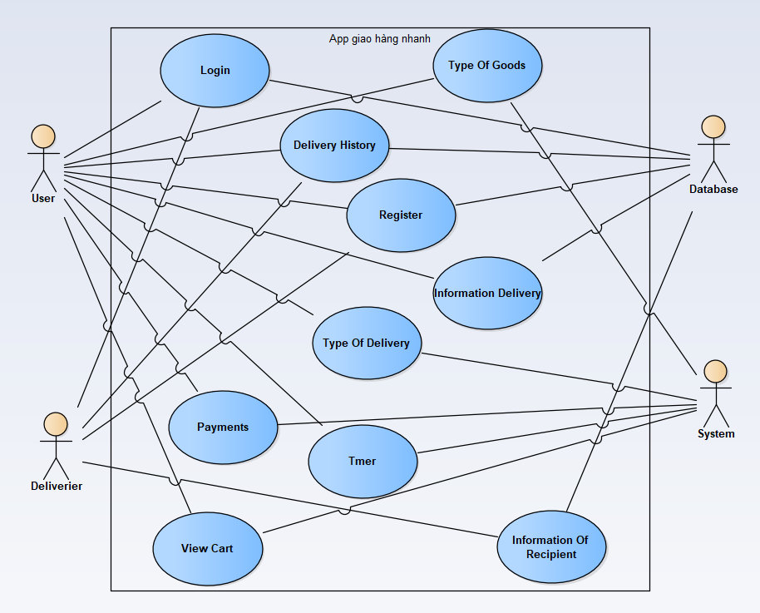

User, Deliverer usecase login
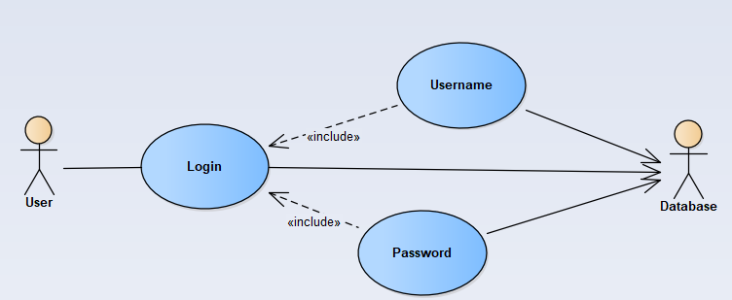
User, Deliverer usecase Login
Actors | User, Database
Description | An user can log in their account into the system based on database by inputing their username/email and password in login form
Data | Users (database)
Stimulus | Interface including form and button
Response | User’s home page
Comments | The user must have a vaid account and correctly input it into the form. In some system, the user may have to confirm their account by using email/phone verification

User, Deliverer usecase register
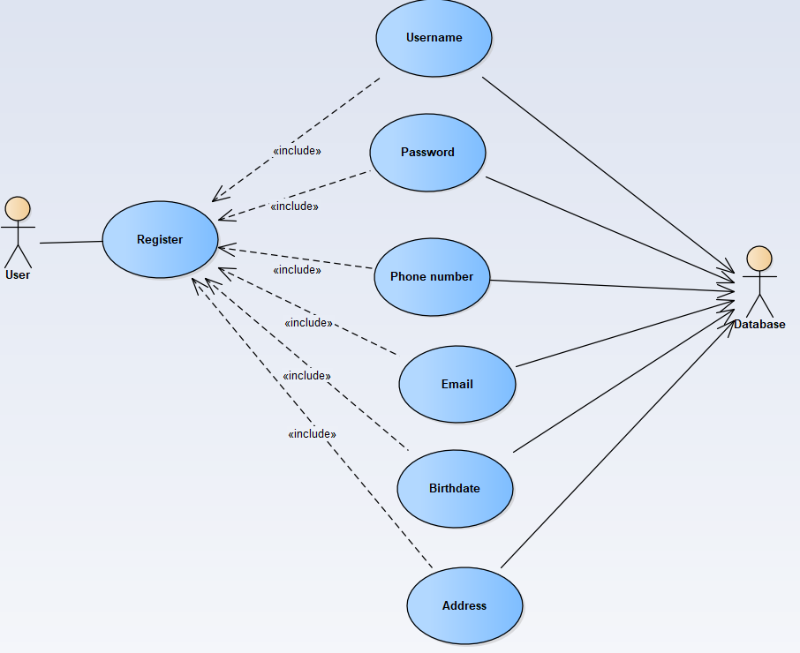
User, Deliverer usecase Register
Actors | User, Database
Description | An user can create a new account into the system by inputting some basic information of them in sign up form
Data | Users (database)
Stimulus | Interface of app including form and button
Response | Message: Account has been created successfully
Comments | The user must input some basic and valid information (username is unique) into the form. Some system, the user may have to verify by using email/phone or to wait for accepting by admin.
User usecase Type of goods
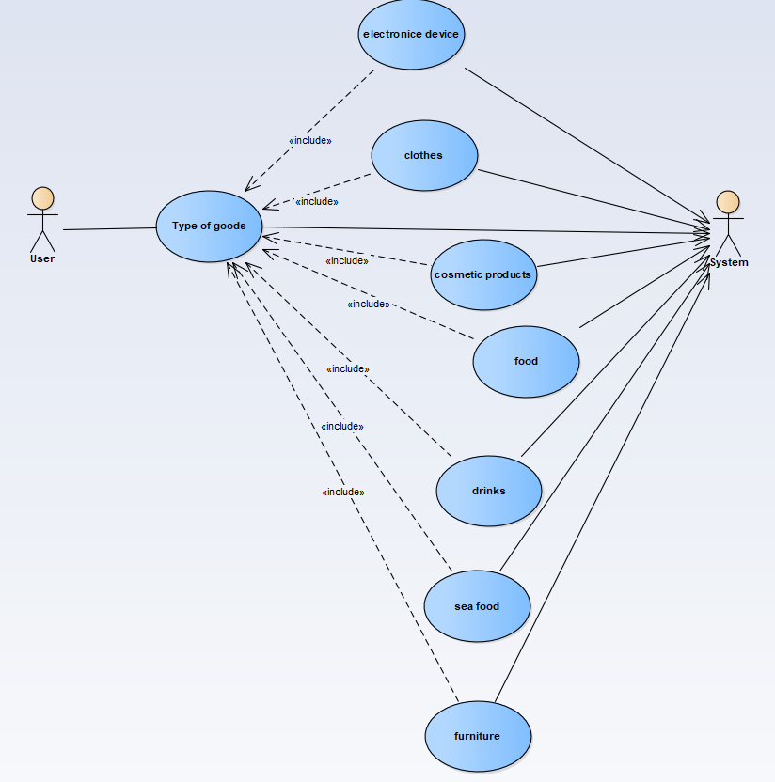
User usecase Type of goods
Actors | User, System
Description | An user can choose a type of goods (electronic, cosmetic, food,…) to add into view cart in system
Data | Products that have chosen in view cart (system)
Stimulus | Interface including the list of goods, food
Response | Message: Add to cart successfully
Comments | The user may choose goods based on their purpose, types of goods and food in order to purchase

User usecase Information of deliverier
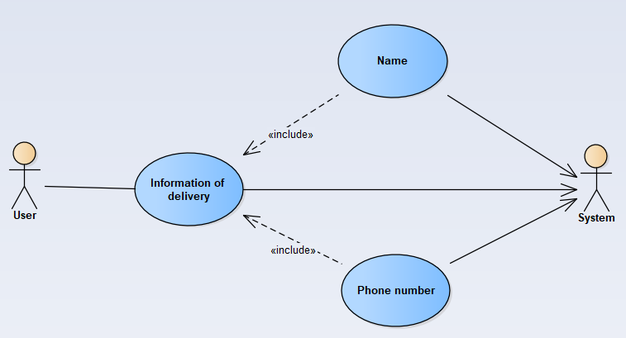
User usecase Information of delivery
Actors | User, System
Description | User can view the information of deliverier
Data | Including name, phone number
Stimulus | Interface include a form to represent information
Response | Message: Information of deliverier
Comments | The user must watch information of deliverier that their products have purchased

User usecase timer
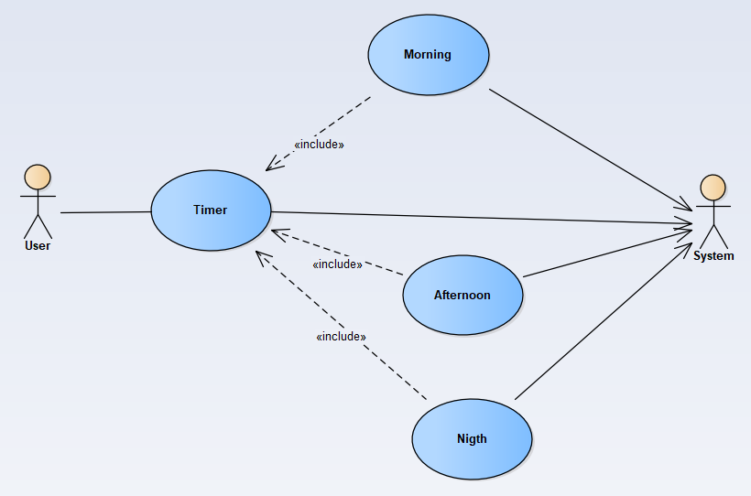
User usecase timer
Actors | User, System
Description | An user can set delivery time
Data | User’s input
Stimulus | Interface include input form (morning, afternoon, evening)
Response | time form
Comments | The user must set time so that the delivery can take place smoothly
User usecase Type of delivery
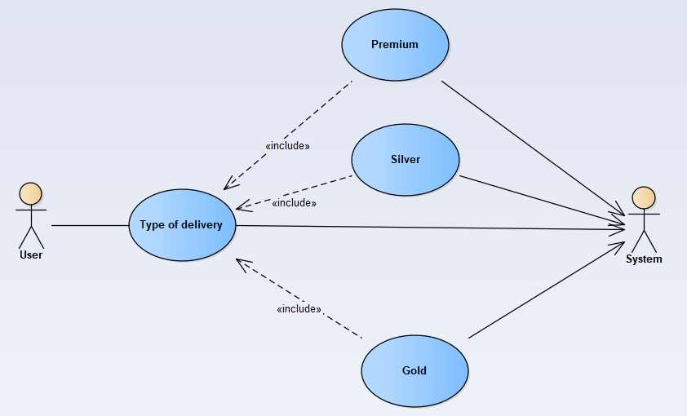
User usecase Type of delivery
Actors | User, System
Description | An user choose the form of delivery
Data | User’s choice
Stimulus | Interface include input form and submit button
Response | Result and recommendation that is more suitable for convenience and price
Comments | The user must choose types of delivery( premium, silver, gold) to suit their demand
User usecase Payments
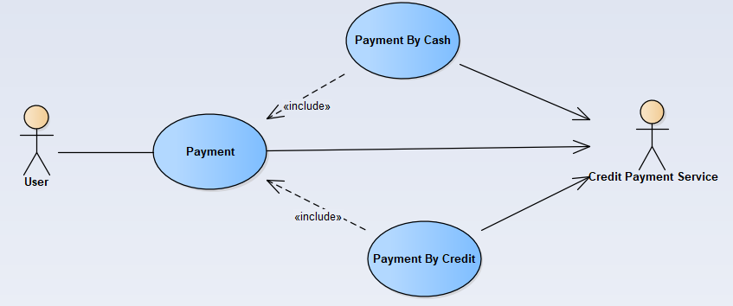
User usecase Payments
Actors | User, Credit Payment Service
Description | User can choose types of paying
Data | User’s choice
Stimulus | Interface include input form and confirm button
Response | You have chosen payment by …(cash or credit)
Comments | Users can choose the payment method that suits them

User usecase View cart
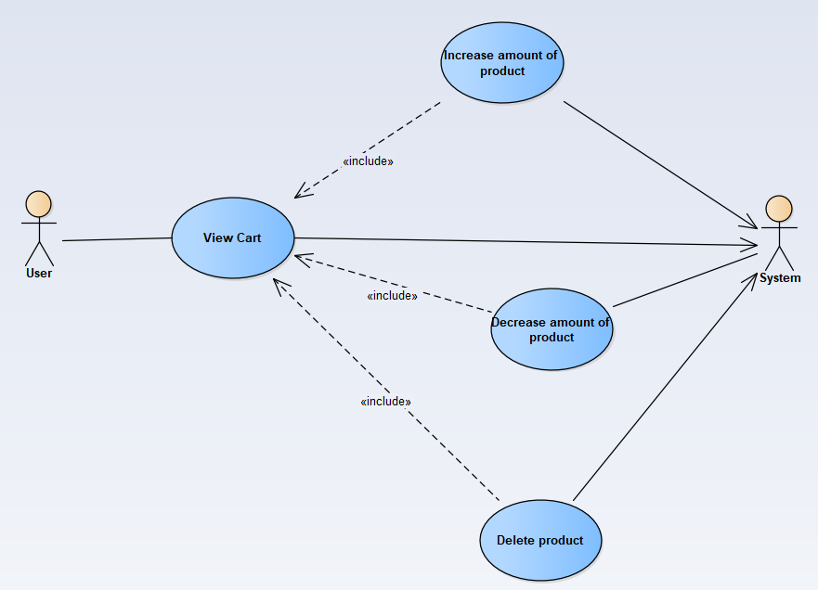
User usecase View cart
Actors | User, System
Description | User can increase, decrease, delete product
Data | User’s adjustment
Stimulus | Interface include input form and button
Response | You increased successfully  (Or You decreased successfully)  (Or You deleted successfully)
Comments | The user may view cart about things that they purchased
Deliverer usecase Delivery History
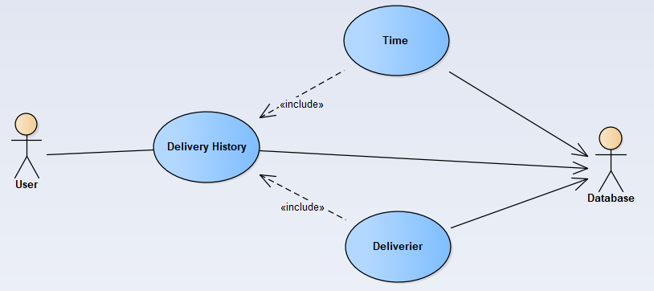
Delivery usecase Delivery History
Actors | User, Database
Description | Review history (delivery time, delivery person)
Data | Information on delivery of goods
Stimulus | Interface include information form
Response | Interface include the list of delivery history
Comments | User can see the delivery history
Deliverer usecase Information of recipient
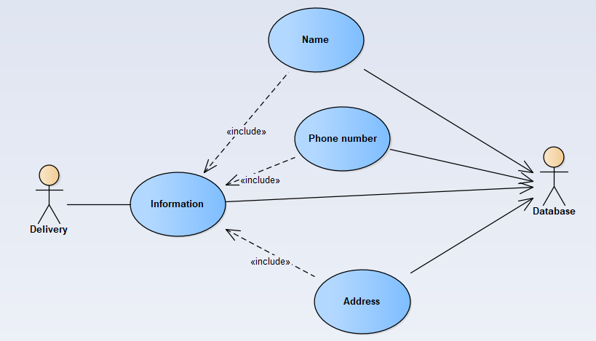
Deliverer usecase Information of recipient
Actors | Deliverer, Database
Description | Deliverer can see the personal information of recipients
Data | Information saved from database
Stimulus | Interface include information form
Response | Recipient’s information
Comments | the carrier can view recipient’s information into the form that save to the database

Staff usecase Calculate money for goods
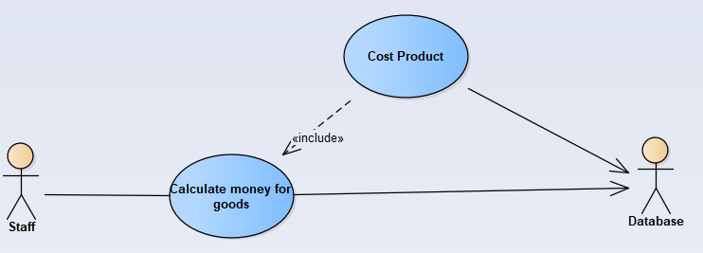
User usecase Calculate money for goods
Actors | Staff, Database
Description | To calculate amount of money for goods that purchased
Data | Money(database) and staff’s input
Stimulus | Interface include input form
Response | Amount of money
Comments | The staff can see the price of each products and calculate total goods purchased
User usecase Cancellation of order
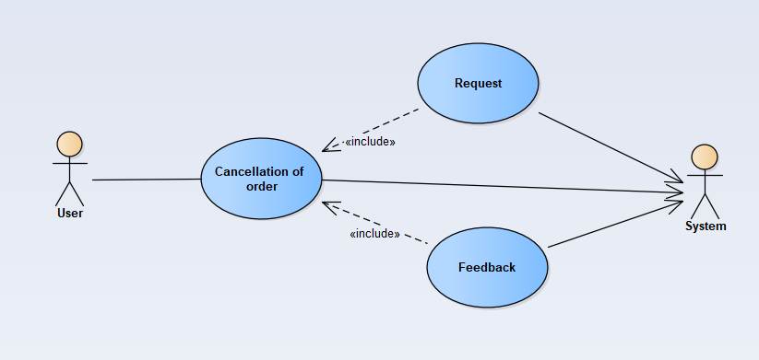
User usecase Cancellation of order
Actors | User, System
Description | To cancel a purchased order to the system
Data | User’s confirm
Stimulus | The interface includes a list of orders
Response | User successfully cancel
Comments | The user can view and cancel their orders which they bought
User usecase Evaluate
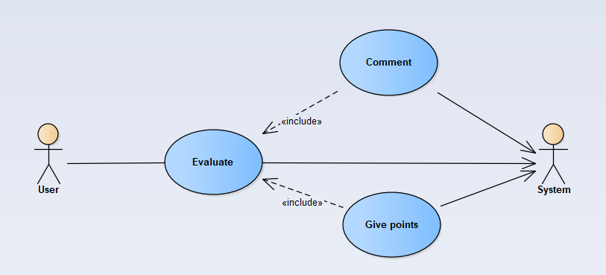
User usecase Evaluate
Actors | User, System
Description | User can evaluate shops or products to the system
Data | User’s evaluate
Stimulus | Interface that is an evaluate form and feed back from stores
Response | Evaluate has been saved successfully
Comments | The user can be feedback and evaluate about the quality of purchased products
User usecase Voucher
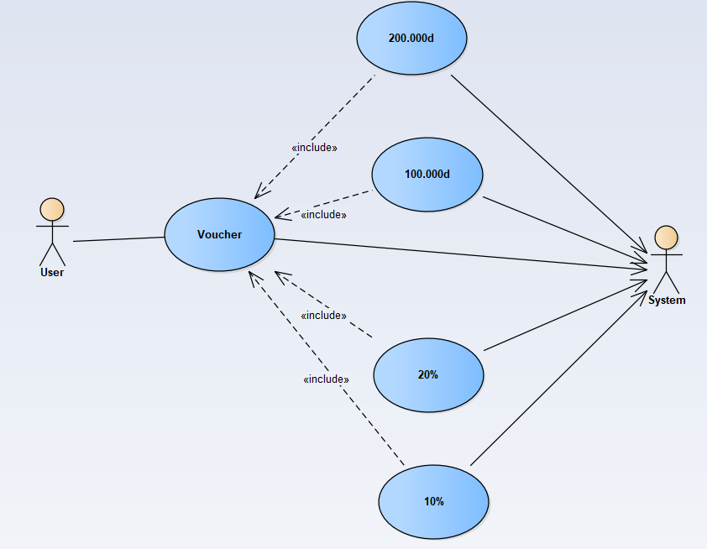
User usecase Voucher
Actors | User, System
Description | List of other voucher for user apply from the system
Data | User’s choice
Stimulus | Interface include the list of other limited vouchers
Response | Vouchers today have
Comments | Users can choose coupons to discount products they have purchased
User usecase Location
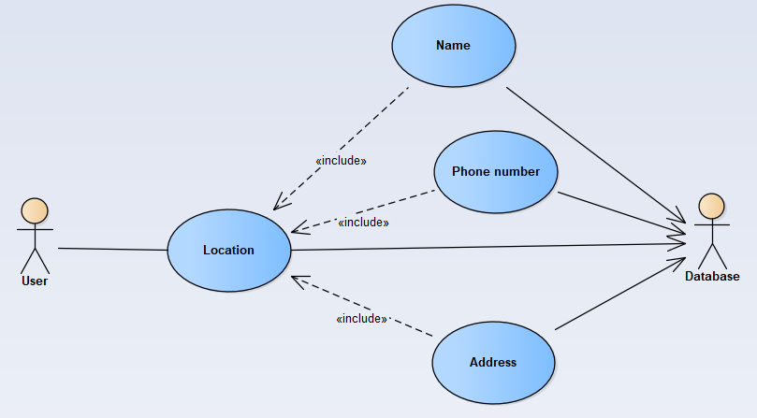
User usecase Location
Actors | User, Database
Description | User can enter information about their location (name, phone number, address)
Data | User’s input
Stimulus | Interface is a form that holds the user's location information
Response | Information has been updated successfully
Comments | The user can enter and add their information about the delivery location for their convenience

