**FPT International School**

--- o0o ---

**PROJECT REPORT**

**<Web selling Bags>**

Batch: T2210E

Semester: 1

Group: 3

HOANG QUOC DUY

HOANG BA CHUC

PHAM THI XUAN THUY

DUONG DUC LUAN

DO TRUONG THO

**Hanoi – 28/3/2023**

**Table of Contents**

1. Problem Definition 3

1.1 Overview 3

i. Introduction 3

ii. Implementation Environment 4

1.2 User Stories 5

1.2.1 Admin 5

a) Register 5

b) Manage Products 5

c) Manage Categories 5

d) Manage Users 5

1.2.2 Customers 5

e) Search Product 5

f) View Product 5

g) Purchase Product 5

2. Flowchart 6

2.1 Register 6

2.2 Manage Product 7

2.3 Manage Categories 8

2.4 Manage Users 9

2.5 Search Products 10

2.6 Purchase Products 11

3. UI\UX 12

3.1 Homepage 12

3.2 Shop 14

3.3 … 14

3.4 … 14

3.5 … 14

3.6 ... 14

3.7 ... 15

3.8 ... 15

3.9 ... 15

3.10 ... 15

4. Summary 16

# Problem Definition

## Overview

### Introduction

BagBag is an online store for various types of Bags. They have collection of bags. Now they want to revamp their website with all the products listed on the website. Consumers should find it easy to view various products and decide upon purchasing the right product to meet their requirements.

A website needs to be designed to display various bags available with the store. Details of locations, feedback must be included.

The website is to be developed for the Windows Platform using HTML5, JavaScript and Geolocation. The site should work well in all leading browsers including Chrome, IE, Firefox etc.

**Requirement Specification:**

The Web site is to be created based on the following requirements.

1. The Home Page should be created making use of Sections with a suitable logo, the header section can be added which will show images of various Bags.
2. The site must contain the links to navigate through various types of Bags, BackPacks etc.
3. Site should have different section for Men and Women and bags should be placed accordingly.
4. Links of bags must be categorized like (Bags, Sling Bags, BackPacks etc.)
5. Specification and Pricing of Bags should be added along with the images.
6. Website should provide section for various brands offered in the store.
7. Gallery section should be added for viewing different images.
8. Feedback must be allowed to enter by the viewer
9. Site map, Gallery, about us, Queries link, Contact us link must be added. Show the location using maps or GeoLocation API.
10. The complete description must be allowed to get download as pdf or doc file.
11. The advertise section with various facilities provided should be mentioned.

### Implementation Environment

* HTML5/ CSS/ JavaScript
* Boostrap / Jquery/ Boostrap Hover
* Amazing Slider
* Dreamweaver
* Google Chrome/ Mozilla FireFox/ Internet Explorer
* Ajax
* Methodology: Scrum
* ElevateZoom
* Local Storage
* Json

## User Stories

### Customers

#### Search Product

As a customer, I want to find products to purchase for myself.

#### View Product

As a customer, I want to view the details of your product to consider to purchase or not.

#### Purchase Product

As a customer, I want to purchase your product, can change quantity of the product, and see the total of my deal.

# Flowchart

## Register

## 

## Search Products

## Purchase Products

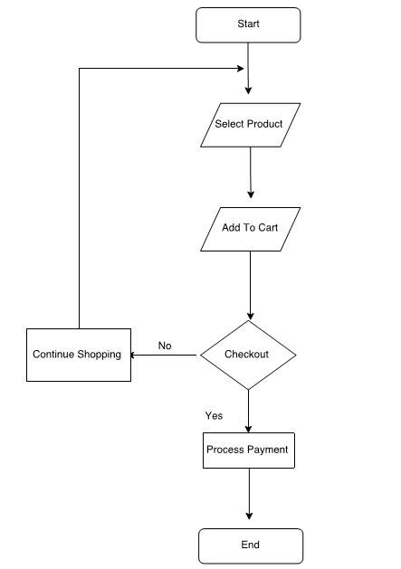

# UI\UX

## Homepage

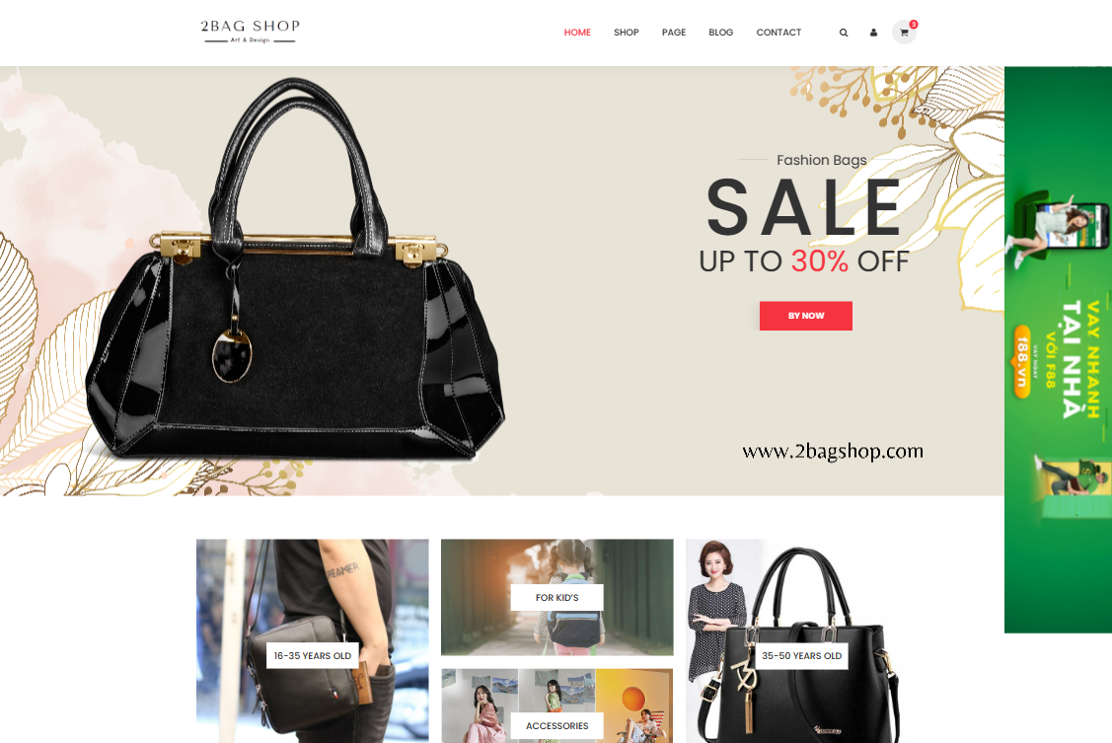

## Shop



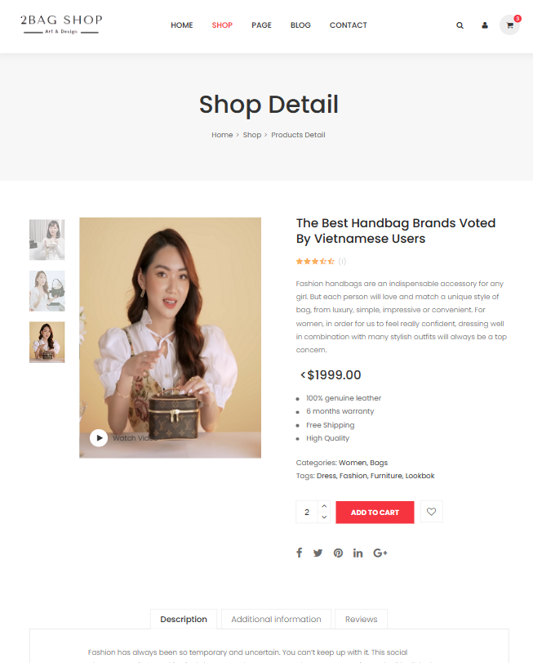

## Gallery

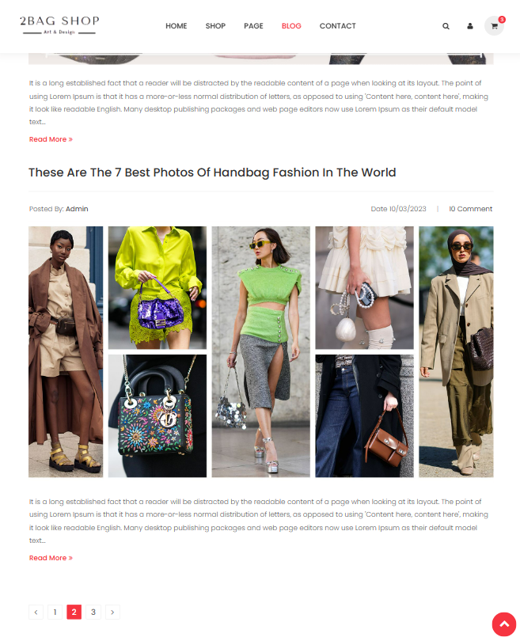

## About



## Contact

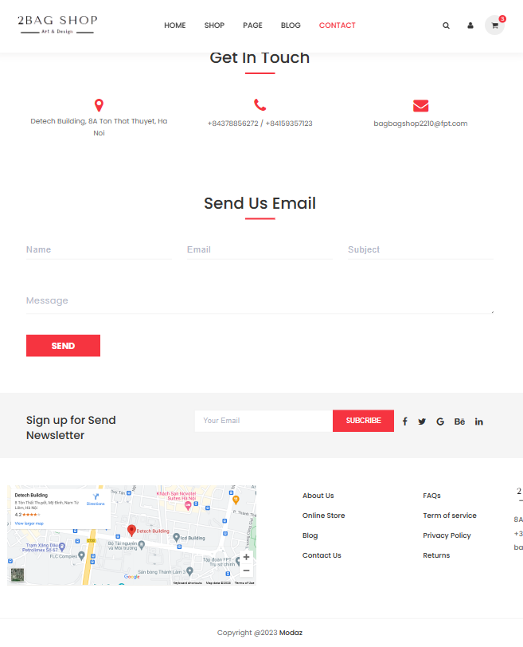

## Feedback

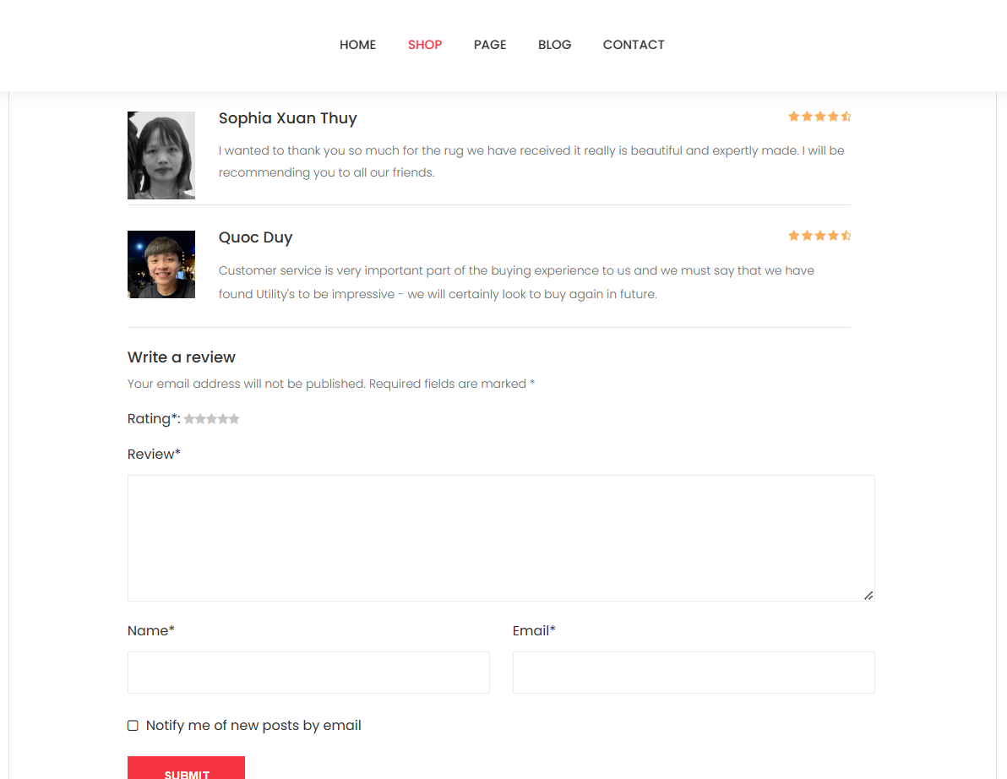

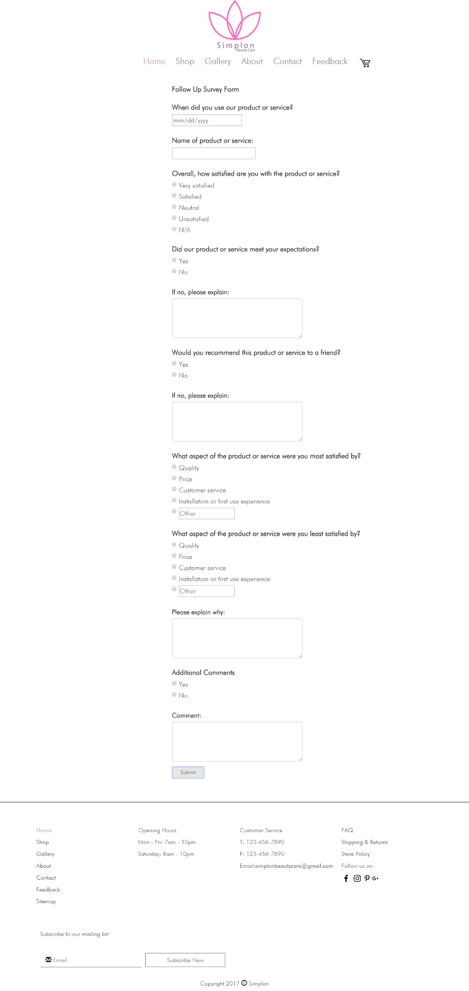

## Shopping Cart



## Checkout

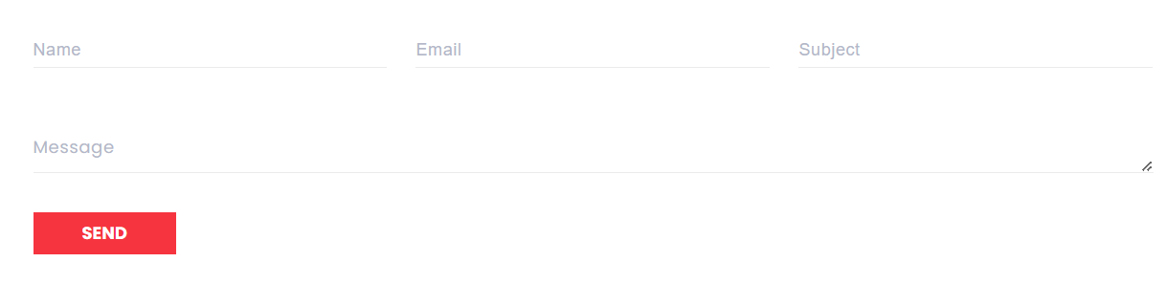

## Admin ( Login)

