**HO CHI MINH UNIVERSITY OF SCIENCE**

**FACULTY OF INFORMATION TECHNOLOGY**



**REPORT: Project 01:**

**Hide and Seek**

By:

22127057 – Đỗ Phan Tuấn Đạt

22127064 – Phạm Thành Đạt

22127123 – Lê Hồ Phi Hoàng

22127131 – Trần Nguyễn Minh Hoàng

TABLE OF CONTENTS

A. INTRODUCTION 4

B. WORKING ENVIRONMENT 5

I. Programing language 5

II. Code editor 5

III. Code management 5

C. GENERAL CODE ANALYSIS 6

I. Seeker Agent 6

1. Code representation 6

2. Seeker’s vision 6

3. Path-finding using search algorithms 7

II. Mapping 8

III. Graphical demonstration 8

1. Main menu 8

2. Demonstrating the running process 9

3. Score display 9

D. LEVEL-SPECIFIC ANALYSIS 9

I. Level 1 9

II. Level 2 9

E. EVALUATION & COMMENTS 10

I. Level 1 10

1. Map 1 10

2. Map 2 10

3. Map 3 11

4. Map 4 11

5. Map 5 12

II. Level 2 13

1. Map 1 13

2. Map 2 14

3. Map 3 14

4. Map 4 15

5. Map 5 16

III. Level 3 17

IV. Comments 18

F. REFERENCES 18

# INTRODUCTION

This project was initialized as part of the course CSC14003 – Introduction to Artificial Intelligence. Its purpose is to help the students learn the basics of creating and implementing artificially intelligent agents through the simple childhood game hide-and-seek.

Note that the agents in this project are in no way capable of learning since all utilized algorithms are search algorithms, not neural networks.

# WORKING ENVIRONMENT

## Programing language

100% Python

## Code editor

Visual Studio Code

## Code management

GitHub

# GENERAL CODE ANALYSIS

## Seeker Agent

### Code representation

* The seeker agent is represented as the Seeker class, stored in the seeker.py file of each level.
* A Seeker object is constructed as follow:

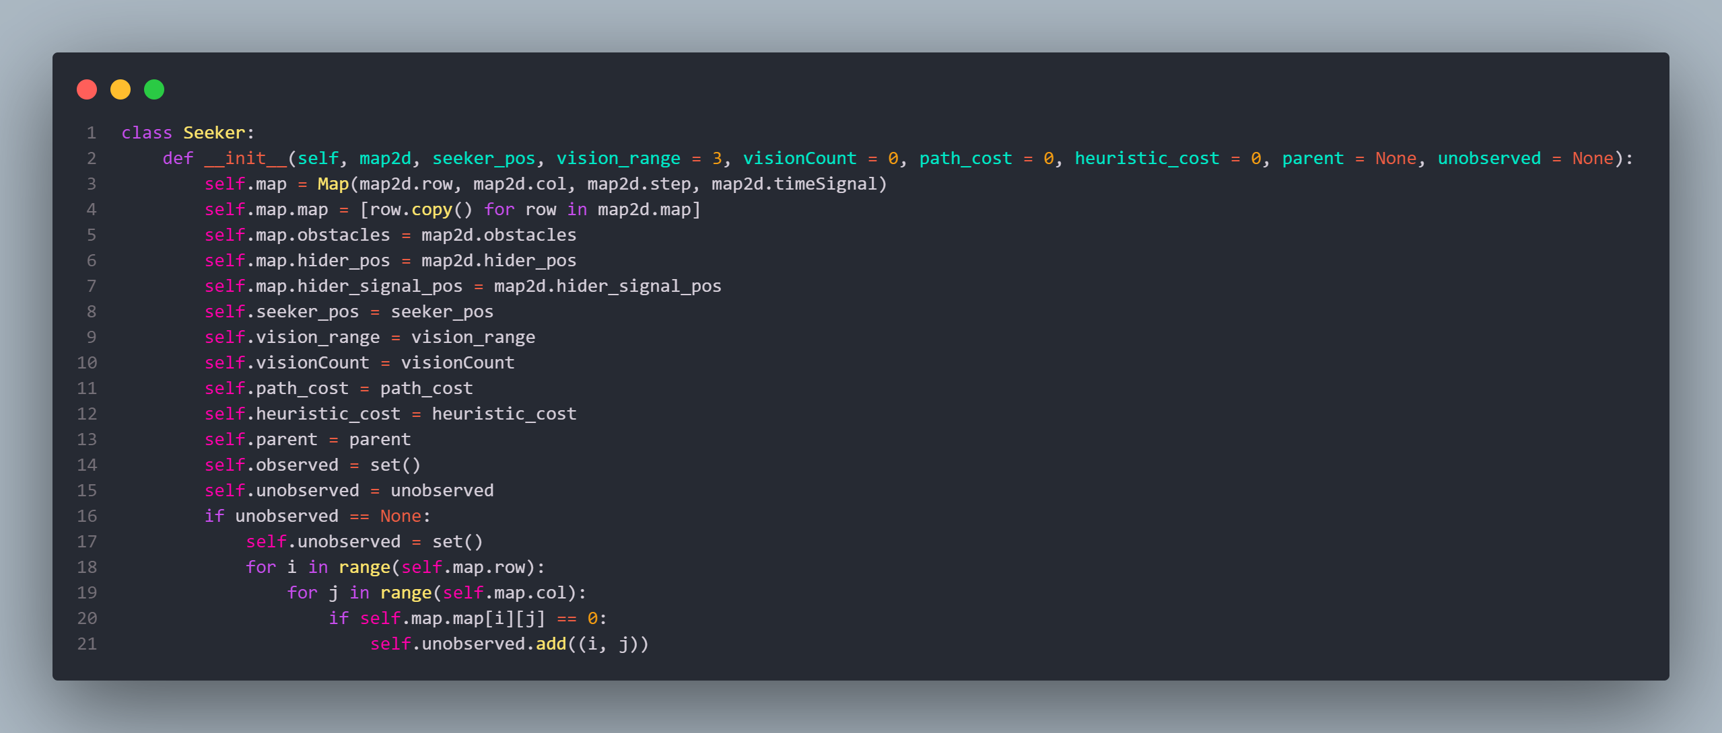

* In case you haven’t realized, this Seeker class also serves a dual purpose as a representation of the puzzle state, hence the *path_cost*, *heuristic_cost* and *parent* paremeters used in initialization, as well as the *__lt__* operator implemented further down the source code. This may look a bit odd, but it will come in handy later.

### Seeker’s vision

* As required, the seeker has a vision that ranges 3 tiles away from it in all 8 directions, as illustrated below:

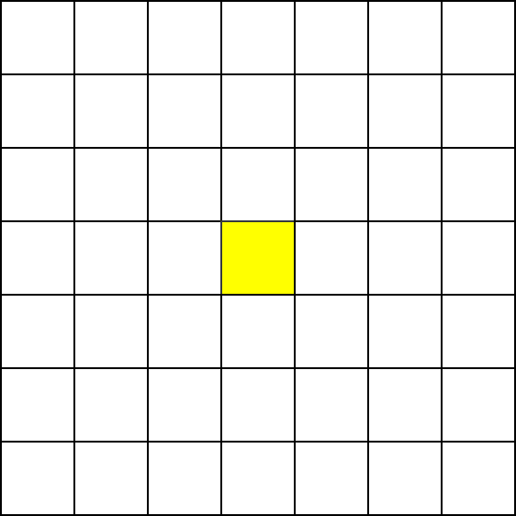

* When there is an obstacle/wall within its range of vision, observable tiles are updated as follow:

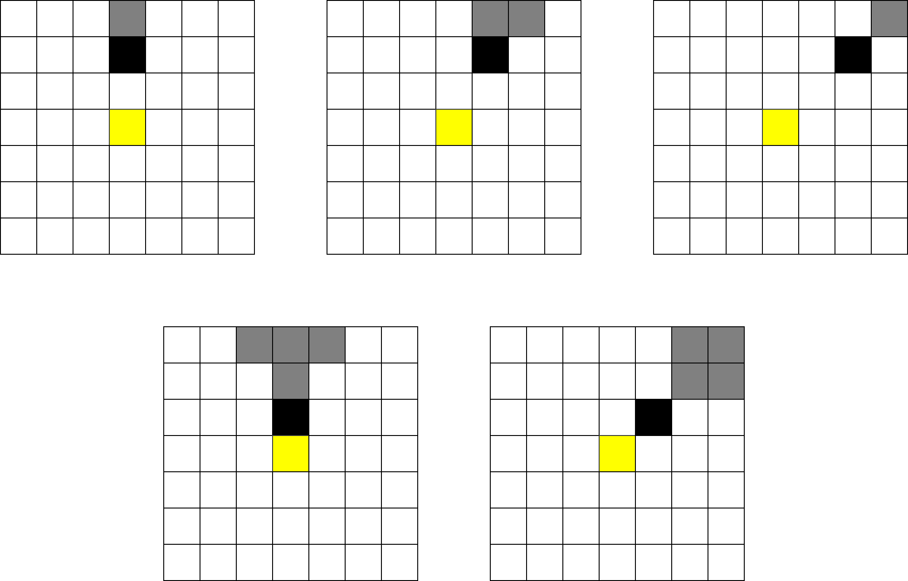

(**Black tiles** represents obstacles/walls; **grey tiles** are those that are now unobservable. The same logic applies for other quarters within the range of vision)

* In cases of long walls or multiple obstacles, the tiles that become unobservable are simply combinations of the above conditions.

### Path-finding using search algorithms

* Within the Seeker class, 3 search algorithms are implemented:
  + Breath-first search (BFS)
  + Hill climbing search, in which the seeker tries to move towards positions with the highest possible number of observable tiles.
  + A* search using Manhattan distance between current position and target position as the heuristic function.
* The priorities of each search strategies are as follow:
  + When neither hider or signal is present within observable tiles, traverse the map using Hill climbing search.
  + Upon encountering a local maximum (when all possible moves lead to a reduce in observable ties), switch to BFS to search for another unexplored portion of the map.
  + At any point during traversal, if a signal or hider appears in sight, immediately switch to A* search to reach the position of said hider/signal.
* The seeker takes 1 step per time unit, and also remembers tiles it has already observed/walked through so as to reduce redundant steps.

## Mapping

* The map in which the seeker and hider(s) will play in is represented by the Map class in the map.py file of each level.
* The only way to input a map is though text (.txt) files, which must be formatted as requested by educators:
  + The first line contains two integers N x M, which is the size of the map.
  + N next lines represent the N x M map matrix. Each line contains M integers. The number at row i, column j determines whether wall, hiders or seeker is set. If there is wall at this position, we will have value 1. If there is hider, we will have value 2. If there is seeker, we will have 3. Otherwise (empty path), we will have 0.
  + The last lines store 2 pair numbers indicate top left, bottom-right of each obstacle.
* Map class also offers multiple functions to assist with the operation of the program and debugging.
* Among them is *get_hider_pos()* function, which helps with indicating a capture
  + This function returns the x, y coordinates of the hider in level 1, and a list of x, y coordinates in later levels.

## Graphical demonstration

* This process is greatly assisted by the **pygame** module. So make sure to have the module installed before running the program.

### Main menu

* Upon starting the program, users will be met with the main menu containing the title and subtitle of the game, along with some buttons.
* The buttons are objects of the Button class, which is designed specifically around the **pygame** module.
  + Each button can change size when the cursor hovers on it.
  + Upon clicking a button, it initiates a function, which opens another screen.

### Demonstrating the running process

* The seeker’s path will be illustrated in a “game runner” screen. This screen will initialize after all calculation and processing are done (meaning only after the seeker finishes the game) so it might take a while to show up.
* Since the whole path taken by the seeker is saved, the GUI will only have to display every step in a slideshow.

### Score display

* The bottom of the game runner will have a bit of space reserved for score display.
* Score starts at 0, and decreases by 1 per time unit that passes. For each hider the seeker manages to catch, the score will increase by 20.
  + As mentioned above, the *get_hider_pos()* function provided my Map class will help with indicating a capture.
* When terminating the game runner, said score will also be printed out to console for debugging.

# LEVEL-SPECIFIC ANALYSIS

## Level 1

* In this level, things are at their most simple form: 1 hider which cannot move, 1 seeker and no time limit; the game ends when the seeker successfully catch the hider (i.e. they occupy the same tile).
* The seeker’s strategy is also at its base form that I have described in section C above.

## Level 2

* There are multiple stationary hiders in this level, the number of which the seeker knows.
* The strategy used by the seeker is largely the same, with the only difference being that it will not stop until all hiders are caught.

# EVALUATION & COMMENTS

* This section will focus on evaluating the performance of the program. Each level features 5 different maps. 3 runs will be performed on each map to record the average time and resource consumed by the program.

## Level 1

### Map 1

|  |  |  |  |
| --- | --- | --- | --- |
| Run | Score | Time (miliseconds) | Space (megabytes) |
| 1 | -13 | 22.105455 | 1.148438 |
| 2 | -28 | 95.970869 | 3.605469 |
| 3 | -13 | 9.648561 | 1.164062 |
| Avr | -18 | 42.57496167 | 1.972656333 |

### Map 2

|  |  |  |  |
| --- | --- | --- | --- |
| Run | Score | Time (miliseconds) | Space (megabytes) |
| 1 | -422 | 2164.680 | 30.094 |
| 2 | -47 | 13.485 | 1.484 |
| 3 | -333 | 1294.753 | 17.547 |
| Average | -267.3 | 1157.64 | 16.375 |

### Map 3

|  |  |  |  |
| --- | --- | --- | --- |
| Run | Score | Time (miliseconds) | Space (megabytes) |
| 1 | -209 | 2418.203 | 26.703 |
| 2 | -165 | 1460.073 | 16.918 |
| 3 | -192 | 1903.081 | 26.387 |
| Average | -188.67 | 1927.110 | 23.336 |

### Map 4

|  |  |  |  |
| --- | --- | --- | --- |
| Run | Score | Time (miliseconds) | Space (megabytes) |
| 1 | -91 | 642.522 | 14.047 |
| 2 | -63 | 174.661 | 10.535 |
| 3 | -132 | 3776.902 | 18.035 |
| Average | -95.33 | 1531.36 | 114.205 |

### Map 5

|  |  |  |  |
| --- | --- | --- | --- |
| Run | Score | Time (miliseconds) | Space (megabytes) |
| 1 | -10 | 26.582 | 3.504 |
| 2 | -10 | 14.787 | 3.547 |
| 3 | -11 | 85.644 | 9.652 |
| Average | -10.33 | 42.447 | 5.5677 |

## Level 2

### Map 1

|  |  |  |  |
| --- | --- | --- | --- |
| Run | Score | Time (miliseconds) | Space (megabytes) |
| 1 | 27 | 297.400 | 3.254 |
| 2 | 35 | 70.783 | 1.465 |
| 3 | 35 | 230.805 | 2.758 |
| Average | 32.33 | 199.66 | 2.492 |

### Map 2

|  |  |  |  |
| --- | --- | --- | --- |
| Run | Score | Time (miliseconds) | Space (megabytes) |
| 1 | -443 | 9585.526 | 36.570 |
| 2 | -442 | 10845.965 | 38.926 |
| 3 | -356 | 8593.667 | 29.031 |
| Average | -413.66 | 9675.052 | 34.842 |

### Map 3

|  |  |  |  |
| --- | --- | --- | --- |
| Run | Score | Time (miliseconds) | Space (megabytes) |
| 1 | -184 | 10921.771 | 29.594 |
| 2 | -85 | 8108.374 | 34.168 |
| 3 | -217 | 11707.010 | 26.641 |
| Average | -162 | 10245.718 | 30.134 |

### Map 4

|  |  |  |  |
| --- | --- | --- | --- |
| Run | Score | Time (miliseconds) | Space (megabytes) |
| 1 | -172 | 15674.640 | 48.75 |
| 2 | -215 | 16618.833 | 52.109 |
| 3 | -338 | 53120.585 | 118.676 |
| Average | -241.6 | 28471.352 | 73.178 |

### Map 5

|  |  |  |  |
| --- | --- | --- | --- |
| Run | Score | Time (miliseconds) | Space (megabytes) |
| 1 | -470 | 118617.489 | 160.703 |
| 2 | -529 | 115374.011 | 112.895 |
| 3 | -355 | 66782.402 | 109.594 |
| Average | -451.33 | 100257..9673 | 127.73 |

## Level 3

* Level 3 uses the same set of maps as level 2, so only the result tables will be listed
  + Map 1

|  |  |  |  |
| --- | --- | --- | --- |
| Run | Score | Time (miliseconds) | Space (megabytes) |
| 1 | 40 | 34.73 | 1.25 |
| 2 | 30 | 38.686 | 1.051 |
| 3 | 35 | 69.499 | 1.547 |
| Average | 35 | 47.638 | 1.283 |

* + Map 2

|  |  |  |  |
| --- | --- | --- | --- |
| Run | Score | Time (miliseconds) | Space (megabytes) |
| 1 | -168 | 4028.924 | 24.477 |
| 2 | -278 | 6556.450 | 30.910 |
| 3 | -299 | 10329.924 | 32.977 |
| Average | -248.33 | 6971.766 | 29.454 |

* + Map 3

|  |  |  |  |
| --- | --- | --- | --- |
| Run | Score | Time (miliseconds) | Space (megabytes) |
| 1 | -186 | 13528.262 | 37.375 |
| 2 | -197 | 10723.233 | 25.934 |
| 3 | -193 | 12502.166 | 28.02 |
| Average | -192 | 12251.22 | 30.443 |

* + Map 4

|  |  |  |  |
| --- | --- | --- | --- |
| Run | Score | Time (miliseconds) | Space (megabytes) |
| 1 | -157 | 12374.505 | 50.457 |
| 2 | -129 | 15581.947 | 67.988 |
| 3 | -337 | 57083.051 | 159.547 |
| Average | -207.66 | 28346.501 | 92.664 |

* + Map 5

|  |  |  |  |
| --- | --- | --- | --- |
| Run | Score | Time (miliseconds) | Space (megabytes) |
| 1 | -565 | 181661.581 | 297.09 |
| 2 | -479 | 96586.793 | 166.895 |
| 3 | -546 | 131795.551 | 123.34 |
| Average | -530 | 136681.308 | 199.775 |

## Comments

From the date gathered, there are a few comments that can be made:

* Obviously, larger maps will lead to lower score due to more wandering around. Additionally, the processing takes substantially more time and resources the larger the map, and the further the hider(s) are from the seeker.
* Smaller maps with more hiders in them will naturally lead to higher scores thanks to the reward/penalty rate of 20/1.
* Escaping hiders are surprisingly easy to catch in level 3, which might be because of how we programmed the hider to run.
* Signals sometimes becomes distractions, leading the seeker away from the hider, or to the wrong side of a wall.

# REFERENCES

* <https://www.youtube.com/watch?v=GMBqjxcKogA>
* *Artificial Intelligence: A Modern Approach - 3rd Edition* by Stuart Russel and Peter Norvig
* <https://www.geeksforgeeks.org/a-search-algorithm/>
* <https://www.codecademy.com/resources/docs/ai/search-algorithms/hill-climbing>