Exercise 2: Find association rules in the weather.nominal dataset by Weka explorer a. Load the data in Weka Explorer. Select the Associate tab. How many different associations rule mining algorithms are available?

b. Choose Apriori algorithm with the following parameters (which you can select by clicking on the chosen algorithm: support threshold = 15% (lowerBoundMinSupport = 0.15), confidence threshold = 90% (metricType = confidence, minMetric = 0.9), number of rules = 50 (numRules = 50). After starting the algorithm, how many rules do you find? Could you use the regular weather dataset to get the results? Explain why

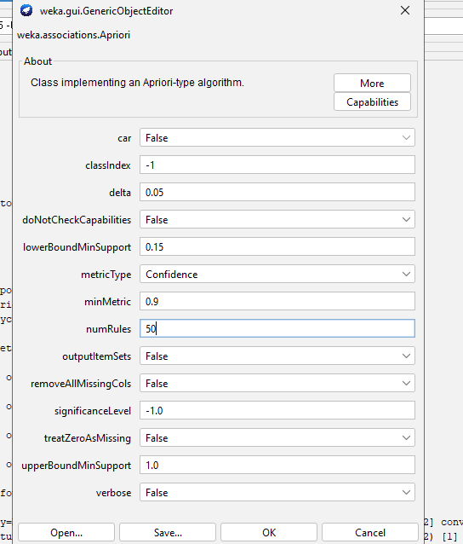

c. Paste a screenshot of the Explorer window showing at least the first 20 rules.

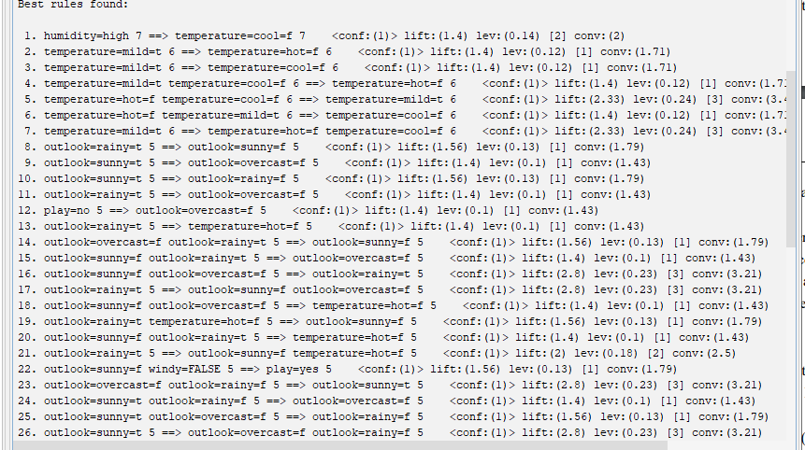

d. Based on the output, what is the support for this item set? outlook = rainy humidity = normal windy = FALSE play = yes

e. Apriori algorithm generates(bam vao Associate) association rules from frequent itemsets. How many itemsets of size 4 were found? Which rule(s) have been generated from itemset of size 4

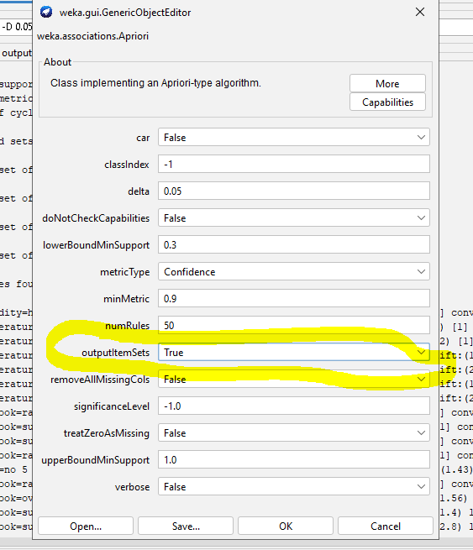

Sai số ít nhất là :3,2,1

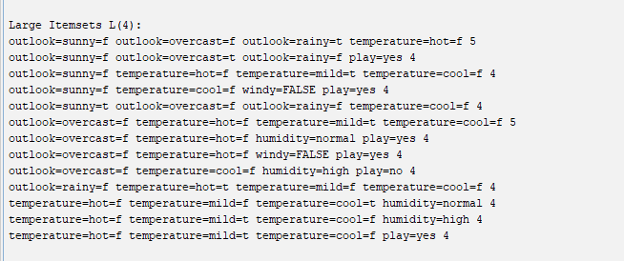 (temperature=mild, windy=false, play=yes, outlook=rainy)? List their numbers in the list of rules

f. What is the total number of possible rules for the weather data for each combination of values in the following table?

Minimun confidence: 0.9,

Minimum support: 0.3,

Number of rules:168