Networking

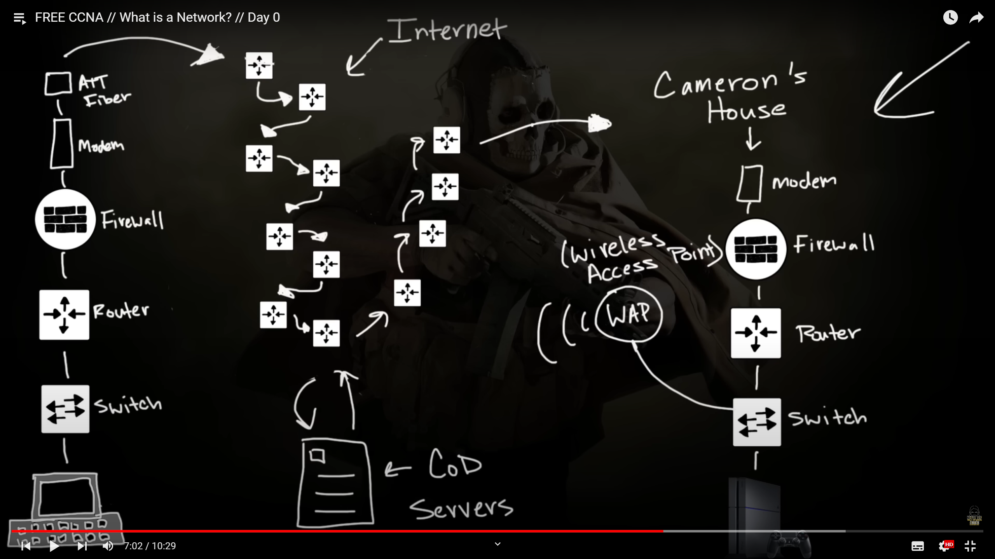

1. Router:
2. Switch:
3. WAP: Wireless Access Point.
4. WAN: Wide Area Network
5. LAN: Local Area Network
6. Firewall
7. Server
8. Network Controller