**Subject: PRF192- PFC**

**Workshop 04**

**Objectives:**

1. Managing data using pointers
2. Developing programs using simple menus

**Part 1: Use notebook**

**Exercise 1** (1 mark) : Explain outputs:

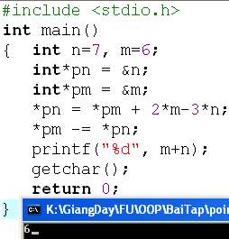

*pm = *pm + 2*m – 3*n;

n = *pn = 6 + 2*6 – 3*7 = -3

*pm -= *pn;

m = *pm = *pm - *pn = 6 – (-3) = 9

=> Output = m + n = 9 – 3 = 6

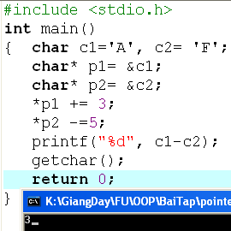*p1 += 3 => c1 = *p1 = *p1 +3 = c1+3 = A + 3 = D

* p2 -= 5 => c2 = *p2 = *p2 -5 = F – 5 = A

=> Outputs =C1 – C2 = *p1 - *p2 = D – A = 3

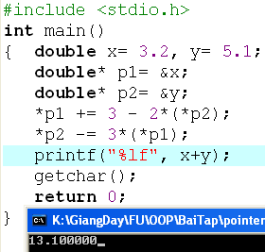x = *p1 += 3 -2*(*p2) = *p1 + 3 – 2*5.1 = 3.2 + 3 -2*5.1 = -4

y = *p2 -= 3*(*p1) = p2 – 3*(p1) = 5.1 – 3*(-4) = 17.1

=> Output = x +y = -4 + 17.1 = 13.1

**Exercise 2: (1 marks) What are outputs**

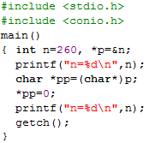

M = *p1 = *p1 + 12 – m +(*p2) = 7 +12 – 8 + 8 = 19

n =*p2 = m + n -2*(*p1) = 8 + 19 – 2*19 = -11

=> Output = m + n = 19 - 11 = 8

**Exercise 3: (2 marks) Walkthroughs**

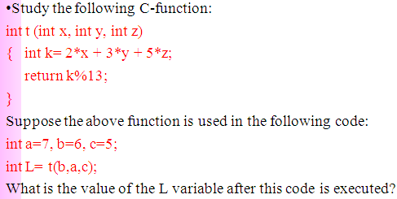

L = 2*6 + 3*7 + 5*5 = 58

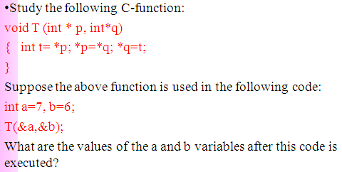

t = 7 = *p = *q = t => b= 7 => a =6

=> Output T (6,7)

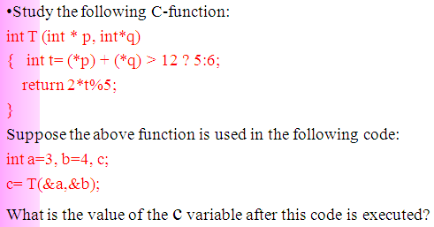

a = *p = 3

b = *q = 4

(*p) +(*q) = 3 + 4 = 7 < 12 => t = 6 => return = (2*6) % 5= 2

**Part 2: Develop a program using simple menu**

**Program 1(3 marks):**

|  |  |
| --- | --- |
| **Objectives** | Practice implementing a program with simple menu. |
| **Related knowledge** | None |
| **Problem** | Write a C program that will execute repetitively using a simple menu as following:   1. **Process primes** 2. **Print min, max digit in an integer;** 3. **Quit**   **Select an operation:**   1. When user selects the option 1, the program will accept a positive integral number and print out a message about whether the input number is a prime or not. 2. When user selects the option 2, the program will accept a positive integral number and print out the minimum and maximum digit in this number. 3. The program will terminate when user selects the option 3. |
| **Analysis** | **Nouns:**  - positive integral number 🡪 **int n**  - A number represents a choice of user 🡪 **int choice;**  **Functions**:  **int prime( int n) 🡪 see above**  **void printMinMaxDigits( int n) 🡪 see above** |
| **Suggested algorithm (logical order of verbs)** | Begin  Do /* Print out the menu and get user choice*/  { Print out “1- Process primes\n”;  Print out “2- Print min, max digit in an integer \n”;  Print out “3- Quit\n”;  Print out “Select an operation:”;  switch(choice)  { case 1: do  { Input n;  }  while(n<0);  If ( prime(n)==1) Print “ It is a prime\n”;  Else Print “ It is not a prime\n”;  break;  case 2: do  { Input n;  }  while(n<0);  printMinMaxDigits( int n) ;  break;  }  }  while ( choice >0 & choice<3);  End |

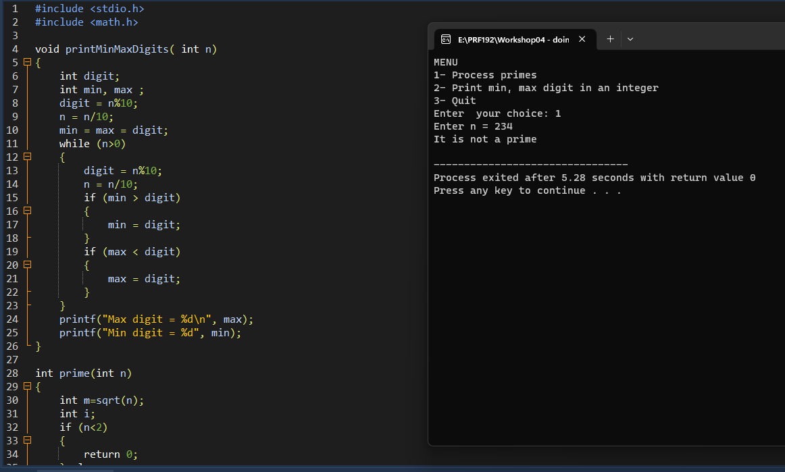

**Program 2(3 marks): ( refer to the workshop 2 for algorithms)**

Write a C program that will execute repetitively using a simple menu as following:

**1-Fibonacci sequence**

**2-Check a date**

**3-Quit**

**Choose an operation:**

1- When the option 1 is selected, the program will accept a positive integral number, called as n, then the first n Fibonacci numbers will be printed out

2- When the option 2 is selected, the program will accept a date then the program will tell that whether this data is valid or not.

3- If the option 3 is selected, the program quits

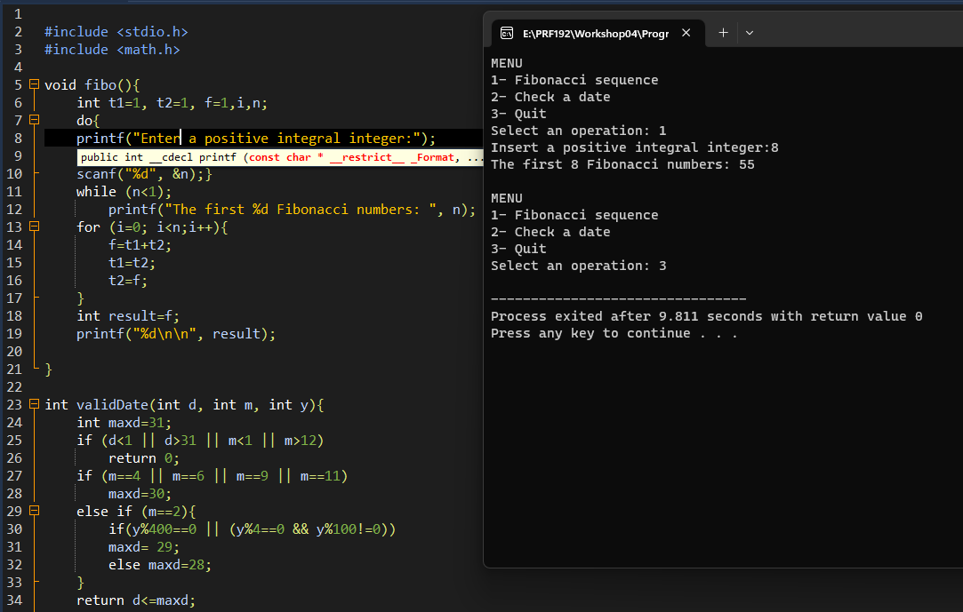

**More Programs**

You can pick 2 or 3 functions in the workshop 2, associate them to a new program.