**Subject: PRF192- PFC**

**Workshop 06**

**Objectives: Managing arrays**

**Sample: Canadian SIN (Social Insurance Number)**

SIN: **1**9**3** 4**5**6 **7**87 | check digit is **7** add first set of alternates to themselves

9 4 6 8 9 4 6 8 **18 8 12 16**

add the digits of each sum **1+8+8+1+2+1+6 = 27 (T1)**

add the other alternates 1+3+5+7 = 16 (T2)

total = T1+T2 = 27+16=43

Next highest integer multiple of 10 T3= 50 (50>43).

Difference T3-total = 50-43= **7** Matches the check digit, therefore this SIN is valid

SIN: 193456787

|  |  |  |  |  |  |  |  |  |  |  |  |  |
| --- | --- | --- | --- | --- | --- | --- | --- | --- | --- | --- | --- | --- |
| N0 | N1 | N2 | N3 | N4 | N5 | N6 | N7 | N8 | N9 |  |  |  |
|  | 1 | **9** | 3 | **4** | 5 | **6** | **7** | **8** | **7** |  |  |  |
|  |  |  |  |  |  |  |  |  |  |  |  |  |
|  | **9** | **4** | **6** | **8** | **9** | **4** | **6** | **8** | **18** | **8** | **12** | **16** |
| C0 | C1 | C2 | C3 | C4 | C5 | C6 | C7 | C8 | C9 | C10 | C11 | C12 |

**Algorithm for checking whether a number is a Canadian SIN or not**

Use the array N, 10 elements, N[0] is not used

Use the array C, 12 elements, C[0] is not used

From n, computing N[i]:

From N, computing C[i]:

Compute

T1= C9/10 + C9%10 + C10/10 + C10%10 + C11/10 + C11%10 + C12/10 + C12%10

T2= N1 + N3 + N5 + N7;

Total= T1+T2

T3= (Total/10+1) *10; ( Total=**4**3 🡪 T3 = (**4**+1)*10

If (T3-Total == N9) return “Valid”

else return “Invalid”

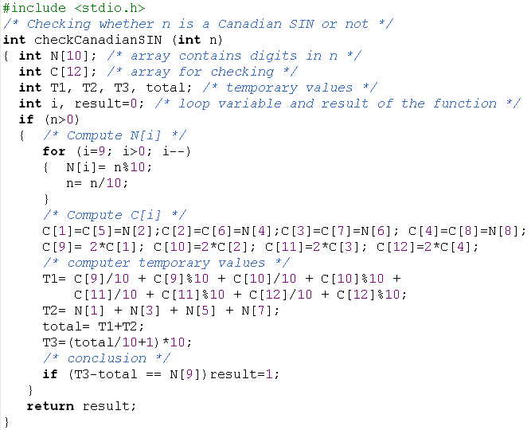

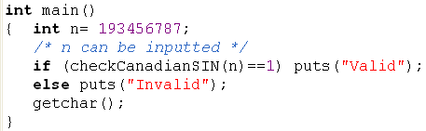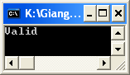

Refer to the sample above, write the following problem.

**Problem 1 (4 marks)**

An ISBN consists of exactly **10 digits**.  The rightmost digit is the check digit.  The check digit is validated modulo 11.

* multiply each digit from the first to the ninth by a weight from 10 to 2 respectively (the first digit by 10, the second by 9,..., the ninth by 2).
* the sum of the products plus the check digit should be divisible without remainder by 11.
* if there is a remainder, the whole number is not a valid ISBN.

Consider the following example:

|  |  |  |  |  |  |  |  |  |
| --- | --- | --- | --- | --- | --- | --- | --- | --- |
| ISBN 0003194876 | check digit is 6 add first set of alternates to themselves  0 0 0 3 1 9 4 8 7 10 9 8 7 6 5 4 3 2 **0 0 0 21 6 45 16 24 14** = 126  add check digit 6 total 132 divide by 11 12 remainder 0 Therefore this ISBN is valid. | | | | | | | | |
| I1 | I2 | I3 | I4 | I5 | I6 | I7 | I8 | I9 | **I10** |
| **0** | **0** | **0** | **3** | **1** | **9** | **4** | **8** | **7** | **6** |
|  |  |  |  |  |  |  |  |  |  |
| C1 | C2 | C3 | C4 | C5 | C6 | C7 | C8 | C9 |  |
| **0**\***10**=**0** | **0**\***9**=**0** | **0**\***8**=**0** | **3**\***7**=**21** | **1**\***6**=**6** | **9**\***5**=**45** | **4**\***4**=**16** | **8**\***3**=**24** | **7**\***2**=**14** |  |

T= C1+ C2+C3+C4+C5+C6+C7+C8+C9 + I10; (T=132)

If (T%11==0) print out “Valid” else print out “Invalid”

Write a program that will accept a number (>=1 000 000 000) then show whether the number is an ISBN or not.

ISBN Validator ============== ISBN (0 to quit): 0003194876

This is a valid ISBN.

ISBN (0 to quit): 0003194875

This is not a valid ISBN. ISBN (0 to quit): 0

Have a Nice Day!

**Problem 2 (6 marks)**

Develop a C-program that helps user managing an 1-D array of real numbers(maximum of 100 elements) , with initial number of elements is 0, using the following simple menu:

1- Add a value

2- Search a value

3- Print out the array

4- Print out values in a range

5- Print out the array in ascending order

Others- Quit

* When the option 1 is selected, user will enters a value then it is added to the array
* When the option 2 is selected, user will enters a value then number of it’s existences will be printed out.
* When the option 3 is selected, values in the array will be printed out.
* When the option 4 is chosen, user will enter 2 values, minVal and maxVal, the values in array which are between minVal and maxVal are printed out (minVal <=value<=maxVal)
* When the option 5 is chosen, values in array will be printed out in ascending order but **their position are preserved. ( sorting based their pointers only)**

